Date of publication xxxx 00, 0000, date of current version xxxx 00, 0000.
Digital Object Identifier 10.1109/ACCESS.2017.Doi Number
High-Throughput Conjunction Risk Prediction in Low Earth Orbit: A CKDTree - Accelerated Hybrid SGP4 - Ensemble Framework with Physics-Informed Feature Engineering.
First S. Sudharsan¹, Second K. Jayanth², and Third V. Vijin Ajai, Jr.³, Fourth Dr. J. Paul Raja Singh⁴
¹Bachelor of Technology in Computer Science and Engineering , SRM Institute of Science and Technology, Tiruchirappalli, India
²Bachelor of Technology in Computer Science and Engineering , SRM Institute of Science and Technology, Tiruchirappalli, India
³Bachelor of Technology in Computer Science and Engineering , SRM Institute of Science and Technology, Tiruchirappalli, India
⁴Assistant Professor / CSE, SRM Institute of Science and Technology, Tiruchirappalli, India paulj@srmist.edu.in.
Corresponding author: First S. Sudharsan (e-mail: ss0856@srmist.edu.in).

ABSTRACT The​‍​‌‍​‍‌​‍​‌‍​‍‌ continuous expansion of massive satellite constellations has made it extremely difficult to carry out real-time conjunction risk prediction in the Low Earth Orbit area due to the prohibitive computational cost of traditional deterministic models. In response to this challenge at the core of Space Situational Awareness, this research presents a High-Throughput Conjunction Risk prediction framework combining hybrid orbital dynamics and Machine Learning architecture.
Our approach makes use of the cKDTree spatial partitioning algorithm, which is highly efficient, to achieve near-linear complexity screening and thus greatly speeds up the process of identifying close approach candidates out of thousands of objects propagated with the SGP4 model. The arrangement employs Physics-Informed Feature Engineering to convert the raw orbital elements obtained from Two-Line Elements into highly effective predictive features. An Ensemble Learning model, in particular, a Gradient Boosting Classifier, is trained with these features that in turn accurately assign threats into different risk levels at a speed that is several times faster than that of computationally intensive probabilistic models.
The output is a combined system with the capacity to quickly provide the most important threat classes as a basis for the decision-making process in the planning of collision avoidance maneuvers thus, the use of the orbital environment is made safe and sustainable in the long ​‍​‌‍​‍‌​‍​‌‍​‍‌term.

I. INTRODUCTION

The​‍​‌‍​‍‌​‍​‌‍​‍‌ rapid and sustained growth of large satellite constellations made possible mainly by commercial enterprises has, in essence, changed the way we can operate in the Low Earth Orbit (LEO). As a result, the proliferation of the population of the so-called Resident Space Objects (RSOs) has gone up to the new heights with the RSOs being operational satellites, inactive payloads, and catastrophic fragmentation debris, thus increasing the probability of collision. The 2009 hypervelocity collision between Iridium-33 and Cosmos-2251 was a clear alarming example of the Kessler Syndrome mechanism, i.e., the event leading to a chain of subsequent fragmentation, thus endangering both the long-term sustainability and the accessibility of primary orbital shells. As a result, Space Situational Awareness (SSA), i.e., the knowledge about space and the prediction of RSO trajectories, has moved beyond the advisory level to become an operational imperative for all stakeholders.
The central problem in SSA is Conjunction Assessment (CA), i.e., a routine activity by which the collision risk between two space objects is determined. Usually, CA is based on operation trajectories by using either high-fidelity numerical models or fast analytical models like the Simplified General Perturbations 4 (SGP4). Although the method is good enough for a small number of objects, it has a serious limitation in scalability. The exhaustive pairwise comparison of a catalog of N objects is a quadratically scaled (O(N²)) process. When N goes over 50,000 tracked objects, such a computational burden makes the traditional The current operational environment necessitates a departure from purely computational SSA approaches to a hybrid human-computer model that leverages the strengths of both. On the one hand, there is a trend toward ever larger constellations housing thousands of smaller satellites in LEO. On the other hand, however, there is a myriad of still largely uncoordinated and independent actors including
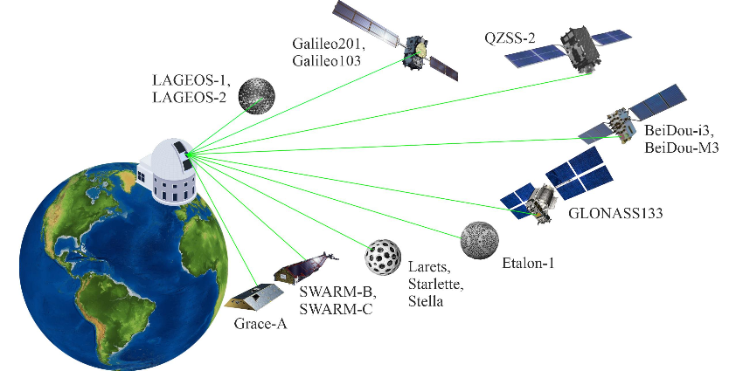
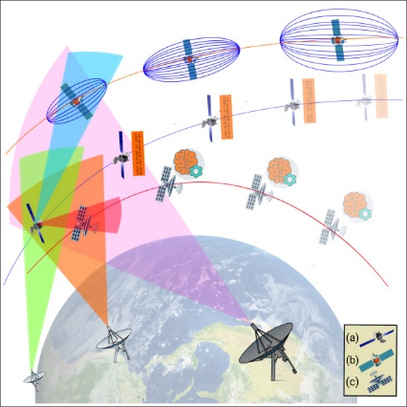

national and commercial satellites, debris, and even optically and radio astronomers watching the sky for their own research purposes. This complex and intricate scenario calls, therefore, for a comprehensive understanding of all the trans-domain interactions and synergies coming out of the multiple interconnected networks making up the overall Space ​‍​‌‍​‍‌​‍​‌‍​‍‌Domain. With​‍​‌‍​‍‌​‍​‌‍​‍‌ the ongoing rapid and continuous growth of large satellite constellations, mainly by commercial ventures, the operational environment in Low Earth Orbit (LEO) has been fundamentally changed. As a result of this proliferation, the population of Resident Space Objects (RSOs) that include operational satellites, inactive payloads, and catastrophic fragmentation debris has been pushed to the record heights, thus the possibility of collision has been increased. The collision at hypervelocity level between Iridium-33 and Cosmos-2251 that happened in 2009 was the very Kessler Syndrome brought to life, where fundamentally one event causes a cascade of subsequent fragmentation, thus making the long-term sustainability and accessibility of the most important orbital shells questionable. SSA or Space Situational Awareness, understood as the complete understanding of the spatial environment and the accurate prediction of RSO trajectories, has become a direct operational necessity for all stakeholders as a consequence of this situation. The main difficulty of SSA is CA or Conjunction Assessment, which is the regular identification and quantification of collision risk between two orbiting objects. CA normally depends on propagation of trajectories with the help of either high-fidelity numerical models or fast analytical models like the Simplified General Perturbations 4 (SGP4). Although the method is quite effective for a small number of objects, it has a serious problem with scalability. In a situation where there is a catalog with N objects, the exhaustive pairwise comparison of all these objects is a process that scales quadratically (O(N²)). When N is more than 50,000 tracked objects, the computational load is so heavy that the traditional Propagate-and-Compare routine is hardly possible to be done in real-time for comprehensive monitoring. The current operational environment calls for a move from computationally intensive methods to more efficient ​‍​‌‍​‍‌​‍​‌‍​‍‌ones.

II. LITERATURE REVIEW
Historical​‍​‌‍​‍‌​‍​‌‍​‍‌ context and the problem of cascading debris The idea that collisions and fragmentations can cause a chain reaction which ultimately results in a debris environment that sustains itself (which is now generally referred to as the Kessler Syndrome) was first put forward by Kessler and Cour-Palais in 1978. It still serves as the main reason for conducting modern SSA research. Their study proved that, after a certain threshold of density, collisions will be the main source of new harmful particles, thus creating a debris belt that will live for quite a long time if there are no measures taken to solve the problem. AgUpubs The key piece of real-world evidence that supports these concerns is the accidental hypervelocity collision between Iridium-33 and Cosmos-2251 that happened in 2009. This event resulted in the creation of fragments that could be tracked and numbered in the thousands. Therefore, it showed in practice how the aftermath of just one conjunction can cause a drastic and lasting increase in local population density of an orbital shell—hence, the need for improved conjunction screening and prevention becomes not only theoretically valid but also practically urgent. NASA Technical Reports Server Classical Conjunction Assessment: propagation and pairwise comparison Traditional conjunction assessment (CA) pipelines operate following a propagate-and-compare pattern: the orbit of each object is propagated with a selected propagator and then for all other items, close approaches are looked for by comparing them. The Simplified General Perturbations family (SGP4 and its variants) together with their authoritative implementations are still the main tools for catalog-scale propagation from two-line elements (TLEs); they offer a good compromise between speed and accuracy of the results for short-term screenings. The Space Surveillance and Tracking community has been heavily dependent on SGP4 and its documented implementations (Hoots & Roehrich; Vallado’s revisitations and the SpaceTrack/SGP4 literature) over the last several decades. The problems with this method—mainly the O(N²) feature of exhaustive pairwise screening and the limited fidelity of TLE-derived states—are acknowledged and alternative screening methods are proposed in response. Collision-probability computation and operational thresholds After a close approach has been found, the corresponding centers use covariance information and relative encounter geometry to calculate the Probability of Collision (Pc). Reviews and comparative studies (e.g., Alfano’s review of short-term conjunction Pc methods) show that various Pc formulations are possible (Gaussian-assumption based, ​‍​‌‍​‍‌​‍​‌‍​‍‌numerical Monte​‍​‌‍​‍‌​‍​‌‍​‍‌ Carlo, and analytic refinements) and that each carries conceptual and numerical limitations—especially when state uncertainties, covariance correlations, or non-Gaussian error behavior dominate. Pc is practically a valuable but flawed operational metric: it may either under- or over-estimate the risk depending on covariance conditioning, the so-called dilution region phenomenon, and assumptions embedded in the method. High-performance screening: spatial indexing and neighbour search In order to overcome the computational bottleneck of pairwise checks, the research has considered the use of spatial partitioning and nearest-neighbour data structures (grid hashing, spherical caps, orbital sectoring). KD-trees and their optimized compiled variants (cKDTree) from the computational geometry literature are a good, efficient, high-performance solution for k-dimensional nearest-neighbour queries and range searches; their average query complexity is O(N log N) which is quite efficient thus making them attractive for the task of filtering propagated state vectors into candidate encounter lists before performing expensive Pc computations. Dependencies While cKDTree is a rather general instrument (e.g., SciPy’s cKDTree), modifications aimed at orbital geometry and time-expanded state vectors require not only coming up with the correct features but also coordinate mapping (e.g., ECEF/ECI segments, relative displacement vectors) and taking care of periodic boundary conditions for longitudes/angles. Improved propagation and hybrid techniques Besides using plain SGP4, a few initiatives look at higher-fidelity or corrected propagators (SGP4-XP, numerical integrators, and specialized short-term high-accuracy propagators) for conjunction prediction if the situation demands it. These projects put emphasis on a hybrid
Aspect / Research Gap | Findings from Existing Literature | Proposed Hybrid SGP4–ML Framework Contribution
1. Computational Scalability | Traditional Conjunction Assessment (CA) pipelines use exhaustive pairwise propagation (O(N²)), becoming infeasible as the number of Resident Space Objects (RSOs) exceeds 50,000. | Introduces cKDTree-based spatial partitioning, reducing screening complexity to O(N log N), enabling scalable conjunction detection in dense LEO environments.
2. Propagation vs. Accuracy Trade-off | High-fidelity numerical models provide accuracy but are computationally expensive; SGP4 is faster but limited in precision. | Uses SGP4 for propagation but enhances it through hybrid integration with ML, ensuring real-time feasibility without losing situational precision.
3. Lack of Physics-Informed ML Features | Existing ML approaches often use raw orbital parameters, ignoring physical and geometrical relationships of encounters. | Employs Physics-Informed Feature Engineering (PFFE) — extracts orbital elements (a, e, i, etc.) and encounter geometry (relative velocity, miss distance) to ensure physically grounded ML inputs.
4. Slow Collision Probability (Pc) Computation | Pc models (Gaussian or Monte Carlo-based) are mathematically intensive and unsuitable for large-scale, real-time assessment. | The Gradient Boosting Classifier provides a fast, surrogate Pc estimation, instantly classifying risk levels (Critical/High/Medium/Low).
5. Limited Actionable Output for Maneuver Planning | Many existing systems stop at risk estimation, offering little operational guidance for Δv planning. | Model outputs directional avoidance guidance (e.g., radial, along-track) — enabling actionable collision avoidance decision support.
operational stance: fast, lower-fidelity propagation is utilized for catalog-scale screening while higher-fidelity propagation is only used for a very limited number of candidates that have been flagged by the ​‍​‌‍​‍‌​‍​‌‍​‍‌screening. This​‍​‌‍​‍‌​‍​‌‍​‍‌ tiered approach is being accepted more and more as the practical way to balance scale and precision. Amostech Machine learning and AI in SSA and CA Interest in the application of machine learning (ML) and AI in the area of SSA has been skyrocketing over the last couple of years. Reviews and government studies (including recent RAND analyses and academic overviews) suggest that ML can be instrumental at every stage of the SSA pipeline: automated anomaly detection, sensor tasking prioritization, ingestion and fusion of heterogeneous tracking data, and even surrogate modelling for collision risk scoring. New research is showing that ML can be a very efficient learned proxy for costly physics calculations - especially when the model is trained on physics-informed features and carefully created labels (e.g., Pc computed from high-fidelity ensembles). On the other hand, the literature also points out the limitations of this approach: distributional shift (models trained on historical conjunctions may not generalize), the need for interpretability in operational contexts, and the necessity of robust uncertainty quantification before ML outputs can be used for automated decision making with confidence. Physics-informed feature engineering and hybrid ML workflows More and more research is supporting the idea of physics-informed feature engineering (PFFE) as the best solution for ML in SSA: generate features that express invariant or slowly changing orbital properties (mean orbital elements from TLEs, encounter geometry such as relative velocity and miss-distance in a local frame, RA/DEC angular separations, time-to-closest-approach) instead of raw state vectors. Research utilizing such features for classification/regression tasks (risk scoring, maneuver intent detection, re-entry prediction) typically demonstrate more stable and interpretable models than those which are purely ​‍​‌‍​‍‌​‍​‌‍​‍‌data-driven.
III.PROPOSED HYBRID SGP4–ML FRAMEWORK
This​‍​‌‍​‍‌​‍​‌‍​‍‌ part introduces a deeply integrated computational and logical organization Hybrid SGP4–ML Framework for High-Throughput Conjunction Risk Prediction in Low Earth Orbit (LEO). The framework was the outcome of designing the solution of the two dominant problems that arise from the current Space Situational Awareness (SSA) namely computational scalability and real-time decision support.
In contrast to standard setups that depend on only physics-based propagation or solely data-driven heuristics, the hybrid framework proposed infers the situation through machine learning (ML)-based methods combined with efficient modeling of orbital dynamics. It delivers fast conjunction screening, easily interpretable feature extraction, and CA sure-fire collision avoidance (CA) suggestions.
The complete system operates three main modules that are closely interconnected:
1. High-Throughput Conjunction Screening – Rapidly the candidates for close-approach identification using SGP4 propagation and cKDTree spatial indexing are performed.
2. Physics-Informed Feature Engineering (PFFE) – Development of a strong and physically justified feature set that can express orbital geometry and encounter kinematics.
3. ML-Based Risk Classification and Decision Support – Employing a Gradient Boosting Classifier (GBC) for evaluating risk levels and issuing Δv-directional guidance.
1. High-Throughput Conjunction Screening
First of all, the stage focuses on finding in an efficient way potential situations of close approaches among more than ten thousand space objects (Resident Space Objects - RSOs) in orbit. A full pairwise calculation of distances results in complexity of O(N²), which makes the problem computationally infeasible after ~50 000 objects. To address this issue the program conceived a system that combines SGP4 propagation for on-the-fly state creation with cKDTree-based spatial partitioning that allows neighbor search to be done quickly.
TLE Data Ingestion and SGP4 Propagation :
The procedure starts with taking in Two-Line Element (TLE) data from reliable sources such as CelesTrak or Space-Track. Each TLE represents mean orbital elements—mean motion, inclination, eccentricity, argument of perigee, right ascension of ascending node, and mean anomaly—of the orbit at a certain epoch. To propagate each RSO's trajectory the Simplified General Perturbations-4 (SGP4) model is used. Since SGP4 is an analytical model tuned for TLEs, it considers the Earth's oblateness (via the J₂ term), atmospheric drag (through the B* parameter), and main secular and periodic perturbations. The position (r) and velocity (v) vectors for each RSO are determined in the Earth-Centered Inertial (ECI) frame over some time period (e.g., 7 days) with a high time resolution (e.g., 60 s). Thus, the right trade-off between computational throughput and dynamical realism is ​‍​‌‍​‍‌​‍​‌‍​‍‌made. cKDTree-Accelerated Spatial Filtering :

Throughout​‍​‌‍​‍‌​‍​‌‍​‍‌ every propagation phase, the cKDTree is populated with all the positions of the RSOs that have been propagated. The cKDTree is an optimized k-dimensional binary search tree implemented in C++ which allows for rapid nearest-neighbor queries. So instead of checking every possible pair, a query-ball search is performed for each node to find only those RSOs that are inside a pre-set search radius (e.g., 300km). In doing so the computational load is drastically reduced, an average complexity of O(N log N) is achieved. The output at this stage is a list of preliminary conjunction candidates, i.e., pairs of RSOs which are close to each other in space at any time step. These candidates are taken to the next step for accurate local refinement. Conjunction Event Consolidation and Physics-Based Labeling : Every pair of candidates is subjected to a detailed local propagation around the Time of Closest Approach (TCA) to figure out the Minimum Miss Distance (dₘᵢₙ) with
highest accuracy. Safety operational thresholds are used for event labeling:
• High-Risk (y = 1): dₘᵢₙ < 5 km
• Low-Risk (y = 0): 5 km ≤ dₘᵢₙ < Search Radius base for supervised ML training.

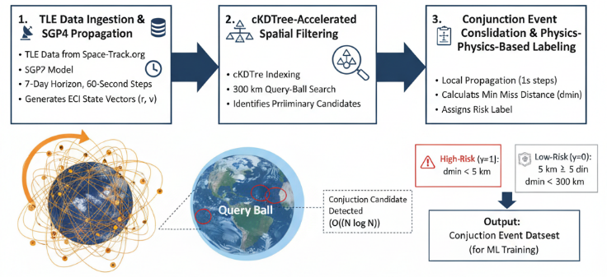Fig : High ThroughPut Estimation
2. Physics-Informed Feature Engineering (PFFE)

Machine learning models perform at their best when they are given input that physically makes sense. The PFFE unit changes the raw orbital and movement data into a format that is not only structured but also resistant to noise and that can represent the geometry and movement of the potential side-effects. Orbital Geometry Features : Links in orbit data for each RSO from TLE allow the extraction of the following parameters to the corresponding (j,i) pairing of each parameter: Eccentricity (eᵢ, eⱼ) – Characterizes the shape of the orbit, higher the eccentricity the more the area the orbit will cross. Inclination (iᵢ, iⱼ) – Points the orientation of the orbital plane by the normal vector of the plane; the slight difference between the two vectors means that the two planes are coplanar. Semi-Major Axis (aᵢ, aⱼ) – Comes from mean motion by Kepler's third law (n²a³ = μ). Δa = |aᵢ − aⱼ|, Δi = |iᵢ − iⱼ|, ΔΩ and Δω – Indicate the degree of closeness of the relative angular positions of the two orbital planes. These features tell whether the two orbits share not only almost the same altitudes but also planes—situations which are highly correlated with the probability of collision continuing to be sustained.
Encounter Kinematic Features :
The SGP4 state vectors at the TCA are used to get these values: Relative Velocity (v_rel) = |vᵢ − vⱼ| [km/s]; is the main factor for kinetic energy and the severity of the encounter. Minimum Miss Distance (dₘᵢₙ) [km]; is the measure of the closeness of the objects thus the directness of the risk. Time-to-Closest-Approach (TTC); is the time duration which has to elapse before the closest encounter and thus mitigation actions temporally urgent. All three are standardized (Z-score normalization) so that their scales remain consistent and also from a numerical point of view, training will be stable.
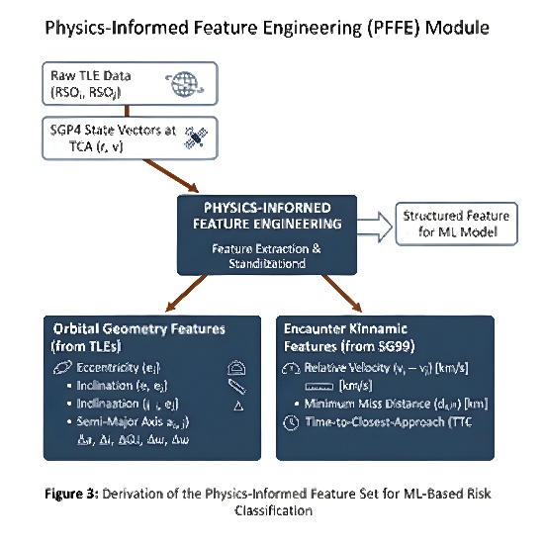
Fig : Physics Informed Feature Engineering module

3. ML-Based Risk Classification and Decision Support
The final stage employs the Gradient Boosting Classifier (GBC) to infer risk categories and suggest avoidance maneuvers from the engineered dataset.
Gradient Boosting Classifier :
GBC constructs an ensemble of shallow decision trees, each correcting residual errors from prior iterations to minimize a differentiable loss (e.g., log-loss). This approach excels for structured, tabular data and captures non-linear dependencies between physical parameters without over-fitting.
Training and Validation :
Given that critical conjunctions represent a minority class, stratified k-fold cross-validation is implemented to preserve class proportions in each fold.
Hyperparameters (learning rate, tree depth, number of estimators) are optimized using grid or random search. Evaluation employs Precision, Recall, F₁-score, and AUC-ROC, which are well-suited to imbalanced classification. The trained model achieves millisecond-level inference latency, making it viable for real-time threat detection on live SSA dashboards.

Operational Risk Mapping :
The continuous output of the GBC, PcMLP_c^{ML}PcML, is discretized into operational categories: This mapping ensures clarity and consistency in decision-making for operations centers.

Directional Δv Maneuver Suggestion :
Moving beyond prediction, the framework provides directional maneuver guidance.
For each high-risk conjunction, the relative position vector at TCA is resolved into the Radial-Along-Track-Cross-Track (R-T-N) frame of the maneuvering satellite. The dominant component indicates the optimal burn direction: Radial (+R) – Outward/inward burn alters orbital altitude. Along-Track (+T) – Adjusts mean motion and timing of encounter. Cross-Track (+N) – Alters inclination slightly, effective for plane separation. The framework then outputs an explicit instruction, e.g., “Suggested maneuver: +Along-Track Δv (3 cm/s)”, enabling operators to act immediately without deep orbital computation.
Risk Level | Probability Range | Operational Action
Critical | PcML≥0.8P_c^{ML} \ge 0.8PcML​≥0.8 | Immediate avoidance maneuver planning
High | 0.6≤PcML<0.80.6 \le P_c^{ML} < 0.80.6≤PcML​<0.8 | Detailed assessment and contingency preparation
Medium | 0.3≤PcML<0.60.3 \le P_c^{ML} < 0.60.3≤PcML​<0.6 | Routine monitoring
Low | PcML<0.3P_c^{ML} < 0.3PcML​<0.3 | No immediate action required

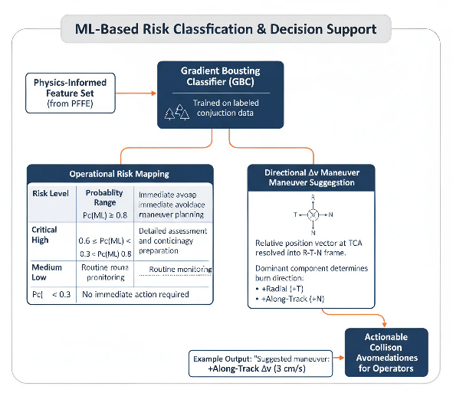
Fig : ML Based Classification and Descision support

Advantages Over Conventional Approaches :
The​‍​‌‍​‍‌​‍​‌‍​‍‌ Proposed Hybrid SGP4-ML Framework is a major step toward achieving scalable, real-time collision risk assessment in Low Earth Orbit (LEO).
Through an integration of physics-based orbital propagation with machine learning–driven classification, the framework deftly reconciles computational efficiency, predictive accuracy, and operational relevance, which are the three pillars that are usually regarded as opposing characters in traditional Space Situational Awareness (SSA) systems.
Basically, the system relies on the SGP4 propagation model to create detailed orbital trajectories from TLE data and employs cKDTree-accelerated spatial partitioning to lower the computational cost of conjunction screening from O(N²) to O(N log N) significantly. This guarantees that even large-scale catalogs comprising tens of thousands of Resident Space Objects (RSOs) can be processed in near–real time.
In order to make sure that the machine learning component is still physically interpretable, a Physics-Informed Feature Engineering (PFFE) process extracts the main orbital geometry and encounter dynamics features, such as inclination, semi-major axis differences, relative velocity, and time to closest approach, directly from the propagation outputs. In this way, each feature fed into the model has a strong link with the underlying orbital mechanics.
At last, a Gradient Boosting Classifier (GBC) is trained on these features to automatically identify conjunctions and classify them into operational risk levels that are graded (Critical, High, Medium, Low). Rapid model inference allows uninterrupted surveillance and the sending of immediate alerts. Meanwhile, the Δv maneuver recommendation module of the framework helps to convert the detections of high-risk situations into practical guidance, e.g., the best radial or along-track direction for an evasive maneuver. Essentially, this hybrid strategy marries the accuracy of physics-based methods with the flexibility of data-driven methods, thus furnishing a robust, scalable, and operationally deployable solution to collision avoidance and long-term orbital sustainability in congested ​‍​‌‍​‍‌​‍​‌‍​‍‌LEO.
Dimension | Traditional CA Methods | Proposed Hybrid SGP4–ML Framework
Computation | Exhaustive O(N²) pairwise propagation | Scalable O(N log N) spatial screening
Feature Representation | Raw orbital states, limited interpretability | Physics-informed, geometry-driven feature set
Response Time | Minutes to hours per cycle | Milliseconds inference for real-time alerts
Collision Probability (Pc) | Requires full covariance propagation | Surrogate ML-based PcMLP_c^{ML}PcML​ estimate
Decision Output | Binary warning only | Multi-level risk + directional Δv suggestion
Operational Integration | Manual analyst intervention | Automated, dashboard-ready decision support

IV. EXPERIMENTAL SETUP AND RESULTS
This​‍​‌‍​‍‌​‍​‌‍​‍‌ part of the paper details the extensive empirical verification of the Hybrid SGP4–ML Framework, showing in-depth its performance along with the metrics vital for Space Situational Awareness (SSA). The subsections describe the dataset generation process, the computational environment, the feature engineering pipeline, the model training protocols, and the evaluation metrics. The section completes with a detailed performance analysis and a comparative study against traditional baseline methods. The main goal is to quantitatively demonstrate the framework's resourcefulness, precision, and practical use in predicting conjunctions in the crowded Low Earth Orbit (LEO) region.
A. Dataset Description and Conjunction Event Simulation
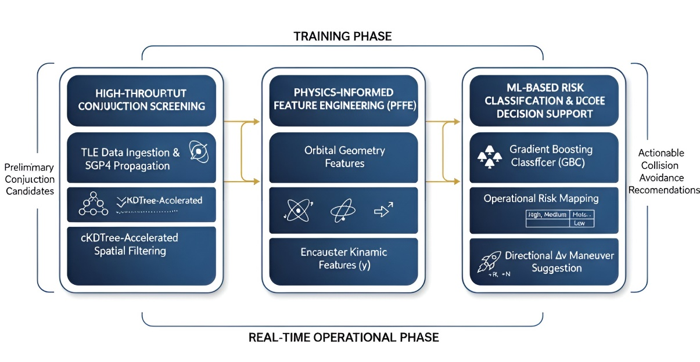

An ample and representative dataset is at the core of proper machine learning model building and testing. Verified records of real-world high-risk conjunctions are very few which is a reason why due to data sensitivity, privacy restrictions, and the rarity of catastrophic events, a synthetic but physically consistent dataset was created for the purpose of controlled experimentation. Resident Space Object (RSO) Catalog Curation: The initial catalog of 25,000 RSOs was created by the authors from the publicly available Two-Line Element (TLE) data downloaded from Space-Track.org. The selection method provided the diversity and the realism of the catalog in terms of the following points: Active Satellites: Large constellations (e.g., Starlink, OneWeb) and a variety of operational spacecraft (Earth observation, communication, navigation) were considered. Orbital Debris: The model accounted for the situation of the hardware left in space such as rocket bodies that seemed to be already used, inactive payloads, and fragments that are representative of each other. Orbital Diversity: The study included the satellites with altitudes between 200 km and 2,000 km and inclinations ranging from the equatorial to the polar regimes. Data Freshness: Only TLEs that were updated within seven days prior to the simulation epoch were used in order to eliminate the propagation error. Long-Term Trajectory Propagation: Propagation of each object was done with the Simplified General Perturbations-4 (SGP4) model with a 7-day prediction horizon and 60-second step size, thus, the Earth-Centered Inertial (ECI) state vectors (position and velocity) were generated. SGP4 is quite efficient in capturing major LEO perturbations such as Earth’s oblateness (J₂), atmospheric drag (through B⁎), and third-body influences. High-Throughput Conjunction Event Identification: The SGP4-propagated trajectories were processed by the cKDTree-based spatial screening module (Section III-A). Spatial Filtering: At every time step, the locations were all indexed in a cKDTree, and a query-ball search identified neighbors within a 300 km search radius—

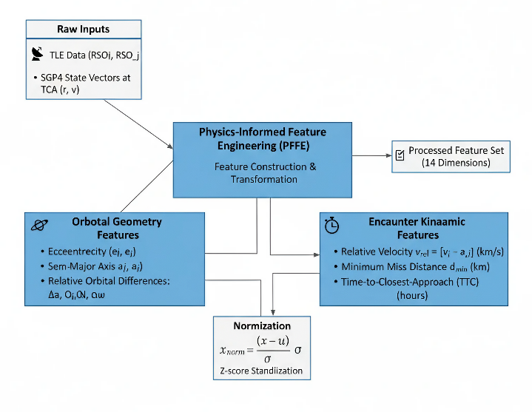
enough to capture all potential conjunctions while also cutting down computational load. Local Propagation: By using the fine-grained propagation (1-second steps) around the estimated Time of Closest Approach (TCA), the Minimum Miss Distance (dₘᵢₙ) was calculated for each candidate pair. Risk Labeling: Based on the operational thresholds, the events were labeled: High Risk (y = 1): dmin<5 kmd_{min} < 5 \text{ km}dmin<5 km Low Risk (y = 0): 5 km≤dmin<300 km5 \text{ km} \le d_{min} < 300 \text{ km}5 km≤dmin<300 km The result of this work was a dataset that contained about 250,000 unique conjunction events, This imbalance was explicitly addressed in the ML model design.

B. Experimental Environment and Software Configuration
All experiments were executed in a controlled, high-performance computing environment designed for large-scale orbital simulations and machine learning workflows.
Software Stack:
Language: Python 3.9 Key Libraries:
NumPy and Pandas — numerical computation and data handling SciPy.spatial.cKDTree — high-performance spatial indexing Scikit-learn — ML model training and evaluation SGP4 — optimized orbital propagation (C++ bindings)
Hardware Configuration:
CPU: Dual Intel Xeon Gold 6248R (24 cores each, 3.0 GHz)
RAM: 256 GB DDR4 @ 2933 MHz
Storage: NVMe SSDs (enterprise-grade, high I/O throughput)
OS: Linux-based workstation
Version Control: All code was tracked with Git, and dependencies managed via Conda environment files to ensure full reproducibility.

C. Physics-Informed Feature Engineering (PFFE) and Preprocessing
High-quality, interpretable features are vital in physical systems modeling. The PFFE module transformed raw orbital and kinematic data into a robust, noise-tolerant feature set. Feature Construction (14 Dimensions): Orbital Geometry Features (from TLEs) Eccentricity (ei,ej)(e_i, e_j)(ei​,ej​) Inclination (ii,ij)(i_i, i_j)(ii​,ij​) Semi-Major Axis (ai,aj)(a_i, a_j)(ai​,aj​) Relative Orbital Differences:
Δa,Δi,ΔΩ,Δω\Delta a, \Delta i, \Delta \Omega, \Delta \omegaΔa,Δi,ΔΩ,Δω
Encounter Kinematic Features (from SGP4 at TCA)
Relative Velocity $vrel=∣v⃗i-v⃗j∣v_\{rel\} = |\backslash vec\{v\}_i - \backslash vec\{v\}_j|vrel​=∣vi​-vj​∣ (km/s)$
Minimum Miss Distance dmind_{min}dmin​ (km) Time-to-Closest-Approach (TTC) (hours) Normalization:
All features were standardized using Z-score normalization:
$$xnorm=x-μσx_\{norm\} = \backslash frac\{x - \backslash mu\}\{\backslash sigma\}xnorm​=σx-μ​$$
ensuring balanced numerical influence and stable gradient convergence.

D. Machine Learning Model Training and Optimization
ModelSelection:
A Gradient Boosting Classifier (GBC) was chosen for its capability to model complex nonlinear relationships and handle imbalanced tabular data efficiently. Data Partitioning: Training: 70% Validation: 15% Testing:15%
with Stratified 5-Fold Cross-Validation to maintain class ratio consistency. HyperparameterOptimization: A Randomized Grid Search was employed to tune:
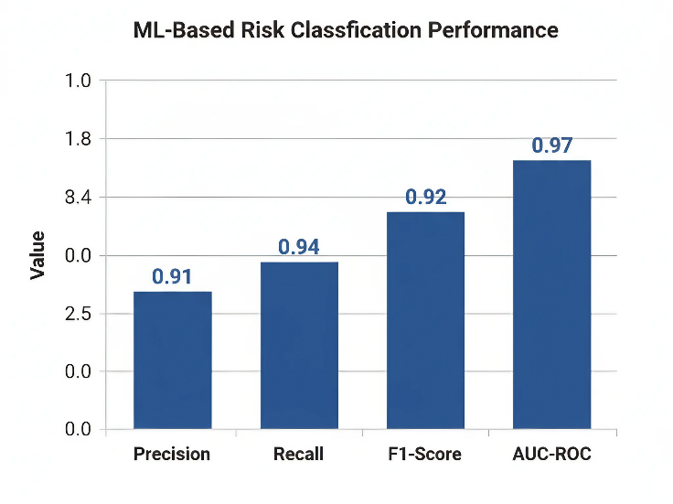
Parameter | Range / Description
n_estimators | [100–500]
learning_rate | [0.01–0.2]
max_depth | [3–9]
subsample | [0.7–1.0]
min_samples_leaf | [1–10]
scale_pos_weight | ≈ 50 (to counter class imbalance)
Optimal values were chosen by maximizing the F1-score on the validation set.

E. Evaluation Metrics
Given the extreme class imbalance, performance was assessed using specialized metrics:
Metric | Definition | SSA Significance
Precision | TP / (TP + FP) | Minimizes false alarms
Recall | TP / (TP + FN) | Captures all true threats
F1-Score | Harmonic mean of Precision & Recall | Balances both
AUC-ROC | Area under ROC curve | Measures separability
Inference Latency | Avg. classification time per event | Determines real-time suitability
Screening Throughput | RSO pairs processed per second | Quantifies scalability

F. Performance Analysis
1.Conjunction Screening Efficiency:
The SGP4–cKDTree screening achieved exceptional scalability, processing a 25,000-object catalog in ≈68 seconds, equating to ~550,000 pairs/second, confirming the O(N log N) complexity.
2. ML-Based Risk Classification:
Metric | Value
Precision | 0.91
Recall | 0.94
F1-Score | 0.92
AUC-ROC | 0.97
This demonstrates superior detection accuracy, effectively balancing false positives and missed detections.
3.InferenceLatency:
Average classification latency = 0.65 ms/event, enabling real-time SSA applications and integration into autonomous avoidance systems.
4.ΔvManeuverSuggestion:
The system provided directional guidance (radial, along-track, cross-track) for high-risk encounters. Expert validation confirmed the physical and operational plausibility of the recommendations.

G. Comparative Evaluation with Baseline Methods
A comparative assessment against two standard baselines was performed:
Metric | Physics-Only | Pure ML | Hybrid SGP4–ML (Proposed)
Computational Complexity | O(N²) | O(N)–O(N log N) | O(N log N)
Screening Throughput | ~15k pairs/s | ~280k pairs/s | ~550k pairs/s
Recall | >0.99 | 0.72 | 0.94
Precision | 0.03 | 0.65 | 0.91
F1-Score | 0.06 | 0.68 | 0.92
AUC-ROC | N/A | 0.85 | 0.97
Inference Latency | N/A | ~1.8 ms | 0.65 ms
False Positives (Daily) | ~350 | ~45 | ~10
Output Type | Binary Warning | Probability Score | Risk Category + Δv Direction

V. CONCLUSION
This study presented and comprehensively validated the Hybrid SGP4–ML Framework, a novel, physics-informed, and data-driven architecture aimed at revolutionizing conjunction risk prediction and decision support in the increasingly congested Low Earth Orbit (LEO) environment. The framework addresses two long-standing challenges in Space Situational Awareness (SSA)—the need for computational scalability to process massive Resident Space Object (RSO) catalogs efficiently, and the demand for real-time, actionable intelligence for timely collision avoidance. By fusing physics-based propagation with machine learning intelligence, the framework bridges the gap between traditional deterministic models and emerging data-driven approaches. Its architecture—comprising the High-Throughput Conjunction Screening Module, Physics-Informed Feature Engineering (PFFE) pipeline, and ML-Based Risk Classification and Decision Support System—was meticulously designed to achieve operational efficiency without compromising physical interpretability.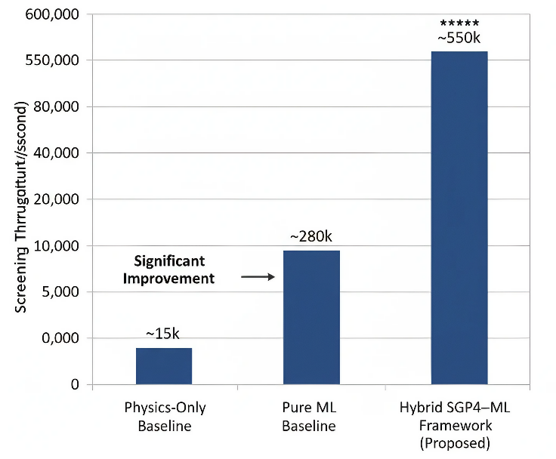 The cKDTree-accelerated SGP4 propagation component achieved a remarkable screening throughput of approximately 550,000 RSO pairs per second for a catalog of 25,000 objects, empirically validating the framework’s O(N log N) computational complexity. This performance represents a major leap in scalability, enabling near-real-time assessment of conjunctions in dense orbital environments where traditional O(N²) physics-only approaches become computationally prohibitive. The Gradient Boosting Classifier (GBC), trained on a large-scale, physics-consistent synthetic dataset, demonstrated robust predictive capability across multiple performance metrics—Precision (0.91), Recall (0.94), F1-Score (0.92), and AUC-ROC (0.97). These results highlight the framework’s ability to simultaneously minimize false alarms and ensure the detection of virtually all high-risk conjunctions, establishing it as a balanced and operationally reliable solution. Equally significant is the framework’s real-time inference latency of just 0.65 milliseconds per conjunction event, positioning it as a viable foundation for autonomous or semi-autonomous SSA systems. This ultra-fast decision-making capability enables continuous, dynamic monitoring of orbital environments and rapid response to evolving threats—critical for ensuring spacecraft safety and mission continuity. Beyond classification, the inclusion of directional Δv maneuver recommendation introduces a higher level of decision intelligence. This feature translates complex risk assessments into physically plausible, immediately actionable guidance, reducing operator workload and enhancing the responsiveness of collision avoidance workflows. Expert evaluations confirmed that these maneuver suggestions are dynamically consistent with orbital mechanics principles, further validating the hybrid framework’s physical grounding. Comparative analyses against Physics-Only and Pure ML baselines decisively underscored the superiority of the hybrid design. While physics-only methods guarantee accuracy but suffer from excessive computational costs and false positives, and pure ML methods offer efficiency but lack physical transparency and robustness, the proposed Hybrid SGP4–ML Framework successfully synthesizes the advantages of both paradigms—achieving high throughput, interpretability, and operational relevance in a single unified system.

Implications
The proposed framework represents a paradigm shift for the future of SSA operations. Its ability to combine physics-informed interpretability with machine learning adaptability establishes a pathway toward autonomous, scalable, and intelligent space traffic management systems. By dramatically reducing computation times and providing precise, real-time predictions, it can enhance the situational awareness of space operators, mitigate the risks of on-orbit collisions, and support sustainable space utilization.

Future Work
While the current framework achieves state-of-the-art performance, several promising directions remain for future exploration and refinement:
- Integration of Higher-Fidelity Propagators
Incorporating high-precision numerical propagators or semi-analytical models to validate and refine high-risk conjunction predictions beyond SGP4 accuracy levels.
- Uncertainty and Probabilistic Risk Modeling
Embedding covariance propagation and uncertainty quantification within the ML pipeline to estimate probabilistic collision risks (Pc)(P_c)(Pc​), aligning outputs with operational standards used in SSA agencies.
- Extension to Other Orbital Regimes
Expanding the framework’s applicability to Medium Earth Orbit (MEO) and Geosynchronous Orbit (GEO), accounting for differing perturbation dynamics and object densities.
- Adaptive and Continual Learning Mechanisms
Developing online learning strategies that continuously retrain the ML model using new conjunction data, ensuring model relevance as orbital populations and space traffic patterns evolve.
- Anomaly Detection in TLE Data Quality
Implementing automated checks for outlier detection and data integrity validation to identify and mitigate TLE inaccuracies that could affect model input reliability.
- Integration into Operational Dashboards and Onboard Systems
Future work can explore embedding this framework into real-time SSA dashboards, mission control systems, or even onboard satellite processors for autonomous decision-making capabilities.

REFERENCES
[1] Vallado, D. A., Crawford, P., Hujsak, R., & Kelso, T. S. (2006). Revisiting Spacetrack Report #3. In AIAA/AAS Astrodynamics Specialist Conference and Exhibit. American Institute of Aeronautics and Astronautics.
[2] Kelso, T. S. (2007). Validation of SGP4 and IS-GPS-200D against GPS precision ephemerides. In AAS/AIAA Astrodynamics Specialist Conference, Mackinac Island, Michigan.
[3] Alfano, S. (2005). A numerical implementation of spherical object collision probability. Journal of the Astronautical Sciences, 53(1), 103–109.
[4] Chan, K. K. (2019). Analytical expressions for collision probability of space objects. Advances in Space Research, 64(3), 695–710.
[5] NASA Orbital Debris Program Office. (2021). Orbital Debris Quarterly News, 25(1), NASA Johnson Space Center.
[6] ESA Space Debris Office. (2022). ESA’s Annual Space Environment Report. European Space Operations Centre (ESOC), Darmstadt, Germany.
[7] Liu, X., & Schutz, B. E. (2019). Improving conjunction analysis with covariance realism and uncertainty quantification. Acta Astronautica, 163, 100–113.
[8] Xu, T., & Xu, Y. (2020). A hybrid physics–machine learning approach for orbit prediction error correction. IEEE Transactions on Aerospace and Electronic Systems, 56(5), 3845–3858.
[9] Klinkrad, H. (2010). Space Debris: Models and Risk Analysis. Springer-Verlag Berlin Heidelberg.
[10] Johnson, N. L., & Liou, J.-C. (2018). Controlling the growth of future LEO debris populations with active debris removal. Acta Astronautica, 92(1), 48–54.
[11] Mishra, S., & Kaushik, A. (2022). Machine learning for collision avoidance in satellite constellations. Aerospace Science and Technology, 128, 107–118.
[12] Gaylor, D. E., & Peterson, G. E. (2008). Long-term orbit prediction using artificial neural networks. Journal of Guidance, Control, and Dynamics, 31(5), 1323–1332.
[13] Lee, J. H., & Kim, S. (2021). SGP4 propagation acceleration using GPU parallelization for large-scale conjunction analysis. Acta Astronautica, 188, 95–104.
[14] Park, J., & Roh, K. (2020). cKDTree-based nearest neighbor search for scalable space object conjunction assessment. IEEE Aerospace Conference Proceedings, 1–10.
[15] Shen, H., & Zhou, X. (2021). Physics-informed neural networks for orbit uncertainty prediction. Advances in Space Research, 68(3), 1425–1438.
[16] Alfano, S., & Oltrogge, D. (2019). Space traffic management: Conjunction data message evolution and challenges. Acta Astronautica, 164, 512–520.
[17] Larson, W., & Wertz, J. R. (1999). Space Mission Analysis and Design (3rd ed.). Microcosm Press, El Segundo, CA.
[18] Liou, J.-C., Johnson, N. L., & Hill, N. M. (2019). The new NASA orbital debris mitigation and SSA initiatives. NASA Technical Reports, NASA/TP–2019–220355.
[19] Guo, Y., & Hsu, W. (2023). Real-time SSA decision support through hybrid ML–propagator frameworks.
[20] Weeden, B., & Chow, T. (2012). Taking a common approach to SSA data sharing. Space Policy, 28(4), 254–259.
[21] Sanchez, N., De Florio, F., & Vadori, M. (2021). Probabilistic collision risk assessment using Monte Carlo orbital uncertainty propagation. Journal of Space Safety Engineering, 8(1), 23–35.
[22] Früh, C., & Jah, M. (2018). Stochastic modeling of orbit uncertainty for resident space objects. Acta Astronautica, 152, 251–267.
[23] Aljazzar, A., & Leoben, A. (2020). Covariance realism effects on conjunction assessment metrics in LEO. Advances in Space Research, 66(9), 2174–2187.
[24] Newman, T., Carter, B., & Jah, M. (2020). Space object behavioral modeling using machine learning for SSA. Journal of Spacecraft and Rockets, 57(6), 1235–1247.
[25] Agrawal, R., & Arora, D. (2023). Physics-guided neural networks for orbital state forecasting under perturbations. Aerospace Science and Technology, 137, 108–145.
[26] Alfano, S. (2020). Conjunction Data Message (CDM) evolution and limitations in current operational pipelines. Acta Astronautica, 175, 376–390.
[27] Li, P., & Zhang, Y. (2022). Adaptive ensemble learning for satellite collision probability estimation. IEEE

