Author(s) Declaration
1. We hereby state that article authored by us is an original contribution. It has neither been submitted for publication nor published elsewhere in any print/electronic form. It does not infringe on the right of others and does not contain any libelous or unlawful statements.
2. We assign all the copyright of this article to the journal wherever required. We have taken permission from the copyright holder and acknowledged the source.
3. We represent that we have taken the consent from our University / Institution / Employer / Project Guide / Supervisor / Research Committee before publishing our article with International Journal of Research and Innovation in Applied Science (IJRIAS).
4. We have not assigned copyright to publish this article to any other journal.
5. We fully understand the Terms and Conditions / Policies given by International Journal of Research and Innovation in Applied Science (IJRIAS).
6. Only we are responsible for impact/outcomes of this publication decision and We will not ask for refund or pursue any legal action against International Journal of Research and Innovation in Applied Science (IJRIAS), India for the same.
7. We confirm that we are satisfied with Authenticity / Validity / Originality of International Journal of Research and Innovation in Applied Science (IJRIAS). In case of refusal of our publication by our University / Institution / Employer / Project Guide / Supervisor / Research Committee, We will not ask for refund or pursue any legal action against the journal.
8. In case of a multi-authored article, the corresponding author have obtained permission to enter into agreement and assign copyright from all the co-authors in writing, and all the co-authors have thoroughly read and agreed with the above warranties and authorization.
9. We permit editors to publish the article in the journal or in any other means with editorial amendment, if any, to make it suitable for publication. Further, We hereby assign copyright to the publisher for its publication in any form/language including all media, and exclusive right to use the matter for the life of the work.
10. In case of any Copyright Infringement claim being filed and proven against our published article in future, International Journal of Research and Innovation in Applied Science (IJRIAS), India has the complete right to remove our article from the index immediately without prior notice.
11. We agree to indemnify the Editors/Publisher of the journal against all claims or action arising from any breach of warranty on my/our behalf in this agreement.
12. We are aware that International Journal of Research and Innovation in Applied Science (IJRIAS) ISSN (Online): 2454-6194 is assigned by the National Science Library, New Delhi, India.
13. We represent that We have taken the consent from our Co-Authors before publishing our article with International Journal of Research and Innovation in Applied Science (IJRIAS).
Name(s) of Author(s):
Dang Tien Thang | 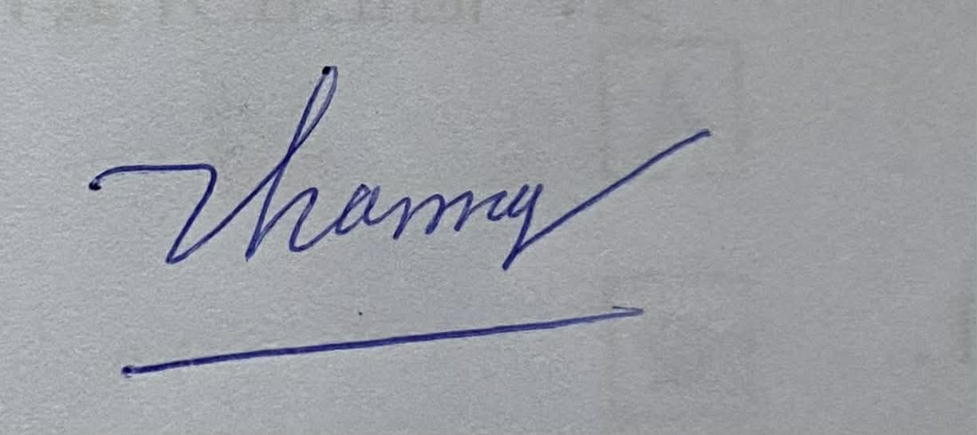
Unique Manuscript ID (UMI) of Manuscript:
Title of Paper: The Use of English Business Terminology in Commercial Livestreams on Gen Z Customers’ Purchase Intention
Corresponding Author
Full Name:
Nguyen Bao Giang | 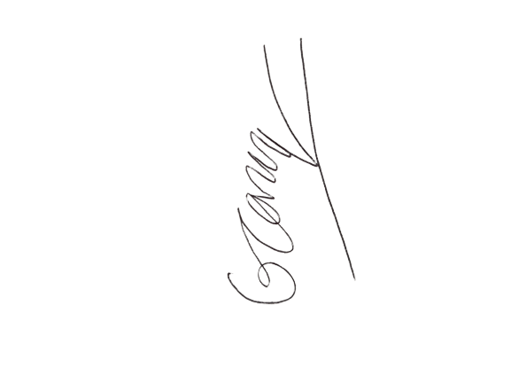
Phạm Ngoc Diem | 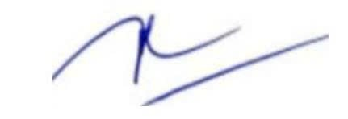
Le Quoc Thang | 