Between Home and Restaurant: Living Conditions, Work Patterns, and Family Health among Minang Migrant Entrepreneurs in Kuala Lumpur

ABSTRACT : This community service paper presents a field-based engagement program conducted with the Minang Saiyo Community in Kuala Lumpur, a group of Indonesian Minang migrant families whose livelihoods are closely tied to restaurant entrepreneurship. The program addressed the relationship between domestic living conditions, restaurant-based work patterns, and family health in migrant working households. Many participants lived in environments where residence, business support, storage, rest, and childcare overlapped, creating challenges related to ventilation, sanitation, spatial comfort, safety, and healthy daily routines.
The program was carried out by experts in architecture and building engineering through field observation, participatory discussion, environmental health education, and technical guidance on simple spatial improvements. The intervention focused on practical aspects of healthy living environments, including natural ventilation, lighting, sanitation, circulation safety, waste handling, moisture control, and clearer separation between clean and service areas. Recommendations were designed to be low-cost, gradual, and feasible within rented or spatially constrained settings.
The activity found that participants responded positively to practical and context-sensitive guidance that connected health, family well-being, and spatial arrangement. The program also showed that architecture-based community service can contribute meaningfully to strengthening healthy living practices among migrant entrepreneur families. More broadly, the study highlights the importance of spatial literacy as part of community empowerment in urban migrant settings.

Keywords - healthy living environment, migrant working families, community service, Minang entrepreneurs; spatial health education

INTRODUCTION

Migration is not only a movement of people across borders, but also a reconfiguration of everyday life, work, family routines, and domestic space. In many urban migrant settings, housing functions far beyond shelter alone. It becomes a place of economic survival, family care, storage, rest, and social reproduction. For migrant families who run small food businesses, the boundary between home and workplace is often blurred, creating a spatial condition in which domestic and productive functions overlap on a daily basis. This overlap is especially significant in dense urban environments, where limited space, rental arrangements, and economic pressure shape how families organize their living and working environments. Housing, therefore, must be understood as a central social determinant of health, well-being, and everyday resilience (Bentley et al., 2025; The Human Right to Adequate Housing, n.d.; WHO Housing and Health Guidelines, n.d.).

A growing body of literature shows that poor housing conditions are closely associated with adverse physical and mental health outcomes. Inadequate ventilation, crowding, moisture, poor sanitation, unsafe circulation, and low indoor environmental quality can increase health risks, reduce comfort, and weaken daily functioning, particularly in households where several activities occur within the same limited space. The World Health Organization emphasizes that unsafe and substandard housing contributes directly to health burdens and highlights crowding, indoor environmental hazards, and injury risks as core concerns in healthy housing policy. Reviews on housing and health similarly show that ventilation, dryness, thermal comfort, and freedom from hazards are fundamental characteristics of healthy housing (Bentley et al., 2025; Niza et al., 2024).

These concerns become more acute in migrant contexts. Recent reviews indicate that migrant and refugee populations are disproportionately affected by housing inequality, including overcrowding, insecure tenure, inadequate ventilation, and poor neighborhood conditions, all of which can influence respiratory health, psychosocial well-being, and family stability. Housing insecurity among migrant populations is not only a technical or economic issue, but also a health equity issue. For low-wage and self-employed migrant households, healthy living cannot be separated from the quality of the spaces they inhabit and adapt. In urban migrant life, the dwelling frequently becomes a hybrid space where care, labor, food preparation, and recovery from work occur simultaneously (Rana et al., 2025; Eshetu et al., 2026).

This condition is highly relevant to the Minang migrant community in Kuala Lumpur. Many members of the Minang Saiyo Community have established their livelihoods through restaurant entrepreneurship, often supported by long working hours and family-based labor arrangements. As a result, domestic living conditions are closely connected to restaurant-related activities, either directly or indirectly, through food preparation support, storage, rest, and childcare. In such spatial settings, the organization of the living environment affects not only comfort but also hygiene, circulation safety, family routines, and health-related behavior. Research on home-based work has shown that domestic space often absorbs productive functions in response to livelihood demands, especially in households with limited resources and incremental spatial adaptation (Wagemann et al., 2024; Gough & Kellett, 2001; Reuschke, 2016)

Within this context, community service in architecture and building engineering can make a practical contribution by translating built-environment knowledge into simple and applicable guidance for healthier daily living. Rather than treating health only as a medical issue, this approach recognizes that family well-being is strongly shaped by environmental conditions such as airflow, lighting, sanitation, moisture control, circulation, and the separation of clean and service areas. Practical recommendations that are low-cost, gradual, and feasible within rented or constrained spaces are therefore especially relevant for migrant entrepreneur families (WHO Housing and Health Guidelines, n.d.; Niza et al., 2024; Osibona et al., 2021).

This paper presents a community service program conducted with the Minang Saiyo Community in Kuala Lumpur, focusing on the relationship between living conditions, restaurant-based work patterns, and family health among Minang migrant entrepreneurs. The program combined field observation, participatory discussion, environmental health education, and technical guidance on simple spatial improvements. The paper aims to identify the main environmental challenges experienced by the community, describe the forms of intervention delivered through the program, and explain how architecture-based community service can support healthier living practices in migrant urban settings.

METHODOLOGY

This community service program employed a participatory, field-based, and problem-oriented approach to address the relationship between living conditions, restaurant-based work patterns, and family health among Minang migrant entrepreneur families in Kuala Lumpur. The activity was designed as an applied community engagement program rather than an experimental intervention. It combined environmental observation, participatory discussion, health-oriented education, and technical guidance on feasible spatial improvements. This approach is consistent with community-based public health practice, which emphasizes contextual understanding, local relevance, and practical problem solving through collaboration with community members (Indicators, Guidance and Tools, n.d.).

Study setting and community partner
The program was conducted in Kuala Lumpur, Malaysia, in collaboration with the Minang Saiyo Community, a migrant community consisting largely of Indonesian Minang families whose livelihoods are closely connected to restaurant entrepreneurship. In this setting, the dwelling and the workplace are functionally interrelated through food preparation support, storage, rest, childcare, and family labor arrangements. Because housing conditions are increasingly recognized as an important determinant of health, the study of these hybrid domestic-work environments is highly relevant for community service in architecture and building engineering (Housing, n.d.; Housing Impacts Health, n.d.).

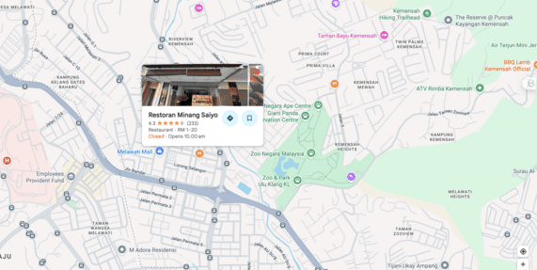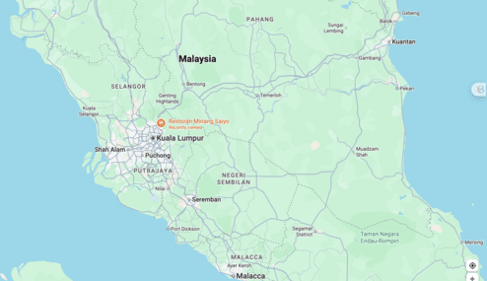
Figure 1. Spatial location of the Minang Saiyo Community and the PKM activity site in Kuala Lumpur, Malaysia
Figure 1 presents the geographical context of the community service program. The left panel identifies the local site of the Minang Saiyo Community and its restaurant-based activity setting within Kuala Lumpur, while the right panel places the site within the wider regional geography of Malaysia. The figure provides spatial context for understanding the living and working environment of the migrant community.

Service approach
The program adopted a participatory environmental health approach in which community members were involved not only as recipients of information, but also as active participants in identifying environmental problems, discussing everyday routines, and reflecting on realistic solutions. This approach was selected because interventions related to healthy living environments are more meaningful when they respond to actual spatial practices, economic limitations, and housing constraints. WHO guidance on healthy housing similarly emphasizes the importance of practical and context-sensitive actions grounded in real living conditions (WHO Housing and Health Guidelines, n.d.).

Stages of implementation
The methodology was implemented in four main stages.

1. Preliminary identification
The first stage focused on identifying the general profile of the community, the characteristics of their living and working environments, and the main environmental issues affecting daily family life. At this stage, the team noted recurrent concerns such as overlapping domestic and business functions, ventilation limitations, storage congestion, sanitation risks, circulation problems, and weak separation between clean and service areas. This step was important because housing-related health risks are often cumulative and shaped by multiple environmental factors rather than a single condition (Anyanwu & Beyer, 2024).

2. Field observation
The second stage involved direct field observation of selected living and working environments used by participating families. Observation focused on practical spatial and environmental indicators, including natural ventilation, daylight access, sanitation, moisture, waste handling, circulation safety, storage organization, and separation between domestic and service-related activities. These indicators were chosen because indoor environmental quality, ventilation, safety, and environmental performance are widely recognized as important components of healthy housing (World Health Organization et al., 2018).

3. Participatory discussion and educational sessions
The third stage consisted of participatory discussion sessions with community members to explore daily routines, identify points where family health and spatial conditions intersected, and discuss shared environmental challenges. The educational component introduced practical principles of healthy living environments, including ventilation, lighting, sanitation, moisture control, waste management, and safer movement within limited spaces. This stage encouraged participants to relate environmental conditions to family well-being, comfort, rest, and caregiving practices. Such educational translation is important when technical knowledge must be converted into understandable and behavior-linked action (World Health Organization et al., 2018).

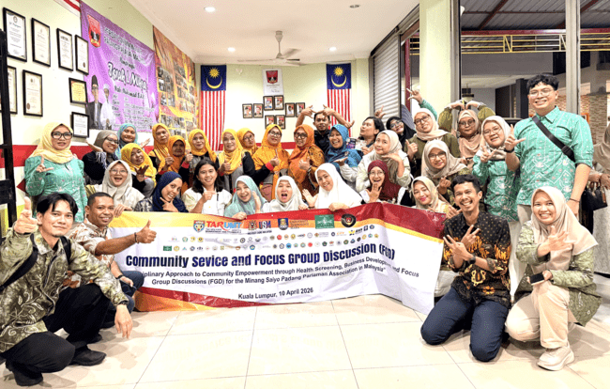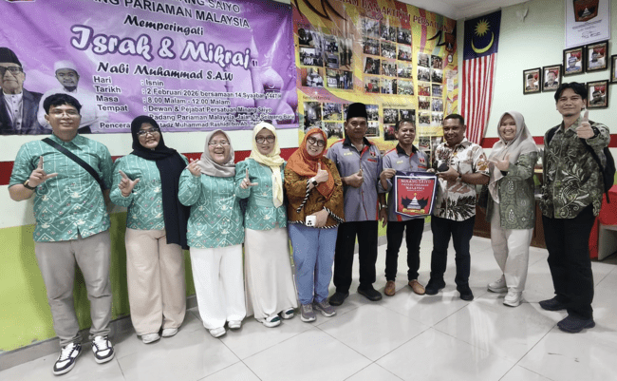
Figure 2. Participatory discussion and educational session with the Minang Saiyo Community in Kuala Lumpur
Figure 2, shows the participatory discussion and educational session conducted with members of the Minang Saiyo Community in Kuala Lumpur. The activity brought together the community and the service team in a shared forum to discuss everyday living conditions, health-related environmental challenges, and practical strategies for improving healthy living environments. The session reflects the collaborative and community-centered approach of the program.

4. Technical guidance and contextual recommendations
The final stage involved the delivery of simple technical guidance based on field observations and discussion results. Recommendations were designed to be low-cost, realistic for rented or limited spaces, gradual in implementation, and easy to maintain. Examples included improving cross-ventilation, reorganizing storage, separating clean and service zones, improving the use of natural light, reducing dampness, improving waste placement, and clarifying circulation paths. This reflects the practical contribution of architecture- and engineering-based community service, where environmental improvement may begin through small but meaningful spatial adjustments rather than large-scale redesign (World Health Organization et al., 2018).

Data collection techniques
Although this paper is presented as a community service report rather than a full empirical research article, the documentation of the activity drew on several forms of field-based evidence, including direct observation notes, participatory discussion records, visual documentation, facilitator reflections, and participant responses during the sessions. These materials were used to identify recurring patterns and practical environmental issues rather than to produce statistical generalization. This approach is appropriate for community-engaged interventions, where contextual interpretation and practical relevance are central to the analysis (World Health Organization et al., 2018; Anyanwu & Beyer, 2024).

Analytical approach
The analysis used a descriptive and interpretive approach. Observational findings and participant responses were organized into thematic categories such as ventilation, sanitation, spatial overlap, circulation, waste handling, and comfort. These categories were then interpreted in relation to the community’s everyday living and working patterns. The aim was not to test a statistical hypothesis, but to explain how environmental conditions shaped daily family health practices and how the intervention responded to those conditions (World Health Organization et al., 2018).

Ethical and practical considerations
The activity was conducted with respect for participant comfort, voluntary involvement, and contextual sensitivity. Because the target community included migrant families managing both livelihood and household responsibilities, the team prioritized respectful communication and practical recommendations rather than intrusive assessment. The intervention was educational and supportive in nature, focusing on empowerment through applicable knowledge. This is important in community-based settings, especially where participants face spatial constraints, economic limitations, and housing insecurity (Li & Liu, 2018; World Health Organization et al., 2018).

RESULTS

The community service activity showed that the daily lives of Minang migrant entrepreneur families in Kuala Lumpur were strongly shaped by the overlap between domestic space and restaurant-related work. Field observation and participatory discussion identified recurring environmental challenges in living environments that simultaneously supported residence, rest, storage, childcare, and business-related functions. The most visible issues were limited ventilation, weak separation between clean and service areas, storage congestion, sanitation concerns, and constrained circulation. These conditions indicate that the quality of the domestic environment plays an important role in shaping comfort, hygiene, and everyday family well-being. This finding is consistent with previous studies showing that indoor environmental quality, including airflow, sanitation, and environmental safety, is closely linked to healthy living conditions (Wagemann et al., 2024).

Environmental conditions identified in the field

Ventilation emerged as one of the most relevant practical issues. In spatially constrained environments where cooking support, resting, and family interaction occur in close proximity, insufficient air movement may intensify discomfort, humidity, and perceived uncleanliness. In addition, weak zoning between clean and service areas increased the risk of disorder in daily household management. Storage congestion and limited circulation also affected the ease and safety of movement within the living environment (World Health Organization et al., 2018).. These findings support the view that healthy housing depends not only on the availability of shelter but also on the environmental performance of the dwelling and the way space is organized in everyday use (Al horr et al., 2016).

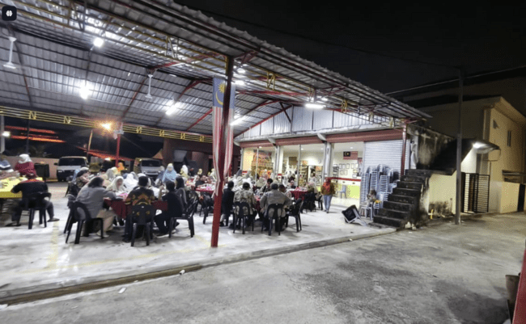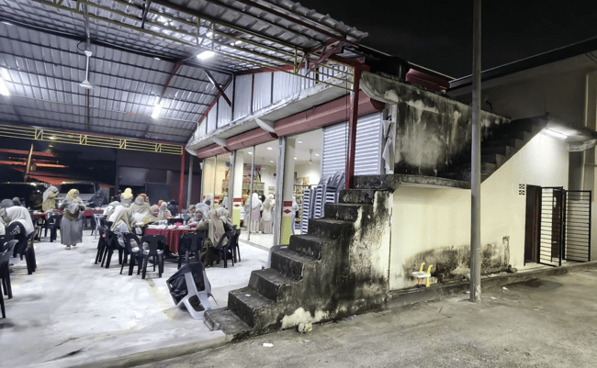
Figure 3 Restaurant-based activity setting of the Minang Saiyo Community in Kuala Lumpur
Figure 3, shows the physical setting of the Minang Saiyo Community’s restaurant-based environment in Kuala Lumpur. The images illustrate the open dining area, the main building structure, and the adjoining stair access, highlighting how commercial, social, and support functions are closely integrated within a limited space. This setting reflects the spatial overlap between livelihood activities and everyday family-based use in the migrant community.

Another recurring result concerned the lack of clear functional separation between household life and restaurant-related support activities. In several cases, storage, food-related preparation support, circulation, and family routines appeared closely interwoven. This does not necessarily indicate disorder in a moral sense, but rather spatial adaptation under conditions of limitation. The literature on home-based work is useful here because it explains that households often reorganize space incrementally in response to livelihood demands, especially when work and family survival are deeply connected (Wagemann et al., 2024). The Minang migrant setting reflects this logic of adaptation. Space is not simply occupied, but continuously adjusted to serve multiple needs at once.

Health and family well-being as spatially mediated issues
A second important result was the recognition, among participants, that environmental conditions influence family well-being more directly than they had previously articulated. During the educational and discussion sessions, participants responded positively to explanations linking layout, ventilation, sanitation, moisture control, and circulation safety with daily health and comfort. This matches the draft paper’s initial finding that context-sensitive and applied guidance was well received by the community.

This outcome is significant because it shows the value of spatial literacy in community empowerment. Many household health problems are often discussed only in behavioral terms, while the spatial environment that structures daily behavior receives less attention. Yet housing research consistently shows that poor living conditions shape both immediate and cumulative health risks. The WHO’s housing guidance treats inadequate living conditions as a public health concern, not merely as a matter of household preference (World Health Organization et al., 2018). Likewise, more recent evidence on migrant and refugee populations shows that housing inequalities, including overcrowding, inadequate conditions, and poor environmental quality, are associated with adverse physical and psychosocial outcomes (Rana et al., 2025).

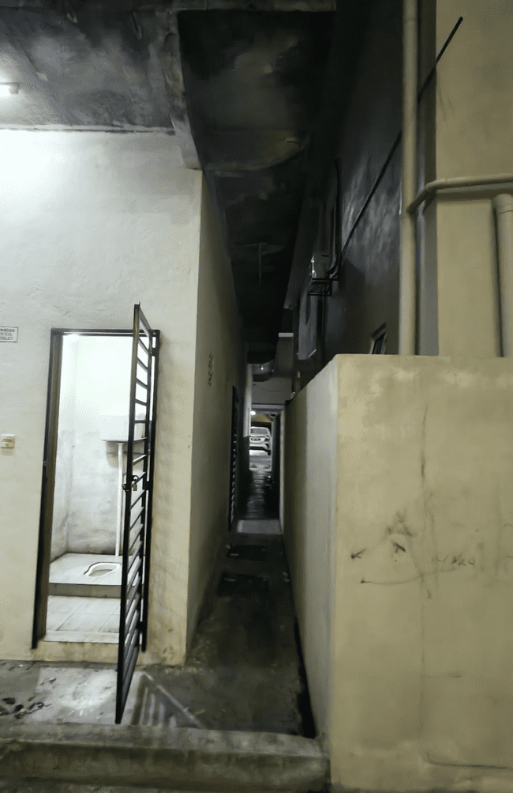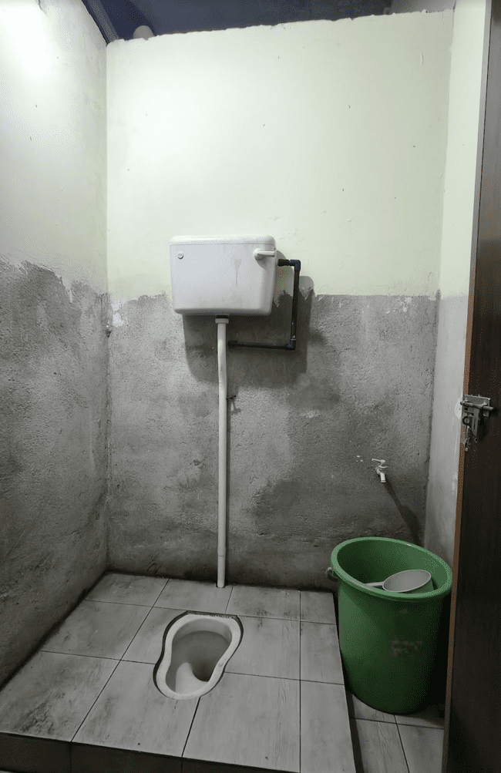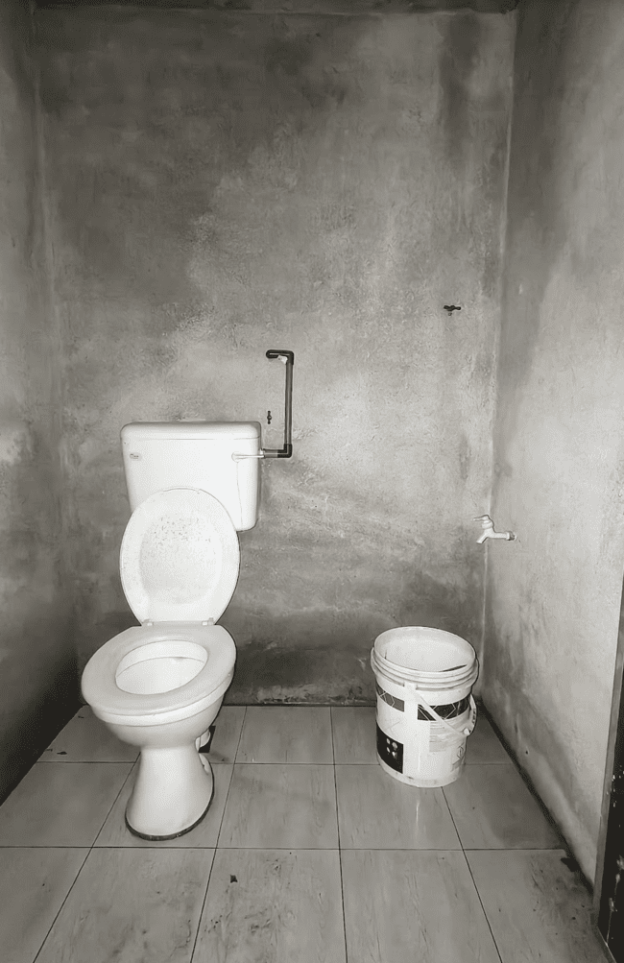
Figure 4. Sanitation and service-area conditions in the observed migrant living environment
Figure 4, shows the sanitation and service-area conditions observed in the migrant living environment, including a narrow circulation passage and toilet facilities. The images highlight basic environmental issues related to hygiene, spatial limitation, surface condition, and the organization of service spaces. These conditions are relevant to the discussion of healthy living environments and family well-being in constrained domestic-work settings.

In the present activity, this broader argument became visible at the micro scale of everyday family life. Participants were not dealing with abstract environmental concepts, but with practical matters such as where air could flow, where waste could be placed, how circulation could be made safer, and how clean and service areas could be better distinguished. These are modest interventions in appearance, but they are meaningful because they translate health into manageable spatial actions. This is especially important for migrant households living in rented or constrained environments, where major physical renovation may not be feasible.

Participant response to the intervention
The educational and technical guidance sessions were positively received by community members. Participants responded well to practical explanations linking spatial arrangement with health, family comfort, and daily routine. Rather than requiring complex design solutions, the community showed greater interest in simple and feasible actions such as improving airflow, managing waste more carefully, reorganizing storage, and clarifying the separation between domestic and service-related activities (Rana et al., 2025). This indicates that architecture- and engineering-based guidance becomes more meaningful when it is delivered in non-technical language and adapted to the realities of rented or limited spaces. Such a response also confirms the value of context-sensitive environmental education in community empowerment (World Health Organization et al., 2018).

Interpreting the household as a hybrid living-work environment
The findings also show that the Minang migrant household in this context functions as a hybrid living-work environment. The overlap between family life and restaurant-related support activities should not be seen simply as a spatial deficiency, but as a form of adaptation to livelihood demands, limited floor area, and incremental use of domestic space. This interpretation is consistent with studies on home-based work, which argue that domestic environments often absorb productive functions when households rely on family-based and flexible economic strategies (Gough & Kellett, 2001; Reuschke, 2016; Wagemann et al., 2024). In this case, the intervention was effective because it did not impose an idealized housing model, but instead offered realistic adjustments that could support healthier and safer living practices within the household’s existing rhythm.

Summary of intervention outcomes
Overall, the activity produced four main results. First, domestic and restaurant-related functions were closely intertwined in the daily lives of participants. Second, the most recurrent environmental concerns were ventilation, sanitation, storage congestion, circulation safety, and weak separation between clean and service areas. Third, participants responded positively to practical and low-cost guidance. Fourth, the activity strengthened awareness that spatial arrangement is directly related to family well-being. These results support the argument that community service in architecture and building engineering can contribute meaningfully to healthier living practices in migrant urban settings.

Table 1. Simple Summary of Observed Environmental Issues and Intervention Responses
Aspect observed | Main issue identified | Practical implication for family life | Intervention guidance delivered | Immediate response observed
Ventilation | Limited air movement in multi-use living spaces | Reduced comfort, humidity, and odor accumulation | Advice on improving cross-ventilation and airflow | Participants recognized the importance of airflow for comfort and health
Spatial zoning | Weak separation between clean and service areas | Hygiene risk and overlap of domestic and work-related activities | Guidance on clearer functional separation | Participants showed better understanding of cleaner spatial arrangement
Storage organization | Congested storage in limited spaces | Cluttered environment and reduced usability | Suggestions for reorganizing storage more efficiently | Participants considered the recommendations practical and feasible
Circulation safety | Narrow or obstructed movement paths | Less safe movement for adults and children | Advice on clarifying circulation routes | Participants acknowledged the need for safer internal movement
Sanitation and waste handling | Inconsistent waste placement and service-area management | Lower hygiene quality in everyday living | Guidance on waste handling and service-area improvement | Participants responded positively to simple hygiene-oriented adjustments
Table 1 summarizes the main environmental issues identified during field observation and links them with their practical implications for family life, the guidance delivered through the program, and the immediate responses from participants. The table shows that the living environments of Minang migrant entrepreneur families were shaped by overlapping domestic and work-related functions, which affected ventilation, hygiene, storage, circulation, and spatial order. It also demonstrates that participants responded positively to simple and feasible recommendations, particularly those related to airflow, cleaner zoning, storage reorganization, safer circulation, and waste management. These results suggest that even modest, low-cost spatial adjustments can support healthier daily practices when they are adapted to the realities of migrant household conditions.

DISCUSSION

The findings of this community service activity indicate that the living environments of Minang migrant entrepreneur families in Kuala Lumpur should be understood as hybrid domestic-work settings rather than as conventional residential spaces. As summarized in Table 1, the main issues identified during the field activity were limited ventilation, weak separation between clean and service areas, storage congestion, constrained circulation, and sanitation-related concerns. These conditions were closely linked to the overlap between household life and restaurant-related support functions, showing that the quality of everyday living cannot be separated from the spatial pressures created by livelihood activities. This interpretation is consistent with studies on home-based work, which show that domestic environments often absorb productive functions when families rely on flexible and family-based economic strategies (Wagemann et al., 2024).

The results also reinforce the argument that family health in migrant communities is spatially mediated. The issues identified in Table 1 were not merely technical deficiencies in the built environment, but environmental conditions that shaped comfort, hygiene, safety, and the manageability of daily routines. Limited airflow affected thermal comfort and freshness of indoor space, while poor zoning between clean and service areas increased the risk of disorder in domestic management. Congested storage and unclear circulation reduced the usability and safety of the home, particularly in settings where several functions were carried out simultaneously. These observations support broader literature on healthy housing, which emphasizes that ventilation, sanitation, indoor environmental quality, and spatial safety are fundamental to well-being and health (World Health Organization et al., 2018).

At the same time, the spatial conditions observed in this community should not be interpreted only as signs of inadequacy. They also reflect forms of adaptation under constrained circumstances. For migrant families living in rented or limited spaces, domestic environments must accommodate both livelihood and family care, often through incremental and improvised arrangements. From this perspective, the overlap between residence and work is not simply a design problem, but a practical response to economic necessity, limited control over space, and the demands of everyday survival. This reading is important because it shifts the discussion away from idealized housing standards and toward a more grounded understanding of how migrant households negotiate spatial limitations in real life (Al horr et al., 2016).

In this context, the positive responses recorded in Table 1 are particularly significant. Participants were most responsive to recommendations that were simple, realistic, and immediately applicable, such as improving airflow, reorganizing storage, clarifying circulation paths, and separating cleaner household functions from service-related activities. This suggests that the value of the intervention lay not in proposing major physical redesign, but in translating environmental knowledge into practical strategies that families could understand and adapt within their existing conditions. The findings therefore highlight the importance of context-sensitive guidance in architecture- and engineering-based community service. In migrant settings, usefulness often depends less on technical complexity than on whether recommendations are compatible with the household’s actual rhythm, resources, and constraints (Wagemann et al., 2024).

The discussion also points to the importance of spatial literacy as a form of community empowerment. Table 1 shows that participants responded not only to information about health, but to explanations that helped them see the relationship between space, behavior, and family well-being more clearly. This is a meaningful contribution because many household health issues are often discussed only in behavioral terms, while the environmental setting that shapes those behaviors receives less attention. By making ventilation, zoning, circulation, storage, and sanitation more visible as spatial issues, the program enabled participants to reinterpret their homes as environments that could be improved gradually through manageable action. In this sense, the intervention contributed not only to awareness, but also to the practical capacity to make healthier spatial decisions in everyday life.

For the field of architecture and building engineering, these findings carry a broader implication. Community service does not always need to result in construction outputs or formal design proposals in order to be meaningful. In this case, the main contribution was the provision of applied environmental knowledge that connected housing conditions with family health and daily routine. This confirms that architecture can contribute through education, interpretation, and small-scale environmental strategy, especially in settings where large interventions are not feasible. The role of the architect or building expert in community service can therefore extend beyond design production to include facilitation, translation of technical knowledge, and empowerment-oriented guidance.

Overall, the discussion confirms that the Minang migrant household in Kuala Lumpur operates as a hybrid living-work environment in which spatial quality directly affects family well-being. The evidence summarized in Table 1 strengthens the argument that practical environmental problems such as ventilation, zoning, sanitation, storage, and circulation are central to healthy daily living in migrant urban settings. It also shows that low-cost, context-sensitive guidance can be effective in strengthening healthier living practices. These findings support the broader claim that architecture-based community service can play a meaningful role in improving quality of life among migrant working families.

CONCLUSION

This community service activity demonstrated that healthy living among Minang migrant entrepreneur families in Kuala Lumpur is closely connected to the spatial quality of their domestic-work environments. The findings showed that daily life in the Minang Saiyo Community is shaped by the close overlap between residence, restaurant-related support activities, storage, rest, and childcare. Within these hybrid living arrangements, environmental issues such as limited ventilation, insufficient separation between clean and service areas, storage congestion, sanitation concerns, and circulation constraints affect not only physical comfort but also family well-being and everyday health practices.

The program also showed that architecture- and building engineering-based community service can provide a meaningful and practical contribution to migrant family welfare. Through field observation, participatory discussion, environmental health education, and simple technical guidance, the activity helped participants recognize the relationship between space, health, and daily routine more clearly. The positive response from participants indicates that low-cost, context-sensitive, and applicable recommendations are highly relevant for migrant households living in rented or spatially constrained conditions.

An important contribution of this activity lies in strengthening spatial literacy as part of community empowerment. The program confirmed that improving family health does not depend only on behavioral awareness, but also on the ability to understand and manage environmental conditions such as airflow, lighting, moisture, waste placement, and functional zoning within limited spaces. In this sense, the PKM activity did not merely transfer information, but encouraged participants to reinterpret their living environments as spaces that can be improved gradually through realistic adjustments.

Overall, this paper affirms that community service in architecture and building engineering can play a strategic role in supporting healthier living practices among migrant working families. Future programs may expand this model through follow-up assistance, comparative work with other migrant communities, and closer integration between environmental health education and practical spatial intervention. Such efforts would further strengthen the role of applied spatial knowledge in improving quality of life in urban migrant settings.

ACKNOWLEDGEMENTS

The authors would like to sincerely thank the Minang Saiyo Community in Kuala Lumpur, Malaysia, for their generous cooperation, warm hospitality, and active involvement in this community service program. The openness of the participants in sharing their daily realities, challenges, and experiences greatly enriched this activity and made the program both meaningful and contextually grounded.
The authors also express their deep appreciation to all members of the service team and partner institutions for their valuable collaboration, interdisciplinary contributions, and shared commitment to improving healthy living environments for migrant families.
Finally, the authors gratefully acknowledge all institutional and local support that contributed to the successful implementation of this program.

REFERENCES

- Al horr, Y., Arif, M., Katafygiotou, M., Mazroei, A., Kaushik, A., & Elsarrag, E. (2016). Impact of indoor environmental quality on occupant well-being and comfort: A review of the literature. International Journal of Sustainable Built Environment, 5(1), 1–11. https://doi.org/10.1016/j.ijsbe.2016.03.006
- Anyanwu, C., & Beyer, K. M. M. (2024). Intersections among housing, environmental conditions, and health equity: A conceptual model for environmental justice policy. Social Sciences & Humanities Open, 9, 100845. https://doi.org/10.1016/j.ssaho.2024.100845
- Bentley, R., Mason, K., Jacobs, D., Blakely, T., Howden-Chapman, P., Li, A., Adamkiewicz, G., & Reeves, A. (2025). Housing as a social determinant of health: A contemporary framework. The Lancet Public Health, 10(10), e855–e864. https://doi.org/10.1016/S2468-2667(25)00142-2
- Eshetu, H. B., Blackford, K., Lobo, R., Alemu, M. B., Tessema, G. A., & Crawford, G. (2026). Housing Insecurity and Health Outcomes Among Migrants from Culturally and Linguistically Diverse Backgrounds in High-Income Countries: A Scoping Review. Journal of Immigrant and Minority Health, 1–19. https://doi.org/10.1007/s10903-026-01849-4
- Gough, K. V., & Kellett, P. (2001). Housing Consolidation and Home-based Income Generation: Evidence from Self-help Settlements in Two Colombian Cities. Cities, 18(4), 235–247. https://doi.org/10.1016/S0264-2751(01)00016-6
- Housing. (n.d.). Retrieved April 16, 2026, from https://www.who.int/teams/environment-climate-change-and-health/healthy-urban-environments/housing?utm_source=chatgpt.com
- Housing impacts health: New WHO guidelines on housing and health. (n.d.). Retrieved April 16, 2026, from https://www.who.int/news/item/26-11-2018-housing-impacts-health-new-who-guidelines-on-housing-and-health?utm_source=chatgpt.com
- Indicators, guidance and tools. (n.d.). Retrieved April 16, 2026, from https://www.who.int/teams/environment-climate-change-and-health/healthy-urban-environments/housing/indicators-guidance-and-tools?utm_source=chatgpt.com
- Li, J., & Liu, Z. (2018). Housing stress and mental health of migrant populations in urban China. Cities, 81, 172–179. https://doi.org/10.1016/j.cities.2018.04.006
- Niza, I. L., Bueno, A. M., Gameiro da Silva, M., & Broday, E. E. (2024). Air quality and ventilation: Exploring solutions for healthy and sustainable urban environments in times of climate change. Results in Engineering, 24, 103157. https://doi.org/10.1016/j.rineng.2024.103157
- Osibona, O., Solomon, B. D., & Fecht, D. (2021). Lighting in the Home and Health: A Systematic Review. International Journal of Environmental Research and Public Health, 18(2), 609. https://doi.org/10.3390/ijerph18020609
- Rana, K., Kent, J., & Andrew, P. (2025). Housing inequalities and health outcomes among migrant and refugee populations in high-income countries: A mixed-methods systematic review. PubMed. https://pubmed.ncbi.nlm.nih.gov/40121396/?utm_source=chatgpt.com
- Rana, K., Kent, J. L., & Page, A. (2025). Housing inequalities and health outcomes among migrant and refugee populations in high-income countries: A mixed-methods systematic review. BMC Public Health, 25(1), 1098. https://doi.org/10.1186/s12889-025-22186-5
- Reuschke, D. (2016). The importance of housing and neighbourhood resources for urban microbusinesses. Taylor & Francis. https://www.tandfonline.com/doi/abs/10.1080/09654313.2016.1168364
- The human right to adequate housing. (n.d.). OHCHR. Retrieved April 15, 2026, from https://www.ohchr.org/en/special-procedures/sr-housing/human-right-adequate-housing
- Wagemann, E., Maynard, V., & Simons, B. (2024). Housing and home-based work: Considerations for development and humanitarian contexts. Cities, 147, 104833. https://doi.org/10.1016/j.cities.2024.104833
- WHO Housing and health guidelines. (n.d.). Retrieved April 15, 2026, from https://www.who.int/publications/i/item/9789241550376?utm_source=chatgpt.com
- World Health Organization, United States, France, & United States (Eds.). (2018). WHO housing and health guidelines. World Health Organization.

