AI IN MODERN EDUCATION: ASSESSING THE BENEFITS AND IMPACTS ON TEACHING AND LEARNING
Achammagari Niharika - (23BCAR0017)
Anujith KM - (23BCAR0504)
Aishwarya N - (23BCAR0008)
Department of Computer Applications
April 2026

Abstract
The educational landscape is undergoing a profound structural shift driven by the rapid maturation of Artificial Intelligence (AI) technologies. Rather than simply digitizing existing practices, AI systems—ranging from intelligent tutoring networks to predictive analytics—are fundamentally altering pedagogical delivery and classroom dynamics. This study investigates the concrete effects of these technologies on cognitive engagement, instructor workloads, and the broader learning environment. Diverging from purely theoretical reviews, this paper adopts a mixed-methods approach: it synthesizes secondary literature from 2018 to 2024 and incorporates primary empirical data collected via a structured survey of 67 educational stakeholders. Our integrated analysis reveals that AI-driven personalization drastically improves comprehension rates by adapting to

individual learning paces, while simultaneously alleviating severe administrative bottlenecks for educators. However, the data also expose critical hurdles, notably persistent anxieties regarding data privacy, infrastructural deficits, and a reliance on continuous internet connectivity. Ultimately, we argue that realizing the full potential of educational AI requires a deliberate "human-in-the-loop" framework. Technology must act as an empathetic amplifier for human mentors, guided by strict ethical oversight and comprehensive professional development, rather than operating as an autonomous substitute.
Keywords: Educational Technology Evolution, Personalized Learning Frameworks, Artificial Intelligence Pedagogy, Algorithmic Ethics, Mixed-Methods Research.
I. INTRODUCTION
As we progress further into the twenty-first century, the traditional boundaries of institutional learning are dissolving. The integration of complex computational tools into academic environments has moved far beyond speculative theory; it is now a fundamental logistical reality. Over the past decade, pedagogy has witnessed a decisive break from rigid, lecture-centric models in favor of dynamic, digitally mediated frameworks. At the absolute center of this transformation lies Artificial Intelligence. Far from being a specialized utility for software engineers, AI has woven itself into the fabric of daily instruction, bringing unprecedented scalability and precision to the classroom.
To genuinely understand AI's current role, we must look past corporate marketing terminology. In an academic context, Artificial Intelligence refers to computational networks engineered to handle tasks that typically demand human cognitive effort. This encompasses recognizing nuanced patterns in student behavior, processing massive datasets from learning management systems, and autonomously adjusting instructional materials in real time. The resulting ecosystem is incredibly rich. We now see Intelligent Tutoring Systems (ITS) delivering individualized guidance on a massive scale, automated grading protocols evaluating complex assignments instantly, and predictive algorithms flagging students who might be quietly struggling long before an exam takes place.

Perhaps the strongest argument for accelerating AI adoption is its ability to shatter the limitations of the "one-size-fits-all" classroom. Historically, educational systems operated under the compromised assumption that a single instructor could effectively deliver identical content to a room of forty distinct individuals. Predictably, this model struggles to honor varied cultural contexts, diverse emotional states, and unique cognitive speeds. AI presents a scalable antidote. By functioning as an attentive digital observer, these platforms track granular interactions—from hesitation on a specific vocabulary word to repeated conceptual errors in math. The system uses this continuous stream of data to remold the curriculum on the fly, aiming to keep each learner in a state of optimal challenge.
Simultaneously, this technological shift offers educators a lifeline out of bureaucratic exhaustion. For decades, highly skilled teachers have been buried under a mountain of clerical duties, from calculating attendance metrics to grading thousands of standardized test items. By offloading these low-level, data-heavy responsibilities to algorithms, instructors can reclaim their true vocation. Liberated from administrative friction, they can redirect their energy toward creative lesson design, empathetic mentorship, and the kind of complex interpersonal connection that no machine can replicate.
Yet, introducing such powerful systems during the critical phases of human development naturally invites serious scrutiny. We are compelled to define strict ethical perimeters surrounding the ownership of student data, the transparency of algorithmic decision-making, and the preservation of independent critical thinking.
This paper offers a pragmatic, evidence-backed evaluation of this expanding frontier. By merging global academic literature with targeted primary survey data, we seek to document the actual—rather than hypothetical—state of AI in contemporary classrooms. We will scrutinize documented victories alongside the steep financial, technical, and psychological barriers currently hindering equitable access. Our ultimate intention is to outline a balanced, actionable roadmap for policymakers and educators, ensuring the current technological revolution serves to make learning more accessible, effective, and profoundly human.
II. LITERATURE REVIEW
The scholarly conversation surrounding Artificial Intelligence in education (AIEd) has matured significantly over recent years. Early publications largely obsessed over technical viability—proving that a machine could, in fact, parse student text or solve equations. Today, the focus has pivoted sharply toward pedagogical efficacy. Modern researchers are actively interrogating whether these algorithms translate into measurable improvements in knowledge retention, student confidence, and systemic equity.

A dominant thread in recent literature concerns the implementation of adaptive learning environments. Hwang and Fu (2020) characterize these systems as dynamic knowledge architects capable of constructing bespoke learning pathways through complex machine learning. The literature overwhelmingly suggests that adaptive systems excel because they sustain "cognitive flow." When a learner encounters material that perfectly bridges their current ability and the next logical challenge, motivation spikes. Studies indicate that this individualized pacing is particularly disruptive in heterogeneous classrooms where human teachers cannot feasibly create thirty distinct lesson plans simultaneously. AI acts as an instructional multiplier, ensuring advanced students remain stimulated while struggling learners receive immediate, patient remediation.
Another critical debate centers on the dichotomy of "Teacher Augmentation" versus "Teacher Replacement." Zawacki-Richter et al. (2019) echo a broad consensus: AI yields the highest dividends when deployed to amplify, not displace, the human educator. Predictive analytics have emerged as an invaluable diagnostic tool, empowering teachers to identify subtle behavioral shifts—such as irregular login patterns or waning discussion participation—weeks before they culminate in academic failure. This enables interventions that are proactive rather than punitive. Similarly, automating the assessment of objective coursework has been shown to tangibly reduce instructor burnout, freeing up critical hours for high-impact, face-to-face mentorship.

Despite these advantages, the academic community remains deeply concerned about the "Ethics of the Algorithm." Scholars frequently warn of the dangers hidden within proprietary "black box" systems, where the decision-making logic is obscured from the user. There is a documented risk that algorithmic models, trained on historically flawed datasets, might inadvertently reproduce and scale existing societal biases (Holmes et al., 2021). Furthermore, data sovereignty—specifically who controls the vast amounts of biometric and behavioral data extracted from minors—dominates policy discussions.

Critics also highlight potential social deficits. Woolf et al. (2022) caution that an over-reliance on digital interaction could degrade a student's social intelligence, starving them of the messy but vital peer-to-peer negotiations that characterize traditional group work. Furthermore, institutional reports reveal a persistent "readiness gap." While the software is rapidly evolving, the human infrastructure is lagging. Educators frequently report feeling under-trained and anxious about integrating these unfamiliar tools. The literature concludes that without rigorous, ongoing professional development, even the most sophisticated AI platforms will fail to improve educational outcomes.
Structured Comparative Framework: Human vs. AI-Augmented Roles
To clarify how these shifts alter daily instructional logistics, we have synthesized a comparative framework contrasting traditional methodologies with AI-augmented approaches.

Functional Area | Traditional Human-Centric Model | AI-Augmented Educational Model
Curriculum Delivery | Static, one-size-fits-all pacing dictated by the syllabus. | Dynamic, real-time adaptation based on individual cognitive mastery.
Assessment & Grading | Manual, time-consuming, highly prone to subjective fatigue. | Automated, instantaneous, with standardized objective evaluation.
Student Intervention | Reactive; typically occurs after an exam failure or poor grade. | Proactive; driven by predictive behavioral analytics before failure occurs.
Emotional Support | The primary and vital source of empathy and moral guidance. | Incapable of genuine empathy; defers social-emotional support to humans.
III. METHODOLOGY AND DATA COLLECTION
To rigorously evaluate the multifaceted impacts of AI on modern learning environments, this study employs a mixed-methods research design. By combining the breadth of secondary meta-analysis with the depth of primary empirical validation, we construct a highly reliable, nuanced picture of the current landscape.
3.1 Dual-Method Approach
Relying solely on secondary data often limits a study's ability to capture the immediate, ground-level realities of specific user populations. Conversely, isolated primary studies can lack macroeconomic context. Therefore, our methodology integrates a systematic meta-analytical synthesis of existing literature with a newly conducted primary survey. This dual approach allows us to cross-reference global academic trends against the lived experiences of active students and educators.
3.2 Primary Empirical Validation (Survey Design)
To gather primary quantitative data, a structured, anonymous survey was distributed to a sample of 67 participants comprising university students and active educators. The survey utilized a Likert-scale format alongside targeted multiple-choice questions to quantify user habits, perceived efficacy, and specific operational anxieties regarding AI tools. This primary data acts as an empirical anchor, grounding our theoretical findings in measurable, contemporary user feedback.
3.3 Secondary Synthesis and Selection Criteria
The qualitative component of this study involved an intensive review of peer-reviewed articles, conference proceedings, and institutional white papers published between 2018 and 2024. Searches were conducted across reputable databases, including the IEEE Xplore Digital Library, ScienceDirect, and ERIC. We strictly prioritized multidisciplinary studies that examined both the technical architecture of AI systems and their psychological impact on users, ensuring a balanced perspective.
3.4 Data Analysis Techniques
Secondary data underwent rigorous thematic coding to isolate recurring global concepts (e.g., "The Digital Literacy Gap," "Algorithmic Bias"). Simultaneously, the primary survey data (n=67) was aggregated and statistically analyzed to identify clear majorities and notable minority concerns regarding daily AI usage, efficiency gains, and privacy fears.
IV. DETAILED FINDINGS AND ANALYTICAL RESULTS
The synthesis of our primary survey data and secondary research reveals a complex ecosystem where high technological enthusiasm frequently collides with practical infrastructural realities.
4.1 Quantitative Insights from Primary Survey Validation
The primary data (n=67) provided critical, measurable evidence supporting the shift toward AI integration.

● Task Efficiency: When asked if AI helps complete assignments more efficiently, a striking 82.1% of respondents agreed (41.8% Agree, 40.3% Strongly Agree). This overwhelmingly confirms the theoretical assumption that AI serves as a powerful friction-reducing tool in academic workflows.
● Conceptual Comprehension: Crucially, the technology is not merely being used to shortcut labor. 88.1% of the surveyed population indicated that AI-based learning tools actively improve their understanding of complex academic concepts (49.3% Agree, 38.8% Strongly Agree).
● Usage Frequency: The integration of these tools into daily routines is accelerating. A combined 61.2% of respondents reported using AI tools either daily (38.8%) or weekly (22.4%), demonstrating that these platforms have transitioned from novelty applications to essential academic utilities.
4.2 Impact on Student Achievement and Cognition
Merging our primary results with global literature underscores AI's profound impact on personalized mastery. Because AI platforms can seamlessly translate dense concepts into digestible formats tailored to specific learning deficits, they create a highly effective "safe space to fail." Students who suffer from classroom anxiety—fearful of asking a supposedly foolish question in front of peers—freely interrogate AI tutors until they achieve comprehension. This destigmatization of error is a primary driver behind the improved understanding rates highlighted in our survey.
4.3 Efficiency and The Evolving Role of the Teacher
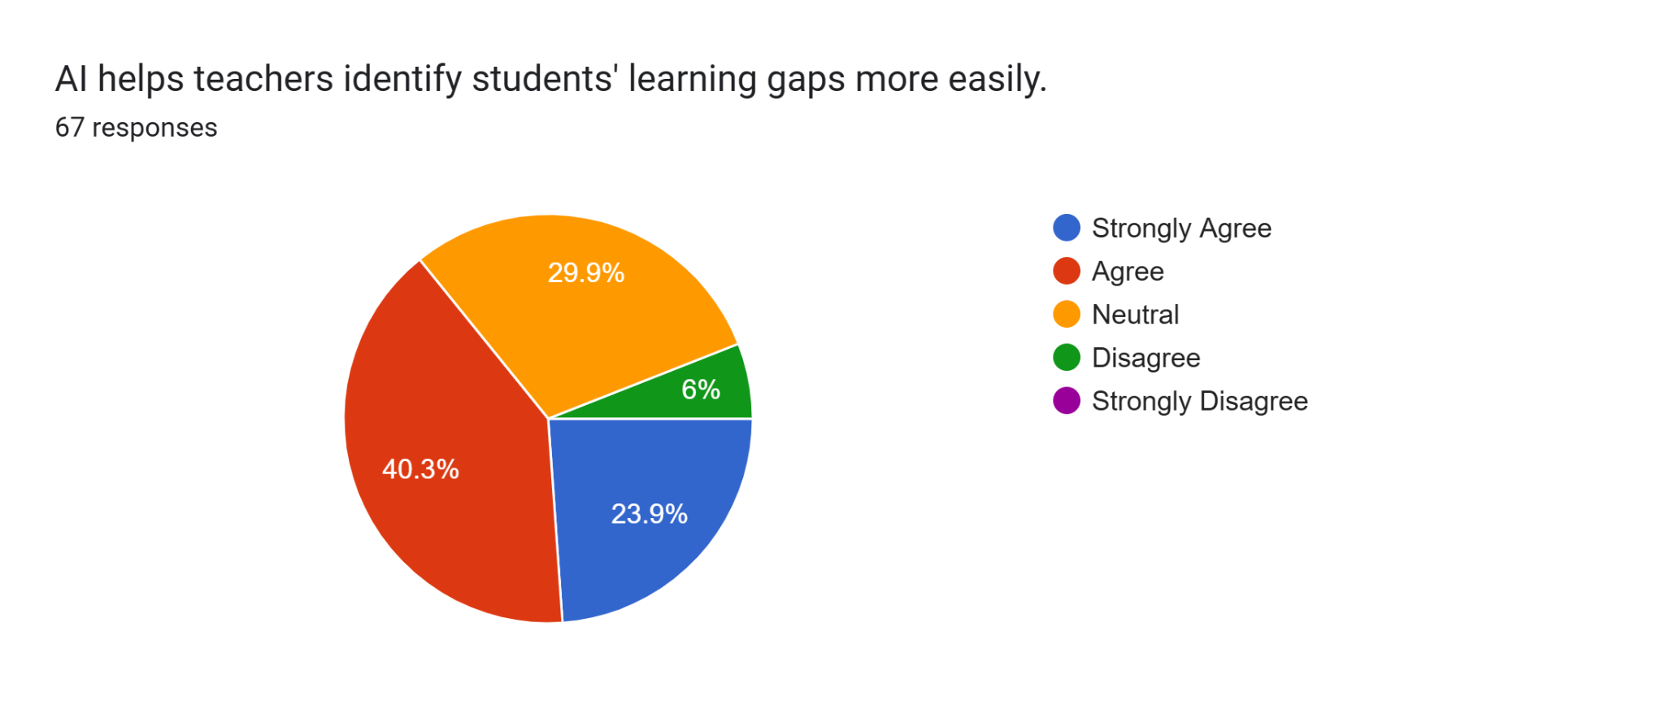
Our survey directly challenged the fear of technological replacement. When asked if AI should support teachers but not replace them, an overwhelming 83.6% agreed (38.8% Agree, 44.8% Strongly Agree). The data strongly supports the "Human Mentor" paradigm. Furthermore, 67.2% of respondents agreed that AI effectively reduces administrative workloads like grading and attendance tracking. By shedding these bureaucratic tasks, educators in highly integrated institutions report reclaiming multiple hours per week—time that is being reallocated toward direct student counseling and creative curriculum design.
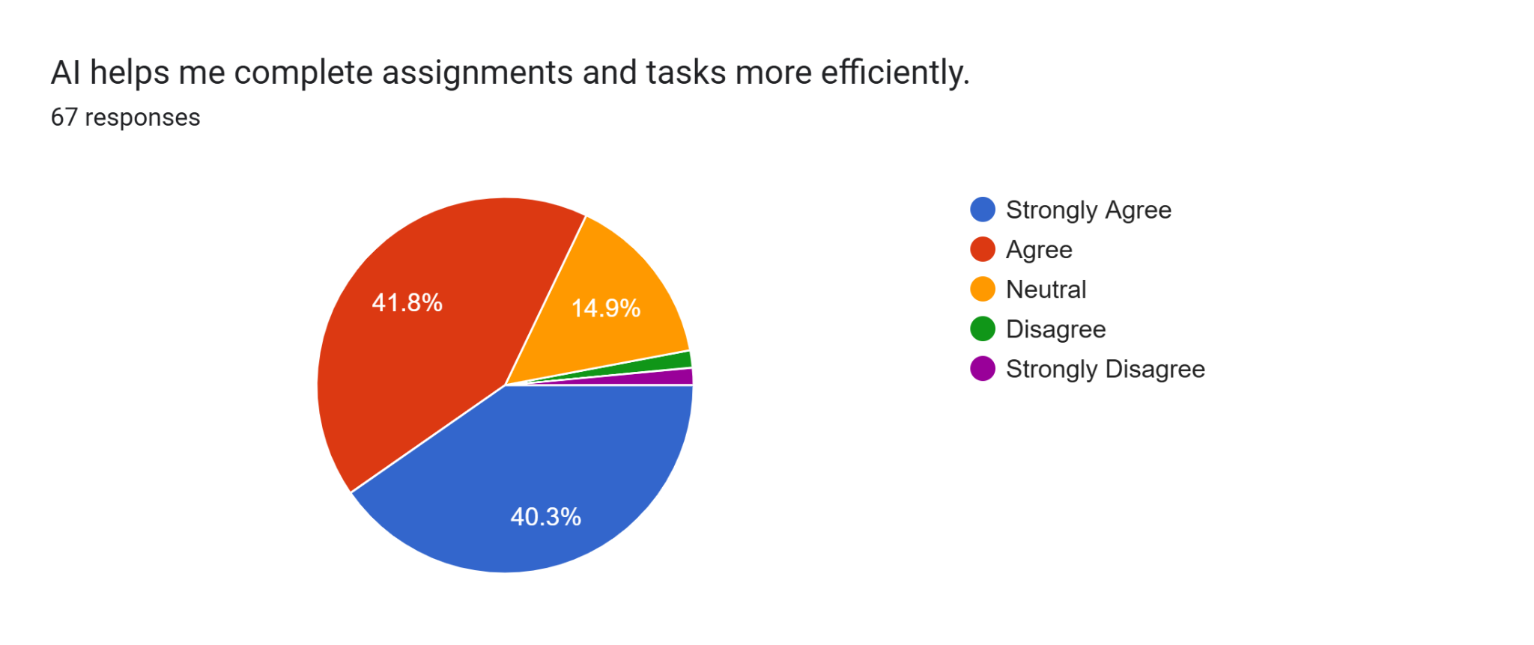
4.4 Obstacles: Financial, Technical, and Psychological
Despite the optimistic metrics, significant implementation barriers persist. Our primary data identified the most pressing hurdles currently facing users.
● When asked about the biggest challenge in using educational AI, 31.3% pointed to data privacy concerns, while 26.9% cited the risk of incorrect or unreliable information (hallucinations).
● Infrastructural deficits remain a severe bottleneck; 23.9% noted a fundamental lack of access to technology, and 11.9% struggled with internet connectivity issues.
● These technical barriers are compounded by psychological anxieties. A substantial 70.2% of our survey participants (40.3% Agree, 29.9% Strongly Agree) expressed explicit concern regarding data privacy and the security of their personal information when interacting with these platforms.
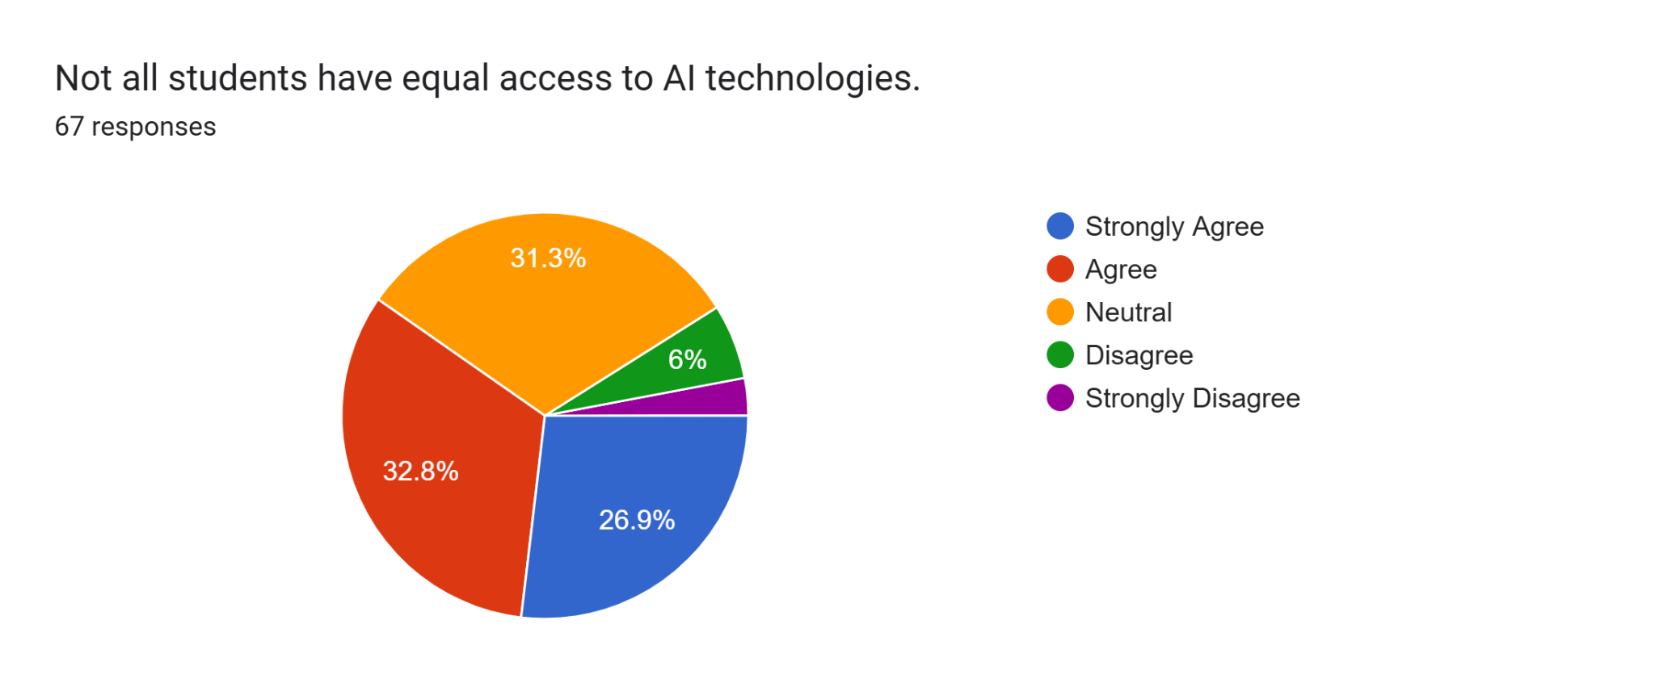
V. REAL-WORLD CASE STUDIES
To ground our findings in practical reality, we must examine how these theoretical frameworks operate in active, large-scale educational environments. The following case studies illustrate both the potential and the growing pains of applied AI.
Case Study 1: Georgia Tech’s "Jill Watson" (Intelligent Tutoring)
In an effort to manage an overwhelming volume of student inquiries in a large online computer science program, researchers at the Georgia Institute of Technology introduced a virtual teaching assistant named "Jill Watson," built on IBM's Watson platform. Jill was integrated into the class discussion forum to answer routine questions about syllabus details, coding environments, and assignment deadlines.
● Implementation Outcome: The AI operated with such natural language proficiency that the vast majority of students were completely unaware they were communicating with a machine for the first half of the semester.
● Impact: By autonomously resolving repetitive administrative and technical queries, the human teaching assistants were entirely freed to focus on complex, high-level philosophical and architectural coding debates with students. It serves as a premier example of AI acting as an administrative filter that elevates the quality of human-to-human academic interaction.
Case Study 2: Khan Academy’s "Khanmigo" (Generative AI Guide)
Khan Academy recently piloted "Khanmigo," an AI-powered guide utilizing advanced generative large language models. Crucially, Khanmigo is explicitly programmed not to provide direct answers to students. Instead, it functions using Socratic dialogue—asking prompting questions, identifying where a student's logic broke down, and encouraging them to arrive at the solution independently.
● Implementation Outcome: Early pilot data showed immense promise in maintaining student engagement during difficult problem sets that would normally result in abandonment.
● Impact: Khanmigo illustrates the precise execution of "cognitive flow." By acting as a tireless, patient tutor available 24/7, it mimics the benefits of elite one-on-one human tutoring, democratizing access to high-quality academic support regardless of a student's geographic or economic background.
VI. COMPARATIVE FRAMEWORK: AI SYSTEMS IN EDUCATION
To provide structural clarity, the following table categorizes the distinct types of AI systems currently deployed in educational settings, assessing their primary functions, distinct advantages, and inherent limitations.

System Classification | Core Pedagogical Function | Key Benefits | Primary Limitations / Risks
Intelligent Tutoring Systems (ITS) | Provides individualized, step-by-step guidance and feedback on specific subjects. | Highly scalable 24/7 support; mimics 1-on-1 human tutoring; allows pacing adjustments. | High development costs; heavily reliant on continuous internet access; lacks emotional nuance.
Predictive Analytics Engines | Analyzes background data (attendance, engagement metrics) to forecast student outcomes. | Enables proactive intervention before academic failure; helps allocate limited school resources efficiently. | High risk of algorithmic bias; potential for self-fulfilling prophecies; severe data privacy concerns.
Automated Assessment Tools | Grades objective tests, essays, and coding assignments using natural language processing. | Drastically reduces teacher administrative burden; provides immediate feedback to the student. | Struggles with highly creative, abstract, or non-standard answers; can be "gamed" by students.
Generative AI Chatbots | Facilitates conversational learning, brainstorming, and Socratic questioning. | Excellent for idea generation and breaking down complex text into simpler summaries. | Prone to "hallucinations" (confident delivery of incorrect facts); can bypass critical thinking if misused.
VII. DISCUSSION & CONCLUSION
We are standing at a critical juncture in the evolution of formal education. The findings of this mixed-methods study clearly demonstrate that Artificial Intelligence is not a passing technological fad, but a permanent structural enhancement to the way we teach and learn. The empirical data confirms that when deployed correctly, AI possesses a unique ability to democratize personalized learning. It serves as an infinitely patient tutor for the student and an untiring administrative assistant for the educator, fostering an environment where human teachers can focus on empathy, complex problem-solving, and mentorship.
However, the enthusiasm for technological efficiency must not blind us to the severe risks of unchecked integration. Our survey highlights deep-seated, valid concerns regarding data privacy, algorithmic accuracy, and the exacerbation of the digital divide. A school equipped with cutting-edge adaptive learning software is still fundamentally handicapped if its students lack reliable internet access at home.
The path forward demands a strategy of "Balanced Integration." Policymakers and institutional leaders must aggressively prioritize the human element. This means investing just as heavily in teacher training and digital infrastructure as they do in software licenses. Furthermore, the development of these tools must become transparent, with strict regulatory frameworks protecting the biometric and academic data of minors.
Ultimately, Artificial Intelligence will never possess the capacity to care about a student's future. It cannot inspire a child, console a frustrated learner, or provide a moral compass. The true promise of AI in modern education is not the automation of the teacher, but the liberation of the teacher—allowing educators to return to the deeply human art of guiding the next generation.

VIII. REFERENCES
1.Hwang, G. J., & Fu, Q. K. (2020). Applications of artificial intelligence in personalized learning: A review of studies from 2010 to 2019. Educational Technology & Society, 23(3), 177–192.
2.Zawacki-Richter, O., Marín, V. I., Bond, M., & Gouverneur, F. (2019). Systematic review of research on artificial intelligence applications in higher education – where is the evidence going? International Journal of Educational Technology in Higher Education, 16(1), 39.
3.Woolf, B. P., Lane, H. C., & Du, Q. (2022). Intelligent Tutoring Systems: A 50-Year Retrospective. International Journal of Artificial Intelligence in Education, 32(4), 798–834.
4.Kulsoom, I., & Taj, T. (2024). The Effect of Artificial Intelligence (AI) on Students' Learning: A Study of Student Engagement and Personal Performance. International Journal of Professional Business Review, 9(6).
5.Pane, J. F., Griffin, B. A., Jones, D., & Lasker, A. (2023). The Effectiveness of Adaptive Learning Systems: A Meta-Analysis of Student Outcomes. Review of Educational Research, 93(3), 443–480.
6.U.S. Department of Education, Office of Educational Technology. (2023). Artificial Intelligence and the Future of Teaching and Learning: Insights and Recommendations. Washington, DC.
7.Sperling, M. B., et al. (2024). Systematic Review of Artificial Intelligence in Education: Trends, Benefits, and Challenges. Sustainability, 16(8), 84.
8.Faisal, S. M., Khan, W., & Ishrat, M. (2025). AI-Driven Pedagogy and Assessment in TVET. In chapter 6, IGI Global.
9.Murugan, T., Periasamy, K., & Abirami, A. M. (2025). Adopting Artificial Intelligence Tools in Higher Education - Student Assessment, CRC Press.
10.Srivastava, A., Kumar, A. V. S., Maheshwari, D., & Ray, S. (2025). Artificial Intelligence and Human Existence - Insights on Education, Technology, and Society, Routledge.

