A MANUALLY OPERATED SEED DRILL FOR SMALL-SCALE FARMERS.

Rotimi Rufus DINRIFO^{1*} and Olanrewaju Akintunde TANIMOLA²
^{1,2} Department of Agricultural and Biosystems Engineering, Lagos State University of Science and Technology, Ikorodu, Lagos Nigeria
*Corresponding author e-mail : rdinrifo@yahoo.com , ORCID: 0000-0002-1385-0173
ABSTRACT.
The objective of this work was to design and construct a manually operated seed drill for small-scale farmers, particularly those cultivating small acreages in urban and peri-urban areas of Lagos, Nigeria. The machine was constructed using readily available materials and standard mechanical components. The low-cost equipment is pushed by a human operator and operates via a ground- wheel-driven chain and sprocket system that transmits motion to a seed metering mechanism. The drill works best in tilled soils where coverage of the sown seed is easier. The drill was tested with the planting of corn seeds. The efficiency of the machine was 72% and the depth of sowing was influenced by the degree of tilth and moisture content of the soil. With no requirement for fuel or electricity, this innovation is poised to enhance agricultural productivity, especially in resource-constrained settings.

Keywords: sowing, human-operated, affordable, design, construction

1.0 Introduction
Sowing is one of the most important agricultural operations for raising crops (Akhtar et al., 2006; Morgan et al., 2024; Dennett, 2024). The basic objective of sowing is to put the seed and, sometimes, fertilizer and other agrochemicals at desired depth and spacing, and thereafter cover the seed with soil. In many countries, especially the less developed ones, sowing is generally carried out manually (by hand). Sowing by hand consumes time, often causes fatigue and backache due to the long hours required for the careful hand-metering of seeds (Borbale, et al., 2021). Mechanization plays a vital role in the reduction of the stress (Bamigboye & Mofolasayo, 2006). However, most of the sowing machines available in the market today, especially the tractor-mounted ones, though effective are costly and require high maintenance. They are unaffordable to small scale farmers in Nigeria. There is therefore the need to develop machines that are cheap and affordable (Pingali, 2007); Sims & Kienzle (2017) and Huang & Zou (2018)). Manually operated seed drills fit into this category.

A lot of work has been reported by various investigators relating to manual or animal drawn seed drills for sowing. Singh et al., (2006) assessed a manually operated seed drills for farm women. Modifications were made as per ergonomical data of the subjects, to existing seed drills. The physiological workload requirement was reduced by 23% and 33.9% in pulling and pushing modes of operation with the modified unit of CIAE seed drill as compared to its original unit. Kalay (2015) presented the design and fabrication of a manually operated single row multi crop planter. The seed metering device was designed to be interchangeable to allow for the different varieties and types of seeds. The work of Shambhu & Thakur (2019) was based on the laboratory and field performance evaluation of manual seed drill for sowing jute and tiny seeds.

Several manually operated seed drills have resulted from engineering research at universities and polytechnics in Nigeria (Adekanye & Akande (2015); Soyoye, et al., (2016); Ochin, et al., (2019); Ali (2019) and Sedara et al., (2020)). Various "push-type" and "jab" planters have been fabricated and sold in Nigeria for small-scale maize and bean farming. These researchers often focus on locally sourced materials and specific smallholder farmer needs. Different farmers at different places tend to have different requirements.
Lagos State, like many other modern cities is growing rapidly (Auwalu & Bello,2023; Onilude & Vaz, 2021). It has been estimated that Lagos residents consume N5 trillion worth of food annually, the bulk of which are sourced from other states in the hinterland of Nigeria or imported from outside the country. The Lagos State Government has therefore set itself the ambitious target of 40% sufficiency in food production, up from the present 20% (LSMAFS , 2024). The Lagos urban and peri-urban farmers are characteristically small land holders; because of land availability constraints. The present design is specifically tailored towards the need of the urban and peri-urban low scale farmers. This will significantly reduce the drudgery involved in their farming activities.

2. METHODOLOGY / MACHINE DESIGN
The objectives set to be met by this design include that the machine should be operated entirely by human power; use locally available, low-cost materials; ensure ease of operation and maintenance and achieve adjustable, but regular seed spacing .
2.1 Material selection and requirements of components
Materials with appropriate engineering properties were used for different components of the seed drill as the drill is subjected to varying loads, torque and frictional effects. Angle iron was selected as the material suitable for the frame of the seed drill based on its strength and rigidity properties. The hopper is trapezoidal on the inside and having an external cuboidal shape. This shape was informed by the type and location of the seed metering mechanism. Galvanised steel sheet was used for the hopper and the thickness is 3mm. The handle is used to provide the push force from a human operator to move the seed drill from one point to another during sowing operation. Galvanized steel pipe was used for the handle because of its ability to resist corrosion and its durability. The metering mechanism is a major component in a seed drill. It picks required numbers of seed and delivers them into the soil through the chute at required depth created by furrow openers. A fluted roller was used to build the metering device. The furrow opener opens the soil and seeds falling through the chute drop into the furrow. Angle iron was selected for fur opener and the furrow closer.

2.2 Design Calculations
The force required to operate the seed drill
The force required to push a manual seed drill depends primarily on soil conditions, the depth of sowing, and the weight of the machine (Collins & Fowlers , 1996). The weight of the machine and the soil type influence the rolling resistance of the ground wheels of the drill. The type and conditions of the seed opener and closing device, the depth of the furrows affect the draught (Deepak , 2001 and Ebubekir et al, 2006).
Estimating the rolling resistance
The force required to push a manual seed drill comprises the force to overcome the rolling resistance of the wheels on soil, which is primarily caused by soil deformation, and the force due to the interaction of the furrow opener cutting through the soil. In addition, where there is a slope, the work against force of gravity must be accounted for.
The basic formula to calculate the rolling resistance force F_{rr} is:
F_{rr} =C_{rr} x N
Where: F_{rr}: Rolling resistance force (Newtons, N); C_{rr}: Coefficient of rolling resistance (dimensionless) and N: Normal force or weight of the drill + seeds (Newtons). When on a horizontal surface, N = m x g (mass in kg x 9.81 m/s²) = 294.3 N.
Using a C_{rr} = 0.3, F_{rr} = 0.3 x 294.3 N = 88.29 N
Additional efforts required when working on slopes: Pushing uphill requires adding a gravitational component (mg Sinθ) to the rolling resistance. Assuming a slope of 15º Fs =76.2 N

The draught force of furrow opening and closing devices
The furrow devices present significant draught. Sarker et al, (2019)) indicated that a typical, single-row, manually operated seed drill requires a pushing or pulling force of approximately 70 to 110 Newtons (N), which is roughly equivalent to pushing 7 to 11 kilograms of weight. Shambhu &Thakur (2018) reported a draught force between 72 and 78 N. Thus, for a seed drill operating at less than 1.5km/hr and with only 5cm penetration, as in our case, we may adopt draught value of 80N.
Estimates for total maximum force : This is the sum of these forces - rolling resistance, the slope effect and furrow devices draughts (88.29 N +80 N + 76.2N) =244.5 N
Studies (Sinha et al., 2019, Chethan & Krishnan 2017) indicated that forward speed of workers on specialized, small-scale machinery (e.g. drills, planters) show optimal performance often occurring in the range of 1.4 to 2.5 km/h. If we use the operating speed 1.4 km/h (0.389m/s), then
P = force x speed = 254.5 x 0.389 = 95.11 W (approx. 0.12 hp).

An average human performing sustained, manual labour can generate a useful power output of approximately 75–100 Watts (about 0.1 to 0.13 horsepower) (Campbell, 1990 and Stanley, 2023). Thus, the drill is within the range of equipment that could be pushed or pulled.

Power transmission – the chain and sprocket drive
Speed of ground wheel (Nw),
The linear speed of the machine (1.4 km/hr = 0.389m/s) was converted to rotary speed using
$N=\frac{linear speed X 60}{π d }$ where N = rotary speed of ground wheel and d the diameter of the wheel. N was estimated to be 23.36 rpm. Torque on ground wheel (T_{w}), N.m was estimated using T_{w}= F r Where T_{w} is the torque and r the radius of the ground wheel

Determination of maximum bending moment on the shaft
Power is transmitted to the machine by the chain drive system determines the bending moment of the shaft . The force transmitted to the shaft was determined using the theorem of the chain drive system (Sharma & Mukesh, 2010). So, the load on the chain or chain load (Q) is given by:
$Q=K_{1}P_{t }$
where,
K_{I} =coefficient of the chain (1.15 for the mild steel)
P_{t} =push force.

The drill was designed to be operated manually to make it cost effective
Power is transmitted from the wheel to the seed metering wheel through pintle chain. Power transmitted in manual seed drill is low. A chain sprocket system was introduced which have two sprockets (small sprocket has 18 teeth and large sprockets has 48 teeth). The chain length is calculated by the following equation (Share &Mukesh,2010).

$$M=\frac{2c}{p}+\frac{Z_{1}+Z_{2}}{2}+\frac{(Z_{1}-Z_{2})^{2}}{2πp}$$

M=number of chain links
C=centre to centre distance between two sprocket mm.
P=is the chain pitch, mm
Z_{l} and Z₂ are the number of teeth in the driver sprocket and driven sprocket respectively.

Thus, for the conditions specified, M=81

The length of the chain (mm) is calculated from L_{c}= M × p, where L_{c}=chain length, mm; m the number of chain links and p the chain pitch, mm. Chain pitch values for seed drills typically follow ANSI roller chain specifications. In agricultural equipment design, medium pitch chains are used for seed metering and transmissions. Using a chain of pitch 1/2” or 1.27mm The length of the chain is given by L_{c}=81 × 1.27mm = 102.7mm

2.3 Construction of the seed drill.
The drill components were constructed and assembled at the Workshop of the Lagos State University of Science and Technology, Ikorodu. This involved the operations shown in Table1. The cost of construction, was estimated using the prevailing market price in Lagos, Nigeria. This is also shown in Table 2.

Table 1: Components and Construction Processes
Component | Function | Materials | Construction Processes
Frame | Provides structural support and houses all components | Angle iron | Cutting, Welding, filling etc
Seed Hopper | Trapezoidal shape, to hold and direct seeds into the metering device at the base | Made from galvanized steel sheets | Sheet metal- operations- cutting, rolling, forming, joining
Handle | To move the machine from a one point to another during sowing operation. | Galvanized steel pipe | Cutting, Welding, filling etc
Seed Metering Mechanism | To control the seed rate during sowing | A fluted roller, PVC | Selection and assembly
Furrow Openers | Designed to create a clean V-shaped furrow | made of hardened steel | Cutting, Welding, filling etc
Ground Wheel | Mild steel wheel for driving the seed plate. | Mild steel | Cutting, Welding, filling etc
Transmission chain | Chain and sprocket system to reduce speed and increase torque for precise seed drop | Steel | Selection. Assembly
Seed chute | guiding seeds from metering outlet to furrow | Mild steel sheet | Sheet metal- operations- cutting, rolling, forming, joining
Seed Covering Blades | Small angled blades attached behind furrow openers to cover seeds with soil. | Steel | Cutting, Welding, filling etc

Table 2 : Estimate of construction cost
Component | Estimated Cost (₦ - Naira), 2026 market prices
Mild Steel (Angle Bar & Sheet) | ₦27,500
Wheel Assembly (mild steel) | ₦11,000
Seed Hopper & Metering Unit | ₦18,000
Furrow Opener & Covering Unit | ₦7,5,000
Bushings, Bolts & Nuts | ₦8,000
Painting & Finishing | ₦5,000
Fabrication/Labour Fees | ₦30,000
Total Estimated Cost | ₦107,000
2.4 Description of the seed drill
The manually operated seed drill consists of the frame, operator handle, hopper - seed dispenser box, metering device chute, furrow opener, furrow closer, metal wheels, sprocket and chain drive mechanisms. The hopper / seed dispenser box) is made of MS sheet, having a cuboid shape. The shape was informed by the type and location of the metering device. A fluted roller seed metering device was selected considering the size of the seed, the inter and intra row spacing. Two bushes of bore 21.2 Ø mm are provided on each side of the seed box through which main shaft passes. A shovel type furrow opener of 250 mm length was fitted just ahead of the hopper or seed box. The depth of and furrow opening device is adjustable, by changing it at the point of attachment. To prevent wheel slippage in field, eight numbers of 30mm long spikes were welded at equal interval on the periphery of each wheel.

During operation, the seed drill is pushed forward using the handle, the ground wheel rotates, driving the chain-sprocket system. The chain drive transmit power to the seed metering mechanism at the bottom of the hopper /seed tank. The seeds are fed into the machine through the hopper and then moved by gravity into the metering chamber. The device releases two to three seeds at a time. The delivery from the seed metering system is connected to the pipe carrying the seeds to the furrow made by the furrow- openers, and the furrow is thereafter covered by the covering device. Figure 1 and Figure 2 show some the details of the seed drill. Figure 3 shows a pictorial view of the front end of the seed drill
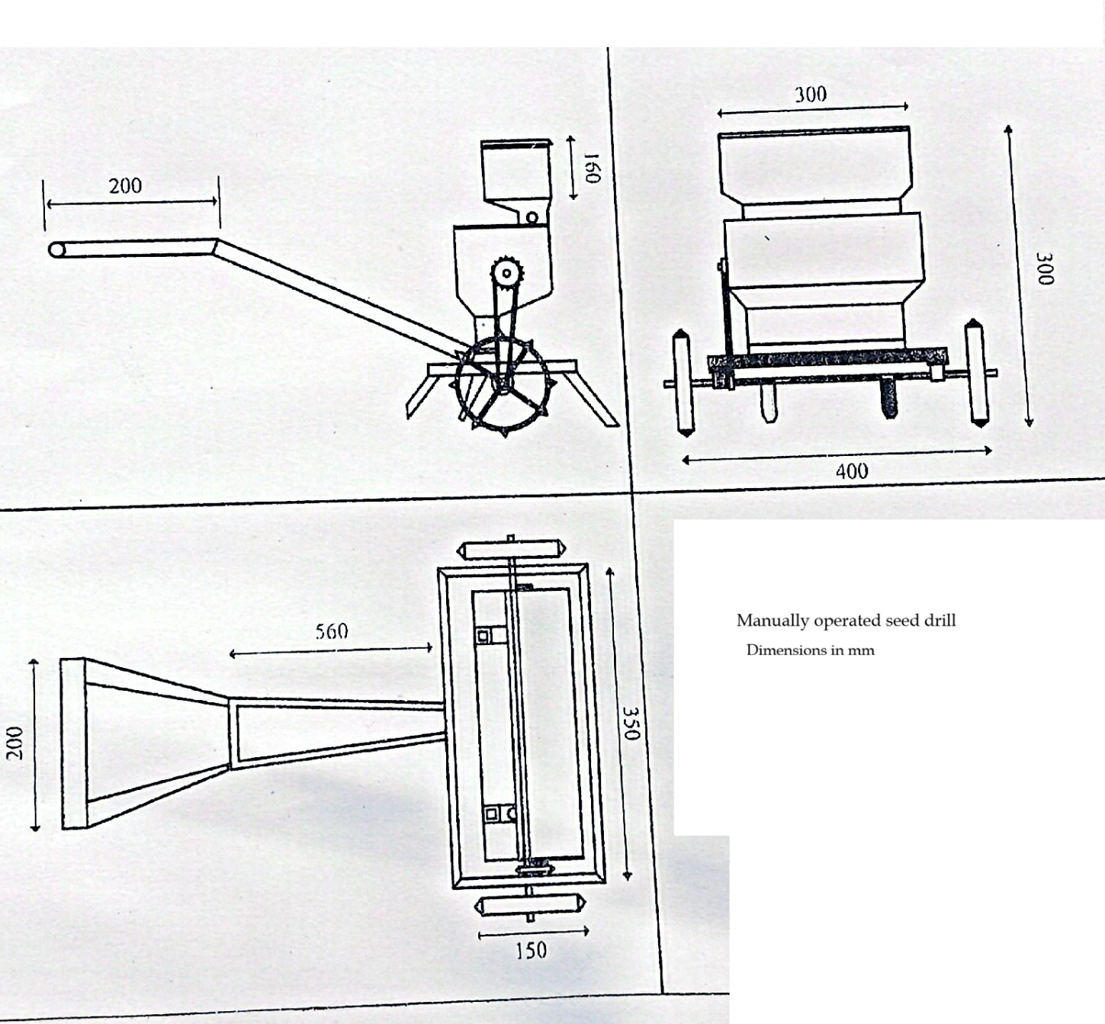

Figure 1: The Seed drill- orthographic view

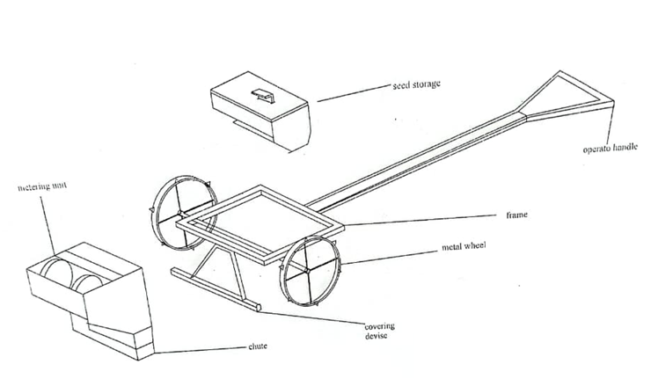

Figure 2: The Seed drill – different components.

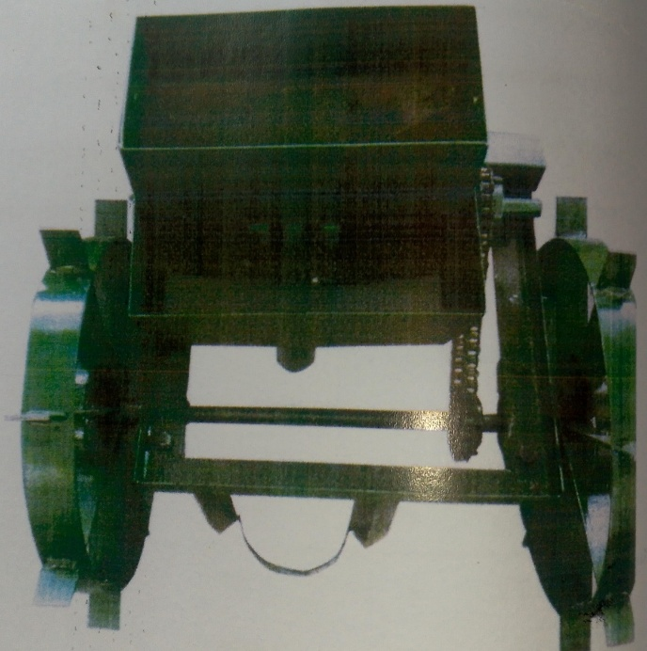
Figure 3: The Seed drill – a picture of the front view.

3.0 Performance Evaluation

3.1 Field Preparation: Traditional tillage in Nigeria primarily involves the use of hand-held tools, especially the hoes, mattocks and the shovels (Senjobi et al., 2013). The hoe was used to dig, turn over and aerate the soil shovel. The areas to be planted with crops that were tilled however, ridges and mounds were not made.

3.2 Field performance test.
The tests were carried in conformance with the ASABE S658 Planter Test Standard series for performance evaluation (ASABE, 2024). The machine was tested on three different plots, each of approximately 50 m². The moisture content of each field was determined using the gravimetric oven method. Since the plots were not exactly rectangular, the length of a row sown was between 7m and 9m. A row was planted in each plot. This was replicated on the other two plots. The field observations included speed of operation, depth of seed placement, and the effective field capacity. Mean observations were recorded.

3.3 Measurements and parameters determinations.
i. Sowing depth: a small trench was dug across the planting row, exposing the sown seed. Two rulers, or any other straight edge, with one laid across the top of the trench, and the other used to measure the depth to the seed in the trench.
ii. Spacing within rows: Tape rules were used to measure the distances between the seed holes on the rows. An adjustable marker on the machine indicates the position of the next row. The following parameters were evaluated:

a. Seed Delivery Rate (calibration) –determining the quantity of seeds per hectare (kg/ha). This was done by jacking up the drive wheel , collecting seeds from the furrow tube while rotating the ground wheel for a set number of turns (e.g., 20 rotations). The equivalent area is calculated as : Area = Wheel Circumference x No of Rotations x Row Spacing
Seed delivery rate = weight of the seeds collected /equivalent area
The seed drill planted one row at a time and the inter row spacing, marked by the distance between the field furrows, was 60 cm.
b. Seed distribution uniformity –
  - missing seed percentage (e.g., % of holes with no seeds);
  - seed spacing consistency. The coefficient of variation in seed sowing is a statistical measure evaluating the uniformity of seed spacing. It is the ratio of the standard deviation of the measured distances between seeds to the average (mean) distance. CV < 20% is acceptable for a manual drill;
  - multiple seed percentage (e.g., % of holes with >3 seeds);
  - depth uniformity (standard deviation of sowing depth). This is to ensures that seeds are deposited at a consistent depth (e.g., 2–5 cm). This was done by uncovering seeds to measure depth variations.
- Seed damage percentage: there is the need to evaluate the percentage of seeds damaged by the metering mechanism. This is achieved by visually inspecting the seeds after metering. The percentage seed damage was estimated as
D_{pc} = N_{bs}/ N_{tp} x100 ;
where D_{pc} =percent seed damage, N_{bs} = number of damaged seeds, and N_{tp} = total number of seeds sown. Acceptable levels are generally under 0.5%.
- Field efficiency (%) Seed drill field efficiency is usually determined as
Field efficiency (%) =$\frac{Effective field capacity }{Theoretical field capacity} x 100$
where Effective field capacity was measured as the actual area sown per hour including turning time. The theoretical field capacity calculated as C_{t} =(W x S_{f})/10, where W is the working width in meters, S_{f} the forward speed of machine or operator in Km/hr. The 10 is a constant used to convert the units (mx km/hr) directly into ha/hr. The number of furrow opener in this seed drill is one. In this specific case, the working width is equal to the row spacing (S) that is to be maintained between adjacent passing.
4.0 Results and Discussion

The seed drill’s performance was evaluated through a combination of metrics, metering and operational parameters. The crop planted was maize (variety DK777). The type of soil on the field was a sandy clay loam.

4.1 Seed drill performance.
The Seed drill tests evaluated the machines mechanical accuracy and optimal seed distribution, Table 3 presents results for some of the parameters evaluated

Table 3: Determined parameters (Average values)

Parameter | Average Values
Capacity (seed usage - kg /ha) | 18.05 kg /ha
Depth of sowing (mm) | 41
Field efficiency (%) | 72%
Effective field / sowing capacity (ha/h) | 0.084
Soil moisture, % (db) | 15.32 %
Speed of operation (km/h) | 1.43
Operator speed | 1.42 Km/hr

a. Seed Delivery Rate (calibration)
The average quantity of seeds collected after 20 turns of the land wheel was 0.0051kg. The equivalent area sown was estimated as 0.0002826 ha. Therefore, seeding rate =18.05 kg/ha
b. Seed distribution uniformity
Table 4: Speed spacing & Coefficient of Variation

Parameter | Value
Average (mean) seed spacing µ | 30.2 cm
Standard deviation σ | 10.01 cm
Coefficient of variation (CV) | 33.14%

c. Seed damage percentage:
The assessment of seed damage is based on the weight of seeds collected during calibration test. The collected seeds, after 20 turns of the ground wheels were sorted and weighed.

$$D=\left(\frac{W_{d}}{W_{t}}\right) x100$$
Where D = seed damage (%)
W_{d} =weight of damaged seeds (cracked, chipped or crushed)
W_{f} = total weight of seeds collected

The seed damage percentage obtained was 3.5%. A seed damage percentage of 3.5% is considered a borderline or even a high unacceptable rate. This could be caused by a mechanical mismatch or a wrong disc cell size for the seed variety. It could also mean that the seed may be too dry (brittle) or too soft (easily crutched). Further works shall be done in this area.

4.2 Effects of Moisture content on the drill’s operations
The recorded moisture content of the three fields was: 13.3%, 14% and 12.5% wet basis respectively. It was found that the moisture content of the field affected the depth at the which the machine sows the seeds. This could be attributed to the fact that a loose moist soil is easier to open than a dryer one. The furrow opener push force generally increases with a decrease in soil moisture content. This also affect the pushing force needed to operate the planter. The moisture content of the soil plays a critical role in determining the pushing force (draught) required to operate a seed drill. Rashidi et al., (2013) reported that lowering moisture content increases the draught force needed, as dry soil is firmer and harder for furrow openers to penetrate.

4.3 Cost benefits of the seed drill
A cost-benefit analysis of the locally fabricated manual seed drill was carried out. It shows that it is a highly profitable, low-cost investment for smallholder farmers compared to traditional planting, offering significant reductions in labour, time, and seeding costs. The cost per hectare is significantly lower than traditional methods. Maintenance is low because they are built with simple mechanisms (wheels, hoppers, tubes) and readily available materials. Fabrication Cost was estimated at N107,000.
A comparison of the seed drill with similar seed drills from published research data was carried out. Most research works do not go as far as specifying costs; a few did. Soyoye et al., (2016) gave no cost estimates. Sani et al., (2021) reported ₦21,000.00 as fabrication cost for a single-row manually operated grain planter. Rabbani et al., (2016) , authors from Bangladesh, reported a cost of Bangladeshi Taka (Tk 1775), about ₦20,000. Our own cost appeared higher , however when consideration is made for the high inflation in Nigeria (inflation was significant in the period 2018-2025, surging to over 27% in early 2025 due to reforms) and the time difference, https://abujapolitico.com/nigerias-inflation-to-ease-to-27-1-by-2025-nesg-stanbic-ibtc-report-predicts/) the costs are comparable.

5.0 Conclusion

A manually operated seed drill has been successfully constructed with the use of available local materials. Its performance evaluation was also carried out. The machine will go a long way in increasing the sowing efficiency of sowing, will help in sowing seed at uniform distance and in reducing drudgeries encountered in the traditional method of sowing. Its affordability and fuel independence make it particularly suitable for smallholder farmers, contributing to sustainable agricultural intensification.

REFERENCES
Adekanye, T. A., & Akande, A. M. (2015). Development and evaluation of a manual multi-crop planter for peasant farmers. Elixir Agriculture, 35095-35101.
Akhtar, M., Cheema, M. S., Jamil, M., & Ali, L. (2006). Effect of time of sowing on some important characters of wheat, Triticum aestivum genotypes. Journal of Agricultural Research (JAR)., 44(4), 255-259.

Ali, M. R. (2019). Design and development of a multi-crop manual seed drill. Agricultural Engineering International: CIGR Journal, 21(3), 51-60.
ASABE (2024): ASABE S658 Planter Test Standard. ASABE Technical Library. American Society of Agricultural and Biological Engineers, 2950 Niles Road, St. Joseph, MI 49085. https://elibrary.asabe.org/
Auwalu, F. K., & Bello, M. (2023). Exploring the Contemporary Challenges of Urbanization and the Role of Sustainable Urban Development: A Study of Lagos City, Nigeria. Journal of Contemporary Urban Affairs, 7(1), 175-188.
Bamigboye, O A & Mofolasayo A (2006): Performance evaluation of a two-row okra planter. Agricultural Engineering International: CIGR Journal Manuscript PM 0662 vol 8
Borbale, M. K., Pohekar, A. U., Nistane, J. R., Nichit, N. S., Yesankar, T. I., & Kaware, A. G. (2021) : Study of traditional method of weeding and fertilizing and their drawbacks. International Research Journal of Engineering and Technology, 8(3), 236-242.

Campbell, E (1990): Influence of spacing time of sowing and nitrogen fertilizer on the yield of wheat . Indian Journal of Agronomy 15: 251-253

Chethan, C. R, Krishnan D.A (2017): Dynamic push–pull strength data generation for agricultural workers to develop manual dry land weeders current science. 2017; 8:25.

Collins, B. A & D. B. Fowler (1996): Effect of soil characteristics, seeding depth, operating speed, and opener design on draught force during direct seeding. Soil & Tillage Research 39 ( 1996) 199-2 1
Deepak, C (2001) : Performance Evaluation of Various Types of Furrow Openers on Seed Drills—a Review, Journal of Agricultural Engineering Research, Volume 79, Issue 2, 2001, Pages 125-137, ISSN 0021-8634, https://doi.org/10.1006/jaer.2000.0688. (https://www.sciencedirect.com/science/article/pii/S0021863400906887)
Dennett, M. D. (2024) : Effects of sowing date and the determination of optimum sowing date. In Wheat (pp. 123-140). CRC Press.

Ebubekir, A, Ozgoz E, Taser O F, Tekelioglu O (2006): Assessment of different types of furrow openers using a full automatic planter. Asian Journal of Plant Sciences. 5(3): 537-542, 2006
Huang, M., & Zou, Y. (2018) : Integrating mechanization with agronomy and breeding to ensure food security in China. Field Crops Research, 224, 22-27.

Kalay, K. G (2015): Optimization of design and operational parameters of a pneumatic seed metering device for planting cotton seeds. Biosystems Engineering 94(4): 429-438
LSMAFS (2024) : The Lagos State Government is planning for Lagos Agriculture and Food Systems (LSMAFS) -Roadmap 2.0 Lagos State Ministry of Agriculture and Food Systems – available at https.//lasagric.com.
Morgan, K., McDonald, G., Allen, R., Faulkner, M., & Trengove, S. (2024 ): Evaluating the importance of sowing rate, depth and time of sowing on emergence and yield–wheat and canola. Hart Trial Results 2024, University of Adelaide , 119.-124

Ochin, N. G., Adewumi, A. A., Faleye, T., Adeyi, A. M., Willoughby, F. A., & Ehiosun, P. (2019) : Development and performance evaluation of single row manual seed planter. Journal of Agricultural and Crop Research, 7(3), 31-37.
Onilude, O. O., & Vaz, E. (2021) : Urban sprawl and growth prediction for Lagos using GlobeLand30 data and cellular automata model. Sci, 3(2), 23.
Pingali, P. (2007) : Agricultural mechanization: adoption patterns and economic impact. Handbook of agricultural economics, 3, 2779-2805.

Rabbani, M A; M. M. Hossain, J. F. Asha and N. A. Khan (2016): Design and development of a low cost planter for maize establishment J. Sci. Technol. Environ. Inform. 04(01): 270-279 | Rabbani et al. (2016) EISSN: 2409-7632, www.journalbinet.com DOI: 10.18801/jstei.040116.30

Rashidi, M., Najjarzadeh, I., Jaberinasab B., Mohammad S E & Fayyazi M. (2013): Effect of Soil Moisture Content, Tillage Depth and Operation Speed on Draft Force of Moldboard Plow. Middle-East Journal of Scientific Research 16 (2): 245-249, 2013 ISSN 1990-9233 © IDOSI Publications, 2013 DOI: 10.5829/idosi.mejsr.2013.16.02.11675

Sani, A., Mohammed, U.S., Saleh, A.* And Yunusa, S.U (2021): Development and performance evaluation of a single-row manually operated grain planter. Nigerian Journal of Scientific Research, 20(5): 2021; September–December; journal.abu.edu.ng; ISSN-0794-0319 pp 582-588
Sarker, T. R, M Alam, M R Ali, C. K. Saha & M A Haque 2019 Design and development of a multi-crop manual seed drill Agric Engr International : CIGR Journal , 21(3) : 51-60. [https://cigrjournal.org](https://cigrjournal.org/index.php/Ejounral/article/download/5360/3065/24635)
Sedara, A., Ibrahim, Y., Manuwa, S., & Sedara, O. (2020): Development of a low-cost seed drill for sowing amaranth seed. World Acad. J. Eng. Sci, 7(3), 39-45.
Senjobi, B. , Ande, O. and Okulaja, A. (2013) Effects of Tillage Practices on Soil Properties under Maize Cultivation on Oxic Paleustalf in South Western Nigeria. Open Journal of Soil Science, 3, 163-168. doi: 10.4236/ojss.2013.33019.
Shambhu, V. B & A.K. Thakur (2018): Functional Performance of a Manually Operated Seed Drill for Jute International Journal of Current Microbiology and Applied Sciences ISSN: 2319-7706 Volume 7 Number 06 (2018) Journal homepage: http://www.ijcmas.com
Shambhu, V B &Thakur A K (2019): Laboratory and field performance of manual seed drill for sowing jute and tiny seeds. Indian Journal of Agricultural Sciences89 (1): 129–32, January 2019/
Sharma, A & Mukesh E (2010) : A textbook on Farm machinery Design principles and problems. Jain brothers. New Delhi. Second Edition
Sims, B., & Kienzle, J. (2017): Sustainable agricultural mechanization for smallholders: what is it and how can we implement it?. Agriculture, 7(6), 50.

Sinha, Priya, SV Jogdand, Shubham Sinha & Shambhu Singh (2019): Journal of Pharmacognosy and Phytochemistry 2019; 8(6): 2488-2492 )

Singh, P S, Laxman P G, Agarwai N (2006): Ergonomic Evalaution of manually operated seed drill for farm women. Journal of Agricultural Engineering (India) 43(1): 42-48
Soyoye, B. O., Ademosun, O. C., & Olu-Ojo, E. O. (2016): Development of a manually operated vertical seed-plate maize planter. Agricultural Engineering International: CIGR Journal, 18(4), 70-80.
Stanley J. M (2003) : Human Power and the Watt. Physics 162, Spring Term 2003. http://hendrix.uoregon.edu/~stanm/phys162s2003/Alternative%20Lab%201.htm

