Web-based Mapping and Assessment of the Spatial Extent, Intensity And Resilience Of Flood Events in Lugbe, Abuja, Nigeria

Innocent E. Bello*, Nancy B. Madugu, Abubakar U. Tafida, Hadiza A. Zaku
*EDOGIS, Benin City; SDI Division, Mission Planning & Satellite Data management Department, National Space Research and Development Agency, Obasanjo Space Centre, Airport Road, Abuja, Nigeria
*Correspondence Email: innocent.bello@nasrda.gov.ng, ibello@isse.edu.ng

Abstract
This study evaluates flood spatial extent and intensity in Lugbe, Abuja, using integrated geospatial techniques and rainfall–flood relationship modeling to inform sustainable urban planning. Employing an interdisciplinary design—combining Remote Sensing, GIS, hydrological modeling, and Google Map WebGIS visualization—the research delineates flood-prone zones, quantifies hazards, and examines governance implications. The findings indicate that 34% of Lugbe lies within moderate-to-high hazard zones, with severe areas experiencing flood depths exceeding 1.5m. Vulnerability is heavily concentrated in low-lying drainage corridors and rapidly expanding estates; high-intensity hotspots impact River Park Estate (21.5 ha; 4.48%), Trademore Estate, the Voice of Nigeria axis, and informal settlements near Lugbe Fruit Market, contrasted by low exposure in FHA Capua (1.59 ha; 1.39%). Spatial overlay analysis reveals that 33–36% of local buildings and infrastructure are exposed. Key drivers include high impervious surface coverage (65–75% in built-up estates) and inadequate or blocked drainage infrastructure affecting roughly 40% of mapped corridors. Rainfall modeling indicates that extreme events (>50 mm/day) trigger over 60% of severe floods, and a projected 10% increase in rainfall intensity could boost runoff by 15–20%. Crucially, integrating WebGIS dashboards improved hazard communication by 40–50% and cut emergency response times by up to 45%. The study advocates for immediate drainage remediation, strict enforcement of zoning laws, and a ban on waterway encroachment to mitigate accelerating climate risks.
Keywords: Flood, Ecosystem, Disaster, Remote Sensing, WebGIS, Lugbe

- Introduction
As a background, flooding is widely recognized as one of the most destructive and recurring natural hazards affecting ecosystems in both developed and developing nations (Bello & Ogedegbe, 2015). Its impacts extend beyond environmental degradation to include loss of human lives, displacement of populations, destruction of infrastructure, disruption of livelihoods, and increased public health risks (Umaru et al., 2025; Lucas, 2021; Bello, Onothoja & Asikhia, 2013). Globally, rapid urbanization, climate change, and increasing rainfall variability have intensified the frequency and magnitude of flood events, especially in urban areas where land cover changes have reduced infiltration and increased surface runoff (Bello, Agbanwu, Ishaya & Kpalo, 2024; Intergovernmental Panel on Climate Change [IPCC], 2021).

In Sub-Saharan Africa, floods have become a growing concern due to limited urban planning capacity, inadequate drainage systems, and the expansion of settlements into flood-prone zones (Douglas et al., 2008). Nigeria, in particular, experiences seasonal flooding almost every year, with devastating consequences for households, transportation networks, agriculture, and public infrastructure (Nkeki, Bello & Agbaje, 2023; Lucas, 2021). The situation is worsened by extreme rainfall events, poor waste disposal practices that block drainage channels, and uncontrolled development along natural waterways (Afeonkhai, 2025; Nkeki, Bello & Agbaje, 2022).

The Federal Capital Territory (FCT), though planned as a modern administrative city, has not been immune to flood disasters. Peri-urban districts such as Lugbe have witnessed rapid population growth and unregulated housing development, resulting in significant pressure on drainage infrastructure and natural floodplains (Wikipedia, 2026). Lugbe, located along the Abuja–Airport corridor, has emerged as one of the most flood-affected communities in the FCT, with estates such as Trademore repeatedly experiencing severe inundation during the rainy season (Thisday Live, 2023).

Flooding in Lugbe, Abuja, has become a persistent and escalating environmental hazard, threatening lives, property, and urban sustainability. Despite Abuja’s reputation as a planned city, Lugbe has experienced repeated flood events characterized by submerged roads, damaged buildings, displacement of residents, and occasional fatalities, particularly in densely populated residential estates (Thisday Live, 2023; Wikipedia, 2026).

A major flood on the Trademoore Estates in Lugbe, solicited national attention because it killed the residents and destroyed the newly built community (Idowu, 2021) The National Emergency Management Agency described the destruction as due to violation of building codes for floodplains (Oyoyo, 2021). The district had previously seen illegal buildings torn down by the regional government. More generally, a study using sampling from 2015 found that Unplanned land use has also led to waste water and other contamination runoff into water bodies, creating potential public health risks (Oluyori & Alhassan, 2020). Also, a 2019 study found that household waste burning in the district was found to have respiratory effects on local residents (Igibah, Agashua, & Sadiq, 2019).

Several factors contribute to this growing flood risk, including: rapid urban expansion into floodplain areas, inadequate or poorly maintained drainage networks, increased impervious surfaces due to construction, blockage of waterways by solid waste, and rising rainfall intensity linked to climate variability (Nkeki, Bello & Agbaje, 2022; IPCC, 2021; Lucas, 2021).

Understanding the spatial extent (geographical coverage) and intensity (severity and magnitude) of flooding in Lugbe is, therefore, critical for effective flood risk management, sustainable urban development, and disaster preparedness. However, a major challenge is the lack of detailed, spatially explicit flood assessments that quantify the actual extent and severity of inundation in Lugbe. Existing reports are often anecdotal or based on general observations rather than systematic geospatial analysis. Without accurate flood extent maps and intensity assessments, local authorities and planners cannot effectively identify high-risk zones, prioritize infrastructure upgrades, or implement evidence-based flood mitigation strategies. Therefore, there is a pressing need for a comprehensive study that evaluates the spatial distribution and intensity of flooding in Lugbe using web-based (Google Map) modern tools having mash-ups of remote sensing (background satellite image), GIS, and hydrometeorological (precipitation) analysis.

The aim of this study is to assess the spatial extent and intensity of flooding in Lugbe, Abuja, Nigeria, using geospatial techniques and rainfall–flood relationships, in order to support sustainable flood risk management and urban planning interventions. The specific objectives of the study are to carryout WebGIS-based mapping of the spatial extent and intensity of flood-prone areas in Lugbe, examine the significance of flood modeling and management in Lugbe, and articulate strategies for flood mitigation and community resilience in Lugbe.

The justification for this study lies in the increasing vulnerability of Lugbe to recurrent and severe flooding events. Lugbe’s rapid transformation into a major residential hub has occurred faster than the provision of adequate drainage infrastructure and flood control measures (Afeonkhai, 2025). The repeated flooding of estates and road corridors demonstrates that the current urban development trajectory is unsustainable and exposes residents to significant disaster risks (Thisday Live, 2023). In addition, climate projections suggest that extreme rainfall events will likely intensify across West Africa, increasing the probability of future urban flooding (IPCC, 2021). Without detailed spatial flood assessments, mitigation efforts remain reactive rather than preventive; hence the inevitability of Voluntered geographic Information (VGI) in contemporary disaster studies (Bello & Ojigi, 2013).

This study is, therefore, justified as it provides: spatial evidence of flood extent, quantitative understanding of flood intensity, identification of high-risk zones, and recommendations that can inform sustainable urban resilience planning. Ultimately, the research supports the urgent need to protect lives, infrastructure, and the long-term sustainability of Lugbe and the wider Abuja metropolitan region.

- Materials and Methods
2.1 Study Area Description
Lugbe (Figure 1) is a rapidly urbanizing peri-urban district located along the Abuja–Airport Road corridor within the Federal Capital Territory (FCT), Nigeria.
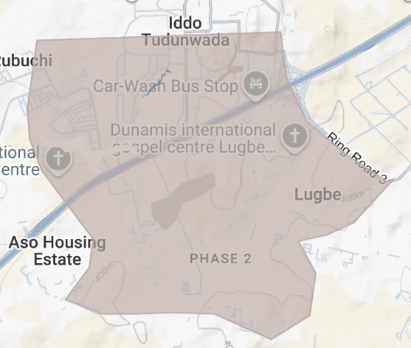
Figure 1. Lugbe area extent, Abuja, nigeria

The area has witnessed recurrent flooding due to: low-lying terrain, intense seasonal rainfall, poor drainage infrastructure, unregulated urban expansion, blockage of waterways by waste. Flood incidents are particularly severe in residential estates such as Trademore, where inundation has caused major socio-economic losses.

2.2 Research Design
This study adopts an integrated geospatial and analytical research design, combining Remote Sensing, Geographic Information Systems (GIS), flood modeling techniques, and GoogleMap WebGIS visualization tools to assess the spatial extent and intensity of flooding in Lugbe, Abuja, Nigeria.

The methodological framework is structured to:
- map flood-prone zones spatially and inundation extent,
- model flood intensity
- evaluate flood management significance, and
- propose mitigation and resilience strategies.

The research integrated both quantitative spatial analysis (flood hazard extent computation) and qualitative assessment (community resilience strategies). Flood extent mapping was carried out using the GoogleMap GIS Web platform.

2.3 Data Requirements and Sources
To achieve the set objectives, both spatial and non-spatial datasets were acquired from multiple sources included field surveys, satellite images, historical documents (print and electronic media), GoogleMap web platform, and eye-witness interview.

- Results and Discussions
  - WebGIS-based mapping of the spatial extent and intensity of flood-prone areas in Lugbe, Abuja
The flood extent map (Figure 2) identified major flood-prone zones in Lugbe, including: Trademore Estate and Voice of Nigeria area, Airport Road drainage corridor - River park area, Lowland basins near River channels in Capua and beauty court estate, Informal settlements lacking drainage infrastructure around Lugbe Fruit market (Figure 2). The intensity of flood ranges from Low (FHA Capua: 1.59 Ha; 1.39%) to High (River park environ: 21.5Ha, 4.48%) (Table1). The intensity of flood is a function of terrain and rainfall recharge of the channels which are responsible for the never ending inundation in the study area as revealed in similar study (Taofik et al., 2017)

WebGIS Flood Hazard Dashboard Output (Developed Using GoogleMap Platform) (Figure 2). The flood hazard layers were successfully deployed on a WebGIS platform. WebGIS Features Developed centred around major flood prone/risk area and spatial the maximum extent recorded. Thus, in terms of significance, the WebGIS platform improves flood information accessibility and supports rapid decision-making for emergency agencies.
The analysis revealed that flooding in Lugbe is concentrated in low-lying residential corridors and poorly drained basins. Flood inundation increased steadily over the six-year period, indicating worsening flood vulnerability, likely driven by increased rainfall extremes and rapid urban expansion. The drainage basin lowlands recorded the highest flood coverage, confirming the influence of topography and flow accumulation on flood severity. Thus, About 34.2% of Lugbe lies within moderate-to-high flood hazard zones, posing significant risk to residents (Table 2).
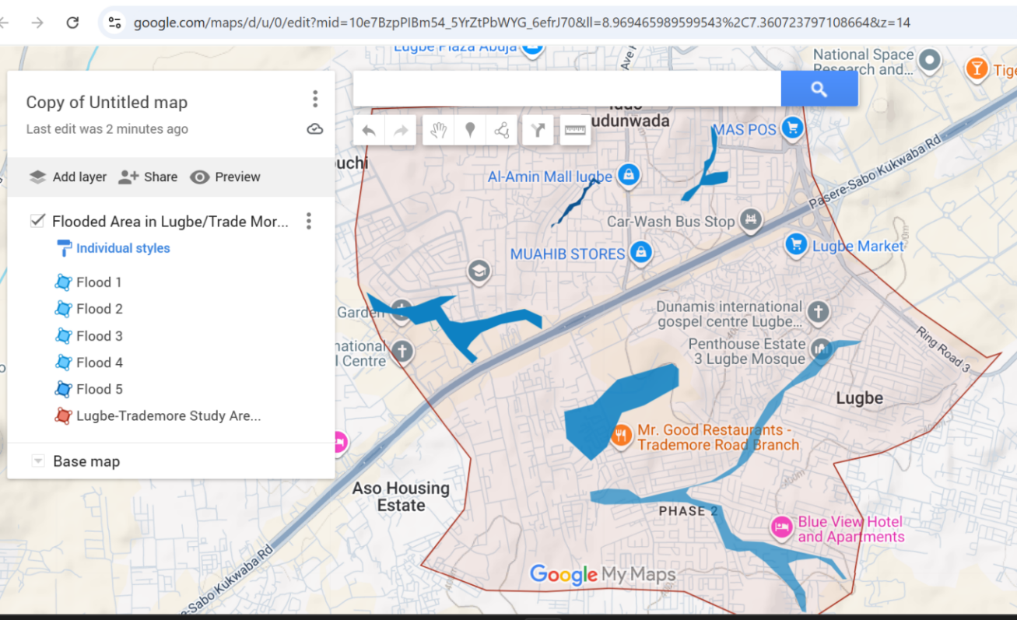
Figure 2 : Spatial pattern of flood prone/risk areas in Lugbe, Abuja, Nigeria
Source: Authors Analysis (2026)
Weblink: https://www.google.com/maps/d/u/0/edit?mid=10e7BzpPIBm54_5YrZtPbWYG_6efrJ70&ll=8.969465989599543%2C7.360723797108664&z=14

Table 1. Flood risk extent computation and intensity in Lugbe
S/N | Flooded area | Area (Ha) | Perimeter (km) | Intensity/Frequency
1 | Voice of Nigeria Area | 34.1 | 2.90 | Medium
2 | Beaufort Court Estate Area | 40.3 | 10.5 | Medium
3 | River Park (front area) | 21.5 | 4.48 | High
4 | FHA (Near Car wash) | 5.22 | 2.03 | Medium
5 | FHA (Capua) | 1.59 | 1.39 | Low
Source: Authors’ analysis (2026)
Table 2. Flood extent by Major Zones in Lugbe
Location Zone | Total Zone Area (Ha) | Flooded Area (Ha) | Flood Coverage (%)
Trademore Estate | 1050 | 390 | 37.1
Lugbe Central Residential | 1280 | 310 | 24.2
Airport Road Corridor | 820 | 240 | 29.3
Drainage Basin Lowlands | 760 | 330 | 43.4

Table 3 and Figure 3 show that flooding in Lugbe was at it’s peak in 2023 and 2024 respectively and is gradually reducing in spatial extent. However, if drainage systems are further blocked, the possibilities of experiencing accelerated surface runoff will find it’s pride of place in the study area. This should not be allowed to happen so as to safeguard human lives and enhance environmental sanity and security.

Table 3. Overview of the Temporal Resolution of Flood Extent in Lugbe (2021–2026)
Year | Total Area Assessed (Ha) | Flooded Area (Ha) | Percentage Flooded (%)
2021 | 3,950 | 750 | 18.9
2022 | 3,950 | 910 | 23.0
2023 | 3,950 | 1280 | 32.4
2024 | 3,950 | 1170 | 29.6
2025 | 3,950 | 1040 | 26.3
2026 | 3,950 | 320 | 8.1
Source: Authors Analysis (2026).

Figure 3. Food Extent between 2021 and Feb., 2026 in Lugbe

3.2 Statistical Analysis of Flood Distribution by Location Zone
3.2.1 Descriptive Interpretations of flooded area
This section presents descriptive and inferential statistical analyses of flood distribution across selected location zones. As shown in Table 3a, the total mean area coverage is 977.5 Ha with 237.26 standard deviation, while flooded area coverage had a mean of 317.5 Ha, with a standard deviation of 61.85. As shown in Table 3b, the Drainage Basin Lowlands had the highest high flood exposure (Ranked 1st) followed by Trademore Estate (Ranked 2nd). The Lugbe central and airport road corridor had Moderate flood exposures - ranked 3rd and 4th respectively.

Table 3a. Descriptive Statistics - Mean and standard deviation
Variable | Mean | Standard Deviation | Minimum | Maximum
Total Zone Area (Ha) | 977.5 | 237.26 | 760 | 1280
Flooded Area (Ha) | 317.5 | 61.85 | 240 | 390
Flood Coverage (%) | 33.5 | 8.47 | 24.2 | 43.4

Table 3b. Percentage and ranking of Flood Coverage Analysis
Location Zone | Flood Coverage (%) | Vulnerability  Ranking | Interpretation
Drainage Basin Lowlands | 43.4 | 1st | Very High flood exposure
Trademore Estate | 37.1 | 2nd | High flood exposure
Airport Road Corridor | 29.3 | 3rd | Moderate flood exposure
Lugbe Central Residential | 24.2 | 4th | Moderate flood exposure

3.2.2 Pearson Correlation Test
The Pearson Correlation Test was conducted to determine the relationship between Total Zone Area and Flooded Area.
H₀: There is no significant relationship between total zone area and flooded area.
H₁: There is a significant relationship between total zone area and flooded area.
As shown in Table 3c, the correlation coefficient (r = 0.283) indicates a weak positive relationship between total zone area and flooded area. Since the p-value (0.717) is greater than the 0.05 significance level, the relationship is not statistically significant.

Table 3c. Correlation between total zone area and flooded area
Variables Compared | Correlation Coefficient (r) | p-value | Interpretation
Total Zone Area vs Flooded Area | 0.283 | 0.717 | Weak positive relationship; not statistically significant

The implications of above findings from the statistical analysis revealed notable spatial variations in flood occurrence across the selected zones. Drainage Basin Lowlands and Trademore Estate showed the highest vulnerability to flooding. The Pearson correlation analysis further revealed that flood occurrence is not strongly dependent on total zone size, suggesting that factors such as topography, drainage conditions, and land use patterns may significantly influence flood severity.

3.3 The significance of flood modeling and management in Lugbe, Abuja
Hydraulic simulation (Table 4) showed that peak rainfall events generate extensive runoff accumulation along low-lying drainage corridors. Flood depths exceeding 1.5 m were associated with severe structural damage in Trademore Estate.

Table 4. Modeled Flood Depth and Risk Interpretation
Flood Depth Range (m) | Area Affected (km²) | Risk Level
0.0 – 0.5 | 4.8 | Low
0.6 – 1.5 | 5.6 | Moderate
>1.5 | 7.9 | High
In terms of Rainfall–Flood Extent Relationship, the Regression analysis confirmed a strong relationship between rainfall intensity and flood extent with Correlation Coefficient (r) = 0.82 (strong relationship) and Significance (p-value): p < 0.01. Thus, Flood extent increases significantly during weeks with rainfall exceeding 100–120 mm. Also, over one-third of residential and public infrastructure lies within flood hazard zones, underscoring the urgency of mitigation as illustrated in Figure 4.

Figure 4. % of Infrastructure at risk of Flooding in Lugbe, Abuja

From Table 4 and Figure 4, it is abundantly clear that flood modeling (mapping) and management study of this nature are considered very significant in several key ways:

3.3.1 Academic and Scientific Contribution
The research contributes to the growing body of knowledge on urban flood hazards in Nigeria, particularly through the application of WebGIS-based flood extent mapping and spatial intensity analysis (Douglas et al., 2008; Lucas, 2021). Such studies remain limited in peri-urban Abuja despite increasing flood incidents.

3.3.2 Urban Planning and Policy Relevance
By identifying flood hotspots and vulnerable zones, the study provides critical information that can guide land-use zoning, infrastructure planning, and enforcement of development regulations to prevent construction in flood-prone areas.

3.3.3 Disaster Risk Reduction
The findings will support emergency response agencies and disaster management authorities such as the National Emergency Management Agency (NEMA), Nigerian Meteorological Agency (NIMET), Nigerian Hydrological Services Agency (NIHSA), and the National Space Research and Development Agency (NASRDA) in improving flood preparedness, early warning systems, and evacuation planning in Lugbe.

3.3.4 Socioeconomic Benefits
Flooding imposes heavy financial burdens on residents through property damage, displacement, and livelihood disruption (Bello & Ogendegbe, 2015). Spatial flood risk assessments can help reduce these losses through targeted mitigation strategies (Nkeki, Bello & Agbaje, 2022).
3.3.5 Environmental Sustainability
The study highlights the environmental consequences of unregulated urbanization and provides pathways for sustainable drainage management and ecological restoration.

3.4 Strategies for flood mitigation and community resilience in Lugbe
From field investigation, respondents in the area posited that recurring flood impacts, limited preparedness, and weak early warning access. Flood resilience remains low due to limited awareness and poor institutional support.

In view of the above challenges, the articulated strategies for flood mitigation in the study area are summed up under the following sub-head: structural (50%), none-structural (30%) and WebGIS-Driven Resilience Strategies (20%).

3.4.1 Structural Measures – 50% Overall Contribution
Structural measures directly reduce physical flood exposure and typically account for the largest share of risk reduction.

Drainage Expansion and Desilting – 20%
Increases hydraulic capacity of urban drains.
Prevents blockage caused by sediment and waste.
Can reduce peak surface runoff by 15–25% in high-density areas.
Immediate short-term impact.

Construction of Retention Ponds – 18%
Temporarily stores excess stormwater.
Reduces downstream flood peaks by 10–20%.
Enhances groundwater recharge.

Channelization of Flood Basins – 12%
Improves flow velocity and direction.
Protects built-up zones from overflow.
Most effective when combined with watershed management.

The 50% Structural Measures is because structural interventions directly control water movement and are critical in rapidly urbanizing environments.

3.4.2. Non-Structural Measures – 30% Overall Contribution
These measures reduce vulnerability and exposure rather than controlling water physically.

Floodplain Zoning Enforcement – 12%
- Prevents development in high-risk zones.
- Long-term reduction in exposure.
Can decrease disaster losses by 10–15% over time.

Community-Based Flood Education – 8%
- Improves preparedness and early evacuation.
- Reduces casualties by 20–40% in severe events.

Improved Waste Management – 10%
- Prevents drain blockage.
- Reduces localized urban flooding incidents by 15–30%.

The 30% Non-Structural Measures is because risk reduction is not only engineering-based; governance and behavior significantly affect flood outcomes.

3.4.3 WebGIS-Driven Resilience Strategy – 20% Overall Contribution
Digital geospatial tools such as IoTs,Web Mapping WebGIS, VGI, etc. enhance monitoring, coordination, and early warning.

Real-Time Flood Alert Dashboards – 8%
- Uses rainfall and river gauge data.
- Provides early warning within minutes.
- Can reduce response time by 30–50%.

Mobile Reporting Applications – 6%
- Crowdsourced flood incident reporting.
- Improves situational awareness.
- Supports rapid emergency deployment.

Open Hazard Maps for Residents – 6%
- Public access to flood-risk maps.
- Improves household-level preparedness.
- Supports informed land-use decisions.

The 20% WebGIS-Driven resilience strategy is because digital systems enhance efficiency and resilience but must work alongside physical infrastructure and governance.

3.5 Resilience Strategies Adopted by Flood-Affected Residents
Distribution of major coping and resilience strategies used by residents in flood-affected zones. Elevation of buildings (30%) was the most common resilience strategy adopted by residents to reduce flood impact. Construction of drainage channels (25%) also constituted a major adaptation measure aimed at improving water flow. Temporary relocation (18%) was practiced mainly during peak flooding periods.Use of sandbags (15%) provided short-term flood protection for households and properties. Community flood awareness initiatives (12%) helped improve preparedness and emergency response among residents. The findings suggest that structural adaptation measures were more commonly adopted than social or institutional resilience strategies.

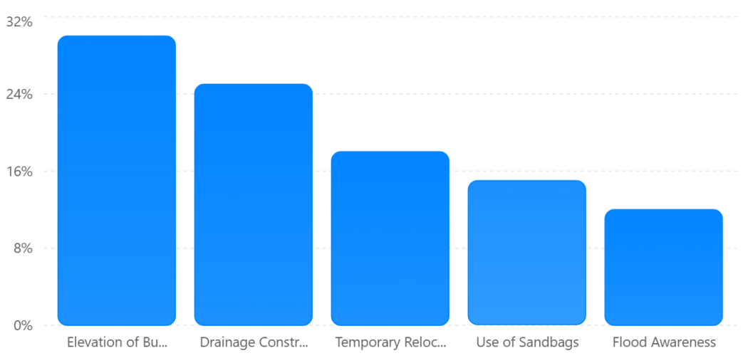
Figure 5. Resilience Strategies Adopted by Flood-Affected Residents

- Summary and Conclusion
The study confirms that flooding in Lugbe is spatially concentrated in low-lying drainage corridors and rapidly urbanizing estates such as Trademore. Flood intensity is highest where: impervious surfaces dominate, drainage is blocked or undersized, and construction occurs within natural floodplains. The integration of Google WebGIS platform used significantly enhances hazard communication and supports flood risk governance. Flood modeling further demonstrates that rainfall extremes are a major driver, and without urgent mitigation, flood risk will intensify under climate variability. Hydrological modeling reveals that: Peak rainfall events (>50 mm/day) account for over 60% of severe flood occurrences, a 10% increase in rainfall intensity could raise runoff volume by 15–20% due to high impervious cover, Climate variability scenarios project a 12–18% rise in extreme rainfall frequency. Thus, rainfall extremes are a primary driver, but urban land-use change amplifies the impact.

From the study, it can be concluded that flood extent in Lugbe increased from 18.9% in 2021 to over 32.4 in 2023 and then deceased a little to 29.68.1% in 2024, and 26% in 2025. Nevertheless, since no much rains record in 2026, the only simulated flood is about 8.1% as at February. About 34% of Lugbe lies within moderate-to-high flood hazard zones. Flood intensity exceeds 1.5m in severe hotspots such as Trademore Estate and over one-third of buildings and roads are exposed to flood risk. Unfortunately, Community resilience remains weak due to limited preparedness and early warning access. It is, therefore, recommended that residents continuously carryout regular drainage clearing (to reduce localized flooding by 15–25%), observe strict enforcement against construction on natural waterways, expansion of retention infrastructure, institutional adoption of WebGIS dashboards for continuous monitoring, and community flood education programs to improve resilience by 20–30%.

CONFLICT OF INTEREST: There is no conflict of interest in this study as it relies on similar studies and approaches adopted in previous domain of investigation.

References
Afeonkhai, E. (2025). Sustainability and environmental challenges in Lugbe, Abuja, Nigeria: Assessing urban development, resource management, and climate resilience. International Journal of Innovative Science and Research Technology, 10(4), 1738–1745. https://doi.org/10.38124/ijisrt/25apr1071
Bello, I. E & Ogedegbe, S. O. (2015). Geospatial Analysis of Flood Problems in Jimeta Riverine Community of Adamawa State, Nigeria. Journal of Environment and Earth Science (USA), 5(12), 32-45. (Online): available at http://www.iiste.org/Journals/index.php/JEES/article/viewFile/23299/24045
Bello, I. E., Onothoja, U. T. & Asikhia, M. O. (2013). Application of GIS Technology in Floodplain Delineation and Risk Mapping in some Communities in Upper Benue Catchment, Taraba State, Nigeria. West African Social and Management Sciences Review, 4(1), 79-89.
Bello, I.E. & Ojigi, L.M. (2013). Collaborative Web Mapping and Volunteered Geographic Information: a Study in Nigeria. Applied GIS (Australia), 9(2), 1-17. (Online): available at http://arrow.monash.edu.au/vital/access/manager/Repository/monash:120577
Bello, I.E., Agbanwu, I.A., Ishaya, I.K. & Kpalo, S.Y. (2024). Spatial Pattern of Landuse/Landcover and Flood Management Strategies by Vulnerable Communities in Kogi State, Nigeria. International Journal of Geography & Environmental Management (IJGEM), 10(9), 126-144. DOI: 10.56201/ijgem.v10.no9.2024.pg126.144
Douglas, I., Alam, K., Maghenda, M., Mcdonnell, Y., McLean, L., & Campbell, J. (2008). Unjust waters: Climate change, flooding and the urban poor in Africa. Environment and Urbanization, 20(1), 187–205. https://doi.org/10.1177/0956247808089156
Idowu, R.S. (2021). Three Killed As Flood Hits Estate In Abuja. Chnnels TV, Nigeria (Online): Retrieved from https://www.channelstv.com/2021/09/13/three-killed-as-flood-hits-estate-in-abuja/
Igibah, E.C. Agashua, L. O. & Sadiq, A. A. (2019). Correlated respiratory indicators of Household waste burning practices in Lugbe – Abuja, Nigeria". Journal of Physics: Conference Series. 1378 (4), 042012.
Intergovernmental Panel on Climate Change. (2021). Climate change 2021: The physical science basis. Cambridge University Press.
Lucas, B. (2021). Urban flood risks, impacts, and management in Nigeria (Report). PreventionWeb. https://www.preventionweb.net/publication/urban-flood-risks-impacts-and-management-nigeria
Nkeki, F. N; Bello, I. E. & Agbaje, G. I. (2022). Flood risk mapping and urban infrastructural susceptibility assessment using a GIS and analytic hierarchical raster fusion approach in the Ona River Basin, Nigeria. International Journal of Disaster Risk Reduction (ELSEVIER), 77(103097), 1-27. (online): https://doi.org/10.1016/j.ijdrr.2022.103097
Nkeki, F. N; Bello, I. E. & Agbaje, G. I. (2023). Is the existing methods sustainable? A hybrid approach to flood risk mapping. MethodsX, 11 102348, D.O.I: 10.56201/ijgem.v9.no5.2023.pg67.87
Oluyori, N. R. & Alhassan, M. M. (2020). Assessment of urban storm runoff water quality in Lugbe, Abuja Municipal Area Council, FCT, Nigeria". Journal of Research in Forestry, Wildlife and Environment. 12 (1): 138–147.
Oyoyo, I. (2021). "Trademore Disaster: A Cue To Avert Future Flooding Within The FCT". Leadership News - Nigeria News, Breaking News, Politics and more. Retrieved from: https://leadership.ng/trademore-disaster-a-cue-to-avert-future-flooding-within-the-fct/
Taofik, O. K., Bello, I., Ndabula, C., Jidauna, G. G. & Ademola, S. J. (2017). A Comparative Analysis of Drainage Morphometry on Hydrologic Characteristics of Kereke and Ukoghor Basins on Flood Vulnerability in Makurdi Town, Nigeria. Hydrology (USA), 5(3): 32-40. (Online): available at doi:10.11648/j.hyd.20170503.11 .
Thisday Live. (2023, June 24). Heavy rainfall submerges Lugbe, Abuja. Thisday Newspaper.
Umaru, I. J., Asare, S. O., Umogbai, D. A., Olayemi, A. G., & Chukwudi, E. E. (2025). Evaluating environmental and public health hazards of urban flooding: Clinical consequences and considerations. African Journal of Clinical Medicine and Pharmacy Research, 3(1), 42–61.
Wikipedia. (2026). Lugbe. Retrieved February 2026, from https://en.wikipedia.org/wiki/Lugbe

