E-CLEARANCE: A Web-Based Student Clearance Management System for St. Clare College of Caloocan

Ezekiel D. Batisatic, Raniel M. Costanilla, Charisse Maxinne C. Cruz, Eugene A. De la Cruz, Quennie J. Justiniane, Adrian C. Villegas
St. Clare College
Corresponding Author: Charisse Maxinne C. Cruz

ABSTRACT
This study focused on the development of “E-Clearance: A Web-Based Student Clearance Management System for St. Clare College of Caloocan.” The research was conducted in response to the challenges encountered in the traditional manual clearance process, such as long waiting lines, delays in obtaining signatures, overcrowding within school premises, and inconvenience experienced by both students and staff. The study aimed to develop a system that would provide a more efficient, reliable, accessible, and organized clearance process for non-graduating students of the institution.
A quantitative research method using a descriptive research design was employed in the study. Data were gathered through a paper-based survey questionnaire distributed to 198 non-graduating college students from different tertiary programs at St. Clare College of Caloocan during the Academic Year 2025–2026. The questionnaire utilized a five-point Likert scale to determine the respondents’ experiences with the existing manual clearance process and their perceptions regarding the proposed web-based system. Frequency, percentage, and weighted mean were used to analyze the collected data.
The findings revealed that students commonly experience inconvenience, delays, and difficulty in completing the manual clearance process. Results also showed that the majority of respondents strongly agreed that the proposed E-Clearance System would improve efficiency, accessibility, convenience, and reliability in processing student clearances. The respondents also favored features such as real-time updates and online monitoring of clearance status.
The study concluded that the proposed E-Clearance Management System is a valuable solution that can significantly improve the existing clearance process of St. Clare College of Caloocan by reducing manual workload, minimizing delays, and enhancing overall operational efficiency and student satisfaction.
Keywords: E-Clearance System, Web-Based System, Student Clearance Management, Digital Clearance Process

INTRODUCTION
In academic institutions, clearance processes are considered essential administrative requirements that students must complete before receiving grades or proceeding to the next academic level. However, many schools still implement manual and paper-based clearance procedures that often result in delays, inefficiency, long waiting lines, and inconvenience for both students and administrative personnel. At St. Clare College of Caloocan, students are required to physically visit multiple offices to obtain signatures and complete their clearance requirements, which contributes to congestion within the campus during clearance periods.
Studies have shown that digital transformation and web-based systems significantly improve administrative efficiency, reduce paperwork, and streamline institutional processes. Existing literature also emphasizes that manual administrative workflows often lead to slower transaction processing, data management issues, and reduced user satisfaction. In response to these challenges, the researchers proposed the development of an E-Clearance: A Web-Based Student Clearance Management System for St. Clare College of Caloocan.
The proposed system aims to provide a more accessible, efficient, and reliable platform where students can monitor their clearance status online while authorized departments can electronically review, approve, reject, or place clearance requests on hold. Through automation and centralized data management, the study seeks to improve the overall efficiency of the clearance process while minimizing delays, confusion, and manual workload.

METHODOLOGY
This study employed a quantitative research method using a descriptive research design to examine students’ experiences with the existing manual clearance process and their perceptions regarding the proposed E-Clearance System. The study focused on non-graduating college students from different tertiary programs at St. Clare College of Caloocan.
Data were collected through a researcher-made paper-based survey questionnaire consisting of three parts: demographic profile, problems encountered in the manual clearance process, and perceptions regarding the proposed web-based system. A five-point Likert scale consisting of Strongly Agree, Agree, Neutral, Disagree, and Strongly Disagree was used to measure the respondents’ level of agreement.
The research questionnaire underwent content validation by the research adviser and selected faculty members to ensure clarity, relevance, and appropriateness of the survey items. Necessary revisions were made based on their recommendations before the actual distribution of the questionnaires.
Table 1. Likert Scale Interpretation.
Scale | Verbal Interpretation
5 | Strongly Agree
4 | Agree
3 | Neutral
2 | Disagree
1 | Strongly Disagree

A total of 198 valid responses were gathered from first-year to third-year students enrolled in various programs such as BSCS, BSBA, BEED, BSED-English, BSHM, and BSTM during the Academic Year 2025–2026. The collected data were analyzed using frequency counts, percentages, and weighted mean to determine the overall responses and identify common patterns regarding the current clearance process and the proposed system. The respondents were selected using convenience sampling based on the availability and willingness of non-graduating college students to participate during the data gathering period.
Table 2. Demographic Profile of Respondents.
Profile | Frequency | Percentage
First Year | 114 | 57.58%
Second Year | 52 | 26.26%
Third Year | 32 | 16.16%
Total | 198 | 100%
For system development, the researchers adopted the System Development Life Cycle (SDLC) using the Agile model. The Agile approach allowed iterative development, continuous feedback, and gradual improvement of the proposed web-based clearance system.
Figure 1. Agile SDLC Model of the E-Clearance System.
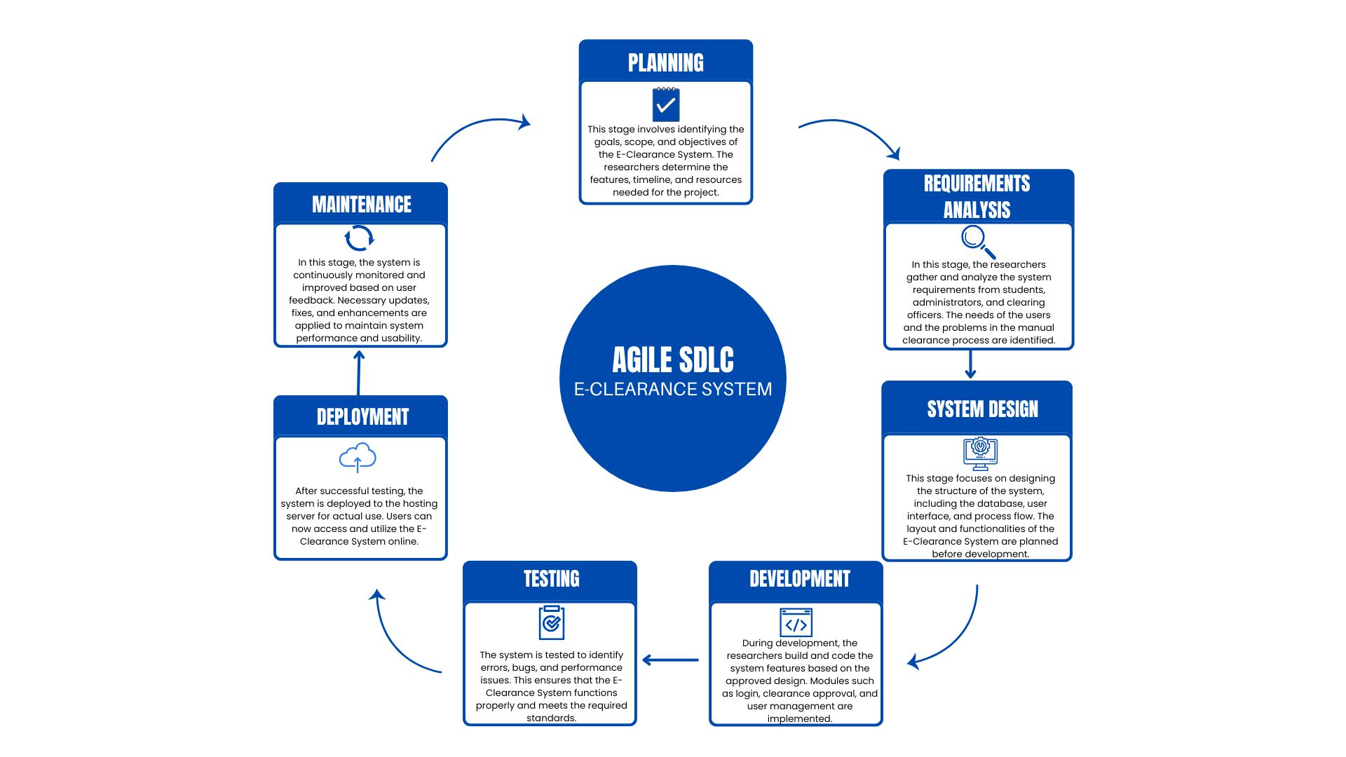

RESULTS
The findings of the study revealed that students commonly encounter problems in the traditional manual clearance process, particularly in terms of delays, long waiting lines, inconvenience, and difficulty in tracking clearance approvals. Many respondents expressed concerns regarding the time-consuming nature of physically visiting multiple offices to complete their requirements.
Table 3. Weighted Mean of Problems Encountered in Traditional Clearance Process.
Indicators | Weighted Mean | Interpretation
The traditional student clearance process is time-consuming. | 4.32 | Agree
It is difficult to track which department’s clearance is completed. | 4.18 | Agree
Visiting each department for approval is physically tiring. | 4.25 | Agree
The process often causes delays in completing my clearance. | 4.30 | Agree
The process is inefficient due to long waiting times at each office. | 4.35 | Agree
Students experience confusion about the order of departmental approvals. | 4.05 | Agree
Miscommunication between departments slows down the clearance process. | 4.12 | Agree
Lost or misplaced documents make the clearance process stressful. | 4.20 | Agree
It is hard to know the exact requirements for each department before visiting. | 4.10 | Agree
The traditional clearance process negatively affects academic or personal schedules. | 4.28 | Agree
Overall Weighted Mean | 4.22 | Agree

Results from the survey showed that the majority of respondents agreed that the proposed E-Clearance System would significantly improve the efficiency and accessibility of the clearance process. More than 80% of the respondents agreed or strongly agreed that the system would provide faster transaction processing, improve convenience, reduce errors in record-keeping, and allow real-time monitoring of clearance status.

Table 4. Weighted Mean of Perceptions Regarding the E-Clearance System.
Indicators | Weighted Mean | Interpretation
A digital student clearance system would save time compared to the traditional process. | 4.70 | Strongly Agree
A digital system would make it easier to track clearance status. | 4.65 | Strongly Agree
A digital system would reduce the need to visit multiple offices physically. | 4.72 | Strongly Agree
A digital system would provide clearer instructions for departmental requirements. | 4.60 | Strongly Agree
Notifications and updates would make the process more efficient. | 4.68 | Strongly Agree
Submitting documents online would be convenient and user-friendly. | 4.71 | Strongly Agree
A digital system would help prevent lost or misplaced paperwork. | 4.69 | Strongly Agree
The clearance process could be completed more flexibly. | 4.63 | Strongly Agree
A digital system would improve communication between departments. | 4.66 | Strongly Agree
Students are interested in using a digital student clearance system. | 4.80 | Strongly Agree
Overall Weighted Mean | 4.68 | Strongly Agree

The findings further indicated that students strongly support the implementation of a digitalized clearance system that minimizes manual processing and reduces the burden of obtaining signatures through physical office visits.
Figure 2. Student Clearance Process Flowchart.

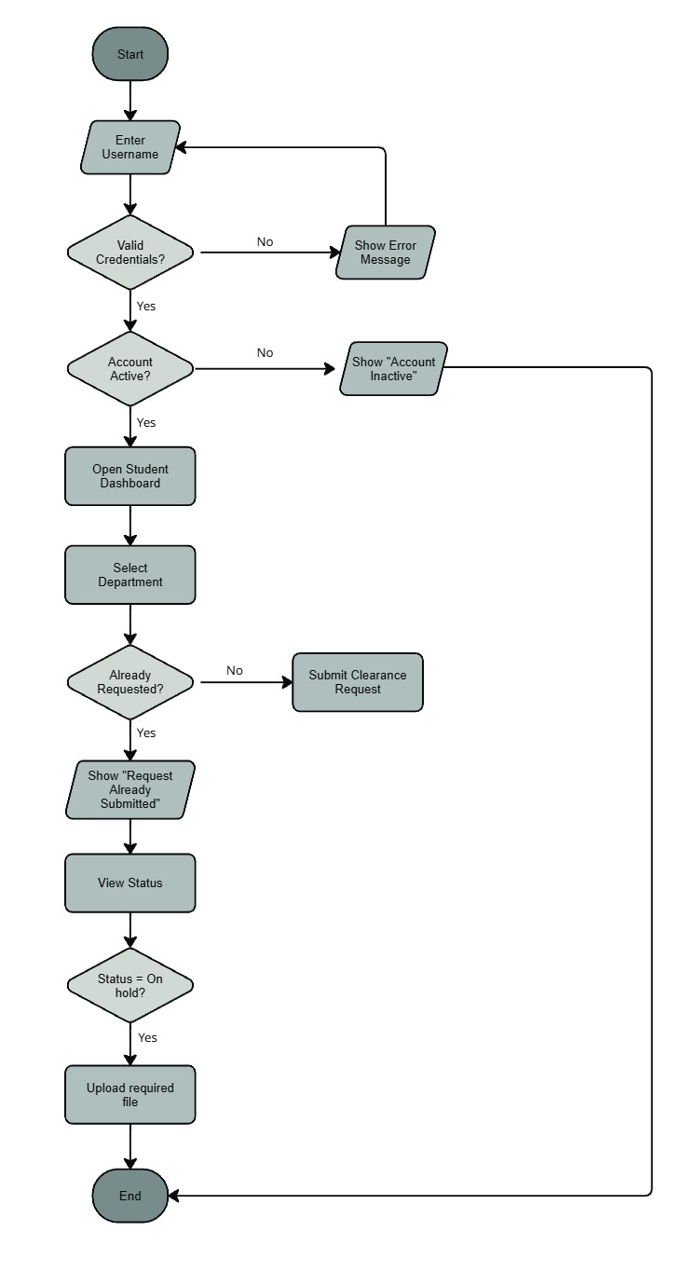

DISCUSSIONS
The results of the study support the importance of implementing web-based administrative systems in educational institutions. The findings confirm that the existing manual clearance process at St. Clare College of Caloocan presents several challenges for students and school personnel, particularly during peak clearance periods. The respondents’ positive perception toward the proposed E-Clearance System indicates that students value accessibility, efficiency, convenience, and reliability in school transactions.
The study also highlights the effectiveness of digital transformation in improving institutional operations. Through features such as online monitoring, centralized records management, and real-time status updates, the proposed system addresses the common issues associated with manual clearance procedures. These findings are consistent with related literature and studies emphasizing that automated systems improve administrative efficiency, reduce delays, and enhance user satisfaction.
The proposed E-Clearance System was designed with centralized database management and role-based user access for students and authorized department personnel. The system includes authentication through assigned account credentials and allows departments to electronically approve, reject, or place clearance requests on hold. Real-time status updates improve transparency and reduce delays associated with manual verification processes. The web-based platform also minimizes paper usage and improves accessibility for users within the institution.
Furthermore, the adoption of the Agile model in system development supports continuous improvement and user-centered design, ensuring that the developed system meets the needs of both students and authorized departments.

SYSTEM VALIDATION AND USER ACCEPTANCE TESTING

The developed E-Clearance System underwent initial user evaluation through survey questionnaires administered to the respondents of the study. The results showed that the majority of students positively accepted the proposed system in terms of accessibility, efficiency, convenience, and usability. The findings indicated that the respondents favored the implementation of a digital clearance platform to replace the traditional manual process. Feedback gathered from the respondents was also considered during system improvement and refinement. The evaluation results indicated that the developed system met the expected functional requirements and was acceptable to the intended users.

Figure 3. Login Interface of the E-Clearance System.
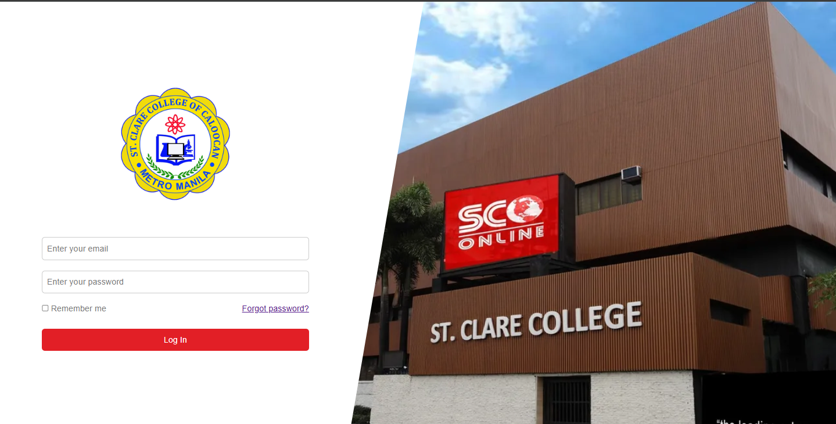

The login interface of the E-Clearance System is designed to be user-friendly and accessible for both students and department administrators. Users can log in using their assigned username and password provided by the school. After successful authentication, users are redirected to their respective dashboards based on their assigned roles. The system also ensures that only authorized users can access specific functions and student clearance records through role-based authentication.

Figure 4. Student Dashboard Interface.
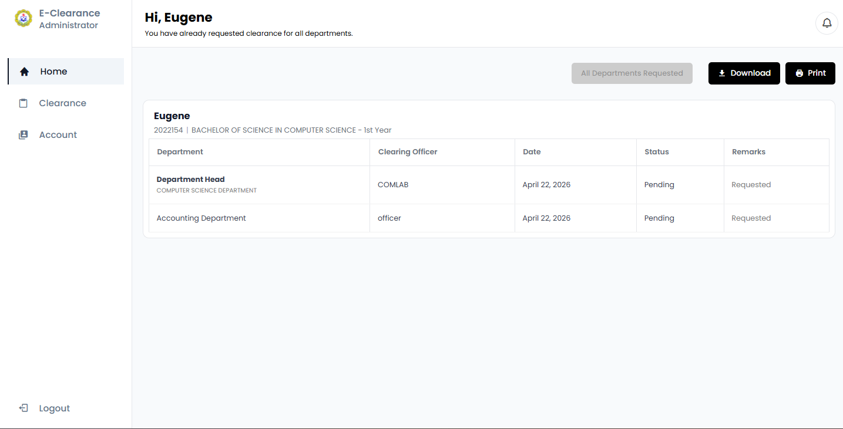
The student dashboard allows students to request clearance approval from different departments and offices within the institution. Students can monitor the status of their clearance requests, whether pending, approved, on hold with remarks, or rejected. The dashboard also enables students to download or print their completed clearance when necessary.
Figure 5. Department Approval and Clearance Management Interface.
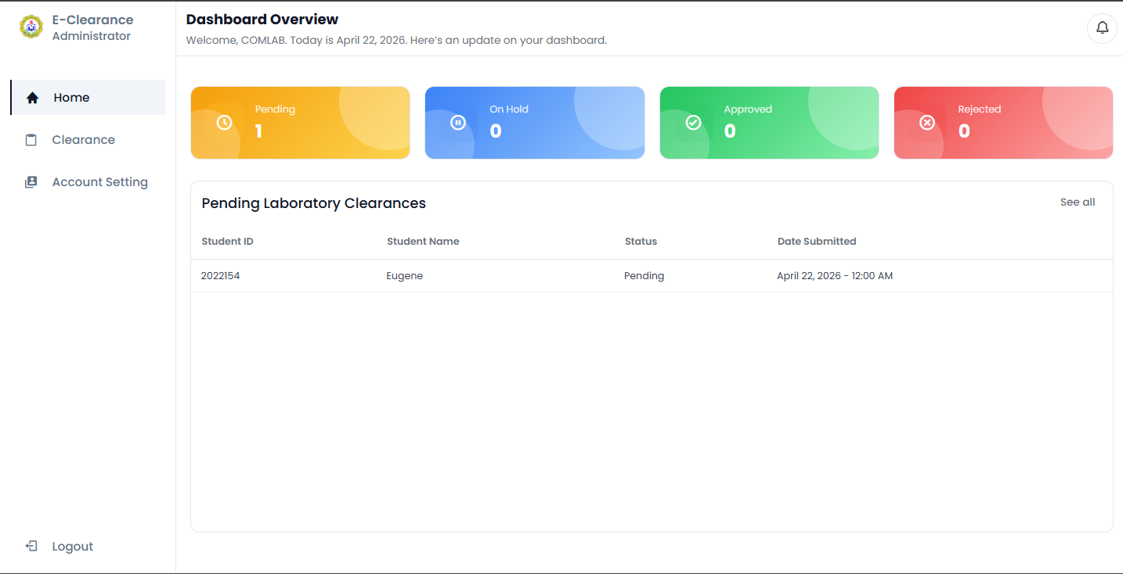

The department approval interface provides department administrators with a summary of student clearance requests, including pending, approved, on hold, and rejected statuses. Authorized personnel can evaluate student requests, update clearance remarks, and request additional documents if necessary through the system or by requiring students to visit the campus.

CONCLUSION
The study successfully developed an E-Clearance: A Web-Based Student Clearance Management System for St. Clare College of Caloocan. The proposed system was designed to address the inefficiencies and challenges associated with the traditional manual clearance process, including delays, long queues, and inconvenience experienced by students and staff.
Based on the results of the study, the majority of respondents strongly supported the implementation of the proposed system, recognizing its potential to improve efficiency, accessibility, convenience, and reliability in processing student clearances. The system was also able to meet the objectives of the study by streamlining approval procedures, providing real-time updates, and reducing manual workload.
Therefore, the E-Clearance Management System serves as an effective and reliable solution that can significantly improve administrative operations and enhance student satisfaction within St. Clare College of Caloocan.

ACKNOWLEDGEMENT
The researchers would like to express their sincere gratitude to all the individuals who contributed to the completion of this study. First and foremost, the researchers offer their heartfelt gratitude to the Father in Heaven for His guidance, wisdom, strength, and blessings throughout the conduct of the research.
The researchers would also like to sincerely thank their thesis adviser, Ma’am Jeanethjoy D. Naturales, for her unwavering guidance, support, and valuable knowledge that greatly contributed to the successful completion of the study. Special appreciation is also extended to Ma’am Maireen Baltazar for her meaningful advice, guidance, and inspiration that significantly improved the quality of the research.
The researchers are deeply grateful to the panelists for their time, effort, evaluation, and valuable suggestions. Gratitude is also extended to St. Clare College of Caloocan for providing the opportunity and educational environment that made this study possible.
Lastly, the researchers sincerely thank their parents, guardians, respondents, and everyone who supported and inspired them throughout the completion of this study.

REFERENCES

- Adamu, A. (2022). Online clearance system. FUDMA Journal of Sciences (FJS), 6(2), 283–291. Retrieved from https://www.researchgate.net/publication/370757433_ONLINE_CLEARANCE_SYSTEM
- Al-Samarraie, H., & Saeed, N. (2022). The role of digital transformation in improving higher education administration. Education and Information Technologies, 27, 7893–7915. https://doi.org/10.1007/s10639-022-10935-8
- AlSideiri, A., Tawafak, R. M., AlFarsi, G., Khudayer, B. H., & Cob, Z. C. (2023). Development of online clearance system using web-based system. In 2023 Fifth International Conference on Electrical, Computer and Communication Technologies (ICECCT) (pp. 1–6). IEEE. https://doi.org/10.1109/ICECCT56650.2023.10179667
- Bawack, R. E., & Kala Kamdjoug, J. R. (2023). Digital transformation and process efficiency in organizations: Evidence from education sector systems. Government Information Quarterly, 40(2), 101784. https://doi.org/10.1016/j.giq.2022.101784
- Desalegn, A., W/Michael, D., & Tamirat, B. (2022). Final clearance management system. Wachemo University. Retrieved from https://www.scribd.com/document/622124498/Final-Clearance-Management-System
- Hasan, S. B., Abdullah, Y. N., & Darwesh, M. K. (2023). Design and implementation: The digital transformation of the student clearance system for Soran University. Academic Journal of Nawroz University, 12(3). Retrieved from https://tinyurl.com/46zajhw8
- Jauculan, L. L., & Patayon, U. B. (2024). Enhancing UX/UI: A mixed-approach evaluation of a web-based student clearance system at a state university in the Philippines. Procedia Computer Science, 234, 1061–1068. Retrieved from https://www.sciencedirect.com/science/article/pii/S1877050924004587
- Jornadal, M. L. F., Panimoto, J. A. S., Patiño, D. P. J., Cajilig, V. C. P., Fortunado, R. V., Pelaez, A. Y., & Forca, A. J. (2025). Electronic clearance system with SMS notification in the case of Guimaras State University. Komputasi: Jurnal Ilmiah Ilmu Komputer dan Matematika, 22(1), 76–87. Retrieved from https://www.researchgate.net/publication/388910884_Electronic_Clearance_System_with_SMS_Notification_in_the_Case_of_Guimaras_State_University
- Macuroy, M. G. L., Galima, M. B., & Miranda, J. P. B. (2023). Online student clearance system [Unpublished undergraduate thesis]. Don Mariano Marcos Memorial State University - North La Union Campus Institutional Repository. Retrieved from https://lakasa.dmmmsu.edu.ph/handle/123456789/155
- Mangubat, J. M. L., Reubal, K. V. P., Caluya, J. F. M., Pepito, J. K. B., Catungal, M. L. P., & Encarnacion, P. C. (2023). Online student clearance management system. International Journal of Science and Applied Information Technology, 12(5), 38–43. Retrieved from https://www.warse.org/IJSAIT/static/pdf/file/ijsait011252023.pdf
- Mustofa, Z., Yusuf, W. E., & Dewi, M. U. (2021). Web-based student administration information system in Tsanawiyah Negeri 2 Semarang Madrasah. Journal of Engineering, Electrical and Informatics, 1(2), 51–64. Retrieved from https://scholar.archive.org/work/u4ieyj3zdzd6bepp46bjkw2byu/access/wayback/https://ejurnal.stie-trianandra.ac.id/index.php/jeei/article/download/893/694
- Okoye, K. R., Nwoke, O. A., & Eze, M. I. (2022). Design and implementation of a web-based student clearance system. International Journal of Computer Applications, 184(45), 20–26. Retrieved from https://www.ijcaonline.org
- Olatunde, T., & Faboya, O. T. (2025). Automated final year online clearance system: A case study of a university. Iconic Research and Engineering Journals (IRE Journals), 9(3). Retrieved from https://www.irejournals.com/formatedpaper/1710410.pdf
- Quijano, B., Esmino, B. J., Zulueta, J., & Duca, J. (2021). Clearance processing system for students and faculty. Retrieved from https://www.scribd.com/document/537430689/Clearance-Processing-System
- Salloum, S. A., Al-Emran, M., & Shaalan, K. (2021). Understanding the impact of information systems on administrative efficiency in higher education. Education and Information Technologies, 26, 123–140. https://doi.org/10.1007/s10639-020-10261-7

