HOMOEOPATHIC MANAGEMENT OF CHRONIC PLANTAR PSORIASIS USING SEPIA: AN EVIDENCE-BASED CASE REPORT
Dr. Raavi Lagnajita ¹
Professor PG Guide
Mail. ID. lagnajota11@gmail.com Mob No. 9849071018
Department of Organon of Medicine

Dr. R. Gayathri Internee ²
Mail. ID. gayathrirajanala150@gmail.com Mob No. 9347152547
Dr. R. Sireesha Internee ³
Mail. ID. rathodshireesha2@gmail.com Mob No. 9182284046
Dr. A. Tejasri Internee ⁴
Mail. ID. tejasrianumandla2003@gmail.com Mob No. 6305154328
Department of Organon of medicine
Hamsa Homoeopathic Medical College
Hospital & Research Centre,
Siddipet, Telangana State
Under Kaloji Narayana Rao University of Health Sciences

Corresponding Author
Dr. Raavi Lagnajita
Professor PG Guide
Department of Organon of Medicine
Hamsa Homoeopathic Medical College
Hospital & Research Centre,
Siddipet, Telangana State

ABSTRACT
Background: Plantar psoriasis is a chronic inflammatory dermatological condition characterized by hyperkeratosis, fissuring, scaling, itching, and discomfort involving the soles of the feet, often leading to impairment in daily activities and reduced quality of life. Conventional treatment approaches may provide temporary symptomatic relief; however, recurrence and adverse effects remain significant therapeutic challenges.
Case Presentation: A 36-year-old female presented with chronic thick scaly eruptions on the left sole for six years, associated with severe itching, fissures, occasional bleeding, and aggravation from cold weather, wet feet, and before menstruation. The patient also exhibited characteristic constitutional and mental symptoms, including chilly disposition, desire for sour food, aversion to fatty food, perspiration of feet, indifference toward family members, emotional sensitivity, and aversion to sympathy. Based on individualized case analysis, totality of symptoms, and repertorial evaluation, Sepia 1M was prescribed as a constitutional remedy.
Outcome: Progressive clinical improvement was observed during an eight-month follow-up period, including reduction in itching, fissuring, bleeding, and hyperkeratotic plaques, with improvement in emotional well-being and overall quality of life. A mild relapse following wet foot exposure responded favorably to repetition of the indicated remedy.
Conclusion: This case highlights the potential role of individualized homoeopathic treatment in the management of chronic plantar psoriasis. The observed improvement suggests that constitutional homoeopathic prescribing may serve as a supportive therapeutic option in selected cases; however, larger clinical studies are warranted to establish effectiveness and reproducibility.
Keywords: Plantar Psoriasis, Homoeopathy, Sepia, Individualized Treatment, Case Report, Constitutional Prescribing.

INTRODUCTION
Psoriasis is a chronic, immune-mediated inflammatory dermatological disorder characterized by hyperproliferation of keratinocytes and dysregulation of the immune system, resulting in erythematous, scaly plaques affecting the skin, nails, and joints. It affects nearly 2–3% of the global population and significantly impairs physical, psychological, and social well-being due to its chronic relapsing course and associated comorbidities. The pathogenesis of psoriasis involves a complex interaction of genetic predisposition, environmental triggers, and immunological mechanisms, particularly the activation of T-helper (Th1 and Th17) pathways and pro-inflammatory cytokines such as tumor necrosis factor-alpha (TNF-α), interleukin (IL)-17, and IL-23.
Plantar psoriasis is a localized and often debilitating variant of psoriasis involving the soles of the feet, presenting with hyperkeratosis, scaling, fissuring, pain, and pruritus that can markedly interfere with walking and daily activities. Due to its resemblance to other dermatological conditions such as eczema, fungal infections, and palmoplantar keratoderma, diagnosis may be clinically challenging. Conventional treatment modalities including topical corticosteroids, vitamin D analogues, systemic immunomodulators, and phototherapy may provide symptomatic relief; however, recurrence, adverse effects, and variable therapeutic outcomes remain important clinical concerns.
Homoeopathy adopts an individualized and holistic approach to disease management by considering the totality of symptoms, including mental, physical, and characteristic particulars of the patient. Constitutional prescribing aims to stimulate the body’s self-regulatory mechanisms and address both local pathology and constitutional susceptibility. The present case report describes the individualized homoeopathic management of a patient diagnosed with chronic plantar psoriasis, highlighting the clinical outcome following prescription based on symptom totality and repertorial evaluation.

TO DOCUMENT:
- To study the clinical presentation, pathogenesis, and management of psoriasis and to highlight its impact on patient health and quality of life.to document and evaluate the clinical outcome of individualized homoeopathic management using sepia in a patient diagnosed with plantar psoriasis with emphasis on symptoms resolution and functional recovery.

Objectives
- To understand the aetiology and pathogenesis of psoriasis
- To classify different types of psoriasis
- To Analyse clinical features and diagnostic criteria
- To review current treatment modalities
- To identify complications and adverse effects of therapy
Types of Psoriasis
- Plaque Psoriasis (Psoriasis vulgaris) – Most common type
- Guttate Psoriasis – Small drop-like lesions, often post-infection
- Pustular Psoriasis – Characterized by pus-filled lesions
- Erythrodermic Psoriasis – Severe, widespread redness and scaling
- Inverse Psoriasis – Occurs in skin folds
- Nail Psoriasis – Nail pitting, discoloration
- Psoriatic Arthritis – Joint involvement ²

Epidemiology / Statistics
- Prevalence: ~2–3% worldwide
- Higher prevalence in adults than children
- Equal distribution in males and females
- Peak onset: 15–35 years
- Family history present in ~30% of cases ^{4,5,6}
Pathogenesis:
- Psoriasis involves immune system dysregulation:
- Activation of T-cells (especially Th1 and Th17 cells)
- Release of cytokines: TNF-α, IL-17, IL-23
- Increased keratinocyte proliferation (cell turnover reduced from 28 days to 3–5 days)
- Angiogenesis and inflammation
- This leads to thickened epidermis and scaling plaques ⁷

Precipitating Factors
- Genetic predisposition
- Infections (e.g., streptococcal throat infection)
- Stress
- Trauma (Koebner phenomenon)
- Drugs (lithium, beta-blockers, antimalarials)
- Alcohol and smoking
- Climate (cold weather) ¹

Clinical Features
- Well-defined erythematous plaques with silvery scales
- Common sites: scalp, elbows, knees, lower back
- Itching or burning sensation
- Auspitz sign (pinpoint bleeding on scale removal)
- Nail changes: pitting, onycholysis
- Joint pain (in psoriatic arthritis) ¹

Differential Diagnosis
- Seborrheic dermatitis
- Eczema (Atopic dermatitis)
- Lichen planus Tinea corporis (fungal infection), Ptyriasis rosea ²

Investigations
- Clinical diagnosis (primarily)
- Skin biopsy (confirmatory)
- Blood tests (to rule out systemic involvement)
- ESR and CRP (inflammation markers)
- X-ray (if arthritis suspected) ¹

General Management
- Patient education and counselling
- Avoid triggers (stress, alcohol, smoking)
- Maintain skin hydration
- Lifestyle modifications
- Balanced diet and exercise ¹
Conventional Treatment ¹

Topical Therapy
- Corticosteroids
- Vitamin D analogues (Calcipotriol)
- Coal tar
- Retinoids

Systemic Therapy
- Methotrexate
- Cyclosporine
- Acitretin
Phototherapy:
- UVB therapy, PUVA (Psoralen + UVA)

Complications
- Psoriatic arthritis
- Cardiovascular diseases
- Metabolic syndrome
- Depression and anxiety
- Skin infections ¹

Adverse Effects of Treatment
- Steroid side effects (skin thinning, striae)
- Methotrexate toxicity (liver damage)
- Cyclosporine (nephrotoxicity, hypertension)
- Retinoids (teratogenicity)
- Biologics (risk of infections) ¹

CASE REPORT
PRESENTING COMPLAINT:
- Name: XYZ
- Age/Sex: 36-year-old female
- Marital status: Married
- Mother tongue: Telugu
- Occupation: Homemaker Address: Miyapur, Hyderabad

Chief Complaints
A 36-years old female patient presented with the following complaints
- Thick, scaly eruptions on left sole only for6 year
- Severe itching, worse in evening and before menses
- Worse in cold weather, wet foot, washing legs
- Deep cracks on left heel with occasional bleeding
- Burning after scratching

History of Present Illness
- The complaint started as dryness on the left sole, gradually progressing to:
- Scaling with fissures.
- H/o repeated steroid ointment use with temporary relief
Symptoms are:
- Worse in cold weather, wet foot, washing legs
- Worse standing for long time
- Worse before menstruation
- Better by warmth and covering
Physical Generals
- Chilly patient
- Desire for sour foods
- Aversion to fatty food
- Perspiration on feet

Mental Symptoms
- Indifference toward family and mother-in law
- Easily offended
- Aversion to sympathy
- Feels exhausted and overworked
Analysis of symptoms:(according to Hahnnemann)
COMMON:
- Thick scaly eruption on left sole
- Severe itching
- Burning
UNCOMMON:
- Itching <evening, before menses, cold weather, wet feet/washing legs
- Chilly patient
- Desire for sour food
- Aversion to fatty food
- Perspiration on feet
- Indifference towards family(mother-in-law)
- Easily offended
- Aversion to sympathy
Evaluation:(according to Kent)
Mental generals:
- Indifference toward family
- Easily offended
- Aversion to sympathy
Physical generals:
- Chilly patient
- Desire for sour food
- Aversion to fatty food
- Perspiration on feet
- Modalities :<cold weather > wet feet
Particulars:
- Thick scaly eruption on left sole
- Itching <evening, before menses
- Burning after scratching

Repertorial Analysis
The case was analyzed according to classical homoeopathic principles by giving due importance to mental generals, physical generals, and characteristic particulars. The totality of symptoms was constructed based on individualizing features of the patient. Repertorial analysis was performed using Kentian hierarchy to arrive at the similimum.

Totality of Symptoms Considered for Repertorization
Mental Generals
- Indifference toward family members
- Easily offended
- Aversion to sympathy
Physical Generals
- Chilly patient
- Desire for sour food
- Aversion to fatty food
- Perspiration of feet
- Aggravation from cold weather and wet feet
- Aggravation before menstruation
Particular Symptoms
- Thick scaly eruption on the left sole
- Severe itching, worse in evening and before menses
- Deep fissures with occasional bleeding
- Burning sensation after scratching

Totality of Symptoms:
- Psoriasis affecting on left sole
- Indifference towards family
- Easily offended, aversion to sympathy
- Chilly patient
- Desire for sour food
- Aversion for fatty food
- Perspiration on feet
- Itching<evening, before menses, cold, wet feet
- Thick scaly eruptions
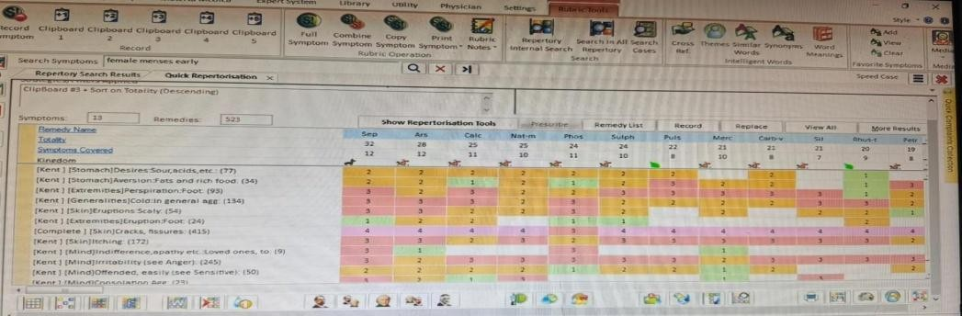

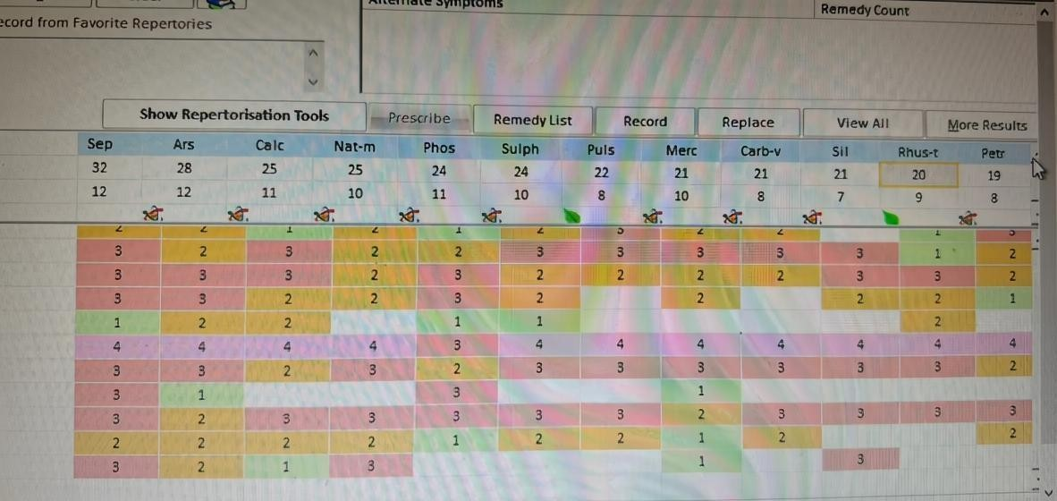

Remedy:
- Sepia
- Potency: 1M
- Dose: Single dose, followed by placebo

Based on repertorial evaluation and correlation with Materia Medica, Sepia emerged as the most suitable constitutional remedy, showing close correspondence with the patient’s mental disposition, constitutional features, modalities, and characteristic particulars. Hence, Sepia 1M was prescribed in a single dose followed by placebo and regular follow-up.
Follow-up Period | Clinical Observation | Prescription
1st Month | Mild reduction in itching and bleeding; fissures remained tender with persistent scaling | Placebo, twice daily for 1 month
2nd Month | Early flattening of plaques observed; emotional irritability persisted | Placebo, twice daily for 1 month
3rd Month | Significant reduction in itching; hyperkeratosis reduced though mild scaling persisted | Placebo, twice daily for 1 month
4th Month | Mild relapse following wet foot exposure; increase in dryness and irritation | Sepia 1M, single dose followed by placebo for 1 month
5th Month | Cracks almost healed; plaques lighter with marked symptomatic relief | Placebo, twice daily for 1 month
6th Month | No bleeding; minimal itching; emotional well-being improved | Placebo, twice daily for 1 month
7th Month | Near-complete recovery of plantar lesions with disappearance of fissures | Placebo, twice daily for 1 month
8th Month | Skin remained stable; quality of life improved with no fresh eruptions | Placebo, twice daily for 1 month

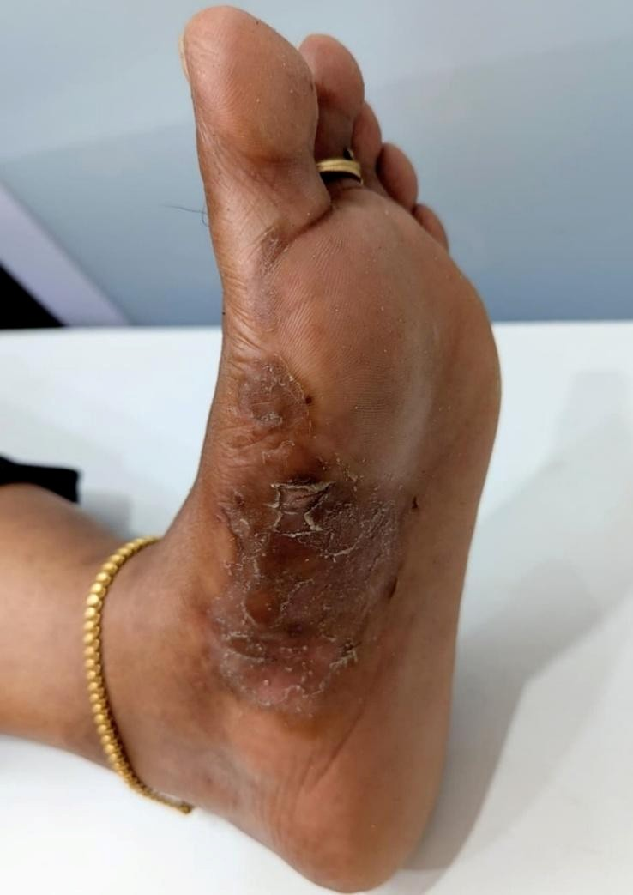
- 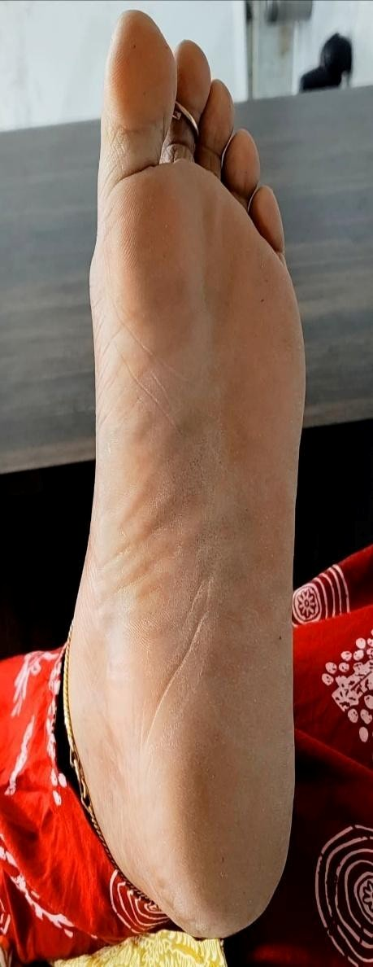

DISCUSSION
Plantar psoriasis is a chronic and often disabling variant of psoriasis characterized by hyperkeratotic plaques, fissuring, scaling, and pain that significantly impair walking and quality of life. The condition frequently demonstrates a relapsing course and may show only temporary relief with conventional topical therapies, particularly corticosteroids, which are often associated with recurrence after discontinuation. In the present case, the patient had persistent unilateral plantar lesions for six years with repeated use of steroid ointments resulting in only transient symptomatic relief.
The individualized homoeopathic approach adopted in this case was based on a detailed evaluation of mental generals, physical generals, and characteristic particulars according to classical homoeopathic principles. The selection of Sepia was guided by the totality of symptoms, including indifference toward family members, aversion to sympathy, emotional irritability, chilly constitution, desire for sour food, aversion to fatty food, perspiration of feet, and aggravation before menstruation and from wet feet and cold weather. These constitutional and characteristic features closely corresponded to the remedy profile of Sepia.
The patient demonstrated gradual but sustained clinical improvement over the follow-up period. Reduction in itching, bleeding, fissuring, and hyperkeratosis was observed progressively, with a mild relapse during the fourth month following exposure to wet conditions, which responded favorably to repetition of Sepia 1M. By the seventh and eighth months, the lesions had resolved significantly with improvement in both emotional well-being and functional quality of life.
From a clinical perspective, this case suggests that individualized homoeopathic management may offer a complementary therapeutic approach in chronic plantar psoriasis, particularly in patients experiencing recurrent symptoms or limited long-term relief with conventional measures. However, psoriasis is a multifactorial immune-mediated disease with variable clinical outcomes, and conclusions regarding therapeutic efficacy cannot be generalized from a single case report. Further systematic studies, larger observational cohorts, and controlled clinical trials are required to evaluate the reproducibility, effectiveness, and long-term outcomes of individualized homoeopathic treatment in plantar psoriasis.

CONCLUSION
This case report demonstrates the potential role of individualized homoeopathic treatment in the management of chronic plantar psoriasis. The prescription of Sepia, selected on the basis of totality of symptoms and individualized case analysis, was associated with gradual and sustained clinical improvement, including reduction in scaling, fissuring, itching, and discomfort, along with improvement in the patient’s emotional well-being and quality of life.
The findings of this case suggest that a constitutional homoeopathic approach may serve as a supportive therapeutic option in selected cases of plantar psoriasis, particularly where chronicity and recurrence are prominent concerns. Nevertheless, given the inherent limitations of a single case report, the observed outcomes should be interpreted cautiously. Further well-designed clinical studies, larger case series, and controlled trials are necessary to evaluate the reproducibility, effectiveness, and long-term benefits of individualized homoeopathic treatment in psoriasis management.

ACKNOWLEDGEMENT
“The authors express their sincere gratitude to Director. Dr. Umesh Akkaladevi, Principal Dr.Nurus Saher Khan, and Prof. Dr. Kaathi Srinivaas Babu Professor & PG Guide Department of Homeopathy Pharmacy Hamsa Homoeopathy Medical College, Hospital & Research Centre, Siddipet District, Telangana, for their valuable suggestions and continuous support.”

CONFLICT OF INTEREST
The authors declare that there is no conflict of interest regarding the publication of this case report. No financial support, commercial funding, or external sponsorship was received for this study. The authors alone are responsible for the content and writing of the manuscript.
REFERENCES
- Jameson JL, Fauci AS, Kasper DL, Hauser SL, Longo DL, Loscalzo J, editors. Davidson’s Principles and Practice of Medicine. 24th ed. Edinburgh: Elsevier; 2022.
- Sacchidanand S, Oberai C, Inamadar AC, editors. IADVL Textbook of Dermatology. 5th ed. Mumbai: Bhalani Publishing House; 2022.
- Clinical Dermatology. Habif TP, Campbell JL, Chapman MS, Dinulos JGH, Zug KA. 7th ed. Philadelphia: Elsevier; 2021.
- Kumar V, Abbas AK, Aster JC. Robbins and Cotran Pathologic Basis of Disease. 10th ed. Philadelphia: Elsevier; 2021.
- Mohan H. Textbook of Pathology. 8th ed. New Delhi: Jaypee Brothers Medical Publishers; 2019.
- World Health Organization. Global report on psoriasis. Geneva: World Health Organization; 2016.
- National Institute of Arthritis and Musculoskeletal and Skin Diseases (NIAMS). Psoriasis overview. Bethesda (MD): NIAMS; 2023.
- Katzung BG, Vanderah TW. Basic and Clinical Pharmacology. 16th ed. New York: McGraw Hill; 2021.
- Hahnemann S. Organon of Medicine. 6th ed. New Delhi: B Jain Publishers; 2002.
- Kent JT. Lectures on Homoeopathic Philosophy. New Delhi: B Jain Publishers; 2004.
- Boericke W. Pocket Manual of Homoeopathic Materia Medica. New Delhi: B Jain Publishers; 2010.
- Boger CM. A Synoptic Key of the Materia Medica. New Delhi: B Jain Publishers; 2005.

