Brand Positioning Beyond Marketing: A Strategic Management Perspective on Competitive Advantage

Jafirullah Khan
Assistant Professor
Department of Business Administration, Atish Dipankar University of Science and Technology (ADUST)
jafirullah.khan@gmail.com

Ishmum Muhib
MBA, Department of Business Administration, Atish Dipankar University of Science & Technology (ADUST) (Ongoing)
ishmummuhib3@gmail.com

Tanveerullah Khan Adnan
Doctor of Business Administration (DBA, partially completed), University of West of Scotland (London Campus)
MSc in Accounting and Finance, University of Bedfordshire (UK)
BBA, Major in Finance, University of Dhaka
tanveer.adnan@hotmail.com

Abstract
Positioning of brands was once a sensitive marketing communication tool, shaped by consumer perceptions. Positioning, however, has become increasingly relevant in contemporary business settings due to intense competition. It discusses brand positioning as a strategic management tool and, in an argumentative manner, argues that it should be viewed as an organizational competence rather than a promotional tool. The study assesses the application of positioning in light of its impact on competition, strategic decision-making, and the organization's long-term performance. The study has shown that proper positioning entails integrating an organization's internal capabilities and strengths with market capabilities and strengths, enabling firms to develop distinctive and sustainable identities in the market. Organizations can perform well due to corporate strategy and positioning, which enhance differentiation and deter competitors from imitating them. The discussion has identified the positioning aspects that may affect managerial activities, organizational culture, and coordination across organizational functions. Finally, according to the article, the policy component of positioning must be based on normal governance, strategic control regimes, and market repositioning. It is argued that positioning is a dynamic strategy process that must be reviewed and revised over time in response to technological change or an upsurge in customer demand. The results indicate that a company that positions itself as a strategic planning tool has a greater competitive advantage and higher long-run performance. Generally, the article is a valuable contribution to the management literature because it presents a multidimensional tool for positioning the brand based on organizational identity, the company's market image, and market performance.
Keywords: Brand Positioning, Strategic Management, Competitive Advantage, Business Strategy

Introduction

Strategic Importance of Brand Positioning
The modern business environment is highly competitive, and rivalry is growing due to globalization and the digital revolution; hence, business organizations are struggling to define their strategic identity. One of the most effective strategies for building differentiation and shaping consumer perceptions in this context is brand positioning. Uncertainties regarding how organizations perceive their products and services as distinct from competitors' are sensitive matters that will shape long-term considerations in their use. Positioning helps firms develop value propositions aligned with customers' expected value and the firm's competencies (Porter, 1985). Brand positioning is a strategic business approach aimed at maintaining a competitive advantage and market credibility (Aaker, 1996).
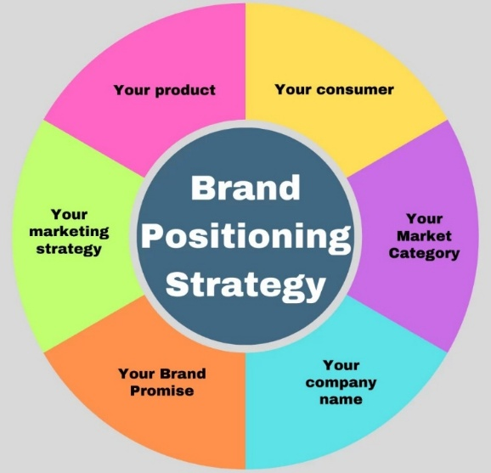
Figure 1: Brand Positioning Strategy Parts (DesignerPeople, 2024).

From Marketing Function to Strategic Capability
The brand positioning concept has long been regarded as a marketing communication activity whose impact can no longer be limited to promotion. Existing organizations recognize that positioning decisions determine the innovation strategy, resource allocation, and organizational policy. Brand positioning shapes stakeholders' perceptions and an organization's success in the market. The effectiveness of forming unique mental associations among consumers is increasingly dependent on competition (Keller, 2013). Positioning, when incorporated into overall strategic planning, may enable organizations to develop defensible market positions that are difficult for other organizations to overcome (Barney, 1991).

Purpose and Scope of the Study
The article contends that brand positioning is a strategic management perspective rather than a marketing perspective. Among the organizational experiences mentioned is positioning, which helps the organization enhance its competitive advantage and sustainability. A brand positioning strategy and a stable business policy can provide consistent performance in evolving markets (Kapferer, 2012). The multidimensional positioning strategy instrument would be more relevant in intuiting why managers must negotiate in complex business environments (Kotler & Keller, 2016).

Research Approach and Illustrative Examples
It is theoretically grounded, and examples from industry practice are used to enhance practical relevance. The research is founded on the existing literature. Nonetheless, it relies on brands' practices to explain how strategic positioning occurs in a competitive world. By chance, Apple and Nike are two companies that have consistently demonstrated how brand positioning can drive innovation, organizational focus, and customer perceptions. Based on this, one can put the theoretical discourse into perspective, and it can be argued that positioning is a strategic organizational capability rather than a promotional exercise.

Conceptual Background

Understanding Brand Positioning
Brand positioning is a marketing tactic for developing a memorable and meaningful image in the minds of a product's or an organization's target consumers. It is a tactical act by which companies shape their desired image relative to their competitors. Positioning choices aim to identify the specific qualities, advantages, and values that will distinguish a brand in saturated markets. The modern positioning theory states that companies must create a distinct image; otherwise, they are likely to be mispositioned among substitutes (Ries & Trout, 1981). Good positioning is related to the compatibility between the promise during the communication and the experience provided to the consumer (Fuchs & Diamantopoulos, 2010). Without such coherence, positioning will be superficial and will not be remembered by consumers.
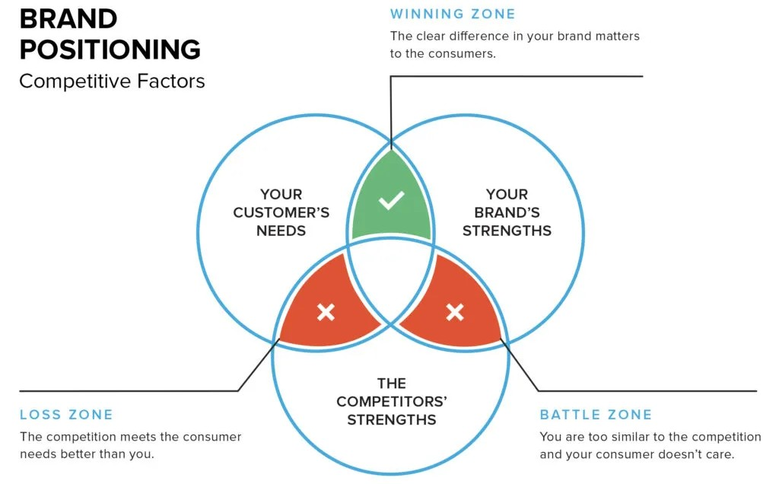
Figure 2: Brand Positioning Competitive Factors (Chopra, 2025).

Dimensions of Strategic Positioning
The available scholarly literature considers brand positioning a complex phenomenon encompassing product qualities, symbolic meaning, and organizational profile. The advertisements and quality of service, the corporate conduct and the interest of the stakeholders assist companies in developing brands. This would then necessitate internal capabilities aligned with internal competencies and market demand, thereby enabling strategic positioning. Positioning strategies should be responsive to market forces and consumer preferences (Blankson & Kalafatis, 2007). Perhaps, when organizations offer more stable value propositions and communication through touchpoints, they will be able to create a more sustainable brand image (Hooley et al., 2017). The broader definition is premised on the richness of managerial positions.

Conceptual Framework of Strategic Brand Positioning
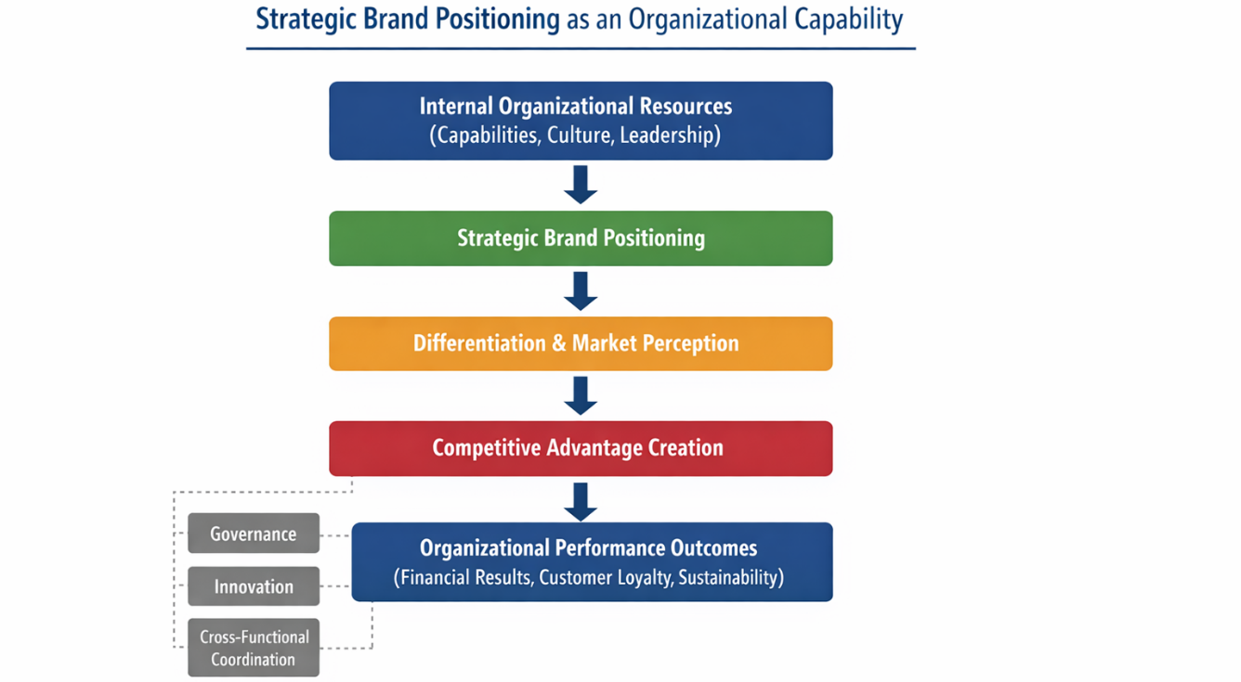
Figure 3: Strategic Brand Positioning as an Organizational Capability (self-made).
The conceptual map of the brand's positioning as a multidimensional strategic capability is presented in Figure 3. The model demonstrates the role of internal organizational resources (leadership, culture, and capabilities) in strategic brand positioning, which, in turn, leads to differentiation and shapes market perceptions. All these processes contribute to achieving competitive advantage and to the company's long-term performance outcomes, including customer loyalty and sustainability. The sustaining mechanisms at the framework level comprise governance structures, innovation practices, and cross-functional coordination. This synthesized model shows that positioning is not merely a marketing phenomenon but a strategic process fundamental to organizational management.

Positioning within Strategic Management Thought
Brand positioning has ceased to be a marketing tool and has become an organizational resource. Positioning determines stakeholders' perceptions of the company's plans and their credibility. It influences the development planning and product decision-making processes, as well as the priorities for innovation and market expansion. Proper positioning helps firms gain market share that is difficult for competitors to imitate (Urde & Koch, 2014). Brand equity is an enduring construct that entails the establishment of emotional attachment and trust in the product and among consumers (Beverland, Napoli, & Farrelly, 2010). Positioning is a strategic process; hence, it provides a theoretical context for discussing its role in establishing competitive advantage.

Brand Positioning as a Strategic Tool

Positioning as a Strategic Orientation
One of the strategic resources organizations use to shape their competitive identities is brand positioning. It provides a procedural channel for allocating organizational resources in accordance with long-term business objectives rather than promoting short-term objectives. Companies that embark on short positioning plans are well positioned to ensure synchronized product development, customer involvement, and market development plans. The strategic positioning helps corporations develop differentiated value propositions that are difficult for competitors to replicate (Cravens & Piercy, 2008). It transforms the corporate vision into market actions that change the relationship with the key stakeholders (Hatch & Schultz, 2003). Positioning plays a role in managerial decision-making and in achieving organizational goals.

Integration of Positioning with Business Strategy
The brand positioning strategy should align with the company's overall strategy to achieve long-term outcomes. Without a connection between positioning and organizational policy, the likelihood of creating weak messages and failing to penetrate the market increases. Good companies have ensured that internal capabilities, operational mechanisms, and strategic investments can explain positioning decisions. Corporate communication can be made effective with brand positioning and organizational strategy (Day, 2011). Positioning matters in managers' resource allocation and strategic focus within functional areas (Srivastava, Shervani, & Fahey, 1998). The coordination of business processes will ensure that the organization's offering is well managed in this integration.
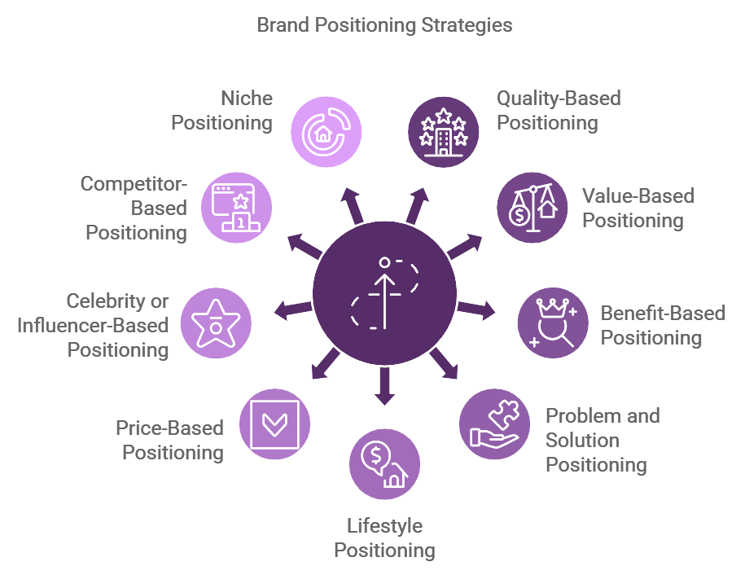
Figure 4: Brand Positioning Strategies (Sharma, 2024).

Positioning as a Basis for Differentiation
Another strategic importance of brand positioning is to create a strong competitive advantage. The functional attributes do not constitute a point of differentiation, making it difficult for the organizations to maintain a competitive advantage due to the high similarity of the products and services they offer. Positioning aids companies in distinguishing themselves through symbolic associations, emotional connections, and brand narratives. When it is adequately positioned, it will reduce consumer price sensitivity and lead to long-run brand loyalty (Sharp, 2010). Organizations with services that are clearly distinguished and those where the advantages are obvious are in a better position to escape imitations and commoditization in the market (Trout & Rivkin, 2008). Positioning is therefore a fortification of strategy that cushions profitability and long-term market share.

Achieving Organizational Alignment
Brand positioning is addressed within internal organizational alignment. Defined positioning helps employees develop a shared understanding of the organization's nature and its role in the competitive world. This transparency has an impact on corporate culture and quality of service, and it is based on the manner in which the organization makes decisions. Position statements are strategic policies that offer a new direction for activities and administrative decisions (de Chernatony, 2010). Positioning will enable departments to communicate with one another, thereby facilitating the articulation of strategic goals (Simoes & Dibb, 2001). The congruence between internal operations and external positioning has led to a unified and natural brand experience for customers.

Adaptability of Strategic Positioning
It should be sufficiently rigid to maintain its position but not so rigid as to preclude adaptation to market changes. Industries remain influenced by technological change, evolving consumer needs, and disruptive competition. Firms in which positioning is perceived as a strategic instrument that continually changes are better positioned to respond to new opportunities and threats (Morgan et al., 2019). Positioning is long-term and helps ensure that businesses do not lose their relevance in favor of long-term brand equity (Esch et al., 2009). Positioning, on the other hand, is an element of strategy, but never a fleeting one, but rather a renewal.

Limitations and Risks of Strategic Positioning
- Internal resistance
Resistance in the organization (e.g., by employees or managers) to the implementation of the strategic positioning proposed.
- Resource constraints
Resource constraints (e.g., budget, technology, or human resource constraints) hinder the implementation of positioning strategies.
- Misaligned positioning
An example is when brand positioning is not aligned with internal strengths or market demands, resulting in confusion or missed opportunities.
- Fast market disruption
Technological changes, consumer needs, or competitors' activities can alter a brand's traditional position, rendering it outdated or even inefficient.
- Failed repositioning
Any inability to reposition or alter the brand would confuse or elicit adverse perceptions among the target clientele.

Positioning and Competitive Advantage

Linking Positioning to Competitive Advantage
In contemporary markets, brand positioning is essential for establishing an organization's competitive advantage. A company can have a competitive advantage when it is capable of offering high value to its customers in a way that is difficult to replicate. This is enabled by positioning, which establishes a mental connection that helps consumers choose among alternatives. Organizations can develop positioning strategies that enable them to stand out and emerge as distinct. The capability to play a noble and significant role will make organizations more influential in determining customer preferences and loyalty. Good positioning is therefore an effective strategic tool for creating sustainable advantage (Porter, 1985). Without a clear position, companies cannot articulate their value and are susceptible to competitive duplication.

Positioning as a Source of Perceived Value
Customer perceptions have become more significant determinants of competitive advantage than mere product features. One of the most famous elements of technological and quality gaps of competitors in a variety of industries is that the gaps are smaller, but the psychological division is more prominent. Positioning helps businesses shape perceptions and comparisons of rival products in customers' minds. The proper placement of the brand will eliminate confusion in the purchasing decision and enhance emotional bonds among consumer groups. Less price-sensitive consumers are those who find a brand highly appropriate and aligned with their needs and values. Strategic positioning, hence, embeds mundane products and services within substantial value propositions (Keller, 2013). This source of competitive advantage, which is founded on perception, turns out to be a powerful tool for protecting against competition.

Differentiation and Strategic Focus
Positioning is one of the competitive advantage factors that enable firms to attain focus differentiation (Varadararayan, 2010). Organizations that aim to win all market segments often lose their identity and become weak in terms of strategy. On the other hand, positioning would encourage companies to target particular segments and add value in a personalized manner. A hydrated role controls the product development, quality of service, and communication. This is a narrow-based strategy that helps companies be more resourceful and avoid direct competition with stronger competitors. Strategic focus that is created through positioning makes the organization more efficient and effective in the market. Specialization in a competitive space enhances companies' competitiveness (Hooley et al., 2017). Positioning is thus one of the strategic specialization tools.

Long-Term Sustainability through Positioning
The final contribution of brand positioning to competitive advantage concerns long-term sustainability. Competitive environments are changing, and the advantage in terms of technology or price might be quite seasonal. It is more effective when building good, coherent long-term relationships with consumers, in which a coherent brand meaning is developed. High positioning builds trust, credibility and loyalty, which can be sustained even in the changing market conditions. Organizational reputational capital established over an extended period is difficult for rival organizations to eradicate. Positioning coherence is effective and strengthens the organization, helping it maintain stable financial performance. This implies that long-term profits will be realized, because positioning is not a short-term marketing process but a long-term strategic process (Aaker, 1996). These opinions highlight the significance of positioning in the long-term competitive performance.

Managerial & Policy Implications

Practical Strategic Positioning Process
- Conduct Internal Capability Audit
Start by evaluating the strengths and weaknesses of your organization. Identify resources that can sustain your positioning strategy, such as budget, expertise, and technology.
- Analyze Customer Perception
Collect information by use of customer surveys, focus groups, or feedback systems to know how your customers view your brand and its competitors (Homburg, Klarmann, & Schmitt, 2010).
- Define Positioning Statement
Write a positioning statement that is both clear and concise, and in a manner that makes your brand stand out among the others, and one that resonates with the values and needs of the target audience.
- Align Departments
Ensure that every department in the organization knows and aligns with the positioning statement (Wilson & Gilligan, 2005). These are marketing, sales, product development, HR, and customer service since they contribute to the delivery of the positioning.
- Monitor Performance Indicators
Periodically assess the performance of the positioning strategy using metrics such as brand awareness, market share, and customer loyalty.
- Review Annually
Positioning is not a stagnant position. The positioning strategy must be reassessed annually to align with market conditions, customer preferences, and competition.

Positioning Performance Metrics
- Brand Awareness
What is the level of brand recognition of your brand in the market? Monitor brand recall and recognition (McDonald & Wilson, 2016).
- Customer Loyalty
Are your customers repeat customers? Retention and customer lifetime value.
- Market Share
What is the market share of your brand against the competitors? Keep track of market share patterns.
- Price Premium
Would your customers pay a premium for your brand due to its reported value? Measured price elasticity and premium pricing effectiveness.
- Employee Alignment
Get internal teams, particularly those that deal with customers, to know and identify with the positioning strategy. Alignment can be measured using employee surveys or feedback (Wedel & Kannan, 2016).

Conclusion
Brand positioning is one of the most strategic tools, with far greater utility than marketing communication. In contemporary competitive environments, positioning is used to help organizations define their identity by differentiating their products and retaining customer interest. This study has demonstrated that effective positioning is an internal organizational process rather than a promotional strategy. Positioning, in conjunction with corporate strategy, provides solid direction for decision-making, resource allocation, and long-term strategy.
Good positioning will help a business reach its target market and a niche within a competitive market. Similar organizations are those that, although they are positioned differently, do not differ in the core of their capabilities or strategic objectives, and are more effective at keeping their promises and fulfilling them. This type of affiliation promotes the brand and helps ensure long-term customer loyalty. Positioning helps firms adapt to the evolving market environment by providing a point of reference.
It must be put on the policy and managerial levels. To define the preferred brand position, managers must be trained in the organization's structures, processes, and culture. Positioning strategies must be adjusted frequently to remain aligned with the evolving environment. Lastly, positioning is a significant competitive advantage that has significantly shaped organizational behaviour and stakeholder attitudes and could assist the business in sustaining its performance over the long term.

Reference List
Aaker, D. A. (1996). Building Strong Brands. New York: Free Press.
Barney, J. (1991). Firm resources and sustained competitive advantage. Journal of Management, 17(1), 99–120. https://doi.org/10.1177/014920639101700108
Beverland, M. B., Napoli, J., & Farrelly, F. (2010). Can all brands innovate in the same way? A typology of brand position and innovation effort. Journal of Product Innovation Management, 27(1), 33–48. https://doi.org/10.1111/j.1540-5885.2009.00698.x
Blankson, C., & Kalafatis, S. P. (2007). Positioning strategies of international and multicultural-oriented service brands. Journal of Services Marketing, 21(6), 435–450. https://doi.org/10.1108/08876040710818921
Chopra, S. (2025). Brand positioning: A strategic guide to help you stand out. FreshSparks. https://freshsparks.com/brand-positioning/ (accessed on: 06/02/2026).
Cravens, D. W., & Piercy, N. F. (2008). Strategic marketing (9th ed.). McGraw-Hill Education.
Day, G. S. (2011). Closing the marketing capabilities gap. Journal of Marketing, 75(4), 183–195. https://doi.org/10.1509/jmkg.75.4.183
de Chernatony, L. (2010). From brand vision to brand evaluation: The strategic process of growing and strengthening brands (3rd ed.). Routledge.
DesignerPeople. (2024). Brand positioning – Ultimate guide to captivate your audience in 2026. DesignerPeople Blog. https://www.designerpeople.com/blog/brand-positioning-strategy/ (accessed on: 06/02/2026).
Esch, F. R., Schmitt, B., Redler, J., & Langner, T. (2009). The brand anchoring effect: A judgment bias resulting from brand awareness and temporary accessibility. Psychology & Marketing, 26(4), 383–395. https://doi.org/10.1002/mar.20278
Fuchs, C., & Diamantopoulos, A. (2010). Evaluating the effectiveness of brand-positioning strategies from a consumer perspective. European Journal of Marketing, 44(11/12), 1763–1786. https://doi.org/10.1108/03090561011079873
Hatch, M. J., & Schultz, M. (2003). Bringing the corporation into corporate branding. European Journal of Marketing, 37(7/8), 1041–1064. https://doi.org/10.1108/03090560310477654
Homburg, C., Klarmann, M., & Schmitt, J. (2010). Brand awareness in business markets: When is it related to firm performance? International Journal of Research in Marketing, 27(3), 201–212. https://doi.org/10.1016/j.ijresmar.2010.03.004
Hooley, G., Piercy, N., Nicoulaud, B., & Rudd, J. (2017). Marketing strategy and competitive positioning. Pearson Education.
Kapferer, J. N. (2012). The new strategic brand management: Advanced insights and strategic thinking (5th ed.). Kogan Page.
Keller, K. L. (2013). Strategic brand management: Building, measuring, and managing brand equity (4th ed.). Pearson Education.
Kotler, P., & Keller, K. L. (2016). Marketing management (15th ed.). Pearson Education.
McDonald, M., & Wilson, H. (2016). Marketing plans: How to prepare them, how to profit from them (8th ed.). Wiley.
Morgan, N. A., Whitler, K. A., Feng, H., & Chari, S. (2019). Research in marketing strategy. Journal of the Academy of Marketing Science, 47(1), 4–29. https://doi.org/10.1007/s11747-018-0598-1
Porter, M. E. (1985). Competitive advantage: Creating and sustaining superior performance. Free Press.
Ries, A., & Trout, J. (1981). Positioning: The Battle for Your Mind. New York: McGraw-Hill.
Sharma, A. (2024). 9 types of positioning in marketing. Young Urban Project. https://www.youngurbanproject.com/types-of-positioning-in-marketing/ (accessed on: 06/02/2026).
Sharp, B. (2010). How brands grow: What marketers do not know. Oxford University Press.
Simões, C., & Dibb, S. (2001). Rethinking the brand concept: New brand orientation. Corporate Communications: An International Journal, 6(4), 217–224. https://doi.org/10.1108/13563280110409854
Srivastava, R. K., Shervani, T. A., & Fahey, L. (1998). Market-based assets and shareholder value: A framework for analysis. Journal of Marketing, 62(1), 2–18. https://doi.org/10.1177/002224299806200102
Trout, J., & Rivkin, S. (2008). Differentiate or die: Survival in our era of killer competition (2nd ed.). Wiley.
Urde, M., & Koch, C. (2014). Market and brand-oriented schools of positioning. Journal of Product & Brand Management, 23(7), 478–490. https://doi.org/10.1108/JPBM-11-2013-0445
Varadarajan, R. (2010). Strategic marketing and marketing strategy: Domain, definition, fundamental issues and foundational premises. Journal of the Academy of Marketing Science, 38(2), 119–140. https://link.springer.com/article/10.1007/s11747-009-0176-7
Wedel, M., & Kannan, P. K. (2016). Marketing analytics for data-rich environments. Journal of Marketing, 80(6), 97–121. https://doi.org/10.1509/jm.15.0413
Wilson, R. M. S., & Gilligan, C. (2005). Strategic marketing management: Planning, implementation and control (3rd ed.). Routledge.

