AN AYURVEDIC MANAGEMENT OF PANDU w.s.r. to
ANAEMIA OF CHRONIC DISORDERS
“A CASE STUDY”
Dr. Shubham Banolta¹, Dr. Sanjay Kumar Tripathi²
¹P.G. Scholar, ²Professor
P.G. Department of Kayachikitsa, Rishikul Campus, UAU, Haridwar.
ABSTRACT: Anaemia is Decrease in RBC count, Haemoglobin and/or Haematocrit values resulting in lower ability for the blood to carry oxygen to blood tissues. The clinical condition of Pandu in Ayurveda can be co-related with Anaemia described in Modern Medical Science, due to the resemblance in the clinical signs and symptoms. Pandu Roga is one of the diseases mentioned in Ayurveda, which is one of the “Varnopalakshita Roga” i.e., a disease characterized by the change in the colour of an individual. Anaemia is a major global public health problem and the most prevalent nutritional deficiency disorder in the world which is a significant issue for global public health. Each has its own cause. It can be short term or long term. Different types of anemia have different causes i.e; it can be due to Nutritional deficiency, Haemolytic, Haemorrhagic, Aplastic or may be due to any Chronic Disorder. In Ayurvedic classics, the description of Pandu is available in three forms i.e. Pandu as a disease, Pandu as a complication and Pandu as a sign of certain diseases. Several oral iron preparations are used to treat anaemia, but they come with a variety of side effects, including nausea, vomiting, diarrhoea, constipation and a metallic taste. Due to changes in the intestinal flora, these worsen the patient's condition. There are many forms of anemia. The article is a case study which focus over the management of anaemia due to chronic disorders by Ayurvedic prospective.
Keywords: Pandu, Haemoglobin, Varnopalakshita Roga.
INTRODUCTION:
In this disease reduction of haemoglobin, number of RBCs per cubic mm of blood and quantity of Hb% are resulting in pallor of the skin. Globally, anaemia affects 1.62 billion people, which corresponds to 24.8% of the population. It is estimated that about 20- 40% of maternal deaths in India are due to anaemia and one in every two Indian women (56%) suffers from some form of anaemia.
- Shabdarnava Kosh claims that " पाण्डुस्तु पीतभागार्थः केतकीधूलिसन्निभ:" refers to Pandu's resemblance to the white golden pollen grains of the Ketaki flower.
- “पाण्डुत्वे नोपलक्षितो रोग: पाण्डुरोग:” means the disease which resembles Pandu Varna is known as Pandu
Anaemia due to chronic disorders develops secondary to disease process but there is no actual invasion of bone marrow. In general anaemia in chronic disorder is usually Normocytic Normochromic but can have mild degree of Microcytosis with Hypochromia unrelated to Iron deficiency.
2 factors appear to play significant role is pathogenesis of anaemia in Chronic disorders:
- Defective red cell production.
- Reduced red cell lifespan.
TYPES OF PANDU ROGA
- Acharya Charak described the disease under five categories namely Vataja, Pittaja, Kaphaja, Sannipataja and Mridabhakshanajanya.
- Acharya Susrutha has accepted only four types of Pandu excluding Mridabhakshanjanya Pandu they are: Vataj Pandu, Pittaj Pandu, Kaphaj Pandu, Sanipataj Pandu.
- Acharya Harita mentioned eight types of Pandu in Harita Samhita and described Kamla, Kumbhakamla, Halimaka as their Synonyms.

ETIOPATHOGENESIS
दोषाः पित्तप्रधानास्तु यस्य कुप्यन्ति धातुषु । शैथिल्यं तस्य धातूनां गौरवं चोपजायते ||
ततो वर्णबलस्नेहा ये चान्येऽप्योजसो गुणाः । व्रजन्ति क्षयमत्यर्थं दोषदूष्यप्रदूषणात् ||
सोऽल्परक्तोऽल्पमेदस्को निःसारः शिथिलेन्द्रियः । वैवर्ण्य भजते, तस्य हेतुं शृणु सलक्षणम् ||
(च॰ चि॰ 16/4-6)
Aggravated pitta predominant dosha vitiates the dhatu. This vitiation of dhatu cause sluggishnesss (shithilata) and heaviness (gaurava) in the dhatu resulting in diminution of complexion (varna), strength (bala), unctuousness (sneha) and the qualities of ojas. Thus, the person develops diminished blood (rakta) and the fatty tissue (meda dhatu) and absence of the vitality of all the tissues (nihsara) decreases functional status of sense organs (sithilendriyah) and discoloration of the body.

Why “Anaemia of Chronic Diseases” exist?
- The Inflammatory cytokine response to chronic disease serves an adaptive evolutionary purpose.
- Bacteria often require Iron as a nutrition for survival. The body’s ability to lock up iron stores in times of potential infection may help to inhibit bacterial growth. Long term, however, it results in anaemia.
PATHOPHYSIOLOGY
Chronic Diseases (Infections, autoimmune conditions, metabolic diseases, malignancies etc.)

Release of Inflammatory cytokines (IL-1, IL-6, TNF-α)
Decreased Erythropoietin production and release from kidneys
Decreased bone marrow response to Erythropoietin
IL-6 stimulates liver to produce hepcidin

Hepcidin inhibits iron transporter proteins on macrophages and enterocytes

Decreased release of iron from macrophage stores (reticuloendothelial system)
Decreased absorption of iron from the gut

Decreased haeme synthesis

Decreased Erythropoiesis in red bone marrow

Still sufficient levels of iron available to fill whatever RBCs there are with normal amounts of Hemoglobin

Normocytic Anaemia

CASE REPORT
- Chief Complaints:
Black stool (on and off) × 2 years.
Generalised weakness
SOB (exertional)
- History of Present Illness:
According to the patient he was apparently asymptomatic 2 years back. Then he developed black coloured stool which was of loose consistency and with mucous. The episodes occurred multiple times in a day. The stool was foul smelling and dark in color. There was no history of fresh blood in the stool. The patient also complained of weakness following the episodes. There was no associated history of vomiting, fever, or abdominal trauma. No similar complaints were reported in the past. He also complaint of Generalised Weakness due to which he was unable to perform his day-to-day activities. On further Enquiry he also complaint of Shortness of Breath which was associated with exertional activities only. He also complaint of Tenesmus.
- Treatment History
- Blood transfusion: 2 units; (22/2/2025) and (27/02/2025)
- k/c/o HTN X 5 years; Tab. Telmisartan 40mg OD
- NO H/O T₂DM, Thyroid Dysfunction.
- Personal History:
- Bowel- Incomplete Evacuation, black coloured, loose stools.
- Appetite- Reduced.
- Micturition- Normal, 4-5 times/day and 1-2 times during night hours.
- Sleep – Sound.
- Thirst- Normal, 2-3 litres water consumed per day.
- Addiction- Not any.
General Physical Examination:
- General condition and appearance found ill looking, Age 57 years Male/Adult; weight: 72 kg, height: 178 cm, non-obese with BMI: 22.7kg/m².
- Pallor - Present
- No cyanosis, icterus, clubbing and lymphadenopathy were seen.
- Vitals of the patient at the time of visit were stable with
- Pulse rate: 84/min, regular.
- Blood pressure: 130/68 mm of Hg.
- Respiratory rate: 22/min, regular.
- Clinically afebrile.
- His prakriti was Kaphapitta dominant having madhyam bala and mridu koshtha.
Systemic Examination:
- Gastrointestinal Examination: soft, non-tender abdomen.
- Respiratory system Examination: Normal vesicular breathing sound heard, no added sounds, bilaterally equal air entry.
- Cardiovascular system: Normal S1 S2 heard, no Murmurs Audible.
- Urogenital system: NAD

INVESTIGATIONS (Dated March 26, 2025: Reports attached)
- USG – suggestive of:
- Coarse and Raised Hepatic Echotexture.
- Cholelithiasis.
- Mild Prostomegaly.

- COMPLETE BLOOD COUNT (before treatment)

Parameter | Before treatment | After treatment
Hb gm% | 8.10 gm/dL | 10.10 gm/dL
PCV | 26% | 34%
PCF | 31% | 40%
RBC Count | 3.58 milli/mm³ | 4.39 milli/mm³
MCV | 72.40 fL | 77.40 Fl
PBF | RBC’s-Anisocytosis, Hypochromic  WBC’S-WNL, no significant abnormal form seen.  Platelet- appears adequate on smear. | RBC’s-Normochromic, Mild Hypochromic WBC’S-WNL, no significant abnormal form seen.  Platelet- appears adequate on smear.

Treatment Given
- Vyadhiharni Rasayana- 100mg
Zeharmohara pishti- 250mg
1X2 with Honey
Swarna gairik- 100mg
Sphatika Bhasma- 250mg
Shring Bhasma- 250mg
Hridyarnava rasa- 250mg
- Punarnava makoye kutaki swarasa- 20 ml BD with equal amount of water.
- Phaltrikadi kwath- 10gm
1X2
Punarnavashtak kwath- 10gm

CRITERIA FOR ASSESSMENT (Along with Result)

SUBJECTIVE PARAMETERS

PARAMETERS | At the time of first visit | After 15 days | After 30 days
Panduta | ++ | ++ | -
Shwaas | + | + | -
Daurbalya | ++ | + | -
Gatrashoola | + | - | -
hridyaspandana | + | - | -

OBJECTIVE PARAMETERS (Reports Attached)

PARAMETER | Before Treatment | After Treatment
Hb (gm%) | 7.0g/L (17 March, 2025) | 8.10g/L (27 march,2025) | 10.10g/L (28 april, 2025)

Probable Mode of action of drugs
- Vyadhiharni Rasayana- correcting Agnimandya, digesting Ama, clearing Rasavaha and Raktavaha Srotas, enhancing Rasa-to-Rakta Dhatu transformation, stimulating hematopoiesis, and exerting Rasayana-immunomodulatory effects, thereby improving hemoglobin levels and overall strength.
- Liver drugs like Punarnava, makoye, kutaki, Nisha hareetaki etc. improve anemia by restoring iron metabolism, improving storage and utilization of hematopoietic vitamins, enhancing protein synthesis, detoxifying toxins, improving digestion and nutrient absorption, and supporting bone marrow erythropoiesis.
- Hridyarnava rasa- Includes Gandhaka, Parada, Tamra, Trikatu etc. which acts as Agni-deepana, Lekhana, and Yakrit-uttejaka effects. Tamra stimulate bone marrow activity and improve RBC production.
- Zeharmohara pishti- by correcting Pitta imbalance, it prevents further destruction or improper formation of RBCs.
Discussion
The present case highlights the Ayurvedic management of Pandu, which correlates with Anaemia of Chronic Disorders. The patient presented with classical features like panduta (pallor), daurbalya (weakness), shwasa (dyspnoea) and gatrashoola (body ache). Conventional treatment with blood transfusion and iron preparations often provides temporary relief but is associated with side effects. In this case, the use of Ayurvedic formulations such as Vyadhiharni Rasayana, Zeharmohra Pishti, Swarna Gairika, and Punarnava-based preparations showed encouraging results. The therapy not only improved haemoglobin and RBC indices but also provided relief in subjective complaints within one month. The Rasayana and Rakta vardhaka properties of these medicines helped in correcting dhatu kshaya and restoring bala.

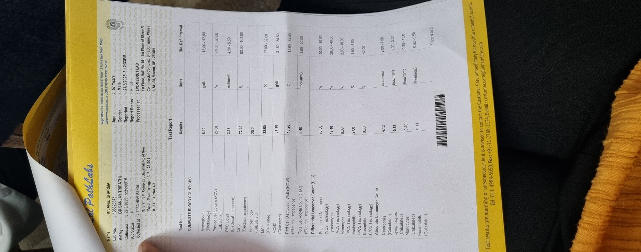
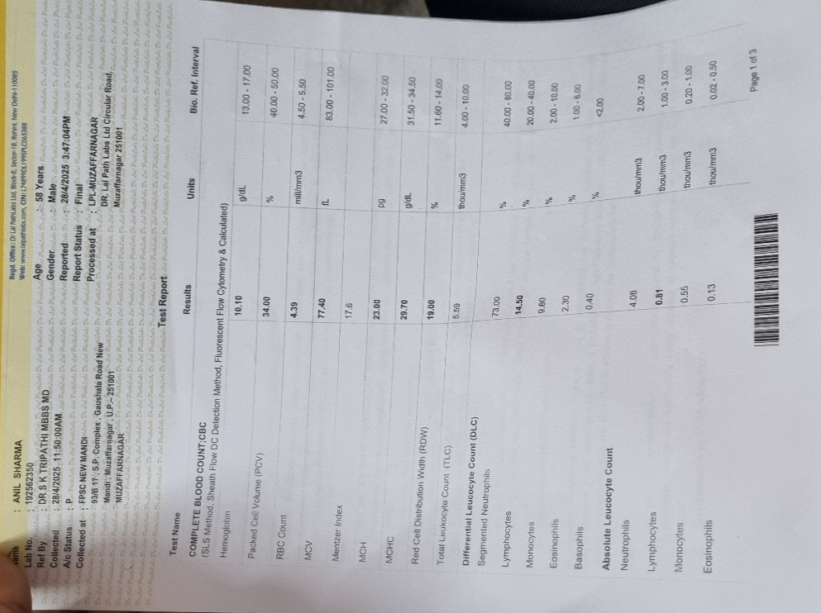

Conclusion
This case demonstrates that Ayurvedic formulations can play a significant role in managing Pandu (Anaemia of Chronic Disorders). The therapy not only improved hematological parameters but also reduced clinical symptoms, enhancing overall quality of life. Hence, Ayurvedic management can be considered as a safe and effective supportive approach in chronic anaemia.

Savils. Savill’s System of Clinical Medicine, 14th ed. London, Edward Arnold Publishers; 1964. p. 813.
Kawaljit K. Anaemia ‘a silent killer’ among women in India: Present scenario. European Journal of Zoological Research 2014; 3(1): 32-36.
National Family Health Survey (NFHS-III), 2005-2006, http://www.nfhsindia.org/pdf/ India.pdf, last accessed on 4th February, 2014.
Taranath Tarkavachaspati. “Shabdasthome Mahanidhi”. Veedanyantra Press, Calcutta 1976
Pandey Ajay Kumar, Textbook Of kaya chikitsa, Chapter 2, Chaukhmbha Publications, New Delhi, First Edition 2019; 2:168
. Shastri SN. “Panduroga Chikitsa adhyayah”. In Carak Samhita 1st edition. Varanasi, IN: Chaukhamba Bharati Acadamy 2 (2013): 486.
Shastri, A. D. “Pandurogpratishedhoupkram Varnan”. In Susruta Samhita Part II 1st edition. Varanasi, IN: Chaukhamba Sanskrit Sansthan (2013): 365.)
Tripathi Pt. Harihara Prasad Harita Samhita Hari Hindi VyakhyaSahita, Varanasi, Chuakhambha Krishna Das Academy, 2nd Edition,2009, Tritiya Sthana, Chapter 21, Pg. 358)
https://calgaryguide.ucalgary.ca
Prakash R Deshpande: A Clinical Study on Vyadhiharana Rasain Sandhigata-Vata. ayurpub 2016;I (3) 108-113

