A GIS based Fuzzy Membership Approach for Mapping Yellowfin Tuna (Thunnus albacares) Potential Zones in Sri Lanka's Exclusive Economic Zone
Pubudu Karunarathna¹, P.G.R.N.I. Pussella²
^{1,2}Department of Remote Sensing and GIS, Faculty of Geomatics, Sabaragamuwa University, Belihuloya, Sri Lanka

ABSTRACT
The Sri Lankan offshore fishing industry faces numerous challenges including dynamic weather conditions, financial constraints, and limited technological adoption for locating productive fishing grounds within the country's Exclusive Economic Zone (EEZ). This study aimed to develop a GIS based model integrating fuzzy membership analysis to identify the Yellowfin Tuna (Thunnus albacares) potential zones in EEZ of Sri Lanka. Six oceanographic parameters were used in the model: sea surface temperature (SST), chlorophyll-a concentration (CHLO-a), dissolved oxygen (OXY), salinity (SAL), density (DEN), and bathymetry (BATHY). Monthly data for 2019 were obtained from Copernicus Marine Service and General Bathymetric Chart of the Ocean (GEBCO) data catalogs. Parameter maps were reclassified using fuzzy membership functions based on species-specific optimal ranges derived from literature (SST: 22-30°C; CHL-a: 0.05-0.25 mg/m³; BATHY: <160 m; SAL: 32-37 PSU; DEN: 1020-1027 kg/m³; OXY: >5 mg/L). Fuzzy overlay analysis generated monthly habitat suitability maps, which were combined to produce an annual forecast map. Validation used 63,105 fishery dependent catch locations from the Department of Fisheries (2019) and 67,310 random points. Results showed that an 80.3% accuracy within forecasted suitable zones. Forecast maps revealed seasonal variability in potential fishing grounds, with sensitivity of 75.7% and specificity of 84.5%. The Kappa coefficient of 0.60 indicated substantial agreement beyond chance, while ROC analysis yielded an Area under the Curve (AUC) of 0.86, demonstrating excellent discriminatory ability. With persistent high suitability areas identified in eastern and southern EEZ regions. The model successfully generated potential fishing zone predictions at 4 km resolution. As the forecasted areas are mostly within close range of the shore, they will reduce travel and search time, resulting in beneficial fuel savings for fishermen. This GIS-based fuzzy approach provides a cost-effective, scientifically robust tool for identifying Yellowfin Tuna potential zones, with direct applicability for sustainable fisheries management in Sri Lanka and potential adaptability for other data-limited regions.
Keywords: GIS based modelling, Fuzzy Logic, Oceanographic Parameters, offshore fishing, Yellowfin Tuna (Thunnus albacares),
INTRODUCTION
As a developing country in the South Asian region, fishing industry is vital for the economic development of the country and Sri Lanka has huge potential of having export market of fishery. But major part of fishing depends on coastal fishing. Even though Sri Lanka has 436 000 km2 ocean area within EEZ, offshore fishing operations are limited (Samaranayake, 2003). It is very much important to identify and forecast of the fish potential areas within EEZ to increase offshore fishing. In 2021, fish and fishery products generated export revenue of approximately Rs.63, 222 million (CBSL, 2021). The industry employs an estimated 600,000 people directly in fishing activities, with numerous additional jobs in processing, boat building, and distribution networks (MFAR, 2019).
Despite this economic significance, the contribution of the fishing industry to Gross National Production declined from 2.6% in 2009 to 1.4% in 2015 (Perera et al., 2016; CBSL, 2016). Coastal fishing dominated production, contributing 52% of total fish production in 2015, while offshore and deep-sea activities contributed only 35% (Perera et al., 2016). This underutilization of offshore resources persists despite government initiatives providing financial loans for vessels, resulting in over 6,000 vessels currently operating in offshore waters (MFAR, 2019).
The offshore fishing industry faces multiple pressures: dynamic weather and climatic conditions, financial difficulties among fishermen, inability to precisely locate fish aggregations, and limited adoption of innovative technological approaches successfully applied in other countries (Perera et al., 2016). The inability to precisely locate fish aggregations forces fishermen to incur significantly higher operational costs in terms of both time and money, which frequently culminates in poor or non-existent harvests.
Fish types such as Tuna, Seer and Carangids are the major marine sector fish caught by commercial sectors in Sri Lanka (J.A.D.B. Jayasooriya, 2013). Yellowfin tuna (Thunnus albacares) has major export commodity over other types of fish species. However 16% of the yellowfin tuna landed meets exportable quality standards due to inadequate onboard storage facilities on multiday fishing vessels (World Bank, 2022). This limitation together with the low catch per unit effort (CUPE) occur because many fishermen still rely on traditional methods to locate fish aggregations than using new technologies to locate prices fish aggregations (Ministry of Fisheries, 2020; Food and Agriculture Organization, n.d.)
As one of the promising solutions in this point, use of new technologies to explore new potential zones for fishing within the EEZ of the country is very important. The countries which have well developed fishing industries such as China, USA, Japan and India use satellite based information to find and predict potential fishing zones (Bigelow et al. 1999; Zhu et al. 2014).
As a collaborative attempt of Ministry of Fisheries and Aquatic Resources (MFAR) and National Aquatic Resources Research and Development Agency (NARA) of Sri Lanka initiated a project to develop a Satellite based Fishery Forecasting System for Sri Lanka in 2001 to increase the fish production of the country and the system was launched in 2007 with the financial assistance of Icelandic International Development Agency (MFAR, 2009). In 2008, a prediction model for yellowfin tuna fish was built up based on the satellite data and previous track records in Sri Lanka and it was used sea surface temperature, sea surface chlorophyll concentration and sea surface heights as the model parameters (Rajapaksha, 2010). This model was very helpful to the fishermen initially, since it was very difficult to search the paths and migration patterns of this type of fish locally (Zagaglila et al. 2004). However, model was so limited with the accuracy level, since it was used data for only two years in the process of building it (Rajapaksha, 2010). After this, a limited number of attempts have been taken to develop methods to solve this problem with different fishery and oceanographic parameters.
Studies in other regions have successfully applied GIS-based empirical models for Yellowfin Tuna habitat assessment. Yen (2012) developed habitat suitability index (HSI) models for the Western and Central Pacific Ocean using four oceanographic factors (SST, chlorophyll-a, sea surface height, and salinity), achieving 71.9% prediction accuracy. Similarly, fuzzy rule-based classification has been applied to model Yellowfin Tuna distribution in the Persian Gulf.
With the developments Geographic Information Systems have capabilities to integrate multisource oceanographic data and analyze spatial relationships in marine environments (Chang and Guo, 2021). In habitat modeling fuzzy logic approaches are more suited because they can accommodate the inherent uncertainty and gradation in species-environment relationships, unlike traditional binary classification methods (Bandemer and Gottwald, 1990). According to the current situation, an approach with using spatial and temporal variation of oceanographic conditions and parameters is highly needed in order to uplift the fishery industry in Sri Lanka. These factors include Sea Surface Temperature (SST), Concentration of Chlorophyll_a (CHLO_a), Bathymetric data (BATHY), Salinity (SAL), Density of the Sea Water (DEN) and Oxygen Concentration (OXY). Therefore, the main objective of this study is to develop a potential GIS based model to identify and forecast fish potential zones in the EEZ of Sri Lanka.
This study aims to develop a Remote Sensing and GIS based model integrating fuzzy membership analysis to identify and forecast Yellowfin Tuna potential zones in Sri Lanka's EEZ. By incorporating six oceanographic parameters and validating against extensive fishery dependent data, this research provides a scientifically robust tool for sustainable fisheries management in Sri Lankan waters.
METHODOLOGY
Study Area
As, the methodology for this study is basically associated with the collection of geo-information of environmental (biological, chemical and physical) characteristics of the Ocean and analyzing them. EEZ area of the Sri Lanka has selected as the Study area for this research. The Sri Lanka's Exclusive Economic Zone (EEZ), extending 200 nautical miles from the coastline, covering approximately 436,000 km² (Figure 1). The EEZ lies within the northern Indian Ocean, bounded by latitudes approximately 5°N to 10°N and longitudes 79°E to 85°E.
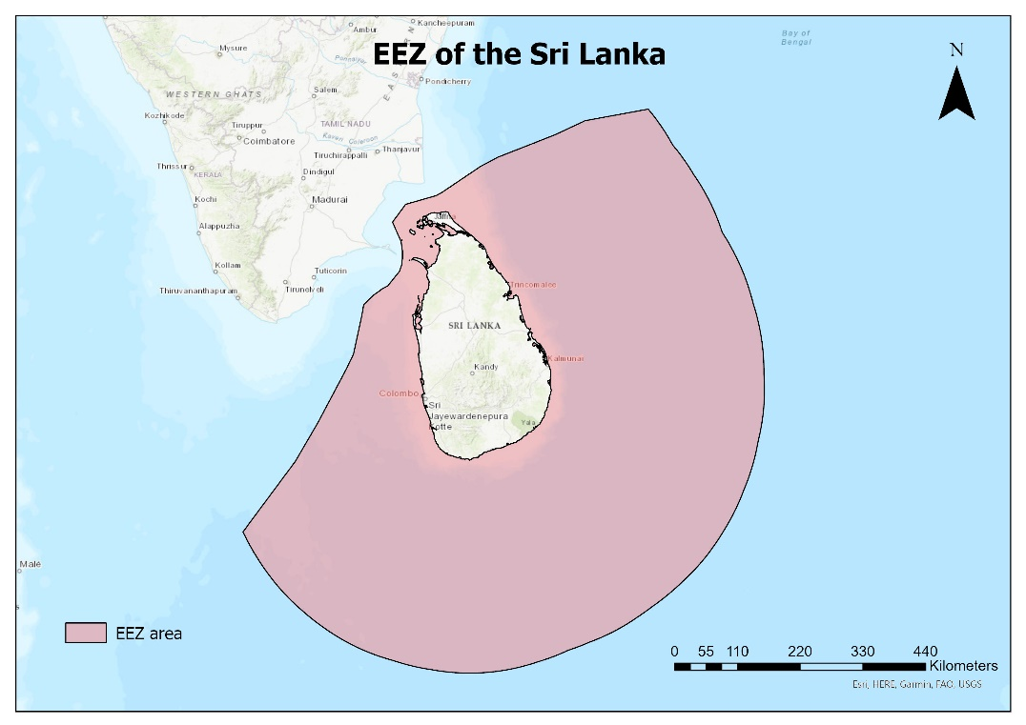
Figure 1: Study Area Map (Sri Lanka's EEZ)
Data Acquisition
Remote sensing data
Oceanographic parameter data were obtained from publicly available sources for the year 2019 (Table 1). All downloaded data were in NetCDF format and converted to raster layers (.tif) in ArcGIS using the 'Make NetCDF Raster Layer' function. Raster layers were then extracted using an EEZ shapefile mask to match the study area. All processing was conducted in the WGS 1984 coordinate system.
Table 1: Remote Sensing Data Sources and Specifications
Parameter | Data Source | Spatial Resolution | Temporal Resolution
Sea Surface Temperature (SST) | Copernicus Marine Service | 4 km | Monthly mean
Chlorophyll-a Concentration (CHLO-a) | Copernicus Marine Service | 4 km | Monthly mean
Dissolved Oxygen (OXY) | Copernicus Marine Service | 25 km | Monthly mean
Salinity (SAL) | Copernicus Marine Service | 25 km | Monthly mean
Density (DEN) | Copernicus Marine Service | 20 km | Monthly mean
Bathymetry (BATHY) | General Bathymetric Chart of the Ocean | 0.4 km | Annual mean
The EEZ boundary shape file was obtained from the Marine Gazetteer (https://www.marineregions.org/), and Sri Lanka's administrative boundary from the Humanitarian Data Exchange (https://data.humdata.org/).
Fishery data
Fishery-dependent data for 2019 were obtained from the Department of Fisheries, Sri Lanka. These data originated from log sheets (Figure 2) completed by fishermen, recording catch locations, species, and quantities. Yellowfin Tuna (Thunnus albacares) records were filtered from the database and monthly datasets were created. A total of 63,105 Yellowfin Tuna catch locations within the EEZ were founded for year 2019 and those points were used for the model validation.
Conceptual Methodology
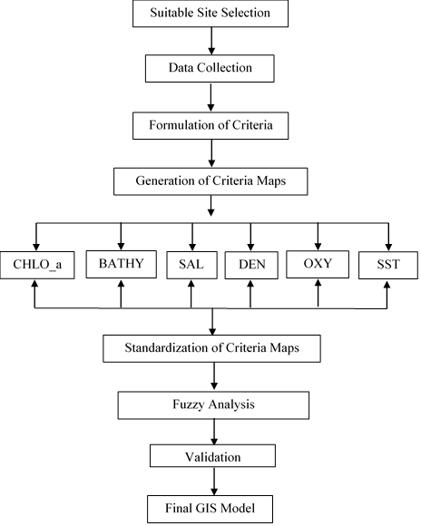
Figure 2: Conceptual Methodology
Data Harmonization and Resolution Considerations
A significant methodological consideration was the varying spatial resolutions of input datasets: SST and chlorophyll-a at 4 km, density at 20 km, and dissolved oxygen and salinity at 25 km resolution (Table 1). To enable integrated analysis within the GIS framework, all raster layers were resampled to a common 4 km grid using bilinear interpolation. This approach preserves the higher-resolution surface parameters while incorporating subsurface variables, though it introduces inherent uncertainty in areas where fine scale variability in subsurface conditions may influence habitat suitability.
To assess the potential impact of resolution mismatch, a sensitivity analysis was performed by comparing habitat suitability maps generated with and without the inclusion of coarse resolution parameters. The spatial patterns remained consistent, suggesting that the broader oceanographic regimes captured by subsurface parameters are adequately represented at the resampled resolution for regional scale habitat assessment. However, localized predictions (< 10 km scale) should be interpreted with appropriate caution.
Criteria Values for the Analysis
Suitable values and values ranges for selected six parameters were decided from the literature reviews. In the model these values were used to create final forecast map.
Table 2: Suitable Conditions for Selected Oceanographic Parameters for Yellowfin Tuna (Thunnus albacares)
Parameter | Suitable Conditions | Supporting Literature
Sea Surface Temperature (SST) | 22 - 30°C | Hu et al. (2010); Rajapaksha (2010)
Chlorophyll-a Concentration (CHLO-a) | 0.05 - 0.25 mg/m³ | Yen et al. (2012)
Dissolved Oxygen (OXY) | > 5.0 mg/L | Hu et al. (2010); Pillai & Satheeshkumar (2012)
Salinity (SAL) | 32 - 37 PSU | Mondal & Lee (2023)
Density (DEN) | 1020 - 1027 kg/m³ | Derived using Salinity and Sea Surface Temperature
Bathymetry (BATHY) | < 160 m | Hu et al. (2010)
Fuzzy Membership Analysis
In this study, habitat suitability was modeled using the Fuzzy Membership tool in ArcGIS Pro, which transforms oceanographic variables into a standardized suitability scale ranging from 0 (definitively unsuitable) to 1 (definitively suitable). For oceanographic parameters with defined optimal ranges (SST, Chlorophyll-a, salinity, and density), Fuzzy Gaussian or piecewise linear membership functions were applied to assign high membership values to the optimal range and decrease suitability towards the extremes. For dissolved oxygen, a Fuzzy Large membership function was applied because habitat suitability increases with higher oxygen concentrations above the minimum physiological requirement (>5 mg/L) for Yellowfin Tuna. Conversely, for bathymetry, a Fuzzy Small membership function was used to represent the species' preference for relatively shallower productive waters along continental shelf and slope regions (<160 m), where suitability decreases as depth increases.

Fuzzy Overlay Analysis
Monthly habitat suitability layers were integrated using the Fuzzy Gamma operator (gamma=0.9), which provides a balanced approach between the increasing and decreasing effects of other fuzzy operators, allowing for a realistic compensatory relationship between oceanographic variables. The resulting monthly HSI maps, ranging from 0 to 1, were then aggregated using an arithmetic mean to generate an annual prediction map, effectively identifying areas characterized by persistent high suitability for Yellowfin Tuna (Thunnus albacares) throughout 2019.
Model Validation
Model performance was evaluated using multiple metrics beyond simple classification accuracy. The Habitat Suitability Index (HSI) map was reclassified into binary classes (suitable/unsuitable) using a threshold of HSI > 0.65, based on species-specific optimal ranges derived from literature. A confusion matrix was constructed by comparing predicted suitability against 63,105 fishery dependent catch locations (representing presence data) and 67,310 randomly generated background points (representing available habitat conditions). Background points were generated with a minimum 4 km distance from catch locations to avoid spatial autocorrelation and pseudo replication.
From the confusion matrix, the following performance metrics were calculated:
- Overall Accuracy
- Sensitivity
- Specificity
- Precision
- F1 Score
- Kappa Coefficient
Additionally, Receiver Operating Characteristic (ROC) curve analysis was performed by plotting the true positive rate (sensitivity) against the false positive rate (1 - specificity) across all possible HSI thresholds from 0 to 1 in 0.05 increments. The Area Under the Curve (AUC) was calculated using the trapezoidal rule to assess the model's overall discriminatory ability, where AUC values > 0.7 indicate acceptable discrimination, > 0.8 indicate excellent discrimination, and > 0.9 indicate outstanding discrimination (Hosmer et al., 2013).
Software Used
All spatial analyses were conducted using ArcGIS ArcMap 10.8 and ArcGIS Pro.
RESULTS
Oceanographic Parameter Maps
Monthly maps for 2019 were generated for all six oceanographic parameters. Notable seasonal variability was observed in surface parameters, while bathymetry remained constant due to the annual availability of bathymetry. Using suitable parameter values and fuzzy memberships, monthly fuzzy membership layers were created using all these oceanographic parameters.

Sea Surface Temperature (SST)
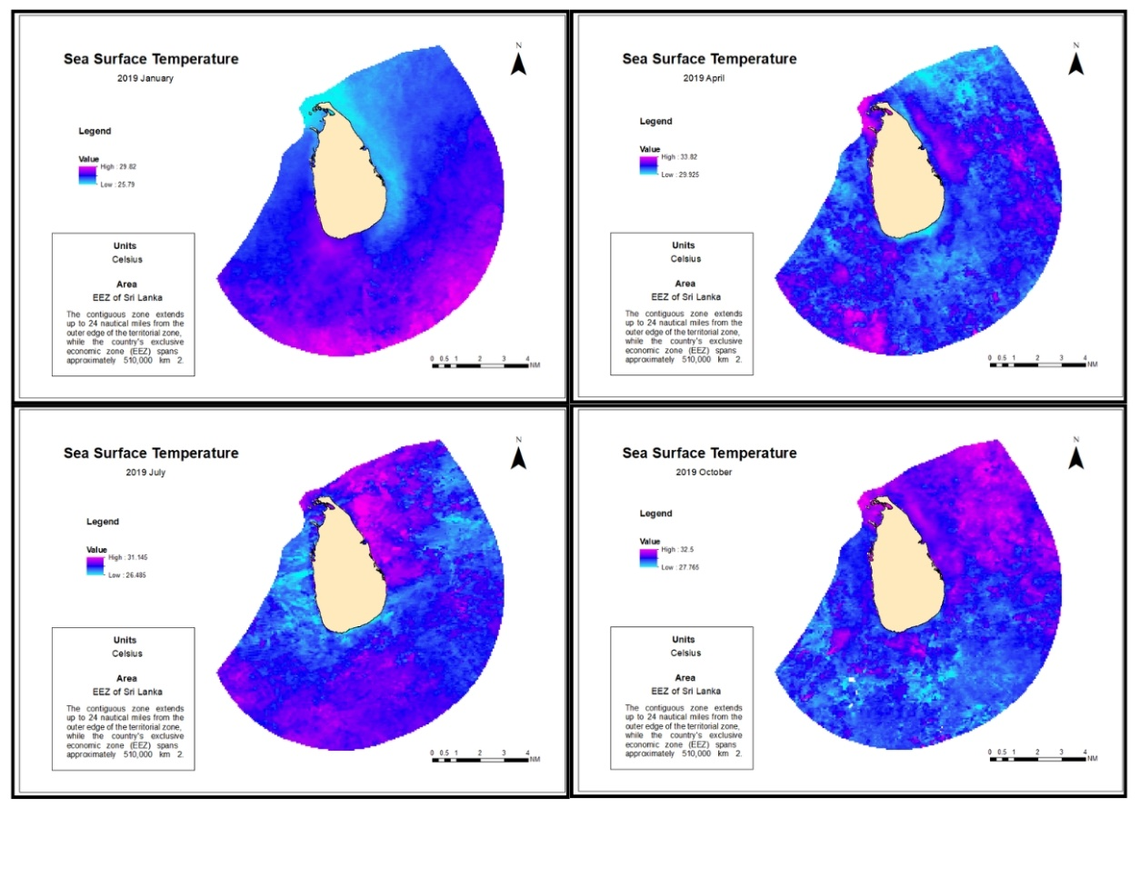
Figure 3: Monthly variability of sea surface temperature (°C) in the Exclusive Economic Zone (EEZ) of Sri Lanka during 2019 (January, April, July, and October).
Bathymetry (BATHY)
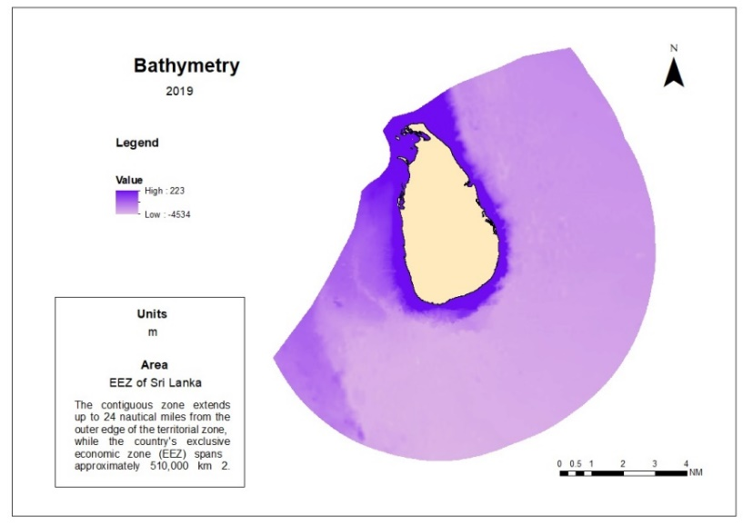
Figure 4: Bathymetry (m) in the Exclusive Economic Zone (EEZ) of Sri Lanka during 2019.

Chlorophyll-a Concentration (CHLO-a)
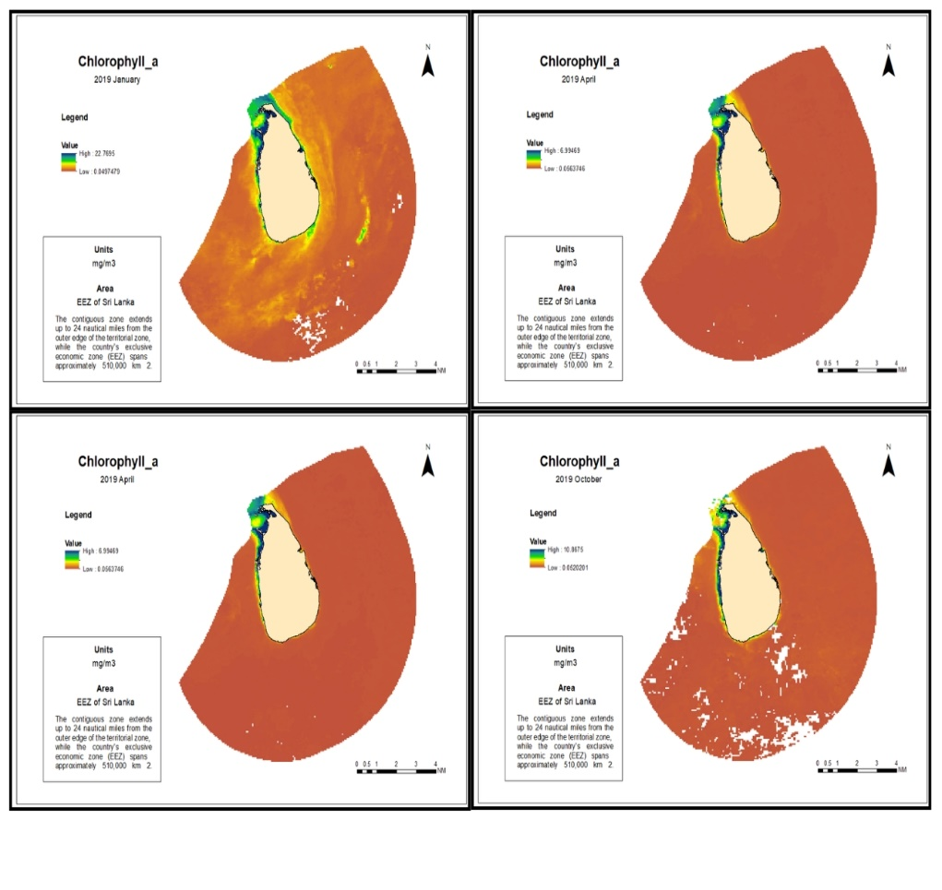
Figure 5: Monthly variability of Chlorophyll-a Concentration (mg/m³) in the Exclusive Economic Zone (EEZ) of Sri Lanka during 2019 (January, April, July, and October).
Dissolved Oxygen (OXY)
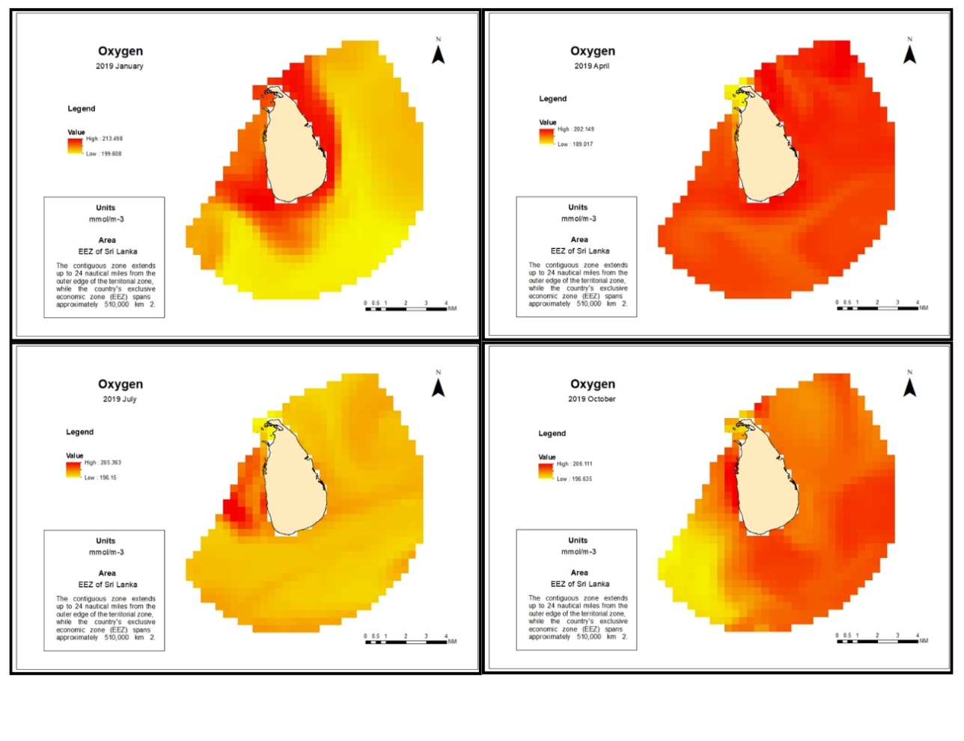
Figure 6: Monthly variability of Dissolved Oxygen (mg/L) in the Exclusive Economic Zone (EEZ) of Sri Lanka during 2019 (January, April, July, and October).
Salinity (SAL)
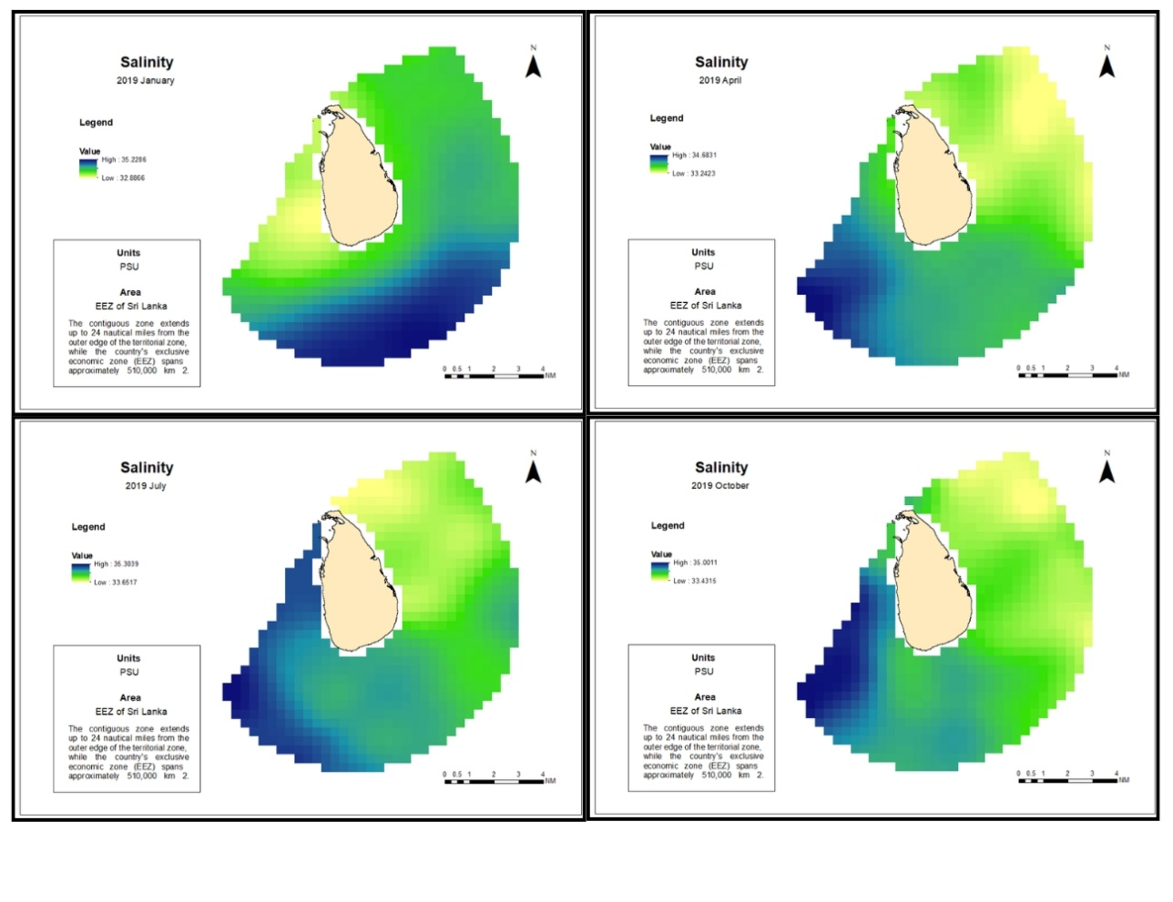
Figure 7: Monthly variability of Salinity (PSU) in the Exclusive Economic Zone (EEZ) of Sri Lanka during 2019 (January, April, July, and October).
Density (DEN)
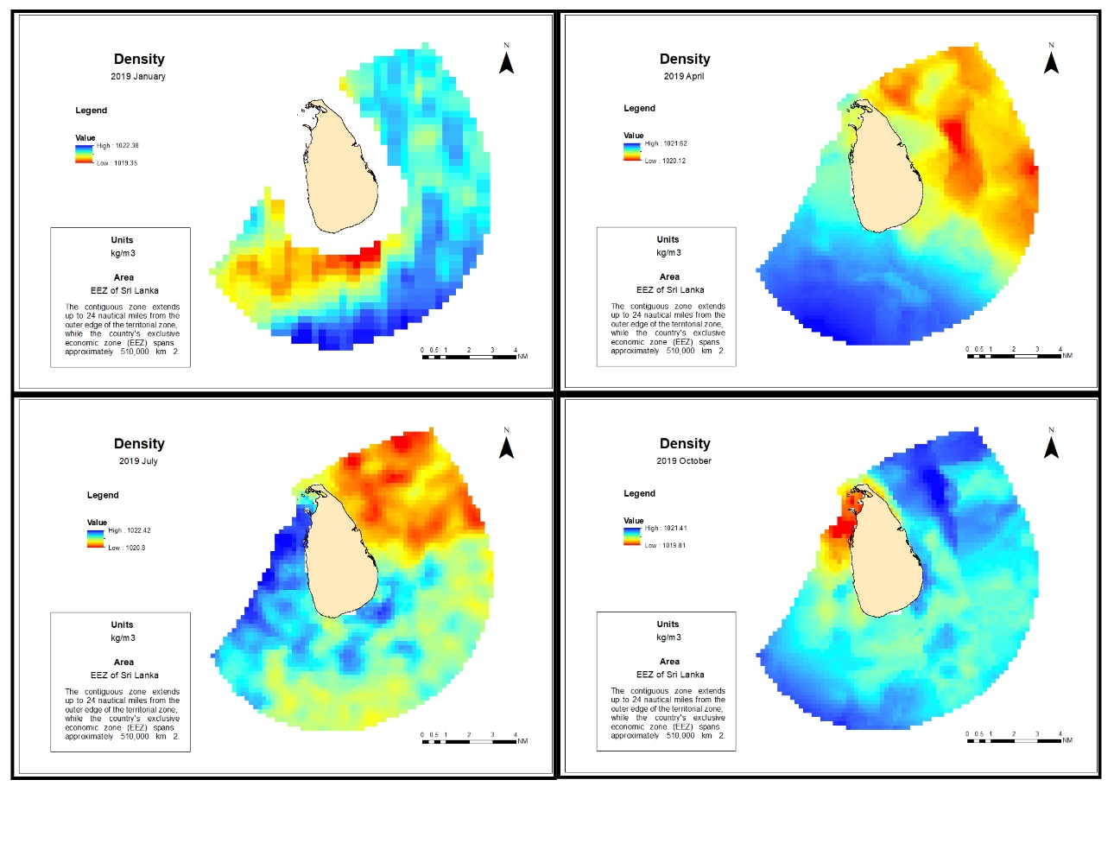
Figure 8: Monthly variability of Density (kg/m³) in the Exclusive Economic Zone (EEZ) of Sri Lanka during 2019 (January, April, July, and October).
Fuzzy Membership Analysis
Monthly Habitat Suitability Index (HSI) Maps
Fuzzy membership transformation reclassified each parameter layer to a 0 -1 scale based on species-specific optimal ranges according to the select values from the literature. For each month forecast maps (Figure 9) was created using fuzzy overlay. Areas with membership values approaching 1 (dark blue) represent optimal conditions for Yellowfin Tuna. HSI values ranged from 0.00 to 0.93 across the EEZ. High suitability areas (HSI > 0.65) were identified as potential fishing zones.
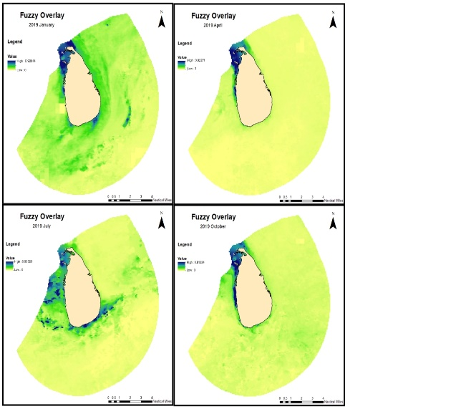
Figure 9: Monthly variability of Habitat Suitability Index in the Exclusive Economic Zone (EEZ) of Sri Lanka during 2019 (January, April, July, and October).
Annual Prediction Map
Combining monthly HSI maps through fuzzy overlay generated the annual Yellowfin Tuna potential zone prediction map (Figure 10). This map identifies areas persistently suitable throughout the year, representing reliable fishing grounds. The raster values on the map range from 0 (low suitability) to approximately 0.93217 (high suitability), represented by a yellow to blue gradient. High potential zones were concentrated in the north western part of the EEZ of the Sri Lanka.
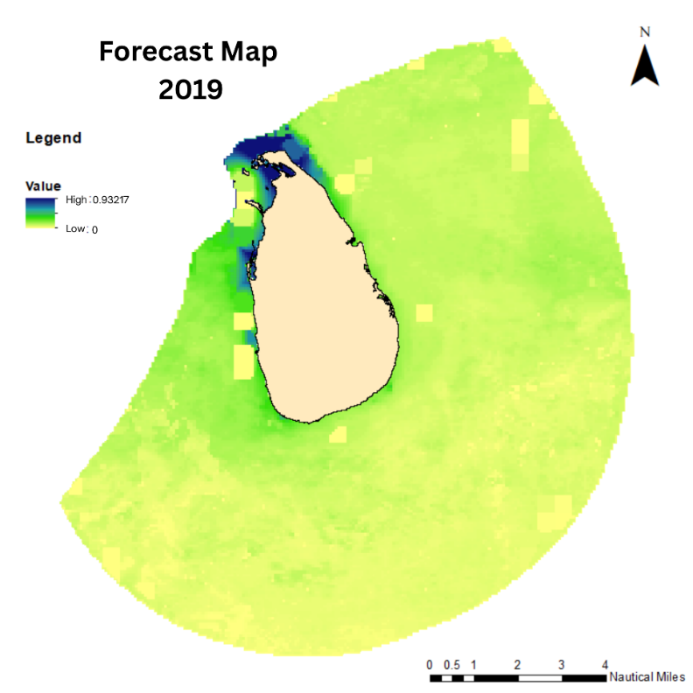
Figure 10: Fish potential areas Map in the Exclusive Economic Zone (EEZ) of Sri Lanka during 2019
Model Validation
Model validation using 63,105 fishery-dependent catch locations and 67,310 randomly generated background points (total N = 130,415) demonstrated robust predictive performance (Table 3). The confusion matrix revealed 47,760 true positives (catch points correctly classified as suitable), 56,907 true negatives (background points correctly classified as unsuitable), 15,345 false negatives (catch points in predicted unsuitable areas), and 10,403 false positives (background points in predicted suitable areas).
The model achieved an overall accuracy of 80.3%, with sensitivity of 75.7% (correctly identifying actual catch locations) and specificity of 84.5% (correctly identifying unsuitable areas). Precision of 82.1% indicates that areas predicted as suitable contained catch locations in over four-fifths of cases. The F1 score of 78.8% represents a balanced harmonic mean of precision and sensitivity.
The Kappa coefficient of 0.60 indicates substantial agreement beyond chance (Landis & Koch, 1977), confirming that the model's predictive ability significantly exceeds random classification. ROC analysis yielded an Area under the Curve (AUC) of 0.86 (Figure 12), representing excellent discriminatory ability according to conventional interpretation (AUC > 0.8 = excellent). This threshold-independent metric confirms that the fuzzy membership model reliably distinguishes suitable from unsuitable Yellowfin Tuna habitat across the full range of suitability values, not merely at the selected HSI > 0.65 threshold.
These metrics collectively demonstrate that the fuzzy membership approach successfully captures the environmental preferences of Yellowfin Tuna in Sri Lankan waters, with performance comparable to or exceeding similar habitat modeling studies (Yen et al., 2012 reported 71.9% accuracy for Yellowfin Tuna in the Pacific Ocean).
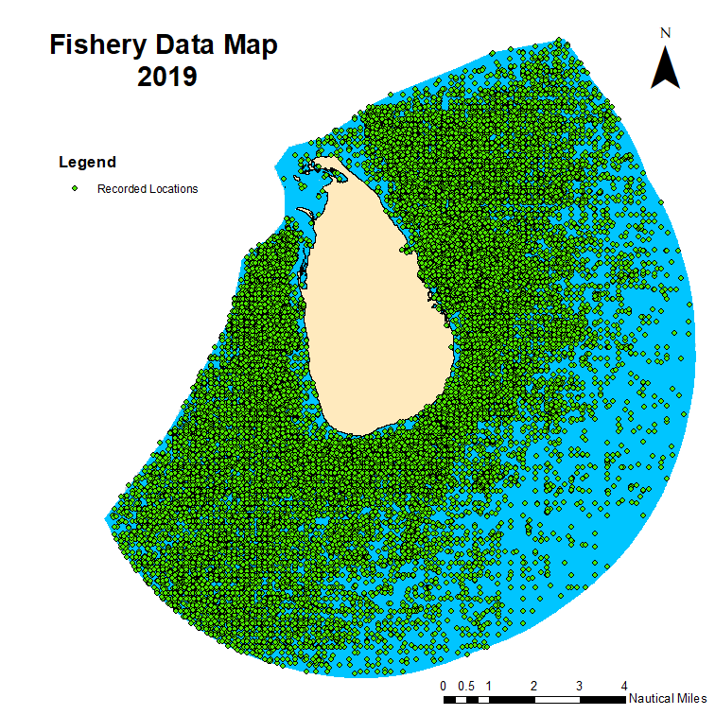
Figure 11: Fishery Data Map
Table 3: Validation Details Table
Metric Category | Metric | Value
Sample Size | Total Catch Points | 63,105
 | Background Points | 67,310 (Randomly generated)
 | Total Validation Points | 130,415
Confusion Matrix | True Positives (TP) | 47,760
 | False Negatives (FN) | 15,345
 | False Positives (FP) | 10,403
 | True Negatives (TN) | 56,907
Performance Metrics | Overall Accuracy | 80.3%
 | Sensitivity (Recall) | 75.7%
 | Specificity | 84.5%
 | Precision | 82.1%
 | F1 Score | 78.8%
 | Kappa Coefficient | 0.60 - Substantial Agreement (0.61-0.80)
 | AUC (ROC Curve) | 0.86 - Excellent discrimination (>0.80)
Threshold | Suitability Threshold | HSI > 0.65 (Optimal conditions cutoff)

Figure 12: Receiver Operating Characteristic (ROC) Curve for Yellowfin Tuna Habitat Suitability Model
The ROC curve plots sensitivity (true positive rate) against 1-specificity (false positive rate) across all possible HSI thresholds. The solid blue line represents the fuzzy membership model, with the red point indicating the selected threshold (HSI > 0.65). The Area under the Curve (AUC) of 0.86 indicates excellent discriminatory ability.
DISCUSSION
Methodological Advantages of Fuzzy GIS Approach
This study demonstrates that integrating fuzzy membership analysis with GIS provides a robust framework for identifying potential Yellowfin Tuna zones in Sri Lanka’s EEZ, as this approach offers significant advantages over binary habitat modeling. First, fuzzy logic accommodates the inherent gradation in species-environment relationships. Rather than imposing arbitrary thresholds that classify areas as simply "suitable" or "unsuitable," fuzzy membership values (0 -1) represent the continuum of habitat quality (Bandemer and Gottwald, 1990). This approach is particularly important for highly migratory species like Yellowfin Tuna, which may utilize marginal habitats during transit or when optimal conditions are unavailable. A validation accuracy of 80.3% confirms the model's effectiveness in capturing the environmental envelope preferred by Yellowfin Tuna.
The methodology of this study is transparent and reproducible. All data sources are publicly available for download, and parameter thresholds are derived from published literature. This framework can be easily adapted for use in other regions or for other species.
Influence of the Oceanographic Parameters on the Final Model
As the primary objective was to identify potential fishing areas for the entire year and validate the overall model, the intermediate forecasting results were omitted from this section. The results indicate that all selected parameters significantly influenced the final model; however, the current approach did not allow for a quantitative analysis of each parameter's individual weight. Furthermore, since parameter thresholds were derived from existing literature, they may vary due to regional differences, unconsidered oceanographic variables, or specific behavioral patterns of Yellowfin Tuna. Consequently, future research should utilize methods to determine optimal local values and assess the relative influence of each factor to achieve greater predictive accuracy

Validation Strengths and Bias Considerations
The validation approach using 63,105 fishery dependent catch points represents both a strength and a limitation. The large sample size and temporal alignment with oceanographic data (both 2019) provide robust statistical power. However, fishery dependent data inherently contain biases that warrant discussion.
Sources of Validation Bias
- Reporting Accuracy: Logbook data may record port of landing rather than actual fishing locations. Discussions with Department of Fisheries officials suggest that approximately 15-20% of reported coordinates may represent generalized areas rather than GPS-recorded positions.
- Fishing Effort Distribution: Catch locations reflect where fishermen chose to fish, not necessarily where fish are present. If fishermen avoid certain areas due to distance, weather concerns, or traditional knowledge, those areas may contain suitable habitat that remains unfished and thus invalidated.
- Temporal Mismatch: While monthly oceanographic data were used, catch events occur at specific times. A weekly or daily analysis might show different correspondence patterns.
Addressing Validation Limitations
The 24.3% of catch points falling outside predicted suitable zones likely reflects a combination of model errors/omissions, data reporting inaccuracies, use of marginal habitats during transit or when optimal areas are unavailable, and oceanographic conditions at the exact time of fishing differing from monthly means.
Future validation efforts should incorporate:
- Fishery Independent Surveys: Collaboration with research vessel surveys to collect presence absence data unbiased by fishing effort.
- Vessel Monitoring System (VMS) Data: If available, VMS tracks would provide precise fishing locations and effort distribution.
- Temporal Subsampling: Validation using weekly or daily oceanographic composites when available.
- Participatory Mapping: Engaging fishermen to validate predicted zones through structured feedback mechanisms.
Spatial Resolution Constraints and Uncertainty
The heterogeneous spatial resolutions of input datasets (4-25 km) represent a fundamental limitation of this study. While bilinear resampling enabled data integration, this approach may introduce uncertainty in two ways. First, fine scale oceanographic features (< 4 km) that influence tuna behavior, such as oceanic fronts or mesoscale eddies, cannot be resolved. Second, the disaggregation of coarse resolution (25 km) salinity and oxygen data to 4 km grids implies spatial homogeneity that may not reflect actual oceanographic conditions, particularly in dynamic coastal shelf transition zones.
Operational Integration with Fisheries Advisory Systems
The validated model provides a scientifically robust foundation for operational fisheries advisory services in Sri Lanka. Three pathways for practical implementation are proposed.
Integration with NARA's Existing Systems
The National Aquatic Resources Research and Development Agency (NARA) currently operates satellite based fishery forecasting services. The fuzzy membership model developed in this study could complement existing systems by providing quantitative habitat suitability indices rather than binary predictions, incorporating six parameters versus the three parameter approach of the 2008 model (Rajapaksha, 2010), and offering monthly and annual forecasts at 4 km resolution. Integration would require developing automated data ingestion pipelines from Copernicus Marine Service and establishing routine model updating protocols.
Mobile and Web Based Decision Support
Following the successful model of INCOIS Potential Fishing Zone (PFZ) advisories in India, the habitat suitability maps could be disseminated through multiple channels:
- Mobile Application: A smartphone application providing real time HSI maps, with features including: GPS vessel tracking, route optimization to high suitability areas, and fisher feedback mechanisms for catch reporting.
- SMS Alerts: Automated text message alerts delivered to registered fishermen before departure, indicating approximate coordinates of predicted high suitability zones.
- Web Portal: A publicly accessible web interface displaying current monthly forecasts, archived suitability maps, and downloadable data for fishing vessel operators.
- Community Display Boards: Printed maps displayed at major fishing harbors (Negombo, Galle, Trincomalee) for fishermen without smartphone access.
Economic and Operational Benefits
Preliminary economic assessment based on validation results suggests that directing fishing effort to areas with HSI > 0.65 could reduce average search time, decrease fuel consumption by huge margin for a fishing trip, and increase catch per unit effort (CPUE) through more efficient targeting of productive grounds.
Limitations and Future Improvements
Several limitations should be acknowledged and addressed in future work:
- Most of the available data have a resolution of 4 km or coarser. Utilizing higher resolution data would improve accuracy and reliability; furthermore, integrating real time data would unlock the model's full potential for real time fish forecasting applications.
- Due to variations in water column properties, surface values may not fully represent the habitat structure beneath the surface. Integrating oceanographic model outputs for subsurface conditions could significantly improve model accuracy.
- As this study focused exclusively on Yellowfin Tuna due to limited literature on their specific oceanographic preferences, future research should be conducted on other economically significant fish species to identify their optimal oceanographic parameters. This would allow for the expansion of this model to a broader range of species.
- Although temporal validation using 2019 fishery data provides meaningful results, validation across multiple years with varying oceanographic conditions would further strengthen confidence in the model’s reliability.
- Validation based on fishery-dependent data may overestimate model performance. Therefore, incorporating fishery-independent surveys would improve model validation and help mitigate bias.
CONCLUSION
This study successfully developed and validated a GIS based fuzzy membership model integrating six oceanographic parameters to identify potential Yellowfin Tuna fishing zones within Sri Lanka's Exclusive Economic Zone. The model achieved robust predictive performance with overall accuracy of 80.3%, sensitivity of 75.7%, and specificity of 84.5% when validated against 63,105 fishery dependent catch locations and 67,310 background points. The Kappa coefficient of 0.60 indicated substantial agreement beyond chance, while ROC analysis yielded an AUC of 0.86, demonstrating excellent discriminatory ability. Seasonal variability in habitat suitability was observed, with persistent high-potential areas identified in the eastern and southern EEZ regions.
The methodological approach offers several advantages over traditional binary habitat models. Fuzzy membership functions accommodate the inherent gradation in species environment relationships, while the integration of multisource satellite data provides a reproducible framework applicable to data limited regions. By utilizing publicly accessible oceanographic data, the model represents a cost effective tool for sustainable fisheries management.
This research addresses a critical gap in Sri Lanka's offshore fishing industry, where limited technological adoption has historically constrained the utilization of EEZ resources. The forecast maps, validated against extensive catch data, can directly support operational decision making by enabling fishermen to reduce search time, fuel consumption, and operational costs. With 75.7% of catch locations concentrated within predicted suitable zones, the potential for improved fishing efficiency is substantial.
The model's adaptability extends beyond Yellowfin Tuna to other commercially valuable species and ecologically significant marine organisms, given appropriate parameterization. Furthermore, the methodology is transferable to other geographic regions with comparable oceanographic data availability.
Future research directions should focus on:
- Integrating higher resolution subsurface oceanographic data as they become available.
- Incorporating dynamic oceanographic features such as fronts and eddies.
- Developing machine learning ensemble approaches for comparison with fuzzy logic.
- Validating across multiple years to assess inter annual variability.
- Incorporating fishery independent survey data for more robust validation.
- Creating operational decision support tools for real time fishery advisory dissemination.
With continued refinement and operational integration, this modeling approach can contribute significantly to sustainable fisheries management, food security, and economic development in Sri Lanka's offshore fishing sector.
REFERENCES
- Bandemer H. and Gottwald S (1990). Einführung in Fuzzy-Methoden
https://books.google.com/books?hl=en&lr=&id=J62AEQAAQBAJ&oi=fnd&pg=PA3&dq=24.%09Bandemer+H.+and+Gottwald+S+(1990).+Einf%C3%BChrung+in+Fuzzy-Methoden&ots=gBMlZZK61W&sig=SKcfW6h_4jLZ940baZtKsMaOsjA
https://www.academia.edu/download/89461820/82410529.pdf
- Bigelow, K.A.Boggs, C.H., and He, X. 1999. Environmental effects on swaordfish and blue shark catch rates in the U.S. North Pacific long-line fishery. Fishery and Oceanography 8(3): 178-198. https://doi.org/10.1046/j.1365-2419.1999.00105.x
- Central Bank of Sri Lanka (CBSL), 2016. Annual Report of Central Bank of Sri Lanka
- Cibele Teixeira Pinto, Xin Jing and Larry Leigh (2020). Evaluation Analysis of Landsat Level-1 and Level-2 Data Products Using In Situ Measurements
https://www.mdpi.com/2072-4292/12/16/2597
- Dineshbabu Ap, Sujitha Thomas (2016). GIS and its applications in Marine Fisheries Conservation and Management in Karnataka,India
https://www.researchgate.net/profile/Dineshbabu-Ap/publication/326344257_GIS_and_its_applications_in_Marine_Fisheries_Conservation_and_Management_in_Karnataka_India/links/5b46e018aca272c60937906e/GIS-and-its-applications-in-Marine-Fisheries-Conservation-and-Management-in-Karnataka-India.pdf
- G.J. Meaden, F. Carocci(2006). Current issues, status and applications of GIS to marine fisheries
- Haputhantri, S.S.K. 2004. Assessment of a coastal fishery of Sri Lanka using single species and multi-species approaches. Unpublished Ph.D. dissertation, Institute National Polytechnique de Toulouse, France.
- Hosmer, D.W., Lemeshow, S., & Sturdivant, R.X. (2013). Applied Logistic Regression (3rd ed.). John Wiley & Sons.
https://www.researchgate.net/profile/Andrew- Cucchiara/publication/261659875_Applied_Logistic_Regression/links/542c7eff0cf277d58e8c811e/Applied-Logistic-Regression.pdf
- Hu, F., Song, L., & Xu, L. (2010). Developing an integrated habitat index for yellowfin tuna (Thunnus albacares) in the Indian Ocean based on longline fisheries. IOTC-2010-WPTT-51. Food and Agriculture Organization of the United Nations.
https://openknowledge.fao.org/bitstreams/bc1a0170-b140-49d7-b3c5-9bbd3b81041f/download
- lsina C Trillas E. and Valverde L (1983). On some logical connectives for fuzzy set theory. Journal of Mathematical Analysis and its Applications
- J.A.D.B. Jayasooriya (2013). Analysis of Catch Assessment of Tuna Fisheries in Sri Lanka
- Landis, J.R., & Koch, G.G. (1977). The measurement of observer agreement for categorical data. Biometrics, 33(1), 159-174.
https://www.jstor.org/stable/2529310
- Ministry of Fisheries and Aquatic Resources Development. (MFARD), 2009 Fisheries Statistics, 2008.
- Ministry of Fisheries and Aquatic Resources Development. (MFARD), 2019 Fisheries Statistics, 2018.
- N Gopalakrishna Pillai and Palanisamy SatheeshkumarBiology (2012), Fishery, Conservation and Management of Indian Ocean Tuna Fisheries
http://dx.doi.org/10.1007/s12601-012-0038-y
- National Research Council (NRFS), Nutrient Requirements of Fish and Shrimp, 2011
- Perera K B P, Herath H M L K, Jayasinghe-Mudalige U K, Edirisinghe, J C Udugama J M M & Wijesuriya W., Price analysis of selected marine fish available in Colombo fish markets, Sri Lanka Journal of Economic Research , Volume 4 (1) December 2016 pp. 19-33
DOI: 10.4038/sljer.v4i1.69
- Rajapaksha, J. 2010. Evaluation and improvement of satellite based forecast system for Sri Lanka Yellowfin Tuna fishery. United Nations University Fisheries Training Programme, Iceland. https://www.grocentre.is/static/gro/publication/210/document/jagath09prf.pdf
- Samaranayake, R.A.D.B. 2003. Review of national fisheries situation in Sri Lanka. p. 987 - 1012. In G. Silvestre, L. Garces, I. Stobutzki, M. Ahmed, R.A. Valmonte-Santos, C. Luna, L. Lachica Aliño, P. Munro, V. Christensen and D. Pauly (eds.) Assessment, Management and Future Directions of Coastal Fisheries in Asian Countries. WorldFish Center Conference Proceedings 67, 1 120 p.
- Sandipan Mondal, Ming-An Lee (2023). Habitat modeling of mature albacore (Thunnus alalunga) tuna in the Indian Ocean
https://www.frontiersin.org/journals/marine-science/articles/10.3389/fmars.2023.1258535/full
- Sri Lanka Business report on fisheries ON Sri Lanka Business srilankabusiness.com, 2019
- Sund, P.N., Blackburn, M. and Williams, F. (1981). Tunas and their environment in the Pacific Ocean: a review. Oceanogr. Mar. Biol. Ann. Rev. 19:443–512.
https://documentatiecentrum.watlab.be/imis.php?module=ref&refid=97508
- Sydnes, A.K and Normam, A.K. (2003). Desk study on the fisheries sector in Sri Lanka
- The fisheries forecasting system in Japan for coastal pelagic fish. FAO Fisheries Technical Paper, 301 (72 pp.)
https://books.google.com/books?hl=en&lr=&id=DjgT2j-c0lMC&oi=fnd&pg=PA1&dq=17.%09The+fisheries+forecasting+system+in+Japan+for+coastal+pelagic+fish.+FAO+Fisheries+Technical+Paper,+301+(72+pp.)+&ots=ITpOtza6UN&sig=EdFgKARui5z_DGUPTwWpTNfIaHk
- Uda, M. (1973). Pulsative fluctuation of oceanic fronts in association with the tuna fishing grounds and fisheries. J. Fac. Mar. Sci. Techn. Tokai University 7:245-265.
https://cir.nii.ac.jp/crid/1572543025507196288
- Yamanaka, I., Ito, S., Niwa, K., Tanabe, R., Yabuta, Y., & Chikuni, S. (1988). Spiny Lobster Catches and the Ocean Environment
https://www.academia.edu/download/39210727/CHAPTER_16__SPINY_LOBSTER_CATCHES_AND_THE_OCEAN_ENVIRONMENT__250-261.pdf
- Yen, K.-W., Lu, H.-J., Chang, Y., & Lee, M.-A. (2012). Using remote-sensing data to detect habitat suitability for yellowfin tuna in the Western and Central Pacific Ocean. International Journal of Remote Sensing, 33(23), 7507–7522.
https://doi.org/10.1080/01431161.2012.685973
- Zagaglia C. R., J. A. Lorenzzetti and J.L. Stech. 2004. Remote sensing data and longline catches of yellowfin tuna (Thunnus albacares) in the equatorial Atlantic. Remote Sensing of Environment 93:267–281.
https://doi.org/10.1016/j.rse.2004.07.015
- Zhu, G.P., Chen, X.J. and Xu, L.X. 2014. Preliminary study on the fishery biology of yellowfin tuna, Tunnas albacares, in the western central Indian Ocean. Mar. Fish. 28:25-29.
https://openknowledge.fao.org/bitstreams/a1aeeed3-31c5-43b5-b3d9-75fed7a93bdd/download

