International Journal of Research and Scientific Innovation (IJRSI)

Online E- Journal ISSN 2321-2705 www.rsisinternational.org
*Print, Manually Fill, Scan and upload through final submission system. Date: April 30, 2026
*This is mandatory that this Declaration is signed by Authors.

Author (s) Declaration
- I/We hereby state that article authored by me/us is an original contribution. It has not neither been submitted for publication nor published elsewhere in any print/electronic form. It does not infringe on the right of others and does not contain any libelous or unlawful statements.
- I/We assign all the copyright of this article to the journal wherever required I/We have taken permission from the copyright holder and acknowledged the source.
- I / We represent that I / We have taken the consent from our University / Institution / Employer / Project Guide
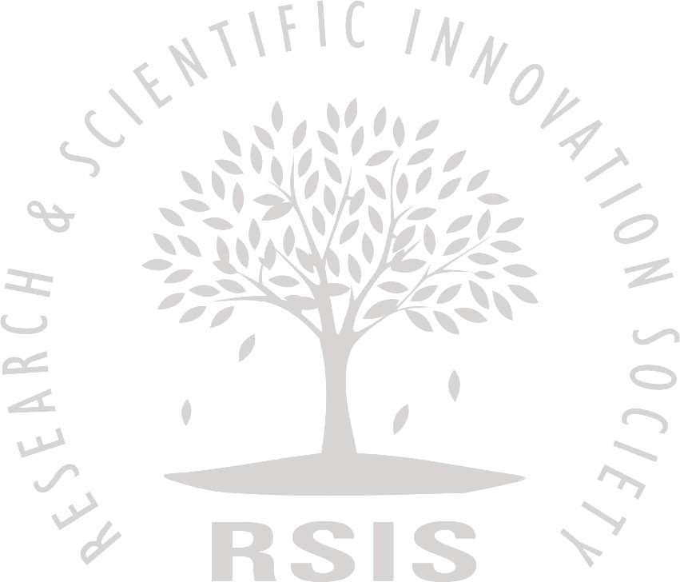
/ Supervisor / Research Committee before publishing our article with International Journal of Research and Scientific Innovation (IJRSI)
- I/We have not assigned copyright to publish this article to any other journal.
- I/ We fully understand the Terms and Conditions / Policies given or International Journal of Research and Scientific Innovation (IJRSI)
- Only I / We are responsible for impact / outcomes of this publication decision and I / We will not ask for refund or pursue any legal action against said personalities International Journal of Research and Scientific Innovation (IJRSI), India for the same.
- I / We confirm that we are satisfied with Authenticity / Validity / Originality of International Journal of Research and Scientific Innovation (IJRSI) and in case of refusal of our publication by our University / Institution / Employer / Project Guide / Supervisor / Research Committee, I / We will not ask for refund or pursue any legal action against said personalities or International Journal of Research and Scientific Innovation (IJRSI), India for the same.
- In case of a paper by multi-authored article, I/corresponding author have obtained permission to enter into agreement and assign copyright from all the co-authors, in writing and all the co-authors have thoroughly read and agreed with above warranties and authorization.
- I/We permit editors to publish the article in the journal or in any other means with editorial amendment, if any to make it suitable for publication. Further, I/We hereby assign copyright to the publisher for its publication in any form/language including all media, and exclusive right to use the matter for the life of the work. Publisher may assign its rights under this Agreement.
- I / We accept that in case of any Copyright Infringement claim being filed and proven against my / our published article in future, then International Journal of Research and Scientific Innovation (IJRSI), India have complete rights to remove my / our article from the index immediately without prior notice, and I / We will not ask for refund or pursue any legal action against said personalities or International Journal of Research and Scientific Innovation (IJRSI), India for the same.
- I/We agree to indemnify the Editors/Publisher of the journal against all claims or action arising from any breach of warranty on my/our behalf in this agreement.
- I / We are aware that International Journal of Research and Scientific Innovation (IJRSI), ISSN (Online): 2321-2705 is assigned by the National Science Library, New Delhi, India.
- I / We represent that I / We have taken the consent from our Co Authors before publishing our article with International Journal of Research and Scientific Innovation (IJRSI)
Name(s) of Author(s): CHERRY MAE B. ICAT and ALGER P. DURA

Unique Manuscript ID (UMI) of Manuscript: UMI: 12IJ09SIN18985

Title of Paper: ETHICAL LEADERSHIP AND POLITICAL BEHAVIOR IN A NATIONAL GOVERNMENT AGENCY AS PREDICTORS OF PERFORMANCE AMONG PUBLIC SECTOR EMPLOYEES: A SEQUENTIAL EXPLANATORY APPROACH

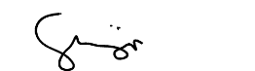
CHERRY MAE B. ICAT

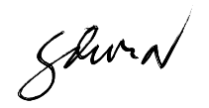
ALGER P. DURA

