Machine Learning for Antenna Design, Prediction, and Optimization: A Review
Idris Saadu Idris
Pan African University Institute for Basic Sciences, Technology and Innovation (PAUSTI), Nairobi, Kenya.
Idrissaad010@gmail.com. +2347036780737
ORCID: https://orcid.org/0000-0001-5202-6382
Abstract— Antenna design, prediction, and optimization have become increasingly important due to the growing complexity of modern wireless communication systems. Traditional design approaches, which rely on analytical models and iterative trial-and-error methods, are often time-consuming and may not yield optimal solutions, particularly for antennas with complex geometries and stringent performance requirements. To address these limitations, optimization techniques have been widely adopted in antenna engineering. These include single-objective optimization, which focuses on improving a specific parameter such as gain or bandwidth, and multi-objective optimization, which simultaneously considers multiple performance metrics like gain, bandwidth, efficiency, and isolation. However, conventional optimization algorithms often face challenges such as high computational cost, slow convergence, and limited effectiveness in handling high-dimensional and nonlinear design problems. Recent advancements in machine learning (ML) have introduced efficient alternatives for antenna design and performance prediction. ML-based methods, including surrogate models and deep learning techniques, enable rapid prediction of antenna characteristics while significantly reducing dependence on computationally expensive electromagnetic simulations. These approaches also enhance the exploration of large design spaces and improve optimization efficiency. This review highlights recent developments in antenna design, prediction, and optimization, with emphasis on the integration of ML techniques into both single- and multi-objective optimization frameworks. It discusses key methods, challenges, and future research directions, emphasizing the potential of intelligent and automated design strategies for next-generation wireless applications such as 5G and IoT.

Index Terms— AI, Machine Learning, Antenna Optimization, PSO, NSGA.

INTRODUCTION
Over the past few decades, machine learning (ML) has rapidly emerged as a powerful tool across many fields of science and engineering. Its ability to analyze large volumes of data, identify patterns, and automate complex tasks has transformed the way problems are approached in modern technology. Although ML is still a relatively developing field, it has already had a profound impact on several industries by providing innovative solutions and enabling new insights that were previously difficult to obtain. Recently, the influence of ML has begun to extend into the design and optimization of antennas. Traditional antenna design methods often require extensive simulations and iterative adjustments, which can be time-consuming and computationally demanding. With the advent of the Big Data era, machine learning techniques are increasingly being explored to address these challenges. By learning from existing data and simulation results, ML models can predict antenna behavior and assist in optimizing design parameters more efficiently. As a result, machine learning offers significant potential for accelerating the antenna design process while maintaining high levels of accuracy. This capability makes ML a promising approach for improving the performance and efficiency of modern antenna systems.
Antenna design and measurement is the process of creating an electromagnetic structure that can effectively transmit or receive signals in a specific frequency range [1–3]. Antenna design involves various optimization criteria, such as bandwidth, gain, radiation pattern, impedance matching, and others. Traditionally, antenna designs and measurements have been based on empirical and analytical methods, which can be time-consuming and computationally expensive [1–4]. Although the antenna optimization task is carried out efficiently using various Computational Electromagnetic (CEM) simulation tools. These existing tools consume more time and computing resources to solve the antenna optimization problems. Table 1 shows the various CEM tools and EM solver and their optimization limitation. Recently, Artificial Intelligence AI/Machine Learning ML (AI/ML) techniques have been applied to antenna design to optimize various designs & measurement criteria more efficiently and effectively compared to traditional methods [4-5].

Table 1: CEM tools and EM solver and their optimization limitation

S/No | Name of CEM Tool | Method of EM Solver | Limitations
1 | FEKO | MOM | Large antenna arrays are not suited
2 | CST | FEM, FIT, and TLM | TLM Execution time is large and enhanced with the size of the antenna structure
3 | HFSS | FEM, FDTD | Execution time is quite large and enhanced with the size of the antenna structure
4 | COMSOL | FEM, BOUNDARY ELEMENT  METHOD | Used for solving many time-domain problems, but particularly when the signals are narrowband
5 | SONNET | GTD | It can run very slowly
6 | MEEP | FDTD | It can solve simple geometries

Antenna design generally depends on full-wave electromagnetic (EM) simulation computer-aided design (CAD) software tools like HFSS, CST Microwave Studio, or FEKO, which implement techniques such as Finite Element Method (FEM), Finite-Difference Time-Domain (FDTD), or Method of Moments (MoM) [4-6].
Although accurate, the simulations are time-consuming, particularly for [6]:
• High-frequency designs (e.g., mmWave or THz antennas),
• Electromagnetically large structures,
• Sophisticated multi-parameter optimizations,
• Complete 3D models with dense meshing requirements.
The long computation times render iterative tuning and large-scale design space exploration virtually impossible. Traditional antenna design methods have numerous limitations, including inefficiency in exploring large design spaces, reliance on simplifying assumptions, time-consuming iterations, and difficulty managing complex structures and optimization goals. To overcome these challenges, researchers and engineers are turning to ML and optimization algorithms [7-8].
In [9], the study predicts two parameters, Diversity and Gain. XGB regression, several model including Nonparametric regression, Random Forest regression, Mars (Multivariate Adaptive regression splines) were used, among which Mars (Multivariate Adaptive regression splines) gives a high prediction accuracy, The ML models demonstrated strong predictive accuracy, achieving R² = 96.92%, explained variance score (EVS) = 97.58%, mean squared error (MSE) = 0.58%, root mean squared error (RMSE) = 7.63%, and mean absolute error (MAE) = 5.68%.
The implementation of various machine-learning techniques, including Extreme Gradient Boosting (XGB) regression, yielded outstanding outcomes. XGB achieved an R-squared value and variance scores of 98 %, demonstrating exceptional accuracy. It also showed minimal error rates in efficiency prediction, with a reassuringly low Mean Absolute Error (MAE) of 1.62 %, a Mean Squared Error (MSE) of 0.37 %, and a Root Mean Squared Error (RMSE) of 2.78 %. The antenna design is rigorously tested using CST and ADS simulation tools, confirming its superior performance compared to existing systems. The study explores multi-objective optimization, covering efficiency, bandwidth, and compactness, which are crucial for future wireless communication systems. This study highlights the potential of integrating THz technology with machine learning to enhance antenna design, presenting a novel framework for the evolution of future wireless networks with improved performance and energy efficiency [10].
In [11] Several ML models were used, among which are: Gradient Boosting Regressor, Extra Trees Regression, XGB Regression, Non- Parametric Regression, and Ridge Regression. XGB Regression gives the highest prediction accuracy. The ML models demonstrated strong predictive accuracy, achieving R² = 93.34%, explained variance score (EVS) = 93.91%, mean squared error (MSE) = 1.94%, root mean squared error (RMSE) = 13.93%, and mean absolute error (MAE) = 4.73%. These results validate the capability of ML to accelerate antenna design by minimizing iterative simulations. The combination of multi-band operation, high gain, strong isolation, and ML-assisted optimization makes the proposed antenna a promising candidate for next-generation THz systems, including short-range secure communications, low-power sensor networks, non-destructive testing, biomedical imaging, and ultra- fast 6G backhaul links.

Antenna design and dataset generation for machine learning training

Antenna design procedure
This section explains the step-by-step process for the antenna design, simulation, and dataset generation for Machine Learning training.
The antenna performances depend on several interrelated parameters, such as: Geometric attributes (size, length, width, thickness), Material properties (dielectric constant, conductivity), Boundary conditions, and feeding mechanisms [6].
The first step starts by designing the antenna based on the operating frequency or applications.
The design process of a patch antenna is achieved by using the equations designated for the purpose of designing a specific shape. Therefore, the equations for the width and length of the patch are shown in [7];

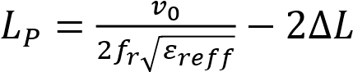 1.0
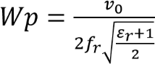 1.1
were,
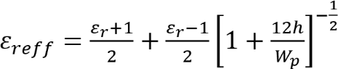 1.2
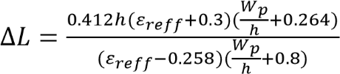 1.3
The dimensions of the substrate can be calculated by using the equations below [7];
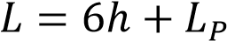 1.4
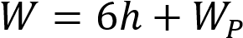 1.5
The dimension of the length of the transmission line is obtained by using the equations below [7];

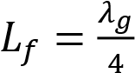 1.6
where,
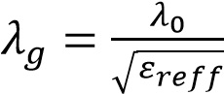 1.7
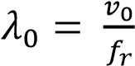 1.8
The dimension of the width of the transmission line is obtained by using the equations below [7];
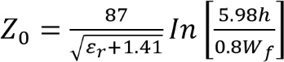 1.9

Simulation process
Antenna design generally depends on full-wave electromagnetic (EM) simulation computer-aided design (CAD) software tools like HFSS, CST Microwave Studio, or FEKO, which implement techniques such as Finite Element Method (FEM), Finite-Difference Time-Domain (FDTD), or Method of Moments (MoM) [6].

Dataset Generation for Machine Learning Training
Before training a model, a dataset must first be generated. These datasets will be generated by varying several antenna parameters, such as the length and width of the path, slot size, and antenna array in MIMO designs. ML, a subfield of artificial intelligence, enables systems to learn from data and improve without explicit programming, as shown in Fig. 1. By training algorithms on labeled datasets, they can recognize patterns, make predictions, and generalize to new, unseen data. This automation and predictive power can significantly enhance antenna design, leading to faster design cycles and improved performance. Combining ML with traditional methods pushes the boundaries of antenna performance and efficiency [8].
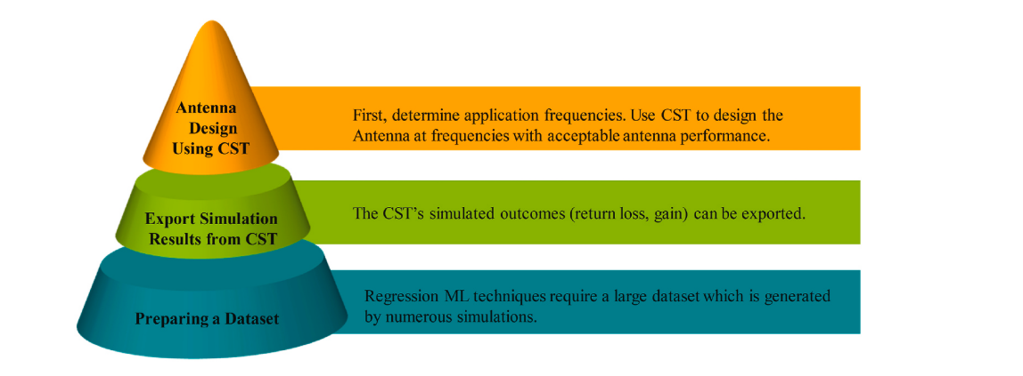
Fig 1: Data acquisition workflow for Machine Learning [9].
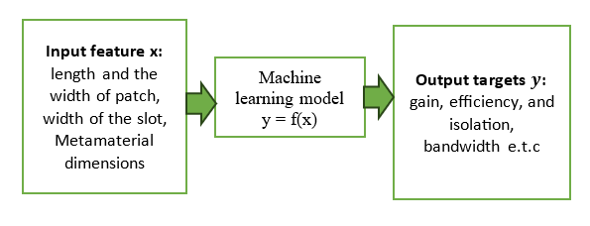
Fig 2: Input features and output target for the ML model

Fig 3: Dataset generation process for ML training [8]

[8] explain the step-by-step process to develop a Machine Learning model to predict and optimize the return loss of antenna designs, specifically targeting multi-band or wideband performance for IoT applications.
To predict return loss using ML, a model must first be trained. The dataset is generated by varying the lengths of La,
Wa and Wb, which act as input features for the ML algorithms, along with frequency. La ranges from 9 to 12 mm in 1 mm increments, Wa ranges from 7 to 11 mm in 1 mm increments, and Wb ranges from 0.25 to 1 mm in 0.25 mm increments, as per these design parameter variations. Each antenna design is simulated in HFSS, generating return loss values over frequencies from 1 to 20 GHz, divided into 451 points. This process results in a dataset of 36,080 values.
The figure below explains the design process for the dataset generation [8].

Fig 4: Dimension of the antenna design steps [8]

Fig 5: Antenna parameters [8]

After dataset generation, the next step is to train the model. The flowchart in Figure 1, below, explains the steps to follow for the ML Training. The first thing after generating the dataset is to create a clean the dataset using Exploratory data analysis and pre-processing, then the dataset will be divided into two depending on the availability of your data, but if you want your model to perform well you must have a big dataset, the dataset will be divided in to training dataset and testing dataset, on the training dataset side multiples models are screened, the best one is selected and optimized through cross-validation and hyper-parameter turning, then retrained on full training data and finally evaluated using unseen test data to produce an optimal model. Cross-validation and hyperparameter tuning are used to avoid overfitting. The model interpretation (Feature importance, Partial dependence Plots PDP, and Shapley Additive explanation SHAP) will help us to avoid “black box”, the ML model selected best on the performance metric such as the MSE, RMSE, R², and then the best model will be deployed for the prediction and optimization.
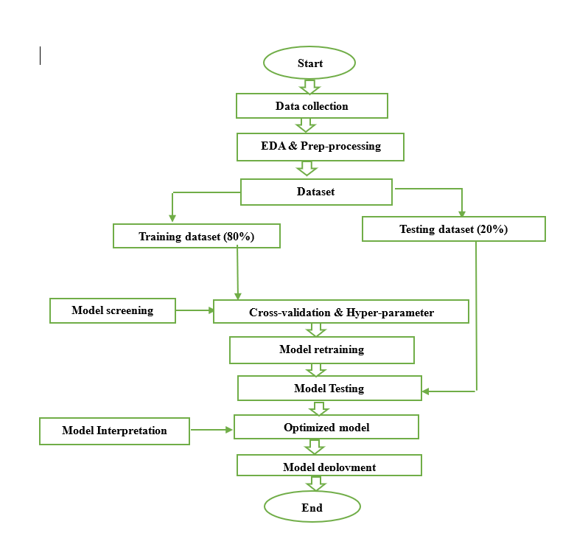
Figure 6: Steps for the machine learning optimization and prediction
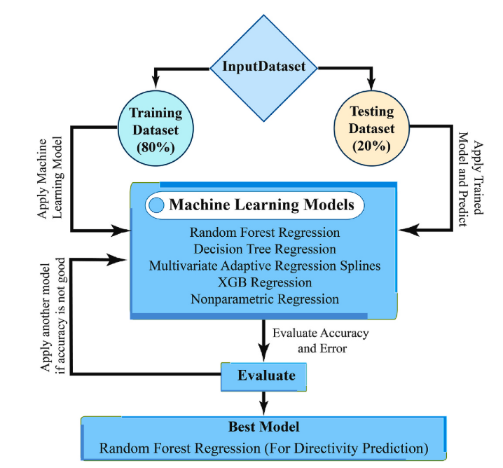
Fig. 7: Diagram illustrating the stages involved in creating machine learning [9].

Overview of the ml and dl algorithms for antenna design and prediction
Artificial Intelligence (AI) encompasses several advanced computational techniques, among which Machine Learning (ML) and Deep Learning (DL) are important subsets. These approaches enable systems to learn patterns from data and make intelligent decisions without explicit programming. In the field of antenna engineering, various ML and DL algorithms have been applied to support tasks such as antenna design, performance prediction, optimization, and model selection, helping to improve efficiency and accuracy in the development process. The figure below shows the overview of the
Figure 8: Association toward AI, ML, and DL [8]
- Supervised Learning (SL)
In a supervised learning model, the computer learns from a labeled dataset in order to generate predicted responses to new input. Regression and classification are two forms of supervised learning techniques. In the classification task, a model is trained using the learning algorithm on a set of samples and their corresponding labels. Once trained, the model should be able to classify any unseen data into one of the labels. The regression algorithm's goal is to discover the mapping function that will transfer input variables (x) to a continuous output variable (y). There are many supervised learning algorithms proposed in the literature. Figure 5 shows a categorization of supervised learning algorithms along with their suitability for different applications.
- Unsupervised Learning (UL)
An unsupervised learning algorithm uses an unlabeled dataset to train the model, attempting to make sense of it by extracting features, co-occurrence, and underlying patterns in the data. In many cases, the labeling of data may not be available or costly, and unsupervised learning overcomes this issue by learning from data and classifying them without the use of labels. Unsupervised learning is quite useful for detecting patterns in data that are not visible using traditional methods [8-12].
- Reinforcement Learning (RL)
Reinforcement learning (RL) is a sort of ML in which a model learns how to behave in a given environment by executing actions and assessing the outcomes [8-12].
- Artificial Neural Networks
The ANNs are computational neural networks that are capable of performing the same tasks as the human brain. Based on their learning characteristics, ANNs may be grouped into three types. These include the supervised neural network, the unsupervised neural network, and the reinforcement neural network [8-12].

- DL Algorithm
DL is a sort of technology that models the neural network of the brain. Connected layers are utilized to develop DL algorithms. The input layer is the initial layer in DL, whereas the output layer is the last layer. Hidden layers consist of all the intermediate layers. The weight, bias, and activation function all impact the signal strength transmitted to the neuron in the subsequent layers. There are two learning stages in DL. In the first stage, the input data are subjected to a nonlinear transformation, and a statistical model is generated; in the second stage, the model is enhanced via a mathematical process known as derivative. These two procedures are performed hundreds to thousands of times until the neural network reaches an acceptable level of accuracy [8-12].
Some of the supervised ML used for the prediction and optimization of an antenna are;
XGB regression
In the realm of machine learning, XGBoost, or Extreme Gradient Boosting, is a popular and highly efficient tool. Whether you’re trying to predict something or categorize it, this method can help. XGBoost is a potent technique for developing supervised regression models [9-14].
Nonparametric regression
Nonparametric regression is a widely applicable methodology as it does not necessitate the specification of a specific functional form for the relationship between variables. Instead, the approach uses techniques like kernel smoothing or local polynomial fitting to approximate the underlying distribution of the data. This enables the modeling of intricate interactions in a more adaptable manner, without relying on pre- existing knowledge [9-14].
Random forest regression
Random Forest Regression is a way to use machine learning to classify and track changes over time. This method might be useful [48]. It adds to Random Forest, a way of sorting things into groups. It was made to do that. Random Forest Regression is a useful method for predicting many things, and it can be used to guess a continuous output variable. Random Forest Regression predicts output factors that are always the same [9-14].
Mars (Multivariate Adaptive regression splines)
A regression method called MARS can handle relationships that aren’t linear by breaking the input space into segments and fitting simple linear functions, or splines, into each section. It automatically chooses the important variables and breaks to make a piecewise linear approximation of the goal function, which lets you model in a way that is both easy to understand and powerful [9-14].
Performance measurement metrics
This part of the study explains the performance metric for the model selection. The best model will be selected based on these parameters; the one with the highest values is always selected as the best model. These performance metrics are: Mean Absolute Error (MAE), Mean Squared Error (MSE), Root Mean Squared Error (RMSE), R-squared (R2), and Explained Variance Score (Var Score) are some of the statistical metrics that are used to determine the models’ performance [9-14].
Mean Absolute Error (MAE) is a statistic that is used to assess the predictive model’s accuracy. It is widely used to evaluate a model’s ability to correctly forecast future values. To get MAE, we simply average the absolute value of the discrepancies between our forecasts and observations [9-14].
$MAE=\frac{1}{n}\sum_{i=1}^{n}{\left|β_{A}-β_{P}\right|}$ 2.1
Where n = number of errors$\left|β_{A}-β_{P}\right|$= error absolute
When conducting regression analysis, the Mean Squared Error (MSE) is yet another well-known measure that is used for the purpose of determining how accurate a prediction model is. Specifically, the average squared deviation is calculated by it among forecasted and observed values. By squaring the deviations, MSE provides more weight to larger errors than Mean Absolute Error (MAE) [9-21].

$MSE=\frac{1}{n}\left[\sum_{i=1}^{n}{{\left(β_{A}-β_{P}\right)}^{2}}\right]$ 2.2

The Root Mean Squared Error (RMSE) is a popular statistic for ${\left(β_{A}-β_{P}\right)}^{2}$
measuring the quality of a regression model’s predictions. It is calculated from the Mean Squared Error (MSE) and gives a measure of the typical size of the discrepancy between projected and actual values, expressed in the same units as the original data [9-14]. RMSE, or Root Mean Squared Error, is calculated as follows:
$RMSE=\sqrt{\frac{1}{n}}\sum_{i=n}^{n}{{\left(β_{A}-β_{P}\right)}^{2}}$ 2.3
As a statistical metric, R-squared (R2) specifies how much of the total ${\left(β_{A}-β_{P}\right)}^{2}$
alteration in the dependent variable can be attributed to the independent variables [9-21]. The coefficient of determination is a simple measure of the predictive power of the independent variable(s) over the dependent variable. The value of R2 can range from 0 % to 100 %.

$R^{2}=1-\frac{\sum_{i}^{n}{{\left(β_{A}-β_{P}\right)}^{2}}}{\sum_{i}^{n}{{\left(β_{P}-α\right)}^{2}}}$ 2.4
A statistic known as the Variance Score calculates how much of the total variance can be attributed to the model [9-21]. It is analogous to the R-squared statistic, except its value is scaled between 0 % and 100 %.
Where $β_{P}$ and $β_{A}$ represent the predicted values and actual values, respectively, $α$ indicates the average of the data, and n represents the number of data points [9-22].
In summary
The antenna design process begins with the conceptualization, design, and simulation of a microstrip antenna using electromagnetic simulation tools such as CST, HFSS, or ANSYS. After the initial design, the antenna performance is evaluated and refined through iterative adjustments when necessary. A dataset is then generated by varying key design parameters and operating frequencies. The data is pre-processed through normalization, feature engineering, and augmentation to improve its quality for analysis.
Python libraries such as NumPy, Pandas, and Matplotlib are used for data processing and machine learning implementation, with coding performed in Google Colab. The dataset is divided into training (80%) and testing (20%) sets. The training data is used to develop machine learning models, including Decision Tree, Random Forest, Artificial Neural Network (ANN), K-Nearest Neighbors (KNN), Extra Trees, CatBoost, Gradient Boosting, and XGBoost, etc., to predict the antenna performance metrics such as gain, efficiency, radiation pattern, isolation, and bandwidth, etc. Finally, the models are evaluated using performance metrics such as R², Mean Squared Error (MSE), Mean Absolute Error (MAE), Mean Absolute Percentage Error (MAPE), fitting time, and prediction time, after which the most suitable model is selected for the prediction [30-35].
Surrogate modeling is one of the most widely used machine learning applications in antenna design. Instead of repeatedly performing full-wave electromagnetic simulations, which are computationally expensive and time-consuming, machine learning models are trained using previously generated simulation data to predict the antenna’s performance. By learning the relationship between design parameters and simulation outputs, these surrogate models can quickly estimate results, significantly reduce computational cost, and accelerate the antenna design and optimization process.
Some of the Regression ML used for the prediction and optimization of an antenna are;

Optimization of the antenna
Although several hyperparameter optimization techniques exist, this study focuses on three of the most commonly used methods for screening purposes. This study will review single and multi-objective optimization problems, including Particle Swarm Optimization (PSO) and genetic algorithm–based approaches, such as the Non-dominated Sorting Genetic Algorithm (NSGA) [40-45].
Multi-objective optimization problem extends this to problems with multiple conflicting objectives, where there's no single optimal solution but a set of trade-off solutions known as the Pareto front (or Pareto-optimal set). The goal is to find a diverse set of non-dominated solutions that approximate this front. A solution A dominates B if A is better in at least one objective and not worse in others.
PSO is an iterative optimization technique in which each potential solution, known as a particle, moves within the search space by updating its position based on its own best-known solution and the best solutions found by other particles in the swarm. Due to its simplicity, ease of implementation, and the fact that it does not require gradient information, PSO has become a widely used method for solving complex optimization problems [40-45].

Non-dominated Sorting Genetic Algorithm (NSGA) is a population-based evolutionary optimization algorithm used to solve multi-objective optimization problems, where more than one objective must be optimized simultaneously. It is particularly useful in engineering applications such as antenna design, where objectives like gain, bandwidth, efficiency, and isolation may need to be optimized at the same time. The NSGA is of three types: NSGA-I, for single optimization, NSGA-II, for 2-3 conflicting metric parameters, and NSGA-III, for 4-above conflicting parameters [40-45].
The optimization process utilizes either single-objective optimization or multi-objective optimization PSO (MOPSO), depending on the number of parameters to be optimized. To identify the optimal set of antenna parameters that maximizes the combined score of coverage area and efficiency. The objective function is defined as the negative sum of the predicted coverage and efficiency values from the ANN models, as PSO aims to minimize the objective function. In PSO, a swarm of particles explores the search space, where each particle represents a potential solution with specific parameter values. The particles adjust their positions based on their individual experiences and the global best-known position, updating their velocities and positions iteratively. The PSO algorithm converges to the optimal set of parameters that maximizes the objective function, which in this case, are the antenna parameters that achieve the highest coverage and efficiency [40].
Objective function:
F(params) = - (predicted_coverage + predicted efficinecy)
Params = (Antenna_Angle, Signal_Strength, Interference_Level, Data_Speed)
Now, PSO iterates over all parameters and adjusts the weights. And the velocity will be updated based on equations (3.1), and the positions of the antenna are updated with equations (3.2).

𝑣_{𝑖}(𝑡+1) = 𝑤. 𝑣𝑖(𝑡)+ 𝐶₁. 𝑅₁(𝑃_{𝑖} (𝑡)− 𝑥_{𝑖}(𝑡)) + 𝐶₂. 𝑅₂(𝑔(𝑡)−𝑥_{𝑖}(𝑡)) 3.1
𝑥_{𝑖}(𝑡+1) = 𝑥_{𝑖}(𝑡) + 𝑣_{𝑖}(𝑡+1) 3.2

Where:
𝑣_{𝑖}(𝑡) is the velocity of particle i at time t
𝑥_{𝑖}(𝑡) is the position of particle i at time t
w is the inertia weight
𝑐₁ 𝑎𝑛𝑑 𝑐₂ are cognitive and social coefficients
𝑟₁ 𝑎𝑛𝑑 𝑟₂ are random numbers between 0 and 1
𝑝_{𝑖}(𝑡) is the best-known position of particle i
𝑔(𝑡) is the global best-known position

Multi-Objective Function Formulations of Antenna Design
This work proposed a method that targets two objective functions: (1) the reflection coefficient and (2) the size of the radiating patch of antennas. The multi-objective optimization problem is defined by [41]

$$Minimize F \left(x\right)={\left[f_{1}\left(x\right){,f}_{2}(x)\right]}^{T}$$
$$s.t g_{j}\left(x\right)≤0, j=1, 2,…., J,$$
$h_{i}\left(x\right)=0,i=1, 2,….,L$ 3.3

where x = Z_{L}=[Z_{L1}, Z_{L2},…, Z_{LN}] represents the vector of the states for all internal ports, in which “0” represents “open” and “1” represents “short”. J represents the number of inequality constraints, and L is the number of equality constraints. f₁(x) is the objective function related to antenna radiation size. F₂(x) is the objective function related to the reflection coefficient of the antenna. The first objective function is to minimize the working radiation area of the antenna.

$f_{1}=C \left(x\right).R(x)$ 3.4

where C and R (x) are the length of working rows and columns, respectively.
The second objective function is to minimize the S11 of the working frequency band, which is defined by

$f_{2}(x)= \max_{ω}{{\left|S_{11}(x, ω)\right|}_{dB}}$ 3.5
Where; ${\left|S_{11}(x, ω)\right|}_{dB}$ refers to the reflection coefficient in dB. $ω$ represents the antenna operating frequency.

Performance-constrained NSGA-II algorithm
This study proposed a multi-objective optimization algorithm, called Performance-Constrained NSGA-II (PC-NSGA-II), designed to address the multi-objective optimization challenge outlined in Equation (3.3). The PC-NSGA-II algorithm is based on a low computational cost multi-port model, so we use the traditional NSGA-II to perform optimization. The PCNSGA-II algorithm not only provides a Pareto frontier where two objectives mutually constrain each other. And all solutions within the resulting Pareto front meet the requirement of a reflection coefficient below -10dB. In the PCNSGA-II algorithm, performance constraints are added to the selection operation of the NSGA-II algorithm. Once the algorithm reaches a predefined iteration threshold, individuals exhibiting reflection coefficients that fail to meet the specified specification are downgraded to the lowest priority level. Consequently, every solution within the optimized Pareto front meets the design specification, enabling its application for fabrication. The specific steps of the proposed PC-NSGA-II method are outlined as follows [41]:
Step 1: Establish the initial antenna structure and obtain the multi-port network model of the antenna.
Step 2: Formulate the objective functions of the size of antenna (as Eq. (3.4)) and the reflection coefficient (as Eq. (3.5)).
Step 3: Set the population size, the total number of iterations, and the number of iterations for adding performance constraints, and relevant parameters for crossover and mutation operators.
Step 4: Generate the initial population accordingly.
Step 5: Conduct non-dominated sorting and crowding distance calculation on the population to establish its hierarchical structure.
Step 6: Perform selection, crossover, and mutation operations.
Step 7: If the predefined iteration threshold for adding performance constraints is reached, downgrade any solution with a reflection coefficient exceeding -10 dB to the lowest priority level. Otherwise, proceed to the next step.
Step 8: Perform elite selection to identify a predetermined number of outstanding individuals.
Step 9: If the total number of iterations is met, preserve the Pareto front. Otherwise, go to Step 3.3.

Table 2: Emerging opportunities and open research challenges in the application of AI and ML for advanced antenna design.

Ref | Research Area | AI/ML Role | Benefits | Challenges/Future Directions
[39, 55] | Array Optimization | ML optimizes element spacing, configuration,  and gain in antenna arrays | Efficient, personalized array design,  cost savings | Application-specific tuning, high  integration with hardware and other  technologies
[50, 56] | EMC Optimization | Neural networks, GA optimize antennas  for reduced interference and  improved electromagnetic compatibility | Avoids interference, ensures coexistence  in complex environments | Need for large data, application specificity,  real-time design support
[42, 54] | Geometry Optimization | Neural networks, Genetic algorithms  optimize antenna shapes and structures | Improved performance, efficiency,  personalization | Focus on specific applications,  increased automation, integration  with emerging tech
[40, 54] | Data Quality & Availability | Quality training data crucial for generalization | Drives model performance and real-world  Applicability | Synthetic data, data augmentation,  transfer learning to compensate for  data gaps
[43, 49] | Non-linear Optimization | AI/ML tackles non-linear relationships  in antenna parameters using NN,  PSO, GA | Handles complex systems, reduces  time and cost | Expanding model robustness, automation,  hybrid model integration

Table 3: A comparative analysis of existing literature on diverse machine learning–based optimization techniques.

Ref | Antenna Type Used | ML/AI method used | Optimization Achieved
[38] | Microstrip antennas | DNN | The relative RMS error with 800 training  sample is 6.1%
[41] | Cavity-backed slot antenna | PSO | Achieved a 15% performance improvement  and a maximum gain of 8.8 dBi with  reduce size
[51] | Printed monopole dual-port MIMO  Antenna | PSO | Achieved −56.41 dB resonance at 2.45  GHz, attaining 0.6 dBi peak gain and  improved isolation
[48] | Wire antennas | GA | 17 elements and  length of 4.881 λ, had a gain 0.4 dB  greater
[44] | Microstrip antennas | Support Vector Regression (SVR) | Improved gain and minimized prediction  Errors
[52] | MU-MIMO systems | ABC | Achieved 98–99% system throughput  with reduced computation complexity  and runtime
[53] | Multiband inverted E and U-shaped  Antenna | Decision Tree and Random Forest | RF model designed for multiband antennas  operating in t
[45] | Dual Band Patch antenna | GA | Achieved in 200 iterations,43 h. with fitness  parameter α = 0.7
[46] | Microstrip Patch Antenna | GA | Achieved at 67.5 s. cost function with the  overhead of 2.5 × 10 < sup > −5 </sup  > %
[47] | CPW-fed circularly polarized antenna | GA + Evolution Strategy | Axial Ratio is 2.96 dB at 2.45 GHz. Return  Loss ≤ −10 dB in BW

discussion and conclusion
This study has reviewed the growing role of Artificial Intelligence (AI) in the field of antenna engineering. It examined various Machine Learning (ML) and Deep Learning (DL) algorithms that can be applied to antenna design, optimization, and antenna selection. The study also discussed ML/DL-based antenna design procedures integrated with electromagnetic simulators such as CST, HFSS, and FEKO, highlighting how these tools can support intelligent and data-driven antenna development.
It explained a well-understandable step-by-step process for ML design and optimization of an antenna, from scratch, i.e., from the design process, data collection, ML model training, selecting the best model, and applying it for the design and optimization in antenna applications.
In addition, several antenna optimization approaches were explored, including parallel optimization, single-objective and multi-objective optimization, variable-fidelity optimization, and multilayer ML-assisted optimization. The review further presented the application of ML/DL techniques in intelligent antenna selection for wireless communication systems, emphasizing their capability to enhance system performance.
Since AI-driven antenna design relies heavily on data, the study also outlined the step-by-step procedure for generating datasets using FEKO, which is essential for training reliable ML/DL models. At the same time, the review addressed the challenges associated with implementing AI in antenna engineering, such as data requirements, computational complexity, and model generalization.
Overall, the findings demonstrate that the integration of ML and DL techniques can significantly accelerate the antenna design process while maintaining high accuracy, reducing design errors, and minimizing computational time. These approaches also enable effective prediction of antenna behavior, improved computational efficiency, and a reduction in the number of required simulations.
Therefore, the insights provided in this review will be valuable for researchers and engineers seeking to explore AI-driven methods for antenna design, optimization, and selection in wireless communication systems, particularly in addressing multi-objective optimization challenges were improving one antenna parameter may negatively affect another.

References
[1] P. A. Gajbhiye, S. P. Singh, and M. K. Sharma, A comprehensive review of AI and machine learning techniques in antenna design optimization and measurement, vol. 2, no. 1. Springer International Publishing, 2025. doi: 10.1007/s44291-025-00084-9.
[2] D. Mair, M. Fischer, J. Konzilia, M. Renzler, T. Ussmueller, and S. Member, “Evolutionary Optimization of Antennas for Structural Health Monitoring,” no. January, pp. 4905–4913, 2023.
[3] L. Lizzi, F. Viani, R. Azaro, and A. Massa, “Optimization of a Spline-Shaped UWB Antenna by PSO,” vol. 6, pp. 182–185, 2007.
[4] E. Balevi and J. G. Andrews, “Online Antenna Tuning in Heterogeneous Cellular Networks with Deep Reinforcement Learning,” pp. 1–32.
[5] S. K. Goudos, S. Member, K. Siakavara, and N. John, “Bee Colony Optimization for UHF RFID Applications,” no. c, pp. 1–4, 2014.
[6] C. Engineering, “MACHINE LEARNING FOR ANTENNA DESIGN OPTIMIZATION :,” pp. 263–276, 2025, doi: 10.5281/zenodo.15845037.
[7] M. S. Rana, S. Hossain, S. B. Rana, and M. M. Rahman, “Microstrip patch antennas for 66
various applications: a review,” 2023. doi: 10.11591/ijeecs.v29.i3.pp1511-1519.
[8] R. Jain, R. R. Vandana, and V. Thakare, “Design and analysis of antenna through machine learning for next ‑ generation IoT system,” Discov. Internet Things, 2025, doi: 10.1007/s43926-025-00126-4.
[9] M. A. Haque et al., “Machine learning-based technique for directivity prediction of a compact and highly efficient 4-port MIMO antenna for 5G millimeter wave applications,” Results Eng., vol. 24, no. August, p. 103106, 2024, doi: 10.1016/j.rineng.2024.103106.
[10] M. S. Ahammed, R. A. Ananta, J. J. Tiang, M. Nahas, N. S. S. Singh, and M. A. Haque, “A high-gain THz microstrip patch antenna designed for IoT and 6G communications with predicted efficiency using machine learning approaches,” e-Prime - Adv. Electr. Eng. Electron. Energy, vol. 13, no. June, p. 101058, 2025, doi: 10.1016/j.prime.2025.101058.
[11] A. Haque et al., “Diamond & Related Materials High-performance terahertz MIMO antenna for 6G : Graphene integration and machine learning prediction,” Diam. Relat. Mater., vol. 161, no. September 2025, p. 113182, 2026, doi: 10.1016/j.diamond.2025.113182.
[12] A. Haque et al., “Results in Optics Regression machine learning methods for isolation prediction and massive gain broadband MIMO antenna design for 28 GHz applications,” vol. 21, no. May, 2025.
[13] M. A. Haque et al., “Predictive modelling and high-performance enhancement smart thz antennas for 6 g applications using regression machine learning approaches,” Sci. Rep., vol. 15, no. 1, pp. 1–27, 2025, doi: 10.1038/s41598-025-18458-0.
[14] M. A. Haque et al., “Machine learning-based novel-shaped THz MIMO antenna with a slotted ground plane for future 6G applications,” Sci. Rep., vol. 14, no. 1, pp. 1–27, 2024, doi: 10.1038/s41598-024-79332-z.
[15] S. In and S. Learning, “Types of Machine Learning,” pp. 1–13, 2025.
[16] M. Learning, “SC02 - Antenna Design using Optimization and Machine Learning Abstract : Recommended pre-requisites : Learning Objectives : SC02 - Antenna Design using Optimization and Machine Learning Course Outline : Instructors :,” no. Ml.
[17] H. M. El Misilmani, “A review on the design and optimization of antennas using machine learning algorithms and techniques,” no. January, pp. 1–28, 2020, doi: 10.1002/mmce.22356.
[18] “Machine Learning-assisted Antenna Design Optimization : A Review and the State-of-the-art,” no. August, pp. 15–20, 2020, doi: 10.23919/EuCAP48036.2020.9135936.
[19] Y. Tong, “Machine learning-based theoretical optimization of antenna design,” vol. 27, pp. 681–690, 2022.
[20] S. Rana, S. R. Islam, S. Sarker, and R. Rt, “Results in Engineering Machine learning based on patch antenna design and optimization for 5 G applications at 28GHz,” Results Eng., vol. 24, no. October, p. 103366, 2024, doi: 10.1016/j.rineng.2024.103366.
[21] J. K. Rai et al., “Machine learning driven design and optimization of a compact dual-port CPW-fed UWB MIMO antenna for wireless communication,” pp. 1–13, 2025.
[22] A. A. Adeleke, J. A. Okolie, C. C. Ogbaga, P. P. Ikubanni, P. U. Okoye, and O. Akande, “Machine Learning Model for the Evaluation of Biomethane Potential Based on the Biochemical Composition of Biomass,” no. 0123456789, 2023.
[23] M. S. Yahya, S. Soeung, S. K. A. Rahim, U. Musa, S. S. Ba Hashwan, and M. A. Haque, “Machine Learning-Optimized Compact Frequency Reconfigurable Antenna With RSSI Enhancement for Long-Range Applications,” IEEE Access, vol. 12, pp. 10970–10987, 2024, doi: 10.1109/ACCESS.2024.3355145.
[24] M. A. Haque et al., “Machine learning-based technique for directivity prediction of a compact and highly efficient 4-port MIMO antenna for 5G millimeter wave applications,” Results Eng., vol. 24, no. August, p. 103106, 2024, doi: 10.1016/j.rineng.2024.103106.
[25] M. A. Haque et al., “Performance improvement of THz MIMO antenna with graphene and prediction bandwidth through machine learning analysis for 6G application,” Results Eng., vol. 24, no. August, p. 103216, 2024, doi: 10.1016/j.rineng.2024.103216.
[26] A. Haque et al., “Diamond & Related Materials High-performance terahertz MIMO antenna for 6G : Graphene integration and machine learning prediction,” Diam. Relat. Mater., vol. 161, no. September 2025, p. 113182, 2026, doi: 10.1016/j.diamond.2025.113182.
[27] M. A. Haque et al., “Machine learning-based technique for gain prediction of mm-wave miniaturized 5G MIMO slotted antenna array with high isolation characteristics,” Sci. Rep., vol. 15, no. 1, pp. 1–21, 2025, doi: 10.1038/s41598-024-84182-w.
[28] R. A. Ananta et al., “Regression machine learning-based highly efficient dual band MIMO antenna design for mm-Wave 5G application and gain prediction,” Sci. Rep., vol. 15, no. 1, pp. 1–27, 2025, doi: 10.1038/s41598-025-13514-1.
[29] M. M. Alam et al., “Machine learning-based dual-band circular MIMO antennas for high-performance 6 G IoT system,” Results Eng., vol. 28, no. October, p. 108107, 2025, doi: 10.1016/j.rineng.2025.108107.
[30] M. A. Haque et al., “Multiband THz MIMO antenna with regression machine learning techniques for isolation prediction in IoT applications,” Sci. Rep., vol. 15, no. 1, pp. 1–23, 2025, doi: 10.1038/s41598-025-89962-6.
[31] J. H. Nirob et al., “High-performance grid-structured MIMO antenna with regression machine learning for high-speed sub THz and THz 6G IoT applications,” Sci. Rep., vol. 15, no. 1, pp. 1–25, 2025, doi: 10.1038/s41598-025-15773-4.
[32] P. Kavitha and A. Thatikonda, “Optimizing antenna placement and angles for maximizing coverage and efficiency using PSO,” vol. 10, no. 2017, pp. 799–807, 2025.
[33] H. Wang, Q. Yang, H. Wang, and X. Peng, “Performance-Constrained Multi-Objective Optimization of Antennas for Miniaturization Design Performance - Constrained Multi - Objective Optimization of Antennas for Miniaturization Design,” pp. 0–7, 2024.
[34] N. Jin and Y. Rahmat-samii, “Review Article Particle Swarm Optimization for Antenna Designs in Engineering Electromagnetics,” vol. 2008, 2008, doi: 10.1155/2008/728929.
[35] J. Dong, Q. Li, and L. Deng, “Fast Multi-Objective Optimization of Multi-Parameter Antenna Structures Based on Improved MOEA / D with Surrogate-Assisted Model 1 INTRODUCTION”.
[36] M. H. Boulaich, S. Ohamouddou, and M. A. Ennasar, “Constrained Multi-Objective Genetic Algorithm Variants for Design and Optimization of Tri-Band Microstrip Patch Antenna loaded CSRR for IoT Applications : A Comparative Case Study arXiv : 2601 . 17513v1 [ cs . NE ] 24 Jan 2026,” vol. 11.
[37] Z. Ma and J. Liu, “An Improved NSGA-II Algorithm for Multi-Objective Optimization of Irregular Polygon Patch Antennas,” pp. 1–22, 2025.
[38] Al-Eryani Y, Akrout M, Hossain E. Antenna clustering for simultaneous wireless information and power transfer in a MIMO full-duplex system: a deep reinforcement learning-based design. IEEE Trans Commun. 2021;69(4):2331–45.
[39] Zhang J, Akinsolu MO, Liu B, Zhang S. Design of zero clearance SIW endfire antenna array using machine learning-assisted optimization. IEEE Trans Antennas Propag. 2021;70(5):3858–63.
[40] Gecgel S, Goztepe C, Kurt GK. Transmit antenna selection for large-scale MIMO GSM with machine learning. IEEE Wirel Commun Lett. 2019;9(1):113–6.
[41] Guo J, Chen Z, Ban Y-L, Kang Y. Precise enumeration of circulating tumor cells using support vector machine algorithm on a microfluidic sensor. IEEE Trans Emerg Top Comput. 2014;5(4):518–25.
[42] Villegas FJ, Cwik T, Rahmat-Samii Y, Manteghi M. A parallel electromagnetic genetic-algorithm optimization (EGO) application for patch antenna design. IEEE Trans Antennas Propag. 2004;52(9):2424–35.
[43] Aleksander M, Pohrebennyk V. Synthesis and optimization of neural network parameters for control non-linear objects, 2014.
[44] Tokan NT, Gunes F. Support vector characterisation of the microstrip antennas based on measurements. Prog Electromagn Res B.2008;5:49–61.
[45] Shi D, Lian C, Cui K, Chen Y, Liu X. An intelligent antenna synthesis method based on machine learning. IEEE Trans Antennas Propag. 2022;70(7):4965–76.
[46] Ren Z, Zhang Z, Wei J, Dong B, Lee C. Wavelength-multiplexed hook nanoantennas for machine learning enabled mid-infrared spectroscopy. Nat Commun. 2022;13(1):3859.
[47] Boozari M, Yasi N, Khalaj-Amirhosseini M. Application of different learning methods for arrays sensitivity analysis with uncertain excitation and location tolerances. AEU - Int J Electron Commun. 2022;157: 154423.
[48] Zhou Y, Liu Y, Wang N, Han X, Li J. Partial discharge ultrasonic signals pattern recognition in transformer using BSO-SVM based on microfiber coupler sensor. Measurement. 2022;201: 111737.
[49] Sagar MSI, et al. Application of machine learning in electromagnetics: mini-review. Electronics. 2021;10(22):2752.
[50] Singh SP. A novel approach to calculate the deftness and suitability factor of thermoelectric generator using thermodynamic state. Int J Electron Commun Technol. 2012;3(1):39–42.
[51] Bao N, et al. Wi-Breath: a WiFi-based contactless and real-time respiration monitoring scheme for remote healthcare. IEEE J Biomed Heal Inform. 2022. https:// doi. org/ 10. 1109/ JBHI. 2022. 31861 52.
[52] Kaya Keleş M. Breast cancer prediction and detection using data mining classification algorithms: a comparative study. Teh Vjesn. 2019;26(1):149–55.
[53] Li Q, et al. A portable microwave intracranial hemorrhage imaging system based on PSO-MCKD-CEEMDAN method. IEEE Trans Microw Theory Tech. 2022. https:// doi. org/ 10. 1109/ TMTT. 2022. 32013 76.
[54] Singh SP, Gupta S, Rajapakse JC. Sparse deep neural network for encoding and decoding the structural connectome. IEEE J Transl Eng Heal Med. 2024;12:371–81.
[55] Patnaik A, Choudhury B, Pradhan P, Mishra RK, Christodoulou C. An ANN application for fault finding in antenna arrays. IEEE Trans Antennas Propag. 2007;55(3):775–7.
[56] Urooj S, Singh SP. Computer-aided detection of breast cancer using pseudo zernike moment as a texture descriptor. In: Computer Society of India, 2016.

Authors and Affiliations


Idris Saadu Idris is an Electrical Engineer, researcher, and academic with expertise in Telecommunications and Wireless communication systems. He is currently pursuing a PhD in Electrical Engineering (Telecommunications) at the Pan-African University Institute for Basic Sciences, Technology and Innovation (PAUSTI) hosted at Jomo Kenyatta University of Agriculture and Technology in Nairobi, Kenya. His research focuses on Reconfigurable antennas, MIMO antenna systems, wireless communications, Machine Learning applications in antenna design, fiber-optic communication, and renewable energy systems. He obtained a Master of Engineering, Electrical Engineering (Communication) from Bayero University, Kano, Nigeria. He also holds a Bachelor of Engineering in Electrical Engineering from Kano University of Science and Technology, Wudil, now Aliko Dangote University of Science and Technology, Wudil, Nigeria. Idris has extensive professional and academic experience. He currently works as a Senior Engineer at the Federal Capital Development Authority (FCDA), Nigeria, and serves as a Consultant Engineer with IBAAB International Nigeria Limited. In addition, he has lectured part-time at Binyaminu Usman Polytechnic in Jigawa State, Nigeria. He is a registered engineer with the Council for the Regulation of Engineering in Nigeria (COREN) and a member of several professional bodies, including the Nigerian Society of Engineers (NSE), the Nigerian Institute of Electrical and Electronics Engineers (NIEEE), and the Nigerian Computer Society (NCS), and is a certified Project Management Professional (PMP), and Chartered Member, Chartered Institute of Project Managers of Nigeria (CIPMN), he obtained a certificate in Cyber Security from National Information Technology Development Agency (NITDA). He has participated in numerous international conferences, workshops, and training programs related to Telecommunications, Digital technology
and research development. His current research aims to advance MIMO antenna technologies for modern wireless systems, particularly in 5G, IoT, next-generation emerging communication networks, and electromagnetic design techniques with machine learning-based optimization.

