The New Global Order Compared to Other World Orders: A Critical Analysis in International Political Economy
Wasike David
Lecturer, Department of Public Administration, Faculty of Business and Management (FBM),
International University of East Africa (IUEA), Kampala Uganda
Doctoral Student, Faculty of Business and Management (BAM), Uganda Martyrs University (UMU),
Kampala, Uganda

Abstract

This study critically examines the emergence of a new global order and contrasts it with historical world orders—the Westphalian, Bipolar, and Unipolar systems—through the lens of international political economy (IPE). While traditional frameworks focused on state-centric hierarchies and economic asymmetries, the new global order is characterized by multipolar power distribution, technological disruption, economic interdependence, and normative contestation. The article provides a comparative analysis of power structures, economic systems, institutional frameworks, and normative dimensions, highlighting the continuities and ruptures in global governance. Findings suggest that the new global order represents a hybrid system where state and non-state actors jointly shape international politics and economics, requiring innovative multilateral governance approaches.

Keywords: New global order, multipolarity, international political economy, governance, economic interdependence, world orders

- Introduction

Over the last five centuries, the international system has changed dramatically, reflecting shifts in political power, economic setups, and social beliefs (Ikenberry, 2018). The Westphalian system, established in 1648, focused on state sovereignty and legal equality, laying the groundwork for modern international relations. This system mainly dealt with territorial conflicts in Europe, promoting stability through diplomatic norms and treaties. The shift from this order to later structures, such as Bipolarity during the Cold War and Unipolarity afterwards, shows how historical crises, technological advances, and ideological changes have continually reshaped global power dynamics (Hurrell, 2007; Cox, 1987).

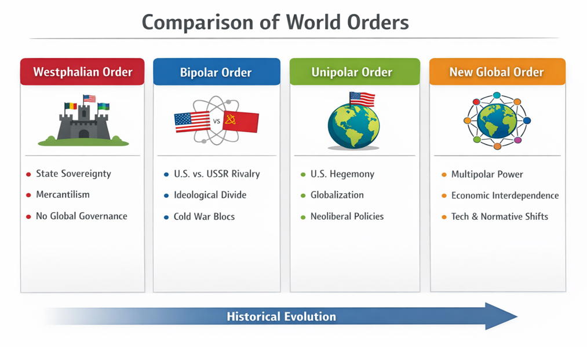

The Westphalian order was revolutionary in its time but had limitations. It mainly involved European powers and prioritized military and political dominance over economic integration or global governance. In contrast, the Bipolar order that emerged after World War II focused on the ideological and strategic rivalry between the United States and the Soviet Union. This period established alliances, security pacts, and spheres of influence, creating a structured, yet tense, international system (Gaddis, 2005). During this time, economic policies were shaped by ideology, with capitalist and socialist blocs vying for global power, often leading to proxy conflicts that affected regions far beyond Europe.

The following Unipolar moment, mostly linked to the rise of the United States after the Cold War, created a world order dominated by a single superpower in economic, military, and cultural terms (Ikenberry, 2011). This period allowed for the growth of liberal institutions like the World Trade Organization, the International Monetary Fund, and the World Bank, which promoted global economic integration based on U.S.-led norms. However, critics claimed that Unipolarity also led to systemic inequalities, encouraged interventionism, and did not properly account for rising economies or non-state players (Kupchan, 2002).

In today's world, the idea of a “new global order” emerges as a response to the shortcomings of previous frameworks. It reflects the rise of emerging economies like China, India, and Brazil, the growing power of multinational corporations, and the significance of global issues such as climate change, digital governance, and public health (Baldwin & Evenett, 2020; Stiglitz, 2021). Unlike earlier systems, this new global arrangement does not have a single leader or a prevailing ideology. Instead, it is marked by overlapping networks of authority, where states, international organizations, corporations, and civil society all influence outcomes, often in conflicting ways. Technology, especially digitalization and financial innovation, is crucial in this new order. The spread of digital currencies, e-commerce, and AI-driven economic platforms changes traditional sources of power and influence. Additionally, social media and international communication networks speed up the exchange of ideas and norms, fostering both cooperation and competition on a global scale (Keohane & Nye, 2012; Nye, 2019). This creates a system where power is more widely distributed, influence is more intricate, and governance is more contested than in any previous arrangement.

To understand the new global order, we need a multi-faceted approach that brings together political, economic, and technological aspects. Scholars suggest that this order will be defined not just by how state power is distributed but by how well actors can respond to change, manage interdependence, and negotiate new norms (Hurrell, 2007; Ikenberry, 2018). This article contributes to this conversation by comparing the new global order to historical configurations, examining its implications for institutions and norms, and evaluating its effects on global economic governance, security arrangements, and international cooperation.

2. Conceptual Framework: World Orders in International Political Economy (IPE)
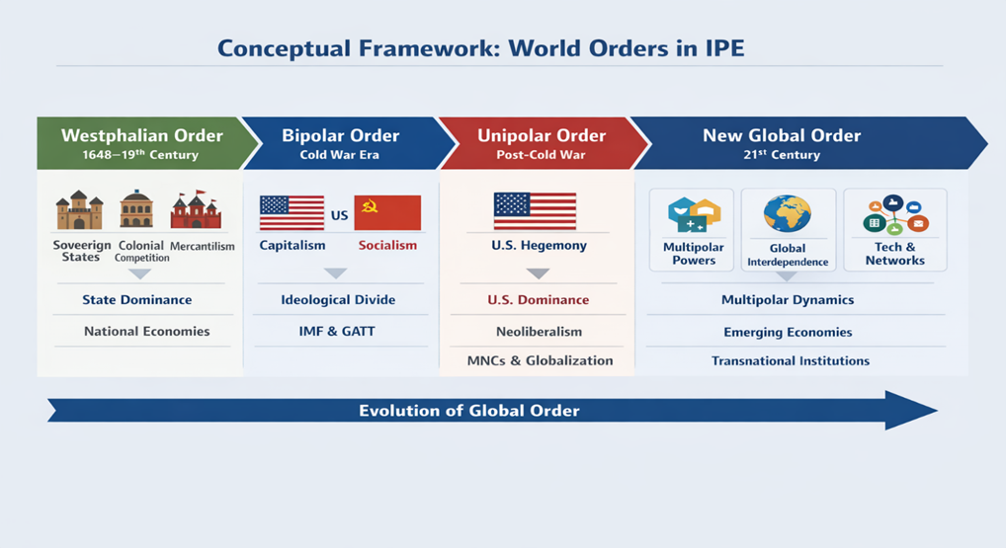
We’re living through a big change in how the world works. It’s not just that the United States isn’t calling all the shots anymore—countries like China, India, and Brazil have stepped up and started to redraw the map for global trade, investment, and diplomacy (Hurrell, 2006). These rising powers don’t just accept the old rules. They push new development ideas, work closely with other countries in the Global South, and focus on building stronger regions. This shift away from a world with one clear boss has made things more fluid and unpredictable.
Technology and digital networks are stirring things up too. Power isn’t just about armies or money now—it’s also about data, cyber skills, and the ability to build global networks. Multinational corporations, big tech companies, and all sorts of non-state players now have a real say in what happens (Castells, 2010). States can’t just act on their own; they need to work with or, sometimes, compete against private and transnational actors. The old idea of sovereignty doesn’t always hold.

With all this economic interconnectedness, the world’s got new strengths and new risks. Global finance and supply chains mean quick access to money and markets, sure, but bumps anywhere can ricochet everywhere—2008 proved that (Reinhart & Rogoff, 2009). You can’t control every risk on your own anymore. States and global institutions have to work around a tough maze of economic connections, where local problems can blow up big, fast.

We’re also seeing more debates about the rules everyone should follow. There isn’t just one standard for trade, human rights, or environmental action anymore (Ikenberry, 2018). People argue about who should take the lead on climate change, who gets a say in digital rules, and how to fix old institutions. These debates show how the new players are pushing for change and clashing with the older powers.

New organizations and networks are also breaking up the old monopoly held by Western-led institutions. Groups like the G20, the BRICS New Development Bank, and regional banks have become powerhouses for cooperation and policy-sharing (Breslin, 2013). They bring people together for everything from financial security to building roads and bridges, showing the world isn’t run from just one command center anymore.

And really, everything is connected now—security, the economy, technology. Cyberattacks, pandemics, the fallout from climate change—they all cross borders and demand that governments, companies, and organizations team up (Nye, 2011). To really understand today’s international political economy, you have to look at how ideas, money, and influence twist together in a fast-moving, networked world where no one holds all the cards.

3. Comparative Analysis of World Orders
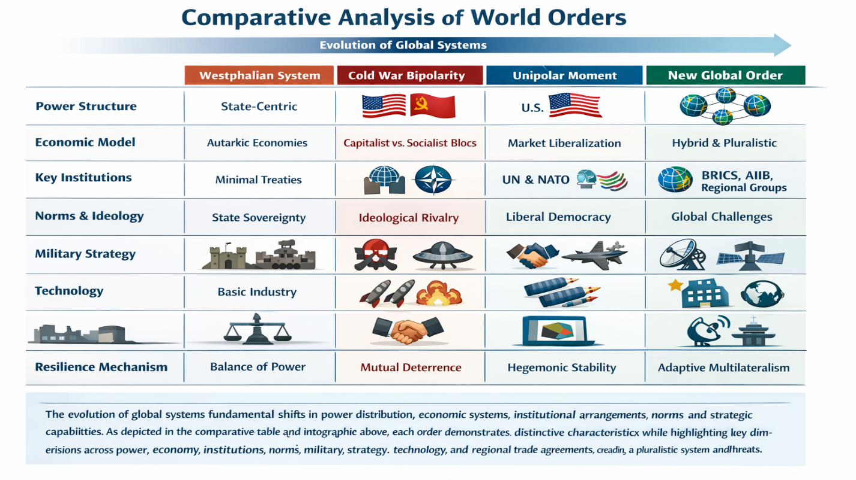
The evolution of world orders has been a process of significant changes in the distribution of power, economies, institutions, and strategic capabilities. As indicated in the comparative table and the infographic above, each world order has its unique features while emphasizing the history of global evolution from a unipolar system of nation-states to a multipolar system.

Power distribution has been a key characteristic in all orders. The Westphalian system was founded on hierarchical authority, while the bipolar system was founded on two hegemonic blocs, led by the US and the USSR. The unipolar system saw all powers concentrated in the US, which could then act as a global police force, while the new global system sees powers distributed among multiple states and actors, a far more networked approach to global relations.

Economic structures have also followed a similar trend. The Westphalian economic structure was characterized by autarky, while the bipolar structure was characterized by a strict division between capitalism and socialism. The unipolar structure was characterized by liberalization under the leadership of the United States (Keohane, 1984). The contemporary economic structure is a hybrid mix of state-led policies and liberalization, technological advancements, and regional trade agreements that have led to a pluralistic structure that includes different models of development (Baldwin & Evenett, 2020).

Institutions have become more pluralistic and fragmented. Minimal institutional engagement was a hallmark of the Westphalian era, and bipolarity was heavily institutionalized in the UN and NATO frameworks. The unipolar world was dominated by international financial institutions such as the IMF, World Bank, and WTO. The new global order has brought with it new institutions such as the AIIB, BRICS Bank, and regional regulatory bodies, and the rules for cooperation will depend upon the legitimacy and congruence of interests and adaptive rule-making (Narlikar, 2010).

Normative and ideational principles have evolved from sovereignty and ideological rivalry to a complex and diverse set of principles. While previous orders were based on material power or ideological compatibility, the current system of governance is based on legitimacy, soft power, and normative power, as evident in areas such as global warming, human rights, and digital governance (Acharya, 2014; Finnemore & Sikkink, 1998).

Another important aspect is the military and strategic dynamics, which have also undergone significant change. Earlier, territorial armies and nuclear deterrence were the hallmarks of the global order (Waltz, 1979), whereas the unipolar world allowed for expeditionary warfare led by the United States. Currently, the military and strategic dynamics are multi-domain and network-centric, including cyber warfare and space warfare, as well as coalition warfare, given the distributed nature of threats across the globe (Nye, 2011; Brands, 2020).

Lastly, the stability and resilience of the global order depend upon its ability to adapt to emerging crises. Earlier, the stability of the Westphalian world was ensured through sovereign balance, bipolar stability through deterrence, and unipolar stability through hegemony. The new world order is based upon multilateral negotiations and coalition-building to address emerging threats such as pandemics, climate change, and transnational security threats, indicating a significant departure from the past, as seen in the centralized approaches to global problems (Keohane, 1984; Finnemore & Sikkink, 1998).

In conclusion, it is worth reiterating that, based on this comparative analysis, it is evident that the new global order is fundamentally characterized by pluralism, interdependence, and multi-domain influence. This is further visually represented in the infographic provided, which captures the evolutionary journey from a Westphalian system to a current multipolar system in relation to various dimensions of power, economics, institutions, norms, military strategies, technology, and resilience mechanisms, among others.

4. Critical Perspectives
Hegemonic stability theory (HST) has come in for considerable criticism in the context of emerging global order, particularly as the decline of a single hegemony complicates the provision of global public goods. HST posits that a hegemony is necessary to provide stability in international society by providing public goods such as international institutions, ensuring open markets, and maintaining international rules (Kindleberger, 1973). However, the emerging multipolar world order, characterized by emerging economies such as China and India, challenges HST’s assumption of a single hegemony providing stability. This is particularly so since none of these emerging economies has either the ability or legitimacy to provide public goods. Ikenberry (2018) points out that the decline of liberal internationalism spearheaded by the U.S. has resulted in a fragmented global order. This has seen a diffusion of power, which has complicated international coordination.

Moreover, the move towards a multipolar world also presents both challenges and opportunities for global governance. On one hand, the absence of a hegemon makes coordination problems more challenging, especially in areas such as trade, security, and climate change. On the other hand, it also promotes more inclusive and flexible global governance that takes account of multiple interests and regional concerns.

The emerging powers are pressing for reform in global governance to better reflect the interests of the Global South, thereby questioning the legitimacy of traditional systems such as the Bretton Woods system. This also highlights that while the decline of hegemony may make global systems less cohesive, it also promotes hybrid global governance systems that combine formal and informal systems.

From a critical political economy approach, the dependency and world systems theories emphasize the persistence of structural inequalities in the global system. Thus, the diffusion of power does not mean that the developing countries have broken free from the asymmetrical relationships characterized by unequal exchanges and a lack of industrialization and dependence on external capital and technology (Frank, 1967). Moreover, the world systems approach emphasized by Wallerstein (2004) also highlights the persistence of the core-periphery hierarchy in the global system and its implications for the marginalization of the peripheral economies in the global trade and production systems. Thus, the emergence of a new global order may not address the inequalities that have persisted in the global system for so long.

At the same time, South-South cooperation has also surfaced as a possible corrective to the existing dependency relations, providing alternatives to development and economic integration. Such cooperation has included the BRICS alliance and trade agreements in Africa and Asia to promote intra-regional trade, infrastructure development, and knowledge sharing. However, it has also been argued that this does not automatically mean the end of hierarchical relations, as power relations also exist in the South. Moreover, the reliance on external finance and technology transfer continues to limit the autonomy of many developing states. Hence, South-South cooperation provides alternatives within the existing limits of the global capitalist system.

Constructivist perspectives offer an alternative perspective by focusing on norms, ideas, and identity in understanding the changing global order. Constructivists differ from other perspectives in that they believe international relations are shaped by shared ideas and social interactions, rather than material power (Finnemore & Sikkink, 1998). In addition, in the contemporary global order, various governance models, such as liberal democratic models, state-centric models, and authoritarian models, are shaping global discourse. For example, issues such as digital sovereignty, data governance, and artificial intelligence governance highlight the impact of normative contestation on domestic and international relations. This shows that, in addition to material contestation, global order is also ideationally contested.

Finally, environmental and normative dimensions have become central to critical analyses of the global order, reflecting the growing importance of transnational challenges that transcend state boundaries. Issues such as climate change, pandemics, and technological disruption require coordinated responses that go beyond traditional notions of sovereignty and power politics. Keohane and Nye (2012) argue that complex interdependence necessitates networked governance structures involving states, international organizations, and non-state actors. Similarly, Acharya (2014) emphasizes the emergence of a “multiplex world,” where diverse actors and governance frameworks coexist and interact. In this context, legitimacy, accountability, and inclusivity become critical for effective global governance, highlighting the need for adaptive and participatory approaches to managing global public goods.

5. Implications for Global Governance

The move towards a multipolar and digitally connected global system requires a fundamental transformation of global governance structures. As argued by Andrew Hurrell (2007), the transfer of power to other global locations challenges the legitimacy and efficacy of existing multilateral systems. As Amrita Narlikar (2010) also argues, there is a need for emerging powers to be granted greater representation in global decision-making structures such as the United Nations and the World Trade Organization. Therefore, there is a need for global governance structures to become more inclusive and responsive to emerging digital governance structures in dealing with global challenges such as cybersecurity, AI, and data governance.

One of the important implications of the new global order is the emergence of regional architectures of governance as a complementary pillar to global architectures. According to Amitav Acharya, regional organizations like the African Union and the European Union have become critical arenas for policy experimentation, norm diffusion, and capacity building. They have become important in building resilience to challenges while also mitigating overdependence on global architectures that may be slow to react or even constrained by political factors. In Africa, for instance, these organizations have become important in building peace, promoting economic integration, and mitigating crises.

Normative pluralism is one of the defining features of global governance in contemporary times, which is a reflection of the coexistence of different political, economic, and cultural value systems. G. John Ikenberry (2018) refers to the tension between liberal internationalism and other models of global governance proposed by rising powers, while Martha Finnemore and Kathryn Sikkink (1998) refer to the dynamic character of international norms and their evolution through processes of socialization and contestation. Global governance is no longer defined by a single hegemony, but by processes of negotiation and compromise, and adaptive legitimacy, where power is constantly up for renegotiation among various actors and stakeholders.

On the one hand, economic fragmentation, fueled by geopolitical tensions and changes in global supply chains, may have significant implications for global governance. Baldwin & Evenett (2020) have argued that economic fragmentation among global economies may undermine multilateralism but also promote economic blocs. On the other hand, Thomas Friedman (2021) has emphasized the significant impact of globalization 4.0, in which digital interdependence has the potential to revolutionize economic relations. However, policymakers have to walk a tightrope in balancing economic openness with their national interests.

This is because technological change makes the picture more complicated, as new areas are created that are beyond the existing regulatory space. For instance, the rise of artificial intelligence, blockchain, and digital currencies is creating new challenges that need to be addressed at the global level to ensure that there is not only ethics but also security and access. The existing institutions are not able to cope with the challenge of regulating new areas, and this is creating governance challenges that are being exploited for both legitimate and illegitimate purposes, including by states and non-state actors.

Lastly, the emerging global order necessitates a redefinition of sovereignty and cooperation in addressing collective action challenges such as climate change, pandemics, and transnational security threats. Governance in such a context needs to transcend conventional state-centric approaches to more flexible forms of governance that prioritize collaboration. Hybrid approaches to governance, which combine global, regional, and national levels of governance, are becoming increasingly necessary to cope with complexity and uncertainty. In such a sense, the future of global governance will depend on its ability to sustain adaptability, inclusiveness, and balancing competing interests in an increasingly interconnected but fragmented world.

References
Acharya, A. (2014). The end of American world order. Polity Press.
Baldwin, R., & Evenett, S. J. (2020). COVID-19 and trade policy: Why turning inward won’t work. CEPR Press.
Breslin, S. (2013). Globalization, regionalism and the rise of the emerging powers. Palgrave Macmillan.
Castells, M. (2010). The rise of the network society (2nd ed.). Wiley-Blackwell.
Finnemore, M., & Sikkink, K. (1998). International norm dynamics and political change. International Organization, 52(4), 887–917.
Frank, A. G. (1967). Capitalism and Underdevelopment in Latin America. Monthly Review Press.
Friedman, G. (2021). The Storm Before the Calm: America’s Discord, the Coming Crisis of the 2020s, and the Triumph Beyond. Doubleday.
Friedman, T. L. (2021). Thank You for Being Late. Farrar, Straus and Giroux.
Friedman, T. L. (2021). The world is flat: A brief history of the twenty-first century (Updated ed.). Farrar, Straus and Giroux.
Hurrell, A. (2006). Hegemony, liberalism and global order: What space for would-be great powers? International Affairs, 82(1), 1–19.
Hurrell, A. (2007). On Global Order. Oxford University Press.
Ikenberry, G. J. (2018). Liberal Leviathan: The origins, crisis, and transformation of the American world order (2nd ed.). Princeton University Press.
Keohane, R. O. (1984). After hegemony: Cooperation and discord in the world political economy. Princeton University Press.
Keohane, R. O. (1984). After hegemony: Cooperation and discord in the world political economy. Princeton University Press.
Keohane, R. O., & Nye, J. S. (2012). Power and Interdependence (4th ed.). Pearson.
Kindleberger, C. P. (1973). The world in depression 1929–1939. University of California Press.
Krasner, S. D. (1999). Sovereignty: Organized hypocrisy. Princeton University Press.
Mearsheimer, J. J. (2019). The great delusion: Liberal dreams and international realities. Yale University Press.
Narlikar, A. (2010). New Powers in the Club: The Challenges of Global Trade Governance. Oxford University Press.
Nye, J. S. (2011). The Future of Power. PublicAffairs.
Reinhart, C. M., & Rogoff, K. S. (2009). This time is different: Eight centuries of financial folly. Princeton University Press.
Strange, S. (1996). The retreat of the state: The diffusion of power in the world economy. Cambridge University Press.
Wallerstein, I. (2004). World-systems analysis: An introduction. Duke University Press.

