Breathing in Dhaka: Air Pollution Effect on Human Health
Moktar Hossain ª*, Md Abu Hasan ª, Md Naimur Rahman ª, Nusrat Sultana Kumu ª
ª Bangladesh Reference Institute for Chemical Measurements (BRiCM), Dr. Kudrat-e-Khuda Road, Dhanmondi, Dhaka-1205, Bangladesh
Corresponding Author*: Moktar Hossain, moktar@bricm.gov.bd
ABSTRACT
Air pollution poses a significant threat to human health and the environment, with motor vehicles, rapid urbanization and industrial processes major contributors. This comprehensive review examines the impact of various air pollutants, including nitrogen dioxide (NO₂), ozone (O₃), carbon monoxide (CO), sulfur dioxide (SO₂), and particulate matter (PM2.5), on human health. Long-term and short-term exposure to these pollutants has been linked to respiratory and cardiovascular diseases, as well as chronic conditions like cancer. Data from studies in regions like Dhaka, Bangladesh through environmental monitoring and health surveys, demonstrate alarming levels of pollutants exceeding WHO guidelines. Results shows the association between hazardous substance and respiratory system. Nitrogen dioxide, for instance, can generate reactive oxygen species (ROS) and free radicals, leading to oxidative stress and cellular damage. Ozone exposure increases the risk of oxidative stress and DNA damage, potentially contributing to cancer development. Carbon monoxide displaces oxygen from hemoglobin, causing tissue hypoxia and various health issues. Sulfur dioxide contributes to acid rain formation, respiratory problems, and environmental damage. Particulate matter, especially PM2.5, can penetrate the lungs, causing respiratory irritation, cardiovascular diseases, and adverse birth outcomes. Preventive measures like flue gas desulphurization and regulatory standards aim to mitigate air pollution's adverse effects, emphasizing the need for urgent action to safeguard public health. The research concludes that immediate policy interventions and public perception are crucial to reduce health hazard and strengthen urban air quality. Additionally, the outcomes highlight the necessity for consistent monitoring systems, stricter exhaust regulations, and sustainable urbanized planning to reduce long-term health effects and ensure a more sustainable living environment.
Keywords
Air Pollution, Health Impact, Toxic Emissions, Respiratory Diseases, Pollution Mitigation
INTRODUCTION
Air pollution has become a pressing global issue, with severe toxicological consequences for both human health and the environment (Ghorani-Azam et al., 2016; Mabahwi et al., 2014; Manisalidis et al., 2020). In Dhaka, Bangladesh, the challenges associated with rapid urbanization and industrial expansion have significantly worsened air quality, creating substantial health risks for the population (Khandker et al., 2023; Pavel et al., 2021). According to the World Health Organization (WHO), while various factors contribute to air pollution, motor vehicles and industrial activities are among the leading sources. These emissions release harmful pollutants, including particulate matter (PM), nitrogen oxides (NOx), and volatile organic compounds (VOCs), which pose serious health and environmental threats. The health effects of air pollution vary based on the duration of exposure. Short-term exposure can lead to respiratory irritation and cardiovascular issues, while long-term exposure is associated with chronic illnesses such as asthma, chronic obstructive pulmonary disease (COPD), and cancer. Additionally, air pollution exacerbates pre-existing health conditions, potentially leading to premature mortality (Al Ahad et al., 2020; Dominski et al., 2021; Gul & Das, 2023; Manisalidis et al., 2020). Beyond its health implications, poor air quality has broader socio-economic impacts, including increased healthcare costs and reduced workforce productivity. Addressing this issue requires robust strategies, including strict emission regulations, cleaner transportation alternatives, and the adoption of sustainable industrial practices to mitigate its adverse effects.

Gases That Lead Air Pollution
In Dhaka, Bangladesh, the air is heavily polluted with a mix of harmful substances such as nitrogen dioxide (NO₂), ozone (O₃), carbon monoxide (CO), sulfur dioxide (SO₂), and fine particulate matter (PM2.5) (Pavel et al., 2021). These pollutants primarily originate from a range of sources, with the most significant contributors being emissions from motor vehicles, industrial activities, and the burning of fossil fuels (Khandker et al., 2023; Pavel et al., 2021).
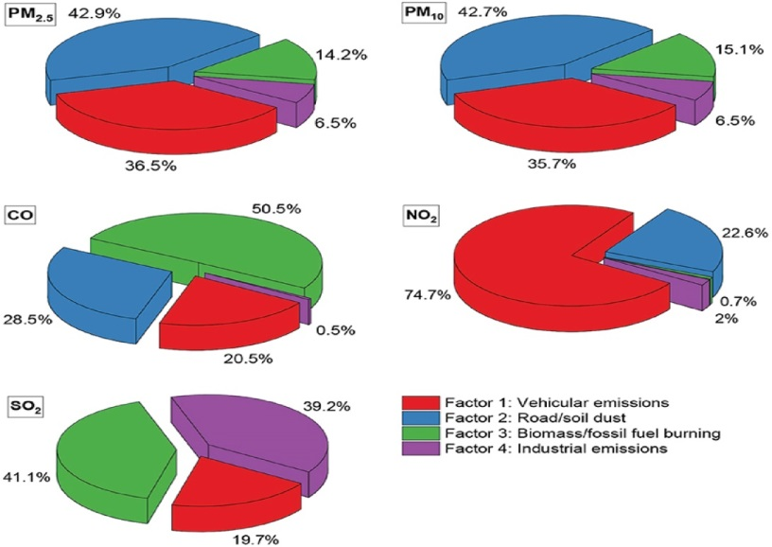
Figure 1: PMF source apportionment. (Pavel et al., 2021).
Effect of Nitrogen Dioxide (NO₂) on Air Pollution
Nitrogen dioxide (NO₂) is not just a reddish-brown gas, it's a highly reactive and poisonous one. In fact, it can be fatal if inhaled in large quantities. This gas, an intermediate in the industrial synthesis of nitric acid, is a part of the NOx family of atmospheric pollutants. Its production, primarily for fertilizers, reaches millions of tons each year (Basic Information about NO2 | US EPA, n.d.; Nitrogen Dioxide - Wikipedia, n.d.).
The World Health Organization (WHO) has established global guidelines for nitrogen dioxide (NO₂) exposure, recommending a maximum 24-hour mean concentration of 25 µg/m³ and an annual mean limit of 10 µg/m³ to protect public health. (WHO Air Quality Guidelines for Particulate Matter, Ozone, Nitrogen Dioxide and Sulfur Dioxide, 2006). South Asia is facing a concerning trend. It's one of the few regions in the world where NO₂ levels are on the rise in some areas. Between 2000 and 2019, NO₂ exposure in South Asia increased by a staggering 22 per cent, while global averages decreased by 5 per cent. This is a clear call for action (Pavel et al., 2021). The cities exceeded the WHO Annual Air Quality Guideline for (NO)₂ (10 µg/m³), with Dhaka having the highest level in the country at 23.6 µg/m³, followed by Chattogram with 21.3 µg/m³, Sylhet with 13.5 µg/m³, Rajshahi with 13.1 µg/m³, and Khulna with 11.0 µg) (Nitrogen Dioxide: A Growing Health Hazard for Dhaka | The Daily Star, n.d.).

Sources of NO₂ in the Atmosphere
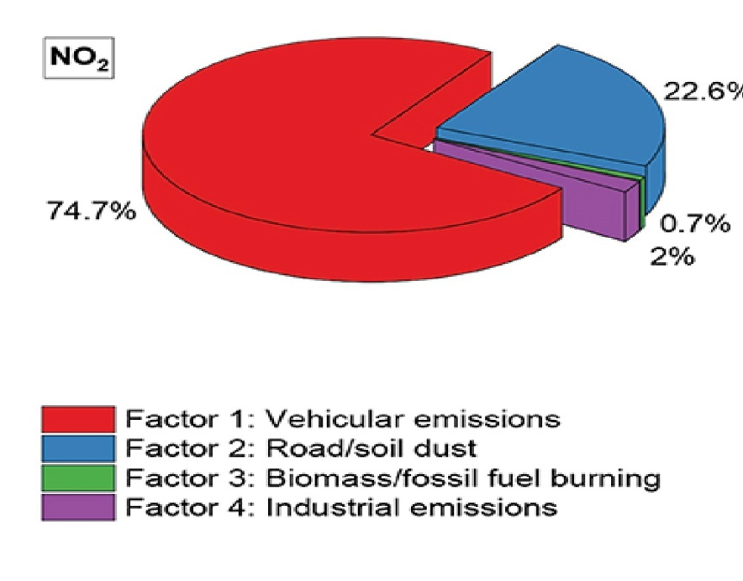

Figure 2: NO₂ source apportionment (Pavel et al., 2021).
Nitrogen dioxide (NO₂) is primarily produced through high-temperature combustion processes, where oxygen reacts with nitrogen in the atmosphere. Major sources include vehicle exhaust emissions, power generation plants, and the burning of fossil fuels. Additionally, photochemical reactions involving nitric oxide (NO) and other air pollutants in the presence of sunlight contribute to NO₂ formation. Indoors, smoking is a significant contributor, substantially increasing nitrogen oxides (NOₓ) levels (Nitrogen Oxides | Center for Science Education, n.d.; Nitrogen Oxides (NOx), Why and How They Are Controlled, 1999). An investigation was conducted in six garment industries to measure the concentration of nitrogen dioxide (NO₂) in air samples collected from four different locations within each facility (Hasan MM et al., 2018). The strategic sampling points for each garment industry are detailed in Table 1 (Hasan MM et al., 2018).
Table 1: Concentration of (NO)₂ in collected air at four different places. (Hasan MM et al., 2018)
Factory | East Side (µg/m³) | West Side (µg/m³) | North Side (µg/m³) | South Side (µg/m³) | Average (µg/m³) | Standard Deviation (S.D.)
RMG-1 | 45.22 | 39.69 | 18.29 | 90.95 | 48.54 | 30.56
RMG-2 | 2.03 | 27.44 | 44.21 | 8.13 | 20.45 | 19.18
RMG-3 | 6.10 | 96.54 | 78.27 | 15.75 | 41.66 | 40.78
RMG-4 | 12.70 | 23.37 | 29.98 | 84.86 | 37.72 | 32.21
RMG-5 | N.D. | 18.80 | 13.21 | 2.03 | 8.51 | 8.98
RMG-6 | 12.19 | 11.80 | N.D. | N.D. | 5.99 | 6.92

The highest average concentration of NO₂ was observed in RMG-1, located in Gazipur. In all cases, the maximum NO₂ levels were consistently found near the production sections of the industries. This suggests that industrial boilers and power sources in the production areas are the main contributors to NO₂ emissions (Hasan MM et al., 2018).

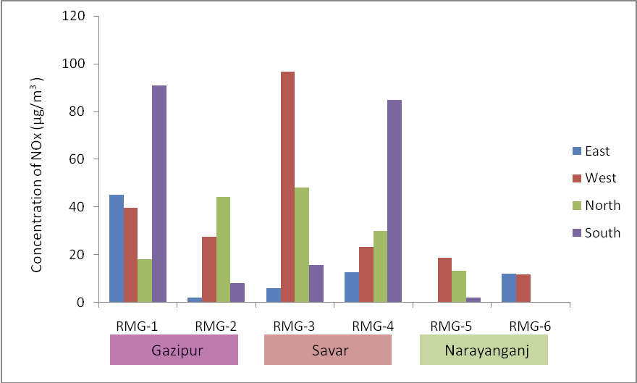

Figure 3: NO₂ concentration was measured at four locations: East, West, North, and South sides of the factories (Hasan MM et al., 2018).
How NO₂ Impact on Human Body
Air pollution exposure is linked to oxidative stress and inflammation in human cells, which can lay the groundwork for chronic diseases and cancer. Nitrogen dioxide (NO₂) is a key player in this process, contributing to the formation of free radicals in the human body. When we inhale NO₂ from the air, it can react with other molecules in the respiratory system, particularly with substances like water (H₂O) and oxygen (O₂), leading to the production of reactive intermediates such as nitric oxide (NO) and other nitrogen-containing compounds. These reactive intermediates, especially in the presence of oxygen, can contribute to the formation of various free radicals, including superoxide (O₂⁻ ), hydroxyl radicals (OH), and nitrogen dioxide radicals (NO₂). These radicals are highly reactive and can cause damage to cells (Phaniendra et al., 2015). NO₂ reacts with the respiratory system, causing damage to cells and generating reactive oxygen species (ROS) and free radicals. These free radicals can harm critical cellular components such as DNA, proteins, and lipids. Over time, this damage can interfere with DNA replication and potentially lead to cancer. Additionally, NO₂ and protein nitration may have combined effects on tumorigenesis. The consumption of NO₂ requires oxygen, but in the hypoxic environment of tumors, NO₂ consumption may decrease, resulting in localized increases in NO₂ levels. According to Thomas et al., NO₂ concentrations regulate several biological processes, including angiogenesis, erythropoiesis, and glycolysis. At low levels, NO₂ activates HIF-1α, while at higher levels, it inactivates p53, a tumor suppressor protein that regulates cell cycle genes such as p21. Since over 90% of lung tumors exhibit p53 defects, its nitration-induced inactivation could contribute to cancer development. Additionally, proteins associated with lung cancer, such as HNRNPK, are nitrated, potentially enhancing cell proliferation and promoting anchorage-independent growth. Nitration of annexin III may also impact cell growth, signaling, and processes like angiogenesis, glycolysis, and antioxidant defense, further promoting tumorigenesis. Consequently, NO₂ may create a tumor-promoting microenvironment, leading to tumor heterogeneity and metastasis, thus contributing to the development of chronic diseases and cancer (Masri, 2010).

Effect of Ozone (O₃) on Air Pollution
Ozone (O₃) is an inorganic molecule, a pale blue gas with a distinctive pungent odor. It naturally exists in small amounts in Earth's stratosphere, where it plays a crucial role in absorbing solar ultraviolet radiation (Ozone - Wikipedia, n.d.). In recent years, ozone exposure has risen in 12 of the world’s 20 most populous countries, with India, Pakistan, and Bangladesh experiencing significant increases. Ozone concentrations have increased by 14% in Bangladesh, 15% in Pakistan, and 17% in India (Ozone Exposure | State of Global Air, n.d.). Exposure to ozone can have serious health consequences. It can trigger the formation of reactive oxygen species (ROS) and free radicals in the body, leading to oxidative stress. This stress can damage DNA and cellular structures, which may initiate or accelerate the development of cancer over time. Chronic inflammation, combined with DNA damage from free radicals, can increase the likelihood of mutations and cellular changes that may ultimately lead to the formation of cancerous cells.
What Free Radicals of O₃ Originate in Human Body?
O₃ is not a radical itself but can generate radicals through two mechanisms. The first involves ozone reacting with olefins (e.g., R-CH=CH₂) via the Criegee ozonation pathway, forming a 1,2,3-trioxolane intermediate that breaks into a diradical. The second mechanism occurs when ozone interacts with electron donors like glutathione (GSH), producing an O₃·⁻ radical anion that reacts with a proton (H⁺) to form a hydroxyl radical (HO·) and dioxygen (O₂). This process can be detected using 5,5-dimethyl-1-pyrroline-N-oxide, which forms a spin adduct with HO·. Similar radical formations have been noted with catechol. These mechanisms illustrate how ozone contributes to radical production, which can cause oxidative damage in cells and the environment (Gomez et al., 2008; Pryor, 1994). Free radicals target vital cellular molecules, such as DNA, proteins, carbohydrates, and fats, leading to significant damage and potential diseases (Lobo et al., 2010; Phaniendra et al., 2015). Radicals cause DNA damage, including base and sugar lesions, DNA-protein cross-links, and strand breaks (Dizdar, 1998). Radicals stabilize by capturing electrons from other molecules, triggering a chain reaction. This can lead to:
Cell Membranes: Lipid peroxidation, compromising membrane integrity and potentially causing cell death.
DNA Damage: Mutations that disrupt normal cell function and can lead to diseases like cancer.
Proteins: Structural and functional modifications, interfering with cellular processes.
Cellular Components: Mitochondrial damage, reducing energy production and potentially causing cell death.
The Criegee pathway shows ozone reacting with an alkene to form a trioxolane intermediate, generating reactive oxygen species that lead to oxidative stress. The GSH pathway depicts ozone depleting glutathione to produce hydroxyl radicals, which trigger lipid peroxidation, DNA damage, protein oxidation, and mitochondrial impairment, ultimately causing cellular dysfunction and disease.
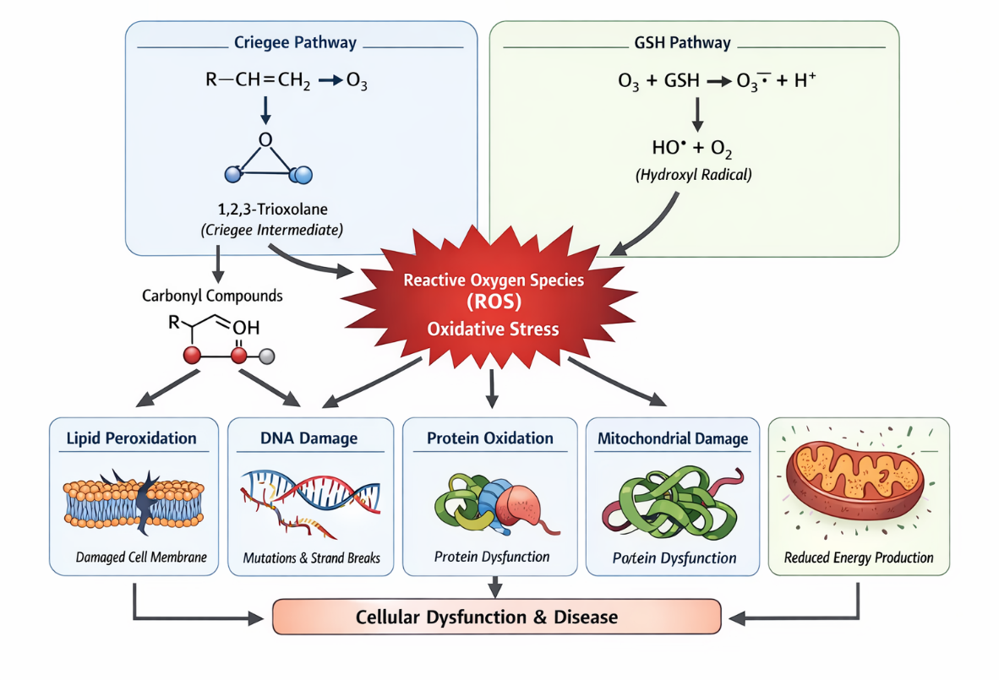
Figure 4: Ozone-induced oxidative damage pathways
Impact of Carbon Monoxide (CO) on Air Pollution
Carbon monoxide (CO) is a hazardous, colourless, odourless, tasteless, and flammable gas that presents significant health risks. Often referred to as a "silent killer," CO is challenging to detect without specialized equipment, making it especially dangerous. The Environmental Protection Agency (EPA) has established air quality standards for CO exposure, limiting concentrations to a maximum of 35 parts per million (ppm) over one hour and 9 ppm over an eight-hour period. These limits correspond to 10 mg/m³ for 8-hour exposure and 40 mg/m³ for 1-hour exposure to protect public health from the harmful effects of this gas. Major sources of CO emissions include tobacco smoke, gas stoves, pilot lights, wood stoves, fireplaces, and gas- or kerosene-powered space heaters. CO is also emitted by gasoline engines, camping lanterns, stoves, and can accumulate in enclosed spaces such as attached garages and street-level intake vents.
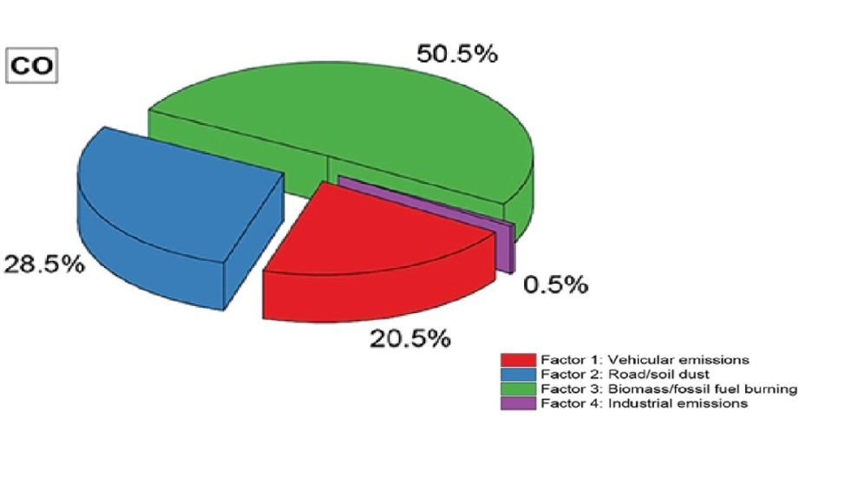
.

Figure 5: CO source apportionment (Pavel et al., 2021)
Impact of Carbon Monoxide on Haemoglobin and Health
CO competes with O₂ for binding sites on haemoglobin, reducing the blood's oxygen-carrying capacity. This displacement impairs oxygen delivery to tissues and hinders oxygen diffusion into mitochondria, worsening oxygen deficiency. CO exposure also disrupts intracellular oxidation and may increase platelet adhesiveness, further compromising health.
Health complications from CO exposure include:
- Breathing difficulties (shortness of breath, cessation of breathing)
- Chest pain (especially in individuals with angina)
- Low blood pressure
- Tissue hypoxia (oxygen deprivation)
- Muscle weakness
- Irregular heartbeats
Smoking as a Source of Carbon Monoxide Exposure
Smoking significantly raises carboxyhaemoglobin levels, with nonsmokers typically having levels of 0.6%, which can increase to 10%-15% after smoking a cigarette, further impairing oxygen delivery.
Effect of Sulphur Dioxide (SO₂) on Air Pollution
Sulphur dioxide (SO₂) is a toxic gas with a sharp odour, often reminiscent of burnt matches. It plays a significant role in air pollution, contributing to the formation of acid rain and affecting both human health and the environment. SO₂ is primarily produced by the combustion of sulphur-containing fossil fuels such as coal and oil. Additionally, it is emitted through various industrial activities, including copper extraction, fertilizer production, aluminium smelting, and steel manufacturing.
- Chemical Formula: SO₂
- IUPAC Name: Sulphur dioxide
- Molar Mass: 64.066 g/mol
- Solubility: Soluble in water
Sources of Sulphur Dioxide
Sulphur dioxide is predominantly generated from human activities, particularly the burning of fossil fuels that contain sulphur, such as coal used for heating and oil burned in diesel engines. It is also released through industrial processes, including the production of fertilizers, aluminium, and steel. Naturally, sulphur dioxide is emitted from volcanic eruptions and geothermal activity. The presence of SO₂ in the atmosphere can lead to the formation of secondary pollutants like sulfuric acid, which is a major contributor to acid rain.
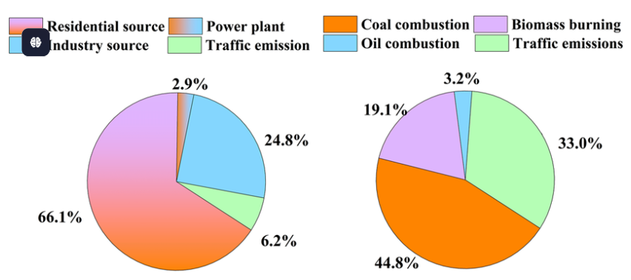
Figure 6: Source apportionment of SO_{2.}
Effect of Sulphur Dioxide (SO₂) on Air Pollution
The national environmental standard for sulfur dioxide (SO₂) is set at 350 µg/m³ and 570 µg/m³ as a 1-hour average, as of September 29, 2021. When released into the atmosphere, SO₂ can react with other compounds to form fine particulate matter (PM), contributing to air pollution and having significant environmental and health consequences.

Key Effects of SO₂ on Air Pollution
Acid Rain Formation: SO₂ can combine with other atmospheric pollutants, resulting in the formation of sulfuric acid, which contributes to acid rain. This has harmful effects on aquatic ecosystems, soil quality, and vegetation.
Visibility Reduction: Emissions of SO₂ can lead to the formation of haze, reducing visibility and compromising air quality, particularly in urban areas. This can present safety hazards, especially in high-traffic zones.
Environmental Damage: SO₂ emissions can directly damage vegetation and contribute to soil acidification. This disrupts plant growth, affects biodiversity, and impairs agricultural productivity.
Health Impacts: Long-term exposure to elevated levels of SO₂ can cause severe health problems, particularly affecting the respiratory and cardiovascular systems. Respiratory conditions such as bronchitis, asthma, and other lung irritations can worsen with prolonged exposure to SO₂.
Respiratory Issues: SO₂ can irritate the respiratory system, causing symptoms such as coughing, wheezing, phlegm production, and asthma attacks. These effects are exacerbated during physical exertion. Prolonged exposure has also been linked to cardiovascular diseases.
Groups Most Sensitive to Sulphur Dioxide Exposure
- Children
- Adults with lung diseases
- Individuals with asthma or other pre-existing respiratory conditions
RELATED WORK
Air pollution continues to be a pressing issue in Dhaka, posing a significant threat to public health. Multiple studies have highlighted the dangerously high levels of air pollutants, particularly particulate matter (PM), nitrogen dioxide (NO₂), and sulfur dioxide (SO₂). Research by Alam (2019) reveals that PM concentrations in Dhaka often surpass the World Health Organization (WHO) guidelines, contributing to serious respiratory issues such as asthma and bronchitis, especially among vulnerable groups like children and the elderly (Alam, 2019). Furthermore, a systematic review by Saha (2021) examined the health impacts of air pollution in Bangladesh, underscoring the link between poor air quality and the rising rates of morbidity and mortality. The study found that air pollution is a major contributor to cardiovascular diseases, a condition that is becoming increasingly common in urban areas like Dhaka. Their findings align with a report from the (Health Effects Institute, 2020), which estimates that ambient air pollution contributes to approximately 50,000 premature deaths annually in Bangladesh (Health Effects Institute, 2020; Saha, 2021).
Moreover, research by (Biswas, 2021) investigated the seasonal variations in air quality in Dhaka, revealing that pollution levels peak during the dry winter months due to increased vehicular emissions and construction activities. This seasonal pattern exacerbates health risks, particularly during the months when respiratory infections are also prevalent (Biswas, 2021). The study emphasizes the need for targeted interventions during high-pollution seasons to mitigate health impacts.
Public awareness regarding air pollution in Dhaka is also a critical concern. A study by (Rahman, 2022) assessed the knowledge and perceptions of residents about air quality issues. Their findings indicate that while most residents recognize air pollution as a health threat, there is a significant lack of understanding regarding specific sources and preventive measures. This gap in knowledge hinders community engagement in advocating for cleaner air initiatives and policies (Rahman, 2022).
Furthermore, environmental justice issues have been raised in the context of air pollution in Dhaka. Research by highlights how low-income communities disproportionately suffer from the health effects of air pollution due to their proximity to industrial zones and heavy traffic areas. The authors argue that policy interventions must consider socio-economic disparities to effectively address the health impacts of air pollution (Shamsuddoha, 2023).
In summary, existing literature underscores the urgent need for comprehensive strategies to tackle air pollution in Dhaka. These strategies should include public education campaigns, stricter regulations on emissions, and enhanced monitoring of air quality to protect public health.
METHODOLOGY
This research is a narrative review focusing on Dhaka, the capital city of Bangladesh. The objective is to assess the impact of air pollution on human health by synthesizing findings from previously published studies.
To ensure transparency and relevance, a systematic approach was followed for selecting studies. Relevant literature was identified through academic databases such as Google Scholar, PubMed, and ScienceDirect using keywords including “air pollution in Dhaka,” “PM2.5 health effects,” “air pollutants Bangladesh,” and “urban air quality and health impacts.” Only peer-reviewed articles, government reports, and internationally recognized publications written in English were considered. Studies published within a relevant time frame (primarily the last 10–15 years) were prioritized to ensure up-to-date information.
The selected studies were screened based on their relevance to air pollution in Dhaka or similar urban environments, the clarity of their methodology, and the reliability of their data sources. Studies with non-standardized or poorly defined measurement methods were noted, and their limitations were considered during analysis.
The extracted data from these studies included information on key air pollutants such as SO₂, NO₂, CO, and PM2.5, ozone as well as their measured or reported impacts on human health and the environment. These data were compared and analyzed qualitatively to identify common trends, patterns, and health outcomes associated with air pollution exposure.
Additionally, secondary information regarding environmental impacts, such as acid rain formation and ecosystem damage, was also included to provide a broader understanding of pollution effects. For example, Sulphur dioxide contributes to acid rain through atmospheric chemical reactions, which negatively affect ecosystems and human health.
Overall, this study integrates findings from multiple sources to provide a comprehensive overview of air pollution and its health impacts in Dhaka, while acknowledging the variability in measurement methods and data quality across the reviewed studies.
RESULTS AND DISCUSSION
The analysis of air pollution in Dhaka, Bangladesh, reveals alarming levels of various pollutants and their significant impact on human health and the environment. This section expands on the initial findings, highlighting the critical need for sustainable interventions to address air pollution and safeguard public health. It also emphasizes the importance of collaboration among policymakers, industries, and the public to effectively combat this issue.
Nitrogen Dioxide
Nitrogen dioxide is a major pollutant in Dhaka, primarily emitted by vehicles and industrial processes. Data shows that nitrogen dioxide levels in Dhaka far exceed the World Health Organization’s guidelines, reaching 23.6 micrograms per cubic meter, more than double the recommended annual limit of 10 micrograms per cubic meter. The main sources of nitrogen dioxide include high-temperature combustion in vehicles, power plants, and industrial activities. Long-term exposure to nitrogen dioxide can lead to respiratory and cardiovascular diseases, including asthma, bronchitis, and lung cancer. Additionally, nitrogen dioxide contributes to the formation of secondary pollutants, such as ozone and particulate matter, which worsen air quality.
Carbon Monoxide
Carbon monoxide, often referred to as a "silent killer," is another serious pollutant in Dhaka. The city's carbon monoxide levels frequently surpass the Environmental Protection Agency’s standards of 35 parts per million (ppm) for 1-hour exposure and 9 ppm for 8-hour exposure. The primary sources of carbon monoxide in Dhaka are vehicle emissions, industrial processes, and residential heating. Carbon monoxide binds to hemoglobin more readily than oxygen, reducing the oxygen supply to tissues and leading to symptoms such as breathing difficulties, chest pain, and, in severe cases, death.
Sulphur Dioxide
Sulphur dioxide is mainly produced from the combustion of sulfur-containing fossil fuels such as coal and oil. The national environmental standard for sulphur dioxide is 350 micrograms per cubic meter for a 1-hour average. In Dhaka, industrial activities and vehicle emissions contribute significantly to sulphur dioxide pollution. Exposure to sulphur dioxide can cause respiratory problems, cardiovascular diseases, and worsen existing conditions, particularly in vulnerable groups like children and those with asthma. Environmentally, sulphur dioxide contributes to acid rain, which can severely damage ecosystems, soil, and vegetation.
Particulate Matter
Particulate matter (PM2.5) is among the most hazardous air pollutants due to its ability to penetrate deep into the lungs and bloodstream. In Dhaka, PM2.5 levels often exceed safe limits, mainly due to traffic emissions, industrial activities, and construction dust. Prolonged exposure to PM2.5 is linked to serious health conditions such as ischemic heart disease, lung cancer, chronic obstructive pulmonary disease, respiratory infections, stroke, and adverse birth outcomes.
CHALLENGES AND POTENTIAL SOLUTIONS
The escalating air pollution in Dhaka presents substantial challenges, driven by rapid urbanization, industrial expansion, and a rising number of vehicles. Tackling this issue requires a comprehensive approach, including stringent regulations, public education, and technological advancements.
Recommended Solutions
- Enforcing stricter emission standards for vehicles and industries to reduce harmful pollutants.
- Promoting the use of renewable energy and transitioning from fossil fuels.
- Improving public transportation infrastructure to decrease reliance on private vehicles.
- Expanding green spaces and urban vegetation to enhance air quality and naturally filter pollutants.
- Regularly monitoring air quality and providing the public with real-time data to raise awareness and encourage protective measures.
Limitations and Future Research Directions
This study has several limitations that should be acknowledged. It primarily relies on secondary data, which may introduce variability due to differences in methodologies and data quality. The focus on urban areas, especially Dhaka, limits the generalizability to rural regions. Limited high-resolution temporal data restricts analysis of short-term pollution exposure. Additionally, confounding factors such as socioeconomic and health conditions were not fully considered. Future research should incorporate real-time monitoring and advanced data analytics techniques. Longitudinal studies are needed to assess long-term health impacts of pollutants. Expanding research to rural areas and vulnerable populations will improve the comprehensiveness of findings.
CONCLUSION
In conclusion, air pollution presents a serious threat to both human health and the environment, demanding immediate action at local, national, and global levels. This review has highlighted the harmful effects of air pollution on the health of residents in Dhaka, Bangladesh. Through an examination of the sources and impacts of key pollutants, we have emphasized the need for urgent, sustainable solutions and sound policymaking. Ongoing research into the health consequences of air pollution and the development of effective, sustainable interventions are essential to addressing this global health challenge. Prioritizing public health and environmental sustainability is crucial to ensuring a healthier future for Dhaka’s residents and beyond.
Statements and Declarations
We affirm that this manuscript is an original work, has not been previously published, and is not currently under consideration for publication elsewhere. All authors have reviewed and approved the manuscript, and we confirm that the order of authorship has been mutually agreed upon by all contributors. We acknowledge that the Corresponding Author is the designated point of contact for the Editorial process and is responsible for communicating with the other authors regarding the manuscript’s progress, submission of revisions, and final approval of proofs.
Competing Interests and Funding
The authors declare no competing interests. Additionally, this project did not receive any external funding from any sources.
REFERANCE
- Al Ahad, M. A., Sullivan, F., Demšar, U., Melhem, M., & Kulu, H. (2020). The effect of air pollution and weather exposure on mortality and hospital admission and implications for further research: A systematic scoping review. PLoS ONE, 15(10), e0241415. https://doi.org/10.1371/journal.pone.0241415
- Alam, M. S. (2019). Air quality and health effects in Dhaka: Current status and future directions. Environmental Science and Pollution Research.
- U.S. Environmental Protection Agency. (n.d.). Basic information about NO₂. Retrieved June 12, 2024, from https://www.epa.gov/no2-pollution/basic-information-about-no2
- Biswas, S. (2021). Seasonal variation of air quality and its health impact in Dhaka city. Atmospheric Environment.
- Dizdar, M. M. (1998). Mechanisms of free radical damage to DNA (pp. 1–24). National Institute of Standards and Technology. https://www.nist.gov/publications/mechanisms-free-radical-damage-dna
- Dominski, F. H., Lorenzetti Branco, J. H., Buonanno, G., Stabile, L., Gameiro da Silva, M., & Andrade, A. (2021). Effects of air pollution on health: A mapping review of systematic reviews and meta-analyses. Environmental Research, 201, 111487. https://doi.org/10.1016/j.envres.2021.111487
- Wikipedia contributors. (n.d.). Free radical damage to DNA. Retrieved June 12, 2024, from https://en.wikipedia.org/wiki/Free_radical_damage_to_DNA
- Ghorani-Azam, A., Riahi-Zanjani, B., & Balali-Mood, M. (2016). Effects of air pollution on human health and practical measures for prevention in Iran. Journal of Research in Medical Sciences, 21(5). https://doi.org/10.4103/1735-1995.189646
- Gomez, A. L., Lewis, T. L., Wilkinson, S. A., & Nizkorodov, S. A. (2008). Stoichiometry of ozonation of environmentally relevant olefins in saturated hydrocarbon solvents. Environmental Science & Technology, 42(10), 3582–3587. https://doi.org/10.1021/es800096d
- Gul, H., & Das, B. K. (2023). The impacts of air pollution on human health and well-being: A comprehensive review. Journal of Environmental Impact and Management Policy, 36, 1–11. https://doi.org/10.55529/jeimp.36.1.11
- Hasan, M. M., Rabbi, M. A., Maitra, B., Faruk, O., Sarwar, M., & Roy, P. K. (2018). Assessment of nitrogen oxides and sulphur dioxide content in the ambient air near the garments industries of Bangladesh. Journal of Environmental and Social Sciences, 5(1), 132.
- Health Effects Institute. (2020). State of global air 2020.
- Khandker, S., Ahmad, A., McGushin, A., & Abelsohn, A. (2023). Air pollution in Bangladesh and its consequences. https://doi.org/10.21203/rs.3.rs-1184779/v2
- Lobo, V., Patil, A., Phatak, A., & Chandra, N. (2010). Free radicals, antioxidants and functional foods: Impact on human health. Pharmacognosy Reviews, 4(8), 118–126. https://doi.org/10.4103/0973-7847.70902
- Mabahwi, N. A. B., Leh, O. L. H., & Omar, D. (2014). Human health and wellbeing: Human health effect of air pollution. Procedia - Social and Behavioral Sciences, 153, 221–229. https://doi.org/10.1016/j.sbspro.2014.10.056
- Manisalidis, I., Stavropoulou, E., Stavropoulos, A., & Bezirtzoglou, E. (2020). Environmental and health impacts of air pollution: A review. Frontiers in Public Health, 8. https://doi.org/10.3389/fpubh.2020.00014
- Masri, F. (2010). Role of nitric oxide and its metabolites as potential markers in lung cancer. Annals of Thoracic Medicine, 5(3), 123–127. https://doi.org/10.4103/1817-1737.65036
- Wikipedia contributors. (n.d.). Nitrogen dioxide. Retrieved June 12, 2024, from https://en.wikipedia.org/wiki/Nitrogen_dioxide
- The Daily Star. (n.d.). Nitrogen dioxide: A growing health hazard for Dhaka. Retrieved June 12, 2024, from https://www.thedailystar.net/news/bangladesh/news/nitrogen-dioxide-growing-health-hazard-dhaka-3417286
- UCAR Center for Science Education. (n.d.). Nitrogen oxides. Retrieved June 12, 2024, from https://scied.ucar.edu/learning-zone/air-quality/nitrogen-oxides
- U.S. Environmental Protection Agency. (1999). Nitrogen oxides (NOx), why and how they are controlled.
- Wikipedia contributors. (n.d.). Ozone. Retrieved June 12, 2024, from https://en.wikipedia.org/wiki/Ozone
- State of Global Air. (n.d.). Ozone exposure. Retrieved June 12, 2024, from https://www.stateofglobalair.org/air/ozone
- Pavel, M. R. S., Zaman, S. U., Jeba, F., Islam, M. S., & Salam, A. (2021). Long-term (2003–2019) air quality, climate variables, and human health consequences in Dhaka, Bangladesh. Frontiers in Sustainable Cities, 3. https://doi.org/10.3389/frsc.2021.681759
- Phaniendra, A., Jestadi, D. B., & Periyasamy, L. (2015). Free radicals: Properties, sources, targets, and their implication in various diseases. Indian Journal of Clinical Biochemistry, 30(1), 11–26. https://doi.org/10.1007/s12291-014-0446-0
- Samitivej Hospitals. (n.d.). PM2.5 air pollutants: Tiny particles that can have huge health consequences. Retrieved June 12, 2024, from https://www.samitivejhospitals.com/article/detail/pm2-5-air-pollutants
- Pryor, W. A. (1994). Mechanisms of radical formation from reactions of ozone with target molecules in the lung. Free Radical Biology and Medicine, 17(5), 451–465. https://doi.org/10.1016/0891-5849(94)90172-4
- Rahman, M. M. (2022). Public perception and awareness of air pollution in Dhaka: A survey study. Journal of Environmental Management.
- Saha, R. (2021). Health impacts of air pollution in Bangladesh: A systematic review. Environmental Health Perspectives.
- Shamsuddoha, M. (2023). Environmental justice and air pollution in Dhaka: Disparities in exposure and health outcomes. Journal of Environmental Psychology.
- Queensland Government. (n.d.). Sulfur dioxide. Retrieved June 12, 2024, from https://www.qld.gov.au/environment/management/monitoring/air/air-pollution/pollutants/sulfur-dioxide
- Thangavel, P., Park, D., & Lee, Y. C. (2022). Recent insights into particulate matter (PM2.5)-mediated toxicity in humans: An overview. International Journal of Environmental Research and Public Health, 19(12). https://doi.org/10.3390/ijerph19127511
- World Health Organization. (2006). Air quality guidelines for particulate matter, ozone, nitrogen dioxide and sulfur dioxide.
- Yang, Z., Mahendran, R., Yu, P., Xu, R., Yu, W., Godellawattage, S., Li, S., & Guo, Y. (2022). Health effects of long-term exposure to ambient PM2.5 in Asia-Pacific: A systematic review of cohort studies. Current Environmental Health Reports, 9(2), 130–145. https://doi.org/10.1007/s40572-022-00344-w

