The Efficacy and Challenges of Traffic Impact Assessment (TIA) in Region IV-A, Philippines: A Case Study Analysis

Bernadeth D. Hora

¹Department of Public Works and Highways Quezon 1st District Engineering Office, Brgy. Abang, Lucban, Quezon, Philippines
²Polytechnic University of the Philippines (Open University) Sta. Mesa, Manila, Philippines

Author Emails
^{a)}horabernadeth@gmail.com ^{b)} bdeth_48@yahoo.com

Abstract. Region IV-A (CALABARZON) in the Philippines is experiencing rapid urbanization. As a result, traffic congestion is intensifying, mainly due to the rise of commercial, industrial, and residential developments. The Traffic Impact Assessment (TIA) has become crucial for evaluating transportation consequences for government and commercial projects. The research examines the challenges, effectiveness, and practical implementation of TIA in the region. Using a qualitative approach, it analyzes policy frameworks, TIA reports, and related transportation data. Several obstacles hinder TIA effectiveness: a lack of standardized regulations, inadequate traffic data, and poor collaboration between government bodies and local governments. It evaluates the external contextual and environmental risks that influence the TIA implementation, including physical infrastructure constraints, socio-political governance factors, environmental conditions, and institutional working conditions. Thus, it finds that TIA can help reduce impacts and promote sustainable planning, but its full utility is constrained by current regulations and institutional weaknesses. Therefore, the study suggests that improving traffic management and development in the region requires stronger laws, more robust traffic data methods, and greater cooperation between the public and private sectors.

Keywords: CALABARZON; Traffic Impact Assessment; Transportation Policy; Urban Mobility; Urbanization

INTRODUCTION

This investigation assesses the efficacy and challenges of Traffic Impact Assessments (TIA) in Region IV-A (CALABARZON), a Philippine region undergoing significant urban expansion. The findings suggest that while the Traffic Impact Assessment (TIA) serves as a crucial tool for evaluating the transportation implications of developmental projects, its standardized implementation across a region presents both benefits and drawbacks. The swift urbanization of cities, especially in areas marked by emerging residential developments, commercial districts, and industrial zones, has exacerbated traffic congestion on key roadways.

Despite certain local government entities adopting Traffic Impact Assessment (TIA) mandates through legislative measures, the absence of a cohesive national or regional framework leads to fragmented application, thereby diminishing the efficacy of TIA in mitigating traffic congestion. This fragmentation is worsened by challenges such as department regulations, limited and poorly integrated traffic data, and weak coordination between national agencies and local governments, all of which limit the TIA effectiveness in reducing regional traffic congestion.

Consequently, notwithstanding these obstacles, the research underscores the Traffic Impact Assessment's potential as a crucial, forward-thinking policy instrument capable of facilitating swift urban mobility when executed proficiently. To fully realize the advantages of TIA in a dynamic region like Region IV-A, it is imperative to strengthen the policy framework, refine traffic data management practices, and bolster inter-agency collaboration. Addressing these deficiencies ensures that the effective implementation of Traffic Impact Assessments significantly contributes to directing urban expansion and alleviating traffic congestion within the region.

Furthermore, a Traffic Impact Assessment (TIA) is necessary for the Department of Public Works and Highways because the data is being used in designing the road projects, particularly on how much concrete is needed in widening, planning for the diversion road, and bypass roads (Department of Public Works and Highways, 2025). Additionally, during the construction, the TIA can be used as a strategy and a basis if there is a need for rerouting, to divert traffic, and to adjust the time of road construction (Regidor & Teodoro, 2005).

Statement of the Problem

Traffic Impact Assessment has emerged as a critical traffic tool. In the ideal state, urban planning relies on the Traffic Impact Assessment. Assessing the efficacy and challenges of TIA in Region IV-A offers crucial insights for addressing the region's burgeoning traffic, a direct result of its rapid real estate and infrastructure development, thereby facilitating sustainable urban progress. Despite the region's swift expansion, it is grappling with escalating congestion on key roadways, including SLEX, Aguinaldo Highway, and Governors Drive. The research found in the AADT that when daily traffic volumes surpassed 100,000 vehicles, speeds dropped dramatically, falling below 20 km/h (Project for Masterplan on High Standard Highway Network Development (Phase 2) Final Report Executive Summary, n.d.). The situation was further complicated by the presence of cars, heavy-duty trucks, and the usual jumble of vehicles on the road.
Therefore, a Traffic Impact Assessment evaluates the traffic created by a project, predicts traffic volumes, identifies areas of congestion, and suggests solutions, such as detours and key roadways, in areas experiencing growth. It promotes sustainable transportation for every constituent.
A Traffic Impact Assessment (TIA) is important in fast-growing areas like Region IV-A. But some areas still face issues, such as weak enforcement outside certain LGUs, expensive studies, and unclear rules for less critical projects. Knowing these issues helps create better policies and improve traffic. A TIA should look ahead. It predicts traffic, suggests changes, and recommends environmentally friendly local transport options.

Objective of the Study

The main goal of this study is to review how Traffic Impact Assessments work and the challenges with their use in CALABARZON, so a better plan for city traffic can be developed as the region continues to grow.

To achieve the study's general objective, it will focus on the following.
1. Assess TIA Efficacy
2. Identify the implementation bottlenecks
3. and analyze the traffic dynamics.

Significance of the Study

The importance of this study lies in its thorough examination of the Traffic Impact Assessment (TIA) process in Region IV-A, covering both its application and outcomes. The findings have the potential to help local government units (LGU) improve their methodologies for evaluating and regulating development initiatives. Moreover, national entities such as the Department of Public Works and Highways (DPWH) could benefit from the research by gaining insights into fostering inter-agency cooperation and optimizing traffic data management.

Scope and Delimitation

The study focuses on evaluating the effectiveness factor and identifying the main challenges of the Traffic Impact Assessment (TIA) in Region IV-A. It specifically delves into how the external contextual and environmental risk influences TIA implementations.

The risk is categorized into four main areas:

A. Physical
B. Socio-Political
C. Environmental
D. And the working conditions

The scope is limited to Region IV-A, and the study employs a qualitative approach, examining TIA reports, policy frameworks, and traffic data, specifically the Annual Average Daily Traffic (AADT) from the Department of Public Works and Highways. This aims to provide a robust understanding of risk factors that may hinder TIA effectiveness in rapidly urbanizing areas.

Review of Related Literature

  - Defining Traffic Impact Assessment (TIA)

A Traffic Impact Assessment (TIA) is a structured method for assessing the potential traffic impacts of a new development. The process involves several steps.
1. First, data is collected. This involves gathering information on current traffic conditions, such as the number of vehicles on the road, their speeds, and the functioning of intersections.
2. Trip Generation: Estimating the number of new vehicle trips (defined as one-way vehicular movements to or from the development) that the development will create.
3. Trip Distribution and Assignment: This involves figuring out where the new vehicle trips will start and finish – that's trip distribution – and then assigning those trips to routes within the road system, which is trip assignment.
4. Impact Analysis: This involves assessing how the new traffic will affect the Level of Service (LOS) of the surrounding road network. The Level of Service (LOS) is a standardized measure, usually ranging from A (free flow) to F (forced flow/congestion), that evaluates the quality and performance of traffic flow on roadways (Transportation Concept Report, n.d.).

  - The Philippine Context

In the Philippines, a Traffic Impact Assessment (TIA) is often included in the Environmental Impact Statement (EIS). This EIS is required to get an Environmental Compliance Certificate (ECC) from the government. Although agencies like the Department of Public Works and Highways (DPWH) and the National Center for Transportation Studies (NCTS) have guidelines, the lack of a single, national law specifically requiring TIA has led to inconsistent practices. Some local government units (LGU), such as those in Laguna, have created their own local rules, but this approach is still not consistent nationwide (Chapter 7. URBAN TRANSPORT, 2006).

  - The CALABARZON Case

CALABARZON's proximity to Metro Manila has made it a major center for industry, commerce, and housing. Consequently, major thoroughfares such as the South Luzon Expressway (SLEX) and national roads like Aguinaldo Highway and Governor's Drive are perpetually gridlocked. The area's traffic woes are a direct result of its rapid, often unchecked, growth.

The Traffic Impact Assessment (TIA) process, in this context, serves as a representative example of the national situation, illustrating both the importance of these evaluations and the challenges encountered in their practical application.

Conceptual Framework

Traffic congestion is a growing problem in the municipalities of Region IV-A. These challenges arise from the inadequacies and inefficiencies inherent in transportation infrastructure, including roadways and public transit systems, within a swiftly urbanizing environment. National transport planners have formulated a Traffic Impact Assessment (TIA) Guideline, a policy instrument that provides strategies to mitigate the impacts of new developments on transportation networks (Regidor et al., 2021). The primary obstacle, however, lies in the regional-level institutionalization of the TIA Guideline, particularly due to the absence of a national mandate compelling local government units (LGUs) to adopt its provisions (Rendon et al., n.d.).
In addition, institutionalizing the Traffic Impact Assessment (TIA) is influenced by external contextual and environmental risks. These identified risks compromise the reliability of traffic forecasting models, the effectiveness of infrastructure development initiatives, and the efficacy of mitigation strategies. In the CALABARZON Region, external risks are divided into four main categories: physical, socio-political, environmental, and working conditions (Bermudez, 2023). A comprehensive understanding of these factors is crucial, given their direct impact on the precision of traffic assessments and the practical viability of executing traffic mitigation strategies. Traffic Impact Assessment is influenced not only by technical traffic modelling but also by several external contextual factors that may affect project implementation and transportation planning outcomes.
Thus, Traffic Impact Assessment (TIA) is influenced not only by internal operational and project risk performance. Instead, external contextual and environmental risks are the most critical to consider in TIA.
Physical Risk: Physical difficulties and constraints that hinder the achievement of defined objectives. Equipment damage, labor injuries, and site conditions are among the physical risks that affect the project's completion schedule.

Socio-Political Risk: This category of risk encompasses the social and political aspects of projects. It is noticed that there are many problems related to social and political factors for the completion of the project.

Environmental Risk: The risks associated with environmental conditions at the project site, which can also play an important role in project completion. Rainfall, earthquakes, natural disasters, pollution, and safety regulations are some of the risk factors that can delay construction completion.

Working Condition Risk: These risks refer to the operational and institutional challenges encountered during the preparation and review of the Traffic Impact Assessment. It includes limited technical expertise, insufficient traffic data collection, and a lack of coordination among different agencies.

The study’s conceptual framework demonstrates how external contextual and environmental risks affect the effectiveness of the Traffic Impact Assessment in Region IV-A. The following risks, particularly physical, socio-political, environmental, and working conditions, are firmly identified as key factors in the implementation and reliability of the TIA. Figure 1 depicts the conceptual framework illustrating the relationship between TIA effectiveness and external risk.
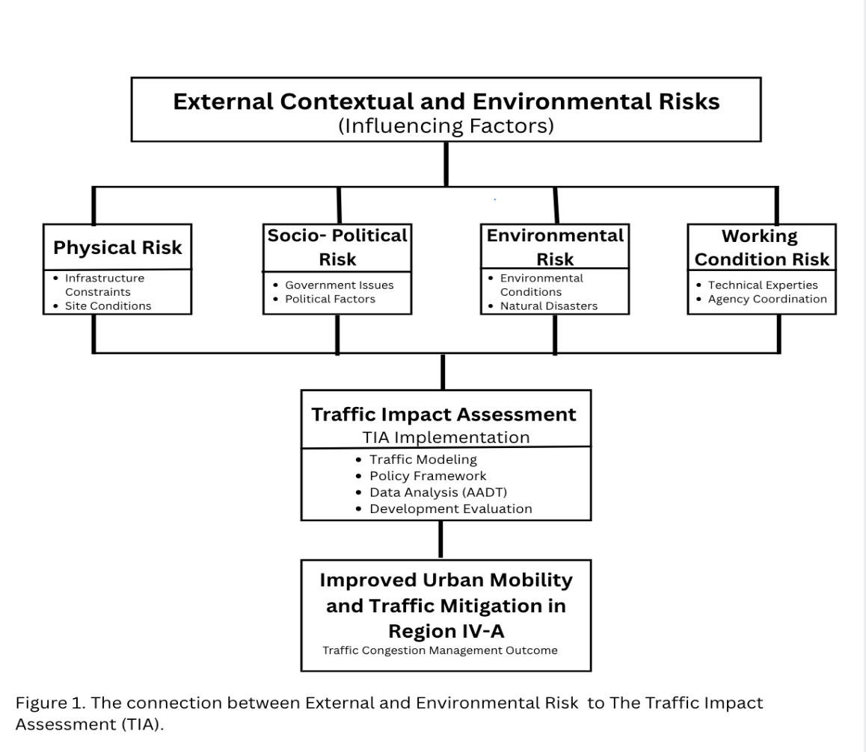
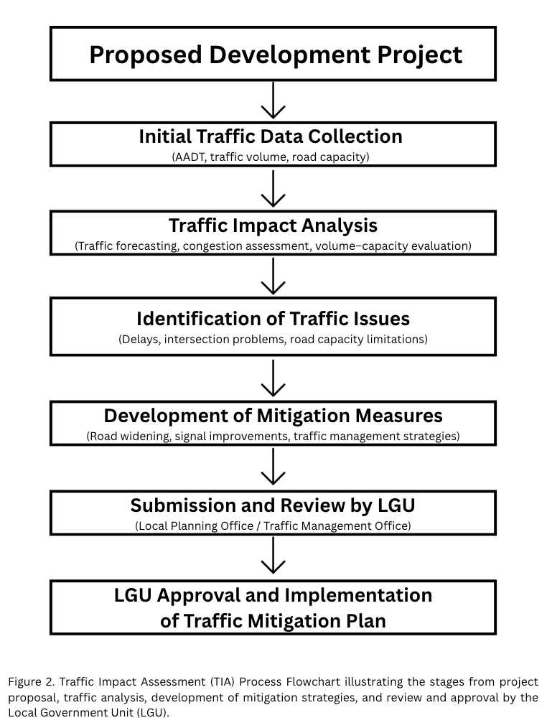

Analytical Method

The study examined the facilitating and hindering factors affecting the institutionalization of the Traffic Impact Assessment in Region IV-A. The factors that determine TIA are regional policies and actions related to TIA. Data for this study were collected using a policy research method. The TIA institutionalization mechanism is developed through a combination of descriptive analysis, observed results, and policy research. This method provides the best way to incorporate TIA into the local governance structure. The answer to "How to mitigate traffic in Region IV-A" is the mechanism itself.

The mechanism also provided capacity interventions to enhance stakeholders' skills in TIA and transport planning. The study marks a step toward forming a committee to advocate for TIA, finalize the TIA ordinance, and institutionalize it. In addition, it also considers the external contextual and environmental risk that includes the physical structure conditions, socio-political governance factors, environmental constraints and lastly the working conditions as the main variables affecting the implementation of the Traffic Impact Assessment across Region IV-A.

Methods

The study adopts a qualitative case study research design. This study systematically evaluates how the Traffic Impact Assessment (TIA) is used in Region IV-A (CALABARZON). It allows for deep exploration of the relationship between rapid infrastructure development and urban mobility in the region. The case study framework examines high-growth areas to identify patterns, recurring challenges, and the region's efficacy.

The methodology includes:

1.Documentary Analysis: Reviewing existing TIA reports, government guidelines, and relevant ordinances from key LGUs in the region, such as Laguna and Cavite.

• Technical Documents: Exposition of the existing Traffic Impact Assessment for major real estate projects, industrial developments, and road constructions.
• Regulatory framework: Reviewing the national guidelines from DPWH, DILG, and local traffic ordinances
• Developmental Plans: Comprehensive Land Use plans to verify the integration of the TIA recommendation.

2. Synthesis of Existing Data: To establish a foundational understanding, this study synthesizes existing data. It uses publicly available traffic data from agencies such as the Department of Public Works and Highways (DPWH), including metrics such as Annual Average Daily Traffic (AADT), as well as information from local planning offices.

• Annual Average Daily Traffic
• Volume-Capacity ratios from the Department of Public Works and Highways

.
3. Expert Inquiry and Literature Synthesis: Incorporating insights from a hypothetical or literature-based perspective of transportation planners, government officials, and developers to understand the practical challenges and successes of TIA in the region.

• Position Papers and Technical Journals: Insights from local/national transportation planners and civil engineers regarding the practical hurdles of TIA in
Philippines.
• Public Records: Minutes of Public hearings and LGU consultations that involve developers and government officials
• Case Jurisprudence: Feedback on the existing literature on TIA successes and failures.

The gathered documents and datasets were examined using qualitative thematic analysis and comparative interpretation. This ensured methodological clarity. Traffic statistics, such as Annual Average Daily Traffic (AADT) and Volume–Capacity ratios, were analysed to identify trends in congestion and infrastructure demand in select high-growth CALABARZON locations. Findings from documentary sources, policy guidelines, and technical studies were classified to pinpoint recurrent problems, policy gaps, and implementation difficulties with Traffic Impact Assessment (TIA). Data from expert literature, regulatory frameworks, and traffic statistics were combined to identify recurring patterns in the efficacy of TIA procedures. To provide a comparative perspective and frame the CALABARZON experience within broader transportation planning procedures, selected case studies from other Philippine regions and global Traffic Impact Assessment studies were evaluated.

RESULTS AND DISCUSSION

Current Traffic Conditions in CALABARZON

The Department of Public Works and Highways (DPWH) measures the Annual Average Daily Traffic (AADT) from the different District Engineering offices across the region. Based on their data, the breakdown of traffic vehicle types is motorcycles/tricycles, passenger cars, public utility vehicles, trucks, and buses.

Based on the 398 traffic survey sites in Region IV-A, there are the top 9 main roads with the highest traffic volume, including Antipolo Circumferential Road A, McDonald Junction - Aguinaldo Highway, Imelda Avenue, Corazon C. Aquino Avenue, Cavite Batangas Road, Marikina-Infanta Road, Noveleta-Naic-Tagaytay Road, Novelita-Rosario Diversion Road, and Zapote-Alabang Flyover to CAVITEX (Alabang–Zapote Road, 2016).

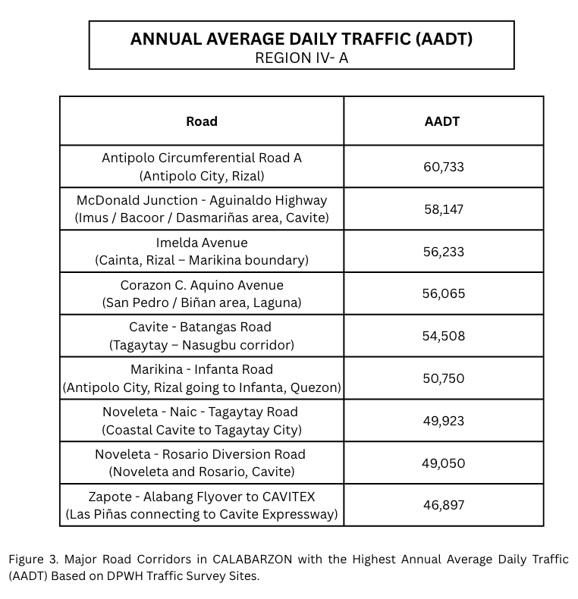

According to transport standards.

10,000-20,000 AADT: Moderate Traffic
20,000-40,000 AADT: Heavy Traffic
40,000 and more: Very heavy congestion potential.

Therefore, based on AADT data in Region IV-A, many roads exceeded 50,000 vehicles per day, indicating a high risk of severe congestion. high demand for traffic mitigation strategies (Regidor et al., 2021).
The high traffic volumes confirm that a Traffic Impact Assessment is necessary for Region IV-A, especially given its urbanizing status. Thus, the major contributing factors to traffic congestion are, a. Rapid Urban Expansion, b. Industrial parks, c. residential subdivisions, and d. Commuter traffic going to Metro Manila. Without proper implementation of the Traffic Impact Assessment, it can lead to a. Overload of road capacity, b. increase in travel time, and lastly, reduce the road level service (LOS). Traffic Impact Assessment TIA is necessary in the region because CALABARZON has high traffic demand corridors, the road capacities are approaching the limits, and urban growth is accelerating.

Current Practices of Traffic Impact Assessment (TIA)

The Region IV-A (CALABARZON) Traffic Impact Assessment follows the national guidelines developed by the University of the Philippines National Center for Transportation Studies (UP-NCTS) in 2001. Local government units adopt the same structure to properly address concerns about Traffic Impact Assessment.
The framework shown in the Figure is realistic and practical for the following reasons: a. it covers all types of development, including those that may not be defined as environmentally critical to require TIA, b. It is very much within the context of existing systems and thus will not involve introducing any new processes.

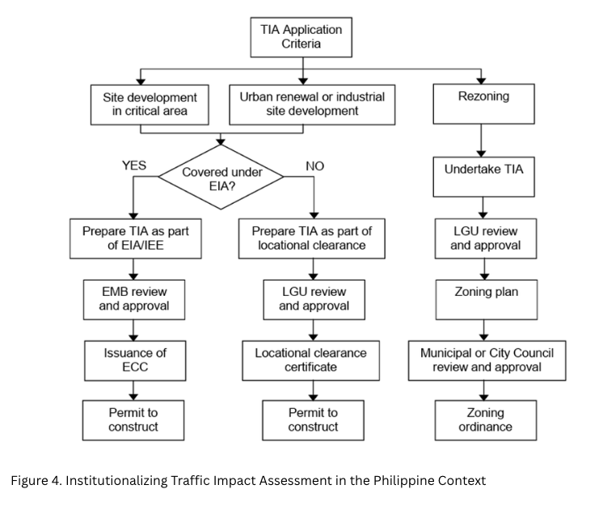
CALABARZON practices the framework provided by the Philippine National Center for Transportation Studies (UP-NCTS) in 2001, pioneered by the province of Laguna through the Provincial Order requiring TIA for developments. DPWH Region IV-A oversees infrastructure impacts, often partnering with DTI for industry roads. Unfortunately, there is no proper implementation of the Traffic Impact Assessment in the whole region. Therefore, TIA is not properly implemented across the region.

Key Challenges in TIA Implementation

- Lack of Standardized Policies
Currently, there is no national law that standardizes the Traffic Impact Assessment being implemented across the Philippines, including Region IV-A. Instead, the TIA relies on a patchwork of guidelines, including local ordinances and integration into existing processes, such as Environmental Impact Statements.

Furthermore, the draft of TIA guidelines was developed by the University of the Philippines-NCTS with JICA support around 1999-2003. The said organization is proposing institutionalization through DENR’s EIA rules for land use. In addition, the draft also relies on the DILG administrative orders. These remain recommendations rather than binding national law (R. & R., 2003, pp. 4208-4223).

In addition, Region IV-A does not have an approved Traffic Impact Assessment; only the local government units that adopt the Laguna Provincial Government ordinance in their zoning ordinances, without the provincial uniformity. In short, there is no region-specific law that overrides the enforcement of TIA.

- Insufficient Traffic Data

Traffic data is sufficient; unfortunately, it becomes insufficient because TIA is not properly implemented, and there is no specific study to serve as a basis for its implementation. They only have the data, but no study provides a strong basis for properly implementing the TIA.

C. Weak Inter-Agency Coordination

Coordination is key to effectively mitigating traffic congestion in the region. Ideally, there must be inter-agency coordination for the Traffic Impact Assessment in region IV-A, involving only the TIA review committee, with LGU, DPWH, DILG, and DOTr representatives to create a standardized method.

Effectiveness of TIA in Mitigating Traffic Impacts

In mitigating traffic impacts, the Traffic Impact Assessment is primarily a theoretical tool and an ideal basis for implementing traffic mitigation, especially when the Key agencies play their roles. The following are the key agencies:

A. DILG and LGUs
They are the agency that leads local ordinance enforcement. They can issue locational clearances and monitor compliance.

B. DPWH
They are the key agencies that provide traffic data, review infrastructure impacts, and the key agency that funds maintenance of national roads.

C. DENR-EMB
They are the key agency that integrates the Traffic Impact Assessment (TIA) into the Environmental Impact Assessment (EIS)

D. DOTr and NCTS-UP
They are the key agency that offers technical guidelines and modelling standards

E. DHSUD
They are the key agency that ensures alignment of land use plans with the Comprehensive Land Use Plan (CLUP).

Consequently, while the Traffic Impact Assessment helps lessen traffic-related problems in region IV-A, its overall effectiveness is limited by inconsistent application and a lack of national standards. Laguna's ordinance, a local effort, puts this possibility front and center, mandating measures to address it. However, the lack of complete data on the extent of reduced congestion underscores the need for ongoing monitoring and adjustments (Lucena City begins traffic rerouting amid commuter backlash, 2026). To improve the effectiveness of these evaluations, it's advisable to strengthen the enforcement of policies and establish standardized national guidelines.

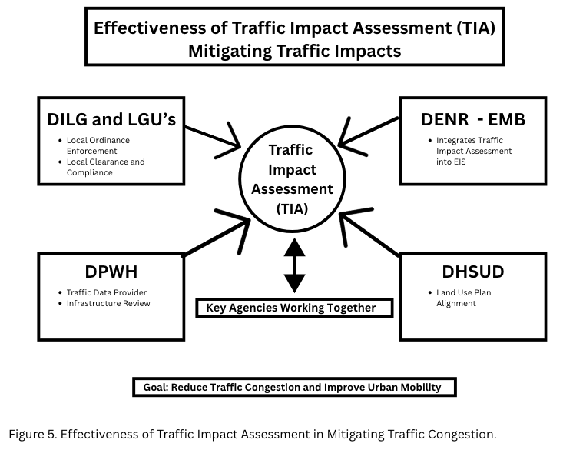

Policy Implications for Urban Mobility in CALABARZON

Incorporating Traffic Impact Assessments into regional planning initiatives is essential for CALABARZON's urban mobility policies. This integration aims to facilitate multimodal transportation systems and improve interagency collaboration throughout the region. These actions are essential for reducing the increasing traffic congestion that often accompanies industrial and urban growth.

A. Traffic Impact Assessment Integration
The Department of the Interior and Local Government (DILG) and/or Regional Development Council (RDC) resolutions require that all Comprehensive Land Use Plans (CLUPs) and zoning ordinances standardize Traffic Impact Assessments (TIAs).

B. Multimodal and Sustainable Shift
Adopts Traffic-Oriented Development (TOD) zoning around the CALAX and SLEX interchanges, that prioritize public transportation.

C. Coordination and Infrastructure
The regional Development Council (RDC) in the Region IV-A oversees flagship projects, and there must be an inclusive planning for resilient urban arteries.
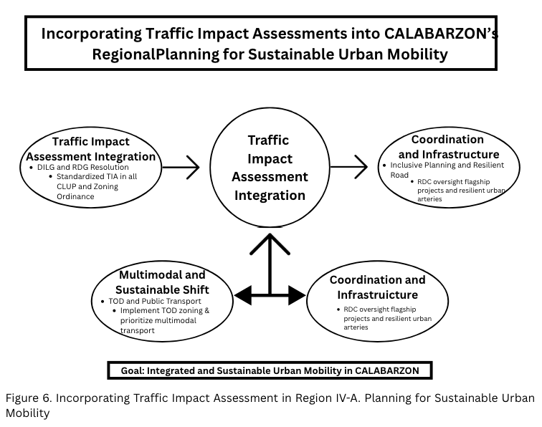

A basic quantitative interpretation of Annual Average Daily Traffic (AADT) data (the average number of vehicles passing a specific point on a road each day over a year) was used to reinforce the analysis. Many major arterial routes (primary roads designed for the rapid movement of high traffic volumes) fall into the heavy to extremely heavy classifications, frequently exceeding the 40,000 AADT threshold based on traffic counts at 398 CALABARZON monitoring sites (CALABARZON Traffic Management Plan 2017-2022, n.d.). In several corridors, road space demand exceeds the normal capacity of urban arterial highways, with daily volumes surpassing 50,000 cars. (Capalad et al., 2026, pp. 55-60) Statistically, this suggests many regional road segments operate at or above their specified capacity. (CALABARZON Traffic Management Plan 2017-2022, n.d.) This observation supports the study’s qualitative conclusions and reinforces that the transportation network is under significant strain from growing urbanization and rising car ownership (Mojares, 2013, pp. 24-40). Therefore, incorporating Traffic Impact Assessments (TIA)—formal studies evaluating the expected traffic effects of new developments—into development planning is crucial to ensure future infrastructure projects include appropriate mitigation measures and maintain acceptable service levels within the region's road network.

CONCLUSION

The study examined the effectiveness and challenges of implementing the Traffic Impact Assessment (TIA) in Region IV-A (CALABARZON), one of the most rapidly urbanizing regions in the country. The study's findings indicate that while TIA serves as an important planning tool for evaluating the transport impacts of development projects, it is practical to implement it consistently across the whole region. The swift urban expansion in Region IV-A, particularly the proliferation of residential subdivisions, commercial centers, and industrial areas, has exacerbated traffic snarls on key transportation routes. The routes encompass the South Luzon Expressway (SLEX), Governor's Drive, and Aguinaldo Highway.

The researcher found that most local governments require Traffic Impact Assessments (TIAs) based on their own rules. However, the lack of a unified national or regional system has led to inconsistent application across the area. The main obstacles include the absence of standardized rules, difficulties in accessing and integrating traffic data, and insufficient coordination between national agencies and local governments. These institutional and regulatory constraints can diminish the efficacy of the Traffic Impact Assessment in mitigating traffic congestion within the region.

Therefore, despite these challenges, the study highlights the potential impact of the Traffic Impact Assessment as an essential, proactive policy and a valuable planning tool that can support rapid urban mobility when effectively implemented. By strengthening the policy framework, improving traffic data management, and enhancing inter-agency coordination, it is essential to maximize the benefits of TIA in a rapidly developing region such as Region IV-A. Thus, addressing these gaps, the Traffic Impact Assessment implementation plays an important role in guiding urban development and mitigating traffic congestion in the region. Withal, the challenges encountered in implementing Traffic Impact Assessment in CALABARZON are linked to the external contextual risk. The physical constraints in road infrastructure, socio-political governance issues, environmental vulnerabilities, and the operational working conditions collectively influence the effectiveness in implementing the Traffic Impact Assessment (TIA).

RECOMMENDATIONS

The researcher emphasizes that to strengthen the implementation and effectiveness of Traffic Impact Assessments (TIA) in Region IV-A, several policy and institutional improvements are essential.

First, there must be an established, comprehensive national legal framework that institutionalizes Traffic Impact Assessment at the national and local levels. Although several agencies have already provided guidelines, the lack of a single national policy could lead to inconsistent implementation of Traffic Impact Assessments (TIAs) across different local government units. A national policy using the Traffic Impact Assessment framework would ensure that all major developments are thoroughly evaluated for their traffic effects. This approach would significantly alleviate and control traffic issues.
Secondly, all local governments across Region IV-A must adopt the standardized Traffic Impact Assessment guidelines and integrate them into their Comprehensive Land Use Plans (CLUPs) and zoning ordinances. Through this, the local level may have proper references and guidelines to better regulate large-scale developments, such as residential, industrial parks, and commercial centers, which significantly affect traffic conditions across the region.

Thirdly, strengthening traffic data management and monitoring systems must be addressed properly. Government agencies such as the Department of Public Works and Highways (DPWH) and the Department of Transportation (DOTr), together with the planning officers in different agencies, must establish a centralized, up-to-date traffic database. Reliable data, such as the Annual Average Daily Traffic (AADT), vehicle classification counts, and travel time studies, will significantly improve the accuracy and effectiveness of the Traffic Impact Assessment and in policy decision-making, especially for the concerned agencies and local government units.

Fourthly, stronger inter-agency coordination must be promoted among key institutions, such as local government units, the Department of Public Works and Highways, (DPWH), the Department of the Interior and Local Government (DILG), the Department of Human Settlements and Urban Development (DHSUD), and the Department of Environment and Natural Resources (DENR). Establishing a national-to-regional-to-provincial Traffic Impact Assessment enables the committee to review how TIA ensures development proposals are evaluated through a multidisciplinary, coordinated process.

Finally, the study ultimately advocates for the advancement of sustainable, multimodal transportation planning, specifically through the implementation of Transit-Oriented Development (TOD) approaches in proximity to and within significant transportation expressway interchanges and corridors. By fostering public transport use, enhancing pedestrian infrastructure, and harmonizing land-use planning with transportation planning, traffic congestion can be alleviated, thereby supporting enduring urban mobility within Region IV-A; these strategies are also applicable to other regions seeking to mitigate traffic congestion.
By implementing these recommendations, we can effectively address traffic congestion and strengthen the role of Traffic Impact Assessment as a crucial planning tool. This will help us manage the effects of development and create a sustainable transportation system in rapidly growing urban areas.

REFERENCES

- (2006). Chapter 7. URBAN TRANSPORT. Office of the Ombudsman. https://www.ombudsman.gov.ph/UNDP4/wp-content/uploads/2012/12/Chap-07.-Urban-Transport-30Nov06-UPF.pdf
- (2016). Alabang–Zapote Road. Wikipedia. https://en.wikipedia.org/wiki/Alabang%E2%80%93Zapote_Road
- (2025). Department of Public Works and Highways. Department Order No. 93. https://www.dpwh.gov.ph/DPWH/references/issuances/department_order?combine=site+developmental+plan
- (February 21, 2026). Lucena City begins traffic rerouting amid commuter backlash. Sentinel Times. https://www.sentineltimes.net/2026/02/lucena-city-begins-traffic-rerouting.html
- (n.d.). CALABARZON Traffic Management Plan 2017-2022. https://calabarzon.depdev.gov.ph/wp-content/uploads/2018/01/Traffic-Mgt-Plan-2018.pdf
- (n.d.). Project for Masterplan on High Standard Highway Network Development (Phase 2) Final Report Executive Summary. https://openjicareport.jica.go.jp/pdf/12341590.pdf
- (n.d.). Transportation Concept Report. https://dot.ca.gov/-/media/dot-media/district-4/documents/d4-transportation-planning-local-assistance/system-regional-planning/tcrs/f0020306_sr-1-south-tcr-final-4-23-18-a11y.pdf
- Bermudez, P. (July 7, 2023). Special task forces in Calabarzon formed to address hazards. Philippine Information Agency. https://pia.gov.ph/special-task-forces-in-calabarzon-formed-to-address-hazards/
- Capalad, C. A., Mendoza, K. J., Ibañez, C. A. & III, B. G. (2026). Spatio-temporal Analysis of Traffic Accessibility in Cavite. ISPRS Archives 542025, pp. 55-60. https://doi.org/10.5194/isprs-archives-XLVIII-5-W4-2025-55-2026
- Mojares, J. (2013). Urbanization &amp; Its Effect in CALABARZON. JGIP- Volume 6 (102013), pp. 24-40. https://doi.org/10.13140/RG.2.2.22876.77449
- R., R. J. & R., T. M. (2003). Institutionalizing Traffic Impact Assessment. Journal of the Eastern Asia Society for Transportation Studies 5, pp. 4208-4223. https://doi.org/10.11175/easts.5.4208
- Regidor, J. R. & Teodoro, R. V. (2005). Traffic Impact Assessment for Sustainable Traffic Management and Transportation Planning in Urban Areas. RP NCTS 2005-07. https://serp-p.pids.gov.ph/publication/public/view?slug=traffic-impact-assessment-for-sustainable-traffic-management-and-transportation-planning-in-urban-ar
- Regidor, J. R., Kubota, I. & Sakamoto, K. (2021). A Comparative Analysis of Traffic Impact Assessment in the Philippines, Japan, and South Korea: Implementation and the Use of Computer Simulation as an Analytical Tool. Philippine Engineering Journal 22(2). https://doi.org/10.13185/PEJ2021.22201
- Regidor, J. R., Kubota, I. & Sakamoto, K. (2021). A Comparative Analysis of Traffic Impact Assessment in the Philippines, Japan, and South Korea: Implementation and the Use of Computer Simulation as an Analytical Tool. Philippine Engineering Journal 22(2). https://doi.org/10.13185/PEJ2021.22201
- Rendon, M. C., Agustin, N. A., Lidasan, H. S. & Guarino, D. L. (n.d.). Institutionalizing Transport Impact Assessment: The Case of Cotabato City. https://www.ncts.upd.edu.ph/tssp/wp-content/uploads/2017/02/2010-04_rendon_final.pdf

