“A REVIEW ON OBESITY TREATMENT IN AYURVEDA AND HOME REMEDIES.”
Shraddha S. Jadhav^{1*}, Pranali R. Ohol^{2*}, Shivani M. Mandake^{3*}, Gouri R. Patole^{4*},
Sushma S. Patil^{5*}

- Government College of Pharmacy, Karad. 415124 - Dist. – Satara (Maharashtra).
- Government College of Pharmacy, Karad. 415124 - Dist. – Satara (Maharashtra).
- Government College of Pharmacy, Karad. 415124 - Dist. – Satara (Maharashtra).
- Government College of Pharmacy, Karad. 415124 - Dist. – Satara (Maharashtra).
- Government College of Pharmacy, Karad. 415124 - Dist. – Satara (Maharashtra).

ABSTRACT
Obesity has become a major global health concern, gradually surpassing malnutrition and infectious diseases as a leading cause of poor health outcomes. It is strongly associated with several chronic conditions such as diabetes mellitus, coronary heart disease, certain types of cancers, and respiratory disorders. In Ayurvedic medicine, natural formulations have been widely explored for managing obesity. One such formulation described in the classical text Rasaratna Samuccaya includes a decoction prepared from Triphala—a combination of Amla, Haritaki, and Bibhitaki—along with Guggulu. The present review aims to evaluate the effectiveness of this herbal formulation in the management of obesity. Relevant information was collected from classical Ayurvedic scriptures, modern scientific literature, and previously published research studies. A comprehensive literature review was conducted focusing on the selected herbs and their properties, particularly analyzing them through the Ayurvedic concept of Pancha Padārtha (five fundamental attributes of a substance).
The analysis indicates that this herbal combination possesses significant anti-obesity potential due to its compatibility with properties such as Lēkhana (scraping action) and Shōshana (absorptive action), which are beneficial in reducing excess fat and balancing Kapha (Shleshma) dosha. Furthermore, multiple studies support the lipid-lowering and metabolism-enhancing effects of these ingredients, contributing to weight management. Based on both classical references and modern research evidence, the reviewed herbal formulation demonstrates promising efficacy in the treatment of obesity.
- Keywords: Obesity, Ayurveda Treatment, Herbal Medicine, Home Remedies

INTRODUCTION
The illness process of obesity is characterized by an excessive build-up of body fat and has a complicated genetic environmental etiology, which has many harmful effects on different organs. According to this definition, BMI (Body Mass Index=[Weight (kg)/ Height (m2)]) is a measure of adiposity and it has been widely believed that obesity is less detrimental in older adults because of the finding that the BMI value linked with the lowest relative mortality is slightly higher in older adults than in younger adults. According to the World Health Organization (WHO), central obesity is defined as a waist circumference more than 102 cm for males and 88 cm for women.According to Ayurveda, obesity also known as Athisthoulya, is the result of an excessive buildup of the substance MedōDhātu (fat tissue) in the body. Ayurveda & contemporary medicine can be used to treat disease and contemporary management prioritizes lifestyle guidance, diets for weight loss, medications and surgeries. Anti-obesity drugs are used in the short term to maximize the weight loss achieved with low- calorie diets, but are not used in the long-term maintenance of weight. The discipline of Ayurveda has used Ayurvedic medications that contain the properties of Medōhara (reduce fat) & Lēkhaniya to treat obesity. Herbs were selected from authentic text, Rasaratna Samuccaya and it is mentioned in Kshudrarōgādi Chikitsithaya.
Decoction chosen from an authentic book has the following ingredients:
Haridrā (Curcuma longa) and Thēja Patra (Cinnamomum tamala) and it lower the body's serum cholesterol as well as excessive Mēda (fat) The current study based on an Ayurvedic medicinal formula that used in obesity that written over Rasaratna Samuccaya.⁽²⁾ The study critically analyzed the pharmacological activities of the ingredieninselected formula in the management of obesity. Aims and objectives The study was created to determine the anti-obese activity of the ingredients in selected herbal formula in the management of obesity.
For adults WHO defines overweight and obesity as follows:
Overweight is a BMI greater than or equal to 25; and Obesity is a BMI greater than or equal to 30. BMI provides the most useful population-level measure of overweight and obesity as it is the same for both sexes and for all ages of adults. However, it should be considered a rough guide because it may not correspond to the same degree of fatness in different individuals. For children, age needs to be considered when defining overweight and obesity. Children under 5 years of age For children under 5 years of age: overweight is weight-for-height greater than 2 standard deviations above WHO Child Growth Standards median; and Obesity is weight-for-height greater than 3 standard deviations above the WHO Child Growth Standards median. For children aged 5–19 years, overweight and obesity are defined using BMI-for-age based on the WHO Growth Reference. A child is considered overweight when their BMI-for-age is more than 1 standard deviation above the reference median, while obesity is defined as BMI-for-age exceeding 2 standard deviations above the median.⁽¹⁾

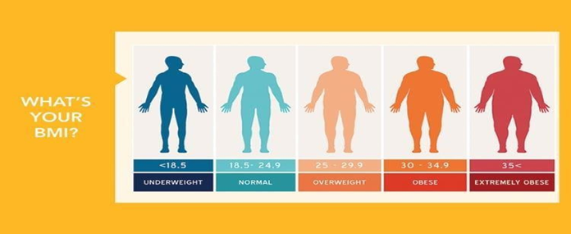

Fig: 1
- METHODOLOGY:
This review study was done to collect and understand information about Ayurvedic treatment and home remedies used for obesity management (Sthaulya), especially their safety and possible side effects.
For this study, information was collected from different online research sources such as Scopus, ResearchGate, PubMed, Google Scholar and Many earlier review papers on herbal and Ayurvedic treatment of obesity have used similar sources. The articles selected for this review were published between 2000 and 2025, so that the information is recent and reliable. Different keywords were used to search for relevant studies, such as “Ayurveda for obesity,” “Sthaulya treatment,” “Guggulu for weight loss,” “Garcinia cambogia,” and “home remedies for obesity.”
Different types of studies were included, like review articles, clinical studies, and experimental research. Only those studies were selected which focus on Ayurvedic or herbal treatment for obesity,
How the treatment works or its benefits, Mention safety, side effects, or precautions.
After selecting the studies, the important information was carefully read and collected. This included details about how the medicines work, their benefits, and their safety and Contraindications. The collected data was then arranged in a simple and clear way. Finally, this information was used to support the review of literature.

HISTORY OF OBESITY:
The history of Ayurvedic treatment for obesity, referred to as Sthoulya or Medoroga in classical texts, dates back to ancient times, primarily documented in the major Ayurvedic treatises (Samhitas). ⁽²⁾
Historical and conceptual background:
- Conceptualization in Ancient Texts:
Classical References: The condition of Sthoulya is extensively described in the Charaka Samhita (specifically in the Ashtauninditiya Adhyaya and Santarpaniya Adhyaya in the Sutrasthana), the Sushruta Samhita, and the Ashtanga Hridaya by Acharya Vagbhata. The "Contemptible Person" (Ashta Nindita Purusha): Acharya Charaka classified eight types of individuals who are "contemptible" due to their body extremes, and the excessively obese person (Atisthoola) is considered one of the worst among them, due to its complicated nature and propensity for multiple diseases. ⁽²⁾
Pathogenesis (Samprapti): Sthoulya is categorized as a Santarpanotha Vikara, a disease caused by over-nourishment or excessive consumption of foods that are heavy (Guru), sweet (Madhur), and unctuous (Snigdha), combined with a sedentary lifestyle and lack of physical and mental exertion. Dosha and Dhatu Imbalance: The core imbalance is primarily an aggravation of Kapha Dosha and the subsequent over-accumulation of Meda Dhatu (fat tissue). This excessive Meda then obstructs the body's channels (Srotorodha), preventing proper nourishment from reaching other tissues and ironically leading to increased appetite and a vicious cycle of fat production.
- Historical Line of Treatment (Chikitsa Sutra):
The fundamental therapeutic principle for Sthoulya established in these ancient texts is Apatarpana Chikitsa (depletion therapy), or Guru Cha Atarpana (heavy but non-nourishing therapy), which aims to reduce the body's excess bulk and fire up the fat metabolism.
This management approach historically and currently is structured into three main components:

Shodhana (Purification Therapy-Panchakarma) Purification procedures were historically recommended for individuals with good strength and a significant accumulation of toxins (Bahudoshavastha).

Vamana (Therapeutic Emesis): Primarily used to eliminate aggravated Kapha Dosha from the upper gastrointestinal tract, a key factor in obesity.
Virechana (Therapeutic Purgation): Used to cleanse the digestive tract and reduce fat accumulation, often employed when Vamana is not suitable.
Basti (Medicated Enema): Specifically, a Lekhana Basti (scraping/reducing enema) or Ruksha Niruha Basti (non-unctuous enema) is traditionally advocated to reduce Meda and Kapha.
- Shamana (Palliative Therapy - Internal Medication and External Procedures)
Internal Medications (Aushadha): Ancient formulations use herbs with Lekhana (scraping), Rukshana (drying), Deepana (appetizer), and Pachana (digestive) properties.Popular historical ingredients include Guggulu (known for its fat-burning properties, often in preparations like Medohar Guggulu or Navaka Guggulu), Triphala (for digestion andmetabolism), Vidanga, and Musta. Kshara Yogas (alkaline preparations like Yava Kshara) were also prescribed.
External Procedures (Bahir Parimarjana): Udvartana (Dry Powder Massage): Considered one of the best external therapies. The ancient texts, including Charaka and Vagbhata, specifically recommend Ruksha Udvartana (massage with dry, coarse herbal powders) to break down subcutaneous fat, liquefy Kapha, and improve circulation.
- Aahara & Vihara (Diet and Lifestyle) the history of Sthoulya treatment places huge emphasis on modifying diet and lifestyle, as they are the primary causes.
Diet (Aahara): Advice traditionally centers on consuming light (Laghu), dry (Ruksha), and warm foods. The historical recommendations include: Grains like Yava (barley) and Mudga (green gram). Metabolism-enhancing spices like Trikatu (a blend of ginger, black pepper, and long pepper).Avoiding new varieties of rice, curd, unboiled milk, excessive sugar, and fatty, processed, or heavy foods.
Lifestyle (Vihara): Key historical advice includes: Avoidance of Divaswapna (daytime sleeping), which is highly Kapha- aggravating. Regular Vyayama (physical exercise) to burn extra calories and mitigate Kapha.Advice on Sadvritta (good code of conduct) for overall mental well-being. In essence, the Ayurvedic approach to obesity has remained remarkably consistent since the time of the Samhitas, focusing on the reduction of Kapha and Meda through a combination of purificatory therapies, herbal preparations, and rigorous diet and lifestyle modifications. ⁽²⁾
- DEFINITION AND EPIDEMIOLOGY:
Calculating body mass index (BMI), also known asquetelet index is defined by dividing the mass (Kg) by the square of the height (m) – it is the epidemiological indicator for the diagnosis of overweight and obesity. According to the adapted classification by the World Health Organization (WHO), obesity is defined by a BMI greater than or equal to 30 Kg/m². The presence of overweight or obesity increases the risk of comorbidities, there is an association between BMI and mortality or chronic disease. ⁽³⁾
- Classification of obesity according to BMI (Kg/m2) and the risk of disease

BMI(kg/m²) | Classification | Class of obesity | Risk of disease
<18,5 | Underweight | - | High
18,5-24 | Normal weight | - | Normal
>25 | Overweight | - | Little high
25-29,9 | Class I Obesity | I | Moderate
35,0-39’9 | Class II Obesity | II | High Risk
>40 | Class II Obesity | III | Very High Risk

Formula: Weight (kg) ÷ Height (m²)

TYPES OF OBESITY:
- Android:
Male type of obesity where surplus fat is marked in the upper half of the body. The lower body region demonstrates comparatively reduced proportions relative to the upper body when assessed through standard measurement and evaluative criteria. It is common in females too Undergone hormone treatment .Around menopause due to thyroid gland’s disturbance Vital organs affected – Heart, Liver, Kidney & Lungs Major risk factor for heart diseases. ⁽⁴⁾
- Gynoecia:
Ordinary in both sexes but females more affected. Excess fat declaration is in the lower part of the body. The spine is never erect due to heavy hips and thighs. Vital organs affected Kidneys, uterus, intestines, bladder. These organs may affect the heart. ⁽⁴⁾

CAUSATIVE FACTORS FOR OBESITY: ⁽⁵⁾
The heredity component (Bijadosha), besides dietetic, regimen, and psychological factors in the causation of obesity is described in Charka Samhita. Except for these factors, the components which may vitiate Meda (Fatty Tissue) and Kapha (One of the three senses of
humor of the Body) could be considered as causative factors of Obesity. Dhatvagni Mandya (Weak digestive fire at the level of body tissues) is the main cause besides other components in the etiopathology of Sthaulya. In the context of obesity, exogenous factors primarily include a Meda-promoting diet and lifestyle, while endogenous components involve the imbalance of Doshas, as well as alterations in Dhatus (body tissues), Malas (waste products), and Srotas (body channels) come under the endogenous factor.
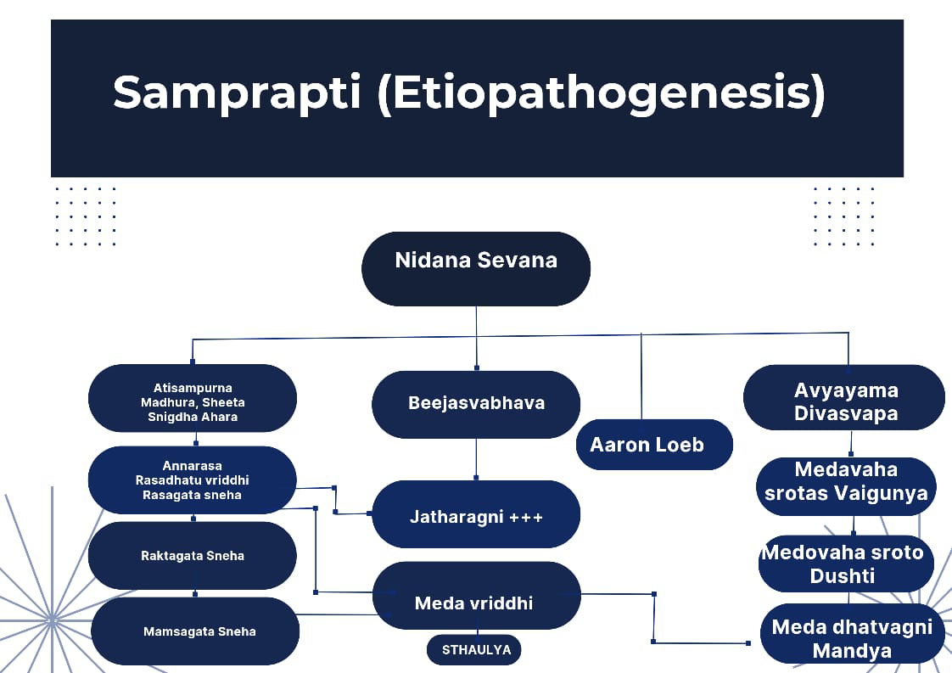
Fig: 2

SYMPTOMS: ⁽⁶⁾
- Breathlessness even on little exertion / physical activity
- Lack of interest in doing work.
- Profuse sweating with foul body odor.
- Excessive hunger.
- Feeling of tiredness.
- Excessive sleep.
Ayurveda: In Ayurveda, Atisthaulya (Obesity) is described as excessive accumulation of Meda (fat/adipose tissue) and Mamsa (flesh/muscle tissue) leading to flabbiness of hips, abdomen, and breast. ⁽⁶⁾

AYURVEDIC MANAGEMENT LINE OF TREATMENT:
(Under strict supervision of Registered Ayurvedic Physician) Shamana (Palliative)

Treatment: Langhan (Fasting) ⁽⁷⁾
Langhana in Ayurveda refers to a therapeutic approach for weight management and obesity. Since Langhana involves dietary modifications, fasting, and lifestyle changes, the "dose" isn't a specific medication quantity.Instead, it's a personalized approach tailored to an individual's needs.

The mechanism of action in obesity treatment typically involves:
- Appetite suppression: Reducing hunger and increasing satiety.
- Energy expenditure: Increasing metabolism and fat burning.
- Fat absorption inhibition: Reducing dietary fat absorption.
- Metabolic regulation: Improving insulin sensitivity and glucose metabolism.

Dose (Guidelines)
- Fasting: Duration and frequency vary (e.g., intermittent fasting, 16:8 or 5:2).
- Dietary Modifications: Focus on light, easy-to-digest foods, portion control, and balanced nutrition.
- Lifestyle Changes: Regular physical activity, stress management, and adequate sleep.
Interactions:
- Medications: Potential interactions with medications for diabetes, blood pressure, or other conditions.
- Nutrient Deficiencies: Risk of deficiencies if not properly planned.
- Health Conditions: May not be suitable for everyone, especially those with certain medical conditions.

Side Effects:
- Hunger and Cravings: Initial adjustment period.
- Fatigue: Potential for low energy, especially during fasting.
- Nutrient Deficiencies: If not balanced, may lead to deficiencies. 4. Electrolyte Imbalance: Potential risk during prolonged fasting. Benefits:
  - Weight loss and fat reduction.
  - Improved digestion and metabolism.
  - Enhanced energy levels.
  - Better management of obesity-related health issues.

Precautions:
- Consult a Healthcare Provider: Before starting Langhana, especially if you have health conditions.
- Personalized Approach: Tailor the approach to your individual needs and health status.
- Monitoring: Regularly monitor your health and adjust as needed.

Ama pachan (oral use of digestives to augment the fat metabolism) ⁽⁸⁾
Ama Pachan is an Ayurvedic approach to improve digestion and metabolism, aiding in weight distribution and health.
Mechanism of Action:
- Enhances digestive fire (Agni).
- Breaks down undigested food (ama).
- Improves nutrient absorption.
- Supports detoxification.

Dose (Guidelines)
- Herbal formulations like triphala, ginger, or haritaki.
- Dosage varies based on individual needs and formulation Interactions.
- Potential interactions with medications or other supplements.
- Consult a healthcare provider before combining with other treatments.

Side Effects:
- Generally safe, but potential gastrointestinal side effects. - Monitor and adjust dosage as needed.

Benefits:
- Improved digestion and metabolism.
- Weight management support.
- Enhanced nutrient absorption.
- Overall health and well-being.

Precautions:
- Consult a qualified Ayurvedic practitioner or healthcare provider.
- Tailor the approach to individual needs and health status.
- Monitor health and adjust as needed.

Ruksha Udwartan (Dry medicated powder massage) ⁽⁹⁾
Heavy and non-nourishing diet/items like Honey, salad etc. are advised.
Heavy and Non-Nourishing Diet/Items (e.g., Honey, Salad) this approach involves consuming specific foods that promote satiety and support weight management.

Mechanism of Action:
- Honey: Natural sweetener, potential metabolism booster.
- Salad: Low-calorie, high-fiber, promotes satiety.

Dose (Guidelines)
- Honey: 1-2 teaspoons per day
- Salad: Regular consumption as part of a balanced diet

Interactions:
- Honey: Potential interactions with diabetes medications, the most significant allergic protein present in apis dorsata bee venom is phospholipase A2 (Apid1).
Symptoms: Difficulty breathing, rapid heartbeat, dizziness, confusion and nausea or vomiting.
-Excessive consumption may lead to weight gain or blood sugar issues.
- Salad: Generally safe, but potential digestive issues if not properly prepared.

Benefits:
- Weight Management: Supports satiety and healthy eating habits.
- Nutrient-Dense: Provides essential vitamins and minerals.

Precautions:
- Consume in Moderation: Balance honey and salad with other nutrient-dense foods.
- Choose Wisely: Option for raw, unprocessed honey and fresh, varied salads.
- Individual Needs: Consider dietary restrictions and health conditions.

PHYSICAL EXERCISE: ⁽¹¹⁾
- Asanas (Postures).
Surya Namaskar (Sun Salutation) – full-body workout, improves metabolism. Trikonasana (Triangle Pose) – tones abdomen and waist.

Bhujangasana (Cobra Pose) – strengthens spine and reduces belly fat. Pawanmuktasana (Wind-relieving Pose) – improves digestion and reduces bloating. Dhanurasana (Bow Pose) – stretches whole body, burns calorie.
Paschimottanasana (Seated Forward Bend) – reduces abdominal fat.
Ardha Matsyendrasana (Half Spinal Twist) – massages abdominal organs, improves digestion.
- Pranayama (Breathing Techniques)
Kapalabhati – forceful exhalation, improves fat metabolism. Bhastrika – increases oxygen supply, boosts energy.
Anulom Vilom – balances metabolism and calms mind.
- Meditation & Relaxation.
Helps in stress management (stress often leads to overeating and obesity).

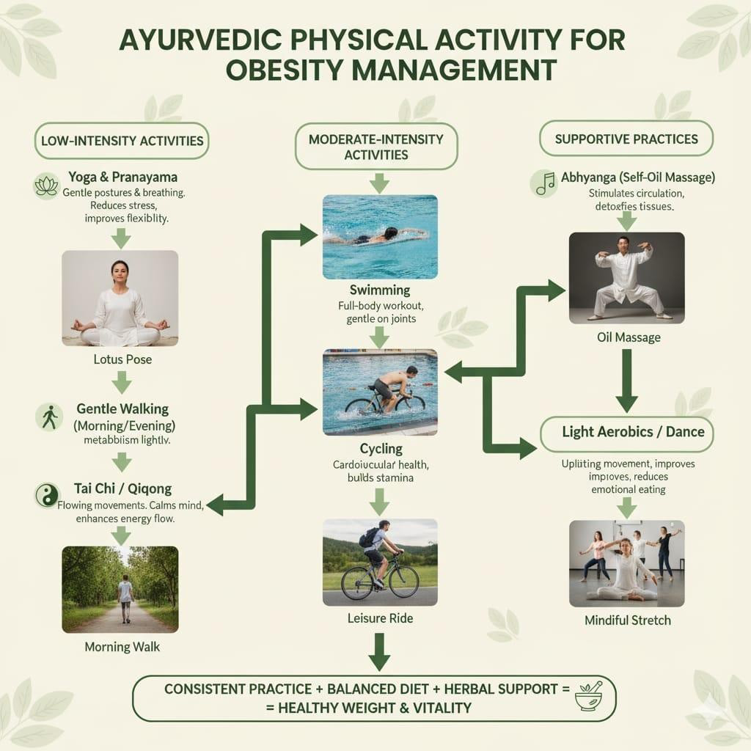

Fig: 3
Yoga manages obesity by: Improving digestion and metabolism, Burning excess fat, Strengthening muscles, Reducing stress and emotional eating.
Mental work is also recommended. SamshodhanaChikitsa (Purificatory procedures): Mental work.

Cognitive Behavioral Therapy (CBT) ⁽¹²⁾
Helps individuals identify and challenge negative thought patterns and behaviors that contribute to overeating and weight gain.
Mindful Eating: Focuses on paying attention to hunger cues, eating slowly, and enjoying food to avoid emotional eating.
Stress Management: Techniques like physical activity and improved sleep quality help reduce stress, which can trigger emotional eating.
Goal Setting: Working with a therapist or dietitian to set small, realistic, and personalized weight loss and lifestyle goals.
Self-Monitoring: Keeping a food diary and activity log to track eating habits and progress.
Social Support: Engaging with support groups or trusted individuals to reduce feelings of isolation and provide ongoing motivation. Developing Healthy
Habits: Incorporating regular physical activity into your routine and improving your overall sleep quality.

Panchakarma : ⁽¹²⁾
- Vaman (Therapeutic emesis)
- Virechan (Therapeutic purgation)
- Lekhan vasti (Medicated enema) are advised for the management of Sthaulya.
- Single drugs: Guduchi, Vidanga, Musta, Sunthi, Amla, Vaca, Daruharidra, Guggulu, etc.
Compound Formulations: Trikatu, Navak Guggulu, Triphala Guggulu, Vidangadi Churna, Takrarishta, Navayasa lauha, Arogya Vardhini Vati etc.
- Vaman (Therapeutic Emesis)
  - Mechanism: Removes excess kapha and toxins from the body.
  - Dose: Administered under Ayurvedic practitioner guidance.
  - Interactions: Potential interactions with medications; consult a practitioner.
Side Effects: Generally safe, but potential dehydration or electrolyte imbalance.
  - Benefits: Detoxification, improved digestion, and weight management.
  - Precautions: Done under practitioner guidance, monitor health.
- Virechan (Therapeutic Purgation)
  - Mechanism: Removes toxins and excess pitta from the gastrointestinal tract.
  - Dose: Administered under practitioner guidance.
  - Interactions: Potential interactions with medications; consult a practitioner.
  - Side Effects: Generally safe, but potential dehydration or electrolyte imbalance.
  - Benefits: Detoxification, improved digestion, and weight management.
  - Precautions: Done under practitioner guidance, monitor health.
- Lekhan Vasti (Medicated Enema)
  - Mechanism: Removes toxins, reduces fat, and improves metabolism.
  - Dose: Administered under practitioner guidance.
  - Interactions: Potential interactions with medications; consult a practitioner.
  - Side Effects: Generally safe, but potential discomfort or infection.
  - Benefits: Detoxification, weight management, and improved digestion.
  - Precautions: Done under practitioner guidance, monitor health. Single Drugs.
  - Examples: Guduchi, Vidanga, Musta, Sunthi, Amla, Vaca, Daruharidra, Guggulu.
  - Mechanism: Various mechanisms, including improving digestion, metabolism, and detoxification.
  - Dose: Varies based on the herb and individual needs.
  - Interactions: Potential interactions with medications; consult a practitioner.
  - Side Effects: Generally safe, but potential side effects vary by herb.
  - Benefits: Weight management, improved digestion, and overall health.
  - Precautions: Consult a practitioner, monitor health.Compound Formulations.
  - Examples: Trikatu, Navak Guggulu, Triphala Guggulu, Vidangadi Churna, Takrarishta, Navayasa Lauha, Arogya Vardhini Vati.
  - Mechanism: Various mechanisms, including improving digestion, metabolism, and detoxification.

Dose: Varies based on the formulation and individual needs.
  - Interactions: Potential interactions with medications; consult a practitioner.
  - Side Effects: Generally safe, but potential side effects vary by formulation.
  - Benefits: Weight management, improved digestion, and overall health.
  - Precautions: Consult a practitioner, monitor health.

DIET: ⁽¹³⁾

Category | Recommended(kapha-Pacifying) | Food/Tastes to limit/Avoid
Tastes(Rasa) | Pungent (katu),bitter(tikta),astrigent(kashaya) | Sweet (Madhura),  Sour (Amla), Salty (Lavana) |
Qualities(Gunas) | Light (Laghu), Dry (Ruksha), Warm (Ushna) | Heavy (Guru), Oily/Unctuous  (Snigdha), Cold (Sheeta)
Grains | Barley (Yava), Millet (Jowar, Bajra, Ragi), Buckwheat, Old Wheat, Quinoa | New/Fresh Grains (Navanna),⁽¹²⁾Polished  Rice, Cooked Oats, Yeasted Bread.
Pulses/Legumes | Horse Gram (Kulatthi), Mung Bean (Mudga), Chickpeas, Red Lentils. | Black Gram (Masha), Kidney Beans (in  excess).
Vegetables | Bitter Gourd, Leafy Greens, Radish, Cabbage, Broccoli, Carrots, Onions,  Garlic. (Ideally steamed or lightly sautéed). | Potato, Sweet Potato, Cucumber, Avocados, Tomatoes (raw).
Fruits | Light fruits: Apples, Pears, Pomegranate, Cranberries. | Heavy or Sour fruits: Banana, Mango,  Grapes, Dates, Coconut, Pineapple.
Dairy | Buttermilk (Takra) (highly beneficial). Warm, low-fat milk with Turmeric/Ginger (in moderation). | Heavy or Cold Dairy: Cheese, Yogurt  (Dadhi), Ice Cream, Cold Milk.
Sweeteners | Raw Honey (in small quantities, never cooked or mixed with hot water/ghee). | Refined Sugar,  Jaggery, Syrups, Candy.
Oils | Minimal use of light oils (Olive, Sunflower) | All fried foods, excess Ghee, excessive fatty/oily substances.  |(12)

Lifestyle During Obesity Management ⁽¹⁴⁾

Dietary Modifications
Balanced, calorie-controlled diet:
Reduce total calorie intake while ensuring nutritional adequacy. Increase intake of:
  - Fruits and vegetables.
  - Whole grains.
  - Lean proteins (fish, poultry, legumes)
  - Low-fat dairy products Reduce intake of:
  - Sugary foods and beverages.
  - Refined carbohydrates (white bread, sweets)
  - Saturated and Trans fats.
  - Fried and fast foods. Portion control:
Eat smaller portions and avoid second helpings. Meal timing:
Avoid skipping meals; eat at regular intervals.

2. Physical Activity ⁽¹⁴⁾
Aerobic exercise:
At least 150–300 minutes per week (e.g., brisk walking, cycling, swimming). Strength training:
2–3 times per week to maintain muscle mass.
Daily habits: Use stairs instead of elevators, walk short distances, avoid prolonged sitting.

3. Behavioral Modifications ⁽¹⁵⁾
Self-monitoring involves maintaining a structured record of dietary intake, physical activity, and changes in body weight over time. Goal setting: Set realistic and gradual goals (e.g., 0.5–1 kg/week weight loss).
Stress management: Practice yoga, meditation, or relaxation techniques.
Sleep time: Ensure 7–8 hours of sleep per night;
poor sleep increases hunger hormones.
Avoid emotional eating:

Identify and evaluate factors such as psychological stress or boredom that may contribute to episodes of overeating.

4. Avoidance of Unhealthy Habits ⁽¹⁶⁾
Limit alcohol consumption. Avoid smoking.
Reduce screen time (TV, mobile, computer).

5. Regular Monitoring and Support ⁽¹⁷⁾
Regular follow-up with healthcare professionals (doctor, dietitian). Join support groups or weight management programs for motivation.
- HOME REMEDIES FOR OBESITY: ⁽¹⁸⁾

Lemon Juice:
Lemon juice is widely regarded as an effective home-based remedy for supporting the management of obesity. It is rich in fiber, vitamins like vitamin B and C, minerals including calcium, magnesium, iron, zinc, and phosphorus. It helps improve digestion and aids in detoxification. Optimal digestive function is a fundamental prerequisite for effective weight loss, as it enables efficient nutrient assimilation necessary for fat metabolism. The citric acid present in lemons is very effective in burning fat .Furthermore; it helps remove toxins from your body that slow down your metabolism. A recent study published in the journal of Nutrition Research in 2015 showed that a lemon detox program was very effective in reducing fat and insulin resistance in a group of overweight Korean women in comparison to the control group.
- Mix three teaspoons of lemon juice, one teaspoon of honey, and one-half teaspoon of black pepper powder in one glass of water. (If freshly ground black pepper is used, a quantity of approximately one-quarter teaspoon is recommended.)
- Drink it in the morning on an empty stomach.
- Do this daily for at least three months. Alternatively, you can simply have a cup of warm water mixed with a teaspoon of lemon juice.
Raw, unfiltered apple cider vinegar is commonly cited as a home-based intervention for reducing excess body weight. Although its definitive role in weight loss remains inconclusive, preliminary evidence suggests that it may exert protective effects against the development of obesity. Apple cider vinegar (ACV) was found to decrease cholesterol in animals fed high cholesterol diet in comparison to the controls in animal models. The use of vinegar as part of a healthy diet can in the long run help in weight loss and diabetes. It facilitates lipid metabolism, thereby helping to prevent the accumulation of excess body fat. Mix two teaspoons of raw, unfiltered apple cider vinegar in a glass of water. It is recommended to consume it daily in the morning, preferably prior to meals. You can also drink a glass of water mixed with one teaspoon each of raw, unfiltered apple cider vinegar and lemon juice. You can have up to two tablespoons of apple cider vinegar in a day. Exceeding the recommended intake should be avoided, as prolonged excessive consumption may lead to a reduction in blood potassium levels and a decline in bone mineral density over time.

Aloe Vera:
Aloe Vera is useful in treating obesity because it stimulates metabolism, increases energy consumption, and mobilizes unused fat in the body. Aloe vera contains more than 75 different biologically active substances. This plant has been used in traditional medicine for wound healing, anti-inflammatory activity, antiseptic properties and also as a laxative. A study done in 2008 showed that phytosterols isolated from Aloe vera was effective in reducing body fat accumulation in obese diabetic animal models.

Green Tea:
Green tea is another popular natural remedy to promote weight loss. Green tea is rich in polyphenols like epigallocatechin gallate (EGCG), epigallocatechin, and epicatechin gallate which are beneficial for health. A study at Penn State revealed that epigallocatechin-3-gallate (EGCG), a compound found in green tea, helps slow down weight gain by limiting fat absorption and increasing the body’s ability to use fat. Another report from Penn State showed that decaffeinated green tea along with exercise helped in achieving weight loss in mice. While another study published in 2009 showed that the catechins present in green tea had a small positive effect on weight loss and weight management. Furthermore, green tea is rich in essential nutrients, including vitamin C, carotenoids, zinc, selenium, chromium, and other trace minerals. The regular consumption of approximately three to four cups of green tea per day is suggested to support the management of obesity. It may also be used in combination with ginger tea or cayenne pepper to enhance its effects. Cayenne pepper has been recognized for its potential role in weight management, as it contains capsaicin, a bioactive compound that promotes fat oxidation and increases energy expenditure. Other than capsaicin, chilies have vitamin C, β carotene, and lutein which are well-known antioxidants. In addition, it stimulates digestion and suppresses excess appetite caused by malabsorption of nutrients in the body.
- Make cayenne pepper tea by pouring a glass of hot water over cayenne pepper (start with one tenth of a teaspoon or just a dash of cayenne pepper and gradually increase its quantity to one teaspoon). Squeeze the juice from half a lemon in it. Drink this tea regularly for a month.
- Mix two tablespoons each of lemon juice in 10 ounces of water (one glass contains 8 ounces). Stir in a dash of cayenne pepper and drink it.
- Use cayenne pepper and other spices, such as ginger, black pepper, and mustard seeds, generously in your meal preparations.

Curry Leaves:
Curry Leaves Eating 10 fresh curry leaves daily in the morning works as a great Ayurvedic remedy to deal with obesity and diabetes caused by obesity Curry leaves, which are lavishly used for garnishing and flavoring dishes, are rich in proteins, carbohydrates, fiber, minerals, carotene, nicotinic acid, vitamins A and C, calcium and oxalic acid. It is a rich source of biologically active compounds like koenigin, girinimbin, koenidine, triterpenoids etc.⁽³⁾The leaves are traditionally used for its stomachic, tonic, antihelminithic, antidiabetic, antidiarrheal, and carminative properties.

Tomatoes:
Tomato is an excellent natural medicine bursting with goodness that can help you in your battle against obesity. Tomato is rich in vitamin A and C, potassium, phosphorus, magnesium, and iron that are required for normal activity of nerves and muscles., the pigment lycopene responsible for the bright red color of tomatoes which is beneficial for the body. It works as a powerful antioxidant that neutralizes damage by free radicals to cells in the body. Other biological constituents of tomatoes include coumaric acid and chlorogenic acid. They fight cancer by blocking powerful carcinogens like nitrosamines. Tomatoes also have anti- inflammatory and antithrombotic properties. The bioavailability of lycopene and other nutrients increases upon cooking and processing. Campari tomatoes which contain very high amounts of lycopenes, were shown to lower lipid levels in diet- induced obese zebra fish models in a paper published in 2011. Eat a couple of tomatoes every morning on an empty stomach. Make sure you eat the peels and seeds as well because they contain dietary fiber. Tomatoes contain compounds that tend to alter the levels of hormones that affect your appetite. Furthermore, vitamins A, C, and K, which are rich in and magnesium, manganese, choline, folate, and other nutrients, they are good for your health. Also, they are packed with antioxidants that protect against cancers.

Cabbage
Cabbage has been used as a remedy for weight loss and obesity. Being a cruciferous vegetable, it contains phytochemicals that help improve the imbalance of estrogen
Metabolism. Cabbage belongs to the Brassica genus, of which kale, cauliflower, broccoli etc. are also members.
Here are the commonly used methods to determine obesity:
WHO Classification:
Normal: 18.5 – 24.9
Overweight: 25 – 29.9
Obese: ≥ 30
- Waist Circumference (WC):
Measures central/abdominal obesity⁽³⁾ Risk:
Men: >102 cm
Women: >88 cm
- Waist–Hip Ratio (WHR):
Formula: Waist circumference ÷ Hip circumference High risk:
Men: >0.90
Women: >0.85
- Skinfold Thickness Measurement:
Using calipers at triceps, abdomen, thigh, etc. to estimate body fat %.
- Bioelectrical Impedance Analysis (BIA):
Uses electrical conductivity through body tissues to estimate fat vs. lean mass.
- Dual-Energy X-ray Absorptiometry (DEXA): Gold standard for measuring body fat %, fat distribution, and lean body mass.
- Hydrostatic Weighing (Underwater Weighing):Measures body density to calculate fat percentage.
- MRI / CT Scan: Accurate methods to measure visceral fat (research/clinical use).

AYURVEDIC DRUG : ⁽¹⁹⁾

Garcinia cambogia:
  - Mechanism: Inhibits citrate lyase enzyme, reducing fat synthesis, and suppresses appetite.
- Dose: 500-1000 mg, 2-3 times a day.
  - Side Effects: Nausea, headaches, digestive issues.
  - Benefits: Weight loss, improved metabolism, reduced fat storage.
  - Precautions: Consult a doctor before use, especially for pregnant or breastfeeding women.

Gymnema sylvestre: ⁽¹⁹⁾
  - Mechanism: Reduces sugar cravings and improves insulin sensitivity.
  - Dose: 200-400 mg, 2-3 times a day.
  - Side Effects: Generally safe, but may cause digestive issues or hypoglycemia in some individuals.
  - Benefits: Weight loss, improved insulin sensitivity, reduced sugar cravings.
  - Precautions: Consult a doctor before use, especially for pregnant or breastfeeding women, or those with diabetes.

Vidanga: ⁽²⁰⁾
  - Mechanism: Improves digestion, reduces fat accumulation, and enhances metabolism.
  - Dose: 1/2 to 1 teaspoon, 1-2 times a day.
  - Side Effects: Generally safe, but may cause digestive issues in some individuals.
  - Benefits: Improved digestion, weight loss, reduced fat accumulation.
  - Precautions: Consult a doctor before use, especially for pregnant or breastfeeding women.
Guggul (Commiphora mukul): (²¹)
  - Mechanism: Stimulates thyroid function, improving metabolism and fat burning.
- Dose: 500-1000 mg, 2-3 times a day.
  - Side Effects: Digestive issues, skin rash.
  - Benefits: Weight loss, improved thyroid function.
Precautions: Consult a doctor, especially for thyroid disorders.
Haritaki ,Harad (Terminalia chebula): ⁽²²⁾
  - Mechanism: Improves digestion and metabolism.
  - Dose: 1/2 to 1 teaspoon, 1-2 times a day.
  - Side Effects: Generally safe, may cause digestive issues.
  - Benefits: Improved digestion, weight management.
  - Precautions: Consult a doctor, especially for pregnant or breastfeeding women.
Amala (Emblica officinalis): ⁽²³⁾
  - Mechanism: Rich in vitamin C and antioxidants.
  - Dose: 500-1000 mg, 1-2 times a day.
  - Side Effects: Generally safe.
  - Benefits: Improved metabolism, antioxidant support.
  - Precautions: Consult a doctor for high doses.

Shilajit: ⁽²⁴⁾
  - Mechanism: Improves energy and metabolism.
- Dose: 100-500 mg, 1-2 times a day.
  - Side Effects: Generally safe, may cause allergic reactions.
  - Benefits: Improved energy, enhanced metabolism.
  - Precautions: Consult a doctor, especially for pregnant or breastfeeding women.
Kutki (Picrorhiza kurroa): ⁽²⁵⁾
  - Mechanism: Improves digestion, reduces inflammation, and enhances liver function.
  - Dose: 400-800 mg, 2-3 times a day.
  - Side Effects: Generally safe, may cause digestive issues.
  - Benefits: Improved digestion, liver support, weight loss.
  - Precautions: Consult a doctor, especially for pregnant or breastfeeding women.
Musta ,Nagarmotha (Cyperus rotundus): ⁽²⁶⁾
Mechanism: Improves digestion, reduces bloating, and enhances metabolism.
  - Dose: 500-1000 mg, 2-3 times a day.
  - Side Effects: Generally safe.
  - Benefits: Improved digestion, reduced bloating, weight management.
  - Precautions: Consult a doctor, especially for pregnant or breastfeeding women.
Chitrak (Plumbago zeylanica):
  - Mechanism: Improves digestion, enhances metabolism, and reduces inflammation.
  - Dose: 250-500 mg, 2-3 times a day.
  - Side Effects: May cause skin irritation, digestive issues - Benefits: Improved digestion, enhanced metabolism, weight loss.
  - Precautions: Use under medical supervision, especially for pregnant or breastfeeding women.
Pippali (Piper longum):
  - Mechanism: Improves digestion, enhances metabolism, and reduces inflammation.
- Dose: 250-500 mg, 2-3 times a day.
  - Side Effects: Generally safe, may cause digestive issues.
  - Benefits: Improved digestion, enhanced metabolism, weight management.
  - Precautions: Consult a doctor, especially for pregnant or breastfeeding women.
Vacha, Sweet Flag (Acorus calamus): ⁽²⁷⁾
  - Mechanism: Improves digestion, reduces bloating, and enhances metabolism.
  - Dose: 250-500 mg, 2-3 times a day.
-Side Effects: May cause nausea, vomiting, or allergic reactions.
-Benefits: Improved digestion reduced bloating, weight management
-Precautions: Use under medical supervision, especially for pregnant or breastfeeding women.

Comparison of Ayurvedic and Conventional Treatment for Obesity ⁽²⁸⁾

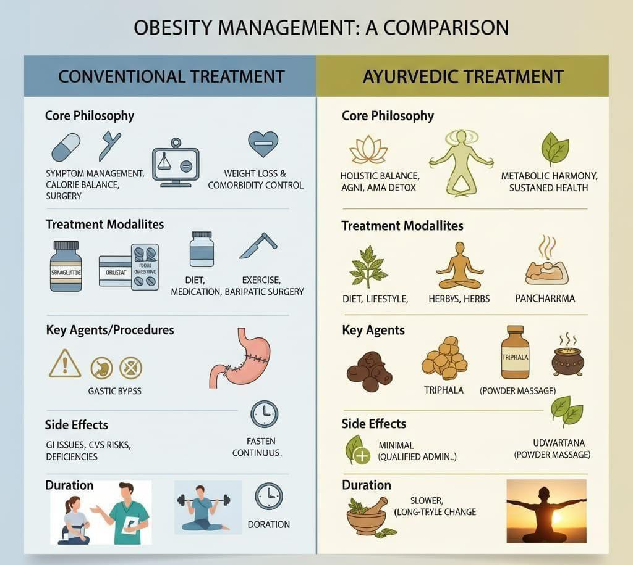

Fig. 4

MARKETED FORMULATION: ⁽²⁹⁾
      - Classical Ayurvedic formulation:

Formulation | Primary ingredient | Benefits and mode  of action | Marketed forms
Medohar Guggulu | Shuddha Guggulu, Triphala, Black Pepper, Vidanga | Aims to manage weight by targeting Meda Dhatu (fat tissue). Regulates fat metabolism, breaks down excess fat, and aids inDetoxification. | Tablets from brands like Patanjali and Baidyanath.
Triphala guggulu | Triphala (Amla, Haritaki, Bibhitaki) and Guggulu | Detoxifies the body and supports healthy metabolism. Its fat- scraping (Lekhaniya) | Tablets from brands like Baidyanath.
Varanadi kwath | Varuna, Agni, Bilva, and Sigru | A polyherbal decoction that helps | Liquid (kwath) and tablet forms from
 |  | optimize metabolism and burn excess fat. particularly for  Kapha and Vata imbalances. | brands like Kerala Ayurveda.

Modern Ayurvedic Formulation:

Formulation | Primary ingredients | Benefits and mode of action | Marketed forms
Divya Medohar Vati | Amla,Baheda,  Harad,Guggul shuddha, Shilajeet shuddha | Patanjali's version of a classic formula. Aims to enhance  metabolism and address obesity. | Tabletsfrom Patanjali.
Zandu Lean & Slim Capsules | Blend of 5 herbs | Marketed as a natural fat-burnerthat supports weight management and  boosts metabolism | Capsulesfrom Zandu
Liposem Tablets | Vrikshamla, Guggulu, Sarpagandha, Arjuna | Supports cardiovascular healthwhilehelping to manage body weight. Aims to normalizecholesterolandtriglyceridelevels | Tablets from Kerala Ayurveda.
Fat Reducer Juice | Amla, Harad,  Gokhru,Giloy, Daruharidra | A liquid formulation that is said to help manageweight through detoxification and  improved metabolism. | Juice from brands like Krishna's Herbal & Ayurveda.
InchEase | Ayurvedic supplementfor weight loss | Combines Ayurvedic principles for healthy weight management, burning fat, and boosting  metabolism. | Capsules from  brands like  Vedikroots.

      - Safety & Contraindications in Ayurvedic Management of Obesity (Sthaulya)

Sr. No. | Drug / Remedy | Main Action in Obesity | Contraindications | Safety / Precautions
1. | Guggulu (Commiphora mukul) | Reduces fat (Medohara), lowers cholesterol, improves metabolism | Pregnancy, breastfeeding, hyperthyroidism, severe liver disease | May cause acidity, headache, or skin allergy; use in proper dose; monitor thyroid and liver in long-term use.⁽⁵⁶⁾
2. | Guggulu formulations (e.g., Triphala Guggulu, Medohar Guggulu) | Helps in fat metabolism, detoxification, weight reduction | Weak digestion, diarrhea, pregnancy | Generally safe in studies, but mild gastric discomfort or loose motion may occur; take after food with warm water. ⁽⁵⁶⁾
3. | Garcinia (Garcinia cambogia) | Reduces appetite and fat formation | Pregnancy, lactation, liver disorders | May cause nausea, headache, and rarely liver toxicity; avoid long-term unsupervised use. ⁽⁵⁷⁾
4. | Triphala | Improves digestion and removes toxins (Ama) | Severe diarrhea, dehydration, pregnancy (high doses) | Mild laxative effect; use moderate dose to avoid excessive bowel movement. ⁽⁵⁸⁾
5. | Honey + Warm Water (Madhu Udaka) | Helps in fat breakdown (Lekhana action) | Uncontrolled diabetes, infants | Do not heat honey directly; excess intake may increase calories. ⁽⁵⁸⁾
6. | Lemon Water | Improves digestion and metabolism. | Gastritis, acid reflux, ulcers | May cause irritation in sensitive individuals; dilute properly⁽⁵⁹⁾
7. | Fasting (Langhana therapy) | Reduces Kapha and body weight. | Weak persons, elderly, pregnancy, chronic illness | Should be done under supervision; risk of weakness if excessive⁽⁵⁹⁾
8. | Exercise (Vyayama) | Burns fat and improves metabolism | Severe heart disease, joint problems | Start slowly; avoid over-exercise as it may cause fatigue⁽⁶⁰⁾

- FUTURE PERSPECTIVE:

Ayurvedic treatment and home remedies for obesity are becoming popular, but some improvements are still needed in the future. One main issue is the lack of standard quality of herbal medicines. The same medicine may vary in strength due to differences in plant source and preparation. So, proper standardization and quality control should be improved. Another challenge is regulation. Different countries have different rules for herbal medicines. In the future, there should be clear and uniform guidelines to ensure safety and effectiveness.
There are also problems in manufacturing. Some manufacturers do not follow proper methods. Following Good Manufacturing Practices (GMP) and using modern technology can improve product quality. More scientific research and clinical studies are also needed. This will help to prove the safety and effectiveness of Ayurvedic medicines like Guggulu and Garcinia. Lastly, proper monitoring of side effects and safe use of medicinal plants should be ensured.

- CONCLUSION :
Ayurveda presents a time-tested, integrative approach to obesity management that addresses the disorder's root causes through internal purification, metabolic correction, and lifestyle modification. By harmonizing physical, mental, and spiritual aspects of health, it offers a more balanced and sustainable pathway to wellness. With increasing scientific validation and global recognition, Ayurvedic principles and herbal formulations could play a transformative role in combating the growing epidemic of obesity. Combining traditional Ayurvedic wisdom with modern research and clinical evaluation can lead to safer, more holistic, and enduring solutions for weight management and overall metabolic well-being.

REFERENCE:
- Title: “A review on a selected Ayurvedic herbal formula in the management of obesity: A critical analysis” Author(s): S. L. G. Sewwandi et al. Year: 2023 Pages: The article appears in GSC Biological and Pharmaceutical Sciences, Vol. 24(02), pages 087–092
- Title: A Historical Review of the Sthaulya (Obesity) Authors: Dhananjay Madhavrao Patil, Lata Patil Year: 2022 Page(s): The article in the journal Purana (Vol. LXV, Issue-1, No. 11) is uploaded with page numbering starting at 105 in the PDF version.
- “Origins and evolution of body mass index (BMI): continuing saga” by Henry Blackburn & David Jacobs, published in International Journal of Epidemiology, Vol. 43, Issue 3, June 2014 (published 29 March 2014) FDA Drug Safety Communication: FollowUp to the November 2009 Early Communication about an Ongoing Safety Review of Sibutramine, Marketed as Meridia, 2010 Post market Drug-Safety Information for Patients and Providers/Drug Safety Information for Heath care Professionals/ ucm198206.htm.
- Title: Obesity and Natural Products Authors: Patrícia Rosane Leite de Figueiredo; Ana Luiza de Albuquerque Siebra; Luiz Jardelino de Lacerda Neto; Larissa Rolim de Oliveira; Andreza Guedes Barbosa Ramos; et al.Journal: Journal of Food and Nutrition ResearchYear: 2015Pages: 540–549 (Article pagination).
- Title: “A critical analysis of etiological factors of Sthaulya (obesity)”Journal: Ayushdhara Year: 2019 Volume / Issue: Vol. 6, Issue 2 (March–April)Pages: 2147-2150 (i.e. 4 pages)
- Title: Obesity: Pathology, Signs And Symptoms As Per Ayurveda Authors: Dr. Rangaprasad Bhat and Dr. Raghuram Y.S. MD (Ay) Publication Date: November 3, 2016Website:EasyAyurvedaURL: https://www.easyayurveda.com/2016/11/03/ayurvedic-description-obesity/
- Title: Management of obesity through Langhana and naturopathic fasting: A review Authors: RB Dahal, et al. Journal: Ayurvedic Journal of Research Year: 2025 Volume / Issue:Vol.2,Issue1,Article8Pages:187–
- Title – Management of Obesity through Langhana and naturopathic fasting: A Review Author – Ramesh Bahadur Dahal et. Al. Year: 2025; 2(1), Page No: 43-46, Journal of Ayurveda and Naturopathy.
- Hursel R, Viechtbauer W, WesterterpPlantenga MS. The effects of green tea on weight loss and weight maintenance: a metaanalysis. Int J Obes. 2009;33(9):956-961. doi:10.1038/ijo.2009.135. Title: Ama Pachan: Significance and Symbolism Author:Wisdom Library Publication Date: July 31, 2025.
- Title: Exploring the Impact of Ayurvedic Approaches on Obesity ManagementAuthor: Dr. N. Itani Journal of Ayurveda and Integrative Medicine StudiesYear: 2023 Volume / Issue: Vol. 1, Issue1Pages:45–52.
- Title: Honey Bee Sting (Apis dorsata): Management, Treatment, and Prevention in Domestic BovinesAuthors: Muhammad G.Publication Date: August 12, 2025Journal: The ProfessionalMedicalJournalVolume/Issue:Vol.32,No.8Pages:1135–114URL: https://theprofesional.com/index.php/tpmj/article/download/5457/3772
- Title: 12 Poses of Surya Namaskar and Their Benefits Author: David JonesPublication Date: February 22, 2024.
- Title: Panchakarma Author: Dr. R. Vidyanath Year: 2011Pages: 264 pages Publisher: Bharatiya Book Corporation, New Delhi.
- Journal of Pharmaceutical Research International, Journal of Pharmaceutical Research International. Title: Kapha Balancing Foods Author: Banyan Botanicals Publication Date: February 28, 2024 pacifying-foods. Title: Diet and Lifestyle Modifications in Sthoulya (Obesity) Authors: Dr. Sreeharsha N, Bargale Sushant Sukumar, Divyasree C. H.Year: 2017 (Mar-Apr) Pages: 215-219.

- Budak NH, Aykin E, Seydim AC, Greene AK, Guzel- Seydim ZB. Functional Properties of Vinegar. J Food Sci. 2014;79(5):R757-R764. doi:10.1111/1750-3841.12434. Title: Observational Study on Impact of Pathyapathya in Prevention of Sthoulya (Obesity) Authors: Rameej Raja, Sriram Chandra Mishra, Suryashu Dutt Sharma, Avadhesh Sharma Year: 2023 Pages / Issue: Ayushdhara, Vol. 10, Suppl. 1 (Jan-Feb 2023), pages 19-26
- Grove KA, Sae-Tan S, Kennett MJ, Lambert JD. (−)−Epigallocatechin-3-gallate Inhibits Pancreatic Lipase and Reduces Body Weight Gain in High Fat-Fed Obese Mice. Obesity. 2012;20(11):2311-2313. doi:10.1038/oby.2011.139. Title: Review on the management of Sthoulya with special reference to obesity Author(s):Kalpesh Ranganath & Neena Damle Year: 2018 Journal: Ayurlog: National Journal of Research in Ayurved Science, Vol. 6, No. 5 (August 2018).
- Title: Ayurvedic management of Sthoulya (Medoroga) W.S.R. to obesity Author(s): Anita Lather & Kusum Malik Year: 2023Pages: 65-69 (World Journal of Biology Pharmacy and Health Sciences, Vol. 13, Issue
- Kim MJ, Hwang JH, Ko HJ, Na HB, Kim JH. Lemon detox diet reduced body fat, insulin resistance, and serum hs-CRP level without hematological changes in overweight Korean women. Nutr Res. 2015;35(5):409-430. doi:10.1016/j.nutres.2015.04.001. Title: Outcomes from a Whole-Systems Ayurvedic Medicine and Yoga Approach to Obesity: A Pilot StudyAuthor(s): J. Rioux, et al.Year: 2019 Pages: Article ID 6446167, 8 pagesJournal: Evidence-Based Complementary and Alternative MedicineDOI: 10.1155/2019/6446167
- Title: “A review on a selected Ayurvedic herbal formula in the management of obesity: A critical analysis” Author(s): S. L. G. Sewwandi et al. Year: 2023 Pages: The article appears in GSC Biological and Pharmaceutical Sciences, Vol. 24(02), pages 087–092
- Title: Therapeutic Evaluation of Vrikshamla (Garcinia Cambogia) in the Management of Sthaulya (Obesity) w.s.r Dyslipidemia – A Case Report Author(s): Not specifiedYear: 2022Pages: 50–57Journal: Ayushdhara, Vol. 9, Issue 2Link: Ayushdhara Article
- Title: A Review of the Ayurvedic Classics' Therapeutic Use of Vidanga (Embelia ribes) for Pathological Consequences Associated with DiseaseAuthor(s): Rajkumar GuptaYear: 2025Journal: Journal of Ayurveda and Integrated Medical Sciences
- Title: A Review on Effectiveness of Guggulu in Treatment of Obesity Author(s): Sachinkumar Sahebrao Patil & Arjun Annasaheb Sable Year: 2022Journal: World Journal of Advanced Research and Reviews Pages: 707–712.
- VisitNationalInstitutes/CCRASResearchCentresfornecessaryconsultation.(www.ccras.nic.in) Title: Critical Review on Haritaki w.s.r. to Sthaulya (Obesity)Author: S. PatelYear: 2022Journal: Journal of Ayurveda and Integrated Medical SciencesPages: Not specified
- file:///D:/my%20project/Best%20Ayurvedic%20Medicine%20for%20Weight%20Loss%2 0%E2%80%93%20Safe%20&%20Effective%20Treatment.htmTitle: Amla and Haritaki: Prokinetics Author: L. Rothwell Year: Not specified Journal: In Vivo Healthcare Pages:
- Medindia.net
- Magkos F, Fraterrigo G, Yoshino J, et al. Effects of Moderate and Subsequent Progressive Weight Loss on Metabolic Function and Adipose Tissue Biology in Humans with Obesity. Cell Metab. 2016;23(4):591-601. doi:10.1016/j.cmet.2016.02.005 Title: In-vitro Anti-adipocytic Activity of Katuki (Picrorhiza kurroa Royle ex Benth) Author: Prachi Santosh PandeyYear: 2025Journal: International Journal of Ayurveda and Medical SciencesPages: Not specified.
- Budak NH, Kumbul Doguc D, Savas CM, et al. Effects of Apple Cider Vinegars Produced with Different Techniques on Blood Lipids in High-Cholesterol-Fed Rats. J Agric Food Chem. 2011;59(12):6638-6644. doi:10.1021/jf104912h. Title: A Case Study to Evaluate the Efficacy of Mustak (Cyperus rotundus) in Sthoulya (Obesity) Author: Majumder MadhumitaYear: 2017Journal: AyushdharaVolume & Issue: Vol. 3, Issue 5Pages: Not specified
- Title: A Clinical Study to Evaluate the Efficacy of Vacha (Acorus calamus) in the Management of Sthaulya with Special Reference to Hyperlipidemia.
- Author(s): Not specified Year: 2025Journal: Journal of Ayurveda and Integrative Medicine Pages: Not specified Surjushe A, Vasani R, Saple DG. Aloe vera: a short review.
- Title A survey of marketed ayurvedic/herbal antiobesity product Author jyotibala banjare and supriya bhalerao year2016 Misawa E, Tanaka M, Nomaguchi K, et al. Administration of phytosterols isolated from Aloe vera gel reduce visceral fat mass and improve hyperglycemia in Zucker diabetic fatty (ZDF) rats. Obes Res Clin Pract.2008;2(4):I-II.doi:10.1016/j.orcp.2008.06.002.
- Whiting S, Derbyshire E, Tiwari BK. Capsaicinoids and capsinoids. A potential role for weight management? A systematic review of the evidence. Appetite. 2012;59(2):341-348. doi:10.1016/J.APPET.2012.05.015.
- Ahuja KD, Robertson IK, Geraghty DP, Ball MJ. Effects of chili consumption on postprandial glucose, insulin, and energy metabolism. Am J Clin Nutr. 2006;84(1):63-69. doi:10.1093/ajcn/84.1.63.
- Birari R, Javia V, Bhutani KK. Antiobesity and lipid lowering effects of Murraya koenigii (L.) Spreng leaves extracts and mahanimbine on high fat diet induced obese rats. Fitoterapia. 2010;81(8):1129-1133. doi:10.1016/j.fitote.2010.07.013.
- Tainaka T, Shimada Y, Kuroyanagi J, et al. Transcriptome analysis of anti-fatty liver action by Campari tomato using a zebrafish diet-induced obesity model. Nutr Metab (Lond).2011;8(1):88. doi:10.1186/1743-7075-8-88.Nejatbakhsh R, Riyahi S, Farrokhi A, et al. Ameliorating effects of fennel and cumin extracts on sperm quality and spermatogenic cells apoptosis by inducing weight loss and reducing leptin concentration in diet-induced obese rats. Andrologia. 2017;49(8):e12748. doi:10.1111/and.12748.
- Home Remedies for Obesity & Weight Loss- Top10homeremedies.
- S. Von Haehling,M. Lainscak, and S. D. Anker, ―Sibutramine in cardiovascular disease: is SCOUT the new STORM on thehorizon?‖ European Heart Journal, vol. 28, no. 23, pp. 2830–2831, 2007.
- C. Torp-Pedersen, I. Caterson, W. Coutinho et al., ―Cardiovascular responses to weight management and sibutramine in high-risk subjects: an analysis from the SCOUT trial,‖European Heart Journal, vol. 28, no. 23, pp. 2915–2923, 2007.
- GLG Expert Contributor. New Meridia SCOUT trial has major implications for obesity drugdevelopment,2009,http://www.glgroup.com/News/New-MeridiaSCOUT- TrialhasMajor-Implications-forObesity-Drug-Development- 45006.html.
- Poliklinika-harni/ Ginekološka poliklinika u Zagrebu s 25 godina iskustva – 5D ultrazvuk i laserska terapija.
- K. Cahill and M. Ussher, ―Cannabinoid type 1 receptor antag43onists (rimonabant) for smoking cessation,‖ Cochrane Database of Systematic Reviews, no. 4, Article ID CD005353, 2007.
- K. Fujioka, C. Apovian, and J. Hill, The Evolution of Obesity Therapies: NewApplications for ExistingDrugs. MedscapeCME Diabetes Endocrinology,
- Wikipedia/google-search
- National Library of Medicine/National Centre for Biotechnology Information.
- National AYUSH Mission.
- L. Van Gaal, X. Pi-Sunyer, J. P. Despr´es, C. McCarthy, and A. Scheen, ―Efficacy and safety of rimonabant for improvement of multiple cardiometabolic risk factors in overweight/obese patients: pooled 1-year data from the Rimonabant in Obesity (RIO) program,‖ Diabetes care, vol. 31, supplement 2, pp. S229–240, 2008.
- K. Fujioka, C. Apovian, and J. Hill, The Evolution of Obesity Therapies: New
- Applications for Existing Drugs. Medscape CME Diabetes Endocrinology,
- Wikipedia/google-search
- National Library of Medicine/National Centre for Biotechnology Information.
- National AYUSH Mission.
- L. Van Gaal, X. Pi-Sunyer, J. P. Despr´es, C. McCarthy, and A. Scheen, ―Efficacy and safety of rimonabant for improvement of multiple cardiometabolic risk factors in overweight/obese patients: pooled 1-year data from the Rimonabant in Obesity (RIO) program,‖ Diabetes care, vol. 31, supplement 2, pp. S229–240, 2008.
- A. M. Sharma, I. D. Caterson, W. Coutinho et al., ―Blood pressure changes associated with sibutramine and weight management—an analysis from the 6-week lead-in period of the sibutramine cardiovascular outcomes trial (SCOUT), Diabetes,obesity and Metabolism, vol. 11, no. 3, pp. 239–250, 2009.
- SRI College of Ayurvedic Science & Research Hospital/Obesity Management
- Researchgate-Obesity Management.
- Organicindia/Obesity Management.
- Patil SS, Sable AA. A review on effectiveness of Guggulu in treatment of obesity. World Journal of Advanced Research and Reviews. 2022.
- Ulbricht C, et al. Ayurvedic herbs for hypercholesterolemia: A systematic review and meta-analysis. PubMed Central.
- Giri SK, et al. Clinical safety and efficacy of Ayurveda multi-herbal formulation in the management of obesity. PubMed. 2025.
- Mote DB, et al. Efficacy and safety of Guggulu tablet in obesity. Journal of Ayurveda and Integrated Medical Sciences.
- Hasani-Ranjbar S, et al. A systematic review of the efficacy and safety of herbal medicines used in obesity. NCBI Bookshelf

