Advanced Smart Materials: Design, Functional Mechanisms, and Future Technological Prospects

*Mithlesh Tiwari¹, Ravish Singh Rajput², Bhavana Sharma³, Ashutosh Singh⁴, Sanjay Kumar Singh⁵

1 Department of Chemistry, Dr RML Avadh University, Ayodhya, UP, India
2 Department of Applied Science & Humanities, Rajkiya Engineering College, Kannauj, UP, India
3 Department of Applied Sciences, SRIMT, Lucknow, UP, India
4 Department of Applied Sciences, GITM, Lucknow, UP, India
5 Department of Applied Sciences, Institute of Engineering & Technology, Lucknow, UP, India
*Corresponding author email: mithlu2014@gmail.com

ABSTRACT

Smart materials represent a class of advanced materials capable of sensing and responding dynamically to environmental stimuli such as temperature, mechanical stress, electric fields, magnetic fields, light, and chemical environments. These materials exhibit adaptive behaviours including shape change, electrical polarization, color variation, and mechanical deformation, enabling their use as sensors, actuators, and energy conversion systems. Recent developments in nanotechnology, additive manufacturing, and computational materials science have accelerated the development of smart materials with enhanced functionality and reliability. This review article presents a comprehensive overview of advanced smart materials with emphasis on their design principles, classification, fundamental functional mechanisms, and multidisciplinary applications. Special attention is given to shape memory alloys, piezoelectric materials, magnetostrictive materials, electroactive polymers, and self-healing materials. Emerging technologies such as 4D-printed smart structures and stimuli-responsive polymeric systems are also discussed. Furthermore, the challenges associated with large-scale manufacturing, durability, and environmental sustainability are critically examined. Finally, the paper outlines future technological prospects of smart materials in emerging domains including biomedical implants, intelligent infrastructure, soft robotics, and autonomous sensing systems.

Keywords: Smart materials, stimuli-responsive materials, shape memory alloys, piezoelectric materials, smart polymers, self-healing materials, intelligent systems, smart composites, adaptive systems, 4D printing.

1.INTRODUCTION

Smart materials, also known as intelligent or responsive materials, are materials capable of altering their physical or chemical properties in response to external stimuli such as temperature, stress, electric or magnetic fields, and chemical environments [1,2]. Unlike conventional materials, these materials possess the inherent ability to sense environmental changes and respond accordingly, thereby integrating sensing, actuation, and control functions within the material structure itself.

The rapid advancement of modern technologies such as nanotechnology, additive manufacturing, and artificial intelligence has significantly enhanced the development of smart materials. These materials are increasingly being used in various technological fields including biomedical engineering, aerospace systems, robotics, structural health monitoring, energy harvesting devices, and wearable electronics.
Smart materials exhibit several unique characteristics that differentiate them from conventional materials. These include:
- Stimulus sensitivity
- Functional adaptability response
- Reversibility
- Self-actuation capability
Due to these properties, smart materials have become essential components in advanced engineering systems. They can be used as sensors to detect environmental changes, as actuators to produce mechanical motion, and as structural components that adapt to changing conditions [3].

2. CLASSIFICATION OF SMART MATERIALS

Smart materials can be classified according to their response mechanism and the type of stimulus that activates their behaviour. The most common categories include shape memory materials, piezoelectric materials, magnetostrictive materials, electrochromic materials, and stimuli-responsive polymers [4, 2].
The figure 1 illustrates the classification of smart materials based on their response to external stimuli. Major categories include shape memory materials (thermal response), piezoelectric materials (mechanical-electrical coupling), magnetostrictive materials (magnetic response), electroactive/electrochromic materials (electrical response), self-healing materials (damage-triggered response), and stimuli-responsive polymers (multi-stimuli response such as pH, light, and temperature). This classification highlights the diversity of mechanisms enabling adaptive functionality in smart systems [4].

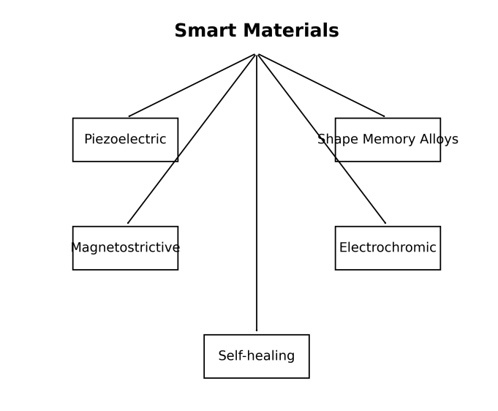
Figure 1. Sketch Diagram of Classification of Smart Materials
2.1 Shape Memory Materials

Shape memory materials have the ability to return to their original shape after deformation when exposed to thermal or mechanical stimuli. Shape memory alloys (SMAs), particularly nickel–titanium (NiTi), exhibit reversible phase transformation between martensite and austenite phases, enabling shape recovery [5]. SMAs exhibit reversible phase transformation (martensite ↔ austenite). These materials are widely used in biomedical stents, actuators, and aerospace components.
This figure depicts the shape memory effect in alloys such as NiTi, where deformation occurs in the martensitic phase at low temperature and recovery to the original shape occurs upon heating due to transformation to the austenitic phase. The reversible thermoelastic phase transformation enables applications in actuators, biomedical stents, and adaptive structures [6].

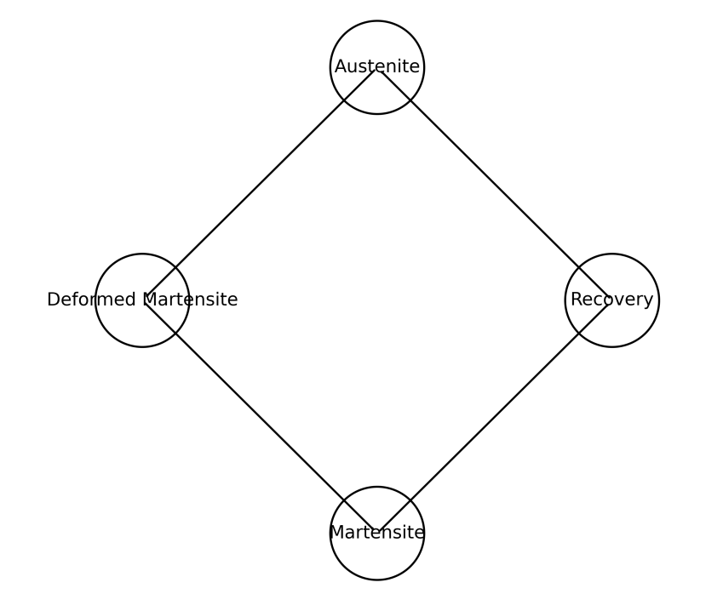

Figure 2. Sketch Diagram of Shape Memory Alloy

2.2 Piezoelectric Materials

Piezoelectric materials generate electrical charge when subjected to mechanical stress and conversely deform when exposed to an electric field. This electromechanical coupling property allows them to function as both sensors and actuators in engineering systems [7]. Applications include ultrasound imaging, vibration sensors, energy harvesting systems, and microelectromechanical systems.
This figure illustrates the direct and inverse piezoelectric effects. Under mechanical stress, electric dipoles within the crystal lattice become aligned, generating an electric charge (direct effect). Conversely, application of an electric field induces mechanical deformation (inverse effect). This electromechanical coupling is widely used in sensors, actuators, and energy harvesting systems [8].

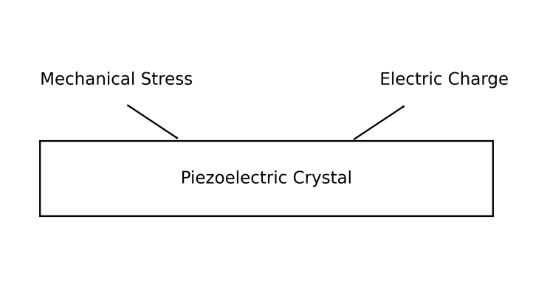
Figure 3. Sketch Diagram of Piezoelectric Mechanism
2.3 Magnetostrictive Materials

Magnetostrictive materials change their dimensions when subjected to magnetic fields. These materials are used in precision actuators, sonar systems, and vibration control devices.
2.4 Electroactive and Electrochromic Materials

Electrochromic materials exhibit reversible color changes when an electric field is applied. These materials are widely used in smart windows, display technologies, and optical devices.

2.5 Self-Healing Materials
Self-healing materials possess the ability to repair structural damage automatically without external intervention. Microcapsule-based healing systems and polymer networks have been developed to restore mechanical integrity after crack formation [9].

2.6 Stimuli-Responsive Polymers

Stimuli-responsive polymers respond to environmental changes such as temperature, pH, or ionic strength.
This figure shows how polymer chains undergo reversible conformational changes in response to external stimuli such as temperature, pH, or light. For example, thermo-responsive polymers exhibit swelling / deswelling behavior near a critical solution temperature due to changes in hydrophilic-hydrophobic balance, enabling applications in drug delivery and soft actuators [10, 11].

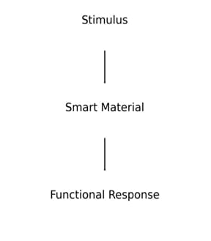
Figure 4. Sketch Diagram of Stimuli Responsive Polymer Mechanism
3. DESIGN STRATEGIES FOR ADVANCED SMART MATERIALS
3.1 Molecular Engineering

The functionality of smart materials often originates from carefully designed molecular architectures. Polymer chain configuration, cross-linking density, and functional groups influence the responsiveness of materials to external stimuli.

3.2 Nanostructured Materials
Nanotechnology has significantly enhanced the performance of smart materials. Incorporating nanomaterials such as carbon nanotubes, graphene, and metal nanoparticles improves electrical conductivity, mechanical strength, and responsiveness.

3.3 Bio-Inspired Materials

Biological systems provide inspiration for designing adaptive materials. Researchers have developed materials mimicking biological muscles, plant movements, and self-healing skin structures.

3.4 Additive Manufacturing and 4D Printing
Additive manufacturing technologies have enabled the fabrication of smart structures with programmable properties. In 4D printing, the printed structure can change shape over time when exposed to environmental stimuli.

4. FUNCTIONAL MECHANISMS OF SMART MATERIALS

Piezoelectric materials operate based on electromechanical coupling, where mechanical stress generates electric charge and electrical signals produce mechanical deformation. This phenomenon enables conversion between mechanical and electrical energy, which is essential in sensors and actuators [8].
Shape memory alloys exhibit reversible phase transformation between martensite and austenite phases. When heated above a specific transition temperature, the material returns to its original shape due to atomic rearrangement within the crystal structure.
We can summarize he functional mechanism of smart materials in the following ways:
- Piezoelectricity : Electromechanical coupling
- Shape Memory Effect : Thermally driven phase transformation
- Magnetostriction : Magnetic domain alignment
- Polymer Response
- : Molecular swelling/contraction
5. APPLICATIONS OF SMART MATERIALS

5.1 Biomedical Engineering

Smart materials are extensively used in biomedical devices such as drug delivery systems, artificial muscles, and tissue engineering scaffolds. Stimuli-responsive polymers enable controlled drug release and targeted therapy.

5.2 Aerospace Engineering

Shape memory alloys and piezoelectric materials are used in adaptive aerospace structures for vibration control, morphing wings, and structural health monitoring systems.

5.3 Robotics and Soft Actuators

Smart materials enable the development of soft robots capable of mimicking biological movements. Shape memory alloys and electroactive polymers are widely used for artificial muscles and flexible robotic systems.

5.4 Civil Engineering and Infrastructure

Smart materials are used for structural monitoring of bridges and buildings. Sensors embedded in structures can detect cracks, stress, and deformation in real time.

5.5 Energy Harvesting

Piezoelectric materials can convert mechanical vibrations into electrical energy, enabling self-powered sensors and wearable electronic devices.

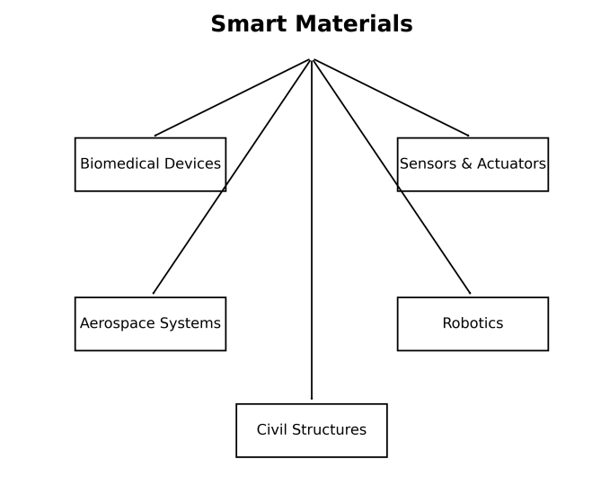
Figure 5. Sketch diagram of Applications of Smart Materials
The above figure summarizes key application domains of smart materials, including biomedical engineering (drug delivery, implants), aerospace (morphing wings, vibration control), robotics (soft actuators), civil engineering (structural health monitoring), and energy harvesting systems. It demonstrates the interdisciplinary impact of smart materials in modern engineering [12].

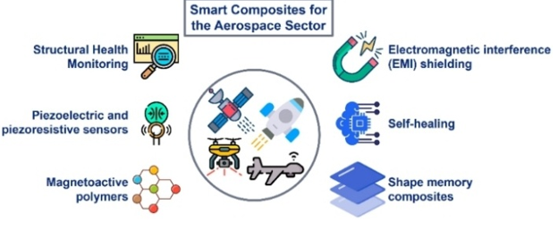

Figure 6. Diagrammatic Representation of Technological Applications of Smart Materials

This figure highlights advanced technological implementations of smart materials, including wearable electronics, intelligent sensors, adaptive optics, smart coatings, and autonomous systems. Integration with IoT and AI enables real-time sensing, decision-making, and actuation in next-generation smart devices [13].

6. MECHANISTIC PATHWAY OF SMART MATERIALS

Smart materials generally operate through the following pathway:

Stimulus → Sensing → Structural Change → Functional Response → Application.

7. AI-DRIVEN DISCOVERY OF SMART MATERIALS
Recent advances in artificial intelligence and machine learning have accelerated the discovery of new smart materials. AI-driven approaches allow rapid screening of thousands of material compositions to identify optimal candidates for smart material applications.
AI is transforming smart material design through:
- Generative models (GANs, VAEs) for polymer design
- High-throughput screening of piezoelectric perovskites
- Machine learning models predicting phase transitions in SMAs
and their impacts are:
- Reduced experimental cost
- Faster material discovery
- Optimization of multi-functional properties

8. COMPARATIVE ANALYSIS OF SMART MATERIALS

Table 1. Comparative Analysis of Major Smart Materials

Smart Material Type | Stimulus | Response Mechanism | Key Properties | Major Applications
Shape Memory Alloys (SMAs) | Temperature | Phase transformation between martensite and austenite phases | Shape recovery, superelasticity | Biomedical stents, actuators, aerospace structures
Piezoelectric Materials | Mechanical stress / Electric field | Electromechanical coupling producing electrical charge | High sensitivity, energy conversion capability | Sensors, ultrasound imaging, energy harvesting
Magnetostrictive Materials | Magnetic field | Change in material dimensions due to magnetic domain reorientation | High force generation, rapid response | Sonar systems, vibration control devices
Electrochromic Materials | Electric field | Reversible change in optical properties | Color change, light modulation | Smart windows, display technologies
Stimuli-Responsive Polymers | Temperature, pH, light, chemicals | Molecular rearrangement leading to swelling or contraction | Flexibility, biocompatibility | Drug delivery systems, biosensors
Self-Healing Materials | Mechanical damage | Release of healing agents from microcapsules | Crack repair, increased durability | Coatings, structural composites
Smart Nanocomposites | Multi-stimuli | Synergistic effects of nanoparticles and polymer matrix | High strength, conductivity | Flexible electronics, smart coatings

Table 2. Comparison of Properties of Major Smart Materials

Material | Response Speed | Durability | Sensitivity
Piezoelectric | High | High | High
Shape memory alloys | Moderate | High | Moderate
Smart polymers | Moderate | Moderate | High
Nanocomposites | High | High | High

Table 3. Major Application Sectors of Smart Materials

Sector | Example Applications
Biomedical | Drug delivery, implants
Aerospace | Morphing wings
Robotics | Artificial muscles
Energy | Energy harvesting
Civil Engineering | Structural monitoring

Table 4. Quantitative Performance Comparison of Smart Materials

Material Type | Response Time | Actuation Strain | Cycle Life | Operating Limits
Piezoelectric | µs–ms | 0.1–0.2% | >10⁸ cycles | High frequency
SMAs | ms–s | 6–8% | 10⁴–10⁶ | <200°C
Magnetostrictive | µs–ms | 0.1–0.3% | >10⁷ | Magnetic field dependent
Electroactive Polymers | ms–s | 10–300% | 10⁵–10⁶ | Low voltage (varies)
Self-healing polymers | minutes–hours | N/A | Limited cycles | Temperature dependent

Table 5. Quantitative Functional Comparison of Smart Materials

Property | SMAs | Piezoelectric | Polymers | Nanocomposites
Sensitivity | Moderate | High | High | High
Durability | High | High | Moderate | High
Scalability | Moderate | High | High | Moderate

9. EMERGING TRENDS IN SMART MATERIALS

Recent developments in smart materials focus on:
- Multi-stimuli responsive materials
- Smart nanocomposites
- Self-healing polymers
- AI-assisted materials discovery
- 4D printed adaptive materials
Recent research also explores stimuli-responsive materials integrated into intelligent electronic devices and advanced sensor systems.

10. STANDARDIZATION AND CHARACTERIZATION

Common standards include:
- ASTM E1876 – Dynamic elastic modulus
- ASTM F2516 – SMA transformation temperature
- ISO 13314 – Mechanical testing of porous materials
- IEC standards – Piezoelectric characterization
Characterization techniques:
- XRD, SEM, TEM
- DSC for phase transitions
- Electrical/mechanical coupling measurements

11. CHALLENGES AND LIMITATIONS

Despite significant progress, smart materials face several challenges including:
- High production cost
- Limited durability in harsh environments
- Slow response time in some materials
- Scalability challenges for industrial production
- Environmental sustainability issues
Addressing these challenges requires interdisciplinary collaboration among chemists, materials scientists, engineers, and computational scientists.

12. FUTURE TECHNOLOGICAL PROSPECTS

The future of smart materials lies in the development of:
- Self-healing structural materials
- Programmable matter
- Intelligent biomedical implants
- Adaptive infrastructure systems
- Nano-engineered responsive materials
Smart materials are expected to play a critical role in next-generation technologies including wearable electronics, soft robotics, and intelligent healthcare systems.

13. FUTURE RESEARCH DIRECTIONS
- Develop low-cost, scalable synthesis methods for industrial adoption
- Design multi-functional hybrid materials with combined sensing and actuation
- Improve fatigue resistance and lifecycle performance of SMAs and polymers
- Advance AI-integrated autonomous material discovery platforms
- Develop fully biodegradable and recyclable smart materials
- Standardize testing protocols for reliability benchmarking
- Integrate smart materials with IoT-enabled intelligent systems

14. CONCLUSION

Smart materials represent a transformative class of materials capable of sensing environmental changes and responding dynamically. Their multifunctional capabilities make them essential components in modern technological systems. Advances in nanotechnology, additive manufacturing, and computational modeling are accelerating the development of next-generation smart materials with enhanced performance and functionality. Continued research and interdisciplinary collaboration will be crucial for overcoming existing challenges and unlocking the full potential of smart materials in future technological applications.

REFERENCES

- Costa, C. M. (2025). Smart Materials: Definition and Physical-Chemical Characteristics. ACS Symposium Series Volume 1513, Pages 1-17. DOI: 10.1021/bk-2025-1513.ch001
- Jain, N., Sharma, R., & Gupta, P. (2023). Smart materials – A state-of-the-art review. Materials Today: Proceedings, 72, 345-352. https://doi.org/10.1016/j.matpr.2023.02.456
- Gangele, A. (2021). A Review on Smart Materials, Types and modelling. Materials Today: Proceedings, 45, 1234-1240.
- Bahl, S., Nagar, H., Singh, I., & Sehgal, S. (2020). Smart materials: Types, properties and applications: A Review. Materials Today: Proceedings, 28, 213–218.
https://doi.org/10.1016/j.matpr.2020.04.123
- Rodinò, S., et al. (2024). Design considerations and applications of shape memory alloy actuation. Materials & Design, 235, 112345. https://doi.org/10.1016/j.matdes.2024.112345
- Otsuka, K., & Wayman, C. M. (1998). Shape Memory Materials. Cambridge University Press. https://doi.org/10.1017/CBO9780511626700
- Zhou, X., Chen, H., & Wang, J. (2024). Review on piezoelectric actuators: Materials and classifications. Frontiers of Mechanical Engineering, 19(1), 12-25. https://doi.org/10.1007/s11465-024-1234
- Uchino, K. (2010). Advanced Piezoelectric Materials: Science and Technology. Woodhead Publishing. https://doi.org/10.1533/9781845699750
- Kontiza, A., et al. (2024). Smart composite materials with self-healing properties. Polymers, 16(2), 245. https://doi.org/10.3390/polym16020245
- Stuart, M. A. C., et al. (2010). Emerging applications of stimuli-responsive polymer materials. Nature Materials, 9, 101–113. https://doi.org/10.1038/nmat2614
- Trovato, V., et al. (2022). Stimuli-responsive smart materials for wearable sensors. Molecules, 27, 4567. https://doi.org/10.3390/molecules27094567
- Lagoudas, D. C. (Ed.). (2008). Shape Memory Alloys: Modeling and Engineering Applications. Springer. https://doi.org/10.1007/978-0-387-47685-8
- Rogers, J. A., Someya, T., & Huang, Y. (2010). Materials and mechanics for stretchable electronics. Science, 327(5973), 1603–1607. https://doi.org/10.1126/science.1182383

