Consumer Preference And Experience In E-commerce Platforms: A Comparative Study Of Amazon And Flipkart
Sathy Saha^{1*} and Dr. Seema Ghanghas²
^{*1}PhD. Scholar, Department Of Management, Om Sterling Global University, Hisar, Haryana,
India.
²Professor, Department Of Management, Om Sterling Global University, Hisar, Haryana, India.
Corresponding e-mail- tupursaha10@gmail.com
Abstract:
This study presents a comparative analysis of consumer preferences and experiences between Amazon and Flipkart, two dominant e-commerce giants in India. This research has used mixed- method approach, through structured Google form survey data were collected from 106 respondents. Analysis included Chi-square tests for platform preference and simple linear regression to determine the predictive power of usability on satisfaction. The research is theoretically grounded in the Technology Acceptance Model (TAM). Statistical analysis revealed a significant difference in platform preference ($X^{2}$= 25.55, p< .05), with Amazon leading in innovation perception. Regression results ($R^{2}$= .388 for Amazon; $R^{2}$= .411 for Flipkart) demonstrate that platform usability is a dominant driver of consumer satisfaction. Qualitative themes further identified a growing “Sustainability gap” and concerns regarding product authenticity as emerging factors in brand loyalty. While the study is limited by a convenience sampling, the results suggest that “ease of use” remains a foundational prerequisite for platform adoption. This research adds critical depth to the e-commerce literature by linking functional usability to evolving ethical consumerism in the Indian market.
Keywords- E-commerce, Customer Preference, Customer Experience, Customer Satisfaction, Amazon, Flipkart, Online Shopping, Technology Acceptance Model (TAM), Consumer Behavior, Sustainability.

- Introduction
The rapid growth of e-commerce has revolutionized consumer shopping behavior globally, especially in emerging market like India where digital penetration is rising significantly. Among many competitors, Amazon and Flipkart are the leading e-commerce giants in India. Consumer prefer these platforms for some factors such as pricing, convenience shopping, product variety, on time delivery and customer service (Sharma & Bhal, 2019). For business it’s very crucial to understand customer preferences which helps create strategies effectively. Beyond preferences, the overall customer experiences with platforms plays an important role to shape customer satisfaction and royalty. The experiential components play an equally vital role in understanding customer behavior on e-commerce platforms. Factors like apps or website usability, smooth and secure payment process, quality full products, true and authentic customer review, personalized recommendations, on time delivery and customer care service significantly influence customer experiences and platforms preference. For service improvement and retain customers, identifying these factors are important.
This study aims to compare customer platforms preference and experiences with Amazon and Flipkart, based on Indian market. By focusing on Amazon and Flipkart, prominent e-commerce giants in India with distinct competitive strategies, this research gives a nuanced perspective on the factors driving customer preferences and satisfaction in the digital competitive environment. The finding of this study will not only increase the literature on e-commerce consumer behavior but also guide e-commerce sites, how they can enhance offers to meet customer expectations and support the strategic development of user centric online shopping platforms.
- Literature Review and Theoretical Framework
2.1 Comparative Service Quality and Consumer Satisfaction: The rivalry between global e-commerce models and localized platforms is a central theme in Indian retail literature. (Vidani, 2024) highlights that while Amazon excels in operational reliability and logistical consistency, Flipkart effectively utilizes localization and competitive pricing strategies to maintain its market share. This competitive dynamic is further explored by (Mishra et al., 2022). who noted that Amazon holds a slight advantage in perceived product variety and quality, Flipkart remains highly competitive through aggressive pricing and value driven offerings. Similarly, (Sharma and Bhul, 2019) established that service quality dimensions especially reliability, assurance and responsiveness are the primary predictors of platform preference and long term customer satisfaction in the Indian context.
2.2 The Role of Trust and Digital Word-Of-Mouth (eWOM): In emerging markets, customer decision making is heavily mitigated by perceived risk and validation of peer experiences. (Kumar and Ramadas,2022) demonstrate that online ratings and source credibility are essential for reducing consumer uncertainty during the purchase journey. Building on this, (Gobbilla and Teja, 2025) found that the impact of customer reviews on Amazon specifically shapes the trust loyalty loop, where positive eWOM significantly enhances the likelihood of repeat purchase. These findings suggest that for firms such as Amazon and Flipkart, the management of user generated content is as critical as the physical supply chain.
2.3 Competitive Dynamics and Gendered Behavioral Patterns: Market leadership in India is characterized by a duopoly between Amazon and Flipkart, yet customer motivates for choosing one over the other vary by demographic (Bharadwaj,2019) identified that factors such as stock availability and discount intensity were the original drivers of this competition. Interestingly, previous research suggested higher male engagement in online shopping; however, contemporary trends indicate a significant shift. As the market matures in 2026, the influence of youth and female demographics has become the primary growth engine for these firms, necessitating a re-evaluation of how experiential factors such as app usability and innovation influence these specific cohorts.
2.4 Innovation, Sustainability and the “Research Gap”: While the existing literature covers service quality and perception extensively, there is a paucity of research that integrates thematic qualitative insights regarding emerging 2026 concerns like sustainability and platform innovation. Most studies focus on a single platform or use purely quantitative methods.
2.5 This study addresses this gap by:
- Providing a mixed methods comparative analysis of Amazon and Flipkart.
- Specifically isolating Innovation, Perception and Sustainability as modern drivers of future shopping preferences.
- Bridging the gap between descriptive statistics and the qualitative “why” behind consumer challenges.
- Research Framework
3.1 Research Objective
Following are the primary objectives of the study:
- To compare customer e-commerce platform preference between Amazon and Flipkart.
- To identify the key factor influence customer preference between Amazon and Flipkart.
3.2 Research Hypothesis
These are research hypotheses based on objectives:
- $H_{0}$: There is no significant difference in consumer preference between Amazon and Flipkart.

$H_{1}$: There exists a statistically significant difference in customer platform preference between Amazon and Flipkart.
- Scope Of The Study
This research focuses on exploring and comparing consumer e-commerce platform’s preferences and online shopping experiences on two leading e-commerce giants in India- Amazon and Flipkart. This study is obstructed to identifying key factors that influence consumer preferences, behavioral patterns and satisfaction levels while interacting with these selected platforms. It also investigated how user experience, product variety, platforms usability, customer care service and advertisement strategies contribute to shaping consumer shopping decision and perceptions.
This research is limited to Indian consumers and is based on primary data collected through structured questionnaires. For e-commerce marketers, business strategists and platforms designers, this study is particularly pertinent to align their services with evolving consumer expectations. Moreover, it also important for academicians and researchers interested in consumer online shopping behavior and e-commerce platform competition. Though this study does not cover all the e-commerce platforms but it gives strong insights for understanding comparative consumer dynamic in rapidly evolving digital marketplace.

- Research Methodology
5.1 Research Design
This study adopts mixed method descriptive and comparative research design aims to systematically examine customer preferences and the determinants influencing their preferences between Amazon and Flipkart, leading e-commerce players in India. A quantitative approach was employed to assess platform usability, innovation, and satisfaction, while a qualitative thematic analysis was used to capture deeper insights into consumer challenges and suggestions. This dual approach ensures a holistic understanding of the competitive dynamics between Amazon and Flipkart in the Indian market.
5.2 Data Collection Method: Primary data were collected through structured Google form questionnaire, distributed to online shoppers through e-mail and social media. Questionnaire designed by the researcher.
Google form link- https://docs.google.com/forms/d/e/1FAIpQLSceQkj3etiuFROxtqosdDYL-mpKwIXJUF9wCXgpF3kQ9i7coA/viewform?usp=header
5.3 Data Type: Mixed method approach, integrating both quantitative and qualitative data to give a comprehensive analysis of customer preferences and experiences on e-commerce platforms.
5.4 Sampling Technique and Justification: This research employed a non-probability convenience sampling method to recruit respondents with prior experience on both platforms. The limitations of non-probability sampling regarding generalizability, this method was selected due to the practical constraints of accessing a national sampling frame of private e-commerce users. To ensure data quality, strict inclusion criteria were applied:
Participants were required to be aged 18+ and have made recent purchases from both platforms.
5.5 Sample Size and Representative Nature: Data were collected from 106 valid respondents. Although the initial target was higher, the current sample provides a robust exploratory snapshot of the 18-34 age demographic, which constitutes the most active segment of India’s digital economy.
5.6 Target Population: Individuals aged 18 and above who have made at least one purchase from Amazon and Flipkart in the past 6 months.
5.7 Data Analysis
To ensure the research objectives were met with academic rigor, the following statistical and qualitative techniques were planned and implemented:
Descriptive Statistics: Frequency and percentage analysis were used to profile the demographic characteristics of the respondents. Measures of Central Tendency (Means) and Dispersion (Standard Deviations) were utilized to evaluate average satisfaction levels and the consistency of user experiences across both platforms.
Inferential Statistics: Chi-square ($X^{2}$) Analysis: A goodness-of-fit test was selected to determine if there is a statistically significant difference in consumer platform preferences between Amazon and Flipkart. Linear Regression Analysis: Grounded in the Technology Acceptance Model (TAM), simple linear regression was employed to measure the impact of platform usability on overall customer satisfaction (Davis, 1989). This allowed the researcher to identify how much of the variance in satisfaction is explained by ease of navigation.
Qualitative Thematic Analysis: For the open-ended survey responses, a thematic analysis was used to identify recurring patterns in consumer suggestions and complaints, specifically focusing on service quality and ethical consumption (Creswell & Creswell, 2023).
Software for Analysis: All data processing and statistical testing were performed using specialized statistical software to ensure the mathematical accuracy of the results.

5.8 Ethical Consideration:
- Participation is voluntary and anonymous and their confidentiality have been maintained.
- Respondents were prior informed about the purpose of the study and they have right to withdraw at any time.
- Data have used purely for academic purpose.

- Data Analysis and Interpretation
6.1 Descriptive Statistics
- Age
Table- 1 Age Of Respondents
Valid | Particular | Frequency (f) | Percent (%) | Valid Percent | Cumulative Percent
Valid | 18-24 | 29 | 27.4% | 27.4% | 27.4%
Valid | 25-34 | 60 | 56.6% | 56.6% | 84%
Valid | 35-44 | 14 | 13.2% | 13.2% | 97.2%
Valid | 45 and above | 3 | 2.8% | 2.8% | 100
Valid | Total | 106 | 100% | 100% | -

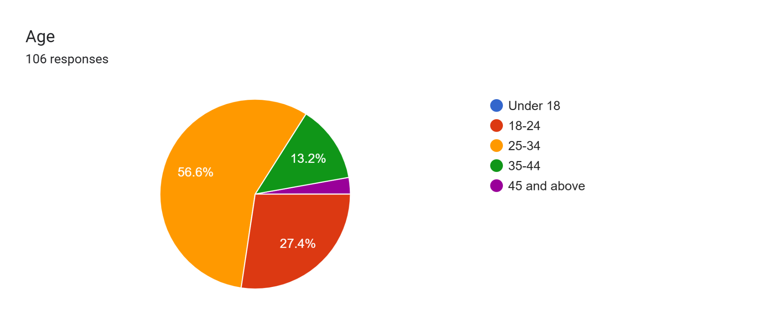
Interpretation: Table 1 displays the age distribution of the respondents, summarizing data analysis for a total number of 106 respondents. The majority of the respondents come under 25-34 age range, 56.6%. It’s indicate a mature sample population. Second major respondents are from 18-24 age range with 27.4% and than relatively smaller proportions are 35-44 age range with 13.2% than 45 and above age range having 2.8%. The finding of this table suggesting to give concentration on 18-34 age demographic. These findings are very important for understanding age composition of the respondents group and can be valuable for marketers for tailoring research or formulating strategies accordingly.

- Gender
Table- 2 Gender Of Respondents
Valid | Particular | Frequency(f) | Percent(%) | Valid Percent | Cumulative Percent
Valid | Female | 64 | 60.4% | 60.4% | 60.4%
Valid | Male | 41 | 38.7% | 38.7% | 99.1%
Valid | Other | 1 | 0.9% | 0.9% | 100
Valid | Total | 106 | 100% | 100% | -

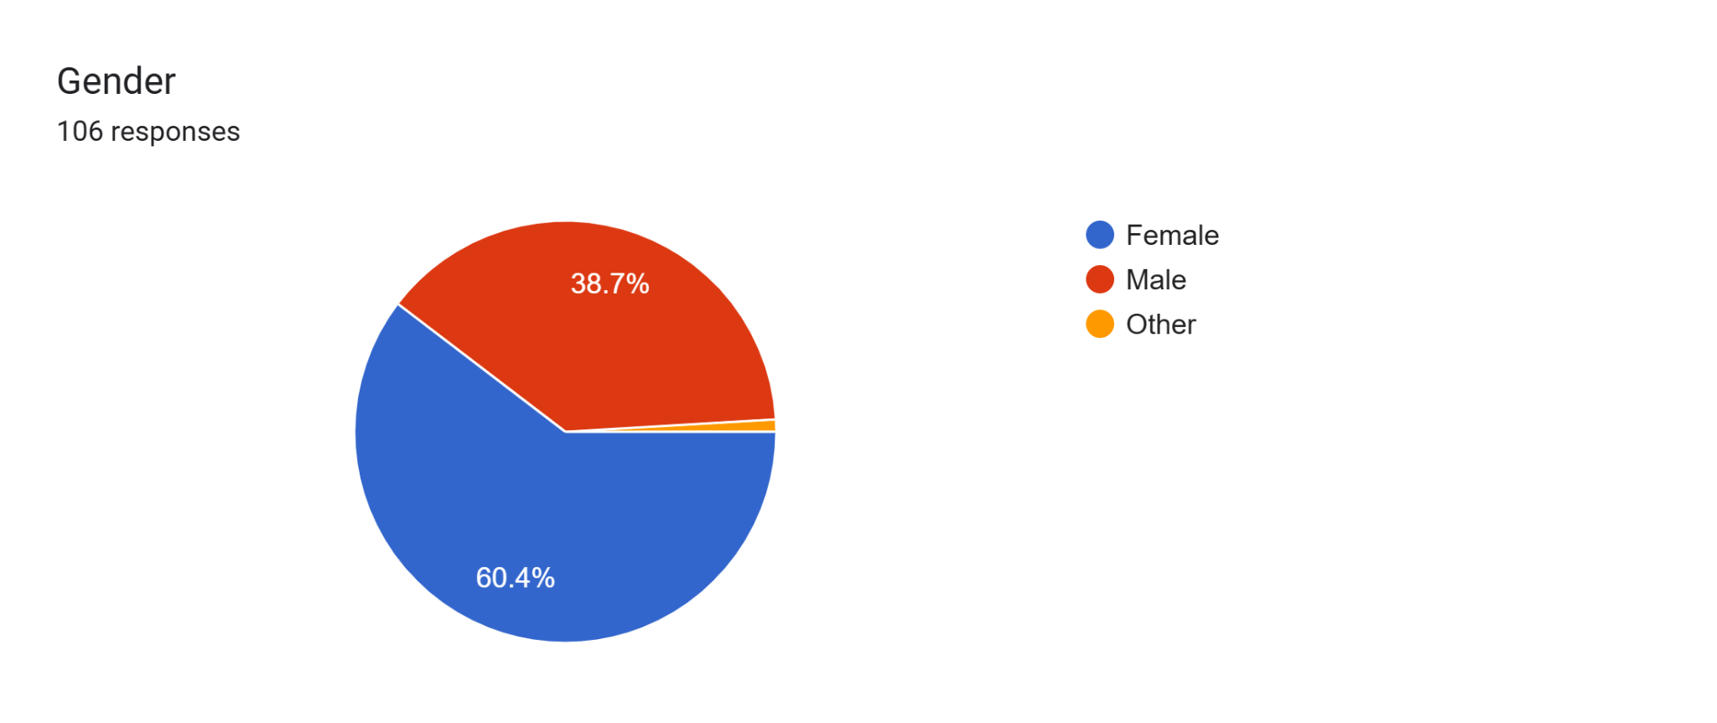
Interpretation: Table 2 gives an overview of gender distribution among the respondents comprising a total of 106 respondents. The data found a significant gender difference, with majority of respondents identifying as women, accounting for 60.4% of the sample while male and other gender respondents are respectively 38.7% & 0.9%. This gender disparity is noteworthy, as it could potentially change the study’s result and conclusions. To engage both Male and Female it is crucial to understand the gender composition of the sample for tailoring communication, marketing or research approaches also to make sure the findings are representative and relevant to both gender.
- Occupation
Table- 3 Occupation Of Respondents
Valid | Particular | Frequency (f) | Percent (%) | Valid Percent | Cumulative Percent
Valid | Student | 48 | 45.3% | 45.3% | 45.3
Valid | Working Professional | 40 | 37.7% | 37.7% | 83%
Valid | Self employed | 12 | 11.3% | 11.3% | 94.3%
Valid | Home maker | 4 | 3.7% | 3.7% | 98%
Valid | Others | 2 | 2% | 2% | 100%
Valid | Total | 106 | 100% | 100% | -

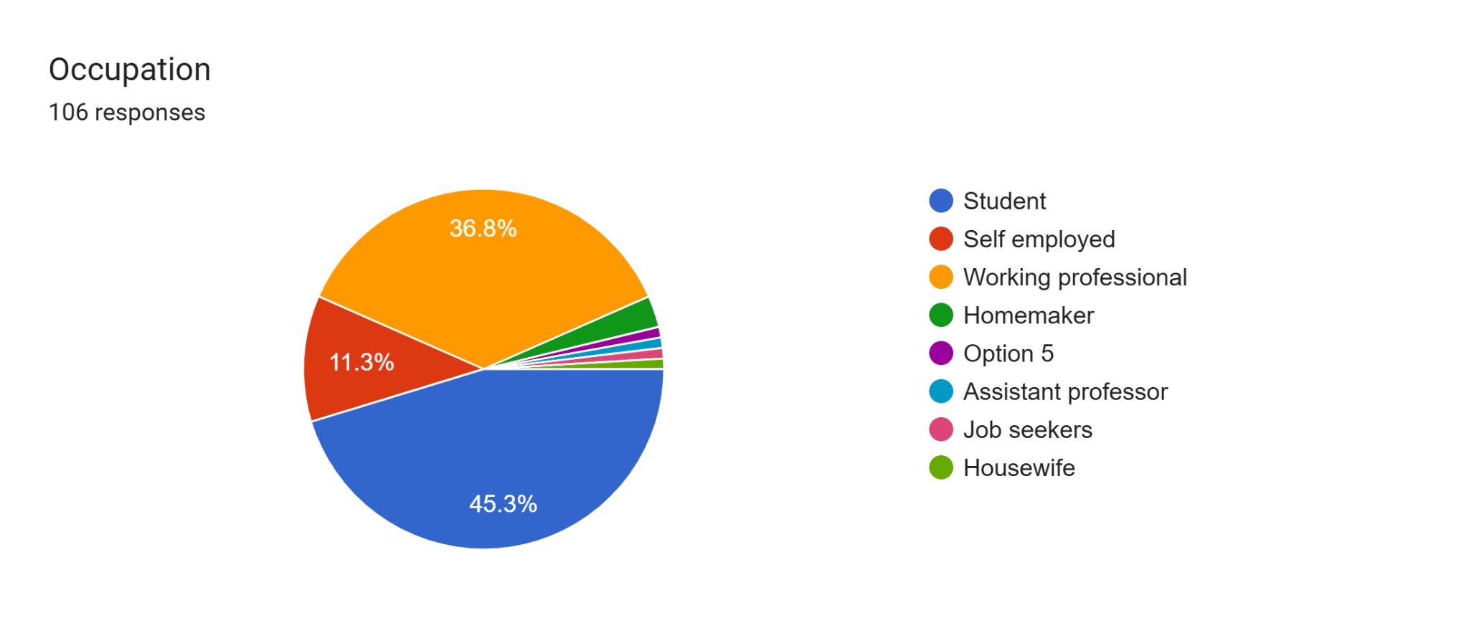
Interpretation: Table 3 provides occupational distribution of the respondents. The majority respondents are student 45.3%, followed by working professional 37.3%, and a smaller representation of self individuals11.3%, respectively home marker 3.7% and other occupation are 2%. This finding reveals that students are the majority user of e-commerce, business should focus on them and create strategies accordingly.
- Frequency Of Online Shopping
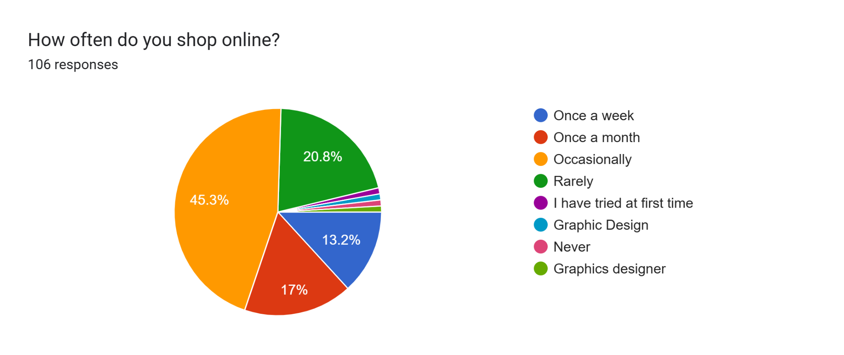
Valid | Particular | Frequency (f) | Percent (%) | Valid percent | Cumulative Percent
Valid | Occasionally | 48 | 45.3% | 45.3% | 45.3%
Valid | Once a month | 18 | 17% | 17% | 62.3%
Valid | Once a week | 14 | 13.2% | 13.2% | 75.5%
Valid | Rarely | 22 | 20.8% | 20.8% | 96.3%
Valid | Never | 1 | 0.9% | 0.9% | 97.2%
Valid | Other | 3 | 2.8% | 2.8% | 100%
Valid | Total | 106 | 100% | 100% | -

Table- 4 Frequency Of Online Shopping
Interpretation: Table 4 revels how often respondents engage in online shopping. The most common frequency is Occasionally 45.3% followed by Once a month 17%, Rarely 20.8%, Once a week 13.2%, Never 0.9% and Other 2.8%. Most of the responses are having occasionally where e-commerce platforms should work to convert it on daily customer engagement.
- Frequently Used Online Platform
Table-5 Frequently Used Online Platform
Valid | Particular | Frequency (f) | Percent (%) | Valid Percent | Cumulative Percent
Valid | Both | 48 | 45.3% | 45.3% | 45.3%
Valid | Amazon | 23 | 21.7% | 21.7% | 67%
Valid | Flipkart | 22 | 20.8% | 20.8% | 87.8%
Valid | Others | 13 | 12.2% | 12.2% | 100%
Valid | Total | 106 | 100% | 100% | -

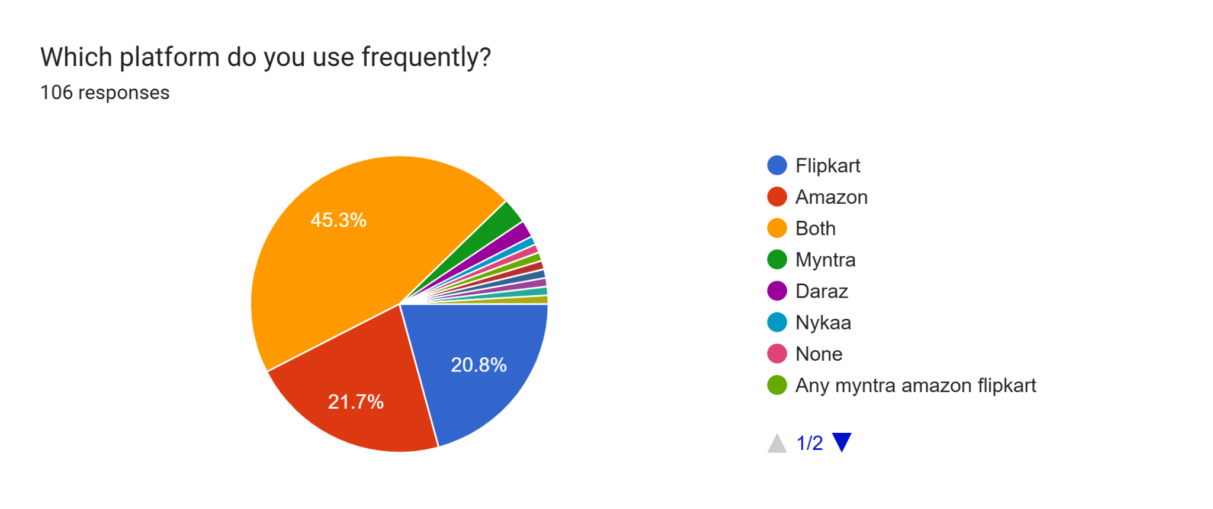
Interpretation: Table 5 shows comparative difference between Amazon and Flipkart. Maximum user preferred both the platform 45.3% respondents for their online purchase but when they specifically choice between two platforms very intense competition exists. Amazon preferred by 21.7% respondents and Flipkart preferred by 20.8%. Noteworthy difference come only 0.9% also other platforms like preferred by 12% also a indicate a high competition between e-commerce platforms where Amazon & Flipkart should give focus for competitive advantage & to hold market position.
- Perception Of Innovation and Technology
Table-6 Perception Of Innovation and Technology
Valid | Particular | Frequency (f) | Percent (%) | Valid Percent | Cumulative Percent
Valid | Both | 44 | 41.5% | 41.5% | 41.5%
Valid | Amazon | 29 | 27.4% | 27.4% | 68.9%
Valid | Flipkart | 18 | 17% | 17% | 85.9%
Valid | Not Sure | 15 | 14.1% | 14.1% | 100
Valid | Total | 106 | 100% | 100% | -

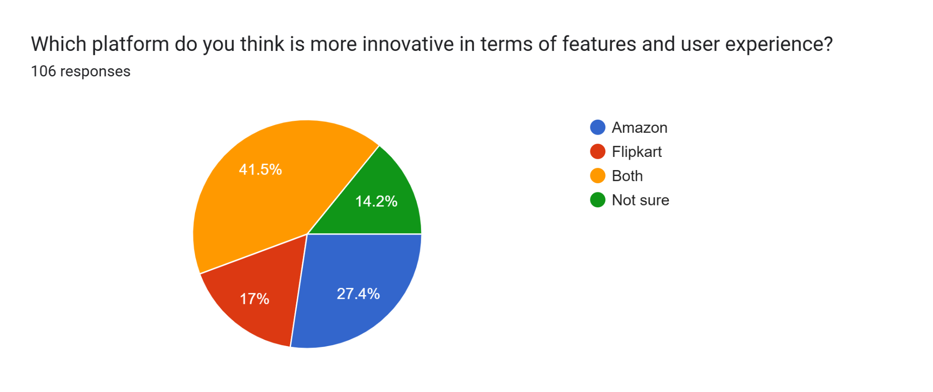
Interpretation: Most respondents (41.5%) felt both the platforms are equally innovative. Amazon lead (27.4%) among them who preferred one platform, Flipkart had moderate share (17%) and 14.1% respondents were not sure, indicating a potential knowledge gap or perception parity. This finding suggest Flipkart to give focus on innovation.
- Experience On Platform Usability
Table- 7 Experience On Platform Usability
Valid | Particular | Frequency (f) | Percent (%) | Valid Percent | Cumulative Percent
Valid | Very Poor | 14 | 13.2% | 13.2% | 13.2%
Valid | Poor | 12 | 11.3% | 11.3% | 24.5%
Valid | Average | 30 | 28.3% | 28.3% | 52.8%
Valid | Good | 29 | 27.4% | 27.4% | 80.2%
Valid | Excellent | 21 | 19.8% | 19.8% | 100%
Valid | Total | 106 | 100% | 100% | -

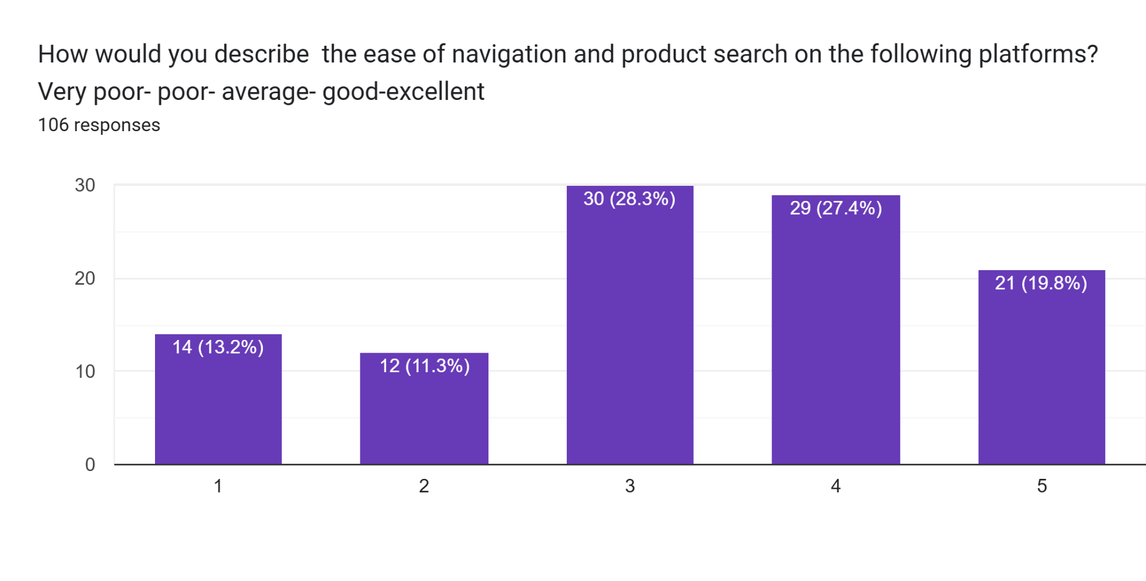
Interpretation: Table 7 is showing that consumer is having experience on platform usability like navigation and product search is average 28.3%. Maximum respondents felt that. Respectively 27.4% user said it’s Good & 19.8% user said its excellent. A smaller proportion respondents experienced these platforms are very poor (13.2%) and poor (11.3). Overall platform has to be user friendly and easily accessible.
- Overall Satisfaction With Amazon
Table- 8 Overall Satisfaction With Amazon
Valid | Rating | Frequency(f) | Percent (%) | Valid Percent | Cumulative Percent
Valid | 1 | 10 | 9.4% | 9.4% | 9.4%
Valid | 2 | 5 | 4.7% | 4.7% | 14.1%
Valid | 3 | 28 | 26.4% | 26.4% | 40.5%
Valid | 4 | 39 | 36.8% | 36.8% | 77.3%
Valid | 5 | 24 | 22.7% | 22.7% | 100%

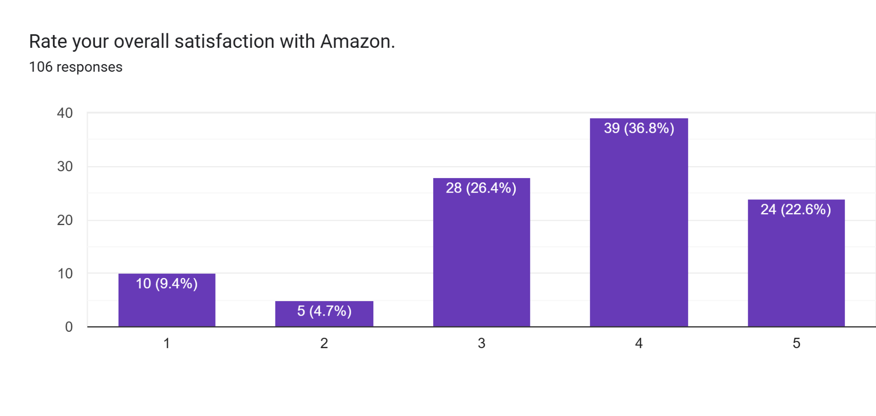
Interpretation: Amazon enjoy a high overall satisfaction rating among users. About 59.5% user rated it either 4 or 5 start. Meanwhile, 26.4% gave a neutral rating and only 14.1% expressed dissatisfaction (rating 1 or 2). This findings revel Amazon is performing well in most areas such as service, delivery and experience.
- Overall Satisfaction With Flipkart

Table- 9 Overall Satisfaction With Flipkart
Valid | Rating | Frequency(f) | Percent (%) | Valid Percent | Cumulative Percent
Valid | 1 | 13 | 12.3% | 12.3% | 12.3%
Valid | 2 | 3 | 2.8% | 2.8% | 15.1%
Valid | 3 | 33 | 31.1% | 31.1% | 46.2%
Valid | 4 | 33 | 31.1% | 31.1% | 77.3%
Valid | 5 | 24 | 22.6% | 22.6% | 100%

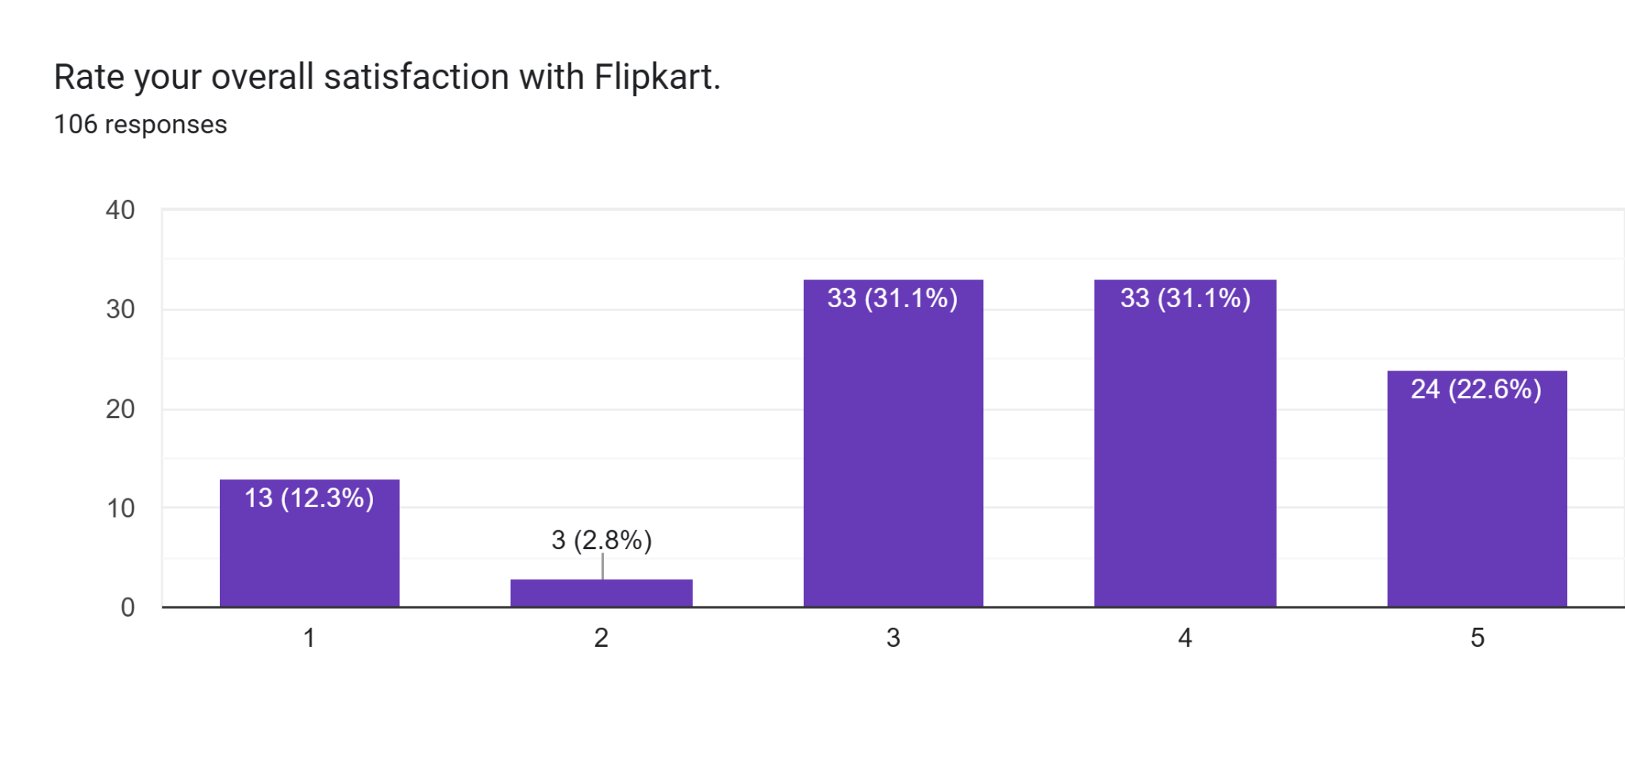
Interpretation: Flipkart satisfaction ratings are generally positive over 53.7% respondents are rating it for 4 or 5 start, indicating a strong but compared to Amazon it has slightly lower satisfaction level. A notable 31.1% respondents rated it neutral, suggesting for improvement. Around 15% showed gave lower rating (1 or 2), which may cause of service or delivery inconsistencies.
- Customer Challenges Faced With Platforms
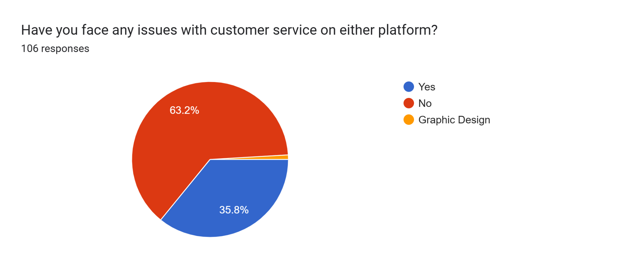
Table- 10 Customer Challenges Faced With Platforms
Valid | Particular | Frequency(f) | Percent(%) | Valid Percent | Cumulative Percent
Valid | Yes | 38 | 35.9% | 35.9% | 35.9%
Valid | No | 67 | 63.2% | 63.2% | 99.1%
Valid | Other | 1 | 0.9% | 0.9% | 100%
Valid | Total | 106 | 100% | 100% | -

Interpretation: The finding of this table revels that maximum respondents (63.2%) have not faced any issues or challenges with these selected platforms while shopping but a noticeable figure 35.9% respondents claimed that they face challenges with these platforms. Which will help e-commerce platform to find out these challenges and taking action on that.
- Respondents Platform Recommendation
Respondents Platform Recommendation
Valid | Particular | Frequency(f) | Percent (%) | Valid Percent | Cumulative Percent
Valid | Amazon | 49 | 46.2% | 46.2% | 46.2%
Valid | Flipkart | 40 | 37.7% | 37.7% | 83.9%
Valid | Both | 6 | 5.7% | 5.7% | 89.6%
Valid | None | 1 | 0.9% | 0.9% | 90.5%
Valid | Others | 10 | 9.5% | 9.5% | 100%
Valid | Total | 106 | 100% | 100% | -

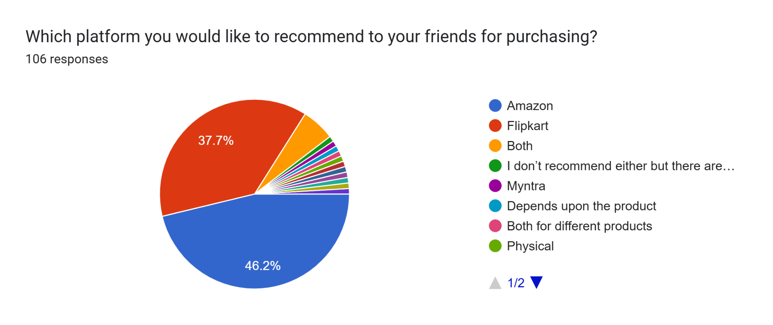
Interpretation: Findings of this table is saying that majority of the respondents (46.2%) will recommend “Amazon” to their friends & family for online shopping according to their experience. Also 37.7% respondents will recommend “Flipkart” to their friends and family. A smaller proportion (5.7%) will recommend both the platforms and 0.9% respondent will not recommend any of them respectively 9.5% respondents will recommend other e-commerce platforms like Meesho, Myntra and others.
- Future Shopping Preference
Table- 12 Future Shopping Preference
Valid | Particular | Frequency(f) | Percent (%) | Valid Percent | Cumulative Percent
Valid | Amazon | 28 | 26.4% | 26.4% | 26.4%
Valid | Flipkart | 14 | 13.4% | 13.4% | 39.8%
Valid | Both | 53 | 50% | 50% | 89.8%
Valid | None | 10 | 9.4% | 9.4% | 99.2%
Valid | Others | 1 | 0.9% | 0.9% | 100%
Valid | Total | 106 | 100% | 100% | -

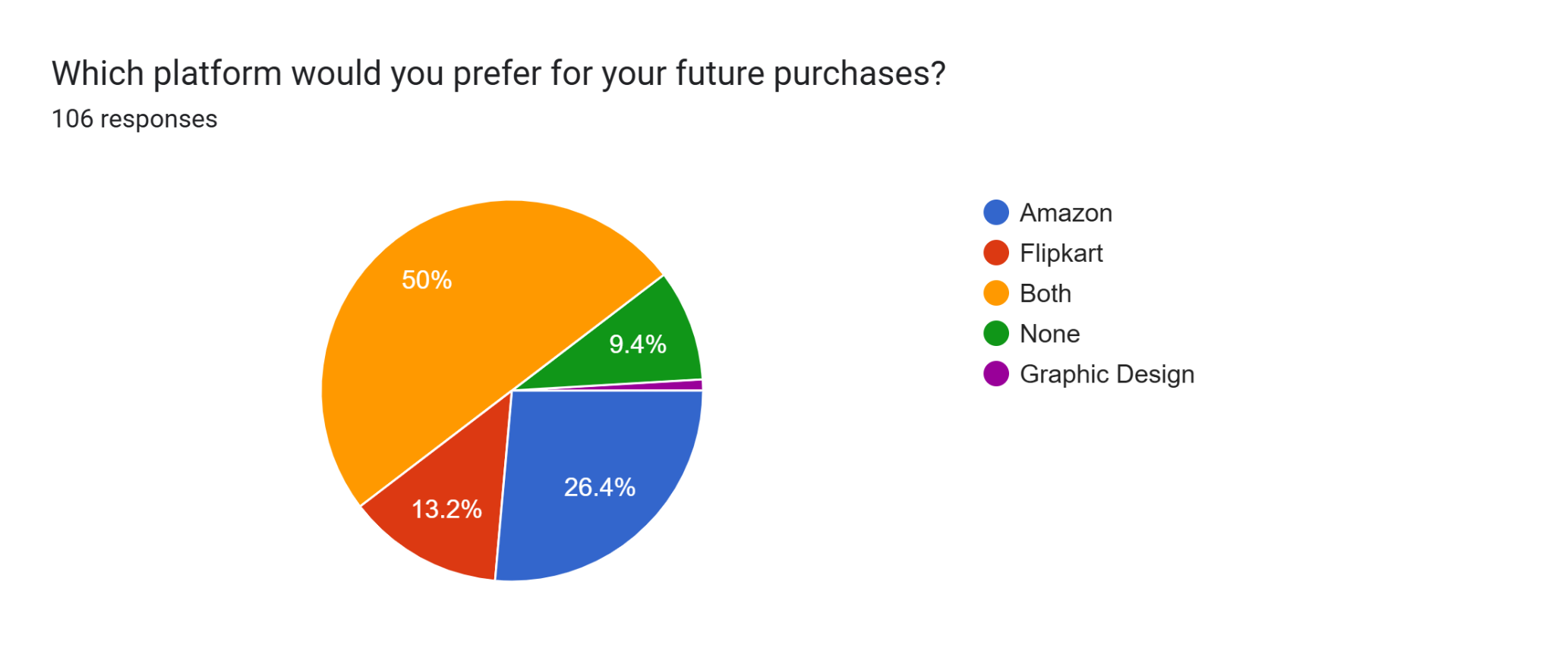
Interpretation: Both the platform preferred by half of the population (50%) for their future shopping. But if consider platform specific than Amazon emerge as the most recommended platform, 26.4% respondents. But Flipkart is having lower preference, only 13.4% respondents prefer it, where suggesting Flipkart for improvement. And a smaller proportion (9.4%) prefer none of the platforms for their future shopping & other (0.9%) prefer other shopping platforms.
6.2 Statistical Analysis
Chi- Square test for platform preference
To test whether there is a significant difference between customer platform preferences among leading e-commerce platform Amazon and Flipkart, a Chi- square goodness of fit test was conducted.

Hypothesis:
- $H_{0}$: There is no significant difference in consumer preference between Amazon and Flipkart.

$H_{1}$: There exists a statistically significant difference in customer platform preference between Amazon and Flipkart.
Platform Preferences | Observed Frequency | Expected Frequency(assuming equal preferences)
Both | 48 | 26.5
Amazon | 23 | 26.5
Flipkart | 22 | 26.5
Others | 13 | 26.5
Total | 106 | 106

Chi Square Test Calculation:
$x^{2}$= ∑(O- E)^2/ E
Both= (48- 26.5)^2/ 26.5 Amazon= (23-26.5)^2/ 26.5
= (21.5)^2/ 26.5 = (-3.5)^2/ 26.5
=17.4433962 ≈ 0.46
≈ 17.45
Flipkart= (22-26.5)^2/ 26.5 Others= (13-26.5)^2/26.5
= (-4.5)^2/ 26.5 = (-13.5)^2/ 26.5
≈ 0.76 ≈ 6.88
$x^{2}$= (17.45+ 0.46+ 0.76+ 6.88)
= 25.55
Degree Of Freedom (df) = Categories – 1
= 4-1
= 3
Critical Value ( ɑ= 0.05)
From Chi square table, $X^{2}$ Critical (3,df, 0.05) ≈ 7.815
Result: Since $X^{2}$ = 25.55> 7.815, the null hypothesis is rejected
Interpretation: Based on the Chi-square test, the calculated value ($X^{2}$= 25.55) exceeded the critical value (7.815) at a significance level of a=0.05. Therefore, the null hypothesis ($H_{0}$) is rejected, confirming that distinct preference patterns exist within the Indian e-commerce market.
6.3 Inferential Statistical Analysis
Correlation Analysis: A Pearson correlation coefficient was computed to assess the relationship between platform usability (ease of navigation and search) and overall customer satisfaction. The results revealed a strong positive correlation for both Amazon (r= .623, p< .001) and Flipkart (r= .641, p< .001). These findings indicate that as the perceived ease of use increases, customer satisfaction levels rise significantly across both platforms.
Simple Linear Regression Analysis
To move beyond descriptive associations, two simple linear regression models were conducted to determine the predictive power of platform usability (X) on overall satisfaction (Y).
Table- 13: Regression Model Summary (Predicting Satisfaction)
Platform | R | $$R^{2}$$ | F | β | p- value
Amazon | .623 | .388 | 65.82 | .569 | < .001
Flipkart | .641 | .411 | 72.49 | .615 | < .001

Interpretation: For Amazon, the regression model was statistically significant, F (1,104) = 65.82, p< .001, with an $R^{2}$ of .388. This suggests that usability explains approximately 38.8% of the variance in satisfaction. Similarly, for Flipkart, the model was significant, F (1,104) = 72.49, p< .001, with usability explaining 41.1% of the variance. The standardized beta coefficients (β= .569 for Amazon; β= .615 for Flipkart) confirm that usability is a critical and robust driver of consumer experience in the Indian e-commerce market.
Thematic Analysis:
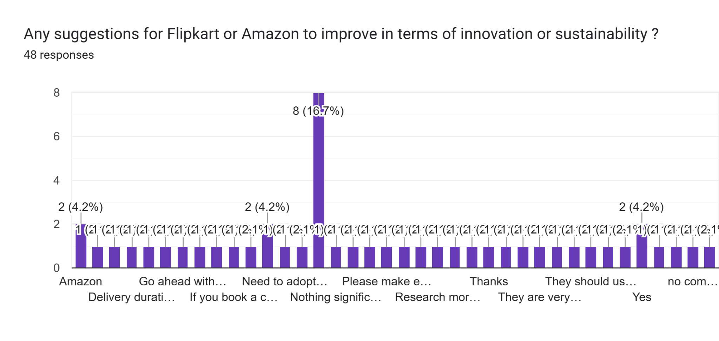
Thematic analysis of customer suggestions for Amazon and Flipkart.
- Product Quality and Authenticity: Suggestions include stopping the sale of fake products, improving overall product quality (as some products are very poor), and ensuring the customer receives the real order.
- Sustainability and Packaging: Recommendations were made to use recyclable and eco-friendly packing material and stop wasting packing material. Packaging for delicate items should also be improved to avoid breakage.
- Customer Service and Policy: There is a need for faster response to customer needs, taking action on complaints, and improving the return policy.
- Platform Functionality and Pricing: Improvement suggestions include adopting more technical matters, improving product search, efficiency in changing addresses and dates, clearly mentioning prices with tax included, and charging less for COD and delivery.
- Innovation and Market Expansion: Suggestions involve researching current technology trends and Flipkart expanding to other international markets.
Each of these themes represents a specific area that customers consider important when forming preferences for one platform over another. Like: customer concerns on Product quality and authenticity directly affect trust and satisfaction, influencing repeat usage and preference.
Issues related Platform functionality, pricing and COD charges may shift customer choice towards the platform perceived as more cost efficient.
Suggestions about Sustainability and Packaging seems customer awareness is growing also they are concern about the environment that can shape brand loyalty and platform alignment.
6.4 Findings
Demographic Profile: The majority of respondents belonged to the 25-34 age group. Female respondents (60.4%) slightly outnumbered male respondents (38.7%), expressing strong engagement of Youth and Female in online shopping.
Occupational Background: Most of the respondents were students (45.3%) and working professional (37.7%). Indicating that online active and economically contribute individuals are the dominant users of e-commerce platforms.
Shopping Frequency: A majority number of respondents (45.3%) do online shopping occasionally, reveling that although online shopping is popular still for many users it’s still situational where e-commerce platforms should focus.
Perception Of Innovation and Technology: Respondents perceived Amazon (27.4%) as more innovative than Flipkart (17%). However, many users recognized both the platforms (41.5%) are offering innovative features and services.
Platform Usability: Platform usability experience was average to good range (28.3% and 27.4%). Showing as generally positive but more improvement required.
Overall Customer Satisfaction: For both the platforms Amazon and Flipkart, most users rated their satisfaction levels 3 and 4 mostly, showing moderate to high satisfaction levels.
Platform Preference: Compared customer platform preference between Amazon and Flipkart, where Amazon preferred by customer mostly (21.7%) also many users preferred both the platforms (45.3%). And according to Chi-Square test: Chi-square vales- 25.55, Degree of freedom- 3 and significance level is 0.05 and Critical value ≈ 7.815. Since, 25.55> 7.815, the null hypothesis is rejected. This indicate a statistically significant difference in consumer platform preferences, with clear user preference towards both platforms, followed by Amazon.
Challenges Faced: A majority of respondents (63.2%) reported no major issues or challenges faced with either platform. Some users (35.9%) reported some issues mainly related to product quality, delivery and pricing policy.
Platform Recommendation: Respondents were willing to recommend both Amazon (46.2%), Flipkart (37.7%) to their friends and family, reflecting a positive perception and trust in both platforms.
Future Shopping Preference: Despite recommending both e-commerce platforms, more users preferred Amazon (26.4%) as their future shopping platform where Flipkart preferred by only 13.4% users. Indicating Amazon’s stronger brand appeal and service satisfaction.
- Discussion
The primary objective of this research was to conduct a comparative analysis of consumer preferences and experiential dynamics between Amazon and Flipkart within the Indian e-commerce landscape. By adopting a mixed method approach, the research transcends simple descriptive statistics to offer a nuanced understanding of platform stickiness and satisfaction.
7.1 Demographic and Behavioral Dynamics
The study found a high concentration of e-commerce engagement among the 25-34 age demographic (56.6%), signaling that digital retail is most prevalent among “digital natives” and young working professional. Notably, the majority of respondents were female (60.4%), which represents an important shift from earlier studies like (Bharadwaj 2019), where male interest was reported as the dominant factor in digital shopping. This demographic shift suggests that e-commerce strategies must increasingly pivot toward female-centric consumer behavior. Furthermore, the finding that 45.3% users shop “occasionally” indicates that while digital penetration is high, the platforms have yet to fully replace physical shop for daily necessities, leaving significant room for market conversion.
7.2 Comparative Platform Performance and Innovation
Statistical analysis through the chi-square test revealed a significant difference in platform preference among Indian customers ($X^{2}$= 25.55, p< .05). Amazon emerged as the leader in innovation perception (27.4%) and future shopping preference (26.4%) compared to Flipkart. These findings align with (Vidani 2024), who suggested that Amazon’s global expertise provides a competitive edge in technological integration and operational reliability. However, the data revealed that 50% of respondents intend to use both platforms in the future, highlighting the pragmatic, multi homing nature of the Indian customer who shift between platforms based on price sensitivity and specific product availability.
7.3 Inferential Insights: Driving Satisfaction
The regression models clearly illustrate the “Cause and Effect” relationship between platform functionality and user satisfaction. The regression findings ($R^{2}$= .388 for Amazon; $R^{2}$= .411 for Flipkart) prove that platform Usability is a foundational driver of the user experience.
This suggests that ease of navigation and search efficiency directly account for approximately 40% of a consumer’s overall satisfaction. This relationship validates the Technology Acceptance Model (TAM) in the context of Indian e-retail, where perceived ease of use remains a non- negotiable prerequisite for platform adoption.
7.4 Thematic Challenges and The Future Of E-Commerce
The qualitative thematic analysis provides the “critical depth” necessary to explain the remaining variance in customer satisfaction. While quantitative ratings were generally positive, the qualitative feedback uncovered a persistent trust gap. Concerns related to Product quality and Authenticity mirror the source credibility issues identified by (Kumar and Ramadas, 2022). Furthermore, the emergence of Sustainability and Packaging as key consumer concerns like eco-friendly materials, indicates that Indian consumers are moving beyond pure price-driven motivations toward ethical consumption. This evolution suggests that the next phase of competitive between Amazon and Flipkart will be fought not just on logistics, but on corporate responsibility and environmental impact.
- Conclusion
This study gives a comprehensive, mixed-method comparative analysis of the Indian e-commerce landscape, specifically focusing on the competitive duopoly of Amazon and Flipkart. The study successfully moved beyond descriptive analysis to identify the underlying drivers of customer satisfaction and platform preference.
The findings confirm that while both platforms enjoy high levels of customer trust and satisfaction, a statistically significant difference exists in platform preference ($X^{2}$=25.55, p< .05), with Amazon emerging as the leader in innovation perception and future shopping recommendation. Importantly, the Regression analysis proved that Platform Usability is a dominant predictor of consumer satisfaction ($R^{2}$≈ 40%), validating the continued relevance of the Technology Acceptance Model (TAM) (Davis, 1989) in the 2026 digital marketplace. However, the qualitative data reveals that the “experience” of modern e-commerce is no longer limited to app navigation. Emerging concerns regarding product authenticity and environmental sustainability represent the new frontier of customer expectations. While Amazon presently leads in perceived technological rapidness, Flipkart’s strong localized pricing strategies maintain its position as a formidable competitor.

- Limitations
Despite the valuable insights reveled through this present study, certain limitations must be acknowledged.
- The research adopted a non-probability convenience sampling method. While this was necessary due to the lack of a centralized national sampling frame for private e-commerce users, it may limit the generalizability of the findings to the broader Indian population. Future research should aim for a stratified random sampling method across diverse geographical regions on India to validate these results.
- The sample size of N=106 is relatively modest. While the Regression analysis (F(1,104) and Chi-square tests demonstrated statistical significance and high predictive power, a larger sample would allow for more complex multi-variate modeling.
- Lastly, this study focused on primarily on the two dominant players, Amazon and Flipkart. Future research would expand this comparative framework to include emerging “Quick commerce” platforms and niche players to see if the Technology Acceptance Model (TAM) constructs hold the same weight in hyper-local delivery contexts. Finally, future longitudinal research could track how the “Sustainability Gap” identified in the qualitative themes evolves into a primary driver of quantitative satisfaction over time.
- References
Bharadwaj, S. (2019). The War Between Flipkart and Amazon India: A Study On Customer
Perception. International Journal Of Research In Humanities, Arts and Literature,
7(5), 2347-4564. https://impactjournals.us
Creswell, J. W., & Creswell, J. D. (2023). Research design: Qualitative, quantitative, and mixed
methods approaches (6th ed.). SAGE Publications.
Davis, F. D. (1989). Perceived usefulness, perceived ease of use, and user acceptance of
information technology. MIS Quarterly, 13(3), 319-340.
https://doi.org/10.2307/249008
Gobbilla, U., & Teja, V. (2025). A Study On Impact Of Customer Reviews On Online Purchase
Decision With Amazon. International Journal Of Engineering, Business and
Management (IJEBM), 9(3), 45-51. https://dx.doi.org/10.22161/ijebm.9.3.5
Kumar, V., & Ramadas, K.V. (2022). The Impact Of Customer Reviews On Online Purchase
Decision. Journal Of Emerging Technologies and Innovative Research
(JETIR), 11 (4), 2349- 5162. https://www.jetir.org/papers/JETIR2404679.pdf
Mishra, S. J., Rout, D., Kantha, R., Majhi, B. (2022). Customer Perception Towards Amazon and
Flipkart: A Comparative Analysis. International Journal Of Science Engineering
& Technology (IJRASET), 10(5), 2147-215
https://doi.org/10.22214/ijraset.2022.42770
Shaikh, A., et al. (2025). The evolution of the Indian e-commerce duopoly: A decade of Amazon
vs. Flipkart. Asian Journal of Business Research. 15 (2), 45-67.
Sharma, A., & Bhal, S. (2019). Customer Preferences For Different Service Quality Dimensions
In Selected E-Commerce Websites In India. Journal Of Management (JOM),
6(3), 77-95. https://doi.org/10.34218/jom.6.3.2019.010
Tran, T. H., & Hang, N. T. (2025). The impact of eco-friendly packaging on brand loyalty in the
e-retail sector: A study of Gen Z consumers. Journal of Sustainable
Marketing, 9 (1), 112-128.
Vidani, J. (2024). Comparative Analysis Between Flipkart and Amazon With The Reference Of
E-commerce Sector. International Journal Business and Management Practices,
2(1), 121-136. https://doi.org/10.22214/i jraset.2022.4277

