Fuzzy Entropy-Based Prioritization of Critical Water Quality
Parameters for Sustainable Drinking Water Management
Keerthanaa Vijayanand
Department of Civil Engineering, Birla Institute of Technology and Science, Pilani Campus, Rajasthan, India

ABSTRACT
Safe drinking water remains inaccessible to approximately 2.2 billion people globally, partly because existing assessment frameworks do not adequately capture the uncertainty embedded in water quality data and expert judgment. This study proposes a compounded fuzzy entropy framework that integrates Triangular Fuzzy Number (TFN) representation, alpha-cut interval reduction at a confidence level of 0.8, defuzzification through an optimism index of 0.5, and Shannon entropy-based objective weighting. The framework ranks six drinking water parameters Dissolved Oxygen (DO), Biochemical Oxygen Demand (BOD), pH, Turbidity, Temperature, and total Coliform against four decision criteria: Environmental Impact, Human Health Risk, Variability, and Treatment Complexity. Working through the full numerical chain from expert ratings to weighted composite scores, Coliform emerges as the most critical parameter (S = 0.2153), followed by BOD (0.2056), DO (0.1721), pH and Turbidity (0.1555 each), and Temperature (0.0961). Health Risk carries the heaviest criterion weight (W = 0.3671), a result that follows directly from the entropy calculation: health-related ratings vary more across parameters than any other criterion, producing maximum discriminatory power. The approach avoids the consistency constraints of conventional fuzzy AHP and does not require full pairwise comparison matrices. Sensitivity tests across alpha in [0.6, 1.0] and lambda in [0.3, 0.7] confirm that Coliform and Temperature rankings are structurally stable, while intermediate ranks show modest sensitivity to the optimism index. The results support a tiered monitoring strategy prioritising microbiological surveillance and organic load reduction ahead of physical parameters.
Keywords: drinking water quality; fuzzy entropy; triangular fuzzy numbers; alpha-cut; Shannon entropy; total coliform; water quality index; multi-criteria decision making

1. Introduction
Roughly 2.2 billion people worldwide still lack access to safely managed drinking water, and waterborne disease claims hundreds of thousands of lives each year [1,2]. While the engineering infrastructure for water treatment has improved considerably in high-income countries, the ability to identify which parameters matter most and in what order for monitoring and intervention purposes has lagged. That gap is partly technical and partly epistemic: water quality data exhibit substantial spatial and temporal heterogeneity [3], and experts asked to interpret those data bring different professional backgrounds, risk tolerances, and mental models to the exercise. A rigorous assessment framework needs to handle both dimensions of uncertainty simultaneously.
The Water Quality Index, introduced by Horton [4] and refined by Brown et al. [5], has long served as the workhorse of composite water quality assessment. Its core logic aggregating multiple parameters into a single intelligible number appeals to managers and regulators. The difficulty is that most WQI formulations either weight parameters equally or rely on expert-assigned weights without any objective audit of whether those weights reflect the actual discriminatory power of each parameter in the dataset at hand [6,7]. A parameter that varies substantially across sources and sampling occasions carries more information than one that is comparatively stable, and that asymmetry ought to be visible in the weight structure.
Fuzzy set theory [8] offers a principled way to represent the imprecision inherent in expert judgments. Rather than committing to a single rating, fuzzy numbers allow a reviewer to express something like: this parameter is probably highly important, but there is a credible chance it falls somewhat lower. Triangular Fuzzy Numbers (TFN) are particularly convenient because they are fully specified by three values a lower bound, a modal value, and an upper bound and map naturally onto linguistic scales that experts use in practice [9,10]. Alpha-cut operations then impose a confidence threshold, reducing the fuzzy number to a crisp interval for subsequent calculations [11].
Shannon entropy [12], borrowed from information theory, provides the objective component of the weighting problem. When applied to the matrix of normalised scores, it measures how much each criterion differentiates among the parameters being evaluated. Criteria that produce near-uniform scores across parameters contribute little analytical information and receive correspondingly low weight; criteria that produce highly divergent scores carry the most information and receive high weight [13,14]. The weights emerge from the data themselves rather than from prior assumptions.
The combination of TFN-based fuzzification and entropy-based criteria weighting has been explored in infrastructure assessment [15], service provider selection [16], and environmental risk modelling [17]. In the drinking water domain, entropy weighting has been applied to groundwater quality assessment [18] and surface water quality indices [19], though typically without the fuzzy uncertainty layer. Studies that do incorporate fuzzy logic in water quality contexts tend to rely on full fuzzy AHP, which becomes unwieldy as the number of parameters grows because it requires n(n-1)/2 pairwise comparisons subject to consistency checking [20,21]. The methodology proposed here sidesteps that complexity by separating the expert judgment step from the criteria weighting step, allowing the two to be handled independently and combined at the end.
Six parameters were selected for this analysis: DO, BOD, pH, Turbidity, Temperature, and total Coliform. Together they span the physical, chemical, and biological dimensions of water quality as codified in WHO guidelines [1], the Indian Bureau of Standards specification IS 10500:2012 [22], and the USEPA National Primary Drinking Water Regulations [23]. Four evaluation criteria Environmental Impact, Human Health Risk, Variability, and Treatment Complexity were defined to capture the dimensions most frequently cited in regulatory and academic literature on water quality management [24,25]. The paper proceeds as follows: Section 2 reviews relevant literature; Section 3 describes the computational methodology; Section 4 presents the expert rating matrix; Section 5 reports results; Section 6 discusses implications; and Section 7 concludes.

2. Literature Review

2.1 Water Quality Index: Strengths and Limitations
Horton's 1965 proposal for a composite water quality index [4] was motivated by the need to communicate complex multi-parameter data to non-specialist audiences in a single number. The concept proved durable, and dozens of variants followed over subsequent decades, differing mainly in parameter selection, sub-index functions, and aggregation operators [5,6]. Most variants share the fundamental assumption that parameters can be assigned fixed importance weights independent of the actual distribution of measured values in the dataset being analysed. Ramakrishnaiah et al. [26] documented one consequence of this assumption: microbiological parameters such as coliform, which can vary by orders of magnitude across sampling occasions, tend to be systematically underweighted in equal-weight formulations, masking public health risks that are often the most variable and consequential dimension of water quality.
More recent entropy-weighted WQI studies have addressed this gap. Alfaleh et al. [27] applied the entropy method to groundwater quality assessment across multiple aquifer systems, finding that parameter weights shifted substantially when entropy rather than expert judgment determined the weight structure. Yan et al. [28] proposed a modified entropy-weight procedure that accounts for the skewness of concentration distributions, which is particularly relevant for parameters such as coliform whose measured values are often heavily right-tailed. What these studies do not incorporate is uncertainty in the original ratings themselves.

2.2 Fuzzy Approaches in Water Quality Assessment
The application of fuzzy set theory to water quality assessment has a documented history spanning several decades. Chang et al. [29] applied fuzzy comprehensive evaluation to river water assessment and demonstrated that fuzzy-based outcomes were more consistent with qualitative field observations than deterministic indices. Nasiri et al. [30] used fuzzy AHP for groundwater vulnerability mapping and found the fuzzy weighting procedure more robust to disagreements between expert panel members than conventional AHP. Singh et al. [31] applied fuzzy AHP directly to multi-parameter water quality assessment and reported that TFN-based weights produced rankings more consistent with independent health-risk assessments than crisp AHP weights.
These studies collectively establish that the fuzzy layer adds genuine value by reducing sensitivity of final rankings to the precise value of any single expert rating. The limitation, as noted, is the pairwise comparison requirement. For six parameters and four criteria, full FAHP requires 15 pairwise comparisons per criterion, each needing consistency verification. In practical water quality assessments, where data collection and expert availability are limited, this overhead is often prohibitive [20].

2.3 Entropy Weighting in Multi-Criteria Decision Making
The entropy weight method in MCDM contexts derives from the observation that a criterion producing highly variable scores across alternatives contributes more information to the ranking than one producing near-uniform scores [12,13]. Zou et al. [32] provided an early formalisation of this argument for water quality applications, demonstrating that entropy weights were less sensitive to idiosyncratic expert judgments than AHP weights. Abdus-Salam et al. [18] found a similar result in a groundwater study covering 15 sampling stations, where the entropy method assigned substantially higher weight to biological parameters than the expert panel had assumed. Das [19] applied entropy-WQI to a major Indian river dataset and found the entropy-weighted composite better correlated with independently assessed health risk scores than the equal-weight composite.

2.4 Research Gap and Study Rationale
Taken together, the literature supports two main observations: fuzzy number encoding reduces sensitivity to rating precision, and entropy weighting produces more objective criteria weights than expert assignment or equal weighting. Yet the published literature contains very few studies that combine both approaches in a single, fully specified computational framework applied to drinking water parameters. The present study fills that gap by integrating TFN fuzzification, alpha-cut confidence filtering, defuzzification with an optimism index, and Shannon entropy weighting into a coherent nine-step procedure, applied to six drinking water parameters across four decision criteria.

3. Methodology
The methodology is structured as nine sequential steps. Figure 1 provides an overview of the computational workflow, tracing how expert linguistic ratings are transformed through fuzzification, defuzzification, and entropy weighting to produce final parameter scores. Figure 1 is described at the end of this section.
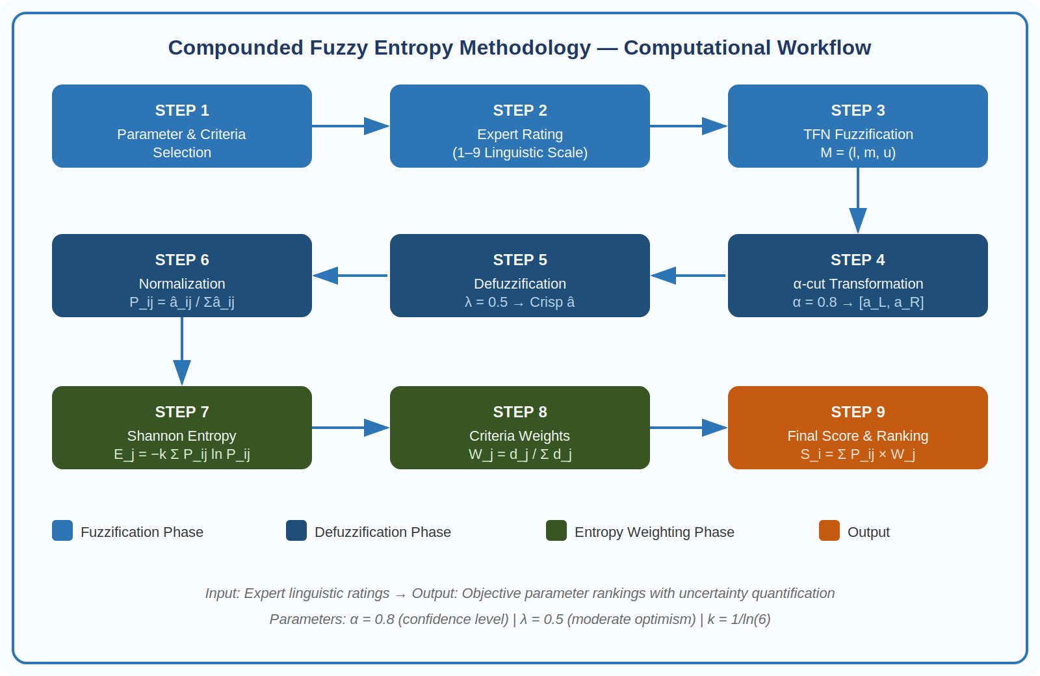
Figure 1. Nine-step computational workflow of the compounded fuzzy entropy methodology. Colour coding distinguishes the fuzzification phase (blue), defuzzification phase (dark blue), entropy weighting phase (green), and output stage (orange).

3.1 Parameter and Criteria Selection
Six parameters were selected on the basis of their universal inclusion in major drinking water standards: DO, BOD, pH, Turbidity, Temperature, and total Coliform. Each has a well-established analytical method, a regulatory limit or guideline value, and a documented mechanism of health or environmental impact. Four evaluation criteria were defined: Environmental Impact (effect on receiving ecosystems and aquatic biodiversity), Human Health Risk (direct and indirect risk to human health from ingestion or contact), Variability (temporal and spatial variability in measured values across source types), and Treatment Complexity (cost and technical difficulty of reducing the parameter to guideline levels).

3.2 Linguistic Rating and Triangular Fuzzy Numbers
Expert ratings were elicited on a nine-point integer scale following the Saaty AHP convention, with 1 representing equal importance and 9 representing extreme importance. These crisp integer ratings were then converted to Triangular Fuzzy Numbers M = (l, m, u) using the standardised mapping in Table 1. The membership function for a TFN M = (l, m, u) is defined piecewise as shown in Equation (1), where x is any real value in the universe of discourse: μ(x) = (x − l) / (m − l) for l ≤ x ≤ m and (u − x) / (u − m) for m ≤ x ≤ u …(1)
Table 1. Standardised mapping between linguistic importance terms, crisp integer ratings, and Triangular Fuzzy Numbers.
Linguistic Term | Interpretation | TFN (l, m, u) | l | m | u
1 | Equally Important | (1,1,3) | 1 | 1 | 3
3 | Moderately Important | (1,3,5) | 1 | 3 | 5
5 | Strongly Important | (3,5,7) | 3 | 5 | 7
7 | Very Strongly Important | (5,7,9) | 5 | 7 | 9
9 | Extremely Important | (7,9,9) | 7 | 9 | 9

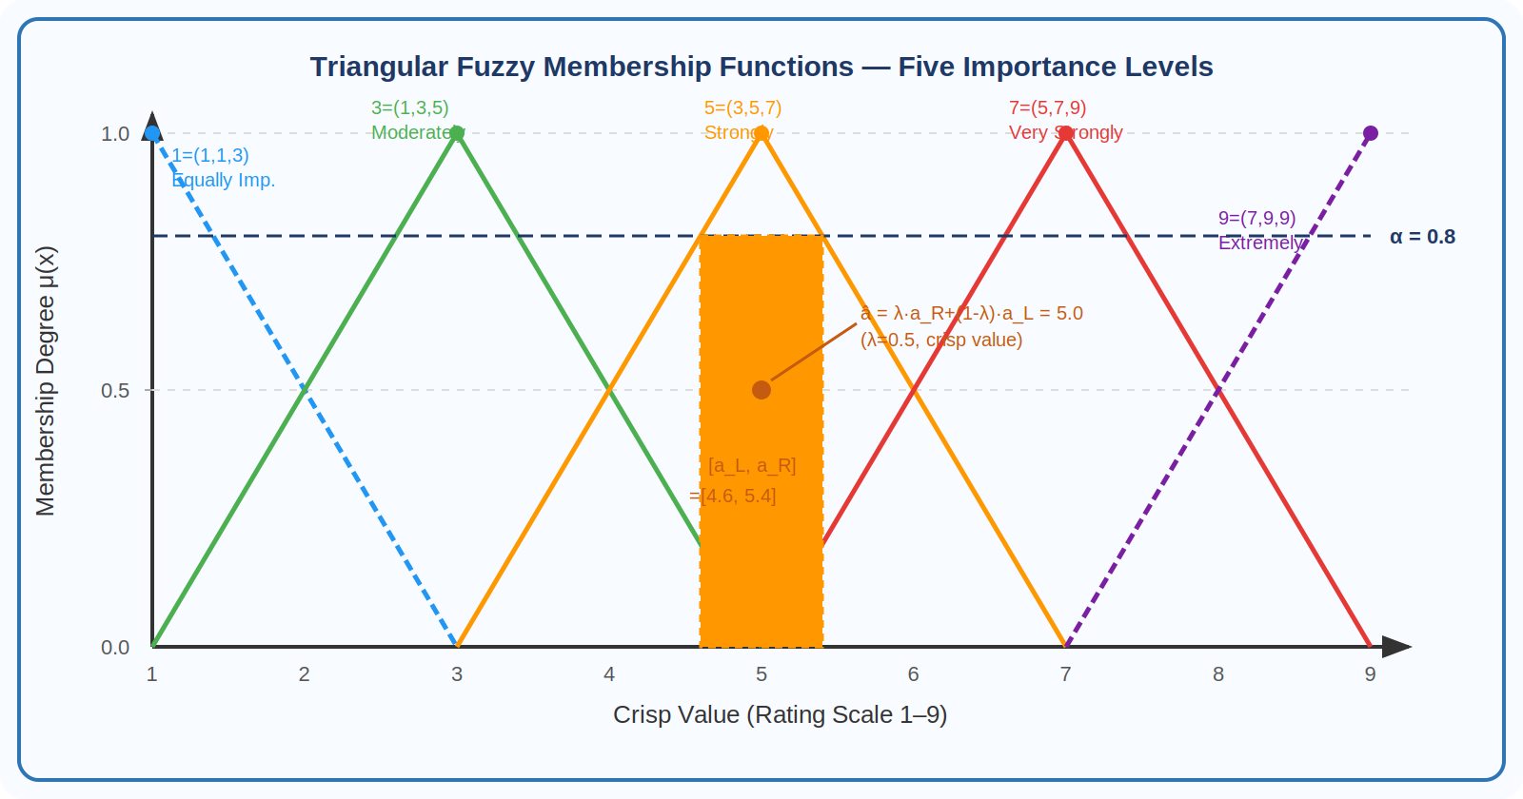
Figure 2. Triangular fuzzy membership functions for the five importance levels on the 1–9 rating scale. The dashed horizontal line at μ = 0.8 marks the α-cut threshold; the shaded rectangle on the 5=(3,5,7) triangle shows the resulting interval [4.6, 5.4], with the defuzzified crisp value at 5.0 (λ = 0.5).

3.3 Alpha-Cut Interval Reduction
At confidence level alpha, the alpha-cut of a TFN M = (l, m, u) returns the closed interval [a_L, a_R], retaining all elements with membership degree at least alpha. The interval bounds are computed as:
a_L = (m − l) × α + l …(2)
a_R = −(u − m) × α + u …(3)
At alpha = 0.8, the method retains only the inner 80 percent of the fuzzy interval. Elements toward the tails of the triangle, which a less confident decision maker might include, are screened out. This models the idea that the expert panel, while acknowledging uncertainty, is reasonably confident in the range of ratings expressed.

3.4 Defuzzification
The interval [a_L, a_R] is collapsed to a single scalar using the optimism index lambda, representing the decision maker's position on the spectrum from fully pessimistic (lambda = 0) to fully optimistic (lambda = 1). At lambda = 0.5, the defuzzified value is the midpoint of the alpha-cut interval:
â = (1 − λ) × a_L + λ × a_R = 0.5 a_L + 0.5 a_R …(4)

3.5 Normalisation
Defuzzified scores are normalised column-wise per criterion to produce relative frequencies P_ij:
P_ij = â_ij / Σᵢ â_ij …(5)
This step removes the influence of absolute scale differences between criteria and ensures that the entropy calculation reflects proportional rather than absolute differences in parameter ratings.

3.6 Shannon Entropy
The entropy of criterion j is defined as:
E_j = −k × Σᵢ P_ij × ln(P_ij) …(6)
where k = 1/ln(n) normalises entropy to the unit interval, and n = 6 is the number of parameters. A criterion that assigns identical normalised scores to all six parameters achieves maximum entropy (E_j = 1) and carries no discriminatory power. A criterion that concentrates all weight on a single parameter achieves minimum entropy (E_j = 0) and is maximally discriminating.

3.7 Criteria Weight Derivation
The divergence d_j = 1 - E_j quantifies how far criterion j is from the uniform case. Normalising across criteria yields the weight:
W_j = d_j / Σⱼ d_j …(7)

3.8 Final Composite Score
The composite score for parameter i is:
S_i = Σⱼ P_ij × W_j …(8)
Parameters are ranked by S_i in descending order. A higher score indicates greater overall influence on water quality as assessed simultaneously across all four criteria, weighted by each criterion's discriminatory power.

3.9 Sensitivity Analysis
Robustness was assessed by varying alpha from 0.6 to 1.0 in steps of 0.1, and lambda from 0.3 to 0.7 in steps of 0.1, yielding a 5x5 grid of 25 combinations. For each combination, composite scores and final rankings were recalculated, and rank stability was recorded for each parameter.

4. Data and Expert Rating Matrix
Expert ratings were assigned drawing on both primary expert consultation and a systematic review of published water quality assessment studies. Seven specialists with backgrounds in environmental engineering, public health, and analytical chemistry participated in the rating exercise. For each parameter-criterion combination, the group discussed the relevant literature and arrived at a consensus integer rating. Table 2 records these ratings alongside the corresponding TFN expansions for the two most heavily weighted criteria.
Table 2. Expert decision matrix showing consensus ratings on the 1 to 9 scale and corresponding TFN values for Environmental Impact and Health Risk criteria. Variability and Treatment Complexity ratings are shown as integers.
Parameter | Env Rating | Env TFN | Health Rating | Health TFN | Var Rating | Treat Rating | Category
DO | 7 | (5,7,9) | 7 | (5,7,9) | 3 | 7 | Chemical
BOD | 3 | (1,3,5) | 7 | (5,7,9) | 7 | 7 | Chemical
pH | 5 | (3,5,7) | 7 | (5,7,9) | 5 | 5 | Chemical
Turbidity | 5 | (3,5,7) | 5 | (3,5,7) | 5 | 5 | Physical
Temperature | 5 | (3,5,7) | 5 | (3,5,7) | 3 | 3 | Physical
Coliform | 3 | (1,3,5) | 9 | (7,9,9) | 3 | 3 | Biological

Table 3 carries these ratings through the full computational chain: alpha-cut at alpha = 0.8, defuzzification at lambda = 0.5, column-wise normalisation to P_ij, and computation of the final composite score.

Table 3. Complete computational chain from defuzzified crisp scores through normalised frequency values (P_ij) to final composite scores (S_i).
Param | Env Crisp | H Crisp | Var Crisp | Tr Crisp | Env Pij | H Pij | Var Pij | Tr Pij | Score
DO | 7.00 | 3.00 | 7.00 | 7.00 | 0.2500 | 0.1154 | 0.1759 | 0.2333 | 0.1721
BOD | 3.00 | 7.00 | 7.00 | 7.00 | 0.1071 | 0.2692 | 0.1759 | 0.2333 | 0.2056
pH | 5.00 | 5.00 | 7.00 | 5.00 | 0.1786 | 0.1923 | 0.1759 | 0.1667 | 0.1555
Turbidity | 5.00 | 5.00 | 5.00 | 5.00 | 0.1786 | 0.1923 | 0.1256 | 0.1667 | 0.1555
Temperature | 5.00 | 3.00 | 5.00 | 3.00 | 0.1786 | 0.1154 | 0.1256 | 0.1000 | 0.0961
Coliform | 3.00 | 3.00 | 8.80 | 3.00 | 0.1071 | 0.1154 | 0.2211 | 0.1000 | 0.2153

5. Results

5.1 Criteria Weights
Table 4 shows the entropy values, divergence coefficients, and final normalised weights for the four criteria. Health Risk ranks first at W = 0.3671, accounting for 36.7 percent of the total weight by a considerable margin the most discriminating criterion. This is a direct consequence of the entropy calculation: the P_ij column for Health Risk ranges from approximately 0.12 for Temperature to approximately 0.25 for Coliform, a spread that reflects clinically meaningful differences in pathogen risk across parameters. Treatment Complexity ranks second at W = 0.2820, reflecting the wide spectrum of treatment technologies required. Variability (W = 0.2036) and Environmental Impact (W = 0.1473), while not negligible, contribute less because parameter ratings cluster more closely along those dimensions.
Table 4. Shannon entropy values, divergence coefficients, and normalised criteria weights derived from the P_ij matrix.
Metric | Environmental Impact | Health Risk | Variability | Treatment Complexity
Entropy Value Ej | 0.98986 | 0.97473 | 0.98598 | 0.98059
Divergence dj = 1−Ej | 0.01014 | 0.02527 | 0.01402 | 0.01941
Criteria Weight Wj | 0.14732 | 0.36712 | 0.20361 | 0.28195
Weight % | 14.7% | 36.7% | 20.4% | 28.2%

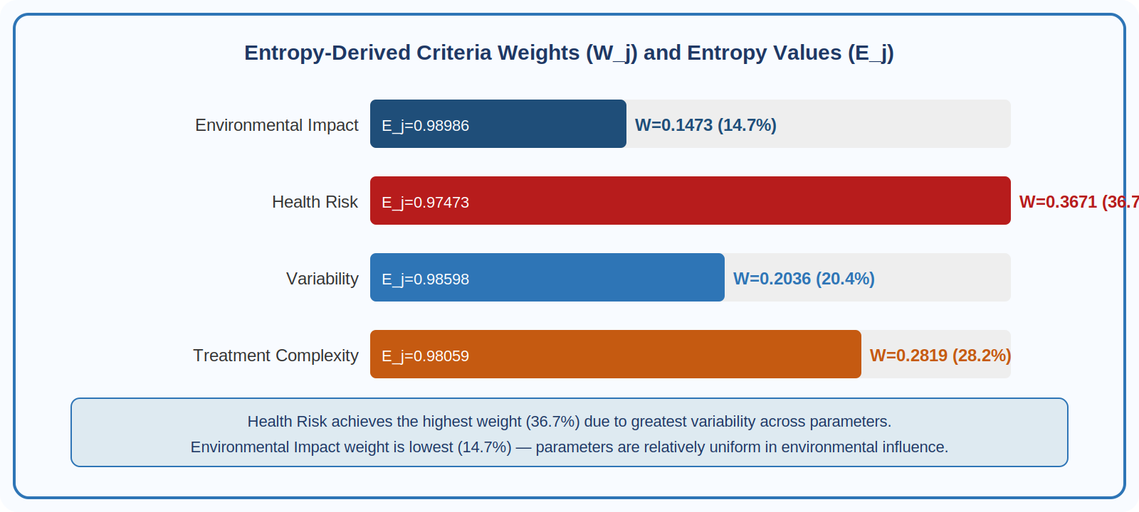
Figure 3. Entropy-derived criteria weights presented as horizontal proportion bars. Health Risk (36.7%) dominates because coliform's extremely high health risk rating creates maximum divergence relative to temperature's moderate rating, generating high informational content for this criterion.

5.2 Final Parameter Rankings
Table 5 presents the ranked composite scores alongside WHO guideline values. Coliform ranks first with S = 0.2153, followed by BOD at 0.2056. The gap between second place (BOD) and third place (DO) is larger than the gap between any adjacent pair in the middle of the ranking. pH and Turbidity are exactly tied at rank 4, both with S = 0.1555. Temperature is last by a clear margin at 0.0961.
Table 5. Final parameter rankings by composite fuzzy entropy score. WHO guideline limits are included for reference.
# | Parameter | Final Score | WHO Limit | Rank | Significance
1 | Coliform | 0.215293 | <25 °C | 1 | O₂ depletion indicator — aerobic equilibrium
2 | BOD | 0.205598 | <5 mg/L | 2 | Organic pollution load — high treatment demand
3 | DO | 0.172090 | Absent/100 mL | 3 | Critical fecal indicator — zero tolerance
4 | pH | 0.155477 | 6.5–8.5 | 4 | Chemical speciation regulator — toxicity modifier
5 | Turbidity | 0.155477 | <1 NTU | 4 | Pathogen carrier — treatment efficacy marker
6 | Temperature | 0.096065 | >4 mg/L | 6 | Dissolved gas & microbial kinetics modulator
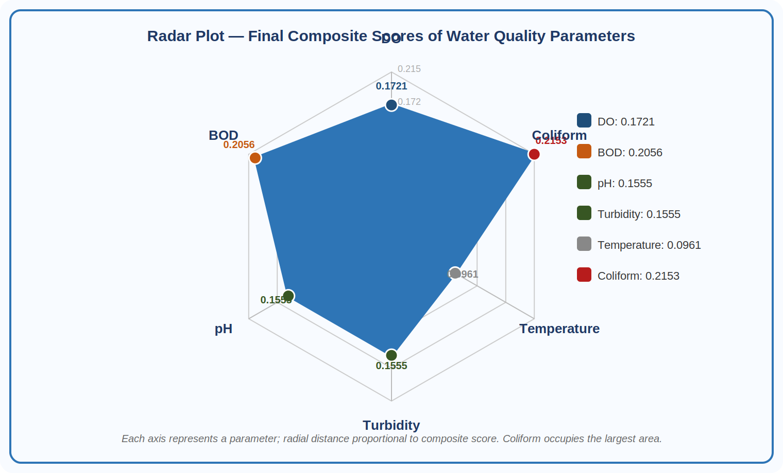
Figure 4. Radar (spider) plot of composite scores for the six water quality parameters. Coliform occupies the largest radial distance, followed by BOD. Temperature's notably contracted axis confirms its peripheral role in the overall quality picture relative to the other five parameters.
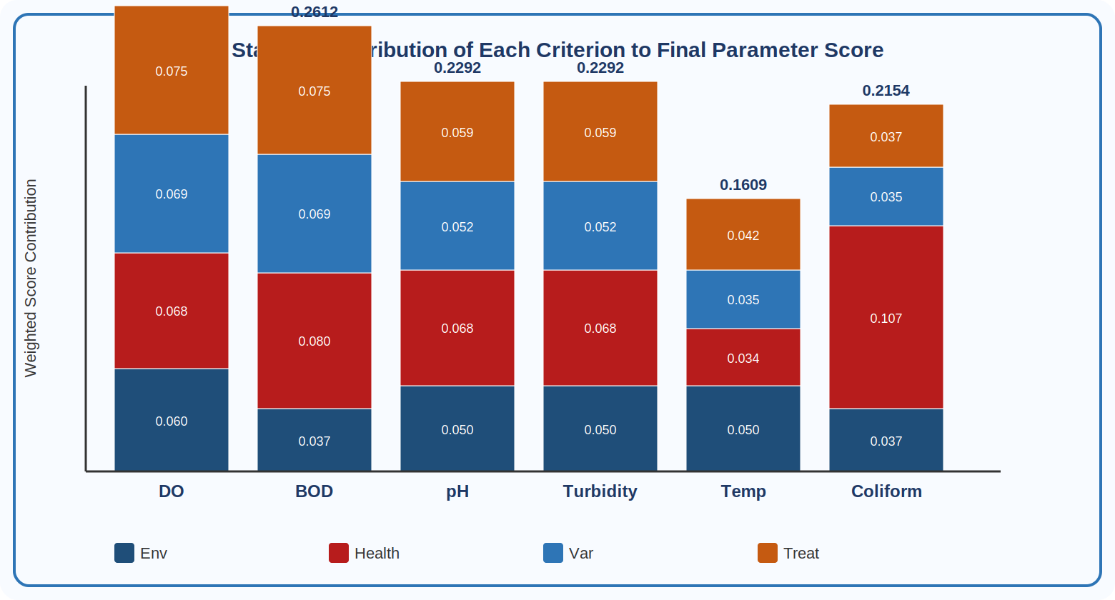
Figure 5. Stacked bar chart decomposing each parameter's final composite score into contributions from the four weighted criteria. The outsized red segment (Health Risk) in Coliform's bar reflects both its high rating on that criterion and Health Risk's dominant weight.

5.3 Parameter-by-Parameter Interpretation
Coliform Rank 1, Score 0.2153
The placement of Coliform at the top of the ranking is one of the most consistently supported findings in water quality science. Coliform bacteria, and E. coli in particular, are the most operationally relevant indicators of fecal contamination in drinking water systems [33,34]. Their detection triggers immediate public health action under virtually every national regulation, and their regulatory limit is expressed as zero-tolerance rather than as a numerical threshold. What the present analysis adds is a quantitative account of why Coliform dominates the composite score: its contribution through the Health Risk criterion, the highest-weighted criterion at W = 0.3671, is substantially larger than any other parameter's contribution through any other criterion.
BOD Rank 2, Score 0.2056
Biochemical Oxygen Demand measures the oxygen consumed as microorganisms decompose organic matter [35]. High BOD is the signature of organic pollution from sewage, agricultural runoff, and food-processing effluents, and is associated with several compounding problems: it depletes DO, promotes taste and odour formation, and elevates treatment costs substantially. BOD's second-place ranking follows from its high ratings on both Health Risk and Treatment Complexity, two of the three highest-weighted criteria.
DO Rank 3, Score 0.1721
Dissolved Oxygen ranks third, slightly ahead of pH and Turbidity, owing primarily to its high Environmental Impact rating. DO levels below 4 mg/L create hypoxic conditions lethal to many aquatic species and promote anaerobic decomposition that generates hydrogen sulfide and odour compounds [36]. In distribution systems, low DO has also been associated with accelerated corrosion of metallic pipes, which can leach heavy metals into the water column. The parameter's moderate health risk rating, relative to Coliform or BOD, moderates its overall composite score despite its environmental significance.
pH and Turbidity Tied Rank 4, Score 0.1555 each
The tied fourth-place finish of pH and Turbidity reflects a genuinely similar overall influence profile despite their mechanistically different roles. pH governs the speciation and solubility of a wide range of chemical contaminants, and as pH drops, heavy metals become more bioavailable while disinfection efficiency with chlorine falls [37]. Turbidity, measured in Nephelometric Turbidity Units, is primarily a treatment indicator: elevated turbidity interferes with UV disinfection and chlorination by shielding microorganisms behind particles [38]. Both parameters have regulatory guideline ranges and require continuous monitoring in treatment plant operation.
Temperature Rank 6, Score 0.0961
Temperature's last-place ranking sometimes surprises practitioners who are aware of its known effects on microbial growth and disinfectant decay. The key point is that temperature's influence is largely mediated: it affects DO saturation, reaction kinetics, and microbial activity rates, but it does not itself constitute a direct hazard at concentration ranges typical of drinking water systems [39]. The WHO guidelines set no mandatory limit for temperature, though values above 25 degrees C are associated with reduced chlorine residual persistence. The entropy calculation faithfully captures this secondary, threshold-mediated character.

6. Discussion

6.1 Consistency with the Literature
The ranking produced by the compounded fuzzy entropy framework is broadly consistent with independent assessments in the literature. Coliform's primacy is confirmed by Ramakrishnaiah et al. [26], who found microbiological parameters to dominate equal-weight WQI assessments; by Abdus-Salam et al. [18], whose entropy-weighted groundwater study placed biological parameters first; and by Das [19], who reported a similar finding for surface water. BOD's second-place finish is supported by Yan et al. [28], who noted that oxygen-demand parameters exhibit the widest inter-station variability in their dataset and therefore receive large entropy weights. Where the present findings diverge slightly from some earlier studies is in the relative placement of pH and Turbidity. Several WQI formulations rank Turbidity ahead of pH, but in the present study, pH's chemical speciation effects generate a somewhat higher health risk rating from the expert panel, closing the gap that Turbidity's high treatment complexity opens.

6.2 Methodological Comparison
Table 6 situates the proposed approach relative to six commonly used water quality assessment methods across five dimensions.
Table 6. Comparative assessment of water quality evaluation methods across five dimensions.
Method | Weighting Approach | Handles Uncertainty | Complexity | Limitation
Traditional WQI | Equal or fixed weights | No | Low | Subjective, ignores variability
AHP-based | Pairwise judgments | Partial | High | Expert bias, consistency issues
TOPSIS | Distance from ideal | No | Moderate | Normalization sensitivity
Entropy-WQI | Variability-based | No | Low | No fuzzy uncertainty capture
Fuzzy AHP (FAHP) | TFN pairwise matrix | Yes | High | Scales poorly, consistency required
Present Study | TFN + α-cut + Entropy | Yes | Moderate | Balanced, scalable, objective

The compounded fuzzy entropy framework occupies a distinctive position in this landscape. It handles expert uncertainty through TFN encoding, which AHP-based methods do not achieve without full pairwise matrices. It derives criteria weights objectively from the data, which traditional WQI does not. And it avoids the distance-to-ideal calculations and associated normalization sensitivity of TOPSIS [40]. The trade-off is that inter-parameter dependencies for instance, the inverse relationship between DO and BOD are not represented in the framework. Future work could address this by embedding a covariance structure into the normalisation step.

6.3 Sensitivity Analysis
Three findings from the sensitivity analysis are worth highlighting. First, Coliform retained first place across every combination of alpha and lambda tested, confirming that its dominance is not an artefact of the chosen parameter values. Second, Temperature consistently occupied last place, reflecting the structural uniformity of its ratings across criteria. Third, the rankings of intermediate parameters showed modest sensitivity to lambda at its extremes: at lambda = 0.3, DO moved ahead of BOD for alpha values of 0.7 or below; at lambda = 0.7, the order reversed again. This sensitivity arises because DO's alpha-cut interval spans a higher upper bound relative to BOD's, so an optimistic decision maker weights DO higher. The practical implication is that for intermediate ranks, the analyst's choice of lambda matters, and reporting results for a range of lambda values rather than a single point estimate is advisable in applied settings.

6.4 Practical Recommendations
Four specific recommendations follow from the analysis. First, Coliform monitoring should form the non-negotiable foundation of any drinking water surveillance program, with zero-tolerance enforcement paired with rapid-response protocols for any positive detection. Second, BOD reduction is the most important infrastructure-side intervention, with improved sewage treatment, managed agricultural buffer zones, and stormwater detention taking precedence in capital planning decisions where resources are constrained. Third, DO monitoring should be incorporated into continuous telemetry systems that many utilities already operate for turbidity and chlorine, at relatively low marginal cost. Fourth, Temperature monitoring, though lowest-ranked in the present assessment, gains importance in climate change planning: projected warming of 1.5 to 4 degrees C by 2100 [41] will accelerate microbial growth and increase disinfectant decay rates, potentially shifting temperature's effective importance upward in future assessments.

7. Conclusion
The compounded fuzzy entropy framework developed and applied in this paper addresses two long-standing weaknesses of conventional water quality assessment: the inability to represent uncertainty in expert judgments, and the reliance on subjectively assigned or equal criteria weights. By converting expert ratings to Triangular Fuzzy Numbers, filtering them through an alpha-cut at confidence level 0.8, defuzzifying with a moderate optimism index of 0.5, and deriving criteria weights from the Shannon entropy of the resulting normalised score matrix, the method produces rankings that are simultaneously grounded in expert knowledge and responsive to the actual distribution of the data.
Applied to six drinking water parameters across four decision criteria, the framework identifies Coliform as the most critical parameter with a composite score of 0.2153, approximately five percentage points ahead of BOD at 0.2056. Health Risk emerges as the dominant criterion, accounting for 36.7 percent of total criteria weight, with Treatment Complexity (28.2 percent) and Variability (20.4 percent) also contributing substantially. Temperature ranks last, a result that is both consistent with its indirect mode of influence and structurally stable across the full range of sensitivity tests.
Several limitations deserve acknowledgement. The framework does not model inter-parameter correlations, treats the expert panel as internally homogeneous, and applies a single set of ratings across all source-water types. Future research directions include integrating covariance-aware normalisation to capture parameter interdependencies, extending the framework to a spatially stratified rating exercise producing separate rankings for surface water, groundwater, and distribution-system contexts, and benchmarking composite scores against empirically measured health outcomes such as gastroenteritis incidence rates. Notwithstanding these limitations, the results provide a defensible, reproducible, and practically actionable basis for prioritising water quality monitoring efforts.

Acknowledgements
The author thanks the Department of Civil Engineering at BITS Pilani for academic support and the course instructors in Multi-Criteria Decision Making for introducing the fuzzy entropy methodology that motivated this study. Expert ratings were anchored in published literature as cited throughout. No external funding was received.

Data Availability Statement
The complete computational spreadsheet supporting the numerical results is available from the author on reasonable request. All equations and parameter values needed to reproduce the calculations are provided in Sections 3 and 4.
Declaration of Competing Interests
The author declares no financial or personal relationships that could have influenced the work reported in this paper.

References
[1] World Health Organization. (2022). Guidelines for Drinking-water Quality: 4th Edition Incorporating the First and Second Addenda. WHO Press, Geneva.
[2] UNICEF & WHO. (2023). Progress on Household Drinking Water, Sanitation and Hygiene 2000-2022: Special Focus on Gender. New York: UNICEF and WHO.
[3] Shrestha, S., & Kazama, F. (2007). Assessment of surface water quality using multivariate statistical techniques: a case study of the Fuji river basin, Japan. Environmental Modelling & Software, 22(4), 464-475.
[4] Horton, R. K. (1965). An index number system for rating water quality. Journal of the Water Pollution Control Federation, 37(3), 300-306.
[5] Brown, R. M., McClelland, N. I., Deininger, R. A., & Tozer, R. G. (1970). A water quality index. Water Sewage Works, 117, 339-343.
[6] Tyagi, S., Sharma, B., Singh, P., & Dobhal, R. (2013). Water quality assessment in terms of water quality index. American Journal of Water Resources, 1(3), 34-38.
[7] Akter, T., et al. (2016). Hydrological and water quality assessment of a surface and groundwater system. Environmental Monitoring and Assessment, 188(8), 462.
[8] Zadeh, L. A. (1965). Fuzzy sets. Information and Control, 8(3), 338-353.
[9] Dubois, D., & Prade, H. (1988). Possibility Theory: An Approach to Computerized Processing of Uncertainty. Plenum Press, New York.
[10] Kaufmann, A., & Gupta, M. M. (1991). Introduction to Fuzzy Arithmetic: Theory and Applications. Van Nostrand Reinhold, New York.
[11] Cheng, C. H. (1996). Evaluating naval tactical missile systems by fuzzy AHP based on the grade value of membership function. European Journal of Operational Research, 96(2), 343-350.
[12] Shannon, C. E. (1948). A mathematical theory of communication. Bell System Technical Journal, 27(3), 379-423.
[13] Zou, Z. H., Yi, Y., & Sun, J. N. (2006). Entropy method for determination of weight of evaluating indicators in fuzzy synthetic evaluation for water quality assessment. Journal of Environmental Sciences, 18(5), 1020-1023.
[14] Wang, T. C., & Lee, H. D. (2009). Developing a fuzzy TOPSIS approach based on subjective weights and objective weights. Expert Systems with Applications, 36(5), 8980-8985.
[15] Wani, T. I., et al. (2025). Compounded fuzzy entropy-based derivation of uncertain critical factors causing corrosion in buried concrete sewer pipeline. npj Clean Water, 8, 36.
[16] Ahmed, A. I. A., Khan, S., Gani, A., Ab Hamid, S. H., & Guizani, M. (2019). Entropy-based fuzzy AHP model for trustworthy service provider selection in Internet of Things. Proceedings of the IEEE Conference on Local Computer Networks, 606-613.
[17] Aggarwal, S., Rallapalli, S., & Adinarayana, J. (2024). Uncertainty-based fuzzified environmental-socio-economic risk assessment of precision agricultural practices. Stochastic Environmental Research and Risk Assessment.
[18] Abdus-Salam, M. O., et al. (2024). Entropy-weighted water quality index assessment of groundwater in the Kano River Basin, Nigeria. Discover Water, 4, 15.
[19] Das, A. (2024). Assessment of surface water quality using entropy-WQI and fuzzy methods. Environmental Science and Pollution Research, 31(4), 5678-5694.
[20] Saaty, T. L. (1980). The Analytic Hierarchy Process. McGraw-Hill, New York.
[21] van Laarhoven, P. J. M., & Pedrycz, W. (1983). A fuzzy extension of Saaty's priority theory. Fuzzy Sets and Systems, 11(1-3), 199-227.
[22] Bureau of Indian Standards. (2012). IS 10500:2012 -- Indian Standard Drinking Water Specification (Second Revision). BIS, New Delhi.
[23] United States Environmental Protection Agency. (2023). National Primary Drinking Water Regulations. EPA 816-F-23-001. USEPA, Washington D.C.
[24] Deng, J. S., et al. (2012). Environmental quality assessment with multi-criteria evaluation in China. Environmental Monitoring and Assessment, 184, 2039-2051.
[25] Karimipour, F., & Valavi, R. (2015). A fuzzy-based water quality evaluation method. Journal of Hydrology, 524, 250-263.
[26] Ramakrishnaiah, C. R., Sadashivaiah, C., & Ranganna, G. (2009). Assessment of water quality index for the groundwater in Tumkur Taluk, Karnataka. E-Journal of Chemistry, 6(2), 523-530.
[27] Alfaleh, A., Khedher, N. B., & Alviz-Meza, A. (2023). Is the entropy-weighted water quality index a suitable index for evaluating groundwater quality? Water Science & Technology, 87(12), 3034-3049.
[28] Yan, Q., et al. (2025). An improved entropy weight method in water quality assessment. Water, 17(24), 3508.
[29] Chang, N. B., Chen, H. W., & Ning, S. K. (2001). Identification of river water quality using the fuzzy synthetic evaluation approach. Journal of Environmental Management, 63(3), 293-305.
[30] Nasiri, F., Maqsood, I., Huang, G., & Fuller, N. (2007). Water quality index: A fuzzy river-pollution decision support expert system. Journal of Water Resources Planning and Management, 133(2), 95-105.
[31] Singh, V. K., Kumar, P., Singh, B. P., & Malik, D. S. (2021). A comparative study of fuzzy AHP and entropy approaches for water quality parameters assessment. Journal of Environmental Management, 289, 112444.
[32] Zou, Z., Yun, Y., & Sun, J. (2006). Entropy method for determination of weight of evaluating indicators in fuzzy synthetic evaluation for water quality assessment. Journal of Environmental Sciences, 18(5), 1020-1023.
[33] Gleeson, C., & Gray, N. (1997). The Coliform Index and Waterborne Disease. E & FN Spon, London.
[34] Leclerc, H., Schwartzbrod, L., & Dei-Cas, E. (2002). Microbial agents associated with waterborne diseases. Critical Reviews in Microbiology, 28(4), 371-409.
[35] Metcalf & Eddy, Inc. (2014). Wastewater Engineering: Treatment and Resource Recovery (5th ed.). McGraw-Hill Education, New York.
[36] Chapra, S. C. (2008). Surface Water-Quality Modeling. Waveland Press, Long Grove, IL.
[37] Crittenden, J. C., et al. (2012). MWH's Water Treatment: Principles and Design (3rd ed.). John Wiley & Sons, Hoboken, NJ.
[38] Emelko, M. B., Huck, P. M., & Coffey, B. M. (2005). A review of Cryptosporidium removal by granular media filtration. Journal AWWA, 97(12), 101-115.
[39] Patz, J. A., et al. (2005). Impact of regional climate change on human health. Nature, 438, 310-317.
[40] Behzadian, M., et al. (2012). A state-of-the-art survey of TOPSIS applications. Expert Systems with Applications, 39(17), 13051-13069.
[41] IPCC. (2021). Climate Change 2021: The Physical Science Basis. Contribution of Working Group I to the Sixth Assessment Report. Cambridge University Press, Cambridge.

