Genetic Basis of Coronary Artery Disease: From GWAS Genome-Wide Association Studies to Precision Medicine

Abstract
Coronary artery disease (CAD) remains the leading cause of morbidity and mortality worldwide and results from a complex interplay of genetic and environmental factors (1, 2). Although traditional risk factors such as hypertension, diabetes mellitus, and dyslipidemia are well established, genetic predisposition significantly contributes to disease susceptibility and progression (1, 12). Advances in genome-wide association studies (GWAS)have identified numerous loci associated with CAD, implicating pathways related to lipid metabolism, inflammation, and vascular remodeling (3,13,14). Epigenetic mechanisms and gene-environment interactions further modulate disease expression and contribute to phenotypic variability (9, 22).
Polygenic risk scores (PRS), which integrate the cumulative effects of multiple genetic variants, have emerged as valuable tools for risk prediction and early identification of high-risk individuals (10, 16). However, despite these advances, challenges related to clinical implementation, population diversity, and ethical considerations remain significant barriers to translation into routine practice ( 24, 28,29). This review provides a comprehensive and critical overview of the genetic architecture of CAD and highlights the translational potential and limitations of precision medicine approaches in cardiovascular care.

Keywords
Coronary artery disease; genetics; GWAS Genome-Wide Association Studies; polygenic risk score; epigenetics; precision medicine

1. Introduction
Coronary artery disease is a multifactorial disorder characterized by the progressive accumulation of atherosclerotic plaques within coronary arteries, leading to myocardial ischemia and infarction (6, 19). Despite substantial advances in pharmacological therapy and interventional cardiology, CAD continues to represent a major global health burden, accounting for a significant proportion of morbidity and mortality worldwide (1, 2). Conventional cardiovascular risk factors-including hypertension, diabetes mellitus, smoking, dyslipidemia, and sedentary lifestyle-have been extensively studied and form the basis of current preventive strategies (1,12).
However, these factors alone fail to fully explain inter-individual variability in disease susceptibility, severity, and clinical outcomes, suggesting a significant contribution from genetic determinants (1, 12). Family-based and twin studies have demonstrated that heritability accounts for approximately 40-60% of CAD risk, underscoring the importance of inherited factors in disease pathogenesis (1, 12). Early genetic insights were derived from monogenic disorders such as familial hypercholesterolemia, which highlighted the central role of lipid metabolism in atherogenesis (4).
With advances in genomic technologies, particularly high-throughput sequencing and genome-wide association studies, CAD is now recognized as a polygenic disorder influenced by numerous genetic variants, each conferring modest effects but collectively exerting substantial influence on disease risk (2, 3). Despite these advances, translation of genetic discoveries into routine clinical practice remains limited, highlighting a critical gap between genomic research and its clinical application (3, 16).

2. Genetic Architecture of CAD
Coronary artery disease is predominantly a polygenic condition resulting from the cumulative effects of multiple genetic variants distributed across the genome (2, 3). These variants, most commonly single nucleotide polymorphisms (SNPs), may influence gene expression, protein function, or regulatory pathways involved in atherogenesis (8). Although individual variants typically confer modest increases in risk, their combined effects can significantly alter disease susceptibility (8).
In addition to common variants, rare mutations with large effect sizes also contribute to CAD risk, particularly in specific populations. A classic example is familial hypercholesterolemia, caused by mutations in genes such as LDLR, APOB, and PCSK9, which result in markedly elevated low-density lipoprotein (LDL) cholesterol levels and early-onset cardiovascular disease (4). The coexistence of common and rare variants underscores the complexity of CAD genetics and highlights the need for integrative approaches to risk assessment (21).
Gene-gene interactions and gene-environment interactions further influence disease expression. Environmental exposures such as smoking, dietary habits, physical inactivity, and metabolic conditions interact with genetic predisposition to modulate cardiovascular risk, emphasizing the multifactorial nature of CAD (9, 22).

3. Key Genes and Molecular Pathways
The development of CAD involves multiple interconnected biological pathways, including lipid metabolism, inflammatory signaling, endothelial dysfunction, and vascular remodeling (6, 19). These processes collectively contribute to the initiation and progression of atherosclerotic plaques.
Major molecular pathways involved in CAD are illustrated in Figure 1.
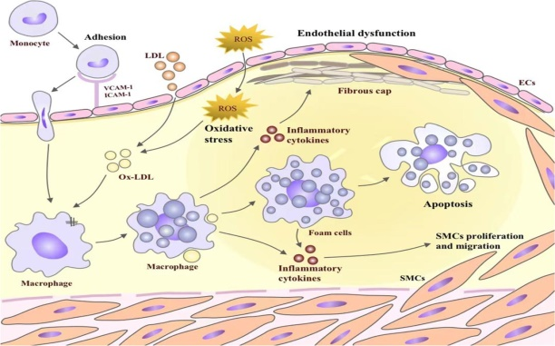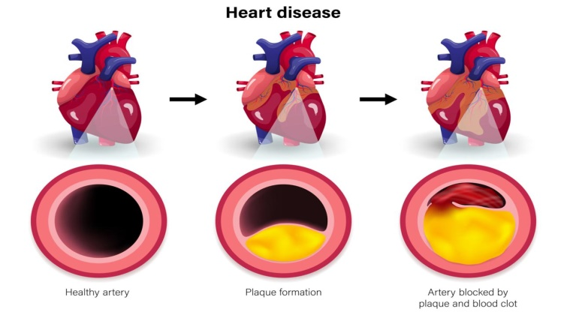

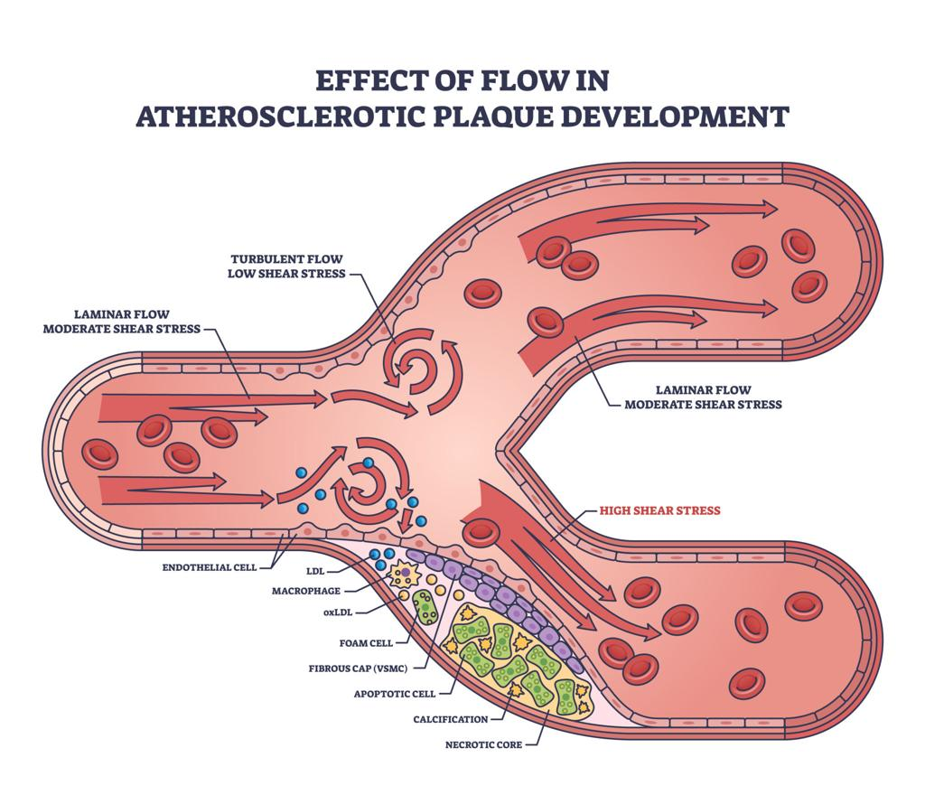

Figure 1: Molecular pathways involved in coronary artery disease, including lipid accumulation, endothelial dysfunction, inflammatory activation, foam cell formation, and plaque progression.
Redrawn and adapted from Libby (2002) and Ference et al. (2017). (6, 19)

3.1 Lipid Metabolism
Lipid metabolism plays a central role in the pathogenesis of atherosclerosis and CAD (19). The LDLR gene encodes the low-density lipoprotein receptor responsible for clearing circulating LDL cholesterol; mutations impair this process, resulting in elevated plasma LDL levels and increased cardiovascular risk (4). The APOB gene encodes apolipoprotein B, a structural component of LDL particles, and is essential for lipid transport, while PCSK9 regulates LDL receptor degradation and influences plasma LDL concentrations (4, 5).
Genetic studies have demonstrated that loss-of-function mutations in PCSK9 are associated with reduced CAD risk, providing a foundation for the development of PCSK9 inhibitors, which have shown significant efficacy in lowering LDL cholesterol and reducing cardiovascular events (5, 19). These findings illustrate the direct translation of genetic discoveries into therapeutic advances.

3.2 Inflammation and Immune Mechanisms
Atherosclerosis is increasingly recognized as a chronic inflammatory disease involving interactions between lipids, immune cells, and the vascular endothelium (6). Inflammatory mediators, including cytokines and chemokines, play a central role in plaque initiation, progression, and destabilization, ultimately leading to acute cardiovascular events (6, 20).
Clinical trials targeting inflammatory pathways, such as interleukin-1β inhibition, have demonstrated reductions in cardiovascular events independent of lipid lowering, further supporting the inflammatory basis of CAD and highlighting new therapeutic avenues (20).

3.3 Chromosome 9p21 Locus
The chromosome 9p21 locus represents one of the most consistently replicated genetic risk regions associated with CAD (7, 13). Variants in this region confer increased disease risk independent of traditional cardiovascular risk factors, suggesting novel mechanisms of disease pathogenesis (7).
Functional studies indicate that this locus influences vascular smooth muscle cell proliferation, cellular senescence, and plaque stability; however, the precise molecular mechanisms remain incompletely understood, representing an important area for future research (7, 15).
Key genes implicated in CAD are summarized in Table 1.

Table 1: Key Genes and Their Role in Coronary Artery Disease
Gene | Function | Clinical Significance | Reference
LDLR | LDL clearance | Familial hypercholesterolemia | (4)
APOB | Lipid transport | Atherosclerosis | (4,19)
PCSK9 | LDL receptor degradation | Therapeutic target | (5)
9p21 locus | Cell cycle regulation | CAD risk | (7,13)

4. Genome-Wide Association Studies (GWAS)
Genome-wide association studies have revolutionized the understanding of complex diseases such as CAD by enabling the identification of genetic variants associated with disease risk across large populations (2, 3). To date, more than 160 susceptibility loci have been identified, implicating diverse biological pathways including lipid metabolism, inflammation, and vascular function (3, 13,14).
These discoveries have expanded the understanding of disease mechanisms beyond traditional risk factors and have highlighted the polygenic nature of CAD. However, a substantial proportion of heritability remains unexplained, a phenomenon referred to as missing heritability, suggesting contributions from rare variants, structural variations, and gene-environment interactions (8, 21).

4.1 Limitations of GWAS Genome-Wide Association Studies
Despite their success, GWAS Genome-Wide Association Studies have several important limitations. Most identified variants confer relatively small effect sizes, limiting their individual clinical relevance (8). Population stratification may introduce bias and lead to spurious associations if not adequately controlled.
A major limitation is the lack of diversity in GWAS Genome-Wide Association Studies cohorts, as most studies have been conducted in populations of European ancestry, limiting generalizability and raising concerns regarding equity in genomic medicine (28, 29). Additionally, many associated variants are located in non-coding regions, complicating biological interpretation and necessitating further functional validation (8, 21).

5. Epigenetics and Gene-Environment Interaction
Epigenetic mechanisms regulate gene expression without altering the underlying DNA sequence and include processes such as DNA methylation, histone modification, and regulation by non-coding RNAs (9). These mechanisms play a crucial role in modulating cardiovascular risk and contribute to the dynamic and reversible nature of gene expression in coronary artery disease.
Environmental exposures such as smoking, dietary patterns, physical inactivity, and metabolic stress can induce epigenetic modifications that influence disease susceptibility and progression (9, 22). For instance, altered DNA methylation profiles have been associated with dysregulation of genes involved in lipid metabolism, endothelial function, and inflammatory signaling pathways, thereby contributing to atherogenesis (9).
In addition, microRNAs (miRNAs) have emerged as important post-transcriptional regulators of gene expression in cardiovascular disease. These small non-coding RNAs influence endothelial integrity, vascular smooth muscle cell proliferation, and inflammatory responses, all of which are central to plaque development and progression (9).
Despite these advances, the clinical application of epigenetic biomarkers remains limited. The dynamic and context-dependent nature of epigenetic modifications, combined with variability across individuals and populations, poses challenges for standardization and clinical implementation (9, 22). Furthermore, the lack of validated, reproducible biomarkers limits their current utility in routine cardiovascular risk assessment.

6. Polygenic Risk Scores (PRS)
Polygenic risk scores (PRS) integrate the cumulative effects of multiple genetic variants to estimate an individual’s genetic susceptibility to coronary artery disease (10, 16). These scores are derived from genome-wide association data by assigning weights to individual SNPs based on their effect sizes and summing them into a composite risk estimate (10).
Numerous studies have demonstrated that individuals with high PRS exhibit a significantly increased risk of CAD compared to those with average genetic risk, even in the absence of conventional risk factors (18, 25). In some cases, the level of risk conferred by a high PRS is comparable to that observed in monogenic disorders, underscoring the potential clinical significance of these tools (10, 18).
The workflow of polygenic risk score development is illustrated in Figure 2.
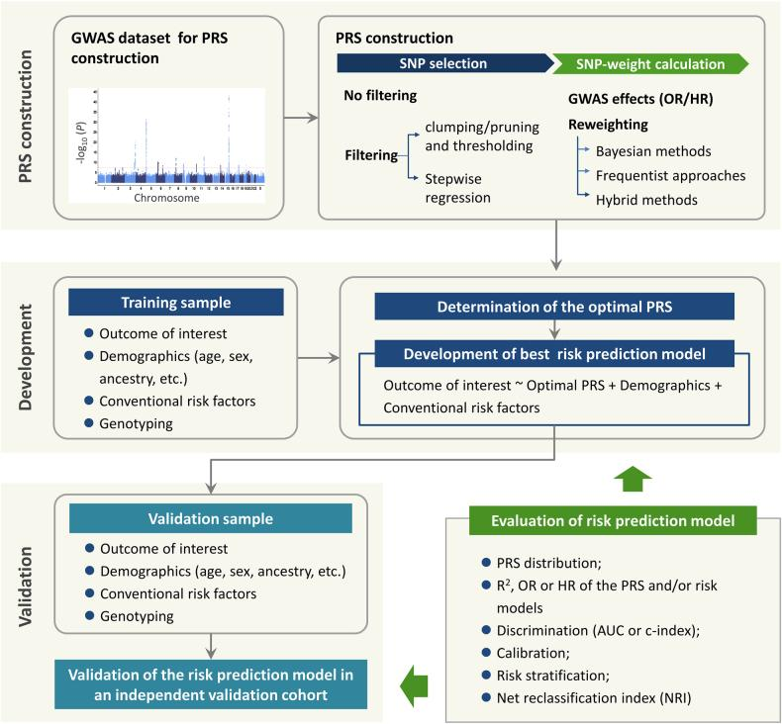

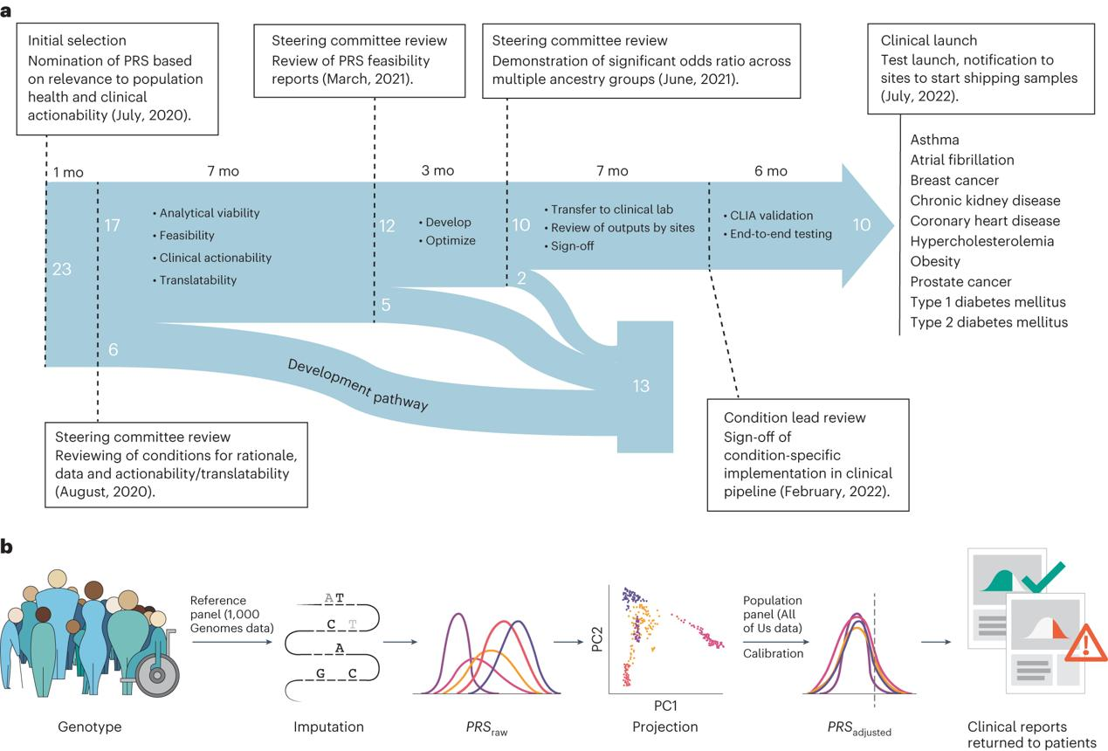

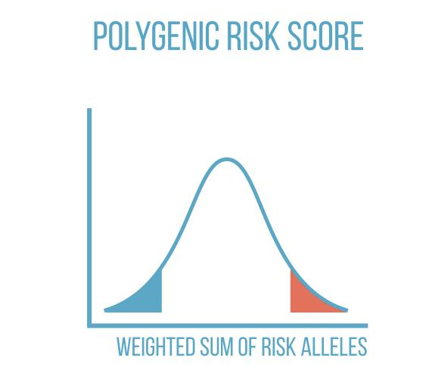
Figure 2: Workflow of polygenic risk score development, including SNP identification through genome-wide association studies, effect size weighting, score aggregation, and clinical risk stratification.
Redrawn and adapted from Khera et al. (2018) and Torkamani et al. (2018). (10, 16)
Despite their promise, PRS have several important limitations that must be addressed before widespread clinical adoption. One major limitation is reduced predictive accuracy across populations due to differences in allele frequencies and linkage disequilibrium patterns, limiting generalizability and raising concerns regarding equity (26, 27). Additionally, the absence of standardized thresholds for defining high genetic risk complicates clinical interpretation and decision-making (24, 26).
Integration of PRS into routine clinical practice is further hindered by cost considerations, lack of clinician familiarity with genomic data, and the absence of clear, evidence-based clinical guidelines (24). Nonetheless, PRS hold considerable potential for enhancing early risk stratification and enabling targeted preventive strategies when used in conjunction with traditional risk factors.
A comparison of major genetic approaches in CAD is presented in Table 2.

Table 2: Strengths and Limitations of Genetic Approaches in CAD
Approach | Strengths | Limitations | Reference
GWAS | Identifies susceptibility loci | Small effect sizes, population bias | (2,3,8)
PRS | Risk stratification | Limited transferability, lack of standardization | (10,16,24,26)
Epigenetics | Dynamic gene regulation | Limited clinical validation | (9)

7. Precision Medicine in CAD
Precision medicine represents a paradigm shift in cardiovascular care, aiming to tailor prevention and treatment strategies based on individual genetic, environmental, and lifestyle factors (23, 24). Advances in genomic research have facilitated the identification of molecular targets and the development of personalized therapeutic approaches.

7.1 Targeted Therapies
Genetic discoveries have played a pivotal role in the development of targeted therapies, particularly in lipid management. PCSK9 inhibitors, developed based on insights into PCSK9 gene function, have demonstrated significant reductions in LDL cholesterol levels and cardiovascular events in clinical trials (5). These therapies exemplify the successful translation of genetic research into clinical practice.

7.2 Pharmacogenomics
Genetic variation influences drug metabolism and therapeutic response, highlighting the importance of pharmacogenomics in cardiovascular medicine. For example, polymorphisms in cytochrome P450 enzymes affect the activation of clopidogrel, leading to variability in treatment response and clinical outcomes (11). Incorporating genetic information into prescribing decisions can improve efficacy and reduce adverse effects.

7.3 Personalized Prevention
Integration of genetic and clinical data enables individualized prevention strategies tailored to patient-specific risk profiles (23). Individuals identified as high-risk through PRS may benefit from early lifestyle interventions, aggressive risk factor modification, and targeted pharmacological therapy (23, 24).

7.4 Challenges in Clinical Implementation
Despite significant advances, several barriers limit the widespread implementation of precision medicine in CAD. High costs associated with genetic testing and limited accessibility in low-resource settings remain major obstacles (24). Additionally, lack of clinician training in genomics and absence of standardized clinical guidelines hinder effective integration into routine practice.
Ethical concerns, including genetic privacy, data security, and potential discrimination, further complicate the use of genetic information in healthcare. The potential misuse of genetic data in insurance and employment contexts raises important ethical and legal considerations (28, 29).
Moreover, the underrepresentation of diverse populations in genomic studies limits the applicability of precision medicine approaches and may exacerbate existing healthcare disparities. Ensuring inclusivity in genetic research is essential for achieving equitable healthcare outcomes (28, 29).

8. Future Directions
Future research is expected to focus on integrating multi-omics approaches, including genomics, transcriptomics, proteomics, and metabolomics, to provide a more comprehensive understanding of CAD pathogenesis (21). Advances in artificial intelligence and machine learning are likely to enhance risk prediction models and facilitate clinical decision-making.
Emerging technologies such as gene editing, including CRISPR-Cas9, hold promise for the treatment of inherited cardiovascular disorders. However, ethical considerations, safety concerns, and regulatory challenges must be carefully addressed before these approaches can be translated into clinical practice (21).

9. Limitations
Despite significant advances in cardiovascular genetics, several challenges remain. Most genetic studies have been conducted in populations of European ancestry, limiting generalizability to other populations and potentially contributing to healthcare disparities (24, 28). Additionally, the functional significance of many identified genetic variants remains unclear, and further research is required to elucidate their biological roles.
The clinical implementation of genetic risk assessment also presents logistical and economic challenges, including cost, infrastructure requirements, and the need for specialized expertise. Ethical considerations related to data privacy and informed consent further complicate the integration of genomics into routine care (24).

10. Conclusion
Coronary artery disease is a complex condition influenced by both genetic and environmental factors (1, 2). Advances in genome-wide association studies and molecular genetics have significantly enhanced understanding of disease mechanisms and risk prediction (3, 16). The development of polygenic risk scores and targeted therapies represents a major step toward the realization of precision medicine in cardiovascular care (5, 10).
However, challenges related to clinical implementation, population diversity, and ethical considerations must be addressed to fully realize the potential of genomic medicine. Continued research, interdisciplinary collaboration, and the development of inclusive genomic datasets are essential for translating these advances into improved patient outcomes (21, 28, 29).

REFERENCES
- Khera AV, Kathiresan S. Genetics of coronary artery disease. Nat Rev Genet. 2017;18(6):331-344.
- Nikpay M, Goel A, Won HH, Hall LM, Willenborg C, Kanoni S, et al. A comprehensive genome-wide association study of coronary artery disease. Nat Genet. 2015; 47(10):1121-1130.
- Nelson CP, Goel A, Butterworth AS, Kanoni S, Webb TR, Marouli E, et al. Association analyses based on false discovery rate implicate new loci for coronary artery disease. Nat Genet. 2017; 49(9):1385-1391.
- Goldstein JL, Brown MS. A century of cholesterol and coronaries: From plaques to genes to statins. Cell. 2015; 161(1):161-172.
- Sabatine MS, Giugliano RP, Keech AC, Honarpour N, Wiviott SD, Murphy SA, et al. Evolocumab and clinical outcomes in patients with cardiovascular disease. N Engl J Med. 2017; (18):1713-1722.
- Libby P. Inflammation in atherosclerosis. Nature. 2002;420(6917):868-874.
- McPherson R, Pertsemlidis A, Kavaslar N, Stewart A, Roberts R, Cox DR, et al. A common allele on chromosome 9 associated with coronary heart disease. Science. 2007; 316(5830):1488-1491.
- Manolio TA, Collins FS, Cox NJ, Goldstein DB, Hindorff LA, Hunter DJ, et al. Finding the missing heritability of complex diseases. Nature. 2009; 461(7265):747-753.
- Ordovás JM, Smith CE. Epigenetics and cardiovascular disease. Nat Rev Cardiol. 2010; 7(9):510-519.
- Khera AV, Chaffin M, Aragam KG, Haas ME, Roselli C, Choi SH, et al. Genome-wide polygenic scores for common diseases identify individuals with risk equivalent to monogenic mutations. Nat Genet. 2018; 50(9):1219-1224.
- Mega JL, Close SL, Wiviott SD, Shen L, Hockett RD, Brandt JT, et al. Cytochrome P450 polymorphisms and response to clopidogrel. N Engl J Med. 2009; 360(4):354-362.
- Kathiresan S, Srivastava D. Genetics of human cardiovascular disease. Cell. 2012; 148(6):1242-1257.
- Deloukas P, Kanoni S, Willenborg C, Farrall M, Assimes TL, Thompson JR, et al. Large-scale association analysis identifies new risk loci for coronary artery disease. Nat Genet. 2013; 45(1):25-33.
- Schunkert H, König IR, Kathiresan S, Reilly MP, Assimes TL, Holm H, et al. Large-scale association analysis identifies 13 new susceptibility loci for coronary artery disease. Nat Genet. 2011; 43(4):333-338.
- Roberts R, Stewart AF. Genes and coronary artery disease: Where are we? J Am Coll Cardiol. 2012; 60(18):1715-1721.
- Torkamani A, Wineinger NE, Topol EJ. The personal and clinical utility of polygenic risk scores. Nat Rev Genet. 2018; 19(9):581-590.
- Abraham G, Havulinna AS, Bhalala OG, Byars SG, De Livera AM, Yetukuri L, et al. Genomic prediction of coronary heart disease. Circulation. 2016; 133(24):1-9.
- Inouye M, Abraham G, Nelson CP, Wood AM, Sweeting MJ, Dudbridge F, et al. Genomic risk prediction of coronary artery disease in 480,000 adults. J Am Coll Cardiol. 2018; 72(16):1883-1893.
- Ference BA, Ginsberg HN, Graham I, Ray KK, Packard CJ, Bruckert E, et al. Low-density lipoproteins cause atherosclerotic cardiovascular disease. Eur Heart J. 2017; 38(32):2459-2472.
- Ridker PM, Everett BM, Thuren T, MacFadyen JG, Chang WH, Ballantyne C, et al. Antiinflammatory therapy with canakinumab for atherosclerotic disease. N Engl J Med. 2017; 377(12):1119-1131.
- Musunuru K, Kathiresan S. Genetics of common, complex coronary artery disease. Annu Rev Genomics Hum Genet. 2019; 20:1-21.
- Emdin CA, Khera AV, Kathiresan S. Mendelian randomization. JAMA. 2017; 317(6):626-634.
- Knowles JW, Ashley EA. Cardiovascular disease: The rise of the genetic risk score. PLoS Med. 2018; 15(3):e1002546.
- Aragam KG, Dobbyn A, Judy R, Chaffin M, Chaudhary K, Hindy G, et al. Limitations of polygenic risk scores. Nat Genet. 2020; 52(6):550-558.
- Levin MG, Rader DJ. Polygenic risk scores and coronary artery disease. Circulation. 2020; 141(8):637-640.
- Martin AR, Kanai M, Kamatani Y, Okada Y, Neale BM, Daly MJ. Clinical use of current polygenic risk scores may exacerbate health disparities. Nat Genet. 2019; 51(4):584-591.
- Duncan L, Shen H, Gelaye B, Meijsen J, Ressler K, Feldman M, et al. Analysis of polygenic risk score usage. Nat Commun. 2019; 10: 3328.
- Sirugo G, Williams SM, Tishkoff SA. The missing diversity in human genetic studies. Cell. 2019; 177(1):26-31.
- Hindorff LA, Bonham VL, Ohno-Machado L. Enhancing diversity in genomics research. Nature. 2018;558(7710):301-303

