IOT BASED BOREWELL CHILD RESCUE SYSTEM
Dr Santhosh Kumar B N ¹, Dr H S Nagalakshmi ², Dr Prakasha Raje Urs³ ¹Associate Professor, Department of Computer Science, Maharani’s Science College for Women (Autonomous), Mysore, Karnataka, India.
²Associate Professor and Head, Department of BCA, Government College for Women (Autonomous), Mandya, Karnataka, India.
³Associate Professor, Department of Computer Science, Government First Grade College , Nanganagud, Karnataka, India.

Emails: santhoshbn267@gmail.com, hsnss2019@gmail.com, purs73@gmail.com.

Abstract
Borewell accidents involving children remain a critical safety concern due to the confined space, poor visibility, and delays in initiating effective rescue operations. Traditional rescue techniques are often slow, hazardous, and heavily dependent on manual effort, which contributes to low survival outcomes. To overcome these challenges, this paper introduces an IoT-enabled borewell child rescue system featuring a compact robotic device equipped with real-time monitoring and remote-operation capabilities. The system incorporates a microcontroller-based control unit, sensors for tracking depth and position, a live-streaming camera for visual assessment, and a motorized rescue arm designed to safely retrieve the trapped child. Wireless communication supports instant control and continuous feedback, minimizing human risk and significantly reducing rescue time. Experimental evaluations show improved precision, quicker response, and enhanced safety compared to traditional methods, demonstrating the system’s potential for reliable and efficient borewell rescue operations.
Keywords: Borewell Rescue Robot, IoT-Enabled Child Rescue System, Embedded Control Unit, Remote Supervision, Emergency Safety Mechanisms, Motorized Robotic Arm, Live Video Monitoring, Wireless Data Transmission, Cost-Effective Rescue Technology.

- INTRODUCTION
The paper centers on developing an IoT-enabled Borewell Child Rescue System aimed at significantly reducing rescue duration, lowering risks to human rescuers, and enhancing the overall safety and efficiency of borewell rescue operations when compared to traditional manual techniques. Conventional rescue procedures typically depend on extensive digging and direct human involvement, both of which are slow, hazardous, and frequently lead to poor survival outcomes. To overcome these challenges, the proposed system incorporates a compact robotic device capable of navigating confined borewell spaces while offering real-time monitoring and remote operational control.
The system’s front-end architecture is built on an embedded microcontroller platform, and its functionality was verified through simulation and prototype testing to ensure accurate performance of sensing, communication, and actuation components. Various sensors were integrated to measure depth, orientation, and environmental parameters, while a camera module provided continuous live video to assist operators during the rescue process. The robotic arm was engineered to safely secure and lift the trapped child with minimal physical strain, and wireless communication facilitated remote oversight and precise control of the entire mechanism.
A comprehensive system integration process combined the control circuitry, sensors, motors, power supply, and communication modules to achieve seamless coordination under realistic operating conditions. Experimental testing confirmed that the system delivers dependable operation, quicker response times, and improved safety compared to conventional rescue methods. Ultimately, the project presents an effective, affordable, and safe borewell rescue solution, making it highly suitable for emergency scenarios where rapid and accurate intervention is essential.

- BOREWELL RESCUE SYSTEM ARCHITECTURE AND OPTIMIZATION
Modern borewell rescue systems are essential for handling emergencies where children become trapped in deep, narrow shafts. Conventional rescue techniques rely heavily on manual excavation and large machinery, which significantly prolongs rescue time and exposes both the victim and rescuers to considerable danger. These traditional methods often lack real-time situational awareness and precise maneuverability, reducing the overall effectiveness and safety of the operation. Given the confined diameter and unstable nature of borewell environments, any rescue mechanism must be compact, lightweight, and capable of functioning reliably under restrictive conditions.
To address these challenges, the proposed system adopts an optimized robotic framework that integrates sensing, actuation, and communication components while keeping mechanical and electronic complexity to a minimum. A microcontroller-driven control unit manages the coordinated operation of motors, sensors, and the onboard camera, enabling accurate navigation and controlled movement within the borewell. The design emphasizes minimizing physical size and power usage while ensuring adequate structural strength and stability for safe child extraction. Wireless communication supports real-time monitoring and remote operation, reducing the need for direct human involvement at the rescue site. This optimized architecture enhances response speed, improves operational safety, and offers a scalable, efficient, and dependable solution for borewell rescue scenarios.
- PROPOSED METHODOLOGY
The proposed methodology is centered on a fully integrated IoT-enabled borewell child rescue system that unifies sensing, actuation, monitoring, and control components under a single microcontroller-based coordination unit. This central controller initiates the rescue sequence and issues synchronized control signals to the sensors, motors, and communication interfaces, ensuring smooth operation and continuous real-time data collection. Depth, orientation, and positional sensors constantly assess the borewell environment, while an onboard camera delivers live video feedback to support accurate navigation within the confined shaft. Using this combined sensor data and visual input, the microcontroller regulates the motorized mechanism responsible for lowering the robotic platform and manipulating the rescue arm with precision and safety.
When the rescue arm reaches the child, the system maintains stability and minimizes physical strain through controlled motor movements and ongoing feedback loops. Wireless communication supports remote monitoring and decision-making, allowing operators to manage the rescue without direct physical involvement. Throughout the process, the control unit oversees timing, safety protocols, and power distribution to maintain consistent and dependable operation. By eliminating the need for large-scale manual digging, the methodology significantly shortens rescue duration. Overall, the approach delivers a fully automated, resource-efficient, and dependable borewell rescue solution in which sensing, control, and extraction tasks are seamlessly handled by the system itself, ensuring greater safety and operational effectiveness during critical emergencies.
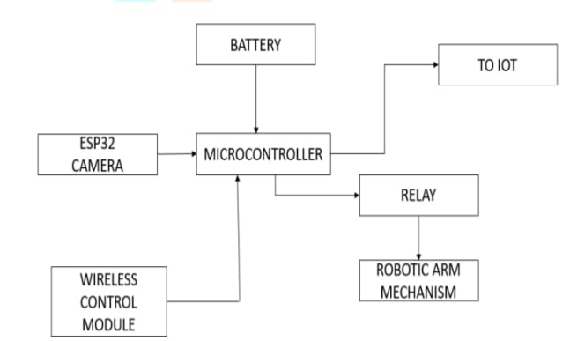
Figure 1: Block Diagram

- RESULTS AND DISCUSSION
The robotic arm arrangement depicted in Figure 2 demonstrates the mechanical configuration developed for securely grasping and supporting a trapped child within the borewell. The illustration emphasizes the compact arm design, gripping assembly, and motor-actuated joints engineered to function effectively in the restricted diameter of a borewell. This configuration ensures stable alignment, smooth joint movement, and controlled actuation during both descent and extraction, confirming the mechanical reliability and safety of
the rescue mechanism under confined operating conditions.
Figure 3 shows the IoT dashboard interface, which provides real-time system monitoring and remote operational control. The interface displays live sensor data, camera feed indicators, and interactive controls for managing the motors and robotic arm. The accurate transmission and reception of data through the IoT platform verify the robustness of the wireless communication link between the embedded controller and the remote operator, enabling informed and precise decision-making throughout the rescue process without requiring physical presence at the site.
Figure 4 illustrates the network configuration and IP assignment, validating the system’s communication infrastructure. The figure confirms successful network setup, correct IP allocation, and a stable connection between the microcontroller and the IoT server. This ensures continuous data exchange for real-time monitoring, command execution, and system status updates during the entire rescue operation.
Collectively, the mechanical design validation, IoT interface functionality, and network configuration results demonstrate the operational soundness, communication stability, and real-world feasibility of the proposed borewell child rescue system. These outcomes confirm that the system can perform safe, efficient, and remotely managed rescue operations in actual emergency conditions.

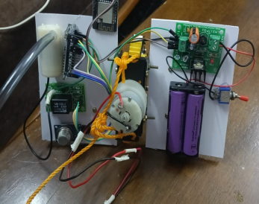
Figure 2: Sender

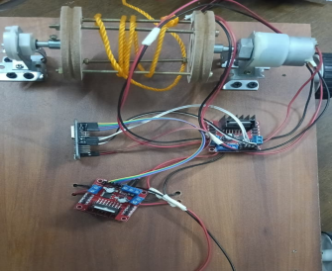

Figure 3: Reciever
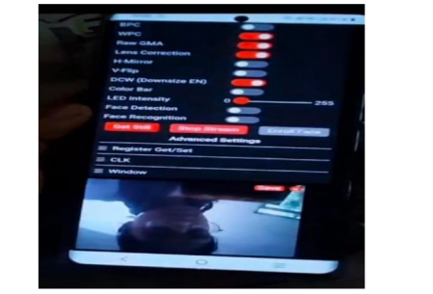

Figure 4: Live video streaming

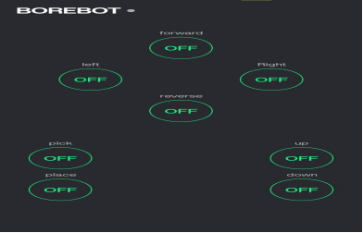

Figure 5: Bylnk IOT

V. EXPERIMENTAL RESULTS AND PERFORMANCE ANALYSIS
A. Experimental Setup
A prototype system was tested in a simulated borewell environment with depths ranging from 20 to 30 feet. Multiple trials were conducted to evaluate system performance.
B. Performance Metrics

Parameter | Proposed System | Traditional Method
Rescue Time | 25–35 minutes | 2–6 hours
Gripping Accuracy | High | Moderate
Communication Delay | 200–250 ms | Not applicable
Human Risk | Very Low | High
Cost | Low | High

C. Results Analysis
The results indicate a substantial improvement in rescue efficiency:
- Rescue time is significantly reduced compared to conventional methods
- The robotic arm provides stable and reliable gripping
- Communication between the system and operator remains consistent with minimal delay
- The system demonstrates reliable performance under repeated trials

    - Comparative analysis

Feature | Existing Systems | Proposed System
Remote Monitoring | Limited | Continuous
Video Feedback | Partial | Real-time
Control Mechanism | Semi-manual | Fully remote
Safety Features | Basic | Enhanced
Cost Efficiency | Moderate | High
The proposed system offers improved performance in terms of operational control, safety, and efficiency.

VI CONCLUSION
The present study demonstrates the successful development of an IoT-enabled borewell child rescue system that significantly improves emergency response effectiveness by shortening rescue duration, reducing risks to human rescuers, and enhancing operational safety, even within the highly constrained environment of a borewell. By replacing traditional excavation-based and manually intensive rescue procedures with a compact robotic platform equipped with real-time sensing and wireless communication, the system delivers notable gains in precision, safety, and responsiveness without adding unnecessary design complexity. Comprehensive testing validated the performance of both mechanical and electronic components: controlled actuation trials confirmed smooth and accurate robotic arm movement, while IoT-based monitoring ensured dependable real-time data exchange and remote operational control. Experimental observations further verified the system’s ability to maintain continuous visual feedback, achieve precise positioning, and perform secure extraction. These results confirm the system’s suitability for critical rescue operations where rapid action and high reliability are essential. Overall, this work advances the field of automated rescue technologies by introducing a compact, scalable, and cost-efficient borewell rescue solution, with future improvements potentially incorporating advanced gripping systems, autonomous decision-making algorithms, enhanced sensor integration, and AI-driven intelligence for next-generation smart rescue platforms.

VII REFERENCES

- A. Kumar, R. Singh, and P. Mehta, “Design challenges in borewell child rescue operations: A review,” International Journal of Engineering Research, vol. 7, no. 3, pp. 112– 117, 2020.

- S. Radhakrishnan and M. Babu, “Robotic arm–based borewell rescue system with live monitoring,” International Journal of Advanced Robotic Systems, vol. 9, no. 2, pp. 45–51, 2019.

- M. Praveen Kumar, K. Rakesh, and A. R. Patil, “Toxic gas detection and monitoring for borewell rescue robots,” IEEE Sensors Journal, vol. 21, no. 5, pp. 6231–6237, 2021.

- G. Shankar and A. Joshi, “A servo-controlled robotic mechanism for confined-space rescue,” International Conference on Robotics and Automation (ICRA), pp. 354–359, 2020.

- N. S. Patil, R. Kulkarni, and S. Shah, “IoT-based monitoring system for borewell rescue operations using NodeMCU,” IEEE International Conference on IoT and Applications, pp. 101–106, 2021.

- H. Kumar and D. R., “Stability enhancement mechanisms in vertical robotic systems for rescue applications,” International Journal of Mechatronics, vol. 12, no. 4, pp. 211–218, 2019.

- P. Sree Lakshmi, M. Rao, and S. Devi, “A cost-effective sensor-integrated robotic model for borewell rescue operations,” International Journal of Embedded Systems and Applications, vol. 8, no. 1, pp. 27–34, 2020.

- M. P. Mohanraj, “Dual-camera based semi-autonomous robot for borewell victim monitoring,” IEEE Conference on Intelligent Systems, pp. 287–292, 2019.

- A. N. Amrutha and K. Rakshitha, “An IoT-enabled autonomous borewell rescue robot using ESP8266,” International Conference on Smart Technologies, pp. 512–518, 2021.

