Performance Evaluation of Ceno-TiO₂/Al Electrodes in Continuous Electrocoagulation of Automobile Wash Wastewater
Mr. Anurag Chandravanshi¹, *Dr. Ravi Kumar²
¹Research Scholar, ²Associate Professor, Department of Mechanical Engineering, Ramchandra Chandravansi University,
Abstract
The increasing generation of fly ash from coal-based power plants poses significant environmental challenges, necessitating sustainable utilization strategies. This study explores the use of modified fly ash cenospheres as eco-friendly and cost-effective materials for wastewater treatment, particularly automobile wash effluent containing high levels of COD, suspended solids, oil, and grease. Various modifications of cenospheres, including chitosan coating and TiO₂ functionalization, were synthesized and characterized using SEM, EDAX, AFM, XRD, FTIR, and surface area analysis. Electrochemical behavior and physicochemical properties were also evaluated.
The performance of modified cenospheres was assessed through electrocoagulation and jar test experiments under optimized conditions. Among the samples, chitosan cross-linked cenosphere (CCP) exhibited superior removal efficiency, faster sedimentation, and higher floc formation compared to other variants. Maximum pollutant removal was achieved at optimized pH and contact time. The findings demonstrate that modified cenospheres, particularly CCP, are effective and sustainable materials for wastewater treatment, offering a promising solution for small-scale industrial applications.
Keywords:- scanning electron microscopy (SEM), energy dispersive X-ray spectroscopy (EDAX), Atomic Force Microscope (AFM), X-ray diffraction (XRD), Fourier Transform Infrared Spectroscopy (FTIR)

Introduction
Over the past few decades, India has focused coal-fired power generation to accommodate its rapidly increasing energy consumption. Coal use rises as a result of increasing electricity output. According to a recent assessment, fly ash produced by burning coal was projected to be seven hundred and eighty million metric tonnes (MMT) globally. China (395 MMT), North America (118 MMT), India (105 MMT), Europe (52.6 MMT), and Africa (31.1 MMT) are the main contributors to this. Additionally, just a small portion of its manufacturing comes from the Middle East (Sutcu et al. 2019). In the next years, it's possible that fly ash production would rise along with coal usage. This enormous amount of fly ash needs to be stored in a big space and disposed of in a way that is both safe and efficient. Fly ash is a waste product from coal-based thermoelectric power plants that is high in aluminosilicates. Both a wet separation approach in fly ash ponds and a dry separation method utilizing an electrostatic precipitator were used to collect the produced fly ash. There are several biological and environmental issues with fly ash disposal (Wang et al. 2003; Hirajima et al. 2010; Haque, 2013). Due to the termination of surface tension, the pulverized coal is burned at a high temperature in the combustion chamber, producing tiny, spherical particles. The cenosphere, an outcome of fly ash with a density of less than or equal to 1 g/cm3, is a spherical hollow particle. Because of its exceptional qualities, including its low density and light weight, it floats on the water's surface (Ho et al. 2001; Blissett & Rowson, 2012). In order to enhance the amount of recovered particles at marginal density, cenosphere particles were separated from the more important portion of fly ash utilizing the sink-float method from fly ash pond. According to Sarkar et al. (2006), the cenosphere has hollow spheres that range in size from 80 to 120 µm with a comparatively smooth surface. Waste material is produced as a result of the massive raw material consumption, which has a significant negative impact on the environment. Additionally, the cenosphere of disposable fly ash causes certain unanticipated problems (Li et al. 2013). Reusing these waste materials will reduce energy consumption and environmental risks. The possible use of Fly Ash atmosphere (FAC) can prevent the coal-based power plant's solid waste disposal issue (Grace et al. 2016). Numerous industrial and environmental applications, particularly in civil engineering, result from the improved quality of the cenosphere, which includes compact size, good preservation factor, higher strength during compression, non-toxic, suitable carrier, and chemical inertness (Deepthi et al. 2010; Hoy et al. 2016). The fly ash cenosphere is recognized as a raw or processed material for a variety of industrial applications and an option for environmental usage due to its beneficial qualities. FAC may be readily extracted from fly ash and used as a catalyst (Lu et al. 2013) and customized low-cost adsorbed (Novais et al. 2016) for the treatment of wastewater. Ten percent or so of the ash particles are used in several commercial applications. To lessen the amount of garbage that accumulates in the environment, fly ash cenosphere is used. There are dangerous pollutants in the car wash water discharge. A car service station typically produces 1000 L of wash water, varying according to the kind of vehicle, washing methods, and number of vehicles (Rodriguez Boluarte et al. 2016). The majority of vehicle repair shops in India dumped their effluent into the city sewage drains. These direct wastewater discharges have an impact on groundwater, drinking water supplies, agricultural output, human health, and aquatic ecosystems (Mallick and Chakraborty, 2019). Yasin et al. (2012) looked at the pollutants that an auto repair shop released into the environment. According to this assessment, the levels of indicators like BOD five times, COD seven times, oil and grease 107 times, iron, and settled solids were twice as high as Pakistan's national environmental quality guidelines. The parameters for the measurement of BOD, COD, and suspended particles concentration of the generated wash water wastewater should be restricted to 10 mg/L, 50 mg/L, and 5 mg/L, respectively, according to the study of Tang et al. (2007).
The present study investigates the efficacy of electrocoagulation (ECT) utilizing modified fly ash cenosphere as an eco-friendly and cost-effective electrode material for treating wastewater generated from automobile wash processes. The research encompasses the characterization and modification of fly ash cenosphere waste from thermal power plants, development of novel electrode configurations, and evaluation of operational parameters such as current density, electrode spacing, pH, and flow rate in both batch and continuous electrocoagulation systems. The study aims to optimize treatment conditions to maximize removal efficiency of pollutants such as COD, suspended solids, oils, grease, and metals, thereby advancing sustainable wastewater management practices. The incorporation of waste materials aligns with environmental conservation goals and highlights the potential for cost-effective solutions in small-scale industrial settings.

Experimental details
The following analytical methods were used to examine the physico-chemical characteristics of the modified cenosphere samples: scanning electron microscopy (SEM), energy dispersive X-ray spectroscopy (EDAX), surface area analysis, X-ray diffraction (XRD) analysis, particle size and zeta potential analysis, Fourier Transform Infrared Spectroscopy (FTIR), and atomic force microscopy (AFM). To identify the transformation of the changed cenosphere samples, advanced analytical tools were utilized. Additionally, the CCP's general characteristics were noted, including its porosity, diameter, mechanical strength, water absorption, and water retention capacity.
An electrochemical work station was used to monitor the electrode material's electrochemical behavior.
SEM Analysis
The SEM micrograph showed the altered materials' surface shape and texture. Analysis using an electron microscope with scanning capabilities (SIGMA HV-Carl Zeiss) revealed the specifics of the materials' surface morphology.
EDAX Analysis
The elements' existence was examined using the Bruker Quantax 200-Z10 EDAX detector.
AFM Studies
Using an Atomic Force Microscope (AFM-XE7, Park Systems) in noncontact head mode, the surface topography of MMC was examined. Propane-2-ol was used to ultrasonicate the material for ten minutes at room temperature. Using a programmed spin coater (SPINNXG-P1), the dispersed MMC was evenly coated on an unscratched smooth glass slide. The coated sample was then analyzed right away. AFM-XPI software produced the 3D picture at an acquisition rate of 0.5 Hz.
Surface Area Analysis
Using a surface area analyzer (BEL SORP Mini II, Metrohm) and BEL master software analysis, nitrogen gas adsorption or desorption observation at the temperatures of liquid nitrogen was used to calculate the particular circumference of the cenosphere samples. The pretreatment was done before the measurements in order to eliminate surface moisture and get the most accurate results. The samples, weighing about 0.2 g, were placed in a Pyrex glass cell and processed for three hours at 30°C with N2 gas. At the conclusion of the pretreatment, the sample weight was precisely determined, and the samples were loaded for analysis in the normal manner with liquid nitrogen acting as a chilling medium.
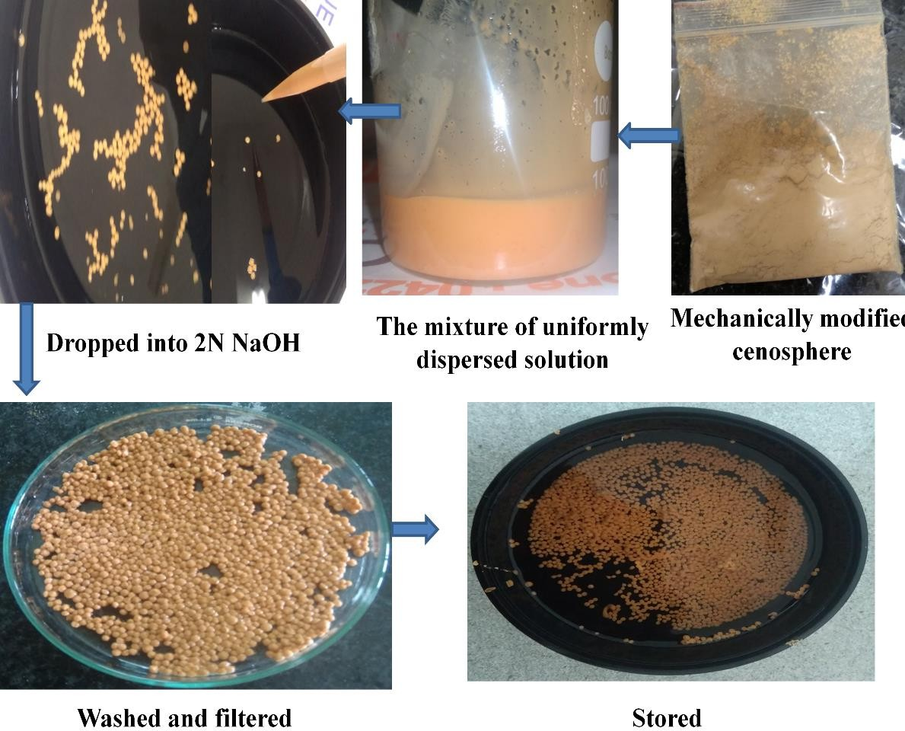

Figure 1 Method and procedure for TiO₂ coated cenosphere.
The modified cenosphere samples' surface charge density was calculated using the pH of the point of zero charge (pHpzc) shown in Figure 1. To do this, 50 milliliters of a 0.01 M NaCl solution were placed in a conical flask, and the solution's initial pH (pH_{i}) was changed from 2 to 12. 0.1 N NaOH or 0.1 N HCl were used to adjust the pH of the mixture. The conical flask was filled with around 150 mg of the improved cenosphere sample, and it were shaken vigorously for 24 hours at a constant speed of 200 rpm at 25°C.
The solution's final pH (pH_{f}) was measured, and the difference between it and the beginning pH (pH_{i}) was displayed. The pH of the changed samples' point of zero charge is indicated when the final pH is equal to the starting pH (pH_{i} = pH_{f}) (Leng et al. 2015).

Result & Discussion
The rise in surface roughness and a decrease in average size is revealed. Sharma (2012) verified that mechanical manipulation altered the FAC's size and enhanced its surface roughness. The surface microstructure of PMC and CCP was shown in Figures 2.
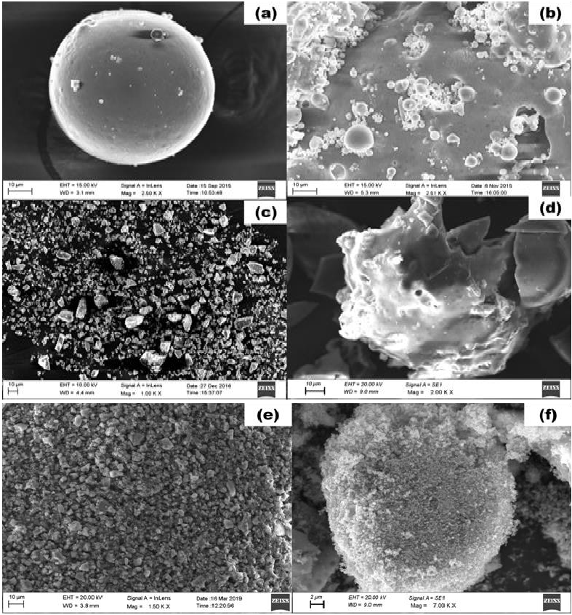
Figure 2 SEM micro image of (a) FAC (b) CMC (c) MMC (d) PMC (e) CCP (f) TiO₂
coated cenosphere
The efficiency of modification was demonstrated by the surface alterations of FAC with a growing amount of surface irregularity and coarseness. The increased size of the transformed cenosphere was found to be indicative of a consistent and continuous chitosan coating. The rough texture of CCP showed that effective crosslinking had formed a connection between the chitosan and the utilized FAC particles. The TiO2 coating on the cenosphere's surface was verified by the SEM micro image in Figure 2. It shown that TiO2 particles of varying thickness cover the cenosphere's surface. According to Gao et al. (2017) and Ketegenov et al. (2019), it may differ on the wavelength spectrum (9–45 nm). On the surface of FAC, the chitosan and TiO2 metal oxides were evenly and consistently covered. As a result, the cenosphere's surface developed functional components and became a composite with enhanced qualities.The information on the topography of the MMC particles was shown by the AFM experiments. The cluster of MMC particles may be seen in Figure 4.2's acquired 3D topographical picture. For the cluster of MMC particles inside the 5 µm × 5 µm surface area, the three most significant roughness parameters—square average roughness (Rq), arithmetic mean roughness (Ra), and mean depth (Rz)—were calculated to be 13.47 nm, 10.95 nm, and 89.74 nm, respectively. Furthermore, XEI software analysis revealed that the cluster of MMC particles' skewness (Rsk) and kurtosis (Rku) were 0.343 and 2.59, respectively. The existence of an uneven size distribution of surplus crystalline, fine material was indicated by the positive skewness score. The MMC particles had a platykurtic distribution, as indicated by the kurtosis (Rku) value < 3. According to Rajesh Kumar and Subba Rao (2012), the alteration of FAC as MMC was proven by the unpredictability in shape, the level of roughness of the surface, and the loss of its uniform size.
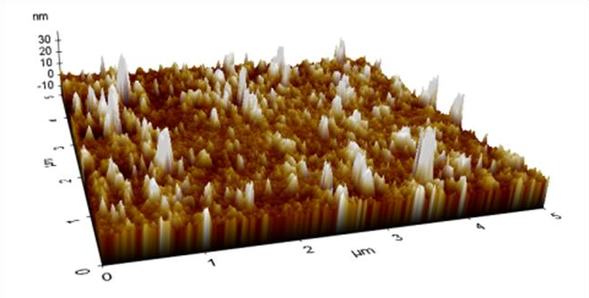

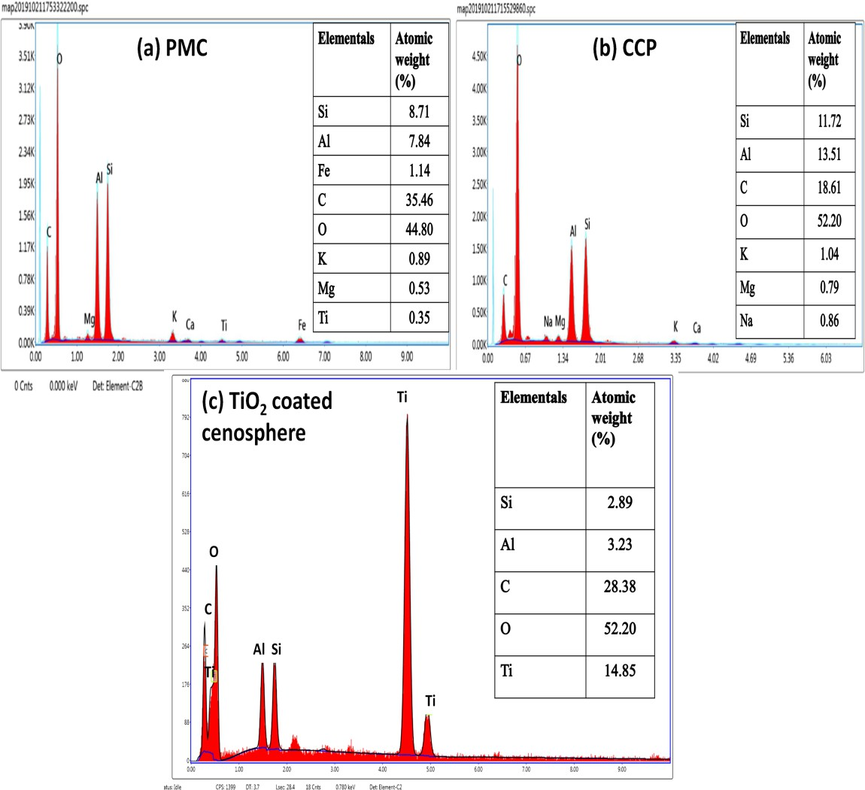
Figure 3. 3D topographical image of MMC

Figure 4. EDAX spectra for (a) FAC (b) MMC (c) CMC
Figures 3& 4 display the EDAX spectrum for cenosphere samples. The main components in FAC have atomic percentages of Si (13%), Al (10.78%), Fe (1.14%), and O (65.28%). It suggests that the oxides of important elements like Al, Si, and Fe make up the majority of the FAC particles, with smaller amounts of other elements like K, Mg, and Ti. The functional compound's alteration of FAC was validated by the percentage changes in its functional parts. Fe2+ and Fe3+ are two of the iron ion states found in FAC. When aluminosilicate glass is used to distribute iron ion particles, the superparamagnetic phase is present.
The mechanical modification enhanced the Fe ion content in MMC and decreased the size of FAC that destroys the aluminosilicate glass. The NaOH-modified cenosphere was illustrated by the detection of Na in shown in Figure 4 CMC. The success of the alteration was demonstrated by the rising proportion of components shown in Figure 4 of the changed cenosphere samples.
The improved cenosphere-chitosan cross-linking with NaOH was verified by the amount of Na in CCP (Figure 5). The efficiency of TiO2 modification and the dominance of a greater proportion of Ti and O on the cenosphere's surface were shown in Figure 5 (Lee et al. 2019). Therefore, the data obtained verified that the essential elements were successfully coated and altered on the cenosphere's surface.
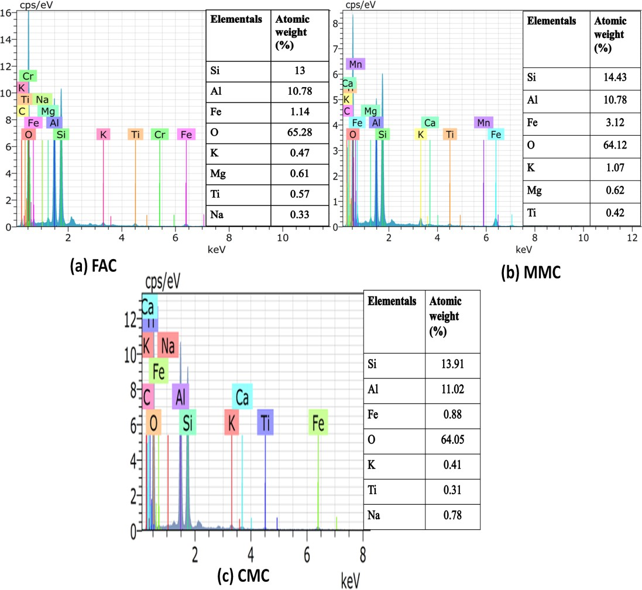

Figure 5 EDAX spectra for (a) PMC (b) CCP (c) TiO₂ coated cenosphere
Conclusion
- To determine the efficacy of modification, the performance of the altered cenosphere samples was examined. In the jar test, modified cenosphere samples like CMC, PMC, and CCP were used. Compared to CMC and PMC, CCP required a lower dose for effective elimination. CCP and PMC achieved rapid COD elimination at 40 minutes of contact time, whereas CMC achieved it at 50 minutes. When compared to CMC and PMC, the CCP had a higher density and floc production rate. For CCP, the entire sedimentation process was completed in 20 minutes, whereas it took twice as long for CMC and PMC.
- Because of its effective adsorptive ability, the maximum COD removal was achieved for CCP and PMC even at the higher agitation speed (150 rpm). Additionally, for the modified cenosphere samples, such as CMC, PMC, and CCP, the highest contamination clearance was attained at an optimized pH of 5, 5, and 6, respectively. The CMC, PMC, and CCP were found to have pHpzc values of 7.4, 6.67, and 7.3, respectively.
- According to the performance analysis, the CCP performed better at removing COD from the car wash water effluent than the two modified cenosphere samples, such as CMC and PMC. FTIR analysis was used to track the functional changes prior to as well as following the treatment.
- The CCP was shown to be an efficient modified environmental sample for electrocoagulation treatment of car wash water effluent. The CCP's general characteristics were observed.
Reference
- Blissett, RS & Rowson, NA 2012, ‘A review of the multi-component utilisation of coal fly ash’, Fuel, vol. 97, no. 7, pp. 1–23
- Deepthi, MV, Sharma, M, Sailaja, RRN, Anantha, P, Sampathkumaran, P & Seetharamu, S 2010, ‘Mechanical and thermal characteristics of high density polyethylene-fly ash Cenospheres composites’, Materials and Design, vol. 31, no. 4, pp. 2051–2060.
- Gao, X, Dai, Y, Zhang, Y, Zhai, X & Fu, F 2016, ‘Effective dye removal from waste water using a novel low-cost NaOH-modified fly ash’, Clays and Clay Minerals, vol. 64, no. 6, pp. 695–705.
- Grace, MA, Clifford, E & Healy, MG 2016, ‘The potential for the use of waste products from a variety of sectors in water treatment processes’, Journal of Cleaner Production, vol. 137, no. 28, pp. 788–802.
- Haque, ME 2013, ‘Indian Fly-Ash: Production and Consumption Scenario’, International Journal of Waste Resources, vol. 3, no. 1, pp. 22–25.
- Hirajima, T, Petrus, HTBM, Oosako, Y, Nonaka, M, Sasaki, K & Ando, T 2010, ‘Recovery of cenospheres from coal fly ash using a dry separation process: Separation estimation and potential application’, International Journal of Mineral Processing, vol. 95, no. 1–4, pp. 18–24.
- Ho, YS, Chiang, CC & Hsu, YC 2001, ‘Sorption kinetics for dye removal from aqueous solution using activated clay’, Separation Science and Technology, vol. 36, no. 11, pp. 2473–2488.
- Ketegenov, T, Tyumentseva, O, Khan, N, Karagulanova, A & Myrzabekova, M 2019, ‘New composite fillers on the base of fly-ash cenospheres modified with titanium dioxide’, Materials Today: Proceedings, vol. 12, no. 1, pp. 128–131.
- Lee, H, Deshmukh, PR, Kim, JH, Hyun, HS, Sohn, Y & Shin, WG 2019, ‘Spray drying formation of metal oxide (TiO₂ or SnO₂) nanoparticle coated boron particles in the form of microspheres and their physicochemical properties’, Journal of Alloys and Compounds, vol. 810, no. 40, pp. 151923.
- Leng, L, Yuan, X, Zeng, G, Shao, J, Chen, X, Wu, Z, Wang, H & Peng, X 2015, ‘Surface characterization of rice husk bio-char produced by liquefaction and application for cationic dye (Malachite green) adsorption’, Fuel, vol. 155, no. 17, pp.77–85.
- Li, JC, Zheng, LF, Sha, XH & Chen, P 2020, ‘Microstructural and mechanical characteristics of graphene oxide‐fly ash cenosphere hybrid reinforced epoxy resin composites’, Journal of Applied Polymer Science, vol. 137, no. 2, pp. 47173.
- Lu, D, Cheng, W, Zhang, T, Lu, X, Liu, Q, Jiang, J, & Ma, J 2016, ‘Hydrophilic Fe₂O₃ dynamic membrane mitigating fouling of support ceramic membrane in ultrafiltration of oil/water emulsion’, Separation and Purification Technology, vol. 165, no. 9, pp. 1–9.
- Novais, RM, Buruberri, LH, Seabra, MP & Labrincha, JA 2016, ‘Novel porous fly-ash containing geopolymer monoliths for lead adsorption from wastewaters’, Journal of Hazardous Materials, vol. 318, no. 18, pp. 631–640.
- Sarkar, A, Rano, R, Udaybhanu, G & Basu, AK 2006, ‘A comprehensive characterisation of fly ash from a thermal power plant in Eastern India’, Fuel Processing Technology, vol. 87, no. 3, pp. 258–277.
- Sharma, A, Srivastava, K, Devra, V, & Rani, A 2012, ‘Modification in Properties of Fly Ash through Mechanical and Chemical Activation’, American Chemical Science Journal, vol. 2, no. 4, pp. 177–187.
- Sutcu, M, Erdogmus, E, Gencel, O, Gholampour, A, Atan, E & Ozbakkaloglu, T 2019, ‘Recycling of bottom ash and fly ash wastes in eco-friendly clay brick production’, Journal of Cleaner Production, vol. 233, no. 28, pp. 753–764.
- Tang, L, Tan, XJ, Cui, FY, Zhou, Q & Yin, J 2007, ‘Reuse of carwash wastewater with hollow fiber membrane aided by enhanced coagulation and activated carbon treatments’, Water Science and Technology, vol. 56, no. 12, pp. 111–118.
- Wang, D, Zhang, Y, Dong, A, Tang, Y, Wang, Y, Xia, J & Ren, N 2003, ‘Conversion of fly ash cenosphere to hollow microspheres with zeolite/mullite composite shells’, Advanced Functional Materials, vol. 13, no. 7, pp. 563–567.

