Improving Domestic Environmental Health among Migrant Service Families: Lessons from a Community Service Program in Kuala Lumpur

Eko Nursanty^{1*}, Zulkiflee Abd Latif², Firda Herlina³, Julianti Marbun⁴, Naimatul Aufa⁵, J.C. Heldiansyah⁵, Rais D. Hi Yusuf⁶, Soraya Rosna Samta⁷, Hilma Erliana⁸, Ade Dwinta⁸

¹Department of Architecture, University of 17 Agustus 1945 (UNTAG) Semarang, Indonesia
²University Teknologi MARA, Shah Alam, Selangor, Malaysia
³Department of Machine Engineering, University of Islam Kalimantan MAB, Indonesia
⁴Departemen of infrastructure and environmental engginering, Panca Bhakti University, Indonesia
⁵Department of Architecture, Lambung Mangkurat University, Indonesia
⁶Departemen of Civil Engineering, Muhammadiyah University of North Maluku, Indonesia
⁷Early Childhood Education, IVET University Semarang, Indonesia
⁸Aceh Barat State Community Academy, Indonesia

Corresponding author: santy@untagsmg.ac.id

ABSTRACT : This community service paper presents the implementation and reflection of a field-based engagement program aimed at improving domestic environmental health among migrant service-worker families in Kuala Lumpur. The target group consisted of long-term migrant families working in the service sector, including domestic work, construction, and other informal urban services, who have lived with their families in the city for many years. Despite their important contribution to urban life, many of these families experience limited housing quality, overcrowding, inadequate ventilation, insufficient lighting, sanitation challenges, and constrained domestic space that affects family well-being. The program was designed and delivered by a multidisciplinary team with expertise in architecture and building engineering. It focused on increasing participants’ awareness of the relationship between housing conditions, everyday health, and family resilience. The activities included field observation, participatory discussion, environmental health education, and practical guidance on low-cost improvements that could be applied in rented or modest living environments. Key topics addressed in the program included airflow and ventilation, natural lighting, hygiene, moisture control, household safety, waste management, and the more effective organization of domestic space. The program showed that community-based interventions grounded in spatial understanding can help migrant families better recognize environmental risks and identify realistic ways to improve their living conditions. The paper argues that community service in architecture and building engineering can contribute meaningfully to healthier domestic environments, especially for vulnerable migrant families in dense urban settings. It also highlights the value of practical, context-sensitive knowledge as a form of empowerment for long-term migrant communities.

Keywords - domestic environmental health, migrant service families, community service, healthy housing, spatial empowerment

INTRODUCTION

Migration reshapes not only labour participation and urban economies, but also the everyday domestic environments in which families live, recover, and reproduce daily life. For long-term migrant service-worker families, the home is more than a place of shelter. It functions as a space for rest, caregiving, hygiene, storage, social interaction, and recovery from physically demanding or unstable work. In dense urban settings, however, these domestic functions are often carried out within constrained and modest housing conditions. Recent scholarship has reaffirmed that housing is a major social determinant of health. Healthy housing is not defined merely by the presence of a roof, but by suitability, security, dryness, ventilation, and freedom from environmental hazards that can undermine physical and mental well-being (Bentley, 2025).

These concerns become more urgent in migrant contexts, where housing disadvantages frequently intersect with economic precarity, insecure tenure, discrimination, and limited access to adequate urban infrastructure. A recent mixed-methods systematic review of migrant and refugee populations found consistent associations between housing inequalities and poor health outcomes, with overcrowding and inadequate ventilation repeatedly linked to respiratory illness, anxiety, and depression. The same review also showed that inadequate rental housing, insecure tenure, and poor neighbourhood conditions contribute to a broad range of physical and mental health problems among migrant households (Rana et al., 2025).

The present paper focuses on migrant service-worker families in Kuala Lumpur, including those engaged in domestic work, construction, and other informal urban services. Although these families contribute significantly to the functioning of the city, their living conditions are often shaped by limited space, inadequate airflow, insufficient natural lighting, sanitation challenges, and the cumulative pressures of long-term urban survival. Existing housing research supports the importance of examining these domestic conditions closely. Work on migrant housing stress has shown that housing disadvantage is strongly associated with perceived stress and poorer mental health among migrant populations, especially where residents are concentrated in informal or otherwise disadvantaged living environments (Li & Liu, 2018).

From the perspective of the built environment, these domestic challenges are not minor background issues. Indoor environmental quality research has consistently demonstrated that air quality, thermal conditions, and visual comfort are closely related to occupant well-being and comfort. Building conditions such as poor ventilation, dampness, weak lighting, and inadequate environmental management can therefore affect health not only directly, but also through discomfort, fatigue, disrupted rest, and reduced quality of everyday family life. Review evidence on home lighting further suggests that residential lighting conditions are linked to visual performance, safety, sleep, and broader health outcomes, reinforcing the importance of domestic environmental quality as a public health concern (Osibona et al., 2021).

The housing situation of migrant workers also needs to be understood as an issue of equity. Recent research on migrant farmworker housing in Canada has shown that overcrowding, environmental hazards, and structural deficiencies in worker housing can harm both physical and mental health, while also reflecting broader inequalities in power and access. Although the occupational and national context differs from that of Kuala Lumpur, the underlying lesson remains relevant: migrant households often experience environmental disadvantage not because housing quality is unimportant, but because structural vulnerability limits their ability to secure healthier living conditions (Rana et al., 2025).

Within this context, community service in architecture and building engineering can make a practical contribution by translating environmental knowledge into realistic household-level action. For vulnerable migrant families, health promotion is more effective when it is connected to the actual domestic setting in which daily life takes place. A field-based and participatory approach can therefore help families recognize how ventilation, lighting, hygiene, moisture control, household safety, waste management, and spatial organization shape well-being in everyday life. This paper presents a community service program conducted with migrant service-worker families in Kuala Lumpur and argues that context-sensitive spatial guidance can strengthen domestic environmental health and family resilience in dense urban migrant settings (Al horr et al., 2016).

METHODOLOGY

This community service program adopted a field-based, participatory, and problem-oriented approach to improve domestic environmental health among migrant service-worker families in Kuala Lumpur.

Research Design and Methodological Positioning
This study was positioned as an applied community-based intervention research with a participatory action orientation. The design was selected because the program combined problem identification, field observation, environmental health education, participatory discussion, and practical guidance for low-cost household improvement. Rather than treating community members as passive recipients, the program involved them as active participants in identifying domestic environmental problems, reflecting on everyday housing practices, and considering feasible adjustments within rented or modest living environments.
This methodological position is relevant because domestic environmental health among migrant service-worker families cannot be understood only through physical housing assessment. It is also shaped by household routines, economic constraints, spatial practices, and residents’ ability to recognize environmental risks. By combining built-environment observation with participatory reflection, the study linked housing conditions, environmental health literacy, and practical behavioral adjustment. This strengthened the paper’s analytical basis and clarified that the program was not merely descriptive community service, but a structured community-based intervention aimed at improving domestic environmental awareness and family well-being.

The methodological design was structured as an applied community engagement model rather than an experimental study. It combined on-site observation, participatory discussion, environmental health education, and practical technical guidance for low-cost household improvement. This approach was selected because housing quality and indoor environmental conditions are strongly associated with health and well-being, while migrant populations often face layered housing disadvantages that require context-sensitive and feasible interventions rather than idealized design solutions (Li & Liu, 2018).

To provide clearer geographical context for the implementation of the community service program, the study site is shown at both regional and local scales. The activity was conducted in Lorong Sungai Mulia 5, Sungai Mulia, Kuala Lumpur, Malaysia, an urban residential area occupied by long-term migrant service-worker families living in modest and spatially constrained domestic environments. Presenting the location at two spatial levels is important for situating the observed domestic conditions within the wider urban setting of Kuala Lumpur as well as within the immediate neighborhood context of the intervention site.

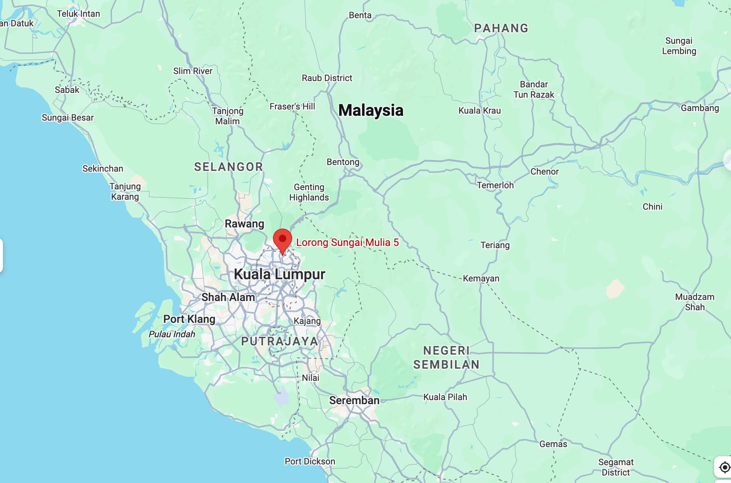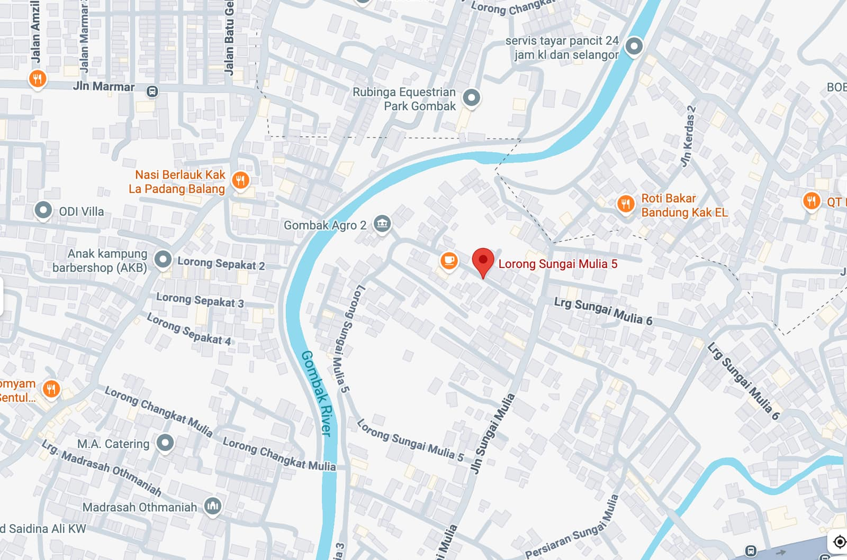

Figure 1. Location of the community service site at Lorong Sungai Mulia 5, Sungai Mulia, Kuala Lumpur, Malaysia

As shown in Figure 1, the intervention site is located within a dense urban area of Kuala Lumpur, where domestic life is shaped by limited residential space, close building proximity, and everyday environmental pressures typical of long-term migrant settlement areas. This locational context is methodologically relevant because domestic environmental health cannot be separated from the broader spatial conditions in which housing is situated. The mapping therefore supports the field-based approach of this study by clarifying where the observed living conditions, participatory discussions, and practical guidance activities took place.

Based on this methodological positioning, the study setting and target group were selected to reflect the lived domestic conditions of migrant service-worker families in a dense urban environment.

Study setting and target group
The activity was conducted in Kuala Lumpur, Malaysia, and focused on long-term migrant service-worker families living in modest or rented urban housing. The target group included families engaged in domestic work, construction, and other informal or service-based urban occupations, as reflected in the draft paper. The methodological relevance of this target group lies in the close relationship between migrant housing conditions, cumulative housing stress, and family well-being. Previous research has shown that migrant populations living in disadvantaged or informal housing experience higher perceived stress and poorer mental health, while broader reviews have linked overcrowding, inadequate ventilation, and other housing inequalities to adverse physical and psychosocial outcomes (Rana et al., 2025).

Participants, Sampling, and Scope of Generalization
The program involved 30 participants from migrant service-worker families living in Kuala Lumpur. Participants were selected through purposive sampling in collaboration with community partners and local migrant networks, particularly Cabang Istimewa Muslimat NU Malaysia. This strategy was used because the program specifically targeted families whose daily living environments were directly related to the issue of domestic environmental health.

Participants were selected based on several criteria: they were part of long-term migrant families, lived in modest or rented urban housing, were engaged in or closely connected to service-based, informal, domestic, construction, or other urban occupations, and were willing to participate in the pre-test, discussion, education, and practical guidance activities. The sample size was appropriate for a small-scale community-based intervention that required direct interaction and contextual observation.

The study does not claim statistical representativeness of all migrant families in Kuala Lumpur or Malaysia. Rather, the findings provide contextual and analytical insights into the relationship between housing conditions, environmental health literacy, and feasible household-level improvement in a specific migrant community setting. Broader generalization would require larger samples, comparative study sites, and post-intervention evaluation.

Service approach
The program used a participatory health-oriented service approach. Community members were engaged not only as recipients of information but also as active participants in identifying domestic environmental problems, discussing everyday routines, and considering realistic ways to improve their living conditions. This approach is consistent with participatory health research involving migrant communities, which emphasizes the value of involving migrants in defining problems, shaping interventions, and producing knowledge that is grounded in lived experience. For this paper, participation was especially important because domestic environmental health is closely tied to daily practices, constraints of rental housing, and culturally embedded household routines.

Stages of implementation
The program was implemented in four main stages.

1. Preliminary identification of domestic environmental issues
The first stage involved preliminary identification of the participants’ domestic environmental conditions and everyday housing-related challenges. This stage focused on recognizing recurrent issues such as spatial limitation, poor airflow, insufficient natural lighting, sanitation constraints, dampness, cluttered storage, and basic household safety concerns. The purpose of this stage was to establish an initial understanding of how domestic space affected family health and resilience in the migrant context. This is methodologically important because housing disadvantage is increasingly understood as a multidimensional health determinant rather than a single physical defect (Bentley, 2025).

2. Field observation
The second stage consisted of direct field observation of selected living environments. Observation focused on practical indicators of domestic environmental health, including:
- airflow and natural ventilation,
- daylight access and lighting conditions,
- cleanliness and hygiene,
- moisture and dampness,
- waste management,
- household safety,
- circulation within limited spaces, and
- general organization of domestic space.
These indicators were chosen because indoor environmental quality research consistently identifies air quality, thermal conditions, and visual comfort as central dimensions of occupant well-being. They also align with evidence that housing conditions such as crowding, poor ventilation, and environmental hazards shape health outcomes among vulnerable populations (Al horr et al., 2016).

To illustrate the field-based and participatory character of the program, selected documentation of the community engagement process is presented below. These activities formed an important part of the observational and interactive stages of the intervention, where the research team met directly with migrant service-worker families, identified domestic environmental concerns, and initiated dialogue on everyday housing conditions and health-related challenges.

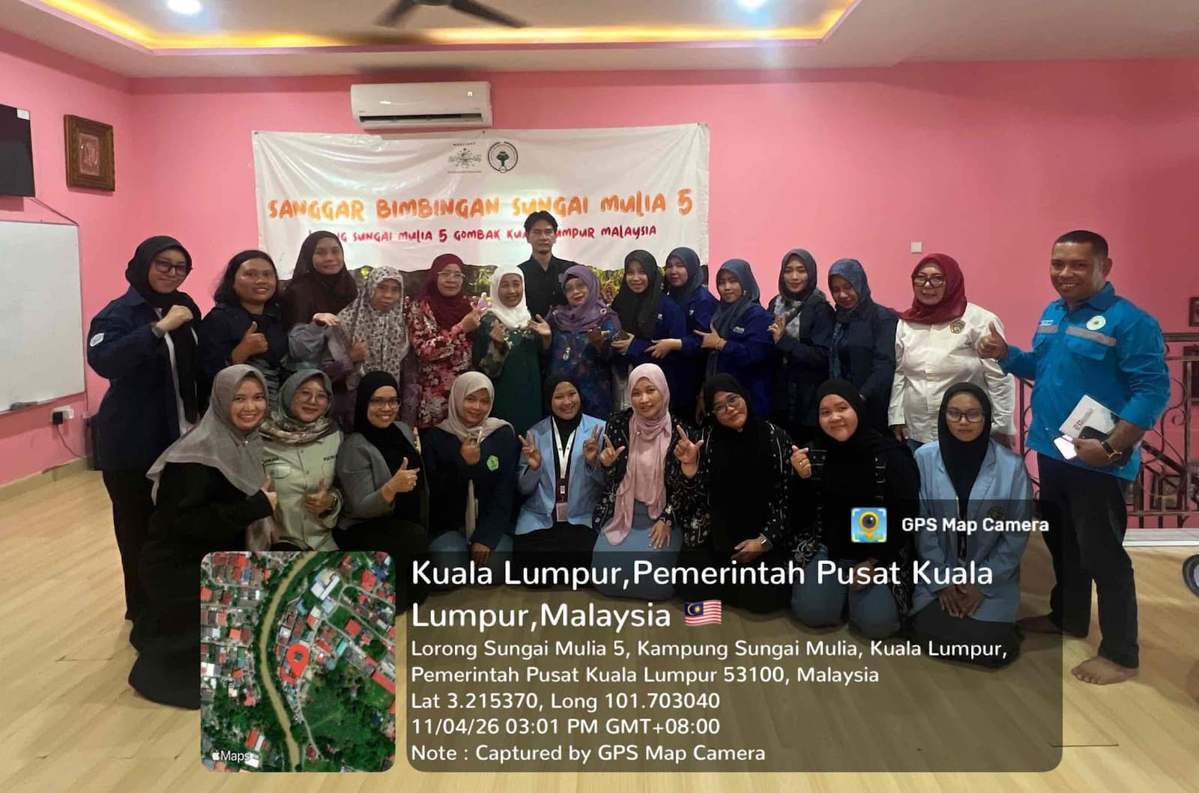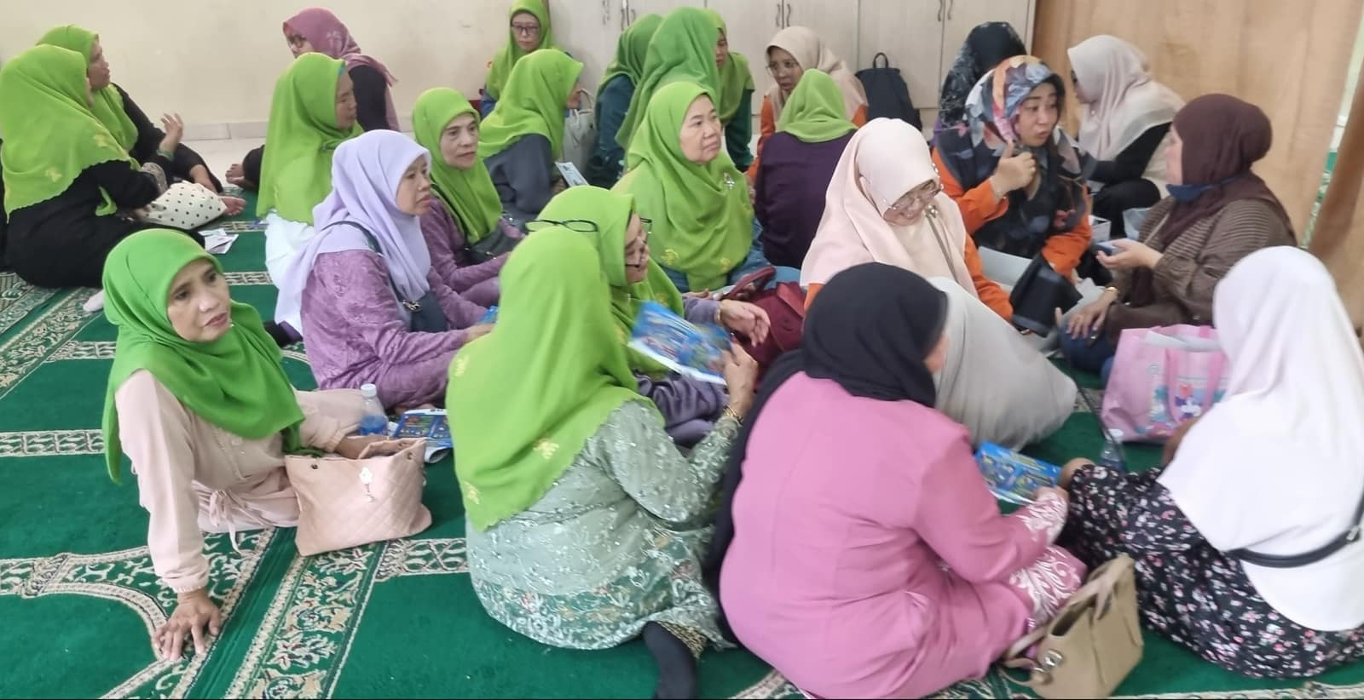
Figure 2. Field engagement and participatory interaction with migrant service-worker families in Kuala Lumpur

Figure 2 documents the direct field engagement activities conducted with migrant service-worker families in Kuala Lumpur. The photographs show the community gathering and participatory interaction that supported the identification of domestic environmental issues, the exchange of lived experiences, and the delivery of initial educational input related to healthy housing and family well-being. The figure illustrates the community-based and field-oriented nature of the program methodology.

3. Participatory discussion and educational sessions
The third stage involved participatory discussion sessions and environmental health education. These sessions were designed to help families reflect on their daily living practices and connect them more clearly with housing conditions. The discussions addressed the relationship between domestic space and family well-being, while the educational component introduced practical principles related to ventilation, natural lighting, hygiene, moisture control, waste handling, and safer use of limited domestic areas. This stage was important because participatory work with migrant communities is most effective when technical knowledge is translated into forms that are understandable, relevant, and directly linked to lived realities (Roura et al., 2021).

4. Technical guidance on low-cost improvements
The fourth stage involved the delivery of practical guidance tailored to the constraints of rented or modest housing. Recommendations were designed to be low-cost, realistic, and incremental. They included improving air movement where possible, optimizing the use of daylight, reducing dampness, organizing storage more effectively, improving waste placement, and making household circulation safer and more manageable. This stage reflects the logic of the program: meaningful improvement in domestic environmental health does not always require structural renovation, but can begin through feasible spatial and environmental adjustments. That orientation is supported by housing-health scholarship, which shows that housing interventions can contribute to health improvement when they address everyday environmental risks in actionable ways (Hernández, 2019).

Documentation and data sources
Although this paper is presented as a community service paper rather than a full empirical research article, the activity was documented through several forms of field-based evidence, including observation notes, records from participatory discussions, visual documentation, facilitator reflections, and participant responses. These materials were used to identify recurrent patterns in domestic environmental conditions and to document how participants interpreted and responded to the guidance provided. This type of documentation is appropriate in participatory and community-based work, where contextual interpretation and practical relevance are often more important than statistical generalization.

Analytical approach
The analytical approach used in this paper was descriptive and interpretive. Observed conditions and discussion outcomes were grouped into thematic categories, including ventilation, lighting, sanitation, moisture control, household safety, waste management, and spatial organization. These categories were then interpreted in relation to family well-being and domestic environmental health. The aim was not to test a formal hypothesis, but to explain how the intervention responded to housing-related challenges and how participants engaged with the proposed improvements. This approach is consistent with participatory and community-based methodologies that prioritize grounded understanding, collaborative reflection, and actionable outcomes.

Ethical and practical considerations
The activity was carried out with attention to participant comfort, voluntary engagement, and contextual sensitivity. Because the target group consisted of migrant families living under varying degrees of housing limitation and economic vulnerability, the team emphasized respectful communication and practical support rather than intrusive assessment. This was important both ethically and methodologically. Studies on migrant housing have shown that structural vulnerability and unequal access to adequate housing shape health outcomes, which means that interventions must be responsive to lived constraints rather than framed around ideal standards alone.

RESULTS

The community service activity revealed that the domestic environments of migrant service-worker families in Kuala Lumpur are shaped by a combination of limited housing quality, constrained interior space, and everyday environmental health risks. These findings were supported not only by field observation and participatory discussion but also by the results of a pre-test questionnaire administered to 30 participants prior to the intervention .

As explained in the methodology section, the 30 participants were selected purposively to reflect the target group of migrant service-worker families living in modest or rented urban housing; therefore, the pre-test results should be interpreted as a contextual baseline rather than as statistically representative data.

Baseline environmental health literacy (pre-test results)
The pre-test results provide an important baseline for understanding participants’ initial level of environmental health awareness. Overall, the findings indicate that knowledge of healthy housing principles was uneven, with several critical gaps in understanding.
While 56.7% of participants correctly recognized that a healthy home should support physical, mental, and social well-being, a substantial proportion (43.3%) still associated housing quality primarily with physical attributes such as size or appearance. This suggests that the concept of healthy housing had not yet been fully internalized as a multidimensional health determinant.

More critically, only 36.7% of respondents correctly identified overcrowding as a factor that increases the risk of respiratory disease transmission, while 63.3% selected incorrect answers. This is a significant finding, given that overcrowded living conditions were frequently observed in the field and are strongly associated with health risks in the literature.

Similarly, knowledge related to indoor environmental quality was limited. Only 50% of participants understood the function of ventilation as a mechanism for removing polluted air and moisture. Even more concerning, only 30% correctly identified damp and moldy walls as causes of respiratory conditions such as asthma and allergies, while the majority (70%) associated them with unrelated health issues.

The weakest area of understanding was related to kitchen environments and respiratory health. Only 23.3% of participants recognized the importance of proper smoke exhaust systems, while 76.7% incorrectly prioritized the use of expensive cooking equipment. This indicates a critical gap in practical environmental health knowledge, particularly in domestic spaces where exposure risks are high.

Knowledge of environmental stressors beyond physical conditions was also limited. Only 33.3% of respondents correctly identified noise as a factor contributing to sleep disturbance and mental stress, suggesting that non-visible environmental risks remain poorly understood.

In contrast, awareness of immediate household safety risks was relatively stronger. A majority of participants (63.3%) correctly identified appropriate responses to hazards such as exposed electrical wiring or slippery surfaces. Similarly, 56.7% recognized that maintaining environmental cleanliness is a shared responsibility among residents.

However, knowledge related to broader environmental quality remained weak. Only 43.3% correctly identified the role of green open spaces in maintaining clean air, indicating limited awareness of the relationship between housing environments and the wider ecological context.

Taken together, the pre-test results demonstrate that while participants possessed some basic awareness of household safety, their understanding of environmental health particularly indoor air quality, moisture control, overcrowding, and environmental stressors was fragmented and incomplete.

To provide a structured overview of participants’ baseline environmental health knowledge, the pre-test results are summarized in Table 1. The table highlights the distribution of correct and incorrect responses across key indicators related to healthy housing, indoor environmental quality, and household safety.

The pre-test results provide a baseline picture of participants’ environmental health literacy before the intervention. Overall, the data show uneven understanding across key aspects of healthy housing. Participants were relatively more familiar with visible and immediate household risks, but showed weaker understanding of less visible environmental hazards such as poor ventilation, dampness, overcrowding, and kitchen-related air quality. To present these baseline patterns more clearly, the results are summarized in Table 1.

Table 1. Baseline Environmental Health Literacy among Participants
No. | Indicator | Correct (%) | Incorrect (%) | Evaluation
1 | Understanding of healthy housing | 56.7 | 43.3 | Moderate
2 | Awareness of overcrowding risks | 36.7 | 63.3 | Low
3 | Knowledge of indoor thermal comfort | 56.7 | 43.3 | Moderate
4 | Function of ventilation | 50.0 | 50.0 | Moderate but uneven
5 | Health impact of dampness and mold | 30.0 | 70.0 | Very low
6 | Importance of smoke exhaust in the kitchen | 23.3 | 76.7 | Critically low
7 | Impact of environmental noise on health | 33.3 | 66.7 | Low
8 | Responsibility for environmental cleanliness | 56.7 | 43.3 | Moderate
9 | Household safety response | 63.3 | 36.7 | Relatively strong
10 | Role of green space in air quality | 43.3 | 56.7 | Limited

As shown in Table 1, the participants entered the program with moderate awareness of general housing concepts and immediate household safety, but with substantial gaps in core environmental health knowledge. The weakest areas were dampness and mold, kitchen smoke exhaust, environmental noise, and overcrowding risk. These findings are important because they reveal that many of the environmental pressures faced by migrant service-worker families were not fully recognized as health-related problems at the outset of the program. This baseline condition helps explain why the intervention was necessary and why practical, spatially grounded education had strong relevance for the community.

The questionnaire findings became more meaningful when read alongside the field observations. Rather than standing as isolated indicators of knowledge, the pre-test results corresponded closely with the actual domestic conditions documented on site. In other words, the areas in which participants demonstrated limited awareness were often the same areas where environmental risks were visibly present in everyday living environments. This convergence between literacy gaps and observed housing conditions forms the basis of the next section.

Domestic environmental problems identified in the field
Field observation and participatory discussion confirmed that the knowledge gaps identified in the questionnaire were closely aligned with actual living conditions. Recurring environmental concerns included poor air circulation, low daylight penetration, damp service areas, overcrowded room arrangements, and weak spatial organization of domestic functions.

Participants often described these conditions as normal aspects of daily life rather than as health risks. This normalization of environmental disadvantage is significant, as it indicates that risk is embedded within everyday domestic routines.

The relevance of overcrowding observed in the field is reinforced by the pre-test findings, where the majority of participants failed to recognize its health implications. This convergence between observed conditions and limited awareness highlights the need for targeted intervention.

Ventilation, moisture, and indoor environmental quality
Ventilation and moisture control emerged as central issues both empirically and cognitively. Field observations showed limited airflow and persistent humidity in many dwellings, while questionnaire results revealed that only half of the participants understood the basic function of ventilation, and only 30% correctly associated dampness with respiratory health risks.

This dual finding is particularly important. It indicates not only the presence of environmental problems but also the absence of conceptual frameworks needed to interpret them as health risks. As a result, environmental discomfort and potential illness are often accepted as unavoidable rather than preventable.

To further illustrate the domestic environmental context of the participants, the following figure presents selected views of the external housing conditions and the immediate neighborhood setting at the intervention site. These visual observations are important because domestic environmental health is shaped not only by indoor conditions, but also by the physical form of the surrounding settlement, including building proximity, access corridors, and the overall spatial character of the residential environment.

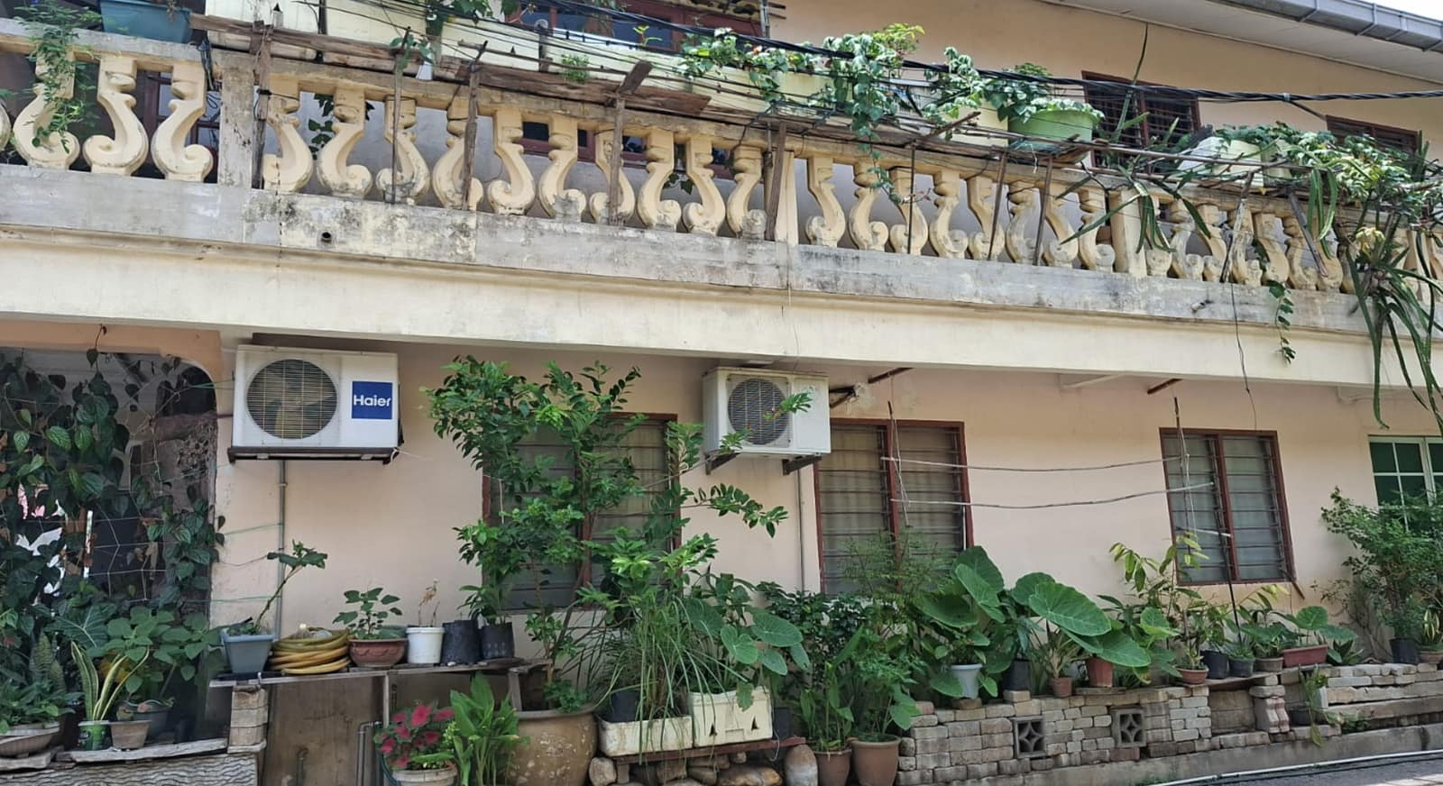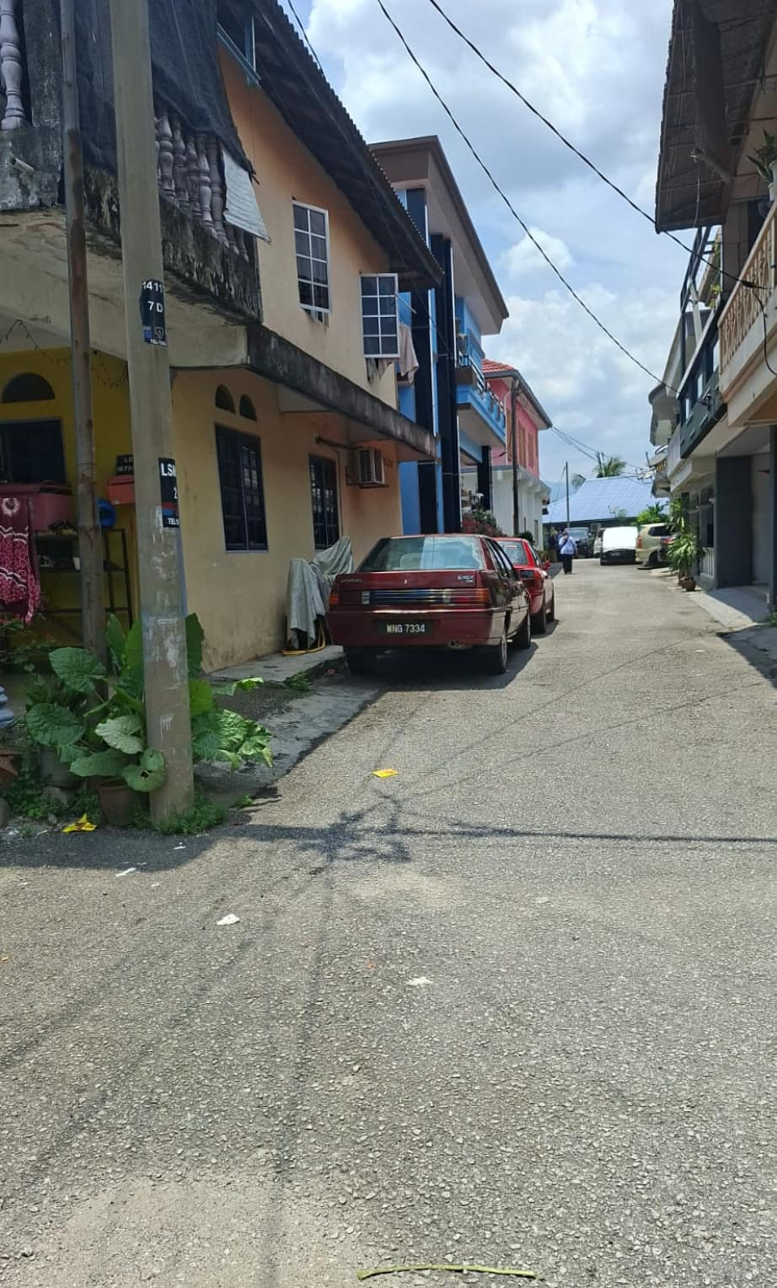
Figure 3. External housing conditions and neighborhood setting of the migrant service-family settlement in Kuala Lumpur

As shown in Figure 3, the domestic environments of participants were situated within a compact and closely built residential setting, where limited spatial separation between buildings could affect ventilation, daylight penetration, and movement within the neighborhood. This broader physical context helps explain why indoor environmental problems such as humidity, constrained airflow, and restricted service-space quality were repeatedly observed during the fieldwork. The figure therefore supports the interpretation that domestic environmental health is shaped by both interior household conditions and the wider morphology of the surrounding settlement.

Sanitation, service areas, and domestic risk
Sanitation and service areas were frequently identified as constrained and functionally limited. Wet areas, kitchens, and circulation zones often lacked adequate ventilation and spatial separation, increasing potential health risks.

The questionnaire results reinforce this observation. The very low level of correct responses regarding kitchen ventilation (23.3%) suggests that participants are exposed to respiratory risks without fully recognizing them. This highlights the importance of focusing not only on infrastructure but also on knowledge and daily practice.

Recognition of housing-health relationships
A major outcome of the program was the shift in how participants interpreted their living environments. Before the intervention, many domestic conditions were treated as ordinary parts of daily life rather than as environmental health risks. Through participatory discussion and practical explanation, participants began to connect ventilation, dampness, crowding, sanitation, and spatial organization with children’s health, family comfort, quality of rest, and emotional well-being. This indicates that the program did more than deliver information. It helped participants reframe the home as an active health environment and strengthened their ability to recognize risk in everyday domestic settings.

Low-cost improvement strategies and participant response
Another important outcome was the strong acceptance of practical, low-cost improvement strategies. Participants responded positively to recommendations such as improving airflow, reducing clutter, reorganizing storage, maintaining drier surfaces, and making better use of available daylight. This response suggests that the main barrier was not unwillingness to act, but limited access to applicable environmental knowledge. Once the issues were explained in clear and relevant ways, participants were able to identify feasible changes within the constraints of rented or modest housing. This demonstrates the concrete value of the program in translating architectural and environmental knowledge into realistic household action.

Domestic environmental health and family resilience
The findings also highlight the relationship between domestic environmental conditions and family resilience. Participants emphasized the role of the home as a space for rest, caregiving, and recovery from demanding work conditions.

Where environmental conditions were poor, the cumulative burden on family life increased. Conversely, the introduction of simple improvement strategies enabled participants to envision more manageable and healthier living environments.

Synthesis of results
Overall, the integration of pre-test data, field observation, and participatory engagement yields five main findings. First, migrant service-worker families experience recurring domestic environmental problems, particularly overcrowding, weak ventilation, insufficient lighting, sanitation constraints, and limited spatial organization. Second, baseline environmental health literacy was uneven, with the most serious gaps found in relation to dampness, kitchen smoke exposure, environmental noise, and overcrowding risks. Third, the questionnaire and field evidence showed a clear convergence between limited awareness and actual housing-related risk. Fourth, participatory and spatially grounded education improved participants’ ability to interpret domestic environments as health-related spaces. Fifth, the positive response to low-cost improvement strategies indicates that the program had practical relevance and immediate empowering value for the community. Taken together, these findings suggest that the intervention was not merely informative, but meaningfully supportive in helping migrant families recognize, reassess, and begin to improve their living environments.

To clarify the overall pattern of findings, the main results of the community service activity are synthesized visually in the following diagram. The figure integrates questionnaire responses, field observations, and participant engagement outcomes into five key findings that explain the domestic environmental challenges faced by migrant service-worker families and the practical significance of the intervention. Presenting these findings in diagrammatic form helps show the relationship between observed housing conditions, environmental health literacy, and the value of low-cost, context-sensitive guidance.

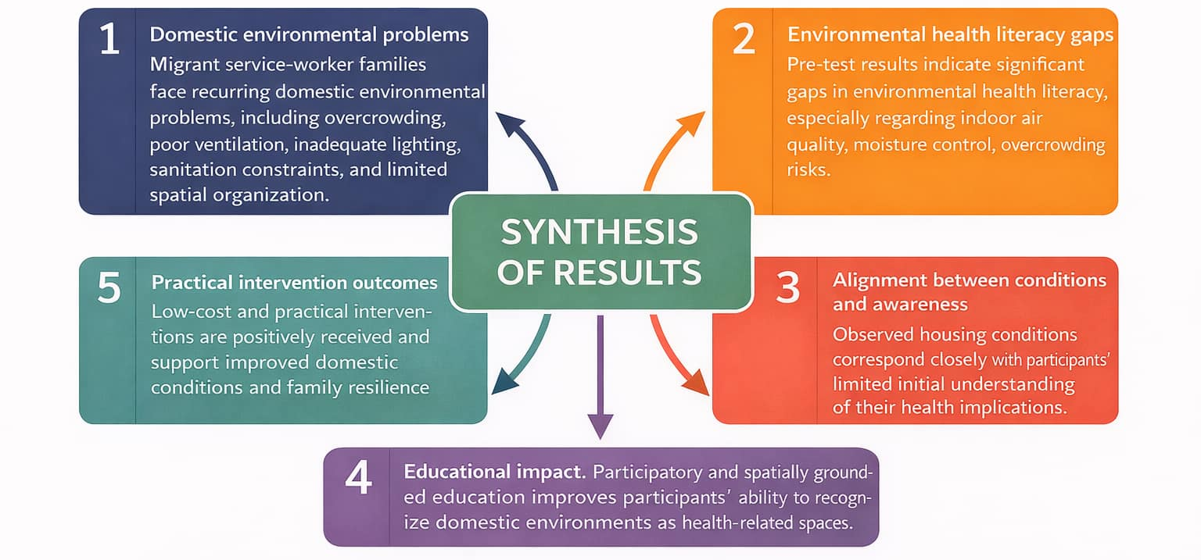
Figure 4. Synthesis of key results from the community service program on domestic environmental health

As shown in Figure 4, the results are interconnected rather than isolated. Recurrent domestic environmental problems were closely linked to limited environmental health understanding at the beginning of the program, while the educational and participatory components helped participants reinterpret their living environments as spaces that directly affect family well-being. The figure also demonstrates that low-cost and realistic interventions were not only well received, but also understood as feasible ways to improve domestic conditions. This synthesis reinforces the argument that architecture- and building engineering-based community service can make a meaningful contribution to healthier domestic environments in vulnerable migrant communities.

These findings suggest that the significance of the program lies not only in identifying domestic environmental problems, but also in demonstrating how knowledge gaps, everyday housing conditions, and practical intervention are closely interconnected. The following discussion interprets these relationships more broadly in relation to family resilience, migrant vulnerability, and the role of spatially grounded community service.

DISCUSSION

Taken together, the discussion shows that domestic environmental health is central to how migrant families endure, recover, and maintain everyday well-being in constrained urban settings. These broader implications are summarized in the following conclusion.

The findings of this community service program confirm that domestic environmental health is not a secondary household issue, but a core component of family resilience among migrant service-worker families in Kuala Lumpur. In the present study, recurrent problems such as overcrowding, inadequate ventilation, limited lighting, sanitation constraints, and weak spatial organization were closely connected to participants’ everyday experiences of rest, caregiving, hygiene, and household manageability. This pattern is consistent with the broader housing-health literature, which argues that housing functions as a major social determinant of health and that healthy housing must be affordable, suitable, secure, dry, warm, and properly ventilated. Conversely, unhealthy domestic environments can negatively affect respiratory health, mental well-being, infectious disease transmission, and injury risk (Rana et al., 2025).

A key point emerging from this study is that environmental disadvantage had become normalized within daily family life. Participants frequently described poor airflow, dampness, constrained wet areas, and crowded living arrangements as ordinary rather than problematic. This normalization is significant because it helps explain why serious environmental risks may remain unaddressed even when they are repeatedly experienced. Recent review evidence on overcrowding shows that crowded housing can harm well-being through multiple pathways, including stress, disrupted routines, reduced privacy, and heightened difficulty in maintaining healthy domestic practices. When relocation is not feasible, small-scale improvements and supportive interventions become especially important (Akter & Bhattacharjee, 2026).

The results also reinforce the argument that migrant vulnerability and urban housing conditions are deeply interconnected. The participating families contribute substantially to the functioning of the city through service work, construction, domestic labour, and informal urban services, yet their living environments often remain spatially constrained and environmentally disadvantaged. This reflects a wider pattern documented in migrant housing research, where insecure, inadequate, or unequal housing conditions are associated with poorer physical and mental health outcomes. Rana et al.’s systematic review is particularly relevant here because it identifies overcrowding, inadequate ventilation, poor rental conditions, and weak neighbourhood quality as recurring pathways linking housing inequality to poor migrant health outcomes .

In this paper, the questionnaire findings strengthen that argument by showing that limited environmental health literacy coincided with real housing risk. Participants showed only partial understanding of ventilation, moisture, overcrowding, and kitchen air quality, while field observation identified precisely these as recurrent environmental problems. The significance of this convergence is that housing-related risk was not only material but also interpretive. Families were living in environments with genuine domestic health hazards, yet often lacked the conceptual tools to read those conditions as preventable risks. This finding resonates with indoor environmental quality research showing that air quality, moisture control, thermal conditions, and visual comfort are central to occupant well-being, not marginal technical issues.

Another important discussion point concerns sanitation and service areas as overlooked domestic health spaces. In the field setting, toilets, kitchens, wet areas, and circulation zones were often narrow, under-ventilated, and weakly separated from other household functions. These spaces are easily dismissed as routine or minor service areas, yet they are critical to hygiene, safety, and exposure control. The low questionnaire score on kitchen smoke exhaust is therefore not a trivial knowledge gap. It points to a broader issue in which high-risk domestic spaces are often used daily without adequate understanding of their health implications. This is consistent with recent work emphasizing that housing-based health interventions should address everyday domestic environments as socially useful sites for health promotion (Bentley et al., 2025).

The findings further show the value of spatially grounded community service. The intervention did not rely on expensive redesign, advanced technology, or formal housing upgrading. Instead, it translated built-environment knowledge into practical household guidance on airflow, storage, dry surfaces, lighting use, clutter reduction, and safer circulation. This matters because the target families lived in rented or modest housing where ideal design solutions were unrealistic. The relevance of such incremental and context-sensitive action is supported by housing intervention scholarship, which argues that actionable, household-level improvements can produce meaningful health benefits when they address concrete everyday risks. It is also consistent with participatory health research with migrants, which emphasizes that interventions are stronger when knowledge is co-interpreted with communities rather than simply delivered to them (Di Fabrizio et al., 2025).

This helps explain why participants responded positively to low-cost and feasible recommendations. Their engagement suggests that the central barrier was not indifference, but the lack of accessible, applicable environmental knowledge. Once domestic conditions were discussed as health-related spaces rather than as fixed constraints, participants were better able to identify realistic changes. This finding is especially important for PKM-based work in architecture and building engineering, because it shows that the discipline’s contribution can extend beyond physical construction toward environmental interpretation, spatial literacy, and family empowerment. In that sense, architecture operates here not only as form-making but also as a mode of public education grounded in lived space.

The study also has implications for how family resilience is conceptualized in migrant settings. Resilience in this context should not be understood only as psychological strength or economic persistence. It is also materially conditioned by whether the home can function as a place of recovery, care, sleep, cleanliness, and manageable daily routine. When domestic environments are overcrowded, damp, dim, or poorly organized, the burden on family life becomes cumulative. By contrast, even modest improvements in ventilation, organization, and environmental awareness can support a greater sense of control and stability. This interpretation aligns with recent work that frames housing as foundational to broader well-being and that links living conditions to social and health resilience across migrant and low-resource populations.

From the perspective of scholarly contribution, this paper extends PKM discussion in two ways. First, it shifts the focus from general health education toward the domestic environmental dimension of family well-being. Second, it demonstrates how architecture and building engineering can contribute to migrant welfare through context-sensitive knowledge, rather than only through physical design output. This is a meaningful extension of existing literature because many studies document migrant housing disadvantage, but fewer show how community-based, spatially informed engagement can help families reinterpret and improve their own environments in practical ways.

To consolidate the main interpretive insights of the study, the following figure presents a visual synthesis of the relationship between domestic environmental health risks, limited environmental health literacy, and practical pathways toward family resilience. Unlike the earlier figures, which documented the field setting and observed housing conditions, this figure translates the study findings into an integrated conceptual summary that highlights both the hidden risks within migrant domestic environments and the practical value of low-cost, spatially grounded intervention.
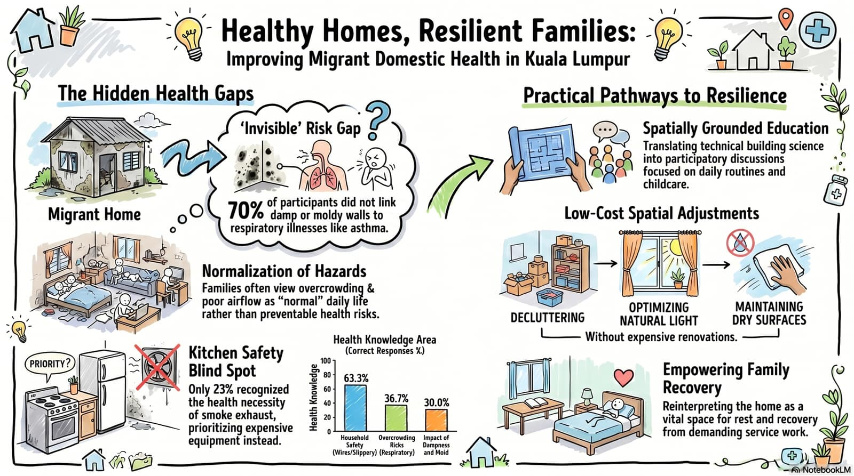
Figure 5. Visual synthesis of domestic environmental health risks and resilience pathways among migrant service-worker families in Kuala Lumpur

As shown in Figure 5, the significance of the program lies not only in identifying material housing problems, but also in revealing how environmental risks are concealed within ordinary domestic routines and everyday assumptions. The visual synthesis demonstrates that resilience does not emerge from ideal housing conditions alone, but also from the ability of families to reinterpret and gradually improve their living environments through accessible knowledge and realistic action. In this sense, the figure reinforces the central argument of the paper: that architecture- and building engineering-based community service can support migrant family well-being by linking spatial understanding with practical empowerment.

Overall, the discussion confirms five broader interpretations of the results. Domestic environmental health is central to migrant family resilience. Housing inequality operates as both a health issue and an equity issue. Environmental risk is often normalized when literacy is limited and constraints are long-term. Participatory, spatially grounded education can help families reinterpret ordinary domestic space as a health environment. Finally, practical low-cost interventions are especially relevant in constrained urban migrant settings because they align with the realities of rental housing, modest budgets, and incremental change.

Although the findings provide meaningful insight into domestic environmental health among migrant service-worker families, they should be interpreted within the scope of the study design. The use of purposive sampling and a relatively small sample size means that the results are not statistically generalizable to all migrant families in Kuala Lumpur. However, the strength of the study lies in its contextual depth, participatory engagement, and ability to reveal how housing conditions, environmental health literacy, and practical household-level improvement are connected in everyday migrant family life.

CONCLUSION

This community service program demonstrates that domestic environmental health is a decisive yet often overlooked dimension of migrant family well-being in dense urban settings. Among migrant service-worker families in Kuala Lumpur, the home is not merely a shelter. It is the primary space for rest, caregiving, hygiene, recovery from work, and the everyday maintenance of family life. When that space is shaped by overcrowding, inadequate ventilation, limited lighting, sanitation constraints, and weak spatial organization, the burden extends beyond physical discomfort. It affects health awareness, household safety, emotional stability, and the overall resilience of the family. These conditions were consistently reflected in both the field observations and the pre-test results reported in the manuscript.

A major contribution of this program lies in showing that the problem is not only material but also interpretive. Many participants had lived for years with environmental disadvantages that had become normalized within daily life. The intervention revealed that poor domestic conditions are often tolerated not because they are harmless, but because their health implications are not fully recognized. In this respect, the program confirms that environmental health literacy is essential for empowering migrant families to see their homes differently, not as fixed constraints, but as living environments that can be understood, managed, and improved.

This paper also shows that architecture- and building engineering-based community service can make a concrete and meaningful contribution to social well-being. Its value does not depend only on physical construction or formal redesign. Equally important is the ability to translate spatial and environmental knowledge into practical, affordable, and context-sensitive guidance that families can apply within rented or modest housing. In the present case, simple strategies related to airflow, moisture control, storage, hygiene, lighting, and safer domestic circulation were not only relevant, but welcomed as realistic pathways toward healthier living.

The broader significance of this study is that it repositions the domestic environment as a critical arena of migrant empowerment. Healthy housing should not be treated as a luxury or a secondary concern, but as a basic condition for dignity, health, and family resilience. For long-term migrant communities, strengthening domestic environmental health means strengthening their capacity to endure, care, recover, and build stability within the pressures of urban life. This paper affirms that community service grounded in spatial understanding can play a strategic role in improving the quality of life of vulnerable migrant families. Future programs should extend this work through follow-up mentoring, broader community partnerships, and replication in other migrant settlements, while also integrating healthy housing more explicitly into community empowerment agendas. By doing so, architecture and building engineering can move beyond technical service alone and become disciplines that actively support health equity, everyday dignity, and the lived resilience of migrant communities.

The study has several limitations. First, the program involved 30 participants selected through purposive sampling, which limits statistical generalization. Second, the study was conducted in a specific migrant community setting in Kuala Lumpur, meaning that the findings may not fully represent the diversity of migrant housing conditions across Malaysia. Nevertheless, the study offers contextual and analytical value by showing how participatory, built-environment-based intervention can support environmental health literacy and practical household improvement among migrant service-worker families.

ACKNOWLEDGEMENTS

The authors would like to express their sincere appreciation to all parties who contributed to the successful implementation of this community service program in Kuala Lumpur.
Special gratitude is extended to Dra. Mimin Mintarsih, Chair of Cabang Istimewa Muslimat NU Malaysia, whose leadership, trust, and facilitation were instrumental in connecting the research team with migrant service-worker families and ensuring the program’s meaningful engagement within the community. Her commitment to community empowerment and social care provided an essential foundation for the program’s impact.

The authors are deeply grateful to the participating migrant families, who generously shared their time, experiences, and openness throughout the activities. Their willingness to engage in discussion and reflection made it possible to ground this work in real-life domestic contexts and to develop practical, relevant insights into environmental health in everyday living conditions.

This program was made possible through the collaboration of a multidisciplinary academic team. The authors acknowledge the institutional support from the Department of Architecture, University of 17 Agustus 1945 (UNTAG) Semarang, Indonesia; Universiti Teknologi MARA, Shah Alam, Selangor, Malaysia; the Department of Machine Engineering, University of Islam Kalimantan MAB, Indonesia; the Department of Infrastructure and Environmental Engineering, Panca Bhakti University, Indonesia; the Department of Architecture, Lambung Mangkurat University, Indonesia; the Department of Civil Engineering, Muhammadiyah University of North Maluku, Indonesia; the Early Childhood Education Program, IVET University Semarang, Indonesia; and Aceh Barat State Community Academy, Indonesia.

The authors also acknowledge all local partners and informal community networks in Kuala Lumpur who provided logistical support, local knowledge, and a welcoming environment for the activities. Their contribution ensured that the program was not only implemented effectively but also aligned with the lived realities of migrant families. Finally, the authors appreciate the collaborative spirit among all team members, whose shared commitment to architecture, environmental health, and community empowerment made this program both meaningful and impactful.

REFERENCES
- Akter, S., & Bhattacharjee, S. (2026). Trauma-informed housing and wellbeing in resettlement: An actionable design model from refugee children’s perspectives and mothers’ photovoice. Wellbeing, Space and Society, 10, 100384. https://doi.org/10.1016/j.wss.2026.100384
- Al horr, Y., Arif, M., Katafygiotou, M., Mazroei, A., Kaushik, A., & Elsarrag, E. (2016). Impact of indoor environmental quality on occupant well-being and comfort: A review of the literature. International Journal of Sustainable Built Environment, 5(1), 1–11. https://doi.org/10.1016/j.ijsbe.2016.03.006
- Bentley, R., Mason, K., Jacobs, D., Blakely, T., Howden-Chapman, P., Li, A., Adamkiewicz, G., & Reeves, A. (2025b). Housing as a social determinant of health: A contemporary framework. Lancet Public Health. https://doi.org/10.1016/S2468-2667(25)00142-2
- Di Fabrizio, C., Gonçalves, J., & Martins, M. D. R. O. (2025). Community-based interventions to improve the health of migrant children in high-income countries: A systematic review. Social Science & Medicine, 383, 118470. https://doi.org/10.1016/j.socscimed.2025.118470
- Hernández, D. (2019). Housing-Based Health Interventions: Harnessing the Social Utility of Housing to Promote Health. American Journal of Public Health, 109(S2), S135–S136. https://doi.org/10.2105/AJPH.2018.304914
- Li, J., & Liu, Z. (2018). Housing stress and mental health of migrant populations in urban China. Cities, 81, 172–179. https://doi.org/10.1016/j.cities.2018.04.006
- Osibona, O., Solomon, B. D., & Fecht, D. (2021). Lighting in the Home and Health: A Systematic Review. International Journal of Environmental Research and Public Health, 18(2), 609. https://doi.org/10.3390/ijerph18020609
- Rana, K., Kent, J. L., & Page, A. (2025). Housing inequalities and health outcomes among migrant and refugee populations in high-income countries: A mixed-methods systematic review. BMC Public Health, 25(1), 1098. https://doi.org/10.1186/s12889-025-22186-5
- Roura, M., Dias, S., LeMaster, J. W., & MacFarlane, A. (2021). Participatory health research with migrants: Opportunities, challenges, and way forwards. Health Expectations, 24(2), 188–197. https://doi.org/10.1111/hex.13201
- Weiler, A. M., & Caxaj, C. S. (2024). Housing, health equity, and global capitalist power: Migrant farmworkers in Canada. Social Science & Medicine, 354, 117067. https://doi.org/10.1016/j.socscimed.2024.117067

