GROWTH AND CHARACTERIZATION OF SULPHAMIC ACID AND L-METHIONINE ADDED SULPHAMIC ACID SINGLE CRYSTALS

Fredselin R.S Vithel¹ and S.R. Cynthia^{2*}

1Department of Physics, Maria College of Engineering and Technology, Attoor, Tamil Nadu, India.

2* Department of Physics, Alagappa Chettiar Government College of Engineering and Technology, Karaikudi, Tamil Nadu, India.

∗ Corresponding author.
E-mail: srcynthiasam@gmail.com

Abstract: Sulphamic acid (SA) and L-methionine added sulphamic acid crystals (LMSA) were grown by slow evaporation technique at room temperature. The Single crystal XRD studies revealed that the grown crystals possessed orthorhombic crystal structure. The presence of various functional modes was confirmed by RAMAN analysis. The EDAX analysis confirmed the presence of L-methionine in the grown LMSA crystal. The surface morphology of crystals was studied. The larger size crystals revealed the excellent crystallinity. The stability of the crystals was ascertained from thermo gravimetric and differential thermal analysis. The third order nonlinear refractive index, nonlinear absorption coefficient and third order optical susceptibility were calculated by the Z-scan technique.

Keywords: L-methionine, Sulphamic acid, Slow evaporation, Transparent crystal.

1. INTRODUCTION

The creation of passive and active photonic devices primarily makes use of nonlinear optical materials [1]. Optics and electronics are two fields where the utilization of single crystals is evident. Sulphamic acid (SA) is one of the most generally used inorganic compounds in industry [3]. In multistage flash evaporation (MSF) desalination plants, SA identifies good applications for heat exchangers, demisters, cleaning, cooling water systems, etc. [2]. Both orthorhombic structure and zwitterionic form of sulfuric acid are present in SA. At low temperatures, large single crystals of pure SA can be formed. Due to these outstanding qualities, SA has been recognised as a standard material for titrimetric analysis by the British analytical techniques committee, IUPAC, and Japanese Industrial Standard (JIS) [4-6].SA has large applications as anti-corrosive agent [7, 8]. Both pure and doped SA crystals have been reported so far by various methods such as slow cooling method, unidirectional solution growth method, aqueous solution growth method etc. These studies also suggested the reported crystals for optoelectronics and various device applications. In addition to that studies have shown that dopping methionine plays an important role in the improvement of crystallization and the growth behaviour of crystals [9-21].
Sulphamic acid has found wide application as a catalyst, especially in polymerization process and used as a catalyst for many organic reactions. It is used as a fire retardant of fire proofing agent, as a cross-linking agent for polymers, in the dyeing of fabrics, as a cleaning agent for air, as herbicide, in pulp bleaching, for scale removal and cleaning metal, in pigment printing, and in producing cigarettes of reduced toxicity [22]. Dopants play a crucial role in improving the physical properties of single crystals [23]. Several researchers have investigated the incorporation of L-methionine with both organic and inorganic materials. Studies have demonstrated that single crystals, such as ammonium dihydrogen phosphate and potassium dihydrogen phosphate doped with L-methionine, exhibit improved nonlinear optical (NLO) properties and enhanced sensor applications compared to the pure one [24-26]. To best of our knowledge L-Methionine added Sulphamic acid crystal was not grown by any other researcher. In this present work pure sulphamic acid crystal and L-methionine added sulphamic acid crystals were grown by slow evaporation technique at room temperature and the structural and optical properties were discussed.

2. EXPERIMENTAL METHODS
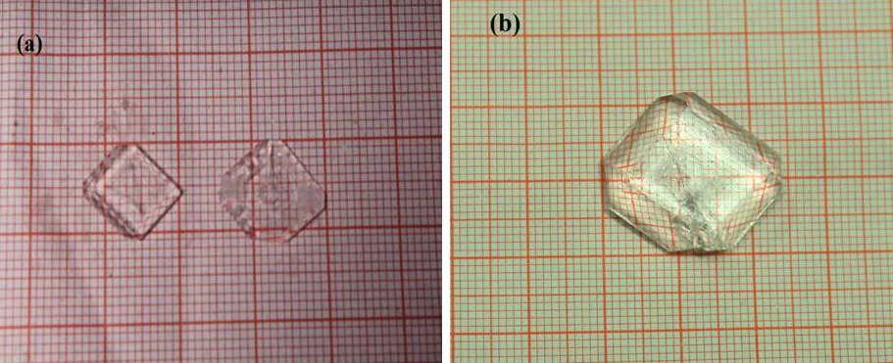

Fig 1 Photographs of the grown a) SA crystal and b) LMSA crystal
Sulphamic acid crystal and sulphamic acid crystal containing L-methionine were produced via slow evaporation method. Sulphamic acid crystal is prepared by disolving sulphamic acid in double-distilled water. For sulphamic acid crystal containing L-methionine, L-methionine powder and high purity sulphamic acid are employed as the initial components in which SA and L-methionine are combined in a 3:1 ratio and dissolved in double-distilled water. For a few hours at room temperature, the dissolved solutions were agitated with a magnetic stirrer to produce a clear solution in separate beakers. The translucent saturated solutions were filtered through filter papers and left to crystallize at ambient temperature in a purified environment. After 20 days, nice transparent crystals that were colorless were gathered and used for characterisation. Fig 1 depicts images of grown crystals. The experimental parameters employed for the growth of SA and LMSA crystals are presented in Table 1. The growth conditions were maintained identical for all batches to ensure reproducibility of the doping effect.
Table 1 Experimental details of SA and LMSA crystal growth
Parameter | SA Crystal | LMSA Crystal
Solvent | Double-distilled water | Double-distilled water
Growth method | Slow evaporation technique | Slow evaporation technique
Growth temperature | Ambient temperature (28–32°C) | Ambient temperature (28–32°C)
Stirring duration | 3–4 hours | 3–4 hours
Crystallization period | 20 days | 20 days
Number of growth batches | Multiple batches | Multiple batches
Reproducibility of growth | Consistent crystal growth observed | Consistent incorporation of L-methionine and crystal quality observed

3. RESULTS AND DISCUSSIONS

3.1 Single crystal X-ray diffraction

Single crystal X-ray Diffraction was investigated using BRUKER AXS KAPPA APEX 11 CCD Diffractometer. Table 2 presents the structures and lattice parameters of SA and LMSA single crystals. The measured lattice parameters for SA are a=8.10 Å, b=8.17 Å, c=9.29 Å and α = β = γ = 90°. SA has unit cell volume of 614 Å m³ and the density is 2.129 mg/m³. The obtained lattice parameters for LMSA are a=8.12 Å, b=8.16 Å, c=9.26 Å and α = β = γ = 90°. The unit cell volume for LMSA is 615 Å m³ and the density of cell volume is calculated as 2.129 Mg/m³. The slight increase in unit cell volume (614 to 615 Å³) suggests that L-methionine is incorporated interstitially without altering the orthorhombic structure of sulphamic acid (SA). In its zwitterionic form (⁺NH₃–SO₃⁻), SA provides active sites for interaction with L-methionine functional groups (–NH₂, –COOH, –SCH₃). Hydrogen bonding between –NH₂/–COOH of L-methionine and –SO₃⁻/–NH₃⁺ of SA, along with weak van der Waals interactions from the –SCH₃ group, leads to slight lattice expansion. Similar lattice modifications have been reported in amino acid-doped crystals, such as DL-methionine doped ADP [24]. These additional intermolecular interactions also account for the observed enhancement in thermal stability of LMSA.The single crystal XRD study revealed that both the grown crystals belong to orthorhombic crystal system with a space group of Pbca, which shows the addition of Methionine has not altered the structure of SA.

Table 2 Structure and lattice parameters of pure SA and LMSA single crystals.
Crystal | Structure | A  (A°) | B  (A°) | C  (A°) | Volume  (m³)
SA | Orthorhombic  (α=β=γ= 90°) | 8.10 | 8.17 | 9.29 | 614
LMSA | Orthorhombic  (α=β=γ= 90°) | 8.12 | 8.16 | 9.26 | 615

3.2 Raman analysis
Fig 2 displays the Raman spectra of SA and LMSA crystal. The Raman spectra of SA and LMSA crystals revealed the distinct vibrational bands characteristic of their structural features. The Raman spectra of SA displayed in Fig 2 (a) contains a high-intensity vibration band observed near 1059 cm⁻¹ was attributed to the symmetric SO₃ stretching vibration. The bands at 1281 cm⁻¹ and 1345 cm⁻¹ corresponded to degenerate SO₃ stretching modes. A band at 1017 cm⁻¹ was assigned to the degenerate NH₃⁺ rocking vibration, while the N–S stretching vibration was observed at 682 cm⁻¹ [27]. Additionally, the vibration band at 543 cm⁻¹ was ascribed to degenerate SO₃ deformation, and the band at 363 cm⁻¹ was due to SO₃ rocking vibrations. The vibration band detected at 256 cm⁻¹ was assigned to N–S torsion [28]. All the Raman modes confirmed the orthorhombic structure of the SA crystal as displayed in the Raman spectra. Hence, the structure of the SA crystal was conclusively validated.
The bands seen at the Fig 2(b) corresponds to LMSA spectra. 372 cm⁻¹and 242 cm⁻¹ peak positions were caused by SO₃⁻ rocking and N-S torsion vibrations, respectively. The 550 cm⁻¹ LMSA vibration bands were attributed to degraded SO₃⁻ deformation. The band at 689 cm⁻¹ of LMSA was caused by C-S astretching mode of vibration [29] . The band, which appeared at 1000 cm⁻¹, showed the arocking avibration of NH₃⁺ in L-methionine with sulphamic acid addition. At 1352 cm⁻¹ and 1279 cm⁻¹ in LMSA, the degraded SO₃⁻ stretching vibration emerged. The band at 2437 cm⁻¹was caused by S-H stretching vibration, and the peak at 1539 cm⁻¹was related to NH₃⁺deformation. C-H stretching mode was assigned to the band seen at 2873 cm⁻¹[30]. The NH₃⁺ stretching vibration linked with the vibration bands noted at 3048 cm⁻¹ in LMSA [31-36]. When comparing SA and LMSA, only a negligible peak shift is observed. This proved that the orthorhombic structure was maintained despite the alteration in sub-lattice geometry.
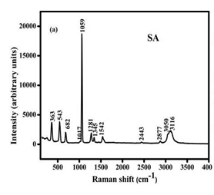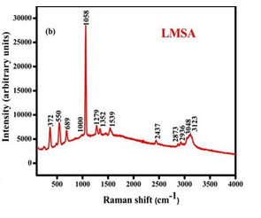

Fig. 2 Raman spectra of a) SA and b) LMSA crystals

3.3 Morphology and compositional analysis

Using scanning electron microscope (SEM), the surface morphology of the SA and LMSA crystals were examined; the image is shown in Fig 3. The SEM scans explored that the particles were not all the same size and that voids and agglomerations were present. The thermal effect (during the synthesis process) causes the crystals overlapping which may be owing to the agglomeration of crystal nucleus. The agglomeration of crystal nuclei may be the reason of the crystals' overlap caused by the temperature effect during the synthesis process. Few spherical shaped smooth microcrystals were grown on the surface. Surface morphology of the crystal is smooth and is crack free. The particle sizes of the SA and LMSA crystals were analyzed using ImageJ. The particle size of the SA crystal was found to be 100 μm, while that of the LMSA crystal was 140 μm. Compared to SA, the LMSA crystal exhibited an increase in particle size.
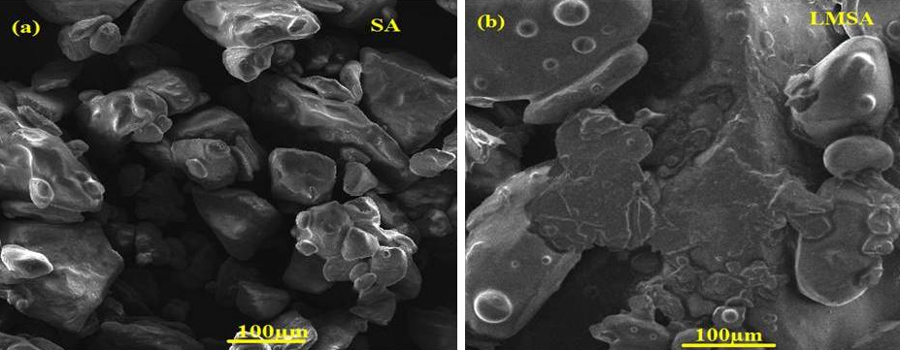

Fig. 3 SEM analysis of a) SA and b) LMSA crystals

The EDAX spectrum of SA and LMSA is shown in Fig. 4. The SA crystal consists of oxygen, nitrogen, and sulfur, while the L-methionine-added sulfamic acid (LMSA) crystal contains oxygen, nitrogen, sulfur, and carbon. The presence of carbon in LMSA confirms the incorporation of L-methionine into the SA crystals.In Table 3a and 3b, the elemental compositions of SA and LMSA are listed.
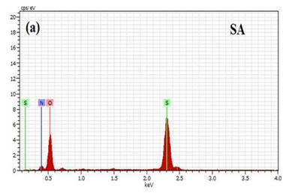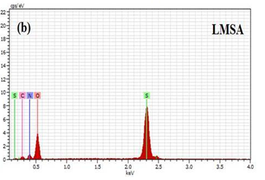

Fig. 4 EDAX analysis of a) SA and b) LMSA crystals

Table 3a Elemental composition of pure SA
Element | Molecular weight  (%) | Atomic weight  (%)
Oxygen | 63.26 | 69.71
Nitrogen | 14.23 | 17.91
Sulphur | 22.51 | 12.37

Table 3b Elemental composition of LMSA
Element | Molecular weight  (%) | Atomic weight  (%)
Oxygen | 51.62 | 53.75
Nitrogen | 17.03 | 20.25
Sulphur  Carbon | 20.14  11.20 | 10.46  15.54

3.4 TG/DTA/DTG Analysis
TG/DTA/DTG analysis is a quite useful tool to determine the phase transition of the formed crystal, the water of crystallization, also reliable information’s like thermal stability, melting point and decomposition of the grown crystal[37]. Fig 5 displays the results of a TG/DTA/DTG study of SA and L-methionine added in SA. The graph indicates that no significant weight loss was observed for the SA crystal up to 261°C. A sudden and substantial weight reduction occurred between 261°C and 448 °C, as evidenced by a sharp peak at 448 °C, confirming the crystal's decomposition at this temperature, consistent with the findings of Brahmaji et al. [15]. In the DTA curve, endothermic peaks appeared at 212 °C and 261 °C, signifying the complete evaporation of water and solvent molecules. As the temperature increased further, the material experienced weight loss, corresponding to its decomposition, as indicated by the pronounced endothermic peak at 448 °C, which aligns with the TGA curve. For LMSA, no significant weight loss was observed up to 265 °C. The weight loss starts from 265 °C and a rapid weight loss was observed at 453 °C. This manner of weight loss revealed the material's breakdown point at 453 °C. Two exothermic peaks were observed at 209 °C and 265 °C which corresponds to the first and second decomposition stage respectively. The DTA curve shows a strong endothermic peak at 453 °C, which represent the last decomposition state. It is noticed that LMSA crystals are therefore thermally stable up to 265 °C. In light of this, we can state that the crystals that have formed are suitable for applications with working temperatures of up to 265 °C. Compared to SA, the LMSA crystal exhibited minimal variation; however, the temperature shifts toward a higher range. This suggests that the addition of L-methionine to sulphamic acid enhances its thermal stability compared to pure sulphamic acid.
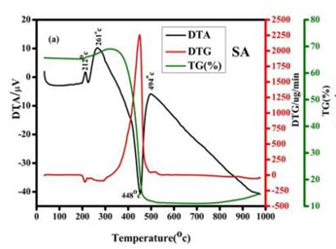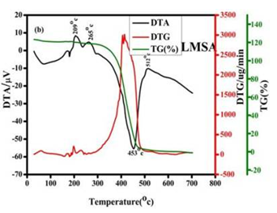

Fig. 5 TG-DTA curves of a)SA and b)LMSA crystal

3.5 Z-scan measurements
The third-order nonlinear optical characteristics of a 1 mm thick LMSA crystal were estimated using the Z-scan technique. A semiconductor continuous wave laser with a wavelength of 532 nm and a power of 100 mW was used to perform the Z-scan experiment. A convex lens with a focal length of 103 mm was employed to focus the crystals. Z-scan is a very good technology for analyzing the nonlinear absorption coefficient (β) and third order nonlinear refractive index (n₂). Fig 6 and 7 depict the graph obtained using the SA and LMSA crystals open aperture and closed aperture methods, respectively. Closed aperture Z-scan curve of both ZA and LMSA indicate the valley followed by a peak, which reveals that the positive nonlinearity with a self-focusing effect [38]. Since the laser used is continuous wave the nonlinearity observed in the sample is purely thermal [39]. Here, the nonlinear absorption coefficient (β) was determined using an open aperture Z-scan technique, which occurs in the SA and LMSA and is represented by a valley with a positive absorption coefficient (β). For the purpose of getting any optical limiting applications, this property is crucial. The third order nonlinear refractive index (n₂) values were determined as 4.72 x 10⁻⁹ cm²/w and 2.42 x 10⁻⁹ cm²/w, nonlinear absorption coefficient (β)= 2.79 x 10⁻⁴ cm/w and 2.72 x 10⁻⁴ cm/w, the positive value of nonlinear refraction revealed the self-focusing nature. Real and imaginary value of third order susceptibility of SA and LMSA are 5.48 x 10⁻⁶ cm²/w, 1.09 x 10⁻⁶ cm/w and 2.98 x 10⁻⁶ cm²/w, 1.22 x 10⁻⁶ cm/w respectively. The third order susceptibility (χ⁽³⁾) of SA and LMSA are 5.58 x 10⁻⁶esu and 2.82 x 10⁻⁶esu respectively. It is important to note that the third-order nonlinear optical susceptibility (χ⁽³⁾) of LMSA is lower than that of pure SA. This reduction suggests that the incorporation of L-methionine does not enhance the third-order nonlinear response of sulphamic acid under the present growth conditions. The observed decrease in (χ⁽³⁾) is significantly larger than the typical experimental uncertainty associated with CW Z-scan measurements, indicating that the reduction is likely intrinsic rather than arising from experimental error alone. Several factors may contribute to this behavior. First, the incorporation of L-methionine molecules into the SA lattice may dilute the density of highly NLO-active sulphamic acid units, thereby reducing the effective nonlinear polarization. Second, the addition of methionine may introduce localized lattice defects or microstrain, as evidenced by the slight lattice expansion observed in single-crystal XRD analysis, which can increase scattering losses and reduce nonlinear efficiency. Third, intermolecular interactions between the functional groups of methionine (−NH₂,−COOH,−SCH₃ ​) and the zwitterionic SA framework may alter charge-transfer pathways and weaken the electronic delocalization responsible for nonlinear optical response. Such modifications in charge distribution can influence the third-order susceptibility significantly.
Despite the reduction in (χ⁽³⁾), the LMSA crystal still exhibits appreciable nonlinear optical behavior comparable to several reported amino acid-based semi-organic NLO crystals. For example, L-methionine barium bromide (LMBB) crystals reported by Shalini et al. [26] showed effective optical limiting behavior with third-order nonlinear optical response in the same order of magnitude. Similarly, L-methioninium hydrogen maleate crystals reported by Natarajan et al. [16] demonstrated useful NLO characteristics arising from intermolecular hydrogen bonding and charge-transfer interactions. The (χ⁽³⁾)value obtained for LMSA remains sufficiently high for potential applications in optical limiting, optical switching, and photonic device fabrication [40]. Furthermore, LMSA offers the additional advantage of improved thermal stability compared to pure SA, which may be beneficial for practical device operation under elevated temperature conditions.

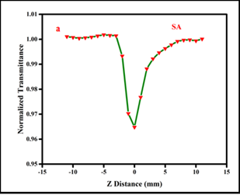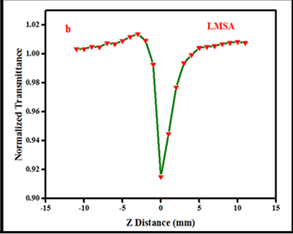

Fig. 6 Z-scan open aperture of a) SA and b) LMSA crystal
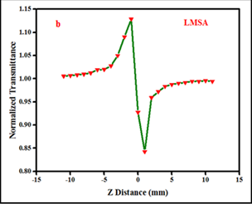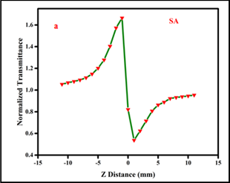

Fig. 7 Z-scan closed aperture of a) SA and b) LMSA crystal

4. Conclusion
The sulphamic acid (SA) and L-methionine added sulphamic acid (LMSA) crystals were successfully grown by the slow evaporation technique at room temperature. Single crystal XRD analysis confirmed that both crystals belong to the orthorhombic crystal system. Raman and EDAX analyses verified the incorporation of L-methionine into the SA lattice without altering the crystal structure. TG-DTA-DTG studies revealed that the LMSA crystal exhibits enhanced thermal stability up to 265°C compared to pure SA, making it suitable for optoelectronic devices operating at elevated temperatures. Z-scan measurements confirmed positive nonlinear refractive index and nonlinear absorption coefficients, indicating self-focusing and optical limiting behavior. The obtained n₂​ and β values suggest that the grown crystals are promising candidates for third-order nonlinear optical applications such as optical limiters, optical switches, optical data processing devices, and frequency conversion applications. The improved thermal stability and nonlinear optical response of LMSA demonstrate its potential advantage over pure SA for practical photonic and optoelectronic applications.

REFERENCES
- R.Ramesh Babu, K.Sethuraman, N.Vijayan, R. Gopalakrishnan, P. Ramasam,y, Dielectric and structural studies on sulphamic acid (SA) single crystal, Material Letters 61 (2007) 3480-3485.
- Mohd.Shkir, B. Riscob, V. Ganesh, N. Vijayan, Rahul Gupta, J.L Plaza, E. Dieguez, and G. Bhagavannarayana, Crystal growth, structural,crystalline perfection, opticsal and mechanical properties of Nd³⁺ doped sulphamic acid (SA) single crystals, Journal of crystal growth, 380 (2013) 228-235.
- Ming wah Wong, Kenneth B.wiberg and Michael J.Frisch, Solvent Effects.2. Medium Effect on the structure energy charge density, and vibrational frequencies of sulphamic acid, J.Am.Chem.Soc. 114 (1992) 523-529.
- R. Valluvan, K. Selvaraju, S.Kumararaman, Growth and characterization of sulphamic acid single crystals: A nonlinear optical material, Mater.Chem.Phys. 97 (2006) 81-84.
- Takayoshi Yohimori and Tatsuhiko Tanaka, preparation of sulphamic acid single crystals and their assay by precise coulometric titration, Anal ChemActa, 66 (1975) 85.
- K.G Anupriya and P.Hemalatha, Effect of Znso₄ and M nso₄ on the growth of sulphamic acid single crystals, Mat.Sci.Res.India, 15, (2018) 151-158.
- F.A.Kanda and A.J.King, , The Crystal Structure of Sulfamic Acid J.Am.Chem.Soc 73 (1951) 2315.
- K Cheng, W.R.Bosenberg and C.L. Tang, Growth and characterization of nonlinear optical crystals suitable for frequency conversion, Prog.Cryst.Growth charact. 20 (1990) 9-57.
- M.Shakir, B. Riscob, V.Ganesh, N.Vijayan, R. Gupta, J. Plaza, E. Dieguez, G. Bhagavannarayana, Crystal growth, structural, crystalline, perfection, optical and mechanical properties of Nd³⁺ doped sulfamic acid(SA) single crystals,J.Cryst.Growth 380 (2013) 228-235.
- R.Ramesh Babu, R.Ramesh, R.Gopalkrishnan,K. Ramamurthi, G. Bhagavanarayana, Growth,structural,spectral,mechanical and optical properties of pure and metal ions doped sulphamic acid single crystals,Spectrochim. Acta part A Mol. Biomol. Spectrosc. 76 (2010) 470-475.
- T.Thaila and S.Kumararaman, Effect of Nacl and Kcl doping on the growth of sulphamic acid crystals, Spectrochim. Acta part A Mol.Biomol. Spectrosc.82 (2011) 20-24.
- R.L. Sass, A neutron diffraction study on the crystal structure of sulfamic acid, Acta Crystallogr. 13 (1960) 320-324.
- Kannan B, Seshadri P R,Murugakoothan P and Illangovan K Growth and Characterisation of Lanthanum Doped Sulphamic Acid Single Crystal, Indian journal of science and technology 6 (2013) 4358.
- Fredselin R. S. Vithel , R Manimekalai, S R Cynthia, V Govindan, M. Ijaz Khan , S Abdullaev , Salman A. AlQahtani and Nouf F. AlQahtani, Growth, characterization, and anti-bacterial activity of l-methionine supplemented with sulphamic acid single crystals, Open Physics, 22 (2024) 20230175.
- B. Brahmaji, P. Viswarupachar, N. SivagangaKumari, L. SantoshKumar and K. RamchandraRao, Idiosyncratic photoluminescence of europium added sulfamic acid single crystal a potential NLO material for optoelectronics and devise applications, Journal of Luminescence 257 (2023) 119649.
- Subramanian Natarajan, Neelamagam Rajan Devi, Sathiya Dhas Martin Britto Dhas, Shanmuganarayanan Athimoolam, Crystal growth and structure of L-methionine L-methioninium hydrogen maleate—a new NLO material, Sci Technol Adv Mater. (2008) 025012.
- H Yin, H Ge , Z Chen and S Yuan, Growth behavior of β form DL-methionine crystal in the presence of inorganic acids and bases additives: A combination of experiments and molecular dynamics simulation study, Journal of Crystal Growth (2022) 587 126636.
- Anupriya K G and Hemalatha P, Effect of ZnSO₄ and MnSO₄ on the Growth of Sulphamic Acid Single Crystals, Mat. Sci. Res. India, 15 (2018) 151.
- Samson Yesuvadiana, Anbarasu Selvaraj, Martina Mejeba Xavier Methodius, Bhagavannarayana Godavarti, Vijayan Narayanasamy and Prem Anand Devarajan, Synthesis, growth and characterization of nitramino sulphonic acid (NASA) NLO single crystal, Optik 126 (2015) 95.
- Indumathi N, Chinnasamy E, Arulmani S, Venkatesan A, Raja Saravanan M E, Deepa K, Inmozhi C, Senthil S, Kaviyarasu K and Uthrakumar R, Third order nonlinear optical and electrical properties of new sulphamic acid lithium chloride single crystal, Materials Today: Proceedings 36 (2021) 141- 145.
- Budhendra Sing, Mohd.Shkir, Alfaiyb S, AjayKaushal, Narendar Nasani, Igor Bdikin, Shoukry H, Yahia I S and Algarni H Structural, optical, thermal, mechanical and dielectric studies of Sulfamic acid single crystals: An influence of dysprosium (Dy³⁺) doping, Journal of Molecular structure (2016) 1119365.
- G. Anthony Benson and William J. Spillane, Sulfamic acid and its N-Substituted Derivatives, Chem. Rev. 80 (1980) 151-186.
- J. Arumugam, N. Suresh, M. Selvapandiyan, S. Sudhakar and M. Prasath, Effect of NaCl on the properties of sulphamic acid single crystals, Heliyon 5 (2019) e01988.
- J. H. Joshi, S. Kalainathan, D. K. Kanchan, M. J. Joshi and K. D. Parikh, Crystal growth, A.C. electrical and nonlinear optical studies of pure and dl-methionine doped ammonium dihydrogen phosphate single crystals, J. Mater. Sci.: Mater. Electron. 30, (2019) 2985–2993.
- K. S Kumar and R. Rajasekaran, Optical and structural studies of L-phenylalaine, L-methionine and L-glutamic acid doped KDP crystals for tuned laser applications, Int. j. tech. res. Appl 9 (2021) 8-17.
- M. Shalini , R.S. Sundararajan, E. Manikandan, M. Meena, B.Samuel Ebinezer, T.C.Sabari Girisun and R. Natarajan, Growth and characterization of L - Methionine Barium Bromide (LMBB) semi-organic crystal for optical limiting applications, Optik 278 (2023) 170705.
- P. Muthusubramanian and A. Sundara Raj, Internal modes and normal coordinate analysis of sulphamic acid, J. Mol. Struct 84 (1982) 25 -37.
- M. Lenin, N. Balamurugan and P. Ramasamy, Growth and characterization of sulphamic acid single crystals grown by Sanakaranarayanan-Ramasamy (SR) method, Cryst. Res. Technol. 42 (2007) 39-43.
- Stewart F. Parker, Nicholas P. Funnell, Kenneth Shankland, Elena A. Kabova, Thomas Häußner, Hans‑Joachim Hasselbach, Sascha Braune, Christoph Kobler and Peter W. Albers, Structure and spectroscopy of methionyl‑methionine for aquaculture, Sci Rep. 11 (2021) 458.
- D.Jaishree, G.Kanchana, R.Kesavasamy, Investigations on growth, optical and thermal properties of sulphamic acid single crystals, Adv.Condens.Matterphys. (2014)5.
- M.Lenin, N.Balamurugan, P.Ramasamy, Growth and characterization of sulphamic acid single crystals grown by sanakaranarayanan-Ramasamy (SR) method.Cryst.Res.Technol.42 (2007) 39-43.
- M. Canagaratna, J.A. Philips, H.Goodfriend, K.R. Leopold, Structure and Bonding of the sulfamic acid Zwitterion: microwave spectrum of⁺H₃N-SO₃, J.Am.Chem.Soc. 118 (1996) 5290-5295.
- D.Philip, A.Eapen, G.Aruldhas, Vibrational and surface enhanced raman scattering spectra of sulfamic acid, J.Solid State Chem.116 (1995) 217-223.
- M.W.Wong, K.B. Wiberg, M.J. Frisch, Solvent effects. 2. Medium effect on the structure, energy, charge density and vibrational frequencies of sulfamic acid, J.Am.Chem.Soc.114 (1992) 523-529.
- A.M. Vuagnat and E.Wagner, Vibrational spectra and structure of solid sulfamic acid and the sulfamate ion, J.Chem.Phys.26 (1957) 77-82.
- Q.Li, S.Li, K.Wang, X.Li, J.Liu, B.Liu, G.Zou, B.Zou, Pressure-induced isosymmetric phase transition in sulfamic acid: A combined Raman and x-ray diffraction study, J.Chem.Phys.138 (2013) 214505.
- J. Arumugam, M. Selvapandiyan, Senthilkumar Chandran, M. Srinivasan, P. Ramasamy, Crystal growth, optical, thermal, laser damage threshold, photoconductivity and third‑order nonlinear optical studies of KCl doped sulphamic acid single crystals, J. Mater. Sci.: Mater. Electron., 31 (2020) 6084–6096 .
- T. C. Sabari Girisun and S. Dhanuskodi, Linear and nonlinear optical properties of tris thiourea zinc sulphate single crystals, Cryst. Res. Technol. 441 (2009) 1297 – 1302.
- N. Priyadarshani, G. Vinitha, T.C. Sabari Girisun, Third order nonlinear optical properties of monoclinic and orthorhombic CuNb2O6 under CW laser illumination, Opt. Laser Technol. 108 (2018) 287–294.
- A. Priyadharshini and S. Kalainathan, Bulk crystal growth, spectral, optical, thermal, electrical and third-order NLO properties of benzylidene malononitrile derivative single crystal: a promising material for nonlinear optical device applications, J Mater Sci: Mater Electron 29 (2018) 2698–2708.

