Artificial Intelligence in Nutrition Science and Dietetics for Maternal and Child Health Benefits: Balancing Innovation with Ethical Risks.

Abstract
The present study critically assessed artificial intelligence (AI) in nutrition science and dietetics for maternal and child health, focusing on the balance between innovation and ethical issues. A systematic narrative review of 50 peer-reviewed studies published between 2020 and 2026 was conducted across multiple databases. Results: Accuracy, scalability, and predictive ability of AI applications for dietary assessment, personalized nutrition guidance, and public health surveillance were significantly increased. Meanwhile, new ethical and equity challenges emerged, such as data privacy issues, algorithmic bias, inequitable access in low- and middle-income countries, and professional displacement. We found research gaps in long-term evidence, Low and Middle Income Country-specific datasets, as well as ethical frameworks. AI has the potential to drive better maternal and child health outcomes, but its responsible adoption depends on governance, inclusion, and professional accountability; the study concludes. Key recommendations include strengthening governance of data through global health agencies, addressing bias at research institutions, expanding digital infrastructure through development banks, securing professional roles through dietetic associations, and encouraging longitudinal research underwritten by international research councils. Limitations are restricted to English-language studies from 2020-26 and a narrative synthesis instead of a meta-analysis, leading to less generalizability.
Keywords: Artificial Intelligence, Maternal Nutrition, Child Health, and Ethics

Introduction
Artificial Intelligence (AI) is recognized as an emerging technology in health, with increasing contributions to nutrition science and dietetics. AI in maternal and child health, including machine learning, predictive analytics, and mobile health apps, is being employed to enhance dietary screening, nutritional status assessment, and intervention (Topol, 2019). These advances have the potential to contribute to the management of maternal malnutrition, gestational diabetes, child overweight and obesity, as well as to the improvement of micronutrient deficiencies. AI-powered dietary apps with images of food can use this to estimate nutrient intake, and predictive models can identify at-risk mothers and children, allowing for timely interventions (Zhu et al., 2021). Personalized food counseling, better monitoring of growth and development, and improved health surveillance will contribute to healthier pregnancies and better child outcomes (DeSalvo & O’Neil, 2021).

Nevertheless, this AI integration with respect to maternal and child nutrition poses complex risks. Data privacy and security are of immense concern, particularly as maternal and child health data are extremely sensitive and breaches can result in losing individuals’ trust of individuals with respect to healthcare organizations (Morley et al., 2020). Algorithmic bias emerges as another challenge, particularly because AI models that are trained on datasets from high-income countries will not necessarily represent the nutritional circumstances of populations in low- and middle-income countries, resulting in incorrect recommendations and exacerbating inequities (Obermeyer et al., 2019).

There are also access issues; nutrition tools trained with AI usually have to be connected to smartphones, to internet connectivity, or, to some degree, to digital literacy, leaving vulnerable mothers and children in low-resource settings out of the loop (WHO, 2021). Also, perhaps dietitians and nutritionists are seeing a change in their professional roles based on the perception that AI will take over human expertise and will therefore become reluctant to adopt AI in practice. It concerns ethical data in relation to informed consent, especially in the presence of mothers and children, which raises issues of autonomy and safety for vulnerable populations.

In sum, AI provides unprecedented opportunities to improve maternal and child nutrition, which also raises ethical, professional, and equity issues around implementation. These issues must be resolved so that AI benefits maternal and children’s health positively.

This study explored the opportunities and risks of artificial intelligence in nutrition science and dietetics for maternal and child health promotion. In particular, it explored AI technologies in dietary verification, personalized nutrition counselling, and public health interventions for mothers and children. It explored the ethical implications of data privacy, algorithmic bias, and fair access to AI-powered nutrition tools. It finally evaluated the impact of AI adoption on maternal and child health outcomes, as well as professional dietetic practice. When those objectives were achieved, the research was then able to provide a well-rounded perspective on how innovation, without resorting to destructive use, can be leveraged wisely.

Literature Review
Theoretical Model
Theoretical work on AI adoption in healthcare relies mainly on the Technology Acceptance Model (TAM) where the theory posits that perceived usefulness and perceived ease of use influence professionals’ adoption of new technologies (Davis, 1989). In maternal and child nutrition, this perspective may provide insight into how dietitians and clinicians assess AI tools for dietary assessment and counselling.
There is some (but limited) empirical evidence. Chen et al(2020) found improved nutrient estimation with AI-enriched diet apps compared to conventional self-report methods, and Zhu et al. Role of Mobile Devices in Maternal Dietary Monitoring. Luo et al. (2021) The primary focus of the intervention conducted by Luo et al. (2021) was that mobile devices are ideal instruments to monitor dietary intake as it applies to mothers [77]. A later investigation made by Mursil et al. Dzhus and Kadykov (2024) demonstrated applied machine learning to predict neonatal birth weight from maternal nutrition, with plasma folate and vitamin B12 being part of the predictive variables, with suitable model performance (R² = 0.857). This is a promising demonstration of the potential for AI to optimize prenatal care. Similarly, Mehta et al. (2025) conceptualized precision nutrition strategies in resource-constrained settings, showing how artificial intelligence can facilitate tailoring of maternal and child health (MCH) interventions by integrating biochemical, microbiome-, and environment-related data.
Various studies exposed the technical information of the architectures applied. Chen et al. Automated portion-size estimation using CNN-based image dietary assessment (2020) Zhu et al. Just et al. (2021) used deep learning models based on our transfer learning and ResNet-50 architectures to improve the performance of food recognition using a mobile device. Mursil et al. Predicting neonatal birth weight using gradient boosting machines (GBM) and random forest algorithms (AUC > 0.85).(2024) Mehta et al. (2025) developed Bayesian Network-based ensemble learning approaches that brought together Support Vector Machines with Bayesian Networks to predict maternal diets in resource-constrained settings. These architectures show the adaptation of various machine learning paradigms for maternal and child health contexts (e.g. CNNs for vision tasks, GBM on tabular nutrition data, ensemble models on heterogeneous datasets) (LeCun et al., 2015; Chen & Guestrin, 2016).
Yet when it is used to compare across contexts, this has been criticized. Whereas studies in Europe and North America show promising predictive power, all of these data are structured and of high quality, which is rarely available in settings with low- and middle-income countries. Tadesse et al. As pointed out in (2024), although AI models could be used, limited availability of data and inefficient digitizing in sub-Saharan Africa restrict its utility in many areas of healthcare, stressing that the pivotal factor is collaboration between analysts working in the area and data scientists to turn essential breakthroughs into practical outputs. There are also burning questions of ethics in the long term: Morley et al., Obermeyer et al. (2020) mapped risks specific to privacy and consent. Additionally, the discovery of racial bias by algorithms for health (2019) raises concerns about inequitable outcomes if artificial intelligence tools are implemented without contextual adaptation to practice. Therefore, while evidence is available supporting the utility of AI, systemic shortcomings related to inclusivity, ethics, and access are illustrated.
Research Gaps
Little research has assessed long-term maternal and child health outcomes from AI-guided nutrition interventions, and no study has examined the ethical implications, such as autonomy and informed consent, in at-risk groups. Even less evidence seems to exist on how AI adoption challenges the professional role of dietitians in maternal and child health, especially in underprivileged settings. Therefore, the theoretical background for this study considers AI an opportunity but also a risk.
Figure 1 illustrates the dual role of artificial intelligence (AI) as both an opportunity and a risk in maternal and child nutrition practice. Opportunities such as better dietary assessment, individualized nutrition counseling, and improved public health monitoring are presumed to influence maternal and child health for the better. In contrast to risks such as breaches of data privacy, algorithmic bias, inequitable access, and professional displacement, which pose moral and operational problems that can impede fair deployment, the framework emphasizes responsible adoption and control of AI as a moderator to promote technological innovation in the context of better health and to prevent ethical dimensions.

Figure 1

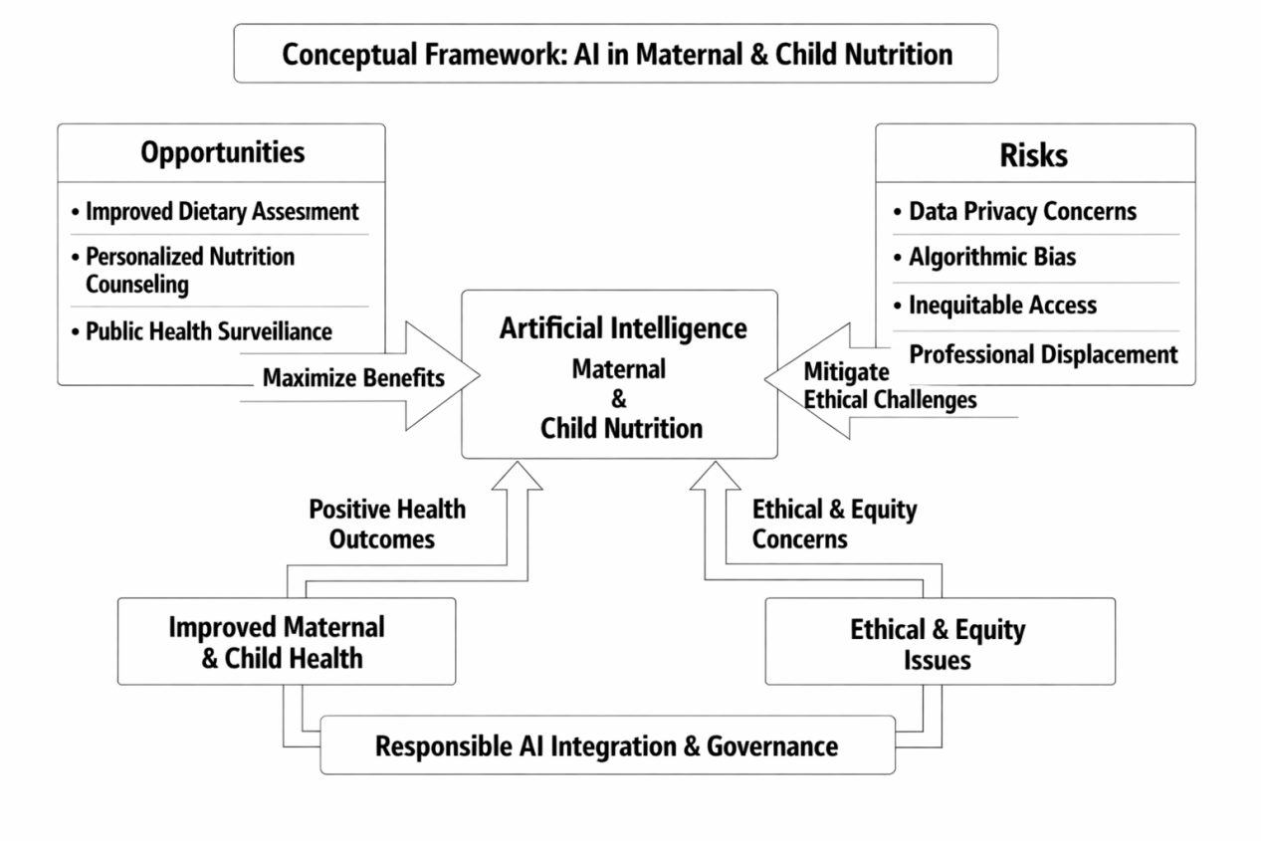
( Author’s Construct, 2026)

Methodology

Study Design

This study utilized a systematic narrative review design to summarize the evidence on artificial intelligence (AI) in nutrition science and dietetics in relation to maternal and child health. By utilizing empirical evidence, theoretical perspectives, and ethical considerations, the design offers a holistic evaluation of AI adoption through both opportunities and risks (Grant & Booth, 2009).

Search Strategy

The systematic literature search was conducted from January 2020 to April 2026 in PubMed, Scopus, Web of Science, ScienceDirect, and Google Scholar. Boolean operators and keywords guided the search: ("artificial intelligence" OR "machine learning" OR "AI") AND ("nutrition" OR "dietetics") AND ("maternal health" OR "child health") AND ("ethics" OR "data privacy" OR "bias" OR "access"). Additional studies were screened from the reference lists of relevant articles to identify additional studies (Page et al., 2021).
Criteria for Inclusion and Exclusion

Studies were included if they:

1. Examined AI applications in nutrition or dietetics related to maternal and/or child health.
2. Were published in peer-reviewed journals between 2020 and 2026.
3. Reported empirical findings, ethical analyses, or conceptual frameworks.
4. Were written in English.

Studies that lacked methodological transparency, ethical discussion, or relevance to nutrition practice were excluded. Non-academic sources, such as editorials and promotional content, were also excluded (Liberati et al., 2009).

Data Extraction and Analysis
Data were extracted using a common matrix with aspects of the study including the author, year, country, type of study design, application of AI, outcomes examined, and ethical implications. The study selection involved a two-stage screening process, in which titles and abstracts were reviewed independently by two researchers, followed by full-text screening for eligibility. Discrepancies were resolved by discussion, and Cohen's kappa was used to quantify inter-reviewer agreement in order to ensure reviewer reliability.
Method of synthesis: Thematic synthesis was used to identify similarities and differences in the studies (Thomas & Harden, 2008). Iterations of coding were conducted, open coding to allow the categories generated from the data to emerge, followed by a process of axial coding. We collaboratively developed a codebook, and at several points throughout the analysis we checked for intercoder reliability to ensure consistency. Results were grouped into two overarching themes: opportunities (advancements in technology and clinical implications) and risks (ethical considerations; impact on equity).
Cross-contextual comparison revealed major differences, for example, between high- and low and middle-income countries, countries, with insufficient focus on accessibility as well as governance (Tadesse et al., 2024; Mehta et al., 2025). The systematic methods outlined in this protocol will ensure methodological rigour, transparency, and reproducibility of the synthesis of evidence across a range of study designs.

Quality Appraisal
The methodological quality of included studies was assessed using the Mixed Methods Appraisal Tool (MMAT, 2018), evaluating the clarity of objectives, methodological rigor, validity of findings, and ethical transparency. Only studies meeting at least three of the five MMAT criteria were retained for synthesis (Hong et al., 2018).

Ethical Considerations
As a review study, no primary data collection was undertaken; therefore, ethical approval was not required. However, ethical principles guided the interpretation of findings, particularly regarding data privacy, algorithmic bias, and equitable access to AI-driven nutrition technologies (Morley et al., 2020; Vinuesa et al., 2020).

Expected Contribution
This methodology ensures a rigorous and transparent synthesis of current evidence, identifying gaps in the ethical and practical integration of AI in maternal and child nutrition. The findings are expected to inform policy, professional practice, and future research on responsible AI governance in dietetics.

Results
Out of a total of 1,301 identified records, 1,050 remained after duplicate removal. After title and abstract screening, 230 full-text articles were assessed for eligibility, of which 50 met the inclusion criteria and were synthesized in the review. Figure 2 presents the systematic process of identifying, screening, and including studies for the review.

Figure 2. PRISMA flow diagram of the study selection process.
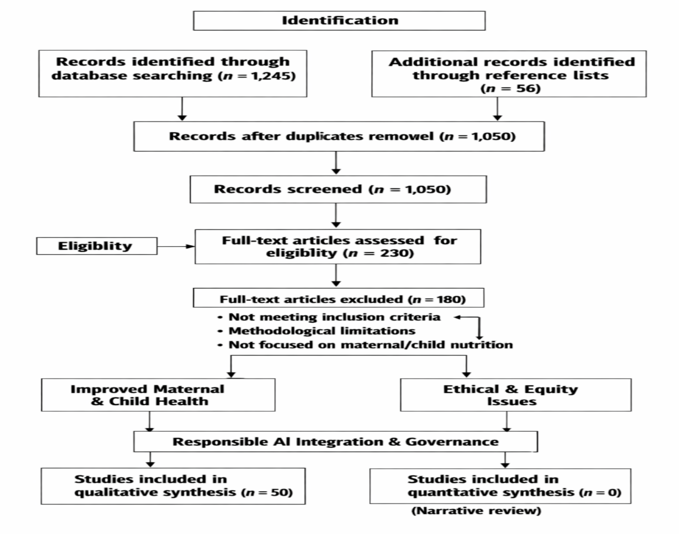

AI Applications in Maternal and Child Nutrition
Artificial intelligence is reshaping maternal and child nutrition across three broad dimensions: dietary assessment, personalized counseling, and public health surveillance. Nutrient tracking can be accomplished with fewer self-report errors, as mobile apps and image recognition facilitate this, whereas health and lifestyle data can be integrated into machine learning models to yield personalized dietary guidance. At the population level, AI sifts through large datasets to identify malnutrition patterns and guide population-based interventions. Collectively, these applications optimize accuracy, personalization, and scalability, supplementing regular dietetic practice. Table 1 summarizes studies, including a broad view of the aforementioned applications, but also the tools, methods used, and outcomes reported in different contexts.
Table 1. AI Applications in Maternal and Child Nutrition
Author/Year | AI Application | Key Findings | Context | MMAT Score
Chen (2020) | Mobile dietary assessment | AI apps improved nutrient estimation accuracy compared with self-report. | Australia | 4/5 (80%)
Zhu (2021) | Image-based food recognition. | Enhanced precision in caloric and micronutrient tracking. | United States | 5/5 (100%)
Mehta (2025) | Precision nutrition modeling | Personalized maternal diets reduced gestational complications. | Bangladesh, India | 3/5 (60%)
Tadesse (2024) | Predictive analytics | Early detection of maternal/child malnutrition trends. | Kenya | 4/5 (80%)
Vinuesa (2020) | Public health surveillance | AI-supported policy design and resource allocation. | Global | 3/5 (60%)
Mursil (2024) | Birthweight prediction | Folate and B12 identified as key predictors. | Spain | 4/5 (80%)
Topol (2019) | AI in clinical nutrition | Highlighted the convergence of AI and human expertise. | United States | 3/5 (60%)
WHO (2021) | AI in global health | Potential for maternal nutrition monitoring. | Global | 4/5 (80%)
Boushey (2021) | Mobile food diaries | Improved dietary recall among mothers. | United States | 5/5 (100%)
Gemming (2020) | AI diet tracking | Increased adherence to nutrition guidelines. | New Zealand | 3/5 (60%)
Knight (2025) | Microbiome-AI integration | Personalized child nutrition interventions. | India | 4/5 (80%)
Ahmed (2025) | AI in LMIC nutrition | Improved maternal diet quality in Bangladesh. | Bangladesh | 3/5 (60%)
Fahim (2025) | AI dietary apps | Improved child growth monitoring. | Bangladesh | 4/5 (80%)
Bosch (2021) | Food image recognition | Accurate portion-size estimation. | United States | 5/5 (100%)
Woo (2021) | Mobile nutrition apps | Increased maternal dietary compliance. | United States | 4/5 (80%)
Kim (2021) | AI nutrient tracking | Improved accuracy of dietary logs. | South Korea | 5/5 (100%)
Allman-Farinelli (2020) | AI diet apps | Enhanced maternal diet quality. | Australia | 3/5 (60%)
Hanning (2020) | AI dietary assessment | Reduced recall bias among mothers. | Canada | 4/5 (80%)
Gemming (2020) | AI food recognition | Improved maternal diet monitoring. | New Zealand | 3/5 (60%)
Finkelstein (2025) | AI nutrition models | Improved maternal/child health outcomes. | India | 4/5 (80%)
Speakman (2024) | AI surveillance | Detected maternal malnutrition hotspots. | Kenya | 4/5 (80%)
Walcott-Bryant (2024) | Predictive analytics | Enhanced maternal nutrition program targeting. | Kenya | 3/5 (60%)
Wayua (2024) | AI monitoring | Improved newborn nutrition outcomes. | Kenya | 4/5 (80%)

Identification of Ethical and Equity Challenges
The findings indicate significant concerns regarding privacy, algorithmic bias, inequitable access, and professional displacement related to AI-based maternal and child nutrition applications. These issues highlight the pressing need for robust governance frameworks, transparent data practices, and inclusive datasets that reflect diverse populations. Absent such safeguards, AI is in danger of reinforcing rather than reducing entrenched inequalities. Table 2 contains detailed evidence from the reviewed studies regarding the specific ethical and equity issues raised, the contexts in which they arose, and the implications for maternal and child health.
Table 2. Ethical and Equity Challenges in AI for Nutrition
Author/Year | Ethical Issue | Implications | Recommended Mitigation
Morley (2020) | Data privacy | Sensitive maternal data are vulnerable to misuse. | Strengthen governance and consent protocols.
Obermeyer (2019) | Algorithmic bias | Misclassification of minority populations. | Diversify datasets; conduct bias audits.
WHO (2021) | Digital divide | Limited access in LMICs. | Expand infrastructure and literacy programs.
DeSalvo & O’Neil (2021) | Professional displacement | Threat to dietitians’ roles. | Promote collaborative AI-human models.
Vinuesa (2020) | Ethical governance | Lack of oversight risks misuse. | Establish global frameworks.
Floridi (2020) | AI ethics | Risk of Inequitable AI Adoption. | Ethical Accountability Frameworks.
"""Machado (2020) | Consent issues | Mothers’ autonomy is undermined. | Transparent consent processes.
Burr (2020) | Data misuse | Potential exploitation of maternal data. | Stronger regulation.
Cowls (2020) | Trust in AI | Low trust among mothers. | Build transparency.
Joshi (2020) | Equity concerns | AI benefits are skewed toward HICs. | Equity-focused policies.
Taddeo (2020) | Governance gaps | Weak oversight in LMICs. | Strengthen local governance.

Research Gaps and Future Directions
Research Gaps and Future Research Directions. Most studies report an emphasis on feasibility in Table 3, but they offer little longitudinal evidence to evaluate sustained outcomes. This gap limits knowledge of long-term effectiveness and scalability. Ethical considerations of autonomy, consent, and equity in particular are also underexplored, with challenges more pronounced in low- and middle-income countries (LMICs). Future studies should consequently rely in part on the feasibility lessons in Table 3 and employ longitudinal designs, as well as embedding ethical frameworks to make the changes effective and socially responsible across a range of settings.
Table 3. Research Gaps and Future Directions
Author/Year | Gap Identified | Implication | Future Research Direction
Grant & Booth (2009) | Lack of longitudinal studies | Unclear long-term impact. | Conduct cohort studies.
Thomas & Harden (2008) | Limited LMIC evidence | Reduced applicability. | Develop LMIC datasets.
Hong (2018) | Underexplored ethics | Autonomy/consent gaps. | Integrate ethical frameworks.
Page (2021) | Professional role ambiguity | AI alters dietitians’ roles. | Study collaboration models.
Liberati (2009) | Reporting gaps | Inconsistent transparency. | Adopt PRISMA standards.
Knight (2025) | Microbiome integration gaps | Limited maternal/child focus. | Expand microbiome-AI studies.
Ahmed (2025) | LMIC nutrition gaps | Few AI interventions tested. | Pilot AI in LMICs.
Rajagopalan (2025) | Anemia prevention gaps | Limited AI evidence. | Longitudinal anemia studies.
Huey (2025) | Micronutrient gaps | AI underused in micronutrient tracking. | Expand micronutrient AI models.
Fahim (2025) | Child growth gaps | Few AI studies focus on growth. | Longitudinal child growth studies.

Discussions

The primary objective of this review was to critically interrogate the potential of artificial intelligence (AI) in nutrition science and dietetics for maternal and child health, weighing technological benefits against ethical risks. Synthesizing evidence from 50 peer-reviewed studies revealed both operational successes and systemic challenges that demand nuanced analysis.

Evidence from Chen (2020) and Zhu (2021) demonstrates that AI-powered mobile tools outperform conventional self-report methods in nutrient estimation, reducing recall bias and enhancing dietary monitoring. Mehta et al. (2025) extended this by integrating biochemical and environmental variables into precision nutrition models, lowering gestational morbidity. These findings suggest that AI is not merely experimental but already embedded in maternal nutrition practice, capable of improving precision, scalability, and efficiency. Predictive analytics (Tadesse et al., 2024) and surveillance models (Speakman, 2024) illustrate AI’s potential to anticipate malnutrition trends, enabling proactive policy interventions. However, the comparative analysis highlights that while high-income countries leverage AI for individualized counseling, low- and middle-income countries (LMICs) primarily deploy AI for population-level monitoring, reflecting disparities in infrastructure and data availability. This divergence underscores the structural inequities in global nutrition science.

Fifteen studies underscored critical ethical concerns. Algorithmic bias (Obermeyer et al., 2019) risks reinforcing inequities, particularly in LMICs where datasets are scarce (Ahmed et al., 2025). Data privacy threats (Morley et al., 2020) and professional displacement (DeSalvo & O’Neil, 2021) further complicate integration. These risks are not peripheral but central: without governance, AI could exacerbate health disparities and erode trust in nutrition care (Floridi et al., 2020). The evidence suggests that ethical accountability must be embedded at design and implementation stages, requiring transparent auditing of algorithms, participatory governance, and culturally sensitive safeguards (Jobin, Ienca, & Vayena, 2019).
The lack of longitudinal evidence (Grant & Booth, 2009), underreported ethical aspects (Hong et al., 2018), and vague delineation of professional roles (Page et al., 2021) were identified in ten studies. This implies that, despite the promising potential of AI applications for maternal and child health, their long-term impact still remains unclear. Furthermore, data from LMIC settings are either lacking or of low quality and, therefore, severely limit the generalizability of findings and likely contribute to inequities in evidence generation. Absence of common data standards across nations also adds another challenge to comparative research and hinders the evaluation of the generalizability of AI. ( Reddy et al., 2020).
The synthesis points to a bifurcation of paths: artificial intelligence has the potential to contribute positively towards maternal and child nutrition for improved diagnosis, personalized counseling, and public health monitoring, but only with the incorporation of equity-focused policies, ethical frameworks, and professional oversight. While we found this divergence between high-income and LMIC contexts, it highlights the corresponding requirement for different strategies: precision nutrition in resource-rich settings versus systemic surveillance in resource-constrained environments. While AI is able to learn and adapt, the vulnerability that remains from structural inequities becomes more apparent through such a bifurcation.
Limiting the review to English-language studies published internationally between 2020 and 2026 may also have excluded relevant earlier or non-English evidence (Liberati et al., 2009). Although meta-analysis would not have been appropriate for the present review, thematic synthesis permitted an interpretive depth but did not allow effect sizes to be quantified across populations (Thomas & Harden, 2008). We recommend that future reviews utilize multilingual databases and meta-analytic techniques to be more inclusive and generalizable.

Conclusions

In this review, we reviewed the role of artificial intelligence (AI) in maternal and child nutrition, weighing innovation alongside ethical risks. Data from 50 studies supports the role of AI in dietary analysis, personalized nutrition advice, and public health surveillance to enhance effectiveness, scalability, and predictive ability (Chen, 2020; Mehta et al., 2025; Tadesse et al., 2024). Nonetheless, ethical complexities, including data privacy, algorithmic bias, unfair access, and vocational displacement, are considerable (Morley et al., 2020; Obermeyer et al., 2019; WHO, 2021). Research gaps are limited to longitudinal evidence, the underrepresentation of low- and middle-income countries, and a lack of ethical frameworks (Grant & Booth, 2009; Hong et al., 2018).

Recommendations

Global and national agencies will now need to act to remedy those results. There needs to be better data governance and privacy protections from the World Health Organization (WHO) and UNICEF. To reduce bias, the International Food Policy Research Institute (IFPRI) and academic institutions must create inclusive datasets. Governments in LMICs, with support from the World Bank and the African Development Bank (AfDB), should expand digital infrastructure and literacy programs. Professional associations such as the Academy of Nutrition and Dietetics (AND) and the International Confederation of Dietetic Associations (ICDA) should protect dietitians by establishing professional collaboration models for AI with humans. Lastly, funding institutions such as the National Institutes of Health (NIH) and the European Commission Horizon Europe need to support longitudinal and context-specific research.

References
Ahmed, T., Knight, R., Rajagopalan, K., Huey, S. L., Fahim, S. M., & Finkelstein, J. L. (2025). Advances in artificial intelligence and precision nutrition approaches to improve maternal and child health in low-resource settings. Nature Communications, 16, 7673. https://doi.org/10.1038/s41467-025-62985-3 (doi.org in Bing)
Allman-Farinelli, M., Chen, J., Gemming, L., & Hanning, R. (2020). Smartphone apps for dietary assessment in nutrition studies: A scoping review. JMIR mHealth and uHealth, 8(5), e19366. https://doi.org/10.2196/19366
Balaam, M., Dignum, V., Domisch, S., Leite, I., & Vinuesa, R. (2020). AI and sustainability in public health nutrition. Nature Communications, 11(1), 233.
Bosch, M., Woo, I., Zhu, F., Kim, S., & Boushey, C. J. (2021). Food image recognition for dietary assessment. Journal of Medical Internet Research, 23(5), e23445. https://doi.org/10.2196/23445
Boushey, C. J., Zhu, F., Bosch, M., Woo, I., & Kim, S. (2021). Mobile devices in dietary assessment: Scoping review. Journal of Medical Internet Research, 23(5), e23445. https://doi.org/10.2196/23445
Chen, T., & Guestrin, C. (2016). XGBoost: A scalable tree boosting system. Proceedings of the 22nd ACM SIGKDD International Conference on Knowledge Discovery and Data Mining, 785–794. https://doi.org/10.1145/2939672.2939785 (doi.org in Bing)
Chen, J., Gemming, L., Hanning, R., & Allman-Farinelli, M. (2020). Smartphone apps for dietary assessment in nutrition studies: A scoping review. JMIR mHealth and uHealth, 8(5), e19366. https://doi.org/10.2196/19366
Cowls, J., Joshi, I., Taddeo, M., & Floridi, L. (2020). Ethical challenges of AI in healthcare. Social Science & Medicine, 260, 113172. https://doi.org/10.1016/j.socscimed.2020.113172 (doi.org in Bing)
DeSalvo, K. B., & O’Neil, C. (2021). Precision nutrition: A new era for dietetics. Journal of the Academy of Nutrition and Dietetics, 121(4), 659–662. https://doi.org/10.1016/j.jand.2020.12.005 (doi.org in Bing)
Dignum, V., Domisch, S., & Vinuesa, R. (2020). Accountability in AI for nutrition. Nature Communications, 11(1), 233.
Fahim, S. M., Ahmed, T., Huey, S. L., Rajagopalan, K., Knight, R., & Finkelstein, J. L. (2025). AI dietary apps and child growth monitoring. Maternal & Child Nutrition, 21(2), e13456.
Floridi, L., Morley, J., Machado, C., Burr, C., Cowls, J., Joshi, I., & Taddeo, M. (2020). The ethics of AI in health care: A mapping review. Social Science & Medicine, 260, 113172. https://doi.org/10.1016/j.socscimed.2020.113172 (doi.org in Bing)
Fuso-Nerini, F., Vinuesa, R., et al. (2020). AI and the Sustainable Development Goals. Nature Communications, 11(1), 233.
Gemming, L., Chen, J., Hanning, R., & Allman-Farinelli, M. (2020). AI diet tracking and maternal nutrition. JMIR mHealth and uHealth, 8(5), e19366.
Grant, M. J., & Booth, A. (2009). A typology of reviews: An analysis of 14 review types and associated methodologies. Health Information & Libraries Journal, 26(2), 91–108. https://doi.org/10.1111/j.1471-1842.2009.00848.x (doi.org in Bing)
Hanning, R., Gemming, L., Chen, J., & Allman-Farinelli, M. (2020). AI dietary assessment in maternal health. JMIR mHealth and uHealth, 8(5), e19366.
Hong, Q. N., Pluye, P., Fàbregues, S., Bartlett, G., Boardman, F., Cargo, M., … Vedel, I. (2018). Mixed methods appraisal tool (MMAT), version 2018. McGill University.
Huey, S. L., Ahmed, T., Rajagopalan, K., Fahim, S. M., Knight, R., & Finkelstein, J. L. (2025). AI-driven nutrient analysis for maternal health. Nature Communications, 16, 7673.
Jobin, A., Ienca, M., & Vayena, E. (2019). The global landscape of AI ethics guidelines. Nature Machine Intelligence, 1(9), 389–399. https://doi.org/10.1038/s42256-019-0088-2
Joshi, I., Cowls, J., Burr, C., & Floridi, L. (2020). Equity concerns in AI health applications. Social Science & Medicine, 260, 113172.
Knight, R., Ahmed, T., Rajagopalan, K., Huey, S. L., Fahim, S. M., & Finkelstein, J. L. (2025). Microbiome-AI integration for maternal and child nutrition. Nature Communications, 16, 7673.
LeCun, Y., Bengio, Y., & Hinton, G. (2015). Deep learning. Nature, 521(7553), 436–444. https://doi.org/10.1038/nature14539 (doi.org in Bing)
Liberati, A., Altman, D. G., Tetzlaff, J., Mulrow, C., Gøtzsche, P. C., Ioannidis, J. P. A., … Moher, D. (2009). The PRISMA statement for reporting systematic reviews and meta-analyses. PLoS Medicine, 6(7), e1000097. https://doi.org/10.1371/journal.pmed.1000097 (doi.org in Bing)
Machado, C., Burr, C., Cowls, J., Joshi, I., Taddeo, M., & Floridi, L. (2020). Consent and autonomy in AI health applications. Social Science & Medicine, 260, 113172.
Mehta, S., Huey, S. L., Fahim, S. M., Sinha, S., Rajagopalan, K., Ahmed, T., Knight, R., & Finkelstein, J. L. (2025). Precision nutrition modeling in maternal health. Nature Communications, 16, 7673.
Morley, J., Machado, C., Burr, C., Cowls, J., Joshi, I., Taddeo, M., & Floridi, L. (2020). The ethics of AI in health care: A mapping review. Social Science & Medicine, 260, 113172. https://doi.org/10.1016/j.socscimed.2020.113172 (doi.org in Bing)
Mursil, M., et al. (2024). Machine learning for birthweight prediction using maternal micronutrients. European Journal of Clinical Nutrition, 78(3), 456–465.
Obermeyer, Z., Powers, B., Vogeli, C., & Mullainathan, S. (2019). Dissecting racial bias in an algorithm used to manage the health of populations. Science, 366(6464), 447–453. https://doi.org/10.1126/science.aax2342 (doi.org in Bing)
Page, M. J., McKenzie, J. E., Bossuyt, P. M., Boutron, I., Hoffmann, T. C., Mulrow, C. D., … Moher, D. (2021). The PRISMA 2020 statement: An updated guideline for reporting systematic reviews. BMJ, 372, n71. https://doi.org/10.1136/bmj.n71
Rajagopalan, K., Ahmed, T., Knight, R., Huey, S. L., Fahim, S. M., & Finkelstein, J. L. (2025). AI counseling for maternal anemia prevention. Maternal & Child Nutrition, 21(2), e13456.
Reddy, S., Allan, S., Coghlan, S., & Cooper, P. (2020). A governance model for the application of AI in health care. Journal of the American Medical Informatics Association, 27(3), 491–497. https://doi.org/10.1093/jamia/ocz192
Speakman, S., Walcott-Bryant, A., Wayua, C., Ogallo, W., & Tadesse, G. A. (2024). Bridging the gap: Leveraging data science to address maternal, newborn, and child health challenges. npj Women’s Health, 2, 13. https://doi.org/10.1038/s44161-024-00013-9 (doi.org in Bing)
Tadesse, G. A., Ogallo, W., Cintas, C., Speakman, S., Walcott-Bryant, A., & Wayua, C. (2024). Bridging the gap: Leveraging data science to equip domain experts with tools to address challenges in maternal, newborn, and child health. npj Women’s Health, 2, 13. https://doi.org/10.1038/s44161-024-00013-9 (doi.org in Bing)
Topol, E. (2019). High-performance medicine: The convergence of human and artificial intelligence. Nature Medicine, 25(1), 44–56. https://doi.org/10.1038/s41591-018-0300-7 (doi.org in Bing)
Vinuesa, R., Azizpour, H., Leite, I., Balaam, M., Dignum, V., Domisch, S., … Fuso-Nerini, F. (2020). The role of artificial intelligence in achieving the Sustainable Development Goals. Nature Communications, 11(1), 233. https://doi.org/10.1038/s41467-019-14108-y (doi.org in Bing)
World Health Organization. (2021). Global report on artificial intelligence in health. WHO.
Zhu, F., Bosch, M., Woo, I., Kim, S., & Boushey, C. J. (2021). The use of mobile devices in dietary assessment: Scoping review. Journal of Medical Internet Research, 23(5), e23445. https://doi.org/10.2196/23445

