Comparative Analysis of EdTech Readiness in Sierra Leone and Ghana: Temporal Alignment, Policy Trajectories, and System-Level Constraints.

ABSTRACT
This study compares EdTech readiness in Sierra Leone and Ghana using the World Bank EdTech Readiness Index (ETRI) framework while explicitly addressing a central methodological problem: the two country profiles are not synchronous. Sierra Leone’s evidence was collected in 2022 and published in a 2025 technical note, whereas Ghana’s October 2025 report applies ETRI 2.0 and includes additional hybrid-learning indicators. Therefore, the paper does not present the two countries as a ranked performance comparison. Instead, it interprets the evidence as a trajectory-sensitive comparison of two systems at different stages of digital education development. Drawing on the official ETRI reports, national policy documents, and peer-reviewed scholarship on technology integration, teacher capacity, and digital equity, the study compares only overlapping indicators across six pillars: school management, teachers, students, devices, connectivity, and digital educational resources. The findings show that Ghana demonstrates stronger readiness across most comparable indicators, especially school leadership, teacher self-efficacy, teacher planning, curriculum awareness, and digital resource use. Sierra Leone’s 2022 baseline shows very low school-level implementation, particularly in device availability, connectivity, teacher use, student access, and digital educational resources. The analysis argues that policymakers should interpret these differences through policy maturity, infrastructure investment, governance capacity, and equity. Ghana illustrates the opportunities and limits of a longer ICT-in-education trajectory: readiness improves, but device sufficiency, connectivity quality, technical support, and disability inclusion remain weak. Sierra Leone illustrates the value of a pre-strategy baseline for guiding implementation of the National Digital Learning Strategy 2025-2030. The study contributes a cautious comparative approach and proposes a future monitoring framework for African EdTech readiness assessment.

Keywords: EdTech readiness, Sierra Leone, Ghana, ETRI, digital learning, policy implementation, teacher capacity, digital equity

INTRODUCTION
Educational technology has become a major feature of education reform because digital tools can support access, teacher development, school management, assessment, continuity of learning, and curriculum delivery. However, digital technology does not, by itself, produce improvements in teaching or learning outcomes. In low- and middle-income education systems, effective use depends on readiness: infrastructure must be available and functional, teachers must be able to integrate digital resources into pedagogy, school leaders must organize implementation, and governments must address inequities in access and use (Ertmer, 1999; Hew & Brush, 2007; Tondeur et al., 2017).
The World Bank EdTech Readiness Index (ETRI) offers a structured way to examine these enabling conditions. ETRI organizes readiness across six pillars: school management, teachers, students, devices, connectivity, and digital educational resources. It also distinguishes between practice, policy awareness, and formal policy existence. This distinction is important because many systems possess digital education policies but lack the school-level capacity, resources, monitoring, and instructional routines needed to translate policy into practice (Kozma, 2008; World Bank, 2025a).
This study compares Sierra Leone and Ghana, two English-speaking West African countries for which recent ETRI evidence is available. The comparison is policy-relevant because both countries are attempting to expand digital learning, but their ETRI profiles reflect different moments in national policy development. Sierra Leone’s ETRI evidence was collected in 2022 through school and policy surveys and later published in 2025. Ghana’s ETRI report was published in October 2025 and applies ETRI 2.0, which expands the original framework by incorporating hybrid-learning indicators and additional instruments (World Bank, 2025a; Lambert-Porter et al., 2025).
The temporal and methodological differences are central to this study. Ghana’s results should be read against a longer ICT-in-education policy trajectory that includes the 2015 ICT in Education Policy and the Education Strategic Plan 2018-2030 (Ministry of Education, Ghana, 2015, 2019). Sierra Leone’s 2022 baseline, by contrast, predates the National Digital Learning Strategy 2025-2030 (World Bank, 2025b). A direct score-by-score ranking would therefore risk overinterpretation. This study instead treats the evidence as a bounded comparison of readiness trajectories: Ghana represents a more policy-mature but still uneven system, while Sierra Leone represents a baseline-stage system entering a new strategic implementation period.
The study contributes to comparative EdTech scholarship in three ways. First, it provides a cautious comparison of Sierra Leone and Ghana using only overlapping ETRI indicators. Second, it clarifies how temporal alignment, ETRI version differences, and policy maturity should shape cross-country interpretation. Third, it strengthens the originality of the analysis by proposing a future comparative monitoring framework that can help African education systems track readiness more consistently over time.

RESEARCH QUESTIONS
The paper is guided by the following research questions:
- How do Sierra Leone and Ghana compare across the overlapping ETRI pillars of school management, teachers, students, devices, connectivity, and digital educational resources?
- How does the difference in reporting years and ETRI versions affect the interpretation of the comparison?
- What does the comparison reveal about the role of policy continuity, infrastructure growth, teacher capacity, and digital equity in national EdTech readiness?
- What policy implications can be drawn for Sierra Leone and Ghana when the comparison is interpreted as a developmental trajectory rather than a strict cross-sectional ranking?

LITERATURE REVIEW AND CONCEPTUAL FRAMEWORK

EdTech readiness as a system-level construct
EdTech readiness is best understood as a system-level construct rather than a count of computers, tablets, or internet connections. Devices and connectivity are necessary but insufficient. Readiness also requires leadership, teacher competence, technical support, relevant digital resources, curriculum alignment, student access, and an equity-oriented implementation architecture. This argument is consistent with research on technology integration, which distinguishes first-order barriers such as infrastructure and technical support from second-order barriers such as teacher beliefs, confidence, and pedagogical practice (Ertmer, 1999; Ertmer & Ottenbreit-Leftwich, 2010).
ETRI reflects this systemic logic. Its six pillars represent a chain of enabling conditions: school leaders plan and prioritize technology use; teachers use digital tools for preparation, teaching, and assessment; students access technology inside and outside school; devices are available and functional; connectivity is reliable enough to support teaching and learning; and digital educational resources are accessible, curriculum-aligned, locally relevant, and inclusive (World Bank, 2025a; Lambert-Porter et al., 2025).

Policy continuity, governance capacity, and implementation
The literature on ICT-in-education policy emphasizes that policy design does not automatically produce classroom use. National policies are more likely to influence practice when they are connected to financing, teacher professional development, curriculum standards, infrastructure planning, assessment, technical support, and monitoring (Kozma, 2008). Where these conditions are weak, policy may operate mainly as a statement of aspiration. Therefore, policy maturity should be evaluated not only by the existence of a strategy but also by the degree to which responsibilities, resources, implementation mechanisms, and accountability structures reach schools.
This point is especially relevant for comparing Ghana and Sierra Leone. Ghana’s 2025 ETRI profile follows a decade of policy activity since the 2015 ICT in Education policy and the Education Strategic Plan 2018-2030. Sierra Leone’s 2022 ETRI profile precedes the National Digital Learning Strategy 2025-2030. The comparison, therefore, examines how different policy trajectories correspond to readiness outcomes while avoiding claims that the two reports provide a synchronized measurement of current performance.

Teacher capacity and pedagogical integration
Teacher capacity remains one of the most important predictors of meaningful technology use. Teachers require more than technical exposure; they need confidence, pedagogical models, curriculum-linked examples, ongoing support, and opportunities to integrate digital tools into assessment, collaboration, and learner-centered activities (Ertmer & Ottenbreit-Leftwich, 2010; Tondeur et al., 2017). A common pattern in education systems is that teachers use technology first for personal productivity and lesson preparation before using it deeply for instruction. This distinction is important in the ETRI comparison because Ghana’s teacher self-efficacy and planning indicators are substantially stronger than Sierra Leone’s, yet Ghana’s classroom-use indicators remain comparatively modest.

Digital equity and inclusive readiness
Digital equity requires attention to access, use, and outcomes. It is not enough to ask whether schools have devices or internet. Readiness must also consider which learners can use technology, how often they use it, whether resources are accessible to students with disabilities, whether rural and low-resource schools are included, and whether digital use supports learning rather than reproducing inequality (Warschauer & Matuchniak, 2010). This equity perspective is central because both ETRI reports show that access and inclusion remain uneven, even where policy awareness or teacher confidence improves.

A trajectory-sensitive conceptual model
Figure 1 summarizes the analytical framework used in this study. The framework connects three interpretive inputs-temporal alignment, policy trajectory, and infrastructure base-to school-level implementation and equity outcomes. It then treats readiness outcomes as developmental stages rather than fixed national rankings. The final component is future monitoring, because the value of baseline ETRI evidence depends on whether education systems use it to track progress in comparable cycles.

Figure 1. Trajectory-sensitive EdTech readiness framework.
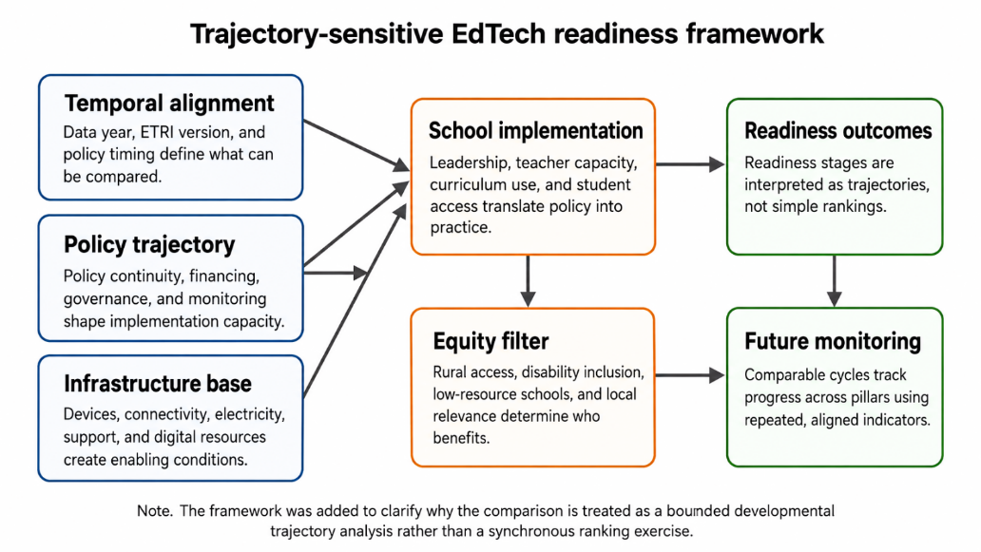

METHODOLOGY

Research design
This study uses a qualitative comparative desk-review design based on secondary data. It is not a statistical meta-analysis and does not calculate a new official ETRI ranking. Instead, it uses official ETRI reports and policy documents to identify patterns, contrasts, and implementation implications. This design is appropriate because the two country reports differ in timing, ETRI version, and some methodological features.
A strict cross-sectional ranking would be methodologically inappropriate. Sierra Leone’s school survey was conducted in May-June 2022 and its policy survey in September 2022, while Ghana’s report was published in October 2025 using ETRI 2.0. Therefore, the analysis compares only overlapping within-school indicators and interprets differences as directional evidence of system trajectories rather than synchronized national performance estimates (World Bank, 2025a; Lambert-Porter et al., 2025).

Data sources and selection of comparable indicators
The primary sources are the Sierra Leone ETRI technical note and the Ghana ETRI report. The Sierra Leone ETRI evidence was collected as part of the Global Education Policy Dashboard. Its school survey covered 300 primary schools across the four provinces and Western Area using stratified random selection with probability proportional to school size; its policy survey was conducted through legislative review by a local consultant (World Bank, 2025a). The Ghana report presents Ghana’s readiness to use technology in schools and applies ETRI 2.0, which includes additional practice and policy indicators focused on hybrid learning, a student survey, and a school checklist (Lambert-Porter et al., 2025).
Supplementary policy sources include Sierra Leone’s Education Sector Plan 2022-2026 and National Digital Learning Strategy 2025-2030, Ghana’s ICT in Education Policy 2015, Ghana’s Education Strategic Plan 2018-2030, and Ghana’s draft EdTech strategy overview (Government of Sierra Leone, 2022; Ministry of Education, Ghana, 2015, 2019; World Bank, 2025b, 2025c). Peer-reviewed literature was used to frame the interpretation of technology integration barriers, teacher capacity, policy implementation, and digital equity.
To reduce overinterpretation, the study excludes indicators that appear only in Ghana’s ETRI 2.0 hybrid-learning extension. Comparable indicators were selected from the overlapping pillars: school strategy, leadership, prioritization, teacher self-efficacy, teacher use for planning and teaching, student self-efficacy and use, device access and support, connectivity availability and quality, and digital educational resource access, use, and quality.

Temporal and methodological alignment
Table 1 presents the alignment logic. Sierra Leone is interpreted as a 2022 baseline-stage case because its ETRI evidence predates the National Digital Learning Strategy 2025-2030. Ghana is interpreted as a later-stage, policy-mature case because its ETRI evidence follows a longer ICT-in-education policy trajectory. This approach preserves comparability while preventing the analysis from treating non-synchronous data as if they were collected under identical conditions.
Table 1. Temporal and methodological alignment of the two ETRI reports.
Dimension | Sierra Leone ETRI | Ghana ETRI | Implication for comparison
Data/report period | School survey: May-June 2022; policy survey: September 2022; technical note published in 2025. | Report published in October 2025. | The comparison is temporally uneven and must be interpreted as trajectory evidence rather than a synchronized ranking.
ETRI version | The original ETRI framework focused on six pillars and policy/practice alignment. | ETRI 2.0 includes additional hybrid-learning indicators, a student survey, and a school checklist. | Only overlapping within-school indicators are compared.
Policy context at the time of evidence | ETRI evidence predates the National Digital Learning Strategy 2025-2030. | ETRI evidence follows a decade of policy activity since the ICT in Education Policy of 2015. | Sierra Leone is analyzed as a baseline-stage system and Ghana as a more policy-mature system.
Analytical stance | Baseline readiness evidence. | Later-stage readiness evidence with hybrid-learning monitoring. | The study emphasizes trends, readiness stages, implementation constraints, and future monitoring.

Note. Source data are drawn from the Sierra Leone and Ghana ETRI reports (World Bank, 2025a; Lambert-Porter et al., 2025), with policy context from the Government of Sierra Leone (2022), the Ministry of Education, Ghana (2015, 2019), and the World Bank (2025b, 2025c).

Figure 2. Temporal positioning of policy and ETRI evidence.
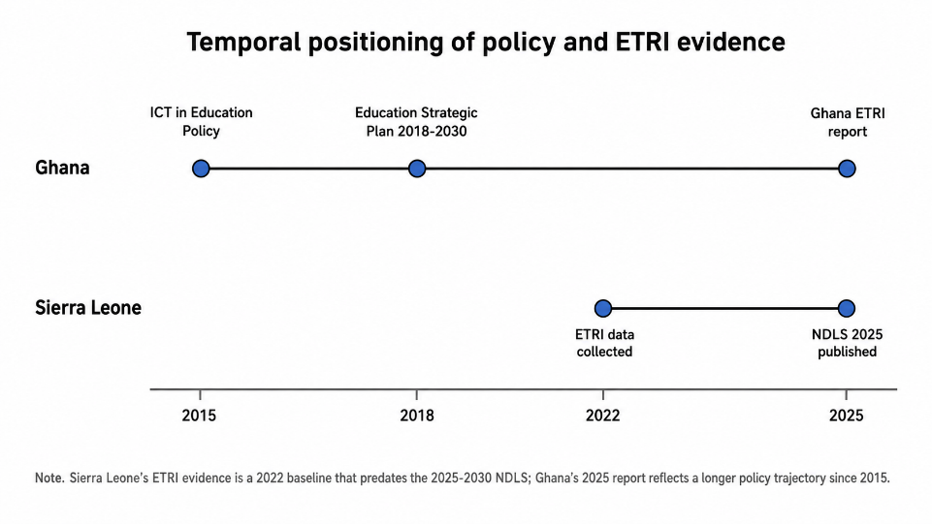

FINDINGS AND COMPARATIVE ANALYSIS

Overall readiness pattern: baseline constraints and uneven maturity
Across the comparable ETRI indicators, Ghana shows higher readiness than Sierra Leone. The most pronounced differences appear in school management, teacher self-efficacy, teacher planning, curriculum awareness, connectivity availability, and digital resource use. Sierra Leone’s 2022 baseline shows very low implementation across nearly all pillars. This does not mean that Ghana has achieved full digital readiness or that Sierra Leone’s current post-strategy position is unchanged. Rather, the results indicate different readiness stages: Sierra Leone’s constraints are primarily foundational, whereas Ghana’s limitations are increasingly related to quality, sufficiency, instructional depth, technical support, and inclusion.
The directional comparison is summarized in Table 2 and Figures 3-5. These figures should be interpreted cautiously. They use overlapping sub-indicators and directly reported percentages to support comparative interpretation, not to create a new official ETRI index.
Table 2. Overlapping ETRI sub-indicator scores used for directional comparison.
Pillar | Sub-indicator | Sierra Leone’s score | Ghana’s  score | Analytical interpretation
School management | School strategy | 2.1 | 3.46 | Ghana shows stronger school-level planning.
School management | Leadership | 2.0 | 3.77 | Ghana shows stronger principal engagement.
School management | Prioritization | 2.4 | 4.69 | Ghanaian principals place a higher priority on ICT skills.
Teachers | Self-efficacy | 1.5 | 4.27 | The largest teacher-related gap is confidence.
Teachers | Use for planning | 1.1 | 3.27 | Ghanaian teachers use ICT more for preparation.
Teachers | Use for teaching | 1.0 | 1.87 | Teaching use is weak in both countries, especially in Sierra Leone.
Students | Self-efficacy | 1.1 | 2.31 | Student digital skill perceptions remain low in both but are lower in Sierra Leone.
Students | Use inside the school | 1.0 | 1.59 | Classroom use remains limited in both countries.
Students | Use outside school | 1.0 | 2.07 | Ghana shows more out-of-school use.
Devices | Student access | 1.3 | 2.49 | Ghana has more devices, but insufficiency remains.
Devices | Student use | 1.0 | 1.82 | Ghana shows partial use; Sierra Leone shows near absence.
Devices | Technical support | 1.5 | 2.06 | Technical support is weak in both.
Connectivity | Availability | 1.0 | 2.70 | Ghana has more school internet access.
Connectivity | Student access | 1.3 | 1.49 | Both countries struggle to connect student devices.
Connectivity | Quality | 1.6 | 2.00 | Quality remains weak even where access exists.
Digital resources | Access | 1.5 | 1.92 | Access remains weak in both.
Digital resources | Use | 1.0 | 1.85 | Ghana shows more digital resource use.
Digital resources | Quality | 1.6 | 2.33 | Ghana reports stronger but still modest resource quality.

Note. Scores are reported on the ETRI 1-5 scale. Values are drawn from the Sierra Leone and Ghana ETRI reports and compared only for overlapping within-school indicators (World Bank, 2025a; Lambert-Porter et al., 2025).

Figure 3. Average practice scores across overlapping ETRI pillars.
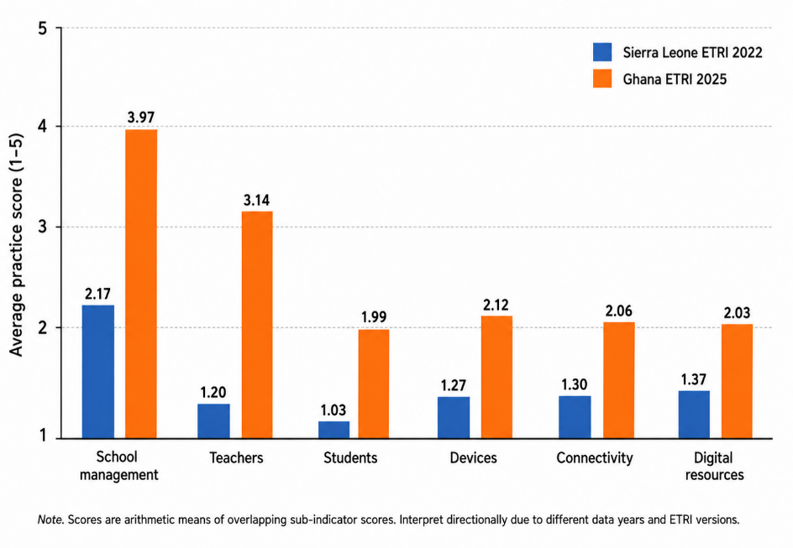

Figure 4. Average policy scores across overlapping ETRI pillars.
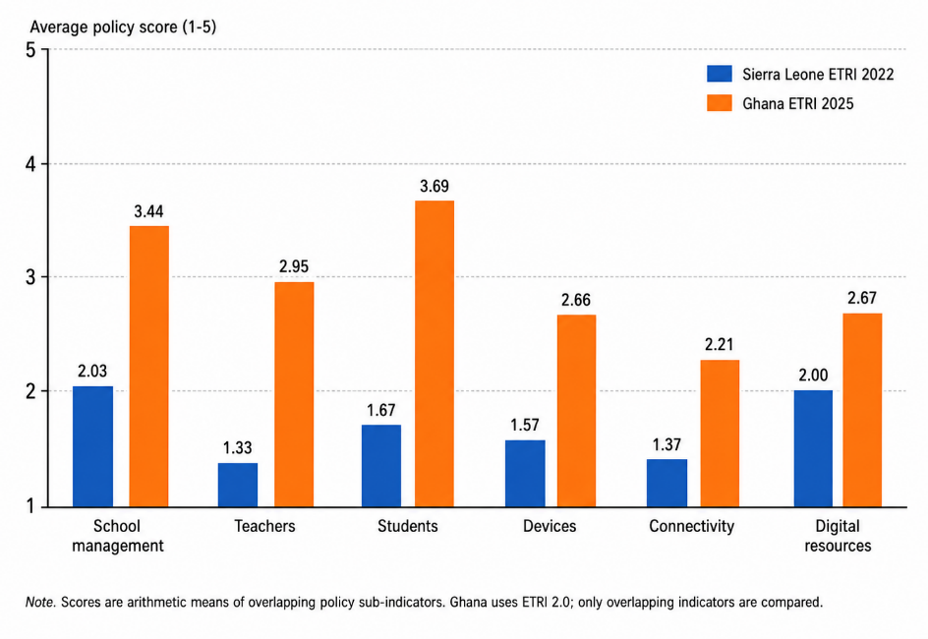

Table 3. Selected directly reported ETRI percentages.
Indicator | Sierra Leone | Ghana | Interpretation
Principals reporting a digital strategy or ICT plan | 25% | 75% | Ghana shows stronger school-level planning.
Principals involving teachers in ICT plan development | 13% | 92% | Ghana shows broader participatory leadership.
Principals are aware of ICT teaching guidelines | 7% | 52% | Policy communication is stronger in Ghana.
Teachers whose initial training included ICT use generally | 9% | 68% | Ghana has broader teacher exposure to ICT training.
Teachers whose initial training included ICT in teaching | 4% | 63% | Ghana has stronger pedagogical ICT training exposure.
Teachers using ICT to present information during instruction | 0% | 29% | Ghana has more classroom use, but use remains limited.
Teachers searching for digital content for class planning | 1% | 59% | Ghana’s planning use is far higher.
Schools with internet access | 1% | 42.6% | Connectivity is a foundational Sierra Leone constraint.
Principals reporting sufficient technical support for devices | 4% | 24% | Technical support remains weak in both.
Teachers using textbook-linked digital resources | 1% | 70% | Ghana has stronger digital resource use.
Digital resources adapted for students with disabilities | 7% | 8% | Both countries show weak disability inclusion in digital resources.

Note. The table includes selected percentages reported in the ETRI reports. Differences should be read as directional evidence of readiness trajectories, not synchronized cross-sectional estimates.

Figure 5. Selected comparable ETRI indicators from the two reports.
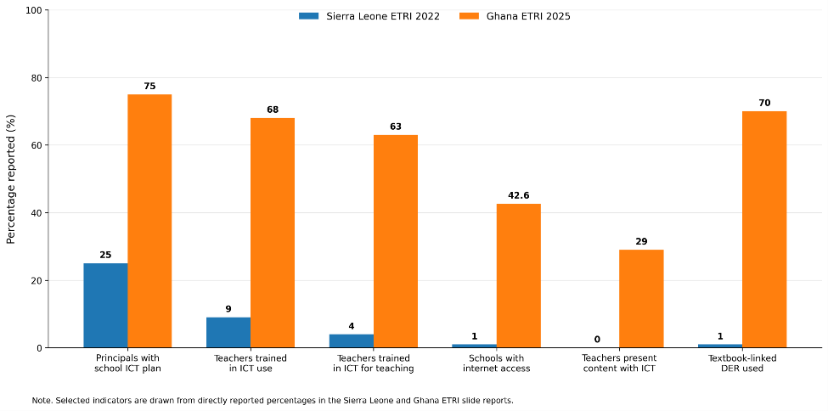

School management and leadership
School management is the strongest comparative domain for Ghana and one of the few entry points for Sierra Leone. In Sierra Leone, scores for school management practices were low: school strategy scored 2.1, leadership 2.0, and prioritization 2.4. However, the policy-awareness indicator for responsibility scored 3.4, suggesting that some principals recognized formal responsibility for ICT integration even where implementation remained weak. In practical terms, 25% of principals reported having a digital strategy or ICT plan, while 60% reported having assigned responsibility for incorporating ICT into school strategic plans (World Bank, 2025a).
Ghana’s school-management indicators were substantially stronger. Ghana scored 3.46 on school ICT strategy, 3.77 on leadership, and 4.69 on prioritization. Seventy-five percent of principals reported having a digital strategy or plan, 92% involved teachers in planning, 91% supported teachers in trying new ICT-based teaching approaches, and 94% reported school-level discussions about ICT advantages and disadvantages (Lambert-Porter et al., 2025).
The analytical implication is that Ghana’s longer policy trajectory appears to have penetrated school leadership routines more strongly than Sierra Leone’s pre-strategy baseline. Yet Ghana’s readiness is incomplete: only 43% of principals reported ICT training in the previous 12 months, and only 34% reported that such training was required. Ghana, therefore, demonstrates stronger leadership awareness but not fully institutionalized leadership development. Sierra Leone’s post-2025 strategy should use school leadership as a bridge between national policy and classroom practice; Ghana should strengthen accountability for implementation quality and support for under-resourced schools.

Teacher capacity, self-efficacy, and classroom use
The teacher pillar shows the clearest contrast between foundational readiness and intermediate readiness. Sierra Leone’s 2022 results show extremely limited teacher ICT use. Teachers reported 0% use of ICT during direct instruction across several classroom indicators, including presenting information, asking students to search for information, asking students to present results using ICT, and assessing learning with digital tools. Lesson-planning indicators were also minimal: only 1% reported searching for content for class, 3% reported sharing educational content with other teachers, and 1% reported preparing presentations for teaching (World Bank, 2025a).
Teacher confidence in Sierra Leone was similarly low. Only 4% of teachers reported confidence in contributing to online discussions, 5% in producing presentations, 7% in preparing lessons where students use ICT, and 5% in assessing learning with ICT. Training exposure was also weak: 9% reported that initial training included general ICT use, and 4% reported that initial training included ICT use for teaching (World Bank, 2025a).
Ghana’s teacher indicators show a different readiness stage. Teacher self-efficacy scored 4.27, with high reported confidence in online discussion, presentation production, lesson preparation, spreadsheet use, ICT-based assessment, and digital collaboration. Use for planning was also much higher than Sierra Leone’s: 59% searched for content for class, 35% shared educational content, 37% prepared presentations, and 63% expanded their ICT knowledge. However, Ghana’s use for teaching scored only 1.87, meaning classroom integration remained weaker than teacher confidence and planning (Lambert-Porter et al., 2025).
This pattern supports the distinction between technical confidence and pedagogical transformation. Ghanaian teachers appear more ready to use technology for preparation and professional productivity, but classroom-level integration remains uneven. Sierra Leone’s priority is to build foundational digital competence, access, and pedagogical examples together. Ghana’s priority is to shift teacher development from confidence and planning toward curriculum-linked, student-centered instructional use.

Student readiness and digital use
Student readiness reflects the combined effects of teacher practice, device availability, connectivity, curriculum expectations, and household access. Sierra Leone’s indicators were almost absent. Teachers reported 0% student use of digital devices during most or every lesson for searching information, project communication, sharing assignment results, submitting work, evaluating information, and producing digital products. They also reported 0% out-of-school use for schoolwork, learning apps, communication with teachers, and homework on digital devices. Student self-efficacy was extremely low, with only 1-3% of teachers believing that at least half of students could perform basic digital tasks (World Bank, 2025a).
Ghana’s student results were stronger but still limited. Student self-efficacy scored 2.31, use inside school 1.59, and use outside school 2.07. Teachers reported that students used digital devices in most or all lessons for searching information in 39% of cases, project communication in 29%, assignment sharing in 26%, submission of work in 19%, evaluation of information in 24%, and production of documents, presentations, or videos in 19%. Outside school, 51% reported student use of digital devices for browsing the internet for schoolwork at least once a week, 46% for homework, and 37% for learning apps or websites (Lambert-Porter et al., 2025).
The curriculum-policy contrast is also important. In Sierra Leone, 24% of teachers believed the curriculum recommended ICT use, 23% reported a guiding document that defined student digital competencies, and 11% reported formal assessments of these competencies. In Ghana, the corresponding levels of awareness were higher: 91% believed the curriculum recommended ICT use, 57% reported a guiding document on student digital competencies, and 59% reported formal assessment (World Bank, 2025a; Lambert-Porter et al., 2025). Ghana, therefore, appears to have embedded digital expectations more strongly into curriculum discourse, while Sierra Leone must still translate strategy into student-level exposure and assessment.

Devices, technical support, and sustainability
Device access is foundational, but the ETRI evidence shows that the relevant issue is not only device presence; it is sufficiency, student availability, classroom use, technical maintenance, and accessibility. Sierra Leone’s device pillar was fragile. Only 1% of schools had working digital devices available; 0% of principals reported that available devices were used in class at least once or twice a week; 5% agreed that there were enough devices for instruction; 4% agreed that technical support was sufficient; and 2% reported devices adapted for students with disabilities (World Bank, 2025a).
Ghana’s device profile was better but still inadequate. The Ghana report states that the average school had approximately 21 devices, of which about 15 were working. Sixty-two percent of schools reported that more than half of working devices were available to students for learning, and 36% reported that students used them in class at least once or twice a week. Yet only 2% of principals agreed that there were enough devices for instruction, 24% reported sufficient technical support, and fewer than 6% reported devices adapted for students with disabilities (Lambert-Porter et al., 2025).
The comparative implication is that Ghana has moved beyond near-absence but not into adequate or inclusive device provision. Sierra Leone’s strategy should avoid device-only reform and build maintenance, accessibility, teacher integration, replacement cycles, and monitoring into procurement plans. Ghana’s next-stage challenge is sustainability: without adequate technical support and device sufficiency, partial access may not become routine classroom practice.

Connectivity and internet quality
Connectivity is one of the clearest differences between the two cases. In Sierra Leone, only 1% of schools had internet access. No schools had student-available devices mostly connected to the internet. Only 5% of principals reported a sufficient number of internet-connected devices, 5% reported sufficient bandwidth or speed, and 4% reported sufficient internet stability. At the policy level, 22% believed the government had a strategy or plan to provide or facilitate school connectivity, while monitoring and support mechanisms were nearly absent (World Bank, 2025a).
Ghana’s connectivity indicators were higher but still constrained. The Ghana report states that 42.6% of principals reported school internet access. However, only 11% reported that devices available to students were connected to the internet, and only 3% reported a sufficient number of internet-connected devices for teaching and learning. Only 26% reported sufficient bandwidth and 26% sufficient stability. On the policy side, 36% believed there was a government strategy or plan for school connectivity, 39% reported monitoring mechanisms for school internet availability, and 16% reported a support mechanism for connectivity problems (Lambert-Porter et al., 2025).
These results show that connectivity readiness moves through stages. Sierra Leone’s baseline challenge is basic school connectivity. Ghana’s challenge is quality, student-level connection, support, and instructional use. Sierra Leone may need phased rural connectivity, offline-first resources, solar power, and low-bandwidth approaches, while Ghana should prioritize reliability, technical support, and student access to connected devices. In both countries, connectivity policy must be tied to pedagogy and equity, not only infrastructure expansion.

Digital educational resources
Digital educational resources are essential because hardware and connectivity do not support learning without accessible, high-quality, curriculum-aligned content. Sierra Leone’s digital resource indicators were very low. Only 3% of principals agreed that their school had sufficient digital learning resources, 4% reported adequate quality, 7% reported curriculum alignment, and 6% reported local contextual adaptation. Teachers’ use of specific tools was nearly absent: 1% reported using computer-based information resources in most lessons, 1% used textbook-linked digital resources, and 0% used digital learning games or collaborative software (World Bank, 2025a).
Ghana’s digital resource use was stronger but uneven. Teachers reported use of computer-based information resources at 63%, textbook-linked digital resources at 70%, word-processing software at 64%, presentation software at 40%, graphing or drawing software at 36%, digital learning games at 32%, and collaborative software at 26%. However, sufficiency and quality remained weak: only 29% of principals reported sufficient digital resources, 27% reported adequate quality, 50% reported curriculum alignment, 12% reported local contextual adaptation, and 8% reported sufficient resources adapted for students with disabilities (Lambert-Porter et al., 2025).
Ghana, therefore, demonstrates active use without full quality assurance, contextual adaptation, or inclusion. Sierra Leone’s task is to build basic access and use, while Ghana’s next policy priority is to improve the quality, relevance, accessibility, and local adaptation of existing digital resources. Both countries should connect digital resource policy with curriculum development, teacher training, assessment, language, context, and inclusive design.
DISCUSSION

Why temporal alignment changes the interpretation
The main interpretive issue is temporal alignment. Sierra Leone’s ETRI evidence documents a 2022 baseline before publication of the National Digital Learning Strategy 2025-2030. Ghana’s 2025 report reflects a system with longer policy continuity. Treating these reports as a synchronized ranking would therefore exaggerate Ghana’s advantage and misrepresent Sierra Leone’s baseline as a current post-strategy outcome. The more defensible interpretation is that the two countries occupy different readiness stages.
Ghana’s profile shows what policy continuity may help produce: stronger leadership awareness, higher teacher confidence, greater curriculum awareness, and more frequent use of digital resources. However, Ghana’s unresolved device sufficiency, connectivity quality, technical support, and disability-inclusion gaps show that policy maturity does not automatically eliminate implementation constraints. Sierra Leone’s profile shows the diagnostic value of a baseline: it identifies the foundational gaps that future strategy implementation must address and provides a reference point for monitoring progress.

Policy maturity, infrastructure investment, and governance capacity
The comparison suggests that readiness develops through the interaction of policy maturity, infrastructure investment, and governance capacity. Policy maturity provides strategic direction, but infrastructure determines whether schools can act on that direction. Governance capacity links the two by assigning responsibilities, communicating guidance, financing implementation, maintaining devices, monitoring access, supporting teachers, and ensuring inclusion. Where any element is weak, readiness remains partial.
Sierra Leone’s case illustrates how foundational infrastructure and implementation capacity can constrain policy ambition. Even if a national digital strategy sets appropriate goals, schools cannot integrate technology without devices, connectivity, technical support, teacher training, and usable resources. Ghana’s case illustrates a later-stage governance challenge. Higher teacher confidence and stronger school leadership do not guarantee classroom transformation when device sufficiency, technical support, connected student access, and inclusive resources remain limited.
This interaction also explains why the same policy intervention may have different effects at different readiness stages. In Sierra Leone, initial investments may need to prioritize minimum enabling conditions: electricity, connectivity, working devices, technical support, teacher foundational digital literacy, and offline-capable resources. In Ghana, the policy emphasis should increasingly shift toward depth and quality: classroom pedagogy, curriculum integration, formative assessment, maintenance systems, disability accessibility, local content, and monitoring of actual student use.

First-order and second-order barriers
Ertmer’s (1999) distinction between first-order and second-order barriers helps clarify the comparison. Sierra Leone shows severe first-order barriers: devices, connectivity, technical support, and digital resources were nearly absent in many schools. It also shows second-order barriers, including low teacher confidence and weak awareness of guidelines. Ghana shows partially improved first-order conditions and stronger teacher confidence, yet usage during teaching remains modest. This evidence implies that second-order pedagogical change remains incomplete even after confidence and planning improve.
The policy implication is that infrastructure and professional development must be integrated. Sierra Leone cannot rely on teacher training alone if teachers lack devices, connectivity, and resources. Ghana cannot rely on infrastructure alone if teacher use remains concentrated in planning rather than classroom instruction. In both cases, readiness requires coordinated action across infrastructure, teacher development, leadership, curriculum, technical support, and digital resources.

Equity as the central test of readiness
Equity is the central test of EdTech readiness. A system can improve national averages while leaving rural schools, low-income communities, learners with disabilities, and under-resourced schools behind. The ETRI evidence shows that disability inclusion is weak in both countries. Ghana’s stronger aggregate readiness does not remove this concern: fewer than 6% of principals reported devices adapted for students with disabilities, and only 8% reported sufficient digital resources adapted for students with disabilities. Sierra Leone’s baseline shows even more foundational access gaps (World Bank, 2025a; Lambert-Porter et al., 2025).
Sierra Leone has an opportunity to build inclusion into the implementation of the National Digital Learning Strategy 2025-2030 from the beginning. Ghana, with a more mature but uneven system, may need to retrofit inclusion into procurement, resource development, teacher training, and monitoring. In both countries, readiness should be assessed by who benefits, how often learners use technology, whether resources are accessible and locally meaningful, and whether digital opportunities improve learning rather than widen existing inequalities.

POLICY IMPLICATIONS AND RECOMMENDATIONS

Implications for Sierra Leone
1. Use the 2022 ETRI evidence as a baseline for implementing the National Digital Learning Strategy 2025-2030. The strategy should include measurable targets for each ETRI pillar and should plan a repeat readiness assessment during the strategy period.
2. Prioritize foundational infrastructure without adopting a device-only model. Electricity, connectivity, maintenance, technical support, replacement cycles, accessibility, and offline-first resources should be planned together.
3. Develop teacher professional development that combines basic digital literacy with pedagogy. Training should focus on practical classroom tasks such as finding and adapting content, presenting information, supporting student research, assessing learning, and using curriculum-linked digital resources.
4. Embed equity from the outset. Rural connectivity, disability-accessible devices, inclusive resources, local language and contextual adaptation, and support for low-resource schools should be part of implementation design rather than later additions.

Implications for Ghana
1. Move from teacher confidence and lesson planning toward deeper classroom integration. Professional development should emphasize learner-centered digital pedagogy, formative assessment, student collaboration, project-based learning, and critical evaluation of digital information.
2. Strengthen device sufficiency and technical support. Ghana’s partial access will not become sustainable classroom use unless schools have adequate devices, maintenance support, and functioning systems for repair and replacement.
3. Address inclusion gaps in disability-accessible devices and digital resources. Inclusion should be translated into procurement criteria, resource-quality standards, teacher training, and monitoring indicators.
4. Use ETRI 2.0 hybrid-learning indicators to build resilience, while recognizing that realistic hybrid learning in underserved communities may require low-bandwidth, offline, radio, and mobile-supported approaches rather than online-only delivery.

Implications for comparative EdTech research in Africa
Future comparative research should report the year of data collection, year of publication, ETRI version, instruments used, policy context at the time of measurement, and whether indicators are directly comparable. Where reports differ in timing or framework version, researchers should frame comparison as a trajectory analysis rather than a synchronized ranking. Regional bodies and development partners could strengthen comparability by supporting aligned ETRI cycles across countries and by preserving common core indicators across framework revisions.

TOWARD A FUTURE COMPARATIVE MONITORING FRAMEWORK
To strengthen the originality and policy usefulness of comparative EdTech readiness research, this study proposes a monitoring framework for future African ETRI assessments. The framework is not a new statistical index. It is a set of reporting principles and indicator domains designed to improve comparability across time and countries while retaining sensitivity to national context.
Table 4. Proposed future comparative monitoring framework for African EdTech readiness assessment.
Monitoring domain | Core question | Example indicators to track over time
Temporal comparability | Are countries being compared at similar policy and data-collection moments? | Data-collection year, publication year; ETRI version; major policy milestones before and after data collection.
Policy-to-practice alignment | Do formal policies reach schools and classrooms? | Principal awareness of guidelines; school ICT plans; assigned responsibilities; teacher awareness of curriculum expectations; monitoring mechanisms.
Infrastructure and sustainability | Can schools sustain digital use? | Working devices; internet access; bandwidth and stability; electricity; technical support; maintenance and replacement arrangements.
Teacher and student use | Does access translate into pedagogical practice and student opportunity? | Teacher self-efficacy: use for planning, use during teaching, student use inside and outside school, digital assessment, and student production tasks.
Resource quality and inclusion | Are digital resources relevant, accessible, and equitable? | Sufficiency, quality, curriculum alignment, local contextual adaptation, language relevance, and disability-accessible devices and resources.
Equity distribution | Who benefits from readiness improvements? | Urban-rural differences, public-private differences, and gender, disability, socioeconomic, and regional distributions where data are available.

The framework would allow Sierra Leone to measure progress from its 2022 baseline during implementation of the National Digital Learning Strategy 2025-2030. It would also allow Ghana to monitor whether its stronger policy and teacher-readiness profile translates into deeper classroom integration, higher-quality digital resources, improved technical support, and more inclusive student access.

LIMITATIONS
This study has five limitations. First, it relies on secondary data and does not include new interviews, classroom observations, student assessments, or teacher surveys. Second, the timing and framework version of the ETRI reports differ, which limits direct comparability. Third, the arithmetic averages shown in the figures are not official ETRI composite scores; they summarize overlapping sub-indicators to support directional interpretation. Fourth, the analysis focuses on national-level evidence and may understate subnational variation within both countries. Fifth, because Sierra Leone’s ETRI evidence predates the National Digital Learning Strategy 2025-2030, the findings should not be treated as a current evaluation of that strategy.
The study’s conservative design partly mitigates these limitations. The analysis explicitly identifies temporal and methodological differences, restricts comparison to overlapping indicators, avoids ranking language, and frames the findings as evidence of readiness trajectories rather than synchronized national performance.

CONCLUSION
This study compared EdTech readiness in Sierra Leone and Ghana using the ETRI framework while explicitly addressing temporal and methodological differences between the two reports. Ghana’s 2025 ETRI profile shows higher readiness across most comparable indicators, especially school management, teacher self-efficacy, teacher planning, curriculum awareness, and digital resource use. Sierra Leone’s 2022 baseline shows very low readiness across devices, connectivity, teacher use, student access, and digital educational resources. However, these differences should not be interpreted as a static hierarchy. Ghana reflects a longer policy trajectory with continuing implementation constraints; Sierra Leone reflects a pre-strategy baseline that can guide future implementation and monitoring.
The central contribution of the study is to shift the comparison from ranking to trajectory analysis. Ghana illustrates both the benefits and limits of policy maturity: awareness and confidence can improve, while device sufficiency, technical support, connectivity quality, classroom integration, and inclusion remain incomplete. Sierra Leone illustrates how baseline evidence can identify foundational gaps before the government implements a new national strategy. The broader policy lesson is that EdTech readiness requires alignment among leadership, governance, teacher capacity, infrastructure, digital resources, student access, technical support, and equity. Future progress in both countries should be assessed by whether digital learning becomes routine, inclusive, pedagogically meaningful, and sustainable at the school level.

REFERENCES
- EdTech Hub. (2020). EdTech in Ghana: A rapid scan. EdTech Hub. https://docs.edtechhub.org/lib/4TKSDH2I
- Ertmer, P. A. (1999). Addressing first- and second-order barriers to change: Strategies for technology integration. Educational Technology Research and Development, 47(4), 47–61. https://doi.org/10.1007/bf02299597
- Ertmer, P. A., & Ottenbreit-Leftwich, A. T. (2010). Teacher technology change. Journal of Research on Technology in Education, 42(3), 255–284. https://doi.org/10.1080/15391523.2010.10782551
- Government of Sierra Leone. (2022, January 1). Sierra Leone Education Sector Plan: Transforming learning
- for all 2022-2026. Available at https://docs.edtechhub.org/lib/MYV4GHKW.
- Hew, K. F., & Brush, T. (2006). Integrating technology into K-12 teaching and learning: current knowledge gaps and recommendations for future research. Educational Technology Research and Development, 55(3), 223–252. https://doi.org/10.1007/s11423-006-9022-5
- Kozma, R. B. (2008). Comparative Analysis of Policies for ICT in Education. In Comparative analysis of policies for ICT in education (pp. 1083–1096). https://doi.org/10.1007/978-0-387-73315-9_68
- Lambert-Porter, E. C. M. H. (2025). Ghana - Examining Readiness to use Technology in Schools : ETRI results. World Bank. http://documents.worldbank.org/curated/en/099408504302618278
- Ministry of Education, Ghana. (2015, August 1). ICT in Education Policy - Ghana. Ministry of Education Ghana. Available at https://docs.edtechhub.org/lib/K24G4PWY.
- Ministry of Education. (2019, January 1). Education Strategic Plan 2018-2030. Government of Ghana.
- Available at https://docs.edtechhub.org/lib/NKY7MT7S.
- Taddese, A. (2020). EdTech in Ghana: A rapid scan. https://doi.org/10.53832/edtechhub.0030
- Tondeur, J., Van Braak, J., Ertmer, P. A., & Ottenbreit-Leftwich, A. (2016). Understanding the relationship between teachers’ pedagogical beliefs and technology use in education: a systematic review of qualitative evidence. Educational Technology Research and Development, 65(3), 555–575. https://doi.org/10.1007/s11423-016-9481-2
- Warschauer, M., & Matuchniak, T. (2010). New Technology and Digital Worlds: Analyzing evidence of equity in access, use, and Outcomes. Review of Research in Education, 34(1), 179–225. https://doi.org/10.3102/0091732x09349791
- World Bank. (2025a). Is Sierra Leone’s education sector ready for technology? Baseline technical note using EdTech Readiness Index (ETRI) 2022. World Bank. https://doi.org/10.1596/42881
- World Bank . (2025b). National Digital Learning Strategy for the Sierra Leone Ministry of Basic and Senior Secondary Education and Teaching Service Commission 2025-2030 (English). Washington, D.C. : World Bank Group. http://documents.worldbank.org/curated/en/099601408042527956
- World Bank. (2025c). EdTech Strategy Snapshot : An Overview of Ghana’s Draft National EdTech Strategy (English). Washington, D.C.: World Bank Group. http://documents.worldbank.org/curated/en/099846001142617472

