A Comparative Study on Trade Union Rights in Sri Lanka and International Labour Standards: Evidence from the Semi-Government Sector
SMK .Siyasinghe
Department of Electrical, ATI- Colombo.
Sri Lanka institute of Advanced Technological Education (SLIATE).
Kaushee2001@gmail.com

Abstract
This article examines the gap between international labour standards and the practical realization of trade union rights in Sri Lanka's semi-government sector. Although Sri Lanka has ratified ILO Convention No. 87 on freedom of association and Convention No. 98 on the right to organize and collective bargaining, the dissertation findings show that formal legal recognition does not automatically produce effective workplace rights. Drawing on qualitative evidence from semi-structured interviews with union leaders, union members, labour-rights advocates and legal experts in transport, health, energy and postal services, the article argues that the main problem is institutional rather than purely legal. Regulatory ambiguity, politicized appointments, managerial resistance, bureaucratic delay and weak enforcement reduce union autonomy, discourage membership and weaken collective bargaining. The article proposes legal clarification for semi-government employees, strengthened enforcement, depoliticized institutional governance, capacity building for trade unions and regular tripartite dialogue as practical reforms to close the gap between Sri Lanka's international commitments and domestic labour practice.
Keywords: Trade union rights; ILO Convention 87; ILO Convention 98; semi-government sector; Sri Lanka; collective bargaining; regulatory ambiguity.

1. Introduction
In Sri Lanka's industrial relations framework, trade unions have always been important. They have worked as crucial intermediaries between workers, employers, and the government in addition to defending workers' rights and advancing labor law. However, the labor movement's fragmentation, politicization, and institutional decline have made their current role more contentious. This paper focuses on one basic question: why do officially recognized trade union rights in Sri Lanka's semi-government sector continue to be poor in practice?
Because it functions at the nexus of commercial management and public ownership, the semi-government sector is very important. Although the state frequently owns, controls, or has significant influence over the institutions in this sector, they do not usually offer their workers the same rights as core public-sector employees. In addition, these workers often face restructuring demands, performance standards, and management techniques from the private sector. Because of this hybrid character, there is a regulatory gray area where workers may be considered as private-sector employees when more robust employment protections are sought, yet as public-sector employees when industrial action is banned.
Therefore, the lack of legal recognition is not the research problem. ILO Conventions No. 87 on freedom of association and No. 98 on the right to organize and engage in collective bargaining have been ratified by Sri Lanka. A formal foundation for trade union action is also provided by domestic legal tools such the Industrial Disputes Act, the Trade Unions Ordinance, and constitutional rights of freedom of association. The actual application of these rights is still uneven and frequently ineffectual, though.
The analysis finds an ongoing discrepancy between the rights that are acknowledged by the law and the rights that are actually exercised. This disparity is especially apparent in situations when workers' capacity to organize, participate in meaningful representation, and bargain collectively is compromised by political influence, administrative discretion, lax enforcement, and bureaucratic delays.
There are four main goals for this article. First, it evaluates how closely Sri Lanka's labor practices conform to global labor norms. Secondly, it pinpoints the operational and structural obstacles that impact trade union organization and autonomy in semi-governmental organizations. Third, it looks at how collective bargaining procedures are weakened by regulatory uncertainty. Lastly, it suggests workable changes that can turn formal legal rights into legally binding workplace safeguards.

This work maintains the original study's research logic, evidence foundation, and policy-oriented focus while providing useful insights into strengthening trade union rights in Sri Lanka's semi-government sector, despite being presented as a concise journal article rather than a chapter-based dissertation.

2. Literature Review and Theoretical Foundation
The literature reviewed in the dissertation highlights three interrelated themes. First, Sri Lanka's domestic labour-law framework provides a formal basis for trade union registration, dispute resolution and collective bargaining, yet these protections are weakened by procedural delays, limited enforcement capacity and bureaucratic complexity. Legal remedies often take too long to be meaningful, causing workers and unions to lose confidence in formal institutions. This creates a practical compliance deficit even when statutory rights exist.
Second, politicization is a persistent feature of Sri Lankan trade unionism. Many unions have links to political parties, and this can produce competing unions inside the same workplace. Political affiliation may sometimes provide short-term influence, but it often damages independence, creates internal rivalry and weakens collective bargaining unity. In semi-government institutions, politicization is intensified because management boards and senior appointments may also be politically influenced. Union-management relations therefore become embedded in a wider political economy rather than being determined only by labour law.
Third, the semi-government sector produces a distinctive vulnerability. Unlike employees in the fully public sector, workers may not enjoy consistent civil-service protections. Unlike workers in internationally visible export sectors, they may not benefit from strong external buyer pressure or sector-specific labour compliance monitoring. The sector therefore carries the disadvantages of both public control and private managerial discretion. Regulatory Ambiguity Theory is useful because it explains how unclear rules enable selective interpretation by those in power. Institutional Compliance Theory is also relevant because it shows that ratifying international norms is insufficient unless domestic institutions can enforce those norms consistently.
ILO Convention 87 requires freedom of association, organisational independence and protection from administrative interference. ILO Convention 98 complements this by protecting workers against anti-union discrimination and requiring the promotion of voluntary collective bargaining. In the semi-government context, the challenge is that these standards must operate in institutions where the employer may be both a commercial corporation and an extension of state authority. This makes clarity of responsibility central to rights compliance.

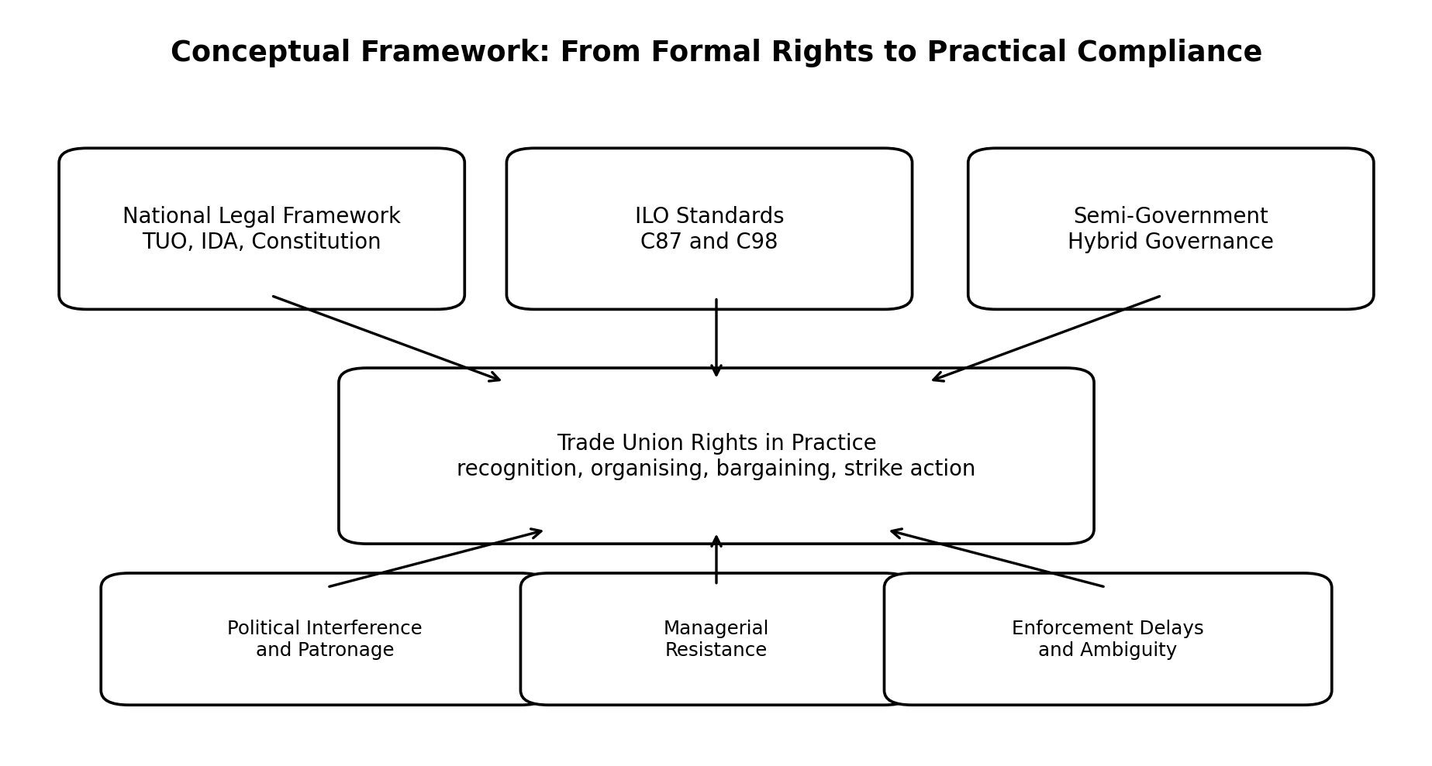
Figure 1. Conceptual framework linking legal framework, ILO standards, hybrid governance and rights in practice.

3. Methodology
In order to find out how trade union rights are perceived and understood in Sri Lanka's semi-government sector, the study used a qualitative, interpretivist research design. In order to guarantee representation across important semi-government sectors where trade union activity is institutionally prominent, participants were chosen using purposive sampling. Interviews were conducted until thematic saturation was achieved, with a duration of 40 to 60 minutes. After the seventeenth interview, when no significantly new themes surfaced, saturation became apparent, and the remaining interviews verified the recurrence and consistency of previously noted patterns.
Twenty stakeholders from the postal, transportation, health, and energy sectors participated in semi-structured interviews to gather primary data. Participants included senior union leaders, rank-and-file members, legal experts, and labour-rights advocates. The comparison of high-level viewpoints on labor law and collective bargaining with the actual experiences of employees dealing with intimidation, threats of transfer, challenges with recognition, and delays in the process was made possible by this research approach.

Thematic analysis was used to analyze the interview data. The codes were divided into four main categories: reform directions, impacts on union effectiveness, hurdles and problems, and legal and institutional alignment. In order to compare interview results with Sri Lankan labor laws, ILO Convention No. 87, ILO Convention No. 98, pertinent policy reports, and extant scholarly literature, document analysis was conducted. Additionally, by identifying recurrent phrases like union, legal, political, management, weak, and bargaining power, a straightforward word-frequency analysis was employed to bolster the thematic findings and highlight the importance of institutional and governance-related issues.

4. Findings and Discussion
The main finding is that semi-government trade union rights exist in a paradox of legal recognition and practical denial. Respondents generally accepted that Sri Lanka has a formal legal framework for trade union activity, but they described these rights as difficult to enforce. The repeated idea was that the law is strong on paper but weak in implementation. Grievance procedures are slow, labour tribunals may take years to resolve disputes and workers often abandon legal pathways because delay reduces the value of justice.
A second finding is that hybrid governance creates uncertainty over accountability. Respondents described semi-government workers as being caught between two regimes. When unions seek stronger employment security, management may describe the institution as commercially oriented. When workers prepare for industrial action, authorities may invoke public-service obligations or essential-service arguments. This dual identity allows decision makers to choose whichever interpretation supports administrative control at the time.
Third, political interference emerged as the most significant obstacle to union autonomy. Participants reported that appointments, recognition, facilities, promotions and transfers may be influenced by political loyalty. Politically connected unions may gain access to management, while politically inconvenient unions may be marginalised. This pattern encourages patronage, discourages independent organising and turns collective representation into a competition for political favour.
Fourth, managerial resistance limits the exercise of trade union rights even where unions formally exist. Respondents referred to transfer threats, denial of facilities, labelling union leaders as troublemakers and selective disciplinary action. These practices create a climate of fear that discourages younger employees from joining unions or attending meetings. As membership declines, bargaining strength also declines, producing a cycle in which workers perceive unions as ineffective because unions lack the support required to become effective.
Fifth, the research shows that the right to collective bargaining is weakened by fragmentation and low solidarity. Many semi-government institutions contain multiple unions divided by party affiliation, grade, occupation or personal rivalry. Fragmentation enables management to negotiate selectively or avoid meaningful negotiation. As a result, bargaining becomes less collective and more dependent on informal lobbying, political access or ad hoc settlement. This undermines the spirit of ILO Convention 98, which expects voluntary and effective machinery for collective negotiation.
The word-frequency analysis supports the thematic interpretation. The most frequent term was union, followed by member, leader and legal, while political and weak also appeared among the top terms. This pattern suggests that respondents framed the problem primarily as an institutional rights issue rather than a narrow wage grievance. The importance of political and weak indicates that unions are viewed as constrained by governance conditions rather than by lack of legal identity alone.
Another important finding concerns the use of essential-service restrictions. Participants did not deny that transport, health, energy and postal services have public importance. Their concern was that essential-service logic can be applied selectively to suppress industrial action without providing an equally strong alternative for timely negotiation. When the right to strike is restricted but bargaining machinery remains weak, workers lose their final leverage while management retains administrative power. This weakens both freedom of association and the credibility of collective bargaining.
The evidence also indicates an inter-generational problem. Younger workers may see unions as old-fashioned, politically captured or unable to protect them from transfer, disciplinary inquiry or loss of opportunity. This perception reduces meeting attendance and membership contributions. It also deprives unions of new leadership, digital communication skills and professional expertise. Therefore, union revitalisation must be treated as part of labour-rights reform, not as a separate internal matter.

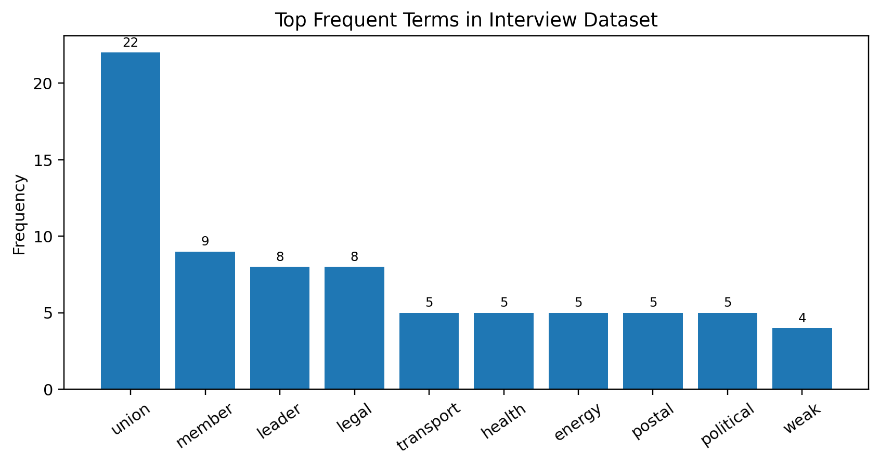
Figure 2. Top frequent terms in the interview dataset, based on the dissertation word-frequency table.

5. Compliance Gap Analysis
The compliance gap is best understood as a chain of institutional failure. Formal legal recognition creates an appearance of conformity with international labour standards, but weak enforcement prevents full realisation. Political interference and managerial discretion then exploit this weakness. Workers respond with caution, fear or withdrawal, reducing membership and bargaining power. The final outcome is a system where trade union rights are available in principle but conditional in practice.
This finding is theoretically significant because it demonstrates that compliance with international labour standards cannot be measured only by ratification. It must be assessed through institutional effectiveness, access to timely remedies, protection from anti-union discrimination and the real ability of unions to bargain without undue interference. In semi-government institutions, regulatory ambiguity makes such assessment especially important because the identity of the employer is blurred between state authority and commercial management.
The analysis therefore shifts attention from a narrow legal question to a governance question. The existence of law is necessary, but it is not sufficient. Effective compliance requires independent institutions, transparent procedures, credible sanctions for anti-union conduct and safe channels for workers to participate in collective representation. Without these conditions, semi-government workers experience labour rights as uncertain permissions rather than enforceable guarantees.
Table 1. Summary of the institutional compliance gap
ILO / legal requirement | Semi-government reality identified in the study | Consequence
Freedom from interference | Political patronage, politically influenced management and essential-service restrictions | Union autonomy and right to strike are weakened
Protection against anti-union discrimination | Transfer threats, intimidation, weak remedies and slow legal process | Workers hesitate to join or participate actively in unions
Voluntary collective bargaining | Fragmented unions and managerial resistance to recognition or negotiation | Bargaining becomes ad hoc and dependent on informal influence
Effective domestic enforcement | Administrative delay and unclear responsibility between state owner and corporate manager | Formal rights become difficult to realise in practice

6. Recommendations and Policy Implications
The first recommendation is comprehensive legal clarification. The Trade Unions Ordinance and Industrial Disputes Act should be reviewed to specify how trade union recognition, dispute settlement and collective bargaining apply to semi-government workers. Essential-service restrictions should be defined narrowly and transparently, with safeguards against arbitrary use. Clear time limits for dispute resolution would also reduce the practical denial of justice caused by delay.
Second, Sri Lanka should establish a dedicated oversight mechanism or specialised labour-relations unit for semi-government institutions. Such a body could monitor recognition disputes, review anti-union allegations, promote uniform guidelines and act as a bridge between the Ministry of Labour, management and unions. This would reduce the accountability gap created by hybrid governance.
Third, depoliticisation is essential. Managerial appointments, union recognition processes and grievance handling should be based on transparent criteria rather than party affiliation. Although political history cannot be removed from Sri Lankan trade unionism overnight, procedural safeguards can reduce the misuse of political power in industrial relations.
Fourth, unions themselves require renewal. The study indicates that workers, especially younger employees, may hesitate to join unions because they see them as politicised, fragmented or ineffective. Regular elections, financial transparency, gender and youth inclusion, legal-literacy training and digital communication can strengthen internal democracy. Issue-based coalitions across unions may also help reduce fragmentation while preserving organisational independence.
Finally, tripartite dialogue should be institutionalised. Regular forums involving government, semi-government employers and trade unions can address grievances before they escalate into industrial disputes. International partners such as the ILO and regional labour networks can support this process through training, benchmarking and technical advice, but domestic ownership of reform remains essential.
Implementation should be staged. Immediate actions can include circulars clarifying recognition procedures, mandatory written reasons for refusing union facilities and timelines for grievance handling. Medium-term actions should include amendments to relevant labour statutes and establishment of a monitoring mechanism. Long-term actions should focus on building a professional industrial-relations culture where negotiation, evidence-based decision making and respect for worker voice are seen as contributors to service quality rather than threats to institutional control.

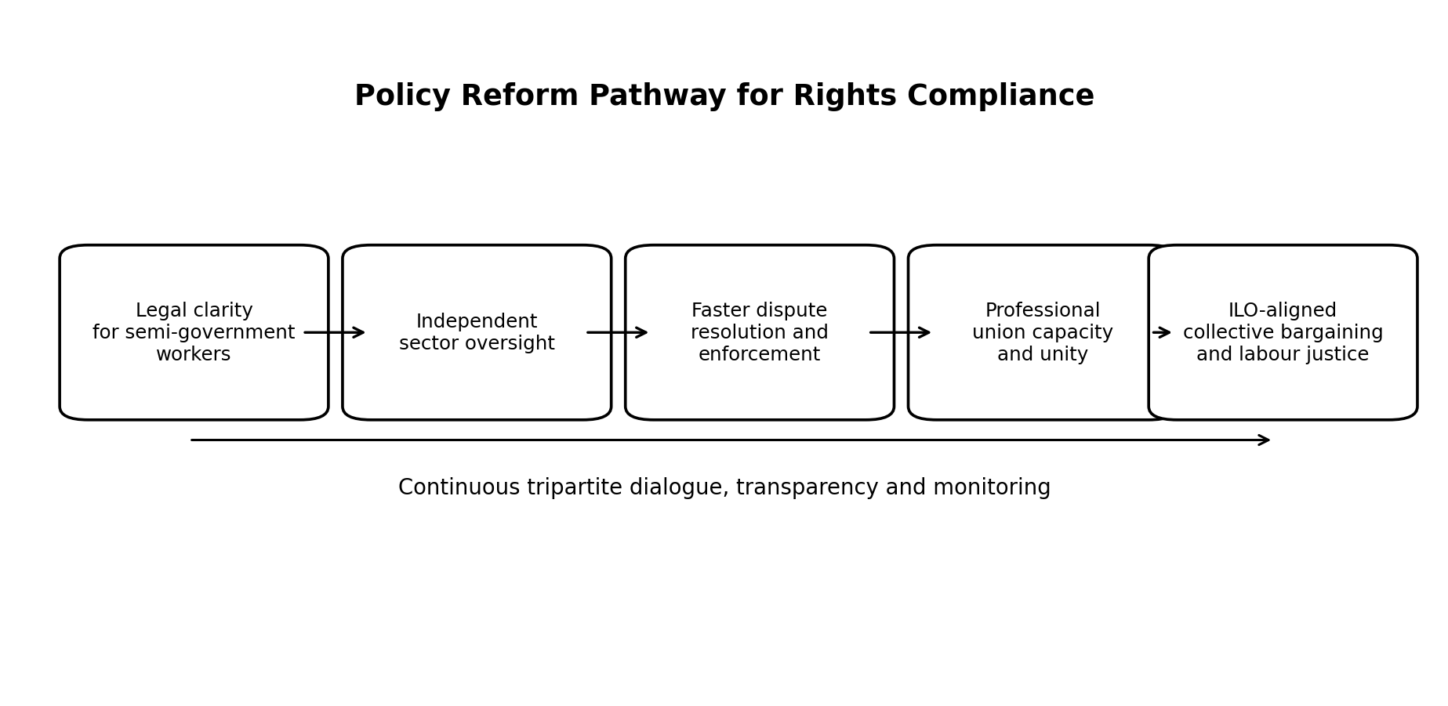
Figure 3. Policy reform pathway for improving compliance with ILO standards in semi-government institutions.
Table 2. Actor-wise reform matrix
Actor | Priority action | Expected outcome
Government / Ministry of Labour | Clarify labour-rights rules for semi-government institutions and strengthen enforcement timelines | Reduced ambiguity and faster remedies
Semi-government employers | Apply transparent recognition, grievance and bargaining procedures | Improved trust and reduced disputes
Trade unions | Strengthen internal democracy, member education and issue-based unity | Higher participation and stronger bargaining power
ILO / civil society / academia | Provide technical assistance, benchmarking and labour-rights education | Evidence-based reform and monitoring

7. Contribution, Limitations and Future Research
The article contributes to knowledge by focusing on a relatively under-researched part of Sri Lanka's labour market. Many studies examine public-sector unions or private-sector labour relations, but the semi-government sector has distinct institutional characteristics. By combining regulatory ambiguity with institutional compliance, the study explains why the same legal framework can produce different results across sectors.
Methodologically, the study combines thematic analysis with word-frequency validation, giving interpretive depth while also showing the recurrence of key terms in the interview dataset. Practically, it provides policy-oriented recommendations that can be used by policymakers, unions, labour administrators and civil-society actors interested in strengthening worker representation.
The limitations must also be recognised. The sample was qualitative and limited to twenty participants across selected sectors, so the findings should not be treated as statistically representative of all semi-government workers. Some participants may also have avoided sensitive details because of fear of political or workplace consequences. Future research should use mixed methods, compare public, private and semi-government sectors, examine gender and youth experiences in unions and conduct longitudinal analysis of how political cycles affect union autonomy.

8. Conclusion
The study's conclusions show that the problem of defending trade union rights in Sri Lanka's semi-government sector is really an institutional one rather than just a legal one. Despite Sri Lanka's ratification of ILO Convention No. 87 on freedom of association and Convention No. 98 on the right to organize and collective bargaining, as well as the legal recognition of these rights by domestic labor legislation, their actual application is still uneven and inadequate.
According to the report, trade union autonomy and efficacy are still threatened by managerial resistance, political meddling, unclear regulations, and delays in enforcement procedures. As a result, rather than being enforceable promises, workers frequently view trade union rights as conditional privileges. This inhibits active engagement in trade union activities, erodes worker trust in official labor institutions, and diminishes collective bargaining.
It takes more than merely symbolic adherence to international labor norms to address these issues. Clear legal reforms, efficient enforcement methods, depoliticized institutional governance, increased internal union capacity, and frequent tripartite communication between the government, employers, and trade unions are all necessary. In order to convert formal legal recognition into practical working practices, such actions are necessary.
In the end, protecting trade union rights shouldn't be seen as a barrier to service delivery or organizational performance. Strong and autonomous trade unions, on the other hand, provide long-term industrial stability, employee morale, institutional responsibility, and workplace fairness. Therefore, ensuring effective trade union rights in semi-government organizations is a practical necessity for democratic governance and sustainable national development, in addition to being a matter of international obligation and human rights compliance.

References
Biyanwila, S. (2015). Sri Lankan trade unions and labor politics: A historical review. University of Colombo Press.
Business & Human Rights Resource Centre. (2023). Sri Lanka: Government accused of attacking trade union rights as four unions face exclusion from Labour Advisory Council.
Business & Human Rights Resource Centre. (2024). Sri Lanka: Unions and civil society oppose the Economic Transformation Bill fearing harm to workers and labour rights.
Fernando, P. (2020). Essential services and the freedom to strike in Sri Lanka. Colombo Law Review, 31(2), 45-67.
Gamage, D. (2013). Trade union rights in Sri Lanka: A critical assessment in light of balancing the interests of workmen, employers and the state. University of Colombo ARS Proceedings.
Gamage, D., & Hewagama, K. (2013). Politicisation and fragmentation of Sri Lanka's labour movement. Sri Lanka Journal of Human Resource Management, 10(2), 34-47.
Gunawardana, S., & Biyanwila, S. (2008). Labor and development in Sri Lanka's semi-government sector. South Asian Economic Studies, 14(1), 21-39.
International Labour Organization. (2024). Assessment of the realization of freedom of association and collective bargaining: Sri Lanka.
International Trade Union Confederation. (2010). Annual survey of violations of trade union rights: Sri Lanka.
Ruwanpura, K. (2015). Global production, national institutions, and labor rights in Sri Lanka. Cambridge University Press.

