CASE REPORT OF A PATIENT WITH WAARDENBURG SYNDROME

SAJIDA H. DHALLA, MOHAMED R. SACHEDINA

TANGA REGIONAL REFERRAL HOSPITAL

ABSTRACT

Objective: Waardenburg Syndrome (WS) is a very rare condition and sparsely reported in the African Continent. WS causes significant morbidity, especially regarding Congenital Hearing Loss.

Case: A 10-year-old girl reported to our clinic with congenital hearing loss and the inability to speak. The girl also had a patch of white hair on the front and deep blue eyes. An Otoacoustic Emission (OAE) test and High-Resolution CT of the Temporal bone were done. Congenital Hearing loss was confirmed, and counselling was done for the child to develop alternative communication methods.

INTRODUCTION

Waardenburg syndrome (WS) refers to a group of diverse genetic disorders marked by hearing loss (HL) and pigmentation abnormalities of the skin, hair, and eyes. WS is the most common (2–5%) syndromic cause of congenital sensorineural HL. (1,2,3)

A leading biological theory describes WS as a neurocristopathy caused by abnormalities in the migration, growth, and development of neural crest-derived cells (1,4,5). These disrupted developmental processes impact melanocytes, craniofacial structures, limb muscles, and enteric ganglia, offering a unified explanation for the syndrome's multisystem features.

Based on clinical features, WS can be classified into four types (WS1-4). In essence, Waardenburg syndrome (WS) is an auditory-pigmentary disorder that is the result of the absence of melanocytes from key anatomical structures, including the eyes, skin, hair, or the stria vascularis of the cochlea. However, other abnormalities may also be present such as musculo-skeletal defects which can include hypoplasia of limb muscles, contractures, bilateral cutaneous syndactyly, aplasia of the ribs, and congenital upward displacement of the shoulder blade (Sprengel shoulder). Despite this clinical heterogeneity, HL remains the most disabling feature affecting the well-being and quality of life of individuals with WS. (6,7)

CASE

A 10-year-old girl visited our hospital with her mother, from a faraway village within our region, with the complaint of inability to hear and talk since birth. Mother reports no history of ear discharge or pain, and no tenderness. The child was born by normal delivery and had no complications or illness after being born, and no history of loss of consciousness or seizures. The mother also reported that all developmental milestones were within normal age, and that no other sibling has difficulty hearing or talking. Not only the siblings, but none within the blood relatives, including the great grandparents, had any history of hearing loss, light-colored eyes, or white hair at an early age. The child was vaccinated at the nearby health facility as per the national guidelines.

The family had never sought medical attention due to their financial status, and it was through an NGO’s assistance that they could attend the clinic this time. Also, the mother reports that most of their communication is through hand gestures.

On examination, the child was alert and responded to gesture commands but was clearly deaf. The child also presented with a broad nasal root and a patch of white hair on the central front hairline (white forelock). The child had striking blue eyes (bilateral isohypochromia iridis). The right eye had a positive red reflex test, while the left eye did not.

Oto-Acoustic Emissions(OAE) Test results showed ‘REFER’ on both ears. An Auditory Brain Stem Response(ABR) test could not be done, as it was not available at our center. However, a high-resolution CT scan of the temporal bone was done, which also showed normal ear anatomy. Genetic Testing could not be done for this patient as the test was not available at our setting and proved to be very expensive if sent outside the country.

The results were then discussed with the family, and counselling was done on how the child can be helped to learn sign language and where to attend an appropriate school for the disability involved.

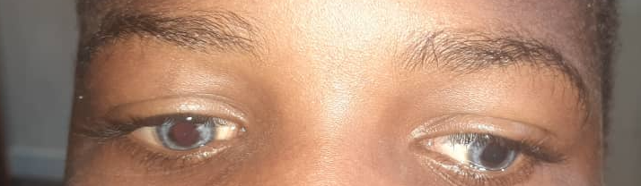
Fig. 1; Bilateral blue colored eyes.

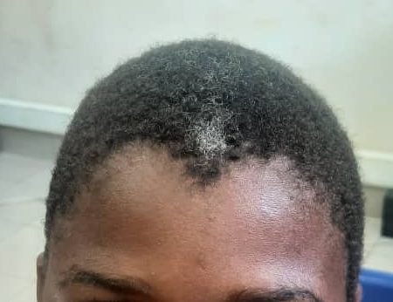
Fig. 2; White forelock of hair.

DISCUSSION

Through background scholarly searches, no previous case of this kind has been published in our country as yet, confirming the rarity of the disorder in our setting.

The patient in this scenario presents late, whereas the best-case scenario would have been early detection, especially in relation to hearing. Hence, the importance of Universal Newborn Screening (UNHS) is noted here. For this patient, Cochlear Implantation would not be the most appropriate management, as first, economically, the patient’s family cannot afford this device, secondly, the child is past her speech development phase, and hence, implantation is encouraged in patients in the first year of life.

WS is a rare genetic disorder affecting roughly 0.9-2.8% of the global deaf population. It is the leading cause of autosomal dominant syndromic hearing loss, with an estimated worldwide occurrence of 1 in 42,000 to 50,000 people. However, data from African countries such as Kenya have been estimated at 1 case per 20,000 individuals. (8)

Distinctive morphological traits of WS can often be identified right at birth or shortly thereafter. Common features include a white lock of hair on the forehead, a wide nasal bridge, and lighter-colored eyes. Parents often observe that their child does not respond to auditory stimuli.

WS type I is characterized by evidence of dystopia canthorum and the full symptomatology of the disease. Individuals with WS type I also have a narrow nose, marked hypoplasia of the nasal bone, a short philtrum, and a short and retropositioned maxilla.

Individuals classified with WS type II represent a diverse group characterized by normally positioned canthi (without dystopia canthorum). The two primary diagnostic markers for this type are sensorineural hearing loss (present in 77% of cases) and heterochromia iridium (found in 47% of cases). Type 2 is the most frequently reported subtype in studies conducted in Africa, exhibiting substantial variability in phenotype both within and between families, as well as incomplete penetrance. (9,10)

WS type III (Klein-Waardenburg syndrome) is similar to type I but is also characterized by musculoskeletal abnormalities, while WS type IV (Waardenburg-Shah syndrome) is the association of WS with congenital aganglionic megacolon (Hirschsprung disease).

Congenital profound sensorineural hearing loss occurs in 9-62.5% of patients with WS, while the white forelock is observed in 17-58.4%. Hyperplasia of the root of the nose is reported in 17.6-78% of those with WS.

Every patient who is clinically suspected of having WS needs to undergo a thorough audiological assessment. Across all subtypes of WS, sensorineural hearing loss is the most common characteristic.
(11)

Molecular genetic testing is currently regarded as a key part of the diagnostic evaluation for WS. It helps confirm subtype classification, facilitates the detection of pathogenic variants for family cascade screening, and provides a definitive diagnosis in cases with unclear or overlapping clinical features.(12)

CONCLUSION

This case study aims to highlight the presence of this syndrome within the Tanzanian population, which is rarely reported, and emphasizes the need for further research, in-depth clinical characterization, molecular landscape, and the pathobiology of WS in Africa, especially within the hearing-disabled, to determine how frequently this syndrome contributes to their disability.

This is the first notable case reported from this country. However, neighboring countries like Kenya and Rwanda not only have reported and published cases but have also included the genetic type of the Wardenburg syndrome.

CONSENT

Assent was obtained from the parents of the child, for the publication of this case report.

REFERENCES

- Song, J.; Feng, Y.; Acke, F.R.; Coucke, P.; Vleminckx, K.; Dhooge, I.J. Hearing Loss in Waardenburg Syndrome: A Systematic Review. Clin. Genet. 2016, 89, 416–425.
- Chen, H. Waardenburg Syndrome. In Atlas of Genetic Diagnosis and Counseling; Springer: New York, NY, USA, 2016; pp. 1–9. ISBN 978-1-4614-6430-3.
- Sun, F.; Xiao, M.; Ji, D.; Zheng, F.; Shi, T. Deciphering Potential Causative Factors for Undiagnosed Waardenburg Syndrome through Multi-Data Integration. Orphanet J. Rare Dis. 2024, 19, 226.
- Winters, R.; Masood, S. Waardenburg Syndrome. In StatPearls; StatPearls Publishing: Treasure Island, FL, USA, 2025
- Huang, S.; Song, J.; He, C.; Cai, X.; Yuan, K.; Mei, L.; Feng, Y. Genetic Insights, Disease Mechanisms, and Biological Therapeutics for Waardenburg Syndrome. Gene Ther. 2022, 29, 479–497.
- Kiani, R., Gangadharen, S. K., & Miller, H. (2007). Case report. Association of Waardenburg syndrome with intellectual disability, autistic spectrum disorder and unprovoked aggressive outbursts: A behavioral phenotype. The British Journal of Developmental Disabilities, 53(104), 53–62.
- Reynolds, J. E., Meyer, J. M., Landa, B., Stevens, C. A., Arnos, K. S., et al. (1995). Analysis of variability of clinical manifestations in Waardenburg Syndrome. American Journal of Medical Genetics, 57(4), 540–547.
- Dourmishev AL, Dourmishev LA, Schwartz RA, Janniger CK. Waardenburg syndrome. Int J Dermatol. 1999 Sep. 38 (9):656-63.
- Oysu C, Baserer N, Tinaz M. Audiometric manifestations of Waardenburg's syndrome. Ear Nose Throat J. 2000 Sep. 79 (9):704-9.
- Tagra S, Talwar AK, Walia RL, Sidhu P. Waardenburg syndrome. Indian J Dermatol Venereol Leprol. 2006 Jul-Aug. 72 (4):326.
- Agrawal R, Walia S. Waardenburg Syndrome Type 1. Indian J Ophthalmol. 2022 Jul. 70 (7):2679-2681.
- Bertani-Torres W, Lezirovitz K, Alencar-Coutinho D, et al. Waardenburg Syndrome: The Contribution of Next-Generation Sequencing to the Identification of Novel Causative Variants. Audiol Res. 2023 Dec 21. 14 (1):9-25.

