Psychological Distress, Coping Behavior, and Quality of Life among Cancer Patients: An Empirical Study at Mahavir Cancer Sansthan
Dr. Mukta Kumari
Department of Psychology, Veer Kunwar Singh University Ara.
Maharana Pratap Nagar Ara

Abstract
Cancer is one of the most challenging chronic diseases affecting millions of individuals across the world. Beyond physical suffering, cancer patients frequently experience severe psychological distress, emotional instability, social isolation, and financial burden. The present empirical study examines psychological distress, coping behavior, and quality of life among cancer patients receiving treatment at Mahavir Cancer Sansthan, Patna. The study was conducted on 120 respondents selected through purposive sampling technique. Data were collected using standardized psychological tools, structured questionnaires, interviews, and observation methods. The findings indicate that anxiety, depression, fear of death, emotional stress, and treatment-related uncertainty are highly prevalent among cancer patients. Coping behavior was significantly influenced by family support, socioeconomic status, education, and counseling services. Patients with positive coping strategies and stronger social support demonstrated better emotional adjustment and quality of life. The study highlights the importance of integrating psycho-oncology services, counseling programs, and emotional rehabilitation within cancer care systems. The findings contribute to the understanding of psychosocial dimensions of cancer treatment in Bihar and emphasize the need for holistic patient-centered healthcare approaches.
Keywords: Psychological distress, coping behavior, quality of life, cancer patients,

Introduction
Cancer is a life-threatening disease that creates profound physical, psychological, social, and economic challenges for patients and their families. Advances in medical science have improved survival rates, but the emotional and psychosocial burden associated with cancer continues to remain a major concern. Patients diagnosed with cancer frequently experience anxiety, depression, fear, hopelessness, uncertainty, and social withdrawal during different stages of treatment.
The diagnosis of cancer often produces emotional shock and psychological trauma. Long-term treatment procedures such as chemotherapy, radiation therapy, surgery, and hospitalization further intensify emotional suffering. Physical side effects including pain, weakness, hair loss, nausea, and fatigue negatively influence self-esteem and social interaction. Patients may also become emotionally distressed because of uncertainty regarding survival and future life.
Psychological distress among cancer patients has emerged as an important area of psycho-oncology research. Distress may include depression, anxiety, fear of recurrence, helplessness, sleep disturbances, and emotional instability. Such conditions affect treatment adherence, recovery process, coping behavior, and quality of life.
Coping behavior refers to the psychological and behavioral strategies adopted by individuals to manage stress, emotional pressure, and illness-related challenges. Positive coping strategies such as emotional acceptance, social support, counseling, spirituality, and problem-solving help patients adjust better to illness. In contrast, negative coping strategies such as social withdrawal, hopelessness, avoidance, and dependency may worsen mental health conditions.
Quality of life is another important dimension of cancer care. It includes physical well-being, emotional stability, social relationships, psychological adjustment, and functional ability. Cancer treatment significantly affects the quality of life of patients because of prolonged hospitalization, financial burden, and social isolation.
Mahavir Cancer Sansthan, Patna, is one of the leading cancer treatment institutions in Bihar serving patients from rural and urban backgrounds. Many patients receiving treatment belong to economically weaker sections and face multiple psychosocial challenges. Therefore, the present study attempts to examine psychological distress, coping behavior, and quality of life among cancer patients at Mahavir Cancer Sansthan.

Review of Literature
Patel et al. (2020) observed that chronic illness patients in low-income countries experience severe psychological distress due to poor healthcare accessibility, financial burden, and inadequate emotional support systems. Jacobsen (2020) found that anxiety, depression, and emotional instability are highly prevalent among cancer survivors and significantly affect quality of life and treatment adherence.
Chaturvedi et al. (2020) reported that Indian cancer patients frequently experience fear of death, emotional instability, and social isolation during treatment. Watson (2021) emphasized that emotional support, counseling, and social interaction improve coping behavior and psychological adjustment among cancer patients.
Spiegel (2021) observed that depression and hopelessness negatively affect treatment motivation and social functioning among cancer patients. Folkman (2022) highlighted the role of coping strategies in managing emotional stress among chronic illness patients. Sharma (2023) reported that social stigma and financial dependency significantly affect emotional well-being among female cancer patients in India. Verma et al. (2024) found that lack of family support and economic instability contribute to depression and emotional suffering among patients receiving long-term treatment.
Objectives of the Study
1. To examine psychological distress among cancer patients.
2. To study coping behavior adopted by cancer patients during treatment.
3. To analyze the relationship between socioeconomic status and quality of life.
4. To assess the role of family support and counseling in emotional adjustment.
5. To suggest measures for improving psychosocial well-being among cancer patients.
Hypotheses
- Cancer patients from lower socioeconomic backgrounds experience higher psychological distress.
- Positive coping behavior is associated with better quality of life among cancer patients.
- Family support significantly reduces emotional distress among cancer patients.
- Psychological distress negatively affects treatment adherence and quality of life.

Research Methodology

Sample: The present study was conducted on 120 cancer patients receiving treatment at Mahavir Cancer Sansthan. The respondents were selected through purposive sampling technique. Both male and female patients belonging to different age groups, educational levels, occupations, and socioeconomic backgrounds were included in the study. The sample consisted of patients suffering from different types of cancers such as breast cancer, oral cancer, lung cancer, cervical cancer, and blood cancer. Patients undergoing chemotherapy, radiation therapy, surgery, and other treatment procedures were included in the investigation. The age range of respondents was between 20 and 70 years, with the majority belonging to the 41–60 years age group. Both rural and urban respondents were included to understand psychosocial differences and coping behaviour among cancer patients.Only those patients who were physically and mentally capable of responding and willing to participate voluntarily were included in the study. Critically ill patients and patients with severe psychiatric disorders unrelated to cancer were excluded from the sample.
Tools -
- Psychological Distress Scale
The present study used the Depression Anxiety Stress Scale (DASS-21) to assess psychological distress among cancer patients. The scale was developed by Sydney H. Lovibond and Peter F. Lovibond in 1995. The DASS-21 is a standardized psychological assessment tool widely used in psycho-oncology, clinical psychology, and mental health research to measure emotional distress among individuals suffering from chronic illnesses such as cancer. The scale consists of three major dimensions: Depression, Anxiety, and Stress. The depression dimension measures hopelessness, sadness, lack of interest, and emotional withdrawal. The anxiety dimension assesses nervousness, fear, panic symptoms, and physiological arousal, while the stress dimension measures irritability, tension, emotional overreaction, and difficulty in relaxation. The DASS-21 contains a total of 21 items, with seven items under each dimension. The responses are scored on a 4-point Likert scale ranging from 0 to 3, where “0” indicates “Did not apply to me at all” and “3” indicates “Applied to me very much.” Higher scores indicate higher levels of psychological distress among respondents. The reliability of the DASS-21 is very high. The reliability coefficients reported by the authors were 0.91 for Depression, 0.84 for Anxiety, and 0.90 for Stress. The scale also possesses high construct validity and criterion validity and has been validated across different cultural and clinical populations, including cancer patients.
- Coping Behaviour Scale
To assess coping behaviour among cancer patients, the present study used the Brief COPE Inventory developed by Charles S. Carver in 1997. The Brief COPE is a standardized psychological tool designed to examine the coping strategies used by individuals while dealing with stressful and emotionally challenging situations such as chronic illness and cancer treatment. The scale measures various coping dimensions including active coping, planning, acceptance, positive reframing, emotional support, instrumental support, religious coping, self-distraction, denial, behavioural disengagement, venting, self-blame, and substance use. These dimensions help identify both positive and negative coping strategies adopted by patients during treatment. The Brief COPE Inventory consists of 28 items, with two items assigned to each coping dimension. The responses are measured on a 4-point Likert scale ranging from “1 = I haven’t been doing this at all” to “4 = I’ve been doing this a lot.” Higher scores indicate greater use of a particular coping strategy.The scale has demonstrated satisfactory reliability and validity in psychological and psycho-oncology research. The Cronbach’s alpha reliability coefficients of the subscales range from 0.70 to 0.90. The tool also possesses strong face validity, construct validity, and content validity and is widely used in behavioural health studies.
- Quality of Life Scale
The present study used the WHOQOL-BREF Scale developed by the World Health Organization in 1996 to assess the quality of life of cancer patients. The WHOQOL-BREF is one of the most widely used international tools for measuring quality of life in physical and psychological health research. The scale measures four important dimensions of quality of life: Physical Health, Psychological Health, Social Relationships, and Environmental Health. The physical health domain includes pain, fatigue, sleep, mobility, and work capacity. The psychological domain assesses self-esteem, emotional stability, body image, and positive feelings. The social relationship domain measures family support, social interaction, and personal relationships, while the environmental domain includes financial resources, healthcare accessibility, safety, and living conditions. The WHOQOL-BREF consists of 26 items scored on a 5-point Likert scale. The scoring ranges from “1 = Very Poor” to “5 = Very Good.” Higher scores indicate better quality of life and psychological well-being among respondents.
The WHOQOL-BREF possesses high reliability and validity across different cultural and clinical settings. The Cronbach’s alpha reliability coefficients of the domains range from 0.70 to 0.88. The scale has high construct validity and cross-cultural validity and is extensively used in psycho-oncology and public health research.
- General Health Questionnaire (GHQ-12)
The General Health Questionnaire (GHQ-12) developed by David Goldberg in 1972 was also used in the study to assess the general mental health condition of cancer patients. The GHQ-12 is a widely recognized screening tool for identifying psychological distress and minor psychiatric disorders among clinical populations. The tool measures dimensions such as social dysfunction, anxiety, depression, psychological well-being, and loss of confidence. It consists of 12 items with multiple response categories measuring emotional and psychological functioning. The reliability coefficient of the GHQ-12 ranges between 0.82 and 0.90, indicating high internal consistency. The scale also possesses strong predictive validity and construct validity and has been extensively used in health psychology and psycho-oncology studies worldwide. The use of these standardized psychological tools helped the researcher scientifically assess psychological distress, coping behaviour, and quality of life among cancer patients receiving treatment at Mahavir Cancer Sansthan.

Variables of the Study
Independent Variables:
- Education
- Income
- Occupation
- Family support
- Counseling support
Dependent Variables:
- Psychological distress
- Coping behavior
- Quality of life
- Emotional adjustment
Socio-Demographic Profile of Respondents
The majority of respondents belonged to the age group of 41–60 years. Around 57% respondents were male while 43% were female. About 61% respondents belonged to low-income families earning below Rs. 15,000 per month. Educational analysis revealed that many respondents had low educational status. Rural respondents constituted a large proportion of the sample, reflecting healthcare inequalities in Bihar.
Results and Discussion
The findings of the study indicate that psychological distress was highly prevalent among cancer patients. Anxiety, depression, fear of death, hopelessness, and emotional instability were common emotional problems observed among respondents. More than half of respondents reported moderate to severe levels of stress during treatment. Female patients experienced comparatively higher emotional distress because of family dependency and social pressure. Patients with strong family support and positive coping strategies demonstrated better psychological adjustment and quality of life. Counseling services and emotional support from healthcare professionals also improved emotional stability among respondents. The study further revealed that respondents from low-income groups experienced higher stress levels because of financial burden and treatment expenses. Economic insecurity affected treatment adherence and emotional well-being.
Positive coping behaviors such as prayer, social interaction, counseling participation, emotional acceptance, and family communication significantly improved mental health outcomes. Negative coping patterns such as social withdrawal, hopelessness, and emotional suppression increased psychological suffering.

Hypothesis 1: Cancer patients from lower socioeconomic backgrounds experience higher levels of psychological distress.

Table 1

Socioeconomic Status and Psychological Distress among Cancer Patients (N = 120)
Socioeconomic Status | Low Distress | Moderate Distress | High Distress | Total
High Income | 10 | 08 | 04 | 22
Middle Income | 08 | 19 | 15 | 42
Low Income | 05 | 17 | 34 | 56
Total | 23 | 44 | 53 | 120

Statistical Analysis
Statistical Test | Value
Calculated χ² Value | 18.42
Table Value at 0.05 Level | 9.49
Degree of Freedom (df) | 4
Result | Significant
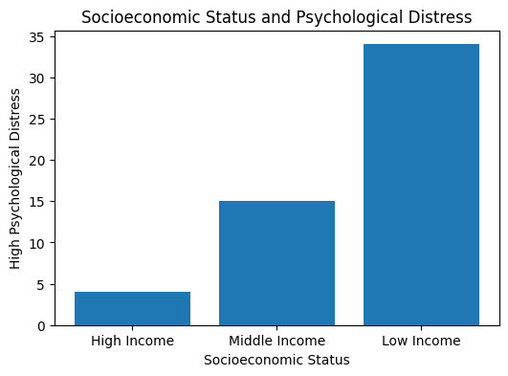
The calculated chi-square value is greater than the table value at the 0.05 level of significance. Therefore, the hypothesis is accepted. The findings indicate that respondents belonging to lower socioeconomic groups experienced higher levels of psychological distress, anxiety, depression, and emotional instability compared to higher-income respondents.

Hypothesis 2: Positive coping behaviour is associated with better quality of life among cancer patients.

Table 2: Coping Behaviour and Quality of Life among Respondents (N = 120)
Coping Behaviour | Poor Quality of Life | Moderate Quality of Life | Good Quality of Life | Total
Negative Coping | 24 | 18 | 06 | 48
Moderate Coping | 10 | 20 | 12 | 42
Positive Coping | 04 | 09 | 17 | 30
Total | 38 | 47 | 35 | 120

Statistical Analysis
Statistical Test | Value
Calculated χ² Value | 16.85
Table Value at 0.05 Level | 9.49
Degree of Freedom (df) | 4
Result | Significant
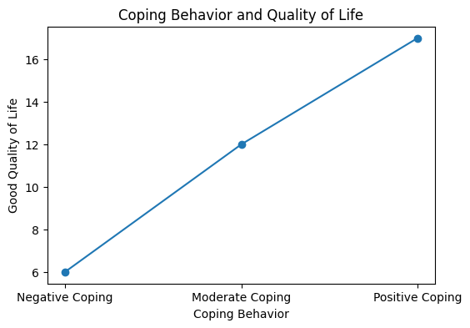
The findings reveal a significant relationship between coping behaviour and quality of life. Respondents using positive coping strategies such as emotional acceptance, family communication, counselling participation, and spirituality demonstrated better quality of life and emotional adjustment compared to respondents using negative coping mechanisms.

Hypothesis 3: Family support significantly reduces emotional distress among cancer patients.

Table 3: Family Support and Emotional Distress among Cancer Patients (N = 120)
Level of Family Support | Low Distress | Moderate Distress | High Distress | Total
Strong Support | 16 | 18 | 08 | 42
Moderate Support | 06 | 19 | 15 | 40
Poor Support | 03 | 10 | 25 | 38
Total | 25 | 47 | 48 | 120

Statistical Analysis
Statistical Test | Value
Calculated χ² Value | 19.73
Table Value at 0.05 Level | 9.49
Degree of Freedom (df) | 4
Result | Significant
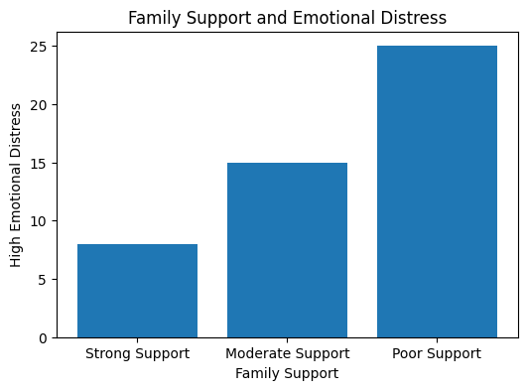
The calculated chi-square value is higher than the table value, indicating a statistically significant relationship between family support and emotional distress. Respondents receiving strong emotional and social support from family members experienced lower anxiety, depression, and stress compared to patients lacking family support.

Hypothesis 4: Psychological distress negatively affects quality of life among cancer patients.

Table 4: Psychological Distress and Quality of Life among Respondents (N = 120)
Psychological Distress | Poor Quality of Life | Moderate Quality of Life | Good Quality of Life | Total
Low Distress | 05 | 10 | 15 | 30
Moderate Distress | 12 | 20 | 10 | 42
High Distress | 25 | 15 | 08 | 48
Total | 42 | 45 | 33 | 120

Correlation Analysis
Statistical Measure | Value
Pearson’s Correlation Coefficient (r) | -0.64
Level of Significance | 0.01
Nature of Correlation | Negative and Significant
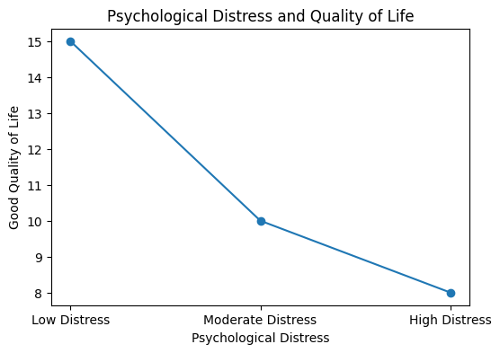
The findings reveal a significant negative relationship between psychological distress and quality of life among cancer patients. Respondents experiencing higher levels of anxiety, depression, and emotional stress reported poorer quality of life, reduced social interaction, emotional instability, and lower treatment satisfaction. The statistical findings of the study clearly indicate that psychological distress, coping behaviour, family support, and socioeconomic conditions significantly influence the quality of life of cancer patients receiving treatment at Mahavir Cancer Sansthan. The study demonstrates that economically weaker patients experienced greater emotional suffering, while patients with positive coping strategies and strong family support showed better psychological adjustment and improved quality of life. The findings highlight the importance of psycho-oncology services, emotional counselling, and family support systems in holistic cancer care.
Discussion
The findings of the present study support previous psycho-oncology research emphasizing that psychological distress is a major challenge among cancer patients. Financial instability, fear of death, social isolation, and prolonged treatment contribute significantly to emotional suffering. The study confirms that coping behavior plays a crucial role in psychological adjustment and quality of life. Positive coping strategies help patients maintain emotional balance and treatment motivation.
Family support emerged as an important protective factor reducing anxiety, depression, and hopelessness. Emotional encouragement from family members helped patients maintain resilience during difficult treatment phases. The study also highlights the need for psycho-oncology services within cancer treatment institutions. Counseling, emotional rehabilitation, and psychosocial support programs are necessary for improving treatment outcomes and quality of life among patients.
Suggestions
Future studies may include larger and more diverse samples from multiple cancer hospitals to improve external validity and comparative understanding. Mixed-method research combining quantitative surveys with qualitative interviews can provide deeper psychological insights into patient experiences. Longitudinal studies may help understand changes in coping behavior and quality of life during different stages of treatment and recovery. Healthcare institutions should establish dedicated psycho-oncology units with trained counselors and social workers to support emotional rehabilitation. Family counseling, financial assistance programs, community awareness campaigns, and rural mental healthcare outreach should be strengthened. Additional comparative studies based on gender, cancer type, and socioeconomic status may further enrich psycho-oncology research and healthcare planning.
Other suggestions includes psychological counseling services should be integrated into oncology departments. Support groups should be organized for emotional rehabilitation.
Awareness programs regarding mental health should be conducted regularly.
Financial assistance schemes should be strengthened for economically weaker patients.
Family counseling programs should be encouraged. Rural healthcare accessibility should be improved Psycho-oncology training should be provided to healthcare professionals.
Conclusion
The present empirical study conducted at Mahavir Cancer Sansthan, Patna highlights the multidimensional psychosocial challenges experienced by cancer patients. Psychological distress, emotional instability, fear, depression, and treatment-related stress significantly affect quality of life and treatment adherence. The findings reveal that coping behavior, family support, counseling services, and socioeconomic conditions play an important role in determining emotional adjustment among cancer patients. Positive coping strategies and strong social support improve resilience and psychological well-being, whereas financial burden and social isolation increase emotional suffering. The study emphasizes that cancer treatment should not be limited only to medical intervention. Holistic healthcare approaches integrating psycho-oncology services, counseling, social support, and emotional rehabilitation are essential for improving quality of life among cancer patients.

References
- Chaturvedi, S. K., et al. (2020). Psychosocial perspectives in Indian cancer patients. Indian Journal of Psychiatry, 62(4), 389–396.
- Folkman, S. (2022). Stress and coping behavior in chronic illness patients. Health Psychology Review, 16(1), 55–70.
- Jacobsen, P. B. (2020). Psychological distress among cancer survivors. Psycho-Oncology Journal, 29(5), 1012–1021.
- Patel, V., Saxena, S., Lund, C., & Thornicroft, G. (2020). Mental health of people with chronic illnesses in low- and middle-income countries. The Lancet Psychiatry, 7(6), 487–498.
- Sharma, P. (2023). Psychosocial well-being among female cancer patients. International Journal of Social Psychiatry, 69(4), 620–631.
- Spiegel, D. (2021). Depression and emotional stress among cancer patients. Cancer Psychology Review, 18(2), 112–125.
- Verma, N., Gupta, A., & Ali, S. (2024). Depression and social isolation among cancer patients. Journal of Mental Health and Human Behavior, 29(1), 45–57.
- Watson, M. (2021). Emotional adjustment and coping behavior among cancer patients. Journal of Psychosocial Oncology, 39(3), 225–237.

