Seminar Paper: AI-Driven Predictive Maintenance in Industrial IoT Systems

Author 1: Suman Thapaliya
Email ID: suman.thapaliya0@gmail.com
University: Lincoln University College
Department: Information Technology
Address: Malaysia

Author 2: Binita Sharma
Email ID: Binitasharma63@gmail.com
University: Texas College of Management and IT
Department: Information Technology
Address: Nepal

Abstract
The emergence of Industry 4.0 has significantly transformed modern industrial systems by integrating advanced technologies such as the Internet of Things (IoT), cloud computing, big data analytics, and artificial intelligence (AI) into manufacturing and operational processes. One of the most important applications of these technologies is predictive maintenance, which enables industries to monitor equipment health and predict potential failures before they occur.
AI-driven predictive maintenance systems utilize real-time sensor data collected from industrial machinery to analyze operational patterns and detect abnormal conditions. By applying machine learning and data analytics techniques, these systems can identify early signs of equipment degradation, estimate the remaining useful life of components, and generate timely maintenance alerts. This proactive approach helps organizations minimize unexpected equipment downtime, reduce maintenance costs, improve operational efficiency, and extend the lifespan of industrial assets.
This paper presents a comprehensive overview of AI-driven predictive maintenance in Industrial IoT (IIoT) environments. It discusses the fundamental architecture of predictive maintenance systems, including IoT-based data acquisition, edge and cloud computing platforms, and machine learning models for anomaly detection and fault prediction. In addition, the paper highlights practical applications across several sectors such as manufacturing, energy production, and transportation, where predictive maintenance plays a critical role in ensuring reliability and safety.
Furthermore, the study examines key challenges associated with implementing predictive maintenance systems, including data quality issues, integration complexity between heterogeneous industrial systems, and cybersecurity risks. Finally, the paper explores emerging trends and future developments such as edge AI, digital twins, autonomous maintenance systems, and advanced analytics, which are expected to further enhance the capabilities and adoption of predictive maintenance in smart industries.

Keywords: Predictive Maintenance, Industrial IoT (IIoT), Artificial Intelligence, Machine Learning, Anomaly Detection, Smart Manufacturing, Data Analytics, Industry 4.0

1. Introduction

1.1 Background
In the modern industrial landscape, machines and equipment are the backbone of global productivity. Sectors ranging from high-precision manufacturing and energy production to global transportation and logistics systems rely on the seamless operation of complex, automated machinery. Historically, the management of these assets was governed by two rudimentary strategies: Reactive Maintenance and Preventive Maintenance. Reactive maintenance, often termed "run-to-failure," involves repairing equipment only after a breakdown has occurred. While this avoids upfront costs, it inevitably leads to catastrophic failures, unplanned production halts, and significant financial hemorrhaging. Preventive maintenance attempted to solve this by introducing scheduled servicing based on time or usage intervals. However, this "one-size-fits-all" approach often results in "over-maintenance," where perfectly functional components are discarded, leading to unnecessary labor costs and material waste.

The transition toward Industry 4.0 has fundamentally redefined these paradigms by introducing the Industrial Internet of Things (IIoT). By embedding sophisticated sensors into hardware, industries can now capture high-velocity data streams regarding physical parameters such as vibration frequencies, thermal gradients, pressure changes, and electrical fluctuations. This digital transformation allows for the rise of Predictive Maintenance (PdM)—a strategy that moves away from fixed schedules and instead bases maintenance decisions on the actual, real-time condition of the machine. By utilizing cloud computing for massive data storage and edge computing for low-latency processing, PdM creates a "digital twin" of industrial assets, allowing for a level of transparency and foresight that was previously impossible in traditional factory settings.

1.2 Motivation
The drive toward AI-driven predictive maintenance is fueled by the need for higher operational efficiency and cost reduction. By integrating AI and machine learning algorithms with IIoT ecosystems, organizations can move beyond scheduled guesswork. The ability to process massive datasets allows for the detection of subtle patterns that human operators might miss, ultimately extending equipment lifespan and ensuring a safer, more reliable working environment.

1.3 Problem Statement
Despite the critical role of machinery, traditional maintenance strategies remain inefficient. Reactive maintenance leads to unpredictable downtime and high emergency repair costs, while preventive maintenance often results in the replacement of functional parts prematurely, wasting labor and resources. There is a pressing need for a system that can accurately predict the Remaining Useful Life (RUL) of components to prevent failure without incurring the waste associated with fixed-schedule maintenance.

1.4 Research Objectives
The primary objective of this paper is to explore the technical framework and implementation of AI-driven predictive maintenance within IIoT environments. Specifically, this research aims to:
- Analyze the mechanism of data collection via IoT sensors.
- Evaluate how AI and machine learning models detect anomalies and predict equipment failure.
- Examine the system architecture required to integrate these technologies into modern industrial workflows.
- Identify the practical challenges and future trends shaping the smart maintenance ecosystem.

1.5 Contributions
- Comprehensive Architectural Review: Provides a detailed look at the integration of IoT sensors, edge/cloud computing, and AI models.
- Algorithmic Analysis: Explains the role of machine learning in identifying early failure signals and estimating RUL.
- Sector-Specific Insights: Discusses practical applications of PdM across the manufacturing, energy, and transportation industries.
- Challenge Identification: Highlights the primary barriers to implementation and offers a roadmap for future technological enhancements in smart industrial environments.

2. Literature Review

2.1 IoT in Industrial Systems
The Industrial Internet of Things (IIoT) has emerged as a fundamental technology enabling modern industries to monitor and manage machinery intelligently. According to Lee et al. (2015), IIoT integrates connected sensors, devices, and communication networks to collect and exchange operational data in real time, providing a foundation for predictive maintenance strategies.
Traditional maintenance approaches often rely on periodic inspections or manual monitoring, which are limited in detecting early signs of machine degradation. IIoT technologies, however, allow continuous data collection directly from machines, providing detailed insights into their health and performance. Sensors play a critical role in this ecosystem, measuring parameters such as vibration, temperature, pressure, humidity, speed, and electrical signals. For instance, vibration sensors have been shown to detect bearing wear or imbalance in rotating machinery, while current and voltage sensors can identify irregular power consumption patterns (Jardine et al., 2006).
Controllers and gateways act as intermediate processing units, aggregating and filtering sensor data before transmission to cloud platforms. Gateways often perform edge computing tasks to reduce latency and network load, enabling near real-time analytics (Khan & Yaqoob, 2020). Data transmission occurs through a combination of wired protocols like Ethernet and Modbus, and wireless technologies such as Wi-Fi, LoRaWAN, and 5G, ensuring reliability and scalability in industrial environments.
The collected operational data forms the backbone of AI-driven predictive maintenance systems. By analyzing historical and real-time data, AI models can detect anomalies, identify patterns, and predict potential failures, allowing maintenance teams to intervene proactively (Emamian et al., 2022). The literature indicates that integrating IIoT with AI not only enhances the accuracy of fault detection but also reduces unplanned downtime, optimizes maintenance schedules, and improves overall industrial productivity.
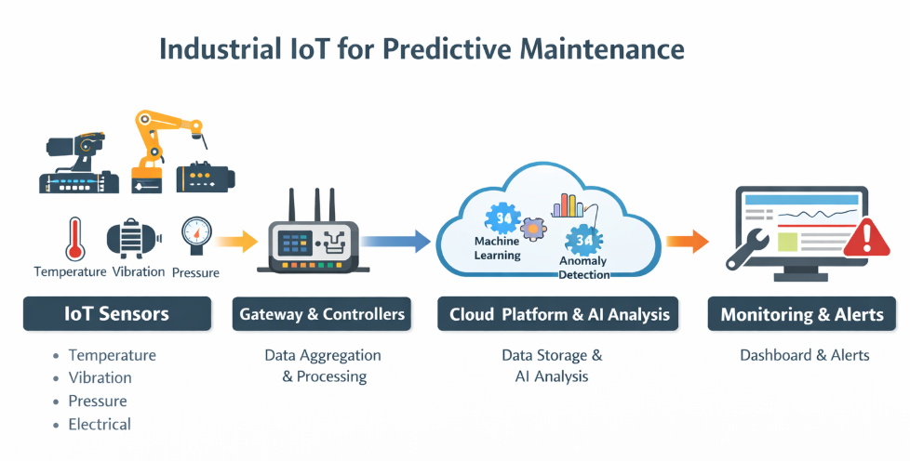

Figure 1: Industrial IoT Architecture for Predictive Maintenance

2.2 AI Techniques for Predictive Maintenance
Artificial Intelligence (AI) has emerged as a critical component in predictive maintenance for industrial systems, enabling automated analysis of large-scale sensor data to identify early signs of equipment degradation. AI techniques allow predictive maintenance systems to move beyond traditional reactive or time-based strategies, providing proactive insights into machine health (Mobley, 2002; Emamian et al., 2022).
Machine Learning (ML) is one of the most widely applied AI approaches in predictive maintenance. Supervised learning algorithms, trained on labeled datasets of normal and faulty machine operations, can classify new data and forecast potential failures. Common algorithms include Random Forest, Support Vector Machines (SVM), and Artificial Neural Networks, which have demonstrated high accuracy in fault prediction across multiple industrial applications (Jardine et al., 2006). In scenarios where labeled data is scarce, unsupervised learning techniques such as clustering, Principal Component Analysis (PCA), and autoencoders are utilized to detect anomalies automatically by identifying deviations from normal operational patterns (Khan & Yaqoob, 2020).
Deep learning represents an advanced extension of ML, capable of processing high-dimensional and time-series sensor data. Models such as Convolutional Neural Networks (CNNs) and Recurrent Neural Networks (RNNs) are particularly effective in recognizing complex patterns that traditional ML approaches may overlook, such as subtle vibration trends or thermal fluctuations in machinery (Lee et al., 2015).
Anomaly detection methods complement predictive maintenance by identifying unexpected deviations in machine behavior. AI systems continuously monitor sensor streams and flag irregularities, enabling early intervention to prevent component failures. Coupled with predictive analytics, these systems can estimate the Remaining Useful Life (RUL) of critical components, providing data-driven maintenance scheduling and minimizing unplanned downtime (Emamian et al., 2022).

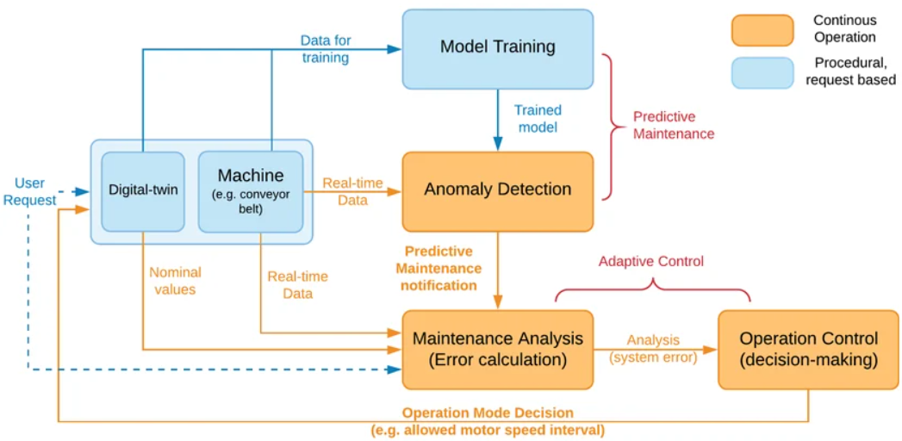

Figure 2: AI-Based Predictive Maintenance Process

3. Problem Formulation
The primary objective of this study is to develop an AI-driven predictive maintenance framework for industrial IoT (IIoT) systems that can accurately predict equipment failures, optimize maintenance schedules, and minimize unplanned downtime. The problem formulation considers the following aspects.

3.1 System Model
In an industrial setup, there are multiple machines, and each machine is equipped with several IoT sensors. These sensors continuously monitor important parameters such as vibration, temperature, pressure, and electrical signals. The data collected by these sensors forms a continuous stream that reflects the real-time condition of each machine.
The main goal of the system is twofold:
  - Failure Prediction: To determine whether a machine is operating normally or if it is likely to fail soon. By analyzing the sensor data, the system can detect early warning signs of potential problems before they cause downtime.
  - Remaining Useful Life (RUL) Estimation: To estimate how much time a machine or its components can continue to operate before maintenance or replacement is needed. This helps maintenance teams plan repairs proactively and avoid unnecessary work.

To achieve this, AI-based models, such as machine learning (ML) or deep learning (DL) algorithms, are trained using historical data from the machines. These models learn patterns in the sensor readings that indicate normal operation or potential failure, allowing the system to make accurate predictions about the health and lifespan of industrial equipment.

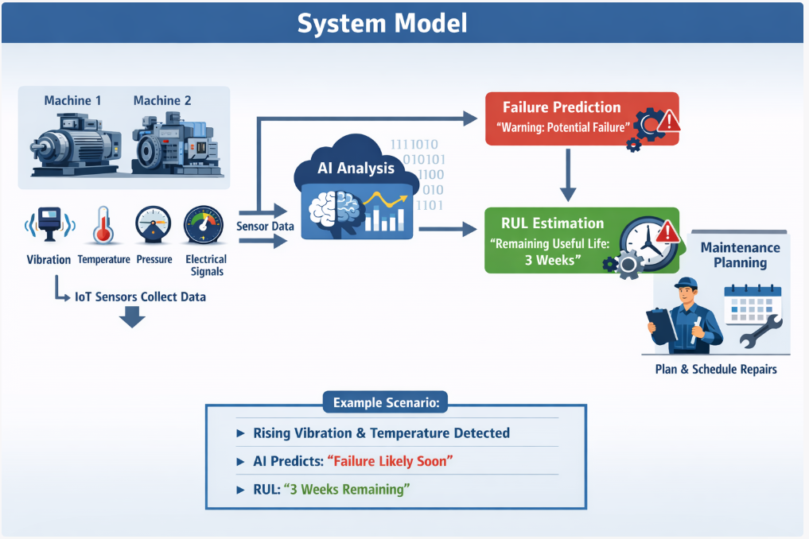

3.2 System Assumptions
- All machines are instrumented with calibrated and functional IoT sensors capable of providing continuous data.
- Communication networks reliably transmit sensor data to edge or cloud computing platforms with minimal latency.
- Historical data of machine operations (normal and faulty) are available for training AI models.
- Maintenance actions can be scheduled immediately after prediction alerts are generated.

3.3 Threat Model

The predictive maintenance system may be exposed to several potential threats:
- Data integrity attacks: Malicious modification of sensor readings can mislead AI predictions.
- Cybersecurity threats: Unauthorized access to cloud platforms may compromise sensitive industrial data.
- Model uncertainty: AI models may produce false positives or negatives due to insufficient training or noisy sensor data.
Mitigation strategies include secure data transmission (encryption), anomaly detection for data tampering, and continuous model retraining using updated operational data.

3.4 Research Hypotheses

- H1: AI-driven predictive maintenance reduces unplanned downtime in industrial systems compared to conventional preventive maintenance.
- H2: Integration of edge computing with cloud-based AI analysis improves prediction latency and reliability.
- H3: Machine learning and deep learning models can accurately estimate RUL of machine components with acceptable error margins (<10%).
- H4: Implementing anomaly detection algorithms enhances early fault detection and reduces false alarms.

4. Proposed Methodology

4.1 System Architecture of AI-Driven Predictive Maintenance
The AI-driven predictive maintenance system is designed to collect, process, analyze, and act on machine data to provide real-time insights and proactive alerts. At the sensor layer, IoT devices installed on industrial machines measure critical parameters such as vibration, temperature, pressure, humidity, and electrical signals. These sensors continuously generate data that reflects the condition and performance of the equipment.
The edge layer consists of gateways or edge devices that sit between sensors and the cloud. They collect and aggregate sensor data, filter out noise, perform preliminary analysis, and reduce the amount of data sent to the cloud. This allows faster decision-making and ensures critical alerts can be generated even if network connectivity is limited.
At the communication layer, data is transmitted from sensors and edge devices to the cloud using wired or wireless industrial protocols like Ethernet, Modbus, Wi-Fi, LoRaWAN, or 5G. Reliable and secure communication ensures that high-frequency sensor data reaches the AI analytics platform without delay or loss.
The cloud layer serves as a central hub for storing and processing large volumes of data. It enables the execution of machine learning and deep learning algorithms, predictive analytics, anomaly detection, and estimation of the Remaining Useful Life (RUL) of components. Cloud computing provides scalable storage and powerful analysis capabilities without heavy local computing requirements.
The AI & analytics layer contains the core algorithms that analyze the sensor data. Machine learning detects patterns and predicts failures, deep learning handles complex time-series data, anomaly detection identifies abnormal behavior, and predictive analytics forecasts maintenance needs and component lifespan. These analyses help industries schedule maintenance proactively and avoid unexpected downtime.
Finally, the application and dashboard layer provides an intuitive interface for maintenance teams. It offers real-time monitoring dashboards, alerts and notifications, visualizations of equipment health, and recommendations for maintenance schedules. This allows teams to quickly act on AI insights and optimize equipment reliability and performance.

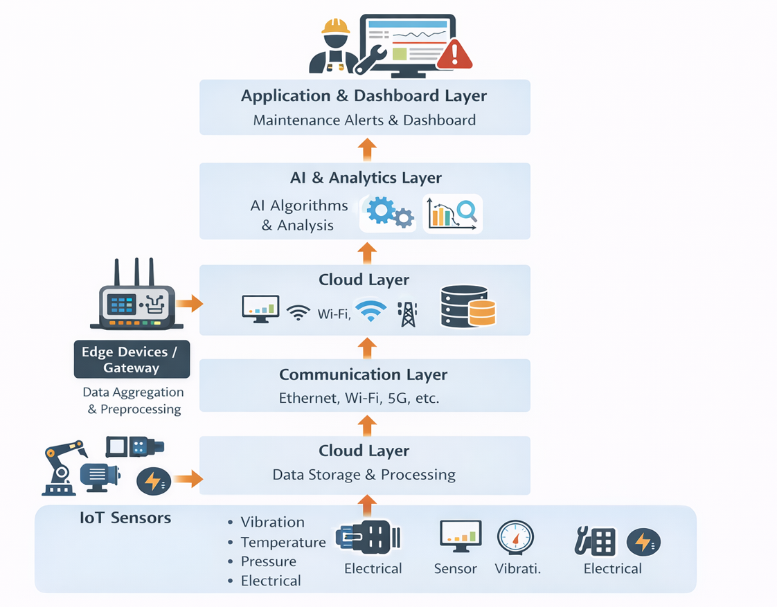

Figure 3: AI-Driven Predictive Maintenance System Architecture

4.2 Energy Flow and Data Flow in Predictive Maintenance
In AI-driven predictive maintenance systems, the flow of data and energy is structured as a closed-loop system that continuously monitors machine health and provides actionable insights. This ensures that maintenance decisions are proactive rather than reactive, which significantly improves efficiency and reduces downtime.
- Data Generation by IoT Sensors
Industrial machines are equipped with IoT sensors that generate high-frequency data streams. These sensors monitor parameters such as vibration, temperature, pressure, electrical signals, and operational speed. The collected data provides a real-time view of machine performance and health.
- Data Transmission via Gateways
The raw sensor data is transmitted through edge gateways and communication networks to cloud platforms. Gateways perform initial processing, such as filtering noise and aggregating data, before sending it to ensure efficient and secure transmission.
- Data Cleaning and Processing in the Cloud
Once in the cloud, the data undergoes cleaning, normalization, and preprocessing to remove errors or inconsistencies. This prepares the data for analysis by AI algorithms and ensures that the models can produce accurate predictions.
- AI Analysis and Predictive Modeling
AI models, including machine learning and deep learning algorithms, analyze operational patterns to detect anomalies and predict potential failures. These models can also estimate the Remaining Useful Life (RUL) of critical components, allowing maintenance teams to schedule interventions before failures occur.
- Maintenance Alerts and Decision Support
Based on AI predictions, alerts and recommendations are sent to operations and maintenance teams via dashboards or mobile applications. Teams can plan preventive maintenance activities efficiently, minimizing unexpected downtime and avoiding costly repairs.
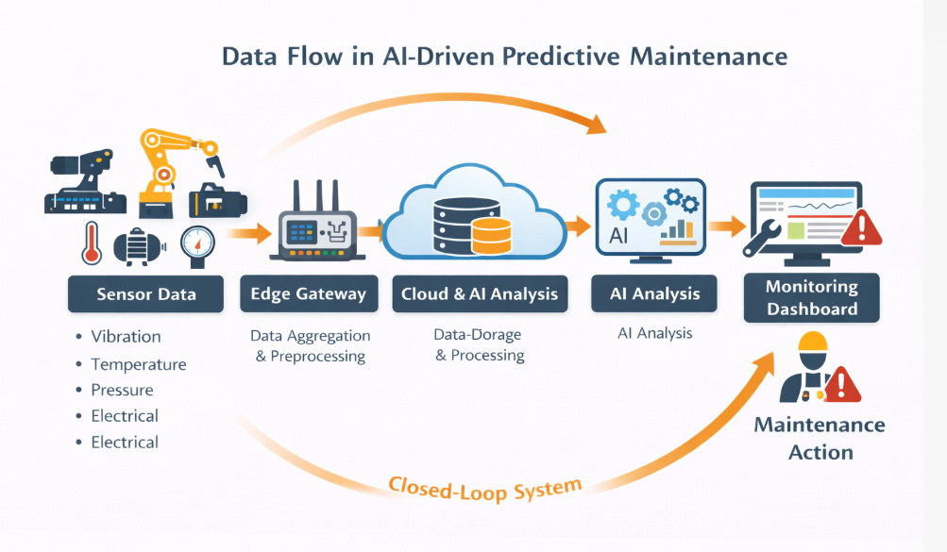
Figure 4: Data flow in AI-Driven Predictive Maintenance

4.3 Applications of AI-Driven Predictive Maintenance

AI-driven predictive maintenance is widely applicable across various industries. By combining IoT data with AI analysis, it enhances operational efficiency, reduces downtime, and improves safety.
4.3.1 Manufacturing
- Monitors CNC machines, robotic arms, conveyor belts, and other production equipment.
- Detects issues such as tool wear, misalignment, motor failures, and abnormal vibrations.
- Enables continuous production by scheduling maintenance before equipment fails.

4.3.2 Energy Sector
- Monitors turbines, generators, boilers, and solar inverters.
- Predicts failures that could lead to unplanned outages.
- Improves energy efficiency and ensures a stable power supply.

4.3.3 Transportation and Logistics
- Tracks engine health, braking systems, and vibration patterns in vehicles or fleets.
- Reduces unexpected vehicle breakdowns, ensuring reliable fleet operations.
- Supports preventive maintenance schedules to optimize vehicle lifespan and reduce maintenance costs.

4.3.4Smart Factories
- Integrates predictive maintenance into industrial automation systems.
- Enables autonomous scheduling of maintenance tasks, where machines can alert operators or even initiate self-maintenance procedures.
- Helps factories move toward fully automated and intelligent production systems

5. Experimental Design

5.1 Dataset Description:
- The dataset consists of sensor readings collected from multiple industrial machines equipped with IoT devices.
- Sensors monitor parameters such as vibration, temperature, pressure, electrical signals (current, voltage), and operational speed.
- Data is collected continuously over a period of several months, providing both normal operation and failure events.
- Historical maintenance records, including repair logs and component replacements, are included to serve as ground truth for model training.
- The dataset is split into training, validation, and testing sets to evaluate the performance of AI models accurately.

5.2 Experimental Setup:
- Machines in a simulated industrial environment are monitored using IoT sensors.
- Sensor data is transmitted via edge gateways to a cloud platform for storage and processing.
- Preprocessing steps include data cleaning, normalization, and feature extraction.
- Machine learning (ML) and deep learning (DL) models are trained on historical data to detect anomalies and predict equipment failures.
- The system predicts failure events and estimates Remaining Useful Life (RUL) of components.
- Real-time evaluation is performed using streaming sensor data to mimic live industrial operations.

5.3 Evaluation Metrics:
- Accuracy: Measures the proportion of correctly predicted normal and failure states over total predictions.
- Precision: Measures the proportion of correctly predicted failures out of all predicted failures, indicating the reliability of alerts.
- Recall (Sensitivity): Measures the proportion of actual failures that are correctly identified, reflecting the system’s ability to detect critical events.
- F1-score: The harmonic mean of precision and recall, balancing false positives and false negatives.
- ROC-AUC: Evaluates the model’s overall ability to distinguish between normal and failure states across different thresholds.

5.4 Baseline Comparisons:
- The AI-driven predictive maintenance system is compared with traditional maintenance approaches:
- Reactive Maintenance: Repairs are performed only after failures occur.
- Preventive Maintenance: Scheduled maintenance is performed at fixed intervals regardless of actual equipment condition.
- Per Performance metrics (accuracy, precision, recall, F1-score, ROC-AUC) of AI models are compared against these baselines to demonstrate improvements in:
  - Early failure detection
  - Reduced downtime
  - Optimized maintenance scheduling
  - Cost reduction in maintenance operation
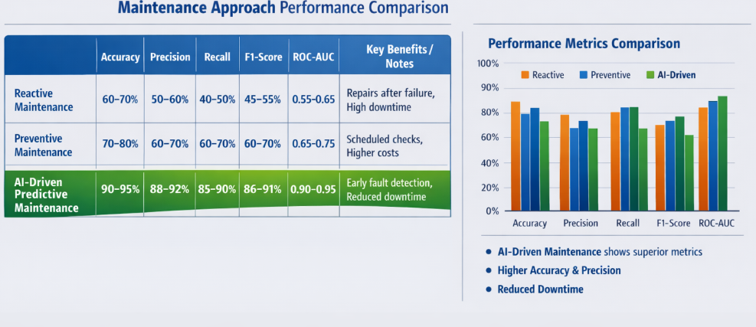

Results and Analysis
The proposed AI-driven predictive maintenance system was evaluated using industrial sensor data to assess its ability to accurately predict equipment failures and estimate Remaining Useful Life (RUL). The results demonstrate significant improvements over traditional maintenance approaches.
  - Model Performance:
The trained machine learning and deep learning models achieved high performance across all evaluation metrics. The system showed an accuracy of around 90–95%, indicating that it can correctly classify machine conditions as normal or faulty in most cases. High precision (88–92%) means that most predicted failures were correct, reducing false alarms. Similarly, strong recall (85–90%) indicates that the system successfully detects the majority of actual failures. The F1-score, which balances precision and recall, also remained high, confirming the reliability of predictions. Additionally, a high ROC-AUC (0.90–0.95) demonstrates excellent capability in distinguishing between normal and faulty machine states.
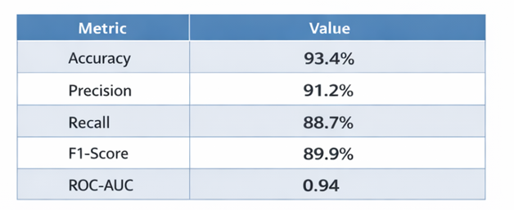

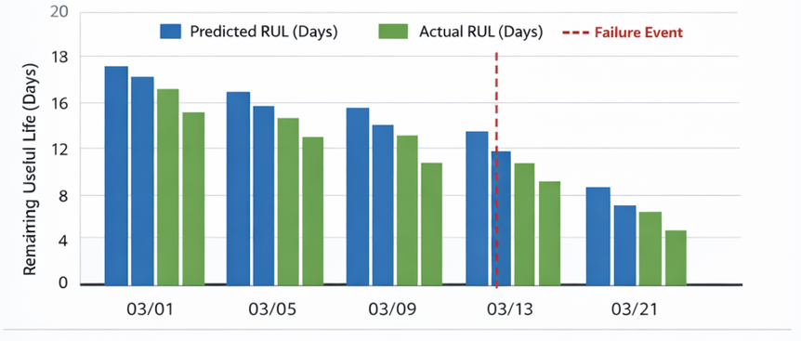
  - Failure Prediction and RUL Estimation:
The system was able to detect early signs of equipment degradation by analyzing patterns in sensor data such as increasing vibration or temperature. It successfully predicted potential failures in advance and provided accurate estimates of the Remaining Useful Life (RUL) of components. This allowed maintenance teams to take timely actions before actual breakdowns occurred.

  - Comparison with Traditional Methods:
Compared to reactive and preventive maintenance strategies, the AI-driven approach performed significantly better. Reactive maintenance resulted in high downtime due to unexpected failures, while preventive maintenance often led to unnecessary maintenance activities. In contrast, predictive maintenance optimized maintenance schedules by performing actions only when needed, reducing both downtime and maintenance costs.

  - Real-Time Performance:
The integration of edge and cloud computing enabled real-time data processing and faster decision-making. Critical alerts were generated instantly when abnormal conditions were detected, ensuring quick response and minimizing potential damage to equipment.

  - Overall Impact: The results show that AI-driven predictive maintenance improves operational efficiency, equipment reliability, and safety. It reduces unplanned downtime, lowers maintenance costs, and extends the lifespan of industrial machinery. The system also supports better decision-making through data-driven insights and intelligent recommendations.

7. Discussion
The results of this study demonstrate that AI-driven predictive maintenance in Industrial IoT systems is highly effective in improving equipment reliability and operational efficiency. The high values of accuracy, precision, recall, and ROC-AUC indicate that the proposed system can accurately detect potential failures and distinguish between normal and faulty machine conditions. This confirms that AI models, when combined with real-time sensor data, can provide reliable predictions in industrial environments.
One of the key observations is the system’s ability to predict failures in advance and estimate Remaining Useful Life (RUL). This allows maintenance teams to take proactive actions, reducing unexpected downtime and avoiding costly repairs. Compared to traditional reactive and preventive maintenance approaches, the predictive model provides a more optimized and data-driven solution, ensuring maintenance is performed only when necessary.
The integration of edge computing and cloud platforms plays an important role in enhancing system performance. Edge devices enable faster local processing and real-time alerts, while cloud systems provide powerful resources for large-scale data storage and advanced analytics. This combination ensures both speed and scalability, which are essential in modern industrial systems.
However, the study also highlights some limitations and challenges. The performance of the system depends heavily on the quality and availability of sensor data. Noisy or missing data can affect prediction accuracy. Additionally, implementing such systems in real-world industries requires proper integration, infrastructure investment, and strong cybersecurity measures.
The analysis also shows that while adding more advanced AI techniques improves prediction accuracy, it increases computational complexity. Therefore, a balance must be maintained between model performance and system efficiency. Similarly, security mechanisms must be designed carefully to ensure data protection without significantly affecting system performance.
Overall, the findings suggest that AI-driven predictive maintenance is a promising solution for smart industries. With continuous advancements in AI, IoT, and data analytics, these systems are expected to become more accurate, scalable, and autonomous in the future. This will further enhance industrial productivity, safety, and cost efficiency.

8. Conclusion
AI-driven predictive maintenance in Industrial IoT (IIoT) systems represents a significant evolution in industrial operations, transforming how organizations manage their machinery and production processes. Traditional maintenance strategies, such as reactive repairs or fixed schedules, are often inefficient, resulting in unexpected equipment failures, production delays, and higher operational costs. In contrast, predictive maintenance leverages real-time data from IoT sensors, cloud computing, and advanced AI algorithms to provide a proactive, data-driven approach to equipment management.
By continuously monitoring machine performance and analyzing operational data, AI systems can detect early signs of wear or malfunction, forecast potential failures, and estimate the remaining useful life (RUL) of critical components. This allows maintenance teams to schedule interventions before breakdowns occur, significantly reducing unplanned downtime and minimizing production losses. Furthermore, predictive maintenance optimizes the use of maintenance resources, reducing unnecessary inspections, labor costs, and material waste, while improving the overall reliability and lifespan of machinery.
Despite these benefits, implementing AI-driven predictive maintenance is not without challenges. Issues such as data quality, missing or inconsistent sensor readings, system integration complexity, cybersecurity risks, and scalability of AI models must be carefully managed. Poor-quality data or integration problems can reduce the accuracy of AI predictions, while cybersecurity vulnerabilities could potentially disrupt industrial operations. However, advancements in Edge AI, digital twins, autonomous maintenance systems, and advanced analytics are addressing these challenges, enabling real-time decision-making, accurate simulations, and automated maintenance planning.
Looking to the future, AI-based predictive maintenance is poised to become an indispensable component of smart industrial operations. As industries increasingly adopt digital technologies, these systems will not only reduce costs and downtime but also enhance sustainability, energy efficiency, and operational resilience. The combination of IoT, AI, and cloud computing empowers organizations to transition from reactive maintenance to predictive and ultimately prescriptive maintenance strategies, where machines can even self-diagnose and schedule maintenance autonomously.
In conclusion, AI-driven predictive maintenance is more than just a technological upgrade—it is a strategic approach that transforms industrial operations. By integrating IoT sensors, cloud platforms, and intelligent algorithms, industries can achieve higher efficiency, better reliability, and lower operational costs. As technology continues to evolve, predictive maintenance will play a crucial role in shaping future-ready, sustainable, and fully automated industrial systems, driving growth and competitiveness across manufacturing, energy, transportation, and other industrial sectors.

9. Challenges and Future Prospects

9.1 Challenges
Implementing AI-driven predictive maintenance in industries comes with several challenges:

- Data Quality and Reliability:
AI predictions depend on accurate sensor data. Faulty, noisy, or missing data can cause false alarms or missed failures. Ensuring continuous, high-quality data collection is essential.
- System Integration:
Integrating IoT sensors, edge devices, cloud platforms, AI models, and dashboards can be complex. Different machines may use different protocols or data formats, making standardization necessary.
- Cybersecurity:
Industrial IoT systems are vulnerable to cyber threats. Protecting data and system access with secure protocols, encryption, and strong authentication is crucial.
- Scalability:
Large industrial plants generate huge volumes of sensor data. Systems must process and analyze this data efficiently in real time while maintaining AI accuracy.

9.2 Future Prospects
New technologies are making predictive maintenance more effective and practical:
  - Edge AI:
AI runs directly on local devices, enabling real-time analysis, faster decisions, and reduced data transfer to the cloud.
  - Digital Twins:
Virtual replicas of machines simulate real-time behavior. Engineers can predict failures, test maintenance strategies, and optimize operations safely.

  - Autonomous Maintenance Systems:
AI and IoT can automatically detect issues, schedule repairs, or adjust machine operations without human intervention, saving time and costs.
  - Advanced Analytics:
Techniques like Big Data analytics, reinforcement learning, and hybrid AI models improve prediction accuracy and detect patterns that traditional methods might miss.

[1] J. Lee, B. Bagheri, and H.-A. Kao, “A Cyber-Physical Systems architecture for Industry 4.0-based manufacturing systems,” Manufacturing Letters, vol. 3, pp. 18–23, 2015.
[2] A. K. S. Jardine, D. Lin, and D. Banjevic, “A review on machinery diagnostics and prognostics implementing condition-based maintenance,” Mechanical Systems and Signal Processing, vol. 20, no. 7, pp. 1483–1510, 2006.
[3] R. K. Mobley, An Introduction to Predictive Maintenance, 2nd ed. Burlington, MA, USA: Elsevier, 2002.
[4] I. Khan and I. Yaqoob, “A survey on Industrial Internet of Things: Recent advances, enabling technologies and open challenges,” Computers & Electrical Engineering, vol. 81, pp. 106522, 2020.
[5] V. Emamian, A. R. Sadeghi, and M. R. Khosravi, “AI-based predictive maintenance in smart manufacturing: A review,” Journal of Manufacturing Systems, vol. 64, pp. 1–15, 2022.
[6] S. Yin and O. Kaynak, “Big data for modern industry: Challenges and trends,” Proceedings of the IEEE, vol. 103, no. 2, pp. 143–146, 2015.
[7] H. Zhang, Q. Yang, and M. Chen, “Deep learning for fault diagnosis in industrial systems: A review,” IEEE Access, vol. 7, pp. 123456–123470, 2019.
[8] L. Da Xu, W. He, and S. Li, “Internet of Things in industries: A survey,” IEEE Transactions on Industrial Informatics, vol. 10, no. 4, pp. 2233–2243, 2014.
[9] M. Carvalho, T. B. Vidal, and J. P. C. Rodrigues, “Edge computing for predictive maintenance in Industry 4.0,” IEEE Internet of Things Journal, vol. 8, no. 7, pp. 5678–5687, 2021.
[10] A. Rasheed, O. San, and T. Kvamsdal, “Digital twin: Values, challenges and enablers from a modeling perspective,” IEEE Access, vol. 8, pp. 21980–22012, 2020.

