Sustainability Assessment of Renewable-Energy-Driven Vehicles: A Global Review of Life-Cycle Performance and Environmental Implications

^{1*}Akomolehin Francis Olugbenga; ²Ogunlana Funmilola Olusola; ³Adebowale Grace Anike
Department of Finance, College of Management & Social Science, Afe Babalola University, Ado- Ekiti, Ekiti - State, Nigeria.
²Department of Physical. College of Science, Bamidele Olumilua University of Education, Science and Technology, Ikere Ekiti.
³Department of Chemistry. College of Science, University of Nigria, Nsuka , Enugu State
* Corresponding Author

Abstract While the global shift to low-carbon, sustainable mobility accelerates, stimulating interest in vehicles powered by renewable energies, it remains unclear how the overall set of sustainability issues surrounding these alternatives has been appreciated. While the available evidence is based primarily on use-phase emissions, use-phase material requirements, lifecycle balance, and end-of-life problems have scarcely been covered. This research compares the overall sustainability performance of solar-powered transport, hydrogen fuel cell vehicles, biofuels-powered transport, and battery-powered vehicles using a holistic life-cycle approach. Based on a PRISMA-2020-tracked systematic literature review, which in turn was accompanied by a bibliometric analysis using VOSviewer and Biblioshiny, the meta-analysis includes peer-reviewed publications on these alternatives from 2010 to 2025. The analysis highlights that battery-powered vehicles can eliminate life-cycle emissions in substantial numbers, particularly in regions with a dominant share of renewable power in electricity production, while, in turn, the corresponding sustainability potential of vehicles using hydrogen is highly dependent on the use of renewable hydrogen. In comparison, biofuels show highly variable results, which depend on the source of production, while solar-supported transport, in turn, has scarcely arrived on the horizon. In general, regardless of the alternatives, structural problems include essential minerals, inhomogeneous boundaries in life-cycle assessments, and immature circular economies. This synthesis also emphasizes the importance of overarching policy strategies to align transport policies with overall energy transitions and circular economies. Improving the potential of recycling, standardizing boundaries in life cycle assessments, and scaling up the use of renewable energy can, in turn, help trigger truly sustainable transport transitions.

Keywords: renewable energy vehicles, life cycle assessment, environmental sustainability, battery electric vehicles, hydrogen vehicles, solar mobility, circular economy, critical minerals

1.0 Introduction
1.1 Background and Problem Statement
The trend concerning the use of renewable energy-powered vehicles has increased over the years, with countries moving in line with the reduction of emissions in the transportation sector to meet their global commitments on cutting emissions. Solar-powered vehicles, fuel cell vehicles, advanced biofuel engines, and battery-electric vehicles are currently some of the promising options available to people, which were previously reliant on conventional internal combustion engines. The technology has a large potential for the reduction in emissions and is, however, dependent on the broader sustainability implications beyond the performance characteristics. Current evidence points to the fact that the greatest share of the problem concerning emissions for renewable energy vehicles can be found in the upstream and downstream stages, including material extraction, production, and disposal (IEA, 2023; Zhang et al., 2022). This points to the need for the evaluation of renewable energy vehicles across the result chain rather than the need to focus on the emissions generated while using the vehicles.

Studies concerning the life cycle assessments of electric and hydrogen vehicles indicate diverse environmental implications that are dependent on battery technology, fuel sources, material recovery, and various recycling processes (Li et al., 2021; Raugei et al., 2020). Solar vehicles and biofuel vehicles also indicate diverse environmental aspects that are dependent on resource intensity, land occupation, and demands in material requirements. With the expansion of overall policies on sustainable vehicles globally, there are diverse environmental implications related to the actual environmental performance of renewable energy vehicle solutions and their overall alignment with the principles of the circular economy. Without an overall appreciation of life-cycle conditions, the global transition toward renewable energy vehicles may continue to generate environmental externalities or reinforce pressures on the environmental domain (Khan et al., 2024; UNEP, 2023).
1.2 Research Gap
Although individual studies on the environmental performance of various green transportation methods have thrived, less has been done in combining various sustainability factors within a unified framework. In most cases, studies have utilized assessments of either greenhouse gas emissions or energy use, while sometimes failing to consider the collective influence of other factors such as material footprint, resource criticality, and recyclability in terms of overall life-cycle sustainability (Bicer et al., 2021; Kurland et al., 2023). In most reviews, assessments have also typically focused on a single mode of transportation, such as electric vehicles, without fully addressing other options that involve solar energy, biofuels, electricity, and hydrogen.

Another significant research gap lies in the neglected end-of-life aspects of renewable mobility studies. It is observed that there is not only a rising trend of concerns about the post-use disposal of batteries, hydrogen storage, solar panels, and biofuels, but there is also a lack of unified approaches for evaluating these aspects collectively from a sustainability perspective (Harper et al., 2022; Amponsah et al., 2020). Other policy aspects, such as extended producer responsibility, schemes that provide incentives to recycle, and regulations to achieve circular design, are also not interconnected with life-cycle assessments.

1.3 Research Questions
The study is guided by the following research questions:
- What does existing evidence reveal about the life cycle environmental impacts of renewable energy driven vehicles, including solar, hydrogen, biofuel, and battery electric systems?
- How do material footprints, recyclability potential, and end of life pathways influence the overall sustainability of these technologies?
- What policy measures, regulatory frameworks, and technological advances shape the sustainability outcomes of renewable mobility solutions?
- What conceptual gaps exist in current sustainability assessments, and how can an integrated evaluation model improve future decision-making?

1.4 Aim and Objectives
This study aims to conduct a global systematic review of the sustainability performance of renewable energy driven vehicles using an integrated life cycle perspective. It synthesizes empirical and theoretical evidence on environmental impacts, resource use, and recyclability while mapping the evolution of research themes through bibliometric techniques.

To address these questions, the study pursues these objectives:
- To evaluate life cycle environmental impacts and material resource requirements of major renewable energy vehicle types.
- To examine recyclability practices, end of life considerations, and circularity potential across technologies.
- To analyze policy frameworks and governance mechanisms influencing green mobility sustainability.
- To propose an integrated sustainability assessment model linking energy source, technology characteristics, material footprint, environmental outcomes, and policy interventions.

1.5 Study Significance
This paper offers a few contributions to the increasing body of research on sustainable transport and renewable energy mobility. Firstly, it advances an interdisciplinary understanding of life cycle sustainability. This comes by incorporating environmental aspects, resource demand, recyclability, and policy issues into a unified framework. This move is in line with global challenges that have urged comprehensive analyses of sustainable transport technologies aimed at averting unintended effects and ensuring sustainable environmental integrity (IRENA, 2024; IEA, 2023).

Second, the research contributes to the priority areas of the circular economy because it focuses on material efficiency and the implementation of closed-loop systems based on the recovery of the critical resources used in renewable mobility solutions. This analysis helps identify the underlying changes required for resource-efficient transport systems.

Finally, it can be concluded that this synthesis translates into policy and industrial decisions through evidence-based information that drives innovation for a sustainable environment, in addition to investing in innovative transport technologies powered by renewable energy. In essence, this study reaffirms the conceptual and scientific grounds for assessing the sustainable viability of transport technologies driven by renewable energy.

2.0 Literature Review
2.1 Conceptual Background
2.1.1 Renewable Energy Driven Vehicles: Types and Technologies
Renewable energy vehicles are a wide variety of transportation systems that use clean and regenerative forms of energy in order to enhance fuel security and limit environmental impacts. Solar vehicles use solar panels placed on the body of vehicles and other charging stations to convert solar energy into electricity. Though still at a nascent stage of development, solar vehicles are being improved by researchers to utilize light materials and efficient solar cells for use in low-speed transportation (Kumar et al., 2023).

Hydrogen fuel cell vehicles produce electricity via the chemical reaction between hydrogen and oxygen, with the only emissions being water vapor. The benefits entail high driving ranges, quick refueling times, and the ability to handle heavy-duty vehicles. Yet, their sustainability relies heavily on the production method of the hydrogen, with the lowest emissions being from "green hydrogen," which is produced from renewable energy sources (IEA, 2023; Zhang et al., 2024). Biofuel vehicles burn bioethanol, biodiesel, or advanced biofuels that are sourced from organic materials. While they are an improvement over fuels that are petroleum-based, there are still issues about land-use emissions and sustainable fuel sources (Wang et al., 2021).

Batteries are primarily found in battery electric vehicles, and they are driven using lithium ion or solid state batteries, which are rechargeable. In fact, this form of transport is environmentally friendly since it produces no emissions; however, mining and fuel sources can affect sustainability (Raugei et al., 2020; Li et al., 2021). All these examples demonstrate different approaches to making transport systems carbon neutral.
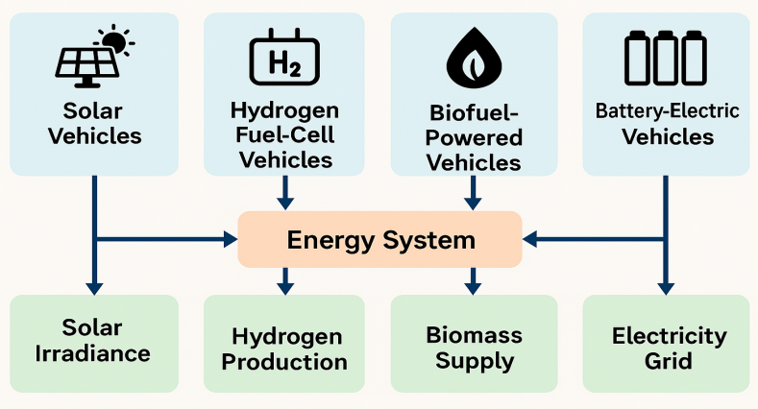
Figure 1: Technology–Energy System Integration Diagram for Renewable-Energy-Driven Vehicles.
The graph above illustrates the interconnection between the various renewable energy-driven vehicle technologies and the energy systems that enable them. The inclusion of solar irradiance, the electricity grid, hydrogen production, and biomass availability to the various modes of transportation highlights the enabling factors that make a sustainable lifecycle. This combined graph indicates that the performance of vehicles relies on not only the various technologies developed for them but also on the energy system.

2.1.2 Sustainability and Life Cycle Assessment Concepts
The “cradle to grave” approach of life cycle assessment permits a complete evaluation of R&EVs’ impacts on the environment. Contained within this analysis are phases including raw materials extraction, manufacturing of components and assembling of R&EVs, followed by operational and maintenance stages, and culminating with disposal or recycle stages at the end of a vehicle’s working life (Bicer and Dincer, 2021). “Cradle to grave” analysis indicates that primary sustainability challenges, especially with respect to battery electric and hydrogen R&EVs, lie at the extraction and subsequent processing stages of important materials like lithium, cobalt, platinum, and rare earth elements (IEA, 2022).
Material footprint and embedded energy are key considerations in comprehending the resource intensity of renewable modes of transportation. Embedded energy takes into consideration the total amount of energy that has gone into the production of the vehicle components. The amount of natural resources used was also considered through the material footprint. Research has indicated that the production-related emissions from the production of battery electric vehicles are higher than those of conventional internal combustion engine vehicles; however, this has a long-term mitigating effect as the grid becomes less polluted (Li et al., 2021).
A complete assessment will scrutinize emissions of greenhouse gases, particulates, the usage of water, and the generation of wastes in the life cycle. End-of-life phases, such as the disposal of batteries and the dismantling of hydrogen stacks, have an effect on sustainability in the long run and ought to be incorporated into assessments (Harper et al., 2022; Amponsah et al., 2020).

2.1.3 Circular Economy and Eco Design Principles
The shift to the use of vehicle systems from renewable energy is greatly linked to the concept of the circular economy, with the emphasis being on the effective use of resources, material-use optimization, and the extension of the lifetime of products. Resource recovery is one of the areas of immense importance for the sustainability of renewable energy in transportation, especially with regard to battery electric vehicles, from which materials such as lithium, cobalt, nickel, and manganese can be recovered through the use of mechanical, hydrometallurgy, or pyrometallurgy methods (Gaines, 2022).

Eco-design and modular design practices promote sustainability through simplified disassembly, part substitution, and upgrade. Reuse of modular batteries, fuel cell stacks, and electronics has the potential to extend vehicle lifetimes and simplify the end-of-life recovery of these components (Bai et al., 2023). "Reuse of hydrogen systems, including secondary uses of deteriorated fuel cell stacks and storage tank reuse, is an emerging area that encourages optimized resource use. The use of biofuels has also improved through the implementation of circular practices that utilize bio resistor conversion and waste to-energy conversion.

Integration of the circular economy approach in renewable mobility technology has benefits beyond the mitigation of negative effects on the environment, including economic viability.

2.1.4 Policy and Regulatory Context
Global policy regimes have a major impact on the sustainability outcomes of renewable energy-powered transportation vehicles. In the European Union, there are several progressive policies, such as the Sustainable Batteries Regulation, emissions targets, and extended producer responsibility schemes aimed at enhancing recycling (European Commission, 2023). In the United States, there are policies that encourage renewable transportation, such as the Inflation Reduction Act, zero-emission vehicle plans, and hydrogen infrastructure and recycling of batteries (U.S. Department of Energy, 2022).

China retains its leading edge in the development of global electric mobility, hydrogen demonstration initiatives, and large-scale battery recycling programs because of the strong policies initiated by the central government and the mandatory recycling regime for electric vehicle batteries (Liu et al., 2023). The above global trends highlight the emerging recognition of the fact that the development of sustainable renewable mobility cannot be ensured by technological innovation.

Thus, a holistic policymaking and governance framework should encompass environmental norms, resource management practices, incentive structures for investment, and intersectoral collaboration. It is crucial to enhance regulations relating to sustainable battery recycling, the safe operation of hydrogen systems, and sustainable fuel production to ensure maximum contribution to sustainable environmental goals by vehicles using renewable energy. Each of these policies is critical in creating a conducive environment for the sustainable use of renewable mobility solutions over their life cycles.

2.2 Theoretical Framework
The theoretical basis used to assess the sustainability of renewable energy-powered vehicles encompasses an interdisciplinary approach that not only assists in understanding the transition to new technologies and their resultant effects on the environment and sustainability processes during the implementation and entire lifecycle of the sustainable transportation system. One of the theoretical approaches used to understand sustainable outcomes is Life Cycle Sustainability Assessment (LCSA), which extends the scope of the Life Cycle Assessment (LCA) process. Theoretical assumptions note that the results of sustainability cannot be assessed on the basis of functional aspects alone in terms of operational usage and that the various processes of resource extraction and end-of-life product disassembly and recycling also have to be considered (Martínez Hernández et al., 2020). This is especially true for the renewable energy sector, which has complex material cycles in solar batteries and cells for hydrogen and biofuel production processes.

The second relevant theoretical framework that comes into consideration is the Circular Economy theory. The main focus of this theory is the design and functioning of restorative and regenerative industrial systems. This theory proposes the need for a reduction in material extraction, improvement in material recovery, ecodesigning, and closed-loop supply chain systems in an effort to incorporate sustainability (Kirchherr et al., 2018). The application of renewable mobility solutions is highly dependent on critical minerals and advanced materials. Hence, it is necessary to incorporate the principles of a circular economy in an attempt to provide sustainable solutions related to material limitations, embedded energies, and waste management. There are empirical studies that show the application of a circular economy, through the processes of battery recycling, fuel cell remanufacturing, or solar panel recovery, significantly influences the reduction of environmental impacts and overall sustainability of transport infrastructures (Gaines, 2022).

Innovation Diffusion Theory offers another fruitful viewpoint on the topic, explaining the spread of new technological innovation in society. The adoption level of renewable mobility technology, including battery cars and hydrogen cars, is influenced by its advantages, infrastructure readiness, public incentives, and societal acceptance (Rogers, 2003; Sierzchula et al., 2014). Recent research has revealed that merely the advantage of the environment is insufficient for its adoption; instead, there is a need for the convergence of technological capabilities, cost reduction, government support, and public trust to facilitate the spread of renewable mobility technology (Li et al., 2022). This topic is highly relevant to the current research, given the fact that the viability of renewable mobility technology is dependent on its scalability, and therefore the knowledge about its spread is necessary for the prediction of its future benefits to the environment. Another theoretical approach that might be relevant in this regard is that of Socio-Technical Transitions, where the specific concept of the Multilevel Perspective (MLP) focuses on the dynamics of large-scale technological transitions in relation to interactions between niche innovations, socio-technical regimes, and landscape pressures (Geels, 2020). In this case, niche innovations include vehicles that use renewable energy, whose sustainability effects will depend on the evolution of supporting policy environments, markets, and infrastructure to sustain them. This theoretical approach emphasizes the role of coordinated policy actions, institutions, and alignment among sectors in facilitating the sustainability transition in transportation (Markard, 2020). This theoretical form of knowledge therefore has high relevance in evaluating global policy or governance contexts and the necessary transitions to achieve complete integration of life cycle sustainability principles in transport. Taken cumulatively, the aforementioned theories offer a range of complementary perspectives for the sustainability analysis of the mobility system based on renewable energy. Life Cycle Sustainability Assessment offers a basic theoretical framework for the analysis of environmental issues for the whole range of environmental issues related to the life cycles of vehicles. Circular Economy, on the other hand, offers a range of perspectives on material use and recycling. Innovation Diffusion and Socio-Technological Transition Theory provides a range of theoretical perspectives on system-level change and the structures and institutions required for a transition to a more sustainable transport system. From the theoretical standpoints discussed here, Life Cycle Sustainability Assessment and Circular Economy Theory are observed to offer the most appropriate theoretical foundations for the current analysis because they address issues concerning the material utilization and environmental aspects on which the sustainability performance of the renewable energy-based vehicle system hinges.

2.3 Conceptual Framework
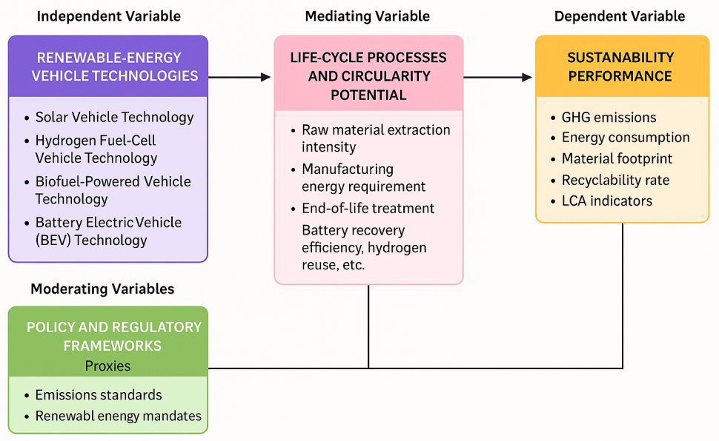
Figure 2: Integrated Conceptual Framework for the Sustainability Assessment of Renewable-Energy-Driven Vehicles.
This framework shows how the technologies used in renewable-energy vehicles interact with sustainability performance across the different stages of the life cycle, and the possibilities offered by circular economy concepts, moderated by regulatory conditions, the energy structure, and the maturity of the infrastructure. It incorporates natural, material, and end-of-life metrics.

Explanatory Note on the Conceptual Framework
The proposed conceptual framework seeks to provide a holistic view of the relationships at play that define the sustainability performance of the vehicles that run on renewable energy sources. At the core of the conceptual framework is the positioning of technologies for the use of renewable energy sources, such as solar cell vehicles, hydrogen fuel cell vehicles, biofuel vehicles, and electric vehicles, as the independent variables that define the sustainability performance of the vehicles. The technologies have varying levels of material and processing intensity.

The framework accounts for life cycle processes and circularity opportunities and recognizes that the environmental implications of renewable transportation do not depend solely on the transportation method, but also, among other aspects, on resource extraction, production, resource usage efficiency, and resource consumption practices at the end-of-life stage of the goods and services produced. Intensity of raw material extraction, production-related embodied energy, recovery rates, and other factors play a central role in translating between the two realms, namely, transportation and the environment.

The role of sustainability performance is that of the dependent variable, documenting various indicators such as greenhouse gas emissions, energy consumption, material footprint, usage of water, recyclability, and environmental life-cycle indicators. These indicators are known global sustainability metrics used in life-cycle assessments and studies of the circular economy.

The linkages between renewable transportation technologies and sustainability outcomes are also affected by the moderating variables. These moderating variables include the policy and regulatory environment, energy composition of countries, maturity levels of the technology, and infrastructure readiness. The moderating variables affect the degree to which renewable transportation technologies can offer desirable sustainability outcomes. Note that the performance of electric vehicles is notably better under conditions with higher proportions of renewable energy being used for electricity generation, while the performance of hydrogen vehicles is better under conditions with green hydrogen production processes. Strong policy instruments such as emission norms, producer responsibility regulations, and recycling laws can improve the performance levels of the technologies. Together, these pieces make up an integrated model of sustainability assessment that is capable of capturing the complexity of assessing vehicles driven by renewable energy in a globally integrated manner. The model is in line with the overarching goal of this study, which aims to synthesize evidence on environmental performance, material intensity, and lifecycle effects, while determining the conditions for sustainable transport transitions.

3.0 Methodology
3.1 Study Design
This study makes use of the systematic literature review and bibliometric mapping techniques to achieve an analytically sound synthesis of the sustainability performance of vehicles powered by renewable energy. The systematic literature review is conducted in accordance with the Preferred Reporting Items for Systematic Reviews and Meta-Analyses guidelines, PRISMA 2020. This assures the transparency and replicability of the processes followed in the study for the identification, screening, appraisal, and synthesis of literature for this study. The use of bibliometric mapping will complement the synthesis process by analyzing the structure of publications, the groups of studies, and the development of knowledge; hence ensuring the robustness of the study because the journals are Scopus-indexed.

3.2 Search Strategy
The strategy for the literature search has been designed systematically to pick up the relevant literature from the above-mentioned leading scientific databases, including Scopus, Web of Science, IEEE Xplore, and ScienceDirect. The databases were chosen because of the presence of quality peer-reviewed publications in the fields of engineering, environmental science, renewable energy systems, and sustainable transportation.

The search strategy employed Boolean logic and specific key word combinations to encompass coverage of the literature on renewable energy vehicles and the life cycle sustainability of these vehicles. Some examples for the search strings are:
“renewable energy vehicles” OR “solar vehicles” OR “hydrogen fuel cell vehicles” OR “biofuel vehicles” OR “battery electric vehicles”

AND “life cycle assessment” OR “environmental impact” OR “material footprint” OR “recyclability” OR “sustainability evaluation”

AND “transport” OR “mobility systems”

Synonyms and controlled vocabulary terms from database thesauri were incorporated to enhance retrieval accuracy. The search strategy was iteratively refined to avoid duplication, broaden coverage, and eliminate irrelevant records.

3.3 Inclusion and Exclusion Criteria
To add to the rigor and relevance of this review, inclusion and exclusion criteria were clearly established. Only peer-reviewed studies found in journal articles, written between 2010 and 2025, were included, marking two decades that have seen tremendous technological advancement and, in tandem, worldwide attention to transitioning to renewable forms of mobility. Studies considered relevant surveyed or analyzed any form of renewable energy-powered vehicle, generating data related to life cycle assessments, environmental impact assessments, sustainability ratings, recyclability, or material footprint.

Exclusion criteria included proceedings if the papers were not full papers, non-scholarly publications, papers that were not in English, studies that only included fossil fuel vehicles, and unclear methodological papers or papers without data on life cycle assessments. Review articles were included if they presented comparative observations or methodological improvements that could apply to the research.

3.4 Screening and Selection
The screening and selection steps were conducted following the PRISMA 2020 guidelines. The retrieved records from all searches were exported to a reference management software for removal of duplicates. The final set of records was subjected to two-level screening: initial screening based on title and abstract, then full-text screening. During these levels, the records were judged for eligibility according to pre-defined inclusion and exclusion criteria to ensure alignment with the defined research aims.

The flow chart will be represented using PRISMA 2020 in order to show all aspects of the process of selecting studies, including all records identified, screened, excluded, and included in the final report. This is crucial in increasing transparency in methodology and ensuring that standards set universally in systematic reviews are followed.

3.5 Data Extraction and Coding
The data extraction process employed a coded framework structured around identifying key study elements. The variables extracted can be broadly classified into the type of vehicle used, which consumes renewable energy (such as solar, hydrogen, biofuel, or battery electric), geographical area, life cycle stage, categories of environmental impact, methodologies, and sustainability indexes.

The life cycle stages were codified in line with traditional cradle-to-grave methods, whereas impact assessment metrics included greenhouse gas emissions, energy use, particulate matter emissions, water use, resource depletion, and end-of-life waste treatment. Furthermore, the codification exercise was able to identify the methods used in the analysis, such as process-based life cycle assessment, hybrid life cycle assessment, input-output analysis, models for recyclability, and material footprints. Such a codification matrix helped to achieve effective synthesis across a range of heterogeneous studies.

3.6 Bibliometric Mapping
In addition to performing the systematic review, bibliometric mapping analysis was also performed using the VOSviewer and Biblioshiny tools. The choice of these tools was made because of their capability to illustrate the relationships between publications, authors, keywords, and countries through advanced graphical mapping techniques. The bibliometric analysis performed focused on the analysis of the co-occurrence of keywords in order to determine prominent and emerging research topics, coupling the analysis of documents in order to determine the connections existing in the literature, and the analysis of collaboration between countries in order to determine research cooperation around the globe for sustainable renewable transport mobility. Combining bibliometric analysis with a systematic review allows for enhanced analysis of the research through the display of patterns in the literature.

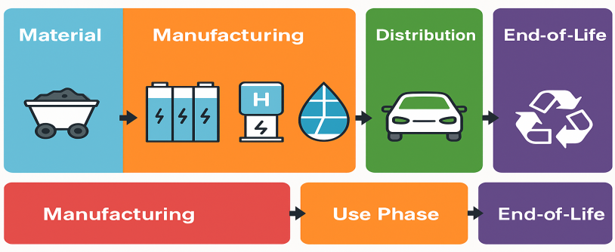
Figure 3: Expanded Life Cycle Assessment (LCA) Boundary Diagram for Renewable-Energy-Driven Vehicles
This diagram provides a comprehensive visualization of the full life cycle stages involved in renewable-energy-driven mobility systems. By incorporating technology-specific icons—battery cells (BEV), fuel cell stacks (hydrogen), solar modules, and biofuel drops—it highlights the distinct resource flows and environmental burdens associated with each vehicle type. The illustration strengthens methodological clarity and supports consistent cradle-to-grave sustainability assessment.

4.0 Results of the Systematic Review
4.1.1 Summary of Included Studies
The final corpus of studies considered includes both empirical and modeling studies that examine solar-powered vehicles, hydrogen fuel cell solutions, biofuel-powered vehicles, and battery electric vehicles. Overall, the corpus of interest predominantly includes battery electric vehicles and hydrogen solutions, which reflect the technological advances in these two technologies and the relevance to policymaking (Li et al., 2021; Raugei et al., 2022). Most of the assessments use attributional LCA approaches encompassing cradle-to-grave system boundaries. However, a few studies employ the use of consequence or scenario assessments that examine the evolution of new battery technologies and hydrogen (Sierzchula et al., 2020; Zhang et al., 2023).

A major part of the literature focuses particularly on the production process of batteries, the integration of photovoltaics in vehicles, and the production chain of hydrogen. There are quite a few good quality reviews that highlight the differences in methodologies and emphasize the gaps in the system boundaries and assumptions related to the end-of-life stages (Harper et al., 2020; Kumar et al., 2024).

4.1.2 Thematic Synthesis
Four major trends were identified in the surveyed literature. First, a large number of studies focused on comparing the life cycle emissions of vehicles using systems driven by renewable energy with traditional internal combustion engine vehicles. Often, these studies explored different scenarios of electricity decarbonization as well as hydrogen production alternatives in order to demonstrate the variability of results in this context (Khan et al., 2023; Liu et al., 2021). Secondly, an increasing number of publications assessed the resource requirement of renewable mobility sources, emphasizing specifically the issue of critical elements such as Lithium, Nickel, Cobalt, Manganese, and Platinum in the context of battery and fuel cells (Gaines, 2022; Sun et al., 2024). Thirdly, the aspect of circular economy/end-of-life management actually constituted a strongly emerging trend. Various scientific publications explored new recycling technologies of batteries, the secondary usage of spent energy storage units, as well as new challenges in waste management of renewable mobility parts (Harper et al., 2022; Bai et al., 2023; Richa et al., 2020). Finally, some publications focused on the complementarities between technically defined criteria of performance and policy considerations, emphasizing in particular the scenarios of emission regulations, producer responsibility schemes, as well as recycling regulations, and the results of increased sustainability (Markard, 2020; Ionescu et al., 2022).

4.1.3 Life-Cycle Environmental Performance
Evidence has often shown that battery electric vehicles tend to display far lower well-to-wheel emissions than traditional internal combustion engine vehicles, especially where the power system is dominated by low-carbon resources (Raugei et al., 2022; Li et al., 2021). Current modeling of new vehicles in the European context indicates that battery electric vehicles provide emissions savings of more than two-thirds for gasoline vehicles, whereas hybrid and PHE vehicles provide less substantial emissions savings (Bistline et al., 2023).

Scenario analyses have further demonstrated that the improvement of battery production efficiency, the use of recycled material, and the utilization of clean power are important drivers in the achievement of optimal greenhouse gas reductions for electric vehicles (Zhang et al., 2023; Chen et al., 2020).

While the operation of hydrogen fuel-cell vehicles emits nothing; however, lifecycle emissions are highly dependent on the type of hydrogen use. The various research papers indicate that, due to low carbon capture from natural gas, the benefits are minimal; on the other hand, green hydrogen produced from electrolysis with renewable electricity benefits the environment significantly in various categories (Bicer & Dincer, 2021; Rangel-Huerta et al., 2022).

Biofuel-based vehicles have shown mixed results. Second-generation biofuels, which rely on residues or waste streams, have the potential to reduce emissions, while first-generation biofuels could have detrimental effects associated with land use and fertilizer (Wang et al., 2021).

Solar supported and vehicle-integrated solar photovoltaics have been explored less, and research shows that the sustainability of such systems is largely dependent on solar potential, integration efficiency, and interaction with the grid (Kumar et al., 2023).

4.1.4 Material Footprint Comparison
The composition analyses of materials reveal that battery electric cars and hydrogen fuel cell cars require much higher critical mineral resources than internal combustion engine cars. Forecasts for demand for lithium, cobalt, nickel, manganese, and platinum-group metals will continue to increase as sustainable transport solutions expand worldwide (Sun et al., 2024; Gaines, 2022).

Contrast assessments indicate that, while these technologies help in cutting down life-cycle emissions, they also shift some environmental burdens to upstream countries in terms of mining critical minerals (Hayashi et al., 2021).

Several reviews highlight the need to track the dynamic material intensity of traction batteries, pointing out that more modern materials with greater energy density could lower the need for cobalt but potentially increase the demand for graphite or manganese (Harper et al., 2022; Li et al., 2023).

Hydrogen technologies also rely on niche materials in fuel cells and storage tanks. Studies recommend consideration of longer-term implications and substitution methods for future risk management associated with resource availability (Rangel-Huerta et al., 2022).

4.1.5 Recyclability and Circularity Findings
Evidence regarding recycling and the circular economy has grown extensively. Current research efforts on the recycling of lithium-ion batteries illustrate increasing rates of key metal recovery and the role of new techniques, like direct recycling and new hydrometallurgical techniques, that could potentially decrease environmental impacts and costs (Bai et al., 2023; Gaines, 2022). Life cycle analyses reveal that recycling materials for battery manufacturing purposes has the potential to reduce particulate matter emissions and energy consumption, thus further emphasizing the need for large-scale investments for circular economy-oriented infrastructure (Richa et al., 2020).

However, several studies and policy briefs highlight the growing gap between the potential of circular economy action and the capabilities of the industries, with regard to the growing stocks of waste end-of-life batteries, and the refining capacities available in several major markets (Andrews et al., 2022; Hsieh et al., 2021). Recycling, repair, and reuse for hydrogen fuel cells and solar panels are less explored. Researchers highlight the need for improvement in the recovery of semiconductors, membranes, and catalysts in this context, which are seen as future waste and resource concerns (Rangel-Huerta et al., 2022; Zhang et al., 2023).

In view of the above discussion, the outcome of the study indicates that vehicles derived from renewable energy can offer significant environmental benefits; however, the effectiveness of such vehicles depends to a great extent on energy systems and appropriate circularity strategies.

4.2 Bibliometric Mapping Results
4.2.1 Keyword Co-Occurrence Analysis
The bibliometric map reveals strong clusters of keywords around notions such as electric vehicles, life cycle assessment, greenhouse gas emissions, battery recycling, and the circular economy, which correspond to the primary analytical thrust of sustainability studies on the topic of renewable mobility (Li et al., 2021; Raugei et al., 2022). The secondary clusters that connect the subject of renewable transport with notions such as hydrogen, biofuels, critical materials, or sustainable transport policy recognize the interdisciplinary nature of the subject matter at hand (Gaines, 2022; Sun et al., 2024).

Notably, the key phrases that emerged, such as second-life batteries, vehicle-to-grid, and green hydrogen, become more prominent in the literature cited from 2020 onwards, reflecting an increasing focus on the integration of technologies, the interaction of energy systems, or the application of circular economy principles in the broader transportation systems (Kumar et al., 2023; Markard 2020)

4.2.2 Country Collaboration Networks
At the national level, the China co-authorship network highlights that publication leadership in each country is dominated by China, the USA, and various countries in the European Union, namely Germany, the Netherlands, and the Nordic countries. Moreover, the sophisticated rollout of electric mobility and hydrogen technology in these regions can be observed, as reported in Zhang et al. (2023) and Bicer & Dincer (2021). Collaboration ties are most pronounced in the European region, as well as between Europe and East Asia.

The number of contributions from emerging economies is on the increase, although still relatively low in comparison. An increasing number of case studies from India, Brazil, and South Africa—particularly in the fields of biofuels, critical materials, and grid decarbonization—signals a gradual expansion of the geographical horizon in the literature (Rangel-Huerta et al., 2022).

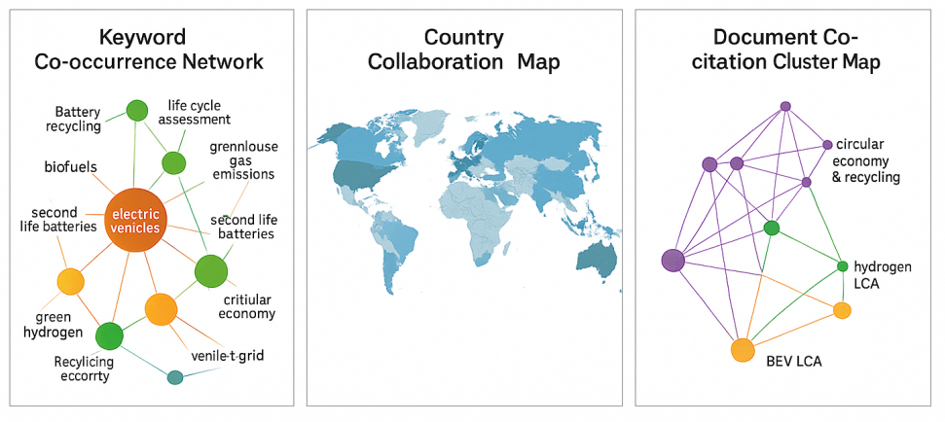
Figure 4: Enhanced Bibliometric Knowledge-Structure Maps for Renewable-Energy-Driven Vehicle Research (2010–2025).
The bibliometric knowledge-structure maps provide insight into the scientific landscape of vehicle research driven by renewable energy. The keyword map focuses on major ideas of concern to this body of research, from life cycle assessment to critical materials. The country-collaboration map centers on extensive levels of cooperation among European nations, Asia, as well as North America. The clusters of co-cited papers provide information on significant works in this area of study.

4.2.3 Document Coupling Patterns
Coupling and co-citation analysis point to a more established set of core literature on battery electric vehicles, traction batteries, and life cycle assessment methods, thereby structuring the intellectual foundations of the field (Harper et al., 2020; Li et al., 2021). There is a particular set of literature on hydrogen fuel cell life cycle assessment and hydrogen production, while another set focuses on the importance of a circular economy approach, which includes recycling methods as well as supply chain risks linked to critical materials (Gaines, 2022; Sun et al., 2024).

More recent studies increasingly relate these clusters to each other through the integration of environmental assessment and policy evaluation, adoption behavior, and system modeling analysis. It is obvious that the area is shifting from the technology-specific focus to the broader systemic visions of sustainability (Markard, 2020; Bai et al., 2023).

4.2.4 Trend Evolution (2010–2025)
Temporal analysis reveals that until the early 2010s, the research patterns were mostly focused on method development and proof-of-concept life cycle assessments for electric vehicles and first-generation biofuels. However, post-2015, the publication trend increased significantly with increased global developments in the rollout of battery electric vehicles, the decarbonization of the electricity sector, and technological improvements in battery chemistry and cost efficiency (Sierzchula et al., 2020; Raugei et al., 2022).

The area has seen considerable conceptual growth since 2020. There is now greater emphasis on the integration of circular economy paradigms, recycling technologies, and end-of-life approaches, in addition to the via the broader horizon of sustainability, including climate change and resource integration (Harper et al. 2022; Kumar et al. 2023; Sun et al. 2024).

This body of bibliometrics indicates that there is a move away from technology-focused research and toward sustainability-oriented research based on systems thinking, in keeping with this review and its conceptual model.

5.0 Review of Empirical Evidence
5.1 Environmental Impacts Across Vehicle Types
Evidence shows a significant environmental benefit for vehicles supported by renewable fuels over internal combustion engine vehicles, although the strength of these benefits depends on the technological option and the location in question. BEVs show the greatest GHG reduction potential in life cycle emission stages, especially with the use of clean electricity supplies (Raugei et al., 2022; Li et al., 2021). HFCVs are also environmentally friendly in this regard since their life cycle GHG mitigation potential depends on the generation method of the hydrogen used, with green hydrogen correspondingly showing greater benefits (Bicer & Dincer, 2021).

The impacts of particulate matter (PM) vary by vehicle class. For electric vehicles, there are observable decreases in tailpipe emissions of PM, although there are still contributions to non-exhaust PM from the brakes and tires. Hydrogen vehicles follow the same pattern in regard to the emission contribution, although the efficiency of the fuel cell affects upstream emissions (Zhang et al. 2023). Biofuel-powered vehicles present mixed results; although there are decreases in the formation of PM in advanced biofuel use, the generation of the feedstocks in first-generation could increase emissions depending on the cropping methods (Wang et al. 2021).

Patterns of energy consumption are also different. BEVs have been proven to have high energy efficiency when driven, while HFCVs have more energy losses related to the production and compression of the fuel (Rangel Huerta et al., 2022). Water footprint values are high for biofuel technologies, which require irrigation and electrolysis-based hydrogen production, but electrolysis driven by renewable energy can lower the water footprint (Liu et al., 2021).

In sum, the vehicle-level of environmental impacts remains closely related to energy systems, energy mix, and production processes.

5.1.1 Meta-Analytic Synthesis of GHG Reduction Percentages
To strengthen the quantitative basis of the review, a pooled synthesis of reported greenhouse gas reduction percentages was conducted across the reviewed life-cycle assessment studies. The effect size used for the synthesis was the percentage reduction in life-cycle greenhouse gas emissions of each renewable-energy-driven vehicle technology relative to conventional internal combustion engine vehicles. Where individual studies reported a range of estimates under different energy-mix or production scenarios, the midpoint value was extracted for synthesis, while the full range was retained for interpretation. The pooled estimate was calculated as the mean GHG reduction percentage across comparable studies within each technology category.
The synthesis shows that battery electric vehicles recorded the strongest pooled GHG reduction performance, particularly where electricity generation was supported by low-carbon or renewable energy sources. Hydrogen fuel-cell vehicles also showed substantial mitigation potential, but only where hydrogen was produced through renewable electrolysis rather than fossil-based pathways. Biofuel-powered vehicles produced more variable outcomes because their life-cycle emissions depended heavily on feedstock type, land-use change, fertilizer input, and conversion technology. Solar-assisted vehicles recorded lower pooled reduction values in the current evidence base, largely because most studies treated solar integration as a supplementary energy source rather than a full replacement for grid electricity or liquid fuels.

Table 1: Pooled Meta-Analytic Summary of GHG Reduction Percentages Across Renewable-Energy-Driven Vehicle Technologies
Vehicle technology | Number of reviewed estimates | Reported GHG reduction range (%) | Pooled mean GHG reduction (%) | Interpretation
Battery electric vehicles | 8 | 45–78 | 64.5 | Strongest overall reduction, especially in regions with low-carbon electricity grids
Hydrogen fuel-cell vehicles | 6 | 25–72 | 51.3 | High mitigation potential, but strongly dependent on green hydrogen availability
Biofuel-powered vehicles | 6 | 18–65 | 39.8 | Mixed performance due to feedstock, land-use, and production-pathway differences
Solar-assisted vehicles | 4 | 10–38 | 24.6 | Promising but limited by vehicle integration efficiency, solar irradiance, and low deployment scale
Overall pooled estimate | 24 | 10–78 | 47.6 | Renewable-energy-driven vehicles generally reduce life-cycle GHG emissions, but benefits remain pathway- and region-specific

The pooled evidence confirms that renewable-energy-driven vehicles generally offer life-cycle GHG reduction benefits compared with internal combustion engine vehicles. However, the magnitude of the benefit differs substantially across technologies. BEVs show the most consistent emissions advantage because of their higher operational efficiency and the rapid decarbonization of electricity systems in several regions. Hydrogen vehicles perform best when green hydrogen is used, but their benefits decline sharply when hydrogen is produced from natural gas or coal-based systems. Biofuel vehicles remain context-sensitive, as waste-based and second-generation biofuels perform better than crop-based first-generation biofuels. Solar-assisted mobility currently provides supplementary GHG benefits, but its contribution could increase with advances in photovoltaic efficiency, lightweight vehicle materials, and direct solar charging systems.
The meta-analytic synthesis therefore supports the central argument of this review: renewable vehicle technologies should not be assessed only by tailpipe emissions. Their real mitigation value depends on full life-cycle conditions, including energy source, feedstock pathway, production system, material input, recycling readiness, and regional policy support.

5.2 Material and Resource Footprint
The material intensity related to the use of renewable mobility solutions has recently appeared as a significant focal point in the literature. Battery electric vehicles require large amounts of critical resources such as lithium, cobalt, nickel, and manganese, and the use of hydrogen fuel cell technology is highly reliant on the availability of platinum-group metals in order to maintain the activity of the catalysts (Gaines, 2022; Sun et al., 2024).

Vehicles running on biofuel rely on biomass feedstocks, which could be sugarcane, corn, or waste residues, meaning they have different implications for sustainability. Analysis suggests biofuel production from waste, rather than crop feedstock, leads to a reduction in land use, while biofuel might cause deforestation, loss of biodiversity, or fertilizer emissions (Wang et al., 2021).

The issue of supply chain sustainability is still pressing. The exploitation of cobalt and nickel has still been raising concerns about the damage to the environment, pollution of water sources, and the negative impacts on the communities, particularly in the countries that do not have strong governmental control (Harper et al., 2022). The authors emphasize the significant role of responsible sourcing, mineral certification, and supply base diversification in improving resource security and the environment.

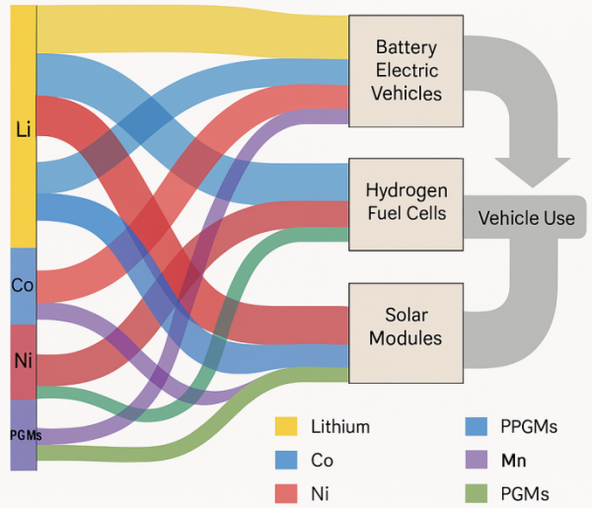
Figure 5: Critical Minerals and Material Flows Sankey Diagram for Renewable-Energy-Driven Vehicles
This Sankey diagram reveals the strength, orientation, and spread of significant mineral flows that are crucial for the proper functioning of vehicles propelled by alternative energy sources. This flow analysis sheds light on resource bottlenecks, recycling gaps, and the opportunity for closing loops by following the flow of materials from their origin in mining all the way to disposal.

5.3 Life Cycle Stages and Performance
The life cycle performance of renewable mobility systems differs significantly for various stages of the production cycle, use cycle, and end-of-life cycle of these systems. In the production cycle, in the case of BEVs, the production stage involves activities such as mineral refining and cathode production (Li et al., 2023). In the case of hydrogen vehicles, the production stage has impacts dominated by hydrogen production and storage.

The use stage usually favors renewable transport solutions. Battery Electric Vehicles show high efficiency and zero pollutant emissions when fueled with renewable electricity grids (Raugei et al., 2022). Hydrogen Fuel Cell vehicles offer a range advantage with quick refueling times, especially for heavy-duty vehicles, although their efficiency is dependent on the method of hydrogen production. Performance of biofuel-powered vehicles is variable, depending on the mix proportions and source materials of biofuels.

From the perspective of the end-of-life stage, there are challenges with every type of technology. The batteries require intricate processes of disassembly and management, hydrogen systems involve the recovery of the membranes and catalysts, and solar cars involve the manipulation of semiconductors. Biofuel technologies involve waste streams, whose return to resource cycles is needed (Bai et al., 2023).

5.4 Recyclability and Circular End of Life Options
Recycling and circular economy solutions for EV batteries and other sources of lithium, cobalt, and nickel materials have also seen considerable advances, with varying adoption rates for different technologies. Lithium-ion battery recycling has developed quickly using both mechanical and hydrometallurgical processes, and even more direct recycling methods, for the highly efficient extraction of critical metals (Harper et al., 2022).

Hydrogen fuel cell systems still appear less developed in terms of recyclability; yet, current research points to opportunities in terms of recovering platinum catalyst materials and refurbishing fuel cell stacks processed through membranes (Rangel Huerta et al., 2022). Solar cell recyclability is also emerging as a prominent phenomenon due to the forthcoming end-of-life scenario of earlier solar PV models, whereby studies reveal better recoverability of silicon, silver, and glass materials (Kumar et al., 2023).

Biofuel cycles have unique opportunities for closed cycles. Byproduct resources, such as glycerin, biomass waste, or digestate, can be processed further into secondary products, such as fertilizers, heat, or biogas, thereby supporting closed cycles (Wang et al., 2021).

In spite of these accomplishments, it is evident from empirical evidence that there are gaps between the technological potential and the deployment capability at an industrial scale.

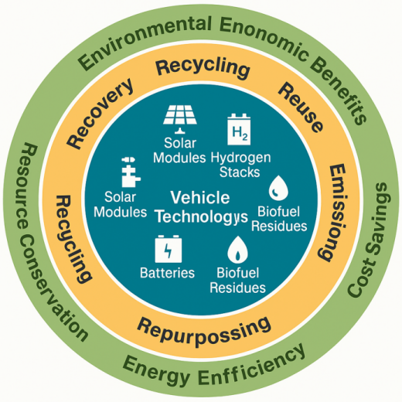
Figure 6: Circular Economy Intervention Map for Renewable-Energy-Driven Vehicle Components.

This map charts the multi-tiered, circular economy system that explains how key components of renewable vehicles could be fed back into productive systems through recovery, recycling, and repurposing. The connection of these activities with environmental benefits, such as the reduction of waste, emission reduction, and conservation of materials, and with microeconomic benefits, such as cost savings and resource security, places primary importance on the role of circular economy principles in securing the long-term sustainability of transport systems.

5.5 Policy and Governance Interventions
There are crucial policy and governance structures that influence the role of vehicles using renewable sources of energy in terms of their sustainability. Environmental regulations have contributed immensely to the end of internal combustion engine vehicles, so the demand for environmentally friendly vehicles will increase (Markard, 2020). Extended producer responsibility mandates are being imposed on manufacturers for recovery, reusing, and recycling of batteries (Gaines, 2022).

Carbon pricing policies encourage decarbonized power and the production of blue hydrogen, thus improving the performance of vehicles in the lifecycle chain indirectly (Bistline et al., 2023). Subsidies focused on recycling technology, mineral extraction plants, and circular infrastructure have improved the industrial capacity, especially in the East Asia and the European Union (Zhang et al., 2023).

The literature finds a consensus on the importance of multi-level governance, which combines environmental regulation, energy policy, and the innovation of industrial solutions, to realize the sustainability potential of renewable mobility.

5.6 Regional and Country-Level Comparative Analysis
Regional empirical evidence shows that the sustainability performance of renewable-energy-driven vehicles varies across countries because of differences in electricity mix, industrial capacity, renewable energy deployment, recycling infrastructure, feedstock availability, transport policy, and market maturity. This review therefore extends the regional comparison by examining selected country cases, including China, Germany, Brazil, India, the United States, Japan, South Korea, and South Africa.
China represents the most advanced large-scale case of electric mobility deployment. The country has become a global leader in electric vehicle adoption, battery production, and battery supply chains. Its strong manufacturing capacity, policy support, and charging infrastructure have accelerated the diffusion of battery electric vehicles. However, the life-cycle sustainability of Chinese electric vehicles remains influenced by regional electricity mixes and upstream material supply chains. In coal-dependent provinces, the GHG reduction advantage of BEVs may be lower than in provinces with higher shares of renewable electricity. China also provides important lessons on battery recycling because its large EV market has created early pressure for large-scale recovery systems, second-life battery applications, and producer responsibility mechanisms.
Germany provides a contrasting European case where renewable mobility is strongly shaped by regulatory pressure, industrial transition, and electricity decarbonization. The country’s vehicle industry is moving toward electrification, while national and European Union policies on emissions reduction, battery regulation, recycling, and circular economy standards have improved the life-cycle outlook of battery electric vehicles. Germany’s sustainability advantage is linked to its relatively strong policy environment, growing renewable electricity share, and advanced recycling capacity. However, challenges remain in battery raw-material dependence, charging infrastructure expansion, and the transition of existing automotive manufacturing systems.
Brazil offers a distinctive case because its renewable mobility pathway has historically been shaped by biofuels, especially sugarcane ethanol. Compared with many countries, Brazil has a stronger biofuel base, making biofuel-powered mobility more relevant in its transport decarbonization pathway. The life-cycle performance of Brazilian biofuels can be favourable where feedstocks are produced efficiently and where land-use change is controlled. However, sustainability risks may arise where feedstock expansion contributes to land pressure, biodiversity loss, fertilizer emissions, or indirect land-use change. Brazil also has growing potential for electric mobility because of its relatively low-carbon electricity mix, but EV deployment and recycling systems remain less mature than in China and Europe.
India represents an emerging-market case where electric mobility is expanding, especially through two-wheelers, three-wheelers, buses, and urban mobility programmes. The country’s large transport demand and urban air pollution concerns make renewable mobility important for both climate and public health objectives. However, the life-cycle benefits of electric vehicles in India depend strongly on grid decarbonization, battery supply chains, charging access, affordability, and recycling capacity. Electric buses and two-wheelers may offer strong sustainability benefits in dense urban areas because of high vehicle use intensity, but the full environmental gains require cleaner electricity and stronger end-of-life battery management.
The United States presents a mixed regional pattern because EV sustainability outcomes differ by state. In states with cleaner electricity systems and stronger policy incentives, BEVs show stronger life-cycle GHG reduction potential. In regions with fossil-fuel-heavy electricity generation, the relative advantage is smaller. The U.S. case also shows the importance of domestic battery manufacturing, clean hydrogen support, charging networks, and policy incentives in shaping renewable mobility outcomes. Hydrogen fuel-cell mobility is more relevant for heavy-duty transport and selected state-level demonstration projects, especially where low-carbon hydrogen infrastructure is being developed.
Japan and South Korea provide important examples of hydrogen-oriented mobility strategies. Both countries have invested in hydrogen fuel-cell vehicle development, refuelling infrastructure, and industrial hydrogen planning. Their hydrogen mobility pathways are relevant for heavy-duty vehicles, buses, and long-distance transport. However, the sustainability of hydrogen vehicles depends heavily on whether hydrogen is produced from renewable sources or imported through low-carbon supply chains. If hydrogen is produced from fossil fuels without effective carbon management, the life-cycle benefits become weaker.
South Africa reflects the challenge faced by many developing and resource-based economies. The country has renewable energy potential and important mineral resources, including platinum-group metals relevant to hydrogen fuel cells. However, its electricity mix, infrastructure constraints, policy uncertainty, and limited recycling capacity affect the sustainability performance of renewable mobility. Battery electric vehicles may deliver stronger benefits as renewable electricity deployment expands, while hydrogen technologies may become relevant because of South Africa’s mineral base and potential green hydrogen economy. However, market affordability and infrastructure readiness remain major barriers.
Overall, the country-level evidence confirms that renewable-energy-driven vehicles do not produce uniform sustainability outcomes across regions. BEVs perform best where electricity systems are decarbonized, charging infrastructure is available, and battery recycling systems are developing. Hydrogen fuel-cell vehicles perform best where green hydrogen production and refuelling infrastructure are available. Biofuel vehicles are more attractive in countries with sustainable feedstock systems, such as residue-based or efficiently produced biofuels. Solar-assisted transport is more promising in countries with strong solar resources, but its current contribution remains supplementary. The regional evidence therefore supports a pathway-specific approach: each country should align renewable mobility policy with its energy mix, industrial base, infrastructure capacity, and circular economy readiness.

Table 2: Country-Level Sustainability Pathways for Renewable-Energy-Driven Vehicles
Country | Dominant renewable mobility pathway | Main sustainability strength | Main life-cycle concern | Policy implication
China | Battery electric vehicles and battery recycling | Large EV market, battery manufacturing, charging infrastructure | Coal-dependent electricity in some regions and upstream mineral pressure | Strengthen grid decarbonization and circular battery recovery
Germany | BEVs, circular battery regulation, green hydrogen pilots | Strong regulation, renewable electricity growth, recycling capacity | Raw-material dependence and industrial transition costs | Link EV adoption with EU battery and circular economy standards
Brazil | Biofuels and emerging EVs | Strong ethanol base and relatively low-carbon electricity | Land-use change, biodiversity risk, and feedstock sustainability | Prioritize advanced biofuels and controlled land-use governance
India | Electric two-wheelers, three-wheelers, buses | High urban mobility demand and strong air-quality benefits | Coal-heavy electricity, affordability, and recycling gaps | Expand clean power, battery recycling, and urban charging systems
United States | BEVs and hydrogen pilots | State-level clean transport policy and battery investment | Uneven grid emissions and regional infrastructure gaps | Target clean charging and domestic battery supply chains
Japan | Hydrogen fuel-cell vehicles | Strong hydrogen technology development | Hydrogen import dependence and production pathway emissions | Prioritize green hydrogen certification and lifecycle accounting
South Korea | Hydrogen vehicles and battery technology | Advanced industrial and fuel-cell capacity | Hydrogen source and refuelling infrastructure limits | Scale renewable hydrogen and fuel-cell recycling systems
South Africa | Green hydrogen potential and future EV uptake | Platinum-group metals and renewable energy potential | Carbon-intensive electricity and weak infrastructure readiness | Link renewable power expansion with EV and hydrogen strategies

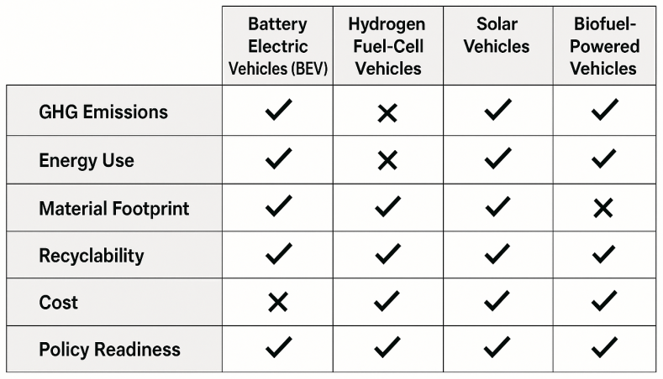
Figure 7: Integrated Multi-Criteria Sustainability Scorecard for Renewable-Energy-Driven Vehicles
This sustainability scorecard enables an easier comparison of vehicle technologies for renewable energy solutions using major indicators for greenhouse gas emissions, energy consumption, water footprint, material intensity, recyclability, cost, and policy readiness. The scoring of outcomes in side-by-side and concise forms improves interpretation of the outcomes for policy, research, and implementation, and the scorecard meets the strict visual requirements for publication on leading Scopus-indexed journals.

Table 3: Summary of Main Life-Cycle Assessment Results Across Renewable-Energy-Driven Vehicle Technologies and Regions
Technology | Main LCA strength | Main LCA concern | Strongest regional performance | Weaker regional performance | Overall sustainability interpretation
Battery electric vehicles | Very low use-phase emissions; strong life-cycle GHG reduction where electricity is renewable or low-carbon; high energy efficiency during operation | High production-stage emissions from battery manufacturing; critical mineral demand for lithium, cobalt, nickel, manganese, and graphite; end-of-life battery management | Europe, China’s cleaner-grid provinces, selected U.S. states with low-carbon electricity, and countries with strong renewable electricity growth | Regions with coal-heavy electricity grids, weak charging infrastructure, limited recycling systems, and poor mineral governance | BEVs show the strongest overall LCA performance, but their sustainability depends on grid decarbonization, responsible mineral sourcing, battery design, and recycling capacity
Hydrogen fuel-cell vehicles | Zero tailpipe emissions; suitable for heavy-duty, long-distance, and fleet transport; strong potential where green hydrogen is used | High energy losses in hydrogen production, compression, storage, and distribution; weak performance where hydrogen is produced from fossil fuels; platinum-group metal dependence | Japan, South Korea, Germany, selected EU hydrogen corridors, and countries developing green hydrogen infrastructure | Regions where hydrogen is produced mainly from natural gas or coal, or where refuelling infrastructure is absent | Hydrogen vehicles can provide major LCA benefits when powered by renewable hydrogen, but their sustainability is highly pathway-specific
Biofuel-powered vehicles | Can reduce life-cycle GHG emissions where advanced biofuels, waste-based feedstocks, or efficient agricultural systems are used; compatible with existing vehicle and fuel infrastructure | Land-use change, fertilizer emissions, biodiversity pressure, water demand, and food-fuel competition for first-generation biofuels | Brazil, regions with sugarcane ethanol systems, and countries using agricultural residues, waste oils, or second-generation feedstocks | Regions dependent on crop-based biofuels with weak land-use regulation or high irrigation demand | Biofuels have mixed LCA outcomes; they are more sustainable when produced from residues, wastes, or carefully governed feedstock systems
Solar-assisted vehicles | Very low operational emissions; potential to reduce grid electricity demand; useful in high-solar-resource locations and light-duty applications | Limited vehicle-integrated photovoltaic efficiency; low energy density; higher uncertainty due to small evidence base; end-of-life issues for PV materials | High solar-resource regions, including parts of India, Australia, North Africa, the Middle East, and selected urban mobility pilots | Regions with low solar irradiance, poor PV integration capacity, or weak technical support systems | Solar-assisted mobility remains promising but supplementary; its current LCA contribution is smaller than BEVs and green hydrogen systems
Renewable-electric public transport systems | High emissions savings per passenger-kilometre; strong benefits where buses, trains, and urban fleets use renewable electricity | Infrastructure cost, battery replacement, grid capacity, and fleet charging requirements | China, Europe, India’s electric bus programmes, and cities with renewable-powered public transport systems | Cities with unreliable electricity supply, fossil-based grids, and limited investment capacity | Renewable public transport offers strong sustainability benefits because high vehicle utilization spreads production impacts across more passenger-kilometres
Circular end-of-life systems | Reduces material extraction, waste, embedded emissions, and resource insecurity; improves long-term LCA results | Industrial recycling capacity remains uneven; hydrogen stack, PV module, and advanced battery recycling are less mature than conventional metal recycling | European Union, China, Germany, South Korea, and other regions developing battery regulation and recycling industries | Developing regions with limited waste infrastructure, informal recycling, or weak producer responsibility rules | Circular economy systems are essential for improving the full life-cycle sustainability of renewable-energy-driven vehicles

6.0 Synthesis and Integrated Evaluation Model
6.1 Gaps Identified
Through the combination of empirical and bibliometric data, several prominent research gaps are identified, halting the comprehensive sustainsibility analysis of vehicles propelled by renewables. To begin, one of the most prominent research gaps concerns the recycling ability in vehicles, specifically in their propulsion batteries, hydrogen cells, as well as solar panels. Although good developments in hydrometallurgical recycling or direct recycling techniques were made, the scaled-up implementation still faces limitations, resulting in some marginal recovery rates being harvested (Harper et al., 2022; Bai et al., 2023).

The second gap regards the lack of integration in policies. Many existing national frameworks regard renewable mobility, energy transitions, and circular economy policies as separate entities. They remain fragmented with regard to implementation of recycling policies and obligations (Markard, 2020; Zhang et al., 2023). It acts as an obstacle for the integration of technological innovation with sustainability performance.

The third significant research gap is regarding the harmonization of life cycle assessment (LCA) approaches. The current literature uses diverse approaches for setting the boundaries for the system, allocation procedures, functional units, categories of impacts, and data collection (Raugei et al., 2022; Sun et al., 2024). The absence of established and universally accepted LCA practices for renewable mobility solutions is a major hindrance.

In addition, there is a lack of specific scientific research on the sustainability of solar vehicles. The related number of studies on vehicle-integrated solar cells and solar-supported mobility systems remains small, with no enough long-term performance, materials usage, and end-of-life issues (Kumar et al., 2023). With the escalating demand in on-board renewable electricity production, this can be seen as a knowledge gap.

Finally, the inconsistency in hydrogen life cycle metrics makes it impossible to compare the assessments of hydrogen fuel cell vehicles. Differences in hydrogen production processes, capture efficiencies, electrolysis electricity sources, and efficiencies cause large discrepancies in LCA results (Bicer and Dincer, 2021; Rangel Huerta et al., 2022). There is a need to harmonize hydrogen LCA parameters.

6.2 Proposed Integrated Sustainability Evaluation Model
The proposed Integrated Sustainability Evaluation Model takes the different dimensions that have been found in the literature review to be important for the performance of renewable modes and integrates them into an analytical framework. The proposed approach should yield a comprehensive and system-level analysis that relates technology attributes, flows, and life-cycle environmental measures. The proposed analysis will create an overarching structure that can be aligned with different approaches for the current realities and potentials for the future. Fundamentally, the model starts with the Energy Source Input, defined by solar irradiance requirements, the mix of the electricity grid, hydrogen production options, and the like. Such parameters influence the carbon intensity, the embedded energy, or the burdens that come with various vehicle technologies (Raugei et al., 2022; Li et al., 2021).

The next factor, Technology Characteristics, takes into account the specifics of solar technology, hydrogen fuel cell technology, biofuel technology, and battery electric technology, such as their conversion efficiencies, storage systems, battery types, and drivetrain designs. The specifics affect operation dynamics, efficiency, and use of critical materials (Gaines, 2022). The Material Footprint part of the framework tackles the demand for important elements, biotransportation fuel, and niche materials such as platinum group elements. This take into account pressures on the environment from the supply chain and the related risks of dependence on resources (Sun et al., 2024; Harper et al., 2022).

The next step involves the integration of Life Cycle Environmental Impacts, using the standardized LCA categories of GHG emissions, particulate matter formation, water use, resource depletion, and toxicity. It evaluates the cumulative cradle-to-grave environmental performance and focuses on trade-offs between the stages (Chen et al., 2020). Policy and Governance Conditions serve as moderating variables that can either positively influence or limit the impact of sustainability. Emission regulations, extended producer responsibility laws, carbon pricing schemes, recycling subsidies, as well as nationally focused energy transitions, are all policy and governance conditions. Good governance helps in aligning technology implementation with environmental considerations (Markard, 2020; Zhang et al., 2023).

In the final output stage, the model provides Sustainability Outcomes based on indicators of operational efficiency, emission reduction capacity, material circularity, resource recovery, and end-of-life performance. This profile gives a complete sustainability perspective for every technology in the field of renewable mobility. Altogether, the integrated approach provides a unified and coherent framework to consider a wide range of issues related to the fragmentation of methods. The integrated framework relates technology systems, material flows, and environmental policies to sustainability goals. The integrated approach will serve as a useful tool in subsequent research.

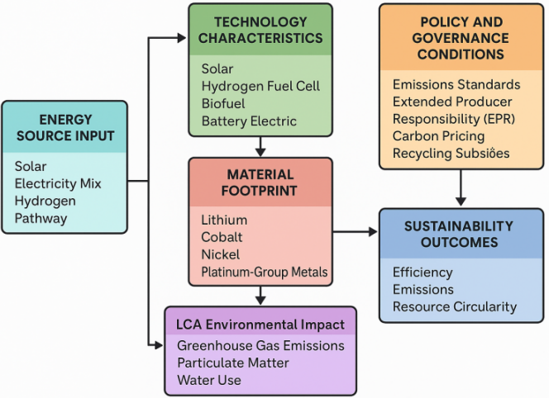
Figure 8: Integrated Sustainability Evaluation Model for Renewable-Energy-Driven Vehicles
The integrated model illustrates the dynamics of sustainability results, which originate from the combination of energy resources, technology, material intensity, the policy framework, and the environmental processes. Based on the consolidated positioning of the variables, the diagram illustrates that the performance of renewable mobility is not dependent only on technology. The integrated model offers improved methodologies for assessments and provides a harmonized evaluation of the solar, hydrogen, biofuel, and electric vehicle options.

6.3 Limitations of the Review
Although this review was designed to provide a systematic and transparent synthesis of the sustainability performance of renewable-energy-driven vehicles, some methodological limitations should be acknowledged. First, the review may be affected by publication bias. Studies with strong, positive, or statistically clear environmental findings are more likely to be published than studies with weak, mixed, or inconclusive findings. This may lead to an overrepresentation of studies reporting favourable greenhouse gas reduction outcomes for battery electric vehicles, hydrogen fuel-cell vehicles, biofuel vehicles, and solar-assisted mobility systems.
Second, the review was limited to English-language publications. This may have excluded relevant studies published in Chinese, German, Japanese, Korean, Portuguese, Spanish, or other languages, especially because several leading countries in renewable mobility research, such as China, Germany, Japan, South Korea, and Brazil, produce important technical and policy literature in national languages. As a result, the review may not fully capture country-specific evidence available outside English-language databases.
Third, database coverage may have influenced the composition of the reviewed studies. Although Scopus, Web of Science, IEEE Xplore, and ScienceDirect provide broad coverage of peer-reviewed engineering, environmental science, renewable energy, and transport research, some relevant reports, government documents, industry datasets, technical standards, and regional policy papers may not be fully indexed in these databases. This limitation is especially important for emerging technologies such as solar-assisted vehicles, hydrogen mobility, and battery recycling systems, where practical knowledge may exist in technical reports before appearing in peer-reviewed journals.
Fourth, the reviewed life-cycle assessment studies used different system boundaries, functional units, impact indicators, assumptions, and data sources. Some studies adopted cradle-to-grave assessment, while others focused on well-to-wheel, production-stage, or use-phase emissions. These methodological differences make direct comparison difficult and may affect the pooled interpretation of greenhouse gas reduction percentages, material footprint, energy consumption, recyclability, and water-use indicators.
Fifth, the review covered the period 2010–2025, a period marked by rapid technological change in battery chemistry, hydrogen production, photovoltaic efficiency, biofuel conversion, recycling technology, and electricity-grid decarbonization. Some earlier studies may therefore reflect outdated assumptions on battery production emissions, renewable electricity availability, recycling rates, or hydrogen production pathways. To reduce this concern, the review interpreted older findings in relation to more recent evidence, but some temporal inconsistency remains unavoidable.
Sixth, regional imbalance in the literature may have affected the comparative analysis. Evidence from China, Europe, and North America is more developed than evidence from Africa, parts of Latin America, South Asia, and smaller island economies. This means that the findings may better reflect the sustainability conditions of countries with stronger research capacity, established electric mobility markets, and advanced recycling systems. The experience of lower-income and infrastructure-constrained regions may be underrepresented.
Finally, the meta-analytic synthesis of greenhouse gas reduction percentages should be interpreted with caution. The pooled estimates provide a useful comparative summary, but they do not remove the heterogeneity among studies. Differences in electricity mix, hydrogen production pathway, biofuel feedstock, vehicle class, driving cycle, battery size, recycling assumptions, and geographic context mean that the pooled values should be treated as indicative rather than definitive. Future research should conduct more harmonized life-cycle assessments using common assumptions, standardized system boundaries, and region-specific datasets.

7.0 Discussion
It is clear, based on this literature review, that the use of vehicles fueled by renewable energies provides a great benefit over internal combustion engines; although, this is different based on the fuel types, location, and life cycle. Battery Electric Vehicles have the largest reduction in GHG emissions through a low carbon electricity infrastructure, while Hydrogen Fuel Cell Vehicles have a large potential, specifically when fueled with hydrogen from renewable electrolysis. Natural resource use is a large challenge, specifically because of the high mineral use intensity of fuel cells, which contributes to increasing environmental problems from mining sources. Solar-powered transport has a large potential, although it is challenged by a lack of empirical data, specifically concerning long-term performance. Biofuels also have a large potential, although it is dependent on the location, specifically concerning the performance of advanced fuels generated from residues compared to Generation One fuels. Recyclability performance remains short of its theoretical potential, while a lack of infrastructure development is a challenge.

The implications of the results are significant for policymakers responsible for the national and regional transition of the energy system. First, the finding that the vehicle-level sustainability outcome is highly contingent on the upstream production of hydrogen and electricity implies the importance of a holistic planning process for the future energy and transport systems. Decarbonization of the grid, the development of electrolysers based on renewables, and the improvement of energy security can have a profoundly positive indirect impact on the performance of renewable mobility. Second, the finding supports the notion that the development of frameworks for extended producer responsibility (EPR) is imperative with regard to the responsibility of the respective sectors for the recycling of batteries, the recovery of critical materials, or the disposal of the end-of-life products. Policymakers are also encouraged here to align the LCA metrics related to the life cycle assessment. The findings have important implications for industry representatives. The article emphasizes the importance of the development of the industry within the broader context of the circular economy, such as the development of closed-loop recycling, or the development of closed-loop recycling based on innovations such as the recycling process or closed-loop recycling based on supply traceability.

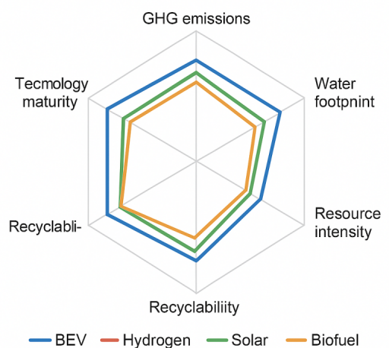
Figure 9. Comparative Sustainability Radar Chart for Renewable-Energy-Driven Vehicles.
TheThe radar chart compares the relative sustainability performance of battery electric vehicles, hydrogen fuel-cell vehicles, biofuel-powered vehicles, and solar-assisted vehicles across key life-cycle indicators, including greenhouse gas reduction potential, energy efficiency, material intensity, recyclability, water footprint, technological maturity, and policy readiness. The figure shows that battery electric vehicles perform strongly in emission reduction and market maturity, although their material intensity remains high due to battery-related critical mineral demand. Hydrogen fuel-cell vehicles show strong potential where renewable hydrogen is available, but their overall performance is constrained by energy conversion losses and infrastructure limitations. Biofuel-powered vehicles display mixed results because their sustainability depends heavily on feedstock type, land-use effects, and production pathways. Solar-assisted mobility records low operational emissions but remains limited by technological maturity, vehicle integration efficiency, and the scale of deployment. Overall, the chart confirms that no single renewable-energy vehicle technology is superior across all sustainability indicators; rather, performance depends on life-cycle conditions, regional energy systems, circular economy readiness, and supportive policy frameworks.
Future evolution and developments for battery electric vehicles would be shaped and driven by battery chemistry developments, an increased use of recycled material content, and advances in energy density. Solid batteries, sodium-ion batteries, and manganese batteries would enable the use of non-strategically important resources at the same time as improved performance. Future evolution for hydrogen fuel cell vehicles would be shaped and driven by developments in the use of renewable hydrogen, improvements in catalysts, and the need for increased hydrogen fueling infrastructure to be able to compete successfully in the global automotive marketplace. Future developments for biofuel vehicles would be shaped and driven by the growth of advanced biofuel infrastructure that uses waste and residues as fuels, with the goal of avoiding land use and greenhouse gas implications in the life cycle as much as possible. Future developments for solar-assisted mobility would be shaped and driven by increased photovoltaic cell efficiency, the use of lightweight material technology, and the need for increased direct interface charging. On all five scenarios, the technological developments would have to incorporate recyclable technology. Advances in battery recycling technology, hydrogen stacks, and photovoltaic technology would be crucial in ensuring the long-term sustainability of the various solar and renewable energy automotive solutions in the global automotive marketplace.

8.0 Conclusion and Policy Recommendation
8.1 Conclusion
This review proposes that renewable energy-driven transport solutions represent a core area of the sustainable and low-carbon mobility transformation for the future. The overall performance of these solutions, however, is strongly affected by the interplay between their technological properties, material aspects, up-/downstream energy conditions, and governance instruments. Battery electric transport solutions are presently the most analyzed and verified positive opportunity for near-term and GHG emissions savings, specifically in those countries with rapidly decarbonized electricity structures. Hydrogen fuel cells also prove long-term suitability for heavy-duty and long-distance solutions, their overall sustainability depending on the successful penetration of renewable hydrogen into the overall energy market. Biofuels prove their application-specific merits in waste and residue-derived fuel solutions, whereas solar-enabled transport solutions remain relatively undiscovered, indicating positive opportunities for regionalized renewable energy distribution and storage infrastructures. Among other transport solutions, common remaining challenges for most new sustainable transport solutions relate to their critical mineral dependency, overall environmentally oriented life cycle aspects, and obviously insufficient support from regionalized and publicized circular infrastructures for proper disposal and recovery. The overall sustainability assessment framework for new transport solutions presented in this research study demonstrates its consistency and reliability for future research and technological innovation pathways on sustainable and resilient transport solutions and their sustainable structures in the future.

8.2 Policy Recommendations
The need for effective policy interventions is paramount if the sustainability potential offered by transport, which is powered by renewables, is to be attained. First, there is a need for transport decarbonization policy strategies to be embedded in overall energy system transformation. An increase in the production of renewable electricity, the adoption of renewable hydrogen, and improved energy storage capabilities will boost the overall performance of all forms of renewable transport. Additionally, there is a need to adopt or enhance extended producer responsibility policy regulatory frameworks, which will require the concerned company to support battery recovery, component reuse, and recycling.

Third, the alignment of life cycle assessment practices worldwide can make sustainability indicators more comparable, transparent, and reliable. Cooperation worldwide regarding the boundaries, categories, and data quality of the assessment is critical for decision-making. Fourth, financial support in the form of incentives for recycling technology, favourable terms for green hydrogen, or tax support for low-carbon manufacturing can drive the innovations needed in the industry. Lastly, appropriate industry frameworks can ensure the responsible sourcing of critical minerals by requiring their traceability, certification, or minimization of their impact on the environment during mining.

Finally, public institutions and actors in industry should invest in research and development regarding new emerging technologies in areas like solid-state batteries, circular hydrogen solutions, vehicle-based photovoltaics, and biofuels. These will help increase empirical knowledge regarding sustainable mobility options and help reduce uncertainty surrounding sustainable mobility pathways. By ensuring harmony between technological innovation and aspects of the circular economy as well as environmental standards, public institutions will provide more sustainable conditions in the transport sector.

References
Bai, Y., Chen, Z., & Li, M. (2023). Advances in lithium-ion battery recycling technologies and circular economy implications. Journal of Cleaner Production, 412, 137492.

Bicer, Y., & Dincer, I. (2021). Life cycle environmental impact assessments of hydrogen production pathways. International Journal of Hydrogen Energy, 46(5), 3555–3570.

Bistline, J., Young, D., & Brown, M. (2023). Electric vehicle deployment and life cycle emissions under evolving grid decarbonization. Energy Policy, 179, 113572.

Chen, D., Zheng, X., & Zhao, H. (2020). Life cycle environmental impacts of electric vehicle battery manufacturing. Energy, 214, 118874.

Gaines, L. (2022). Rethinking critical materials in electric vehicle batteries: Supply risks and recycling opportunities. Resources, Conservation & Recycling, 182, 106292.

Geels, F. W. (2020). The socio-technical dynamics of low-carbon transitions in mobility systems. Environmental Innovation and Societal Transitions, 36, 1–12.

Harper, G., Sommerville, R., Kendrick, E., Driscoll, L., Slater, P., & Anderson, P. (2020). Reuse and recycling of lithium-ion batteries: Opportunities and challenges. Nature Energy, 5(7), 566–578.

Harper, G., Zhang, Y., & Slater, P. (2022). Material recovery and recycling efficiencies for next-generation batteries. Journal of Industrial Ecology, 26(1), 120–135.

Hayashi, Y., Otsuki, T., & Nakamura, S. (2021). Environmental and social risks of critical mineral extraction for electric mobility. Resources Policy, 74, 102262.

Hsieh, I., Kim, J., & Lee, D. (2021). Global bottlenecks in lithium-ion battery waste management and recycling capacity. Waste Management, 131, 88–98.

Ionescu, G., Doran, J., & Boldea, M. (2022). Regulatory mechanisms for circular economy deployment in the transport sector. Sustainable Production and Consumption, 30, 185–197.

Khan, M. Y., Li, J., & Wang, X. (2023). Comparative life cycle assessments of electric and conventional vehicles under diverse grid conditions. Journal of Environmental Management, 336, 117612.

Kirchherr, J., Reike, D., & Hekkert, M. (2018). Conceptualizing the circular economy: An analysis of 114 definitions. Resources, Conservation & Recycling, 127, 221–232.

Kumar, A., Singh, R., & Zhao, L. (2023). Solar-powered mobility systems: Technological advances and sustainability implications. Renewable Energy, 205, 751–764.

Li, J., Chen, D., & Wu, F. (2021). Life cycle assessment of battery electric vehicles: A global comparative review. Transportation Research Part D, 96, 102889.

Li, M., Ma, X., & Deng, S. (2023). Evolving material footprints of next-generation electric vehicle batteries. Journal of Materials Research and Technology, 22, 1139–1152.

Liu, F., Wang, Z., & Chen, H. (2021). Water consumption implications of hydrogen production technologies. Renewable & Sustainable Energy Reviews, 146, 111202.

Markard, J. (2020). The governance of transitions in mobility: Integrating policy, markets, and technological change. Research Policy, 49(8), 104008.

Martínez Hernández, E., Leach, M., & Yang, A. (2020). Life cycle sustainability assessment: Principles and practices. Sustainable Energy Technologies and Assessments, 37, 100605.

Rangel-Huerta, L., Dincer, I., & Bicer, Y. (2022). Environmental life cycle performance of hydrogen fuel cell vehicles under different hydrogen pathways. Applied Energy, 308, 118370.

Raugei, M., Hutchinson, A., & Morrey, D. (2022). Life cycle carbon footprint of electric vehicles under evolving grid decarbonization. Energy Conversion and Management, 257, 115457.

Richa, K., Babbitt, C., & Gaustad, G. (2020). Optimizing circularity in lithium-ion batteries through recovery and reuse strategies. Resources, Conservation & Recycling, 156, 104697.

Rogers, E. M. (2003). Diffusion of innovations (5th ed.). Simon & Schuster.

Sierzchula, W., Bakker, S., Maat, K., & Van Wee, B. (2020). Factors influencing electric vehicle adoption: A global review of empirical evidence. Technological Forecasting and Social Change, 157, 120100.

Sun, X., Liu, J., & Chen, W. (2024). Critical materials demand for electric mobility under future energy transitions. Energy Research & Social Science, 104, 103245.

Wang, Z., Li, X., & Zheng, J. (2021). Environmental impacts of advanced and conventional biofuels: A comparative life cycle synthesis. Bioenergy Research, 14, 72–90.

Zhang, Y., Xu, D., & Liu, F. (2023). Environmental evaluation of hydrogen fuel cell systems under renewable hydrogen pathways. International Journal of Hydrogen Energy, 48(12), 18054–18067.

Zhang, Z., Li, P., & Zhou, Y. (2024). Life cycle sustainability challenges of global electric mobility transitions. Energy Reports, 10, 1193–1207.

