"Transforming Life Through Welding: An International Model Integrating Prison Rehabilitation and Skill Development for Sustainable Nation Building"
Principal Author: Shri. CHANDRAN SUBRAMANI IWT, CWI, CQI (UK) Lead Auditor ISO9001, 45001, 14001 & 3834, NDT Level-II Inspector. Indian Maritime University, Chennai - 600119, Tamilnadu, India. Hon. Welding Skill Development Coordinator for the Southern Region (IIW-INDIA). Elected Hon. Vice Chairman from The Indian Institute of Welding – Chennai Branch. Email: chandran3000@gmail.com, Telephone no: +91 8838558281 https://orcid.org/0009-0006-0268-3644

Abstract:
Globally, more than 12 million people are incarcerated, with India accounting for nearly 600,000 prisoners, of whom approximately 56–60% are youth aged 18-35 years. This population represents a significant opportunity for skill-based rehabilitation and social reintegration. Simultaneously, India’s fabrication, manufacturing, and shipbuilding sectors face a growing shortage of qualified welding professionals, with an estimated demand of 12,000-15,000 skilled personnel by 2030. However, many prison-based vocational training program remain limited by non-standardized curricula and weak industry alignment. To address this gap, the Transforming Life through Welding - initiative was developed as a rehabilitation and workforce development model.
The program delivered 240 hours of Manual Metal Arc Welding (MMAW) training (3F/3G), aligned with ISO 9606-1 welder qualification requirements and NSQF Level 3.5 competency standards. The curriculum consisted of 60% practical training, 30% theoretical instruction, and 10% life-skill and behavioral development modules, supported by VR/AR-based welding simulator technology. Assessment results showed that 60% of participants successfully achieved welding performance qualification (WPQ) certification validated through NDT and DT methods. Behavioral outcomes indicated improvements in discipline (40%), technical competency (50%), and self-confidence (75%). Trained inmates also contributed to prison fabrication and maintenance activities and received support for post-release employment through a dedicated facilitation cell.
The study demonstrates that standardized welding education can serve as an effective tool for rehabilitation, employability, and social reintegration. The proposed model offers a sustainable and replicable framework for correctional skill development, supporting inclusive workforce development and the vision of Viksit Bharat 2047.
Keywords:
Welding Education, Prison Rehabilitation, Skill Development, Industrial Workforce, ISO 9606, Welder Qualification, Social Reintegration, Nation Building, Human Centric, Discipline, PPE.

Introduction:

The rehabilitation of prisoners through structured skill development has emerged as a global priority for promoting social reintegration and economic empowerment. Modern correctional systems increasingly emphasize vocational education and technical training as tools for reducing recidivism and improving post-release employability. In India, however, rehabilitation efforts within prisons often lack standardized, industry-aligned training frameworks, limiting opportunities for successful reintegration into society.

Simultaneously, India's fabrication, infrastructure, manufacturing, and shipbuilding sectors face a growing demand for qualified welding professionals. Addressing these dual challenges requires innovative approaches that combine correctional rehabilitation with workforce development. This study presents a prison-based welding skill development model, transforming life through welding, designed to equip inmates with industry-relevant competencies and nationally recognized qualifications. The skill program aligns with ISO 9606-1 welder qualification requirements, ISO 3834 welding quality standards, Integrated Management System (IMS) principles, and NSQF Level 3.5 competency standards. By integrating vocational training with rehabilitation objectives, the initiative seeks to enhance employability, support social reintegration, and contribute to the development of a skilled workforce in line with the vision of Viksit Bharat 2047.

II. Objectives:
- To deliver a structured 240-hour welding training program aligned with ISO 9606-1, ISO 3834, and NSQF Level 3.5 competency standards.
- To develop inmates’ technical, behavioral, and life skills, enhancing discipline, confidence, and employability.
- To assess and certify welding competencies through industry-recognized qualification and performance testing methods.
- To promote sustainable rehabilitation and post-release employment through industry, CSR, and skill development partnerships, supporting the vision of Viksit Bharat 2047.

III. Literature Review:
Vocational education and skill development are widely recognized as effective tools for prisoner rehabilitation, social reintegration, and crime reduction. Modern correctional systems increasingly emphasize rehabilitation-oriented approaches that equip inmates with employable skills, educational & personal qualifications, and personal development opportunities. The United Nations Standard Minimum Rules for the Treatment of Prisoners (Nelson Mandela Rules, 2015) identify education and vocational training as essential components of prisoner rehabilitation, encouraging correctional institutions to prepare inmates for successful reintegration into society.

International evidence demonstrates a strong relationship between correctional education and positive post-release outcomes. Scandinavian countries, particularly Norway, have adopted rehabilitation-focused prison systems that prioritize education, vocational training, and social inclusion. These programs have contributed to lower recidivism rates and improved employability among released prisoners. Similar approaches in Germany and other European nations highlight the importance of structured skill development in promoting social responsibility and reducing repeat offending. In the United States, correctional education has been extensively studied. A landmark meta-analysis by Davis et al. (2013) for the RAND Corporation found that inmates who participated in correctional education program were significantly less likely to return to prison than those who did not participate. The study reported a reduction in recidivism of approximately 15 to 18 percentage points and improved employment prospects after release (after the punishment periods). These findings have strengthened the case for integrating vocational and technical education into correctional rehabilitation systems. Research from Canada and Japan further supports the effectiveness of employment-oriented rehabilitation program. Canadian correctional institutions have successfully incorporated vocational training and employment preparation into offender rehabilitation strategies. Similarly, Japanese correctional facilities emphasize technical skills, discipline, and work ethics, enabling inmates to acquire employable competencies while fostering personal responsibility and social reintegration. The literature also highlights the importance of industry-recognized certification and employer engagement. Vocational program aligned with recognized occupational standards provide inmates with portable qualifications that remain valuable after release. Studies indicate that certified individuals are more likely to secure employment and sustain long-term careers. Employer engagement, industry partnerships, and post-release placement support are therefore considered essential components of successful rehabilitation program. In addition to technical competencies, researchers emphasize the importance of behavioral and life-skill development. Program that integrates communication skills, teamwork, discipline with positive attitude, problem-solving, and self-confidence training often produce better rehabilitation outcomes than technical training alone. Such holistic approaches help individuals adapt successfully to workplace environments and community life after release.

In India, prison rehabilitation has gained increasing attention through policy reforms and skill development initiatives. The Model Prison Manual (2016) advocates educational and vocational program as key elements of prison reform and inmate rehabilitation. Similarly, the National Policy for Skill Development and Entrepreneurship (2015) promotes inclusive skill development and encourages the extension of vocational training opportunities to marginalized populations, including prison inmates. Several Indian states have implemented vocational training program in trades such as tailoring, carpentry, agriculture, handicrafts, food processing, and basic engineering. While these initiatives have generated positive outcomes, many continue to face challenges related to curriculum standardization, certification recognition, infrastructure limitations, and weak industry linkages. Consequently, inmates often complete training program without obtaining qualifications that are formally recognized by employers or aligned with national competency standards. Indian judicial pronouncements have also emphasized the reformative role of prisons. The Supreme Court of India has repeatedly observed that prisons should function as Centre’s of correction and rehabilitation rather than merely institutions of punishment. These observations support the expansion of educational, vocational, and employment-oriented initiatives that enhance the prospects of successful social reintegration.

Despite these developments, significant gaps remain in the implementation of internationally benchmarked vocational program within correctional institutions. Few prison-based initiatives integrate internationally recognized qualification standards, structured competency assessment, and sustainable employment pathways. In particular, limited attention has been given to welding and fabrication skills despite growing demand from manufacturing, infrastructure, energy, offshore, and shipbuilding sectors. The present study addresses this gap by introducing a structured welding skill development model aligned with ISO 9606-1 welder qualification requirements, ISO 3834 welding quality standards, and NSQF Level 3.5 competency frameworks. The model integrates practical welding training, theoretical instruction, behavioral development, certification-oriented assessment, and employment facilitation. By combining internationally recognized standards with rehabilitation-focused learning, the program seeks to enhance employability, strengthen social reintegration, and contribute to national workforce development. The reviewed literature demonstrates that effective correctional rehabilitation requires a combination of technical training, recognized certification, behavioral development, industry engagement, and employment support. The proposed welding skill development model builds upon these principles and offers a sustainable and replicable framework for prison-based rehabilitation, workforce empowerment, and inclusive national development.

IV. Interpretation of Qualitative Findings:
The qualitative analysis highlights the socio-economic and psychological challenges faced by prisoners and the limited effectiveness of conventional prison systems in achieving sustainable rehabilitation. Despite substantial expenditure on food, welfare, infrastructure, administration, and legal processes, improvements in inmate behavior, mental well-being, and post-release reintegration remain limited. The absence of structured skill development and employment-oriented program often restricts behavioral transformation and economic self-sufficiency. Additionally, imprisonment frequently creates emotional, social, and financial hardships for inmates' families, affecting their long-term well-being. According to National Crime Records Bureau (NCRB) data (Figure 1), prison expenditure in India is primarily allocated to food (62.1%), followed by welfare activities (22%) and vocational education (8.8%). Smaller allocations are made for clothing (4%), medical care (1.6%), and other expenses (1.4%). These figures indicate that relatively limited resources are directed toward skill development and rehabilitation initiatives compared to operational expenditures.
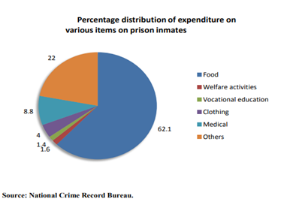
Figure 1. Expenditure on running prisons in India (pie chart)
The findings further reveal limited industry participation and professional engagement in prison rehabilitation program, resulting in reduced opportunities for employability and social reintegration. This underscores the need for structured, industry-aligned skill development initiatives that promote behavioral change, economic empowerment, and sustainable rehabilitation. The Transforming Life through Welding - Initiative addresses these challenges by providing internationally aligned welding training, competency certification, and employment-oriented skill development. The program demonstrates how vocational education can create pathways to stable employment, strengthen self-confidence, support family livelihoods, and facilitate successful reintegration into society.
The following criteria present the observations from narrative analysis:
Sl. NO. | OBSERVED CRITERIA | KEY FINDINGS / OBSERVATIONS | INTERPRETATION / IMPACT
1 | Economic Cost of Prison Management | High expenditure on prison operations including food, welfare, staff salary, and legal systems - without measurable improvement in prisoner outcomes; | Indicates inefficient use of government resources and lack of performance-based reform measures.
2 | Skill Development and Training Initiatives | No structured or continuous vocational or technical programs found. | Absence of skill-based rehabilitation leads to unemployment and re-offending risk post-release.
3 | Attitude and Behavioral Development | Prisoners show minimal improvement in personal discipline, teamwork / individual responsibility. | Demonstrates poor behavioral reformation and lack of moral or civic guidance.
4 | Mental and Emotional Well-being | Prisoners experience mental stress, hopelessness, and low morale due to isolation and lack of counseling. | Weak psychological support system; increases vulnerability to violence and depression.
5 | Family and Social Impact | Families suffer financially and emotionally; children’s education interrupted; social stigma persists. | Highlights secondary victimization of families and community alienation.
6 | Institutional and Administrative Support | Minimal engagement from NGOs or welfare departments; limited long-term rehabilitation planning. | Lack of coordination between correctional institutions and social organizations.
7 | Citizenship and Responsibility Awareness | Prisoners are not guided toward regaining citizenship identity or civic responsibility. | Reduces potential for social reintegration and productive citizenship.
8 | Public and Policy Perception | Society views prisoners as offenders rather than potential contributors. | Need for awareness campaigns and positive social inclusion frameworks.
9 | Future and Motivation Level | Prisoners express deep worry about post-release life, Employability, and society acceptance. | Urgent requirement for structured re-entry through industrial skill initiatives such as “Life through Welding.”
10 | Prisoners Life Change and Output | Represents a model of rehabilitation through skill empowerment, promoting both individual transformation and collective peace within society. | The project fosters a strong sense of social responsibility, discipline & human values, also reduction in criminal behavior, Re-integrated into society as skilled workers.
Table:1, Observed Criteria and Findings from Narrative Analysis
Despite significant investments, India’s prison system struggles to achieve true reformation and reintegration. Introducing industry-linked skill programs like welding training can transform imprisonment into productive learning and sustainable rehabilitation.

V. Methodology
This study adopted a qualitative program evaluation approach to examine the effectiveness of a structured welding skill development initiative in enhancing technical competency, behavioral transformation, and social reintegration among prison inmates. The program was implemented at the Industrial Skill Development Training Centre, Central Prison, Chennai (Puzhal Zone), Tamil Nadu, India, through collaboration between Prison authorities, industry experts, and skill development stakeholders.
The Transforming Life through Welding initiative was conceptualized and coordinated by Mr. Chandran Subramani, IIW-India, Welding Skill Development Coordinator and Examiner/Inspector, in association with the TN Prison Department and Central Prison Authorities. The program framework, training curriculum, learning resources, and technical infrastructure were provided as part of a rehabilitation-focused skill development initiative.
After prison counselling, nominated total of 100 inmates were selected to participate in the program based on eligibility criteria established by prison authorities, including behavioral suitability, willingness to participate, and physical fitness for welding training. The training program comprised 240 hours of instruction in Manual Metal Arc Welding (MMAW-111) (3F/3G- PF) and was aligned with ISO 9606-1 welder qualification requirements, ISO 3834 welding quality standards, and NSQF Level 3.5 competency frameworks. The curriculum was structured to include 60% practical training, 30% theoretical instruction, and 10% life-skill and behavioral development modules. Training delivery incorporated classroom sessions, workshop practice, welding simulator-based learning (VR/AR), safety awareness, engineering drawing interpretation, and basic fabrication techniques.
Participant performance was evaluated through continuous assessment, practical demonstrations, and competency-based testing. Welding performance was validated through Welders Performance Qualification (WPQ) Assessments supported by Non-Destructive Testing (NDT) and Destructive Testing (DT) methods. In addition, behavioral outcomes such as discipline, self-confidence, teamwork, and responsibility were assessed through observation, mentoring feedback, and pre- and post-training evaluations.
The methodology aimed to provide a holistic rehabilitation framework by integrating technical skill development, behavioral transformation, certification, and employment-oriented support, thereby enhancing the prospects for successful social reintegration and post-release employability.
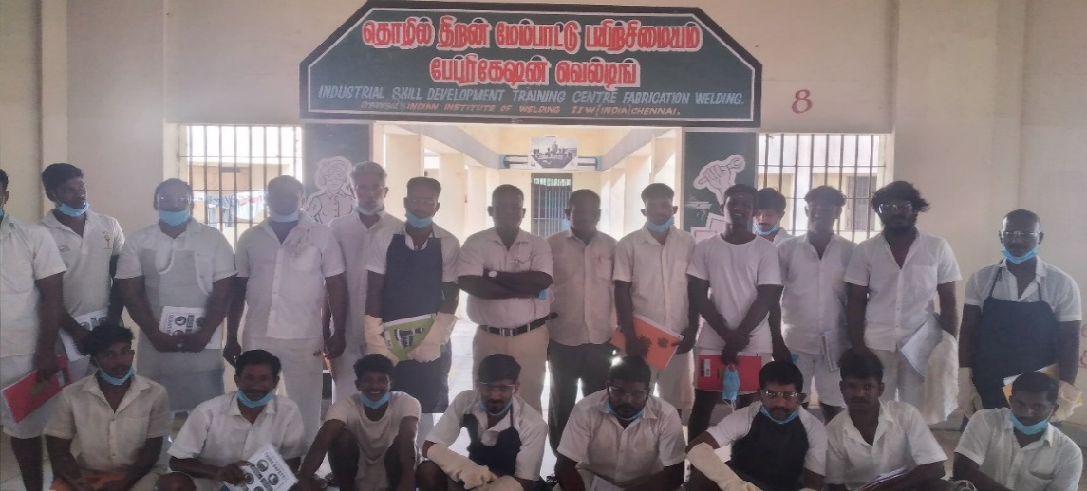
Figure: 2, Photographic Evidence of the Initiated Industrial Skill Development Training Centre.

VI. Ethical Considerations:
The Transforming Life through Welding - initiative was implemented with the approval and support of the Tamil Nadu Prison Department and Central Prison Authorities, Chennai. The program was conducted under the permissions granted through O.R. No. 22498/PW.3/2019 dated 29.07.2019, O.R. No. 9649/PW.3/2021 dated 17.03.2021, and O.R. No. 23921/PW.3/2022 dated 30.06.2022. These approvals authorized the implementation of prison-based welding skill development and rehabilitation activities within the correctional environment.
Participation in the training program was voluntary, and eligible inmates were enrolled based on their willingness to participate, behavioral suitability, and fitness for vocational training. Participation or non-participation had no impact on inmates' legal status, sentence duration, parole eligibility, remission benefits, or prison privileges, thereby ensuring freedom from coercion or undue influence. All participants were treated with dignity, fairness, and respect throughout the program. Personal information, training records, and assessment results were maintained confidentially and used solely for educational, rehabilitation, and research purposes. No individual participant identities are disclosed in this study. The training activities were conducted in compliance with applicable occupational health and safety requirements. Participants were provided with appropriate personal protective equipment (PPE), safety awareness training, supervised practical sessions, and controlled workshop facilities to minimize risks associated with welding operations. The program promoted equal opportunity, non-discrimination, and inclusive participation, ensuring access to training, assessment, and certification regardless of social, economic, or educational background. The initiative was guided by the principles of rehabilitation, human dignity, and social reintegration as outlined in the United Nations Standard Minimum Rules for the Treatment of Prisoners (Nelson Mandela Rules, 2015).
The primary objective of the program was to enhance employability, support successful reintegration into society, and contribute to sustainable rehabilitation through internationally aligned welding skill development and competency certification.

The program was successfully developed and implemented by the Principal Researcher and Author a qualified IWT, CWI, and NDT Inspector with CQI IMS Auditor, in alignment with recognized standards and national and international qualification systems.
A. Program Design:
The training curriculum was meticulously structured to ensure technical rigor, behavioral development, and industry readiness. The program had a total duration of 192 hours, focused on the Manual Metal Arc Welding (MMAW - 111) process, specifically in 3F and 3G welding positions (PF). Further to be developed training Modules of GMAW (MIG, MAG, FCAW) with GTAW (TIG) welding process with different welding positions. All training modules were aligned with the ISO9606-1 qualification framework, ensuring global recognition of welding competence. The curriculum was structured to ensure a balanced blend of technical and personal development 60% practical training in welding techniques, 30% theoretical learning on fundamentals and PPE safety, and 10% life skills and attitude development focusing on discipline, teamwork, and communication. This integrated approach equipped trainees with both professional competence and personal discipline, supporting their smooth reintegration into the workforce.
B. Assessment and Evaluation:
A comprehensive multi-stage assessment system was developed to ensure both technical and behavioral competencies were objectively evaluated.
Technical Evaluation: Each participant’s welding performance was tested through Destructive Testing (DT) and Non-Destructive Testing (NDT) methods, including visual inspection, bend tests & radio-graphic examination, in accordance with EN/ISO.
Behavioral Assessment: Pre- and post-training surveys were conducted to measure improvements in discipline, confidence, and workplace behavior.
Performance Monitoring: Individual progress was tracked through daily performance logs, trainers’ evaluation reports, and assess periodic reviews conducted by certified welding inspectors - CWI / IWT qualified welding examiner. This evaluation framework ensured data-driven validation of training effectiveness and performance.
C. Supporting Components:
To enhance the learning experience and bridge the technology gap within correctional environments, several supporting elements were integrated:
VR/AR-based Simulation Practice: Provided a risk-free digital environment for trainees to visualize weld techniques, arc behavior, and defect correction before live practice.
Electrical and Blueprint Fundamentals: Introduced basic electrical circuit knowledge and engineering drawing to improve understanding of fabrication systems.
Personality Development and Soft Skills Training: Focused on confidence-building, self-awareness, and employability enhancement through motivation sessions.
Industry Partnership: Collaboration with MSME industry partners ensured post-release employment facilitation for qualified trainees.
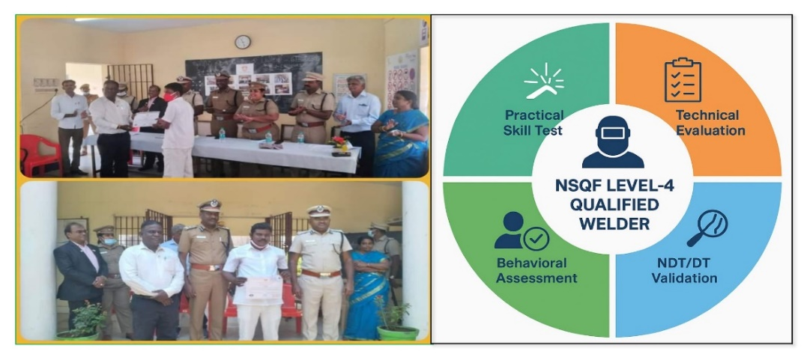
Figure: 3. Conducted best welder competition & Awarded ISO 5817 Stringent Level Qualified
The Transforming Life through Welding - program yielded significant results in both technical and behavioral dimensions, demonstrating the transformative potential of structured vocational training within correctional environments. Selected counseling based a total of 100 inmates participated in the training program through prison officials. Out of these, 60 participants (60%) successfully achieved ISO 9606-1 structural steel welder qualification, verified through destructive and non-destructive testing (DT/NDT) methods under certified inspection supervision. The remaining (40%) trainees completed partial training modules and continued with internal prison-based welding assignments for further practice and continual evaluation.
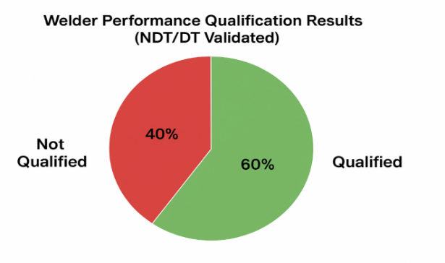
Figure:4. Final Result for Welder Performance (Pie Chart)
- Performance Improvement Analysis:
The data reflect that a progressive correlation exists between technical proficiency and behavioral stability. Participants who demonstrated higher welding performance scores also showed greater self-discipline, focus, and teamwork capability. This correlation validates that technical engagement fosters psychological transformation, contributing to long-term adaptability and social reintegration.

- Performance Indicator | Baseline Assessment (Pre-Training) | Improvement Achieved (Post-Training) | Success Criterion (≥70% Improvement = Excellent)
PERFORMANCE INDICATOR | PRE-TRAINING BASELINE | POST-TRAINING IMPROVEMENT (Expectation 70% - Excellent)
Discipline and Work Ethic | Low level to Moderate | + 40% improvement (Average)
Technical Competence | Basic level to Un-skilled | + 52.5% improvement (Satisfactory)
Confidence & Self-Motivation | Low level to Moderate | + 65% improvement (Good)
Table:2, Recorded Performance Improvement
B. Employment and Reintegration Outcomes:
Following certification, qualified inmates were engaged in in-prison fabrication, repair, and maintenance activities, contributing to facility operations while generating income to support their families. A Post-release Employment Facilitation Cell was established within the prison training center to coordinate placement opportunities with CSR and industry partners. Early outcomes indicated that trained welders received favorable consideration from fabrication and shipbuilding industries seeking certified manpower. These findings affirm that standardized welding training within correctional facilities can serve as an effective bridge between incarceration and employability, promoting both individual rehabilitation and industrial workforce development.

VII. Discussion:
The outcomes of this initiative clearly validate that structured welding skill development within correctional environments serves as a powerful instrument for both employability enhancement and moral reformation. by integrating internationally recognized standards such as ISO 9606-1 and the NSQF Level 3.5 framework, the program effectively bridged the gap between incarceration and industrial readiness.
The results demonstrate that when inmates are trained under industry-grade conditions, they can evolve into competent, disciplined, and socially responsible professionals. This transformation extends beyond technical skill acquisition; it promotes self-confidence, work ethics, and a constructive mindset, all of which are crucial for successful reintegration into society. Nevertheless, the implementation of the program encountered several operational challenges, including limited infrastructure availability, administrative clearance delays, and constraints in tool and equipment maintenance.
Despite these limitations, the initiative’s success was largely attributed to the collaborative partnership model involving CSR sponsors, prison authorities, and certified welding instructors, which ensured continuous resource support, quality assurance, and program sustainability. Overall, the findings underscore that industry-integrated rehabilitation models, when supported by standardized training systems and cross-sector collaboration, can play a transformative role in reducing recidivism, enhancing national skill capacity, and advancing the vision of inclusive nation building through skill-based reform.

VIII. Challenges and Observations:
The implementation of the Transforming Life through Welding - Initiative revealed several critical challenges within the prison environment. Internal support from prison officials was limited, and coordination between administrative and training units remained weak. The establishment of structured rules and regulations for fabrication and welding training within prison premises was identified as essential but has not yet been formalized. In addition, insufficient internal resources; including tools, consumables, and safety equipment, restricted the effectiveness of skill practice and learning outcomes. The procurement and safe custody of external training materials also presented logistical and security challenges, further slowing overall progress. At the initial stage, many prisoners exhibited low motivation and indifference toward welding activities, primarily due to negative attitudes and limited awareness of skill-based opportunities. It was further observed that a considerable portion of the prison population showed low levels of physical fitness and reduced work efficiency. Despite these constraints, the narrative findings indicate that many prisoners possess strong technical aptitude and learning potential. Once engaged in training, they demonstrated the ability to grasp welding concepts quickly and perform assigned tasks with growing competence. The introduction of a monthly stipend and work-based incentives notably improved participation levels and fostered a sense of dignity, purpose, and social value within the prison community. These findings suggest that, with structured management support, adequate material provision, and consistent motivational reinforcement, the model program can evolve into a sustainable and replicable framework for rehabilitation and social reintegration.

IX. Recommendations / Improvements Activity;
Based on the outcomes of this study, several key recommendations are proposed to strengthen and expand the impact of prison-based welding skill development programs at both national and international levels. National Replication and Policy Integration: The success of this model underscores the need for its nationwide replication under the frameworks of the National Skill Development Corporation (NSDC) and the Directorate General of Training and Employment (DGTE). Establishing Welding Skill Development Units within major prisons across India can create a standardized and scalable rehabilitation ecosystem aligned with the National Skills Qualification Framework (NSQF). Standardization through International Frameworks: To ensure global recognition and employability, future programs should align with international quality benchmarks such as ISO 3834 (Weld Quality Management System) and ISO 9606-1 (Welder Qualification Testing). This alignment will ensure that inmates receive certifications equivalent to those required in fabrication industries and shipbuilding sectors worldwide.
Integration with Industry 5.0 and Digital Learning Tools: The adoption of Industry 5.0 technologies (Mainly Human Centric Mission Focused), including Virtual Reality (VR) and Augmented Reality (AR) simulation platforms, is recommended to enhance digital literacy and practical understanding among trainees. These tools can replicate real-time welding conditions and provide immersive learning experiences, improving training efficiency and safety.
Sustainability and Employment Linkages: Establishing a centralized - Prison Skill Employment Cell; under the Ministry of Skill Development & Entrepreneurship (MSDE) will help connect trained inmates with industry employment opportunities. This cell can serve as a coordination hub between correctional institutions, industry associations, and CSR sponsors to ensure continuous engagement and placement support.
Social Reintegration and Economic Empowerment: To ensure long-term rehabilitation, mechanisms for microfinance, entrepreneurship training, and self-employment support should be introduced for released inmates. Partnerships with public and private banks, NGOs, and industrial clusters can facilitate small-scale fabrication units or welding service enterprises operated by certified ex-inmates.
Global Collaboration and Knowledge Exchange: The model can be adapted internationally through collaboration with global bodies such as the International Labour Organization (ILO) and UNESCO - UNEVOC. Establishing cross-country exchange programs will allow sharing of best practices in prison-based vocational rehabilitation, thereby promoting inclusive global workforce development. Also, to be collaborate with International Institute of Welding (Head of the Institute).
Collaboration and Strategic Activation: It is the right time to collaborate with IIW-India and State and Central Government skill development bodies, along with the relevant Sector Skill Councils, to establish a governing body & technical committee and a mission targeted mainly a targeted goal on Viksit Bharat 2047.

This strategic collaboration will help standardize training frameworks, ensure quality certification, and implement a nationwide rehabilitation program aimed at transforming prisoners into skilled professionals. The initiative will effectively promote social reintegration, dignified livelihood opportunities, and contribute to industrial manpower development across key sectors.
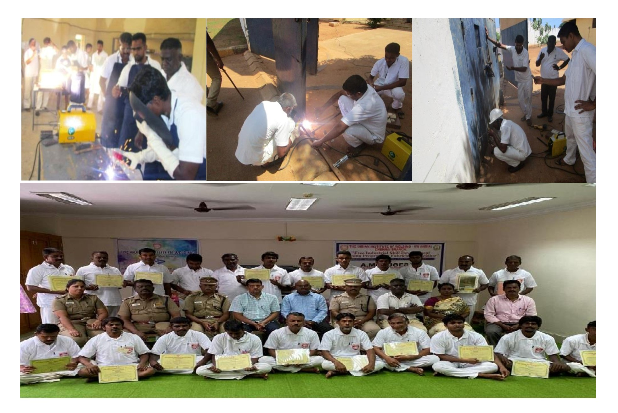
Figure:5. Photographic Evidence of the Welding Training, Assignment & Validation

Training Plan and Benefits:

The Project-focused skill development training program is designed to fulfill the requirements. The initiative aims to build a skilled and certified workforce capable of meeting industrial and national standards.

Recommended Employment Phase (Pre-release & Post-release): Upon successful completion of training and assessment, certified candidates will be offered one of the following employment opportunities:
- Prison Maintenance & Fabrication Work (Pre-release); Engaging in internal maintenance and small-scale fabrication within the facility.
- External Camp Work (Pre-release); Participation in on-site fabrication, Manufacturing and shipbuilding yard projects.
- National Employment (Post-release); Placement in domestic industries manpower supporting after prison tenure.
- Overseas Employment (Post-release); Opportunity for international placement based on performance and valid international skills certification.
- Self-Employment (Post-release): Supporting government initiatives under the MSME (Micro, Small, and Medium Enterprises) scheme, including free registration and loan facilities, also guiding startup for innovation projects.

Training Benefits; During the training period, participants receive attractive stipends and access to welfare support programs, ensuring sustained motivation and active engagement throughout the training-to-employment transition. Additionally, monthly performance-based award with rewards and a special annual paid holiday (for family visits) provision are offered to recognize dedication and continuous improvement.

Proposed NSQF-Aligned Training Modules (India):
NSQF LEVEL | DESIGNATION / ROLE | COMPETENCY DESCRIPTION | QUALIFICATION FOCUS
Level 1 | Welding Helper / Unskilled Assistant (Foundation level) | Basic understanding of welding tools, materials handling, PPE | Foundational knowledge and safety practices.
Level 2 | Basic Operational Welding Skills (Basic Level) | Performs simple welding operations under supervision. (1F/1G) | Practical exposure to basic welding processes.
Level 3 | Welding Assistant / Supporting Technician (Standard Level) | Supports skilled welders in preparation, alignment, and inspection activities. (2F/2G) | Process familiarity and teamwork competence.
Level 3.5 | Qualified Welder (Intermediate Level) | Certified skilled welders in preparation and welding quality inspection activities. (3F/3G) | individuals can perform routine welding tasks independently.
Level 4 | Independent Certified Welder (Expert Level) | Performs independent welding tasks as per ISO 9606-1 qualification standard. (6G) | Performance qualification and professional certification.
Level 5 | Welding Supervisor/CWI Inspector / Coordinator (Supervisory Level) | Oversees welding operations, ensures quality compliance as per the standards. (CWI, TOT syllabus) | Supervisory skills and inspection, weld quality management systems.
Table:3 NSQF structured Training Levels and Qualification modular system
This structured training levels and qualification modular system ensures progressive skill enhancement, leading to sustainable employability and rehabilitation through globally recognized welding Standards.
Proposed for Phase Implementation:
Analysis of state-wise prisoner populations highlights the need for the immediate introduction of structured skill development and rehabilitation programs in prisons with the highest inmate strength.
The proposed Transforming Life through Welding - Initiative aims to convert incarceration into a platform for skill empowerment, socio-economic reintegration, and reduced recidivism through vocational welding training and personnel counseling.
Priority states for phased implementation include Uttar Pradesh (≈20,000), Maharashtra (≈10,000), Andhra Pradesh (≈9,000), Tamil Nadu (≈8,500), West Bengal (≈8,000), Madhya Pradesh (≈7,500), Bihar (≈7,000), Punjab (≈6,750), Haryana (≈6,500), and Karnataka (≈6,000).
These ten states collectively represent a major share of India’s prison population and are identified as key focal regions for launching the Transforming life through welding; skill-based rehabilitation phase model.
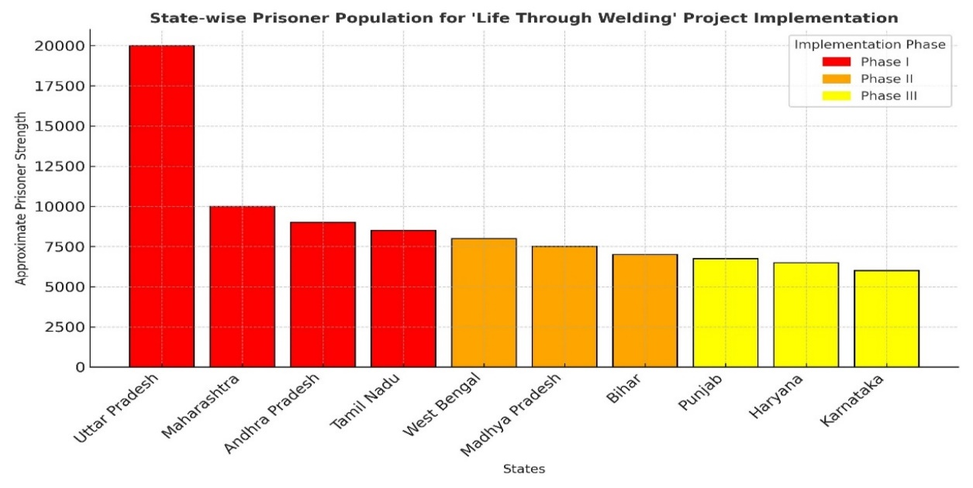
Figure 6. State-wise Prisoner Population Indicating Phase-wise Implementation (Bar Chart)
The chart illustrates that Uttar Pradesh (Indian state) leads with the highest inmate strength, followed by Maharashtra, Andhra Pradesh, and Tamil Nadu; forming the Phase-I priority cluster. These states together represent a substantial proportion of India’s total prison population and hence are ideal for launching the Transforming Life through Welding initiative focusing on welding skill training and behavioral rehabilitation.

Module Proposed for the Title of Welders performance qualification Assessment:
Module Code | Course Title | Duration | Total Hours | Structure | Process/Qualification | Enrolment Group
WPT-1 (Intern. Expert) | Certified International Welding Expert | 3 Months | 480 Hrs | (400 Practical + 80 Theory) | SMAW, GMAW, GTAW, FCAW - 6G (NSQF-4) | Qualified “Standard level” Qualification,
WPT-2 (STD.) | Certified Structural ARC Welder (SMAW) | 45 Days | 280 Hrs | 240 Practical + 40 Theory | SMAW - 3G/3F (NSQF-3) | Qualified “Basic level” Qualification,
WPT-3 (STD.) | Certified Structural MIG Welder (GMAW) | 45 Days | 280 Hrs | 240 Practical + 40 Theory | GMAW - 3G/3F (NSQF-3) | Qualified “Basic level” Qualification,
WPT-4 (STD.) | Certified Structural TIG Welder (GTAW) | 45 Days | 280 Hrs | 240 Practical + 40 Theory | GTAW - 3G/3F (NSQF-3) | Qualified “Basic level” Qualification,
WPT-5 (Expert) | Certified Pipe Welder (SMAW + GMAW) | 45 Days | 280 Hrs | 240 Practical + 40 Theory | SMAW & GMAW 6G (NSQF-4) | Qualified “Standard level” Qualification,
WPT-6 (Expert) | Certified Pipe Welder (SMAW + GTAW) | 45 Days | 280 Hrs | 240 Practical + 40 Theory | SMAW & GTAW 6G (NSQF-4) | Qualified “Standard level” Qualification,
WPT-7 (Expert) | Certified Pipe Welder (GTAW + SMAW) | 45 Days | 280 Hrs | 240 Practical + 40 Theory | GTAW & SMAW 6G (NSQF-4) | Qualified “Standard level” Qualification,
WPT-8 (Basic) | Certified Brazing Technician (Brazer) | 45 Days | 280 Hrs | 240 Practical + 40 Theory | OAG Weld & Braze 2F/2G (NSQF-3) | Skilled/Un-skilled/ Counseling selection
WPT-9 (Basic) | Certified Welder - Basic (SMAW) | 45 Days | 280 Hrs | 260 Practical + 20 Theory (Foundation) | SMAW 2F/1G (NSQF-2) | Skilled/Un-skilled/ Counseling selection
WPT-10 (Basic) | Certified Welder- Basic (GMAW) | 45 Days | 280 Hrs | 260 Practical + 20 Theory (Foundation) | GMAW 2F/1G (NSQF-2) | Skilled/Un-skilled/ Counseling selection
WPT-11 (Basic) | Certified Welder - Basic (GTAW) | 45 Days | 280 Hrs | 260 Practical + 20 Theory (Foundation) | GTAW 2F/1G (NSQF-2) | Skilled/Un-skilled/ Counseling selection
WPT-12 (Fdn.) | Welding Assistance (Foundation) | 45 Days | 280 Hrs | 260 Practical + 20 Theory (Foundation) | Basic Joint / Gas cutting, (NSQF-1) | Skilled/Un-skilled/ Counseling selection
Table:4. Recommended NSQF with Welding Training Modular (Structured Qualification)
X. Conclusion
The initiative Transforming Life through Welding - Conclusively demonstrates that skill-based correctional education is not merely a tool for rehabilitation, but a strategic instrument for national development. By embedding Integrated management system and ISO 9606-1 (Requirements of ISO3834 WQM) welder performance qualification standards (EN & ISO) within NSQF-aligned training frameworks, this model transforms correctional institutions into centers of structured technical excellence, producing globally competitive and industry-ready welding professionals. The incorporation of AI-based monitoring under CCTV supervision, along with Sustainable welding Training VR/AR-enabled welding simulations (Using cost saving & energy) and digital performance analytics, enhances training effectiveness monitoring systems and discipline, and productivity, resulting in measurable improvements in employability, self-confidence, and social reintegration. Aligned with the national vision of Viksit Bharat 2047, this initiative directly advances India’s objectives of inclusive growth, innovation-led development, sustainability, and workforce transformation. It addresses critical skilled manpower shortages while redefining prisons as engines of human capital generation rather than centers of isolation. By harmonizing advanced digital technologies with a human-centric approach under Industry 5.0 principles, this research establishes a replicable and scalable framework for dignified rehabilitation.

Transforming prisoners into professionals is not merely social reform; it is nation-building in action. Skill progress is measured using software-based weld quality analytics, simulation logs, and performance dashboards rather than biological tracking. aligned with Industry 5.0 principles, this human-centered and technology-driven model redefines prisoner reformation through dignity, discipline, and innovation. It effectively bridges social transformation with industrial advancement, addressing skilled manpower shortages while promoting inclusive growth. Ultimately, the initiative stands as a replicable global framework of social engineering, proving that through the power of welding, lives can be rebuilt, families restored, and nations strengthened.

References:
- NSDC: Skill India Mission - Transforming Workforce Development in India, Govt. Report,2022.
- Author; Chandran Subramani; Emerging Strategies for Skill Development and Standardization of ISO 3834 Standard by Weld Quality Management (WQM) Approach. URL;https://www.doi-ds.org/doilink/02.2023-88146716/UIJIR
- Ministry of Skill Development & Entrepreneurship (MSDE), National Skill Gap Report, 2022.
- International Institute of Welding (IIW), ISO 9606-1 Std. for Welder Qualification Testing.
- National Crime Records Bureau (NCRB), Prison Statistics India 2023.
- NSDC, National Skills Qualification Framework (NSQF) Level Descriptors, 2022
- Author; Joe labriola: Post- prison Employment Quality and Future Criminal Justice Contact; URL;https://www.jstor.org/stable/10.7758/rsf.2020.6.1.07?seq=1
- IIW Guidelines for the Implementation of Education, Training and Qualification in Welding.
- Davis, L. M., et al. (2013). Evaluating the Effectiveness of Correctional Edu. RAND Corporation.
- United Nations. (2015). Nelson Mandela Rules.
- Model Prison Manual, Government of India (2016).
- National Policy for Skill Development and Entrepreneurship (2015).
- Norwegian Correctional Service rehabilitation studies.
- Relevant Supreme Court of India prison reform judgments.
- International Institute of Welding. (2024). Guidelines for the training, qualification, and certification of welding personnel. IIW.
- International Labour Organization. (2021). Skills development and lifelong learning: Resource guide for workforce development. ILO.
- United Nations Office on Drugs and Crime. (2015). The Nelson Mandela Rules: United Nations Standard Minimum Rules for the Treatment of Prisoners. UNODC.
- United Nations Educational, Scientific and Cultural Organization. (2022). Technical and Vocational Education and Training (TVET): Strategy and Development Framework. UNESCO.
- Davis, Lois M.., et al. (2013). Evaluating the effectiveness of correctional education: A meta-analysis of programs that provide education to incarcerated adults. RAND Corporation.
- World Economic Forum. (2023). The Future of Jobs Report 2023. WEF.
- American Welding Society. (2020). AWS QC7: Standard for AWS Certified Welders. AWS.
- European Federation for Welding, Joining and Cutting. (2022). European Welding Education, Training and Qualification System. EWF.
------------

