Ectopic Thyroid Tissue Presenting as Thoracic Extradural Cystic Lesion in a Child: A Rare Case Report
Abstract
Ectopic thyroid tissue is a rare developmental anomaly resulting from aberrant migration of the thyroid gland during embryogenesis. Although ectopic thyroid tissue is most commonly identified in the lingual region, it may rarely occur at distant anatomical sites. We report a rare case of ectopic thyroid tissue presenting as a thoracic extradural cystic lesion in a 12-year-old girl.
The patient presented with progressive difficulty in walking, bilateral lower limb weakness, and stool incontinence of one month's duration. Magnetic resonance imaging revealed a loculated extradural cystic lesion extending from D2 to D8 vertebral levels, causing significant spinal cord compression and radiologically suggestive of an arachnoid cyst. The patient underwent D3–D7 laminectomy and excision of the lesion. Histopathological examination demonstrated thyroid tissue composed of colloid-filled follicles. Immunohistochemistry showed strong positivity for thyroid transcription factor-1 (TTF-1) and thyroglobulin, with focal cytoplasmic and membranous positivity for CK19, diffuse membranous positivity for CD56, and reduced galectin-3 expression, supporting the diagnosis of ectopic thyroid tissue.
Extensive evaluation to exclude a primary thyroid malignancy, including thyroid function tests, ultrasonography, contrast-enhanced computed tomography of the neck, positron emission tomography-computed tomography, and subsequent thyroidectomy, revealed no evidence of malignancy within the orthotopic thyroid gland. The patient showed neurological improvement following surgical decompression.
This case highlights an exceptionally rare presentation of ectopic thyroid tissue in a pediatric patient and underscores the importance of histopathological examination and immunohistochemistry in establishing the diagnosis of unusual spinal lesions.
Keywords: Ectopic thyroid tissue; Thoracic extradural lesion; Spinal cord compression; Immunohistochemistry.

Introduction
Ectopic thyroid tissue is a rare developmental anomaly resulting from aberrant embryological migration of the thyroid gland from the foramen cecum to its normal pretracheal position. The reported prevalence is approximately 1 per 100,000–300,000 individuals, with most cases occurring in the lingual region. Ectopic thyroid tissue may occasionally be found in unusual locations such as the mediastinum, heart, lungs, gastrointestinal tract, and spinal region. Diagnosis may pose a significant challenge, particularly when located at distant sites and in the absence of any lesion within the orthotopic thyroid gland. Spinal involvement is exceptionally rare, especially in children, and may mimic more common benign lesions radiologically. Establishing the diagnosis requires careful correlation of histopathological findings, immunohistochemistry, and comprehensive evaluation to exclude metastatic disease from a primary thyroid carcinoma.
We report a rare case of ectopic thyroid tissue presenting as a thoracic extradural cystic lesion in a 12-year-old girl with progressive paraparesis. The lesion was initially diagnosed radiologically as an arachnoid cyst, highlighting the diagnostic complexity and the importance of considering ectopic thyroid tissue in the differential diagnosis of unusual spinal lesions.

Microscopic Examination
Histological sections revealed thyroid tissue composed of variably sized follicles filled with eosinophilic colloid. Intervening stroma was fibrovascular.
The presence of benign thyroid tissue favored the diagnosis of ectopic thyroid tissue rather than metastatic disease.

Immunohistochemical Findings
To determine the lineage of the lesion and confirm the diagnosis, immunohistochemical studies were performed.
Marker | Result | Interpretation
TTF-1 | Strong nuclear positivity | Thyroid follicular epithelial origin
Thyroglobulin | Diffuse cytoplasmic positivity | Confirms thyroid differentiation
CK19 | Focal positivity | Supports thyroid origin
Galectin-3 | Negative | Supports a benign thyroid lesion
CD56 | Diffuse membranous staining | Characteristic of benign thyroid tissue
The immunophenotypic profile confirmed thyroid origin and supported the diagnosis of ectopic thyroid tissue.

Pathological Differential Diagnosis
Several differential diagnoses were considered.
Metastatic Papillary Thyroid Carcinoma
This was an important differential diagnosis because papillary thyroid carcinoma may metastasize to distant sites. However, extensive clinicoradiological evaluation failed to demonstrate any primary lesion within the thyroid gland. Furthermore, the histomorphological and immunohistochemical findings did not support metastatic papillary thyroid carcinoma.
Benign Ectopic Thyroid Tissue
The presence of colloid-filled thyroid follicles, absence of significant cytological atypia, and supportive immunohistochemical findings favored the diagnosis of benign ectopic thyroid tissue.
Metastatic Follicular Thyroid Carcinoma
This possibility was considered because of the thyroid follicular differentiation of the lesion. However, the absence of a primary thyroid neoplasm and the benign histological features argued against metastatic follicular thyroid carcinoma.

Evaluation of Orthotopic Thyroid Gland
To exclude the possibility of an occult primary thyroid malignancy, comprehensive investigations were undertaken.
Thyroid Function Tests
The patient was euthyroid with normal thyroid function tests.
Ultrasonography
Ultrasonography of the neck demonstrated a normally located thyroid gland without nodules, suspicious calcifications, or abnormal cervical lymph nodes.
Contrast-Enhanced CT Neck
CT examination revealed a normal thyroid gland within the thyroid bed and no evidence of cervical lymphadenopathy or ectopic thyroid tissue.
PET-CT Scan
Whole-body FDG PET-CT showed postoperative changes in the thoracic spine but no metabolically active lesion in the thyroid gland or elsewhere in the body. No FDG-avid cervical lymphadenopathy or distant metastasis was identified.

Final Pathological Diagnosis
Based on the characteristic histomorphological features, thyroid-specific immunohistochemical marker expression, absence of malignancy within the orthotopic thyroid gland, and negative metastatic workup, a diagnosis of:
Ectopic Thyroid Tissue Presenting as a Thoracic Extradural Cystic Lesion
was rendered.

Follow-Up
The patient showed neurological improvement following surgical decompression. Subsequent thyroidectomy performed to exclude primary thyroid malignancy revealed no evidence of malignancy, further supporting the diagnosis of ectopic thyroid tissue. Long-term clinical and radiological follow-up is ongoing.

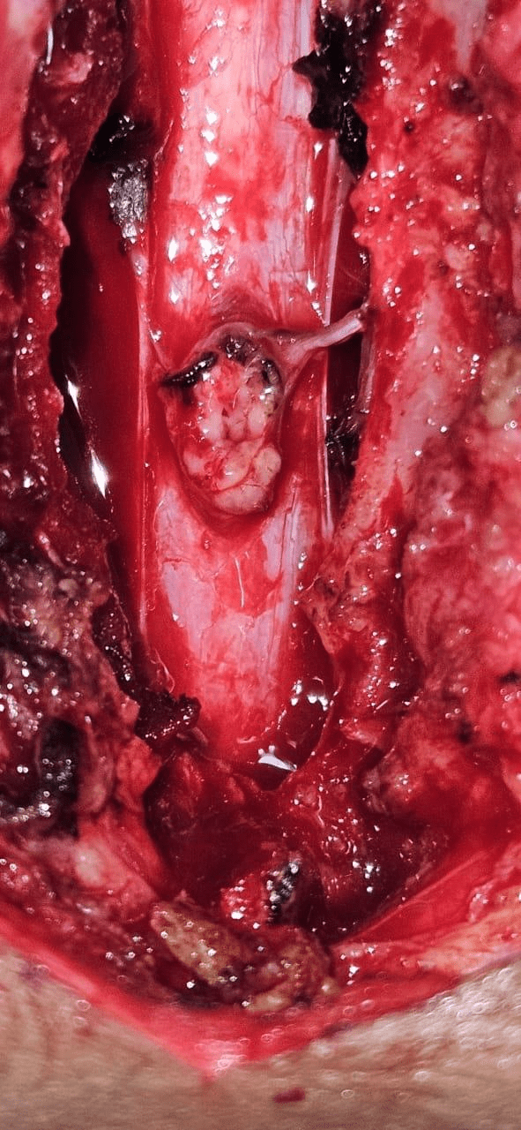
Figure 1. Intraoperative photograph of the thoracic extradural lesion
Legend:
Intraoperative image showing a well-circumscribed nodular lesion arising within the thoracic extradural compartment following laminectomy. The lesion was associated with a cystic cavity and appeared attached to the surrounding dura, correlating with the radiologically suspected arachnoid cyst.
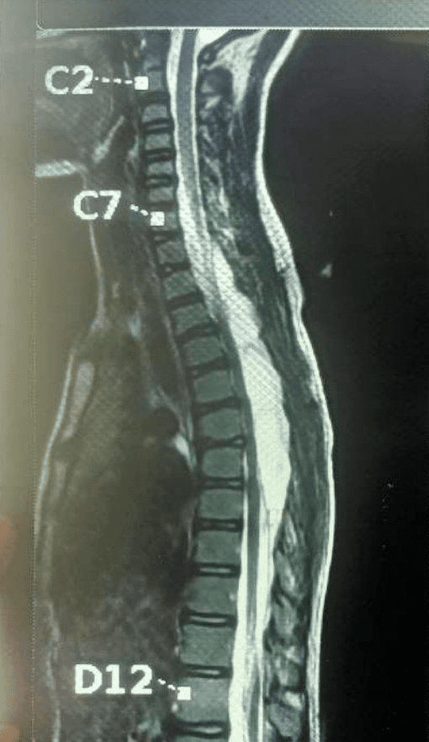
Figure 2. Magnetic resonance imaging of the thoracic spine
Legend:
Sagittal T2-weighted magnetic resonance image demonstrating a large loculated extradural cystic lesion extending from D2 to D8 vertebral levels in the posterior spinal canal, causing significant anterior displacement and compression of the thoracic spinal cord. The lesion was radiologically interpreted as an arachnoid cyst.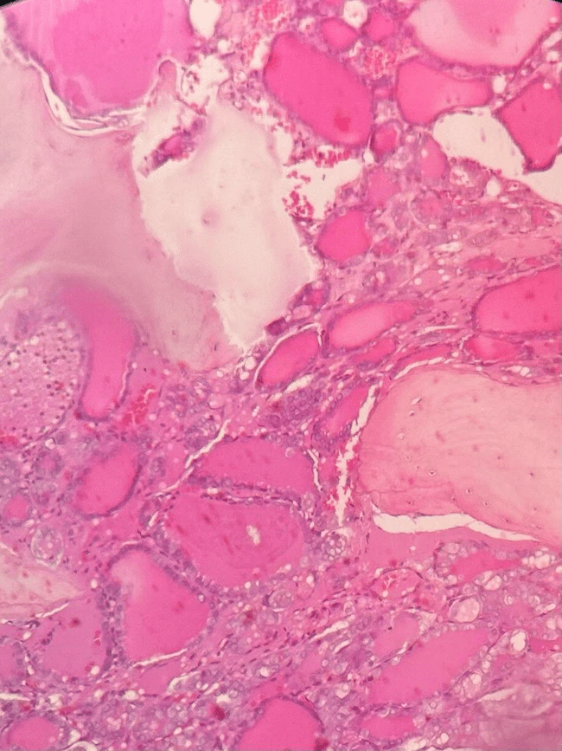
Figure 3 Histopathological Examination (H&E, ×100)
Legend:
Photomicrograph showing thyroid tissue composed of variably sized colloid-filled follicles lined by follicular epithelium and separated by fibrovascular stroma, consistent with ectopic thyroid tissue.
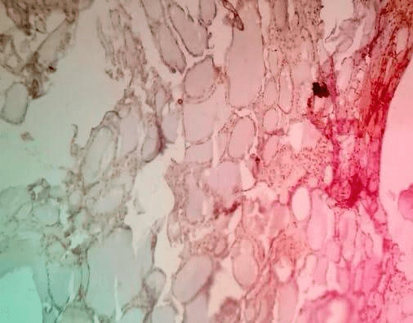
Figure 4. Immunohistochemical staining for TTF-1 (IHC, ×200)
Legend:
Lesional cells showing strong nuclear positivity for thyroid transcription factor-1 (TTF-1), confirming thyroid follicular epithelial origin and supporting the diagnosis of ectopic thyroid tissue.

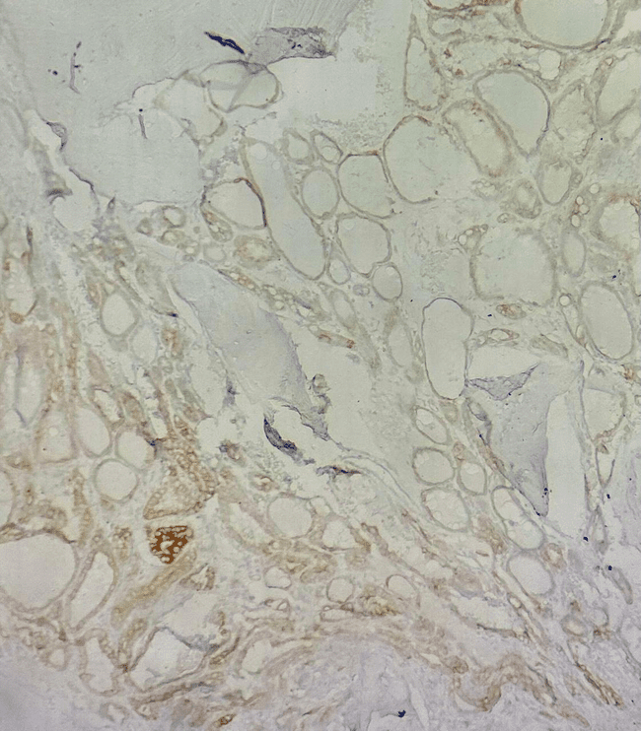
Figure 5. Immunohistochemical staining for CK19 (IHC, ×200)
Legend:
Lesional cells showing focal membranous and cytoplasmic positivity for Cytokeratin 19 (CK19), supporting thyroid follicular differentiation and the diagnosis of ectopic thyroid tissue.
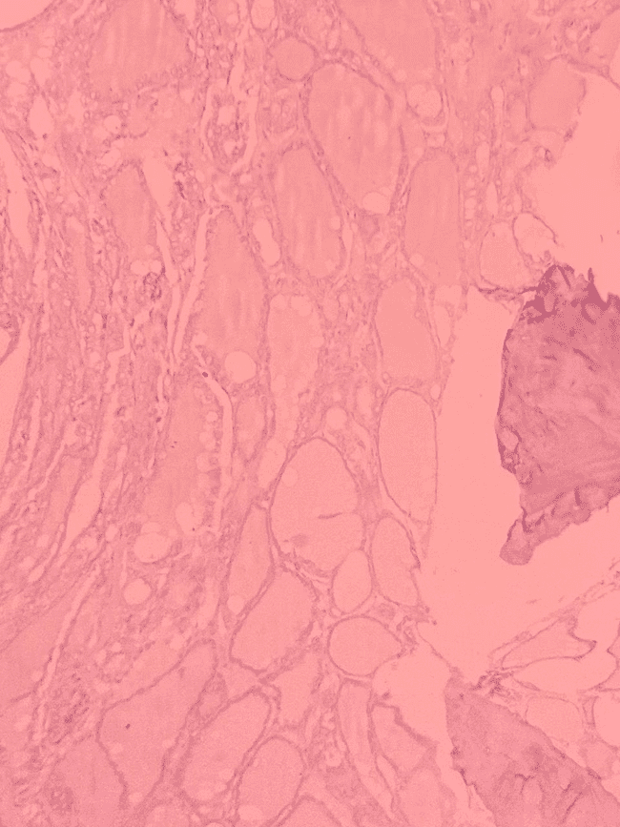
Figure 6. Immunohistochemical staining for CD56 (IHC, ×200)
Legend:
Lesional cells demonstrate diffuse membranous positivity for CD56, a finding characteristic of benign thyroid tissue and supportive of the diagnosis of ectopic thyroid tissue.

Discussion
Ectopic thyroid tissue is an uncommon developmental anomaly resulting from aberrant migration of the thyroid gland during embryogenesis. Although most cases occur in the lingual region, ectopic thyroid tissue may be identified at several unusual anatomical locations. Fu et al. [1] reviewed the available literature and noted that ectopic thyroid tissue is rare, while malignant transformation occurs only in a small proportion of cases. The present case represents an exceptionally unusual presentation of benign ectopic thyroid tissue occurring as a thoracic extradural cystic lesion in a pediatric patient.
Embryologically, the thyroid gland originates from the primitive pharyngeal floor at the foramen cecum and migrates caudally to its normal pretracheal location during early fetal development. Failure or aberration of this migratory process may result in ectopic thyroid tissue along the thyroglossal tract or, rarely, at distant anatomical sites. The precise mechanism underlying ectopic thyroid tissue in the thoracic extradural compartment remains unclear but may involve abnormal embryonic displacement of thyroid precursor cells during development.
Asokan et al. [2] described ectopic lingual thyroid as a rare developmental anomaly and emphasized the diagnostic difficulties associated with ectopic thyroid tissue occurring outside its normal anatomical location. Similar diagnostic challenges were encountered in our patient. A 12-year-old girl presented with progressive paraparesis, bilateral lower-limb weakness, and stool incontinence of one month's duration. MRI demonstrated a loculated extradural cystic lesion extending from D2 to D8 vertebral levels with significant spinal cord compression. Based on the radiological appearance, the lesion was initially interpreted as an arachnoid cyst, illustrating the difficulty of establishing a preoperative diagnosis.
Vaillant et al. [3] reviewed unusual locations of ectopic thyroid tissue and highlighted the importance of considering ectopic thyroid tissue in the differential diagnosis of lesions arising at atypical sites. While ectopic thyroid tissue has been reported in the mediastinum, thoracic cavity, and other distant locations, thoracic extradural involvement remains exceedingly rare. The unusual location in the present case contributed significantly to the diagnostic complexity and delayed consideration of a thyroid-origin lesion.
The occurrence of ectopic thyroid tissue in children is particularly uncommon. Mustafa et al. [4] reported triple ectopic thyroid tissue in a 4-year-old child, demonstrating the wide spectrum of developmental thyroid migration abnormalities encountered in pediatric practice. Similarly, Hasan et al. [5] described lingual thyroid presenting in a child with hypothyroidism. In contrast, our patient was euthyroid and presented with neurological manifestations due to spinal cord compression rather than symptoms related to thyroid dysfunction, highlighting the variable clinical presentation of ectopic thyroid tissue.
Accurate diagnosis relies heavily on histopathological examination and immunohistochemistry. In the present case, microscopic examination demonstrated variably sized colloid-filled follicles lined by follicular epithelium and separated by fibrovascular stroma. Immunohistochemical analysis showed strong positivity for TTF-1 and thyroglobulin, confirming thyroid follicular epithelial differentiation. In addition, focal CK19 positivity, negative galectin-3 expression, and diffuse membranous CD56 positivity supported the diagnosis of benign ectopic thyroid tissue. These findings were crucial in excluding other extradural lesions and establishing the thyroid origin of the lesion.
Al Alwan and Alhawsawi [6] emphasized that ectopic thyroid tissue may remain clinically silent for prolonged periods and may coexist with a normally located thyroid gland. Consistent with these observations, our patient had a normal orthotopic thyroid gland on ultrasonography and contrast-enhanced CT examination. Thyroid function tests were within normal limits, and PET-CT revealed no metabolically active lesion within the thyroid gland or elsewhere in the body.
Alanazi and Limaiem [7] highlighted the importance of comprehensive clinicoradiological and pathological correlation in establishing the diagnosis of ectopic thyroid tissue. In the present case, extensive evaluation including thyroid function tests, ultrasonography, contrast-enhanced CT of the neck, PET-CT imaging, and subsequent thyroidectomy failed to identify any malignancy within the orthotopic thyroid gland. These findings strongly supported the diagnosis of ectopic thyroid tissue rather than metastatic thyroid disease.
Although malignant transformation within ectopic thyroid tissue has been reported, it remains rare. Ali et al. [8] described ectopic thyroid carcinoma occurring in the mandible despite the presence of a normally located thyroid gland. Unlike that report, our patient demonstrated benign ectopic thyroid tissue without evidence of malignancy on histopathological examination, immunohistochemistry, imaging studies, or subsequent thyroidectomy.
Management of ectopic thyroid tissue depends on the anatomical location, symptomatology, and presence or absence of malignant features. Surgical excision is generally indicated in symptomatic lesions causing compressive manifestations or when the diagnosis remains uncertain. Following excision, periodic clinical and radiological surveillance may be considered because recurrence and malignant transformation, although uncommon, have been reported in the literature.
A major strength of the present case lies in the exhaustive clinicopathological evaluation. The combination of a D2–D8 thoracic extradural lesion, characteristic histomorphological findings, thyroid-specific immunohistochemical marker expression, normal thyroid function tests, negative PET-CT findings, and absence of malignancy within the orthotopic thyroid gland established the diagnosis of ectopic thyroid tissue presenting as a thoracic extradural cystic lesion. Furthermore, the patient's neurological improvement following surgical decompression highlights the importance of timely recognition and management of such rare lesions. To our knowledge, thoracic extradural ectopic thyroid tissue causing spinal cord compression in a child is exceedingly rare, with very few cases reported in the literature.

Conclusion
This case highlights an exceptionally rare presentation of benign ectopic thyroid tissue as a thoracic extradural cystic lesion causing spinal cord compression in a child. The unusual location and radiological resemblance to an arachnoid cyst posed significant diagnostic challenges. Histopathological examination, supported by thyroid-specific immunohistochemical markers and comprehensive exclusion of orthotopic thyroid malignancy, was essential for establishing the diagnosis. Awareness of this rare entity may facilitate accurate diagnosis and timely management of similar lesions encountered in clinical practice.

References
- Fu G, Guo F, Zhang W, Ruan X, Zheng X, Wang Z, Gao M. Diagnosis and treatment of ectopic thyroid carcinoma: A case report and literature review. Front Oncol. 2022 Nov 18;12:1072607. doi:10.3389/fonc.2022.1072607.
- Asokan L, Sunitha M, Kirupananthan N, Kannaiyan G, Kasinathan B, Praveen MR, Rao SM. Ectopic Lingual Thyroid-A Rare Presentation. Indian J Otolaryngol Head Neck Surg. 2023 Dec;75(4):3834-3838. doi:10.1007/s12070-023-03839-6.
- Vaillant PF, Devalckeneer A, Csanyi-Bastien M, Ares GS, Marks C, Mallea M, Cortet-Rudelli C, Maurage CA, Aboukaïs R. An unusual ectopic thyroid tissue location & review of literature. Neurochirurgie. 2023 Nov;69(6):101497. doi:10.1016/j.neuchi.2023.101497.
- Mustafa M, Karmazyn B, Chen DW, Eugster EA. Triple Ectopic Thyroid Gland in a 4-Year-Old Child. AACE Endocrinol Diabetes. 2025 Apr 10;12(1):46-49. doi:10.1016/j.aed.2025.02.002.
- Hasan SH, Pulock OS, Nahar K, Chowdhury MJBA, Dey E. Rediscovering the physical exam: lingual thyroid in juvenile hypothyroidism-a case report. BMC Pediatr. 2026;26(1):240. doi:10.1186/s12887-026-06623-x.
- Al Alwan I, Alhawsawi KI. Delayed Diagnosis of Ectopic Thyroid Due to Ignored Borderline Result of Newborn Screening for Congenital Hypothyroidism. Am J Case Rep. 2026;27:e948708. doi:10.12659/AJCR.948708.
- Alanazi SM, Limaiem F. Ectopic Thyroid. In: StatPearls [Internet]. Treasure Island (FL): StatPearls Publishing; 2026 Jan–. Available from: https://www.ncbi.nlm.nih.gov/books/NBK539892/
- Ali MOM, Mohamed NIA, Ahmed AAE, Adam NAI, Basher MOS, Elkhedir AAB. Ectopic thyroid carcinoma in the mandible with normally located goiterous thyroid gland: A case report. Int J Surg Case Rep. 2022 Aug;97:107433. doi:10.1016/j.ijscr.2022.107433.

