Redesigning Workdesks Using Ergonomic Function Deployment (EFD) to Reduce Musculoskeletal Risks for Warehouse Operators
¹ Luthfi Hibban, ^{1*}M Mutmainah, ²Andry Setiawan
¹ Department of Industrial, Engineering, Faculty of Engineering, Universitas Muhammadiyah Jakarta, 10510 Jakarta, Indonesia
² Department of Industrial Engineering, Faculty of Applied Science and Technology, Institut Sains dan Teknologi Nasional, 12640 Jakarta, Indonesia
*Corresponding Author
mutmainah@umj.ac.id

ABSTRACT
Inergonomic workstation design significantly amplifies the risk of Work-Related Musculoskeletal Disorders (WMSDs). This study addresses ergonomic challenges faced by scan-in finished goods operators at a metal manufacturing company, who endure static standing postures for seven hours daily using a workdesk that is excessively high and narrow.
Objective: This study aims to redesign the workstation to mitigate musculoskeletal risks and improve working postures using the Ergonomic Function Deployment (EFD) method.
The EFD approach was utilized to integrate operator needs with ergonomic principles through the House of Ergonomics (HOE). Baseline musculoskeletal complaints were assessed using the Nordic Body Map (NBM) questionnaire, while working postures were evaluated via Rapid Upper Limb Assessment (RULA). The design dimensions were developed based on representative Indonesian anthropometric data combined with field observations.
The NBM survey revealed significant discomfort in the feet (66.67%), ankles (66.67%), and calves (33.33%), indicating high-risk levels. To resolve this, an adjustable workdesk (height ranging 102–112 cm) integrated with an ergonomic standing-support stool and footrest was developed. Post-implementation RULA analysis demonstrated a significant risk reduction, with the final posture score dropping from 4 (medium risk) to 2 (acceptable posture).
The EFD-based workdesk redesign effectively minimizes musculoskeletal risks, enhances operator comfort, and promotes sustainable ergonomic principles in warehouse logistics.

Keywords: Ergonomic Function Deployment (EFD), RULA, Musculoskeletal Disorders (MSDs), Warehouse Logistics, Workstation Redesign.

INTRODUCTION
Human resources are a critical factor in a company's success, particularly in the manufacturing and warehousing sectors, which still rely heavily on manual labor. However, numerous studies have indicated that unergonomic workstation design is one of the primary causes of Work-related Musculoskeletal Disorders (WMSDs). This risk results from a combination of non-neutral working postures, repetitive movements, static loading, and a mismatch between workstation dimensions and workers’ anthropometric characteristics(Kim, 2023; Sahu & Pandit, 2025; Zare et al., 2019). Such conditions not only increase musculoskeletal discomfort and pain but also reduce operators’ comfort, work accuracy, and productivity (Abdullah et al., 2026; Septiani et al., 2024).
In warehouse environments, activities such as material handling, product stacking, order picking, packing, and finished-goods scanning are generally performed in a standing position with limited space for movement. Numerous studies have shown that standing workstations with inadequate ergonomic design are associated with moderate to high ergonomic risk levels, as assessed using methods such as RULA, REBA, and QEC, and contribute significantly to the prevalence of musculoskeletal complaints among workers (Hosseini et al., 2025; Jin et al., 2025). In contrast, ergonomic interventions through workstation redesign have been proven to reduce working posture risk scores, decrease MSD complaints, and improve operator comfort and performance (Bernardes et al., 2020; Sahu & Pandit, 2025; Zare et al., 2019).
The problem investigated in this study was identified in the finished-goods warehouse of a metal automotive component manufacturing company. In this area, operators are required to scan finished products before storing them on warehouse shelves to ensure that product information is accurately integrated into the company’s inventory management system. The following figure illustrates the operators’ working postures during the scanning process.
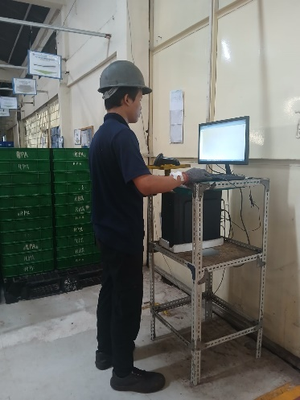
Figure 1 Scan-in Operator Work Process
These activities are performed repeatedly during working hours, standing at a desk with limited space. Field observations and Nordic Body Map (NBM) questionnaires indicate a high rate of musculoskeletal complaints among operators. The following are the results of initial observations to assess the complaints occurring in the field.

Figure 2 Nordic Body Map score results
Based on field observations and the initial results of the Nordic Body Map (NBM) questionnaire administered to finished-goods operators, a substantial level of pain and discomfort was reported across multiple body regions. Operator 1 reported “Very Painful” sensations in 17 body parts, while Operators 2 and 3 reported pain in 11 and 9 body parts, respectively. In percentage terms, the most prevalent complaints were concentrated in the lower extremities, particularly the feet (66.67%), ankles (66.67%), and calves (33.33%). This high level of physical discomfort is associated with working conditions that require operators to stand continuously for a 7-hour shift without seating facilities, combined with a workdesk that is excessively high and has a limited working surface area.
From a biomechanical perspective, prolonged static standing can impede venous blood return to the heart, increase pressure on muscle tissues, and lead to pain and swelling in the calves and ankles. Previous studies have demonstrated that prolonged static postures are strongly associated with an increased risk of musculoskeletal disorders affecting the lower limbs, lower back, and shoulders (Butar & Zetli, 2025; Colim et al., 2020; Septiani et al., 2024). Furthermore, ergonomic literature indicates that maintaining static postures for more than four hours per day significantly increases the risk of vascular and musculoskeletal disorders among industrial workers.
These subjective complaints were further validated through the Nordic Body Map (NBM) assessment, which yielded individual scores of 94 and 88, placing the workstation in the high-risk category and indicating the need for immediate corrective action. This finding is consistent with previous studies showing that high NBM scores are associated with a high prevalence of musculoskeletal complaints and serve as a strong indicator of the need for ergonomic interventions in workplace facilities (Abdullah et al., 2026; Colim et al., 2020; Nadiyah et al., 2025). Therefore, the current finished-goods scan-in workstation does not comply with fundamental ergonomic principles and has the potential to reduce operator comfort, safety, and productivity.
In recent years, work facility design has increasingly adopted a user-centered approach. The integration of methods such as NBM, REBA, RULA, and Quality Function Deployment (QFD) has been widely used to translate workers’ needs into ergonomic workstation design specifications (Abdullah et al., 2026; Muslimah et al., 2025). However, conventional QFD primarily focuses on functional requirements and product quality, often overlooking workers’ physiological, biomechanical, and musculoskeletal considerations (Bernardes et al., 2020; Tabrizi et al., 2025).
To address these limitations, the Ergonomic Function Deployment (EFD) method was developed by incorporating ergonomic principles into the House of Ergonomics (HOE) matrix. This approach enables workers’ needs and complaints, referred to as the Voice of Customer (VOC), to be systematically translated into technical specifications that align with users’ characteristics and ergonomic requirements (Bernardes et al., 2020). Numerous studies have demonstrated that the application of EFD, combined with anthropometric data, can improve working postures, reduce musculoskeletal risks, and enhance operator comfort(Bernardes et al., 2020; Tabrizi et al., 2025). Its effectiveness has been demonstrated in various manual work environments, including engraving workstations, where worker complaints were successfully transformed into precise design parameters (Sadi Zaky et al., 2025), and dismantling workstations, where workstation redesign significantly reduced injury risk levels through improvements in workbench structure(Wicaksono et al., 2024).
Despite these advancements, most previous studies have focused on production and assembly environments. The application of EFD in warehousing operations, particularly in finished-goods scan-in activities that involve prolonged standing, limited workspace, and high data accuracy requirements, remains limited. Moreover, current warehouse improvement initiatives tend to emphasize automation, robotics, and smart intralogistics systems that require substantial investment (Abdullah et al., 2026). In contrast, several studies have shown that work facilities designed according to workers’ anthropometric characteristics can directly reduce musculoskeletal disorder risks and improve workplace comfort (Hosseini et al., 2025; Kim, 2023).
Based on these considerations, a research gap exists regarding the application of Ergonomic Function Deployment (EFD) to redesign workdesks for warehouse operators who are exposed to prolonged standing, constrained workstation dimensions, and a high prevalence of lower-extremity musculoskeletal complaints. Therefore, this study aims to redesign the workdesk using the EFD method by integrating the Voice of Customer (VOC), workers’ anthropometric data, and ergonomic principles into the House of Ergonomics (HOE) matrix. The novelty of this research lies in the development of an adjustable workdesk for finished-goods scan-in activities, validated through ergonomic posture assessment. The proposed design is expected to reduce the risk of musculoskeletal disorders, enhance operator comfort, and improve warehouse productivity.
RESEARCH METHODOLOGY
Research Design
This study employs a quantitative–descriptive case study design integrating an ergonomic engineering approach to systematically redesign a warehouse operator workdesk. The optimization framework is driven by the Ergonomic Function Deployment (EFD) method.
Research Stages
- Literature Review and Conceptual Framework Formulation
Reviewing existing literature concerning Work-Related Musculoskeletal Disorders (WMSDs), postural risk assessment tools (Nordic Body Map [NBM], RULA, and REBA), and the implementation of QFD/EFD frameworks in restructuring work facilities and assistive devices (Adiyanto et al., 2022; Amrussalam et al., 2023).
- Field Study, Problem Identification, and Objective Formulation
Conducting on-site observations of finished goods scan-in operators, documenting awkward postures and operational workflows, and conducting preliminary interviews to identify physical discomfort and operational bottlenecks. The structural execution follows a systematic sequence adapted from comparable EFD studies conducted on finished goods and soybean milling workstations (Amrussalam et al., 2023).

- Data Collection
- Operator Characteristics and Anthropometry.
Measuring core physical dimensions—including standing eye height, standing elbow height, forward arm reach, and other relevant body metrics—to establish a baseline for workdesk dimensional constraints (Butar & Zetli, 2025).
- Musculoskeletal Complaints (Nordic Body Map)
Administering the NBM questionnaire to map out specific anatomical locations and the severity of physical discomfort, thereby classifying the baseline MSD risk levels (Adiyanto et al., 2022; Nadiyah et al., 2025).
- Work Posture Analysis (RULA)
Capturing video and photographic data of scan-in procedures, followed by a formal RULA assessment to generate initial postural risk scores and determine required levels of corrective action (Nofierni et al., 2025; Rofih et al., 2025).
- Voice of Customer (VOC) Operator
Utilizing structured interviews and Likert-scale questionnaires to capture operational needs, complaints, and spatial preferences regarding the workdesk (e.g., target height ranges, surface areas, scanner positioning, and sit-stand options). This approach aligns with VOC gathering protocols deployed in EFD-driven push-cart and batik-colet tool redesigns (Muslimah et al., 2025).
- Data Processing and Ergonomic Function Deployment (EFD) Application
- Initial Risk Assessment.
Compiling and interpreting baseline NBM discomfort categories and RULA/REBA scores. This step focuses heavily on cross-referencing and mapping out prevalent discomfort concentrated in the lower extremities and lower back region, following validated assessment practices in the food, SME, and packaging sectors (Nadiyah et al., 2025; Rofih et al., 2025).
- House of Ergonomics (HOE) Matrix Construction
- Converting the raw VOC data and NBM pain points into definitive ergonomic requirements (e.g., mitigating lower limb strain, facilitating variable dynamic postures, and maximizing surface reach zones).
- Developing an intersection relationship matrix that maps ergonomic requirements against concrete technical desk characteristics (minimum–maximum height clearances, surface depth and width, integrated scanner fixtures, footrest configurations, and active seating/standing supports). This executes the core EFD principle of translating user needs into quantifiable engineering specifications (Amrussalam et al., 2023).
- Calculating importance weightings for ergonomic criteria and performing technical prioritization analyses, mirroring priority frameworks utilized in EFD-based trolley, transport, and pallet transfer design optimizations (Butar & Zetli, 2025; Yuliyanti et al., 2026).
- Conceptual Design of the Adjustable Workdesk
- Generating multiple adjustable workdesk engineering concepts (featuring height flexibility, expanded work surfaces, and seamless sit-stand adaptability) utilizing gathered anthropometric percentiles (e.g., using 5th–95th percentile standing elbow heights to determine vertical adjustment ranges) (Butar & Zetli, 2025).
- Where feasible, concepts will be digitally validated using Digital Human Modeling (DHM) to simulate human-furniture interaction and predict post-redesign RULA scores prior to physical assembly, as demonstrated in SME and batik production studies (Adiyanto et al., 2022; Muslimah et al., 2025).
- Final Design Selection and Detailing
- Selecting the optimal design concept based on its House of Ergonomics (HOE) target compliance, manufacturing feasibility, and alignment with the standard ergonomic principles of ENASE/ECSHE (Effective, Comfortable, Safe, Healthy, Efficient) (Amrussalam et al., 2023).
- This culminates in producing full engineering blueprints and detailed spec sheets detailing dimensions, mechanical lift systems, scanner brackets, and ergonomic standing supports.
- Validasi Ergonomis Redesain Workdesk
Ergonomic validation was conducted to evaluate the suitability of the redesigned workdesk using ergonomic analysis software. The redesigned workdesk model was integrated with a digital human model based on the operators' anthropometric data. Subsequently, work activity simulations were performed to analyze working posture, reachability, and ergonomic risk levels.
The assessment was carried out using ergonomic analysis tools available in the software, such as the Rapid Upper Limb Assessment (RULA) or Rapid Entire Body Assessment (REBA) methods, to identify the risk level of musculoskeletal disorders. The simulation results were used to verify whether the redesigned workdesk improved working posture and reduced ergonomic risks compared to the existing workstation. If high-risk conditions were still identified, further design modifications and revalidation were performed until an ergonomically acceptable design was achieved.
- Conclusions and Recommendations
Formulating conclusions regarding the absolute effectiveness of the EFD method in mitigating musculoskeletal degradation among warehouse operators, while outlining implementation guidelines and scalability recommendations for adjacent logistics and warehouse ecosystems.
RESULT AND DISCUSION
Identification of MSDs Complaints by Scan-in Operators
Based on field observations, physical complaints indicating MSDs (Musculoskeletal Disorders) risks were identified among scan-in finished goods operators. To address this issue, a fishbone diagram was utilized to trace the root causes of these complaints, categorizing them into human, method, and machine factors. Through this analysis, appropriate and effective corrective solutions can be formulated to minimize the risk of physical complaints for the operators.
Figure 3 Fishbone Diagram
Based on the fishbone diagram analysis and the Nordic Body Map questionnaire, the primary cause of MSDs complaints was an unergonomic workstation, which placed two out of three operators at high risk with scores of 94 and 88. To minimize this risk, the researcher redesigned the scan-in finished goods workstation by creating a more ergonomic work table tailored to the operators' anthropometry.
RULA Analysis of Current Working Conditions
A Rapid Upper Limb Assessment (RULA) analysis was conducted using software to evaluate the ergonomic risks associated with the operator's initial working posture and workstation.
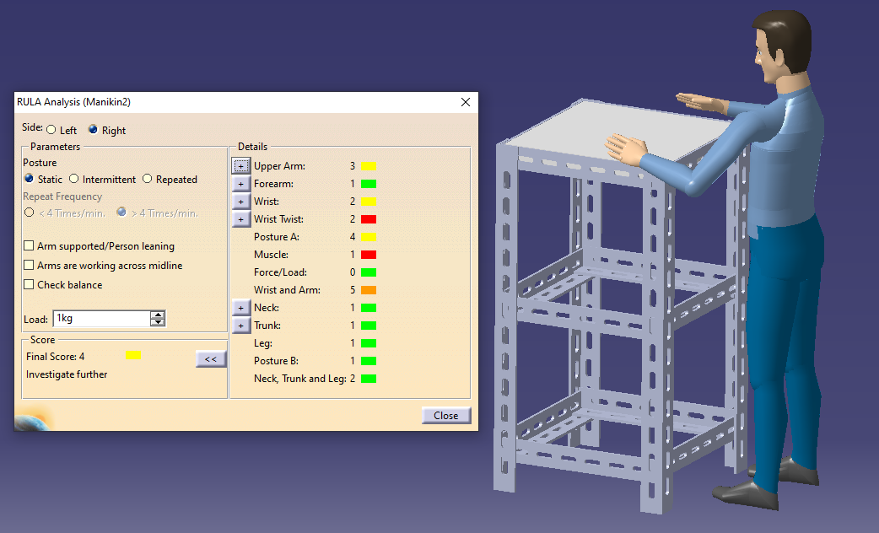
Figure 4 RULA Analysis of Initial Condition Table Design
The RULA analysis yielded a final score of 4, indicating a medium risk level. Although not highly critical, the current working conditions still pose ergonomic risks, necessitating further investigation and posture modifications, such as adjusting the table height and adding a chair to better align with the worker's anthropometrics.
Redesigning the Scan-in Finished Goods Workstation using Ergonomic Function Deployment (EFD)
The design of a table using the Ergonomic Function Deployment (EFD) method is carried out through several systematic stages which are explained as follows:
Technical Interest Arrangement
Based on interviews with operators regarding their expectations for workstation improvements, the following technical requirements have been identified in this study. Operator requirements data from the questionnaire will be processed to calculate importance levels (divided into 5 criteria) and satisfaction levels. The calculation results for both levels are presented below.
Table 1 level of importance
No | Tingkat Kepentingan | VU ( Very Unimportant) | NI (Non Important) | QI (Quite Important) | I (Important) | VI (Very Important) | Total | Niai
1 | workbench is easy to use |  |  | 1 | 1 | 1 | 12 | 3
2 | the work desk is comfortable to use |  |  |  | 2 | 1 | 13 | 3,25
3 | The work desk has an ergonomic design. |  |  |  | 1 | 2 | 14 | 3,5
4 | The work desk has an ergonomic chair with a footrest |  |  |  | 1 | 2 | 14 | 3,5
Total |  |  |  |  |  |  | 53 | 13,5

The table 1 presents the technical importance levels of various work table design aspects based on their contribution relationships (VU, NI, QI, I, VI). The calculation results show that aspects 3 and 4 achieved the highest scores (3.5 each), meaning these two aspects must be the primary focus in the workstation redesign to optimally meet operator needs.
Calculation of Satisfaction Level
Following the identification of customer requirements, an evaluation of the current workstation performance was carried out through a satisfaction level analysis. This analysis aims to measure operators’ perceptions of the existing workstation and identify attributes that require improvement. The calculated satisfaction levels serve as an essential input for the subsequent stages of the EFD process and workstation redesign.
Table 2 Satisfaction levels
No | Tingkat Kepentingan | VU ( Very Unimportant) | NI (Non Important) | QI (Quite Important) | I (Important) | VI (Very Important) | Total | Niai
1 | workbench is easy to use | 2 |  | 1 |  |  | 5 | 1,25
2 | the work desk is comfortable to use |  | 2 | 1 |  |  | 7 | 1,75
3 | The work desk has an ergonomic design. | 1 | 2 |  |  |  | 5 | 1,25
4 | The work desk has an ergonomic chair with a footrest | 1 | 2 |  |  |  | 5 | 1,25
Total |  |  |  |  |  |  | 22 | 5,5
Table 2 indicates that operator satisfaction with the current work table conditions is low, with a total technical satisfaction score of 22 (total value of 5.5). Although aspect number 1 achieved the highest satisfaction score (1.75), the overall workstation remains unsatisfactory in terms of ergonomics and comfort. Consequently, technical improvements focused on upgrading the table design and providing supporting facilities, such as ergonomic chairs and footrests, are required to mitigate long-term MSDs complaints.
House of Ergonomics (HOE)
Determining the technical response
Following the identification of customer requirements, technical responses were established to translate operator needs into specific design characteristics. These technical responses serve as the foundation for developing an ergonomic workstation that aligns with user expectations and supports the reduction of musculoskeletal disorder (MSD) risks.
Tabel 3 Determining the technical response
No. | Level of Importance | Technical Characteristics
1 | The workbench is easy to use | The workbench provides convenient storage facilities.
1 | The workbench is easy to use | The workbench is easy to maintain.
2 | The work desk is comfortable to use | Operators do not experience musculoskeletal disorder (MSD) complaints while using the work desk.
3 | The work desk has an ergonomic design | The work desk dimensions are designed according to the operators' anthropometric measurements.
4 | The work desk has an ergonomic chair with a footrest | The workstation is equipped with a dynamic work chair.
4 | The work desk has an ergonomic chair with a footrest | The work chair is equipped with a footrest.
4 | The work desk has an ergonomic chair with a footrest | The work chair provides comfort during use.

The table 3 indicates that the technical responses are designed to meet the operators' ergonomic needs, enhancing comfort, safety, ease of use, and preventing MSDs risks. Furthermore, the relationship between importance levels and technical characteristics will be analyzed using a relationship matrix to determine the contribution weight of each technical response toward user requirements.
Matrix relationship
Following the determination of technical characteristics in Table 1, the next step is constructing the relationship matrix. This process involves assigning relationship values based on the strength of the technical characteristics' contribution to meeting user needs—classified as strong (9), moderate (3), or weak (1)—to identify the most crucial technical characteristics for product design development.
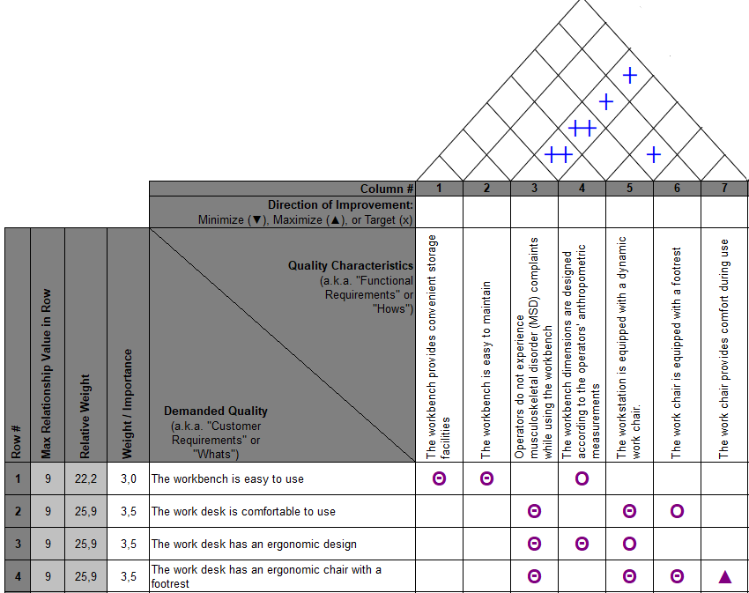
Figure 5 Matrix Relationship
Priority Scale.
Following the identification of ergonomic problems and the determination of design priorities through EFD analysis, a new workstation design was developed. The proposed design focuses on improving operator comfort, reducing physical workload, and minimizing musculoskeletal risks.
Table 4 Contributions and Priorities
No. | Technical Characteristics | Importance Level (Customer Requirements) | Score | Row Weight | Contribution | Priority Rank
1 | The workbench provides convenient storage facilities. | The workbench is easy to use. | 9 | 0.204 | 1.836 | 5
2 | The workbench is easy to maintain. | The workbench is easy to use. | 9 | 0.204 | 1.836 | 6
3 | Operators do not experience musculoskeletal disorder (MSD) complaints while using the workbench. | The workbench is comfortable to use. | 9 | 0.240 | 7.140 | 1
3 |  | The workbench has an ergonomic design. | 9 | 0.278 | 7.140 | 1
3 |  | The workbench has an ergonomic chair with a footrest. | 9 | 0.278 | 7.140 | 1
4 | The workbench dimensions are designed according to the operators' anthropometric measurements. | The workbench is easy to use. | 3 | 0.204 | 3.114 | 4
4 |  | The workbench has an ergonomic design. | 9 | 0.278 | 3.114 | 4
5 | The workstation is equipped with a dynamic work chair. | The workbench is comfortable to use. | 9 | 0.240 | 5.496 | 2
5 | The workstation is equipped with a dynamic work chair. | The workbench has an ergonomic design. | 3 | 0.278 | 5.496 | 2
5 | The workstation is equipped with a dynamic work chair. | The workbench has an ergonomic chair with a footrest. | 9 | 0.278 | 5.496 | 2
6 | The work chair is equipped with a footrest. | The workbench is comfortable to use. | 3 | 0.240 | 3.220 | 3
6 | The work chair is equipped with a footrest. | The workbench has an ergonomic chair with a footrest. | 9 | 0.278 | 3.220 | 3
7 | The work chair provides comfort during use. | The workbench has an ergonomic chair with a footrest. | 1 | 0.278 | 0.278 | 7

The table displays the contribution values of technical characteristics toward meeting user ergonomic needs. Based on Table 4, the characteristic "operators do not experience MSDs while using the work table" yielded the highest contribution score of 7.164. This indicates that this aspect is the most critical priority for development to achieve optimal comfort and work efficiency.
Workstation Redesign
Following the identification of ergonomic problems and the determination of design priorities through EFD analysis, a new workstation design was developed. The proposed design focuses on improving operator comfort, reducing physical workload, and minimizing musculoskeletal risks.
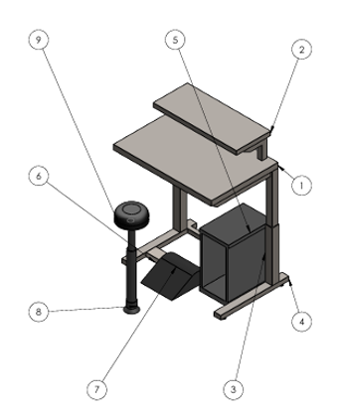
Figure 6 Workstation Design Improvements

Table 5 Bill of Material
Item No. | Part Name | Material | Quantity
1 | Table Base | Steel | 1
2 | Table Top | Steel | 1
3 | Table Legs | Steel | 2
4 | Foot Base | Steel | 1
5 | CPU Holder | Polypropylene | 1
6 | Footrest Support | Steel | 1
7 | Footrest | Plastic | 1
8 | Stool Legs | Steel | 1
9 | Stool Seat Cushion | Foam | 1

The redesign of the scan-in finished goods workstation applies ergonomic principles using SPSS percentile data to accommodate variations in operator body sizes through a sit-stand concept. The design features include: optimal line of sight using Standing Eye Height (P-5: 136 cm), an adjustable table height based on Standing Waist Height (P-50 to P-90: 102–112 cm), an optimal reach zone based on Hand Grip Length (P-25: max 68 cm), a seat area based on Sitting Thigh Width (P-5: 25 cm), and a seat height based on Hip Height (88.5 cm) to reduce leg pressure. Materials selected include robust iron for the table and stool structures, lightweight yet durable plastic and polypropylene for the footrest and CPU holder, and ergonomic foam for maximum seating comfort.
RULA Analysis of Repair Conditions
A Rapid Upper Limb Assessment (RULA) analysis was conducted to evaluate the ergonomic risks of the operator's posture. This approach is essential for assessing the effectiveness of the developed workstation design.
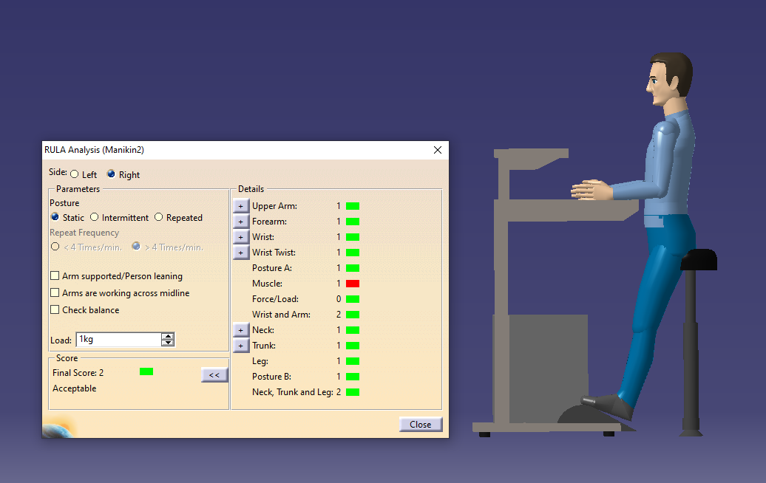
Figure 7 RULA Score of Workstation Redesign
Based on the working posture simulation using software, the final RULA score obtained was 2, which falls into the "acceptable" category. This low score is supported by the neutral positioning of all body parts—including the upper arm, forearm, wrist, neck, trunk, and leg—each receiving a score of 1. Additionally, the light workload (< 2 kg) and a seated working posture equipped with armrests and footrests further contribute to keeping the posture safe, indicating that no further corrective actions are required.
Comparison of Actual Conditions and Workstation Redesign
To evaluate the effectiveness of the proposed workstation design, a comparison was made between the actual workstation conditions and the redesigned workstation. The comparison focuses on workstation dimensions, ergonomic features, and postural risk levels to determine the extent of improvement achieved through the redesign process.
Table 5 RULA score comparison
Workstation Condition | RULA Score | Risk Category
Before Design | 4 | Medium
After Design | 2 | Low
Table 5 demonstrates a reduction in ergonomic risk levels from medium to low. These results confirm that the objective of this study has been achieved, specifically in improving working posture and minimizing ergonomic risks for scan-in finished goods operators.
Postural Risk Improvement Analysis
The effectiveness of the workstation redesign was evaluated using the Rapid Upper Limb Assessment (RULA) method by comparing operators’ postural risk levels before and after the implementation of the ergonomic workstation. The initial assessment yielded a RULA score of 4, indicating a moderate ergonomic risk level that required further investigation and corrective action. This condition was primarily attributed to inappropriate workstation dimensions, the absence of seating facilities, and prolonged static standing postures during scan-in activities.
Following the redesign process based on Ergonomic Function Deployment (EFD) and anthropometric considerations, the RULA score decreased to 2, which falls within the acceptable category. This improvement indicates that the redesigned workstation successfully reduced ergonomic risks and promoted a more favorable working posture. Significant reductions were observed in the upper arm, forearm, and wrist assessment scores as a result of adjustments to workstation height, the provision of a dynamic sit–stand chair, and the addition of a footrest that facilitated a more neutral body posture.
The reduction in the RULA score from 4 to 2 represents a 50% decrease in ergonomic risk, demonstrating that the redesigned workstation effectively minimized musculoskeletal strain during scan-in activities. Similar findings have been reported in previous studies. Research conducted on an air-conditioner assembly line showed that an anthropometry-based workstation redesign supported by digital simulation reduced RULA scores from as high as 7 to 3, indicating a substantial reduction in ergonomic risk (Abdullah et al., 2026). Likewise, studies conducted in transformer manufacturing and various small-scale industries revealed that workstation redesigns based on RULA, REBA, and Nordic Body Map (NBM) analyses successfully reduced ergonomic risk levels from high to moderate or low categories, consistent with the findings of the present study (Nofierni et al., 2025; Ode et al., 2025).
The application of Ergonomic Function Deployment (EFD) in this study is also consistent with previous research demonstrating the effectiveness of EFD and Quality Function Deployment (QFD) in translating workers’ needs and complaints into technical design specifications. Such approaches have been shown to improve workstation ergonomics, reduce postural risks, and enhance worker comfort (Amrussalam et al., 2023; Muslimah et al., 2025). Therefore, the observed reduction in RULA scores confirms that the EFD-based redesign effectively addressed the ergonomic deficiencies identified in the original workstation design.
Improvement in Work Comfort
The redesigned workstation significantly improved operator comfort by addressing the ergonomic issues identified during the preliminary assessment. The implementation of an adjustable workbench with a height range of 102–112 cm, a dynamic sit–stand chair adjustable between 45–88 cm, and a footrest enabled operators to alternate between sitting and standing positions throughout their work activities. This flexibility reduced discomfort associated with prolonged static postures and allowed the workstation to accommodate operators with varying anthropometric characteristics.
The workstation dimensions were designed based on anthropometric measurements, ensuring that equipment such as scanners, keyboards, and computer monitors could be accessed comfortably without excessive reaching or awkward body postures. As a result, operators were able to perform their tasks more efficiently and with reduced physical discomfort.
These findings are consistent with previous studies emphasizing the importance of adjustable workstations designed according to workers’ anthropometric characteristics to promote neutral postures and reduce discomfort (Butar & Zetli, 2025; S.M. et al., 2022). Similar results have been reported among garment workers and Dhokra craft workers, where redesigned chairs and workstations based on anthropometric principles significantly improved comfort and reduced musculoskeletal complaints (Abate & Hailemariam, 2022; Sahu & Pandit, 2025). Therefore, the ergonomic features incorporated into the redesigned workstation directly contributed to improved operator comfort and usability.
Reduction of Physical Workload
The redesigned workstation substantially reduced physical workload by promoting neutral working postures and minimizing unnecessary body movements. Prior to the redesign, operators frequently experienced excessive reaching, elevated shoulder positions, and prolonged standing postures, all of which contributed to musculoskeletal complaints. The redesigned workstation addressed these issues through optimized workstation dimensions, adjustable height settings, and ergonomic seating support.
Furthermore, the inclusion of a footrest helped reduce lower-limb fatigue by providing adequate support during both sitting and standing activities. These improvements alleviated muscle strain in the neck, shoulders, back, and lower extremities, thereby reducing the physical demands associated with scan-in operations.
The findings support previous research indicating that anthropometry-based workstation redesigns effectively promote neutral postures and reduce biomechanical stress. Similar outcomes were reported by Abdullah et al., who found that workstation redesign reduced excessive reaching and awkward upper-body postures, leading to substantial improvements in RULA scores. Studies conducted in manufacturing environments have also demonstrated that ergonomic redesigns based on NBM, RULA, and REBA analyses reduce musculoskeletal risk levels and physical workload, thereby lowering the prevalence of work-related musculoskeletal disorders (Nofierni et al., 2025). Consequently, the reduction in ergonomic risk observed in this study can be attributed to the improved workstation configuration and enhanced postural support provided by the redesigned workstation.
Potential Improvement in Productivity and Occupational Safety
The ergonomic improvements achieved through the workstation redesign are expected to positively influence both productivity and occupational safety. Reduced physical fatigue and musculoskeletal discomfort enable operators to maintain concentration, work efficiency, and performance over extended periods. In the context of finished-goods scan-in activities, improved comfort and reduced physical strain are likely to facilitate smoother work processes and minimize interruptions caused by fatigue or discomfort.
From a safety perspective, the reduction in the RULA score from 4 to 2 indicates a substantial decrease in ergonomic risk, thereby lowering the likelihood of developing work-related musculoskeletal disorders (WMSDs). The redesigned workstation also improves workplace organization through dedicated CPU storage and enhanced cable management, creating a safer and more efficient working environment.
These findings are supported by previous studies conducted in transformer manufacturing and warehouse operations, which concluded that ergonomic workstation redesigns help reduce awkward postures, lower WMSD risks, and ultimately improve worker performance and productivity (Bhatia et al., 2021; Vidyadhar et al., 2024). In addition, reductions in posture assessment scores, such as RULA, REBA, and ROSA, have been associated with decreased MSD risks and increased productivity in both office and industrial settings (Kamat et al., 2017; Ridhosari et al., 2024). Therefore, the results of this study reinforce the argument that ergonomically designed workstations not only enhance worker safety and well-being but also contribute to sustainable productivity improvements.
Overall, the EFD-based workstation redesign successfully improved ergonomic performance by reducing postural risks, enhancing operator comfort, lowering physical workload, and supporting greater productivity and occupational safety. The consistency between the present findings and previous ergonomic studies further strengthens the validity of the proposed workstation design as an effective intervention for minimizing musculoskeletal risks among warehouse operators.
CONCLUSION
Based on the results of the Ergonomic Function Deployment (EFD) analysis and the subsequent engineering discussions, the conventional warehouse workdesk was successfully redesigned into an anthropometrically optimized, adjustable workstation that bridges user requirements and engineering specifications via the House of Ergonomics (HOE). The redesigned workdesk features a mechanical height-adjustment range of 102–112 cm, derived from the 50th and 90th percentiles of standing waist height to support dynamic user heights. To ensure an optimal visual line of sight and minimize neck strain, the maximum desk clearance for the monitor layout is fixed at 136 cm, based on the 5th percentile of standing eye height. Furthermore, the desktop surface spans a length of 68 cm, which corresponds to the 25th percentile of grip reach, and a width of 100 cm, thereby maximizing the operator's primary reach zone during scan-in workflows.
To facilitate comfortable sit-stand transitions and mitigate lower-body fatigue, the workstation is integrated with an accompanying stool engineered with a maximum height of 88 cm based on the 25th percentile of hip height and equipped with an adjustable footrest. The under-desk seating clearance is specifically adjusted to a thigh width of 25 cm, utilizing the 5th percentile to accommodate the operators' physical constraints. Material selections for this structural overhaul prioritize durability, safety, and environmental sustainability. Structural frameworks for the desk and stool legs utilize robust metals, while the footrest is molded from resilient plastics, and the CPU tray consists of lightweight, eco-friendly polypropylene known for its high strength-to-weight ratio and electrical insulation properties. Additionally, the stool seat features high-density foam to deliver superior pressure distribution and long-term ergonomic comfort.
The deployment of the EFD method and anthropometric scaling successfully translated the operators' physical complaints into targeted workspace interventions, yielding substantial improvements in occupational health. By adjusting the overall workspace dimensions and introducing vertical adjustability, the newly developed workdesk effectively eliminates forced, awkward trunk and neck flexion. Empirical evaluation using the Rapid Upper Limb Assessment (RULA) framework demonstrated a highly significant ergonomic risk reduction, with postural scores dropping from a baseline score of 4, which indicates a medium risk requiring corrective action, to a post-intervention score of 2, which is classified as low risk and acceptable. Ultimately, the integration of the anthropometric stool and specialized footrest promotes a neutral body alignment, successfully mitigating localized musculoskeletal strain and significantly minimizing the long-term risk of Work-Related Musculoskeletal Disorders (WMSDs) for warehouse operators.
The study's shortcomings can be summarized as: limited sample size and context, short-term measurement, primary focus on physical aspects of the workstation, lack of integration of multi-component interventions, limited real-world evaluation, and limited evidence on productivity. These limitations align with findings in the ergonomics literature, and therefore it is reasonable and important to explicitly state them in the limitations and future research sections of the article.

REFERENCES
Abate, A. E., & Hailemariam, S. S. (2022). Improving work-related musculoskeletal disorders for sewing machine operators in Ethiopia. International Journal of Occupational Safety and Ergonomics, 29, 573–585. https://doi.org/10.1080/10803548.2022.2058747
Abdullah, Z., Syafikah, N., Halim, I., Ghazaly, M., Maidin, S., Sued, M., Ali, M. A. M., Nordin, N., & Kurniawan, D. (2026). Digital Human Modelling–Driven Ergonomic Risk Assessment, Workstation Redesign, and Usability Evaluation in a Manufacturing Assembly Line. International Journal of Research and Innovation in Social Science. https://doi.org/10.47772/ijriss.2026.100300585
Adiyanto, O., Mohamad, E., Jaafar, R., Ma’ruf, F., Faishal, M., & Anggraeni, A. (2022). Application of Nordic Body Map and Rapid Upper Limb Assessment for Assessing Work-related Musculoskeletal Disorders: A case study in Small and Medium Enterprises. International Journal of Integrated Engineering. https://doi.org/10.30880/ijie.2022.14.04.002
Amrussalam, Rahmawati, & Efendi, J. (2023). REDESAIN FASILITAS KERJA YANG ERGONOMIS DENGAN MENGGUNAKAN ERGONOMIC FUNCTION DEPLOYMENT (EFD). Jurnal Ilmiah Teknik Industri. https://doi.org/10.24912/jitiuntar.v11i1.23809
Bernardes, J. M., Ruiz-Frutos, C., Moro, A., & Dias, A. (2020). A low-cost and efficient participatory ergonomic intervention to reduce the burden of work-related musculoskeletal disorders in an industrially developing country: an experience report. International Journal of Occupational Safety and Ergonomics, 27, 452–459. https://doi.org/10.1080/10803548.2019.1577045
Bhatia, V., Kalra, P., & Randhawa, J. (2021). Ergonomic Interventions for Manual Material Handling Tasks in a Warehouse. 205–212. https://doi.org/10.1007/978-981-15-9054-2_23
Butar, P. S. B., & Zetli, S. (2025). PERANCANGAN FASILITAS KERJA YANG ERGONOMIS DEPARTEMEN STORE PADA PT NOK FREUDENBERG SEALING TECHNOLOGIES. Computer and Science Industrial Engineering (COMASIE). https://doi.org/10.33884/comasiejournal.v13i2.10352
Colim, A., Faria, C., Braga, A., Sousa, N., Rocha, L., Carneiro, P., Costa, N., & Arezes, P. (2020). Towards an Ergonomic Assessment Framework for Industrial Assembly Workstations—A Case Study. Applied Sciences. https://doi.org/10.3390/app10093048
Hosseini, S. M., Lahoori, M. A., & Kahaki, Z. R. (2025). The Effectiveness of Ergonomic Intervention in Work-Related Postures and Upper Crossed Syndrome of Metal Industry Workers. La Medicina Del Lavoro, 116. https://doi.org/10.23749/mdl.v116i4.16165
Jin, X., Dong, Y., Yang, L., Huang, W., Cao, L., Zhang, Z., & He, L. (2025). Ergonomic interventions to improve musculoskeletal disorders among vehicle assembly workers: a one-year longitudinal study. BMC Public Health, 25. https://doi.org/10.1186/s12889-025-21798-1
Kamat, S., Zula, N. M., Rayme, N., Shamsuddin, S., & Husain, K. (2017). The ergonomics body posture on repetitive and heavy lifting activities of workers in aerospace manufacturing warehouse. IOP Conference Series: Materials Science and Engineering, 210. https://doi.org/10.1088/1757-899x/210/1/012079
Kim, I.-J. (2023). An ergonomic focus evaluation of work-related musculoskeletal disorders amongst operators in the UAE network control centres. Heliyon, 9. https://doi.org/10.1016/j.heliyon.2023.e21140
Muslimah, E., Nandiroh, S., Faizi, A. N., Munawir, H., & Fahmi, A. A. (2025). Risk assessment using ERIN and CVL methods to minimize musculoskeletal disorders for operators in the food industry. OPSI. https://doi.org/10.31315/opsi.v18i2.12370
Nadiyah, K., Senjawati, M. I., Putri, G. R., & Satria, A. (2025). Evaluasi Risiko Muskuloskeletal dengan Metode REBA dan Nordic Body Map pada Stasiun Packing Industri Oleokimia. INVENTORY: Industrial Vocational E-Journal On Agroindustry. https://doi.org/10.52759/inventory.v6i2.6
Nofierni, N., Patmawati, D., & Aunurrofiq, F. (2025). Design of Working Facilities Based on Posture Risk Assessment and Anthropometry. JURNAL Al-AZHAR INDONESIA SERI SAINS DAN TEKNOLOGI. https://doi.org/10.36722/sst.v10i2.3610
Ode, L., Fardhan, M., Baeri, S., Widodo, L., & Sukania, W. (2025). PERANCANGAN ALAT BANTU KERJA BERDASARKAN ANALISIS ERGONOMI DI BAGIAN MANUAL HANDLING PT. XYZ. Jurnal Mitra Teknik Industri. https://doi.org/10.24912/jmti.v4i2.34966
Ridhosari, B., Rahman, A., & Rozan, N. M. R. (2024). Reducing the risk level of working posture of office workers in PT X through redesigning the workstation based on rapid office strain assessment (ROSA) method. 3RD CONFERENCE ON INNOVATION IN TECHNOLOGY AND ENGINEERING SCIENCE 2022 (CITES2022): Innovation in Technology and Science for New Era of Engineering Professionalism. https://doi.org/10.1063/5.0201068
Rofih, M., Rahayu, S., & Wiyatno, T. N. (2025). Postural Risk Analysis Based on Rapid Upper Limb Assessment (RULA) Method for Manual Handling Workers in the Food Industry. Jurnal Teknologi Dan Manajemen Industri Terapan. https://doi.org/10.55826/jtmit.v4i3.810
S.M., Q., Aloorkar, P., Hussain, M. A., & Ibrahim, M. A. (2022). Ergonomics and Anthropometry Considerations in Design of Workstation. Proceedings of the International Conference on Industrial Engineering and Operations Management. https://doi.org/10.46254/in02.20220046
Sadi Zaky, H., Anugerah, R., Puteri, M., & Setiawan, A. (2025). Perancangan Ulang Meja Kerja Pengukiran Guna Meminimasi Musculosketal Disorders Pekerja di CV Jati Menggunakan Metode Ergonomic Function Deployment (EFD). Jurnal Universitas Muhammadiyah Jakarta.
Sahu, A., & Pandit, S. (2025). Occupational ergonomic research and contextual design execution of a new workstation to reduce work-related musculoskeletal disorders (WRMSDs) among Dhokra handicraft artisans: an unorganized sector of India. Industrial Health, 63, 579–596. https://doi.org/10.2486/indhealth.2025-0039
Septiani, W., Angelika, V., & Rahmawati, N. (2024). Ergonomic Workspace Design to Reduce the Risk of Musculoskeletal Disorders. E3S Web of Conferences. https://doi.org/10.1051/e3sconf/202450003045
Tabrizi, A., Choobtarash, A. B., Darzi, M., Olazadeh, K., Paridokht, F., & Sahlabadi, S. (2025). Investigation of the association between ergonomic conditions of nursing workstations and the risk of musculoskeletal disorders among nurses: a case study in selected hospitals of Shahid Beheshti University of medical sciences. BMC Nursing, 24. https://doi.org/10.1186/s12912-025-04135-0
Vidyadhar, B., Hebbal, S., Qutubuddin, S., Mr.Vidyadhar., G., & Biradar. (2024). Ergonomic Risk Identification and Postural Analysis in Electrical Transformers Manufacturing Company located in Southern India. International Journal of Occupational Safety and Health. https://doi.org/10.3126/ijosh.v14i2.53692
Wicaksono, B. W., Puteri, R. A., Nelfiyanti, N., & Setiawan, A. (2024). Perancangan Meja Kerja Pada Area Dismantle Dalam Meminimalisir Keluhan MsDs Di PT. XYZ Menggunakan Metode Ergonomic Function Deployment (EFD). JISI: Jurnal Integrasi Sistem Industri, 11(2), 271–280. https://doi.org/10.24853/jisi.11.2.271-280
Yuliyanti, A. T., Dewi, A. P., Anugerah, R., & Prasetyawati, M. (2026). Perancangan Alat Bantu Box Dorong Berbasis Rel Menggunakan Metode Ergonomi Function Deployment (EFD) Sebagai Upaya Pencegahan Musculoskeletal Disorders (MSDS) di PT. Mahasuri Utama. Jurnal Cakrawala Akademika. https://doi.org/10.70182/jca.v2i5.1752
Zare, M., Black, N., Sagot, J., Hunault, G., & Roquelaure, Y. (2019). Ergonomics interventions to reduce musculoskeletal risk factors in a truck manufacturing plant. International Journal of Industrial Ergonomics, 75, 102896. https://doi.org/10.1016/j.ergon.2019.102896

