Understanding night-time safety in Delhi’s urban landscapes through quantitative assessment of vegetation, lighting and ecological interactions

ABSTRACT
Urban safety has traditionally been framed through visibility, surveillance and standardized lighting factors. In night-time landscapes of Delhi, safety is co-produced by the means of dynamic interactions between the vegetation structure, artificial illumination as well as the stray animal behaviour. This research proposes the concept of “hybrid-safety ecologies” where human as well as non-human interactions together can shape up urban safety outcomes. It further examines how the layers of vegetation – involving trees, shrubs and groundcovers which mediate visibility, enclosure as well as atmospheric perception, while also shaping ecological conditions which influence the animal movement. Artificial lighting likewise extends nocturnal activity but alters animal behaviour by the means of the intensity, which produces unpredictable human-animal encounters impacting the perceptions that involve either risk or comfort. This study employs a mixed-methods approach, combining field observations, spatial mapping and the perception surveys across the sites situated in Delhi which further intensifies the relationship between lighting characteristics, vegetation compositions alongside the patterns of stray animal activity. The findings reveal the emphasis towards modulation of nocturnal safety by reinforcing the social presence as well as territoriality which is achieved by informal urban elements, including street vendors, shrines as well as community practices. The understanding of vegetation structure as well as lighting compositions on stray animal behaviour, the research offers critical insights and paves way towards designing inclusive as well as ecologically responsive nocturnal urban landscape spaces.

Keywords: artificial lighting; nocturnal safety; stray animals; vegetation; urban landscapes

INTRODUCTION
Urban safety has traditionally been perceived through the frameworks of visibility, surveillance as well as the technical regulation of public infrastructure. In particular, nocturnal landscapes, artificial lighting, spatially open spaces and movement corridors have been noted as primary determinants of secure public spaces. With respect to Delhi’s night-time landscapes however, there lies a far more complex interaction while relating the perception of safety along with vegetation, lighting, ecological processes and human behaviour.

The Institute for Human Development (2014) discusses that the Delhi’s urban environment after dark has been strongly transformed through the likes of rapid urbanization, uneven infrastructural development, and changing night-time activity patterns. Certain areas remain active with markets, transit corridors, as well as informal economies, there are still many public spaces which have become fragmented, poorly illuminated as well as psychologically isolated. Such disparities in the lighting infrastructure and vegetation management influence directly how safety is perceived as well as experienced.

Artificial lighting not only extends the public activity into the night, but it also helps in creation of atmospheric conditions which shape the comfort, familiarity as well as fear. Rahm (2020) discusses the influence of vegetation towards visibility, enclosure and spatial perception, where the maintained landscapes tend to generate reassurance and order. Along with these factors, the stray animals including dogs, cows, and monkeys actively take up the illuminated as well as vegetated spaces and therefore become an integral part of the Delhi’s nocturnal ecology. Their presence can simultaneously evoke fear, familiarity, guardianship of discomfort, depending upon varied spatial and cultural contexts.

Beyond formal infrastructure, informal systems which include vendors, shrines as well as community presence further contribute towards perception of safety at night-time. This overlap of relationship between the constraints shape-up the hybrid night-time landscapes which challenge the conventional human-centered approaches towards urban safety.

The study therefore seeks to investigate the role of the vegetation patterns, outdoor lighting conditions, and the ecological interactions which shape the perceptions of safety in Delhi’s night-time landscapes. With the help of spatial analysis, ecological observations as well as perception-based surveys, the research attempts to develop an understanding of safety as a multi-species, atmospheric as well as socially negotiated condition within contemporary urban landscapes.

LITERATURE REVIEW
Urban safety has historically remained one of the primary concerns with respect to the planning as well as the design of the public spaces. Safety was largely associated with the elements of visibility, order, as well as territorial control in the early urban planning approaches. However, with emergence of the socially responsive urban theories, the relationship between safety and public space evolved significantly during the twentieth century. Jacobs (1961) through The Death and Life of Great American Cities, argued how the dependence on continuous public activity and social interaction was more significant than mere formal surveillance. Her concept of “eyes on the street” emphasized how active streetscapes alongside the pedestrian movement and informal social monitoring collectively contributed in order to create safer urban environments. Newman (1972) further emphasized territoriality, visibility as well as spatial control as mechanisms for crime prevention. These approaches influenced the approach to landscape architecture where elements such as visibility, openness as well as vegetation management became the essential drivers for designing safer public spaces.

By the late twentieth century, the understanding of safety was expanded beyond the physical control and surveillance through environmental psychology. Appleton’s Prospect-Refuge Theory (1975) proposed safety is perceived by individuals when they have access to spaces of refuge or concealment while simultaneously, they can visually survey their surroundings. These theories created direct relationships between the landscape elements alongside the psychological comfort. Nasar and Fisher’s studies on the domain of safety demonstrated how dense vegetation, hidden corners as well as poor visibility could generate the anxiety within public spaces, while the maintained landscapes would often be perceived with respect to care, order and reassurance.

The role of artificial lighting, similarly has evolved over time within the urban landscapes. Lighting infrastructure in the past was perceived as an important mechanism for extending public life into the night. Contemporary studies however reveal outdoor lighting influences not just the visibility but also creates a sensation of emotional and atmospheric perceptions of safety. Van Rijswijk and Haans (2017) argue that the quality, uniformity and spatial distribution of lighting is strongly linked with how users perceive sense of safety, rather than the intensity of illumination alone.

Nocturnal experiences within urban landscapes are further shaped through the chromatic qualities of lighting. Boyce (2014) emphasizes how warm lighting conditions are further associated with sense of comfort, calmness as well as social friendliness while cooler blue-enriched lighting can improve the visual clarity but at the same time can create clinical or emotionally distant environments. Despite such findings, technical efficiency and visibility is more emphasized over atmospheric quality by urban practices within rapidly urbanizing cities such as Delhi. The interactions between outdoor lighting as well as stray animals becomes increasingly significant in such environments. Delhi in this case, contains a large number of stray dogs, cows as well as monkeys which actively occupy the public spaces at night. Bhattacharjee (2021) argues stray animals closely adapt to the infrastructural conditions with the human behavioural patterns. Due to warmth, visibility as well as availability of food, dogs often gather beneath street lights, near food vendors as well as transit corridors. Turnbull and Barua (2023) describe how medians, shrines and roadside edges are occupied by cows and integrate into the socio-cultural metabolism of the city. These ecological occupations not only influence the circulation patterns but also lead to public perceptions of comfort as well as fear.

The presence of stray animals in these night-time landscapes introduce contradictory perceptions of safety. While in some cases, stray dogs are perceived as informal guardians which signify activity as well as social presence within the deserted streets, this aggressive or clustered behaviour of the stray animals conversely generates anxiety, particularly among elderly individuals as well as night-time commuters. Monkeys which occupy the temple complexes as well as residential edges play a part towards unpredictability as well as discomfort within the nocturnal environments. Consequently, urban safety emerges not only as a human-cantered condition but as a negotiated relationship between the ecological actors, spatial atmospheres, and cultural perceptions.
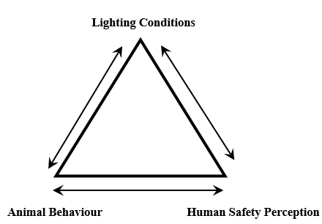

Figure 1. Triangular relationship between lighting conditions, animal behaviour, and the perception of human safety (Source: Author)

Studies associating urban safety alongside landscape architecture have also emphasized the importance of informal infrastructure within public spaces. Gehl (2011) discusses that urban comfort and safety is significantly contributed through active public life as well as continuous public presence. In Delhi, informal systems which include street vendors, shrines as well as neighbourhood gatherings play an important role towards operating as localized safety networks after dark. Gehlot et al. (2023) showcases how vendors contribute occupation, visibility and public interaction within the urban streetscapes, while acknowledging their contribution beyond economic activities. These spaces often attract both human as well as non-human activity, which through the assistance of light, movement and ecological coexistence, helps create hybrid safety ecologies.

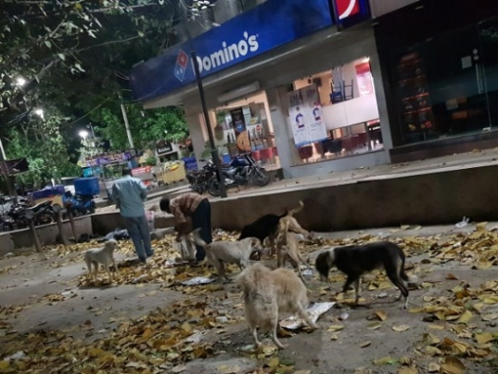
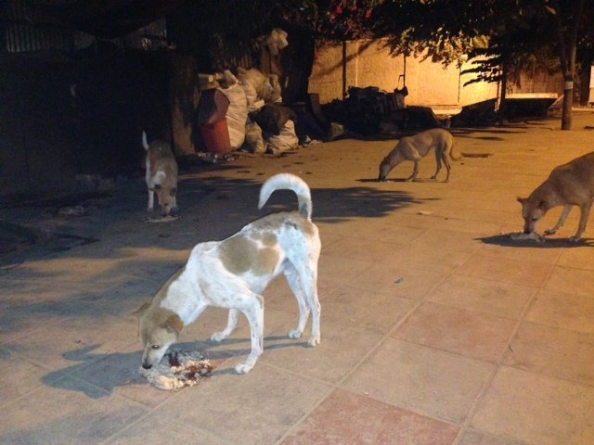

Figure 2. Stray Dogs feeding on leftovers
(Source: Milaap)
Figure 3. Stray Dogs scavenging on food
(Source: Author)

Delhi’s nocturnal environment highlights strong contrasts with respect to infrastructure and its relation with the public accessibility. The Delhi Human Development Report (2014) highlights the contrast in the urban services which includes the likes of street lighting and its maintenance, across varied neighbourhoods, with the informal settlements depending on the fragmented lighting areas, while the wealthier districts often facilitated with consistent illumination as well as organized public landscapes. Kaushik et al. (2022) highlight the growing concerns of light pollution as well as ecological disruption within the Indian cities as a result of uncontrolled artificial illumination alongside the expanding urbanization. Such form of alterations indicate that lighting infrastructures should be understood from the lens of ecological as well as social implications rather than mere technical efficiency.
Despite the rise of research in the field of urban safety, vegetation and lighting, there are prominent gaps which still remain in the understanding of Delhi’s nocturnal landscapes through a multi-species perspective. While most conventional frameworks which include Crime Prevention Through Environmental Design (CPTED) remain predominantly anthropocentric, the understanding of vegetation, chromatic lighting as well as stray animal behaviour from a collective lens remains limited towards emotional and spatial experiences of safety.

In totality, there is a need to examine safety within the contemporary urban landscapes from the lens of social, ecological as well as perceptual systems and the dynamic interaction likewise. In case of Delhi, safety cannot be understood largely on the basis of visibility and surveillance only as the context involves a coexistence of public life, vegetation, stray animals as well as informal infrastructures. Safety as a whole emerges through the layered relationships between the human behaviour, cultural understanding, ecological presence and lighting atmospheres. This study is an attempt to address these gaps through examination of vegetation, outdoor lighting as well as ecological interactions as a whole to shape the perception of nocturnal safety within the Delhi’s urban landscapes.

MATERIALS AND METHODS
Existing research in regard to urban safety largely prominently focuses towards visibility, surveillance as well as crime prevention strategies within the public spaces with limited attention given to the collective understanding of vegetation, lighting atmospheres and animal behaviour towards the perception of nocturnal safety in Indian cities such as Delhi. This study therefore is an attempt to examine the ecological as well as spatial dimensions of safety within the selected urban landscapes of Delhi with the help of following research questions:
- How the perception of safety is influenced from the lens of vegetation patterns and lighting conditions within night-time landscapes?
- What is the role of stray animals in shaping human comfort, accessibility and fear in public spaces at night?
- How do informal infrastructure which includes vendors, shrines as well as community presence contribute towards nocturnal safety ecologies?

To answer the first research question, spatial mapping as well as field documentation were conducted across the selected areas of study which include Laxmi Nagar, Chandni Chowk and Connaught Place. Mapping of circulation patterns, activity zones, lighting typologies as well as vegetation density with the help of field observations, photography as well as spatial analysis to identify relationships between the illuminated spaces, vegetated areas, and human movement.

To address the second and third research question, informal interviews along with perception-based surveys were conducted with the target group being visitors, residents, vendors and commuters across the selected sites. To ensure representation of various user groups, participants were selected through purposive sampling which helped in gathering demographic information which included age, gender, and the category of user groups engaging with these landscapes during evening and night-time hours. These were carried out alongside the responses related to fear, comfort, accessibility, and perceptions of safety which were influenced by factors involving vegetation, lighting conditions, crowd presence and stray animal activity. To conduct descriptive as well as statistical analysis, the questionnaire was designed using a combination of close-ended format and the reliability was then testes through pilot testing and consistency checks. With the help of correlation analysis, the relationships between lighting conditions, vegetation density, stray animal presence and perceived safety were tested which were analysed earlier through survey responses, interview insights and field observations. Finally, the integrated findings were interpreted to comprehend how the ecological as well as social interactions together shape night-time safety within urban landscapes of Delhi.

RESULTS AND FINDINGS
Survey analysis
A questionnaire-based survey was conducted across three sites: Chandni Chowk, Laxmi Nagar and Connaught Place to recognize the factors which influence perceptions of safety in Delhi’s nocturnal landscapes, which focused on three primary variables – outdoor lighting, vegetation characteristics as well as the presence of stray animals, identified through the literature review. A total of 220 respondents participated in this study which included residents, commuters as well as regular users of public spaces. To ensure representation across different user groups, genders and age categories, participants were selected through the means of purposive sampling with the sample comprising of 58% of female and 42% male respondents. 61% of the users represented the 18-35 age group, which was followed by 36-55 age group with 25% of users and the remaining 14% of users were aged 55 and above. Approximately 42% of respondents identified themselves as weekly visitors, which also represented the largest user group. By incorporating respondents across contrasting districts and the user categories, the study intended to enhance the representativeness of perceptions within Delhi’s urban nocturnal environments. The aim of the survey was to investigate how these environmental factors impact comfort, accessibility and the overall willingness of individuals to use public spaces after dark.

The findings reveal that safety perceived is a combination of physical as well as ecological conditions rather than its dependence on a single factor. While outdoor lighting emerges as a significant variable, its correlation with vegetation as well as stray animal presence also played an important role in the experience of night-time landscape. Through correlation analysis, a moderate positive relationship between lighting quality and perceived safety was revealed (r = 0.623), a weak to moderate relationship between stray animal presence and safety perceptions was understood (r = -0.295), while a moderate negative relationship between the vegetation density and perceived safety was observed (r = -0.474), where visibility was restricted. The results showed the negative influence of dense vegetation and stray animals was reduced in areas characterized through suitable and well-maintained lighting.

With focus towards outdoor lighting, the survey results demonstrated it as one of the key determinants of perceived safety at night. More than 74% of respondents stated that they tend to avoid public spaces, streets as well as parks in which the lighting infrastructure is not properly maintained, which also highlights the role of outdoor lighting is far more than illumination itself, rather it is the maintenance which plays a crucial role likewise. Broken fixtures and uneven distribution of lighting were strongly associated with neglect, reduced activity as well as increased vulnerability of these public spaces. Moreover, the responses emphasized towards the quality of lighting as well along with the quantity of lighting. Respondents highlighted the importance of equal distribution of lighting at public spaces. Isolated areas with uneven distribution of lighting were perceived unsafe despite having high illumination levels at certain areas. The survey also investigated the chromatic qualities of lighting in terms of the preferences of the users. While 18% of users did not express any particular preference, yet warm coloured lighting emerged as the preferred option amongst users as people associated it with comfort, familiarity and welcoming atmosphere. Overall, the results indicate that outdoor lighting contributes to safety with not just visibility but also through the influence of comfort of users in a psychological manner. Spaces which are characterized through even distribution, well maintained with warm toned lighting were considered and perceived as safer and more accessible during the night.

Vegetation on the other hand played another significant role in influencing the perceptions of safety with a majority of respondents preferring landscapes which constituted moderate vegetation with clear visual connections across the spaces. Such form of environment was considered safer compared to either completely barren surfaces or areas characterized through dense plantations. Respondents associated the well-maintained landscapes with care, management as well as regular public use, all factors which contributed positively to the feelings of security. On the other hand, dense vegetation was strongly associated with reduced visibility and uncertainty, which increased the feelings of discomfort, particularly during the night-time hours when visibility is constrained. Overgrown shrubs, unmanaged tree canopies, and heavily vegetated corners were commonly identified as elements which contributed to obstructed sightlines as well as created hidden corners. Numerous respondents highlighted that they were less likely to use the public spaces where dense vegetation was combined alongside inadequate lighting. The perceptions as a whole were dependent on how vegetation influences the visibility as well as spatial legibility. The findings and observations reinforce the importance of integrating planting design alongside the lighting strategies in order to generate environments which benefit the local ecology and also create socially comfortable public spaces.

The presence of stray animals, dogs in particular, turned out as one of the most complicated dimensions of the night-time safety. In contrast to the consistent responses with respect to lighting and vegetation, the perceptions regarding stray animals varied significantly among respondents. While discussing about the comfort levels around stray animals at night, the respondents expressed the concerns in relation with unpredictability and potential aggression. Female respondents in particular highlighted the discomfort around the large groups of stray animals as these were often perceived as intimidating, especially in isolated or poorly illuminated spaces.

The survey, however, showcased a contrasting perspective. Nearly 65% of the respondents agreed that the presence of stray animals can create a psychological sense of safety under certain conditions, with most of participants associating the regular presence of dogs in markets, vendor clusters, and residential streets as indicators of an inhabited and socially active environment. The correlation analysis further indicated that suitable lighting enhanced the level of comfort for the people around stray animals by enabling users to observe the animal behaviour better, which reduced uncertainty and perceived risk. Despite the positive associations as mentioned above, nearly 60% of respondents believed that large number of stray animals negatively affect the safety of public spaces, which indicates that while moderate animal presence may contribute to perceived guardianship and familiarity, overcrowding and aggressive behaviour still remain significant concerns for the users.

Spatial analysis
The spatial analysis was done to understand the collective influence of lighting infrastructure, vegetation patterns, human movement, and the presence of stray animals towards the perception of safety within Delhi’s nocturnal landscapes. To conduct the analysis, two sites in particular were selected: Chandni Chowk Metro to Chandni Chowk Public Square, and Laxmi Nagar, with both comprising of contrasting urban morphologies and socio-spatial conditions. While Chandni Chowk represents a historic urban core characterized through intense pedestrian activity and vibrant informal economy, Laxmi Nagar showcases a dense residential-commercial neighbourhood marked by limited public spaces as well as uneven infrastructural provision. With the help of site mapping, the study identifies the relationships between environmental conditions and nocturnal safety perceptions.

SITE 1: Chandni Chowk Metro to Chandni Chowk Public Square, New Delhi
Chandni Chowk is one of the oldest as well as most active urban precincts within Delhi, The study area which extends from the Chandni Chowk Metro to the recently developed Chandni Chowk Public Square was selected because of its historic urban fabric, dense street network, combined with significant pedestrian movement observed, especially at dark, Street vendors, small scale commercial establishments, public gathering spaces and religious shrines collectively contribute towards a highly active nocturnal environment.

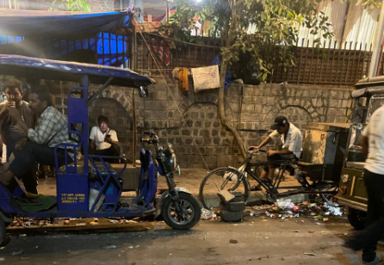

Figure 2. Mismanagement of streets leading to overcrowding of strays (Source: Author)

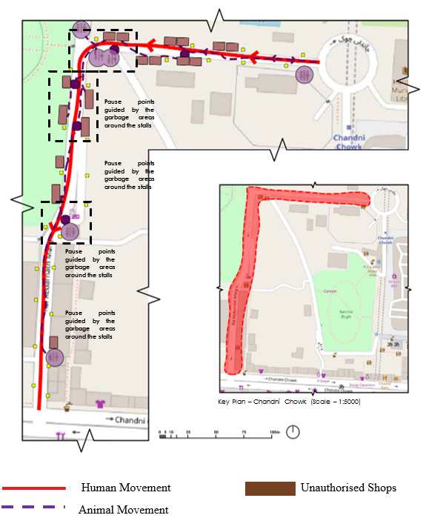

Figure 3. Infrastructural mapping: Chandni Chowk
(Source: Author)

One of the key observations were that despite the presence of pedestrian movement, the lighting distribution remains uneven across the corridor with secondary lanes, recessed building edges as well as densely vegetated pockets experiencing lower illumination levels resulting in localized areas of visual discomfort. This also impacted the behavioural patterns of the stray animals with stray dogs frequently clustering around illuminated vendor zones, food stalls, where human activity and food availability remained high. With a certain number of pedestrians appearing comfortable due to presence of human activity, there were significant users which preferred altering the movement paths to avoid larger group of animals.

While analysing the vegetation patterns, the overall green cover remains limited because of the dense built fabric, yet there are clusters of mature trees which create shaded environments during the night. In certain locations, these dense canopies when combined with the constraint of inadequate lighting, reduce the visibility and give rise to darker pockets within the active public spaces. This further influences the pedestrian movement patterns with users preferring the lanes with maintained visual continuity and higher levels of illumination.
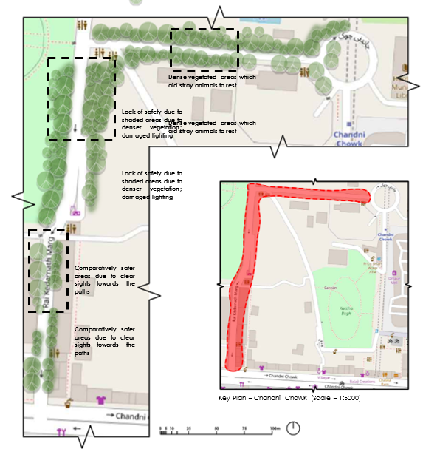

Figure 4. Vegetation map - Chandni Chowk
(Source: Author)

The analysis also highlights the presence of informal infrastructure with vendor clusters functioning as active surveillance nodes. As a whole, Chandni Chowk showcases that high levels of activity as well as human presence can compensate for deficiencies in formal lighting infrastructure. However there still remain areas within the selected precinct which influence the perceptions of safety and accessibility during the night characterized through dense vegetation, inadequate maintenance, and animal clustering.

SITE 2: Laxmi Nagar, New Delhi
Laxmi Nagar presents a contrasting urban condition which comprises of dense residential commercial fabric and street networks which are developed organically. Unlike Chandni Chowk, the area remains deprived of large urban public gathering spaces and is further dominated through narrow streets, mixed use buildings as well as fragmented open spaces. The neighbourhood serves as a representative example of Delhi’s middle-income urban settlements in which commercial activities along with residential uses exist together within highly compact environments.

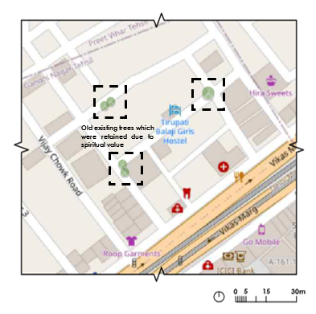
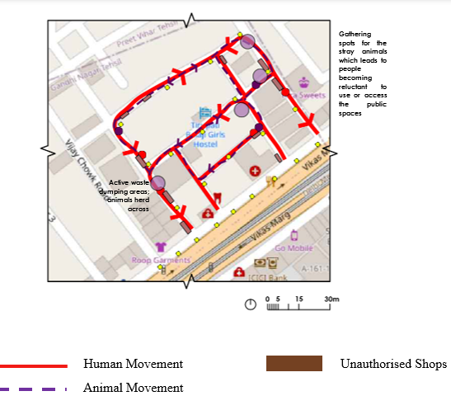

Figure 5. Infrastructural mapping - Laxmi Nagar (Source: Author)
Figure 6. Vegetation mapping - Laxmi Nagar (Source: Author)

The formal street lighting remains considerably less organized when compared with Chandni Chowk. Formal street lighting remains limited and is often supplemented with illumination through the commercial establishments, small roadside vendors and residential buildings. These illumination levels therefore vary significantly across the neighbourhood, creating highly contrasting conditions between active commercial corridors as well as quieter residential streets.

The vegetation cover within the study area was observed to be significantly sparse due to high density of the built development. Public spaces are limited with the lack of dedicated green areas reducing the opportunities for ecological buffering within the urban fabric. Another key observation which emerged through the analysis of the site was the relationship between the waste accumulation, lighting deficiencies as well as stray animal activity. The poorly maintained streets, characterized through litter accumulation and unmanaged public edges attracted stray dogs and other animals, particularly during night-time hours in which pedestrian activity declined. The interaction in between the lighting conditions and the stray animal behaviour was evident within the neighbourhood with poorly illuminated areas and limited human presence experiencing higher levels of animal congregation, which in turn led to many users avoiding such routes during late evening hours. The spatial analysis therefore suggests that the challenges associated with the nocturnal safety in Laxmi Nagar is linked primarily with inadequate maintenance, uneven lighting distribution along with the lack of organized public spaces. Laxmi Nagar demonstrates how infrastructural shortcomings can amplify perceptions of vulnerability within the nocturnal urban environment.

SITE 3: Connaught Place Inner Circle, New Delhi
The inner circle of Connaught Place highlights one of the most prominent commercial and public spaces, considered through its iconic colonial architecture, well-maintained public realm and continuous pedestrian activity. The reason to select this study area was due to its importance as a major urban destination which remains active during the evenings as well as the night time. Several public gathering areas, recreational spaces, retail establishments and restaurants contribute highly to a lively nocturnal environment with a consistent flow of residents, visitors and commuters.
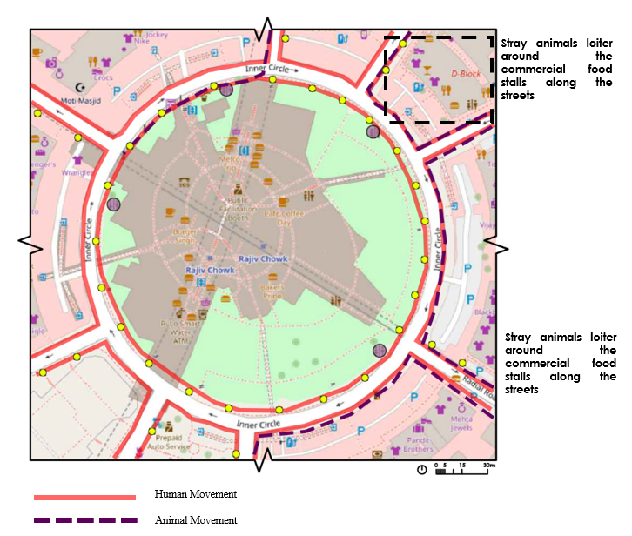

Figure 7. Infrastructural mapping - Connaught Place (Source: Author)

One of the key highlights is the lighting distribution which remains relatively uniform throughout the precinct. The visibility as well as a strong sense of spatial continuity during the night is reinforced through adequate illumination levels towards the central public spaces and primary circulation corridors. The well-lit environment contributes positively to the perceptions of safety as well as accessibility while encouraging pedestrian movement. The presence of stray dogs remained dispersed and less concentrated as compared to the other commercial areas. Most users expressed minimal concern with respect to animal presence during the nighttime movement, with the continuous human activity and organized public environment gave the impression of a comfortable coexistence.
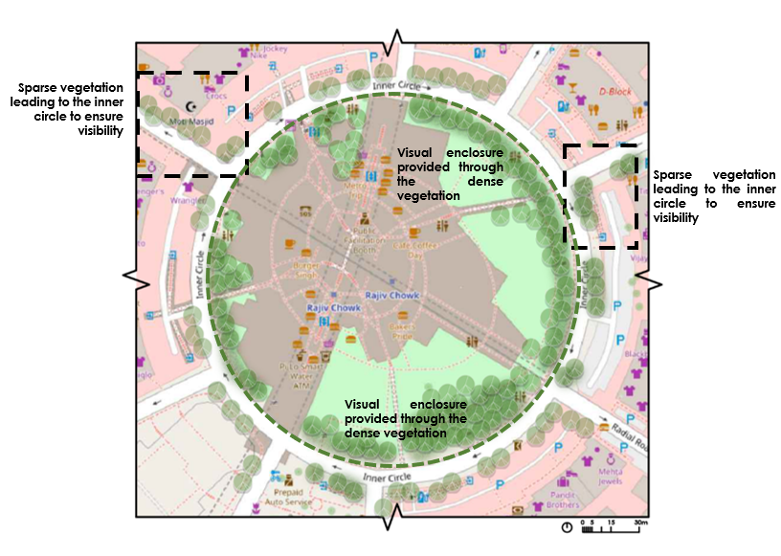

Figure 8. Vegetation Mapping - Connaught Place (Source: Author)

The vegetation within the Connaught Place is characterized through dense vegetative areas at the core with sparse pockets within the streets, with the denser pockets comprising of mature avenue trees. The planting elements do not hamper the overall visibility, rather contribute to the environmental comfort and visual character significantly. The vegetation plays an important role with the integration of lighting systems which ensure that the shaded spaces remain visually accessible after dark. The balance between illumination and lighting assists in maintaining clear sightlines and improves the overall legibility of the public realm.

Connaught Place comprises of continuous pedestrian presence which plays an important role in strengthening natural surveillance across the area. As a whole, these factors form a well-observed and socially active environment which supports the positive perceptions of safety and therefore the selected study area highlights the role of effective lighting, sustained public activity and thoughtfully integrated vegetation can play a crucial role in enhancing the quality, accessibility, and perceived safety of urban public spaces during night time environments.

CONCLUSION
The findings of the study disclose that the perceptions of night-time safety in public spaces are shaped through a complex interaction which involves environmental and social factors which include outdoor lighting, vegetation density, spatial organization and the presence of stray animals. While conventional approaches to urban safety emphasize solely towards surveillance and illumination, the study further highlights the impact of stray animals in influencing people’s experiences and the perceptions after dark. A comparison of the selected study areas further indicates how well-lit and actively used public spaces create a stronger sense of comfort and security among users whereas unmanaged vegetation, poorly illuminated streets and fragmented circulation systems lead to insecurity which discourages the night-time movement.

Through the spatial analysis, the relation between the humans as well as stray animals in urban environments is revealed, which further highlights how these target-groups remain dependent on the surrounding environmental conditions. Areas such as Chandni Chowk integrate the presence of stray animals through the pedestrian movement and informal economic activities alongside continuous human presence. In contrast, areas which contain limited surveillance, lower pedestrian activity as well as inadequate lighting, the presence of stray animals is rather perceived with discomfort and risk. The findings emphasize that stray animals are not independent determinants of safety but are the components of a broader system which has a close relation with spatial and social conditions.

The study highlights the need of strategies which focus towards the rile of multi-species interactions within public spaces, rather than focusing solely on human-cantered approaches, through the integration of effective lighting design, appropriate vegetation management and humane animal welfare measures which would contribute towards safer and more inclusive nocturnal environments. Such interventions can further enhance both ecological balance as well as public comfort together while cutting down conflicts between humans and urban wildlife.

This research aims to open opportunities for future investigations into the behavioural patterns of stray animals under varying landscape conditions. Deeper insights into the management of the nocturnal urban ecologies can be provided through the collaborative efforts of urban local bodies, landscape professionals, animal welfare organizations as well as community stakeholders. In addition, investigating the gender-based and cultural perceptions of safety in relation to stray animal presence would contribute towards a better understanding of urban safety and support the development of inclusive as well as socially responsive public spaces.

REFERENCES
- Appleton, J. (1975). The experience of landscape. John Wiley & Sons.

- Bhattacharjee, D., & Bhadra, A. (2019). Response to sudden surge in human movement by an urban-adapted animal. Department of Biological Sciences, Indian Institute of Science Education and Research Kolkata.

- Bhattacharjee, D., Sarkar, R., Sau, S., & Bhadra, A. (2021). A tale of two species: How humans shape dog behaviour in urban habitats. Department of Biological Sciences, Indian Institute of Science Education and Research Kolkata.

- Chatterjee, S. (2014). Problems faced by LGBT people in the mainstream society: Some recommendations. International Journal of Interdisciplinary and Multidisciplinary Studies (IJIMS), 1(5), 317–331. http://www.ijims.com.

- Chauhan, S. (2017). Twinkle, Twinkle City Light: The Effects of Artificial lighting on Species.

- Rao, P. S. N., Bhagwati, S., Mathur, S., Rastogi, S., Mishra, D. S., Kumar, M., & Kumar, V. (2018). The enabling of safe public spaces in Delhi. Delhi Urban Arts Commission. https://duac.org.in/Upload/City%20Level%20Studies/Vision%20of%20Delhi/653209398198444.pdf

- Hulls, R., & Holding, T. (n.d.). Safer Design Guidelines for Victoria. https://www.planning.vic.gov.au/__data/assets/pdf_file/0014/4631/Safer_Design_Guidelines.pdf

- Gehl, J. (2011). Life Between Buildings. Using Public Space, 1–201. Island Press.

- Gehlot, R., Kapoor, S., Butalia, G. K., & Jain, V. (2023). Invisible Entrepreneurs: unpacking the challenges of street vendors in the Delhi Metropolitan Area. International Research Journal of Multidisciplinary Scope, 04(03), 01–05. https://doi.org/10.47857/irjms.2023.v04i03.096

- Delhi Human Development Report 2013. (2014). Delhi Human Development Report 2013: An Overview. Indian Journal of Human Development, 8(1).

- Karan, S., Saraswat, S., & Anusha, B. S. (2023). Light pollution and the impacts on biodiversity: the dark side of light. Biodiversity, 24(4), 194–199. https://doi.org/10.1080/14888386.2023.2244920

- Kaushik, K., Nair, S., & Ahamad, A. (2022). Studying light pollution as an emerging environmental concern in India. Journal of Urban Management, 11(3), 392–405. https://doi.org/10.1016/j.jum.2022.05.012

- Kumar, A., & Anand, S. (2017). Community Perception towards Solid Waste Management in NCT of Delhi, India. In International Journal of Research and Review. International Journal of Research & Review: 4(7). https://www.ijrrjournal.com/IJRR_Vol.4_Issue.7_July2017/IJRR008.pdf

- Leveau, L. M. (2020). Artificial Light at Night (ALAN) Is the Main Driver of Nocturnal Feral Pigeon (Columba livia f. domestica) Foraging in Urban Areas. Animals, 10(4), 554. https://doi.org/10.3390/ani10040554

- Mondal, D. (2017). Residents say parks in Delhi are unsafe, seek presence of guards. The Sunday Guardian Live (pp. 1–3). https://latest.sundayguardianlive.com/news/9120-residents-say-parks-delhi-are-unsafe-seek-presence-guards

- National Crime Prevention Council. (2003). Crime Prevention Through Environmental Design Guidebook.

- National Crime Prevention Council. (2003b). Crime Prevention Through Environmental Design Guidebook.

- Noomnual, S., & Shendell, D. G. (2017). Young adult street vendors and adverse respiratory health outcomes in Bangkok, Thailand. Safety and Health at Work, 8(4), 407–409. https://doi.org/10.1016/j.shaw.2017.02.002

- Rahm, J., Sternudd, C., & Johansson, M. (2020). “In the evening, I don’t walk in the park”: The interplay between street lighting and greenery in perceived safety. URBAN DESIGN International, 26(1), 42–52. https://doi.org/10.1057/s41289-020-00134-6

- Sharma, T., & Gupta, N. (2023). Nocturnal ecologies: Interactions between urban lighting, vegetation, and stray animals in Delhi. Landscape and Ecology Journal, 8(3), 201–219.

- Sir Stuart Lipton. (2005). The value of public space. The Value of Public Space. https://www.designcouncil.org.uk/fileadmin/uploads/dc/Documents/the-value-of-public-space1.pdf

- Turnbull, J., & Barua, M. (2023). Living waste, living on waste: A bioeconomy of urban cows in Delhi. Transactions of the Institute of British Geographers, 474–490. https://doi.org/10.1111/tran.12573

- Van Rijswijk, L., & Haans, A. (2017). Illuminating for Safety: Investigating the role of lighting appraisals on the perception of safety in the urban environment. Environment and Behavior, 50(8), 889–912. https://doi.org/10.1177/0013916517718888

- Yorzinski, J. L., Chisholm, S., Byerley, S. D., Coy, J. R., Aziz, A., Wolf, J. A., & Gnerlich, A. C. (2015). Artificial light pollution increases nocturnal vigilance in peahens. 3, e1174. https://doi.org/10.7717/peerj.1174

- Yashmita-Ulman, N., Sharma, M., & Kumar, A. (2016). Agroforestry systems as Habitat for avian species: Assessing its role in Conservation. Proceedings of the Zoological Society, 71(2), 127–145. https://doi.org/10.1007/s12595-016-0198-3

