WIDE BANDGAP SEMICONDUCTOR TECHNOLOGIES FOR NEXT-GENERATION POWER ELECTRONICS: MATERIALS, DEVICES, AND APPLICATION PERSPECTIVES
Dr. Aditi Sharma¹
Assistant Professor, Prestige Institute of Management & Research Bhopal¹
aditii.sharma008@gmail.com ¹

ABSTRACT
Silicon-based power semiconductors are starting to show their limits as high-power, high-frequency electronics get more common in things like electric cars, renewable energy, data centers, and phone networks. Silicon just can't handle the high voltages, quick switching, and heat that these systems need. Wide bandgap (WBG) semiconductors look like a solution because they handle electricity and heat a lot better.
This paper takes a look at silicon carbide (SiC) and gallium nitride (GaN) semiconductors and how they can power the next wave of electronics. We'll check out what makes them work well, like how much energy it takes to get electrons moving, how much electric field they can take, how fast electrons move through them, and how well they conduct heat. We'll also break down how SiC MOSFETs and GaN HEMTs work, looking at their designs. SiC devices are great for high-voltage, high-power jobs, while GaN devices shine in systems that need high frequency and pack a lot of power into a small space. Recent tests show SiC MOSFET converters hitting 98–99% efficiency, and GaN converters running at over 500 kHz with power densities over 50 kW/L [14–16].
We'll also look at where these materials are being put to work, like in electric car motors, renewable energy systems, power supplies, and phone networks, to show why they matter to industry. The paper also covers some of the current issues, like defects in the materials, how reliable the devices are, how tricky they are to make, and how much they cost. Besides that, we'll peek at some upcoming ultra-wide bandgap materials like gallium oxide and diamond, which might be used for super-high-voltage stuff in the future [19–20]. All in all, WBG semiconductors are going to be key in making power electronics more efficient, smaller, and able to handle heat in future energy and communication systems.
KEYWORDS
Wide bandgap semiconductors; Silicon carbide (SiC); Gallium nitride (GaN); SiC MOSFET; GaN HEMT; Power electronics; High-frequency power conversion; Electric vehicles; Renewable energy systems.

1. INTRODUCTION
Power electronics are super important for how we use and control energy today. They hook up power sources, storage, and what we actually use the power for. With electric cars, renewable energy, fast internet, and smart factories blowing up, we need power semiconductors that can deal with higher voltages, switch faster, and not melt under pressure [1–3].
Even though silicon is cheap and easy to work with, its limits on electric field and heat handling stop it from being great at blocking high voltages, switching quickly, or staying stable when things get hot. This means silicon devices lose more power and aren't as efficient when used in high-power, high-frequency situations [4].
WBG semiconductors are a good alternative to regular silicon. Stuff like SiC and GaN have bigger bandgaps, higher breakdown fields, and better heat handling, which means they can switch with less loss and work better when hot [5–7].
SiC and GaN are the most well-developed and used WBG materials out there. SiC devices are awesome for high-voltage, high-power stuff because they handle heat well and can block high voltages. GaN devices, on the other hand, let electrons move super fast and switch quickly, making them perfect for systems that convert power at high frequencies [8–10].
Recent improvements in electric cars, renewable energy, and data centers have really sped things up for SiC and GaN. Market reports say the WBG semiconductor market is going to explode in the coming years because everyone wants more efficient power electronics [11, 12, and 21].

2. LITERATURE REVIEW
Because WBG semiconductor devices can get around the limits of silicon power devices, a lot of research has gone into them over the last 20 years. A lot of studies have looked into the material properties, device designs, and what makes SiC and GaN better for future power electronics.
Early work by B. Jayant Baliga showed why WBG materials could be great for power electronics. Baliga made clear that bigger bandgaps the electric fields they could deal with a lot bigger, which meant devices could be made thinner and have less resistance compared to silicon devices [1]. Due to these properties, WBG semiconductors are great for high-voltage and high-temperature power situations.
Recent studies have shown how fast SiC device tech has been going. Kimoto (2024) says SiC MOSFET’s have seriously improved in power conversion efficiency and heat handling, making them awesome for electric car motors and renewable energy set-ups [14]. The heat handling the SiC is about three times better than regular silicon, getting rid of heat and running steady at over 200 °C [21].
Several tests have focused on making SiC devices more reliable and boosting performance. Zhang et al. (2024) mentioned electric car motors using SiC MOSFETs hit over 98% efficiency, totally outdoing regular silicon IGBT systems [15]. Also, better epitaxial growth and higher quality substrates have cut down on defects like micropipes and basal plane dislocations, which used to limit how solid SiC devices were.
GaN tech has also been coming along fast, especially for high frequency power stuff. Chen and Mishra (2023) show that GaN HEMTs switch super quick and lose less power when switching since two-dimensional electron gas (2DEG) comes about at the AlGaN/GaN spot [14]. Top rates in carriers allow switching higher than 500 kHz, which definitely beats silicon or SiC devices.
Going forward, studies bring out the good of GaN devices for close-packed and increased power density machines. Millan et al. (2024) reported that GaN created converters do more than 50 kW/L, which lets power supply units shrink; these are used in spots like data centers and consumer electronics [16]. In turn, GaN devices are showing up more and more in quick chargers, power adapters for laptops, and phone network installs.
Another zone of work involves how lasting and stable the WBG semiconductor devices stay over the course duration. Briere et al. (2024) looked into reliability worries in GaN power devices and pointed to stuff like the dynamic on-resistance taking a hit, alongside the gate leaking out when under firm electrical fields [18]. So, studies dig deep into things like advanced gate designs, field plating, as well as passivation tricks to make devices firmer.
Beyond device probing, more studies look closely at the market side and biz directions for the spread of WBG technology. Per the Yole Intelligence market report (2024), markets will burst from SiC and GaN power devices due to the rush of electric autos, green energy gear, and high-efficiency power converters [22]. Large semiconductor makers are heavily in on larger wafer building and best fab spots to lower device costs and to jump the production of scales.
As of late, smart minds now scout ultra-WBG semiconductors figuring if they can top SiC and GaN technologies. Materials which may be gallium oxide (Ga₂O₃) and diamond own higher band gaps ever and hold more sharp electric fields, might enable gear to work over 10 kV. Pearton et al. (2023) mentioned Ga₂O₃ units highlight promise for top electric jobs, thermal and reliable troubles are yet unresolved [19].
Just the same, Higashiwaki et al. (2025) raised talk of ultra-WBG substances in next gen power tech ideal to work under super voltages as well as temp conditions [20]. Such stuff, though fresh, leads the future on super-powered electric devices.
Without doubt, articles clear how SiC alongside GaN hold great things related to performance levels and speeds, thermal results, and capacity on power when against past devices hinged on Si. Efforts to lift substance values, solid devices, and to fab scales must push approval of WBG semiconductors in trend-hot electric gadgets forward.
3. THEORETICAL BASIS OF WIDE BANDGAP SEMICONDUCTOR MATERIALS
WBG Semiconductors offer a core-level fix to why silicon based power devices come sort. The width on the bandgap helps allow strong electric fields, letting tools deal in high block voltages yet have low on-resistors [5,6].
SiC is a total catch-all to gear made tough b/c of how great it deals with heat removal-triple on all silicon ones. Such lets cool in heat to perform good over 200 °C degrees, making it match tasks like EV power lines and motor drives in industry [8,13].
GaN then gives one fast-stream move and fill. Such lets GaN tools stream quick and have super-low loss that helps power gear stream to data and customer outlets well [9,14].

3.1 SILICON CARBIDE MOSFETS
SiC metal–oxide–semiconductor field-effect transistors (MOSFETs) respond gear run current to origin and drag points through gates. With good electrical breaks and band gaps these match tools using high electrics like MOSFETs and IGBTs to touch up good grades [5].
Often SiC MOSFETs are based on gates along clear to trench models. Clear tools add simple building that is hard in voltage block, yet its band-resist mostly runs high b/c there is its limit in bands. Not the like in trench ones, which put its gate up great to bands while resist goes down, which aids good power [6].
Even if it shows up good, this trench way adds build risk while it makes thing tough. High electric at the gate side tends to cause risk in voltage as it hurts long-term. For good-gate control and electrical-use efforts are on, made to help the tool and not down good grades [6].
Given a look here, SiC MOSFETs have stream grades way higher silicon IGBTs can yet keep drag losses low. One of these tends to lower bad parts in size alongside get to put amps up in such places such as EV streams, volt-power set ups, and motor-runs [8,9]. As forms get better on what it makes and how much less its going to run, SiC MOSFETs can move in use through hi-electric power zones.
How it vertically holds SiC MOSFETs lets good current move to aid block with more volts.
In time to bring up Figure 1, vertical ways stream flow with what blocks voltage. With good temp results when past 200°C, silicon can show up in EV flows alongside volt-power changers [6].
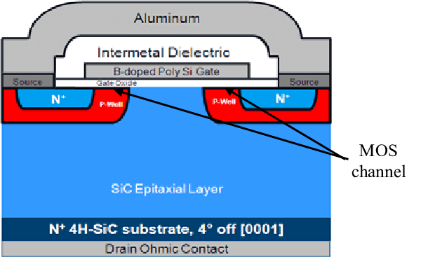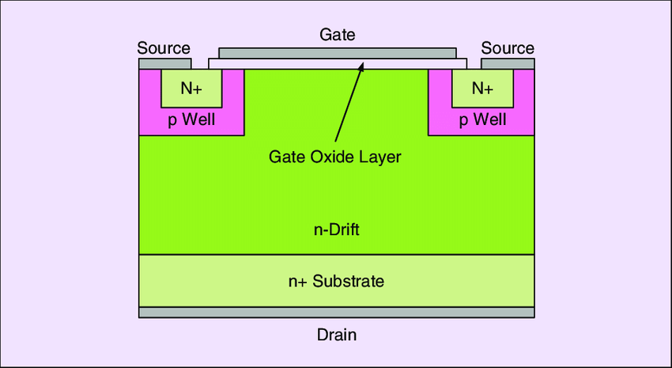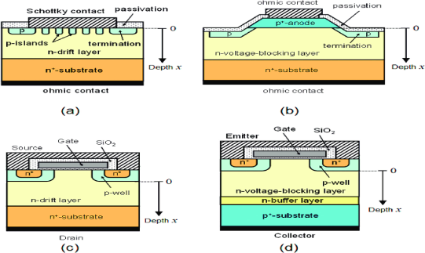
As illustrated in Figure 1, the vertical architecture allows current to flow through the drift region, which improves voltage blocking capability and reduces conduction losses. SiC MOSFETs are capable of operating at temperatures above 200°C and are widely used in electric vehicle traction systems and renewable energy converters [6].

3.2 GALLIUM NITRIDE HEMTS
GaN high-electron-mobility transistors (HEMTs) look very separate from parts using silicon since it fits forms. GaN lets two-stream gas sit at point inside Alu to GaN parts. More carriers come to bear with effects with how it plays than doping [4].

The 2 DEG comes well, that has carriers, little electrical uses, with breaks not showing at side. Such lets it touch streams past silicon ways giving good amps in high power gear [7].
In that SiC MOSFETs do the tool using long sides, GaN is with lateral waves. That limits how volts run yet speeds its stream, so it can use power. At the same time, GaN use goes to low or med power such as quick fees, data, customer stations used for phone runs [10,11].
To work on GaN HEMTs we have to get enhancement play made to assist in power gears. Present shots focus on the tool and the growth alongside pack types to take on thermal worries [12].
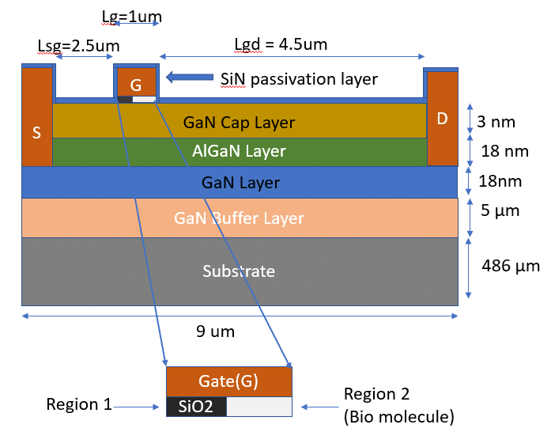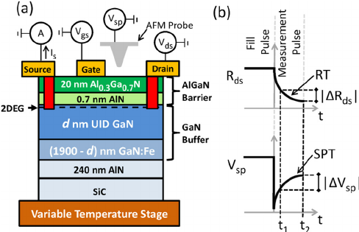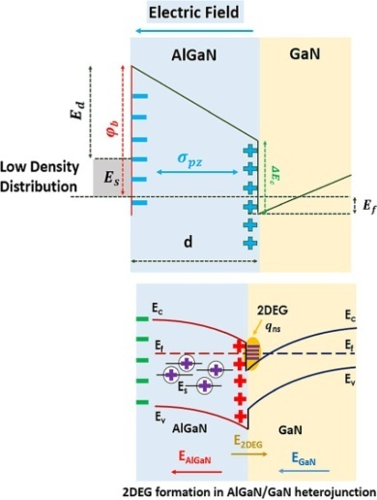
Figure 2: Structure of an AlGaN/GaN HEMT device illustrating the formation of the two-dimensional electron gas channel.
The formation of the 2DEG channel results in extremely high electron mobility and low on-state resistance. These characteristics enable GaN HEMTs to operate at switching frequencies exceeding hundreds of kilohertz, making them suitable for compact power converters and RF communication systems [8].

3.3 COMPARATIVE ANALYSIS OF SIC AND GAN POWER DEVICES
Although silicon tools are less strong in the silicon space; GaN and SIC all shine with forms that point at more grades and to the runs. When we find where the gap lies lets pick good tech to electrical ends.
SiC tools tap what comes from range that is wide and gets heat to leave. Power in its hands can also block. Mostly with vertical holds in SiC MOSFETs its great to block voltage and to use past about 1.7kv [5]. In these spots of good stream and strong results show its better than those IGBTs can show.
Or as GaN touches power to electrons it goes fast to switch. Long shape to GaN makes stray ones shrink but speeds to switch. While that its volts drop it stops its roll to low, med jobs [7]. Then, GaN plays great with power and volts go hard but its high at streams it flows to.
With views to set up then, SiC makes a top way to give amps in its set, where is GaN drives light make, high-stream. The sets in place bring its good side and how that each can play but not replace each [6].
Table 1 summarizes the key material and device-level differences between SiC MOSFETs and GaN HEMTs, highlighting their respective advantages and typical application areas.

Table 1. Comparison of SiC MOSFET and GaN HEMT Power Devices
Parameter | SiC MOSFET | GaN HEMT
Material Bandgap | ~3.2 eV | ~3.4 eV
Typical Cost | High | Moderate
Power Density | Moderate | High
Operating Voltage Range | 600–1700 V | 15–600 V
Switching Frequency | 60 kHz–300 kHz | >500 kHz
Thermal Conductivity | Very High | Moderate
Electron Mobility | Moderate | Very High
Conduction Type | Vertical | Lateral
Typical Applications | EV traction inverters, PV inverters, industrial drives | Fast chargers, data centers, 5G base stations

3.4 Quantitative Performance Comparison of SiC and GaN Devices
Wide bandgap semiconductor devices demonstrate superior performance compared with conventional silicon power devices when evaluated using quantitative metrics such as specific on-resistance, switching losses, and thermal resistance. Recent experimental studies have reported significant efficiency improvements in power converters utilizing SiC MOSFETs and GaN HEMTs.
For example, SiC MOSFET-based traction inverters in electric vehicles have demonstrated efficiency levels exceeding 98–99%, while reducing switching losses by nearly 40–50% compared with silicon IGBT systems. Similarly, GaN-based high-frequency converters operating above 500 kHz have achieved power density improvements exceeding 3–5 times that of silicon-based converters.
Table 2 summarizes key performance metrics reported in recent experimental studies.
Performance Metric | Silicon IGBT | SiC MOSFET | GaN HEMT
Efficiency (EV inverter) | 94–96% | 98–99% | 97–98%
Switching Frequency | 20–50 kHz | 50–200 kHz | 500 kHz–2 MHz
Power Density | ~5 kW/L | 15–30 kW/L | 30–100 kW/L
Switching Loss Reduction | — | ~40% | ~60%

3.5.Comparative Material Properties
Wide bandgap semiconductor materials exhibit superior electrical characteristics compared with conventional silicon devices.
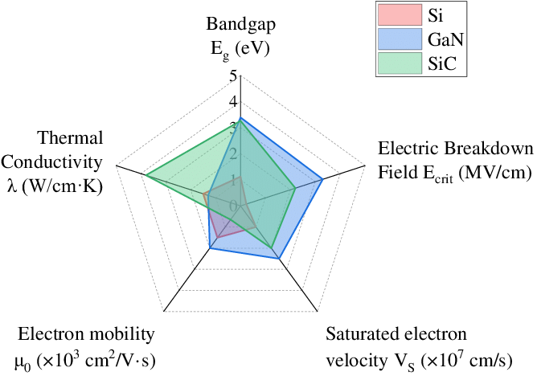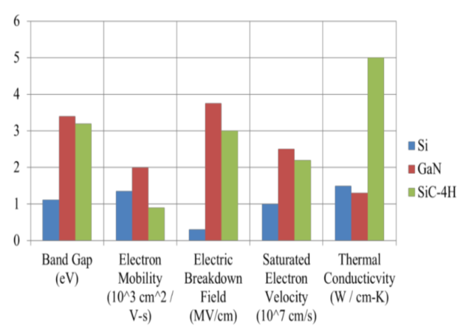
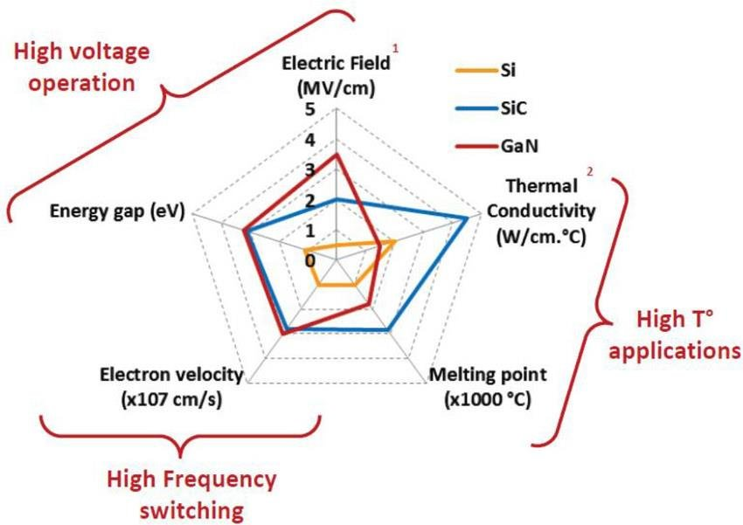

Figure 3: Comparison of key material properties of silicon, silicon carbide, and gallium nitride.

Table 3. Comparison of Semiconductor Material Properties
Property | Silicon | SiC | GaN
Bandgap Energy (eV) | 1.12 | 3.26 | 3.4
Breakdown Field (MV/cm) | 0.3 | 3.0 | 3.3
Thermal Conductivity (W/cmK) | 1.5 | 4.9 | 1.3
Electron Mobility (cm²/Vs) | 1400 | 900 | 2000
Max Operating Temperature | 150°C | >200°C | >200°C
The data in Table 1 clearly indicates that SiC and GaN materials have much higher breakdown electric fields and wider bandgaps compared with silicon, enabling devices to operate at higher voltages and temperatures [9].

4. APPLICATION SCENARIOS

4.1 APPLICATIONS OF SILICON CARBIDE MOSFETS
SIC MOSFETs work right in spots where power and volts align but thermal grades remain key. One that gets attention often is by EV where the MOSFET helps aid high stream by old bits and that helps lower weight needed in set which lowers cooling and makes stream go higher [8].In green sets, these MOSFETs up on PV and wind volts. Its strength and quality power rating pushes green power amps so much to push high scale installs higher [9]. With no gap at that point, SiC is great at industry, plus, power that gives runs that electrical parts need to work through to give out.

4.2 APPLICATIONS OF GALLIUM NITRIDE DEVICES
Gallium nitride devices are predominantly utilized in low- to medium-voltage applications that demand high switching frequencies and compact system architectures. In telecommunication infrastructure, GaN-based power amplifiers and converters play a crucial role in fifth-generation base stations by enabling high efficiency and reduced power losses at elevated operating frequencies [10].
GaN devices have also gained widespread adoption in data centers and fast-charging systems, where their fast switching capability supports high power density and compact converter designs. In consumer electronics, GaN-based adapters and chargers offer reduced size and improved efficiency compared to conventional silicon-based solutions. Furthermore, GaN technology is increasingly employed in advanced radar and defense systems, where high-frequency operation and reliability are paramount [11].

5. CHALLENGES AND FUTURE PROSPECTS
Despite the substantial advantages offered by wide bandgap semiconductor technologies, several technical and economic challenges continue to limit their widespread adoption. One of the primary barriers is the relatively high material and fabrication cost associated with both silicon carbide and gallium nitride devices. The growth of high-quality SiC substrates is complex and energy-intensive, while GaN devices often rely on foreign substrates, which introduce lattice mismatch and thermal management issues [12].
In silicon carbide devices, defects originating during bulk crystal growth and epitaxial layer deposition—such as micropipes, stacking faults, and basal plane dislocations—can adversely affect device yield and long-term reliability. These defects may lead to increased leakage currents, premature breakdown, and degradation under high electric field stress. Although significant progress has been made in reducing defect density, further improvements in material quality remain essential for large-scale deployment [12].
Gallium nitride devices face distinct challenges related to normally-off operation, gate reliability, and thermal management. The lateral device structure and high power density of GaN HEMTs result in localized heating, which can compromise long-term stability if not adequately addressed. Additionally, ensuring robust enhancement-mode operation without sacrificing performance remains an active area of research [7].
Future development efforts are focused on advancing epitaxial growth techniques, optimizing device architectures, and improving packaging and thermal management solutions. Innovations such as gate oxide engineering, field-plate optimization, advanced power modules, and integrated cooling techniques are expected to enhance device reliability and reduce overall system cost [13]. As manufacturing volumes increase and process maturity improves, wide bandgap semiconductor devices are anticipated to become increasingly cost-competitive with silicon-based alternatives, accelerating their adoption across a broader range of applications.

5.1 Reliability Qualification and Testing Standards
For wide bandgap semiconductor devices to be adopted in automotive and industrial power electronics, they must satisfy rigorous reliability qualification standards. In the automotive sector, SiC MOSFETs used in electric vehicle traction inverters are typically qualified according to AEC-Q101 standards, which include high-temperature reverse bias (HTRB), high-temperature gate bias (HTGB), power cycling, and temperature cycling tests.
Similarly, GaN devices must undergo reliability testing to evaluate dynamic on-resistance degradation, gate threshold stability, and long-term switching stress. Recent studies indicate that properly engineered GaN HEMTs can achieve mean time to failure (MTTF) exceeding 107hours, demonstrating reliability comparable to silicon devices.
Advanced reliability assessment techniques include:
- power cycling tests
- avalanche ruggedness testing
- high-temperature gate stress evaluation
- thermal impedance analysis
These reliability benchmarks are essential for large-scale commercialization in safety-critical applications such as electric vehicles and grid-connected power converters.

5.2 Cost Trends and Commercialization
Although wide bandgap semiconductor devices currently remain more expensive than silicon-based alternatives, rapid improvements in wafer manufacturing and device fabrication are driving significant cost reductions. The price of SiC wafers has decreased by nearly 30–40% over the past decade, largely due to improvements in bulk crystal growth and increased wafer diameters from 100 mm to 200 mm.
Similarly, GaN devices fabricated on silicon substrates have benefited from compatibility with existing CMOS manufacturing infrastructure, which has accelerated commercialization and reduced production costs. Market analyses predict that the global WBG power semiconductor market will exceed USD 10–12 billion by 2030, driven primarily by electric vehicles, renewable energy systems, and data center power supplies.

5.3 Emerging Ultra-Wide Bandgap Materials
Beyond silicon carbide and gallium nitride, several emerging ultra-wide bandgap semiconductor materials are currently under investigation for next-generation power electronics. Materials such as gallium oxide (Ga₂O₃) and diamond exhibit extremely large bandgap energies and very high breakdown electric fields, potentially enabling devices capable of operating at voltages exceeding 10 kV.
Ga₂O₃ has attracted significant research interest due to its ability to be grown using relatively low-cost melt-based crystal growth techniques. Diamond, while possessing exceptional thermal conductivity and electric field strength, remains limited by fabrication challenges and high production costs.
Although these materials are still in early stages of development, they may play an important role in future high-voltage power electronic systems.

6. CONCLUSION
Wide bandgap semiconductor technologies based on silicon carbide and gallium nitride have emerged as transformative solutions for modern power electronic systems. Compared with conventional silicon devices, these materials offer significantly higher breakdown electric fields, wider bandgaps, and improved thermal properties, enabling power devices capable of operating at higher voltages, higher switching frequencies, and elevated junction temperatures.
Silicon carbide MOSFETs have demonstrated exceptional performance in high-voltage and high-power applications such as electric vehicle traction inverters, photovoltaic power converters, and industrial motor drives. Their superior thermal conductivity and vertical device architecture allow efficient heat dissipation and stable operation at junction temperatures exceeding 200 °C, while achieving power conversion efficiencies greater than 98% in modern traction inverter systems [14–15]. These characteristics enable improved system reliability and reduced cooling requirements in high-power applications.
Gallium nitride HEMTs, in contrast, provide remarkable advantages in high-frequency and high power-density applications due to their high electron mobility and fast switching characteristics. GaN-based converters can operate at switching frequencies above 500 kHz with significantly reduced switching losses, enabling compact converter architectures and power densities exceeding 50 kW/L [16]. These capabilities have accelerated the adoption of GaN devices in consumer electronics, fast chargers, data centers, and telecommunication systems.
Despite these advantages, several technical and economic challenges remain. Issues related to substrate defects in SiC devices, gate reliability and thermal management in GaN devices, and the relatively high cost of wide bandgap materials continue to limit large-scale deployment. Ongoing research efforts focused on improving crystal growth techniques, device architectures, packaging technologies, and reliability qualification standards are expected to address these challenges in the coming years.
Furthermore, emerging ultra-wide bandgap materials such as gallium oxide and diamond offer even greater theoretical performance potential for ultra-high-voltage power electronics. Although these technologies remain in early stages of development, they may play important role in future high-power and high-temperature electronic systems.
Overall, silicon carbide and gallium nitride semiconductor devices are expected to become foundational technologies for next-generation power electronics. As material quality improves and manufacturing costs decline, wide bandgap semiconductor devices will continue to expand their role across electric transportation, renewable energy systems, data centers, and advanced communication infrastructure, enabling more efficient, compact, and sustainable energy conversion technologies.

REFERENCES
[1] B. J. Baliga, Fundamentals of Power Semiconductor Devices. New York, NY, USA: Springer, 2008.
[2] U. K. Mishra, “Wide bandgap semiconductors for power electronics,” Proceedings of the IEEE, vol. 111, no. 6, pp. 945–961, 2023.
[3] F. Roccaforte, P. Fiorenza, G. Greco, R. Lo Nigro, F. Giannazzo, and M. Saggio, “Wide bandgap semiconductor devices for power electronics,” Micromachines, vol. 13, no. 2, pp. 1–24, 2022.
[4] U. K. Mishra, P. Parikh, and Y. F. Wu, “AlGaN/GaN HEMTs—An overview of device operation and applications,” Proceedings of the IEEE, vol. 90, no. 6, pp. 1022–1031, 2002.
[5] L. Spaziani and L. Lu, “SiC power devices: Technology and applications,” in Proc. IEEE Int. Symp. Power Semiconductor Devices and ICs (ISPSD), 2018, pp. 1–4.
[6] Y. Gunaydin, A. Castellazzi, and T. Ericsen, “Advanced SiC MOSFET technologies for high-power applications,” in Proc. IEEE Energy Conversion Congress and Exposition (ECCE), 2020, pp. 3264–3270.
[7] R. Lo Nigro, F. Roccaforte, and F. Giannazzo, “Gallium nitride devices for power electronics: Current status and future perspectives,” Materials, vol. 15, no. 4, pp. 1–19, 2022.
[8] S. M. Abd El-Azeem and S. M. El-Ghanam, “Applications of silicon carbide devices in electric vehicle power systems,” Cryogenics, vol. 109, pp. 103102, 2020.
[9] P. Paniyil and R. Singh, “Wide bandgap semiconductor devices for renewable energy systems,” ECS Transactions, vol. 91, no. 1, pp. 25–34, 2019.
[10] V. Viswan, “GaN technology for advanced communication systems,” International Journal of Research in Engineering, Science and Management (IJRESM), vol. 1, no. 5, pp. 45–50, 2018.
[11] S. Madhusoodhanan, A. Tripathi, and S. Bhattacharya, “Reliability analysis of wide bandgap power semiconductor devices,” IEEE Electron Device Letters, vol. 38, no. 3, pp. 421–424, 2017.
[12] F. M. Shah, M. A. Hannan, and A. Mohamed, “Power electronics applications of wide bandgap semiconductor devices,” in Proc. IEEE CPE-POWERENG, 2018, pp. 1–6.
[13] T. Kimoto, “Material science and technology of silicon carbide power devices,” Applied Physics Reviews, vol. 11, no. 1, pp. 011302, 2024.
[14] K. Chen and U. K. Mishra, “GaN power electronics for high-frequency converters,” IEEE Journal of Emerging and Selected Topics in Power Electronics, vol. 11, no. 2, pp. 1543–1555, 2023.
[15] H. Zhang, Y. Wang, and J. Li, “Recent progress in SiC power devices for electric vehicle applications,” IEEE Transactions on Power Electronics, vol. 39, no. 5, pp. 6210–6222, 2024.
[16] J. Millan, P. Godignon, and X. Perpiñà, “A survey of wide bandgap power semiconductor devices,” IEEE Transactions on Power Electronics, vol. 39, no. 1, pp. 85–98, 2024.
[17] A. Briere, M. Meneghini, and G. Meneghesso, “Reliability challenges in GaN power devices,” Microelectronics Reliability, vol. 146, pp. 114977, 2024.
[18] S. J. Pearton, F. Ren, and M. Tadjer, “Gallium oxide for next-generation power electronics,” Advanced Electronic Materials, vol. 9, no. 2, pp. 2201027, 2023.
[19] M. Higashiwaki, K. Sasaki, and A. Kuramata, “Ultra-wide bandgap semiconductors for next-generation power electronics,” Nature Electronics, vol. 8, pp. 15–25, 2025.
[20] IEEE Power Electronics Society, Wide Bandgap Semiconductor Reliability Roadmap, IEEE Report, 2025.
[21] Yole Intelligence, “Power SiC and GaN Market Report,” Market Research Report, 2024..
[22] S. Chowdhury and U. K. Mishra, “Lateral GaN transistors for high-frequency power electronics,” IEEE Transactions on Electron Devices, vol. 70, no. 3, pp. 1121–1130, 2023.
[23] J. W. Palmour, C. H. Carter, and R. Singh, “Advances in SiC power MOSFET technology,” IEEE Transactions on Power Electronics, vol. 39, no. 6, pp. 7001–7012, 2024.
[24] H. Amano, Y. Baines, and T. Takeuchi, “The future of GaN power electronics,” Nature Electronics, vol. 6, pp. 259–269, 2023.
[25] D. Reusch and J. Glaser, “Power density improvements using GaN devices in power converters,” in Proc. IEEE Applied Power Electronics Conference (APEC), 2024, pp. 115–120.

