Pinaki Dutta
State Aided College Teacher
Bidhan Chandra College, Rishra, Hooghly
(under University Of Calcutta, W.B)
&
Dr. Apala Ghosh
Professor
Bengal School Of Technology and Management
(under MAKAUT W.B)

The Impact of Financial Inclusion in Promoting Development of Micro, Small and Medium Enterprises (MSMEs)

ABSTRACT
Financial Inclusion refers to provide affordable financial services – such as banking, credit, insurance and digital payments-to all individuals and businesses, especially, those traditionally underserved. Micro, Small and Medium Enterprises (MSME)from the backbone of developing economy, contributing significantly to employment generation, Innovation and GDP growth. Financial Inclusion enhances the development of MSMEs by improving access to essential financial services like credit, savings and digital payments, which boosts their performance, facilitates expansion, promote employment and contributes to their overall sustainability. This study aims to explore the impact of Financial Inclusion on the Micro, Small and Medium enterprises’ (MSMEs) in its development and growth in India. This study takes into account the schemes launched by the Indian Government which are majorly contributing to the growth of these MSMEs. This study also evaluate the impact of digital financial services on MSME. It identifies challenges faced by MSMEs in accessing inclusive finance and also suggests policy measure for strengthening financial inclusion to promote industrial growth. The data-analysis is exclusively done based on the secondary sources of data collected from articles, textbooks, journals, websites, annual reports of MSMEs &published press releases made by the Government officially via the Press Information Bureau.
Keywords: MSMEs, Financial Inclusion, Government schemes, Digital Financial Services.

INTRODUCTION
A large number of studies demonstrates how financial development levels the playing field for business of all sizes (whether it may be large, small or MSME and supports financing which in turn promotes the expansion of MSME. A plethora if research suggests that smaller businesses are more restricted by funding limitations. Research conducted for example by Beek Demiurgic- Kunt, and Maksimovic (2005) shows that financing obstacles hinder the growth of smaller enterprises more than these of bigger enterprises and that this difference is especially noticeable in countries with less established financial system. According to Demiurgic Kunt and Maksimovic (2006) countries with stronger legal and f inancial systems robust rights for creditors and shareholder and efficient Bankruptcy procedures have a greater livelihood of having business operating as companies. In nations where the legal system is less developed and firm must rely on informal financial institution, there is a great hurdle for financing, consequently in nations where the legal system supports formal contracts enterprises that are incorporated enjoy a comparative advantage as narrated by Beek T. Kunt (2006) Klapper L.F. and Panos in their research work in the context of Balacan Countries. Financial inclusion is essential for empowering citizens by giving them access to vital financial services line credit, saving, insurance and pensions. The access is crucial for promoting entrepreneurship and business growth, especially in the MSME sector, which essential to the Indian Economy. MSMEs serve as the main engine of India’s economic growth. They contribute about 30% to the GDP, 35.4% to manufacturing and 45.73% to exports. They also provide a significant source of employment. However, these enterprises often work with thin margins and face considerable financial and technological challenges. This is where the green economy is important. Defined by a move towards sustainable practices and resources-efficient technologies, the green economy presents a multi-trillion-dollar market opportunity. However, for MSMEs to engage in and head their green shift, they need substantial investment, which they can only get it they are well integrated into the formal financial system. The main point here is that without targeted financial supports, MSME cannot make the green transition jeopardizing India’s sustainability goals and its vision for inclusive economy. India’s efforts in financial inclusion have been driven by visionary policies and fast technological adoption. A key initiative is the Pradhan Mantri Jan Dhan Yojana (PMJDH), launched in 2014 to ensure universal access to banking services. The technological backbone for the change in financial inclusion is the “JAM Trinity”- Jan Dhan Aadhar and Mobile. This network has set the stage for a strong digital landscape. A prime example of its impact is the Direct Benefit Transfer (DBT) Scheme, which uses this JAM network to transfer government benefits directly to beneficiaries’ bank account.

Literature Review
Dr. Asha Shivaji Patil [1] has highlighted that for a country to be developed economically; it must focus more on the entrepreneurs and small businesses in supporting and strengthening them. The researcher focused on understanding the significance of PMMY, the products & services offered by it through the Mudra bank, its progress and status in the state of Maharashtra.
Chandra Mohan Malladi et al [2] have focussed on the effect of Digital India Movement and Pradhan Mantri-Jan Dhan Yojana on Financial- Inclusion in India and the challenge in achieving an inclusive society. This also suggested few measures to address those challenges and have emphasised on the importance of transparent collaboration among the stakeholders in contributing to the inclusive ecosystem. The study found that there is still a digital divide between urban population and the semi urban population in terms of financial literacy.
Gaurav Kumar Saxena [3] has analyzed that MSMEs are contributed significantly by private-sector and foreign-banks when compared to the PSBs in India in terms of bank-credit and suggested that, for improved interdependence of MSMEs and Financial inclusion in India are to be reviewed by the Government for its investment and inclusion plans. This study concluded that the performance of the banks directly impacts the performance of the MSMEs and vice versa.
Dr Lasya K R et al [4] have aimed and understood the effect of microfinance institutions on the MSMEs in Bangalore, India. It has specifically focussed on examining the capacity of microfinance and how its enhanced services like loans and credit facilities have resulted it the growth & development of MSMES. It has also analysed the factors that influenced the perception level of MSMES on the contribution aspects of microfinance loans and credit facilities. It is found that emphasis had to be placed on the need of providing support and encouraging collaboration between micro-finance institution policymakers and other stakeholders to promote the region’s sustainable and inclusive economic development.
Mahesh K.M.et al [5] have focused to know the efficiency of digital-transactions and government digital-innovative schemes for the sustainable development of SMEs, understood the credit-lending schemes by various Financial Institution and banks for small & medium enterprises that have contributed to GDP of the Country and also 51 JNNCE Journal of Engineering & Management, Special Edition, 04, January-2025 ISSN 2582-0079 emphasized on the significance of digital start-ups in rendering developing services new-products payment-credit accessibility.
Dr Poonam Pravinbhai Radadiya [6] has conducted exploratory research with primary data to identify, understand and evaluate the role MSMEs in India’s economy. The study investigated how the operations and development of MSMEs in the sectors of production and manufacturing have contributed to the nation’s economy. It is found in this study; the growth of this sector is due to the availability & accessibility of the financial resources with reference to Maharashtra.
Dr Pritha Chaturvedi [7] The researcher has reviewed the significance of small finance banks, importance of financial inclusion, the level of influence SFBs have on the financial inclusion and also the effect of Covid on SFBs. It is found that, formal banking institutions are scarce in number and the concept of SFBs are novel to them. Therefore, SFBs were not able to function with full efficiency citing the lack of awareness about the credit needs of rural population. It was also stated that the country and the government should place more prominence on training the existing employees of SBFs on marketing the institutions and accepting deposits by using technology to reach the remote and underserved areas in the rural regions. Saman Zameer1, Dr. ShujaUddin Khan2 [8] have studied and analyzed the concept of financial-inclusion in India and have attempted to investigate the role of Pradhan Mantri-Jan Dhan Yojana in reaching a wider population through the number of financial services launched through the scheme. This paper studies the different levels, choices and patterns of savings adopted by individuals in accordance to the alternatives available so as to be financial inclusive.
Research Gap:
Although many studies have examined financial inclusion and the development of MSMEs in India, most of them focus only on specific aspects such as micro finance, banking credit or performance of government schemes like Pradhan Maantri Jan Dhan Yojona and Pradhan Mantri Mudra Yojona. However, there is limited research that comprehensively analyses the combined impact of financial inclusion initiatives and digital financial services on the overall growth and development of MSMEs. Therefore, the study attempts to bridge this gap by examining the overall impact of financial inclusion initiatives, governments schemes and digital financial services in the development and growth of MSMEs in India, while also identifying the challenges faced by these enterprises in accessing inclusive financial services and policy measures for strengthening financial inclusion for the development of MSMEs.
Objectives:
- To explore the impact of Financial Inclusion on the Micro, Small and Medium Enterprises (MSMEs) in its development and growth in India.
- To explain the schemes launched by the Indian Government which are contributing to the growth of MSMEs.
- To study the impact of Digital Financial services on MSMEs.
- To identify challenges faced by MSMEs in accessing inclusive finance.
- To suggest the policy measures for strengthening financial inclusion to promote industrial growth.
Methodology
The study is descriptive and analytical in nature, focusing on understanding the relationship between financial inclusion and the development of MSMEs.
Sources of Data
The study is based on secondary data. The data has been collected from various sources such as: Research articles and academic journals .books and textbooks
Government reports and official publications, annual reports of MSMEs, reliable websites and online databases
Need for the Study
The study is to be carried out to understand the situation of MSMEs with reference to the schemes and initiatives taken by the government in boosting its growth. This study aims to analyse the growth and development of MSMEs as an impact of financial inclusion.

IMPACT OF FINANCIAL INCLUSION ON MSME
Micro, Small, and Medium-sized Enterprises (MSMEs) are pivotal contributors to economic growth, particularly in developing nations, where they play a pivotal role in the creation of employment opportunities and the advancement of global economic development. The expansion of the Indian economy’s social and economic sectors is greatly influenced by the MSMEs.
In India, MSMEs account for 30% of India’s Gross Domestic Product (GDP) and over 45% of the exports. These businesses, ranging from micro business entities to mid-sized manufacturers and export-oriented entities MSMEs are at the core of the value chain of Indian economy.

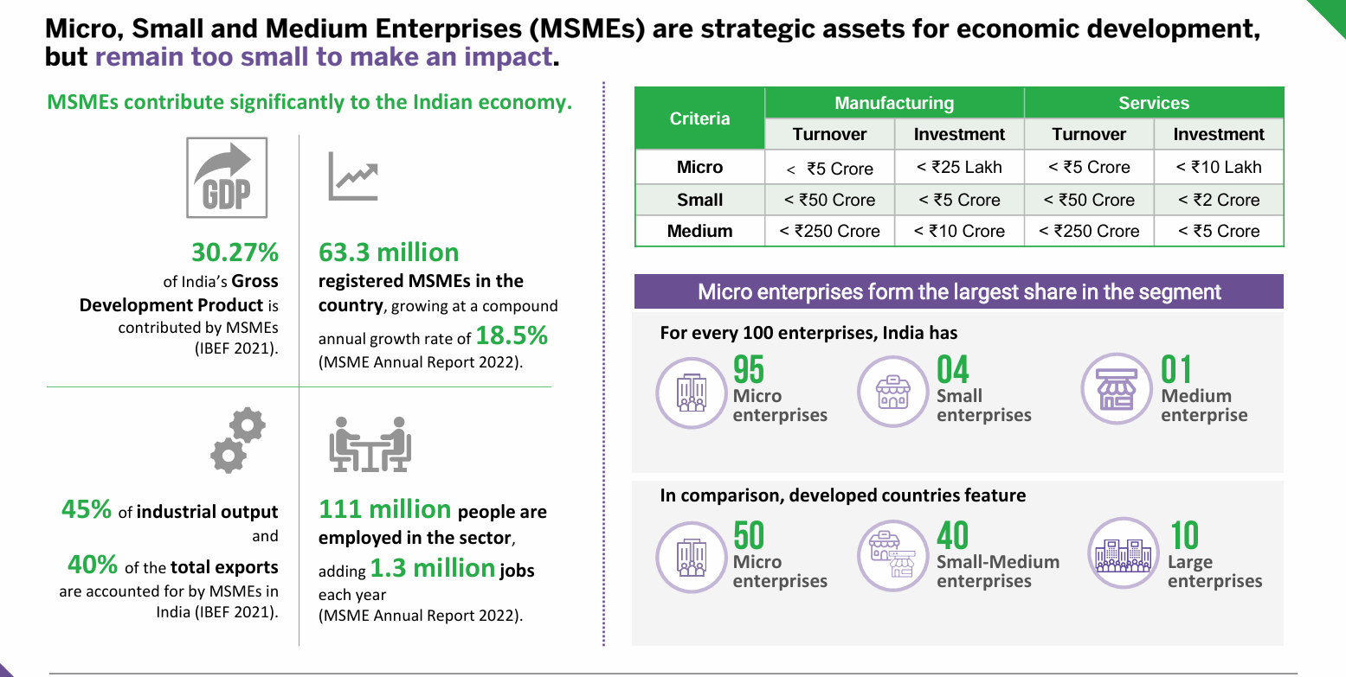

The expansion of the Indian economy’s social and economic sectors is greatly influenced by the MSMEs. MSMEs also aid in reducing the disparity in income distribution by providing individuals with numerous job possibilities and industrialising rural regions. The sector’s employment potential at minimal capital cost is its key advantage.
They provide significant contributions to the nation’s exports, employment and industrial production. For the country to move towards a quicker and more equitable growth, this sector is crucial. The MSME sector is considered a vital engine for achieving the vision of a developed India by 2047, envisioned in the concept of “Viksit Bharat 2047”.

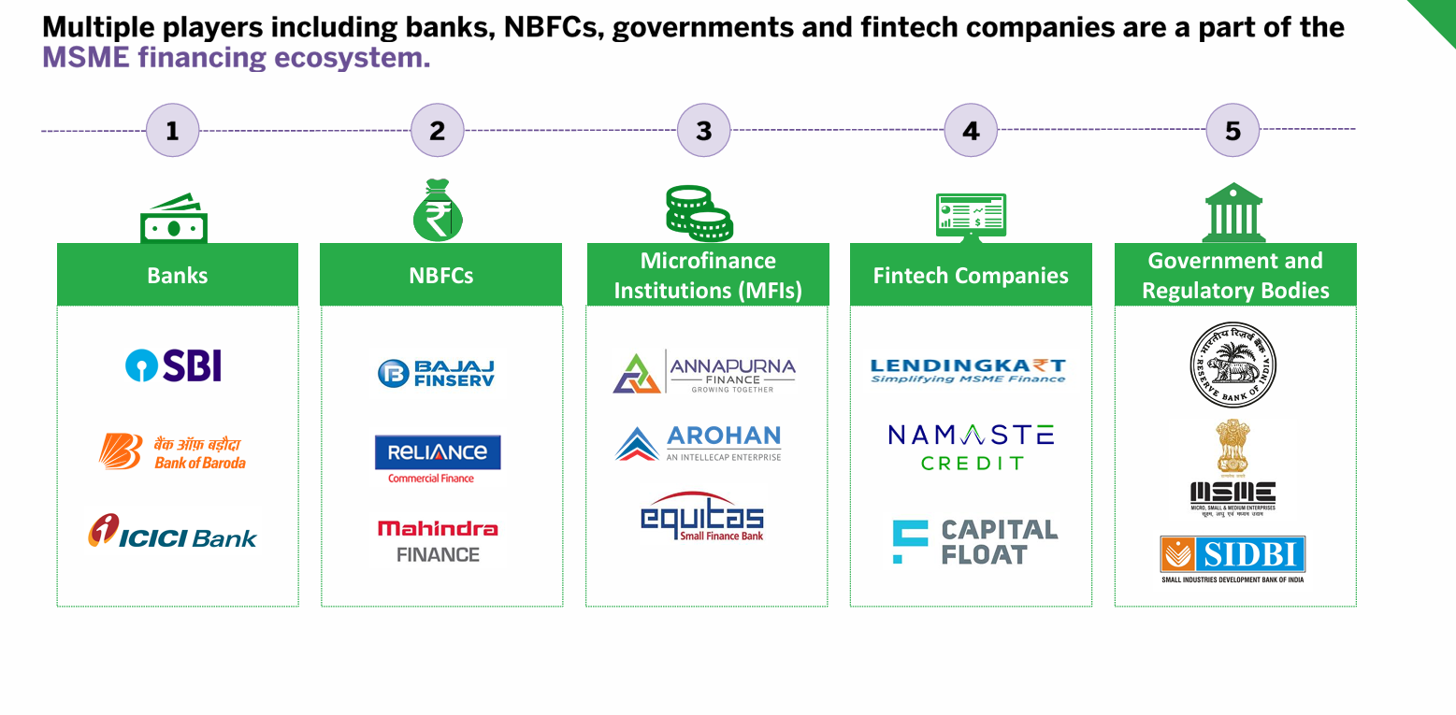

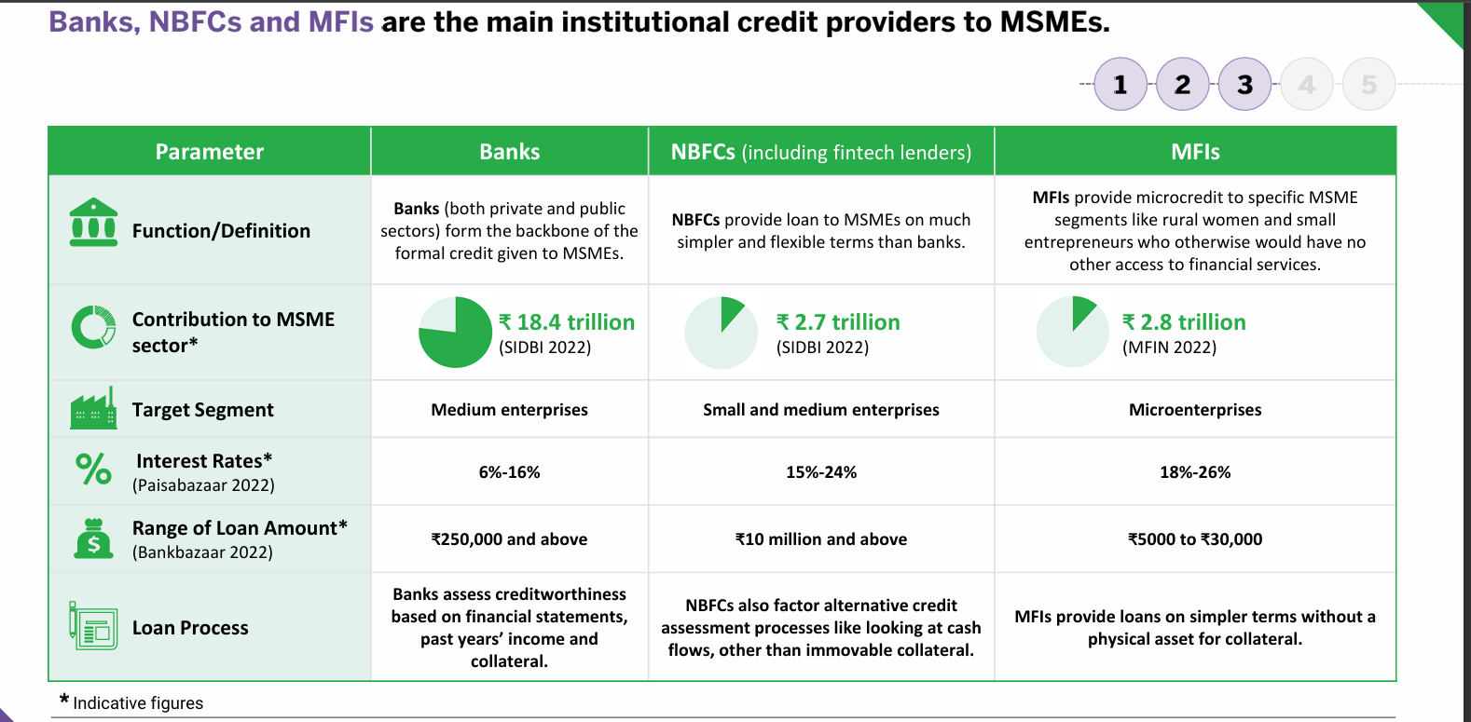

CREDIT FLOW TO MSME BY SCHEDULE COMMERCIAL BANK
Access to credit is critical for the growth and sustainability of MSMEs. The credit flow to MSMEs by Scheduled Commercial Banks (SCBs) registered steady growth over the past five years. The credit outstanding of the MSME sector was ~2X of the pre pandemic levels, indicating underlying growth momentum and improved credit appetite for the MSME sector, as of March 2025. In FY2025, the credit outstanding to MSME grew by a healthy 14.8%to reach `31.3 lakh crore while witnessing a moderation from the high growth seen in the previous fiscal. With 90 day plus delinquencies, declining to a 5-year low of 1.79% as at end of FY2025, the MSME sector is well placed to witness sustainable credit growth over the medium term.
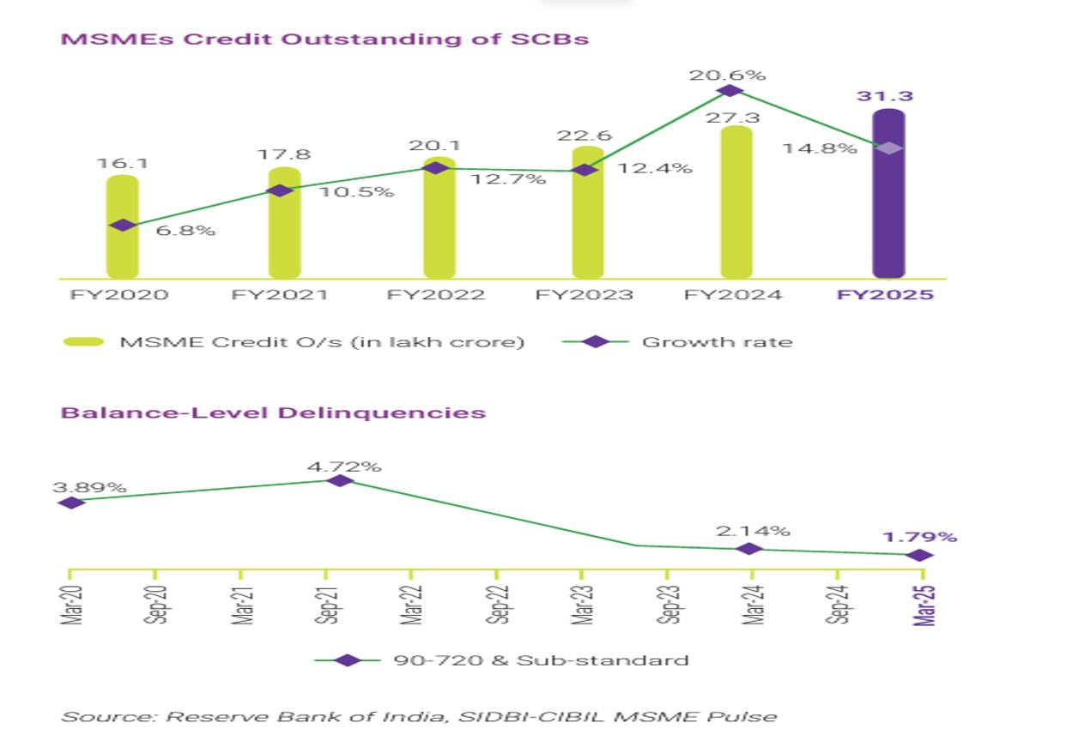

The MSME credit growth by SCBs was higher than the overall gross advances growth at 11%, positioning it as preferred sector by lenders. The NTC segment accounted for 55% of all commercial loan originations in the micro segment in the financial year ending March 2025. Public Sector Banks (PSUs) were the leading institutions for onboarding these new commercial entities.
CONTRIBUTION BY SIDBI:
Small Industries Development Bank of India (SIDBI) has been established under SIDBI Act, 1989 to serve as the Principal Financial Institution for Promotion, Financing and Development of the MSME sector and co-ordination of the functions of the various Institutions engaged in similar activities. SIDBI started operation on April 02, 1990.
SIDBI operates various schemes for financing and promotion and development of MSMEs. Financing schemes are broadly classified into (1) Indirect Finance/ Refinance and (2) Direct Finance. Under Indirect Finance, assistance to MSMEs is extended through Banks (including SFBs), NBFCs, MFIs and other institutions by extending refinance/ resource support assistance against MSME portfolio of such institutions. This creates a multiplier effect and increases the flow of credit to MSMEs. Under Direct Assistance, SIDBI extends financial assistance directly to MSMEs through its branch network.

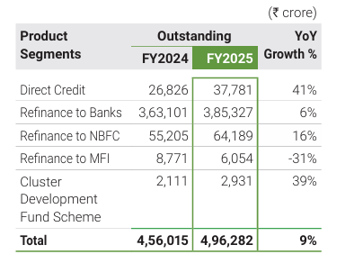
DIRECT LENDING :
The Direct Lending portfolio through Branch Network, Partner Institutions and Digital Lending has grown by 41% during FY2025 with outstanding as at end of FY2025 at `37,781 crore as compared to `26,826 crore as at end of FY2024. The robust growth is primarily due to various structural and product-level interventions, viz., digitisation of entire lending process, introduction of new products, competitive rates, opening of new branches etc. • Direct Lending-Branch Network SIDBI extends direct credit through its branch network to MSMEs. Some of the key initiatives under Direct Lending-Branch Network during FY2025 were
REFINANCE TO BANK:
The Bank extends refinance assistance to augment resources of Primary Lending Institutions (PLIs) to increase flow of credit to MSMEs. The Refinance to Banks’ outstanding portfolio was `3,85,327crore as on March 31, 2025, compared to `3,63,101 crore in FY2024 registering a Y-o-Y growth of 6.1%. The refinance portfolio was spread across 50 PLIs, comprising 11 PSBs, 16 PVBs, 6 FBs, 8 SFBs, 7 RRBs and 2 UCBs and number of MSE customers under refinance was around 29.83 lakh. During the year, disbursements under Refinance to Banks was effected in 40 PLIs benefitting 8.13 lakh MSE customers spread over all the 8 UTs & 28 States and 715 districts (out of 785 districts) in the country. 4 new PLIs were added to the portfolio during the year. The cumulative disbursement out of MSE Refinance (MRF) since its inception in FY2009 up to FY2025 stood at `3,90,217crore. Refinance to NBFCs The NBFC portfolio outstanding of SIDBI as at the end of FY2025 stood at `64,189 crore compared to `55,205 crore during the previous year, recording an annual growth of 16%. The disbursements during FY2025 benefitted around 4.21 lakh MSME customers. The portfolio was spread across the entire spectrum of NBFCs from AAA to unrated NBFCs. During the year, the Bank on-boarded 14 new NBFCs and at the end of FY2025, with total outreach under all schemes reaching 118 NBFCs. Further, the Bank extended financial assistance to 46 smaller NBFCs that were rated A and below/unrated.

REFINANCE TO MICRO FINANCE INSTITUTIONS (MFIs):
The MFI portfolio outstanding of SIDBI as at the end of FY2025 stood at `6,054 crore compared to `8,771 crore during the previous year, recording decline of 31%. During the year, microfinance sector witnessed increased indebtedness among end borrowers, decline in income, etc., resulting in recovery-related stress in MFI loan portfolios. Most of the NBFC MFIs have made higher loan loss provisions and have written-off loans as a fallout of the stress in the sector.
There has been a decline in the offtake as MFIs laid more focus on their credit underwriting and recovery mechanisms. Given the strong headwinds, the Bank took a conscious call to slow down its intervention in the sector in line with the overall slowdown and strategically brought down the loan portfolio under the segment to align with the sectoral trend. II.

SIDBI’S INITIATIVE TO STRNGTHEN MSME:
DIRECT LENDING-PARTNER INSTITUTIONS
To enhance outreach among MSMEs with focus on Informal Micro Enterprises (IMEs), SIDBI partnered with various financial intermediaries for extending direct credit leveraging the expertise and large network of channel partners viz., NBFCs, MFIs, Fintechs, BCs, etc. Key operations undertaken include: PRAYAAS Scheme • SIDBI’s Prayaas scheme provides assistance of `50,000 - `5,00,000 to Informal Micro Enterprises (IMEs) through a phygital journey. The scheme has so far disbursed loans of over 3.15 lakh to IMEs with over 85% women beneficiaries. During FY2025, disbursement of amount `2,029 crore was undertaken with cumulative disbursements under the scheme at `5,792 crore for the period up to FY2025.
• SIDBI engaged with State Rural Livelihood Missions (SRLMs) and state-level agencies to implement Individual Enterprise Scheme (IES) through Cluster Level Federations (CLFs) by leveraging established SHGs and facilitating their members access to larger individual enterprise scheme. • Under the IES, each CLF could onboard its eligible members requiring individual loans in the range of `50,000- `2,00,000. During the year, 28 CLFs were sanctioned limits and over 800 borrowers were sanctioned loans under IES aggregating over `10 crore.
Co-lending operations
• Under co-lending arrangement with NBFCs, the Bank aims to provide affordable credit to smaller MSMEs, especially new borrowers. During FY2025, disbursement of amount `1,791 crore was undertaken with cumulative disbursements under the scheme at `2,080 crore for period upto FY2025 to 6,924 loans.
Purchase of Loan Assets from NBFC by way of Direct Assignment
• SIDBI, through direct assignment has helped NBFCs / HFCs in providing immediate liquidity enabling them to meet their funding requirement to assist more customers.
• During FY2025, `1,157 crore was disbursed with cumulative disbursement, upto FY2025, of `1,206 crore through various NBFCs/HFCs and MSME Pool buy-out of 4,887 loans.
Credit Delivery Arrangement (CDA)
• Credit Delivery Arrangement with NBFCs is an arrangement to amplify reach through structured arrangement with a few NBFCs, to provide assistance to retail customers, by utilising their specialisation and reach. • During the year, `65 crore was disbursed under this arrangement with various NBFCs with cumulative disbursement reaching `699 crore for 2,712 loans. With the above initiatives the direct lending through partner institutions portfolio nearly doubled with outstanding at the end of FY2025 at `5,760 crore, registering YoY growth of 98%.
Digital Financing Opportunities
The Government is taking significant steps to bridge this gap of availability of finance to MSMEs. The foundation laid by GOI in the form of Public Digital Infrastructure- ‘India Stack’, is a robust and unrivalled digital infrastructure that has promoted innovation in financial services and furthered the agenda of financial inclusion.
The various digital rails of India Stack are now the foundation of creative tools being developed for improving flow of credit to the MSME sector. The solutions have not only eased access to credit for the MSME sector but have also enriched the MSME credit underwriting by lenders. Digital lending has promoted faster processing of loans, accelerated digitization and improved efficiency and cost of credit for the MSMEs.
The emergence of Fintech and the unique tech-based lending model is improving the reach of financial services to larger population and remote areas. Fintech are actively sourcing New to Credit Customers. The Fintech lending models have also got a fillip from the increasing use of digital payment apps and the growing proclivity of younger generation for e-commerce and online payment solutions. Estimates suggest that India's digital lending market was worth $270 billion in 2022 and the Indian Fintech market is expected to reach $1 trillion in Assets Under Management by 2030.
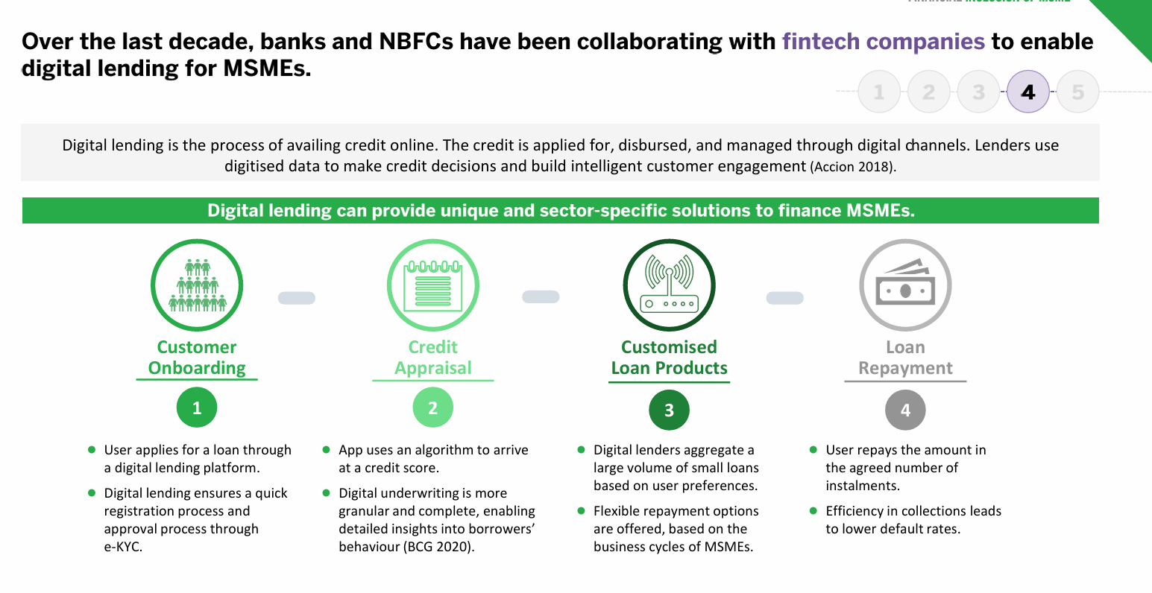
Innovations driven by new-age Fintech / NBFCs and rapid adoption of digital systems/ automation in processes by banks and other Financial Intermediaries are improving the flow of credit to the MSME sector. For example, leveraging analytics and various digital data points spread across a company's operations, such as credit scores of MSMEs by Credit Bureaus, Goods and Services Tax (GST) returns, Income Tax returns, transaction data from UPI/ POS terminals, sales via e-commerce platforms, etc., a 360-degree view of a MSME borrowers is achievable.
Additionally, due to advanced data analytics supported using AI/ ML and the digital pathways mentioned above, financial institutions are moving to scorecard-based risk assessment of MSME borrowers enabling objectivity and increasing the efficiency of lending to the MSME sector. Such an approach has sparked renewed interest in lending to the MSME segment, which has traditionally been viewed as risky by lenders.
GST returns offer rich data and can be instrumental in bridging the information asymmetry for the MSME sector. Data analytics for cashflow assessment of MSMEs basis GST has enabled quick turnaround of loans for MSMEs.
Another advantage of the fast-growing digital lending landscape is the extension of financial products via non-financial platforms i.e., embedded finance. Big tech/ large e-commerce platforms can analyse the inventory, receivables etc., to extend finance to small businesses through lending partners. It is estimated that embedded banking for SMEs could capture up to 26% of global SME banking revenue by 2025. Also, embedded finance options have the potential to push up sales/ revenue of businesses including MSMEs.
The support provided by GOI to the Indian startup ecosystem has positioned India as the third largest startup ecosystem in the world, behind USA and China. GOI initiatives such as Fund of Funds for Startups (FFS) of DPIIT, Self-Reliant India Fund, Startup India Seed Fund Scheme, Credit Guarantee Scheme for Startups etc., have led to the flourishing of startup ecosystem.

SIDBI’S DIGITAL INTERVENTION:
SIDBI has been a leader in developing several digital interventions/ platforms for facilitating finance and other services for the MSME sector. Initiatives such as Standup India Portal, Udyamimitra Portal, ‘PSBLoansin59minutes’ and TReDS platform, facilitate credit and handholding support to various sections of the MSME sector. In recent past, SIDBI has pivoted towards digital lending and is repositioning itself to become a leader in tech-driven solutions for the MSME sector.SIDBI has delivered several digital interventions aimed at the diverse needs of the MSME ecosystem. Few of these recent digital initiatives are-

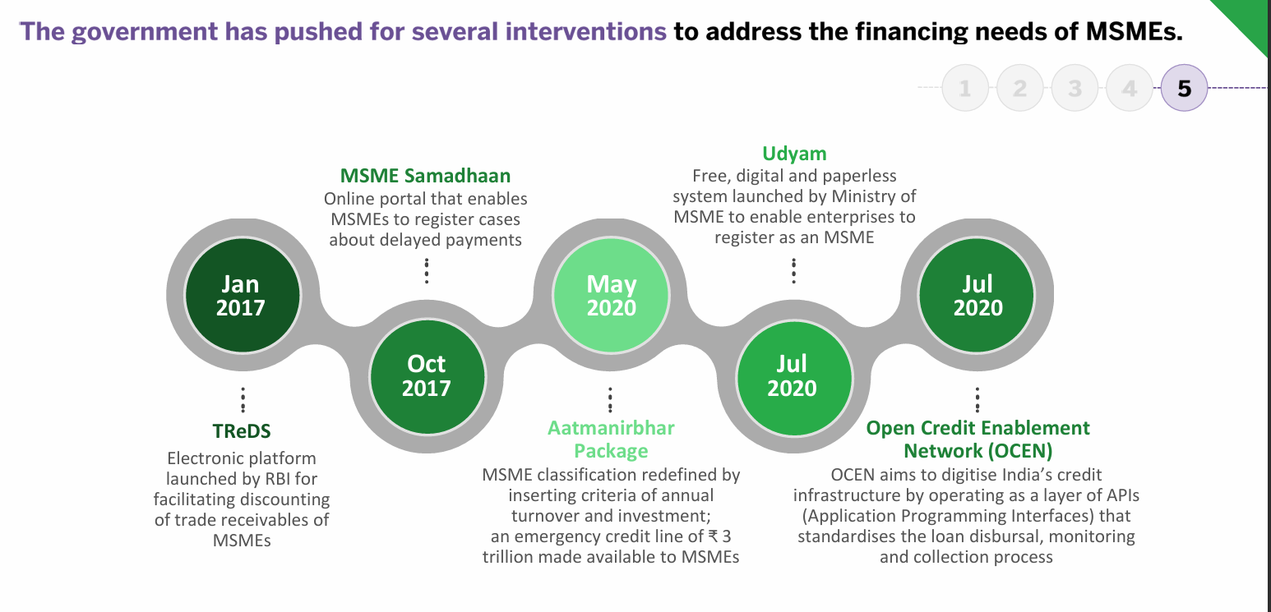

Formalisation of Informal Micro Enterprises (IMEs) through Udyam Assist Platform (UAP): The aspirations of enhancing MSME contribution to GDP and exports necessitates integration of micro/ informal entities with formal channels that can be achieved through digitalisation. In a bid to enable formalisation of the high informality present in the MSME sector, MoMSME and SIDBI launched the Uydam Assist Platform to enable formalisation of Informal Micro Entities (IMEs) and establish credit & market connect for such enterprises. IMEs with an Udyam Assist Certificate shall be treated as Micro Enterprises under MSME for the purposes of PSL classification.
Formalisation of informal sector is expected to bring them within the reach of various Government schemes and interventions including increased access to credit. The platform has already facilitated registration of over 1.85 crore IMEs. Formalisation project would have multiplier effect on IMEs resulting in exponential growth of these IMEs and much higher contribution towards national GDP.
GST Sahay:
SIDBI launched a reference GST Sahay App using Open Credit Enhancement Network (OCEN) and Account Aggregator (AA) frameworks. The app facilitates ‘on tap’ invoice-based (cash flow based) small value credit to micro enterprises as a paperless journey from origination to repayment using trade data from GSTN, bank information through AA, Credit bureau status, e-sign, e-stamping, e-NACH, etc. During the year, the overall progress under GST Sahay program has been encouraging, recording good traction with sanction of credit limits aggregating `600 crore to more than 1,750+ customers, disbursement of `315 crore with number of invoices financed exceeding 15,000+. Over 250+ JAKs and 52 FPSs have been sanctioned the facility for financing their purchases from PMBI and B2B platform respectively.
• Further, the Bank introduced a digital business loan product (`25 lakh) to cater to the diverse financial requirements of enterprises. This product, built leveraging GST Sahay infrastructure, can be easily accessed through a mobile app or website, and harnesses the power of technology to ensure a seamless, paperless, and efficient loan approval process. The business loan product streamlines the entire digital loan processing journey, from application submission to loan approval, resulting in reduced turnaround time and improved customer convenience.
TReDS:
• SIDBI has been operating through 3 TReDS platforms i.e. RXIL, M1xchange & Invoice Mart. SIDBI is amongst the Top 7 financiers among 73 Financiers on RXIL platform. The number of buyers limits also increased to 138 in FY2025 compared to 62 in the previous year. The digital lending portfolio i.e., GST Sahay and TReDS registered a year-on-year growth of 52% with outstanding as at end of FY2025 at `2,170 crore.

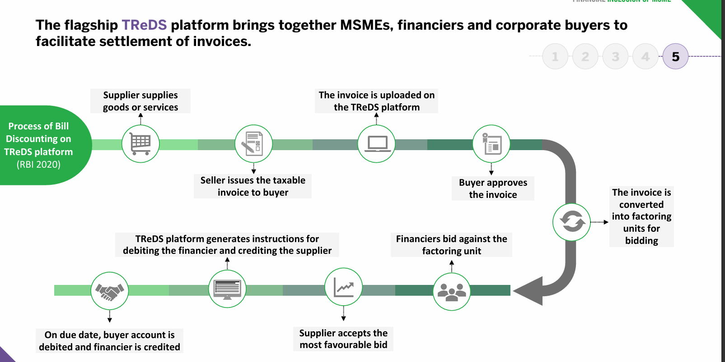

FIT (Finance, Income and Trade) Rank:
Under the mentorship of SIDBI, CIBIL along with Online PSB Loans Limited (OPL), have launched FIT rank leveraging the power of GST, Bank Statements, and Income Tax returns (ITR) information to provide a ranking model for MSME lending. The ranking model uses machine learning algorithms to arrive at probability of an MSME becoming a non-performing asset (NPA) in the next 12 months based on

its financial, income, and trade data on a scale of 1 to 10 with FIT Rank 1 for the least risky MSME and FIT Rank 10 for the most at-risk MSME.
Each FIT rank corresponds to a Probability of Default (PD) and the higher the FIT Rank, the lower is the PD associated with the MSME. Under the scope of the initiative, the Bank had launched a new product viz. “EXPRESS” to cater to the machinery/ equipment finance requirements of MSMEs. The product framework envisages automated evaluation based on FIT score /CIBIL MSME Rank (CMR) & JOCATA composite index of the entity and CIBIL credit vision score of promoters.
MSME Samadhan:
MSMESamadhan is an initiative by the Ministry of Micro, Small and Medium Enterprises (MSME) in India aimed at addressing delayed payments to micro and small enterprises (MSEs).It allows MSEs to file complaints against buyers for delayed payments through an online portal, facilitating a structured mechanism for resolution. The initiative is governed by the Micro and Small Enterprise Facilitation Council (MSEFC), which resolves disputes and ensures timely payment recovery. MSE s can file complaints if they have a valid Udyog Aadhaar number and if the buyer fails to pay within 45 days of accepting goods or services, they are liable to pay a compound fine,the portal provides transparency and accountability, ensuring that MSMEs can hold buyers accountable for overdue payments.This initiative is crucial for the sustainability and growth of MSMEs, as timely payments are essential for their cash flow and operational stability.
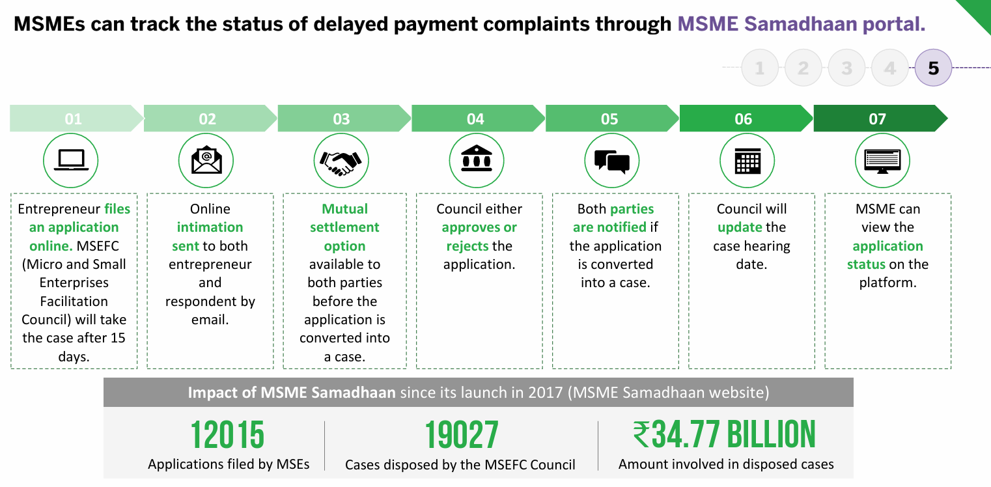
GOVERNMENT SCHEMES TO BOOST UP MSME

PRADHAN MANTRI MUDRA YOJANA(PMMY):
The Pradhan Mantri MUDRA Yojana was launched in April 2015 with the objective of providing financial support to the non-corporate, non-farm small and micro enterprises. This scheme aimed to formalize the informal sector by offering collateral-free loan up to 10 lakh to micro entrepreneur, thus promoting self employment and job creation. MUDRA loans are classified under three categories based on the stage of the business: Shishu (up to ₹50,000), Kishore (₹50,001 to ₹5 lakh), and Tarun (₹5 lakh to ₹10 lakh). These tiered structure ensure that the financial support is tailored to suit the specific need of enterprises at different growth stages.
Table: PMMY performance data (2015-2025)
YEAR | DISBURSMENT (Rs lakh crore) | NO. OF LOANS(Crores)
2015 | 1.22 | 3.48
2020 | 9.27 | 25.60
2025 | 32.36 | 51.41
Source: Mudra Annual Report 2025
The above table shows that under PMMY scheme number of loan increased from 3.48 crores to 51.41 crores and total loan disbursement increased from Rs 1.22 lakh crores to Rs.32.36 lakh crores from 2015 to 2025.
PRIME MINISTER’S EMPLOYMENT GENERATION PROGRAM(PMEGP):
The Prime Minister’s Employment Generation Programme (PMEGP) is a flagship credit-linked subsidy scheme designed to create self-employment opportunities by supporting micro-enterprises in India. It is implemented nationally by the Khadi and Village Industries Commission (KVIC) and at the state level by KVIBs, District Industries Centres (DICs), and banks.
Financial Inclusion through PMEGP:
Aspect of Financial Inclusion | How PMEGP Helps
Access to Formal Credit | Provides collateral-free loans through banks, backed by government subsidy
Reduced Entry Barriers | Margin money subsidy (15–35%) lowers repayment burden, making loans affordable.
Support for Marginalized Groups | Higher subsidies for SC/ST, women, ex-servicemen, and differently-abled entrepreneurs ensure equitable access.
Beneficiary Contribution | Only 5–10% of project cost required upfront, easing financial entry for first-time entrepreneurs.
Digital Integration | Online PMEGP portal ensures transparent applications, linking MSMEs to formal banking and digital systems.
Skill Development | Mandatory Entrepreneurship Development Program (EDP) training equips entrepreneurs to manage finances effectively
Employment Creation | By funding micro-enterprises, PMEGP generates local jobs, stabilizing income and financial participation.
Formalization of Enterprises | Brings rural and small businesses into the formal economy, enabling access to future credit and government schemes.
Current Loan Disbursement Status (2025) | - June 2025 Update  - Loans Sanctioned: ₹906 crore  - Margin Money Subsidy Released: ₹300 crore  - Beneficiaries: 11,480 service sector entrepreneurs across India  As per official press releases and updates by the Khadi and Village Industries Commission (KVIC),
This table shows that PMEGP doesn’t just provide money—it bridges the gap between informal entrepreneurs and the formal financial system, ensuring MSMEs are included in India’s banking, subsidy, and digital economy.
CREDIT GUARANTEE FUND TRUST FOR MICRO AND SMALL ENTERPRISES (CGTMSE):
The Credit Guarantee Fund Trust for Micro and Small Enterprises (CGTMSE) is India’s flagship scheme that provides collateral-free credit to MSMEs by offering credit guarantees to banks and financial institutions. It was launched in 2000 and remains a cornerstone of MSME financial inclusion.

Feature | Details
Scheme Type | Credit guarantee for collateral-free loans
Implemented By | Ministry of MSME & SIDBI
Beneficiaries | Micro and small enterprises (manufacturing & services)
Loan Limit | Up to ₹2 crore
Guarantee Coverage | 50–85% depending on loan size & category
Eligible Institutions | Banks, RRBs, NBFCs, small finance bank
Guarantee Fee | 0.75%–1.0% of sanctioned credit
Recent Update (2025) | Higher coverage, lower defaults, digital claim settlement
Current Status of CGTMSE (up to 2025) | - Total Guarantees Approved: 1.65 crore+  - Total Loan Amount Covered: ₹8.6 lakh crore+  • Budget 2025 expansion  - Guarantee limit for MSMEs doubled from ₹5 crore to ₹10 crore.  - Startups’ guarantee cover doubled from ₹10 crore to ₹20 crore.  - Exporter MSMEs can now access term loan cover up to ₹20 crore.  - Digital Dashboard: State-wise guarantee data is available on the MSME DASHBOARD

CGTMSE has become one of the largest credit guarantee programs in the world, ensuring millions of MSMEs get collateral-free loans and are financially included.
ATMANIRBHAR BHARAT ABHIYAN:
The Atmanirbhar Bharat Abhiyan was introduced by the Indian Prime Minister, Mr. Narendra Modi, to help the country recover from the economic impact of the Coronavirus pandemic by promoting self-reliance. Formally launched on May 12, 2020, the scheme's goal is to turn a crisis into an opportunity by reducing reliance on imports and promoting quality indigenous products. It doesn't promote isolation but aligns with India's cultural values, encapsulated in the phrase "Vasudhaiva Kutumbakam," which means the whole world is one family, drawn from Maha Upanishad. This self-reliance initiative is built on five key pillars: Economy, Infrastructure, Our System, Demography. The First Tranche of the Atmanirbhar Bharat was announced on 13th May 2020 with the primary focus on the Micro, Small and Medium Enterprises sector. It covers the following initiatives –

- Revised definition of MSME.
- Promote e-market linkage of MSMEs
- Providing Emergency Working Capital Facility of up to Rs 25 crore outstanding and turnover of up to Rs 100 crore.
- Debt restructuring of two lakh MSMEs
- Equity infusion via MSME Fund of Fund
- Release MSME receivables from Government and CPSEs.
- No new global tenders for government procurement up to Rs. 200 crores by changing General Financial Rules (GFR).
RAISING AND ACCELERATING MSME PERFORMANCE (RAMP) :
The World Bank supported Central Sector Scheme “Raising and Accelerating MSME Performance” (RAMP) was launched by the Hon’ble Prime Minister on 30thJune 2022. RAMP is being implemented by the Ministry of Micro, Small and Medium Enterprises (MOMSME)over the five-year period 2022-23 to 2026-27
.
 | DETAILS
Launch | June 2022 by Government of India, supported by World Bank
Budget | ASPECT
Objectives | Strengthen MSME ecosystem, accelerate growth, improve access to finance, markets, and technology
Key focus area | -Technology upgradation  -Receivable financing (TReDS)  -Credit guarantees (CGTMSE)  -Green MSMEs  - Women-owned enterprises
Sub schemes | - MSE SPICE: Circular economy promotion  - MSE GIFT: Green investment & financing  - TEAM Initiative: Trade enablement & marketing
Implementation | Centre–State collaboration to align policies and schemes
Expected Impact | Boost MSME competitiveness  - Expand financial inclusion  - Encourage sustainability  - Support women entrepreneurs  - Strengthen resilience in global value chains

The RAMP Programme is in its mid-phase (2022–27), actively funding MSME initiatives across India, with states preparing and implementing Strategic Investment Plans (SIPs) to align local MSME development with national goa
.
CHALLENGES AND RECOMMENDATION
I.Access to Finance:
Access to finance remains a critical challenge for MSMEs, as many financial institutions perceive them as high-risk ventures due to inadequate credit history or business records. The role of financial institutions in addressing this issue involves:
- Tailored Loan Products: Financial institutions need to offer customized financing options, such as working capital loans, invoice discounting, and equipment financing, which cater specifically to the MSME sector.
- Alternative Financing Models: The emergence of fintech has opened new avenues like peer-to-peer (P2P) lending, crowd funding, and supply chain financing, which provide easier access to capital.
- Government Schemes: Various government schemes like MUDRA loans, Credit Guarantee Scheme, and Stand-Up India are designed to facilitate easy access to finance for MSMEs, but these need better implementation and outreach.

II. Delayed Payments
Delayed payments from large corporations and government bodies create severe cash flow issues for MSMEs, often leading to bankruptcy or insolvency. The financial sector can help by:
- Invoice Financing: Financial institutions can provide financing against pending invoices, allowing MSMEs to receive funds before payments are received from clients.
- Promoting Digital Payments: Encouraging digital payment systems can reduce delays by ensuring faster transaction settlements, thus improving cash flow for MSMEs.
- Legal Frameworks: Strengthening legal mechanisms like the MSME Development Act and enforcing penalties for delayed payments can improve payment timelines and protect MSME interests.

III. Infrastructure Bottlenecks
The lack of proper infrastructure hampers the growth of MSMEs. Financial institutions can help by:
- Financing Infrastructure Projects: Banks can provide loans to MSMEs for upgrading infrastructure, purchasing machinery, and expanding facilities.
- Public-Private Partnerships: The financial sector can play a role in facilitating collaborations between private players and government bodies to improve infrastructure, such as roads, power supply, and communication networks.

IV. Requirements of Compliance
MSMEs are required to comply with various regulatory, tax, and labour laws. Financial institutions can assist in this area by:
1.Offering Compliance Products: Providing compliance-related products such as accounting software or advisory services can help MSMEs navigate legal complexities.
2.Simplifying Documentation: Financial institutions can work with regulatory authorities to streamline documentation processes, making it easier for MSMEs to access financing without the burden of cumbersome paperwork

FINDINGS:
1. Financial Inclusion plays a significant role in MSMEs growth: Access to financial services such as credit, savings, insurance and digital payments helps MSMEs to expand their business operations and improve productivity.
2. MSMEs are a key contributor to the Indian economy: The sector contributes around 30% of India’s GDP and more than 45% of exports and generates large employment opportunities, especially in rural and semi urban areas.
3. Credit flow to MSMEs has increased significantly: Lending by Scheduled Commercial banks to MSMEs has shown steady growth , reaching Rs.31.3 lakh crore in FY 2025,indicating improved financial access and stronger demand for credit.
4. Digital Financial Services have improved credit accessibility: Digital platforms like India Stack, fintech lending, GST based data, AI based credit scoring and digital loan processing systems have made financing faster, more transparent and more efficient for MSMEs. Estimates suggest that India's digital lending market was worth $270 billion in 2022 and the Indian Fintech market is expected to reach $1 trillion in Assets Under Management by 2030.Another advantage of the fast-growing digital lending landscape is the extension of financial products via non-financial platforms i.e., embedded finance. It is estimated that embedded banking for SMEs could capture up to 26% of global SME banking revenue by 2025. Also, embedded finance options have the potential to push up sales/ revenue of businesses including MSMEs.
5. SIDBI plays a crucial role in MSME financing: Through direct lending, refinance schemes and digital platforms such as StandUp India Portal, Udyamimitra Portal, ‘PSBLoansin59minutes’ and TReDS platform, GST Sahay, SIDBI has expanded credit outreach to millions of MSMEs across India.
6. Government schemes have strengthened financial inclusions: Programs such as Pradhan Mantri Mudra Yojona (PMMY), Prime Minister Employment Generation Program (PMEGP), Credit Guarantee Fund Trust for Micro And Small Enterprises (CGTMSE),Atmanirbhar Bharat Initiatives, Raising and Accelerating MSME Performance (RAMP) have improved access to collateral free loans and financial support for MSMEs.
finance options have the potential to push up sales/ revenue of businesses including MSMEs.
7. Despite progress MSMEs still face several financial challenges: Issues like limited credit history, complex documentation, delayed payments, infrastructure gaps and lack of financial awareness continue to restrict financial inclusion.

CONCLUSION

The policy initiatives from the Government will continue to provide support and facilitate a sustainable growth of the Indian MSME sector. The investment and turnover limits for classification of all MSME categories – micro, small and medium, have been enhanced to 2.5 and 2 times respectively, to help them achieve higher efficiencies of scale, get better access to capital and support employment generation. The credit guarantee covers for various categories of MSME borrowers including startups and exporters, have been gradually enhanced to bridge the existing credit gap. Further, in the Union Budget 2025-26, specific policy and facilitation measures for labour-intensive sectors such as footwear and leather, toys and food processing have been proposed. Apart from the traditional sectors, a boost is also being given to the startups in the newer technologies through the announcement of a new fund of funds of `10,000 crore. The outlook for Indian MSMEs remains favourable despite global headwinds supported by strong macroeconomic fundamentals, improving domestic consumption demand, emerging export opportunities through bilateral trade agreements with developed economies, accelerating credit f low and consistent policy support from the Government. The MSMEs, on their part, need to improve their competitiveness and productivity at a global level. That would require embracing digitalisation in all spheres, upgrading technologies to ensure quality improvement, undertaking sustainability initiatives, encouraging innovation, adopting financial discipline and importantly, building a culture of governance and transparency. Clearly, MSMEs are well poised to emerge as the growth drivers in achieving the vision of ‘Viksit Bharat@2047’
Access to credit is critical for the growth and sustainability of MSMEs. Some of the common challenges faced by MSMEs in accessing formal credit include information asymmetry, excess documentation and lack of transparency. To address these challenges, the following instructions were issued to banks on June 11, 2024: a) Scheduled commercial banks (SCBs) have been advised to have a uniform turnaround time (TAT) of 14 days for loans up to ₹25 lakh for micro and small enterprises (MSE) borrowers to ensure faster disposal of such loan applications, and clearly display all credit related information under a separate tab on their websites. b) It was reiterated to banks to implement a credit proposal tracking system (CPTS) and inform the MSME borrowers in writing, the main reason/s of rejection of loan applications, furnish them with an indicative checklist of documents required at the time of loan application, and display the pendency position of loan applications on their websites. c) The guidelines on cluster financing were reviewed to provide a clear definition of clusters and address their credit needs. MSE clusters have now been defined as those identified by the Ministry of MSME, Government of India and state governments. Lead banks are required 102 CREDIT DELIVERY AND FINANCIAL INCLUSION to promote credit linkage in all clusters in their districts directly/with other banks, to create awareness among the MSE units and incorporate the credit needs of clusters in the branch/block level credit plans.

Scope for Further Research
1.Future research can be conducted using primary data collected directly from MSME owners to understand their real experiences with financial inclusion, access to credit, and digital financial services.
2. Further studies may focus on specific states or regions in India to compare the level of financial inclusion and its impact on MSME development in different geographical areas.
3. Researchers can examine in detail how fintech platforms, digital lending, mobile banking, and digital payment systems influence MSME performance and financial accessibility.
4. Further research may explore how financial literacy and awareness programs influence the adoption of formal financial services among MSME entrepreneurs.
5.Detailed evaluation of specific government schemes supporting MSMEs can be conducted to measure their effectiveness and identify areas for improvement.

REFERENCE:

1.Gaurav Kumar Saxena, 2023, Financial Inclusion And The Growth Of Micro And Small Businesses, Management Journal for Advanced Research ISSN (Online): 2583 1747, Volume-3 Issue-3, June 2023 PP. 23 27. DOI: 10.54741/mjar.3.3.4 http://mjar.singhpublication.com 3. Chandra Mohan Malladi1, Rupesh K. Soni1, Sanjay Srinivasan1, 2021, Digital Financial Inclusion: Next Frontiers Challenges And Opportunities, CSIT (June 2021)9(2):127–134, https://doi.org/10.1007/s40012-021-00328-5.
2. Mr. Devaraju N 1*, Dr. Prathap B N 2, Ms. Ashwinee G3 (2025) “A Study on Impact of Financial Inclusion on Development & Growth of MSMEs in India”, JNNCE Journal of Engineering & Management, Special Edition, 04, January-2025, ISSN 2582-0079.
3.Dr. SarikaSrivastava, 2020, Role Of MSME Sector In Indian Economy: A Study With Special Reference To Gujarat, Pacific Business Review International Volume 13, issue 3, September 2020.
4.Ministry of Micro,Small and Medium enterprises,http://msme.gov.in.

