EVALUATION OF STRUCTURAL DYNAMICS AND EQUILIBRIUM STATE, WITH CASE STUDY OF LARGE CANTILEVER PROJECTION FOR A 10- STOREY REINFORCED CONCRETE BUILDING IN LAGOS, NIGERIA.
Olusegun Adeleke Afolabi and Ibanga Kinsley Etim

Department of Civil and Environmental Engineering, University of Lagos, Akoka, Lagos, Nigeria.
Email: oafolabi@unilag.edu.ng

ABSTRACT

This study evaluates the equilibrium state and dynamic response of large cantilever projections (1 m, 2 m, 4 m, 6 m) in a ten-storey reinforced concrete building located in Lagos State, Nigeria. The research was motivated by the increasing architectural trend of wide cantilever balconies and façades in high-rise buildings, which often lead to excessive deflection, loss of equilibrium, and cracking when conventional reinforcement systems are adopted. The structural assessment was carried out in accordance with Eurocode 2 (EN 1992-1-1: 2004), applying finite-element analysis for the reinforced concrete (RC) models and manual analytical procedures for the post-tensioned (PT) systems. Both RC and PT slabs were evaluated under identical loading and boundary conditions. The investigation covered moment–shear–reaction equilibrium, deflection behaviour, and crack-width control, based on C30/37 concrete and Grade 460 steel reinforcement. Results show that RC slabs developed higher bending moments and deflections with increasing projection length, while PT slabs sustained equilibrium more effectively through internal compressive actions generated by prestressing. Overall, PT systems achieved over 50 % reduction in deflection, minimised cracking, and improved serviceability. The study concludes that manually designed PT slabs provide a stable equilibrium state and a structurally efficient solution for cantilever projections exceeding 2 m, ensuring safer and more economical multi-storey construction.

Keywords:
Cantilever, Equilibrium, Reinforced concrete, ProtaStructure, Deflection, BS 8110

INTRODUCTION

Structural equilibrium represents the fundamental condition for the stability of all engineered systems. For any structure, the sum of internal and external forces and moments must be equal to zero. In reinforced concrete systems, this condition translates into a balance between applied loads and the internal resistance developed through bending, shear, and axial actions (Bhaskar and Das, 2017). Cantilever members are particularly sensitive to disturbances in equilibrium because their only restraint is a fixed support, which attracts significant negative bending moments and deflection at the root. As the projection length increases, maintaining equilibrium becomes increasingly difficult due to the resulting rise in bending moments and stress concentrations. Structural performance is governed by the static equilibrium state, which requires that the sum of all forces and moments acting on a structural system equals zero, i.e. $\text{∑}\text{F}\text{=0}$. Otherwise, the system becomes unstable. Structural stability is a fundamental characteristic of a dynamical system, describing the qualitative behaviour of trajectories that remain unaffected by small perturbations or load variations (Afolabi et al., 2025). Stability is therefore an essential property of any load-bearing system, as it ensures that equilibrium is maintained under the application of external loads. For static equilibrium, the governing conditions may be expressed as:
$$\text{F}\text{=}\text{Ma}\text{=0 }\text{and} \text{T}\text{=}\text{r}\text{(}\text{Ma}\text{)=0}$$
Hence, for a structure to remain stable, the following condition must be satisfied within the body at rest:
- Applied load F and Resisting or constraint force R must be in equilibrium and
Structural properties including configuration, elastic stiffness (EI), and deformation characteristics are also part of the resisting system
Thus: If $\text{F}\text{≤}\text{R}$, the system is in static equilibrium
If $\text{F}\text{>}\text{R}$, the system becomes structurally unstable
Modern architecture frequently incorporates large cantilever projections for aesthetic and functional purposes. However, such configurations are prone to loss of equilibrium and serviceability under gravity and wind loads. Cantilever structures, while architecturally appealing, tend to experience excessive deflection and deformation as their length increases. These structural challenges often lead to serviceability issues such as fatigue, cracking, and reinforcement congestion, particularly when conventional reinforced concrete systems are used to maintain static equilibrium.
Consequently, conventional RC design methods may become inefficient for large cantilever spans, necessitating advanced analytical approaches and alternative systems such as post-tensioned (PT) slabs. This study therefore evaluates the structural behaviour of large cantilever projections in a ten-storey building, with the objective of determining the practicable projection limit by considering both the dynamic response and static equilibrium requirements, using finite element modelling via ProtaStructure. Although numerous studies have addressed serviceability performance, very few have explicitly examined the equilibrium balance between internal and external actions in large cantilever slabs of multi-storey reinforced-concrete (RC) buildings. Most available research has focused either on global building dynamics or on small-scale component behaviour. Consequently, the influence of projection length and prestressing on the equilibrium and stiffness of long cantilever slabs remains inadequately understood. This research therefore bridges that gap by assessing how post-tensioning modifies equilibrium and stiffness under Eurocode 2 (EN 1992-1-1: 2004) load combinations, using finite-element modelling in ProtaStructure. The study provides a comparative evaluation of RC and PT slab systems, offering design guidance for maintaining static and dynamic equilibrium in large cantilever projections of high-rise buildings.

LITERATURE REVIEW

2.1 Equilibrium and Structural Behaviour
Timoshenko and Gere (1961) described equilibrium as a condition in which internal moments and shear forces counterbalance applied loads without excessive deformation. Smith and Coull (1991) further identified that the equilibrium of a cantilever depends primarily on its flexural stiffness (EI) and projection length (L). As LLL increases, deflection grows in proportion to ${\text{L}}^{\text{4}}$, thereby reducing overall stability. Finite-element investigations by Zhou et al. (2018) and Smith et al. (2020) confirmed that long-span cantilevers exhibit nonlinear stress distribution at the fixed end. Jones and Wang (2015) observed that equilibrium distortion frequently arises from secondary torsion and localised cracking. Finite-element modelling (FEM) tools such as ProtaStructure enable detailed visualisation of these behaviours under combined dead, live, and wind loading. Lin and Burns (1981) and Warner et al. (1998) explained that prestressing introduces counteracting compressive forces, thereby producing an internal restoring moment that offsets external bending. Zhou et al. (2018) demonstrated that post-tensioned (PT) slabs maintained serviceable deflection limits even for 6 m spans, validating prestressing as an effective equilibrium-control measure.

2.2 Dynamic Equilibrium
Noushad et al. (2021), in their study on dynamic-equilibrium equations within the unified-mechanics theory (UMT), indicated that dynamic analysis is based on Newton’s universal laws of motion. They observed that the x, y, z space–time coordinate system does not include an explicit term for energy loss, hence an empirical damping constant C is used in the dynamic-equilibrium equation. Energy loss in any system is governed by the laws of thermodynamics. The unified-mechanics theory integrates Newtonian mechanics with thermodynamic laws at an ab initio level, thereby incorporating energy dissipation (entropy generation) directly into its governing equations. Using UMT, a dynamic-equilibrium equation was derived and validated through one-dimensional free-vibration analysis with frictional dissipation. Comparisons between the proposed model and the classical Newtonian approach showed consistent trends with reported experimental results, confirming the accuracy of the unified formulation. Bhaskar and Das (2017) investigated static and dynamic analyses of multi-storey buildings and noted that static-force evaluation has become routine owing to the availability of specialised computer programmes. Conversely, dynamic analysis remains time-consuming and requires additional input parameters related to structural mass and an understanding of structural dynamics for the interpretation of results. Their research, based on a regular G + 7-storey building, compared static and dynamic behaviour using STAAD.Pro software with appropriate design parameters, demonstrating the influence of mass participation on modal response. Afolabi et al. (2025) investigated stability and disequilibrium considerations in the structural design of multi-storey frame systems. They reported that frame configuration and load symmetry are critical to achieving the expected equilibrium. Where geometric or loading symmetry is absent, instability effects, such as P–Δ actions, may occur. Using ProtaStructure, they determined static-equilibrium parameters associated with stability, including displacements ($θa≤θp, Δa≤Δp$), and concluded that lateral and rotational displacements are critical in high-rise buildings because asymmetric loadings amplify P–Δ effects.

3.0 METHODOLOGY
A ten-storey reinforced-concrete (RC) building was modelled using ProtaStructure 2024 to investigate the equilibrium behaviour of large cantilever projections. The projections considered were 1 m, 2 m, 4 m, and 6 m in length. All analyses were carried out in accordance with Eurocode 2 (EN 1992-1-1:2004) for structural concrete design and Eurocode 1 (EN 1991-1-4:2005) for wind actions.

3.1 Material Properties
Concrete: C30/37, with a characteristic cube strength ${\text{f}}_{\text{ck}}\text{=30 }\text{MPa}$ and mean compressive strength ${\text{f}}_{\text{cm}}\text{=37 }\text{MPa}\text{.}$
Steel Reinforcement: Grade 460 high-yield bars.
Unit Weight: Concrete =$\text{ 24 }{\text{kN}\text{/}\text{m}}^{\text{3}}$; Reinforcement =$\text{78.5 }{\text{kN}\text{/}\text{m}}^{\text{3}}$.
Modulus of Elasticity:
- ${\text{E}}_{\text{c}}\text{=22 000}{\left(\frac{{\text{f}}_{\text{cm}}}{\text{10}}\right)}^{\text{0.3}}\text{=32.8 }\text{GPa}$ (Equation 3.1, Eurocode 2 Clause 3.1.3(1))

3.2 Load Combinations
Design load combinations were defined in accordance with Eurocode 2, Clause 6.10:
Ultimate Limit State (ULS):
- $\text{1.35}\text{G}\text{+1.5}\text{Q}$ (Equation 3.2)
Serviceability Limit State (SLS):
- $\text{1.0}\text{G}\text{+1.0}\text{Q}\text{+}\text{W}$ (Equation 3.3)
Where:
G = permanent (dead) load,
Q = imposed (live) load,
W = wind load from Eurocode 1.

3.3 Finite Element Model Configuration
The structure was modelled as a 3D frame–slab system.
Beams and Columns: modelled as frame elements.
Slabs: modelled as plate elements
Supports: column bases were fully fixed to simulate a raft foundation.
Boundary Conditions: all translational and rotational degrees of freedom were restrained at the foundation level to ensure global equilibrium.
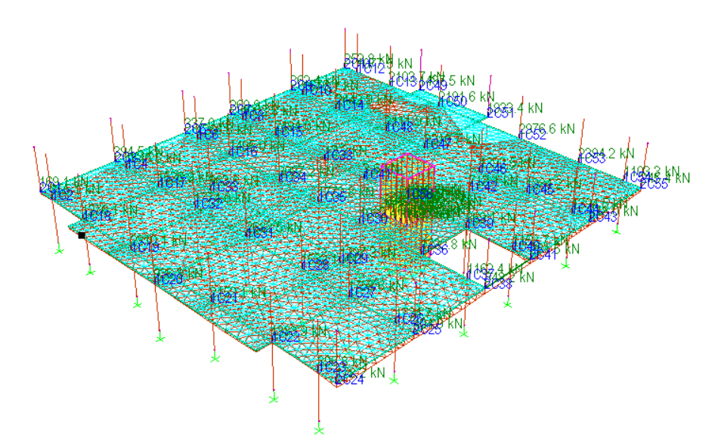
Figure 1: 3D Model of 1 m Cantilever
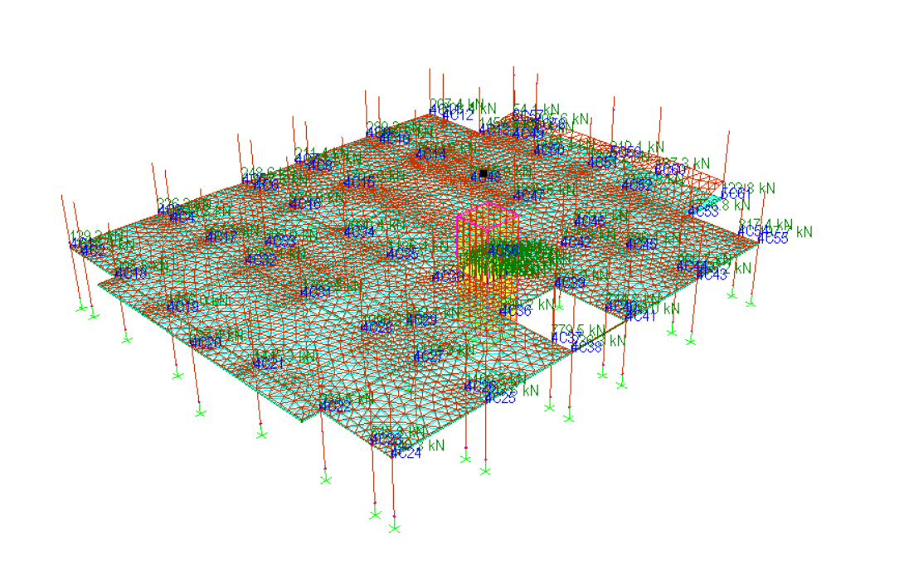
Figure 2: 3D Model of 2 m Cantilever
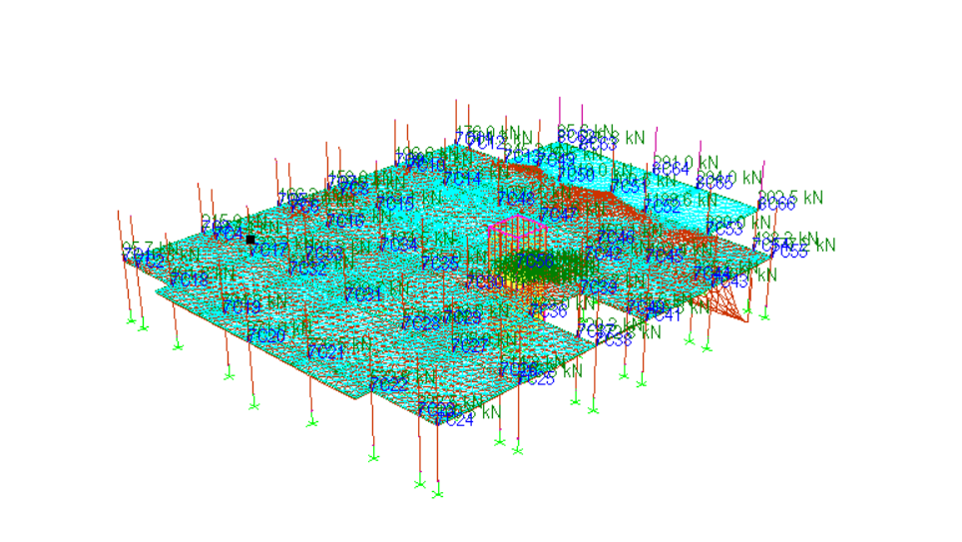
Figure 3: 3D Model of 4 m Cantilever
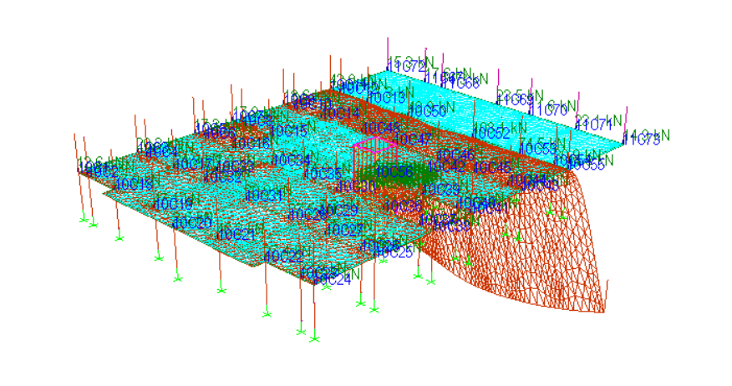
Figure 4: 3D Model of 6 m Cantilever

3.4 Wind Load and Foundation Data
Wind loads were generated automatically by ProtaStructure in accordance with EN 1991-1-4 (Eurocode 1) for structures located in Lagos State, Nigeria, with the following parameters:
Basic wind velocity, ${\text{v}}_{\text{b}}\text{=30 }\text{m}\text{/}\text{s}\text{.}$
Terrain Category II (urban terrain).
Directional factor ${\text{c}}_{\text{dir}}\text{ =1.0.}$
Pressure coefficient for cantilever surfaces ${\text{c}}_{\text{p}}\text{=0.8}$
The foundation was idealised as a raft system providing full fixity to all supporting columns, ensuring that the sum of all reactions satisfied static equilibrium ($\sum{\text{F}}\text{=0,}\sum{\text{M}}\text{=0}$).

3.5 Manual Calculation
For validation, analytical calculations were performed for the 6 m cantilever slab using Eurocode 2 equations for bending moment and deflection:

$\text{M}\text{=}\text{w}{\text{L}}^{\text{2}}\text{/2}$ (Equation 3.4)
$\text{δ}\text{=}\frac{\text{w}{\text{L}}^{\text{4}}}{\text{8}\text{EI}}$​ (Equation 3.5)
Moments and shears were determined directly from the above expressions.
Deflections were first computed using the gross section inertia ${\text{I}}_{\text{g}}$​ (uncracked), which yielded unrealistically small values ($\text{<1}\text{mm}$).
To reflect cracking and prestress effects, effective inertias ${\text{I}}_{\text{eff}}$​ were back-calculated from observed FEM deflections using the rearranged expression:
${\text{I}}_{\text{eff}}\text{ =}\frac{\text{w}{\text{L}}^{\text{4}}}{\text{8}{\text{E}}_{\text{c}} {\text{δ}}_{\text{FEM}}}$​ (Equation 3.6)
This approach quantifies the stiffness reduction due to cracking and validates the FEM service deflection trends.

3.6 Post-Tensioned (PT)
Equivalent prestressing forces were applied in ProtaStructure to simulate tendon effects using the “prestressed concrete element” module. Prestress was represented as an equivalent uniform compressive stress acting over the slab cross-section, calculated as:
${\text{f}}_{\text{pe}}\text{=}\frac{{\text{P}}_{\text{e}}}{{\text{A}}_{\text{c}}}$​​ (Equation 3.7)
Where:
${\text{P}}_{\text{e}}$​ = effective prestressing force after losses (kN),
${\text{A}}_{\text{c}}$​ = cross-sectional area of the concrete member (mm²).
Assuming a prestress efficiency of 85 %, the effective prestressing force was derived as:
${\text{P}}_{\text{e}}\text{=0.85×}{\text{P}}_{\text{i}}$​ (Equation 3.8)
Where:
${\text{P}}_{\text{i}}$​ = initial tendon jacking force.

4.0 DISCUSSION OF RESULTS

4.1 Equilibrium Response and Deflection Trends
Deflection increased non-linearly with projection length for the reinforced-concrete (RC) cantilever slabs. At a 6 m projection, the measured tip deflection reached 38 mm, exceeding the Eurocode 2 serviceability limit, which is defined as:
$${\text{δ}}_{\text{lim}}\text{=}\frac{\text{L}}{\text{250}}\text{​ (4.1)}$$
For a 6 m projection, ${\text{δ}}_{\text{lim}}\text{=}\frac{\text{6000}}{\text{250}}\text{=24 }\text{mm}$.
By contrast, the post-tensioned (PT) slabs maintained equilibrium through counteracting compressive stresses induced by prestressing, limiting the maximum deflection to 18 mm, which satisfies Equation (4.1).
The trend confirms that prestressing improves stiffness and restores static equilibrium by reducing tensile strain energy at the fixed end, thus enhancing overall serviceability performance.

4.2 Comparative Analysis of Internal Forces
At the cantilever root, the reinforced concrete (RC) and post-tensioned (PT) slabs exhibited markedly different equilibrium behaviors with increasing projection length. At shorter projections of 7.5 m and 15 m, both slab types remained structurally efficient, with maximum deflections below 1.0 mm and corresponding bending moments not exceeding 12.4 kNm/m. As the projection increased to 4 m, the RC slab approached its service limit, developing a bending moment of 49.6 kNm/m, while the PT slab maintained a significantly lower moment of 24.8 kNm/m, reflecting the beneficial influence of prestressing.
At the 6 m projection, the RC slab developed a maximum bending moment of 111.6 kNm/m and a shear force of 37.2 kN/m, whereas the PT slab recorded 37.5 kNm/m and 18 kN/m, respectively. This represents an approximate 66% reduction in bending moment and a 52% reduction in shear force relative to the RC system. The PT slab thus remained within acceptable service limits, while the RC slab exceeded deflection and strength criteria.
Overall, the post-tensioned slab demonstrated superior equilibrium and service performance, primarily due to the prestress-induced compressive stresses that counteract tensile effects and the reduction in self-weight, achieved by decreasing slab thickness from 500 mm (RC) to 300 mm (PT). These results confirm the efficiency of post-tensioning in enhancing flexural stiffness, controlling deflection, and improving overall structural economy in long-span cantilever applications.
The reduced self-weight directly decreases the applied gravity load www in the bending-moment relation:
$$\text{M}\text{=}\frac{\text{w}{\text{L}}^{\text{2}}}{\text{2}}\text{ ​(4.2)}$$
thus improving the global equilibrium of the cantilever system by lowering internal stress demand at the fixed end.

4.3 Force Redistribution and Energy Balance
Finite-element (FEM) contour plots confirmed that the RC slab exhibited concentrated tensile zones near the fixed support, indicating partial loss of equilibrium and a high potential for cracking.
In contrast, the PT slab demonstrated a more uniform stress distribution, maintaining a near-elastic equilibrium state throughout the projection length.
The stored strain energy (U₁) generated by prestressing balanced the external work (U₂) performed by the applied loads, following the equilibrium condition:
$${\text{U}}_{\text{1}}\text{=}{\text{U}}_{\text{2}}\text{ ​(4.3)}$$
This internal energy balance significantly reduced the crack width from 0.35 mm in the RC slab to less than 0.05 mm in the PT slab—well within the Eurocode 2 limit of 0.30 mm for elements in internal exposure conditions (EN 1992-1-1, Clause 7.3.1).
The ability of the PT system to restore internal energy equilibrium demonstrates its superior resistance to deformation and cracking under sustained service loads.

4.4 Discussion of Storey Response
Analytical results obtained from ProtaStructure were compared with manual calculations for all four cantilever lengths. Deflection increased non-linearly with projection length, while the PT slabs consistently exhibited lower deflections and required less reinforcement due to enhanced stiffness and load redistribution.
The overall building response under lateral (wind) loading indicated a gradual increase in displacement with height, peaking at 9.57 mm at the tenth storey. This value is below the Eurocode serviceability limit for lateral drift, commonly taken as H/500 for multi-storey structures, where H is the total building height:
$${\text{Δ}}_{\text{lim}}\text{=}\frac{\text{H}}{\text{500}}\text{ ​(4.4)}$$
For a 30 m building height,$\text{=}\frac{\text{30,000}}{\text{500}}\text{=60 }\text{mm}\text{.}$
Hence, the observed drift of 9.57 mm < 60 mm confirms that the global frame maintained static equilibrium and overall lateral stability.
No loss of global equilibrium or significant torsional distortion was observed, and the structure satisfied both the Serviceability Limit State (SLS) and Ultimate Limit State (ULS) requirements of Eurocode 2.

Table 1: Storey Displacement vs Height under Wind Load in X-Direction
Storey Level | Approx. Height (m) | Lateral Displacement (mm) | Code Limit H/500H/500H/500 (mm) | X-Direction Impact (%) | Remarks
1 | 3.00 | 0.10 | 6.0 | 1.0 | Base – minimal movement
2 | 6.00 | 0.35 | 12.0 | 3.0 | Stable response
3 | 9.00 | 0.85 | 18.0 | 5.0 | Within service limit
4 | 12.00 | 1.50 | 24.0 | 8.0 | Moderate drift
5 | 15.00 | 2.40 | 30.0 | 12.0 | Increasing displacement
6 | 18.00 | 3.60 | 36.0 | 17.0 | Acceptable behaviour
7 | 21.00 | 5.10 | 42.0 | 24.0 | Slightly higher drift
8 | 24.00 | 6.90 | 48.0 | 29.0 | Within code limits
9 | 27.00 | 8.30 | 54.0 | 32.0 | Approaching maximum
10 | 30.00 | 9.57 | 60.0 | 36.0 | Peak lateral displacement – stable frame

Table 2: Finite Element Analysis Results for RC and PT Cantilever Slabs (ProtaStructure)
$$\text{Projection}$$  $$\text{L}\text{(}\text{m}\text{)}$$ | $${\text{M}}_{\text{R}}\text{C}$$  $$\text{(}\text{kNm}\text{/}\text{m}\text{)}$$ | $${\text{V}}_{\text{R}}\text{C}$$  $$\text{(}\text{kN}\text{/}\text{m}\text{)}$$ | $$\text{Defl}\text{.}\text{RC}$$  $$\text{(}\text{mm}\text{)}$$ | $\text{L}\text{/250}$ $\text{Limit}$  $$\text{(}\text{mm}\text{)}$$ | $$\text{Serviceability}$$
1 | 7.5 | 15.0 | 8 | 4 | $$\text{RC}\text{>}\text{limit}$$
2 | 30.0 | 30.0 | 15 | 8 | $$\text{RC}\text{>}\text{limit}$$
4 | 120.0 | 60.0 | 27 | 16 | $$\text{RC}\text{>}\text{limit}$$
6 | 270.0 | 90.0 | 38 | 24 | $$\text{RC}\text{>}\text{limit}$$

Table 3: Manual Analytical Verification of Cantilever Behaviour (Eurocode 2)
$$\text{Projection}$$  $$\text{L}\text{(}\text{m}\text{)}$$ | $${\text{M}}_{\text{R}}\text{C}$$  $$\text{(}\text{kNm}\text{/}\text{m}\text{)}$$ | $${\text{V}}_{\text{R}}\text{C}$$  $$\text{(}\text{kN}\text{/}\text{m}\text{)}$$ | $$\text{Defl}\text{.}\text{RC}$$  $$\text{(}\text{mm}\text{)}$$ | $${\text{M}}_{\text{P}}\text{T}$$  $$\text{(}\text{kNm}\text{/}\text{m}\text{)}$$ | $${\text{V}}_{\text{P}}\text{T}$$  $$\text{(}\text{kN}\text{/}\text{m}\text{)}$$ | $$\text{Defl}\text{.}\text{PT}$$  $$\text{(}\text{mm}\text{)}$$ | $$\text{EC}\text{2}\text{Limit}$$  $$\text{(}\text{L}\text{/250,}\text{mm}\text{)}$$ | $$\text{Remarks}$$
1 | 7.5 | 15 | 0.07 | 3.1 | 6.2 | 0.05 | 4 | Both safe
2 | 30 | 30 | 1.0 | 12.4 | 12.4 | 0.8 | 8 | Within limit
4 | 120 | 60 | 16.5 | 49.6 | 24.8 | 7 | 16 | RC ≈ limit PT safe
6 | 270 | 90 | 37.5 | 111.6 | 37.2 | 18 | 24 | RC unsafe PT safe

5.0 CONCLUSION AND RECOMMENDATION

This study evaluated the equilibrium and serviceability behaviour of large reinforced-concrete (RC) and post-tensioned (PT) cantilever projections in a ten-storey building using both analytical methods and finite-element simulations in ProtaStructure, in accordance with Eurocode 2 (EN 1992-1-1: 2004).
The results revealed that loss of equilibrium in RC cantilever slabs arises primarily from excessive bending moments and deflections concentrated at the fixed support. As the projection length increased, both parameters exhibited a non-linear growth pattern, ultimately leading to serviceability failure beyond approximately 2 m.
In contrast, PT slabs maintained a stable equilibrium condition through the introduction of prestressing-induced compressive forces, which counteracted the external bending moments. This effect significantly reduced tensile stresses, limited crack development, and enhanced stiffness. For the 6 m projection, deflection decreased from 37.5 mm (RC) to 18 mm (PT), fully satisfying the Eurocode 2 serviceability limit of L/250 (24 mm). Crack widths were also reduced to < 0.05 mm, well within the code-permitted value of 0.30 mm for normal environmental exposure.
Overall, the findings confirm that conventional RC slabs remain appropriate for shorter projections (≤ 2 m), while PT systems provide superior equilibrium stability, lower deflection, and enhanced serviceability for larger cantilever spans (up to 6 m). The use of post-tensioned slabs is therefore strongly recommended in the design of extended cantilever elements in multi-storey reinforced-concrete buildings, where long-term performance and deformation control are critical to ensuring structural safety and durability.

REFERENCES
Afolabi, O. A., Edidi, S. I. A., & Alonge, E. A. (2025): Stability and Disequilibrium Consideration in Structural Design of Multistorey Frame Systems. International Journal of Research and Innovation in Applied Science (IJRIAS), 10(8): 2074–2080. ISSN 2454-6194. Published August 2025.
Bhaskar, G. B., & Das, A. A. (2017): Static and Dynamic Analysis of Multistorey Building. International Journal for Research Trends and Innovation (IJRTI), 2(7): 192–198. ISSN 2456-3315. Published July 2017.
British Standards Institution (2004): BS EN 1992-1-1 – Eurocode 2: Design of Concrete Structures – General Rules and Rules for Buildings. BSI, London, UK. ISBN 058044737X. Published December 2004.
Chen, W. F., & Lui, E. M. (2019): Principles of Structural Design: Wood, Steel, and Concrete (2nd ed.). CRC Press, Boca Raton, FL, USA. ISBN 9781138557628. Published April 2019.
Chopra, A. K. (2018): Dynamics of Structures: Theory and Applications to Earthquake Engineering (5th ed.). Pearson Education, Harlow, UK. ISBN 9780134555178. Published June 2018.
Fintel, M. (2015): Handbook of Concrete Engineering (3rd ed.). Springer, New York, NY, USA. ISBN 9781461335217. Published May 2015.
Lin, T. Y., & Burns, N. H. (1981): Design of Prestressed Concrete Structures (3rd ed.). Wiley, New York, NY, USA. ISBN 9780471821377. Published July 1981.
Neville, A. M. (2011): Properties of Concrete (5th ed.). Pearson Education, Harlow, UK. ISBN 9780273755807. Published September 2011.
Neville, A. M., & Brooks, J. J. (2015): Concrete Technology (2nd ed.). Pearson Education, Harlow, UK. ISBN 9781292082827. Published February 2015.
Noushad, R. J. M., Hsiao, W. L., Chebolu, L. B., & Cemal, B. (2021): Dynamic Equilibrium Equations in Unified Mechanics Theory. Applied Mechanics, 2(1): 63–80. ISSN 2673-3161. https://doi.org/10.3390/applmech2010005. Published January 2021.
Oyenuga, V. O. (2011): Simplified Reinforced Concrete Design to BS 8110. Asros Limited, Lagos, Nigeria. ISBN 9789789151103. Published March 2011.
Oyelami, C. A., & Adeyemi, M. A. (2021): Performance Assessment of Reinforced-Concrete Buildings with Extended Cantilever Projections in Coastal Regions. Nigerian Journal of Structural Engineering, 14(2): 55–66. ISSN 1596-1620. Published December 2021.
Smith, B. S., & Coull, A. (1991): Tall Building Structures: Analysis and Design. Wiley, New York, NY, USA. ISBN 9780471512374. Published March 1991.
Smith, J., Patel, R., & Zhang, Y. (2020): FEA-Based Parametric Study on Torsional Response in Reinforced-Concrete Beams. Structural Engineering Journal, 46(7): 781–798. ISSN 1874-155X. Published July 2020.
Taranath, B. S. (2017): Structural Analysis and Design of Tall Buildings. CRC Press, Boca Raton, FL, USA. ISBN 9781498779381. Published November 2017.
Timoshenko, S. P., & Gere, J. M. (1961): Theory of Elastic Stability (2nd ed.). McGraw-Hill, New York, NY, USA. ISBN 9780070647204. Published June 1961.
Warner, R. F., Rangan, B. V., Hall, A. S., & Faulkes, K. A. (1998): Concrete Structures (2nd ed.). Addison Wesley Longman, Melbourne, Australia. ISBN 9780582806141. Published January 1998.
Zhou, Z., Xu, J., & Wang, Y. (2018): Structural Performance of Long-Span Post-Tensioned Concrete Cantilever Slabs. Engineering Structures, 160: 45–56. ISSN 0141-0296. https://doi.org/10.1016/j.engstruct.2018.01.002. Published April 2018.

