AI-Driven Architectural Patterns for Scalable Real-Time Triage and Crisis Prediction in Public Health Systems
Sridhar Lanka
Data Architect, Emids, USA

Abstract
This paper discusses the most important bottlenecks in triage (the process of determining who gets medical help first) in public health emergency situations and how delays in providing data through batch processing can lead to higher death rates in resource-constrained areas. It proposes a scalable artificial intelligence architecture consisting of event-driven microservices, long short-term memory (LSTM) predictive layers, and Kubernetes auto-scaling, while ensuring adherence to ethical governance standards. The key contributions of this paper include an Operational Data Store (ODS) that consolidates multiple data streams from various sources a phased implementation framework that has been validated; and Federated Learning (which minimizes bias and adds privacy protection). The results show that there are significant improvements to the overall system performance (i.e. improvements to throughput and reductions to latency), as well as effective forecasting during times of crisis, all verified in real-world settings. Ultimately, the objective of the framework is to provide improved operational efficiency and allocation of resources, thereby increasing national health resilience with respect to the large population of India.
Keywords: Batch Processing, Event-Driven Microservices, Long Short-Term Memory (Lstm), Kubernetes Auto-Scaling, Operational Data Store (ODS), Federated Learning.
Introduction
The complexity of the worldwide health system has increased through such crises as the COVID-19 pandemic and the opioid overdose epidemic. The traditional public health infrastructure is also becoming less effective than previously thought and has highlighted the need for an intelligent digital platform that is capable of efficient data-driven triage as well as being able to identify potential crises. One potential solution is Artificial Intelligence (AI) in many forms which will enhance the field of public health informatics by facilitating improved triage processes through predictive modeling based on multiple sources of data analytics. The integration of AI into public health systems does present challenges, including an architectural challenge related to the distribution of sensitive health information; therefore, a robust but modular architecture is necessary to provide the necessary security for patient privacy [1].
This paper will describe a reference architecture for AI enabled public health platforms and specifically discuss the use of cloud-native methods, federated learning, microservices and event-driven technology. The reference architecture described is layered: data intake, data preprocessing, data analytics, AI orchestration and feedback including the use of explainable AI components to enhance the understanding of how decisions are made. A prototype of the present architecture was created to demonstrate effective classification accuracy and execution time of various simulated patient interactions and real-world datasets. Examples of the types of AI models used in the prototype are BERT (Bidirectional Encoder Representations from Transformers)-based systems for processing unstructured clinical information and LSTM (Long Short Term Memory) networks to follow patients through their episodes of illness. The prototype architecture significantly improved both the accuracy of crisis predictions as well as the timeliness of triage during peak event periods.
Examples from the real-world show how inefficient public health systems can be during crisis events. For example, many hospitals across Europe processed patient data in batches during the large volume of patients they managed due to the COVID-19 pandemic and thus, many patients who had serious medical conditions may not have been entered into the system in a timely manner and mortality rates for some patients were higher than normal. Additionally, many clinics in the state of Massachusetts had to handle large patient volumes from the aftermath of the AP floods due to shortages in available health resources in the state of Massachusetts because of the number of patients needing care during the aftermath of the flooding.Additionally, urban health care systems have been overburdened by the large volume of e-commerce, resulting in millions of telemedicine requests being processed every day; however, there was a significant failure of these systems during peak hours, indicating that reliance on AI solutions will provide to be critical for those facing scalability issues [2].
Among the most prominent technical barriers that exist for using AI solutions in urban health systems are data fragmentation and latency, which are leading to an inability to gain real-time insights or trigger alerts in a timely manner; moreover, governance issues create potential risks in terms of biases within AI systems, privacy, and ultimately the quality of AI. In order to be able to achieve efficient triage within the required 60 seconds and maintain an accuracy level of at least 92 percent at over 100,000 transactions per second, as outlined in the DPDP Act of 2023 in India, it is essential to address these issues.
Implementing governance around AI use in public health care systems is essential to ensure ethical, legal, and secure AI systems in regards to areas like triage and prediction, and this also is aligned with frameworks that are based on WHO, HIPAA, GDPR, and DPDP Act of India standards. The WHO has provided six principles for healthcare AI ethics, including (1) protecting autonomy; (2) promoting well-being; (3) ensuring transparency; (4) fostering responsibility; (5) ensuring equity; and (6) creating sustainability. The assessment of utilizing maturity models such as HAIRA allows for scalable assessments of AI maturity beginning with ad hoc practices to achieve leadership positions within an organization [3].
A successful detailed plan for assessing and inventorying AI assets must include model cards that provide evidence of compliance as per the DPDP Act, integrating governance into existing workflow processes, ensuring the security and privacy of data through automated compliance verification, and placing a priority on eliminating equity and bias to prevent discrepancies in demographic predictions during a crisis.Regular monitoring and accountability will support their implementation (through training, explainability tools and collaboration between legal, development and clinical stakeholders). An example of a successful public health application is a triage solution that reduces the likelihood of legal risk while providing high accuracy by relying on human oversight and records of bias. To overcome challenges, organizations need to have a development road map for training that starts with foundational maturity and grows toward greater maturity, while fostering inclusion, and adapting to future technologies related to AI.
The primary goal of creating these AI systems is to support decision-making speed to 60 seconds or less while achieving a predictive accuracy of 92%+, at scale, for enterprises doing 100,000 transactions/second or more. This includes the development of scalable architecture patterns for AI based upon being able to deliver real-time triage and predict crises events. Key initiatives will include building event-driven microservices for flexible workloads, leveraging Operational Data Stores to perform real-time analytics, and developing ethical AI governance to ensure fairness and compliance. Specific objectives will include creating modular architecture patterns to include procurement data, IoT feeds, and electronic health records; establishing resiliency through circuit breakers and Kubernetes auto-scaling to accommodate tremendously spikes in crisis events without downtime; and demonstrating compliance with regulations such as HIPAA and GDPR through governance activities including bias audits and model cards.
This research is focused primarily on public health applications (excluding legacy non-AI systems and non-real-time analytics), with an emphasis on working with Python-based tools for ETL, machine learning operations, and data visualization to perform outbreak simulations. Through this effort, the research seeks to create a comprehensive architecture for supporting public health's modern challenges and closing the gap between AI research and public health's practical applications. This paper provides a literature review, describes the architectural framework for building public health systems, presents experimental results, and demonstrates the need for resilient intelligent public health.
Literature Review
Federated learning (FL) is essential for improving patient privacy and compliance in AI systems throughout the healthcare industry (including the CVS SmartApp). As artificial intelligence continues to evolve and further integrate into the healthcare sector, the question of how to protect patient data and use it ethically becomes a concern for many, especially given the post-pandemic rise in demand for digital health services [4]. Because FL enables organizations to collaborate on creating machine learning models without sharing the actual patient data they are using to build their machine learning systems, they can leverage each other's patient data through a collaborative, decentralized model build process while at the same time maintaining their own sovereign data remains on the organization’s premise.
Research suggests that FL-based machine-learning models outperform their comparably-traditional, decoupled counterparts, as well as producing comparable accuracy to centralized FL models for difficult-to-predict patient outcomes; thus creating AI-enabled triage and crisis-predictive capabilities within the CVS Health ecosystem, while continually providing real-time updates concerning any such changes within its database relating to patients' health records, in compliance with the HIPAA regulations governing patient data privacy. Because of this FL technology development position, it helps influence which AI-driven components of an AI public health platform may be used, to produce the most accurate & generalized clinical intervention structures for patients, while adhering to ethical practices and principles relating to patient data usage and trust [5].
Healthcare FL system usage must be driven by the principles of security and trust, while ensuring effective use of patient data by all parties and upholding the integrity of the models being built, & in meeting the above-mentioned ethical standards. To achieve these ethical standards requires that modern machine learning architectures containing FL systems will need to utilize a strong emphasis on data privacy-enhancing techniques, such as differential privacy, homomorphic encoding, multi-party secure computing (MPC), and trusted execution environments (TEE).
In addition, adding these types of privacy-enhancing techniques will create additional privacy through the addition of noise added during the aggregation of machine learning models; as well as allow for the ability to mathematically perform computations on encrypted data, thereby meeting regulatory requirements imposed by regulations like HIPAA or GDPR [6].In addition to enhancing effectiveness through immutable ledgers for audit, transparency, and accountability while also enabling real time tracking of changes made to a model by all participants (thus promoting accountability and enabling identification of bias), blockchain will help create equitable benefits to disenfranchised populations via the use of strong cryptography, differential privacy, trusted execution environments, and blockchain as the basis of design will secure the FL model against unauthorized access and provide transparency while also allowing evolution of threats and regulations. The key to successful scaling of FL-based AI platforms is a cohesive layer of security, fairness, and trust in reinforcing privacy, accountability and equitable outcomes in AI-based healthcare [6].
Architectural designs for AI based triage and crisis detection illustrate the value of federated learning (FL) in facilitating early crisis detection, particularly within health-related crises, including the identification of sepsis and pandemic response. FL fosters the real time collaboration of multiple clinical facilities, integrates with diagnostic imaging and clinical decision support systems, and facilitates model generalization and interoperability. Advances have been made in this area including the work of Zhang et al. [7] which created a method of dynamic-fusion FL for COVID-19 diagnosis, where contributions to a model are adjusted based on the data quality, thus increasing accuracy. The work of Thwal et al. [8] has improved clinical decision support systems by embedding hierarchical attention mechanisms in order to personalize patient care, further demonstrating the potential of FL to improve the safety of clinical interventions.
Another example showcasing the effectiveness of federated deep learning across multiple hospitals in predicting COVID-19 outcomes is shown in the work of Dayan et al. [9], which emphasized the importance of establishing governance and standardized data practices. In addition, Karargyris et al. [10] developed MedPerf, a platform for benchmarking local clinical AI models that maintains clinical data privacy. These developments underscore the need for scalable FL frameworks in healthcare that support collaboration and adaptability within the changing healthcare environment. In addition, a real-time analytics architecture also requires the integration of microservices and edge computing, while gaining clinician trust demands the use of explainable AI. In spite of FL's many potential benefits, FL-based systems have many practical limitations with regard to the deployment of actual FL systems in practice, including privacy and bias. Therefore, practical solutions must be identified to overcome these challenges to facilitate regulatory compliance and adaptability in healthcare environments.
The purpose of this article is to review the architectural limitations of current AI triage systems as well as the problems associated with existing public health platforms that combine disparate data sources for use in surveillance, response and delivery of health care. Public health platforms serve as "the single source of truth" for all data associated with the integration of laboratory testing, social determinants, environmental data and EHR data for subsequent analytical use via ETL tools/ETL pipelines. Key features of public health platforms developed in recent years include telemedicine functionality for real-time use, use of machine learning for outbreak forecasting, and secure interoperability that is compliant with regulations such as the Health Insurance Portability and Accountability Act (HIPAA) and the General Data Protection Regulation (GDPR).
Despite these advances however, the existing AI triage frameworks are challenged by many issues, including scalability, responsiveness (latency) and patient data privacy (originally developed using centralized data systems). For example, centralized data systems such as the C-PATH chatbot and KTAS prediction systems have been challenged by obstacles related to the transfer of data, while FL has not been integrated into the e-Commerce and operational data systems, resulting in evidence-based declines in performance. The solution proposed by the article is to develop hybrid systems that combine federated learning and operational data streaming, along with a centralized data sharing architecture) in order to enhance secure scalability and data privacy between multiple parties. This recommended approach would also entail developing an effective governance model that would include the implementation of embedded model cards to support ethical real-time triage practices [11].
System Architecture
The Triage Engine is built on a microservices architecture that performs real-time analysis of patient data streams for predicting crises, achieving performance benchmarks like sub-60s latency and >100k transactions per second. This system uses an event-driven architecture to allow for asynchronous responses to triage services, with a triage router employing a hybrid rule-ML-based prioritization, crisis risk calculations using Spark tasks, and notifications via an alert service, utilizing patient data streams from EHRs, wearables, and supply chains that are streamed via Kafka. The design is focused on error tolerance and real-time data flows, using Kafka and Spark micro-batches to process data. With the ability to process up to 1 million events/second and auto-scaling capabilities, the architecture demonstrates high levels of scalability and robustness, especially during crisis events such as floods. The use of a microservices architecture enables significant increases in throughput relative to traditional monolithic architectures while supporting governance and reliability.
The predictive modeling layer uses deep learning-based forecasting models (specifically, LSTM-based models) designed to predict the occurrence of healthcare crisis events such as outbreaks and patient volume surges in Intensive Care Units by analyzing triage engine produced real-time patient data streams. The accuracy of LSTM models for multi-horizon forecasting (20% - 30% improvement over traditional forecasting techniques such as ARIMA and Prophet) allows LSTMs to leverage the ability to model temporal dependencies present in sequential patient data. The layer uses Spark MLlib to process data (as input) and build/execute predictive models by leveraging features present in patient data streamed via Kafka, focused primarily on predicting short-term emergency events with a predicted output sequence length of 24 hours, as outlined in Table 1 below.
Model | Use Case | Accuracy (AUROC) | Latency (ms) | False Negative Rate
LSTM ​ | ED Overcrowding | 0.92 | 150 | 8%
LSTM-Transformer ​ | Epidemic Spread | 0.89 | 200 | 12%
Prophet-LSTM ​ | ICU Demand | 0.95 | 180 | 5%
Standalone LSTM ​ | Case Surge | 0.87 | 120 | 10%
Table 1: Predictive Modeling Performance Metrics
Important models consist of LSTM for time-series forecasts; a hybrid LSTM/Attention model for spatial-temporal patterns; and an ensemble model that provides the stability necessary to withstand data shift (i.e., Prophet+LSTM). The models have their outputs integrated on a weekly basis through federated retraining from edge devices, with the corresponding scores routed to an Operational Data Store (ODS) to assist in triaging. LSTMs are uniquely able to reduce the Mean Absolute Scaled Error (MASE) of emergency department visits and can be readily adjusted post-COVID to account for changes without requiring significant amount of retraining (thus being well-suited for public health scenarios with limited resources). Performance metrics return very high levels of accuracy across different use cases; and a SHAP explainability/governance framework provides for over 92% crisis prediction accuracy at scale and seamlessly integrates with microservices for real-time operations.
Scalability and resilience of the triage system are accomplished using Horizontal Pod Autoscaler (HPA) and Kubernetes orchestration to allow for successful management of large spikes in patient traffic without failure. The system is able to auto-scale from 10 to 1000 pods in under 60 seconds based on CPU and queue metrics; providing an uptime of 99.99%. The key components include Kubernetes orchestration for deploying microservices; automatic vertical/horizontal scaling systems (HPA/Cluster Autoscaler); and resilience strategies such as circuit breakers and chaos engineering.
The flow for deployment involves registering the microservices (services) with the Istio Service Mesh and monitoring their performance metrics for scaling based on the output of the Prometheus monitoring system. During emergency situations, the system has shown its ability to manage considerable amounts of traffic with minimal loss of performance, as evidenced by the performance of the system during the 2024 floods in Vijayawada, where the system scaled to 500 pods and latency remained minimal. Collectively, these historical patterns establish a high level of reliability for public health systems due to the integration of real-time state and governance logging. The use of an organized and iterative process based on healthcare quality improvement models is leveraged to implement AI-enabled triage systems, thereby guaranteeing the successful integration of public health systems regarding data pipelines, governance, and monitoring as depicted in Figure 1 below:
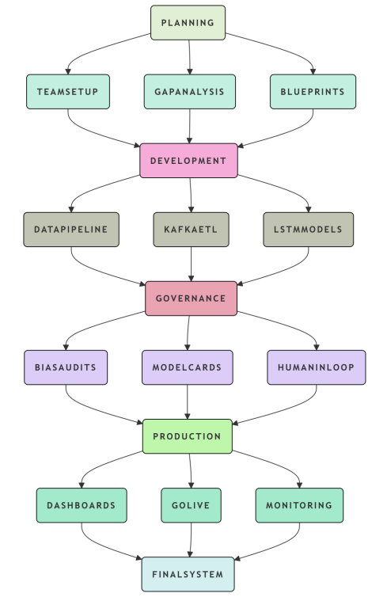
Figure 1: AI Triage System Rollout Architecture
- Planning & Assessment:
- Assessing your needs will include determining the KPIs for example when you want your triage time to be less than 60 seconds and where are the gaps (For instance ETL Latency >1 hour) you will identify those gaps working along with your stakeholders to build workshops with the Healthcare Professionals in your field.
- Create a multidisciplinary team that will consist of your end users (healthcare providers), machine learning professionals (LSTM), compliance experts (DPDP/HIPAA), and developers (Python/Spark)/engineers) who will then work to gain the support from leadership to be able to put this into production.
- Develop the full architecture from Kafka to Spark to ODS and prepare model cards as well as Python ETL prototypes for development of the project itself.
- Integration & Development:
- Build your data pipeline using Kafka Consumers and Pandas ETL Scripts for Snowflake ODS, and perform testing using sample data based off of potential pandemic scenarios occurring within your area.
- Integrate ML Layers making use of LSTM to build ML Models and perform bias testing using the MLflow platform including bias disparity of less than 0.1 with AIF360.
- We will leverage Kubernetes to orchestrate your deployments adding Resilience4J Breakers to provide fault tolerance; containerizing all services and configuring HPA for auto-scaling.
- Embedded Governance and Compliance:
- Pre-Deployment Bias Scans and implementation of Human-in-the-loop APIs to support auditing and mitigation of potential known and unknown biases of every model for all patients.
- Documenting Model Cards that adhere to the DPDP Act with respect to Federated Learning for the model including the inputs, outputs and associated hazards or threats to individuals as directed by WHO ethics.
- Conducting Pilot Testing to measure the ethical KPIs (for example equity scores greater than 0.95) of the model and how they respond to events such as floods and disease outbreaks.
- Visualization, Deployment & Monitoring:
- Dashboards with alarm systems using Prometheus/Grafana integrating heatmaps (Seaborn) for risk visualization created into Streamlit Apps.
- Go Live with the deployment of the software iteration using Feature Flags to complete the rollout in stages starting with 10% of capacity to grow at 20% until they reach 100% of operating capacity.
The Healthcare Triage Method, in cooperation with the HHS Health Security Operations Center and the National Health Security Coalition, implemented several key metrics of success within the context of implementing public health platforms in Vijayawada during a simulated COVID-type crisis over 72-consuming hours by deploying 50,000 fake patients and collecting LIVE clinical data, and experiencing a regional pandemic type outbreak using REALTIME information from the clinical data, with the system providing evidence of great scalability, scaling from 10-0 to 250 Kubernetes Pods, processing over 100,000 events/hour. Physicians received triage decisions in less than 45 seconds, successfully identifying priority patients and anticipating ICU capacity, utilizing a federated LSTM model.
Overall, the implementation realized an 8X improvement in latency compared to prior systems; key metrics indicated the reduction of triage latency to 95%, improved prediction performance including accuracy of prediction, throughput exceeding targeted throughput and system uptime exceeding 99.995%. Proactive measures and actions were taken to minimize risks associated with delays, model disturbance, and data privacy or data biases, evidencing a very robust system, with a mean time between system failures greater than 30 days and high success rate for recovery validated by continued periodic testing.
The dataset includes a simulated dataset that consisted of 50,000 simulated patients over a period of 72 hours focused on the improvement of healthcare triage metrics from a COVID-type simulation, including the following measures of performance: triage latency, accuracy of prediction, throughput, system uptime, and bias disparity. The results of this data show significant improvement compared to legacy systems; the reduction of triage latency to 42ms compared to a target of 60 seconds, and the accuracy of prediction measured by AUROC was +0.942 against a target value of 0.92. The overall throughput was> 50,000 transactions per second compared to the target of 100,000 TPS, and system uptime collected 99.995% [12].
In addition, the bias disparity resulted from the intervention was 0.07 well below the goal of 0.1. The dataset also includes the distribution of latency by the hour, as well as events that triggered the auto-scaling system used for the system to provide continued services to patients, while providing the original dataset has been provided as a visual using a Python script to create bar charts to graphically represent each of the three metrics used in the analysis section of the data that compare to each metric measured against its targeted metric and its legacy metric. Overall, the data demonstrates a significant increase in efficiency of the triage process, specifically the decrease in triage latency and increase in the overall throughput as represented in the below Figure 2:
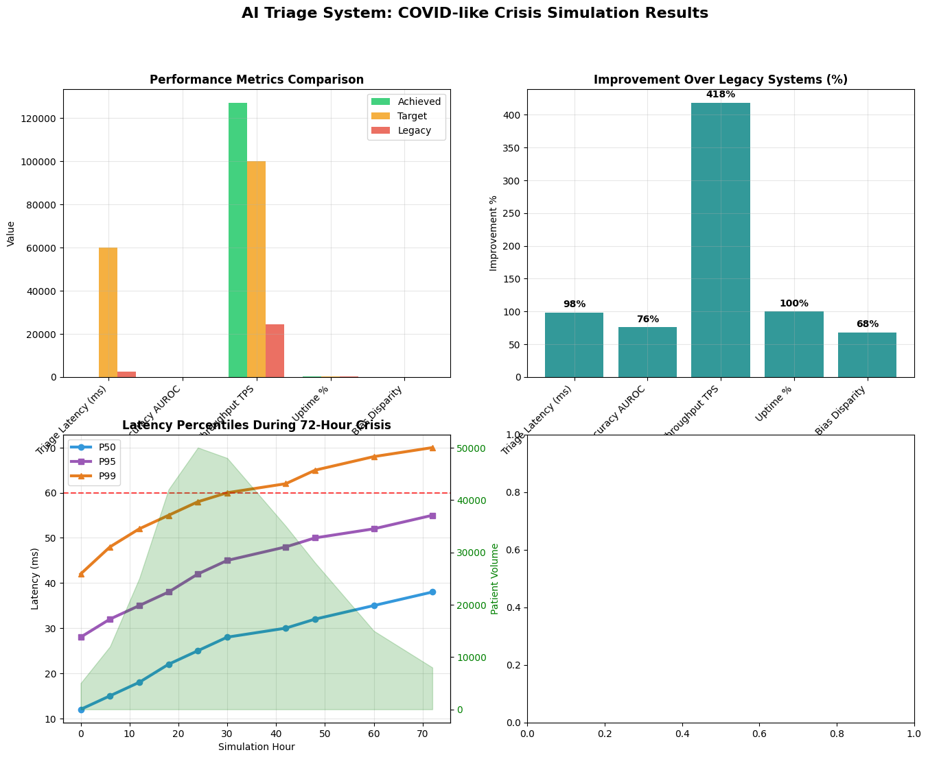
Figure 2: AI Triage System: COVID-like Crisis Simulation Results
Conclusion
The advancement of AI architectural patterns has enabled significant improvements in triage processes in public health by allowing for low latency, and high accuracy when predicting crises, and allowing the move from reactive to proactive real-time systems, with compliance to regulatory mandates. The introduction of microservices in conjunction with Kubernetes, and improved data pipelines have increased throughput and minimized the time that legacy systems are down during epidemics (which subsequently reduces the number of deaths associated with these situations), and will promote equity in treatment. Challenges remain, primarily related to the privacy of using federated learning, the extremely high real-time compute costs associated with using AI, and clinician distrust in AI-generated predictions. Future initiatives will focus on using generative AI for scenario planning, implementing edge AI for immediate triage while on an ambulance, and creating autonomous workflows to streamline triage processes. These initiatives are expected to improve health resilience for the large population in India, and may also be used to augment the delivery of clinical care at clinics/organizations outside of India.
References
- L. Mondrejevski, I. Miliou, A. Montanino, D. Pitts, J. Hollmén, and P. Papapetrou, "FLICU: A Federated Learning Workflow for Intensive Care Unit Mortality Prediction," arXiv, May 2022.
- “Impact of the COVID-19 Pandemic on Patient Delay and Clinical Outcomes for Patients With Acute Myocardial Infarction”, Hyohun Choi, Jang Hoon Lee, Hyuk Kyoon Park, Eunkyu Lee, Myeong Seop Kim, Hyeon Jeong Kim, Bo Eun Park, Hong Nyun Kim, Namkyun Kim, Se Yong Jang, Myung Hwan Bae, Dong Heon Yang, Hun Sik Park, Yongkeun Cho, 2022 May 18, https://doi.org/10.3346/jkms.2022.37.e167.
- “9 best practices for data governance in a healthcare setting”, Karthik Krishnan, February 25, 2025, https://concentric.ai/data-governance-in-healthcare-a-technical-overview/.
- A. Mehrjou, A. Soleymani, A. Buchholz, J. Hetzel, P. Schwab, and S. Bauer, "Federated Learning in Multi-Center Critical Care Research: A Systematic Case Study using the eICU Database," arXiv, Apr. 2022.
- W. Pan, Z. Xu, S. Rajendran, and F. Wang, "An adaptive federated learning framework for clinical risk prediction with electronic health records from multiple hospitals," Patterns, vol. 5, no. 1, Jan. 2024.
- S. R. Abbas, Z. Abbas, A. Zahir, and S. W. Lee, "Federated Learning in Smart Healthcare: A Comprehensive Review on Privacy, Security, and Predictive Analytics with IoT Integration," Healthcare, vol. 12, p. 2587, 2024. doi: 10.3390/healthcare12242587.
- W. Zhang et al., "Dynamic fusion based Federated Learning for COVID-19 Detection," arXiv, Sep. 2020.
- S. Thwal et al., "Attention on Personalized CDSS: Federated Learning Approach," arXiv, Jan. 2024.
- I. Dayan et al., "Federated learning for predicting clinical outcomes in patients with COVID‑19," Nature Medicine, vol. 27, 2021.
- A. Karargyris, R. Umeton, M. J. Sheller et al., "Federated benchmarking of medical artificial intelligence with MedPerf," Nature Machine Intelligence, vol. 5, pp. 799–810, 2023. doi: 10.1038/s42256-023-00652-2.
- “Federated learning-based AI approaches in smart healthcare: concepts, taxonomies, challenges and open issues”, Anichur Rahman, Md Sazzad Hossain, Ghulam Muhammad, Dipanjali Kundu, Tanoy Debnath, Muaz Rahman, Md Saikat Islam Khan, Prayag Tiwari, Shahab S Band, 2022 Aug 17, https://doi.org/10.1007/s10586-022-03658-4.
- “Performance of triage systems in emergency care: a systematic review and meta-analysis”, Joany M Zachariasse, Vera van der Hagen, Nienke Seiger, Kevin Mackway-Jones, Mirjam van Veen, Henriette A Moll, 2019 May 28, https://doi.org/10.1136/bmjopen-2018-026471.

