Application of Ground Source Heat Pump Technology for Cooling Buildings in Sub Saharan Africa

Joseph Levodo*, Mohammed Yamman Mohammed
Department of Mechanical Engineering, University of Greater Manchester, UK

ABSTRACT
The increasing demand for cooling in Sub-Saharan Africa, driven by rapid urbanisation and rising temperatures, is placing significant pressure on already constrained energy systems. Conventional air conditioning technologies are energy-intensive and contribute to greenhouse gas emissions. This study evaluates the potential of ground source heat pump (GSHP) technology as a sustainable alternative for building cooling in the region. A pilot case study based on Cameroon is used to assess the technical feasibility, energy performance, and economic viability of GSHP systems under local climatic and geological conditions. The analysis incorporates empirical data and simulation-based modelling to estimate energy savings, carbon emission reductions, with a payback period of approximately 6 years. Results indicate that GSHP systems can reduce national cooling energy demand by approximately 3691 GWh/year in Cameroon, representing a substantial decrease compared to conventional air conditioning systems. A lifecycle cost perspective suggests long-term economic benefits, particularly when supported by appropriate financing mechanisms. The study also highlights the influence of geological variability and climatic diversity across Sub-Saharan Africa on system performance. Key barriers to adoption, including high upfront costs, limited technical expertise, and weak policy support, are critically examined. The findings demonstrate that GSHP systems can significantly reduce energy demand and emissions while offering long-term economic benefits, although widespread adoption requires policy support and capacity development. Ground source heat pump (GSHP) technology can become a key component of the region's cooling infrastructure. Their adoption not only supports the transition to low-carbon energy systems but also enhances resilience to the impacts of climate change, contributing to improved living standards and sustainable development in sub-Saharan African countries.
Keywords: Ground source heat pump, sub-Saharan Africa, energy efficiency, payback Period

INTRODUCTION
The demand for building cooling is rapidly increasing in sub-Saharan Africa due to rising temperatures, urbanisation, and population growth. As the region experiences continued economic development and urban expansion, the need for effective cooling solutions in residential, commercial, and industrial buildings is becoming more urgent. However, traditional cooling technologies, such as air conditioners, are energy-intensive, often unaffordable for many households and businesses in sub–Saharan Africa, and place significant pressure on already fragile energy infrastructure systems [1]. Moreover, the dependence on these systems contributes to rising greenhouse gas emission, hindering efforts to mitigate climate change. Ground source heat pump (GSHP) technology offers a sustainable and energy-efficient alternative for addressing the growing demand for cooling in sub-Saharan Africa. Ground source heat pump technology leverages the stable temperatures beneath the Earth’s surface to provide cooling, offering significant advantages over conventional cooling systems in buildings. These include reduced energy consumption, lower operational costs, and decreased environmental impact [2]. By providing a renewable and efficient solution, GSHPs align with the global push toward achieving net-zero emissions and sustainable energy transitions. Despite the promising potential of GSHP systems, their adoption in sub-Saharan Africa countries remains limited. High initial installation costs, a lack of public awareness, insufficient technical expertise, and the absence of supportive policies are significant barriers to widespread implementation. Additionally, the region's diverse climatic and geophysical conditions require tailored approaches to optimise GSHP performance and ensure feasibility [3]. This paper evaluates the technical and economic feasibility of GSHP systems for cooling in Sub-Saharan Africa, using Cameroon as a representative case study. It highlights the economic, environmental, and social benefits of adopting GSHP systems and explores strategies to overcome existing barriers. The study also emphasises the importance of policy frameworks, financial incentives, capacity building, and localised research to support the successful integration of GSHPs into the region’s energy landscape. By doing so, it aims to provide a comprehensive understanding of how GSHPs can contribute to meeting the region’s growing cooling needs while advancing sustainable development goals. Despite the growing body of research on GSHP systems globally, there remains a lack of region-specific empirical data and lifecycle cost analyses for GSHP deployment in Sub-Saharan Africa. Most existing analyses are based on data from Europe, Asia, and North America, with limited consideration of the region’s unique climatic conditions, geological diversity, and energy infrastructure constraints. Furthermore, there is a lack of detailed lifecycle cost assessments and context-specific financing models to support decision-making among policymakers and stakeholders. This study addresses these gaps by incorporating a pilot case study and evaluating both technical and economic feasibility within a Sub-Saharan African context
Overview Source Heat Pump Technical
Ground Source Heat Pump is a technology for utilising the free and available ground thermal energy for the purposes of space heating, cooling, and domestic hot water generation. Researchers have introduced an additional usage of snow melting to the existing fundamental usages of GSHP [4]. About 46% of the sun’s energy is absorbed by the earth, leading to approximately constant ground temperatures all year round [5]. GSHP make use of this free and available heat stored in the ground as a heat source and heat sink for heating and cooling, respectively. This is usually achieved by circulating a heat transfer fluid in a closed loop through ground heat exchanging pipes [6]. Fig.1 shows a pictorial representation of schematic of ground source heat pump systems application. The GSHP system consists of a ground heat exchanger, heat pump, and distribution system. For cooling purposes, the GSHP extracts heat from the building and rejects it through the ground heat exchanger Fig.1 [7]. For heating, the ground heat is extracted and distributed to the room through the distribution system. Unlike air conditioners whose source temperature varies with time, the GSHP uses the advantage the ground provides, that the ground temperature remains almost constant all year round after 10m depth, to achieve its purpose. This makes GSHP operate over small temperature lifts, which enhances their performance and makes them much more efficient than air conditioners [8].

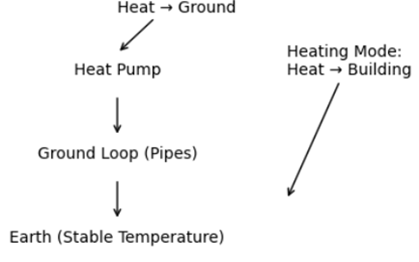
Fig 1 Energy Flow Direction [4]

One of the strategies for controlling the energy demand of nations is the adoption of efficient renewable energy technologies especially for heating, ventilation, air conditioning, and hot water generation. This section provides a fundamental understanding of ground source heat pump technology as an efficient renewable technology to provide the cooling needs of residential and commercial buildings and investigates the potential of energy savings by using ground source heat pumps in sub–Saharan Africa countries.
Energy Savings with Ground Source Heat Pump Technology
There is a debate as to whether GSHP saves energy or not as compared with using conventional heating and cooling systems such as boilers, furnaces, and compression chiller systems. Some researchers argue that, irrespective of the fact that, GSHPs have higher coefficient of performance (COP), typically 3.5 to 5, compared with a typical conventional boiler efficiency of 75-85% for heating purposes, when the extra energy used for powering the water pumps and fans of GSHP are factored in, the COP of ground source heat pumps drops to 3 or lower. This implies that the difference in efficiency is not that much considering the cost involved in the installation of both systems. Therefore, it is always better to reduce the amount of energy and building space requires than to look for a new source of energy as captured by [9]. Others also argue that, the COP of GSHP and efficiency of boiler system are not comparable in terms of performance, since the COP of GSHP involves the transfer of heat from one point to the other, while the efficiency of the boiler system involves the conversion of chemical energy in the fossil fuel to heat energy through the working fluid to serve the application purpose [10]. However, many researchers emphasise that, the higher performance and the multi functionality (heating, cooling, and hot water generation) of a single GSHP technology, outweighs that of an individual stand-alone heating, and cooling systems for various homes [11]. Others also emphasise that, GSHP has great potential for minimising carbon emissions in the environment as compared with fossil fuel systems since GSHPs do not directly involve the burning of fossil fuels as is the case of conventional fossil fuelled heating and cooling systems. Reference [12] performed an experimental and numerical investigation of integrating GSHP with borehole free cooling technology. The study revealed that significant energy savings can be achieved with this integration. Reference [13] performed an investigation on the energy saving and CO₂ saving potential of GSHP in India. It was concluded that, India can save annually, 1639-18700 GW of energy and CO₂ emission of 1.0–1.4 million tons by employing GSHP technology as compared with conventional heating and cooling systems. Reference [14] also found that GSHP could minimise the CO₂ emissions by 0.049 million tons which represented 22 times less than that of electric heating system powered by thermal power plants in the northern part of India. A review of GSHP systems for heating and cooling of buildings was conducted by [15]. It was found that the GSHP technology is versatile, effective in both cold and warm climates, and provides substantial energy savings. Several studies have also shown the energy saving and CO₂ emission reduction potential of GSHPs [16]. There is therefore no doubt that GSHP technology, when adopted in sub-Saharan Africa for the purposes of meeting the cooling needs of residential and commercial buildings will result in significant energy savings and CO₂ emissions reduction as compared with the current cooling used in the continent.

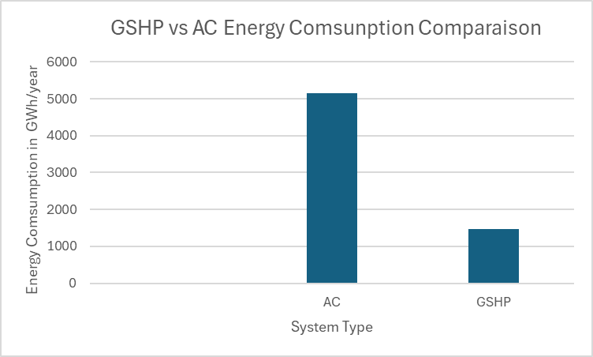
Graph 1 GSHP vs AC Energy Consumption

Energy Efficiency
GSHP systems have a higher coefficient of performance (COP) than traditional air conditioning systems, meaning they can deliver more cooling for the same amount of energy input. A GSHP typically has a COP of 3-5, compared to a COP of 2-3 for conventional air conditioners. This results in reduced energy consumption and lower operational costs, an important consideration in sub-Saharan Africa, where energy efficiency is crucial to mitigating the pressures on power grids.
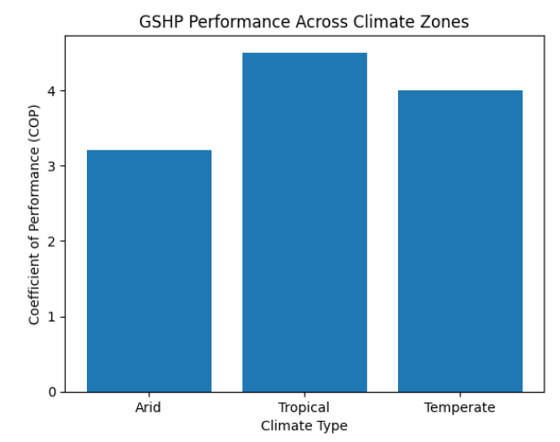

Graph 2 Climate Performance (COP vs climate)

Figure 2 illustrates the variation in the coefficient of performance (COP) of GSHP systems across different climate zones. The results show that system performance is highest in tropical regions, followed by temperate climates, and relatively lower in arid environments. This variation is primarily due to differences in ground temperature stability and thermal conductivity, which directly influence heat exchange efficiency. The inclusion of climate-based performance analysis adds scientific depth to the study by demonstrating that GSHP efficiency is not uniform but strongly dependent on regional conditions. This finding highlights the importance of site-specific design and reinforces the need to consider climatic variability when evaluating the feasibility of GSHP deployment across Sub-Saharan Africa.
Ground Source Heat Pump Technologies Solutions and Challenges in Sub- Saharan Africa
Factors such as misconceptions about GSHP technology, lack of expertise, limited data availability, high costs, and absence of renewable energy incentives may hinder the adoption of GSHP in sub-Saharan Africa. This section discusses these factors and proposes various solutions to mitigate these challenges.
High Initial Capital Costs
The installation of GSHP systems involves significant upfront costs, which can be prohibitive for many building owners, especially in countries with low-income populations. This includes the cost of drilling or excavating to install ground loops, as well as the cost of the heat pump unit and associated equipment.
Technical Knowledge and Training
There is a lack of skilled technicians and engineers trained in the installation and maintenance of GSHP systems in many sub-Saharan African countries. This limits the widespread adoption of the technology, as improper installation or maintenance can lead to reduced system performance.
Ground Conditions
The type of soil and geological conditions affect the installation of GSHP systems. In areas with rocky or uneven terrain, the installation of ground loops may be more challenging and costly. Moreover, the depth required for effective cooling may vary depending on local ground temperatures and conditions.
Financing and Policy Support
The lack of supportive policies and financing options presents another obstacle. Governments need to provide incentives, such as subsidies or tax rebates, to make GSHP systems more affordable for developers and property owners. Additionally, policy frameworks to ensure the adoption of energy-efficient technologies in the building sector are crucial.
Technology Acceptances by the Population
Lack of expertise, skilled labour and workforce, and misconception of the GSHP technology could hinder the application of this technology in sub-Saharan Africa. Shortage of skilled labour personnel in a particular area of study has the disadvantages of decreased prosperity and growth retardation in that field. The misconception of GSHPs as geothermal power source among other misconceptions about this technology serves as a barrier to the utilization, implementation, and investment in this technology. This barrier could be averted by the restructuring of various academic curricular to incorporate the ground source heat pump and geothermal power generation technology, organisation of seminars, workshops and trainings by the invitation of experts in these fields from other spheres of the world should the need arise.

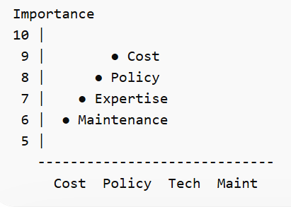
Fig 2 Technology Acceptance
Lack of Renewable Energy Incentive
Renewable heat incentive (RHI) is a payment system established in nations such as England, Scotland, and Wales for the generation of heat energy from renewable energy sources. Its main agenda is to encourage users to produce heat from renewable energy sources as compared with the conventional fossil fuel heating systems for the regulation of CO₂ emission and energy consumption in these countries [17]. Other countries also encourage stakeholders to use renewable energy such as solar for basic hot water needs by granting tax reliefs on various solar modules. Sub-Saharan African countries could use the same model to implement for GSHP.
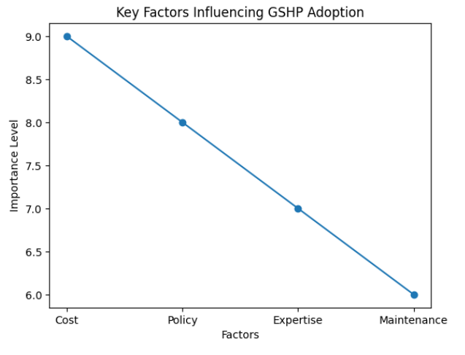
Graph 3 Key factors influencing GSHP adoption in Sub-Saharan Africa

Ground Source Heat pump Technologies Solutions for Cooling in Sub-Saharan Africa
One of the areas that continues to contribute to the increasing energy use in sub-Saharan Africa Countries buildings is room air conditioning. Sub-Saharan Africa has higher ambient temperatures and humidity patterns in major parts of the year. This means constant cooling all year long in most residential and commercial buildings to guarantee the comfort levels of people living and working in the country. Recent trends in the building industry have been the use of sliding doors and windows, which gives no room for ventilation but causes an increase in the cooling demand of these buildings [18]. The use of air conditioners has been the resolve to ensure comfortable temperature conditions in these uncomfortable environments. However, the higher ambient air temperatures in sub-Saharan Africa reduce the efficiency and increase the energy consumption of air conditioners [19]. Researchers have shown that the ground source heat pump (GSHP) is an energy efficient system that can be used for cooling, heating, and hot water generation [20]. The GSHP technology is popular in England, Europe, America, and Asia. For instance, South Korea has mandated all state institutions to use renewable energy systems, like the GSHP, for cooling and heating purposes and has permitted tax grants to encourage all newly built apartments and buildings using this technology. However [21], the GSHP technology is not known in sub-Saharan Africa countries. This section therefore discusses the prospects of the GSHP technology in meeting the cooling demands of residential and commercial buildings in sub-Saharan Africa, placing a potential in energy and cost savings, and reduction in CO₂ emissions as compared to the typical air conditioners used in sub-Saharan Africa [22].
Environmental Benefits
The adoption of GSHP technology in cooling applications can contribute to the region’s climate goals by reducing greenhouse gas emissions. As GSHPs do not rely on fossil fuels and minimize the use of refrigerants, they represent an environmentally friendly cooling option.
Reliability and Sustainability
In areas where the electricity grid is unreliable, GSHPs offer a more sustainable solution for cooling, as they require less external energy and can be integrated with renewable energy sources such as solar power. Their relatively low maintenance and long service life (typically 20-25 years) make them a durable solution for long-term building cooling.
Case Study: Ground Source Heat Pump (GSHP) vs. Air Conditioning in Cameroon
This case study serves as a pilot investigation into the feasibility of Ground Source Heat Pump (GSHP) technology for cooling applications in Sub-Saharan Africa. Cameroon was selected as a representative case due to its tropical climate, increasing cooling demand, and developing energy infrastructure. The study evaluates the technical performance, energy efficiency, environmental impact, and economic viability of GSHP systems compared to conventional air conditioning. By combining empirical data with simulation-based analysis, this pilot provides insight into the practical applicability of GSHP systems under real regional conditions.
METHODOLOGY
Location Selection: Yaoundé, Cameroon’s capital, was chosen for this study due to its urban population density and tropical climate. A typical residential building (150 m²) was modelled to compare the performance of a 5-ton GSHP system and a 5-ton AC system. Data on energy consumption, installation costs, operational efficiency, and carbon emissions were collected from manufacturers’ specifications, local electricity tariffs, and environmental reports. Energy modelling software was used to simulate annual energy consumption and emissions for both systems. Due to limited availability of long-term field data in the region, this study adopts a hybrid methodological approach combining secondary data, manufacturer specifications, and simulation modelling. Where necessary, assumptions were validated using available regional datasets and comparable studies. While this approach provides a realistic estimation of system performance, further large-scale experimental validation is required to confirm long-term operational reliability under diverse Sub-Saharan African conditions.
Cameroon Energy Profile
Cameroon possesses a vast hydroelectric potential estimated at 19.71 gigawatts (GW), yet as of 2013, only 3.72% of this capacity had been harnessed [24]. The country's gross or theoretical hydroelectric potential stands at 294 terawatt-hours per year (TWh/year), while the technically feasible potential is 115 TWh/year [24]. Various studies highlight numerous sites suitable for the development of this significant hydroelectric capacity [25]. Cameroon is home to 74 micro-hydro and 89 major hydroelectric dams. In terms of operational facilities, three major hydropower plants are currently in use: the Edea plant, Song Loulou, and Lagdo, with installed capacities of 276.2 megawatts (MW), 384 MW, and 72 MW, respectively, as of 2020 [26]. The hydropower generation at Edea and Song Loulou is supported by three key reservoirs -Bamendjin, Mape, and Mbakaou which play a crucial role in regulating the flow of the Sanaga River [24].

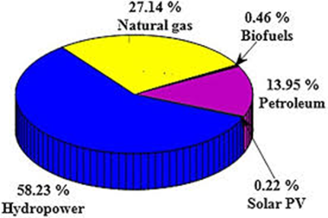
Graph 4 Cameroon renewable energy potential [24]
Availability Data
Key factors such as ground temperature, soil type, and ground thermal conductivity were crucial for the successful study of Ground Source Heat Pump (GSHP) technology. In a tropical country like Cameroon, achieving lower ground temperatures is essential for the system's efficiency. However, the GSHP technology is highly dependent on meteorological conditions, ground characteristics, and building envelope infrastructure. The availability of ground and meteorological data played a significant role in this study. Where data was lacking, experimental methods such as Thermal Response Tests (TRTs) and Enhanced Geothermal Response Tests (EGRTs) were conducted to assess ground thermal properties and evaluated the feasibility of GSHP. Extensive research was also conducted to gather comprehensive data on ground temperature variations with depth, ground thermal properties, and geothermal response tests for different soil types.
RESULTS AND ANALYSIS
Estimation of Annual Energy Consumption of Air-Conditioners against GSHP
An investigation on the energy efficiency of air conditioners in developing countries, the International Energy Agency (IEA) found that 200,400 units of air conditioners were sold in Cameroon in the year 2020. This number was expected to increase by 8% every year [21]. Air conditioners usually have life span between 10–15 years [22]. Using an average life span of 12.5 years, about 1,905,303 units of air conditioners are estimated to have been in use in Cameroon by the year ending 2022. In this study, the average cooling capacity (CC) of the air conditioners is estimated as 4.02 kW and the annual operating hours estimated as 299 days/year x 9 hours/operational day. This gives the operation time of a typical air conditioner in Cameroon to be 2691 hrs/year [23] This study assumed all air conditioners operating in Cameroon in the year 2023 to have 5-star rating with energy efficiency ratio (EER) of 4. The EER of the GSHP is estimated as 14, the minimum rated GSHP in the Canadian market (Energy Standards, 2020). The GSHP is assumed to have cooling capacity of 4.02 kW and operate at 2691 hrs/year, as the air conditioners. the energy consumption of air conditioners used in Cameroon in the year 2023 is estimated as 5153 GWh. The energy consumption of using GSHP in Cameroon in 2023 is also estimated as 1462 GWh. The energy savings of using GSHP instead of air conditioners in Cameroon in 2023 can be estimated from as 3691 GWh/year, which is equivalent to the generation capacity of a 421 MW power plant that operates 24 hours a day all year round.
Payback Period
Payback refers to the period required to recover the additional cost of replacing a conventional system with a new one. The table below presents the estimated payback period for using a GSHP for cooling instead of an air conditioner in Cameroon. The cost of purchasing a 4-kW air conditioner and GSHP was estimated at £2380 and £2917, respectively [23], with installation costs estimated at £200 for the air conditioner and £3750 for GSHP. The cost of electricity in Cameroon is also estimated as £0.25 per kWh [23]. Using these estimated values, the payback period of a typical GSHP for space cooling can be estimated at around 6 years. The payback of the GSHP is likely to reduce further due to increase in fuel prices in the world market in Cameroon in coming years. The payback period is the time it takes for the cumulative savings from the Ground Source Heat Pump (GSHP) to offset its higher initial cost compared to the Air Conditioning (AC) system

Items | Air conditioning | GSHP
Capacity | 4.0kw | 4.0kw
Purchase cost (£) | 3280 | 2917
Total initial cost (£) | 2580 | 6667
Difference cost |  | 4087
Electricity cost (kwh) | 0.25 | 0.25
Annual energy Consumption (kw) | 3401 | 766.9
Annual energy bill (£) | 850.25 | 191.725
Difference annual energy bill |  | 658.525
Payback period (years) |  | 6.21

Table 1 Payback Period
The graph below illustrates the lifecycle cost performance of the GSHP system. Although the initial investment is significantly higher than conventional air conditioning systems, cumulative energy cost savings increase steadily over time. The break-even point is reached at approximately 6–7 years, after which the system yields net economic benefits. This demonstrates the long-term financial viability of GSHP technology despite high upfront costs.

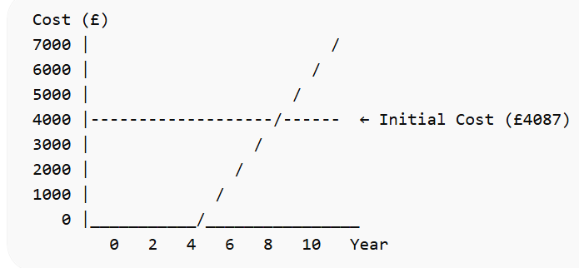
Graph 5 Lifecycle cost comparison showing cumulative savings of GSHP relative to initial investment
Lifecycle Cost and Financing Considerations
While the initial installation cost of GSHP systems is significantly higher than that of conventional air conditioning systems, a comprehensive lifecycle cost analysis reveals substantial long-term economic benefits. GSHP systems typically have a lifespan of 20–25 years, compared to 10–15 years for conventional air conditioning units, resulting in reduced replacement frequency and lower cumulative costs over time. Additionally, GSHP systems offer lower operational and maintenance costs due to their higher energy efficiency and fewer mechanical components exposed to external environmental conditions. From a financial perspective, the high upfront cost remains a major barrier to adoption in Sub-Saharan Africa. To address this challenge, innovative financing mechanisms such as public-private partnerships, green financing schemes, concessional loans, and carbon credit programs should be explored. These approaches can help distribute initial costs over time and improve affordability for households and commercial developers. The integration of GSHP systems into national energy policies and climate financing frameworks could further enhance their economic viability and scalability.
Limitations and future study of GSHP technology for limitations of the study
The installation of Ground Source Heat Pump systems requires significant capital, including drilling and piping, making it less accessible for widespread adoption in sub-Saharan Africa. A lack of comprehensive data on ground temperature, soil thermal conductivity, and hydrogeological conditions hinders proper system design and optimisation. The High ambient temperatures and varying soil conditions can impact GSHP efficiency, requiring site-specific adaptations. In many sub-Saharan African countries, frequent power outages and an unstable grid may affect the consistent operation of GSHP systems. Limited knowledge and trained professionals in GSHP installation and maintenance pose challenges for effective deployment. The absence of clear policies, incentives, and regulatory frameworks for renewable energy technologies slows down GSHP adoption of the technology.
Future Study Recommendations
Conduct large-scale studies on soil thermal properties, geothermal response tests, and ground temperature variations to enhance system efficiency. Investigate hybrid solutions combining GSHP with solar photovoltaic (PV) or other renewable technologies to improve performance and reliability. Explore affordable drilling techniques and alternative heat exchanger designs suited to sub-Saharan soil conditions. Study the potential of integrating GSHP systems with thermal energy storage for better energy management. Implement training programs and awareness campaigns to increase technical expertise and encourage the adoption of GSHP technology.

CONCLUSION and LIMITATIONS
The findings highlight the significant energy and environmental benefits of GSHPs over conventional AC systems. However, the initial investment barriers and need for specialised installation expertise pose challenges. Policymakers and stakeholders should consider incentives, such as subsidies and training programs, to encourage GSHP adoption. Ground source heat pumps represent a promising solution for addressing the growing demand for cooling in sub-Saharan Africa. By leveraging the earth’s natural temperature regulation, GSHP systems offer an energy-efficient, cost-effective, and environmentally friendly alternative to conventional cooling systems. However, for widespread adoption, it is essential to overcome challenges related to upfront costs, technical expertise, and policy support. With the right investments in infrastructure, training, and financing, GSHPs could play a key role in enhancing energy efficiency and promoting sustainable development across sub-Saharan Africa countries.

References
- Abanda, F.H. (2022), Renewable energy sources in Cameroon: Potentials, benefits and enabling environment. Renewable and Sustainable Energy Reviews, 16, 4557-4562
- Appiah, F K, (2016). National Rooftop Solar Program, Energy Commision of Sub Saharan Africa.
- Building Guide, Ground Source Heat Pump (GSHP) (http://www.bigee.net/en/buildings/guide/services/option s/active/OASH/OAH_GSHP/overview/) Assessed 01/07/2025.
- Cho, H, Choi, J M, (2014). The quantitative evaluation of design parameter's effects on a ground source heat pump system. Renew. Energ. 65, 2-6.
- DiPippo, R, (2019), Geothermal Power Plants, third ed.,Butterworth-Heinemann, Oxford, 2019.
- ENEO Government, (2024). Energy Efficiency Standards and Labeling: (Non-ducted Air Conditioners and Self Ballasted Fluorescent Lamps), Regulations, LI1815 Order, Cameroon.
- Energy Commission, (2021). Energy (Supply and Demand) Outlook for Cameroon, Yaounde.
- Ghana Appliance Energy Efficiency Standards and Labelling Program. Accessed 2/04/2026 on http://www.energycom.gov.gh/efficiency/standards-andlabelling .
- Gifford, H. Ground Source Heat Pumps Don’t Save Energy, Assessed on 16/01/2026 (http://www.greenbuildingadvisor.com/blogs/dept/greenbuilding- blog/ground-source-heat-pumps-don-t-saveenergy)
- Khan, H, Afroz, H M M, Rohomon, A, Faruk, M, Salim,vM, (2022). Effect of Different Operating Variables on Energy Consumption of Household Refrigerator. Int. J. Energ. Eng. 3, 4, 144-150.
- Koizumi, S, (2021). Air conditioners in developing countries.
- Koranteng, C, Abaitey, E G, (2009). Simulation based analysis on the effects of orientation on energy performance of residential buildings in Ghana, J. Sci. Tech., 29, 3, 86-101.
- Mensah, K, Choi, J M, (2015). Peak and Annual Snow Load Pattern for Effective Snow Melting System Design in Republic of Korea, Int. J. Air-Cond. Refrig. 23, 4,1550031.
- Mensah, K, Jang, Y S, Choi, J M, (2017). Assessment of Design Strategies in a Ground Source Heat Pump System, Energ. Buildings. 138, 301 – 308.
- MINEE. (2023), Statistical Yearbook of Cameroon’s Water and Energy. Yaoundé: Ministry of Water Resources and Energy. p1-110
- Moor, K D. The relationship between Efficicency and Coefficient of Performance, Assessed on 02/01/2025 (www.cheniere.org/misc/COPvsEFF15.doc )
- Mustafa, A O, (2020). Ground-source heat pumps systems and applications, Renew. Sustain. Energy Rev. 12, 2, 344-371.
- Renewables Energy Policy Network for the 21st Century (REN21), Renewables 2015 Global Status Report, Paris: REN21 Secretariat, 2015
- Sarbu, I, Sebarchievici, C, (2014). General review of ground-source heat pump systems for heating and cooling of buildings, Energ. Buildings 70, 441-454
- SIE-Cameroon. (2021), Situation Energétique du Cameroun. Report, Ministry of Water Resources and Energy. p1-147
- Singh, G, Nouhou, S A, Sokona, Y, (2019). Ghana Renewable Readiness Assessment, International Renewable Energy Agency (IRENA)
- Sivasakthivel, T, Murugesan, K, Sahoo, P K, (2012). Potential Reduction in CO2 Emission and Saving in Electricity by Ground Source Heat Pump System for Space Heating Applications-A Study on Northern Part of India. Procedia Eng. 38, 970-979.
- Sivasakthivel, T, Murugesan, K, Sahoo, P K, (2014). A study on energy and CO2 saving potential of ground source heat pump system in India, Renew. Sust. Energy Rev. 32, 278-293.
- World Bank (2010), Economic of Adaptation to Climate Change, Ghana Country Study; World Bank: Washington, DC, USA.
- World Bank (2020), Economic of Adaptation to Climate Change, Ghana Country Study; World Bank: Washington, DC, USA.
- Zhou, Z, Wu, S, Du, T, Chen, G, Zhang, Z, Zuo, J, He,Q, (2016). The energy-saving effects of ground-coupled heat pump system integrated with borehole free cooling: A study in China. App. Energ. 182, 9-19.

