FAULT-RESPONSIVE PMSM DRIVE WITH FOC-BASED DEMAGNETIZATION COMPENSATION
Mohana Priya M¹*
Department of Electrical Engineering, Sri Ranganathar Institute of Engineering and Technology, Coimbatore, India
Email: mohanamanikandan2004@gmail.com
Arun Kumar J², Sridhar S³, Nandhakumar S⁴
Department of Electrical Engineering, Sri Ranganathar Institute of Engineering and Technology, Coimbatore, India
ABSTRACT: Permanent Magnet Synchronous Motors (PMSMs) are widely used in electric vehicle applications due to their high efficiency, compact size, and superior performance. However, their reliability is affected by electrical and thermal stresses, which can lead to both external and internal faults. Conventional protection methods primarily address external faults such as overcurrent, overvoltage, and overheating, but they are not effective in detecting internal issues such as gradual demagnetization of rotor magnets.
This work proposes a PMSM drive system with integrated safety and monitoring features to enhance operational reliability. The system employs Field Oriented Control (FOC) for precise control of torque and speed while continuously monitoring key parameters such as stator current, voltage, and temperature. In addition to standard protection mechanisms, a sensorless demagnetization detection method is incorporated using variations in electrical signals, eliminating the need for additional hardware sensors.
Based on the detected level of demagnetization, appropriate control actions are implemented using a microcontroller. In the case of slight demagnetization, the system compensates for torque reduction by increasing the current through the control strategy. In severe demagnetization conditions, the system initiates a protective shutdown to prevent further damage to the motor and drive components.
In conclusion, the proposed system enhances the safety, reliability, and fault-handling capability of PMSM drives while maintaining a simple and cost-effective design, making it suitable for practical electric vehicle applications.
Keywords : PMSM, Field Oriented Control, Demagnetization Detection, Fault Diagnosis, Electric Vehicles.

- INTRODUCTION
Existing PMSM drive systems primarily rely on conventional protection mechanisms such as overcurrent, overvoltage, and thermal protection, which are effective only for external faults. Several advanced methods for internal fault detection, including observer-based techniques and signal processing approaches, have been reported in the literature. However, these methods often require complex computations or additional sensors, increasing system cost and implementation complexity. Therefore, there is a need for a simple, cost-effective, and real-time capable solution for detecting internal faults such as rotor demagnetization.
The rapid growth of electric vehicles (EVs) has increased the demand for efficient, reliable, and high-performance motor drive systems. Among the various motor technologies available, the Permanent Magnet Synchronous Motor (PMSM) has emerged as a preferred choice due to its high efficiency, high power density, compact size, and excellent dynamic response. These advantages make PMSMs highly suitable for modern EV applications where energy efficiency and performance are critical. However, despite these benefits, the reliability of PMSM drive systems remains a major concern due to the presence of electrical, thermal, and mechanical stresses during operation.
In practical operating conditions, PMSM drives are subjected to various types of faults, which can be broadly classified as external and internal faults. External faults include overcurrent, overvoltage, and overheating, which are typically caused by load variations, power supply disturbances, or environmental conditions. These faults are relatively easier to detect and are commonly addressed using conventional protection mechanisms. However, internal faults, particularly rotor magnet demagnetization, pose a significant challenge as they develop gradually and are difficult to detect in their early stages.
Demagnetization in PMSMs occurs due to excessive temperature, high armature reaction, or fault conditions, leading to a reduction in the magnetic flux produced by the permanent magnets. This reduction directly affects the torque production capability of the motor, resulting in decreased performance, increased current demand, and potential system instability. If not detected early, severe demagnetization can lead to irreversible damage and complete motor failure. Therefore, it is essential to develop an effective method for early detection and mitigation of such faults to ensure safe and reliable operation.
To address these challenges, this project proposes an advanced PMSM drive system integrated with real-time monitoring and fault detection capabilities. The system utilizes Field Oriented Control (FOC), a widely adopted control technique that enables independent control of torque and flux, thereby ensuring precise and efficient motor operation. By continuously monitoring electrical parameters such as stator current and voltage, along with temperature, the system can identify abnormal operating conditions without the need for additional sensors.
A key feature of the proposed system is the implementation of a sensorless demagnetization detection method based on variations in electrical signals. Instead of relying on dedicated hardware sensors, the system analyzes changes in motor behavior to detect the presence and severity of demagnetization. Based on this analysis, appropriate control actions are executed through a microcontroller. In the case of slight demagnetization, the control strategy compensates for the loss of magnetic flux by increasing the current, thereby maintaining the required torque output. In contrast, when severe demagnetization is detected, the system initiates a protective shutdown to prevent further damage to the motor and associated components.
Overall, the proposed approach enhances the reliability, safety, and fault tolerance of PMSM drive systems while maintaining a simple and cost-effective design. This makes it highly suitable for practical implementation in electric vehicle applications, where continuous operation and system protection are of paramount importance.

II. LITERATURE REVIEW
Recent research on Permanent Magnet Synchronous Machine (PMSM) drives highlights significant advancements in fault detection, control strategies, and electric vehicle (EV) applications. However, a critical analysis reveals certain limitations that motivate the need for improved integrated solutions.
Henghui Li et al. (2024) present a comprehensive overview of fault detection techniques in PMSMs, covering electrical, mechanical, and magnetic faults such as stator winding failures, rotor defects, sensor faults, and demagnetization. The study emphasizes signal-based monitoring using current and voltage analysis for early fault detection. While the review provides a broad classification of diagnostic methods, it mainly focuses on detection techniques and lacks detailed discussion on real-time fault mitigation and control adaptation after fault occurrence, which is crucial for EV safety applications.
Ankit Prajapati (2024) discusses advanced control strategies for PMSM drives in battery electric vehicles, particularly focusing on Field-Oriented Control (FOC). The study demonstrates improved efficiency, dynamic response, and stability under varying operating conditions. However, the work primarily concentrates on performance enhancement and does not sufficiently address the integration of fault detection or protection mechanisms within the control framework, limiting its applicability in safety-critical environments.
Sunil Patil et al. (2023) provide a comparative analysis of SRM, PMSM, and BLDC motors for EV applications. The results indicate that PMSM offers superior efficiency, higher torque density, and smoother operation compared to other motor types. While this study justifies the selection of PMSM for EV systems, it does not consider reliability issues such as fault tolerance, demagnetization effects, or protection strategies, which are essential for long-term operation.
Ramesh et al. (2022) focus on the development of a Field-Oriented Control algorithm for PMSM drives, highlighting effective decoupling of torque and flux, resulting in accurate speed control and fast dynamic response. Although the study establishes the effectiveness of FOC, it assumes ideal operating conditions and does not account for system non-linearities, parameter variations, or fault conditions that commonly occur in practical EV applications.
From the above studies, it is evident that significant work has been done in individual areas such as fault detection, control strategies, and motor selection. However, there exists a research gap in integrating real-time fault detection with adaptive control strategies, particularly for handling critical issues like demagnetization and sensor failures in PMSM drives. Most existing methods either focus on monitoring or control independently, without providing a unified approach for fault diagnosis, compensation, and protection.
Therefore, this work aims to address these limitations by developing a fault-responsive PMSM drive system that integrates real-time monitoring, demagnetization detection, and adaptive control using FOC. The proposed approach enhances system reliability, ensures safe operation under fault conditions, and provides a practical solution for EV applications.
III. PROPOSED METHOD
Unlike conventional PMSM control systems that treat control and protection as separate functions, the proposed method integrates fault detection and control within a unified framework, enabling real-time response to both external and internal faults.
The proposed system presents an enhanced control and protection strategy for a Permanent Magnet Synchronous Motor (PMSM) drive used in electric vehicle applications. The method integrates Field Oriented Control (FOC) with real-time monitoring and a fault detection mechanism to improve system reliability and safety.
1. Overall System Approach
The PMSM drive system is controlled using a microcontroller-based Field Oriented Control (FOC) technique, which enables independent control of torque and flux components. The system continuously monitors key electrical parameters including stator currents, stator voltages. These signals are used not only for control purposes but also for fault detection and system protection.
2. Field Oriented Control (FOC) Implementation
FOC is employed to achieve precise and efficient motor control. The three-phase stator currents are transformed into a rotating reference frame using Clarke and Park transformations. This allows the separation of current components into:
d-axis current (Id): Controls magnetic flux
q-axis current (Iq): Controls torque
The reference currents are compared with measured currents, and the error is minimized using PI controllers. The controller generates appropriate voltage signals, which are converted into PWM signals to drive the inverter connected to the PMSM.
3. Real-Time Monitoring System
The proposed method incorporates continuous monitoring of:
Stator current
Stator voltage
These parameters are analyzed in real time to detect abnormal operating conditions. Threshold limits are defined for each parameter to identify external faults such as overcurrent, overvoltage, and demagnetization fault.
4. Demagnetization Detection
A key feature of the proposed system is the detection of rotor demagnetization without using additional sensors. The method is based on analyzing variations in electrical signals, particularly changes in current and voltage patterns under normal and faulty conditions.
Demagnetization reduces the magnetic flux of the rotor, which affects torque production. This results in:
Increased current demand for the same torque
Deviations in expected current and voltage behavior
By comparing real-time signals with expected operating characteristics, the system identifies the presence and severity of demagnetization.
5. Fault Classification and Control Action
Once demagnetization is detected, the system classifies it into two levels:
a) Mild (Partial) Demagnetization
In this condition, the motor can still operate, but with reduced efficiency. The control system compensates for the loss of flux by increasing the q-axis current (Iq) through the FOC strategy. This helps maintain the required torque output without interrupting operation.
b) Severe Demagnetization
In severe cases, continued operation can damage the motor and associated components. Therefore, the microcontroller initiates a protective shutdown by disabling the inverter switching signals, thereby stopping the motor safely.
6. Microcontroller-Based Implementation
The entire system is implemented using a microcontroller, which performs:
Signal acquisition from sensors
Execution of FOC algorithm
Fault detection and decision-making
Generation of PWM signals for inverter control
The microcontroller ensures fast response and reliable execution of both control and protection functions.

IV. METHODOLOGY
This work proposes a robust control and protection framework for a Permanent Magnet Synchronous Motor (PMSM) drive system, integrating Field Oriented Control (FOC) with real-time monitoring and sensorless fault detection. The objective is to enhance system reliability by identifying both external and internal faults, particularly rotor demagnetization, and applying appropriate control actions.
1. System Architecture
The proposed system consists of a PMSM driven by a three-phase voltage source inverter, controlled by a microcontroller implementing the FOC algorithm. The microcontroller acquires real-time measurements of stator currents, stator voltages, and motor temperature through appropriate sensing circuits. These signals are utilized for both control and fault diagnosis purposes, eliminating the need for additional dedicated fault detection hardware.
2. Field Oriented Control Strategy
Field Oriented Control is employed to achieve decoupled control of torque and flux, ensuring high dynamic performance. The three-phase stator currents are first transformed into a two-axis stationary reference frame using Clarke transformation, followed by conversion into a rotating reference frame using Park transformation. This results in two components: the direct-axis current (Id) and quadrature-axis current (Iq).
The Id component is regulated to maintain the desired flux, while the Iq component controls the electromagnetic torque. Reference values are compared with measured values, and the error signals are processed through proportional-integral (PI) controllers. The resulting control voltages are then transformed back to the three-phase system and used to generate pulse-width modulation (PWM) signals for the inverter.
3. Real-Time Monitoring and Fault Detection
Continuous monitoring of electrical and thermal parameters forms the basis of the fault detection mechanism. The measured stator current, voltage, and temperature are compared with predefined safe operating limits to identify external faults such as overcurrent, overvoltage, and overheating.
For internal fault detection, particularly demagnetization, the method relies on analyzing deviations in electrical behavior. A reduction in rotor magnetic flux leads to an increase in current demand for the same torque output. By observing inconsistencies between expected and measured current–voltage relationships under similar operating conditions, the system detects abnormal patterns indicative of demagnetization.
4. Demagnetization Detection Approach
The proposed method eliminates the need for additional sensors by utilizing existing electrical signals. Under normal conditions, the PMSM operates with predictable current and torque characteristics. Any reduction in permanent magnet strength alters these characteristics, especially affecting the torque-producing current component.
The detection algorithm evaluates the variation in current magnitude and its relationship with torque demand. A threshold-based comparison is used to distinguish between normal operation and demagnetized conditions. This approach ensures a cost-effective and practical solution for real-time applications.
5. Fault Classification and Control Response
Once a fault is detected, the system classifies demagnetization into two levels based on severity:
Mild Demagnetization:
In this condition, the motor remains operational but exhibits reduced magnetic flux. The control system compensates for this loss by increasing the q-axis current (Iq) through the FOC scheme, thereby maintaining the required torque output.
Severe Demagnetization:
When the detected deviation exceeds a critical threshold, indicating significant magnet degradation, the system initiates a protective shutdown. The microcontroller disables the inverter switching signals, ensuring safe termination of motor operation and preventing further damage.
6. Microcontroller Implementation
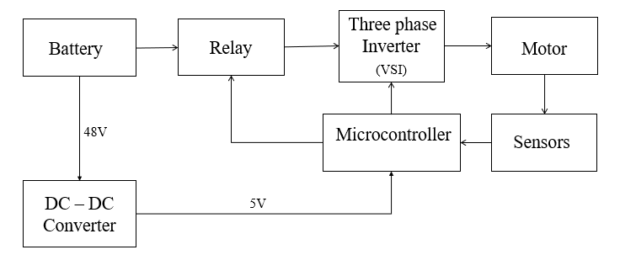
The microcontroller serves as the central unit for executing control and protection tasks. It performs signal acquisition, transformation calculations, PI control, PWM generation, and fault decision-making in real time. The integration of control and diagnostic functions within a single platform ensures fast response, reduced system complexity, and improved reliability. The overall system architecture is shown in Figure 1.
Fig 1: Block Diagram of Proposed System
A. Hardware Components
The proposed PMSM drive system consists of the following key hardware elements:
1.1 Permanent Magnet Synchronous Motor (PMSM)
The PMSM is the primary actuator used in the system. It offers high efficiency, high torque density, and fast dynamic response, making it suitable for electric vehicle applications. The motor operates based on the interaction between the stator’s rotating magnetic field and the rotor’s permanent magnets.
1.2 Three-Phase Voltage Source Inverter (VSI)
A three-phase inverter is used to convert the DC supply from the battery into AC supply required for driving the PMSM. The inverter consists of power semiconductor switches (such as IGBTs or MOSFETs) controlled באמצעות PWM signals generated by the microcontroller.
1.3 Microcontroller Unit (MCU)
The microcontroller acts as the central control unit of the system. It performs:
- Execution of the Field Oriented Control (FOC) algorithm
- Signal processing (Clarke and Park transformations)
- Generation of PWM signals for inverter switching
- Real-time fault detection and decision-making
- Implementation of protection actions (current control / shutdown)
An STM32 or similar high-performance microcontroller is typically used due to its fast processing capability and embedded peripherals.
1.4 Current Sensors
Current sensors are used to measure the stator phase currents of the motor. These measurements are essential for:
FOC control implementation
Torque estimation
Fault detection (including demagnetization analysis)
1.5 Voltage Sensors
Voltage sensing circuits are used to measure the stator or DC bus voltage. These signals help in:
Monitoring system health
Detecting overvoltage or undervoltage conditions
Supporting signal-based fault analysis
1.6 Gate Driver Circuit
Gate driver circuits are used to interface the microcontroller with the power switches of the inverter. They provide necessary voltage and current levels to drive the switching devices safely and efficiently.
1.7 Power Supply Unit
A regulated power supply is used to provide stable DC voltage for the control circuitry, sensors, and gate drivers. It ensures reliable operation of all electronic components.
1.8 Protection Components
Additional protection elements such as fuses, relays, and isolation circuits are included to ensure safe operation during fault conditions and to protect the system from electrical damage.

B. Software Design
The software implementation plays a crucial role in achieving control accuracy and fault detection capability. The major software components are described below:
2.1 Field Oriented Control (FOC) Algorithm
The FOC algorithm is implemented in the microcontroller to achieve decoupled control of torque and flux. It includes:
Clarke Transformation
Park Transformation
PI Controllers for Id and Iq
Inverse Park Transformation
PWM signal generation
This ensures efficient and precise control of the PMSM.
2.2 Signal Acquisition and Processing
Analog signals from current, voltage, and temperature sensors are converted into digital form using ADC modules. These signals are processed in real time for both control and monitoring purposes.
2.3 Fault Detection Algorithm
A real-time fault detection algorithm is implemented to identify:
Overcurrent
Overvoltage
Overtemperature
Demagnetization (based on signal variation)
The algorithm compares measured values with predefined thresholds and expected operating conditions.
2.4 Demagnetization Detection Logic
The software analyzes deviations in current and voltage behavior to detect demagnetization. Based on the severity:
Mild condition: Increase Iq to maintain torque
Severe condition: Trigger system shutdown
This logic is implemented without additional sensors, making the system cost-effective.
2.5 Protection and Control Logic
The control software includes decision-making routines that:
Maintain normal operation under safe conditions
Apply corrective control actions during minor faults
Initiate shutdown during critical faults
2.6 Embedded Programming Environment
The system is programmed using embedded C or similar language. Development tools such as STM32CubeIDE or equivalent platforms are used for coding, debugging, and testing.

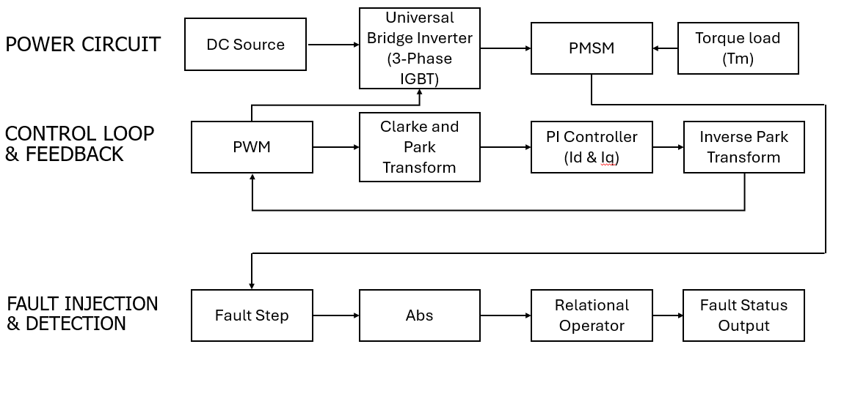
Fig 2 : Block Diagram of PMSM Drive with Field-Oriented Control and Fault Detection Scheme
C. Working Algorithm
The following algorithm describes the sequential operation of the proposed sensorless fault-responsive PMSM drive system with Field Oriented Control (FOC) and demagnetization detection:
Step 1: System Initialization
Initialize the microcontroller, ADC modules, PWM modules, and control parameters.
Set reference values for speed, torque, and current limits.
Define threshold values for fault detection (current, voltage, temperature, and demagnetization limits).
Step 2: Signal Acquisition
Measure three-phase stator currents using current sensors.
Measure stator or DC bus voltage using voltage sensors.
Acquire motor temperature from the temperature sensor.
Convert all analog signals into digital form using ADC.
Step 3: Clarke Transformation
Convert three-phase currents (Ia, Ib, Ic) into two-phase stationary reference frame (Iα, Iβ).
Step 4: Park Transformation
Transform stationary frame currents (Iα, Iβ) into rotating reference frame (Id, Iq) using rotor position information.
Step 5: Reference Generation
Set reference values:
Id reference (flux control, usually zero for PMSM)
Iq reference (based on torque requirement)
Step 6: Current Control using PI Controllers
Compare measured Id and Iq with their reference values.
Process the error signals through PI controllers to generate control voltages (Vd, Vq).
Step 7: Inverse Park and Clarke Transformation
Convert Vd and Vq back to stationary frame (Vα, Vβ).
Convert stationary voltages into three-phase voltages (Va, Vb, Vc).
Step 8: PWM Signal Generation
Generate PWM signals based on the calculated three-phase voltages.
Apply these signals to the inverter to drive the PMSM.
Step 9: Continuous Monitoring
Continuously monitor:
Stator current
Voltage
Compare measured values with predefined safe limits.
Step 10: External Fault Detection
If current exceeds limit → Overcurrent fault
If voltage exceeds limit → Overvoltage fault
Apply immediate protection (current limiting or shutdown if necessary).
Step 11: Demagnetization Detection
Analyze variations in current and voltage signals.
Compare actual current demand with expected torque conditions.
Identify abnormal increase in current indicating reduction in magnetic flux.
Step 12: Fault Classification
a) Mild Demagnetization
If deviation is within acceptable range:
Increase q-axis current (Iq) to compensate for torque loss
Continue motor operation
b) Severe Demagnetization
If deviation exceeds critical threshold:
Classify as severe fault
Step 13: Protective Action
For severe faults:
Disable PWM signals
Shut down inverter operation
Stop the motor safely
Step 14: Loop Execution
Repeat Steps 2 to 13 continuously for real-time operation.
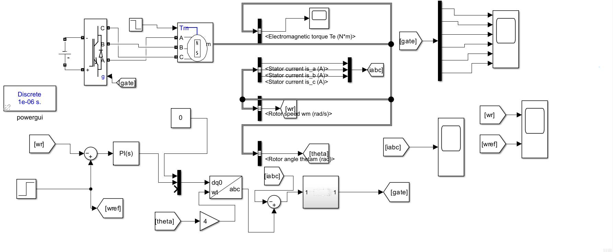
Fig 3 : MATLAB/Simulink implementation of the PMSM drive system with Field Oriented Control (FOC) and feedback loop.
D. Results and Discussion
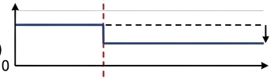
The performance of the Permanent Magnet Synchronous Motor (PMSM) was evaluated under both healthy and demagnetized conditions. A demagnetization fault was initiated at the mid-point of the simulation using a Fault Step trigger to observe the transient and steady-state response of the control system.
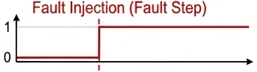
Fig 4 : Fault Trigger fig 5 : Flux Response
1. Fault Trigger and Flux Response
The Fault Step (Fig. 4) signal transitions from 0 to 1, representing the exact moment of fault injection. Consequently, the Rotor Flux Linkage () (Fig. 5) exhibits an instantaneous step reduction. This drop in flux is the primary driver for all subsequent deviations in the motor's electrical and mechanical parameters.
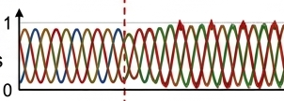

Fig : 6 Stator Current
2. Stator Current Analysis ()
As seen in Fig. 6, the three-phase stator currents remain balanced and sinusoidal during the healthy state. Upon fault injection:
- There is a noticeable increase in the peak amplitude of the stator currents.
- High-frequency distortions appear in the sinusoidal peaks, indicating an increase in total harmonic distortion (THD) due to the magnetic imbalance.
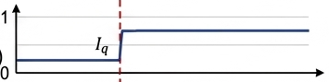
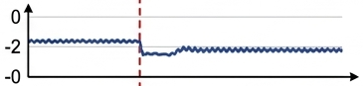

Fig 7 : . Quadrature Current Fig 8 : Direct Current
3. DQ-Axis Current Response
The FOC controller's reaction is best captured in the synchronous reference frame:
- Quadrature Current () (Fig. 7): To maintain the demanded torque despite reduced flux, the speed controller forces a sharp increase in . This validates the inverse relationship between flux and torque-producing current ().
- Direct Current () (Fig. 8): The waveform shows an initial negative transient followed by sustained oscillations. This reflects the controller's struggle to maintain the flux-alignment setpoint under faulty conditions.

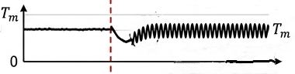

Fig : 9 Electromagnetic Torque
4. Electromagnetic Torque () and Ripple
The Electromagnetic Torque (Fig. 9) shows the most significant mechanical impact:
- Transient Phase: A sharp dip in torque occurs at the fault instant before the PI controllers compensate.
- Steady-State Phase: While the average torque eventually recovers to match the load torque (), it is accompanied by severe torque pulsations. These ripples are a direct result of the non-uniform magnetic field, which can lead to mechanical vibration and long-term bearing wear.


Fig 10 : Fault Detection Performance
5. Fault Detection Performance
The effectiveness of the detection algorithm is illustrated in Fig. 10:
- The logic remains in the "OK" state during normal operation.
- A short detection delay is observed (indicated by the horizontal double-arrow), which represents the time required for the residual signal to exceed the threshold of the relational operator.
- Following this interval, the "FAULT DETECTED" status is successfully triggered, demonstrating the reliability of the proposed detection scheme.
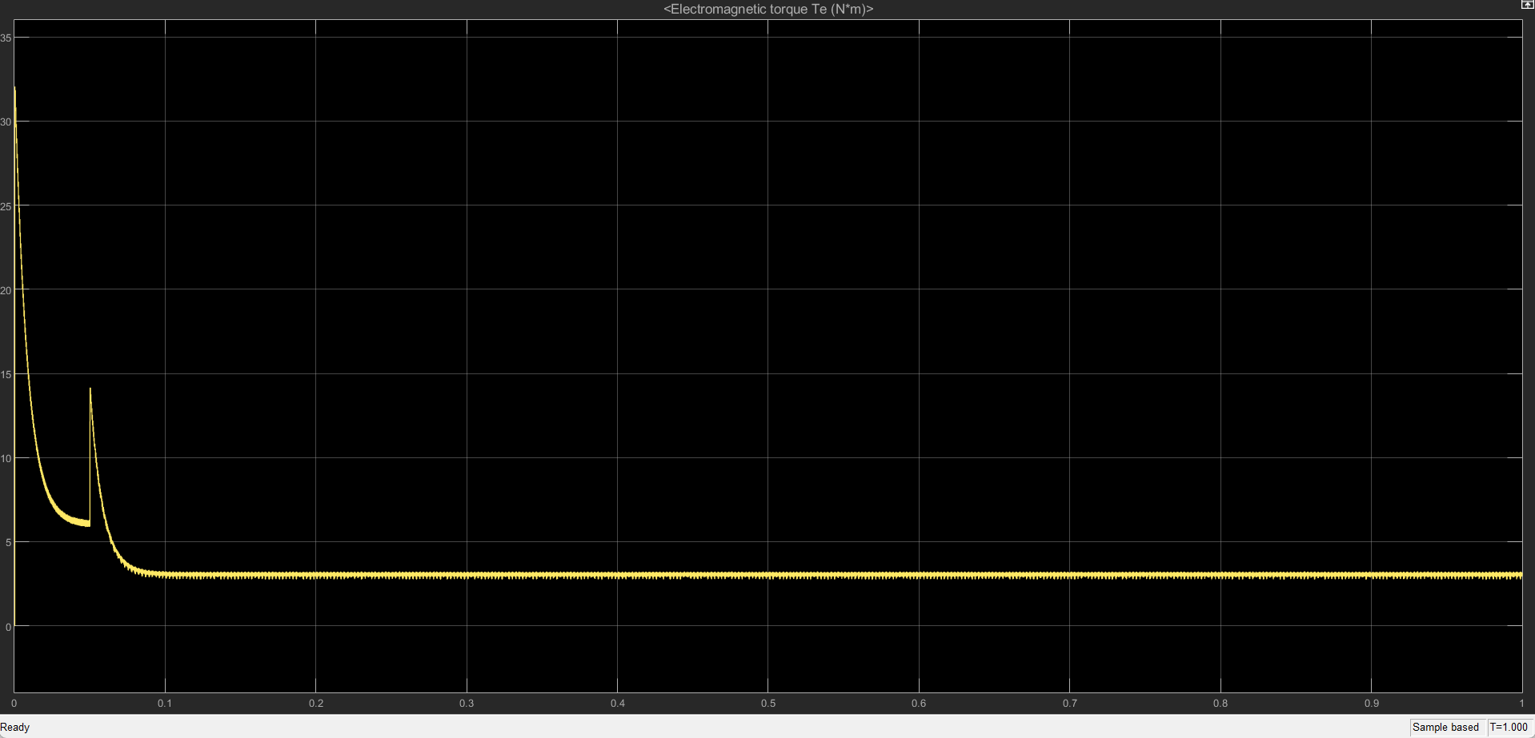

Fig 11 : Simulated output waveform of the Electromagnetic Torque () showing the transition from the starting transient phase to stable steady-state operation at a load.
6. Electromagnetic Torque ()
The output waveform of the Electromagnetic Torque () demonstrates the effectiveness of the Field Oriented Control (FOC) strategy during the motor's startup and steady-state phases.
- Startup Phase: At , the torque reaches a peak value of 32 Nm. This high transient torque is necessary to overcome the rotor's inertia and quickly reach the reference speed.
- Settling Behavior: After a minor overshoot at , the PI controller effectively damps the oscillations, allowing the system to settle within 0.08 seconds.
- Steady-State Phase: From onwards, the torque maintains a constant value of 4 Nm. The waveform is remarkably smooth with negligible ripple, confirming that the FOC and PWM parameters are correctly tuned to match the applied load ().

E. Conclusion of Results
The proposed system demonstrates effective fault detection and control capability for both external and internal faults. The combination of sensor less demagnetization detection and adaptive control actions significantly improves system safety, reliability, and operational continuity, making it suitable for electric vehicle applications.
F. Reference
1.“Demagnetization Fault Diagnosis for PMSM Drive System with Dual Extended Kalman Filter,” Y. Li et al., World Electric Vehicle Journal, vol. 16, no. 2, pp. 112, Feb. 2025.
2.“Non-invasive real-time diagnosis of PMSM faults implemented in motor control software for mission critical applications”, Aselsan A.S., Ankara, Volume 232, 15 June 2024
3.“Fault Diagnosis for PMSM with Demagnetization Fault and Sensor Fault,”Author Y. Kang and L. Yao, IEEE Transactions on Instrumentation and Measurement, vol. 73, 2024.
4.“Fault Detection of Permanent Magnet Synchronous Machines”: An Overview by Henghui Li ORCID,Zi-Qiang Zhu ,ORCID,Ziad Azar ,Richard Clark and Zhanyuan Wu ,Volume 18/ issue 3(2024)
5.“Advanced Control Strategies of PMSM for Battery Electric Vehicle Application”: Authors:Ankit Prajapati , November 2024 20(11s):1139-1149 DOI:10.52783/jes.7390
6.“Performance Comparison of SRM, PMSM & BLDC Motor Drives via Experimentation in Laboratory for EV Application” Authors Sunil Patil, Rakesh Saxena, Yogesh Pahariya vol 11 no.2s (2023)
7.“Autonomous fault detection and diagnosis for permanent magnet synchronous motors using combined variational mode decomposition, the Hilbert-Huang transform, and a convolutional neural networkM”a'd El-Dalahmeh , Maher Al-Greer Volume 110, September 2023
8.“Design and research of permanent magnet synchronous motor controller for electric vehicle” huang Qi,Qiuhong Huang,Hang cheng guo, October 2022 11 , DOI:10.1002/ese3.1316
9.“Development of a PMSM motor field-oriented control algorithm for electrical vehicles” Ramesh ,M. Umavathi , C. Bharatiraja, Volume 65, Part 1, 2022
10."Review of field-oriented control and direct torque control for PMSM drives," A. Jidin, N. N. Jamal, and M. A. Rahman, IEEE Access, Vol. 10, 2022.
11.“Research on a PMSM control strategy for electric vehicles” Authors:Guangliang Liao, Chongqing University ,Wei Zhang, Chuan Cai, December 2021.
12.“Rotor Temperature Safety Prediction Method of PMSM for Electric Vehicle on Real-Time Energy Equivalence” Authors: Anjian Zhou, Changhong Du, Zhiyuan Peng, Qianlei Peng, October 2020.

