AN ADAPTIVE NONLINEAR CONTROL APPROACH FOR QUADROTOR UAV TRAJECTORY TRACKING

Hoàng Bình Ngọc¹ , Vũ Xuân Tùng²* , Lê Thị Thu Hà², Nguyễn Hoài Nam¹, Trần Gia Khánh³

¹Hanoi University of Science and Technology, ²Thainguyen University of Technology, ³Namdinh University of Technology Education

KEYWORDS: Adaptive nonlinear control; Quadrotor UAV; Trajectory tracking; Adaptive fuzzy approximation; Lyapunov stability.

ABSTRACT: Quadrotor unmanned aerial vehicles are nonlinear and underactuated systems whose control performance is strongly affected by model uncertainties and external disturbances. This paper presents an adaptive nonlinear control approach for quadrotor UAV trajectory tracking. The proposed strategy is developed from an adaptive fuzzy control framework for a general second-order nonlinear system, in which the control signal is generated through a Sugeno-type fuzzy structure and the controller parameters are updated online according to adaptive laws derived from the Lyapunov stability criterion. The resulting control architecture is then extended to the position and attitude subsystems of the quadrotor through six control channels with corresponding adaptive parameter update laws. Simulation results show that the quadrotor can follow the prescribed trajectory with stable position and attitude responses, while the tracking errors remain bounded and decrease toward a small neighborhood of zero. The results indicate that the proposed adaptive nonlinear control structure provides good adaptability and satisfactory tracking performance under the considered operating conditions. Therefore, the proposed approach is a feasible solution for quadrotor UAV control in the presence of uncertainties and disturbances.

1. Introduction

In recent decades, unmanned aerial vehicles (UAVs), especially quadrotors, have attracted significant attention because of their wide range of applications in civil, industrial, and military fields, including surveillance, search and rescue, mapping, and environmental monitoring [1], [2]. Despite their mechanical simplicity, quadrotor UAVs exhibit strongly nonlinear, coupled, and underactuated dynamics. In addition, their motion is affected by aerodynamic effects, parameter uncertainty, payload variation, and external disturbances. These features make trajectory tracking and stabilization challenging control problems.

To address these difficulties, many control methods have been proposed for quadrotor systems. Classical linear controllers such as PID and LQR remain attractive because of their simple structure and ease of implementation [3]. Variants such as fuzzy PID and adaptive fuzzy PID have also been investigated to improve control performance [4], [5], while optimization-based tuning methods have been employed to enhance active disturbance rejection control [6]. However, as emphasized in recent review studies [7], controllers based on linearized models often show limited robustness when the operating conditions deviate from the nominal design assumptions.

For this reason, recent research has increasingly focused on nonlinear and intelligent control strategies, including sliding mode control [8], adaptive sliding mode control [9], finite-time sliding-mode-based approaches [10], neural-network-based control [11], and fuzzy-system-based methods [13]–[15]. These approaches generally provide stronger nonlinear compensation and better disturbance-handling capability than conventional linear controllers. Nevertheless, many of them require either a relatively accurate model structure or a more complicated control design.

Motivated by these observations, this paper develops an adaptive nonlinear control approach for quadrotor UAV trajectory tracking using an adaptive fuzzy control framework. The main idea is to construct the control signal through a Sugeno-type fuzzy system and update the controller parameters online through adaptive laws derived from the Lyapunov stability criterion. The approach is first formulated for a general second-order nonlinear system and then extended to the position and attitude dynamics of the quadrotor.

The contribution of the paper is not to introduce an entirely new control theory, but to develop a systematic adaptive nonlinear control structure for quadrotor trajectory tracking and to verify its effectiveness through simulation. In particular, the controller is organized for the position and attitude channels of the quadrotor, allowing the system to handle nonlinear dynamics and uncertainty within a unified adaptive framework.

The remainder of this paper is organized as follows. Section 2 presents the mathematical model of the quadrotor. Section 3 describes the nonlinear control framework. Section 4 develops the control design for the quadrotor. Section 5 presents simulation results and discussion. Finally, Section 6 concludes the paper.

2. Quadrotor Dynamic Model
The mathematical model of the quadrotor is described in the following form:
$\left\{\begin{aligned}&\ddot{x}=\frac{1}{m}\left(C_{ϕ}S_{θ}C_{ψ}+S_{ϕ}S_{ψ}\right)T-\frac{A_{x}}{m}\dot{x}+d_{x} \\ &\ddot{y}=\frac{1}{m}\left(C_{ϕ}S_{θ}S_{ψ}-S_{ϕ}C_{ψ}\right)T-\frac{A_{y}}{m}\dot{y}+d_{y} \\ &\ddot{z}=\frac{1}{m}\left(C_{ϕ}C_{θ}\right)T-g-\frac{A_{z}}{m}\dot{z}+d_{z} \\ &\ddot{ϕ}=\dot{θ}\dot{ψ}\frac{I_{yy}-I_{zz}}{I_{xx}}-\dot{θ}\frac{I_{r}}{I_{xx}}ω_{Γ}+\frac{τ_{ϕ}}{I_{xx}}+d_{ϕ} \\ &\ddot{θ}=\dot{ϕ}\dot{ψ}\frac{I_{zz}-I_{xx}}{I_{yy}}+\dot{ϕ}\frac{I_{r}}{I_{yy}}ω_{Γ}+\frac{τ_{θ}}{I_{yy}}+d_{θ} \\ &\ddot{ψ}=\dot{ϕ}\dot{θ}\frac{I_{xx}-I_{yy}}{I_{zz}}+\frac{τ_{ψ}}{I_{zz}}+d_{ψ}\end{aligned}\right.$ (1)
where the lift force generated by the four rotors is determined as:
$T=k\left(ω_{1}^{2}+ω_{2}^{2}+ω_{3}^{2}+ω_{4}^{2}\right)$, (2)
where $k$ ​ is the lift coefficient, $ω_{i}^{}$ is the angular speed of the i rotor, l is the distance between two opposite rotors, $A_{x}$, $A_{y}$, $A_{z}$ are the inertia moments, $d_{*}$ the disturbance component$*∈\{x,y,z,ϕ,θ,ψ\}$, $x,y,z$ are the coordinates of the quadrotor in the inertial frame, and , $ϕ,θ,ψ$ are the roll, pitch, and yaw angles of the quadrotor.
The torques acting on each rotational axis are:
$\left\{\begin{aligned}&τ_{ϕ}=kl(ω_{4}^{2}-ω_{2}^{2}) \\ &τ_{θ}=kl(ω_{3}^{2}-ω_{1}^{2}) \\ &τ_{ψ}=b(-ω_{1}^{2}+ω_{2}^{2}-ω_{3}^{2}+ω_{4}^{2})\end{aligned}\right.$ (3)
From (2) and (3), the angular velocities of each rotor can be obtained as:
$\left\{\begin{aligned}&ω_{1}=\sqrt{\frac{T}{4k}-\frac{τ_{θ}}{2kl}-\frac{τ_{ψ}}{4b}} \\ &ω_{2}=\sqrt{\frac{T}{4k}-\frac{τ_{ϕ}}{2kl}+\frac{τ_{ψ}}{4b}} \\ &ω_{3}=\sqrt{\frac{T}{4k}+\frac{τ_{θ}}{2kl}-\frac{τ_{ψ}}{4b}} \\ &ω_{4}=\sqrt{\frac{T}{4k}+\frac{τ_{ϕ}}{2kl}+\frac{τ_{ψ}}{4b}}\end{aligned}\right.$ (4)

The mathematical model in (1) will be used to simulate the quadrotor in Section 5

3. Adaptive Nonlinear Control Framework
To address the nonlinear and uncertain characteristics of quadrotor UAVs, this paper adopts an adaptive nonlinear control framework based on adaptive fuzzy approximation. The main idea is to construct the control signal through a nonlinear mapping generated by a Sugeno-type fuzzy system, while the controller parameters are updated online using adaptive laws established from the Lyapunov stability criterion. In this way, the control structure can compensate for uncertain nonlinearities without requiring exact knowledge of the mathematical model.
Consider a general second-order nonlinear system of the form:
$x^{(n)}=f(x,\dot{x},...,x^{(n-1)})+bu$ (5)
where x is the system state, u is the input signal, and f(x) together with the control gain b > 0 are unknown. Let the tracking error vector be defined as
e = [e, ė]ᵀ.
The control law is constructed through a fuzzy basis expansion as
$u_{D}=θ^{T}ζ(x)$ (6)
where ζ(x) is the basis-function vector formed by Gaussian membership functions and Θ is the parameter vector to be adjusted online.
If the system dynamics were exactly known, an ideal control signal could be determined in order to stabilize the tracking error dynamics. In the proposed approach, this ideal signal is approximated by the nonlinear fuzzy-based control structure. Substituting the control law into the system dynamics yields the corresponding closed-loop error model:
$e^{(n)}=-k^{T}e+b(u^{*}-u_{D})$. (8)
where the control gains are selected such that the nominal error system is stable.
For convenience of analysis, the error dynamics are rewritten in state-space form as
$\dot{e}=Λe+b[u^{*}-u_{D}(x,θ)]$ (9)
where the approximation error of the nonlinear fuzzy structure is explicitly taken into account. Let Θ* denote the optimal parameter vector of the fuzzy system, then the approximation residual can be represented through the corresponding minimum reconstruction error. The state equation can therefore be written in the compact form
$\dot{e}=Λe+b(θ^{*}-θ)^{T}ζ\left(Χ\right)-bω$ (10)
To establish the stability of the proposed nonlinear control framework, the Lyapunov function is chosen as
$V=\frac{1}{2}e^{T}Pe+\frac{b}{2γ}{\left(θ^{*}-θ\right)}^{T}\left(θ^{T}-θ\right)$ (11)
where P is a positive definite matrix and γ > 0 is the adaptation gain. Taking the time derivative of the Lyapunov function and selecting the adaptive update law in the form
$\dot{θ}=γe^{T}p_{n}ζ(Χ)$, (12)
it follows that the tracking error remains bounded and evolves toward a neighborhood of the origin.
It should be emphasized that the nonlinear controller used in this paper does not rely on an exact mathematical model of the plant. Instead, it exploits the approximation capability of the fuzzy basis structure together with online parameter adaptation. As a result, the controller is suitable for systems whose dynamics are nonlinear and affected by uncertainty. In the next section, this nonlinear control framework is specialized to the position and attitude dynamics of the quadrotor UAV.

4. Adaptive Nonlinear Control Design for the Quadrotor
In this section, the adaptive nonlinear control framework introduced in Section 3 is applied to the quadrotor UAV. Because the quadrotor is an underactuated system with six state channels but only four independent control inputs, the controller is organized into two coupled loops. The outer loop is responsible for trajectory tracking in the translational coordinates, while the inner loop stabilizes the attitude dynamics. This hierarchical structure allows the nonlinear control law to be implemented in a systematic manner for the full quadrotor system.
4.1. Attitude Control Design
The objective of the attitude loop is to drive the roll, pitch, and yaw angles toward their desired references. Let the attitude tracking errors be defined as
eφ = φ − φd, eθ = θ − θd, eψ = ψ − ψd.
The corresponding error vectors are expressed in second-order form so that the nonlinear control framework of Section 3 can be directly applied.
To construct the control signals for the attitude channels, the basis-function vectors are chosen as
$\left\{\begin{aligned}&ζ(ϕ)=G_{ϕ}(ϕ)⊗G_{\dot{ϕ}}(\dot{ϕ}) \\ &ζ(θ)=G_{θ}(θ)⊗G_{\dot{θ}}(\dot{θ}) \\ &ζ(ψ)=G_{ψ}(ψ)⊗G_{\dot{ψ}}(\dot{ψ})\end{aligned}\right.$ (13)
where Gφ(.), Gθ(.), and Gψ(.) are Gaussian basis vectors, ci denotes the center of each membership function, σi is the width, and ⊗ represents the Kronecker product. These basis vectors provide a nonlinear approximation structure for the roll, pitch, and yaw channels.
Based on the general control law in (6), the attitude control torques are selected as
τφ = Θφᵀζ(φ), τθ = Θθᵀζ(θ), τψ = Θψᵀζ(ψ)
where Θφ, Θθ, and Θψ are the parameter vectors associated with the three attitude channels. The corresponding parameter vectors are updated online using adaptive laws derived from (12). In this way, the roll, pitch, and yaw dynamics are controlled through three nonlinear adaptive channels that compensate for uncertainty in the rotational subsystem.
The main role of the attitude controller is to ensure that the quadrotor orientation follows the desired references generated by the outer-loop motion controller. Since the rotational dynamics are strongly nonlinear and coupled, the adaptive fuzzy-based approximation provides a convenient way to construct a nonlinear control law without requiring exact parameter knowledge.
4.2. Position Control Design
The purpose of the position loop is to achieve trajectory tracking in the translational coordinates x, y, and z. To this end, the following virtual control signals are introduced:
$\left\{\begin{aligned}&u_{x}=\frac{T}{m}(\cos{ϕ}\sin{θ}\cos{ψ}+\sin{ϕ}\sin{ψ}) \\ &u_{y}=\frac{T}{m}(\cos{ϕ}\sin{θ}\sin{ψ}-\sin{ϕ}\cos{ψ}) \\ &u_{z}=\frac{T}{m}(\cos{ϕ}\cos{θ})-g\end{aligned}\right.$ (14)
where ux, uy, and uz denote the virtual translational control inputs. These signals are related to the total thrust and the orientation of the quadrotor, and they provide the interface between the translational and rotational subsystems.
Using these virtual signals, the desired attitude references and the total thrust can be determined for the inner-loop controller. Therefore, the position loop plays the role of generating motion commands, while the attitude loop ensures that the quadrotor orientation evolves consistently with those commands.
The nonlinear control structure for the translational channels is built by defining the basis-function vectors as
$\left\{\begin{aligned}&ζ(x)=G_{x}(x)⊗G_{\dot{x}}(\dot{x}) \\ &ζ(y)=G_{y}(y)⊗G_{\dot{y}}(\dot{y}) \\ &ζ(z)=G_{z}(z)⊗G_{\dot{z}}(\dot{z})\end{aligned}\right.$ (15)
where Gx(.), Gy(.), and Gz(.) are Gaussian basis vectors associated with the translational states and their derivatives. These functions allow the nonlinear terms in the translational dynamics to be represented through adaptive fuzzy approximation.
The virtual control inputs are then generated in the form
ux = Θxᵀζ(x), uy = Θyᵀζ(y), uz = Θzᵀζ(z)
where Θx, Θy, and Θz are the adaptive parameter vectors for the translational channels. Similar to the attitude loop, the online update of these parameters follows the adaptive law given in Section 3. As a result, the translational subsystem is controlled through three nonlinear adaptive channels.
By combining the position loop and the attitude loop, the overall quadrotor controller consists of six nonlinear control channels with six corresponding adaptive parameter update laws. This design provides a unified framework for handling both translational and rotational motion. The resulting controller is expected to maintain stable trajectory tracking even when the system is affected by modeling uncertainty and disturbance.
The next section presents the simulation setup and evaluates the tracking performance of the proposed nonlinear control approach for the quadrotor UAV.

5. Simulation Results and Discussion
The quadrotor parameters used in the simulation are selected as follows:
Parameter | Value | Parameter | Value
$$m$$ | 1.21 | g | 9.8
$$k$$ | 2.98e-5 | $$I_{xx}$$ | 0.01
$$b$$ | 3.23e-7 | $$I_{yy}$$ | 0.01
$$l$$ | 0.25 | $$I_{zz}$$ | 0.0148
Consider the reference trajectory as follows:
$\left\{\begin{aligned}&x_{d}=\cos{(}\frac{π}{20}t) \\ &y_{d}=\sin{(}\frac{π}{20}t) \\ &z_{d}=1; ψ_{d}=0 \\ &\end{aligned}\right.$

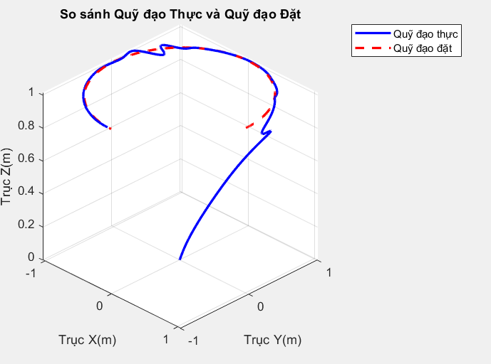  Figure 1. Quadrotor trajectory response | 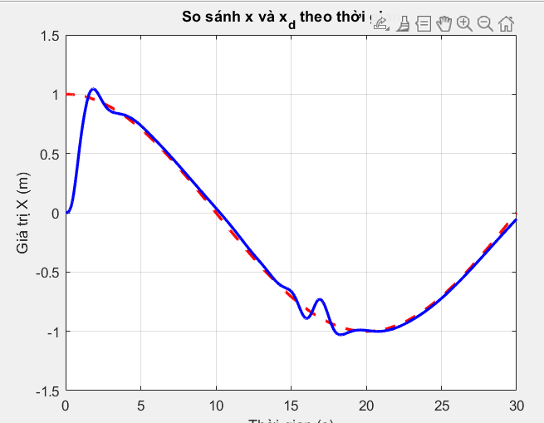  Figure 2. Quadrotor position along the x-axis
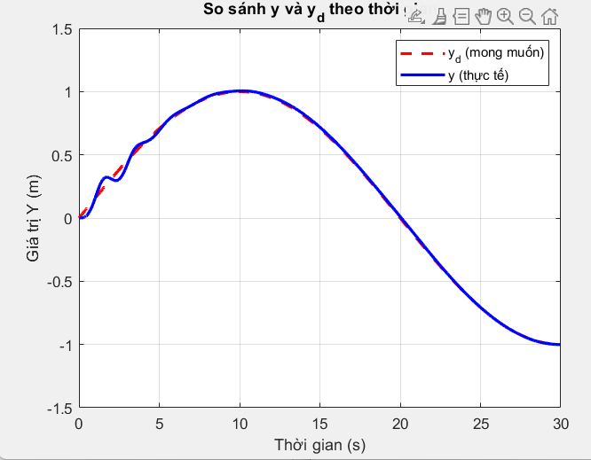  Figure 3. Quadrotor position along the y-axis | 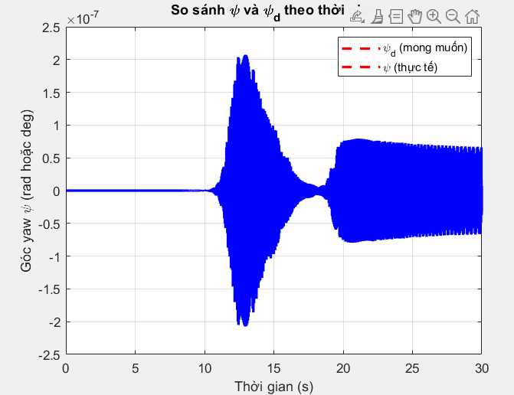  Figure 4. Angle $ψ$
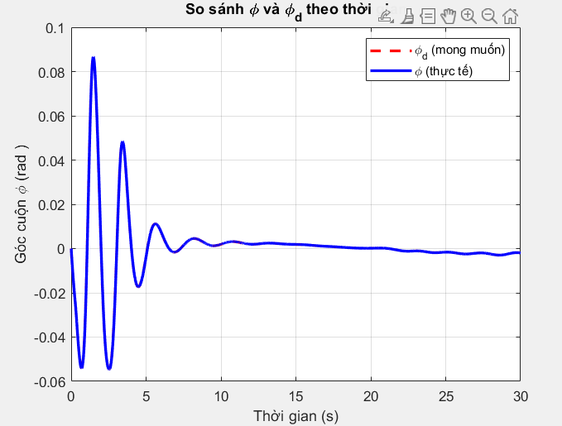  Figure 5. Angle $ϕ$ | 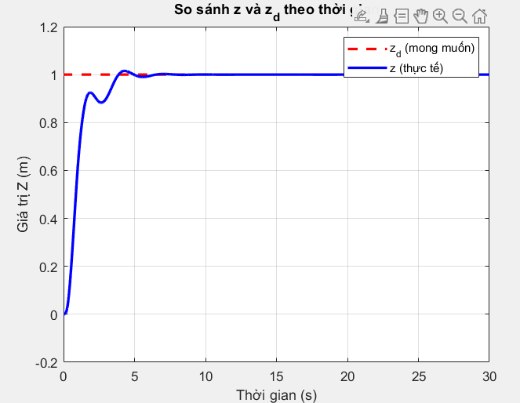  Figure 6. Quadrotor position along the z-axis
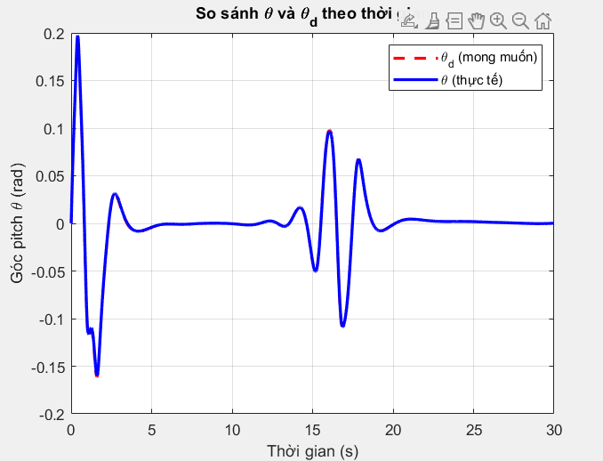
Figure 7. Angle $θ$

To evaluate the effectiveness of the proposed adaptive nonlinear control approach, simulations were carried out on the quadrotor model described in Section 2. The model parameters used in the simulations are listed in Table 1. These parameters represent the mass, gravitational acceleration, lift coefficient, drag moment coefficient, arm length, and inertia values of the quadrotor.

A reference trajectory was specified in order to assess the trajectory-tracking capability of the closed-loop system. The position responses of the quadrotor along the x, y, and z axes, together with the attitude responses in roll, pitch, and yaw, were recorded. The obtained results are illustrated in Figures 1 to 7.

Figure 1 shows the overall trajectory response of the quadrotor. It can be observed that the actual trajectory follows the reference path closely, indicating that the proposed nonlinear control structure is able to coordinate the translational and rotational dynamics effectively. This result confirms that the controller provides satisfactory tracking performance for three-dimensional motion.

The position responses shown in Figures 2, 3, and 6 indicate that the quadrotor tracks the desired motion along the x, y, and z axes with acceptable transient behavior. The responses gradually converge to the reference signals and remain stable throughout the simulation interval. This behavior suggests that the outer-loop control structure can generate suitable motion commands for the translational subsystem even in the presence of nonlinear coupling.

The attitude responses in Figures 4, 5, and 7 show that the roll, pitch, and yaw angles remain bounded and evolve smoothly toward their desired values. This demonstrates that the inner-loop controller is capable of stabilizing the rotational dynamics and supporting the motion commands generated by the position loop. Although transient deviations are present in the initial stage, they decay over time without causing instability.

Overall, the simulation results indicate that the proposed adaptive nonlinear control approach can provide stable trajectory tracking for the quadrotor UAV. The adaptive control structure allows the system to adjust to uncertainty in the model and maintain bounded tracking errors during operation. These results support the applicability of the proposed method to quadrotor systems with nonlinear and uncertain dynamics.

6. Conclusion
This paper presented an adaptive nonlinear control approach for quadrotor UAV trajectory tracking. The proposed method was developed from an adaptive fuzzy approximation framework for a general second-order nonlinear system and then extended to the position and attitude dynamics of the quadrotor. The resulting control structure consists of six adaptive nonlinear control channels with corresponding parameter update laws.

Simulation results demonstrated that the quadrotor can follow the prescribed reference trajectory with stable translational and rotational responses. The position and attitude errors remain bounded and decrease over time, indicating that the proposed adaptive nonlinear control structure is capable of handling the nonlinear and underactuated nature of the quadrotor system.

The main advantage of the proposed approach is that it does not rely on exact knowledge of the plant dynamics and can adapt online to uncertain operating conditions through parameter adjustment. For this reason, the method is a feasible candidate for quadrotor UAV control in the presence of model uncertainty and external disturbance.

Future work will focus on comparative evaluation with other nonlinear controllers, improved robustness under stronger disturbances, and experimental validation on a real quadrotor platform..

Acknowledgment: This work was supported by the project code T2025-NCS04 funded by Thai Nguyen University of Technology (TNUT).

REFERENCES

[1] M. Maaruf, M. S. Mahmoud, and M. A. Al-Ma’arif, "A survey of control methods for quadrotor UAV," Int. J. Robot. Control Syst., Vol. 2, No. 4, pp. 652–665, 2022.
[2] S. H. Derrouaoui, Y. Bouzid, A. Belmouhoub, M. Guiatni, H. Siguerdidjane, "Recent Developments and Trends in Unconventional UAVs Control: A Review," J Int Rob Syst, 109, 68, 2023.
[3] S. Khatoon, D. Gupta and L. K. Das, "PID & LQR control for a quadrotor: Modeling and simulation," 2014 International Conference on Advances in Computing, Communications and Informatics (ICACCI), Delhi, India, 2014, pp. 796-802.
[4] Gedefaw, E. A. et al, “ Improved trajectory tracking control using fuzzy PID surface for quadrotor UAV,” PLoS ONE, 19(11), pp. 1-36, 2024.
[5] Yasmine, Z. “Adaptive fuzzy logic control of quadrotor UAV,” International Journal of Robotics and
Control Systems, Vol. 4, No. 4, pp. 2095-2118, 2024.
[6] C. Peng, Y. Tian, et al., "ADRC trajectory tracking control based on PSO algorithm for a quad-rotor," In: 2013 IEEE 8th Conference on Industrial Electronics and Applications (ICIEA), pp. 800–805, 2013.
[7] P. J. D. de Oliveira Evald, V. M. Aoki, et al., "A review on quadrotor attitude control strategies," Int. J. Intell. Robot. Appl., pp. 1–21, 2024.
[8] Y. Huang, J. Chen, and H. Zhang, "Sliding mode control for quadrotor UAVs: A review of recent advancements," Journal of Intelligent & Robotic Systems, Vol. 94, pp. 211–225, 2019.
[9] Ren, Z. et al,” Adaptive fault-tolerant control for quadrotor UAV based on fuzzy gain sliding mode,”
Journal of Northeastern University, pp209-216, 2024
[10] Dou, J. et al. “ Trajectory tracking and formation control for quadrotor UAVs,” Scientific Reports, 15, 24039, pp. 1-30, 2025.
[11] T. Dierks and S. Jagannathan, "Output feedback control of a quadrotor UAV using neural networks," IEEE Trans. Neural Netw., Vol. 21, No. 1, pp. 50–66, 2010
[12] Z. Xu, T. Yan, S. X. Yang, and S. A. Gadsden, “Bioinspired backstepping sliding mode control and adaptive sliding innovation filter of quadrotor unmanned aerial vehicles,” Biomimetic Intelligence and Robotics, vol.3, no. 3, 2023.
[13] Li, C. et al, “Adaptive fuzzy tracking control for quadrotor UAV with disturbance observer,” Aerospace Science and Technology, vol. 128, 107784, pp. 1-11, 2022.
[14] Zhou, L. et al, “ Fuzzy adaptive backstepping trajectory tracking control for quadrotor systems,” International Journal of Fuzzy Systems, 2024
[15] Wei, P. et al, ” Adaptive backstepping neural control for quadrotor UAVs under disturbances,” Expert Systems with Applications, 296, pp. 1-24, 2025
[16] Tran, V. P. et al.” Robust fuzzy Q-learning tracking control for quadrotor systems,” IEEE Robotics research. 2022
[17] B. Erginer and E. Altug, "Design and implementation of a hybrid fuzzy logic controller for a quadrotor VTOL vehicle," International Journal of Control, Automation and Systems, Vol. 10, pp. 61–70, 2012.
[18] L. A. Zadeh, "Fuzzy sets," Information and Control, Vol. 8, No. 3, pp. 338–353, 1965.
[19] L. X. Wang, "Stable adaptive fuzzy control of nonlinear systems," IEEE Trans. Fuzzy Syst., Vol. 1, No. 2, pp. 146–155, 1993.
[20] S. Labiod and T. M. Guerra, "Adaptive fuzzy control of a class of SISO non-affine nonlinear systems," Fuzzy Sets and Systems, Vol. 158, No. 10, pp. 1126–1137, 2007.
[21] J. S. R. Jang, "ANFIS: adaptive-network-based fuzzy inference system," IEEE Trans. Syst., Man, Cyber.

