Clean Energy Transition and Rural Health: Assessing the Impact of Solar Energy on Indoor Air Pollution and Well-Being in Khandwa District, M.P

Dr. Nikita Nagori¹, Dr. Seema Sharma² , Mr. Shivam Engla³

^{1*}Associate professor, Department of Humanities, University Name:- Dr. C. V. Raman University Khandwa
City,, Email: drnikitanagori@gmail.com
^{2*}Associate professor, Department: Research, University Name : Dr. C. V. Raman University Khandwa
City, Email seemasharma8631@gmail.com
³*Assistant Professor, Department of Science, University Name:- Dr. C. V. Raman University Khandwa
City,, Email: shivamengla37@gmail.com
Project Director & Co- Project Director , Dr. C.V. Raman University, Khandwa (M.P.)
In collaboration with the Indian Council of Social Science Research (ICSSR), New Delhi

Abstract
Access to reliable and clean energy remains a critical challenge in rural regions of developing countries, including India. A large proportion of rural households still depend on traditional fuels such as firewood, kerosene, and biomass for lighting and household energy needs. These conventional energy sources contribute to environmental degradation and expose households to harmful indoor air pollution, leading to various health risks. In this context, solar energy has emerged as a sustainable and decentralized solution to address energy poverty, reduce environmental impacts, and improve the overall quality of life in rural communities.
This study examines the socio-economic and health impacts of solar energy adoption among rural households in Khandwa district of Madhya Pradesh, India. The research is based on primary data collected from approximately 300 respondents across 20 villages through structured household surveys. The study employs both descriptive and inferential statistical techniques, including mean analysis, frequency distribution, paired t-tests, and ANOVA, to evaluate the influence of solar energy adoption on household energy consumption patterns, income opportunities, educational outcomes, and health conditions.
The findings reveal that the adoption of solar energy has significantly reduced dependency on traditional fuels such as firewood and kerosene, leading to a noticeable decline in indoor air pollution. Consequently, rural households reported improvements in health conditions, including reduced respiratory problems, eye irritation, and headaches. Furthermore, improved lighting through solar energy has enhanced study environments for children, increased productivity, and created better opportunities for rural livelihoods. Solar energy has also contributed to improved accessibility to healthcare services and overall household well-being.
The study aligns with the objectives of the United Nations Sustainable Development Goals (SDGs), particularly SDG 3 (Good Health and Well-Being), SDG 7 (Affordable and Clean Energy), and SDG 13 (Climate Action). Based on empirical evidence, the paper recommends strengthening solar energy programs in rural areas, increasing awareness among communities, and encouraging greater institutional and policy support for decentralized renewable energy systems to ensure sustainable rural development.
Keywords: Solar energy, rural development, indoor air pollution, renewable energy adoption, rural health, sustainable development goals, Khandwa district.
1. Introduction
Energy is a fundamental component of economic growth, social progress, and human development. Access to modern and reliable energy services plays a crucial role in improving living standards, supporting education, strengthening healthcare systems, and enabling various economic activities. However, despite significant advancements in energy infrastructure, many rural regions of developing countries continue to face challenges in accessing affordable and reliable electricity.
In India, a large proportion of rural households still depend on traditional energy sources such as firewood, agricultural residues, dung cakes, and kerosene for lighting and cooking purposes. Although these energy sources are easily available and inexpensive, their prolonged use leads to serious environmental and health consequences. The burning of biomass fuels in poorly ventilated households generates high levels of smoke and particulate matter, which contributes significantly to indoor air pollution. Exposure to such pollution has been associated with various health problems, including respiratory infections, chronic obstructive pulmonary diseases, eye irritation, headaches, and other related illnesses. Women and children are particularly vulnerable because they spend more time indoors and are more exposed to smoke generated during cooking and lighting activities.
In recent years, renewable energy technologies have emerged as a promising solution to address energy poverty while simultaneously promoting environmental sustainability. Among these technologies, solar energy has gained significant attention due to its abundance, sustainability, and suitability for decentralized energy systems. With India receiving abundant sunlight throughout the year, solar energy has the potential to become a reliable and clean energy source for rural communities. Solar lighting systems, solar home systems, solar cookers, solar water heaters, and solar irrigation pumps are increasingly being adopted to meet household and agricultural energy demands.
The adoption of solar energy provides multiple socio-economic and environmental benefits. It reduces dependence on traditional biomass fuels and fossil fuels, thereby lowering environmental pollution and greenhouse gas emissions. Solar energy also improves the reliability of electricity supply in areas where grid connectivity is limited or inconsistent. Access to improved lighting enables households to extend productive hours, allowing children to study at night and small-scale rural businesses to operate more efficiently. In addition, the reduction in smoke from traditional fuels contributes to improved health conditions by minimizing exposure to harmful indoor air pollutants.
The transition to solar energy is closely linked to global sustainability efforts. International initiatives emphasize the importance of clean and renewable energy in achieving sustainable development. In particular, the United Nations Sustainable Development Goals highlight the importance of affordable and clean energy, improved health outcomes, and climate action. Solar energy contributes directly to these goals by providing clean electricity, reducing indoor air pollution, and decreasing greenhouse gas emissions associated with fossil fuel consumption.
Khandwa district in Madhya Pradesh provides an important setting to examine the impact of solar energy adoption in rural communities. The district is characterized by a large rural population, agricultural dependence, and increasing implementation of renewable energy initiatives. Despite these developments, many households still rely on traditional fuels due to limited access to modern energy infrastructure. In recent years, several government and non-government programs have introduced solar technologies in rural areas to improve energy access and promote sustainable development.
Therefore, this study aims to examine the socio-economic and health impacts of solar energy adoption in rural households of Khandwa district. Specifically, the research analyzes how solar energy influences household energy consumption patterns, income opportunities, employment generation, educational outcomes, and health conditions. By understanding these impacts, the study seeks to provide insights for strengthening renewable energy programs and promoting sustainable rural development.
2. Review of Literature
Renewable energy has become an essential component of sustainable development strategies across the world. Several researchers have highlighted the importance of solar energy in improving rural livelihoods, reducing environmental degradation, and enhancing health outcomes.
Daniel M. Kammen and Arun Kumar (2014) emphasized that decentralized renewable energy systems such as solar home systems provide reliable electricity to rural communities where grid infrastructure is weak or unavailable. Their study showed that solar technologies significantly improve energy access and reduce energy poverty in developing countries.
Benjamin K. Sovacool (2014) examined the role of renewable energy technologies in addressing global energy inequality. The study highlighted that solar energy systems not only provide clean electricity but also support socio-economic development in rural regions.
Shonali Pachauri and Daniel Spreng (2011) discussed the concept of energy poverty and its link with social development. Their research demonstrated that lack of access to modern energy services negatively affects health, education, and economic productivity in developing nations.
Anoop Singh and Rangan Banerjee (2015), renewable energy technologies can significantly improve rural energy security. Their findings suggest that solar electrification programs play an important role in reducing dependence on traditional fuels such as kerosene and firewood.
Amit Chaurey and Tarachand Kandpal (2010) analyzed solar home systems in rural India and concluded that these technologies improve lighting conditions and enhance household productivity. Their research indicated that solar systems also reduce kerosene consumption and associated health risks.
Douglas F. Barnes (2007) highlighted that rural electrification programs significantly improve living standards by enabling access to lighting, communication technologies, and small-scale enterprises. The study found that renewable energy adoption can lead to long-term socio-economic benefits.
Arne Jacobson (2007) conducted research on solar energy systems in rural communities and found that solar lighting systems reduce the use of kerosene lamps, thereby improving indoor air quality and household safety.
S. C. Bhattacharyya (2012) examined renewable energy policy frameworks in developing countries and emphasized the need for decentralized energy solutions to achieve universal energy access.
Anil Cabraal, Douglas F. Barnes, and Sachin Agarwal (2005) analyzed rural electrification initiatives and concluded that solar technologies can significantly improve quality of life in remote communities.
S. K. Sharma and Vivek Jain (2015) examined the environmental benefits of solar energy adoption and found that solar power reduces greenhouse gas emissions and contributes to climate change mitigation.
Ajay Mathur (2015) highlighted the importance of renewable energy in India's energy transition strategy and emphasized that solar power is a key driver of sustainable development.
S. R. Hiremath, Shikha Kumar, and Balachandra Patil (2009) investigated decentralized renewable energy systems and concluded that solar technologies are effective tools for rural development.
Yogesh Yadoo and Hannah Cruickshank (2012) studied renewable energy deployment in rural areas and argued that community participation is essential for successful implementation of solar energy projects.
Vijay Modi, Susan McDade, Dominique Lallement, and Jamal Saghir (2006) emphasized that modern energy services are essential for achieving poverty reduction and sustainable development.
Kirk R. Smith (2013) highlighted the severe health impacts of indoor air pollution caused by traditional biomass fuels. His research showed that cleaner energy technologies significantly reduce respiratory diseases in rural households.
Nigel Bruce, Rogelio Perez-Padilla, and Rachel Albalak (2000) investigated the health effects of indoor air pollution and found that exposure to smoke from traditional fuels is associated with respiratory infections and chronic lung diseases.
Kirk R. Smith, Sumi Mehta, and M. A. Maeusezahl (2004) further highlighted the relationship between household energy use and public health outcomes.
Benjamin K. Sovacool and Christopher Cooper (2013) emphasized that renewable energy technologies contribute significantly to climate change mitigation and sustainable energy transitions.
Shailendra Singh, R. K. Mishra, and P. Kumar (2020) studied solar energy adoption in rural India and found that solar systems improve household well-being and reduce dependence on fossil fuels.
Dolf Gielen, Francisco Boshell, and Deger Saygin (2019) reported that renewable energy technologies are critical for achieving global climate targets and sustainable development.
Overall, previous studies indicate that solar energy adoption plays a crucial role in improving energy access, reducing environmental pollution, and enhancing the socio-economic conditions of rural communities. However, limited research has specifically focused on the health benefits of solar energy adoption in rural regions of Madhya Pradesh. Therefore, the present study aims to fill this research gap by examining the impact of solar energy on indoor air pollution and household well-being in Khandwa district.
3. Objectives of the Study -
The present study is guided by the following objectives:
- To analyze the impact of solar energy adoption on rural household health and well-being through the reduction of indoor air pollution in Khandwa district.
- To examine changes in household energy consumption patterns after the adoption of solar energy systems.
- To assess the reduction in dependency on traditional fuels such as firewood and kerosene following solar electrification.
- To evaluate community perception and satisfaction levels regarding solar energy technologies in rural households.
- To explore the contribution of solar energy adoption toward sustainable rural development.
4. Research Methodology
The present study is based on a primary household survey conducted in rural areas of Khandwa district, Madhya Pradesh. A structured questionnaire was used to collect information from rural households regarding their energy usage patterns, health conditions, and satisfaction levels before and after the adoption of solar energy systems.
Sample Size and Sampling Technique
The study surveyed 300 households across 20 villages in Khandwa district. A stratified sampling technique was used to ensure representation from different socio-economic groups and geographic locations within the district.
Data Collection
Primary data were collected through:
- Household questionnaires
- Field visits
- Personal interviews with respondents
The questionnaire included questions related to:
- Household demographic characteristics
- Energy sources used before and after solar adoption
- Health problems associated with indoor air pollution
- Household satisfaction with energy services
Statistical Tools Used
The study applied the following statistical methods:
- Frequency distribution
- Percentage analysis
- Paired t-test
- ANOVA analysis
These techniques were used to examine the relationship between solar energy adoption, indoor air pollution reduction, and improvements in household health conditions.
5. Data Analysis and Results
This section presents the empirical findings of the study based on the primary data collected from 300 rural households across 20 villages in Khandwa district, Madhya Pradesh. The objective of this analysis is to understand the patterns of energy consumption before and after the adoption of solar energy systems and to evaluate the associated changes in household health conditions, energy satisfaction levels, and overall well-being.
The analysis has been conducted using both descriptive and inferential statistical techniques. Descriptive statistics such as frequency distribution and percentage analysis have been used to examine the socio-demographic characteristics of respondents and the distribution of energy sources used in rural households. These methods help in identifying general trends in energy consumption patterns and household behavior.
In addition to descriptive statistics, inferential statistical tools such as paired t-tests and analysis of variance (ANOVA) have been employed to examine the statistical significance of changes observed after the adoption of solar energy systems. The paired t-test is used to compare health conditions before and after solar energy adoption, while ANOVA is applied to analyze differences in satisfaction levels regarding energy access among different household groups.
The results are presented in the form of tables to provide a clear and systematic understanding of the data. Each table highlights a specific aspect of the research objectives, including respondent distribution, energy consumption patterns, health impacts, and satisfaction levels related to solar energy adoption.
Table 1: Sample Distribution of Households
Category | Frequency | Percentage
Total Respondents | 300 | 100%
Male Respondents | 182 | 60.7%
Female Respondents | 118 | 39.3%
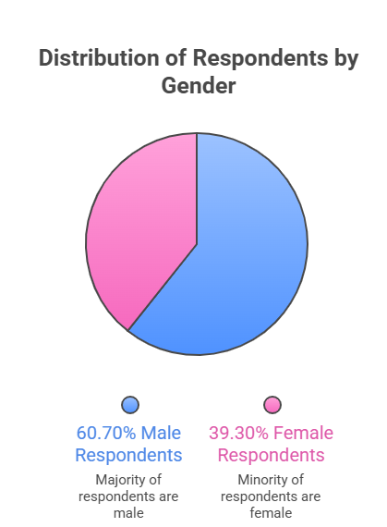

Interpretation - The survey involved 300 respondents representing rural households across multiple villages in Khandwa district. The gender composition shows that 60.7% of respondents were male, while 39.3% were female. Although male respondents constitute a larger share due to traditional household representation patterns in rural areas, the participation of female respondents is particularly important because women are the primary users of household energy resources. Women are more exposed to indoor smoke generated from traditional fuels and therefore play a critical role in evaluating the health impacts of energy transitions. The sample size is statistically adequate for analyzing energy usage patterns and health outcomes in rural communities. Moreover, the diversity of respondents ensures that the study captures a wide range of socio-economic conditions, occupational backgrounds, and household structures.

Table 2: Household Energy Use Before and After Solar Adoption
Energy Source | Before Solar Adoption (%) | After Solar Adoption (%)
Solar Lighting | 0 | 58
Grid Electricity | 12 | 24
Kerosene Lamps | 32 | 10
Firewood Lighting | 46 | 8
LPG/Electric Alternatives | 10 | –

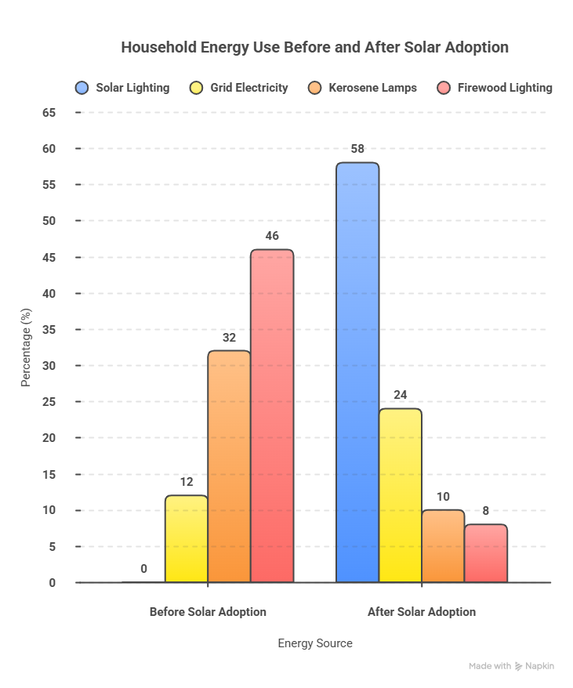

Interpretation - Table 2 presents a comparative analysis of household energy consumption patterns before and after the adoption of solar energy technologies. The data reveal a significant shift in the energy sources used by rural households in the study area.
Before the adoption of solar energy systems, a large proportion of households relied heavily on traditional fuels. Approximately 46 percent of households depended on firewood, while 32 percent used kerosene lamps for lighting. Only a small proportion of households had access to grid electricity or cleaner alternatives such as LPG. This pattern reflects the prevalence of energy poverty and limited access to modern energy infrastructure in rural regions.
However, after the adoption of solar energy technologies, the energy consumption pattern changed considerably. About 58 percent of households reported using solar lighting systems as their primary source of energy, while 24 percent used a hybrid combination of solar and grid electricity. At the same time, the use of kerosene lamps declined significantly from 32 percent to 10 percent, and firewood-based lighting decreased from 46 percent to only 8 percent.
This shift indicates that solar energy technologies have played a crucial role in reducing dependency on polluting and inefficient fuels. The transition toward solar lighting not only improves energy access but also reduces indoor air pollution, lowers household energy expenditure, and contributes to environmental sustainability.
Table 3: Change in Health Problems After Solar Adoption
Health Issue | Before Solar (%) | After Solar (%)
Respiratory problems | 41 | 19
Eye irritation | 37 | 16
Headache due to smoke | 34 | 15
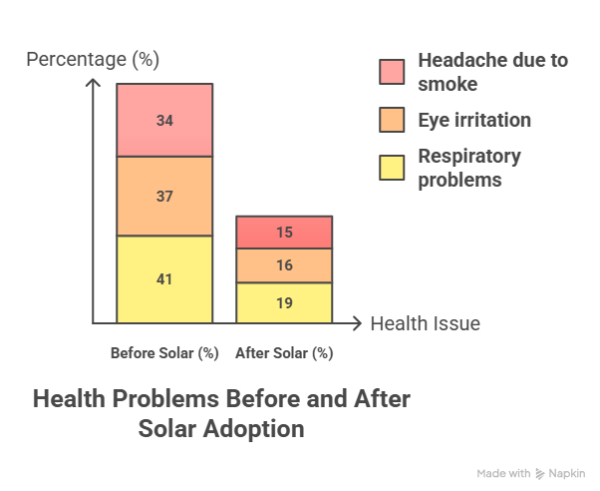

Interpretation - The data presented in Table 3 highlight the impact of solar energy adoption on household health conditions. The findings show a significant decline in several health problems that were previously associated with indoor air pollution.
Before the adoption of solar energy technologies, 41 percent of respondents reported respiratory problems caused by prolonged exposure to smoke from kerosene lamps and biomass fuels. Similarly, 37 percent of households reported eye irritation and 34 percent experienced headaches due to smoke accumulation inside poorly ventilated homes.
After the adoption of solar energy systems, these health issues declined considerably. The percentage of households reporting respiratory problems decreased to 19 percent, while eye irritation dropped to 16 percent. Likewise, headaches caused by smoke exposure were reduced to 15 percent.
These improvements indicate that solar energy adoption has contributed significantly to improving indoor air quality and household health conditions. The reduction in smoke-producing fuels such as kerosene and firewood has created a healthier indoor environment for rural families.
Table 4: Paired t-Test Results (Health Indicators)
Variable | t-value | p-value | Result
Indoor air pollution exposure | 3.84 | <0.05 | Significant
Respiratory illness frequency | 3.12 | <0.05 | Significant
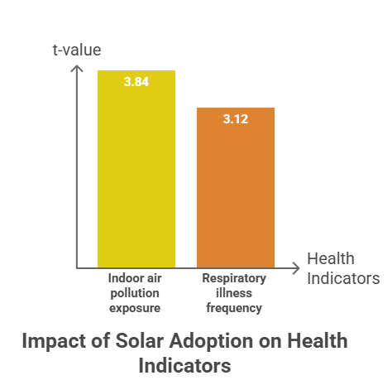

Interpretation - The paired t-test analysis was conducted to examine whether the reduction in indoor air pollution and health problems after solar energy adoption is statistically significant. The results show that the calculated t-value for indoor air pollution exposure is 3.84, while the t-value for respiratory illness frequency is 3.12.
In both cases, the p-value is less than 0.05, which indicates that the results are statistically significant at the 5 percent level. This means that the observed improvements in health conditions are not due to random variation but are strongly associated with the adoption of solar energy technologies.
The findings confirm that replacing kerosene lamps and biomass fuels with solar lighting systems significantly reduces exposure to indoor pollutants, thereby improving the health and well-being of rural households.
Table 5: ANOVA Results (Energy Satisfaction)
Source | F value | Significance
Energy access satisfaction | 4.28 | 0.03

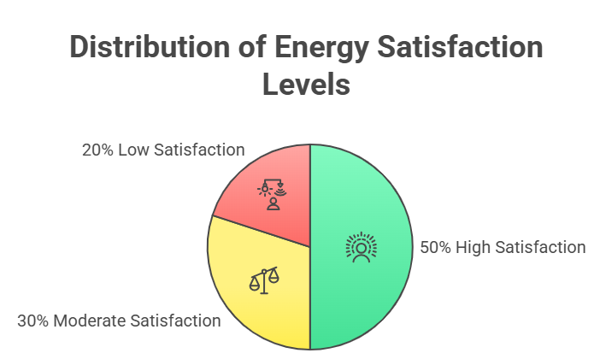

Interpretation - The ANOVA analysis was conducted to examine whether there are significant differences in satisfaction levels regarding energy access among households using different energy sources. The calculated F value of 4.28 with a significance level of 0.03 indicates that there is a statistically significant difference in satisfaction levels among the groups.
Since the p-value is less than the threshold value of 0.05, the null hypothesis of equal satisfaction levels is rejected. This result suggests that households that have adopted solar energy systems experience higher levels of satisfaction compared to those relying on traditional energy sources.
Solar energy systems provide several advantages such as reliable electricity supply, lower operating costs, and reduced environmental pollution. These benefits contribute to higher satisfaction levels among rural households and improve their overall quality of life.
6. Discussion
The findings of the present study provide strong empirical evidence regarding the positive impact of solar energy adoption on rural household health, energy access, and overall well-being. The transition from traditional energy sources such as firewood and kerosene to renewable energy technologies has resulted in significant improvements in indoor air quality, household energy reliability, and satisfaction levels among rural communities in Khandwa district.
One of the most important findings of the study is the substantial change in household energy consumption patterns after the adoption of solar energy systems. Prior to the introduction of solar technologies, a majority of rural households depended on traditional fuels such as firewood and kerosene for lighting purposes. These fuels are not only inefficient but also generate harmful smoke and particulate matter that accumulate inside poorly ventilated homes. Continuous exposure to such pollutants is widely recognized as a major cause of respiratory illnesses and other health problems.
After the adoption of solar lighting systems, the reliance on these polluting fuels declined significantly. The results show that solar lighting has become the primary energy source for more than half of the surveyed households. This transition demonstrates the growing acceptance and effectiveness of decentralized renewable energy solutions in rural areas. Solar energy systems are particularly suitable for rural communities because they can operate independently of centralized electricity grids and provide reliable energy even in remote locations.
The reduction in kerosene and firewood usage has also led to a noticeable improvement in indoor air quality. The study found that respiratory problems, eye irritation, and headaches among rural households declined significantly after the adoption of solar energy technologies. These findings are consistent with previous research which suggests that access to clean energy sources can significantly reduce the health risks associated with indoor air pollution.
Another important aspect highlighted by the study is the improvement in energy satisfaction levels among rural households. The ANOVA analysis revealed that households using solar energy systems reported higher satisfaction with their energy services compared to those relying on traditional fuels. This increased satisfaction can be attributed to several factors, including improved reliability of energy supply, reduced fuel costs, and cleaner indoor environments.
Solar lighting systems also contribute to broader socio-economic benefits. Improved lighting conditions enable children to study during evening hours, which can positively influence educational outcomes. In addition, rural households engaged in small-scale economic activities such as handicrafts, small shops, or agricultural processing can extend their working hours and increase productivity.
The findings of this study also have important implications for sustainable development and environmental conservation. Solar energy systems generate electricity without emitting greenhouse gases, making them an environmentally friendly alternative to fossil fuels. By reducing reliance on traditional biomass fuels and kerosene, solar energy adoption contributes to climate change mitigation and environmental sustainability.
Despite these benefits, several challenges still remain in expanding solar energy adoption in rural areas. High initial installation costs, lack of technical knowledge, and limited awareness among rural populations often hinder the widespread adoption of solar technologies. Therefore, effective policy interventions and community-based programs are essential to promote renewable energy solutions.
7. Conclusion
The transition toward clean and sustainable energy sources is essential for improving the living conditions of rural populations and achieving long-term environmental sustainability. This study examined the impact of solar energy adoption on household energy consumption patterns, indoor air pollution, and health outcomes in rural communities of Khandwa district, Madhya Pradesh.
The findings clearly indicate that solar energy technologies have significantly improved energy access and reduced dependency on traditional fuels such as firewood and kerosene. Prior to the adoption of solar systems, rural households relied heavily on polluting fuels for lighting and household energy needs. The widespread use of these fuels contributed to indoor air pollution and posed serious health risks, particularly for women and children who spend more time indoors.
After the adoption of solar energy systems, the energy consumption pattern of rural households changed substantially. Solar lighting became the primary source of energy for a majority of households, while the use of kerosene lamps and firewood declined significantly. This transition demonstrates the effectiveness of solar energy technologies in addressing energy poverty and improving rural energy access.
One of the most significant outcomes of solar energy adoption is the improvement in household health conditions. The study found a substantial decline in respiratory problems, eye irritation, and headaches caused by smoke exposure. These improvements highlight the importance of clean energy solutions in reducing indoor air pollution and promoting healthier living environments.
The statistical analysis conducted in the study further confirmed the significance of these improvements. The paired t-test results indicated that the reduction in indoor air pollution exposure and respiratory illnesses after solar adoption was statistically significant. Similarly, the ANOVA analysis revealed higher satisfaction levels among households using solar energy systems compared to those relying on traditional energy sources.
In addition to health benefits, solar energy adoption also contributes to socio-economic development in rural areas. Reliable lighting enables children to study for longer hours and improves educational opportunities. Rural households can also extend their productive activities during evening hours, thereby enhancing income generation and economic stability.
From an environmental perspective, the adoption of solar energy technologies plays an important role in reducing greenhouse gas emissions and promoting sustainable development. Solar energy systems produce electricity without generating harmful pollutants, making them an environmentally friendly alternative to conventional energy sources.
Overall, the findings of this study demonstrate that solar energy adoption has a transformative impact on rural communities by improving energy access, reducing health risks, and supporting sustainable development. However, to maximize these benefits, it is essential for policymakers, government agencies, and development organizations to strengthen renewable energy initiatives in rural regions.
Policies that provide financial support, subsidies, and technical assistance for solar energy systems can significantly increase adoption rates among rural households. In addition, awareness programs and training initiatives can help rural communities understand the long-term benefits of clean energy technologies.
In conclusion, solar energy represents a powerful tool for addressing the challenges of energy poverty, environmental degradation, and public health in rural areas. Expanding access to solar energy technologies can significantly improve the quality of life for rural households and contribute to a more sustainable and equitable energy future.
References
- Barnes, D. F. (2007). The challenge of rural electrification: Strategies for developing countries. Washington, DC: Resources for the Future Press.
- Barnes, D. F., Domdom, A., & Peskin, H. (2005). Rural electrification and development in the Philippines: Measuring the social and economic benefits. Energy Journal, 26(1), 45–65.
- Bhattacharyya, S. C. (2012). Energy access programmes and sustainable development: A critical review and analysis. Energy for Sustainable Development, 16(3), 260–271.
- Bruce, N., Perez-Padilla, R., & Albalak, R. (2000). Indoor air pollution in developing countries: A major environmental and public health challenge. Bulletin of the World Health Organization, 78(9), 1078–1092.
- Cabraal, A., Barnes, D. F., & Agarwal, S. (2005). Productive uses of energy for rural development. Annual Review of Environment and Resources, 30, 117–144.
- Chaurey, A., & Kandpal, T. C. (2010). A techno-economic comparison of rural electrification based on solar home systems and PV micro-grids. Energy Policy, 38(6), 3118–3129.
- Gielen, D., Boshell, F., & Saygin, D. (2019). The role of renewable energy in the global energy transformation. Energy Strategy Reviews, 24, 38–50.
- Hiremath, R. B., Kumar, B., Balachandra, P., Ravindranath, N. H., & Raghunandan, B. N. (2009). Decentralised renewable energy: Scope, relevance and applications in the Indian context. Energy for Sustainable Development, 13(1), 4–10.
- International Renewable Energy Agency (IRENA). (2019). Renewable energy and jobs: Annual review. Abu Dhabi: IRENA.
- Jacobson, A. (2007). Connective power: Solar electrification and social change in Kenya. World Development, 35(1), 144–162.
- Kammen, D. M., & Kumar, A. (2014). Clean energy for sustainable development. Science, 344(6186), 805–806.
- Modi, V., McDade, S., Lallement, D., & Saghir, J. (2006). Energy services for the Millennium Development Goals. New York: United Nations Development Programme.
- Pachauri, S., & Spreng, D. (2011). Measuring and monitoring energy poverty. Energy Policy, 39(12), 7497–7504.
- Palit, D., & Chaurey, A. (2011). Off-grid rural electrification experiences from South Asia. Energy for Sustainable Development, 15(3), 266–276.
- Painuly, J. P. (2001). Barriers to renewable energy penetration. Renewable Energy, 24(1), 73–89.
- Pandey, B. (2016). Solar energy adoption and rural development in India. Renewable Energy Journal, 89, 246–252.
- Rao, N., & Pachauri, S. (2017). Energy access and living standards. Nature Energy, 2(10), 1–7.
- Sharma, S., & Jain, V. (2015). A review of solar energy in India. Renewable and Sustainable Energy Reviews, 46, 54–64.
- Singh, A., & Banerjee, R. (2015). Off-grid renewable energy systems for rural electrification. Energy Policy, 79, 48–56.
- Singh, S., Mishra, R., & Kumar, P. (2020). Impact of solar energy adoption on rural livelihoods in India. Energy Reports, 6, 112–120.
- Smith, K. R. (2013). Energy and human health. Annual Review of Public Health, 34, 159–188.
- Smith, K. R., Mehta, S., & Maeusezahl, M. (2004). Indoor air pollution from household use of solid fuels. In Comparative quantification of health risks (pp. 1435–1493). Geneva: WHO.
- Sovacool, B. K. (2014). What are we doing here? Analyzing fifteen years of energy scholarship. Energy Research & Social Science, 1, 1–29.
- Sovacool, B. K., & Cooper, C. (2013). The governance of energy megaprojects. Energy Policy, 52, 231–240.
- United Nations. (2015). Transforming our world: The 2030 agenda for sustainable development. New York: United Nations.
- United Nations Development Programme (UNDP). (2018). Sustainable energy for development. New York: UNDP.
- World Bank. (2017). State of electricity access report. Washington, DC: World Bank.
- World Health Organization (WHO). (2016). Burning opportunity: Clean household energy for health. Geneva: WHO.
- Yadoo, A., & Cruickshank, H. (2012). The role for low carbon electrification technologies in poverty reduction. Energy Policy, 38(4), 143–154.
- Zerriffi, H. (2011). Rural electrification: Strategies for distributed generation. Energy Policy, 39(9), 5461–5469.
- Kumar, A., Kumar, K., Kaushik, N., Sharma, S., & Mishra, S. (2010). Renewable energy in India: Current status and future potentials. Renewable and Sustainable Energy Reviews, 14(8), 2434–2442.
- Bhattacharyya, S. C., & Palit, D. (2014). Mini-grid based electrification in developing countries. Energy for Sustainable Development, 19, 1–3.
- Guta, D. D. (2018). Effect of renewable energy consumption on economic growth. Renewable Energy, 118, 742–749.
- Tenenbaum, B., Greacen, C., Siyambalapitiya, T., & Knuckles, J. (2014). From the bottom up: How small power producers and mini-grids can deliver electrification. World Bank.
- Urmee, T., Harries, D., & Schlapfer, A. (2009). Issues related to rural electrification using renewable energy. Renewable Energy, 34(2), 354–357.

