Structural Performance Evaluation and Failure Assessment of a Reinforced Concrete Bridge Using Numerical Modelling
¹Subhashree Priyadarsini,^{2*}Deepak Kumar Sahu
¹PG Scholar, ²*Assistant Professor
Centurion University of Technology and Management, BBSR, Odisha, India, 752050
subhashreelipsa246@gmail.com, deepaksahu3269@gmail.com
Corresponding Author- Deepak Kumar Sahu

Abstract
Bridge failures represent a critical challenge in transportation infrastructure, leading to structural damage, traffic disruption, and significant safety risks. Analysis of failure data indicates that many bridge failures occur during the service stage, primarily due to design deficiencies, overloading, and inadequate maintenance. These issues highlight the disparity between theoretical design assumptions and actual field conditions, necessitating comprehensive performance evaluation. In this study, a reinforced concrete bridge is analysed using advanced numerical modelling techniques to evaluate its structural response under realistic loading conditions. Key parameters such as bending moment, shear force, deflection, and stress distribution are examined to identify critical zones susceptible to distress. The analytical results are correlated with observed failure patterns, including cracking, spalling, and material deterioration, to validate the structural behaviour. Based on this integrated analytical and observational approach, appropriate mitigation and strengthening strategies are proposed to enhance structural performance. The study emphasizes that bridge safety cannot rely solely on design compliance but requires continuous monitoring, maintenance, and performance-based evaluation. The findings contribute to improved bridge safety assessment by establishing a link between numerical analysis, failure mechanisms, and real-world operational risks.
Keywords: Finite Element Analysis, Bridge Reliability, Structural Assessment, Infrastructure Safety, Durability Analysis

Introduction
Bridges are vital components of modern transportation infrastructure, designed to facilitate uninterrupted traffic flow over railway crossings, rivers, and intersecting road networks. With rapid urbanization and increasing vehicular traffic, the demand for efficient and durable bridge structures has significantly increased. In India, the design and construction of highway bridges are primarily governed by guidelines provided by Indian Roads Congress and Ministry of Road Transport and Highways. These standards provide detailed provisions for load considerations, material specifications, structural analysis, and safety requirements. However, despite strict adherence to these codes during design and construction, numerous bridges have exhibited premature distress and performance deficiencies. Traditionally, bridge design has been based on deterministic approaches, where structures are designed to withstand predefined loads with specified safety factors. While this approach ensures initial structural adequacy, it often fails to account for real-world conditions such as: (a) Variations in traffic loading patterns, Overloading due to uncontrolled vehicular movement, Environmental degradation including corrosion and carbonation, Construction-related deficiencies, Lack of systematic maintenance. Recent advancements in structural health monitoring (SHM) have significantly improved the ability to assess bridge performance in real time. SHM systems utilize sensors and data-driven techniques to detect damage, monitor structural response, and support maintenance decision-making (Farrar & Worden, 2012; Nguyen et al., 2020). These approaches enable early identification of structural deficiencies and enhance the reliability and safety of bridge infrastructure.
The primary objective of this research is to evaluate the structural performance of a reinforced concrete bridge using numerical modelling techniques. The study aims to assess the behaviour of the bridge under realistic loading conditions and identify critical regions prone to structural distress. Another key objective is to analyse bridge failure patterns and understand how these failures contribute to accidents and safety risks. By examining statistical data on failure causes and stages, the study aims to highlight the impact of design deficiencies, overloading, and maintenance issues on bridge performance. In addition, the study aims to evaluate the effectiveness of numerical modelling tools in predicting structural behaviour and identifying vulnerable zones within the bridge. Based on the identified deficiencies, suitable mitigation and strengthening techniques are proposed to enhance structural safety. Finally, the research aims to develop an integrated performance evaluation framework that combines structural analysis, failure assessment, and practical mitigation strategies, with the ultimate goal of reducing bridge-related accidents and improving the reliability of transportation infrastructure.
The novelty of this study lies in integrating numerical modelling with field-observed distress patterns for a bridge subjected to industrial overloading conditions. This approach provides a more realistic assessment compared to conventional design-based evaluations.

Data Collection
The bridge considered in the present study is located in the coal mining region of Odisha, connecting the industrial town of Belpahar with nearby mining and operational areas of the IB Valley coalfield. The bridge is situated in the vicinity of the Central Workshop of IB Valley Area (IBVA) under Mahanadi Coalfields Limited, near Belpahar in Jharsuguda district. The Central Workshop facility and associated infrastructure are located at Belpahar, serving the operational needs of IB Valley mining activities. The bridge serves as an important link for transportation of both regular vehicular traffic and heavy commercial vehicles associated with mining activities. Due to the presence of industrial operations, the traffic volume and axle loads are significantly higher than standard highway conditions. The bridge carries a three-lane roadway with a total deck width of approximately 12 m, which includes carriageway, footpaths, and safety elements such as railings and crash barriers. Accurate data collection forms the foundation of structural analysis. The geometric configuration of the bridge considered in the present study consists of a multi-span arrangement with span lengths of 15 m, 20 m, 20 m, and 15 m, resulting in a total bridge length of 70 m. The bridge carries a carriageway width of 12 m, accommodating three lanes of traffic along with provisions for footpaths and safety elements. The longitudinal girders are spaced at 2.8 m intervals, ensuring effective load distribution across the deck slab. The structural depth comprises a girder depth of 1.5 m along with a slab thickness of 0.25 m, providing adequate stiffness and strength to resist applied loads. The supports are located at the ends and intermediate span junctions, with appropriate boundary conditions assumed to represent realistic structural behaviour, typically idealized as pinned or restrained supports in the analytical model.

2.1 Material properties and loading data
The material properties adopted in the present study are selected in accordance with relevant provisions of Indian Roads Congress and Indian Standard codes to ensure adequate strength, durability, and serviceability of the bridge structure. The grade of concrete varies for different structural components based on their functional requirements. For the superstructure elements, including girders and deck slab, M35 grade concrete is adopted in accordance with the recommendations of IRC:112-2020 (Clause 5.4), which specifies material requirements for concrete bridge structures. The substructure components such as piers and abutments are constructed using M30 grade concrete, suitable for compressive load resistance and exposure conditions. For the foundation system, M40 grade concrete is considered to provide higher strength and durability, particularly under soil pressure and aggressive environmental conditions. The reinforcement used in the structure is of Fe500 grade steel. The unit weight of reinforced concrete is taken as 25 kN/m³, as recommended in IS 875 (Part 1):1987 (Clause 4.1), and is used for calculating the self-weight of structural components contributing to the dead load.
The loading data considered in the analysis is based on standard specifications given in IRC:6-2017, which governs loads and load combinations for road bridges. The dead load (DL) consists of the self-weight of structural components such as slab, girders, and diaphragms, calculated as per IRC:6-2017 (Clause 204). The superimposed dead load (SIDL) includes additional permanent loads such as wearing coat, parapets, crash barriers, and utilities, as specified under IRC:6-2017 (Clause 206). The bridge is subjected to vehicular loading as per IRC provisions, including IRC Class A loading and IRC 70R loading, defined under IRC:6-2017 (Clause 204.1 & 204.2). These loadings represent standard and heavy traffic conditions, respectively, and are applied as moving loads to determine the most critical load positions. Additionally, an impact factor is considered to account for dynamic effects of moving vehicles, as per IRC:6-2017 (Clause 208). The combined effect of these loads is evaluated using appropriate load combinations specified in IRC:6-2017 (Clause 211) to simulate realistic and critical loading scenarios. This ensures that the structural analysis reflects actual service conditions and provides a reliable assessment of bridge performance.
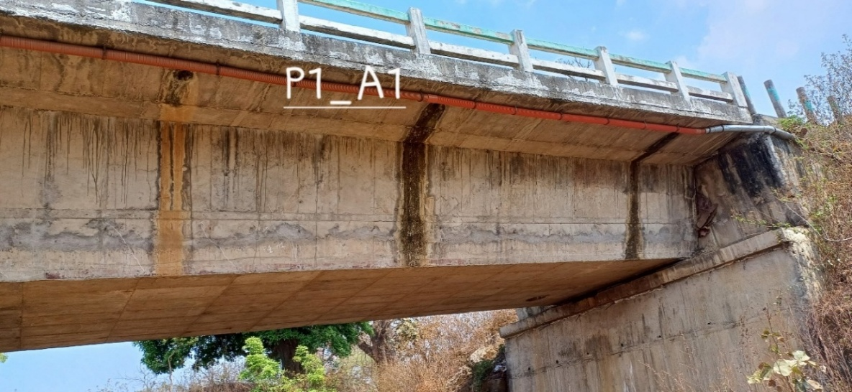
Fig.1. Site condition connecting abutment-A1 to pier-P1
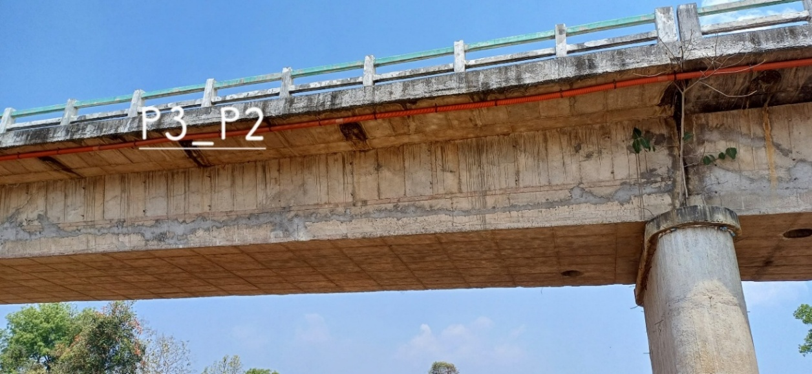
Fig.2. Site condition connecting pier-P2 to pier-P3

Methodology
The present study adopts a systematic and integrated methodology to evaluate the structural performance of a reinforced concrete bridge. The approach combines data collection, numerical modelling, structural analysis, and failure assessment to identify critical structural deficiencies and propose suitable mitigation measures. The methodology is designed to bridge the gap between theoretical design assumptions and actual structural behaviour under real-world conditions.

Structural modelling
The bridge superstructure is modelled using the numerical analysis software CSI Bridge to simulate its structural behaviour under various loading conditions. The modelling approach is based on an idealization of the actual bridge components into suitable finite elements to accurately represent load transfer mechanisms. Advanced numerical modelling techniques play a crucial role in predicting structural behaviour and identifying potential damage mechanisms in bridge systems. Finite element-based approaches combined with structural identification methods have been widely used for performance evaluation and health monitoring of bridges (Zhang & Aktan, 2021; Deng & Cai, 2010). The longitudinal girders are modelled as beam elements capable of resisting bending moments and shear forces, while the deck slab is modelled using plate or shell elements to effectively distribute loads across the girder system. The supports are defined in accordance with actual boundary conditions, typically represented as pinned or roller supports, to simulate realistic restraint and movement conditions. Certain assumptions are adopted in the modelling process to simplify the analysis while maintaining reasonable accuracy. The materials are assumed to exhibit linear elastic behaviour, ensuring that stress is directly proportional to strain within the working range. The support conditions are idealized, neglecting minor flexibility or soil-structure interaction effects.

3.2 Structural analysis
The structural analysis of the bridge is carried out using CSI Bridge to evaluate its behaviour under various loading conditions. A linear static analysis approach is adopted, wherein the relationship between loads and structural response is assumed to be linear within the elastic range of the materials. The analysis provides key structural parameters such as bending moment, shear force, deflection, and support reactions. The bending moment distribution is used to assess flexural behaviour, while shear force values help in identifying critical regions near supports. Deflection results are examined to ensure serviceability requirements are satisfied, and support reactions are used to evaluate load transfer to the substructure. These parameters collectively provide a comprehensive assessment of the structural performance and help in identifying critical zones within the bridge.

3.3 Identification of critical sections and correlation with field observations
Based on the results obtained from the structural analysis, critical sections of the bridge are identified by examining the distribution of internal forces and stresses. The mid-span region is found to experience the maximum bending moment, making it the most critical location for flexural behaviour. The regions near the supports are subjected to maximum shear forces, indicating a higher likelihood of shear-related distress. The analytical results obtained from the structural analysis are compared with the observed distress patterns in the bridge to validate the accuracy of the developed model. The common forms of distress observed include cracking in girders, concrete spalling, and leakage leading to corrosion of reinforcement. These observed conditions are carefully examined in relation to the predicted stress distribution and critical zones identified in the analysis. The correlation between analytical results and field observations helps in confirming the reliability of the model and provides a better understanding of the underlying causes of structural deterioration.
3.4 Modelling Assumptions and Limitations
The numerical model is developed using beam elements for girders and shell elements for deck slab. A mesh size of approximately 0.5 m to 1 m is adopted for the deck slab to ensure adequate accuracy. Diaphragms are assumed to provide lateral load distribution between girders. Supports are idealized as pinned and roller supports, neglecting soil-structure interaction effects.
The analysis assumes linear elastic material behaviour and does not account for cracking, yielding, or nonlinear effects. Dynamic interaction between vehicle and bridge is also neglected. These assumptions may influence the accuracy of the predicted response and should be considered while interpreting results.

Load calculations
In this study, load calculations are performed in accordance with provisions of Indian Roads Congress, ensuring that the analysis reflects realistic service conditions. The loads considered include dead load, superimposed dead load, live load, and impact load. These loads are further combined to simulate critical scenarios that may occur during the service life of the bridge.

4.1 Dead Load (DL)
Dead load represents the permanent load acting on the structure due to its own weight and remains constant throughout the service life of the bridge. It contributes significantly to the overall stress distribution and forms the base load condition for structural analysis. The dead load includes the self-weight of structural components such as the deck slab, girders, diaphragms, and wearing course. The unit weight of reinforced concrete is taken as 25 kN/m³, which is a standard value adopted in structural analysis. The dead load due to the deck slab is calculated based on its thickness and unit weight as follows:
Deck slab load = thickness × unit weight= 0.25 × 25= 6.25 kN/m²
Wearing coat load = thickness × unit weight= 0.075 × 22= 1.43 kN/m²
These loads are considered as uniformly distributed loads acting on the bridge deck and are used in further structural analysis.

4.2 Superimposed Dead Load (SIDL)
SIDL represents additional permanent loads acting on the bridge apart from its self-weight. These include wearing course, parapets, crash barriers, and utilities. In the present study, the wearing coat load is calculated as 1.43 kN/m² and is considered as uniformly distributed load acting on the deck slab as per IRC:6-2017 (Clause 206).

4.3 Live Load (LL)
Live load is the most variable and critical load considered in bridge design, as it represents moving vehicular loads acting on the structure. The magnitude and distribution of live load depend on factors such as traffic intensity, axle configuration, and vehicle type. The IRC Class A and IRC 70R loading are applied as moving loads using lane load definitions in CSI Bridge. Critical load positions are obtained using influence line analysis to capture maximum bending moment and shear force effects.

4.4 Load Combinations
Structures are rarely subjected to a single load in isolation; instead, they experience a combination of different loads acting simultaneously under actual service conditions. Therefore, load combinations are considered in structural analysis to simulate realistic and critical scenarios that the bridge may encounter during its lifetime. In the present study, load combinations are formulated in accordance with the provisions of Indian Roads Congress, as specified in IRC:6-2017 (Clause 211). Typical load combinations include cases such as dead load combined with live load, dead load combined with live load and impact effects, and dead load combined with temperature effects. These combinations are applied to evaluate the most unfavourable conditions that produce maximum bending moments, shear forces, and deflections in the structure.

Numerical modelling
In the present study, the structural modelling and analysis of the reinforced concrete Road Over Bridge has been carried out using CSI Bridge. This software is specifically developed for bridge engineering applications and allows detailed modelling of superstructure and substructure components under realistic loading conditions. CSI Bridge integrates finite element analysis with bridge-specific features such as moving load analysis, influence lines, and code-based load generation, making it highly suitable for evaluating bridge performance. The modelling approach involves representing the longitudinal girders as beam elements capable of resisting bending and shear forces, while the deck slab is modelled using shell or plate elements to ensure proper distribution of loads across the width of the bridge. The support conditions are defined carefully to reflect realistic boundary behaviour, including appropriate restraint and allowance for movement where necessary. In addition, realistic load cases are applied to the model to simulate actual service conditions. This modelling philosophy enables accurate representation of both global structural behaviours, such as overall deflection and load distribution, as well as local effects within individual components.

5.1 Geometry Definition
The first step in the structural modelling process is the definition of the geometric configuration of the bridge. The bridge considered in the present study consists of four spans with lengths of 15 m, 20 m, 20 m, and 15 m, forming a continuous structural system. The superstructure includes multiple longitudinal girders spaced uniformly across the width of the bridge, which are connected by a deck slab to ensure effective load distribution. The geometry of the bridge is defined within csi bridge using grid lines and coordinate systems, which facilitate accurate positioning of structural elements. Both longitudinal and transverse alignments are specified to represent the actual structural layout of the bridge, ensuring that the model closely reflects real-world conditions.
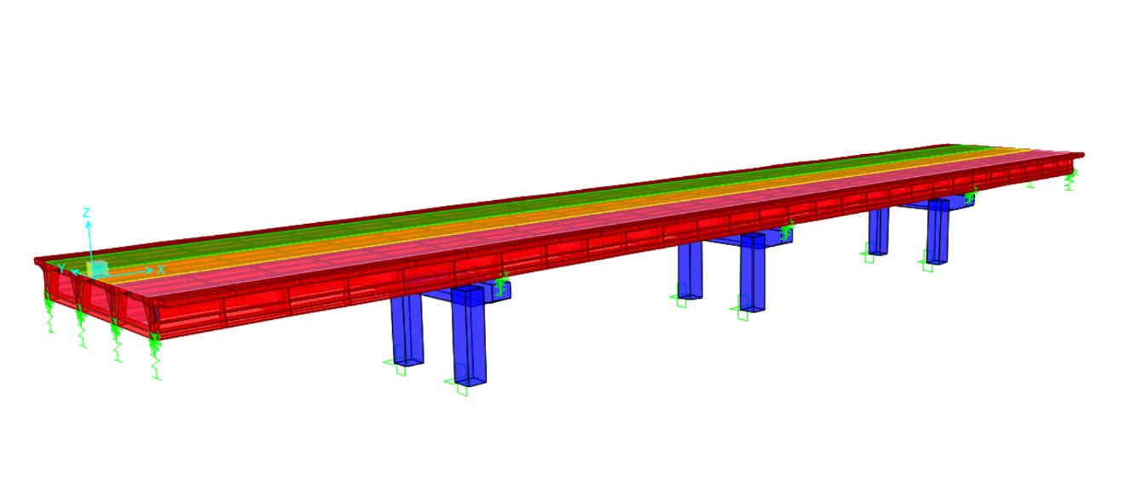
Fig 3. Bridge model using CSi Bridge

Results and discussion
The structural analysis of the reinforced concrete Road Over Bridge was carried out using CSI Bridge. The results obtained from the analysis provide insight into the behaviour of the bridge under various loading conditions. The primary objective of this chapter is to evaluate the structural response in terms of bending moment, shear force, and deflection, and to identify critical regions susceptible to failure. The analysis results are interpreted in relation to theoretical expectations and practical observations to assess the adequacy of the structure.

6.1 Bending Moment Analysis
Bending moment is one of the most critical parameters in bridge design, as it governs flexural behaviour. The analysis results indicate that the maximum bending moment occurs at the mid-span region of each span.
The maximum bending moment value of 2690.66 kN·m at mid-span indicates critical flexural demand. Higher negative bending moment (-5330.78 kN·m) at supports suggests significant stress concentration, which may lead to cracking in the top fibre region. These regions require careful design and inspection.
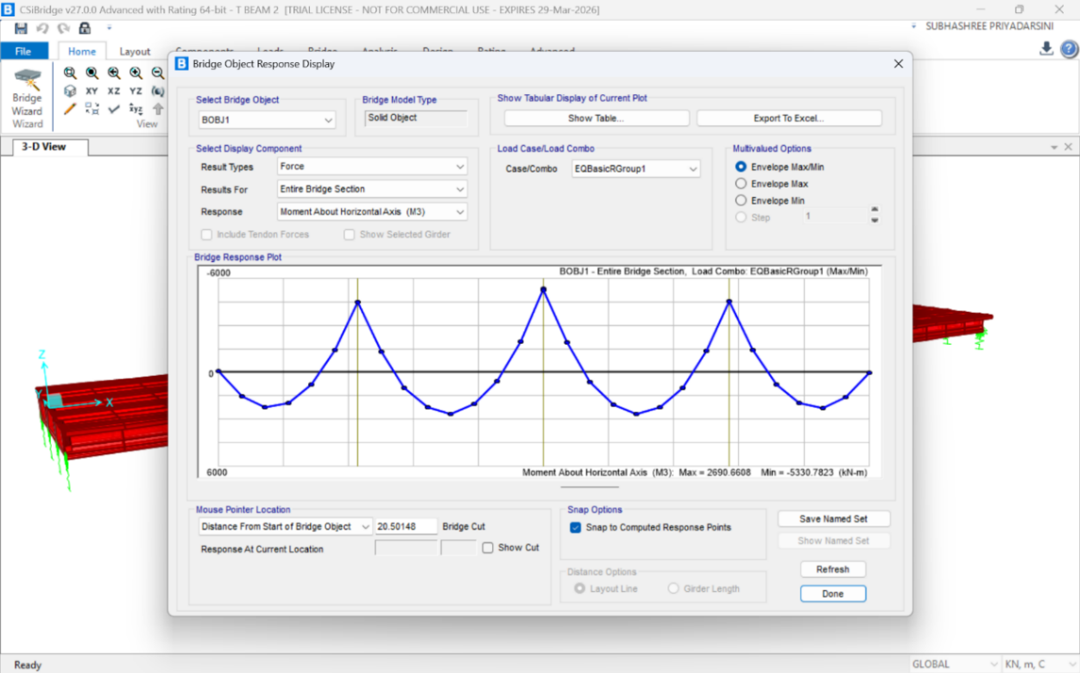
Fig 4. Moment about horizontal axis
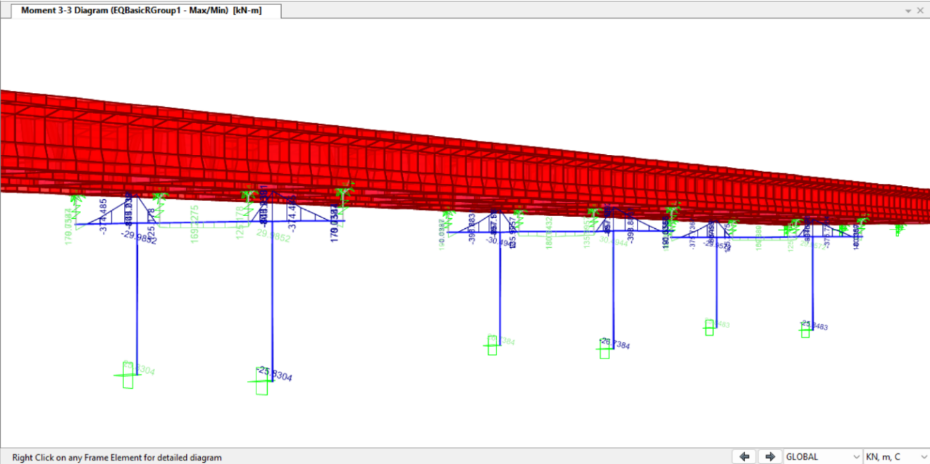
Fig 5. Moment about horizontal axis with values

6.2 Shear Force Analysis
Shear force is a critical parameter in bridge analysis, particularly near the supports where load transfer occurs from the superstructure to the substructure. The shear force is maximum at the supports and decreases towards the mid-span. In the present study, shear force distribution is obtained using CSI Bridge, and the results indicate that support regions are the most critical for shear.
The maximum shear force of approximately 1511 kN near supports indicates potential shear-critical regions. These zones are more susceptible to diagonal cracking and require adequate shear reinforcement or strengthening measures.
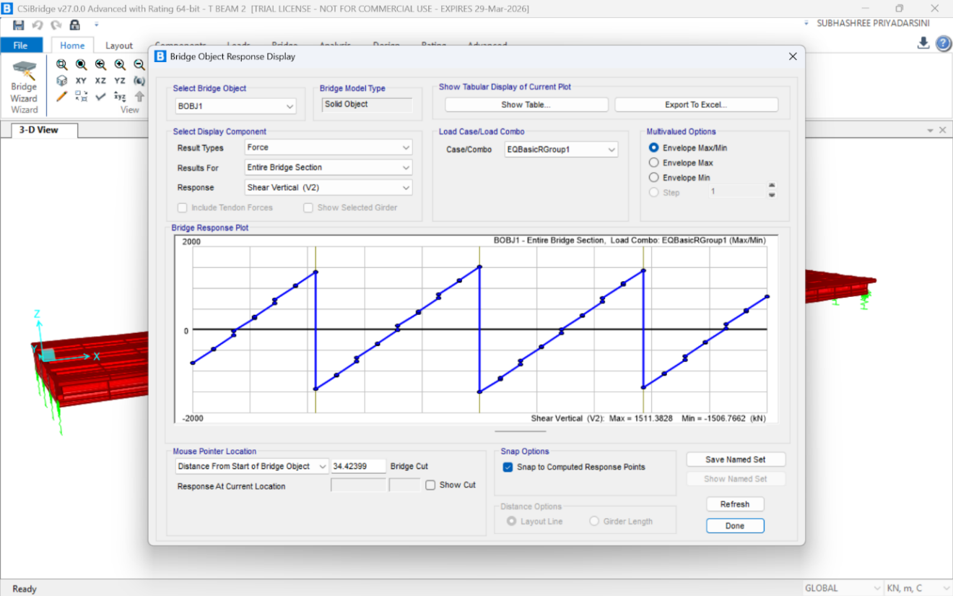
Fig 6. Shear force graph
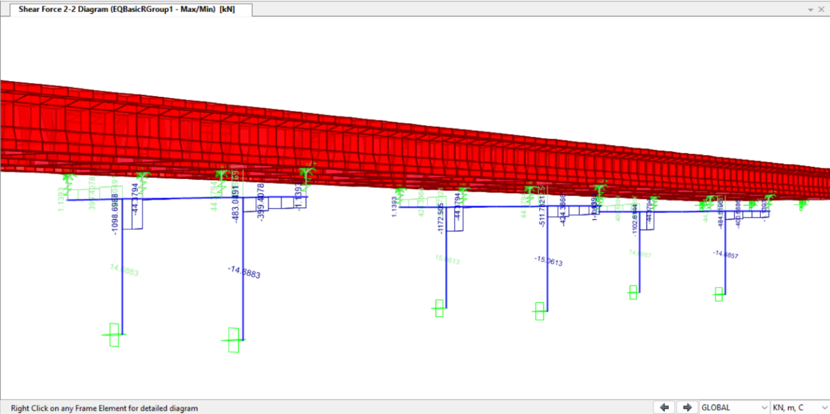
Fig 7. Shear force with values

6.3 Deflection Analysis
Deflection is an important parameter for evaluating the serviceability of a bridge structure, as it indicates the extent of deformation under applied loads. Excessive deflection can lead to discomfort for users, cracking of structural elements, and long-term durability issues. In the present study, the maximum deflection obtained is approximately 0.00006 m. As per serviceability criteria (span/800 ≈ 70,000/800 = 0.0875 m), the observed deflection is significantly lower than the permissible limit. This indicates that the bridge satisfies serviceability requirements and possesses adequate stiffness under the applied loading conditions.

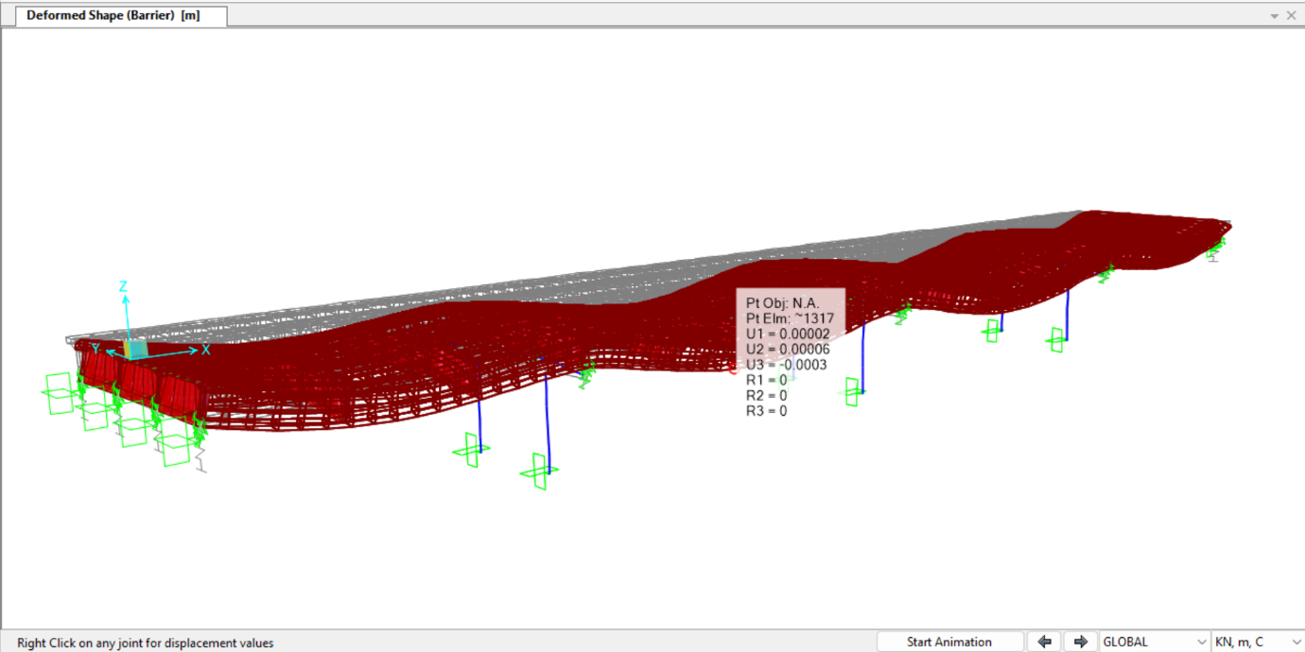
Fig 8. Deflection with values

6.4 Stress Distribution
The stress distribution within the bridge structure follows the expected behaviour of a beam system under loading. Tensile stresses are found to be maximum at the bottom fibre in the mid-span region due to sagging bending moments, while compressive stresses are maximum at the top fibre. In addition, shear stresses are primarily concentrated near the support regions where shear forces are highest. This pattern of stress distribution is consistent with fundamental structural behaviour and helps in identifying critical zones for design and evaluation. The tensile stress at the bottom fibre indicates a high likelihood of flexural cracking in mid-span regions. Similarly, compressive stress at the top fibre near supports confirms stress concentration zones, which may lead to crushing or spalling under long-term loading conditions.
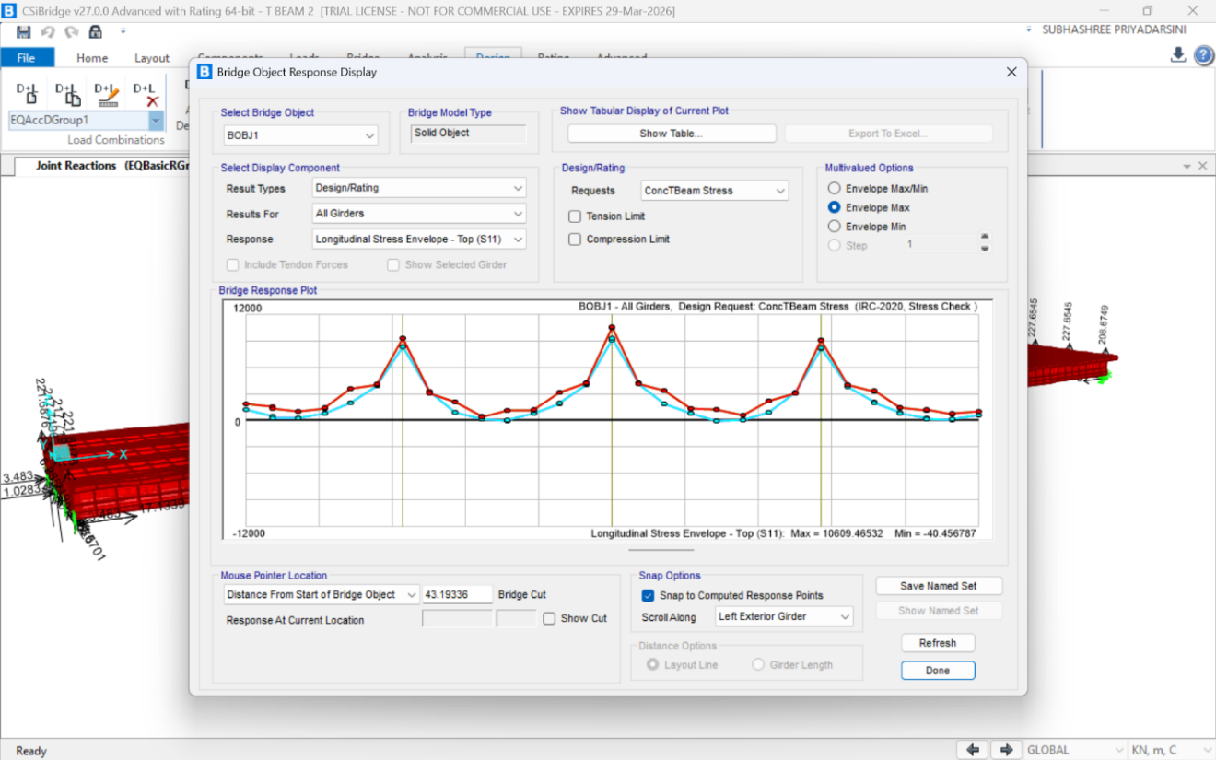
Fig 9. Longitudinal stress envelope- top graph

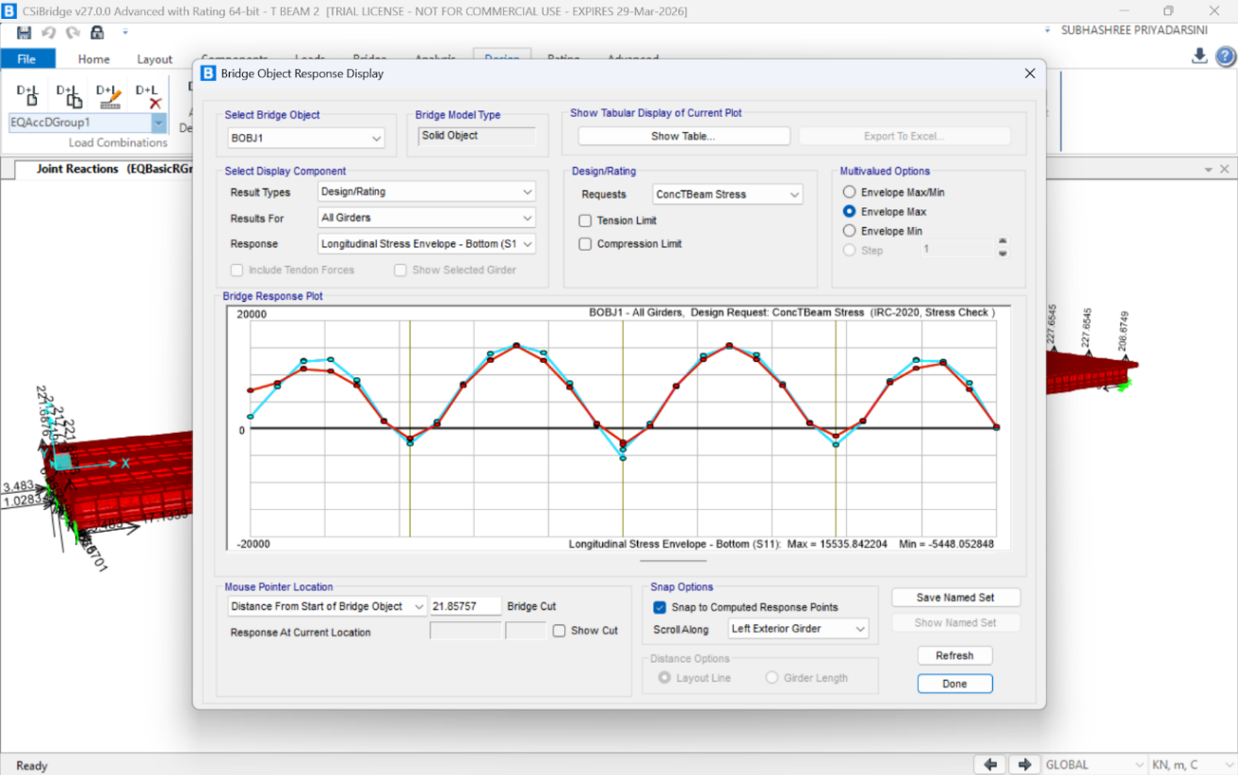
Fig 10. Longitudinal stress envelope- bottom graph
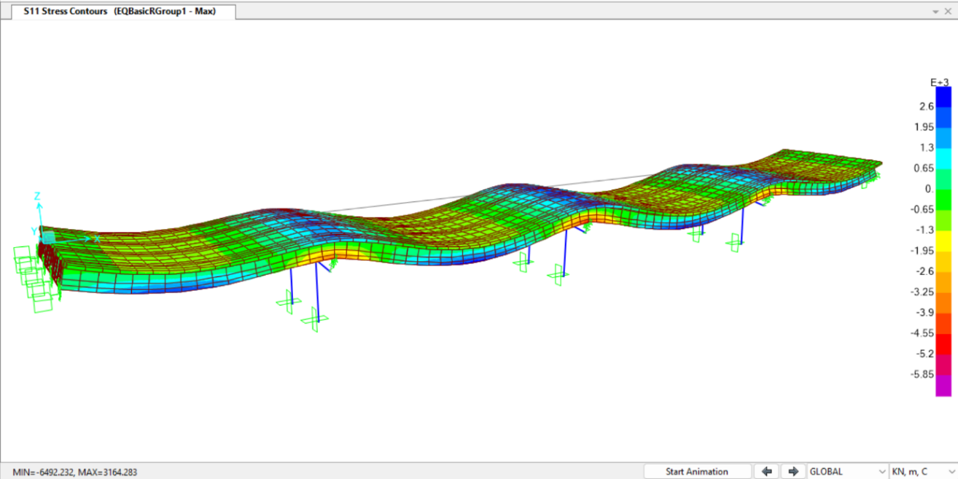
Fig 11. Stress contours graph

6.5 Torsion Analysis
Torsion analysis of the bridge structure indicates that maximum torsional effects occur in the edge girders, primarily due to their exposure to eccentric loading conditions. When loads are applied away from the centreline of the bridge, torsional effects increase significantly, resulting in additional stresses in the structural elements. In contrast, interior girders experience relatively lower torsion as the load distribution is more uniform across them. This variation in torsional response highlights the importance of considering eccentric loading in bridge analysis and design.
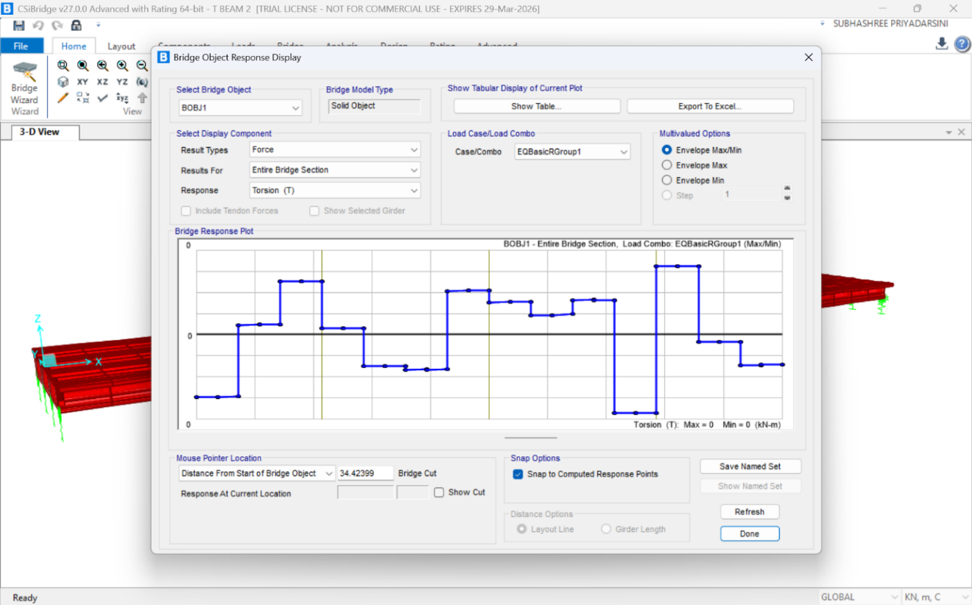
Fig 12 Torsion graph

6.6 Effect of Load Combinations
Different load combinations produce varying stress levels.
- DL + LL → This governs normal conditions
- DL + LL + Impact → This produces maximum stress
Table 1: Structural Performance Evaluation
Parameter | Maximum Value | Location | Remark
Bending Moment | 2690.66 kN·m | Mid-span | Flexural critical
Shear Force | 1511 kN | Support | Shear critical
Deflection | 0.00006 m | Mid-span | Within limit
Stress | 15535 kN/m² | Bottom fibre | Crack-prone

Failure analysis and mitigation
Bridge structures are subjected to various loads and environmental conditions throughout their service life. Although designed as per standards, several bridges experience structural distress due to a combination of loading effects, material degradation, and maintenance deficiencies. Durability-related deterioration such as corrosion of reinforcement, chloride ingress, and carbonation significantly influence the long-term performance of reinforced concrete bridges. Corrosion of embedded steel reduces cross-sectional area and bond strength, leading to structural weakening over time (Poursaee, 2016). The initiation and progression of corrosion are governed by environmental exposure conditions and material properties, which can be predicted using durability models (Angst, 2018). Recent studies have also emphasized the importance of incorporating environmental effects into bridge performance assessment to improve service life prediction (Li et al., 2021). In this study, failure analysis is carried out by correlating analytical results obtained from CSI Bridge with observed distress patterns. The objective is to identify the type, location, and cause of failures and propose appropriate mitigation strategies.

7.1 Causes of Failure
The failure of bridge superstructures is generally the result of multiple interacting factors rather than a single cause. One of the primary causes is excessive loading, where the bridge is subjected to loads beyond its design capacity due to increased traffic volume, overloading by heavy vehicles, or changes in usage over time. This leads to higher bending moments and shear forces, ultimately causing structural distress.

7.2 Critical Failure Zones
Based on the analysis results, the mid-span region of the bridge is identified as flexurally critical due to the presence of maximum bending moments. The support regions are found to be shear critical, as they experience the highest shear forces resulting from load transfer. In addition, the bearing locations are subjected to significant stress concentration, as they act as the interface between the superstructure and substructure. These observations help in identifying the most vulnerable zones within the structure and guide the design and maintenance strategy accordingly.
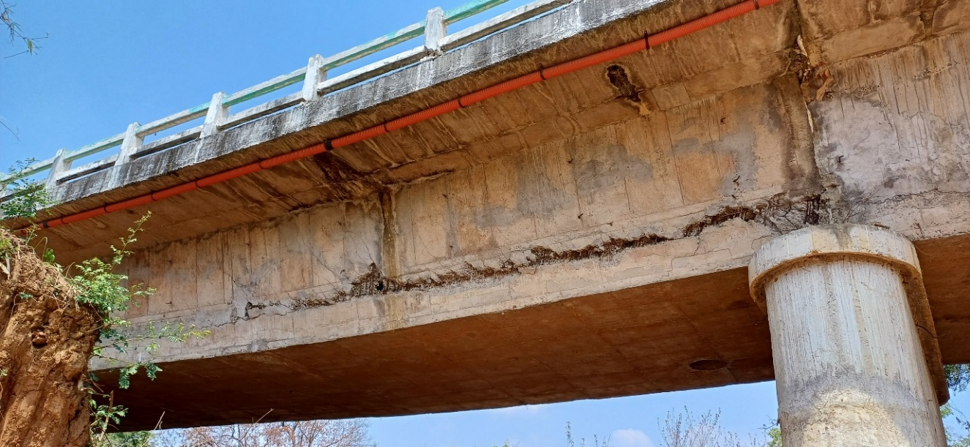
Fig.13. Flexural cracking
Table 2: Correlation between Analytical Results and Observed Distress
Location | Analytical Result | Observed Distress | Interpretation
Mid-span | Max bending moment | Flexural cracks | Strong correlation
Support | Max shear force | Shear cracks/spalling | High risk zone
Bearings | Stress concentration | Local damage | Critical interface

7.3 Retrofitting Techniques
FRP wrapping is widely used for strengthening bridge components, particularly to enhance shear capacity. In this method, fiber reinforced polymer sheets are externally bonded to the surface of structural members, providing additional confinement and resistance to tensile stresses. Due to its lightweight nature and high resistance to corrosion, FRP wrapping improves load-carrying capacity without significantly increasing the dead load of the structure. External prestressing is an effective technique used to reduce tensile stresses and improve the flexural capacity of bridge girders. By introducing external tendons, compressive forces are induced in the structural member, counteracting the tensile stresses caused by bending. This method is especially useful for long-span bridges or structures experiencing excessive deflection.
Concrete jacketing involves increasing the cross-sectional area of structural members by adding an additional layer of reinforced concrete. This technique enhances both stiffness and strength, making it suitable for heavily damaged sections where significant deterioration has occurred. It also improves durability by providing additional protective cover to reinforcement. Crack injection is a repair technique used to restore the integrity of cracked concrete members. In this method, epoxy resin is injected into the cracks, filling the voids and re-establishing continuity of the structure. Based on the analysis, FRP wrapping is recommended for shear-critical regions near supports, while external prestressing is suitable for mid-span regions experiencing high flexural stresses. Concrete jacketing may be applied in severely deteriorated sections to restore strength and stiffness.

Conclusion
The study integrates codal load calculations as per Indian Roads Congress, numerical modelling using CSI Bridge, and correlation of analytical results with observed failure patterns.
- The structural model is analysed under multiple load cases and combinations, and the results are obtained in graphical form. The bending moment diagram indicates that the maximum positive bending moment is approximately 2690.66 kN·m, while the maximum negative bending moment reaches about -5330.78 kN·m, clearly showing higher negative moments over the supports.
- The shear force diagram shows maximum shear values of approximately +1511.38 kN and minimum values of about -1506.77 kN, confirming that shear forces are critical near the support regions.
- The deformation plot indicates that the maximum displacement values range between 0.00002 m and 0.00006 m, demonstrating that the structure has adequate stiffness under the applied loading conditions.
- The torsion diagram shows variation along the span, with maximum torsional effects observed near edge girders, particularly under eccentric loading.
- The longitudinal stress envelope diagrams provide further insight into stress distribution. The bottom fibre stress reaches a maximum of approximately 15535.84 kN/m² and a minimum of about -5448.05 kN/m², indicating high tensile stresses at mid-span. Similarly, the top fibre stress envelope shows maximum compressive stress of approximately 10609.47 kN/m² and minimum values around -40.46 kN/m².

Future scope
This study evaluates the structural behaviour of a reinforced concrete bridge through analytical modelling and failure assessment, offering useful understanding of response characteristics, vulnerable regions, and possible mitigation approaches. However, there is considerable scope to enhance both the precision and practical relevance of such evaluations through further investigation.
The present analysis is limited to linear static methods, which are based on the assumption that materials behave elastically. This simplification does not adequately represent actual field conditions, where reinforced concrete members are subjected to nonlinear phenomena such as cracking of concrete, yielding of steel reinforcement, and progressive material deterioration. Future studies should therefore incorporate nonlinear analytical approaches to better simulate realistic structural responses and failure mechanisms.
In addition, the integration of advanced structural health monitoring (SHM) systems can significantly improve bridge performance assessment. With the availability of modern sensors and data acquisition systems, real-time monitoring and data-driven evaluation techniques can be explored to enhance predictive capabilities.

References
1. American Concrete Institute Committee 440. (2017). Guide for the design and construction of externally bonded FRP systems for strengthening concrete structures. American Concrete Institute.
2. American Association of State Highway and Transportation Officials. (2017). AASHTO LRFD bridge design specifications. AASHTO.
3. American Society of Civil Engineers. (2014). Bridge engineering handbook (2nd ed.). ASCE.
4. Bureau of Indian Standards. (1987). Code of practice for design loads (IS 875, Parts 1–5). BIS.
5. Bureau of Indian Standards. (2000). Plain and reinforced concrete – Code of practice (IS 456:2000). BIS.
6. Bureau of Indian Standards. (2002). Criteria for earthquake resistant design of structures (IS 1893, Part 1). BIS.
7. Brownjohn, J. M. W. (2007). Structural health monitoring of civil infrastructure. Philosophical Transactions of the Royal Society A, 365(1851), 589–622.
8. Casas, J. R. (1997). Load rating of bridges using reliability methods. Journal of Structural Engineering, 123(6), 752–761.
9. Chen, B., Li, Z., & Wang, Y. (2021). Durability assessment of reinforced concrete bridges. Construction and Building Materials, 293, 123456.
10. Computers and Structures Inc. (2020). CSI Bridge analysis reference manual.
11. Federal Highway Administration. (2016). Bridge inspector’s reference manual. FHWA.
12. Frangopol, D. M., & Liu, M. (2007). Maintenance and management of bridge systems. Journal of Structural Engineering, 133(6), 920–934.
13. Fu, G., & You, Y. (2009). Bridge system reliability analysis. Journal of Structural Engineering, 135(5), 430–438.
14. Indian Roads Congress. (2015). General features of design (IRC:5-2015). IRC.
15. Indian Roads Congress. (2017). Standard specifications and code of practice for road bridges: Section II – Loads (IRC:6-2017). IRC.
16. Indian Roads Congress. (2020). Code of practice for concrete road bridges (IRC:112-2020). IRC.
17. Kim, S., Park, S., & Lee, J. (2019). Damage detection in bridge structures using vibration analysis. Engineering Structures, 182, 1–12.
18. Li, H., Ou, J., & Zhang, Y. (2021). Durability assessment of reinforced concrete bridges under environmental effects. Construction and Building Materials, 305, 124789.
19. Nguyen, K., et al. (2020). Bridge structural health monitoring techniques: A review. Applied Sciences, 10(2), 709.
20. Nowak, A. S. (1999). Calibration of LRFD bridge design code. Journal of Structural Engineering, 125(11), 1245–1251.
21. O’Brien, E. J., Keogh, D. L., & O’Connor, A. J. (2009). Effects of traffic loading on bridge structures. Engineering Structures, 31(9), 1999–2008.
22. Poursaee, A. (2016). Corrosion of steel in concrete structures. Woodhead Publishing.
23. Angst, U. (2018). Predicting the time to corrosion initiation in reinforced concrete structures. Cement and Concrete Research, 115, 168–188.
24. Farrar, C. R., & Worden, K. (2012). Structural health monitoring: A machine learning perspective. Wiley.
25. Ye, X. W., Su, Y. H., & Han, J. P. (2014). Structural health monitoring of civil infrastructure using optical fiber sensing technology: A review. Scientific World Journal.
26. Deng, L., & Cai, C. S. (2010). Bridge condition assessment using fuzzy logic system. Engineering Structures, 32(1), 153–162.
27. Zhang, W., & Aktan, A. E. (2021). Structural identification and health monitoring of bridges. Journal of Bridge Engineering.
28. Moses, F., & Verma, D. (1987). Load capacity evaluation of existing bridges. Journal of Structural Engineering, 113(1), 1–19.

