Exploring the Intersection of AI, Big Data and Business Networks: A Bibliometric and Scientific Mapping Study
Khyrunnisa. T. P ¹, Noora Mohamed Kutty ²
¹ Department of Commerce, PSMO College (Autonomous) Tirurangadi, Affiliated to University of Calicut, Malappuram, Kerala, India
¹ khyrunnisa@psmocollege.ac.in
² Department of Commerce, PSMO College (Autonomous) Tirurangadi, Affiliated to University of Calicut, Malappuram, Kerala, India
² noora@psmocollege.ac.in
*Corresponding author: Khyrunnisa. T. P ¹
ABSTRACT
The combination between Artificial Intelligence (AI), Big Data and Business Networks has substantially transformed the system of performance of organizations and has enhanced inter-firm cooperation leading to innovation in various industries. This current bibliometric and scientific mapping research paper examines the intellectual environment of this interdisciplinary discipline in terms of the PRISMA model. The analysis is based on meta-data obtained on Web of Science (2015 to 2025). A package of visualizations (geographical distribution, annual publication patterns, author productivity, major journals, country output and keyword co-occurrence) are done by using RStudio and Vos viewer are used to map the central research topics and developing areas. Important groups draw the major themes and transformational research patterns. The ten most influential papers are put in the spotlight, which provides a selective reference to the background and breakthrough articles. The interpretation of the results on the collected data allows one to have a general picture of the evolution of the field among scholars. The findings indicate the constant growth of the academic contributions toward the entire world, with countries such as the United States, China and the United Kingdom taking the top table in terms of matters regarding research production. Key journals and authors are proposed, confirming the increased significance of AI and Big Data in optimization of the business networks in terms of its agility and efficiency. This work provides valuable lessons to artists and scholars due to its ability to capture the most up-to-date trends and highlight potential future directions of research that could benefit the resilience, scale and innovation in Networked Business context.
Keywords: Artificial Intelligence, Big data, Business Network, Bibliometric Analysis, Innovation trends
INTRODUCTION
The aggregation of the ranges of Artificial Intelligence (AI), Big Data and Business Networks, the phenomenon has become one of the most important fields of study, with the ability to revolutionarily transform the organization behavior, operational processes and strategic motivation in the contemporary business environments (Sanchez-Lopez, 2023). Intelligent analytics, grounded on large data volumes, allows companies to attain practical knowledge, maximize the use of resources and maximize the effectiveness of cooperation in a composite business environment (Ghaouri et al., 2023). Such networks characterized by complex inter-firm interactions exploit AI and Big Data to innovate, increase their nourishment and address issues like privacy of data, energy management and adaptive networks. Its particular importance in generating competitive and sustainable growth expanded new attention in the academic literature as topics in management research have flourished around the nexus of this intersection (González et al., 2022).
This bibliometric and scientific mapping study aims carefully at examining the intellectual framework, research trends and thematic development of the interactions between AI, Big Data, and Business Networks.
The study is informed by a variety of methods and implementations, including: administered clustering, used in the analysis of inter-firm performance sceneries in business networks (Sun et al., 2022), meta machine learning, which enables distributed analytics without violating data privacy (Dsouza et al., 2025) and genetic-algorithm-based approaches, which assist in energy-efficient management of 5G base stations (Galib et al., 2022). Moreover, the distributing reinforcement learning technique of multi-agent systems demonstrates the impressive capability of AI in improving the network interaction and functioning accuracy (Xavier et al., 2022).
Further, AI and Big Data in business networks consume affecting crucial problems. Through bibliometrics, the paper can outline the scientific map and describe the field with its theoretical development, practical implementation and unexploited areas of research. We target researchers and practitioners who can explore AI and Big Data potential to support business networks and boost innovation and strength in a global economy that will continue growing interconnected (Cantu & Tunisini, 2023).
SYSTEMATIC LITERATURE REVIEW: AI AND BUSINESS NETWORKS (2015-2025)
Digital transformation and ai-enabled business models
The Future of Business Model-driven Digital Transformation and AI-Enabled Business Models The power of AI has become a fundamental driver of digital transformation within businesses networks. It does not just spur improvement within an organization, but also helps organizations to re-organize their inter-organizational relationships and ecosystems. (Schroeder et al., 2019) present the case of sterilization through a business network lens focusing on the industrial setting. They have made some suggestions that AI facilitates adaptive coordination and changes of service-based business models. This is confirmed by (Camarinha-Matos et al., 2017), who have come up with a conceptual framework of collaborative networks wherein AI is important in meeting the interaction of the heterogeneous agents. (Papa et al., 2021) go on to believe that AI helps to redefine dynamic capabilities of firms, enabling them to participate in the co-creation and innovation on a digital-mediated platform. Furthermore, (Aguiar Lima Dos Santos et al., 2021) explore the topic of manufacturing networks and point out that AI allows digitally monitoring the production, predicting its maintenance, and improving the coordination between different production units.
Predictive analytics and strategic decision making
The ability to process big data and detect trends is what makes AI an important asset to business strategy decision-making. It supports informed decision making on-the-fly, more so in complex business networks. (Hirt et al., 2025) stress that effective execution of analytics depends on the design relative to the field and business knowledge integration. They reveal that AI can provide some significant decision-making value in terms of being united into strategic processes. Simple and practical proof of the benefit of AI systems is given by (Santos & Campos, 2023) who show that economic forecasting and planning is more accurate when supported by AI systems, especially in highly uncertain and interdependent conditions. Furthermore, (Rivera, 2024) summaries the use of AI in the field of public health networks when predictive modeling helps with epidemic response and organization of healthcare delivery, and algorithmic accountability comes to the face.
Learning and co-creation
Another vital role of AI in business networks is that it helps to share knowledge and innovation. Knowledge flows are upgraded through AI tools which read, memorize and suggest contextual information to stakeholders. The article by (Ben Yahia et al., 2021) formulates collaborative intelligence, explaining the broader concept of the joint problem-solving process in partner firms through an AI-supported approach. The (Papa et al., 2021) defend the idea that AI-based tools will boost the outcomes of knowledge management strategies, including supporting innovation with real-time feedbacks, pattern recognition, as well as insights provided by machine learning. Moreover, the (Camarinha-Matos et al., 2017) claim that, thanks to AI, firms can move beyond straightforward sharing of information to intelligent, flexible collaboration and accomplish in smarter supply chains and service innovation.
Artificial intelligence in business to business (b2b) marketing and supply networks
In a business-to-business environment, AI benefits to reengineer the customer communication process, relationship management and even supply chain coordination. AI assists companies in understanding customers, their needs and preferences, increases logistics and optimal distribution. (Pardo et al., 2022) offer the evidence that AI applications in B2B marketing allow companies to better assess the performance of partners; monitor the behavior of buyers; and operate with complex, multi-levelled distribution channels. (Penttinen & Frösén, 2022) are concerned with branding and market positioning and concluded that AI tools also help finite firms align marketing activities with the strategic issues in the cross-partner networks. In the scope of manufacturing, (Aguiar Lima Dos Santos et al., 2021) note that AI can play a prominent role in contributing to the agility of the supplier networks through the forecasting of demand fluctuations and automation of the procurement strategies.
Ethics, governance and human-ai synergy
As the use of AI increases, ethical issues, transparency and the relationship between human and algorithm employee are dominant. The literature escalates the two-edged sword AI in the networks AI is used to increase efficiency and an increased risk with respect to accountability and fairness. (Rivera, 2024) provides an in-depth discussion of ethical AI implementation at the level of the broad networks. His fear is about experiencing opaque algorithm overly by relying on them in areas that concern human wellbeing. His work reveals why we should adopt the governance structures that integrate the human control prevail component into AI software. Ethical implications are indirectly mentioned in most of the reviewed articles, especially in the situations when an autonomous decision is made or when firms share data
According to the 2015-2025 literature, AI had evolved in a business network as an instrument of automation to become a strategic enabler. The thematic analysis validates the level of convictions that AI facilitates digital transformation, teamwork innovation, information-guided marketing and knowledge-based planning. The lack of representation of the SMEs and emerging economies in the study of AI-business networks. Edging requirements of AI ethics, governance and regulatory compliance in inter-organizational regions. Further study on the long-term effects of AI on business ecosystems and generating inclusive, transparent and morally secure AI are the things that will be obligatory.
OBJECTIVES
- To examine the trends in publication of Intersection of AI, Big Data and Business Networks during 2015-2025.
- To find out most popular authors, journals, country, sources and themes.
- To understand keyword co-occurrence of articles.
Research question
RQ1: How are the publications and citation trend?
RQ2: Which are the clustering dominating research topics, authors, country, sources, journal and themes?
RQ3: What are keywords which most co- occurred?
METHODOLOGY
The figure 1 PRISMA (Preferred Reporting Items for Systematic Reviews and Meta-Analyses) is a well-recognized methodological framework that aims to increase the transparency and the extensiveness of systematic reviews. It also provides a systematic process of finding, filtering and choosing feasible literature with determined parameters that makes evidence synthesis rigorous and replicable (Ekundayo et al., 2021). The research is based on a systematic review of literature with the help of the PRISMA framework that helps to find and review research on the interconnection of artificial intelligence and business networks. The literature review will be based on readings written before and after 1 January 2015 and not before 15 May 2025, where a search will be done in May 2025. To apply consistency and fit with the research purpose, the eligibility was well constructed and the document search process was clearly expressed to make it more open and justify the validity of the research results. As per PRISMA guidelines, the review procedure followed four consecutive stages, identification, screening, eligibility and inclusion.
In the identification stage, web-based search was conducted in the Web of Science database with a specific search query: Title/Abstract/Keyword contains (“Artificial Intelligence” OR “AI” OR “Big Data” OR “Machine Learning”) AND (“Business Network*” OR “Collaborative Network*” OR “Inter-Organizational Network*” OR “Referral Network*” OR “B2B Network*”). The search approach that restricted the language of the article originally retrieved 310 records within the scope of search results.
In the screening process, results were refined according to a group of exclusion criteria. In particular, the publications and documents not in English; proceedings papers, review articles, book reviews and editorial materials were excluded. As a consequence of that process, 59 records were disregarded, which brought 251 available articles to be considered as appropriate for further assessment.
During the step of eligibility, the entire texts of these 251 articles were carefully evaluated. The articles which were deemed not relevant with the main scope- those not talking about integration of AI technologies into the sphere of business or collaborative networks- were also excluded.
The final number of articles is 229 as a total of 22 articles were excluded fulfilling all inclusion criteria. These 229 full-text articles were used as the last step in the inclusion of the qualitative synthesis. Such documents are a rich source of a literature that can be related to the research purpose
Figure 1: PRISMA four-phase flow diagram
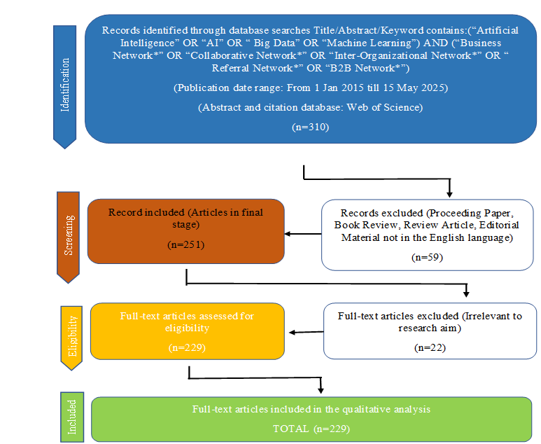
RESULTS AND DISCUSSION
Country scientific production of articles
Figure 2 displays the visualization of the geographical behavior of the research articles in the field Artificial Intelligence (AI) and business networks. Such bibliometric mapping shows the research output of the different countries around the planet, reflecting high levels of regional variation in the number of publications. The stronger shade of blue is associated with a larger number of articles, the more the research is active. The statistics show that the large share of research output in this area was represented by 356 articles by China. This is followed by United States that has 102 articles and Australia with 64 articles. The other significant contributions are those of the United Kingdom (14 articles), Brazil (12 articles), Russia (10 articles) and Argentina (1 article).
With this graphic depiction, one will be able to better understand that the geographical focus on output can embody the regional research priorities and invest in innovation in AI-driven business networks. In its turn, the figure also indicates low contributions of Africa, the Middle East and to a certain extent, Europe and Latin America, which suggests the possible areas of gaps and opportunities in the future cross-border research activities
Figure 2: country scientific production of articles
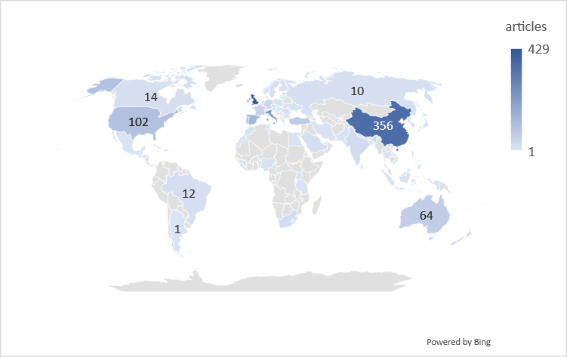
Main information about data
The table 1 provided bibliometric data represents 2015-2025 with the total amount of 229 documents on the basis of 172 sources, i.e., journals and books. This literature body has shown a strong rate of annual growth rate of 25.25% implying that the field of study is growing at a very fast rate. An average age of the documents is 2.57 years, which implies that the field is young and currently developing. The average number of citations per document is 10.16 with a relatively high academic impact. In a total, these documents refer to 13881 sources, which indicates an impressive number of references to existing literature. When it comes to content there are 747 Keywords plus (ID) and 922 key words chosen by the author suggesting rich diversity in its themes. The authorship is very collaborative as 3,945 authors were involved in the dataset. Nevertheless, only 6 articles are one-authored and it means that almost every publication is made in collaboration. The average number of authors in a document is 19.1 with a total of 35.81% international collaborations, which indicate internationalization of the research study. As far as the type of documents is concerned, 219 of them will be classified as articles with 10 more being an early access article. The dominance of peer-reviewed journal publications in the dataset and topicality of timely publishing of research findings is represented in this distribution. On the whole, the information shows an active and community-based and globally-oriented research environment.
Table 1: Summative Data of Web of Science (2015–2025) in 2022
Description | Results
MAIN INFORMATION ABOUT DATA
Timespan | 2015:2025
Sources (Journals, Books etc.) | 172
Documents | 229
Annual Growth Rate % | 25.25
Document Average Age | 2.57
Average citations per doc | 10.16
References | 13881
DOCUMENT CONTENTS
Keywords Plus (ID) | 747
Author's Keywords (DE) | 922
AUTHORS
Authors | 3945
Authors of single-authored docs | 6
AUTHORS COLLABORATION
Single-authored docs | 6
Co-Authors per Doc | 19.1
International co-authorships % | 35.81
DOCUMENT TYPES
article | 219
article; early access | 10
Annual number of research articles
The figure 3 presents a combined analysis of annual research output (bars) and mean citations per article (orange line) in the domain of AI, big data, and business networks from 2015 to 2025, revealing a dynamic interplay between knowledge production and scholarly impact. In the initial phase (2015–2018), the number of publications remains relatively low and inconsistent, yet the citation line shows comparatively higher values with a sharp peak around 2018–2019. This indicates that although few studies were produced, they carried disproportionately high academic influence, suggesting the presence of foundational or pioneering works that significantly shaped the direction of the field.
From 2019 onwards, the bars show a clear and sustained increase in publications, marking a rapid expansion phase especially after 2021, reaching its highest level around 2024. However, this growth in publication volume is accompanied by a steady decline in the citation line, indicating that the average impact per article is decreasing. This inverse relationship highlights a critical structural shift: as the field matures and attracts more researchers, the focus moves from high-impact, theory-building studies to a larger volume of incremental and application-oriented research. Additionally, recent publications (2022–2025) naturally exhibit lower citation averages due to the citation time-lag effect, as they have had less time to accumulate scholarly attention.
By 2024–2025, the figure suggests a high-output but lower-average-impact equilibrium, where the domain has achieved widespread academic engagement but with more diffused and specialized contributions. Overall, the combined visualization reflects the evolution of the research field from concentrated, high-impact beginnings to a phase of rapid expansion and diversification, emphasizing the trade-off between quantity and average citation impact.
Figure 3: Annual Number of Research Articles on Intersection of AI, Big Data, and Business Networks from 2015-2025
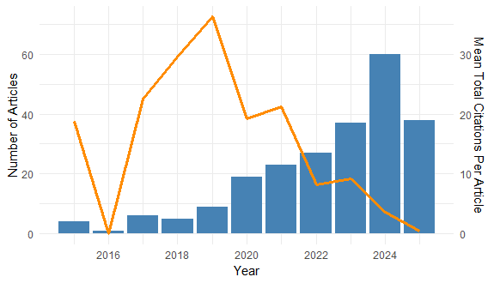
Most productive authors
The figure 4 Top 10 Most Productive Authors is demonstrated by number of documents that is represented in the form of the horizontal bar chart. The most productive author is JAKSE N with about 9 documents and it is far ahead of the rest by numbers. LI WJ has authored approximately 6 documents following JAKSE N, followed by WONG J and LI J, with about 4 documents each, FERREIRA M with about 4 documents, DUCHALAIS E, DELIBEGOVIC S and BAUTISTA OA with about 4 documents each. Finally, AKTAS MK and AGUILERA ML have published approximately 3 publications each. We can see the existence of an apparent inequality in productivity, as JAKSE N is a major player in the region.
Figure 4: Most productive authors on Intersection of AI, Big Data, and Business Networks
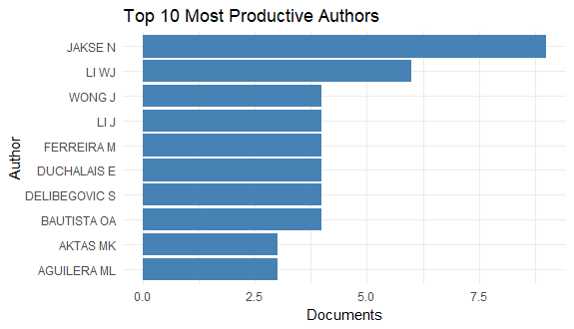
Number of articles published by sources and influential publication
The figure 5 represents Top 10 Sources by Number of Articles in the form of a horizontal bar chart. It is arguments the academic journals and publishing platforms that have made the largest contribution of articles in the analyzed data set. The most productive source was SUSTAINABILITY of which close to 10 articles were published. The top priorities after it are IEEE ACCESS that has added up by about 8 articles These two journals are the most effective platforms to present the academic work. Approximately 5 articles have already been published on PHYSICAL REVIEW B and INDUSTRIAL MARKETING MANAGEMENT, making the journal a reputable contributor to finding the research in the area. The rest of the sources JOURNAL OF MULTIDISCIPLINARY HEALTHCARE, ELECTRONICS, CHAOS SOLITONS & FRACTALS, BMJ OPEN, APPLIED SCIENCES-BASEL and ACTA POLYTECHNICA HUNGARICA have published 2.5 to 4 articles each. These journals divide many disciplines suggesting that the research is interdisciplinary.
Figure 5: Top Ten Articles with the Highest Number of Publications on Intersection of AI, Big Data and Business Networks
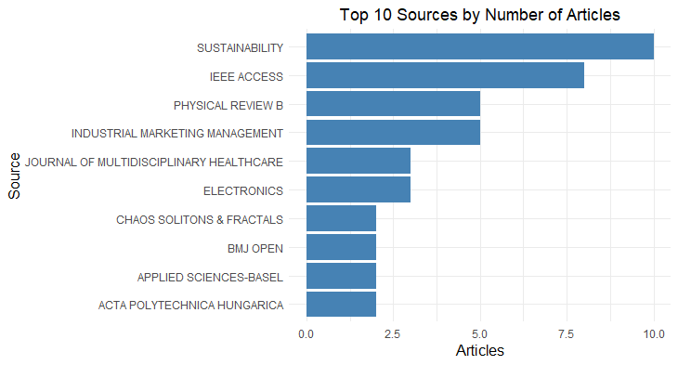
Top ten influential papers
The table 2 features the 10 most internationally quoted research paper in terms of the total number of citations, annual citation and normalized citation counts. The analysis reveals that citation impact is not solely determined by total citations, but by how rapidly and contextually a paper is recognized. While some studies show high cumulative citations, their annual growth rate is relatively moderate, indicating stabilized influence (Schroeder, 2019 – 98 citations; Ali, 2019 – 89 citations). In contrast, recent publications demonstrate higher citation intensity, suggesting strong emerging relevance in the field (Papa, 2021 – 93 citations; Chang, 2020 – 72 citations). Papers with high normalized citation scores reflect greater influence within their specific research domain, regardless of total counts (Papa, 2021 – 93 citations; Hu, 2021 – 59 citations). This indicates a shift toward more impactful and timely contributions, particularly in technology-driven and interdisciplinary areas. Additionally, variations between normalized and total citations highlight the importance of field-adjusted metrics in evaluating true scholarly significance (Hadidi, 2020 – 52 citations; Krishnan, 2019 – 59 citations). Overall, the findings suggest a transition from foundational studies to more dynamic, high-impact recent research shaping the current academic discourse.
Table 2: Top Ten Influential Papers for Intersection of AI, Big Data and Business Networks.
Paper | DOI | Total Citations | TC per Year | Normalized TC
SCHROEDER A, 2019, PROD PLAN CONTROL | 10.1080/09537287.2019.1612111 | 98 | 14.00 | 2.71
PAPA A, 2021, J KNOWL MANAG | 10.1108/JKM-04-2020-0300 | 93 | 18.60 | 4.38
ALI F, 2019, INT J CONTEMP HOSP M | 10.1108/IJCHM-10-2018-0832 | 89 | 12.71 | 2.46
AKHTAR P, 2018, BRIT J MANAGE | 10.1111/1467-8551.12233 | 78 | 9.75 | 2.64
CHANG KC, 2020, IEEE ACCESS | 10.1109/ACCESS.2020.2973648 | 72 | 12.00 | 3.75
KRISHNAN P, 2019, COMPUT COMMUN | 10.1016/j.comcom.2019.09.014 | 59 | 8.43 | 1.63
HU N, 2021, INT J MACH LEARN CYB | 10.1007/s13042-020-01253-w | 59 | 11.80 | 2.78
LI WJ, 2017, J NETW COMPUT APPL | 10.1016/j.jnca.2016.09.014 | 59 | 6.56 | 2.62
DOS SANTOS LMAL, 2021, J MANUF TECHNOL MANA | 10.1108/JMTM-04-2020-0156 | 52 | 10.40 | 2.45
HADIDI R, 2020, IEEE INTERNET THINGS | 10.1109/JIOT.2020.2972000 | 52 | 8.67 | 2.71
Global research distribution and collaboration
The figure 6 demonstrates the mode of usefulness of research and horizontal cooperation of different universities formed through the number of items produced. The number of documents represents the horizontal axis and the universities are presented in the vertical axis. The bars are broken down into two colors which depict the varying forms of collaboration, Red Multiple Country Publication (MCP), collaborations involve international collaborations with foreign countries. Then comes to domestic collaborations; these collaborations occur within a single country are labeled as Single Country Publication (SCP). Based on the figure, the majority of universities depict greater percentage of MCPs, which indicates a high tendency to cooperate in international research. Guangzhou University and the Communaute Universite Grenoble Alpes are the most fruitful of all the institutions, four documents respectively. There are three publications of Wuhan university, Central South University, and the Ministry of Education -China who follows in that order with three publications each suggesting the level of research interest. Both SCP and MCP contributions are presented in a few universities, including Hubei University of Chinese Medicine, Jiangsu University and Beijing, University of Posts and Telecommunications. This means that such institutions are involved in national and international research projects. All in all, the diagram indicates that different universities are involved actively in the joint scholarship and emphasizes the reach of the production of cross-border in research in the academic publication.
Figure 6: Corresponding Author Country Productivity
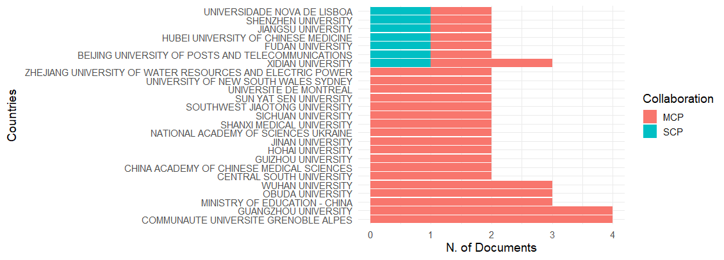
*MCP: multiple country publication *SCP: Single country publication
Thematic map on intersection of ai, big data and business networks
The figure 7 thematic map presented in the given visual examines two critical dimensions, the level of degree of density of development and relevance (centrality) in the academic literature.
Theme Category | Keywords | Meaning | Stage
Motor themes | Big data, management, performance, system architecture, dynamic. | Developed and Core | Mature
Niche Themes | Disease, disparities, experiences, classification, privacy, and state-of-the-art techniques. | less crucial | Isolated
Theoretical Themes | Artificial intelligence, models, intelligence, analytics, diagnosis, and impact. | Underdeveloped | Diagnostics
Emerging or Declining Themes | Molecular dynamics, meta-analysis, prevalence, and data bank | Not very central or dense | Limited relevance or development
The bibliometric analysis for this study was primarily conducted using the RStudio environment in conjunction with the Biblioshiny interface, which enabled comprehensive data analysis and visualization. These tools facilitated the systematic examination of publication trends, citation structures, and thematic evolution within the dataset. On the whole, this map is a valuable resource for identifying both well-established research areas and promising avenues for future study.
Figure 7: Thematic Map
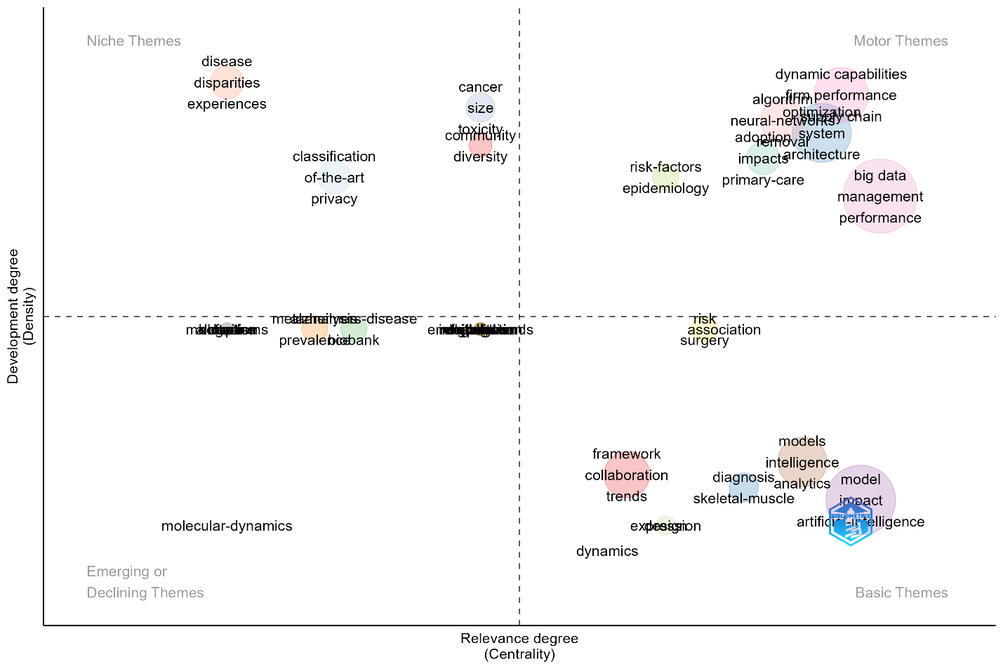
Co-occurrence of keywords
In contrast, Figure 8 presents the keyword co-occurrence network map was generated using VOS viewer, which is widely recognized for its effectiveness in constructing and visualizing bibliometric networks. For this analysis, a minimum occurrence threshold of 5 was applied to ensure the inclusion of only significant and frequently occurring keywords. Additionally, irrelevant or non-informative keywords were manually excluded to enhance the clarity and interpretability of the network. A thesaurus file was also employed to standardize terminology by merging synonymous or closely related keywords into unified terms, thereby improving the accuracy and coherence of the co-occurrence structure. This combined methodological approach ensured both analytical rigor and visual clarity in identifying key research themes and relationships within the study domain.
From an analytical standpoint, the central positioning of the keyword “business network” indicates its high degree of connectivity and co-occurrence with multiple thematic domains, signifying its role as the conceptual anchor of the field. This centrality reflects not only frequency but also structural importance, suggesting that most research streams are directly or indirectly linked to this core construct. The cluster structure reveals distinct yet interrelated research trajectories. The red cluster, comprising keywords such as “social capital,” “entrepreneurship,” and “collaboration,” reflects a strong theoretical orientation toward relational and resource-based perspectives. This indicates that scholars predominantly interpret business networks through the lens of social capital theory and entrepreneurial dynamics, emphasizing trust, relationships, and cooperative value creation.
In contrast, the green cluster, including “social network analysis,” “networking,” and “internationalization,” represents a more methodological and expansion-oriented stream. This suggests a shift toward analytical rigor and the application of quantitative network techniques, alongside a growing interest in how networks facilitate cross-border business activities. The blue cluster, which links “innovation,” “startups,” and “social networks,” highlights the increasing integration of business network research with innovation ecosystem literature. This indicates an emerging emphasis on networks as enablers of knowledge diffusion, creativity and startup growth, reflecting the field’s alignment with contemporary innovation-driven economic contexts.
Importantly, the presence of peripheral and weakly connected keywords such as “blockchain” and “network capability” signals emerging but still underdeveloped research areas. Their relatively low density and weaker link strength suggest that these topics have not yet been fully integrated into the mainstream discourse, representing potential avenues for future research. Overall, the co-occurrence network moves beyond a descriptive mapping by revealing a multi-layered intellectual structure: a well-established theoretical core (social capital and collaboration), a methodological and a set of emerging, technology-driven themes. This pattern indicates a field that is both conceptually mature and dynamically evolving, with increasing interdisciplinarity and opportunities for theoretical integration and empirical advancement.
Figure 8: Co-Occurrence Analysis of Concepts and Keywords
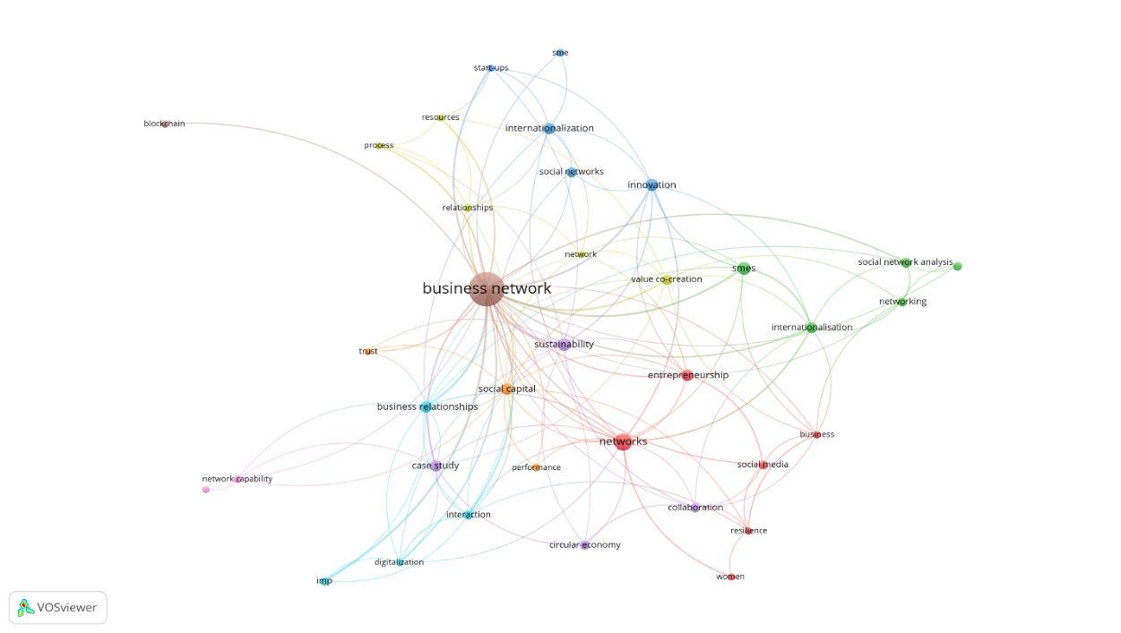
KEY FINDINGS
Analysis Type | Key Findings | Interpretation | Theoretical Link | Practical Implication
Annual Trends | Publications increased sharply after 2020; citations peaked earlier | Field is growing but maturing | Knowledge diffusion theory | Increasing research interest; emerging saturation
Country/Institution | China dominates MCP; limited SCP collaboration | Low international collaboration | Social capital theory | Need for stronger global academic ties
Thematic Map | Motor themes: AI, big data; Basic themes: models, analytics | Tech-driven shift in research | Innovation diffusion theory | Firms must adopt AI-driven networking tools
Keyword Network | “Business network” central; links to social capital, innovation, SMEs | Strong conceptual core forming | Network theory | Emphasizes relational value creation
CONCLUSION
This bibliometric and scientific mapping research, implemented by the PRISMA framework is based on an extensive examination of the artificially intelligent (AI) data flood and business networks research context over the 2015-2025 axis. Analysis shows that research is spread worldwide, and a lot of work is done by a collection of countries and thus, the interdisciplinary field has international nature. The fact that the number of publications increased gradually throughout the decade highlights the growing academic, as well as practical concerns on using AI and big data to optimize business network dynamics. They reveal that highly productive authors and prominent journals have had a pivotal role in the development of this field, giving out thematic analyses based on co-occurrence of concepts and keywords, showing key themes that include analytics powered by AI, network optimization and decision-making supported by data as the most popular ones which form the modern research. Having listed the most influential papers, it is possible to note that they have contributed to theoretical and practical conclusions in the area extensively.
The paper will give to the body of knowledge by providing systematic representation of the intellectual structure and research extractions of AI, big data and business networks, which will be useful to academics, policymakers and practitioners. In the future, it would be appropriate to investigate new sub-themes, including ethical issues that appear in AI and big data in business networks, a role in privacy-preserving technology and cross-sectoral refers to the sustainability or healthcare sector. The study of business network analytics with the latest AI potential, similar to generative models or reinforcement learning can also be productive.
The contribution to academic literature is to trace the evolution of research in the field during the period of 2015 to 2025. It accumulates knowledge regarding subjects in the other disciplines and includes a straightforward account of the connection and integration of the subjects into a complex framework of field study of systems. The scholars can understand the role of data-based technologies in impacting current organizational networks. It also serves as an excellent source of reference in prospective research when one observes the most impulsive writers, journals and pioneer research.
To people in the industry, the report sheds light on how organizations around the world are utilizing digital capacities and data intelligence to drive innovations, smarter decisions and partnerships. Other areas considered in the findings include predictive analytics, digital collaboration and intelligent supply chains that are massively promising to businesses interested in staying afloat. These insights can help business leaders and policymakers to prioritize investments that may not only produce global best practices, but also harness cross-industry cooperation. All in all, this research paper demonstrates the revolutionary possible technology of incorporating AI and big data in business networks, marking the beginning of new ways of finding solution to the complex organizational problems.
ACKNOWLEDGEMENTS
This research was not funded by any grant
Limitations and Future Scope
Although the current research contains a thorough bibliometric and scientific mapping of research carried out on the topics of Artificial Intelligence (AI), Big Data and Business Networks, this analysis is done using publications included in the Web of Science database only, which can rule out the relevant articles of other sources of similar quality. Secondly, bibliometric methods are mainly dependent on citation information and co-occurrence trends, which is not necessarily revealing of the level or quality of intellectual wisdom. The articles included in this is between 2015-2025 (after 2025) are not represented. Lastly, no qualitative evaluation of the content or methodologies in the articles analyzed is present, which would have been a more inspiring contextual interpretation.
Future studies may build on this study by combining the various databases to build a more representative and inclusive dataset. To cover more of the theoretical/applicational face of the field, scholars can complement bibliometric techniques with systematic literature review or meta-analysis. An interindustry or inter-regional comparison can also be useful to generate localized differences in attempts to shape AI and Big Data into business networks. A mixture of bibliometric knowledge and the use of interviews or case studies could also represent a more refined concept of how the digital transformation affects organizational behavior, performance and resilience.
REFERENCES
- Abayomi Abraham Adesina, Toluwalase Vanessa Iyelolu, & Patience Okpeke Paul. (2024). Leveraging predictive analytics for strategic decision-making: Enhancing business performance through data-driven insights. World Journal of Advanced Research and Reviews, 22(3), 1927–1934. https://doi.org/10.30574/wjarr.2024.22.3.1961
- Aguiar Lima Dos Santos, L. M., da Costa, M. B., Kothe, J. V., Benitez, G. B., Schaefer, J. L., Baierle, I. C., & Benitez Nara, E. O. (2021). Industry 4.0 collaborative networks for industrial performance. JOURNAL OF MANUFACTURING TECHNOLOGY MANAGEMENT, 32(2), 245–265. https://doi.org/10.1108/JMTM-04-2020-0156
- Albarrati, A. M., Nazer, R., Abdelwahab, S. I., & Albratty, M. (2025). Artificial intelligence applications and aging (1995-2024): Trends , challenges, and future directions in frailty research. ARCHIVES OF GERONTOLOGY AND GERIATRICS, 134. https://doi.org/10.1016/j.archger.2025.105837
- Andres, B., Urze, P., Araujo, E., & Camarinha-Matos, L. M. (2025). Artificial intelligence use in collaborative network processes. JOURNAL OF INDUSTRIAL INFORMATION INTEGRATION, 47. https://doi.org/10.1016/j.jii.2025.100883
- Arasteh, S. T., Kuhl, C., Saehn, M.-J., Isfort, P., Truhn, D., & Nebelung, S. (2023). Enhancing domain generalization in the AI-based analysis of chest radiographs with federated learning. SCIENTIFIC REPORTS, 13(1). https://doi.org/10.1038/s41598-023-49956-8
- Ben Yahia, N., Eljaoued, W., Ben Saoud, N. B., & Colomo-Palacios, R. (2021). Towards sustainable collaborative networks for smart cities co-governance. INTERNATIONAL JOURNAL OF INFORMATION MANAGEMENT, 56. https://doi.org/10.1016/j.ijinfomgt.2019.11.005
- Benaben, F., Fertier, A., Montarnal, A., Mu, W., Jiang, Z., Truptil, S., Barthe-Delanoe, A.-M., Lauras, M., Mace-Ramete, G., Wang, T., Bidoux, L., & Lamothe, J. (2020). An AI framework and a metamodel for collaborative situations: Application to crisis management contexts. JOURNAL OF CONTINGENCIES AND CRISIS MANAGEMENT, 28(3, SI), 291–306. https://doi.org/10.1111/1468-5973.12310
- Camarinha-Matos, L. M., Oliveira, A. I., Ferrada, F., & Thamburaj, V. (2017). Collaborative services provision for solar power plants. INDUSTRIAL MANAGEMENT \& DATA SYSTEMS, 117(5), 946–966. https://doi.org/10.1108/IMDS-06-2016-0246
- Cantu, C. L., & Tunisini, A. (2023). A circular innovation strategy in a supply network context: evidence from the packaging industry. Journal of Business and Industrial Marketing, 38(13), 220 – 238. https://doi.org/10.1108/JBIM-07-2021-0325
- David Iyanuoluwa Ajiga, Ndubuisi Leonard Ndubuisi, Onyeka Franca Asuzu, Oluwaseyi Rita Owolabi, Tula Sunday Tubokirifuruar, & Rhoda Adura Adeleye. (2024). Ai-Driven Predictive Analytics in Retail: a Review of Emerging Trends and Customer Engagement Strategies. International Journal of Management & Entrepreneurship Research, 6(2), 307–321. https://doi.org/10.51594/ijmer.v6i2.772
- Domenteanu, A., Cotfas, L.-A., Diaconu, P., Tudor, G.-A., & Delcea, C. (2025). AI on Wheels: Bibliometric Approach to Mapping of Research on Machine Learning and Deep Learning in Electric Vehicles. ELECTRONICS, 14(2). https://doi.org/10.3390/electronics14020378
- Dsouza, V. S., Leyens, L., Kurian, J. R., Brand, A., & Brand, H. (2025). Artificial intelligence (AI) in pharmacovigilance: A systematic review on predicting adverse drug reactions (ADR) in hospitalized patients. RESEARCH IN SOCIAL \& ADMINISTRATIVE PHARMACY, 21(6), 453–462. https://doi.org/10.1016/j.sapharm.2025.02.008
- Ekundayo, T. C., Olasehinde, T. A., Okaiyeto, K., & Okoh, A. I. (2021). Microbial Pathogenesis and Pathophysiology of Alzheimer’s Disease: A Systematic Assessment of Microorganisms’ Implications in the Neurodegenerative Disease. FRONTIERS IN NEUROSCIENCE, 15. https://doi.org/10.3389/fnins.2021.648484
- Galib, M., Haerani, S., Mamimg, J., & Munir, A. R. (2022). The Role of SMT and Business Network Accentuation on Value Distribution and Performance Consequences. Journal of Distribution Science, 20(5), 97 – 104. https://doi.org/10.15722/jds.20.05.202205.97
- Ghaouri, M. H., Kassim, S., & Rashid, H. (2023). Waqf-Linked Islamic Fintech Microfinance as a Business Enabler in Post-pandemic Economy: The Experience of Hal Microfinance, Kenya. Studies in Systems, Decision and Control, 470, 357 – 370. https://doi.org/10.1007/978-3-031-28314-7_30
- González, E. P., Martín Martín, J. M., Martínez, J. M. G., & Khodja, H. H. A. (2022). The Disruptive Effect of Technological Innovation in the Tourist Accommodation Industry. International Journal of Innovation and Technology Management, 19(1). https://doi.org/10.1142/S0219877021400083
- Hirt, R., Kühl, N., Martin, D., & Satzger, G. (2025). Enabling inter-organizational analytics in business networks through meta machine learning. Information Technology and Management, 26(1), 57 – 81. https://doi.org/10.1007/s10799-023-00399-7
- Holland, C. P., Thornton, S. C., & Naude, P. (2020). B2B analytics in the airline market: Harnessing the power of consumer big data. INDUSTRIAL MARKETING MANAGEMENT, 86. https://doi.org/10.1016/j.indmarman.2019.11.002
- Keegan, B. J., Iredale, S., & Naude, P. (2023). Examining the dark force consequences of AI as a new actor in B2B relationships. INDUSTRIAL MARKETING MANAGEMENT, 115, 228–239. https://doi.org/10.1016/j.indmarman.2023.10.001
- Liao, S.-H., Hu, D.-C., & Chen, S.-T. (2022). Supply chain integration, capability and performance – a business-to-business network cooperation. Journal of Business and Industrial Marketing, 37(5), 1127 – 1137. https://doi.org/10.1108/JBIM-10-2020-0467
- Papa, A., Chierici, R., Ballestra, L. V., Meissner, D., & Orhan, M. A. (2021). Harvesting reflective knowledge exchange for inbound open innovation in complex collaborative networks: an empirical verification in Europe. JOURNAL OF KNOWLEDGE MANAGEMENT, 25(4, SI), 669–692. https://doi.org/10.1108/JKM-04-2020-0300
- Pardo, C., Wei, R., & Ivens, B. S. (2022). Integrating the business networks and internet of things perspectives: A system of systems (SoS) approach for industrial markets. Industrial Marketing Management, 104, 258 – 275. https://doi.org/10.1016/j.indmarman.2022.04.012
- Patrick Azuka Okeleke, Daniel Ajiga, Samuel Olaoluwa Folorunsho, & Chinedu Ezeigweneme. (2024). Predictive analytics for market trends using AI: A study in consumer behavior. International Journal of Engineering Research Updates, 7(1), 036–049. https://doi.org/10.53430/ijeru.2024.7.1.0032
- Penttinen, V., & Frösén, J. (2022). Shared analytical capabilities in business networks. Industrial Marketing Management, 106, 308 – 322. https://doi.org/10.1016/j.indmarman.2022.08.018
- Pinter, D. G., & Ihasz, P. L. (2019). Bridging Natural Language Processing AI techniques and Corporate Communications: towards an integrative model. INFORMACIOS TARSADALOM, 19(4), 77–99.
- Rivera, N. V. (2024). Big data in sarcoidosis. CURRENT OPINION IN PULMONARY MEDICINE, 30(5), 561–569. https://doi.org/10.1097/MCP.0000000000001102
- Sanchez-Lopez, M. D. (2023). Geopolitics of the Li-ion battery value chain and the Lithium Triangle in South America. Latin American Policy, 14(1), 22 – 45. https://doi.org/10.1111/lamp.12285
- Santos, B., & Campos, P. (2023). SUWAN: A supervised clustering algorithm with attributed networks. INTELLIGENT DATA ANALYSIS, 27(2), 423–441. https://doi.org/10.3233/IDA-216436
- Schroeder, A., Bigdeli, A. Z., Zarcos, C. G., & Baines, T. (2019). Capturing the benefits of industry 4.0: a business network perspective. PRODUCTION PLANNING \& CONTROL, 30(16), 1305–1321. https://doi.org/10.1080/09537287.2019.1612111
- Sun, Y., Qiao, F., Wang, W., Xu, B., Zhu, J., Mansour, R. F., & Qi, J. (2022). Dynamic Intelligent Supply-Demand Adaptation Model Towards Intelligent Cloud Manufacturing. CMC-COMPUTERS MATERIALS \& CONTINUA, 72(2), 2825–2843. https://doi.org/10.32604/cmc.2022.026574
- Uchenna Joseph Umoga, Enoch Oluwademilade Sodiya, Ejike David Ugwuanyi, Boma Sonimitiem Jacks, Oluwaseun Augustine Lottu, Obinna Donald Daraojimba, & Alexander Obaigbena. (2024). Exploring the potential of AI-driven optimization in enhancing network performance and efficiency. Magna Scientia Advanced Research and Reviews, 10(1), 368–378. https://doi.org/10.30574/msarr.2024.10.1.0028
- Wang, H., Smith, D., & Demir, U. (2025). Scaling AI filmmaking with collaborative networking. IET COMMUNICATIONS, 19(1). https://doi.org/10.1049/cmu2.12877
- Xavier, J. A., Siong, G. K., Yew, L. K., Jiang, N., & Alagappar, P. N. (2022). Fostering Business Growth through Generational Change: Is Guanxi Still Important? Translocal Chinese: East Asian Perspectives, 16(2), 228 – 248. https://doi.org/10.1163/24522015-16020004
- Zhang, Q., Lu, J., & Jin, Y. (2021). Artificial intelligence in recommender systems. Complex and Intelligent Systems, 7(1), 439–457. https://doi.org/10.1007/s40747-020-00212-w
- Zhu, Y. P., & Park, H. W. (2024). Publication, Collaboration, Citation Performance, and Triple Helix Innovation Gene of Artificial Intelligence Research in the Communication Field: Comparing Asia to the Rest of the World. JOURNAL OF THE KNOWLEDGE ECONOMY. https://doi.org/10.1007/s13132-024-02280-6

