Mapping the Landscape of Insurtech Research: A Bibliometric Analysis
Sulfath Thadathil^{1,} Dr. Saleena TA²
¹Research Scholar, Department of Commerce, PSMO College (Autonomous), Tirurangadi,
Affiliated to University of Calicut, Kerala, India, Email: tsulfath92@gmail.com.
²Assistant Professor, Department of Commerce, PSMO College (Autonomous), Tirurangadi,
Affiliated to University of Calicut, Kerala, India
*Corresponding Author: Sulfath Thadathil

ABSTRACT
InsurTech, which stands for "insurance technology," refers to technology and innovation with the primary purpose of providing better services and technology to the insurance business in current progressive technological environment and industrial revolution. That industry is increasingly relies on technology to gain a competitive advantage, and it helps decision-makers make sound decisions. New technologies are integrating and strongly influencing people's work and life, and they have emerged as a key driver of the insurance industry's constant innovation. The application of InsurTech has gained widespread attention in the industry, and it is essential to conduct an in-depth deconstruction and analysis of its impact on insurance business innovation. This study aims to analyse the recent trends and patterns of research in the field of Insurtech using bibliometric methods. For this, 668 articles in total were retrieved from the Scopus and Web of Science databases after removing the duplicates. The data was analysed using Bibliometric R-package. The results identified the leading countries, institutions, authors, journals, most occured keywords, scientific publications on the topic and shed light on current research trends. Some of the results demonstrate that the most cited country is the United Kingdom followed by China and Germany, the most productive institution is University of Vaasa, the most productive author is Zhang J followed by Giudici P, Grobys K, Okoli T and Wang J, and the most productive journal is Journal of Risk and Financial Management followed by IEEE Access.
Keywords: Insurtech, Financial Technology, Bibliometrics, Biblioshiny-R package
INTRODUCTION
The insurance industry has gained a deeper understanding of the significance and urgency of digital transformation as a result of Fintech's challenges to the financial and insurance sector. At the same time, the industrial transformation and technological revolution represented by the use of digital technologies like big data, blockchain, cloud computing, and artificial intelligence are emerging(Fan, 2018). Our daily lives are influenced by technology and the innovation. InsurTech is a crucial strategic tool that insurance firms may use to adapt to this unprecedented digital change (Seibe,2019), is turning into one of the main engines of economic expansion. To guarantee that the insurance sector can fulfil the demands of digital transformation and attain better business growth, it is essential to establish the InsurTech's strategy for "sustainable development". Customers expect the same digital experience with insurance as they do with financial transactions and life management via the internet and mobile devices. The integration of the financial infrastructure should result in cost savings and a more efficient financial market (Matousek et al., 2015). To solve inefficiencies or opportunities in the insurance value chain—which usually involves technology, data, and analytics—InsurTech integrates cutting-edge hardware, software, and user interfaces (Hoffman et al., 2002).
But with so many studies out there, it can be tough to see the big picture. That's where bibliometric analysis comes in. This is a way to look at lots of research papers and see patterns. We can find out which papers are most important, who's doing the most interesting work, and what topics are getting the most attention (Donthu et al., 2021). This study aims to explore the research trends in Insurtech by conducting a comprehensive bibliometric analysis using data sourced from Scopus and Web of Science databases. The purpose of this paper is to uncover key trends, recognize leading contributors and institutions, identify influential publications, and delineate emerging themes within the literature. The analysis includes 668 selected articles after removing duplicates that collectively provide insights into global publication patterns, dominant journals and the most frequently discussed keywords. Moreover, this paper investigates under-researched areas and theoretical gaps to propose directions for future research.

RESEARCH QUESTIONS
Thus, the primary objective of this study is to fill the existing research gap by providing answers to the following five research questions:
- RQ1: What are the current research trends in the field of Insurtech?
- RQ2: Which are the most cited countries in research related to Insurtech?
- RQ3: Which are the most ranked journals in research related to Insurtech?
- RQ4: What thematic structure is evident in research related to Insurtech?
- RQ5: Who is the most relevant author in research related to Insurtech?
By addressing these aspects, the findings aim to serve as a foundational resource for academics seeking to deepen their understanding of Insurtech. Additionally, this work aspires to inform policymakers and industry practitioners, equipping them with actionable knowledge about Insurtech for sustainable development and innovation while mitigating associated challenges. This paper not only maps the current state of research but also establishes a roadmap for advancing the discourse in this rapidly evolving domain.
RESEARCH MATERIALS AND METHODS
Bibliometric analysis is a key metric for assessing the quality of scientific output (Singh and Bashar, 2021). Bibliometric analysis highlights key discoveries from a set of bibliographic records (Leong et al., 2021). An important element of the research process is choosing the methods and resources for data analysis. The data for this study has been obtained from Scopus and Web of Science databases. Among the well-known databases frequently employed in bibliometric research are WoS, Scopus, Google Scholar, etc. For this study, the data was collected from Web of Science and Scopus database. Removed 116 duplicate articles using bibliometric R package coding. The software used for analysis is Biblioshiny. Once the database is selected, the next step is to decide the query string. In this study, documents were extracted using the search terms “Insurtech” or “Insurance Technology” or “Insur-Tech” or “Financial Technology”. All the articles (Publication Stage- Final) till the date of data extraction (13th March 2025) are included in the analysis. Further details of the search strategy are given in Table 1.

Table 1: Parameters of the search strategy in Scopus
Database | Scopus
Search Date | 13th March 2025
Search word | Insurtech
Category | Article Title, Abstract and Keyword
Query String | “Insurtech” or “Insurance Technology” or “Insur-Tech” or “Financial Technology”
Total docs before filtration | 4001
Subject criteria | Economics, Econometrics and Finance, Business, management and Accounting
Document type | Article
Period time | No filtration
Language | English
Source type | Journal
Publication Stage | Final
Open Access | All open Access
Total docs after filtration | 548

Table 2: Parameters of the search strategy in Web of Science
Database | Web of Science
Search Date | 13th March 2025
Search word | Insurtech
Category | All fields
Query String | “Insurtech” or “Insurance Technology” or “Insur-Tech” or “Financial Technology”
Total docs before filtration | 1135
Research Area | Business Economics, computer Science
Document type | Article
Period time | No filtration
Language | English
Source type | Journal
Publication Stage | Final
Open Access | All Open Access
Total docs after filtration | 236
Combining the 548 documents from Scopus and 236 documents from Web of Science yielded 784 total documents. After removing 116 duplicate records (documents indexed in both databases), 668 unique articles remained for analysis. No additional documents were excluded at the screening stage; all 668 articles were included in the bibliometric analysis.
RESULTS AND DISCUSSION
This section addresses the five research questions in sequence.
4.1 RQ1: Current Research Trends in Insurtech
The annual scientific production shows limited activity before 2017, followed by a sustained upward trajectory from 2017 onward, indicating that Insurtech has rapidly evolved into an established research domain. Publication output peaks in 2024, confirming intensified scholarly attention. Trending topic analysis further reveals that recent studies are concentrated around Finance, Fintech, and Innovation, demonstrating the interdisciplinary roots of Insurtech. The thematic map supports this pattern by identifying Finance, Fintech, and Innovation as motor themes, while technology, performance management, and internet services appear as basic themes that underpin future development. The word cloud reinforces these findings, where prominent terms include Fintech, Insurtech, machine learning, big data, automation, and sustainable development. Collectively, these results indicate that current Insurtech research is increasingly data-driven, innovation-oriented, and focused on digital transformation.
4.2 RQ2: Most Cited Countries
Citation analysis shows that the United Kingdom is the most cited country with 2201 total citations, followed by China (1641) and Germany (722). Italy and Finland also demonstrate strong influence. These findings suggest that Europe and Asia are the leading knowledge hubs in Insurtech research, while countries such as Indonesia, Australia, Turkey, Nigeria, and the USA also contribute meaningfully to the global literature.
4.3 RQ3: Most Ranked Journals
Bradford Law analysis identifies the Journal of Risk and Financial Management as the most ranked and productive source in the core zone, followed by IEEE Access and Financial Innovation. Other influential outlets include Cogent Economics and Finance, Finance Research Letters, and Journal of Open Innovation: Technology, Market, and Complexity. This concentration indicates that Insurtech scholarship is primarily disseminated through finance, technology, and innovation-oriented journals.
4.4 RQ4: Thematic Structure of Insurtech Research
The thematic structure reveals four clusters: motor themes, niche themes, basic themes, and emerging/declining themes. Motor themes such as Finance, Fintech, and Innovation represent the most developed and central topics in the field. Basic themes including technology performance management and internet services provide the conceptual foundation of the discipline. Niche themes reflect specialized but relatively isolated topics, while emerging or declining themes may signal future opportunities or fading interests. The conceptual structure map using MCA also shows a dominant cluster focused on digital transformation, technology adoption, finance, and socioeconomic implications, indicating a coherent and maturing research field.
4.5 RQ5: Most Relevant Authors
Author productivity analysis identifies Zhang J as the most relevant author with seven publications. Giudici P, Grobys K, Okoli T, and Wang J follow closely with six publications each. Additional contributors such as Grassi L, Huang S, Ozli P, Sun Y, and Wang Y each published five documents. These scholars have played a major role in shaping the contemporary Insurtech knowledge base.

Figure 1: Annual Scientific Production

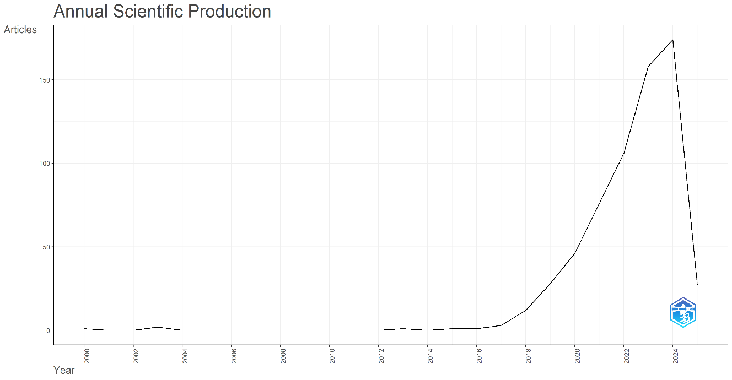
The Figure 1 shows a steady increase in scientific production related to Insurtech from 2017 to 2024, after a period of low activity prior to 2017. This increase reflects growing interest and advancements in the field of insurtech, with a peak in 2024.
Table 3: Most Cited Countries
Country | TC | Average Article Citations
UNITED KINGDOM | 2201 | 40.80
CHINA | 1641 | 19.10
GERMANY | 722 | 51.60
ITALY | 573 | 23.90
FINLAND | 443 | 40.30
INDONESIA | 442 | 11.30
AUSTRALIA | 406 | 29.00
TURKEY | 347 | 57.80
NIGERIA | 338 | 48.30
USA | 313 | 20.90
Note: TC= Total Citations
Table 3 shows the citations across different countries, with the United Kingdom leading by a significant margin of 2201 citations. The results from the table clearly show the dominance of the UK in this domain of research. The China ranks second with 1641 citations, followed by Germany with 722 citations. After the first three countries, there is Italy (573 citations) and Finland (443citations). The remaining countries, including Indonesia, Australia, turkey, Nigeria and USA contribute fewer citations, indicating that the majority of influential research is concentrated in a few key countries.

Table 4: Bradford Law Analysis
SOURCE | Rank | Freq | CumFreq | Zone
JOURNAL OF RISK AND FINANCIAL MANAGEMENT | 1 | 27 | 27 | Zone 1
IEEE ACCESS | 2 | 18 | 45 | Zone 1
FINANCIAL INNOVATION | 3 | 17 | 62 | Zone 1
COGENT ECONOMICS AND FINANCE | 4 | 16 | 78 | Zone 1
FINANCIAL AND CREDIT ACTIVITY: PROBLEMS OF THEORY AND PRACTICE | 5 | 13 | 91 | Zone 1
INVESTMENT MANAGEMENT AND FINANCIAL INNOVATIONS | 6 | 13 | 104 | Zone 1
BANKS AND BANK SYSTEMS | 7 | 11 | 115 | Zone 1
JOURNAL OF OPEN INNOVATION: TECHNOLOGY, MARKET, AND COMPLEXITY | 8 | 10 | 125 | Zone 1
FINANCE RESEARCH LETTERS | 9 | 9 | 134 | Zone 1
FINANCE: THEORY AND PRACTICE | 10 | 9 | 143 | Zone 1
Table 4 shows the ranking of journals based on Bradford Law Analysis using biblioshiny. The results reveal that the most ranked journal is Journal of Risk and Financial Management and second rank is for IEEE Access followed by Financial Innovation.
Table 5: Most Relevant Affiliations
Affiliation | Articles
UNIVERSITY OF VAASA | 10
NATIONAL YANG MING CHIAO TUNG UNIVERSITY | 9
AMMAN ARAB UNIVERSITY | 9
APPLIED SCIENCE PRIVATE UNIVERSITY | 9
ZHEJIANG UNIVERSITY OF TECHNOLOGY | 9
UNIVERSITY OF SFAX | 8
UNIVERSITY OF ZULULAND | 8
RMIT UNIVERSITY | 7
CITY UNIVERSITY OF HONG KONG | 6
KYIV NATIONAL ECONOMIC UNIVERSITY NAMED AFTER VADYM HETMAN | 6

Table 5 highlights the global nature of Insurtech research, with University of Vaasa at the top of the list. Institutions from various regions, including Europe, Asia, and Hongkong, demonstrate the field's widespread importance. The mix of developed and developing regions indicates the possibility of cross-border collaboration to advance research. Emerging contributors, such as City University of Hong Kong and Kyiv National Economic University Named After Vadym Hetman, may play important roles in the future. Overall, the data demonstrate the increasing academic interest and global collaboration opportunities in this field.
Table 6: Countries Scientific Production
Region | Freq
CHINA | 160
UK | 69
INDONESIA | 55
USA | 38
INDIA | 34
ITALY | 29
UKRAINE | 24
MALAYSIA | 23
JORDAN | 22
SOUTH AFRICA | 22

The table 6 depicts the global distribution of research contributions in Insurtech, with China leading significantly with 160 contributions, indicating its strong industrial and technological focus. UK and Indonesia emerge as significant contributors, demonstrating their dedication to technological advancement and digital innovation. According to the regional research, Asia—and China in particular—dominates the global production landscape m/ost frequently. North America, represented by the USA, makes a moderate contribution, while Europe, lead by the UK, also plays a major part. Production activity is moderate in the Middle East and Africa, with South Africa and Jordan, respectively. These regional disparities highlight the need for further investigation into the factors driving production in each region and potential areas for growth and collaboration.

Figure 2: Trending topics
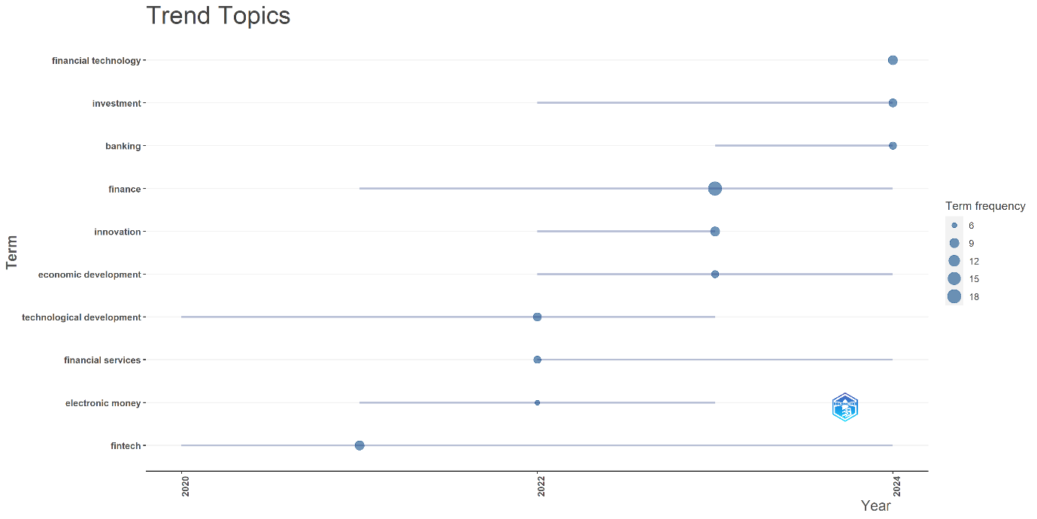
Figure 2 Trending topic analysis provides the keywords utilized in the most trending articles. This is a relevant method for determining the recent trends in the area of our research topic. The graph shows that the recent research in this area is concentrated around Finance, Fintech and Innovation the most.
Figure 3: Thematic Map

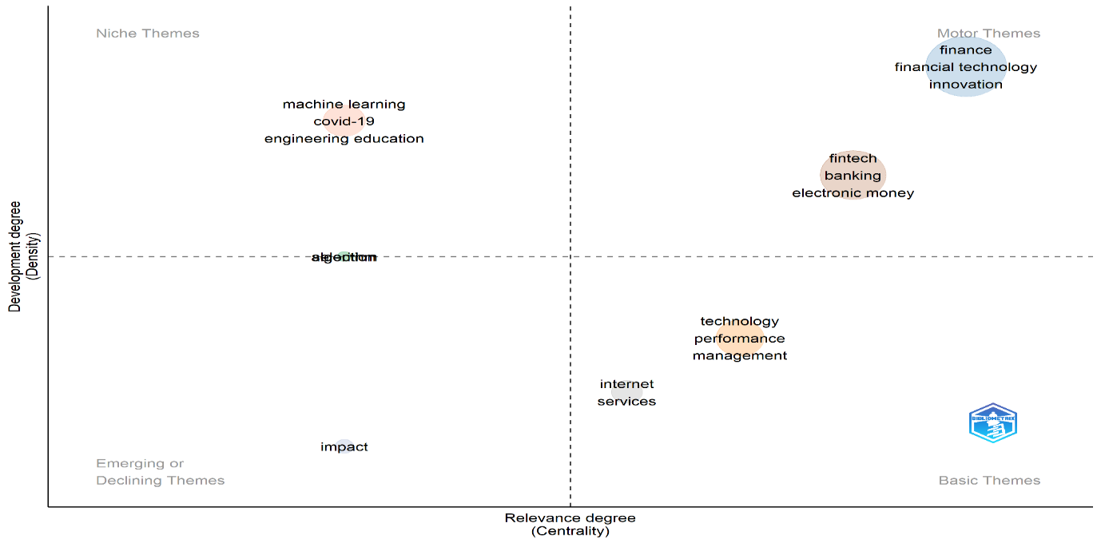
In Figure 3, the thematic map shows four regions such as niche themes (upper left quadrant), motor themes (upper right), emerging or declining themes (lower left) and basic themes (lower right). The thematic map highlights that Motor themes like Finance, Fintech and Innovation are the core and dynamic research areas. Basic themes like technology performance management and internet services are foundational and offer opportunities for deeper exploration. Niche themes might be highly specific but less broadly impactful. Emerging/declining themes could signal potential future trends or areas losing attention.
Figure 4: Word Cloud Analysis
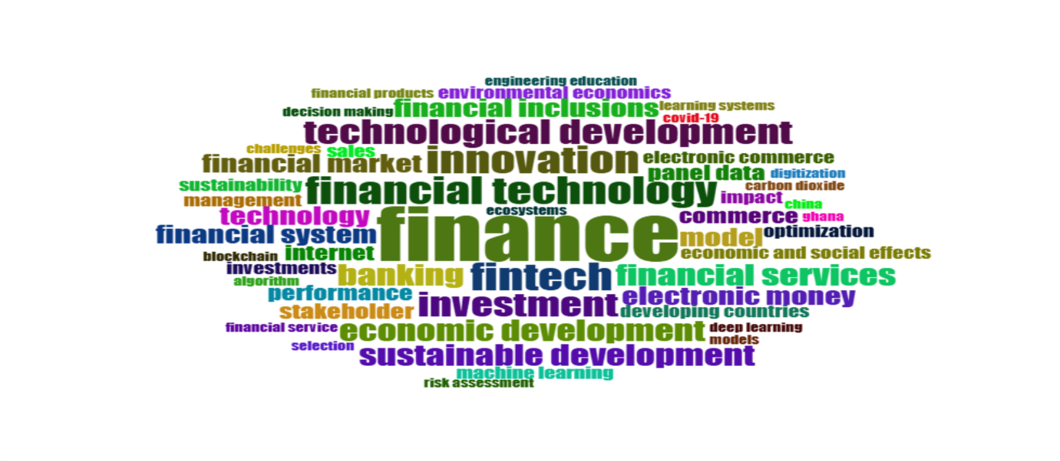The word cloud in figure 4 emphasizes the importance of “Financial Technology” and “Insurtech” in research, underscoring its fundamental role in related studies. Key themes such as “Finance”, "fintech", "innovation", "investment", “technological development” and “sustainable development” highlight Insutech”s potential for addressing technological and societal challenges. Emerging technologies such as "machine learning," "big data," and "automation" are prominent, demonstrating their importance in advancing Insurance sector.
Figure 5: Most Relevant Authors
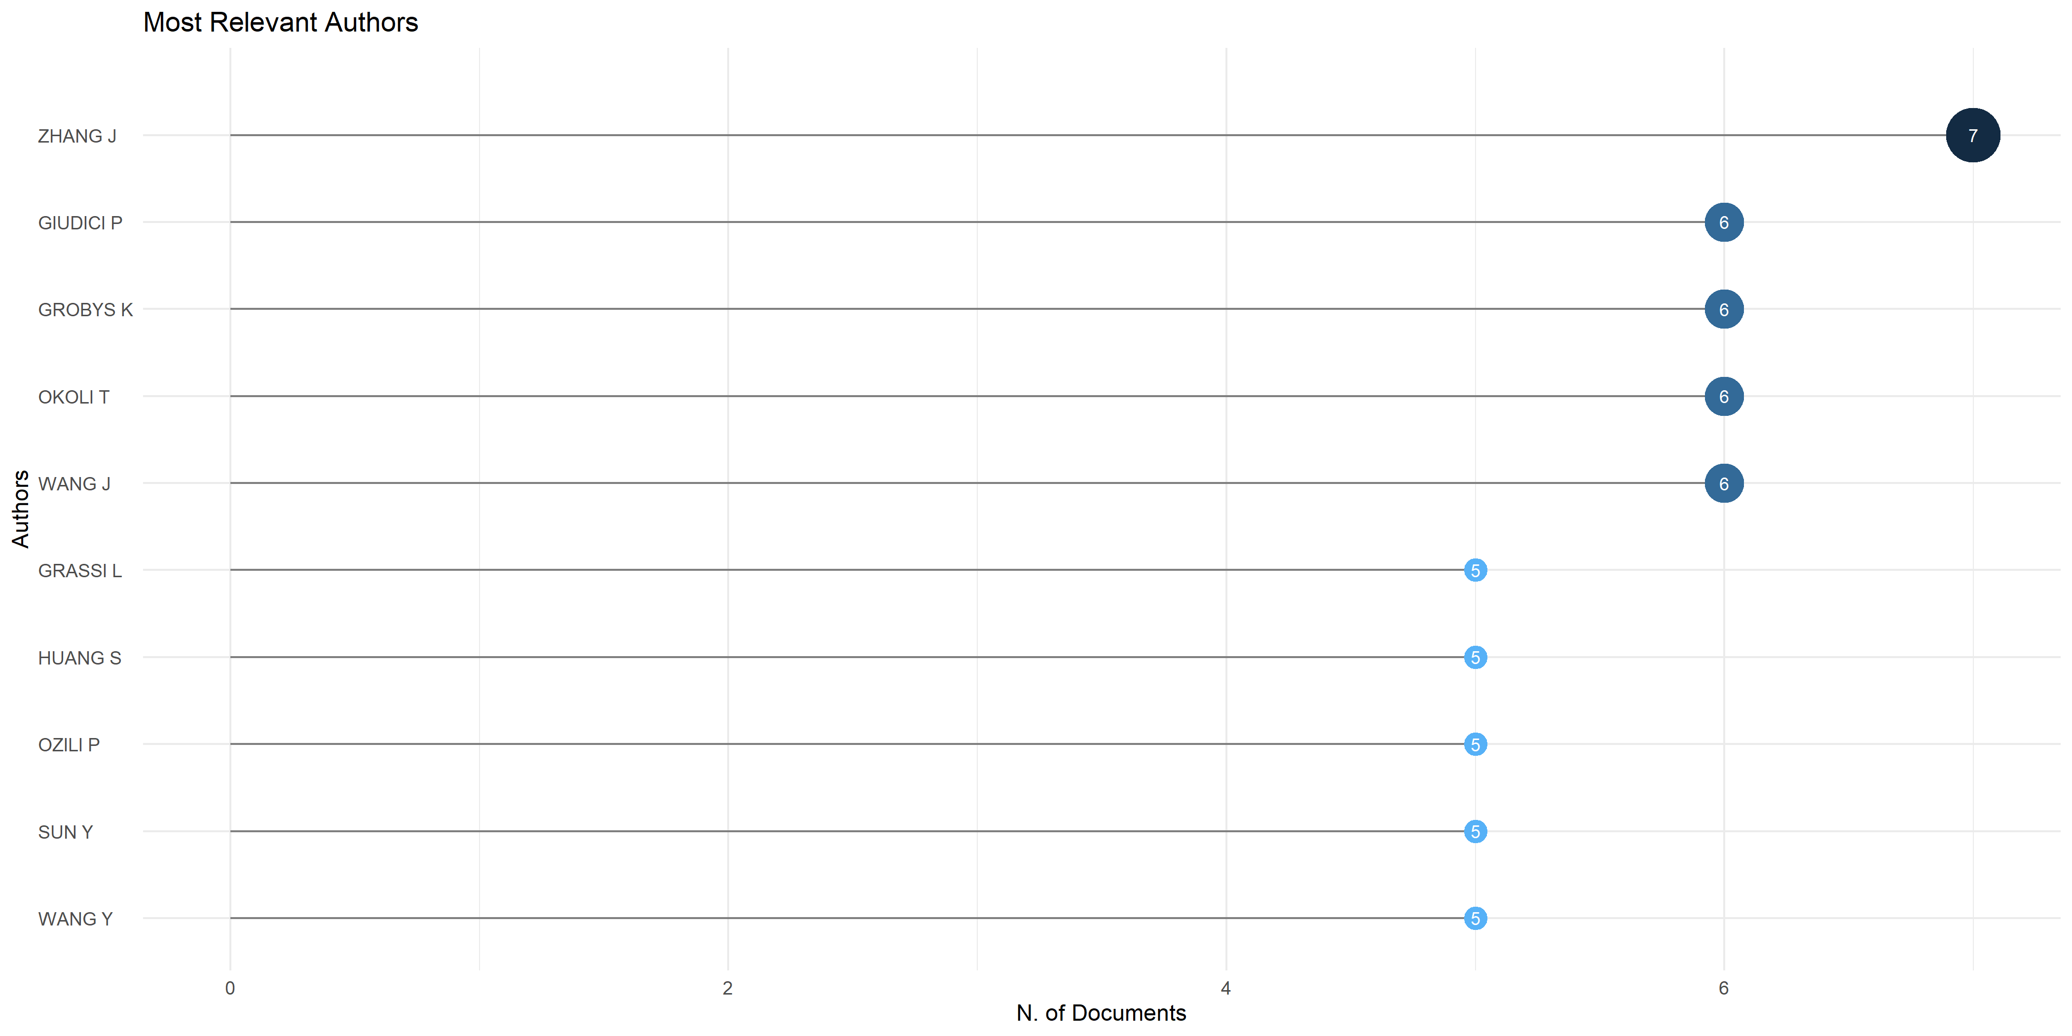
The Figure 5 showcases the most relevant authors in the field of Insurtech based on the number of documents published. Zhang J stands out with the highest number of contributions (7), followed closely by Giudici P, Grobys K, Okoli T and Wang J (6). Grassi L, Huang S, Ozli P, Sun Y and Wang Y have each contributed 5 documents, highlighting their consistent engagement with the topic.

Figure 6: Country Collaboration Map
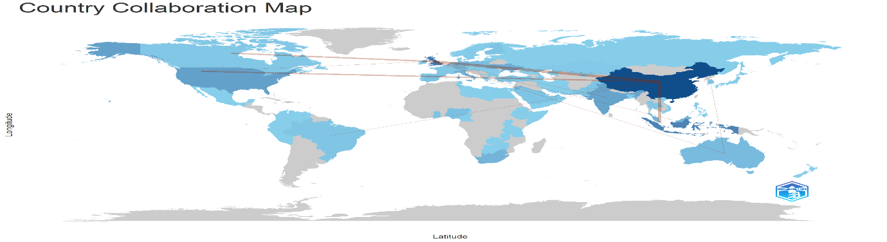
Figure 6 shows a Country Collaboration Map created using Biblioshiny from the bibliometrix R-package (Aria & Cuccurullo, 2017). The map employs colour to demonstrate how closely countries collaborate, with darker colours indicating more powerful partnerships. China is the most active country, forming many co-authorship links with other nations. North America, Europe, and Asia have numerous links, establishing them as major players in international research. This visualisation emphasises the significance of cross-border collaboration in advancing knowledge. The lines connecting countries reflect collaborative links, demonstrating how research activities are linked globally.

Figure 7: Conceptual Structure Map – Method: MCA
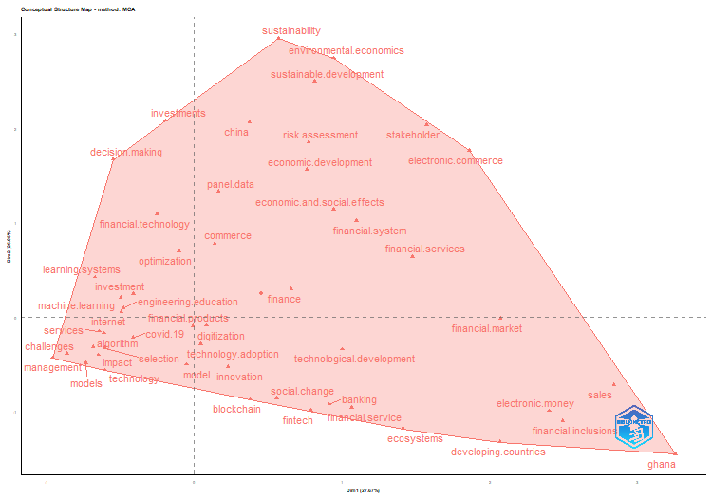
This figure 7 shows settings used for factorial analysis in Biblioshiny. The analysis was based on "ID" fields from the dataset. It used Multiple Correspondence Analysis (MCA) to explore patterns in the data. MCA assists in determining how various keywords or things join together. Only terms that appeared at least once were considered for the analysis. The minimal degree of co-occurrence was fixed at 3. Clustering was done, and one major cluster was identified. This cluster focusses on topics such as digital transformation, finance, technology adoption, and the socioeconomic implications of digital technologies. The close positioning of these publications in the factorial space indicates a high level of semantic similarity, implying that the body of literature under consideration is largely unified in focus. This method is useful for revealing hidden structures in bibliographic data. Such analysis facilitates a better comprehension of thematic areas in study. The tool used was the bibliometrix R-package via Biblioshiny (Aria & Cuccurullo, 2017).
LIMITATIONS AND FUTURE SCOPE
While this study gives essential insights, it's crucial to note its limits. One significant drawback is the exclusive dependence on a single software for data analysis, which ignores the advantages of analysing the data more comprehensively. One important restriction is the reliance on Web of Science and Scopus, for data collecting. Although Web of Science and Scopus is a substantial resource, the authors acknowledge that it may not cover the entire scope of the topic. Incorporating data from other databases might broaden the study's scope. Furthermore, this study did not consider unpublished materials, such as dissertations, textbooks, or conference proceedings, which could provide other viewpoints. Furthermore, by focussing primarily on English-language publications, the study risks overlooking important findings from research undertaken in other languages. Addressing these constraints in future study may result in a more complete understanding of the field.
CONCLUSION
This bibliometric analysis provides valuable insights into the research landscape of Insurtech. The findings highlight the dynamic evolution of this field, driven by its pivotal role in transforming insurance business, improving decision-making, and fostering sustainable development. Through thematic mapping, we identified core research themes, emerging trends, and underexplored areas that present opportunities for future inquiry.
The analyses presented in this article provide a comprehensive overview of the research landscape in Insurtech. The steady growth in scientific production, particularly since 2017, highlights the increasing interest and advancements in this field, culminating in a peak in 2024. The global nature of contributions, led by countries such as United Kingdom, China and Germany reflects the widespread recognition of Insurtech as critical areas of innovation. The remaining countries, including Indonesia, Australia, turkey, Nigeria and USA contribute fewer citations, indicating that the majority of influential research is concentrated in a few key countries.
The thematic map highlights that Motor themes like Finance, Fintech and Innovation are the core and dynamic research areas. Basic themes like technology performance management and internet services are foundational and offer opportunities for deeper exploration. Key themes such as “Finance”, "fintech", "innovation", "investment", “technological development” and “sustainable development” highlight Insutech’s potential for addressing technological and societal challenges. Journals such as Journal of Risk and Financial Management and IEEE Access followed by Financial Innovation play a pivotal role in disseminating cutting-edge findings, while leading affiliations like University of Vaasa and National Yang Ming Chiao Tung University highlights the global nature of Insurtech research. Institutions from various regions, including Europe, Asia, and Hongkong, demonstrate the field's widespread importance. Most relevant author in the field of Insurtech based on the number of documents published is Zhang J.
The country collaboration map indicates China is the most active country, forming many co-authorship links with other nations. North America, Europe, and Asia have numerous links, establishing them as major players in international research. The conceptual structure map using MCA shows the major clusters. Here the major cluster focusses on topics such as digital transformation, finance, technology adoption, and the socioeconomic implications of digital technologies.
Overall, this study demonstrates the interdisciplinary nature of Financial Technology and Insurtech research, emphasizing its centrality in addressing global challenges and enabling technological progress. Future research should aim to deepen the understanding of emerging themes, strengthen collaborations across domains, and ensure that Fintech and Insurtech continue to advance in a way that is equitable, sustainable, and beneficial for society at large.
PRACTICAL IMPLICATIONS
For Researchers: Emerging topics such as Fintech, innovation, machine learning, big data, automation, and sustainable development offer strong opportunities for future Insurtech research. Scholars can explore areas such as AI-driven insurance services, fraud detection, customer trust, and digital inclusion.
For Publishers: The Journal of Risk and Financial Management is the most productive journal, suggesting strong interest in Insurtech studies. The presence of IEEE Access also shows that interdisciplinary and technology-focused journals are important publication outlets.
For Policymakers: The United Kingdom leads in citations, indicating that its research may provide useful policy guidance. China leads in publication output, reflecting a strong research base but relatively lower international visibility. Countries with lower impact can improve visibility by promoting international collaboration and wider dissemination of research.

REFERENCES
- Aria, M., & Cuccurullo, C. (2017). bibliometrix: An R-tool for comprehensive science mapping analysis. Journal of Informetrics, 11(4), 959–975. https://doi.org/10.1016/j.joi.2017.08.007
- Donthu, N., Kumar, S., Mukherjee, D., Pandey, N., & Lim, W. M. (2021). How to conduct a bibliometric analysis: An overview and guidelines. Journal of Business Research, 133, 285–296. https://doi.org/10.1016/j.jbusres.2021.04.070
- Fan, P. S. (2018). Singapore approach to develop and regulate FinTech. In D. Lee & R. Deng (Eds.), Handbook of blockchain, digital finance, and inclusion, Volume 1: Cryptocurrency, FinTech, InsurTech, and regulation (pp. 223–241). Elsevier Inc. https://doi.org/10.1016/B978-0-12-810441-5.00015-4
- Hoffman, K. D., Turley, L. W., & Kelley, S. W. (2002). Pricing retail services. Journal of Business Research, 55(12), 1015–1023. https://doi.org/10.1016/S0148-2963(00)00227-7
- Leong, L.-Y., Hew, T.-S., Tan, G. W.-H., Ooi, K.-B., & Lee, V.-H. (2021). Tourism research progress – A bibliometric analysis of Tourism Review publications. Tourism Review, 76(1), 1–26. https://doi.org/10.1108/TR-11-2019-0449
- Matousek, R., Rughoo, A., Sarantis, N., & Assaf, A. G. (2015). Bank performance and convergence during the financial crisis: Evidence from the ‘old’ European Union and Eurozone. Journal of Banking & Finance, 52, 208–216. https://doi.org/10.1016/j.jbankfin.2014.08.012
- Siebe, T. M. (2019). Digital transformation: Survive and thrive in an era of mass extinction (pp. 123–135). RosettaBooks.
- Singh, S., & Bashar, A. (2021). A bibliometric review on the development in e-tourism research. International Hospitality Review. Advance online publication. https://doi.org/10.1108/IHR-03-2021-0015
- Van Eck, N. J., & Waltman, L. (2010). Software survey: VOSviewer, a computer program for bibliometric mapping. Scientometrics, 84(2), 523–538. https://doi.org/10.1007/s11192-009-0146-3

