SOIL TESTING TECHNIQUES: CONSTRAINTS AND INTELLIGENT AGRICULTURAL DIRECTIONS
Meet Kulkarni¹, Radha Chandrashekhar², Samruddhi Kadlag³, Prof. Dr. Rajani Hardas⁴
Department of Electrical engineering, PES’s Modern college of Engineering, Pune, India.

ABSTRACT
Maintaining soil fertility is central to sustaining crop yields, managing input costs, and protecting the ecological balance of agricultural land. Soil testing serves as the primary scientific means through which farmers and agronomists gather the data needed to make informed decisions about nutrient application and land use. Parameters such as pH, nitrogen, phosphorus, potassium, organic carbon, and electrical conductivity form the foundation of any meaningful fertility assessment, directly shaping fertilizer strategies and crop planning outcomes. In practice, however, the systems currently in place for soil analysis have not kept pace with the scale and complexity of modern agricultural demands.
Most testing continues to be carried out in centralized government or private laboratories, where samples must be physically transported, processed through standardized chemical procedures, and returned to farmers in the form of reports that are often difficult to act on without technical guidance. Procedural delays, geographic inaccessibility, and the limited interpretability of nutrient data remain persistent barriers to widespread adoption, particularly among smallholder farming communities.
This paper reviews the structure and functioning of existing soil testing frameworks, examining laboratory organization, operational workflows, and result communication practices. Particular attention is given to the gap between data availability and practical decision-making at the farm level. The review further explores how portable sensing technologies, IoT-enabled data collection, and intelligent recommendation systems might address these shortcomings and support a transition toward more accessible, farmer-centric soil health solutions.
“Keywords:” Soil Testing, Soil Health, Precision Agriculture, Sustainable Agriculture, IoT, Decision Support Systems.
INTRODUCTION
SOIL NUTRIENT ANALYSIS
Agriculture remains the backbone of food security and rural economies, particularly in developing countries where crop productivity is closely linked to soil fertility and resource management. Increasing global food demand, climate variability, and continuous cultivation practices have intensified pressure on agricultural lands, resulting in nutrient depletion, soil degradation, and declining productivity. In this context, soil testing has emerged as a fundamental scientific tool for assessing soil fertility status and enabling data-driven nutrient management.
Soil testing provides quantitative information regarding soil chemical and physical properties such as pH, nitrogen, phosphorus, potassium, organic carbon, and salinity levels. These parameters directly influence crop growth, fertilizer efficiency, and long-term soil health. Accurate soil analysis allows farmers and agronomists to adopt balanced fertilizer strategies, reduce unnecessary input costs, and improve overall agricultural sustainability.
Conventional soil testing systems primarily rely on centralized laboratory-based analysis using standardized chemical procedures and specialized instrumentation. While such methods ensure high accuracy and reliability, they are often associated with structural challenges including time delays, accessibility constraints, procedural complexity, and limited interpretability of results. Farmers frequently encounter difficulties related to sample submission, travel requirements, report collection, and understanding numerical outputs that may not directly translate into actionable agricultural decisions.
Furthermore, existing soil testing frameworks largely emphasize nutrient quantification and fertilizer recommendations, with comparatively limited integration of holistic, sustainability-oriented guidance or real-time decision support mechanisms. As agriculture increasingly moves toward precision-based and technology-driven approaches, there is a growing need to re-evaluate the existing soil testing ecosystem and explore innovative directions that enhance accessibility, efficiency, and practical usability.
This paper presents a comprehensive review of the current soil testing scenario, including methodologies, laboratory infrastructure, procedural workflows, and operational limitations. The study critically analyses existing challenges and identifies research gaps that hinder large-scale adoption and effectiveness. Additionally, emerging technological directions aimed at modernizing soil testing practices are discussed, highlighting the potential transition toward decentralized, intelligent, and farmer-centric soil analysis systems.
REVIEW METHODOLOGY
This review was conducted through a structured search of academic literature available on Google Scholar, IEEE Xplore, ResearchGate, and institutional repositories including ICAR and FAO publications. The search was carried out between December 2025 and March 2026, with primary focus on literature published between 2019 and 2025, supplemented by foundational references predating this period where relevant to contextual understanding.
Search keywords used included: soil testing, precision agriculture, IoT-based soil monitoring, soil nutrient sensing, autonomous soil sampling, Soil Health Card India, smart farming, electrochemical soil sensors, and decision support systems for agriculture. Boolean operators (AND, OR) were applied to refine results across combinations of these terms.
Papers were selected based on the following inclusion criteria: (i) relevance to soil parameter measurement, monitoring, or analysis; (ii) focus on IoT, robotics, remote sensing, or AI-based approaches; (iii) applicability to agricultural or farming contexts; and (iv) availability of full-text access. Sources were excluded if they were purely theoretical without applied context, unrelated to soil health, or duplicated findings already represented in the review. Government reports and institutional manuals were included selectively to provide policy and infrastructure context specific to India.
A total of 18 references were retained following this process, forming the basis of the comparative and critical analysis presented in subsequent sections.
SOIL TESTING: CONCEPTS AND FUNDAMENTALS
Definition and objectives of soil testing
Soil testing is a scientific process involving the collection, preparation, and laboratory analysis of soil samples to determine their nutrient content and physio-chemical characteristics relevant to crop growth. The primary objective of soil testing is to assess soil fertility status and provide recommendations for balanced nutrient application, crop suitability, and long-term soil management practices ^{[1], [2].}
Soil testing plays a crucial role in improving fertilizer efficiency, minimizing environmental degradation, and enhancing agricultural productivity through informed nutrient management strategies ^{[3].}
Classification of soil testing
Soil testing in agricultural practice can be broadly classified into chemical, physical, and biological analysis.
Chemical Analysis: Chemical soil testing focuses on determining nutrient availability and soil reaction. Common parameters include soil pH, electrical conductivity (EC), macronutrients (N, P, K), secondary nutrients, and micronutrients. These parameters directly influence nutrient uptake and fertilizer response in crops ^{[2], [4].}
Physical Analysis: Physical soil testing evaluates properties such as texture, moisture retention capacity, bulk density, and temperature. These factors influence water movement, root penetration, aeration, and nutrient mobility within the soil profile ^{[5].}
Biological Analysis: Biological soil testing evaluates the living components of soil that drive long-term fertility and ecosystem function. It examines soil organic matter (SOM), which serves as the foundation for nutrient cycling and moisture retention. Microbial activity including bacteria, fungi, and other microorganisms is assessed because these organisms decompose organic material, release nutrients, and maintain soil structure.
Carbon dynamics are also central, tracking how carbon moves through soil systems, influencing both fertility and climate resilience. Key indicators include microbial biomass carbon, respiration rates, and enzymatic activity.
Unlike chemical testing, biological analysis captures the functional health of soil rather than just its nutrient snapshot. It is increasingly integrated into sustainability planning, helping farmers make decisions that preserve soil vitality across generations rather than optimizing for short-term yields alone. ^{[6]}

Parameters commonly tested in agricultural soil laboratories
Routine soil testing programs in India and globally typically include measurement of soil pH, electrical conductivity (EC), organic carbon (OC), available nitrogen (N), available phosphorus (P), available potassium (K), and selected micronutrients such as zinc and iron ^{[2], [7].}
These parameters form the basis of fertilizer recommendation frameworks and balanced nutrient management strategies. Studies analysing the soil testing scenario in India highlight that improper or imbalanced fertilizer use is often linked to inadequate soil testing coverage and interpretation of nutrient status, thereby emphasizing the importance of systematic soil analysis in sustainable agricultural development ^{[7].}
CURRENT SOIL TESTING SCENARIO IN INDIA
SOIL TESTING INFRASTRUCTURE IN INDIA
Soil testing in India is primarily conducted through a network of government-operated soil testing laboratories supplemented by private laboratories and mobile soil testing units. These laboratories function under the Department of Agriculture and are often integrated with national initiatives such as the Soil Health Card (SHC) scheme.
Across India, soil testing infrastructure includes both static and mobile laboratories operating at district and sub-district levels. The national soil testing laboratory database indicates the presence of several hundred operational laboratories across different states ^{[8].}
In the state of Maharashtra specifically, there are 17 government-operated soil testing laboratories distributed across major districts ^{[9].} These laboratories are responsible for conducting standardized chemical analysis of soil samples and issuing soil health reports.
In addition to government laboratories, the Soil Health Portal database reports approximately 320 private laboratories offering soil testing services across India ^{[8].} These private facilities provide similar nutrient analysis services, often with additional customized testing options.
OPERATIONAL WORKFLOW AND STRUCTURE
The conventional soil testing process involves: Field-level sample collection, Sample preparation (drying, sieving, labelling), Laboratory-based chemical and physical analysis, Generation of soil health reports, Fertilizer recommendation issuance
While government laboratories provide subsidized testing, they are typically centralized at district headquarters, requiring farmers to travel for submission and report collection. Private laboratories are generally concentrated in urban and semi-urban regions.
ADOPTION AND FERTILIZER IMBALANCE CONCERNS
Studies examining the soil testing scenario in India highlight that insufficient soil testing coverage contributes to imbalanced fertilizer usage, particularly over-application of nitrogen relative to phosphorus and potassium ^{[7].} This imbalance not only increases input costs but also accelerates soil degradation and environmental stress.
Despite expansion of soil testing infrastructure, adoption remains uneven due to accessibility constraints, procedural delays, and limited awareness among farmers ^{[7].}
STRUCTURAL CHARACTERISTICS OF THE CURRENT SYSTEM
The existing soil testing ecosystem in India exhibits the following structural characteristics: Predominantly centralized laboratory-based testing, Heavy reliance on chemical analytical instruments, Report formats primarily focused on nutrient quantification, Limited integration of real-time or on-field testing mechanisms, Dependency on physical sample transport and processing. The system provides scientifically reliable results the centralized nature introduces delays and practical barriers that reduce efficiency at the farm level.
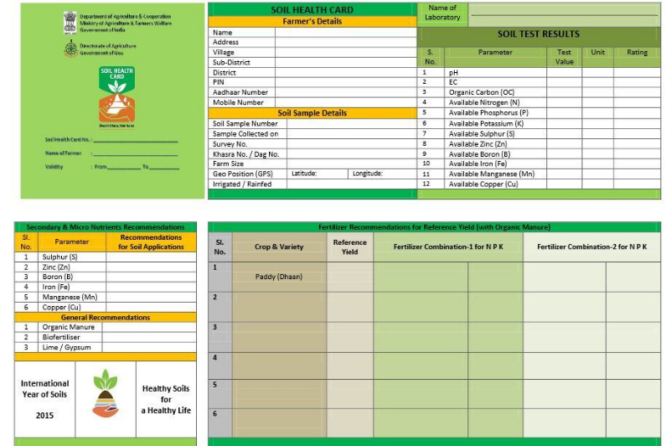
Fig.1. A sample Soil Health Card
Figure 1 illustrates a representative Soil Health Card format currently issued under government programs. The report primarily presents quantitative nutrient values along with corresponding classifications and fertilizer recommendations. Although effective for identifying nutrient deficiencies, the format focuses largely on corrective chemical input measures and does not provide integrated sustainability guidance, long-term soil health strategies, or contextualized crop planning insights.
LIMITATIONS OF THE CURRENT SOIL TESTING ECOSYSTEM
Despite the structured expansion of soil testing infrastructure and the implementation of the Soil Health Card (SHC) scheme, several structural and operational limitations restrict the effectiveness of the current system.
TIME-INTENSIVE LABORATORY DEPENDENCY
Conventional soil testing relies heavily on centralised laboratory-based chemical analysis. The workflow involving sample collection, transport, preparation, laboratory processing, and report generation introduces significant delays. In government laboratories, turnaround time may extend to several weeks depending on workload and administrative processes. Such delays reduce the practical utility of soil test results, particularly when farmers require timely decision-making during critical crop planning stages.
ACCESSIBILITY AND GEOGRAPHICAL CONSTRAINTS
Most government soil testing laboratories are located at district headquarters or designated agricultural centres. Farmers from remote or interior villages must travel to submit samples and collect reports. This introduces indirect costs including transportation expenses, time loss, and opportunity cost of labour. Although private laboratories exist, they are predominantly concentrated in urban or semi-urban areas, limiting accessibility for small and marginal farmers.
COST CONSIDERATIONS
While government-supported testing is subsidised, private soil testing services often involve higher charges depending on the number of parameters analysed. For economically vulnerable farmers, repeated soil testing may not be financially feasible, reducing adoption frequency.
LIMITED INTERPRETABILITY OF SOIL HEALTH REPORTS
Figure 1 illustrates a representative Soil Health Card format currently issued under government programs. The report primarily presents quantitative nutrient values along with categorical classifications such as low, medium, or high. Although effective in identifying nutrient deficiencies, the reporting format largely emphasises numerical data and chemical fertilizer recommendations. Interpretation often requires external guidance from agricultural officers or experts, limiting independent decision-making by farmers.

ABSENCE OF HOLISTIC SUSTAINABILITY GUIDANCE
Current soil testing frameworks focus predominantly on nutrient quantification and corrective fertilizer application. While this approach addresses short-term deficiencies, it does not comprehensively integrate long-term soil restoration strategies, organic and biological soil management options, crop rotation planning, integrated nutrient management practices, or environmental impact considerations. As a result, soil test outcomes frequently translate into input-based corrective measures rather than sustainable soil health planning.
LACK OF REAL-TIME AND CONTINUOUS MONITORING
Traditional soil testing represents a periodic and static assessment of soil condition. It does not support real-time monitoring or dynamic updates based on changing environmental or cropping conditions. In an era of precision agriculture, this static model limits responsiveness and adaptability.
SECTION INSIGHT
The existing soil testing ecosystem in India demonstrates strong scientific reliability but remains structurally centralised, time-intensive, and limited in actionable sustainability-oriented outputs. These limitations highlight the need for modernised soil analysis systems that reduce dependency on centralised laboratories while enhancing usability, accessibility, and decision-support capabilities.
Ref | Core Focus | Technology Used | Parameters Measured | Mobility | Reported Accuracy / Success | Real-Time / Latency | Incremental Consumables | Decision Support | Limitations
[10] | NPK-based smart agriculture | NPK sensors + IoT | NPK | Static | 99.69% yield increase; ~72% fertilizer reduction | Real-time | Reagent-less | Fertilizer optimization | Crop-specific, limited scalability
[11] | Real-time nutrient monitoring | NPK sensors + wireless transmission | NPK | Static | 88–91% accuracy vs. lab | Real-time; <1 second response | None; electronic in-situ probe | Precision agriculture support | Focused on sensing, limited automation
[12] | Multisensory soil monitoring | Integrated sensor array | NPK, moisture, environmental data | Semi-mobile | 0.01 RMSE; 0.92 moisture-macronutrient correlation | Real-time; continuous wireless transmission | None; continuous autonomous monitoring | Data acquisition | Lacks full agronomic advisory layer
[13] | IoT soil monitoring robot | Sensors + irrigation system | Moisture, basic nutrients | Mobile | Successful autonomous threshold-based irrigation | Real-time; immediate sensing-to-actuation | Water (only when soil moisture insufficient) | Irrigation control | Limited nutrient depth
[14] | Autonomous soil sampling | Ground-based robot + sampling unit | Soil sampling (lab analysed) | Mobile | R² = 0.861 vs. lab measurements | Real-time; 90-second pXRF measurement | Physical sampling buckets/scoops | No direct decision layer | Still lab-dependent
[15] | Path planning techniques | Algorithmic navigation | N/A | Mobile | Success rate varies by environment and algorithm | 10–180 ms sensor response | Computational (High RAM/GPU) | No soil analytics | Focus on navigation only
[16] | Autonomous navigation in agriculture | Navigation algorithms | N/A | Mobile | ±0.05 m distance; ±5° orientation accuracy | Real-time feedback control | Computational (LiDAR point cloud processing) | No soil analytics | Environmental constraints
[17] | UAV-assisted field mapping | UAV + row mapping | N/A | Aerial + Ground | High row-extraction feasibility (open canopy) | Near real-time aerial map pre-deployment | Computational (stitching software) | No nutrient analysis | Mapping-focused
[18] | Portable soil sensor system | 3D printed sensors | pH, K | Handheld | Nernstian sensitivity: -61.05 mV/pH; 49.50 mV/dec (K⁺) | Real-time; on-site small sample volumes | Minimal (MacroRhizon extraction tubes) | Limited | Single-parameter focus
Table 1. Comparative Analysis of Recent IoT- and Robotics-Based Soil Monitoring Systems
As shown in Table 1, existing research efforts primarily focus on individual components such as nutrient sensing, robotic navigation, irrigation automation, or portable parameter detection. While these studies contribute significantly to advancing precision agriculture technologies, most systems remain fragmented in scope. Few approaches integrate real-time soil analysis, autonomous data acquisition, and sustainability-oriented decision support into a unified framework.
RESEARCH GAPS AND INTEGRATION CHALLENGES
The limitations identified in the preceding section reflect the constraints of conventional soil testing infrastructure. While emerging technologies including IoT-based sensing, autonomous robotics, and portable analytical devices represent promising directions, a critical examination of current research reveals that these technological advances have not yet resolved the systemic challenges of the traditional ecosystem. The following gaps characterise the present state of technological development in this domain.
FRAGMENTATION OF TECHNOLOGICAL SOLUTIONS
Most existing systems address isolated functionalities rather than end-to-end soil testing workflows. Sensor-based studies primarily focus on nutrient detection accuracy, robotics-based studies concentrate on navigation and field traversal, and portable testing devices emphasise parameter measurement without integrating automation or decision-support capabilities. This fragmentation produces solutions that resolve specific technical problems without addressing the broader structural issues of centralised soil testing infrastructure.
CONTINUED DEPENDENCY ON LABORATORY VALIDATION
Several autonomous sampling systems continue to rely on laboratory-based chemical analysis following sample collection in the field. Although automation improves sampling efficiency, it does not eliminate dependency on centralised laboratory infrastructure. Consequently, the delays, accessibility barriers, and workflow complexity that characterise conventional systems persist even within technologically advanced approaches.
LIMITED DECISION-SUPPORT INTEGRATION
Many IoT-based soil monitoring platforms provide raw sensor data or basic visual dashboards without translating soil parameters into actionable agricultural guidance. Outputs addressing crop suitability, sustainable nutrient management strategies, or long-term soil restoration planning remain underdeveloped. The emphasis on corrective fertilizer input over integrated soil management frameworks limits the practical value of these systems for farmers.
ABSENCE OF A HOLISTIC SUSTAINABILITY LAYER
Whereas the conventional system fails to incorporate sustainability guidance at the reporting stage, current technological approaches similarly omit sustainability dimensions at the design stage. Priorities such as soil regeneration, environmental impact reduction, and balanced nutrient cycling are seldom embedded within the analytical output of emerging platforms. This creates a gap not merely in reporting but in the foundational objectives of the systems themselves.
SCALABILITY AND FARMER-CENTRIC USABILITY
Advanced robotic and IoT systems frequently require technical expertise, infrastructure support, or high initial investment, raising significant uncertainty about scalability across small and marginal farming communities. Usability in rural environments with variable connectivity and limited resources is not consistently addressed in current research, leaving a gap between laboratory-validated performance and real-world deployment.
SECTION INSIGHT
The existing body of research demonstrates meaningful progress in sensing accuracy, automation, and intelligent navigation. However, emerging technological solutions remain fragmented, lab-dependent, and insufficiently oriented toward farmer-centric usability and long-term sustainability. The absence of an integrated, decentralised, and sustainability-aware soil testing framework represents the central research gap in this domain. Addressing it requires combining real-time soil data acquisition, autonomous mobility, intelligent interpretation, and accessible decision support within a single cohesive system.
PROPOSED SYSTEM
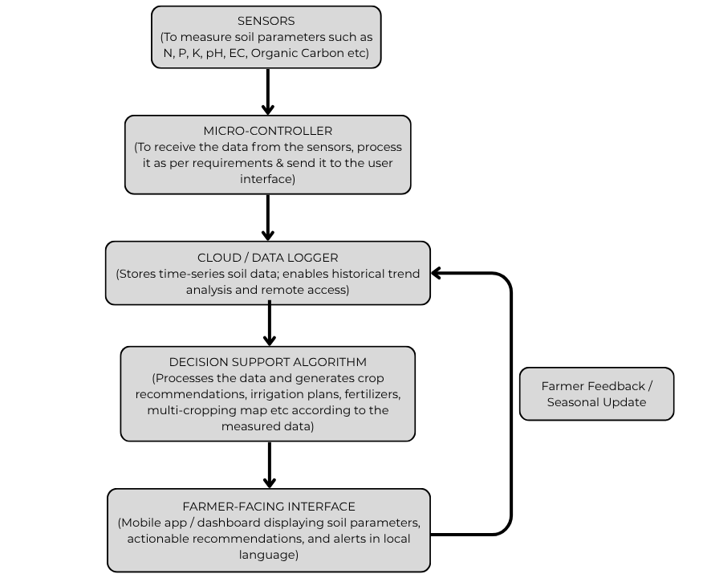
Based on the gaps identified in the preceding analysis, Fig. 2 illustrates a conceptual framework for an integrated, decentralised, real-time soil testing and decision support system. The framework consolidates the fragmented capabilities observed across reviewed systems into a unified pipeline — from field-level sensing through cloud-based data logging, algorithmic decision support, and a farmer-facing interface — with a feedback loop enabling seasonal updates and adaptive recommendations.
Fig. 2. Proposed conceptual framework for an integrated, decentralised, real-time soil testing and decision support system.

LIMITATIONS
This review is qualitative in scope and does not include primary experimental validation. Findings are drawn entirely from published literature, government reports, and documented field observations, without original laboratory trials or controlled agronomic experiments. Interpretations regarding the limitations of conventional soil testing and the projected advantages of emerging technologies therefore remain subject to empirical verification.
The study does not account for regional heterogeneity in soil profiles, agronomic practices, or administrative capacity, which may cause identified constraints to manifest differently across varying geographies. Performance data cited in the IoT and portable sensing comparisons reflects individual study conditions and may not be reproducible across diverse field environments. Assumed baseline conditions like connectivity, power availability, and digital literacy may also not uniformly exist in rural India, limiting generalizability.
Despite these constraints, the review surfaces a critical and under addressed need: affordable, easy-to-use soil testing tools built around farmer requirements rather than laboratory conventions. Portable devices that measure key soil parameters and deliver direct, crop-specific guidance could reduce centralized dependency, accelerate decision-making, and drive meaningful improvements in crop yields and overall agricultural productivity.
CONCLUSION
Soil testing sits at the heart of responsible farming, yet for most smallholder farmers across India, it remains something that happens far away, takes too long, and returns results that are hard to act on. Laboratory-based analysis has served agriculture well in terms of scientific accuracy, but its centralized structure has quietly excluded the very people who need it most. Portable sensors, IoT platforms, and data-driven recommendation tools have started to change this picture, though not fast enough and not in ways that connect into a single, farmer-ready system. Progress in this domain, while encouraging, remains incremental and insufficiently coordinated.
Closing this gap demands less invention and more intention. The technologies needed to build affordable, field-ready soil testing systems largely exist yet the missing link is the institutional will to develop them as a unified whole rather than in isolated silos. Soil scientists, electronics engineers, agronomists, data analysts, and rural development practitioners each hold a piece of this problem, yet coordinated, cross-disciplinary projects in this space remain rare. Funding bodies, both government and private, have a direct role to play in changing that. Research grants and development programs must begin treating affordability, ease of use, and field-readiness as foundational design criteria rather than features to be addressed after the core technology is built. A system that performs well in a controlled laboratory setting but fails in the hands of a farmer with no technical background has not solved the problem but it has only moved it. This system needs sustained, ground-level pilots conducted alongside farming communities, state agriculture departments, and rural cooperatives work that measures what actually changes in how farmers make decisions, how inputs are applied, and what yields result. That kind of evidence takes time and commitment to build, but it is the only foundation on which scalable soil health solutions can stand.
Getting accurate soil information into the hands of a farmer, in a form they can use, on the same day they need it that is the goal worth organizing research, funding, and policy around.
REFERENCES
[1] Food and Agriculture Organization (FAO), Soil Fertility Management in Support of Food Security in Sub-Saharan Africa, FAO Soils Bulletin, Rome, Italy. (2000)
[2] Indian Council of Agricultural Research (ICAR), Methods Manual: Soil Testing in India, ICAR Publications, New Delhi, India. (2011)
[3] N. C. Brady and R. R. Weil, The Nature and Properties of Soils, 15th ed., Pearson Education, 2016.
[4] H. L. S. Tandon, Methods of Analysis of Soils, Plants, Waters and Fertilizers, Fertilizer Development and Consultation Organization (FDCO), New Delhi, India. (2005)
[5] United States Department of Agriculture (USDA), Soil Survey Manual, USDA Handbook. (2017)
[6] R. Lal, “Soil health and carbon management,” Food and Energy Security, vol. 5, no. 4, pp. 212–222, 2016.
[7] Meena, Hari & Sharma, R &., Roohi. (2018). Soil Testing Scenario in India and Its Significance in the Balanced Use of Fertilizers. International Journal of Plant & Soil Science. 22. 1-7. 10.9734/IJPSS/2018/39962.
[8] Lade et al.; Asian J. Agric. Ext. Econ. Soc., vol. 42, no. 2, pp. 100-106, 2024; Article no. AJAEES.112738
[9] Government of India, Soil Health Portal: Soil Testing Laboratories Database, Department of Agriculture & Farmers Welfare. [Online]. Available: https://soilhealth.dac.gov.in/soilTestingLabs [Accessed: Jan. 2026]
[10] S. Adak, “Smart Agriculture with NPK Sensors: A Sustainable Approach to Soil Health and Fertilizer Optimization in Guava Farming,” J. Sci. Res. Reports, vol. 31, no. 7, pp. 45–52, 2025.
[11] R. Adhikary, S. J. Choudhury, and T. Shankar, “Real-Time Soil Nutrient Monitoring Using NPK Sensors: Enhancing Precision Agriculture,” Int. J. Exp. Res. Rev., ISSN 2455–4855, 2025.
[12] V.-D. Băjenaru, S.-E. Istriţeanu, and P.-N. Ancut, “Autonomous, Multisensory Soil Monitoring System,” AgriEngineering, vol. 7, p. 18, 2025.
[13] A. K. Yadav, P. Shukla, A. K. Sharma, and S. K. Gupta, “IoT-Based Soil Monitoring Water Sprinkler Robot,” Int. J. Futuristic Multidiscip. Res., E-ISSN: 2582-2160, 2025.
[14] J. Norbya, H. Hussain, and S. Mandal, “Path to Autonomous Soil Sampling and Analysis by Ground-Based Robots,” J. Environ. Manage., Elsevier, 2025.
[15] L. Liu, X. Wang, X. Yang, H. Liu, J. Li, and P. Wang, “Path Planning Techniques for Mobile Robots: Review and Prospect,” Expert Syst. Appl., Elsevier, 2025.
[16] T. Fujinaga, “Autonomous Navigation Method for Agricultural Robots in High-Bed Cultivation Environments,” Comput. Electron. Agric., Elsevier, 2025.
[17] H. Mansur, M. Gadhwal, J. E. Abon, and D. Flippo, “Mapping for Autonomous Navigation of Agricultural Robots Through Crop Rows Using UAV,” Agriculture, vol. 15, p. 882, 2025.
[18] M. McCole, M. Bradley, M. McCaul, and D. McCrudden, “A Low-Cost Portable System for On-Site Detection of Soil pH and Potassium Levels Using 3D Printed Sensors,” Results Eng., Elsevier, 2025.

