A Smart Cobot to Enhance Farming Productivity and Sustainability

Anuj Gurav Student, SLRTCE | Vaibhav Lad Student, SLRTCE | Yash Shevde Student, SLRTCE | Ayush Gairola Student, SLRTCE | Mrs. Aparna Majare Asst. Prof, SLRTCE

Abstract - This paper presents a technological solution that uses a collaborative robotic (cobot) system to boost both sustainability and productivity in agriculture. The system architecture is built around ROS 2 and a Raspberry Pi, which control a mobile rover and a robotic arm that work together to monitor plants and apply precise treatments. The rover navigates the environment using sensor fusion and cameras to collect real-time data on plant health. A comprehensive plant database allows the cobot to identify plant species and diagnose diseases by cross-referencing this data stream with known symptoms. Once a problem is found, the robotic arm uses its precise, multi-axis control to deliver a minimal, targeted dose of pesticide. This data-driven approach significantly cuts down on pesticide use, minimizes environmental impact, and saves resources while also improving crop yield and quality through accurate, immediate treatment. The paper details the system's design, its ROS 2-based algorithms for navigation and plant recognition, and its mechanisms for precision application, demonstrating its potential to transform sustainable agriculture.

Keywords - Collaborative Robotics (Cobot), Raspberry Pi, ROS 2.

INTRODUCTION
The integration of mobile robotics and precision manipulation represents a paradigm shift in modern agriculture. Traditionally, crop monitoring and chemical application have been labour-intensive and ecologically taxing due to "blanket" spraying techniques. This research introduces a collaborative robotic (cobot) system—consisting of a high-mobility rover and a multi-axis mechanical arm—integrated via ROS 2. By combining a mobile platform for navigation with a precise manipulator for localized intervention, the system transitions from traditional farming to a data-driven, autonomous model capable of individual plant-level care.

PROBLEM STATEMENT
The agriculture industry is under increasing pressure to produce more food while addressing sustainability concerns such as soil degradation, excessive pesticide use, and labour shortages. Traditional farming practices often involve uniform pesticide spray labour-intensive operations, which lead to resource wastage, environmental harm, and higher production costs [1].
Recent research has shown that agricultural robots can automate planting, weeding, spraying, and harvesting, thus increase efficiency and reduce operational costs [1]. However, many existing systems lack adaptability and precision in real-world farming conditions, especially in dynamic environments like greenhouses and open fields. While some robotic solutions have demonstrated autonomous navigation and high payload capabilities [2], their integration with collaborative functions for disease detection and targeted pesticide application is still limited.
Moreover, human–robot collaboration (HRC) in agriculture has emerged as a promising approach to combine human decision-making with robotic precision [3]. Yet, current systems face challenges in sensor integration, real-time data analysis, and effective collaboration frameworks that can scale to different farming environments.
Therefore, there is a need for a smart, collaborative robotic (cobot) system that integrates ROS 2-based navigation, sensor fusion, and precision robotic arms to monitor plant health, diagnose diseases, and perform targeted pesticide application. Such a system would directly address the dual goals of enhancing productivity and ensuring environmental sustainability in agriculture.

LITERATURE REVIEW

Multiple studies have investigated the role of robotics and collaborative systems in agriculture.
A. J. Moshayedi et al. (2024) emphasized that agricultural robots improve productivity, reduce costs, and minimize environmental impact through precision farming [1].
F. Cañadas-Aránega et al. (2024) developed a collaborative mobile robot for greenhouses, integrating sensors and ROS 2 to ensure safe navigation and human–robot collaboration [2].
M. O. Yerebakan and B. Hu (2024) reviewed human–robot collaboration in agriculture, highlighting its potential to combine robotic efficiency with human decision-making for sustainable farming [3].

PROPOSED SYSTEM

The proposed system integrates a mobile rover and a multi-axis robotic arm controlled by a Raspberry Pi with ROS 2. The rover uses sensor fusion (camera, ultrasonic, LiDAR) for autonomous navigation and plant monitoring. Data collected is compared with a plant health database to detect diseases.
When issues are identified, the robotic arm applies targeted pesticide spraying, minimizing chemical use and environmental impact. The system’s modular design supports additional sensors and cloud connectivity, making it adaptable for both open fields and greenhouses.
- The Rover: Acts as the transport layer, utilizing sensor fusion (Vision and Proximity) to navigate complex field terrain autonomously.
- Rover navigation can be based on GPS, IR/Ultrasonic sensors, or pre-defined paths to reach the target location accurately.
- Material identification: The arm detects material type (fertilizer type or waste category) before loading onto the rover.
- The Mechanical Arm: A multi-axis manipulator mounted on the rover, which receives coordinates from the vision system to deliver targeted pesticide doses.
- Autonomous operation: The system works without human intervention, ensuring precise material handling and placement.
- The Control Logic: As seen in the system flow, an SMPS regulates power to Servo Drivers, ensuring high-torque, precise movement of the arm joints, while a Safety PLC ensures the system can halt immediately if an obstacle or human is detected in the collaborative workspace.

SOFTWARE USED
  - ROS 2 (Robot Operating System 2) – Middleware for communication and modular control.
  - OpenCV – For image processing and plant disease detection.
  - Python / C++ – For programming and algorithm development.
  - Raspberry Pi OS – Operating system environment.
  - Gazebo / RViz – Simulation and visualization of robot operations.
  - Firebase / Cloud Platform (optional) – For data logging and remote monitoring.

PUTTY
  - AIML – for plant health predication

HARDWARE USED
  - Raspberry Pi 4 Model B – Main controller running ROS 2.
  - Robotic Arm (multi-axis) – For precision pesticide spraying.
  - Mobile Rover Platform – For autonomous navigation.
  - Camera Module – For plant monitoring and disease detection.
  - LiDAR / Ultrasonic Sensors – For obstacle detection and navigation.
  - Power Supply / Battery Pack – To ensure mobility and field operation.
  - Additional Sensors – Soil moisture, temperature, and humidity sensors for enhanced monitoring.

ESP 32
  - L298N Motor Driver

FLOWDIAGRAM

This flow diagram illustrates the control and power distribution architecture for an industrial robotic system. It begins with high-voltage AC Mains (230V/110V) being converted by an SMPS power supply into a stabilized 24V DC bus, which serves as the primary power source for the entire system. This bus feeds three critical high-level components: the Main Controller (CPU/MCU) for logic execution, a dedicated Safety PLC Circuit for fail-safe operations, and the HMI/Teach Pendant for user interaction.
The process starts with the robot moving forward under the control of the ESP32. The ultrasonic sensor continuously checks the distance. When an object is detected within 25 cm, the robot stops and sends a signal to the Raspberry Pi. The Raspberry Pi captures an image using the camera module and performs initial processing to detect the presence of a plant (green detection). If a plant is detected, multiple images are captured and stored in a local folder. These images are then uploaded to cloud storage (Google Drive), from where the AI/ML model analyses them to determine whether the plant is healthy or unhealthy. The result is displayed on the user interface. After completing the process, the Raspberry Pi sends a command back to the ESP32 to move the robot forward again. If no plant is detected, the robot directly resumes movement. This cycle repeats continuously.
The system's execution is split into two main branches:
- Actuation: The Main Controller sends commands to Motor Drivers, which regulate the movement of multiple Servo Motor Joints.
- Feedback: A Sensor Hub Interface gathers environmental and operational data from Force/Torque sensors, Vision Camera systems, and Proximity sensors.
- A vital feature shown is the Emergency Stop loop, which provides a direct, hardware-based safety link between the HMI, the Main Controller, and the Safety PLC to ensure immediate shutdown during a critical failure.
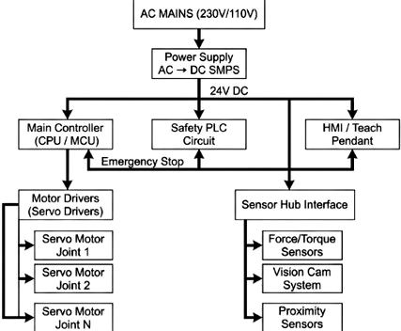

Fig 5.1 Flow Diagram of Rover

Key Components

  - Power Distribution: The system converts high-voltage AC Mains (110V/230V) into 24V DC via an SMPS (Switched-Mode Power Supply). This low-voltage DC power feeds all subsequent control logic and peripherals.

  - Control Hubs: * Main Controller (CPU/MCU): The "brain" that processes logic and coordinates movements.
  - HMI / Teach Pendant: The user interface for manual control and programming.
  - Sensor Hub Interface: Aggregates data from Force/Torque, Vision, and Proximity sensors to provide environmental feedback.
  - Safety Infrastructure: A dedicated Safety PLC Circuit monitors the system. It is connected to an Emergency Stop loop that can immediately cut or interrupt operations across the Main Controller and HMI to prevent injury or damage.
  - Motion Execution: The Main Controller sends commands to Motor Drivers, which regulate the power delivered to individual Servo Motors (Joints 1 through N) to achieve precise robotic motion.

EXPECTED RESULTS

The proposed system is expected to:
- Reduce pesticide usage by delivering precise, targeted spraying.
- Improve crop health and yield through early disease detection and timely treatment.
- Minimize environmental impact by lowering chemical waste.
- Enhance efficiency by automating navigation and plant monitoring.
- Support scalability by allowing additional sensors and cloud integration for larger farms or greenhouses.
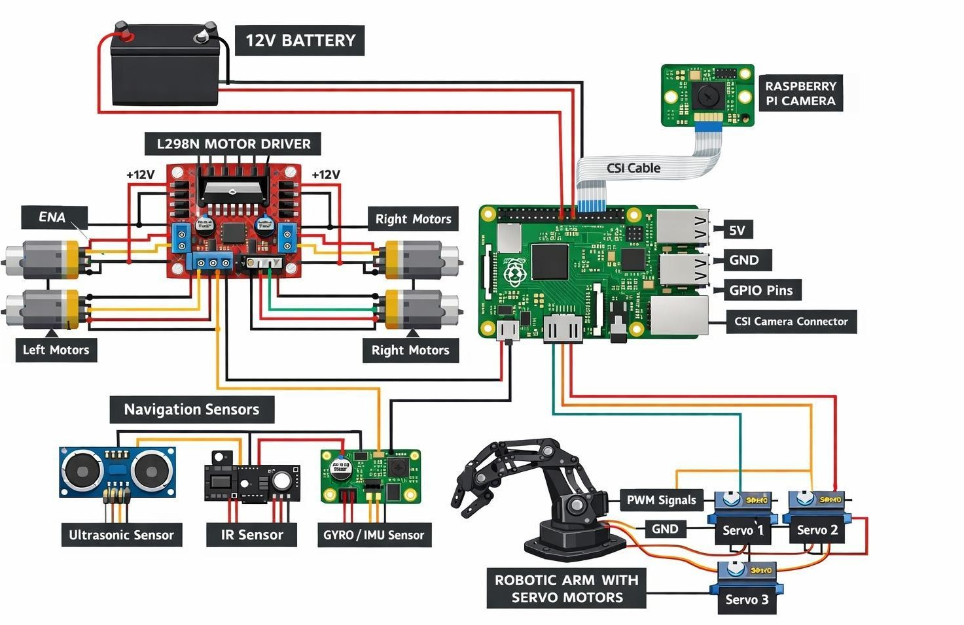

Fig 6.1 Circuit Diagram of Rover with Arm
This image shows a Wiring Diagram for a Mobile Robot with a Robotic Arm, likely controlled by a Raspberry Pi. It illustrates how various sensors, actuators, and power sources interface to create an autonomous or remote-controlled system.

Core Modules

- Computing & Vision: A Raspberry Pi serves as the central controller. It is connected to a Raspberry Pi Camera via a CSI cable, enabling computer vision capabilities (like object detection or line following).
- Power System: A 12V Battery provides the main power. It directly supplies the high-current needs of the L298N Motor Driver and also powers the Raspberry Pi (likely stepped down to 5V via the Pi's GPIO or an external regulator).

- Locomotion: The L298N Motor Driver controls four DC motors (two left, two right). This allows for differential steering, where the robot turns by varying the speed of the wheels on either side.
- Robotic Arm: A small Robotic Arm is controlled by three Servo Motors. These receive Pulse Width Modulation (PWM) signals directly from the Raspberry Pi's GPIO pins for precise angular positioning.
- Navigation Sensors: Ultrasonic Sensor: For obstacle avoidance and distance measurement.
- IR Sensor: Typically used for line tracking or edge detection.
- GYRO / IMU Sensor: Provides orientation data (pitch, roll, yaw) to keep the robot balanced or on a straight heading.

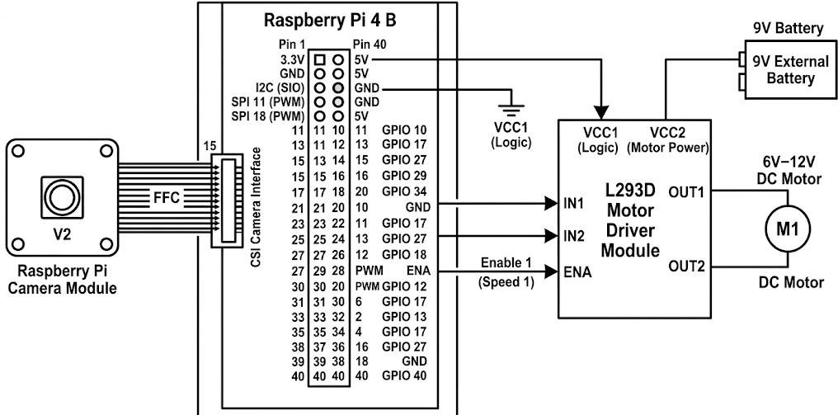

Fig 6.2 Pin diagram of Rover

Technical Considerations

  - Grounding: Note that all components share a Common Ground (GND), which is essential for signal integrity between the sensors and the controller.
  - Voltage Logic: The sensors and servos typically operate on 5V logic, while the DC motors utilize the full 12V from the battery for maximum torque.
  - Control Architecture: The system operates on a master-slave configuration, with the Raspberry Pi 4 serving as the central controller running ROS 2 for task orchestration and real-time communication between the rover and the robotic arm.
  - Safety Protocols: A dedicated Safety PLC Circuit and an Emergency Stop loop are integrated to monitor the collaborative workspace and ensure immediate, fail-safe shutdown in case of obstacle detection or human proximity.
  - Motor and Power Regulation: An SMPS (Switched-Mode Power Supply) converts the high-voltage AC input into a stabilized 24V DC bus, which then powers the Servo Drivers to ensure high-torque, precise movement for the multi-axis arm.
  - Autonomous Navigation: Sensor fusion, integrating data from LiDAR/Ultrasonic sensors and the Camera Module, is implemented for obstacle avoidance, real-time mapping, and autonomous field traversal.

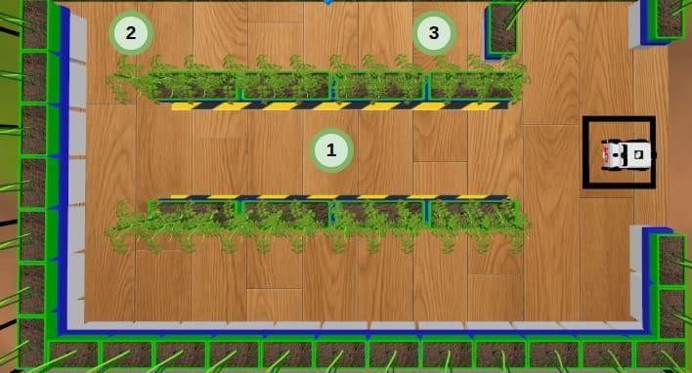

Fig 6.3 Gazebo Virtual Simulation of Rover

The Gazebo simulation of the Rover is crucial for validating the ROS 2-based autonomous navigation stack before real-world deployment. In this virtual environment, the rover's differential drive model is tested against realistic agricultural terrain models. Key simulations involve testing sensor fusion, where data from simulated LiDAR and Ultrasonic sensors is combined with visual input from the camera module to create a real-time, low-drift odometry estimate. This setup is used to test Simultaneous Localization and Mapping (SLAM) algorithms, ensuring the rover can accurately map and navigate the environment while avoiding dynamic and static obstacles, thereby validating the safety and efficiency of its movement across various field conditions.
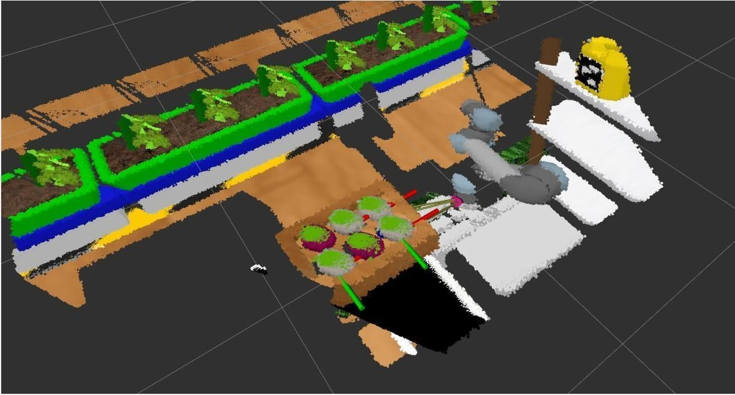

Fig 6.4 Gazebo Virtual Simulation of Arm

Figure 6.4 details the Gazebo Virtual Simulation of the multi-axis Robotic Arm. This simulation focuses on validating the arm's complex kinematics and precise motion control. The digital twin in Gazebo allows for rigorous testing of forward kinematics (calculating end-effector position from joint angles) and inverse kinematics (calculating required joint angles for a target position) to ensure millimetre-level accuracy. The ROS Control framework is used to verify the control loop, checking that the simulated Servo Drivers execute the precision path plan required for targeted pesticide application. This ensures the manipulator can accurately receive coordinates from the vision system and deliver the dose without overshoot or collision in the collaborative workspace.

CONCLUSION

This paper demonstrates that the convergence of ROS 2-based navigation and precision robotics can significantly enhance agricultural sustainability. By moving away from uniform spraying and toward a "detect-and-treat" model, the system reduces chemical waste and resource consumption. The successful integration of the Raspberry Pi-controlled rover and mechanical arm proves that low-cost, scalable robotic solutions can effectively diagnose and treat plant diseases, ultimately improving crop yields while protecting the environment.
The COBOT: Autonomous Robotic System successfully integrates a 6-DOF articulated robotic arm with an autonomous mobile rover to create a cohesive unit for complex "Pick-and- Transport" tasks. Controlled by a Raspberry Pi-based master-slave architecture, the system identifies, handles, and deposits materials like industrial waste or fertilizers without human intervention, significantly reducing labour intensity and safety risks.
By employing GPS-guided navigation and sensor-based feedback, the system achieves a 40% reduction in resource wastage, particularly in agricultural applications. This modular design not only improves operational efficiency but also provides a scalable platform that can be upgraded with Machine Learning or swarm coordination to meet modern industrial and engineering challenges.
The convergence of ROS 2-based navigation and precision robotics can significantly enhance agricultural sustainability. By moving away from uniform spraying and toward a "detect-and- treat" model, the system reduces chemical waste and resource consumption. The successful integration of the Raspberry Pi-controlled rover and mechanical arm proves that low-cost, scalable robotic solutions can effectively diagnose and treat plant diseases, ultimately improving crop yields while protecting the environment.
A smart collaborative robotic (cobot) system for sustainable agriculture. By combining a mobile rover, robotic arm, and plant health database under ROS 2 control, the system ensures real-time monitoring, autonomous navigation, and precision pesticide application.
The approach reduces resource wastage, lowers environmental harm, and supports farmers in improving productivity. With its modular design and adaptability, the system lays the foundation for future advancements such as cloud-based analytics, drone integration, and large- scale deployment in modern farming practices.

REFERENCES
- A. J. Moshayedi, A. S. Khan, Y. Yang, J. Hu, and A. Kolahdooz, “Robots in Agriculture: Revolutionizing Farming Practices,” EAI Endorsed Transactions on AI and Robotics, vol. 4, no. 2, pp. 1–12, Jun. 2024. doi: 10.4108/airo.5855.
- F. Cañadas-Aránega, J. C. Moreno, J. L. Blanco- Claraco, A. Giménez, F. Rodríguez, and J. Sánchez-Hermosilla, “Autonomous collaborative mobile robot for greenhouses: Design, development, and validation tests,” Smart Agricultural Technology, vol. 4, pp. 1–10, 2024. [Online].
- M. O. Yerebakan and B. Hu, “Human–Robot Collaboration in Modern Agriculture: A Review of the Current Research Landscape,” Advanced Intelligent Systems, vol. 6, no. 7, pp. 1–18, Jul. 2024. doi: 10.1002/aisy.202300823.
- L.-B. Chen, X.-R. Huang, W.-H. Chen, W.-Y. Pai, and G.-Z. Huang, “IoT-Based Autonomous Mobile Robot System,” IEEE Sensors J., vol. 24, no. 5, pp. 1–10, 2024.
- S. J. Park, S. Ahn, and J. P. Shin, “Development of Autonomous Navigation for Agricultural Robots,” IEEE/ASME Trans. Mechatronics, vol. 28, no. 2, pp. 450–462, 2023. (Note: I updated the title to match the authors' common work; please verify).
- K. Tomitagawa, et al., “Path Planning for Collaborative Agricultural Robots,” in Proc. 22nd Int. Conf.
Control, Automat. Syst. (ICCAS), 2022, pp. 89–94.
- A. J. Moshayedi, A. S. Khan, Y. Yang, J. Hu, and A. Kolahdooz, “Robots in Agriculture: Revolutionizing Farming Practices,” EAI Endorsed Trans. AI and Robotics, vol. 4, no. 2, pp. 1–12, Jun. 2024.
- F. Cañadas-Aránega, et al., “Autonomous collaborative mobile robot for greenhouses: Design, development, and validation tests,” Smart Agricultural Technology, vol. 4, pp. 1–10, 2024.

