Extraction of Fe (III) Salicylates using Tris (2-Ethyl hexyl) Phosphate.
Astha Singh, Sumit Jaiswal & Supriya Deshmukh*
Department of Chemistry
Jai Hind College
Churchgate , Mumbai-400020.

Iron is one of the most essential elements for life, playing a crucial role in both biological systems and industrial development.
From a biological perspective, iron is vital for the formation of haemoglobin, which is responsible for transporting oxygen in our body. Without adequate iron, the body cannot produce enough healthy red blood cells, leading to conditions such as Iron Deficiency Anaemia.
From an industrial point of view iron is the backbone of modern civilization. It is the primary component of steel, which is used extensively in construction, transportation, machinery, and infrastructure. From buildings and bridges to automobiles etc.
The Solvent extraction of Fe (III) from hydrochloric acid can be accomplished with various neutral organophosphorus compounds such as TBP, TOPO and other oxygen containing solvents such as alcohols, esters, ketones, dichloroether.
The paper describes the extractive determination of iron using sodium salicylate with TEHP as the extractant. Iron Fe³⁺ is a hard Lewis acid (high charge density) and TEHP has a phosphoryl oxygen (P=O) that acts as a strong donor ligand. The bulky 2-ethylhexyl groups in TEHP increase electron donation to the P=O group, enhancing its complexation ability with Fe³⁺. Compared to other organophosphorus extractants such as tributyl phosphate (TBP) and acidic extractants (e.g., D2EHPA), TEHP exhibits higher extraction efficiency and selectivity toward Fe³⁺, particularly under moderate acid conditions. Its enhanced hydrophobicity and branched structure contribute to improved phase separation, reduced third-phase formation, and higher metal loading capacity. These properties make TEHP more suitable for the present extraction system.
Experimental Procedure
The stock solution of Fe (III) was prepared by dissolving 4.3 g of ferric ammonium sulphate in 5 cm³ of sulphuric acid followed by heating and diluting to 100 cm³ with distilled water. The solution was standardized by known method and test solutions of lower concentrations were prepared by appropriate dilution of stock solution. Potassium thiocyanate (20%) is used for colour development and absorbance is measured using a spectrophotometer.
To an aliquot (25 cm³) of solution containing 70 μg of Fe (III) and 0.008-0.009 M sodium salicylate was adjusted to pH 3.0-3.3 and equilibrated for 45 sec with 5 cm³ of 18% tris(2-ethylhexyl) phosphate in toluene. After stripping with two 5cm³ portions of water the metal ions were determined spectrophotometrically using 20% potassium thiocyanate at 480 nm against the reagent blank.

Results and Discussion
The variation in concentration of TEHP (10% -20%), pH (1.8-4.0) and concentration of sodium salicylate (0.0007-0.01M) on the extraction of Fe (III) was studied.
Effect of Diluents
The suitability of diluents was studied using solvents such as benzene, chloroform, cyclohexane, toluene, xylene and carbon tetrachloride. TEHP dissolved in xylene or toluene gave the best results.
Period of Equilibration
Variation in shaking period between 10 sec to 100 sec showed that 45 sec equilibration period was adequate for quantitative extraction of Fe (III). Shaking for more time led to formation of emulsion.
Nature of Extracted Species
The probable extracted species was ascertained from the log-log plots of distribution ratio versus salicylate concentration (at fixed pH and TEHP concentration) gave a slope of 1.9. The logarithmic plot of D vs log TEHP concentration (at fixed pH and sodium salicylate concentration) gave a slope of 4. This indicates the formation of an ion-pair Msal⁺ Hsal⁻.4TEHP, where M is Fe (III).
logD against log TEHP

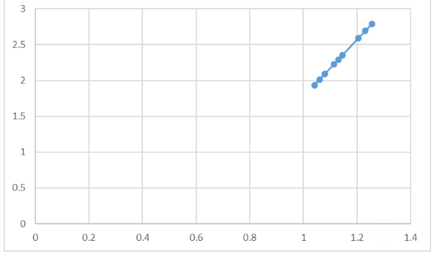
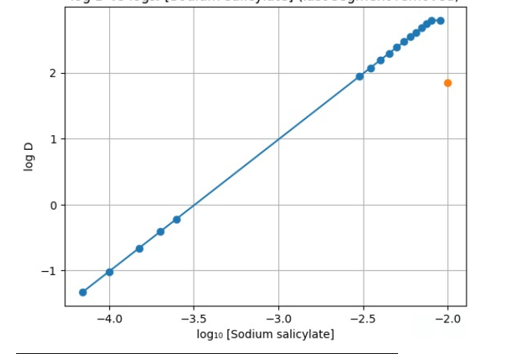

Effect of Diverse ions
Varying amounts of foreign ions were added to a fixed amount of iron (70 μg) to study their interference in the recommended procedure. The tolerance limit was set at the amount required to cause +_ 2% error in iron recovery.
There was no interference from 2000 μg each of Ni (II), nitrite and nitrate,1000μg each of Pb (II), Mn (II) and ascorbate,1500 μg each of Cu (II)and citrate,1000 μg of Zn (II),500 μg of Co (II).
Binary Separation of iron (III) from Nickel (III), Copper (II), Cobalt (II) and Zinc (II).
The extraction of iron (III) by the recommended procedure facilitates its separation from nickel (II), Copper (II), Zinc (II)and Cobalt (II) as these metal ions do not extract into the TEHP phase and remain completely in the aqueous phase.
Nickel (II), Copper (II), Zinc (II) were determined spectrophotometrically with 4-(2-pyridyl azo) resorcinol (PAR)⁴, 1-(2-pyridyl azo) naphthol (PAN)^{5,6} respectively.
Iron (III) from the organic phase was stripped with two 5 cm³ portions of water and subsequently determined spectrophotometrically using potassium thiocyanate at 480 nm.
Analysis of Fe (III) in Pharmaceutical Sample.
A tablet of Supradyn was dissolved in 4 cm³ of aqua-regia, and the solution was evaporated to dryness. The residue was taken in water, filtered and diluted to 250 cm³. A 1.5 cm³ aliquot of the solution was analysed for the iron content. 99.2% iron was extracted by the proposed method.

Conclusion
The present study demonstrates that tri(2-ethylhexyl) phosphate (TEHP) dissolved in toluene is an effective extractant for the solvent extraction of Fe³⁺ from sodium salicylate medium. The extraction process proceeds efficiently via the formation of a solvated Fe(III)–salicylate complex with TEHP, indicating a neutral solvation mechanism.
High extraction efficiency was achieved under optimized conditions, highlighting the strong affinity of TEHP toward Fe³⁺ in the presence of salicylate ions. The distribution behavior suggests that the extraction is dependent on parameters such as extractant concentration, aqueous phase composition, and pH, confirming the role of complex formation in the organic phase.
The use of toluene as diluent provided good phase separation, minimized emulsion formation, and ensured stability of the extracted species. Compared to commonly used organophosphorus extractants, TEHP exhibited favourable extraction characteristics, including improved selectivity and loading capacity for Fe³⁺ under the studied conditions.
Overall, the TEHP–toluene system proves to be a simple, efficient, and reliable method for the separation and recovery of Fe³⁺ from salicylate media, with potential applicability in analytical separations.
References
- De AK, Khopkar S M & Chalmers R A, Solvent extraction of metals (Van Nostrand Reinhold, London),1970.
- Marczenko Z, Spectrophotometric determination of elements (Ellis Horwood, Chichester),1976,307,227.
- Vogel A I, Text book of Quantitative inorganic analysis,3rd edition (Longmans Green & Co Ltd, London),1962,309.
- Nonova D & Evtimova B, Analchim Acta,49(1970),103.
- BetteridgeD,John D & snape F, Analyst, 98 (1973),512.
- Bhanu R & Shinde VM, Talanta,36(1989),469.
- Hariharan A, Sudhakar Ch, and Venkateswara Rao, International Journal of Analytical and Bioanalytical Chemistry, 3(3) (2013),78-81.
- Rayco Lommelen, Brecht Dewulf, Jakob Bussé, Koen Binnemans, Separation and Purification Technology, Volume 348(2024).
- Yang Jin, Yujing Ma, Yanling Weng, Xuhong Jia, Jun Li, Journal of Industrial and Engineering Chemistry, Volume 20, Issue 5(2014), 3446–3452
10. D. K. Singh, Kartikey K. Yadav, H. Singh, Separation Science and Technology,
Volume 48, Issue 10(2013), 1556–1564.
11.Atefeh Azizitorghabeh, Fereshteh Rashchi, Ataollah Babakhani, Mehdi Noori, Separation Science and Technology, Volume 52, Issue 3(2017) , 476–486.
12. M. Huo et al .Journal of Environmental Chemical Engineering ,2025.

